|  |
| --- |
| **Anti-Müllerian Hormone (AMH) MBS listing for female patients who will or have received gonadotoxic treatment** |
| June 2016 |

Developed by:

Dr. Antoinette Anazodo, Chief Investigator Future Fertility Study. Paediatric and Adolescent Oncologist, Sydney Children’s and Prince of Wales Hospital, Director of The Sydney Youth Cancer Service. Churchill Fellow 2015

Mrs. Brigitte Gerstl, National Project Manager Future Fertility Program, Sydney Children’s Hospital

This initiative has been funded by the FUTuRE Fertility research study team and CanTeen Australia.

Table of Contents

Purpose of this document 7

What is fertility preservation and Oncofertility care? 10

Population at risk of infertility 10

Gonadotoxic treatments in cancer patients 11

Gonadotoxic treatments in non-cancer patients 11

Oocyte and embryo cryopreservation 13

Gonadotropin-releasing hormone analogues (GnRHa) 14

In vitro maturation 15

Ovarian transposition 15

Population 19

Access AMH Assay (Beckman Coulter): 19

AMH Gen II ELISA Kit (Beckman Coulter): 20

AMH ELISA (Ansh Labs): 20

picoAMH: 20

Elecsys AMH (Roche Diagnostics): 20

Sample collection and storage requirements 20

Test Interpretation 20

Table 3 Interpretation of AMH cut-off guidelines 21

Basal FSH 21

Antral Follicle Count 21

Inhibin B 22

Estradiol 22

Data………………………………………………………………………………………………....23

Costs……………………………………………………………………………………………….23

MBS ONC1 25

Table 6: Summary of extended PICO to define research question that assessment will investigate 26

Restrictor 28

Comparator 28

Figure 1a: Algorithm for the Assessment of Reproductive Potential for New and Relapsed Paediatric Patients 29

Figure 1b: Algorithm for the Assessment of a patient’s reproductive potential following Gonadotoxic Treatment: Paediatric Patients 30

Figure 2a: Algorithm for the Assessment of Reproductive Potential for New and Relapsed AYA (15-25-year-old) Patients 31

Figure 2b: Algorithm for the Assessment of a patient’s reproductive potential following Gonadotoxic Treatment: Adolescent Young Adult (15 – 25-year-old) Patients 32

Figure 3a: Algorithm for the Assessment of Reproductive Potential for New and Relapsed Adult Patients 33

FUTuRE Fertility chief investigators and lead investigators 35

Australasian Oncofertility Consumer Group 35

Fertility Society of Australia Medical Fertility Preservation Group 35

Access Australia's National Infertility Network Ltd 35

CanTeen Youth Advisory Group 36

CanTeen Leadership Group 36

Youth Cancer Services Strategic Advisory Group 36

IVF Directors 36

Andrology 36

Medical Oncology Group of Australia (MOGA) 36

Cancer Nurse Society of Australia (CNSA) 36

South Australian Oncofertility Group 36

Queensland Oncofertility Group 36

Victorian Fertility Preservation Taskforce 36

Australasian Oncofertility Consortium Charter 49

Table 2: International Guidelines on AMH 51

Executive Summary

The loss of reproductive function due to cancer or non-malignant diseases, treated with gonadotoxic treatment, is a significant survivorship consideration for many young patients. The use of gonadotoxic treatment can impact the future fertility of women, and children and the well-documented late effects consequences of infertility are substantially deleterious to the physical and psychological wellbeing of survivors.

The sub-specialty of oncofertility has been established to ensure that the future reproductive health of all cancer and non-malignant patients receiving gonadotoxic treatment is optimised prior to starting treatment. Advances in fertility preservation options have allowed fertility to be addressed at earlier stages in cancer care. Increased rates of survival have encouraged clinicians and patients to explore the options available for fertility preservation, allowing the potential for patients to have a biological family in the future. Reassurance about this opportunity leads to improvements in satisfaction and quality of life.

This report will discuss all aspects associated with cancer and non-malignant diagnoses which require gonadotoxic treatment that may cause infertility and advancements in fertility preservation options. The report details recommendations focusing on the establishment of a new Oncofertility Medicare item number.

The FUTuRE Fertility research study group, CanTeen Australia and our collaborators believe that fertility preservation should be available to all cancer patients and patients with non-malignant disease receiving gonadotoxic chemotherapeutic agents, as a ‘duty of care’ and this is supported by the Australasian Oncofertility Charter (Appendix 1). The availability of an Anti Müllerian Hormone Test (AMH) Medicare item number will allow female patients to have an assessment of their fertility potential prior to gonadotoxic treatment which will be important when cancer and fertility doctors are assessing the risk of infertility as a result of gonadotoxic treatment. It will also allow patients who have had gonadotoxic treatment to have an assessment of their ovarian reserve following gonadotoxic treatment which is important for patients who have to consider fertility preservation following gonadotoxic treatment or assisted reproductive treatment, and also optimise pregnancy planning after completion of cancer treatment, when decisions issues relating to survivorship, recurrence and future life choices are all of paramount importance. This will allow equitable access to the best way of assessing reproductive potential before and after gonadotoxic treatment for all female Australians of reproductive age.

This report has been orchestrated and developed by the FUTuRE Fertility research study group and CanTeen, and has been through an extensive engagement and collaborative process with stakeholders from national professional groups in the areas of oncology, haematology, nephrology, general medicine, reproductive medicine and andrology, psychology, epidemiology, health economics, translation and policy research. This report provides evidence in support of this PASC application.

We look forward to hearing about a favorable outcome.



Dr Antoinette Anazodo

Paediatric and Adolescent Oncologist

Director of the Sydney Youth Cancer Service

Sydney Children’s Hospital and Prince of Wales Hospital

Chief Investigator FUTuRE Fertility study

Churchill Fellow 2015

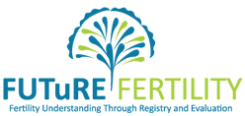

MSAC and PASC

The Medical Services Advisory Committee (MSAC) is an independent expert committee appointed by the Australian Government Health Minister to strengthen the role of evidence in health financing decisions in Australia. MSAC advises the Commonwealth Minister for Health on the evidence relating to the safety, effectiveness, and cost-effectiveness of new and existing medical technologies and procedures and under what circumstances public funding should be supported.

The Protocol Advisory Sub-Committee (PASC) is a standing sub-committee of MSAC. Its primary objective is the determination of protocols to guide clinical and economic assessments of medical interventions proposed for public funding.

# Purpose of this document

The purpose of this document is to provide the PICO and to guide and develop the assessment.

The applicant has requested the addition of one new MBS item number for the discipline of Oncofertility in the following populations:

* Female patients with cancer who have or will receive gonadotoxic treatment, and
* Female non-malignant patients who have or will receive gonadotoxic treatment.

Glossary and Definitions

**Alkylating agents** - activity that inhibits cell division and growth and is used to treat some cancers.

**AOFR** - Australasian Oncofertility Registry.

**Anti-Mullerian Hormone (AMH)** - This is a protein released by the ovaries and is related to the development of follicles in the ovary. Blood tests to check AMH levels may be done as part of fertility testing.

**Assisted Reproductive Technology (ART)** - Methods used to achieve pregnancy by artificial or partially artificial means.

**AYA** – Adolescents and Young Adults, usually aged between 15-25 years old.

**Cancer** - any type of malignant growth or tumor caused by abnormal and uncontrolled cell division.

**Chemoradiation** – chemotherapy followed by radiation to treat cancer

**Egg -** also known as an ovum, is the female reproductive cell or gamete.

**Embryo** – when an egg and sperm come together (fertilization) they form an embryo, which is the early stage of development of an animal.

**Embryo cryopreservation** – Eggs are collected from a female patient’s ovaries and sperm is inserted into the egg (fertilization). The embryos are then frozen and stored.

**Fertility -** the ability to conceive a baby.

**Fertility preservation** – this is a way to help cancer patients keep their fertility after cancer treatment, in order to have their own biological children.

**Fertilization** – This is the fusion of an egg with a sperm, which leads to the development of an embryo.

**FSH -** Follicle stimulating hormone.

**GnRH analogues** (GnRHa)–) – peptide analogs of gonadotrophin-releasing hormone (GnRH).

**Gonadal organs** - defined as ovaries.

**Gonadal tissue or gonads** – Glands that make sex hormones and reproductive cells; ovaries in the female.

**Gynaecology** - The medical practice dealing with the health of the female reproductive system (uterus, vagina, and ovaries).

**Infertility** - the inability to conceive after 1 year of intercourse without contraception.

**Intracytoplasmic sperm injection (ICSI)** - this is an in vitro fertilization procedure in which a single sperm is injected directly into an egg.

**In Vitro Maturation (IVM)** – This is a method of letting immature ovarian follicles mature in vitro (in a test tube). This method is new and used in a very small number of centres but babies have been born using this method.

**IVF** - In vitro Fertilization techniques.

**MBS -** Medicare Benefits Schedule.

**MSAC** - Medical Services Advisory Committee (MSAC).

**Neuroendocrine axis** - the interaction between the nervous and endocrine systems mainly involving the hypothalamus, pituitary and gonads.

**Obstetrics** - The medical practice of looking after pregnant women during pregnancy and childbirth.

**Oocyte cryopreservation** - egg collection and frozen storage.

**Oncofertility** - Oncofertility bridges the disciplines of oncology and reproductive medicine in order to discover and apply new fertility preservation options for young patients facing fertility-threatening diseases or treatments.

**Ovarian cryopreservation** - the collection and frozen storage of tissue from the ovary.

**Ovarian follicle count** - Ovarian follicles are part of the female reproductive system, and are found in the ovary and decrease through reproductive life to zero at menopause. Each follicle contains a single egg. These eggs are developed only once every menstrual cycle (i.e. once a month in females) until menopause.

**Ovarian tissue cryopreservation -** A whole ovary or tissue from part of the ovary is collected frozen and then stored.

**Ovarian transposition** - surgical movement of the ovaries.

**Ovary -** The ovary is one of a pair of female reproductive organs that produce eggs and release hormones, including estradiol.

**PASC** - Protocol Advisory Sub-Committee.

**POF** - Premature ovarian failure.

**Pelvic ultrasound** - This is a type of scan where a probe is rubbed over the lower part of the abdomen (trans-abdominal scan) or inserted into the vagina (trans-vaginal) to look at the ovaries. The probe sends out harmless, high frequency sound waves into the pelvis and an image is formed.

**Psychology** - The study of the mind and of thought, feeling and behaviour.

**Psychologist -** This is a health professional that studies and treats psychological distress.

**Psychological Distress** - This is a term used to describe a range of symptoms and experiences that are commonly held to be troubling, confusing or out of the ordinary.

**Quality of life** - Fertility related well-being.

**Reproductive health -** The health of the reproductive system in its ability to produce gametes (eggs) and circulating steroid hormones (estradiol) to ensure fertility and systemic effects of reproductive hormones.

# 

Background

# What is fertility preservation and Oncofertility care?

Improvements in cancer diagnosis and treatment of children, adolescents and young adults, and adult cancer patients of reproductive age (0-44 years of age) have led to significant improvements in survival rates,[1, 2] which will mean that young people can expect to survive their cancer and lead a normal life, including having their own family in the future. Thus, there is an expectation by clinicians and patients to preserve the reproductive health potential of cancer patients whenever possible.[3-5] A patient’s fertility can be affected by both a cancer diagnosis and cancer treatment (chemotherapy, radiotherapy, bone marrow transplant and surgery).[4, 6-10] which can cause damage to the gonadal organs (ovaries) or the neuroendocrine axis by inhibiting pituitary hormone secretion that drives gamete production. The burden of cancer-related infertility is unknown in Australia, however it is largely a preventable health problem.

There are a number of studies that have shown that infertility following cancer treatment is a major concern. Female fertility lasts until menopause. Potential and actual infertility affects the future quality of life of patients and leads to psychological distress as well as being a predictor of stress in present and future relationships.[3, 11, 12]

Currently the types of fertility preservation techniques available for female patients include:

* Oocyte cryopreservation (egg collection and storage);
* Embryo cryopreservation (fertilization of an egg with either a partner’s or donor sperm);
* Ovarian tissue cryopreservation (the collection and storage of tissue from the ovary – standard of care for adult cancer patients however experimental in children).

With the development of fertility preservation strategies and oncofertility care, [13, 14] an increasing number of patients of reproductive age are being referred for fertility preservation and may be able to plan for a biological family after cancer treatment.[15]

Population at risk of infertility

## Population at risk of infertility

1. Female patients with any cancer irrespective of stage, who will receive or have received gonadotoxic treatment in three categories paediatric, adolescent/ young adult and adult populations; and

2. Female patients with non-malignant disease who will receive or have received gonadotoxic treatment in three categories paediatric, adolescent/ young adult and adult populations.

## Gonadotoxic treatments in cancer patients

|  |  |  |
| --- | --- | --- |
| Cohort | Age | Number patients diagnosed with cancer annually[18] [19] |
| Australian population | 0-45 years | 9,700 |
| Paediatric | 0-14 years | 600 (6%) |
| Adolescent young adult | 15-24 years | 900 (9%) |
| Adult | 25-45 year | 8200 (85%) |

## Gonadotoxic treatments in non-cancer patients

Gonadotoxic treatments are sometimes utilised for many non-malignant conditions[20]

Examples of these conditions include:

* gastrointestinal diseases[21-23]- Inflammatory bowel diseases (IBDs), consists of diseases such as ulcerative colitis (incidence rates are 17.4 per 10,000)[24]  and Crohn's disease (incidence rates are 29.3 per 10,000).[24]
* rheumatologic disorders – 6,000 Australian patients of a reproductive age 15-44 years are affected by arthritis and some are treated with gonadotoxic agents.[25]
* inflammatory bowel diseases (IBDs), consists of diseases such as ulcerative colitis (incidence rates are 17.4 per 10,000)[24]  and Crohn's disease (incidence rates are 29.3 per 10,000).[24]
* rheumatologic disorders – 6,000 Australian patients of a reproductive age 15-44 years are affected by arthritis and some are treated with gonadotoxic agents.[25]
* non-malignant hematologic conditions – the most common condition treated with gonadotoxic agents is aplastic anemia with an international incidences rate of 3-5 persons per million in Western populations.[26]
* autoimmune/vasculitis/glomerular disorders – 1 per 50,000 Australian patients are affected by vasculitis and 20-150 persons per 100,000 are affected by systemic lupus erythematosus (SLE)[27-30] most typically diagnosed in females of child-bearing age. Other glomerular disorders including: anti-neutrophilic cytoplasmic antibodies (ANCA) vasculitis and steroid resistant nephrotic syndrome may occasionally require treatment with gonadotoxic agents.
* gynaecologic conditions – there are a number of non-malignant surgical conditions eg severe endometriosis, in which surgery may render a patient infertile and fertility preservation at the time of operation will give these women and children an opportunity for a biological family in the future with or without the use of a surrogate gestational carrier.
* metabolic diseases[31-33] – there are a number of metabolic conditions which are treated by the use of bone marrow transplantation  and these patients although cured of their metabolic condition are likely to all be infertile.

Risk of infertility in gonadotoxic treatmenttreatment

Cancer related infertility is multifactorial and is dependent on a number of factors such as, primarily the nature of treatment.

* Chemotherapy and bone marrow transplantation- Alkylating agents such as cyclophosphamide, chlorambucil, busulfan, procarbazine, carmustine lomustine, mechlorethamine and melphalan are chemotherapy agents commonly associated with infertility. Combinations of chemotherapy and other new novel agents have also been associated with infertility[31, 32].
* Radiotherapy- The radiation dose, radiation field, fractionation schedule and age at the time of treatment are all important factors in determining the risk to the patient.Surgery to the neuroendocrine or gonadal tissue-. Surgical procedures to female gonadal tissue, pelvis and the neuro-endocrine axis can result in infertility.

Other important variables include a patientsage, pubertal status, gynaecological and reproductive health history, underlying medical conditions, (including genetic or endocrine conditions) and cancer type.

There is currently no reliable data on the number of patients who receive gonadotoxic treatment, who pursue and utilise fertility preservation options or assisted reproductive therapies.[24]

Fertility preservation opportunities

Fertility preservation options for cancer patients vary depending on the age and gender of the patient, the type and stage of the cancer, urgency of cancer treatment, and whether the patient has a partner at the time of diagnosis.[5, 6] Increasing fertility preservation options among cancer patients, has allowed more patients to preserve their fertility prior to commencing cancer treatment.[18]

Options for fertility preservation in post-pubertal females

A number of fertility preservation options are available for post-pubertal women:

# Oocyte and embryo cryopreservation

Oocyte and embryo cryopreservation are well-established and highly endorsed procedures for fertility preservation in female cancer patients.[56-58]

Ovarian stimulation with storage of the oocytes or embryos that have been created is considered the most reliable fertility preservation technique for post-pubertal women. It requires a woman to undergo stimulation for a minimum of 8-12 days with regular blood and ultrasound monitoring and then collection of oocytes under sedation or a general anaesthetic. Oocyte cryopreservation, is an option for single women who may prefer to freeze oocytes relationship uncertainty, maintaining complete autonomy regarding future use of gametes and potential ethical as well as religious concerns. For patients who have a partner or who are willing to use donor sperm, embryos can be created using in vitro fertilization techniques and then frozen.[17, 59, 60]

The term cryopreservation refers to the storage of viable cells at low temperatures (normally at −196°C).[61] The ultra-rapid cooling method also known as vitrification[61] has resulted in an increase in the success rate of both oocyte and embryo cryopreservation.

Additional considerations have to be made by patients, families and specialists before patients undergo oocyte stimulation, such as the potential effects of any delay in oncological treatment and decisions about the best stimulation protocols that limit exposure to increased estrogen levels induced by ovarian stimulation.

# Gonadotropin-releasing hormone analogues (GnRHa)

Gonadotropin-releasing hormone (GnRH) analogues (hormone protection) utilised during chemotherapy to protect the ovaries from the gonadotoxic effects of chemotherapy.[7, 62-64]

Over 20 studies (including five prospective randomized controlled trials) have reported on patients treated with GnRHa during chemotherapy, showingsignificant decrease in premature ovarian failure (POF) rate in survivors.[62, 65-75] Studies have reported that >90% of patients treated with GnRHa during chemotherapy maintained ovarian function, with a pregnancy rate of approximately 19%,[69] 22% indicating that the use of GnRHa co-treatment can help to preserve not only ovarian function but also fertility.[69]

Ovarian tissue cryopreservation for post-pubertal women

Ovarian cortical tissue, which contains the majority of the ovarian pool of follicles, can be harvested in an attempt to circumvent the long-term effects of gonadotoxic treatment.[76]

Ovarian cryopreservation is used in post-pubertal women who cannot delay the start of chemotherapywhere ovarian stimulation is contraindicated.[77] In adults,.[78-80]  cancer treatment, the thawed tissue can be transplanted back into female’s diagnosed with treatment-related ovarian failure, to restore ovarian function and normalise levels of gonadotrophins (hormones secreted by the pituitary which stimulate the activity of the gonads).[76, 81-85] Restoration of ovarian activity was observed in 93% of patients at between 3.5 months and 6.5 months after grafting.[78-80, 86]

To date, there have been live births[81, 87] worldwide reported as a result of cryopreserved ovarian tissue in adult patients.[80, 88-103] A recent study on a series of 60 cases of orthotopic re-implantation, reported that 11 (21%) became pregnant and six have already delivered 12 live births (follow-up 1–10 years).[80] Currently, there have been live births[81, 87] worldwide reported to date as a result of cryopreserved ovarian tissue in adult patients.[80, 88-103] A recent study on a series of 60 cases of orthotopic re-implantation, reported that 11 (21%) became pregnant and six have already delivered 12 live births (follow-up 1–10 years).[80]

# In vitro maturation

In vitro maturation offers another feasible alternative to ovarian stimulation. This technique involves aspiration of immature oocytes after minimal to no stimulatory medication, followed by maturation in vitro from the germinal vesicle to the metaphase II stage.[104] Matured oocytes can then be either cryopreserved or fertilized and cryopreserved in embryo form.[105]

This technique offers time flexibility to cancer patients[106] by successfully maturing oocytes retrieved during the luteal phase. [106] In cancer patients who have a time period or are unable to postpone their cancer treatment for 2 weeks, in vitro maturation a suitable option.[107]

In vitro maturation of oocytes aspirated from antral follicles of harvested ovarian tissue may be an option for pre-pubertal females. This technique has been performed with good success in girls as young as 5 years of age.[108]

In vitro maturation (IVM) is a feasible alternative to ovarian stimulation. This technique involves aspiration of immature oocytes after minimal to no stimulatory medication, followed by oocyte maturation in vitro from the germinal vesicle to the metaphase II stage.[104] Matured oocytes can then be either cryopreserved or fertilized and cryopreserved as embryos.[105]

This technique offers time flexibility to cancer patients[106] as oocytes retrieved during the luteal phase have been successfully matured. In cancer patients who are unable to postpone their cancer treatment for 2 weeks, IVM with or without ovarian tissue extraction is a suitable option.[107]

# Ovarian transposition

Ovarian transposition (surgical of the ovaries) also known as ovarian suspension, oophoropexy, or ovariopexy)[109, 110] can be used for fertility preservation in women receiving pelvic radiation.[109, 110] Ovarian transposition is a surgical technique used to protect ovarian function before a patient receives radiation. This procedure aims to move the ovary out of the irradiation field, protecting it from direct radiation and irreversible damage thereby preserving its function. Laparoscopic ovarian transposition in women <40 years of age is associated with preservation of ovarian function in 88.6% of cases.[111] Studies have reported that 90% of patients who had ovarian transposition before radiotherapy resume normal levels of follicle-stimulating hormone and estradiol.[112]

Current options for fertility preservation in pre-pubertal females

The only method of fertility preservation in pre-pubertal female children is ovarian tissue cryopreservation. The same method is used for children as for adults but the procedure is technically more challenging because of the size of the patient’s ovaries. The main aim of this strategy is to re-implant cortical ovarian tissue into the pelvic cavity (orthotopic site) or a heterotopic site abdominal wall once treatment is completed and the patient is disease-free.[80, 83, 84, 88, 89, 113-118] For children undergoing this procedure, of ovarian cortex (4 x 5 x1 mm) are frozen in individual vials and stored in liquid nitrogen (cryopreserved).[119]

The added advantage of re-implanting ovarian tissue in children is induction of puberty. Frozen ovarian tissue not only retains reproductive potential, but also the functional unit of the ovary, the follicle. Follicles in the transplanted tissue possess the capacity to produce estradiol and other sex hormones that maintain regular menstrual cycles.[119] Sex hormones exert a plethora of different functions in the female body and maintained female steroid producing capacity opens new possibilities.[119]

To date there has only been one birth[101] from a child who had ovarian tissue stored at 13 years of age prior to a bone marrow transplant but the numbers will increase as the time from diagnosis to the childhood cancer survivors wanting to have a family increases.

Ethically approved protocols are needed to ensure that ovarian cryopreservation in pre-pubertal girls not limit pubertal developmental or cause other problems with their fertility potential. Paediatric fertility preservation should only be undertaken under stringent governance at specialised centres.

Anti-Müllerian hormone (AMH) Investigation of infertility

The gonadal hormone anti-Müllerian hormone (AMH) is a 140 kDa disulphide-linked homodimeric glycoprotein produced by the granulosa cells of pre-antral and small antral follicles in the ovary.[134] Anti-Müllerian hormone levels reflect the growth and differentiation of the follicular ovarian pool and reduction in the number of small growing follicles. Although AMH reflects the small growing follicles, it is utilised as a surrogate marker of the primordial follicle pool as there is no well-defined specific marker for the resting follicles. AMH is easily measurable in serum and is correlated with ovarian reserve assessment by ultrasound methods.[135, 136]

Anti-Müllerian hormone is the most accurate currently available biochemical indicator of ovarian reserve and failure.[136-138] Anti-Müllerian hormone serum levels are not affected by within-cycle hormonal changes or follicle growth. This renders anti-Müllerian hormone easy to use clinically as opposed to other currently available markers of ovarian ageing, such as inhibin B, estradiol (E2) and follicle stimulating hormone (FSH) (described later), which are all menstrual cycle dependent and constitute relatively late markers of the ongoing process of primordial follicle pool depletion.

Ovarian ageing relates to the decline of the quantity and quality of the ovarian follicle pool with increasing age. A large number of studies have shown anti-Müllerian hormone as a reputable marker of ovarian aging by demonstrating decreasing levels over time in ovulatory women (Graph 1).[139] Research studies have also shown a strong correlation between anti-Müllerian hormone and antral follicle count assessed by transvaginal ultrasound.[140] A similar association between anti-Müllerian hormone and age, antral follicle count, and follicle stimulating hormone has also been described in women undergoing IVF.[141]

**Graph 1**

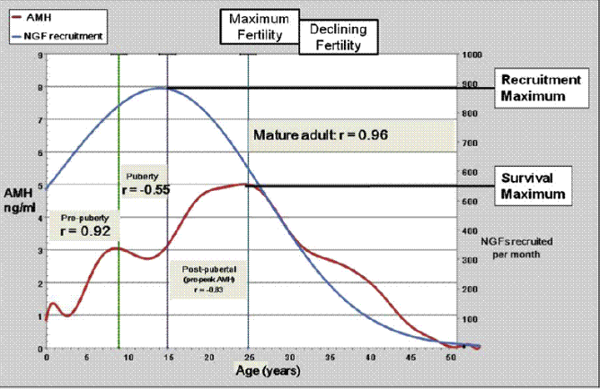

In women receiving gonadotoxic therapy, damages can occur in the primordial follicles in the ovaries, which can lead to premature menopause. Typically, anti-Müllerian hormone levels drop during gonadotoxic treatment with different degrees of recovery following treatment (Graph 2). High dose therapy such as myeloablative therapy prior to bone marrow transplantation (BMT), radiotherapy to gonadal tissue or gonadal surgery can lead to high levels of infertility, whereas other gonadotoxic treatment using chemotherapy, radiotherapy to the neuroendocrine tissue can result in a lowered ovarian reserve and subfertility[142-144] A recent Childhood Cancer Survivor Study (CCSS) reported that premature menopause occurs in 8% survivors and depends on age, dose of irradiation to the ovaries, and cumulative dose of alkylating agents.[145][10]

**Graph 2**

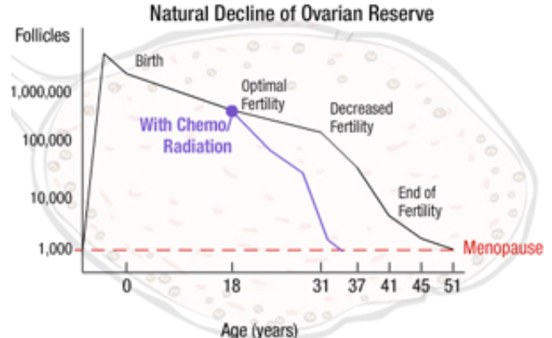

Several studies have shown that anti-Müllerian hormone serum levels decline with increasing chronological age correlating with the natural decline in ovarian reserve. In recent years, several nomograms for normal levels of serum anti-Müllerian hormone from birth to menopause have been developed[146-148] making this a useful test in children, adolescents and adult patients of a reproductive age. A recent study reported that in adolescents who were treated for cancer found that anti-Müllerian hormone was a reliable marker for predicting ovarian function.[149] Similarly, a study by Krawczuk-Rybak et al[149] reported that the utility of anti-Müllerian hormone measurement was a reliable and sensitive marker of a reduced ovarian reserve in young cancer survivors and reported that patients receiving a bone marrow transplant and patients treated for Hodgkin’s Lymphoma, independent of age at treatment (pre-pubertal or pubertal), were at the highest risk for gonadal damage and early menopause.[149]

A Danish study examining a 10-year follow-up of childhood cancer survivors, who are now in their mid-thirties, showed a reduction in anti-Müllerian hormone levels reflecting the effects of gonadotoxic treatment of childhood cancers with gonadotoxic therapy. This study also reported that the proportion of infertile women was significantly higher compared with the general Danish population, and amongst this group of women who received gonadotoxic treatment, the pregnancy rate and outcome was also very poor.[150]

In women with breast cancer it has been demonstrated that pre-treatment anti-Müllerian hormone levels are a useful predictor for later ovarian function. Pre-treatment anti-Müllerian hormone measurements may aid in decision making regarding treatment options and the need for patient’s to pursue fertility preservation procedures.[151, 152] For breast cancer patients with hormone-sensitive breast cancer, awareness of current ovarian reserve assist decisions regarding the duration of adjuvant hormonal treatment and the time at which this can be temporarily discontinued to facilitate pregnancy.

Clinical indications for testing in patients who will or have received gonadotoxic treatment

1. Newly diagnosed or relapsed patients receiving gonadotoxic treatment who are having assessments for fertility preservation prior to the start of treatment. A detailed history is required by either a physician, cancer or fertility doctor to determine the reproductive risk of the patient (see Algorithm 1a: *Algorithm for the Assessment of Reproductive Potential for New and Relapsed Paediatric Patients*; 2a: *Algorithm for the Assessment of Reproductive Potential for New and Relapsed Adolescent and Young Adult (15-25 year old) Patients*; 3a: *Algorithm for the Assessment of Reproductive Potential for New and Relapsed Adult Patients*). Those patients who may have a risk to their reproductive function should have appropriate referral to oncofertility services and have an assessment of ovarian function prior to cancer treatment. AMH testing will be limited to one episode at initial diagnosis or relapse.
2. To determine the return of reproductive function following gonadotoxic treatment (see Algorithm 1b: *Algorithm for the Assessment of a patient’s reproductive potential following Gonadotoxic Treatment: Paediatric patients*; 2b: Algorithm for the Assessment of Reproductive Potential Following Cancer Treatment in Adolescent Young Adult Patients (15 to 25 year old); 3b: *Algorithm for the Assessment of Reproductive Potential Following Cancer Treatment in Adult Patients*). The earliest reassessment time should not be done prior to 12 months and can be done annually to assess the recovery or ovarian function as well as document the extent of infertility a patient has following cancer treatment. AMH testing should be limited to one test a year.

1. To assess the need for fertility preservation following gonadotoxic treatment or to recommend the start of assisted reproductive treatment in patients wishing to start a family. Patients who are considering family planning following cancer treatment and have had gonadotoxic treatment should have investigation. AMH testing should be limited to one test a year. 2b: Algorithm for the Assessment of Reproductive Potential Following Cancer Treatment in Adolescent Young Adult Patients; 3b: *Algorithm for the Assessment of Reproductive Potential Following Cancer Treatment in Adult Patients).*

## Population

1. Female patients with cancer who have had or will receive gonadotoxic treatment in three categories paediatric, adolescent young adult and adult populations; and
2. Female patients with non-malignant disease who have had or will receive gonadotoxic treatment in three categories paediatric, adolescent young adult and adult populations.

**Frequency of test**: maximum one test prior to starting gonadotoxic treatment and then a maximum of one test annually.

**Restriction** - Patients who are currently having AMH testing but will not or have not received gonadotoxic treatment.

AMH Assessment

AMH assays

A number of AMH assays are available:

Access AMH Assay (Beckman Coulter): sensitivity of 0.14 pmol/L, and reported intra-assay coefficients of variation of 1.41-3.30% and inter-assay coefficients of variation of 3.04 - 5.76%.

AMH Gen II ELISA Kit (Beckman Coulter): sensitivity of 0.57 pmol/L, and reported intra- and inter-assay coefficients of variation of less than 5.4 and 5.6% respectively.

AMH ELISA (Ansh Labs): sensitivity of 0.04 pmol/L, and reported intra- and inter-assay coefficients of variation of less than 4.6 % and 8.0 % respectively.

picoAMH:ELISA for ultra-low concentration assessment (Ansh Labs): sensitivity of 0.07pmol/L, and reported intra- and inter-assay coefficients of variation of 1.38% and 3.84% respectively

Elecsys AMH (Roche Diagnostics): sensitivity of 0.21 pmol/L, and reported intra- and inter-assay coefficients of variation of 2.7% and 3.5% respectively.

Currently, there is no international gold standard for testing ovarian reserve.

The literature identifies several studies reporting on correlations between various AMH assay tests [157-159] indicating that the Access AMH assay[160] which now supersedes the AMH Gen II ELISA Kit (Beckman Coulter) can be used as a proxy reference standard.

Assessment of the Access AMH assay revealed excellent linearity and good performance across the measuring range for both intra-assay and inter-assay precision. This assay exhibited greatly increased sensitivity when compared to previous manual methods allowing for accurate reporting to 0.1 pmol/L. The Access AMH assay exhibits total imprecision ≤ 10.0% at concentrations ≥ 0.16ng/mL, and total standard deviation (SD) ≤ 0.032 ng/mL at concentrations < 0.16 ng/mL. Outcomes also demonstrated high levels of AMH immunoreactive stability under refrigerated and freeze/thaw conditions. The results of the dilution testing revealed that AMH samples greater than 70 pmol/L did not need to be diluted as was required with the previous AMH Gen II ELISA Kit (Beckman Coulter).[160]

# Sample collection and storage requirements

* Blood in a 5mL serum/gel tube is required for the AMH test assay. Sample can be collected at any time during the cycle.
* Plasma tubes can be used but results vary between serum and plasma.
* Sample separation is required within four hours of collection.
* Serum and plasma may be stored at 2 to 80C for forty-eight hours prior to testing.
* If the assay cannot be completed within twenty-four hours, or for shipment of samples to another laboratory, freeze at -20oC.
* Results are usually available within twenty-four hours. Samples are stored for one month unless results are abnormally high, and in such cases, samples can be stored for much longer periods with no loss of activity.

# Test Interpretation

Women with serum anti-Müllerian hormone levels less than or equal to 14pmol/L have a reduced chance of success on the IVF program and an increased risk of miscarriage.  Therefore, 14pmol/L is one of the critical values used in the assessment of ovarian reserve.  In addition, women with Anti-Müllerian hormone levels in the lowest quartile (< 25%), will likely have a diminished ovarian reserve, especially if their AMH result is >14pmol/L.[161]

Table 3 Interpretation of AMH cut-off guidelines[162]

|  |  |
| --- | --- |
| **Interpretation**  **(women under age 35)** | **AMH Blood Level** |
| Optimal fertility | 40.04 - 67.9 pmol/L |
| Satisfactory fertility | 21.98 - 40.03 pmol/L |
| Low fertility | 3.08-21.97 pmol/L |
| Very low/Undetectable | 0 - 3.07 pmol/L |

Levels greater than 67.9 pmol/L are suggestive of Granulosa cell tumors

Proposed Reference Standard

# Basal FSH

Basal FSH is Follicle Stimulating Hormone, produced by the brain (via the pituitary gland) to stimulate follicles in the ovary to grow. Basal follicle stimulating hormone (FSH) levels are usually measured on day 3 of the menstrual cycle in order to predict a woman’s ovarian reserve. Ovarian reserve tests (ORTs) have been used to assess the ovarian response to stimulation, for over two decades.[163] An increase in FSH levels occur due to follicle depletion. FSH is known to have diurnal, intra- and intercycle variability.[164, 165] There is no universally accepted cut-off value to identify a poor response. A wide range in threshold values up to 25 IU/L has been used to define abnormal levels of basal FSH. Meta-analysis and systematic reviews have failed to identify any combination of specificity and sensitivity for basal FSH as a test of poor response or prediction of non-pregnancy. In regularly cycling women, FSH can predict a poor response adequately only at very high levels, and hence will be helpful only to a small number of women as a screening test, for counselling purposes.[166, 167] It is understood that the ovarian ageing begins several years before any elevation in FSH levels is noted and hence a normal test cannot rule out a poor ovarian response in some women. Combined with other markers it can be used to counsel couples regarding a poor response but should not be used to exclude regularly cycling women undergoing ART. The usefulness of basal FSH in a general sub-fertile population or elevated levels in young, regularly cycling women is unclear.[168]

# Antral Follicle Count

Antral follicle count (AFC) is the sum of antral follicles in both ovaries, as observed with transvaginal ultrasonography during the early follicular phase. Most studies have defined antral follicles as those measuring 2–10 mm in mean diameter in the greatest 2-dimensional plane; some have defined antral follicles as those measuring 3–8 mm in mean diameter. Antral follicle count has good inter-cycle reliability and inter-observer reliability in experienced centres.[169-173] A low AFC (range 3–10 total antral follicles) has been associated with, but does not necessarily predict, poor response to ovarian stimulation and the failure to achieve pregnancy.[174] Across general IVF study populations of patients at low and high risk for diminished ovarian reserve (DOR), low AFC cutpoints of 3–4 total follicles (both ovaries combined) are highly specific (73%–100%) for predicting poor ovarian response (cycle cancelation, <3–4 follicles or retrieved oocytes)[169, 171, 174-179] but have lower sensitivity (9%–73%). The same cut off points are moderately specific for predicting failure to conceive (64%– 100%), but sensitivity is consistently low (8%–33%). The PPV (the probability that a woman who tests positive truly has DOR) and NPV (probability that a woman who tests negative has normal ovarian reserve) of AFC for predicting poor response have varied widely in studies of general IVF subjects. The high specificity of a low AFC makes the test useful for predicting poor ovarian response and treatment failure, but its clinical utility is limited by its low sensitivity. Inter- and intra- observer variability also may be limiting, especially in centres having less expertise or lower quality ultrasound equipment.

Antral follicle count (AFC) measurement is not a test that can be done in pre-pubertal children who have small ovarian volumes and cannot have trans vaginal scans. The use of AFC by trans abdominal ultrasound has not been studied in paediatric patients and so this test has not clinical use in paediatric patients.

In summary, the use of AFC may help to predict poor stimulation and pregnancy outcome but should not be the sole criterion for the application of fertility preservation or ART. It is not a test that can be done in paediatric patients.

# Inhibin B

Inhibin B is not a reliable measure of ovarian reserve. Inhibin B levels rise with GnRH or FSH stimulation (the basis of dynamic tests of ovarian reserve) and therefore exhibit high intra-cycle variability.[141, 169, 180] Inhibin B levels also vary significantly between menstrual cycles.[169] The routine use of inhibin B as a measure of ovarian reserve is not recommended.

# Estradiol

As a test of ovarian reserve, basal estradiol on day 2, 3, or 4 of the menstrual cycle has poor inter- and intra-cycle reliability.[181] The vast majority of studies have found that basal estradiol does not differ between women with and without diminished ovarian reserve (DOR), regardless of whether the measured outcome is a poor response to ovarian stimulation or failure to achieve pregnancy.[169, 175, 176, 182-188] Basal estradiol alone should not be used to screen for DOR. The test has value only as an aid to correct interpretation of a ‘‘normal’’ basal serum follicular stimulating hormone (FSH) value. An early rise in serum estradiol concentrations is a classic characteristic of reproductive aging and can lower an otherwise elevated basal FSH level into the normal range, thereby causing a misinterpretation of the test. When the basal FSH concentration is ‘‘normal’’ but the estradiol level is elevated (>60–80 pg/mL) in the early follicular phase, there is limited evidence for an association with poor response, increased cancelation rates, or lower pregnancy rates.[188-190]

Barriers to fertility preservation

Currently, there are several barriers surrounding fertility preservation and uptake and these include:

1. ***A lack of evidence-based information regarding oncofertility guidelines:*** Currently, there are 13 guidelines worldwide on fertility preservation, of which 5 including the Clinical Oncology Society of Australia guidelines, have been assessed to be of a suitable standard. However these guidelines still lack crucial evidence-based data.
2. ***Models of care/referral pathways***: In Australia there is no standard approach to fertility preservation. Referral pathways between cancer and reproductive specialists exist but they are often ad hoc. Although centres are beginning to collect fertility preservation data, no data have been published on differences in metropolitan, rural and regional uptake of fertility preservation services, differences in private or public services or if there are cultural, religious or socio-demographic differences in access to fertility preservation in Australia.
3. ***Cost for fertility preservation:*** The cost of fertility preservation investigation and management is prohibitive for large numbers of cancer patients and there is inequity of access across cancer centres.
4. ***Medicare item numbers.*** Medicare currently does not cover all aspects of fertility preservation and storage of gonadal tissue.

# Data

Although centres are beginning to collect national fertility preservation data through the Australasian Oncofertility Registry[191] which the Future Fertility team are leading, to date there has been no Australian data published on the success and complication rates of fertility preservation in patients receiving gonadotoxic treatments, uptake in metropolitan, rural and regional cancer services, or differences in private or public cancer services.

# Costs

Fertility preservation treatments are expensive and it is important that patients have the right assessments done prior to undertaking fertility preservation or assisted reproductive treatments following cancer treatment. The cost of anti-Müllerian hormone is between 50 and 100 dollars and not covered by the Pharmaceutical Benefits Scheme or private health insurance companies.

,

Proposed structure of economic evaluation

A full economic evaluation will be submitted following approval of this stage.

The applicant is proposing that AMH testing is included on the MBS for patients in a number of limited scenarios:

1. Newly diagnosed or relapsed patients receiving gonadotoxic treatment who are having assessments for fertility preservation prior to the start of treatment. A detailed history is required by either a physician, cancer or fertility doctor to determine the reproductive risk of the patient (see Algorithm 1a: *Algorithm for the Assessment of Reproductive Potential for New and Relapsed Paediatric Patients*; 2a: *Algorithm for the Assessment of Reproductive Potential for New and Relapsed Adolescent and Young Adult (15-25 year old) Patients*; 3a: *Algorithm for the Assessment of Reproductive Potential for New and Relapsed Adult Patients*). Those patients who may have a risk to their reproductive function should have appropriate referral to oncofertility services and have an assessment of ovarian function prior to cancer treatment. AMH testing will be limited to one episode at initial diagnosis or relapse.

2. To determine the return of reproductive function following gonadotoxic treatment (see Algorithm 1b: *Algorithm for the Assessment of a patient’s reproductive potential following Gonadotoxic Treatment: Paediatric patients*; 2b: Algorithm for the Assessment of Reproductive Potential Following Cancer Treatment in Adolescent Young Adult Patients (15 to 25 year old); 3b: *Algorithm for the Assessment of Reproductive Potential Following Cancer Treatment in Adult Patients*). The earliest reassessment time should not be done prior to 12 months and can be done annually to assess the recovery or ovarian function as well as document the extent of infertility a patient has following cancer treatment. AMH testing should be limited to one test a year.

**3**. To assess the need for fertility preservation following gonadotoxic treatment or to recommend the start of assisted reproductive treatment in patients wishing to start a family. Patients who are considering family planning following cancer treatment and have had gonadotoxic treatment should have investigation. AMH testing should be limited to one test a year. 2b: Algorithm for the Assessment of Reproductive Potential Following Cancer Treatment in Adolescent Young Adult Patients; 3b: *Algorithm for the Assessment of Reproductive Potential Following Cancer Treatment in Adult Patients).*

Recommendation to PASC

Following national consultation with patients, parents, partners and health care professionals (doctors, nurses, psychologists, and counselors), as well as fertility and andrology laboratory staff, we are seeking a new Medicare listing as follows:

# MBS ONC1

Anti-Müllerian hormone testing in female patients for the assessment of ovarian function, including ovarian reserve and ovarian responsiveness before or after gonadotoxic treatment.

Population:

1. Female patients with cancer who have had or will receive gonadotoxic treatment in three categories paediatric, adolescent young adult and adult populations; and
2. Female patients with non-malignant disease who have had or will receive gonadotoxic treatment in three categories paediatric, adolescent young adult and adult populations.

**Restriction** - Patients who are currently having AMH testing but will not or have not received gonadotoxic treatment.

Summary of Patient Information Comparator Outcomes (PICO)

# Table 6: Summary of extended PICO to define research question that assessment will investigate

|  |  |  |  |
| --- | --- | --- | --- |
| **Population** | **Intervention** | **Comparator** | **Outcomes** |

|  |  |  |  |
| --- | --- | --- | --- |
| Patients receiving gonadotoxic treatment | Anti-Müllerian hormone test in female patients for the assessment of ovarian function, including ovarian reserve and ovarian responsiveness before or after gonadotoxic treatment  Indication for test   1. Newly diagnosed or relapsed patients receiving gonadotoxic treatment who are having assessments for fertility preservation prior to the start of treatment. A detailed history is required by either a physician, cancer or fertility doctor to determine the reproductive risk of the patient (see Algorithm 1a: *Algorithm for the Assessment of Reproductive Potential for New and Relapsed Paediatric Patients*; 2a: *Algorithm for the Assessment of Reproductive Potential for New and Relapsed Adolescent and Young Adult (15-25 year old) Patients*; 3a: *Algorithm for the Assessment of Reproductive Potential for New and Relapsed Adult Patients*). Those patients who may have a risk to their reproductive function should have appropriate referral to oncofertility services and have an assessment of ovarian function prior to cancer treatment. AMH testing will be limited to one episode at initial diagnosis or relapse.   2.  To determine the return of reproductive function following gonadotoxic treatment (see Algorithm 1b: *Algorithm for the Assessment of a patient’s reproductive potential following Gonadotoxic Treatment: Paediatric patients*; 2b: Algorithm for the Assessment of Reproductive Potential Following Cancer Treatment in Adolescent Young Adult Patients (15 to 25 year old); 3b: *Algorithm for the Assessment of Reproductive Potential Following Cancer Treatment in Adult Patients*). The earliest reassessment time should not be done prior to 12 months and can be done annually to assess the recovery or ovarian function as well as document the extent of infertility a patient has following cancer treatment. AMH testing should be limited to one test a year.  **3**.   To assess the need for fertility preservation following gonadotoxic treatment or to recommend the start of assisted reproductive treatment in patients wishing to start a family. Patients who are considering family planning following cancer treatment and have had gonadotoxic treatment should have investigation. AMH testing should be limited to one test a year. 2b: Algorithm for the Assessment of Reproductive Potential Following Cancer Treatment in Adolescent Young Adult Patients; 3b: *Algorithm for the Assessment of Reproductive Potential Following Cancer Treatment in Adult Patients).*  Restrictor   * Patients who are currently having AMH testing but will not or have not received gonadotoxic treatment. | 1. Anti-Müllerian hormone testing and Antral follicle count vs 2. Follicular Stimulating Hormone and Antral follicle count   As AFC is not useful as an indication for ovarian reserve in paediatric patients (under 14 years of age), it will not be used as a comparator in the paediatric subpopulation.  ***Note:***  Based on the algorithm patients will have AMH and the comparator test. | **Primary Outcomes**  **Diagnostic Outcomes**   * AMH test is a surrogate diagnostic marker for measuring ovarian reserve or ovarian aging (given that the reduction in hormone levels reflects the age-dependent fall in the follicular potential of the ovary) * Change in clinical management of a patient undergoing ART.   **Supplement Outcomes**   * Quality of life for family members * Effects on relationship and family life |

# 

# Comparator

1. Anti-Müllerian hormone testing and Antral follicle count vs
2. Follicular Stimulating Hormone and Antral follicle count

As AFC is not useful as an indication for ovarian reserve in paediatric patients (under 14 years of age), it will not be used as a comparator in the paediatric subpopulation.

***Note:***

Based on the algorithm patients will have AMH and the comparator test.

# Figure 1a: Algorithm for the Assessment of Reproductive Potential for New and Relapsed Paediatric Patients

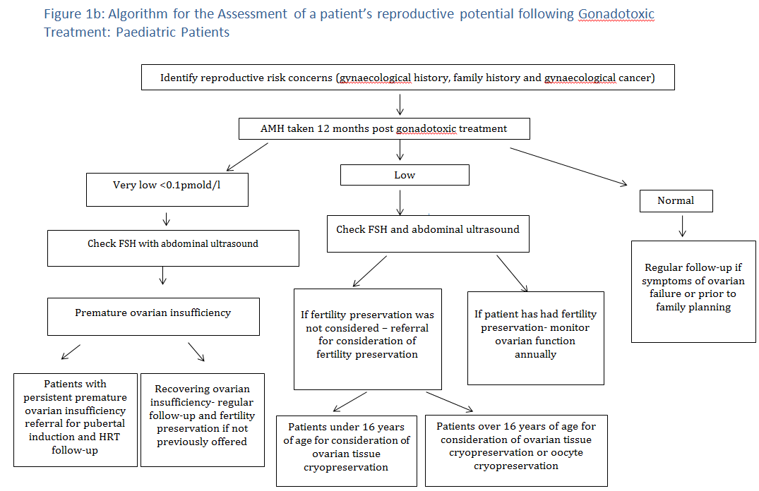

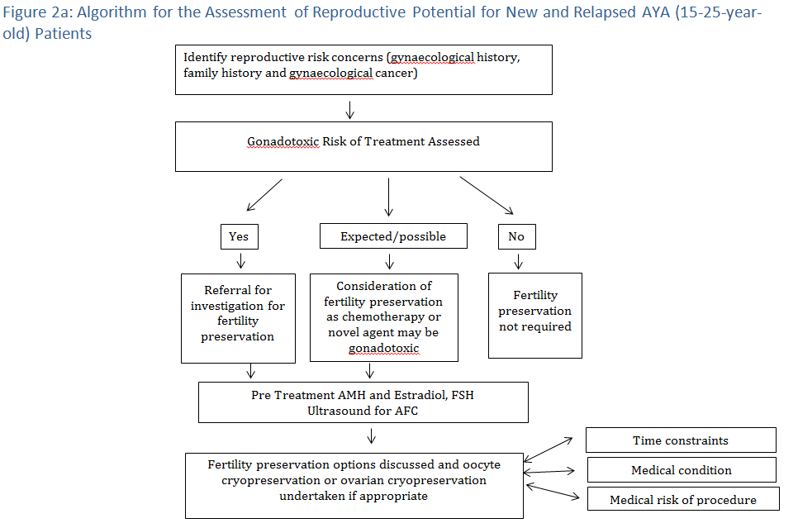

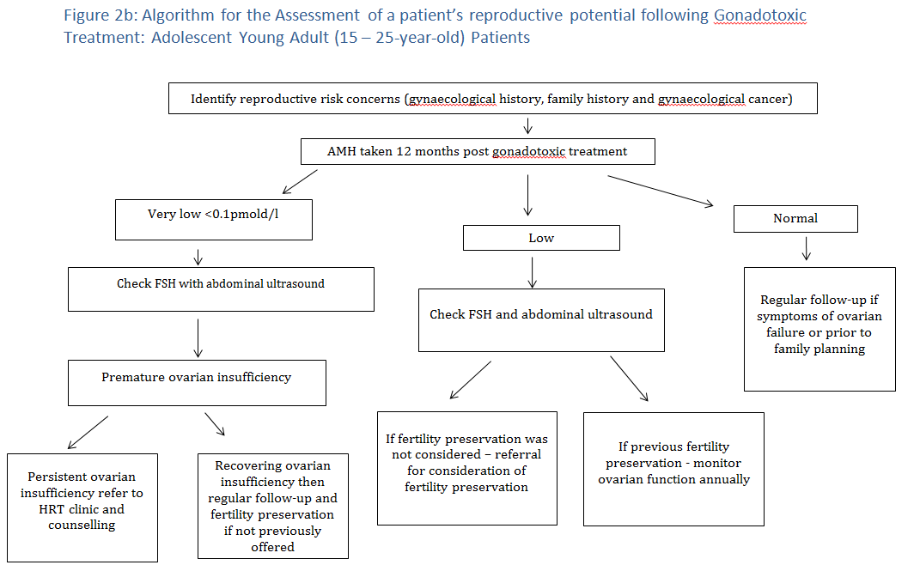

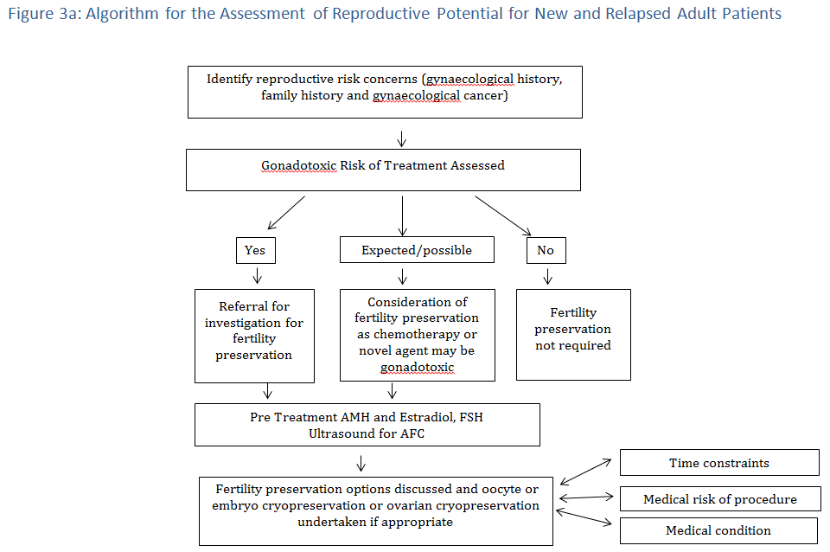

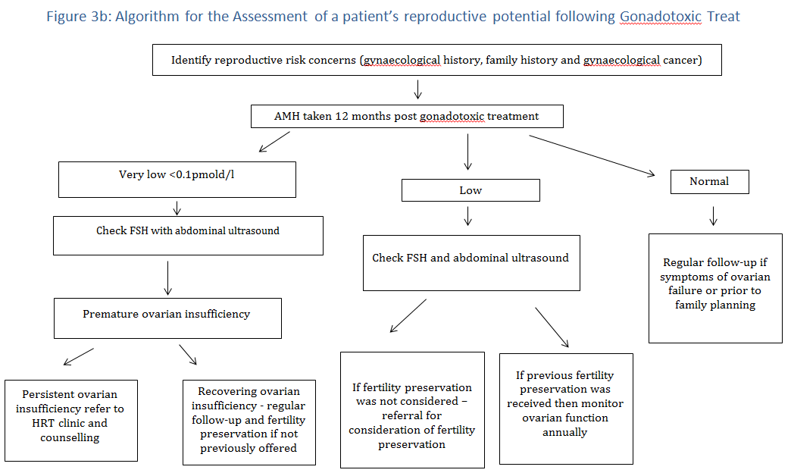

Consultation

The application for the Protocol Advisory Sub Committee Report on Oncofertility Item Numbers has had widespread consultation and support from consumers representing patients, parents and partners, advocacy groups and a range of health care providers as detailed in the list provided below:

## FUTuRE Fertility chief investigators and lead investigators

NSW Dr Antoinette Anazodo (CI)

NSW Ms Brigitte Gerstl (AI)

NSW Professor William Ledger (CI)

NSW Professor Elizabeth Sullivan (CI)

NSW Professor Michael Chapman (CI)

NSW Associate Professor Claire Wakefield (CI)

NSW Professor Richard Cohn (CI)

NSW Dr Rebecca Deans (CI)

NSW Professor Rosalie Viney (AI)

VIC Professor Kate Stern (CI)

VIC Professor Rob Mclachlan (CI)

VIC Dr Yasmin Jayasinghe (CI)

VIC Dr Lisa Orme (CI)

VIC Ms Franca Agresta (AI)

QLD Dr Wayne Nicholls

QLD Associate Professor Anusch Yasdani

QLD Dr Ben Kroon

WA Dr Marianne Phillips

SA Professor Bogda Koczwara

SA Dr Michael Osborne

SA Dr Fiona Young

TAS Dr Rosemary Harrop

## Australasian Oncofertility Consumer Group

NSW Ms Heather Minnich- patient representative

NSW Mr Marcus Ehrlich – patient representative

NSW Ms Rikki Hickey – partner representative

NSW Ms Jo Pedgrift – support person to consumer

QLD Dr Alex Powell - patient representative

SA Mr Mark Haseloff – patient representative

VIC Mrs Sophia HO – parent representative

WA Miss Bronwyn Kilby - patient representative

## Fertility Society of Australia Medical Fertility Preservation Group

## 

## Access Australia's National Infertility Network Ltd

Dr Sandra Dill Managing Director Access Australia's National Infertility Network

## 

## CanTeen Youth Advisory Group

Miss Xenia Alexander, co-Chair

Mark Haseloff, co-Chair

Mr Keifer King

Mr Byron Walker

Mr Jarrod Eggins,

Miss Jenna Moloney

Miss Bronwyn Kilby

Mr Thomas Binns

Miss Jasmine Gailer

Miss Elodie Nadon

Mr Nikhil Autar

## CanTeen Leadership Group

Dr Antoinette Anazodo

Dr Hera Dimitriadis

Dr Lisa Orme

Ms Kate Thompson

Dr Michael Osborn

Mr Allan Hayward

Dr Rachel Hughes

Dr Po Inglis

Ms Roslyn Henney

## Youth Cancer Services Strategic Advisory Group

## 

## IVF Directors

Professor David Molloy, Chair

## Andrology

Professor David Handelsman

Mr Christopher Nicolls

Professor Robert Mclachlan

## Medical Oncology Group of Australia (MOGA)

Professor Rosemary Harrop, Chair

## Cancer Nurse Society of Australia (CNSA)

Ms Deborah Hoberg, Chair SA

Ms Marie Condon, Chair WA

Ms Robyn Wilson, Chair VIC

Ms Lyndal Moore, Chair NSW Hunter

Ms Meredith Cummins, Chair NSW Central

## South Australian Oncofertility Group

## 

## Queensland Oncofertility Group

## 

## Victorian Fertility Preservation Taskforce

References

1. *Australian Institue of Health Welfare (2012) Cancer in Australia An overview 2012.Cat no. 56.AIHW 2012.*

2. De Bree, E., et al., *Pregnancy after breast cancer. A comprehensive review.* Journal of surgical oncology, 2010. **101**(6): p. 534-542.

3. Zebrack, B.J., et al., *Fertility issues for young adult survivors of childhood cancer.* Psycho‐Oncology, 2004. **13**(10): p. 689-699.

4. Anderson, R.A., et al., *Do doctors discuss fertility issues before they treat young patients with cancer?* Human reproduction, 2008. **23**(10): p. 2246-2251.

5. Hyman, J.H. and T. Tulandi, *Fertility preservation options after gonadotoxic chemotherapy.* Clinical medicine insights. Reproductive health, 2013. **7**: p. 61.

6. Sonmezer, M. and K. Oktay, *Fertility preservation in female patients.* Human Reproduction Update, 2004. **10**(3): p. 251-266.

7. Wallace, W.H.B., R.A. Anderson, and D.S. Irvine, *Fertility preservation for young patients with cancer: who is at risk and what can be offered?* The lancet oncology, 2005. **6**(4): p. 209-218.

8. Meirow, D., et al., *Toxicity of chemotherapy and radiation on female reproduction.* Clinical obstetrics and gynecology, 2010. **53**(4): p. 727-739.

9. Gracia, C.R., et al., *Impact of cancer therapies on ovarian reserve.* Fertility and sterility, 2012. **97**(1): p. 134-140. e1.

10. Fleischer, R.T., B.J. Vollenhoven, and G.C. Weston, *The effects of chemotherapy and radiotherapy on fertility in premenopausal women.* Obstetrical & gynecological survey, 2011. **66**(4): p. 248-254.

11. Rosen, A., K.A. Rodriguez-Wallberg, and L. Rosenzweig. *Psychosocial distress in young cancer survivors*. in *Seminars in oncology nursing*. 2009. Elsevier.

12. Klock, S.C., J.X. Zhang, and R.R. Kazer, *Fertility preservation for female cancer patients: early clinical experience.* Fertility and sterility, 2010. **94**(1): p. 149-155.

13. Redig, A.J., et al., *Incorporating fertility preservation into the care of young oncology patients.* Cancer, 2011. **117**(1): p. 4-10.

14. Kondapalli, L.A., *Oncofertility: a new medical discipline and the emerging scholar*, in *Oncofertility Fertility Preservation for Cancer Survivors*. 2007, Springer. p. 221-234.

15. Klonoff-Cohen, H., *Establishing a fertility preservation database: no time like the present.* Expert Review of Obstetrics & Gynecology, 2012. **7**(3): p. 213-225.

16. Waimey, K.E., et al., *Future directions in oncofertility and fertility preservation: a report from the 2011 oncofertility consortium conference.* Journal of adolescent and young adult oncology, 2013. **2**(1): p. 25-30.

17. Woodruff, T.K. and K.A. Snyder, *Oncofertility: fertility preservation for cancer survivors*. Vol. 138. 2007: Springer Science & Business Media.

18. Maltaris, T., et al., *The effect of cancer treatment on female fertility and strategies for preserving fertility.* European Journal of Obstetrics & Gynecology and Reproductive Biology, 2007. **130**(2): p. 148-155.

19. Yee, S., et al., *A national study of the provision of oncofertility services to female patients in Canada.* J Obstet Gynaecol Can, 2012. **34**(9): p. 849-58.

20. *Clinical Oncological Society of Australia. Fertility preservation for AYAs diagnosed with cancer: guidance for health professionals 2011 Available at:* [*Fertility preservation for AYAs diagnosed with cancer: guidance for health professionals 2011*](http://wiki.cancer.org.au/australia/COSA:AYA_cancer_fertility_preservation)*. Accessed on April 17, 2012.*

21. Lee, S.J., et al., *American Society of Clinical Oncology recommendations on fertility preservation in cancer patients.* Journal of clinical oncology, 2006. **24**(18): p. 2917-2931.

22. *Cancer in Australia An overview 2012. Australian Institute of Health Welfare* 2012.

23. *Australian Institute of Health and Welfare (AIHW).* Australian Cancer Incidence and Mortality (ACIM) books: Canberra. AIHW.

24. McConnell, R., M. Stankiewicz, and B. Koczwara, *Access to assisted reproductive technology for cancer patients in Australia.* Asia‐Pacific Journal of Clinical Oncology, 2011. **7**(2): p. 123-128.

25. Zebrack, B.J., et al., *Fertility issues for young adult survivors of childhood cancer.* Psycho-Oncology, 2004. **13**(10): p. 689-99.

26. Rosen, A., K.A. Rodriguez-Wallberg, and L. Rosenzweig, *Psychosocial distress in young cancer survivors.* Seminars in Oncology Nursing, 2009. **25**(4): p. 268-77.

27. Loscalzo MJ and Clark KL, eds. *The Psychosocial Context of Cancer-Related Infertility*. ed. T.P.C.o.C.-R. Infertility. 2007, T.K. Woodruff and K.A. Snyder (eds.) Oncofertility: USA.

28. Gorman, J.R., et al., *How do you feel about fertility and parenthood? The voices of young female cancer survivors.* J Cancer Surviv, 2012. **6**(2): p. 200-9.

29. Whitehead, E., et al., *The effect of combination chemotherapy on ovarian function in women treated for Hodgkin's disease.* Cancer, 1983. **52**(6): p. 988-993.

30. Wallace, W.H.B., et al., *Ovarian failure following abdominal irradiation in childhood: natural history and prognosis.* Clinical Oncology, 1989. **1**(2): p. 75-79.

31. Cruz, M.R.S., et al., *Fertility preservation in women with breast cancer undergoing adjuvant chemotherapy: a systematic review.* Fertility and sterility, 2010. **94**(1): p. 138-143.

32. Kim, S.S., *Fertility preservation in female cancer patients: current developments and future directions.* Fertility and sterility, 2006. **85**(1): p. 1-11.

33. Ramos, E.J., et al., *Cancer anorexia-cachexia syndrome: cytokines and neuropeptides.* Current Opinion in Clinical Nutrition & Metabolic Care, 2004. **7**(4): p. 427-434.

34. Rival, C., et al., *Interleukin-6 and IL-6 receptor cell expression in testis of rats with autoimmune orchitis.* Journal of reproductive immunology, 2006. **70**(1): p. 43-58.

35. Theas, M., et al., *Death receptor and mitochondrial pathways are involved in germ cell apoptosis in an experimental model of autoimmune orchitis.* Human Reproduction, 2006. **21**(7): p. 1734-1742.

36. Martínez, P., F. Proverbio, and M. Camejo, *Sperm lipid peroxidation and pro-inflammatory cytokines.* Journal of Reproductive Immunology, 2006. **71**(2): p. 169-170.

37. Heyns, C.F. and M. Fisher, *The urological management of the patient with acquired immunodeficiency syndrome.* BJU international, 2005. **95**(5): p. 709-716.

38. Marmor, D., et al., *Semen analysis in Hodgkin's disease before the onset of treatment.* Cancer, 1986. **57**(10).

39. Meistrich, M.L., et al., *Damaging effects of fourteen chemotherapeutic drugs on mouse testis cells.* Cancer research, 1982. **42**(1): p. 122-131.

40. Arai, Y., et al., *Sexuality and fertility in long-term survivors of testicular cancer.* Journal of clinical oncology, 1997. **15**(4): p. 1444-1448.

41. Wallace, W.H., R.A. Anderson, and D.S. Irvine, *Fertility preservation for young patients with cancer: who is at risk and what can be offered?* The lancet oncology, 2005. **6**(4): p. 209-218.

42. Stern, C., et al., *Reproductive concerns of children and adolescents with cancer: challenges and potential solutions.* Clinical Oncology in Adolescents and Young Adults, 2013. **3**: p. 63-78.

43. Levine, J. and C.J. Stern, *Fertility preservation in adolescents and young adults with cancer.* Journal of clinical oncology, 2010. **28**(32): p. 4831-4841.

44. Jeruss, J.S. and T.K. Woodruff, *Preservation of fertility in patients with cancer.* New England Journal of Medicine, 2009. **360**(9): p. 902-911.

45. Hovatta, O., *Cryopreservation of testicular tissue in young cancer patients.* Human reproduction update, 2001. **7**(4): p. 378-383.

46. Jadoul, P., M.M. Dolmans, and J. Donnez, *Fertility preservation in girls during childhood: is it feasible, efficient and safe and to whom should it be proposed?* Hum Reprod Update, 2010. **16**(6): p. 617-30.

47. Lambert, S.M. and H. Fisch, *Infertility and testis cancer.* Urologic Clinics of North America, 2007. **34**(2): p. 269-277.

48. Wallace, W.H.B., A.B. Thomson, and T.W. Kelsey, *The radiosensitivity of the human oocyte.* Human Reproduction, 2003. **18**(1): p. 117-121.

49. Wallace, W.H.B., et al., *Predicting age of ovarian failure after radiation to a field that includes the ovaries.* International Journal of Radiation Oncology* Biology* Physics, 2005. **62**(3): p. 738-744.

50. Sanders, J.E., et al., *Pregnancies following high-dose cyclophosphamide with or without high-dose busulfan or total-body irradiation and bone marrow transplantation.* Blood, 1996. **87**(7): p. 3045-3052.

51. Byrne, J., et al., *Early menopause in long-term survivors of cancer during adolescence.* American journal of obstetrics and gynecology, 1992. **166**(3): p. 788-793.

52. Byrne, J., et al., *Effects of treatment on fertility in long-term survivors of childhood or adolescent cancer.* New England Journal of Medicine, 1987. **317**(21): p. 1315-1321.

53. Dargent, D., *Pregnancies following radical trachelectomy for invasive cervical cancer.* Gyn Onc, 1994. **54**: p. 105.

54. Rob, L., et al., *Advances in fertility-sparing surgery for cervical cancer.* Expert Rev Anticancer Ther, 2010. **10**(7): p. 1101-14.

55. Gershenson, D., *Article fertility-sparing surgery for malignancies in women.* J Natl Cancer Inst Monogr, 2005. **34**: p. 43-7.

56. Lee, S.J., et al., *American Society of Clinical Oncology recommendations on fertility preservation in cancer patients.* J Clin Oncol, 2006. **24**(18): p. 2917-31.

57. Ethics Committee of the American Society for Reproductive, M., *Fertility preservation and reproduction in cancer patients.* Fertility and Sterility, 2005. **83**(6): p. 1622-1628.

58. Multidisciplinary Working, G., *A strategy for fertility services for survivors of childhood cancer.* Human Fertility: an international, multidisciplinary journal dedicated to furthering research and promoting good practice, 2003. **6**(2).

59. Ata, B., et al., *Cryopreservation of oocytes and embryos for fertility preservation for female cancer patients.* Best practice & research Clinical obstetrics & gynaecology, 2010. **24**(1): p. 101-112.

60. Duncan, F.E., et al., *The gynecologist has a unique role in providing oncofertility care to young cancer patients.* US obstetrics & gynaecology, 2011. **6**(1): p. 24.

61. Ata, B., R.-C. Chian, and S.L. Tan, *Cryopreservation of oocytes and embryos for fertility preservation for female cancer patients.* Best Practice & Research Clinical Obstetrics & Gynaecology, 2010. **24**(1): p. 101-112.

62. Blumenfeld, Z., G. Katz, and A. Evron, *‘An ounce of prevention is worth a pound of cure’: the case for and against GnRH-agonist for fertility preservation.* Annals of Oncology, 2014: p. mdu036.

63. Blumenfeld, Z. and T. Zuckerman, *Repeated spontaneous pregnancies and successful deliveries after repeated autologous stem cell transplantation and GnRH-agonist treatment.* The oncologist, 2010. **15**(1): p. 59-60.

64. Blumenfeld, Z. and A. Evron, *Preserving fertility when choosing chemotherapy regimens-the role of gonadotropin-releasing hormone agonists.* Expert opinion on pharmacotherapy, 2015. **16**(7): p. 1009-1020.

65. Blumenfeld, Z., *How to preserve fertility in young women exposed to chemotherapy? The role of GnRH agonist cotreatment in addition to cryopreservation of embrya, oocytes, or ovaries.* The Oncologist, 2007. **12**(9): p. 1044-1054.

66. Blumenfeld, Z. and M. von Wolff, *GnRH-analogues and oral contraceptives for fertility preservation in women during chemotherapy.* Human Reproduction Update, 2008. **14**(6): p. 543-552.

67. Del Mastro, L., et al., *Luteinising hormone releasing hormone agonists (LH-RHa) in premenopausal early breast cancer patients: current role and future perspectives.* Cancer treatment reviews, 2011. **37**(3): p. 208-211.

68. Del Mastro, L., et al., *Medical approaches to preservation of fertility in female cancer patients.* Expert opinion on pharmacotherapy, 2011. **12**(3): p. 387-396.

69. Clowse, M.E.B., et al., *Ovarian preservation by GnRH agonists during chemotherapy: a meta-analysis.* Journal of women's health, 2009. **18**(3): p. 311-319.

70. Wong, M., et al., *Goserelin with chemotherapy to preserve ovarian function in pre-menopausal women with early breast cancer: menstruation and pregnancy outcomes.* Annals of oncology, 2013. **24**(1): p. 133-138.

71. Kim, S.S., et al., *Use of hormonal protection for chemotherapy-induced gonadotoxicity.* Clinical obstetrics and gynecology, 2010. **53**(4): p. 740-752.

72. Bedaiwy, M.A., et al., *Gonadotropin-releasing hormone analog cotreatment for preservation of ovarian function during gonadotoxic chemotherapy: a systematic review and meta-analysis.* Fertility and sterility, 2011. **95**(3): p. 906-914.

73. Chen, H., et al., *Adjuvant gonadotropin-releasing hormone analogues for the prevention of chemotherapy induced premature ovarian failure in premenopausal women.* Cochrane Database Syst Rev, 2011. **11**.

74. Yang, B., et al., *Concurrent treatment with gonadotropin-releasing hormone agonists for chemotherapy-induced ovarian damage in premenopausal women with breast cancer: a meta-analysis of randomized controlled trials.* The Breast, 2013. **22**(2): p. 150-157.

75. Wang, C., et al., *Gonadotropin-releasing hormone analog cotreatment for the preservation of ovarian function during gonadotoxic chemotherapy for breast cancer: a meta-analysis.* 2013.

76. Andersen, C.Y., et al., *Two successful pregnancies following autotransplantation of frozen/thawed ovarian tissue.* Human reproduction, 2008. **23**(10): p. 2266-2272.

77. Donnez, J. and M.-M. Dolmans, *Fertility preservation in women.* Nature Reviews Endocrinology, 2013. **9**(12): p. 735-749.

78. Donnez, J., et al., *Ovarian tissue cryopreservation and transplantation: a review.* Human Reproduction Update, 2006. **12**(5): p. 519-535.

79. Donnez, J., et al., *Ovarian tissue cryopreservation and transplantation in cancer patients.* Best Pract Res Clin Obstet Gynaecol, 2010. **24**(1): p. 87-100.

80. Donnez, J., et al., *Restoration of ovarian activity and pregnancy after transplantation of cryopreserved ovarian tissue: a review of 60 cases of reimplantation.* Fertil Steril, 2013. **99**(6): p. 1503-13.

81. Donnez, J., et al., *Restoration of ovarian function in orthotopically transplanted cryopreserved ovarian tissue: a pilot experience.* Reproductive biomedicine online, 2008. **16**(5): p. 694-704.

82. Oktay, K., et al., *Embryo development after heterotopic transplantation of cryopreserved ovarian tissue.* The Lancet, 2004. **363**(9412): p. 837-840.

83. Schmidt, K., et al., *Follow-up of ovarian function post-chemotherapy following ovarian cryopreservation and transplantation.* Human Reproduction, 2005. **20**(12): p. 3539-3546.

84. Demeestere, I., et al., *Ovarian function and spontaneous pregnancy after combined heterotopic and orthotopic cryopreserved ovarian tissue transplantation in a patient previously treated with bone marrow transplantation: case report.* Human Reproduction, 2006. **21**(8): p. 2010-2014.

85. Rosendahl, M., et al., *Biochemical pregnancy after fertilization of an oocyte aspirated from a heterotopic autotransplant of cryopreserved ovarian tissue: case report.* Human Reproduction, 2006. **21**(8).

86. Schmidt, K.L.T., et al., *Follow-up of ovarian function post-chemotherapy following ovarian cryopreservation and transplantation.* Human Reproduction, 2005. **20**(12): p. 3539-3546.

87. Dittrich, R., et al., *Pregnancies and live births after 20 transplantations of cryopreserved ovarian tissue in a single center.* Fertil Steril, 2015. **103**(2): p. 462-8.

88. Donnez, J., et al., *Livebirth after orthotopic transplantation of cryopreserved ovarian tissue.* The Lancet, 2004. **364**(9443): p. 1405-1410.

89. Meirow, D., et al., *Pregnancy after transplantation of cryopreserved ovarian tissue in a patient with ovarian failure after chemotherapy.* New England Journal of Medicine, 2005. **353**(3): p. 318-321.

90. Demeestere, I., et al., *Fertility preservation: successful transplantation of cryopreserved ovarian tissue in a young patient previously treated for Hodgkin's disease.* The oncologist, 2007. **12**(12): p. 1437-1442.

91. Barton, S.E., et al., *Female cancer survivors are low responders and have reduced success compared with other patients undergoing assisted reproductive technologies.* Fertility and sterility, 2012. **97**(2): p. 381-386.

92. Halter, J., et al., *Severe events in donors after allogeneic hematopoietic stem cell donation.* haematologica, 2009. **94**(1): p. 94-101.

93. Oktay, K., A.P. Cil, and H. Bang, *Efficiency of oocyte cryopreservation: a meta-analysis.* Fertility and sterility, 2006. **86**(1): p. 70-80.

94. Donnez, J., et al., *Pregnancy and live birth after autotransplantation of frozen-thawed ovarian tissue in a patient with metastatic disease undergoing chemotherapy and hematopoietic stem cell transplantation.* Fertility and sterility, 2011. **95**(5): p. 1787. e1-1787. e4.

95. Kim, M.K., et al., *Live birth with vitrified-warmed oocytes of a chronic myeloid leukemia patient nine years after allogenic bone marrow transplantation.* Journal of assisted reproduction and genetics, 2011. **28**(12): p. 1167-1170.

96. Isachenko, V., et al., *First live birth in germany after re-transplantation of cryopreserved ovarian tissue: original device for initiation of ice formation.* Clinical laboratory, 2011. **58**(9-10): p. 933-938.

97. Dittrich, R., et al., *Live birth after ovarian tissue autotransplantation following overnight transportation before cryopreservation.* Fertility and sterility, 2012. **97**(2): p. 387-390.

98. Andersen, C.Y., et al., *Long-term duration of function of ovarian tissue transplants: case reports.* Reproductive biomedicine online, 2012. **25**(2): p. 128-132.

99. Oktay, K., I. Türkçüoğlu, and K.A. Rodriguez-Wallberg, *Four spontaneous pregnancies and three live births following subcutaneous transplantation of frozen banked ovarian tissue: what is the explanation?* Fertility and sterility, 2011. **95**(2): p. 804. e7-804. e10.

100. Lucena, E., et al., *Successful ongoing pregnancies after vitrification of oocytes.* Fertility and sterility, 2006. **85**(1): p. 108-111.

101. Demeestere, I., et al., *Live birth after autograft of ovarian tissue cryopreserved during childhood.* Human Reproduction, 2015: p. dev128.

102. Callejo, J., et al., *Live birth in a woman without ovaries after autograft of frozen-thawed ovarian tissue combined with growth factors.* J Ovarian Res, 2013. **6**(1): p. 33.

103. Meirow, D., et al. *Results of one center indicate that transplantation of thawed ovarian tissue is effective. Repeated IVF reveals good egg quality and high pregnancy rate*. Oxford Univ Press Great Slarendon St, Oxford Ox2 6dp, England.

104. Ronn, R. and H.E.G. Holzer, *Oncofertility in Canada: cryopreservation and alternative options for future parenthood.* Current Oncology, 2014. **21**(1): p. e137.

105. Cao, Y.-X. and R.-C. Chian. *Fertility preservation with immature and in vitro matured oocytes*.

106. Oktay, K., et al., *In vitro maturation of germinal vesicle oocytes recovered after premature luteinizing hormone surge: description of a novel approach to fertility preservation.* Fertility and sterility, 2008. **89**(1): p. 228-e19.

107. Noyes, N., et al., *Oocyte cryopreservation as a fertility preservation measure for cancer patients.* Reproductive biomedicine online, 2011. **23**(3): p. 323-333.

108. Revel, A., et al., *At what age can human oocytes be obtained?* Fertility and sterility, 2009. **92**(2): p. 458-463.

109. Al-Talib, A., F. Nezhat, and T. Tulandi, *Fertility Preservation in Women with Gynecologic Cancer.* 2009.

110. Tulandi, T., J.Y.J. Huang, and S.L. Tan, *Preservation of female fertility: an essential progress.* Obstetrics & Gynecology, 2008. **112**(5): p. 1160-1172.

111. Bisharah, M. and T. Tulandi, *Laparoscopic preservation of ovarian function: an underused procedure.* American journal of obstetrics and gynecology, 2003. **188**(2): p. 367-370.

112. Barahmeh, S., et al., *Ovarian transposition before pelvic irradiation: indications and functional outcome.* Journal of Obstetrics and Gynaecology Research, 2013. **39**(11): p. 1533-1537.

113. Donnez, J. and S. Bassil, *Indications for cryopreservation of ovarian tissue.* Human Reproduction Update, 1998. **4**(3): p. 248-259.

114. Oktay, K., et al., *Cryopreservation of immature human oocytes and ovarian tissue: an emerging technology?* Fertility and sterility, 1998. **69**(1): p. 1-7.

115. Oktay, K. and G. Karlikaya, *Ovarian function after transplantation of frozen, banked autologous ovarian tissue.* New England Journal of Medicine, 2000. **342**(25): p. 1919-1919.

116. Radford, J.A., et al., *Orthotopic reimplantation of cryopreserved ovarian cortical strips after high-dose chemotherapy for Hodgkin's lymphoma.* The Lancet, 2001. **357**(9263): p. 1172-1175.

117. Donnez, J., et al., *The role of cryopreservation for women prior to treatment of malignancy.* Current Opinion in Obstetrics and Gynecology, 2005. **17**(4): p. 333-338.

118. Kim, S.S., I.-T. Hwang, and H.-C. Lee, *Heterotopic autotransplantation of cryobanked human ovarian tissue as a strategy to restore ovarian function.* Fertility and sterility, 2004. **82**(4): p. 930-932.

119. Ernst, E., et al., *Case report: stimulation of puberty in a girl with chemo-and radiation therapy induced ovarian failure by transplantation of a small part of her frozen/thawed ovarian tissue.* European Journal of Cancer, 2013. **49**(4): p. 911-914.

120. Hirshfeld-Cytron, J., C. Gracia, and T.K. Woodruff, *Nonmalignant diseases and treatments associated with primary ovarian failure: an expanded role for fertility preservation.* Journal of Women's Health, 2011. **20**(10): p. 1467-1477.

121. Cima, R.R. and J.H. Pemberton, *Medical and surgical management of chronic ulcerative colitis.* Archives of surgery, 2005. **140**(3): p. 300-310.

122. Waljee, A., et al., *Threefold increased risk of infertility: a meta-analysis of infertility after ileal pouch anal anastomosis in ulcerative colitis.* Gut, 2006. **55**(11): p. 1575-1580.

123. Shayya, R. and R.J. Chang, *Reproductive endocrinology of adolescent polycystic ovary syndrome.* BJOG: An International Journal of Obstetrics & Gynaecology, 2010. **117**(2): p. 150-155.

124. Wilson, J., et al., *High incidence of inflammatory bowel disease in Australia: A prospective population‐based Australian incidence study.* Inflammatory bowel diseases, 2010. **16**(9): p. 1550-1556.

125. Elizur, S.E., et al., *Fertility preservation treatment for young women with autoimmune diseases facing treatment with gonadotoxic agents.* Rheumatology, 2008. **47**(10): p. 1506-1509.

126. [*Transfusion outcomes - Aplastic Anaemia Registry*](http://torc.org.au/node/7).

127. Maidhof, W. and O. Hilas, *Lupus: an overview of the disease and management options.* Pharmacy and Therapeutics, 2012. **37**(4): p. 240.

128. Askanase, A., K. Shum, and H. Mitnick, *Systemic lupus erythematosus: an overview.* Soc Work Health Care, 2012. **51**(7): p. 576-86.

129. Lawrence, R.C., et al., *Estimates of the prevalence of arthritis and selected musculoskeletal disorders in the United States.* Arthritis & Rheumatism, 1998. **41**(5): p. 778-799.

130. Pons-Estel, G.J., et al. *Understanding the epidemiology and progression of systemic lupus erythematosus*. Elsevier.

131. Hirschberg, A.L., *Polycystic ovary syndrome, obesity and reproductive implications.* Women's Health, 2009. **5**(5): p. 529-542.

132. Livshits, A. and D.S. Seidman, *Fertility issues in women with diabetes.* Women's Health, 2009. **5**(6): p. 701-707.

133. Nader, S., *Reproductive endocrinology: Live birth prediction in polycystic ovary syndrome.* Nature Reviews Endocrinology, 2010. **6**(2): p. 64-66.

134. Weenen, C., et al., *Anti‐Müllerian hormone expression pattern in the human ovary: potential implications for initial and cyclic follicle recruitment.* Molecular human reproduction, 2004. **10**(2): p. 77-83.

135. Hansen, K.R., et al., *Correlation of ovarian reserve tests with histologically determined primordial follicle number.* Fertility and sterility, 2011. **95**(1): p. 170-175.

136. La Marca, A., et al., *Anti-Müllerian hormone (AMH) as a predictive marker in assisted reproductive technology (ART).* Human reproduction update, 2010. **16**(2): p. 113-130.

137. Su, H., *Measuring ovarian function in young cancer survivors.* Minerva endocrinologica, 2010. **35**(4): p. 259-270.

138. Baird, D.D. and A.Z. Steiner, *Anti-Müllerian hormone: a potential new tool in epidemiologic studies of female fecundability.* American journal of epidemiology, 2012: p. kwr439.

139. Broer, S.L., et al., *Anti-Müllerian hormone: ovarian reserve testing and its potential clinical implications.* Human reproduction update, 2014: p. dmu020.

140. de Vet, A., et al., *Antimüllerian hormone serum levels: a putative marker for ovarian aging.* Fertility and sterility, 2002. **77**(2): p. 357-362.

141. Van Rooij, I.A.J., et al., *Serum anti-Müllerian hormone levels: a novel measure of ovarian reserve.* Human Reproduction, 2002. **17**(12): p. 3065-3071.

142. Fong, S.L., et al., *Assessment of ovarian reserve in adult childhood cancer survivors using anti-Müllerian hormone.* Human Reproduction, 2009. **24**(4): p. 982-990.

143. Borgmann-Staudt, A., et al., *Fertility after allogeneic haematopoietic stem cell transplantation in childhood and adolescence.* Bone marrow transplantation, 2012. **47**(2): p. 271-276.

144. Singh, K.L., M. Davies, and R. Chatterjee, *Fertility in female cancer survivors: pathophysiology, preservation and the role of ovarian reserve testing.* Human Reproduction Update, 2005. **11**(1): p. 69-89.

145. Green, D.M., et al., *Ovarian failure and reproductive outcomes after childhood cancer treatment: results from the Childhood Cancer Survivor Study.* Journal of Clinical Oncology, 2009. **27**(14): p. 2374-2381.

146. Kelsey, T.W., et al., *A validated model of serum anti-Müllerian hormone from conception to menopause.* PloS one, 2011. **6**(7): p. e22024.

147. Nelson, S.M., et al., *Nomogram for the decline in serum antimüllerian hormone: a population study of 9,601 infertility patients.* Fertility and Sterility, 2011. **95**(2): p. 736-741.

148. Nelson, S.M., et al., *External validation of nomogram for the decline in serum anti-Müllerian hormone in women: a population study of 15,834 infertility patients.* Reproductive biomedicine online, 2011. **23**(2): p. 204-206.

149. Krawczuk-Rybak, M., et al., *Anti-Müllerian hormone as a sensitive marker of ovarian function in young cancer survivors.* International journal of endocrinology, 2013. **2013**.

150. Nielsen, S.N., et al., *A 10-year follow up of reproductive function in women treated for childhood cancer.* Reproductive biomedicine online, 2013. **27**(2): p. 192-200.

151. Anderson, R.A. and W.H.B. Wallace, *Antimüllerian hormone, the assessment of the ovarian reserve, and the reproductive outcome of the young patient with cancer.* Fertility and sterility, 2013. **99**(6): p. 1469-1475.

152. Anderson, R.A., P.C. Hindmarsh, and W.H.B. Wallace, *Induction of puberty by autograft of cryopreserved ovarian tissue in a patient previously treated for Ewing sarcoma.* European Journal of Cancer, 2013. **13**(49): p. 2960-2961.

153. Committee, I.P., et al., *Recommendations for fertility preservation in patients with lymphoma, leukemia, and breast cancer.* Journal of Assisted Reproduction and Genetics, 2012. **29**(6): p. 465-468.

154. group, A.Y.A.c.f.p.g.w., *Fertility preservation for AYAs diagnosed with cancer: Guidance for health professionals.* Sydney: Cancer Council Australia.

155. Gan, H.-W. and H.A. Spoudeas, *Long-term follow-up of survivors of childhood cancer (SIGN Clinical Guideline 132).* Archives of Disease in Childhood. Education and Practice Edition, 2014. **99**(4): p. 138-143.

156. National Collaborating Centre for, W.s. and H. Children's, *Fertility: assessment and treatment for people with fertility problems.* 2013.

157. Li, H.W.R., et al., *Correlation between three assay systems for anti-Müllerian hormone (AMH) determination.* Journal of assisted reproduction and genetics, 2012. **29**(12): p. 1443-1446.

158. Welsh, P., K. Smith, and S.M. Nelson, *A single-centre evaluation of two new anti-Müllerian hormone assays and comparison with the current clinical standard assay.* Human Reproduction, 2014: p. deu036.

159. Gassner, D. and R. Jung, *First fully automated immunoassay for anti-Müllerian hormone.* Clinical Chemistry and Laboratory Medicine (CCLM), 2014. **52**(8): p. 1143-1152.

160. Pearson, K., et al., *Assessment of the Access AMH assay as an automated, high-performance replacement for the AMH Generation II manual ELISA.* Reproductive Biology and Endocrinology, 2016. **14**(1): p. 1.

161. [*AMH Blood test*](http://repromed.com.au/what-to-expect/preliminary-investigations/amh-blood-test/)*.*

162. Practice Committee of the American Society for Reproductive, M., *Testing and interpreting measures of ovarian reserve: a committee opinion.* Fertility and Sterility, 2012. **98**(6): p. 1407-1415.

163. Scott, R.T., et al., *Follicle-stimulating hormone levels on cycle day 3 are predictive of in vitro fertilization outcome.* Fertility and sterility, 1989. **51**(4): p. 651-654.

164. Scott Jr, R.T., et al., *Intercycle variability of day 3 follicle-stimulating hormone levels and its effect on stimulation quality in in vitro fertilization.* Fertility and sterility, 1990. **54**(2): p. 297-302.

165. Kwee, J., et al., *Intercycle variability of ovarian reserve tests: results of a prospective randomized study.* Human Reproduction, 2004. **19**(3): p. 590-595.

166. Broekmans, F.J.M., et al., *Performance of basal follicle-stimulating hormone in the prediction of poor ovarian response and failure to become pregnant after in vitro fertilization: a meta-analysis.* Fertility and sterility, 2003. **79**(5): p. 1091-1100.

167. Broekmans, F.J., et al., *A systematic review of tests predicting ovarian reserve and IVF outcome.* Human reproduction update, 2006. **12**(6): p. 685-718.

168. Esposito, M.A., C. Coutifaris, and K.T. Barnhart, *A moderately elevated day 3 FSH concentration has limited predictive value, especially in younger women.* Human Reproduction, 2002. **17**(1): p. 118-123.

169. McIlveen, M., J.D. Skull, and W.L. Ledger, *Evaluation of the utility of multiple endocrine and ultrasound measures of ovarian reserve in the prediction of cycle cancellation in a high-risk IVF population.* Human reproduction, 2007. **22**(3): p. 778-785.

170. Bancsi, L.F., et al., *Impact of repeated antral follicle counts on the prediction of poor ovarian response in women undergoing in vitro fertilization.* Fertility and sterility, 2004. **81**(1): p. 35-41.

171. Frattarelli, J.L., et al., *A prospective assessment of the predictive value of basal antral follicles in in vitro fertilization cycles.* Fertility and sterility, 2003. **80**(2): p. 350-355.

172. Pache, T.D., et al., *Growth patterns of nondominant ovarian follicles during the normal menstrual cycle.* Fertility and sterility, 1990. **54**(4): p. 638-642.

173. Scheffer, G.J., et al., *Quantitative transvaginal two‐and three‐dimensional sonography of the ovaries: reproducibility of antral follicle counts.* Ultrasound in obstetrics & gynecology, 2002. **20**(3): p. 270-275.

174. Hendriks, D.J., et al., *Antral follicle count in the prediction of poor ovarian response and pregnancy after in vitro fertilization: a meta-analysis and comparison with basal follicle-stimulating hormone level.* Fertility and sterility, 2005. **83**(2): p. 291-301.

175. Bancsi, L.F., et al., *Predictors of poor ovarian response in in vitro fertilization: a prospective study comparing basal markers of ovarian reserve.* Fertility and sterility, 2002. **77**(2): p. 328-336.

176. Frattarelli, J.L., et al., *Basal antral follicle number and mean ovarian diameter predict cycle cancellation and ovarian responsiveness in assisted reproductive technology cycles.* Fertility and sterility, 2000. **74**(3): p. 512-517.

177. Chang, M.-Y., et al., *Use of the antral follicle count to predict the outcome of assisted reproductive technologies.* Fertility and sterility, 1998. **69**(3): p. 505-510.

178. Kupesic, S., et al., *Three-dimensional ultrasonographic ovarian measurements and in vitro fertilization outcome are related to age.* Fertility and sterility, 2003. **79**(1): p. 190-197.

179. Ng, E.H.Y., O.S. Tang, and P.C. Ho, *The significance of the number of antral follicles prior to stimulation in predicting ovarian responses in an IVF programme.* Human Reproduction, 2000. **15**(9): p. 1937-1942.

180. Muttukrishna, S., et al., *Antral follicle count, anti‐mullerian hormone and inhibin B: predictors of ovarian response in assisted reproductive technology?* BJOG: An International Journal of Obstetrics & Gynaecology, 2005. **112**(10): p. 1384-1390.

181. Fanchin, R., et al., *High reproducibility of serum anti-Müllerian hormone measurements suggests a multi-staged follicular secretion and strengthens its role in the assessment of ovarian follicular status.* Human Reproduction, 2005. **20**(4): p. 923-927.

182. Hazout, A., et al., *Serum antimüllerian hormone/müllerian-inhibiting substance appears to be a more discriminatory marker of assisted reproductive technology outcome than follicle-stimulating hormone, inhibin B, or estradiol.* Fertility and sterility, 2004. **82**(5): p. 1323-1329.

183. Fiçicioǧlu, C., et al., *Early follicular antimüllerian hormone as an indicator of ovarian reserve.* Fertility and sterility, 2006. **85**(3): p. 592-596.

184. Hall, J.E., C.K. Weltand, and D.W. Cramer, *Inhibin A and inhibin B reflect ovarian function in assisted reproduction but are less useful at predicting outcome.* Human Reproduction, 1999. **14**(2): p. 409-415.

185. Phophong, P., et al., *Basal 17beta-estradiol did not correlate with ovarian response and in vitro fertilization treatment outcome.* Fertil Steril, 2000. **74**(6): p. 1133-6.

186. Ranieri, D.M., et al., *Simultaneous evaluation of basal FSH and oestradiol response to GnRH analogue (FG-test) allows effective drug regimen selection for IVF.* Human Reproduction, 2001. **16**(4): p. 673-675.

187. Penarrubia, J., et al., *Day 5 inhibin B serum concentrations as predictors of assisted reproductive technology outcome in cycles stimulated with gonadotrophin-releasing hormone agonist-gonadotrophin treatment.* Hum Reprod, 2000. **15**(7): p. 1499-504.

188. Evers, J.L., et al., *Elevated levels of basal estradiol-17beta predict poor response in patients with normal basal levels of follicle-stimulating hormone undergoing in vitro fertilization.* Fertil Steril, 1998. **69**(6): p. 1010-4.

189. Licciardi, F.L., H.-C. Liu, and Z. Rosenwaks, *Day 3 estradiol serum concentrations as prognosticators of ovarian stimulation response and pregnancy outcome in patients undergoing in vitro fertilization.* Fertility and sterility, 1995. **64**(5): p. 991-994.

190. Smotrich, D.B., et al., *Prognostic value of day 3 estradiol on in vitro fertilization outcome.* Fertility and sterility, 1995. **64**(6): p. 1136-1140.

191. Anazodo, A., et al., *A Study Protocol for the Australasian Oncofertility Registry: Monitoring referral patterns and the uptake, quality and complications of fertility preservation strategies in Australia and New Zealand.* Journal of Adolescent and Young Adult Oncology. Accepted (4th November 2015)..

Appendix 1

# Australasian Oncofertility Consortium Charter

1. All cancer clinicians should discuss the possible effects of cancer treatment on a patient’s fertility before the start of treatment, irrespective of age, diagnosis and prognosis of the patient.
2. Cancer clinicians should give patients an opportunity to discuss a patient’s future fertility by offering referral to specialists who can discuss fertility preservation strategies and the fertility and reproductive health follow-up following cancer treatment.
3. Cancer centres should have a clear referral pathway between cancer and fertility and/or andrology services to ensure that a fertility preservation consultation and appropriate treatment can be organised in a timely manner when it is deemed appropriate to do so before the onset of cancer treatment.
4. National oncofertility data should be collected to enable the development and implementation of national standardised guidelines and governance structure, which takes into consideration the age of a patient.
5. Oncofertility care should be incorporated into the training curriculum for cancer and fertility multi-disciplinary health professionals at both graduate and postgraduate levels to ensure that oncofertility care becomes standard practice in Australasia.
6. Fertility preservation strategies and storage of gonadal tissue and embryos should be affordable and equitable for all cancer patients irrespective of age, ethnicity, sexual orientation or socioeconomic factors.
7. Fertility related psychosocial support should be available to all cancer patients during and after cancer therapy, irrespective of whether they pursued fertility preservation strategies.
8. Health care professionals should give all patients reproductive health information and support. This will enable patients to initiate or maintain personal relationships following a cancer diagnosis and maintain safe sexual health practices.

Appendix 2

Canteen Australia Summary

For 30 years, CanTeen Australia has supported young people when cancer has turned their world upside down and helped them cope with the physical, emotional and practical impact of living with cancer.

Working with 12-24 year olds, CanTeen supports young people at every stage of their cancer journey, whether they are dealing with their own cancer or the diagnosis or death of a parent or sibling. Individually tailored support is provided to help every young person deal with the impact that cancer is having on their life, through peer support programs or specialist hospital and community-based services that offer medical care, information and psychosocial support. Monitoring and tracking our programs and services through research and evaluation means CanTeen continually strives to meet the needs of young people affected by the dramatic impact of a cancer diagnosis.

CanTeen is transforming the way young cancer patients are treated through the Youth Cancer Services, which are funded until 2017 by the Federal Government, in partnership with State/Territory health departments. Five Youth Cancer Services across Australia deliver world-class treatment and psychosocial support, ensuring that 15 to 25 year old cancer patients have access to a specialist multidisciplinary team comprising of medical, nursing and allied health support. More than 1,200 young cancer patients were treated and supported during 2014-15. Complementing local service delivery are national strategic priorities in research, data, professional development and advocacy to ensure continuous system improvement and national consistency in models of care, survivorship and other key focus areas.



Appendix 3

Current Fertility Preservation Guidelines Outlining Investigations with AMH

Four international fertility preservation guidelines agree that the investigation of reproductive function using FSH, AMH and AFC should be included as part of a female patient’s oncofertility care (table 2). Without Medicare and private health insurance coverage, these guidelines are an unattainable recommendation for many patients.

## Table 2: International Guidelines on AMH

| Country | Fertility Preservation Guideline Title | Relevant information |
| --- | --- | --- |
| International | Recommendations for fertility preservation in patients  with lymphoma, leukaemia, and breast cancer. International Society for Fertility Preservation (ISFP) Practice Committee[153] | Determine ovarian function in premenopausal women with the use of FSH, antral follicle  count (AFC) or AMH |
| Australia | [Fertility preservation for AYAs diagnosed with cancer: Guidance for health professionals.](http://wiki.cancer.org.au/australia/COSA:AYA_cancer_fertility_preservation) [154] | Assessment of ovarian reserve or function should include:  early follicular phase serum FSH  serum anti-Müllerian hormone (AMH)  ultrasound assessment of ovarian volume  ultrasound assessment of antral follicle count |
| Scotland | Long  term follow up of survivors of childhood cancer[155] | Sub/infertility as a late effect of chemotherapy should be investigated by regular pubertal assessment with FSH and AMH |
| UK | Fertility assessment and treatment for people with  fertility problems (update) [156] | 1.3.3 Ovarian reserve testing  1.3.3.2: Use one of the following measures to predict the likely ovarian response to gonadotrophin stimulation in IVF:   * anti-Müllerian hormone of less than or equal to 5.4 pmol/L for a low response and greater than or equal to 25.0 pmol/L for a high response |

Appendix 4

Australasian Oncofertility Registry

The Future Fertility Research team, have developed the Australasian Oncofertility Registry (AOFR)[191] which captures a patient’s cancer and fertility journey from cancer diagnosis through to survivorship. The Australasian Oncofertility Registry is collecting patient data from 177 participating cancer and fertility centres, around Australia and New Zealand, about referrals to and uptake of fertility preservation in children, adolescents, young adults and adults (aged 0-44 years of age); as well as collecting data on the fertility potential (ability to have a child) in cancer patients after diagnosis.

Outcomes generated from the Australasian Oncofertility Registry will be able to provide cancer and reproductive specialists with robust data regarding which cancer treatments have a higher risk of causing infertility, based on a patient’s diagnosis, treatment plan, age and gender. Patient’s participating on the registry will have their cancer and reproductive medical history collected and this data will be used to inform patients of their chance of conceiving after cancer treatment.

Appendix 5

Australasian Oncofertility Consortium

The Australasian Oncofertility Consortium has been established to provide a collaborative forum for the exchange of ideas, clinical research methods, and technologies in the discipline of Oncofertility. The Consortium convenes experts from a wide range of disciplines and diverse geographical locations and has worked collaboratively to create [resources](http://oncofertility.northwestern.edu/health-professionals/how-can-i-get-involved#specialty) for patients (www.futurefertility.com.au). The Consortium is responsible for encouraging an interactive exchange of practices, training, and developing concepts to be translated into Oncofertility practice in order to support and improve treatment outcomes for all cancer patients.