MEDICAL SERVICES ADVISORY COMMITTEE

PD-L1 (Programmed Death 1 Ligand) immunohistochemistry testing for access to pembrolizumab in patients with recurrent or progressive metastatic or locally advanced/unresectable bladder cancer that has recurred or progressed following platinum-based chemotherapy

Protocol 1445

April 2016

Purpose of application

This application is requesting a Medicare Benefits Schedule (MBS) listing for testing of Programmed Death 1 Ligand (PD-L1) expression in patients with recurrent or progressive metastatic or locally advanced/unresectable bladder cancer that has recurred or progressed following platinum-based chemotherapy. Depending on the results of trials currently underway, it is anticipated that testing for PD-L1 expression levels in these patients could be required in order to be eligible for treatment with pembrolizumab.
Pembrolizumab is a highly selective humanised monoclonal antibody that targets the PD-1 receptor. A randomised clinical trial, KEYNOTE-045 (KN045), to determine comparative efficacy and safety of pembrolizumab monotherapy to standard of care in this setting is currently underway. Patients are enrolled into the KN045 study irrespective of their PD-L1 expression levels, i.e. all comers. However, there is a biological rationale that suggests pembrolizumab could be more effective in PD-L1 positive patients. The PD-L1 immunohistochemical 22C3 pharmDx Market Ready Assay will be used to determine PD-L1 expression in tumour tissue in order to explore the relationship between tumour PD-L1 expression and response to treatment with pembrolizumab. The results of this study will inform whether eligibility to use pembrolizumab for the treatment of recurrent or progressive metastatic or locally advanced/unresectable bladder cancer requires prior testing for PD-L1 expression levels. This application is being lodged in case it is required to support a co-dependent technology submission for access to pembrolizumab in patients with metastatic or locally advanced/unresectable bladder cancer who express PD-L1.
This is the third application that MSD has made for PD-L1 testing. The previous applications were made to support a co-dependent technology submission for access to pembrolizumab in PD-L1 positive non-small cell lung cancer patients (Application 1414 and 1440).
To provide context for the remainder of this application, the next two sections will outline the proposed role of the PD-1 pathway in metastatic bladder cancer and clinical trial data highlighting a potential predictive role of PD-L1 expression in determining response to pembrolizumab in this setting.
Population and medical condition eligible for the proposed medical services

Bladder cancer
Bladder cancer is the 10th most commonly diagnosed cancer in Australia, with approximately 2,800 patients diagnosed each year and accounting for 1,140 deaths in 2015. Bladder cancer accounts for approximately 2% of all new cancers in Australia and is one of only a few cancers in Australia in which overall survival has declined over the last thirty years. The five-year overall survival rate has fallen from 67 to 53 per cent between 1982 and 2011.

Role of the Programmed Death-1 pathway as a therapeutic target in cancer
In recent years, it has become apparent that cancers are recognised by the human immune system and that under certain circumstances the immune system can obliterate tumours. Recently, the PD-1 pathway has emerged as a major immune checkpoint by which tumours suppress lymphocyte function. This pathway consists of PD-1, a protein expressed on activated immune cell types such as T cells and B cells, and its ligands, PD-L1 and PD-L2 which are expressed on many tumours. Cancer cells drive high expression levels of PD-L1 on their surface, allowing activation of the inhibitory PD-1 receptor on any T cells that infiltrate the tumour microenvironment, effectively switching those cells off. Indeed, up-regulation of PD-L1 expression levels has been demonstrated in many different cancer types (e.g. bladder cancer [64%], melanoma [40%-100%], NSCLC [35%-95%], and multiple myeloma [93%]) (Plimack et al 2015, Hino et al, 2010, Wang et al, 2011, Dong et al, 2002, Konishi et al, 2004, Liu et al, 2007, Patel et al, 2015).
It has been proposed that immunotherapy targeting this pathway may be a potential cancer treatment modality. Hence several molecules targeting this pathway, including pembrolizumab, are currently under clinical development in bladder cancer.

Pembrolizumab mechanism of action
Pembrolizumab is a potent and highly selective humanised monoclonal antibody (mAb) designed to target the programmed death-1 receptor and thus directly block the interaction between PD-1 and its ligands, PD-L1 and PD-L2. This blockade enhances functional activity of the target lymphocytes to facilitate tumour regression and ultimately immune rejection. Pembrolizumab only potentiates existing immune responses in the presence of antigen and does not non-specifically activate T cells.

Testing for PD-L1 expression
PD-L1 expression in bladder cancer tumour biopsies can be assessed using immunohistochemical (IHC) testing with antibodies that bind specifically to the PD-L1 protein.
The PD-L1 assay used during the pembrolizumab bladder cancer clinical development program is known as the PD-L1 IHC 22C3 pharmDx Market Ready Assay (developed by Dako). This assay was used to assess PD-L1 expression in bladder cancer tumour biopsies in the KEYNOTE 045 (KN045) clinical study.
This assay test uses the mouse anti-human monoclonal antibody (clone 22C3). The PD-L1 IHC 22C3 pharmDx Market Ready Assay (developed by Dako) noted above is the same as that proposed for testing of PD-L1 expression levels in Applications 1414 and 1440 (NSCLC).

If a co-dependent submission for access to pembrolizumab in metastatic or locally advanced/unresectable bladder cancer were to be made in the future, this would rely predominantly on information from KN045, wherein PD-L1 expression testing was assessed using the market ready assay.

Prevalence and prognostic value of PD-L1 expression in bladder cancer
As PD-L1 is a relatively new biomarker, information specific to bladder cancer is limited. In terms of prevalence, in KEYNOTE 012 (KN012) it was observed that approximately 64% of advanced/metastatic bladder cancer patients screened were PD-L1 positive (≥1% PD-L1 expression) (Plimack et al, 2015).
MSD is committed to providing an overview of available literature on prevalence and prognostic value of PD-L1 in advanced/metastatic bladder cancer as part of the co-dependent submission.

Proposed patient population
The patient population which would benefit from PD-L1 testing are those with metastatic or locally advanced/unresectable bladder cancer which has recurred or progressed following platinum-based chemotherapy. The outcome of this test would determine eligibility for subsequent treatment with pembrolizumab, in the circumstance that MSD were to lodge a co-dependent submission.

Evidence for the proposed population

The KN012 clinical trial was the first study confirming that pembrolizumab has activity in advanced/metastatic bladder cancer. It was a Phase I study assessing the antitumor activity and safety of pembrolizumab in patients with recurrent or metastatic PD-L1 positive bladder cancer.

Patients with advanced/metastatic bladder cancer that has recurred or progressed following platinum-based chemotherapy present a challenge at this stage of the disease as a variety of chemotherapeutic agents used in this setting provide a generally poor prognosis where responses are uncommon or occur at very low rates. Hence, considering the dismal outcomes of the currently available treatments, a comparative study, KN045 was designed to compare the benefit of pembrolizumab relative to the standard of care in an all comer population.

The data from KN045 will provide the evidence to support a future submission for the reimbursement of pembrolizumab as a second line therapy in PD-L1 positive patients with recurrent or metastatic bladder cancer.

Keynote 045
KN045 is a Phase III randomised clinical trial of pembrolizumab versus standard of care treatment in subjects with recurrent metastatic or locally advanced/unresectable bladder cancer who experience progression after a platinum-based regimen. This clinical trial is still underway and in the case that MSD decides to lodge a co-dependent submission to support listing of pembrolizumab as a second line therapy in PD-L1 positive patients with recurrent or metastatic bladder cancer, then data from KN045 will represent the pivotal evidence provided.
Patients are enrolled into the KN045 study irrespective of PD-L1 tumour status, ie. all-comers. The PD-L1 status will be determined using the PD-L1 IHC 22C3 pharmDx Market Ready Assay prior to randomisation. In addition, evaluation of clinical efficacy in all-comers and in PD-L1 positive patients will be a primary objective of the study. Key characteristics of the KN045 trial are outlined in Table 1.

Table 1: Trial design for Keynote 045
Trial | Patient population | Study design | Sample Size and Endpoints
Keynote 045 | - Metastatic or locally  advanced/unresectable urothelial cancer.  - Histologically or cytologically-confirmed diagnosis of urothelial cancer of the renal pelvis, ureter, bladder, or urethra.  - Both transitional cell and mixed transitional/non-transitional cell histologies are allowed, but transitional cell carcinoma must be the predominant histology.  - Have had progression or recurrence of urothelial cancer following receipt of a first line platinum-containing regimen | Phase III study  Randomised (1:1)  - Pembrolizumab  200mg Q3W  - Investigator’s choice of standard of care:  - Paclitaxel  175 mg/m² IV Q3W or  - Docetaxel  75 mg/m² IV Q3W or  - Vinflunine  320 mg/m² IV Q3W | Estimated Patient Enrolment = 470  Primary endpoint  - OS  - PFS  Secondary endpoints  - ORR  - Duration of Response (DOR)  - Safety

Biomarker analysis to determine the relationship between PD-L1 expression and response to pembrolizumab in KN045
The PD-L1 IHC 22C3 pharmDx Market Ready Assay, developed by Dako, was used to assess PD-L1 expression in bladder cancer tumour biopsies. The assay used the mouse anti-human monoclonal antibody (clone 22C3) to detect PD-L1 in either an archival FFPE tumour sample or newly obtained core or excisional biopsy. The choice of whether an archival FFPE tumour sample, newly obtained core or excisional biopsy was to be used for PD-L1 testing was made by the treating clinician in the study.

Patients are enrolled into the KN045 study irrespective of PD-L1 tumour status, i.e. all comers. The PD-L1 IHC 22C3 pharmDx Market Ready Assay will be used to determine PD-L1 expression in tumour tissue in order to explore the relationship between tumour PD-L1 expression and response to treatment with pembrolizumab.

Biomarker analysis was performed on new samples (preferred) or archival samples collected. The choice of whether new samples (preferred) or archival samples were to be used for PD-L1 testing was made by the treating clinician in the study. New tumour tissue samples were to be obtained by performing a core needle biopsy or surgical biopsy and archival tumour tissue samples were provided as either FFPE tissue blocks or cut slides. Tumour tissue biopsies were obtained from either the primary tumour location (muscle invasive disease) or the distant metastases which had not been previously irradiated.
Scoring method and PD-L1 expression cut point selection in KN045
To establish the scoring method and PD-L1 expression cut point of the PD-L1 IHC 22C3 pharmDx Market Ready Assay in advanced/metastatic bladder cancer in the KN045 study, the combined positive score (CPS) scoring method was used.

The combined positive score (CPS) scoring method was developed using tumour tissue samples from the KN012 study, and incorporates the scoring of inflammatory cells in addition to tumour cells. This scoring approach was chosen as in the case of bladder cancer, investigations suggest that incorporating presence of PD-L1 expression in inflammatory cells could help improve performance of the test.

Patients are enrolled in the KN045 study on an all-comers basis, i.e. irrespective of their PD-L1 status. The scoring method of CPS with associated cut point of ≥1% described above has been analytically validated for application in the KN-045 study.

CPS ≥1% data as well as information on the development and validation of the test will be presented for MSAC’s consideration in the co-dependent technology submission.

Biomarker validation of PD-L1 expression
A summary of information on PD-L1 biomarker testing analytical validation for the PD-L1 IHC 22C3 pharmDx Market Ready Assay will be presented for MSAC’s consideration in the co-dependent technology submission.

Intervention – proposed medical service

Description of proposed medical service
The PD-L1 22C3 pharmDx assay Market Ready Assay will be made commercially available in Australia. TGA registration of the PD-L1 22C3 pharmDx assay Market Ready Assay, including any applicable registered trademark, is being undertaken by Dako. Registration is pending but is scheduled to be completed prior to consideration of the co-dependent technology submission by MSAC.
Detailed information of the PD-L1 22C3 pharmDx assay Market Ready Assay kit components as well as its performance studies will be presented for MSAC’s consideration in the co-dependent technology submission.

Proposed MBS listing
This is the third application that MSD has made for PD-L1 testing where the previous applications were made to support a co-dependent technology submission for access to pembrolizumab in PD-L1 positive non-small cell lung cancer patients. Taking this into account, MSD has previously received advice from the Department that a new MBS item number should be used as a placeholder through the assessment process. MSD proposes that the same process is maintained for the purpose of this assessment as this arrangement provides MSAC with the flexibility to recommend a new MBS item number be created specifically for PD-L1 testing associated with access to pembrolizumab, should they deem it necessary.
Category 6 – Pathology Services
MBS item number

Immunohistochemical examination of biopsy material by immunoperoxidase or other labelled antibody techniques using the PD-L1 antibody to determine if the requirements relating to programmed cell death ligand 1 (PD-L1) status for access pembrolizumab under the Pharmaceutical Benefits Scheme (PBS) are fulfilled.

Fee: To be determined Benefit: To be determined

Expected utilisation
An estimate of the size of the testing population is provided in Table 2 below. The expected utilisation analysis and data will be verified and presented for MSAC’s considerations in the co-dependant submission.
Table 2: Incidence of metastatic bladder cancer
Incidence: Estimated no. of patients diagnosed with bladder cancer (includes all stages) (2015) | 2,800¹
Percentage of cases diagnosed with regional or locally advanced bladder cancer that have progressed following chemotherapy | 10-20%²

Estimate no. of cases diagnosed with regional or locally advanced bladder cancer that have progressed following chemotherapy | 280-560
No. of bladder cancer deaths (2015)(proxy for no. of patients with advanced/metastatic disease) | 1,140³

Total estimate of no. of patients of with advanced/metastatic bladder cancer and locally advanced/unresectable bladder cancer that have progressed following chemotherapy eligible for PD-L1 testing (2015) | 1420-1700
¹Cancer in Australia: an overview 2014, AIHW, Table B4(4) Pg 92 of document, Cancer in Australia: an overview 2014, AIHW [accessed 27 May 2016]
² Data derived from Clinician input
³Cancer in Australia: an overview 2014, AIHW, Table B4(a), Pg 92 of document, AIHW Cancer in Australia an overview [accessed 7th April 2016]

Reference standard
Currently there are no commercially available diagnostic kits for testing of PD-L1 expression levels. Thus, PD-L1 testing is not currently being carried out on patients in Australia, apart from testing in the clinical trial or research setting. As PD-L1 testing is not part of the current treatment algorithm for advanced/metastatic bladder cancer patients, there is no reference standard for PD-L1 testing on the Medical Benefits Scheme.
This application proposes that the co-dependent technology submission for access to pembrolizumab in patients with recurrent or progressive metastatic or locally advanced/unresectable metastatic bladder cancer that has recurred or progressed following platinum-based chemotherapy nominates PD-L1 testing using the PD-L1 22C3 pharmDx assay Market Ready Assay, given its role in screening patients in the KN045 study as the “evidentiary standard”.
Detailed information of the PD-L1 22C3 pharmDx assay Market Ready Assay kit components as well as its performance studies will be presented for MSAC’s consideration in the co-dependent technology submission.

Delivery of proposed medical test

In the management of bladder cancer, the taking of biopsy specimens is currently part of standard practice and diagnostic work-up.

Where service would be delivered
As IHC testing is a common procedure and as PD-L1 expression is anticipated to be frequently identified (64.2% of cases for ≥1% PD-L1 expression: Plimack et al. 2015), it is proposed that PD-L1 IHC testing be eligible to be carried out in any pathology laboratory holding the appropriate accreditation to claim pathology services through the MBS. In practice, it is anticipated that the majority of PD-L1 testing would occur in pathology laboratories associated with a public hospital.
Consistent with introduction of diagnostic tests associated with access to other targeted therapies, pathologist training and quality assurance programs would be expected to be developed with respect to delivery of diagnostic tests for access to treatments targeting the PD-1 pathway on the PBS.

By whom
A certified pathologist would be responsible for conducting the test and reporting the results.

Frequency of testing and sample considerations
As per the protocols for the KN012 and KN045 studies, only one PD-L1 test was required through the course of their disease. The test would be undertaken prior to commencement of pembrolizumab to enable identification of those patients most likely to benefit from treatment (see section entitled Clinical Management Algorithm). There is currently no known role for PD-L1 testing in monitoring a patient’s response to pembrolizumab treatment. As mentioned previously, KN-045 will include patients enrolled on the basis of archival or newly obtained biopsy tissue. This information will be used to help inform the type of sample required for PD-L1 expression testing. MSD will present this information for MSAC’s consideration as part of a co-dependent technology submission. In addition, the application will seek to provide information on other relevant sample considerations as needed. These could include information on:
  - Biopsy location
  - Type of tissue (e.g. archival or newly obtained)
  - Impact of prior exposure to treatment (e.g. radiation or chemotherapy)

Co-dependent information

Co-dependent drug
Pembrolizumab is the proposed co-dependent pharmaceutical medicine. It has not yet been submitted to the PBAC for the treatment of advanced/metastatic bladder cancer, but will be in the future.
The proposed reimbursement for pembrolizumab is for the treatment of patients with metastatic or locally advanced/unresectable bladder cancer that has recurred or progressed following platinum-based chemotherapy.

Comparator

Test
In the current treatment algorithm for advanced/metastatic bladder cancer, there is no PD-L1 testing for patients with advanced/metastatic bladder cancer that has recurred or progressed following platinum-based chemotherapy. Therefore, for the purposes of the submission, the comparator will be ‘no PD-L1 testing’.
As part of the submission, MSD will collate any information in the public domain relative to other PD-L1 tests that might be available and present them for MSAC’s consideration in the co-dependent technology submission.

Drug
In patients with advanced or metastatic bladder cancer, after failure of platinum-based chemotherapy, there is currently no defined standard of care in second line, but paclitaxel or docetaxel monotherapy are commonly used treatment options. Treatment with vinflunine is not commonly used especially as it is not PBS listed.
Patients with advanced/metastatic bladder cancer that has recurred or progressed following platinum-based chemotherapy present a challenge since at this stage of the disease they generally have a very poor prognosis. In addition, efficacy of existing chemotherapy agents is quite poor and very few patients are treated beyond second line.
In the case where a patient was to progress from second line therapy with pembrolizumab, taking into account their state of health and the dismal outcomes of the currently available treatments, expert clinical advice suggests that it is unlikely that the patient would tolerate subsequent lines of chemotherapy. Based on this advice, it is thought that pembrolizumab will be considered as a replacement therapy in future clinical management algorithms.
The relevant comparator in the second line treatment of patients with advanced or metastatic bladder cancer is therefore thought to be one or more of paclitaxel and docetaxel. This will be later confirmed and justification for this choice will be provided as part of the future submission.

Co-dependence

This application is being lodged in the case it is required to support a co-dependent technology submission for access to pembrolizumab in patients with advanced/metastatic bladder cancer who express PD-L1.

If this is the case, then the MSAC submission will present comparative effectiveness and safety outcomes and cost effectiveness of pembrolizumab versus standard of care in a PD-L1 positive population as well as an “all-comers” population.

Clinical claim for the proposed medical service
The hypothesis being tested in the KN045 clinical trial is that PD-L1 testing followed by treatment with pembrolizumab in PD-L1 positive patients is associated with improved health outcomes. It will be driven by two factors:
1. Acceptable safety and analytical performance of PD-L1 test. (To be assessed by MSAC.)
2. Superior effectiveness with acceptable safety of treating PD-L1 positive patients with pembrolizumab relative to standard of care. (To be assessed by PBAC).
The final clinical claim made in the reimbursement submission will be driven by the results of the KN045.

Expected health outcomes relating to the medical service

PD-L1 Test Outcomes
Outcome measures suitable to assess the analytic performance of PD-L1 IHC testing include:
- Sensitivity
- Specificity
- Positive Predictive Value
- Negative Predictive Value
- Precision

Measure of Clinical Utility of PD-L1 test
- Health outcomes with pembrolizumab in advanced/metastatic bladder cancer population whose tumours express PD-L1 (PD-L1 positive) compared to health outcomes with pembrolizumab in advanced/metastatic bladder cancer population (all comers).
Other considerations
- Rates of re-biopsy
- Rates of re-testing
- Anticipated test turnaround time.
- The estimated number of patients being tested
- The number of patients tested per case of PD-L1 positive result detected
- The number of patients tested per case of PD-L1 positive result treated with pembrolizumab
- The cost of testing per case of PD-L1 positive advanced/metastatic bladder cancer detected
- The cost of testing per case of PD-L1 positive advanced/metastatic bladder cancer treated with pembrolizumab.

Information belonging to the above headings on PD-L1 test outcomes for the use of the PD-L1 IHC 22C3 pharmDx Market Ready Assay for access to pembrolizumab in patients with recurrent or progressive metastatic bladder cancer that has recurred or progressed following platinum-based chemotherapy will be presented for MSAC’s consideration in the co-dependent technology submission.

Drug Outcomes
Measures of clinical efficacy for pembrolizumab include:
Primary outcome:
- Overall survival
- Progression free survival
- Safety and tolerability.
Secondary outcomes
- Objective tumour response rates (complete response or partial response according to RECIST criteria)
- Quality of life
- Disease control rate (response rate + rate of stable disease)
- Duration of response
- Rate of disease progression
- Time to progression

Risks to patient
PD-L1 testing is performed on tissue slices taken from a biopsy specimen obtained as part of standard diagnostic work-up and thus, in itself, does not incur any risks to patient.
The main risk to patient would occur if a re-biopsy is required in order to obtain tissue to perform the IHC test. Cystoscopies performed to obtain biopsies can result in complications such as damage to the urethra; damage to the bladder by puncturing the bladder wall; swelling at the exit of the bladder which may stop the passage of urine; bacteria may get into the blood stream with the development of septicaemia; bleeding; burning and scalding of urine for a few days after the procedure. The rate of incidence of these complications is considered low. In addition to this, the majority of patients at this stage of the disease (advanced/metastatic bladder cancer that has recurred or progressed following platinum-based chemotherapy) have undergone a cystectomy (removal of the bladder) where a cystoscopy can no longer be performed. In this case where a patient has undergone a cystectomy, the biopsy sample would be taken from a distant metastatic site. A re-biopsy would be required in two circumstances:
- If insufficient tissue is retrieved from the initial biopsy to undertake the desired biomarker tests. However, it is unlikely that the re-biopsy would be required specifically to undertake PD-L1 testing alone as IHC only uses a small amount of tissue equivalent to a 4 micron section. Instead the re-biopsy would be required to undertake all biomarker tests relevant to the patient. Hence there would be no increase in re-biopsy rate in this instance.

- If MSAC recommend PD-L1 testing be performed on newly obtained tissue after failure of platinum-based chemotherapy. In this situation all patients who have failed platinum-based chemotherapy (and thus would be eligible for pembrolizumab) would be required to undergo an additional biopsy to source fresh tissue for PD-L1 testing. In this scenario these re-biopsies would be additional to the current standard of care. If MSAC recommend PD-L1 testing be performed on archival tissue samples after failure of platinum-based chemotherapy, then in this situation all patients who have failed platinum-based chemotherapy (and thus would be eligible for pembrolizumab) would not be required to undergo an additional biopsy.

Type of economic evaluation
The decision regarding the structure of the economic evaluation will be made in consideration of the data reported in the KN045 clinical trial, and the determination of which patient sub group(s) are reported as deriving the most clinical benefit from treatment with pembrolizumab.
In the context of the KN045 being designed as a superiority trial, it is anticipated that a cost-utility evaluation will be presented.

Fee for the proposed medical service

Proposed funding
It is proposed that PD-L1 testing should be a “pathologist determinable test”, in line with all other IHC tests.

Direct costs of equipment/resources used with service
IHC testing is a well-established technique in all major pathology labs. Laboratories already have the platform infrastructure and reagents to perform PD-L1 IHC testing. The PD-L1 antibody is the only additional resource required.

The proposed fee
The final fee request has yet to be determined. It is expected to be consistent with other fees for immunohistochemistry and will be based on consideration of the capital and the labour components required for pathologists to undertake PD-L1 testing and report the results. MSD will present the required information on the proposed fee for MSAC’s consideration in the co-dependent technology submission.

Clinical Management Algorithm - clinical place for the proposed intervention

Current treatment algorithm
The current treatment algorithm is outlined in Figure 1. For the purposes of this algorithm, the sponsor has assumed that when patients progress following any of the first line therapy options, the majority are then treated with either paclitaxel or docetaxel monotherapy. Treatment with vinflunine is not commonly used especially as it is not PBS listed.

Future treatment algorithms
The optimal placement of PD-L1 testing in the treatment algorithm for advanced/metastatic bladder cancer is to be determined. This will be determined in consultation with clinical experts, pathologists, and a review of the clinical data.
The following are scenarios regarding the possible timing of the PD-L1 test:
  - Testing performed on a newly obtained biopsy obtained after failure of platinum based therapy (shown in Figure 2)
  - Testing performed on an archival tumour tissue sample after failure of platinum based therapy (shown in Figure 3)

Figure 1: Current treatment algorithm
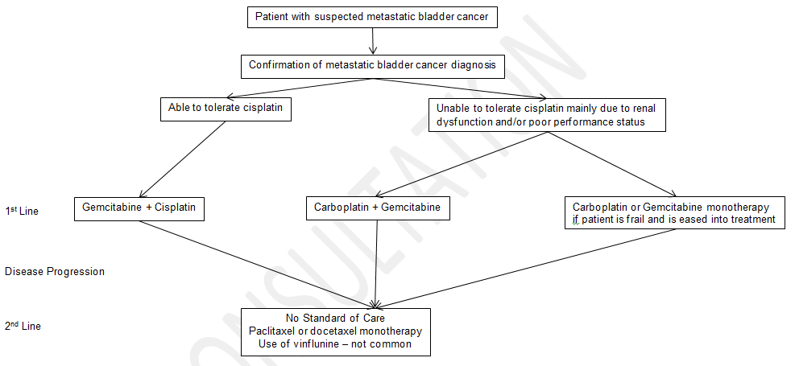

Figure 2: Treatment algorithm showing PD-L1 testing after failure of platinum-based therapy using newly obtained tissue from new biopsy and pembrolizumab treatment

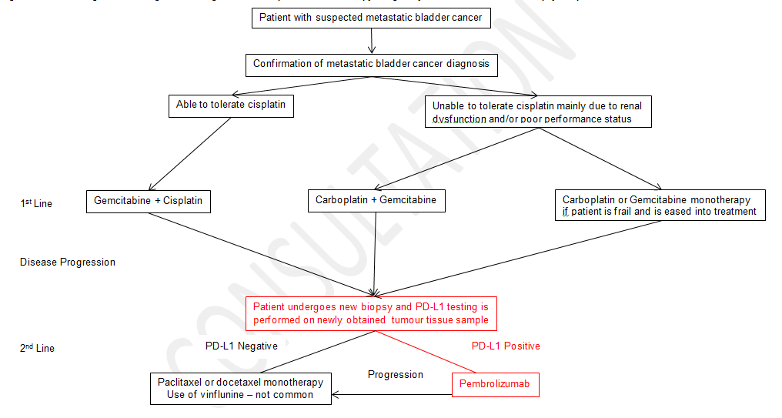

Figure 3: Treatment algorithm showing PD-L1 testing after failure of platinum-based therapy using archival tumour tissue sample and pembrolizumab treatment
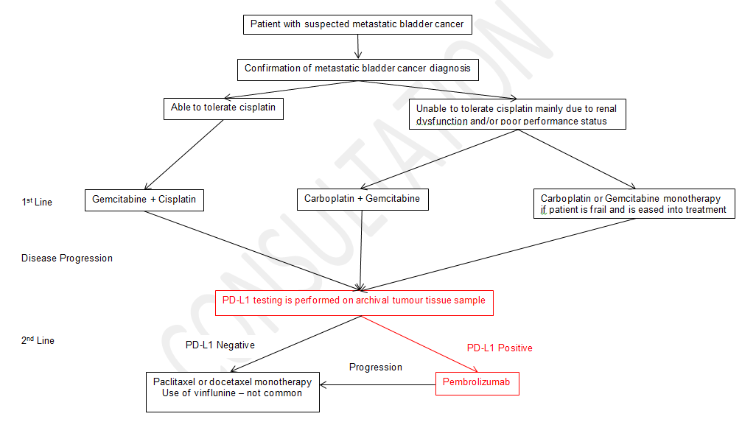

Regulatory Information
Regarding the PD-L1 testing, the regulatory process will be managed by Dako. Regulatory approval of the PD-L1 test is expected prior to MSAC consideration of the co-dependent technology submission.
Pembrolizumab is currently TGA-approved as a treatment for metastatic melanoma regardless of PD-L1 status (ARTG ID: 226597). MSD anticipates filing for an expanded TGA indication to include patients with advanced/metastatic bladder cancer under the parallel TGA and PBAC assessment process.

Decision analytic
An assessment of the cost-effectiveness of introducing PD-L1 testing to determine patient eligibility to pembrolizumab should take into account the parameters outlined in Table 3 and Table 5.
Table 3: Summary of PICO to define research question
PICO | Comments
Patients | Patients with recurrent or progressive metastatic or locally advanced/unresectablemetastatic bladder cancer that has recurred or progressed following platinum-based chemotherapy
Intervention | Test  Immunohistochemistry testing for PD-L1 to determine if the proposed PBS requirements relating to access to pembrolizumab are fulfilled  Drug  Pembrolizumab treatment for PD-L1 positive patients  Co-dependence  Access to pembrolizumab in patients who fulfil the PBS requirements with regards to PD-L1 expression status determined by PD-L1 IHC testing.
Comparator | Test  No PD-L1 testing.  Comparisons will also be made between the evidentiary standard (PD-L1 IHC 22C3 pharmDx Market Ready Assay) and any alternative PD-L1 test for which there is data in the public domain or available to the sponsor  Drug  No standard of care in second line therapy and paclitaxel or docetaxel monotherapy are potential comparator treatment options.  Co-dependence  Comparative outcomes and cost effectiveness comparisons in a PD-L1 tested population treated with pembrolizumab versus standard of care.
Outcomes | Test  Outcome measures suitable to assess the analytic performance of PD-L1 IHC testing include:  - Sensitivity  - Specificity  - Positive Predictive Value  - Negative Predictive Value  - Precision  Measure of Clinical Utility of PD-L1 test  - Health outcomes with pembrolizumab in advanced/metastatic bladder cancer population whose tumours express PD-L1 (PD-L1 positive) compared to health outcomes with pembrolizumab in advanced/metastatic bladder cancer population (all comers)  Other considerations  - Rates of re-biopsy  - Rates of re-testing  - Anticipated test turnaround time.  - The estimated number of patients being tested  - The number of patients tested per case of PD-L1 positive result detected  - The number of patients tested per case of PD-L1 positive result treated with pembrolizumab  - The cost of testing per case of PD-L1 positive advanced/metastatic bladder cancer detected  - The cost of testing per case of PD-L1 positive advanced/metastatic bladder cancer treated with pembrolizumab.  Drug Outcomes  Measures of clinical efficacy for pembrolizumab include:  Primary outcome:  - Overall survival  - Progression free survival  Secondary outcomes  - Objective tumour response rates (complete response or partial response according to RECIST criteria)  - Quality of life  - Disease control rate (response rate + rate of stable disease)  - Duration of response  - Rate of disease progression  - Time to progression  - Safety and tolerability.

Table 4: For investigative services
Prior tests | Initial biopsy and tests to confirm diagnosis of advanced/metastatic bladder cancer. Depending on the final clinical algorithm chosen, PD-L1 testing may use:  - newly obtained tissue from a new biopsy performed after failure of platinum-based therapy  - archival tumour tissue sample after failure of platinum-based therapy
Reference standard | There is no reference standard. The PD-L1 IHC 22C3 pharmDx Market Ready Assay used to determine patient eligibility in KN045 is the evidentiary standard.

Healthcare resources
Healthcare resources that are most likely to be affected, should PD-L1 testing and treatment with pembrolizumab become available include (see Table 5):
- Cost of the PD-L1 antibody and pathologists time in interpreting and reporting the results. Pathology laboratories are likely to have all the required equipment for IHC as it is routinely performed.
- Costs of a second biopsy if there is insufficient tissue or it is deemed that PD-L1 testing should be done on newly obtained tissue after failure of platinum-based treatment.
- Costs of retrieving tissue blocks if PD-L1 testing is undertaken on archival tissue.
- Costs of treating PD-L1 positive patients with pembrolizumab
- Costs for treating adverse events from PD-L1 testing such as obtaining tissue sample biopsies.
- Cost offsets from reduced use of displaced treatments.
- Costs for treating adverse events from treatment (with any therapeutic agent).
- Costs associated with ongoing patient monitoring, e.g. physician visits.
- Health care resources and associated with initial diagnosis are assumed to remain unchanged and may be excluded from the analysis accordingly.

Questions for public funding

Primary question for public funding
What is the safety, effectiveness, and cost-effectiveness of PD-L1 testing to determine eligibility for pembrolizumab treatment in patients with advanced/metastatic bladder cancer who have failed platinum-based chemotherapy compared with current practice (no PD-L1 testing and paclitaxel/docetaxel treatment after failure of platinum-based chemotherapy)?
This question would be evaluated in the scenario where PD-L1 testing is performed after failure of platinum-based chemotherapy on newly obtained or archival tissue.
- What is the comparable effectiveness, safety and cost-effectiveness of pembrolizumab in a PD-L1 unselected population compared to management tailored by the test (pembrolizumab for PD-L1 test positive and standard practice for PD-L1 test negative locally advanced or metastatic bladder cancer after failure to platinum-based chemotherapy)?

Table 5: List of resources to be considered in the economic analysis
 | Provider of resource | Setting in which resource is provided | Proportion of patients receiving resource | Number of units of resource per relevant time horizon per patient receiving resource | Disaggregated unit cost
 |  |  |  |  | MBS | Safety nets* | Other government budget | Private health insurer | Patient | Total cost
Resources provided to identify eligible population
Equivalent to current practice |  |  | To be provided in  submission | To be provided in  submission
Resources provided to deliver proposed intervention (PD-L1 IHC test and pembrolizumab)
PD-L1 IHC testing | MBS | Pathology lab | To be provided in  submission | To be provided in  submission
Additional tumour tissue biopsy (depending on place in therapy of test) | MBS | Public or private hospital | To be provided in  submission | To be provided in  submission
Treatment of adverse events | PBS | Outpatient | To be provided in  submission | To be provided in  submission
Resources provided in association with proposed intervention
Pembrolizumab for patients deemed eligible based on PBS criteria | PBS | Outpatient | To be provided in  submission | To be provided in  submission
Administration cost for pembrolizumab | Hospitals/MBS | Blend of inpatient/outpatient and public and private hospitals | To be provided in  submission | To be provided in  submission
Physician visits (Oncologist or respiratory physician) | MBS | Outpatient | To be provided in  submission | To be provided in  submission
Clinical monitoring (radiological or other imaging, blood counts) | MBS | Outpatient | To be provided in  submission | To be provided in  submission
Treatment of adverse events | PBS | Outpatient | To be provided in  submission | To be provided in  submission
Resources provided in association with comparator 1 (no standard of care, comparator to be determined)
(e.g., pre-treatments, co-administered interventions, resources used to monitor or in follow-up, resources used in management of adverse events, resources used for treatment of down-stream conditions)
Pharmaceuticals (relevant pre-medications, standard of care) | PBS | Outpatient | To be provided in  submission | To be provided in  submission
Administration cost for determined comparator | Hospitals/MBS | Blend of inpatient/outpatient and public and private hospitals | To be provided in  submission | To be provided in  submission
Physician visits (Oncologist or respiratory physician) | MBS | Outpatient | To be provided in  submission | To be provided in  submission
Clinical monitoring (radiological or other imaging, blood counts) | MBS | Outpatient | To be provided in  submission | To be provided in  submission
Treatment of adverse events | PBS | Outpatient | To be provided in  submission | To be provided in  submission
* Include costs relating to both the standard and extended safety net.

References
E R Plimack, J Bellmunt, S Gupta, R Berger, R B Montgomery, K Heath, J Juco, K Emancipator,
K Pathiraja, J K Lunceford, R F Perini and P H O'Donnell. Pembrolizumab (MK-3475) for advanced urothelial cancer: Updated results and biomarker analysis from KEYNOTE-012. J Clin Oncol (Meeting Abstracts) May 2015 vol. 33 no. 15_suppl 4502.
Y Zhang, S Kang, J Shen, J He, L Jiang, W Wang, Z Guo, G Peng, G Chen, J He, and W Liang. Prognostic Significance of Programmed Cell Death 1 (PD-1) or PD-1 Ligand 1 (PD-L1) Expression in Epithelial-Originated Cancer. A Meta Analysis. Medicine Journal: Volume 94, Number 6, February 2015. Medicine 94(6):e515).
Dong H, Stome SE, Salomao DR, Tamura H, Hirano F, Flies DB. Tumour-associated B7-H1 promotes T-cell apoptosis: a potential mechanism of immune evasion. Nat Med. 2002;8:793.
Hino R, Kabashima K, Kato Y, Yagi H, Nakamura M, Honjo T. Tumour cell expression of programmed cell death-1 ligand 1 is a prognostic factor for malignant melanoma. Cancer. 2010;116:1757.
Konishi J, Yamazaki K, Azuma M, et al. B7-H1 expression on non-small cell lung cancer cells and its relationship with tumour-infiltrating lymphocytes and their PD-1 expression. Clin Cancer Res 2004;10: 5094–5100.
Liu J, Hamrouni A, Wolowiec D, Coiteux V, Kuliczkowski K, Hetuin D. Plasma cells from multiple myeloma patients express B7-H1 (PD-L1) and increase expression after stimulation with IFN-{gamma} and TLR ligands via a MyD88-, TRAF6-, and MEK-dependent pathway. Blood. 2007;110:296.
Patel et al, 2015; PD-L1 Expression as a Predictive Biomarker in Cancer Immunotherapy, Mol Cancer Ther; 14(4); 847–56, DOI: 10.1158/1535-7163.MCT-14-0983

Cancer in Australia: an overview 2014, AIHW, Table B4(a), Pg 92 of document, AIHW Cancer in Australia an overview [accessed 7th April 2016]
Cancer in Australia: an overview 2014, AIHW, Five-year relative survival; Change over time Pg 38 of document, AIHW Cancer in Australia an overview [accessed 10th April 2016]

