MSAC Application 1675:

Diagnostic genetic testing for mitochondrial diseases (MDs)

Ratified

PICO Confirmation

Summary of PICO/PPICO criteria to define question(s) to be addressed in an Assessment Report to the Medical Services Advisory Committee (MSAC)
Table 1 PICO for whole genome sequencing in patients with suspected mitochondrial disease (MD)
Component | Description
Population | Individuals with suspected MD (testing may include biological parents or siblings for segregation purposes)
Prior tests | Complete clinical workup including neuromuscular, hearing, and visual tests, etc.  Laboratory investigations including full biochemical, haematological and metabolic workup.  Imaging may include MRI, CT U/S, etc.
Intervention | Whole genome sequencing from a peripheral blood sample to assess whether there is an actionable pathogenicª variant of the mitochondrial (mtDNA) or nuclear genome (nDNA) that is causative for MD, with analysis to be restricted to a virtual panel.  mtDNA deletion testing using long-range PCR or Southern blot analysis to determine the presence of mtDNA single deletions, if patient is suspected of a single mtDNA deletion and WGS was non-informative
Comparator | No genetic testing
Reference standard | N/A
Outcomes | Test information  - Diagnostic yield (including proportion of tested patients in whom test results provide prognostic information, and proportion of tested patients in whom test results provide predictive information)  - Prognostic value  - Predictive value  - Rate of repeat testing after an initial non-informative WGS test  - Rate of repeat data analysis after an initial non-informative WGS test  Health outcomes  - Time to diagnosis  - Impact on clinical management including:  - Commencement of appropriate targeted or non-targeted treatment  - Cessation of inappropriate treatment  - Earlier and more effective management of the condition  - Change in prognosis  - Health-related quality of life  - Number of couples provided information for informed reproductive decisions (e.g. IVF, PGD, donated oocytes, termination)  Value of knowing  Safety  - Adverse events from obtaining a sample for testing  - Psychological adverse events from genetic testing (positive result, negative result or variant of unknown significance) or no genetic testing  - Psychological effects of false positives or false negatives  Healthcare resources  - Cost per proband identified  - Cost of whole gene sequencing test and mtDNA deletion testing  - Number of, and cost associated with obtaining an appropriate sample  - Additional medical practitioner consultations  - Cost of re-testing and/or data re-analysis
Assessment questions | - What is the diagnostic yield of WGS ± mtDNA deletion testing ± histochemical/immunohistochemical analysis of biopsy versus histochemical/immunohistochemical analysis of biopsy alone?  Also the prognostic yield and predictive yield.  - Is there a change in management in patients in whom MD is diagnosed by WGS ± mtDNA deletion testing ± histochemical/immunohistochemical analysis of biopsy vs histochemical/immunohistochemical analysis of biopsy alone?  What is the incremental prognostic value of WGS ± mtDNA deletion testing in patients diagnosed with MD?  What is the incremental predictive value of WGS ± mtDNA deletion testing in patients diagnosed with MD?  - Does treatment with targeted MD therapies lead to better health outcomes in patients in whom specific pathogenic variants have been detected compared with symptom-based treatment options?  - What is the comparative safety of WGS ± biopsy and histochemistry/immunohistochemistry versus biopsy and histochemistry/immunohistochemistry alone?  - Will the information generated as a result of WGS MD testing be of additional value even if there are no changes in treatment options, i.e. the value of knowing?  - Are there any psychological harms from the knowledge that an individual has inherited a pathogenic MD gene variant that has no better treatment options?  - Are there any safety concerns with targeted therapies compared to symptom-based therapies?
ªFor the purposes of this document, ‘pathogenic’ encompasses both ‘pathogenic’ and ‘likely pathogenic’
CT = computed tomography; IVF = in vitro fertilisation; MD = Mitochondrial Disease; MRI = Magnetic Resonance Imaging; mtDNA = Mitochondrial DNA; nDNA = Nuclear DNA; PCR = Polymerase Chain Reaction; PGD = pre-implantation genetic diagnosis; U/S = ultrasound; WGS = Whole Genome Sequencing
Table 2 PICO for cascade testing in close relatives of patients with a pathogenic MD gene variant and in reproductive partners of those with a recessive variant
Component | Description
Population | Biological relatives of an individual with a pathogenic MD gene variant  Reproductive partner of an individual with an identified recessive nDNA MD gene variant, for the purpose of reproductive decision-making.  Fetuses of reproductive couples with known pathogenic MD nDNA gene variant/s where the parents’ genotypes place the fetus at risk of being affected by MD.
Prior tests | Not applicable
Intervention | Variant-specific testing to determine the presence of a familial mtDNA or nDNA pathogenic variant that is causative for MD in biological relatives.  Whole gene testing for reproductive partners if the known pathogenic variant has a recessive mode of inheritance.  Variant-specific testing to determine the presence of familial nDNA and mtDNA pathogenic variant/s that are causative for MD in fetuses.
Comparator | No genetic test
Reference standard | N/A
Outcomes | Test information  - Rate of repeat testing  - Rate of repeat data analysis  - Diagnostic yield (including proportion of patients in whom test results provide prognostic information, and proportion of patients in whom test results provide predictive information)  - Prognostic value  - Predictive value  Health outcomes  - Impact on clinical management including:  - Earlier and more effective management of the condition  - Health-related quality of life  - Number of couples provided with information for reproductive decisions (e.g. IVF, PGD, donated oocytes, termination)  Safety  - Adverse events from obtaining a sample for testing  - Psychological adverse events from genetic testing (positive result, negative result or variant of unknown significance) or no genetic testing  - Psychological effects of false positives or false negatives  Healthcare resources  - Cost of variant specific test (cascade) and whole gene test (for partners)  - Number of, and cost associated with obtaining an appropriate sample  - Additional medical practitioner consultations  - Cost of re-testing and/or data reanalysis
Assessment questions | - What is the diagnostic yield of variant-specific testing to determine the presence of a familial mtDNA or nDNA pathogenic variant that is causative for MD in biological relatives of patients with an identified pathogenic variant?  What is the diagnostic yield of whole gene testing to determine the presence of a nDNA pathogenic variant that is causative for MD in reproductive partners of an individual with an identified recessive pathogenic variant?  What is the diagnostic yield of variant-specific testing of the fetus to determine the presence of familial nDNA pathogenic variant/s that may cause MD in the fetus?  - Is there a change in management in individuals who undergo variant-specific testing? (including but not limited to a wider range of reproductive options)  Will the information generated as a result of variant-specific testing be of additional value in relatives of patients diagnosed with MD?  - Does earlier treatment of relatives who are non-symptomatic or have non-specific symptoms and have inherited the MD variant lead to better health outcomes compared to delaying treatment to the onset of symptoms?  - Will the information generated as a result of variant-specific testing be of additional value to relatives with an inherited pathogenic MD gene variant even if there are no changes in management options, i.e. the value of knowing?  - Are there any safety concerns with variant-specific testing of first degree relatives or fetuses at risk of having MD?  - Are there any psychological harms from the knowledge that an individual has inherited a pathogenic MD gene variant that has no better management options?  - What is the success rate (live births without MD compared to with MD) for the use of artificial reproductive technologies by parents with an identified pathogenic variant that may cause MD in the off-spring?
Note: the questions italicised do not need to be addressed in the assessment report if a refined assessment is performed (assessing cost per proband identified etc, instead of cost per health outcome, for genomic test applications).

Purpose of application
An application requesting Medicare Benefits Schedule (MBS) listing of the medical service whole genome sequencing (WGS) with analysis restricted to a virtual panel for the diagnosis of mitochondrial disease (MD) in patients suspected of having the disease was received from the Australian Mitochondrial Disease Medical Network Ltd by the Department of Health.
The Application is also requesting additional MBS listings for related items:
- Trio testing using virtual panels on an exome/genome background
- Re-analysis of whole exome/genome sequence data for characterisation of new germline gene variants for mitochondrial diseases without a confirmed pathogenic gene variant after WGS
- mtDNA deletion testing for diagnosis of those strongly suspected of having MD and in whom WGS testing was non-informative
- Cascade testing of first-degree family members of an individual with confirmed causative variant(s) for mitochondrial disease by testing of these causative gene variant(s) for diagnostic or segregation purposes
- Cascade testing of fetuses for the familial nDNA variant/s present in their parents, where the parents genotypes place the fetus at risk of MD
- Whole gene testing of a reproductive partner of someone with a confirmed nDNA recessive pathogenic variant related to mitochondrial disease, to determine if they have any pathogenic variants on the same gene(s).
The use of proposed WGS in diagnosis of MD results in superior effectiveness and safety in suspected MD patients compared to no genetic testing or invasive muscle biopsies.
This application is similar to MSAC 1476, and 1600, where whole genome sequencing is considered the gold standard, but is not broadly available. The request for funding therefore allows for virtual panel testing on either whole exome or whole genome background, to increase accessibility.

PICO criteria

Population
The population of interest is all patients (children and adults) who are suspected of having either acute or chronic MD.
MDs are the most common group of inheritable disorders caused by genetic variants in either mitochondrial (mtDNA) or nuclear genomes (nDNA). Mitochondria are the essential organelles present in all nucleated cells of the body (multiple mitochondria per cell, up to thousands in some cell types) and they are the principal generators of cellular energy as adenosine triphosphate (ATP). The human mitochondrial genome is a circular molecule of 16,569 base pairs and contain 37 genes that encode 13 core respiratory chain subunits of the oxidative phosphorylation (OXPHOS) system and 24 RNAs (including 22 tRNAs and 2 rRNAs) for intramitochondrial protein synthesis. Over 1,500 nuclear genes encode mitochondrial structural and functional proteins (Anderson et al. 1981; Gorman et al. 2016). MD results from defects in oxidative phosphorylation (OXPHOS) activity or to integral mitochondrial functions. The responsible pathogenic gene variants can be located on either mtDNA or nDNA (Stenton & Prokisch 2020) and can be base substitutions, deletions, insertions or duplications. Maternally inherited mtDNA in individual cells can be homoplasmic (only a single mtDNA type, either wild- type or variant) or heteroplasmic (two or more mtDNA types) (Riley et al. 2020). Depending on the pathogenic variant load (heteroplasmy levels) in both among different tissues in a given individual and among members of the same family, clinical phenotypes and clinical manifestations may differ. This results in a highly variable disease phenotype complicating the disease diagnosis where a clear genotype-phenotype correlation is not applicable (Keshavan & Rahman 2018; McCormick, Zolkipli-Cunningham & Falk 2018).
MD may present with widely heterogenous clinical syndromes and clinical manifestations, affecting only single organ, mild or oligo-asymptomatic disease to severe or life-threatening multi-organ dysfunction. Acute or chronic symptoms and signs may overlap with more common conditions or progress throughout an individual’s lifespan, affecting both children and adults (Watson, Davis & Sue 2020).
Lacking sensitive and specific biomarkers, decision making for diagnosis, treatment and management is challenging for these disorders and might require multiple consultations, tests and invasive investigations complicating the diagnostic categorisation: ‘unlikely’, ‘possible’ or ‘probable’ (Parikh et al. 2019). Due to these limitations in diagnosis, the common understanding for MD refers to classical mitochondrial disorders such as Leigh syndrome or MELAS (mitochondrial encephalomyopathy, lactic acidosis, and stroke-like episodes). However, new advances in next generation sequencing (NGS), helped to identify more than 100 novel MDs with approximately 350 known genes affecting diverse mitochondrial pathways (Distelmaier et al. 2017; Ng et al. 2021). The initial clinical manifestations can include acute and subacute neurological presentations (such as stroke-like episodes, epilepsy, metabolic decompensation of brainstem function, subacute visual loss and optic neuropathy) or chronic neurological presentations (such as chronic progressive external ophthalmoplegia – CPEO, myopathy, sensorineural hearing loss, optic neuropathy or other chronic neurological presentations) or non-neurological features (such as respiratory failure, cardiomyopathy, conduction defect, liver failure, renal failure, diabetes mellitus, pancreatitis, etc. (Gorman et al. 2016; Gorman et al. 2015; Ng et al. 2021).

Clinical presentation of MD
MDs are clinically heterogeneous, can occur at any age, can involve any organ or tissue, characteristically involve multiple systems, typically affecting organs that are highly dependent on aerobic metabolism and can manifest with a wide range of clinical symptoms (Davis et al. 2021; Gorman et al. 2016). The phenotype-genotype relationship of MD varies extremely, which can delay diagnosis. The clinical features of MDs are summarized in Table 3.
Table 3 Clinical features of MD
Body organ/function | Symptoms
General | Lack of energy, shortness of breath, fever, dizziness/light headedness, congestion, coughing, dry skin
Muscle | Proximal and distal myopathy, general pain, muscle cramping, joint pain, muscle weakness, exercise intolerance
Haematological | Iron deficiency, pancytopenia, sideroblastic anaemia
Eye | Ophthalmoplegia, ptosis, optic neuropathy, pigmentary retinopathy
Lung | Apnoea, aspiration, hypoventilation, pulmonary hypertension
Liver | Liver dysfunction, liver failure
Gastrointestinal | Lack of appetite, dysphagia, vomiting, nausea, stomach cramps, constipation
Brain | Encephalopathy, stroke-like episodes, epilepsy, dementia, ataxia
Heart | Cardiomyopathy, conduction defects, low/high blood pressure
Kidney | Renal tubulopathy, Fanconi syndrome, glomerular dysfunction
Nervous system | Axonal peripheral neuropathy, Dorsal Root ganglionopathy, spastic paraplegia
Ear | Sensorineural deafness
Immune system | Recurrent infection
Endocrine system | Adrenal insufficiency, diabetes mellitus, growth hormone deficiency, hypothyroidism, osteopenia, short stature
Source: Bottani et al. (2020) and Gorman et al. (2016)
Some of the clinical features that are associated with mitochondrial diseases can be grouped into specific syndromes, for example, Leigh syndrome (also known as subacute necrotizing encephalomyelopathy) and Alpers–Huttenlocher syndrome. The heterogeneity in the clinical manifestation of mitochondrial diseases means that both diagnosis and management of these disorders are extremely difficult. Diagnosis is becoming more reliant on genetic testing, in addition to histochemical and biochemical analysis of tissue biopsies. The management of patients with MD includes strategies to reduce morbidity and mortality, the early treatment of organ-specific complications and interventional strategies where possible (Gorman et al. 2016).
Children often present with acute clinical features (such as failure to thrive, motor regression, metabolic encephalopathy, seizures, ptosis, external ophthalmoplegia and cardiomyopathy), whereas most frequent clinical manifestations associated with adult MDs are chronic and include exercise intolerance, sensorineural hearing loss, ophthalmological abnormalities, muscle weakness, central nervous system involvement, cardiac manifestations, gastrointestinal system abnormalities and endocrine abnormalities (Liang, Ahmad & Sue 2014). A list of characteristic phenotypes/syndromes of the MD spectrum and the associated pathogenic variants with clinical features identified to date is provided in Table 4.

Table 4 Characteristic phenotypes/syndromes of the MD spectrum and the associated genes
Phenotypes/Syndromes | Genetics | Clinical features
Childhood-onset mitochondrial diseases
Leigh syndrome | >75 genes in nDNA and mtDNA | Acute periods of neurodevelopmental regression followed by partial recovery, hypotonia, dystonia, hypopnoea, dysphagia, epilepsy, failure to thrive, encephalopathy, and basal ganglia and brainstem lesions
Alpers–Huttenlocher syndrome (AHS) | nDNA (POLG-related) | Intractable epilepsy, psychomotor regression and liver disease; might also include the clinical features of MCHS and MEMSA
Childhood myocerebrohepatopathy spectrum (MCHS) |  | Neuropathy, ataxia, hypotonia, myoclonus (spontaneous muscle contractions), choreoathetosis (the occurrence of involuntary jerky, writhing movements of muscles or muscle groups) and Parkinsonism, in addition to renal tubulopathy
Ataxia neuropathy spectrum (ANS; previously referred to as mitochondrial recessive ataxia syndrome (MIRAS) and sensory ataxia neuropathy dysarthria and ophthalmoplegia (SANDO)) |  | Sensory axonal neuropathy with variable sensory and cerebellar ataxia
Myoclonic epilepsy myopathy sensory ataxia (MEMSA; previously referred to as spinocerebellar ataxia with epilepsy (SCAE)) |  | Epilepsy, PEO, seizures, dysarthria, dementia, spasticity and myopathy
Sengers syndrome | nDNA (AGK variants) | Congenital cataracts, hypertrophic cardiomyopathy, skeletal myopathy, exercise intolerance and lactic acidosis. Patients can present with or without mtDNA depletion in muscle
MEGDEL syndrome (also known as 3-methylglutaconic aciduria with deafness, encephalopathy and Leigh-like syndrome) | nDNA (SERAC1 variants) | Sensorineural hearing loss, encephalopathy, failure to thrive, hypotonia, psychomotor delay, dystonia, spasticity, hypoglycaemia, hepatopathy and lactic acidosis
Pearson syndrome | Single, large-scale mtDNA deletion or rearrangements of mtDNA (often sporadic) | Sideroblastic anaemia of childhood associated with exocrine and/or endocrine pancreatic dysfunction, pancytopaenia and renal tubulopathy
Congenital lactic acidosis (CLA) | nDNA, de novo mtDNA point variants or inherited mtDNA point variants in the genes coding for the puryuvate dehydrogenase complex | Childhood onset, often fatal, progressive neuromuscular weakness, accumulation of lactate in the blood (acidosis), urine and/or CSF
Adult-onset mitochondrial diseases
Leber hereditary optic neuropathy (LHON) | Variants in mtDNA, for example, m.11778G>A (MT-ND4), m.14484T>C (MT-ND6) and m.3460G>A (MT-ND1) | Subacute painless bilateral visual loss. Might also include dystonia, cardiac pre-excitation syndromes and LHON associated with multiple sclerosis-like symptoms (Harding syndrome)
Kearns–Sayre syndrome (KSS) | Single, large-scale mtDNA deletion (often sporadic) | PEO, pigmentary retinopathy (progressive vision impairment due to degeneration of the rod photoreceptors), CSF protein levels of >1 g per l, cerebellar ataxia, cardiac conduction abnormalities (age of onset <20 years), myopathy, diabetes mellitus, deafness, bulbar weakness and dementia
Mitochondrial myopathy, encephalopathy, lactic acidosis and stroke-like episodes (MELAS) syndrome | Variants in mtDNA, such as m.3243A>G in MT-TL1, and 23 other pathogenic variants in MT-TL1 and in other mtDNA genes (for example, MT-TF, MT-TV and MT-TQ) | Stroke-like episodes. Can also include deafness, diabetes mellitus, pigmented retinopathy, cardiomyopathy, cerebellar ataxia, seizures, encephalopathy, lactic acidosis and mitochondrial myopathy
Myoclonic epilepsy with ragged red fibres (MERRF) | Variants in mtDNA, such as m.8344A>G in MT-TK, and other pathogenic variants in MT-TF, MT-TL1, MT-TI and MT-TP | Progressive myoclonic epilepsy, ataxia, weakness. Can also include pigmented retinopathy, sensorineural hearing loss, lactic acidosis, lipomata, spasticity and cardiac conduction defects (Wolff–Parkinson–White syndrome)
Neurogenic muscle weakness, ataxia and retinitis pigmentosa (NARP) | Variants in mtDNA, such as MT-ATP6 m.8993T>G, which is the most common variant, and m.8993T>C, a less severe variant | Early childhood onset can remain quiescent or stable into adulthood, sensorimotor neuropathy, ataxia and pigmentary retinopathy. Can also include seizures, learning disability, dementia, proximal neurogenic muscle weakness, basal ganglia abnormalities, sensorineural hearing loss, short stature, CPEO, cardiac conduction defects, obstructive sleep apnoea and neuropsychiatric disorders. These syndromes form a clinical continuum with Leigh syndrome
Chronic progressive external opthalmoplegia (CPEO) | TYMP, which encodes thymidine phosphorylase | Gastrointestinal dysmotility, muscle weakness and atrophy, neuropathy, retinopathy, hearing loss, leukoencephalopathy and depleted TYMP activity
 | POLG1, which encodes α-DNA polymerase subunit γ1 | Ataxia, peripheral sensory neuropathy, Parkinsonism, premature ovarian failure, psychiatric symptoms, MELAS syndrome and epilepsy
 | POLG2, which encodes DNA polymerase subunit γ2 | Ptosis and proximal myopathy, dystrophy, cerebellar ataxia and gastrointestinal symptoms
 | MPV17, which encodes protein MPV17 | Distal limb weakness, neuropathy, exercise intolerance, diabetes mellitus, ptosis, hearing loss, gastrointestinal dysmotility, depression and Parkinsonism
 | DGUOK, which encodes deoxyguanosine kinase | Exercise intolerance, limb girdle weakness, muscle cramps and occasional dysphagia
 | TK2, which encodes thymidine kinase 2 | Ptosis, scapular winging, facial and proximal muscle weakness and wasting, dysphagia and respiratory deficiency
 | RRM2B, which encodes ribonucleotide-diphosphate reductase subunit M2B | Hearing loss, bulbar dysfunction, renal disease and gastrointestinal disturbance
 | C10orf2, which encodes Twinkle protein | Isolated PEO with or without mild proximal myopathy and exercise intolerance, fatigue, hearing loss, Parkinsonism psychiatric symptoms and cardiac involvement
 | SLC25A4, which encodes ADP/ATP translocase 1 | Indolent or mild PEO with or without ptosis, facial weakness, mild hearing loss, psychiatric symptoms and neuropathy
 | SPG7, which encodes paraplegin | Ataxia, optic atrophy, myopathy, spastic paraparesis and cerebellar atrophy
 | AFG3L2, which encodes AFG3-like protein 2 | Ataxia, spastic paraparesis, myopathy and cerebellar atrophy
 | OPA1, which encodes dynamin-like 120 kDa protein | Optic atrophy, early-onset visual loss, ataxia and deafness, spasticity, axonal neuropathy, diabetes mellitus, epilepsy and dementia
 | C20orf7, which encodes mitochondrial genome maintenance exonuclease 1 | Proximal muscle weakness, generalized muscle wasting, respiratory deficiency, chronic renal failure, cardiac arrhythmias and depression
 | DNA2, which encodes DNA replication ATP-dependent helicase/nuclease DNA2 | Progressive myopathy
 | RNASEH1, which encodes ribonuclease H1 | Myopathy, dysphagia and spinocerebellar signs
 | DNM2, which encodes dynamin 2 | Facial and proximal weakness, axonal neuropathy and cardiomyopathy
Mitochondrial neurogastrointestinal encephalopathy (MNGIE) syndrome | TYMP, RRM2B and POLG variants in nDNA | Gastrointestinal dysmotility, muscle weakness and atrophy, PEO, neuropathy, retinopathy, hearing loss, leukoencephalopathy* and depleted TYMP activity*
Source: Gorman et al (2016)
CSF = cerebrospinal fluid; mtDNA = mitochondrial DNA; nDNA = nuclear DNA; PEO = progressive external ophthalmoplegia.
*Not affected in RRM2B and POLG variants.

Prevalence of disease
There is limited epidemiologic data on primary MDs. While individually rare, the collective minimal prevalence is 1 in 4,300 (prevalence of all pathogenic variants in both nDNA and mtDNA is 23 per 100,000, 95% CI = 14.6 – 34.5 X 10⁻⁵) (Gorman et al. 2015). Tan et al. (2020) calculated lifetime risk of 249 nuclear-encoded autosomal recessive MDs from publicly available genetic databases (publicly available gnomAD database as 48.4 per 100,000 (almost 1 in 2000 people). The disorders with the highest lifetime risk caused by the variants in SPG7, ACADM, POLG and SLC22A5 genes as given in Table 5 below.
Prevalence studies have estimated 1 in 200 – 250 people (or approximately 120,000 Australians) carry a disease-causing mtDNA mutation that puts them at risk of developing a MD or other related symptoms (Liang, Ahmad & Sue 2014; Vandebona et al. 2009). According to the Mito Foundation, one Australian child born each week – or 52 children every year – will develop a severe or life-threatening form of MD (1 in 5000 people).
Skladal et al. (2003) reported that 86 out of 1,706,694 children born during 1987 – 1996 in NSW, Victoria and SA, had a mitochondrial respiratory chain disorder, corresponding to a minimum birth prevalence of 5.0/100,000.
The applicant reported that the established mitochondrial unit at Royal North Shore Sydney has a history of over 25 years caring for mitochondrial patients in NSW, with as many as 70% being ‘out of area’ referrals. Based on the numbers referred to the unit (70-80/year), with a confirmed MD diagnosis in approximately one third, (25 patients/year), it is estimated that approximately 150 patients per year across Australia would have confirmed MD, when collectively accounting for data from other states, other hospitals, and particularly children’s hospitals.

Table 5 Lifetime risk of the most frequent mitochondrial diseases per gene
Gene | Number of disease-causing  variants  in-house database | Number of disease-causing  alleles  in-house database | Number of disease-causing  variants in  gnomAD dataset | Number of disease-causing  alleles in  gnomAD dataset  (European, Non-Finnish  population) | Number of disease-causing  alleles in  gnomAD dataset  (worldwide) | Lifetime risk in-house  database per 100,000  (95%CI) | Lifetime risk in  European (Non-Finnish)  population (gnomAD  dataset) per 100,000  (95%CI) | Lifetime risk in  worldwide population  (gnomAD dataset) per  100,000 (95%CI)
SPG7 | 31 | 195 | 107 | 1160 | 1684 | 5·2 (3·8–6·6) | 8·4 (7·5–9·4) | 3·7 (3·4–4·1)
ACADM | 24 | 195 | 80 | 1126 | 1584 | 4·8 (3·6–6·3) | 7·9 (7·0–8·9) | 3·3 (3·0–3·6)
POLG | 35 | 174 | 137 | 1050 | 1697 | 3·7 (3·3–4·1) | 6·9 (6·1–7·8) | 3·7 (3·4–4·1)
SLC22A5 | 27 | 186 | 77 | 961 | 1911 | 4·3 (3·2–5·8) | 5·8 (5·1–6·5) | 4·8 (4·3–5·2)
BTD | 26 | 53 | 95 | 585 | 945 | 0·35 (0·20–0·60) | 2·1 (1·8–2·5) | 1·2 (1·0–1·3)
ACADVL | 25 | 261 | 108 | 789 | 1183 | 0·45 (0·26–0·75) | 1·3 (1·1–1·6) | 0·64 (0·55–0·74)
CPT2 | 16 | 69 | 72 | 382 | 766 | 0·60 (0·36–0·95) | 0·91 (0·74–1·10) | 0·76 (0·66–0·88)
TRMT5 | 5 | 35 | 23 | 368 | 542 | 0·16 (0·08–0·30) | 0·84 (0·68–1·04) | 0·38 (0·32–0·45)
CLPB | 19 | 61 | 33 | 346 | 510 | 0·47 (0·27–0·77) | 0·75 (0·60–0·92) | 0·34 (0·28–0·40)
HADHA | 14 | 48 | 56 | 310 | 546 | 0·29 (0·16–0·51) | 0·60 (0·48–0·75) | 0·39 (0·33–0·46)
COQ8A | 26 | 64 | 66 | 309 | 523 | 0·51 (0·30–0·84) | 0·60 (0·47–0·75) | 0·36 (0·30–0·42)
CEP89 | 19 | 69 | 41 | 300 | 434 | 0·60 (0·36–0·95) | 0·56 (0·44–0·70) | 0·25 (0·20–0·30)
LIPT1 | 8 | 39 | 31 | 282 | 385 | 0·19 (0·10–0·36) | 0·50 (0·39–0·63) | 0·19 (0·16–0·24)
Source: Tan et al. (2020)

Mitochondrial disease genes and targeted therapies
More than 350 MD-causing genes have been identified to date (Ng et al. 2021). The genes identified in the review by Stenton & Prokischa (2020) and on the PanelApp UK website have been divided into six subsets according to their functional roles: (1) OXPHOS subunits, assembly factors, and electron carriers, (2) mitochondrial DNA maintenance, expression, and translation, (3) mitochondrial dynamics, homoeostasis, and quality control, (4) metabolism of substrates, (5) metabolism of cofactors, and (6) metabolism of toxic compounds. Numerous genes have dual roles across these categories and are listed more than once (Figure 1). The mode of inheritance is also indicated. The majority of pathogenic gene variants are autosomal recessive, and some are autosomal dominant, X-linked dominant or X-linked recessive, with rare sporadic cases due to de novo variants (Gorman et al. 2016). The genes encoded on the mitochondrial DNA are only inherited through the mother. Additionally, in some cases, different pathogenic variants in the same gene can cause different MD syndromes. These different pathogenic variants may also differ in the inheritance pattern, such that one variant causes recessive disease and another variant in the same gene causes dominant disease.
While the current MD management strategy focuses on surveillance for multisystem involvement and effective symptomatic treatment, targeted therapies are available for patients with certain genetic variants, as shown in Table 6. These patients may derive some clinical utility from a genetic diagnosis.
A definitive genetic diagnosis may also help with management of, and/or surveillance for, specific complications even if targeted therapies are not available, and enable patients to be enrolled into appropriate clinical trials.
Each cell contains many mitochondria, and mutations arising in a mitochondrial genome can come to be present in a higher proportion of mtDNA genomes due to successive mitochondrial sampling at each cell division, including cell division to create oocytes. Therefore, pathogenic variants in mtDNA can affect all copies (homoplasmy) or only some (heteroplasmy) of the mitochondrial genome within each cell. The percentage of mitochondria affected by a pathogenic variant is an important factor in determining the severity of disease, or whether a person will eventually develop clinical MD (McCormick, Zolkipli-Cunningham & Falk 2018). Approximately two-thirds of cases of adult-onset disease are caused by pathogenic mtDNA variants.
Figure 1 Mitochondrial disease genes
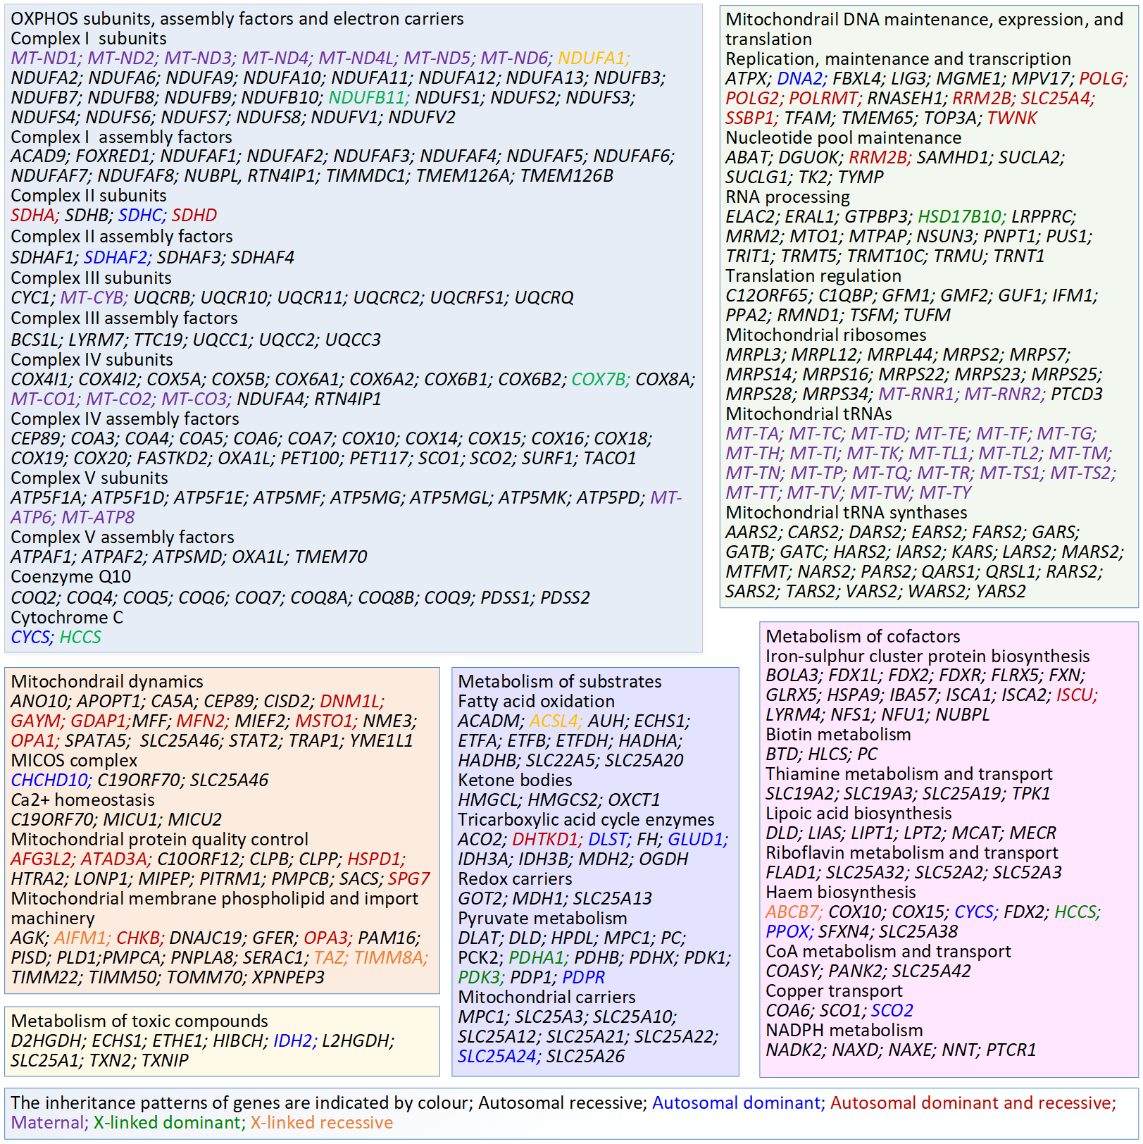
Source: Stenton & Prokisch (2020) and PanelApp UK available at URL:https://panelapp.genomicsengland.co.uk/panels/112/

Table 6 Targeted Therapies for MD caused by specific pathogenic variants
PHENOTYPE | GENOTYPE | MANAGEMENT
MELAS (mitochondrial encephalopathy, lactic-acidosis, stroke-like syndrome)  MIDD (maternally inherited diabetes and deafness) | mtDNA: m.3243A>G  nDNA: variants in MT-TL1 and MT-TK genes | Treatment of acute mitochondrial stroke-like episodes with intravenous (IV) arginine hydrochloride, and daily oral arginine to prevent strokes. Citrulline appears to be more potent, but more studies needed.  KH176 - positive effects on attention performance and measures of depression and anxiety  Idebenone has shown to lower fatigue severity scale scores.  Avoidance of metronidazole is warranted to avoid sudden elevations in lactic acid, potentially inducing a stroke-like event.  Current pre-clinical studies on potential Glutathione treatment (A3243G & A8344G variants), and clinical trials being conducted in the use of Acipimox (A3243G & single large-scale deletions), Nicotinamide Riboside and Everolimus (a rapamycin analogue).  Pre-clinical studies are being undertaken in the use of resveratrol
MNGIE (Mitochondrial Neuro-Gastro-Intestinal Encephalomyopathy) | nDNA: Autosomal recessive variants in TYMP gene | Allogeneic hematopoietic stem cell transplant  Liver transplantation, Erythrocyte-encapsulated thymidine phosphorylase, and gene therapy are also potential treatments.  Trials commencing on Enzyme Replacement Therapy - Erythrocyte Encapsulated Thymidine Phosphorylase
Leber hereditary optic neuropathy (LHON) | mtDNA: m.3460G>A, m.11778G>A, and m.14484T>C | Idebenone can prevent further visual loss, especially in patients with discordant vision. iii  Awaiting results of trials in the use of Elamipretide  Intravitreal injection of AAV vector and Allotopic gene expression.  Clinical studies currently active on the use of PDE5 inhibitors, Curcumin, EPI-743, and preclinical studies in NDI1 usage
Dominant Optic Atrophy | nDNA: OPA 1 | Current trials involving the use of Idebenone
Thiamine transporter-2 deficiency  (Biotin-thiamine-responsive basal ganglia disease) | nDNA: SLC19A3 | Thiamine (20–40 mg/kg daily) and biotin (15 mg/kg daily) greatly improves patients’ clinical condition preventing further episodes with metabolic decompensation, and improvement of neurological and biochemical abnormalities of this disease
Mitochondrial Complex I deficiency | nDNA: Especially ACAD9 variants (e.g., ACAD9 deficiency) | Particularly benefit from Riboflavin orally at 10-20mg/kg daily. JP4-039 is also under investigation.
Pearson’s Disease | mtDNA: Specific mtDNA deletion includes deletion of the complete genes for ATPases 6 and 8, cytochrome c oxidase III, and NADH dehydrogenase 3, 4, 4L, and 5 | Supportive therapy includes pancreatic enzyme replacement, blood transfusions, as well as granulocyte-colony-stimulating factor application.  Clinical trials commencing (by appointment only) in respect to transplantation of MNV-BM-BLD (autologous cd34+ cells enriched with blood derived mitochondria) in paediatric patients
Mitochondrial Disorders presenting with liver failure | nDNA: DGUOK, MPV17, SUCLG1, POLG1 | Supportive management includes supplementation of vitamin K, administration of fresh frozen plasma, and treatment of hypoglycaemia
 | nDNA: TRMU | Can cause transient hepatic problems, which resolve spontaneously after the first year of life. So, in the absence of neurological impairment, liver transplantation may be warranted when liver failure is severe
Hearing loss | mtDNA: Especially in m.1555A>G, and m.1494C>T variants | There is an increased susceptibility to aminoglycoside-induced ototoxicity, so caution must be adhered to in their use.
Pyruvate dehydrogenase deficiency  e.g., Thiamine-responsive pyruvate dehydrogenase deficiency . | nDNA: Pathogenic variants  nDNA: PDHA1 | Ketogenic diet has been shown to increase longevity and improve mental development.  Recruiting for trials in Sodium Phenylbutyrate and dichloroacetate  Variable but possible response to Thiamine orally at 30-40mg/kg daily
Coenzyme Q10 deficiency | nDNA: variations in PDSS1, PDSS2, COQ2, COQ4, COQ6, ADCK3, ADCK4, and COQ9 | Excellent to highly variable response to oral CoQ10 orally at 10-30mg/kg daily, depending on the underlying defect
mtDNA variants | mtDNA variants | Replacement of mutant mtDNA in oocytes or single-cell embryos by mitochondrial replacement therapy to prevent their transmission (legislation changes for approval currently under review)
nDNA variants | nDNA variants | Preventive therapy through prenatal diagnosis after genetic counselling is becoming increasingly important for nDNA-related disorders.
Ethylmalonic encephalopathy | nDNA: ETHE1 variants | Metronidazole and N-acetyl cysteine given together in a cohort of patients was able to improve some of the clinical features of the disease (given on compassionate grounds).  Potentially liver transplantation  JP4-039 and gene therapy approaches are being investigated for potential clinical trialling
Kearns-Sayre Syndrome | mtDNA: mtDNA depletions | CoQ10 & Mitochondrial augmentation therapy trials are currently being undertaken
Leigh Syndrome | nDNA: ND1-G3697A, SUCLA2, ETHE1, ND5-G13513A, EARS2, SURF1, ND6-T14487C  NDUFS4 | EPI-743 improves clinical outcomes in children with genetically confirmed Leigh syndrome.  Clinical trials being piloted in the use of Rapamycin and Everolimus (a rapamycin analogue).  Preclinical studies in the use of gene therapy approaches and NAD+ precursors
MERRF | mtDNA: m.8344A > G variant in MT-TK gene, and other variants in MT-TL1, MT-TH, MT-TS1, MT-TS2, and MT-TF genes | Cytotoxic Necrotizing Factor 1 (CNF1) and the delivery of nucleic acids to the mitochondria are both currently being explored for trialling
Barth Syndrome | nDNA: TAFAZZIN gene variants | Current active trialling of Elamipretide in patients
TK-2 Disease | nDNA: TK-2 variants | Molecular bypass therapy in disorders of mtDNA instability are currently being undertaken
POLG-related disorders | nDNA: POLG variants | Sodium Valproate is absolutely contraindicated in patients with POLG-related disease as it can precipitate liver failure and therefore the POLG gene should be sequenced before prescribing Sodium Valproate to patients with status epilepticus iv
Episodic muscle weakness, mimicking periodic paralysis | mtDNA: MT-ATP6 variants | Affected individuals may improve with acetazolamide treatment. Pre-clinical trials are also being undertaken for PDE5 inhibitors, Rapamycin and Resveratrol treatments.
Mitochondrial defects associated with hyperammonemia | nDNA: TMEM70 or ATP5F1D variants | Require additional detoxification therapy with drugs like L-arginine and sodium benzoate during episodes of metabolic decompensation.
Brown-Vialetto-Van Leare syndrome/Fazio-Londe disease | nDNA: SLC52A2, SLC52A3, (SLC52A1) | Riboflavin given orally at 10-50mg/kg daily provides a generally good treatment response
Biotinidase deficiency | nDNA: BTD | Biotin given orally at 5-10mg/kg daily provides a generally good treatment response
Holocarboxylase synthetase deficiency | nDNA: HLCS | Biotin given orally at 10-20mg/kg daily with a variable but generally good response
Thiamine pyrophosphokinase deficiency | nDNA: TPK 1 | Variable but possible response to Thiamine orally at 20mg/kg daily
Multiple acyl-CoA dehydrogenase deficiency | nDNA: ETFA, ETFB, ETFDH, SLC2SA32, FLAD1 | Good responses to Riboflavin orally at 10mg/kg daily
Molybdenum cofactor deficiency | nDNA: MOCS1, MOCS2, GPHN | Intravenous Cyclic Pyranopterin Monophosphate at doses of 80-320µg/kg daily provides a generally good response in MoCD type A patients.  JP4-039 is currently also under investigation
Thioredoxin 2 deficiency | nDNA: TXN2 | Minimal data available but good response reported to antioxidant treatments, such as Idebenone orally at 20/kg daily
DGUOK (Deoxyguanosine Kinase) Deficiency | nDNA: DGUOK | Liver transplantation has been used as an option in some patients.  Molecular bypass therapy under investigation for the use in clinical trials
Source: Table 1 MSAC Application form for Diagnostic genetic testing for mitochondrial disease.

Biological relatives of a patient with MD and a pathogenic variant
Establishing a genetic diagnosis enables cascade testing of potentially affected relatives for early interventions, as well as having the potential to inform family planning for affected families.
Biological relatives would be tested for the presence of the identified familial pathogenic variant(s). Those that are symptomatic and have the presence of a pathogenic variant confirmed can receive the most appropriate treatment for their genotype and the range of presenting symptoms. PASC advised that the extent of cascade testing for Population B should be at the discretion of the clinician, allowing “biological relatives” to be tested, instead of requiring “first-degree relatives”. This allows for cascade testing of second-degree relatives in the circumstance where first-degree relatives are unavailable or decline testing.
Asymptomatic relatives, who are found to have the pathogenic variant and are at risk of developing MD, can receive appropriate monitoring and earlier interventions to manage their disease more effectively.
Knowing the pathogenic variant is very important for family planning. Inheritance can be either dominant or recessive, for both autosomal and X-linked genes, or maternal for genes located on mtDNA and penetrance varies between patients, even for the same variant. Family planning advice can be detailed and explicit when the presence of a pathogenic MD gene variant is known.
If the pathogenic variant is autosomal or X-linked dominant, artificial reproductive technologies (ART) and pre-implantation genetic diagnosis (PGD) options can be considered. Females with pathogenic mtDNA variants can consider the use of donor oocytes, and legislation is currently being considered to legalise donation of mitochondria in Australia. For individuals with autosomal recessive pathogenic variants, whole gene testing of the reproductive partner improves the confidence of any family planning decisions the couple have made.

Expected size of the population to be tested
The application projected that 400 adult patients nationally will seek WGS for the diagnosis of MD within the first year of listing; including a backlog of 100 adult patients waiting for this service in 2021 (a total of 1000 WGS tests in the first three years estimated). The Assessment Report should include clear justification and basis for the estimates of use, including re-analysis where required, as per the MSAC Guidelines.
PASC noted the applicant’s comments that Population A (symptomatic children and adults) would consist of approximately 400 adults and 52 children per year. In the first year of testing there would be a backlog of about 20 children and approximately 100 adults. PASC noted that the test volume estimate for Population A relates to the number of affected individuals, and is unaffected by whether singleton or trio testing is used.
PASC noted the applicant’s comments that if the diagnostic yield (DY) in Population A was one third, then this would result in approximately 150 probands whose relatives would be eligible for cascade testing (Population B) per year. PASC noted the reported DYs of 54% (in n=242 adult patients, Davis et al., 2021, submitted) and 68% (n=171 mostly children, Theunissen et al. (2018)), and considered that if the diagnostic yield were 60% there would be approximately 270 probands per year whose relatives would be eligible for cascade testing. PASC noted previous assessments had estimated 3 first degree relatives tested per proband (e.g. applications 1476, 1598).
PASC noted that the size of Population C (reproductive partners) and Population D (prenatal testing) were unknown, however estimated partner and fetal testing rates previously accepted by MSAC may be indicated in previous applications (e.g. 1600).

Prior Tests (for individuals with suspected MD)
Prior tests for the proposed whole genome sequencing include those that are part of the clinical assessment to classify patients as being suspected of MD. The diagnostic odyssey of individuals with suspected MD initially starts with a comprehensive clinical assessment including neuromuscular, hearing, and visual. Investigations are performed to determine systems involvement, and to examine metabolic function, looking for defects and deficiencies in the mitochondrial respiratory chain. Biochemical studies evaluate mitochondrial biomarkers in blood, urine and spinal fluid, measuring lactate and pyruvate in plasma and cerebrospinal fluid (CSF), plasma, urine, and CSF amino acids, plasma acylcarnitines, and urine organic acid. The use of newly identified phenotypic biomarkers fibroblast growth factor 21 (FGF21) and growth differentiation factor 15 (GDF15), have been proposed as screening for mitochondrial disease in some countries (Parikh et al. 2019), which may be performed through state- or territory-funded testing or in research settings in Australia.
Similarly, neuroimaging using either computed tomography (CT) or magnetic resonance imaging (MRI) of the brain can assist in the diagnosis of MD.

Intervention

WGS for the detection of pathogenic gene variants known to be involved in MD
The intervention is referred to as whole genome sequencing (WGS), but a similar result can be achieved using whole exome sequencing (WES) combined with mtDNA sequencing. WGS provides comprehensive sequencing of nDNA and mtDNA simultaneously and is becoming the method of choice as it can also detect intronic pathogenic variants. Intronic deletions have been identified in at least three genes (COX6A1, TIMMDC1, and COQ5) to date (Stenton & Prokisch 2020).
PASC noted that there is variable success in retrieving mtDNA data from WES, as WES has a low read depth. Those patients with a low level of heteroplasmy are missed.
Total genomic DNA would be isolated using standard methods mostly from peripheral blood, but occasionally other samples such as saliva may be used instead. Sequencing libraries would be prepared using standard techniques. Any WGS platform could be used to obtain the raw sequencing data. In Australia, WGS is available from laboratories who have joint National Association of Testing Authorities (NATA) and Royal College of Pathologists Australasia (RCPA) accreditation and are specifically accredited to provide genetic testing via WGS.
Currently, there are few pathology providers with this accreditation and testing is likely to remain restricted to a few centres of excellence, with only one or two laboratories in each state to provide testing in the near future. However, that the number of laboratories who will be equipped and accredited to undertake WGS is likely to increase over time.
Diagnosis is provided by analysis of the raw sequence data. Analysis of nDNA small variants, structural variation and copy number variation from 50bp to whole-chromosome aneuploidy would be conducted using a curated list of MD genetic variants (i.e. a “virtual panel”). Comprehensive reference lists of >350 genes known to cause MD are available nationally and internationally on websites such as PanelApp Australia or PanelApp UK. The genes in these lists are rated as green (high evidence for gene-disease association, variants in this gene reportable in the diagnostic setting), amber (the evidence is unclear) or red (low evidence for gene-disease association).
PASC advised that the panel test item descriptors did not need to include a gene list, though should at minimum refer to, for example, the ‘green genes’ on the PanelApp Australia or PanelApp UK panel, i.e. those genes with confirmed pathogenicity or likely pathogenicity. The ‘green genes’ would then constitute the minimum gene set that must be included for this test.
PASC noted that there are hundreds or thousands of copies of the mitochondrial genome per cell, so the required read depth is much higher for mtDNA than for nDNA. PASC noted that there is variable success in sequencing mtDNA data using WES, as WES has a low read depth, so mitochondrial variants in those patients with a low level of heteroplasmy are missed by WES (unless ‘spike in’ baits for mtDNA sequences are used). PASC noted that WGS adequately sequences both mtDNA and nDNA, however few providers currently offer WGS in Australia. PASC noted that there may not be a benefit to proceed with WES (of nDNA) if a pathogenic variant is found in mtDNA, and so advised that where WGS is not used, sequential rather than simultaneous nDNA and mtDNA sequencing should be considered. PASC noted that the mutation spectrum of MD is quite different in children and adults, and this is reflected in the clinical manifestations that are often acute in children but chronic in adults (Liang et al, 2014; PMID: 24239706). PASC noted that mtDNA mutations account for about 75% adult-onset disease but only about 25% of childhood-onset disease (Frazier et al, 2019; PMID 29233888), and that Theunissen et al, 2018 (PMID: 30369941) used mostly children (77% <18 years old). PASC considered for cost-effectiveness, that while it may not matter in what order mtDNA sequencing and WES is performed in sequential testing for children with suspected MD, the high prevalence of mtDNA mutations in the adult MD population means that mtDNA sequencing followed by WES is likely to be a more cost-effective approach. PASC therefore advised that where sequential mtDNA and WES are to be used, then mtDNA should be conducted first and if non-informative then proceed to WES testing of nDNA. The intervention for affected individuals is therefore “whole genome sequencing or whole exome sequencing combined with mitochondrial DNA sequencing” – with either followed by mtDNA deletion testing if previous testing was uninformative. PASC noted the applicant stated a preference for WGS over mtDNA sequencing+WES but acknowledged that the laboratory would already have the patient’s DNA so they would likely not have to return to provide a further sample. PASC considered that sequentially testing mtDNA and nDNA may require a separate MBS item for mtDNA sequencing only.
Analysis of single nucleotide variants and insertion/deletion (indel) variants in mtDNA requires special software, such as mity analysis software (Davis et al. 2021; Riley et al. 2020). This software enables mtDNA variants with low levels of heteroplasmy to be detected.
Variants would be classified using the American College of Medical Genetics and Genomics (ACMG) five-tier system of classification for variants relevant to Mendelian disease (Richards et al. 2015). The classifications are (i) pathogenic, (ii) likely pathogenic, (iii) variants of uncertain significance (VUS), (iv) likely benign, or (v) benign. In this document variants classified as either (i) pathogenic or (ii) likely pathogenic will be referred to as pathogenic variants.
WGS may be performed as a trio study using a sample from the patient and a sample from each of the patient’s biological parents. When the biological parents are not available for testing, e.g. if the child was adopted or the patient is an older adult, the test on the patient with suspected MD would be a “singleton” test. MSAC supported both singleton and trio testing (MBS items 73358 and 73359, respectively) for genetic testing for childhood syndromes (MSAC application 1476). In the 2020-21 financial year, testing under these two item numbers was 11.4% for singleton testing and 88.6% for trio testing. Trio testing of the biological parents concurrently with the affected child was preferred by PASC as it simplifies the analysis of gene variants and aids identification of de novo gene variants. The upper limit of $2,900 for fee for trio testing was justified by improved diagnostic yield in MSAC’s consideration in August 2019. In the 2020-21 financial year, 11.4%:88.6% singleton compared to trio testing ratio was observed for MBS items 73358 and 73359, respectively.
For patients in whom no pathogenic variant is detected, the WGS raw sequence data can be stored and re-analysed at regular intervals in the future for new pathogenic variants.
PASC advised that histochemical/IHC analysis if WGS was uninformative is not an appropriate part of the intervention, as these investigations are effectively the current standard of care.

mtDNA deletion testing
If no pathogenic MD gene variant is identified by WGS, further genetic testing, using methods such as long-range PCR to detect pathogenic mtDNA deletion variants in samples such as saliva, urinary epithelial cells, or muscle tissue, may still be required. This is due to the heteroplasmy of the mtDNA and variable tissue specific thresholds. On occasion, causative mtDNA variants may be undetectable in the blood of patients with MD.
Testing for mtDNA deletions should only occur in cases with high indexes of clinical suspicion of MD who were suspected as having single mtDNA deletion variants.
PASC noted that mtDNA deletion testing methods include long-range PCR, quantitative PCR, and digital droplet PCR, however advised that Southern blotting has been superseded in laboratories as the other methods are quicker, cheaper, and more sensitive.

Cascade testing of biological relatives
Once a pathogenic MD gene variant has been identified, at-risk biological relatives of the proband, both symptomatic and non-symptomatic, may wish to be tested for the known familial variant for either diagnostic, prognostic, or family planning purposes. The tests would need to be variant-specific and are likely to use techniques such as polymerase chain reaction (PCR), Sanger sequencing or multiplex ligation-dependent probe amplification (MLPA).

Reproductive partner testing
Additionally, reproductive partners of probands with a recessive pathogenic variant would be eligible for whole gene sequencing (of the same gene/s in which their reproductive partner has a documented recessive pathogenic gene variant) for reproductive decision-making purposes. Whole gene sequencing would be conducted using either NGS or Sanger sequencing based methodologies.

Frequency of testing
It is expected that only one WGS test per lifetime is required. However, patients who have undergone WGS and in whom no pathogenic variants were identified may have their sequence data re-analysed for the presence of newly identified pathogenic variants at regular intervals, as deemed appropriate by a Specialist or Consultant Physician experienced in the treatment of mitochondrial disease, and undertaken at least 18 months after the initial test or previous re-analysis. This would involve re-analysis of the raw WGS data obtained from the original test, to detect the presence of previously unknown pathogenic variants.

Comparator
The most appropriate comparator to WGS detection of MD pathogenic variants is no genetic testing.
The diagnosis of MD in affected individuals currently requires a muscle, liver or other tissue biopsy (MBS item 30075, and age-appropriate anaesthetic items), the biopsy tissue is then analysed using MBS-subsidised diagnostic tests such as complex histology (MBS item 72380), enzyme histochemistry (MBS item 72844) and immunohistochemistry (MBS item 72846). The applicant noted that these are not suitable comparators to WGS, as they neither provide a definitive genetic diagnosis for MD, nor inform the need for cascade testing. PASC agreed.
However, WGS would result in a reduction in the number of patients required to have a muscle or tissue biopsy. Patients who undergo WGS and are diagnosed with a known pathogenic variant causing MD will not then require a biopsy. In these cases, WGS will replace the existing MBS items listed above (including at least 30075, 72844, and 72846). However, in patients who undergo WGS and are not diagnosed with a known pathogenic variant that causes MD, WGS is an additional test as most of these patients may still require a biopsy.
PASC agreed with the applicant that a muscle biopsy would only be conducted if absolutely necessary. For example: if mtDNA testing, and WGS/WES of nDNA, and mtDNA deletion testing are uninformative.
Of note, for persons who initially refuse genetic testing, these existing MBS items might still be used for diagnosis at a later time point.
Patients aged 10 years or under who are suspected of having monogenic disorders may be tested under MBS items 73358 or 73359. Although this population is considered to be a very small subset of the target population due to non-overlapping phenotypes (and these tests are therefore not considered part of the comparator), some patients tested under these childhood syndromes items may be found to have pathogenic variants related to MD.
PASC considered that the overlap in phenotypes with those for the childhood syndromes items (MSAC application 1476) was very small, and therefore advised that the second proposed comparator (histochemical/IHC analysis of biopsy ±WGS for those aged 10 years of younger who were eligible based on their symptoms for testing under 73358 or 73359) was not needed.

Outcomes
The most important health outcomes outlined in the application are listed below.
Test information
- Rate of repeat testing
- Rate of repeat data analysis
- Diagnostic yield (including proportion of patients in whom test results provide prognostic information, and proportion of patients in whom test results provide predictive information)
- Prognostic value
- Predictive value
Health outcomes
- Time to diagnosis
- Impact on clinical management including:
  - Commencement of appropriate targeted or non-targeted treatment
  - Cessation of inappropriate treatment
  - Change in prognosis
  - Earlier and more effective management of the condition
  - Health-related quality of life
  - Value of knowing
  - Number of couples provided information for informed reproductive decisions (e.g. IVF, PGD, donated oocytes, termination)
Safety
- Adverse events from obtaining a sample for testing
- Psychological adverse events from genetic testing (positive result, negative result or variant of unknown significance) or no genetic testing
- Psychological effects of false positives or false negatives
Healthcare resources
- Cost per proband identified
- Cost of whole gene sequencing test (pro-band), mtDNA deletion testing, variant specific test (cascade) and whole gene test (for partners)
- Number of, and cost associated with obtaining an appropriate sample
- Additional medical practitioner consultations
- Cost of re-testing and/or data reanalysis
- Cost-effectiveness
PASC supported the outcomes as proposed.
PASC noted that there is no reference standard for the proposed testing.

Assessment framework
PASC noted that the MSAC Executive and MSAC had recently reformed the preferred assessment approach for large gene panel tests (e.g. to not disaggregate the panel and population for the assessment, to express cost-effectiveness in pragmatic terms such as ‘cost per proband detected’, and to not require the examination of analytical validity for NGS testing), and that this was the approach supported recently for the assessment of application 1585. A summary of MSAC’s reformed approach for the assessment of genomic tests (including large gene panels) is provided below (Figure 2).
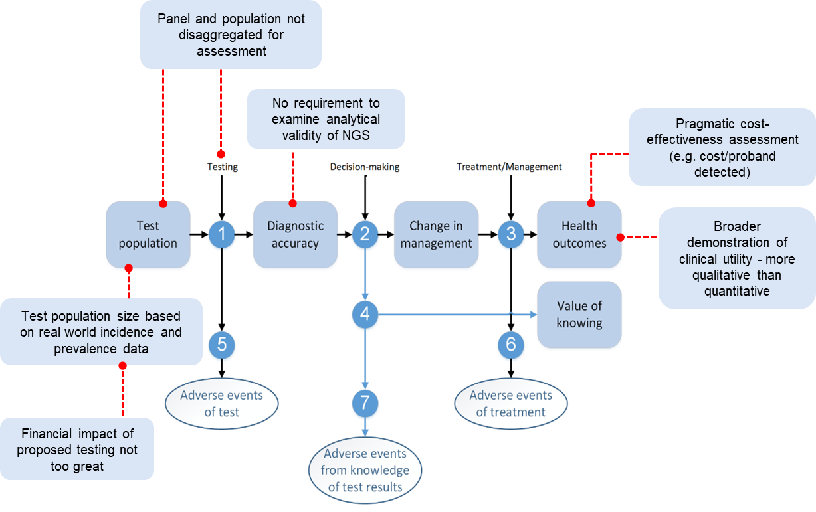
Figure 2 Key points in MSAC’s reformed approach for linked assessment of genomic tests

PASC noted that a refined assessment was proposed by the Department and the HTA group in line with MSAC’s reforms, but that the applicants proposed a comprehensive cost-utility analysis including health outcomes associated with targeted therapies, cascade testing, reproductive outcomes, and adverse events avoided, be performed, as they had won an NHMRC grant to collect data allowing the population of a model. This would require a full linked analysis to be performed.
PASC noted the Department’s advice that the assessment should be pragmatic: given the scope of disease presentation and differences in management of each MD type, there would be a risk of the assessment needing to select specific therapies, but not all, thereby introducing bias. PASC advised the appropriate assessment is a pragmatic one focussing on prognostic and predictive values, and more qualitative rather than quantitative health outcomes, in line with the reformed assessment approach for large genetic panels advised by MSAC.
The assessment questions related to the assessment framework are listed below.
- What is the diagnostic yield of WGS ± mtDNA deletion testing ± histochemical/immunohisto-chemical analysis of biopsy versus histochemical/immunohistochemical analysis of biopsy alone? (including prognostic yield and predictive yield)
What is the diagnostic yield of variant-specific testing to determine the presence of a familial mtDNA or nDNA pathogenic variant that is causative for MD in biological relatives of patients with an identified pathogenic variant?
What is the diagnostic yield of whole gene testing to determine the presence of a familial nDNA pathogenic variant that is causative for MD in reproductive partners of an individual with an identified recessive pathogenic variant?
What is the diagnostic yield of variant-specific testing of the fetus to determine the presence of a familial nDNA pathogenic variant/s that may cause MD in the fetus?
- Is there a change in management in patients in whom MD is diagnosed by WGS ± mtDNA deletion testing ± histochemical/immunohistochemical analysis of biopsy vs histochemical/immunohistochemical analysis of biopsy alone?
What is the incremental prognostic value of WGS ± mtDNA deletion testing in patients diagnosed with MD?
What is the incremental predictive value of WGS ± mtDNA deletion testing in patients diagnosed with MD?
Is there a change in management in individuals who undergo variant-specific testing?
Will the information generated as a result of variant-specific testing be of additional value in relatives of patients diagnosed with MD?
- Does treatment with targeted MD therapies lead to better health outcomes in patients in whom specific pathogenic variants have been detected compared with symptom-based treatment options?
Does earlier treatment of relatives who are non-symptomatic or have non-specific symptoms and have inherited the MD variant lead to better health outcomes compared to delaying treatment to the onset of symptoms?
- Will the information generated as a result of WGS MD testing be of additional value even if there are no change in treatment options, i.e. the value of knowing or informing cascade testing?
Will the information generated as a result of variant-specific testing be of additional value to relatives with inherited familial pathogenic MD gene variant even if there are no change in management options, i.e. the value of knowing?
- What is the comparative safety of WGS ± biopsy and histochemistry/immunohistochemistry versus biopsy and histochemistry/immunohistochemistry alone?
Are there any safety concerns with variant-specific testing of first degree relatives or fetuses at risk of having MD?
- Are there any psychological harms from the knowledge that an individual has a pathogenic MD gene variant that has no change in management/treatment options?
- Are there any safety concerns with targeted therapies compared to symptom-based therapies?
NB: italicised questions would not need to be addressed if a reformed assessment approach is used (assessing cost per proband identified etc, instead of cost per health outcome, for genomic test applications).

Clinical management algorithms

Current clinical management pathway
The diagnostic pathway for patients with MD is complex, including multiple clinical consultations and various biochemical, histopathological, enzymological tests supported by the analysis of a tissue biopsy, predominantly muscle. The presentation may be acute, as is often the case in children, especially neonates. Neonates presenting acutely often require immediate admission to a neonatal intensive care unit with variable manifestations including encephalopathy, encephalomyopathy, severe systemic metabolic acidosis, lactic acidaemia, multi-organ failure (liver, renal), hypoglycaemia and/or cardiomyopathy. Children in their early infancy may also present with sudden deteriorations, a ‘failure to thrive’ and/or motor regression of their developmental milestones. Adolescents and adults tend to have less acute and more chronic presentations of MD symptoms.
On presentation, all patients with suspected MD (acute or chronic) receive a complete clinical workup and full biochemical, haematological and metabolic laboratory investigations. Patients may also receive biomarker testing for FGF-21 and GDF-15. Complete imaging (MRI, CT U/S, etc.) of affected areas may also be required. Patients with clinical indicators supportive of MD require a muscle biopsy to confirm that the patient is likely to have MD.
A diagnosis of probable or highly probable MD is usually given after a muscle biopsy is performed that is indicative of MD. However, due to the invasive nature of the muscle biopsy, a firm diagnosis of MD in children is often delayed until adulthood. Instead, a ‘strongly suspected’ MD diagnosis is more often sought. After receiving a diagnosis of unlikely, probable or highly probable, patients proceed to symptomatic treatment that may be general to the illness or specific to the patient’s phenotype.
For children 10 years or younger with developmental delay, intellectual disability or at least two congenital abnormalities to whom MBS item numbers 73358 and 73359 apply, confirmatory genetic testing may be an option. In those in whom a pathogenic MD gene variant is identified through 73358/73359 and related items, targeted treatments may be available and cascade testing of close family members may result in early detection specific family planning advice to both the affected child (when age appropriate) and close family members will be available
The current clinical pathway (applicable to both children and adults) is shown in Figure 4.
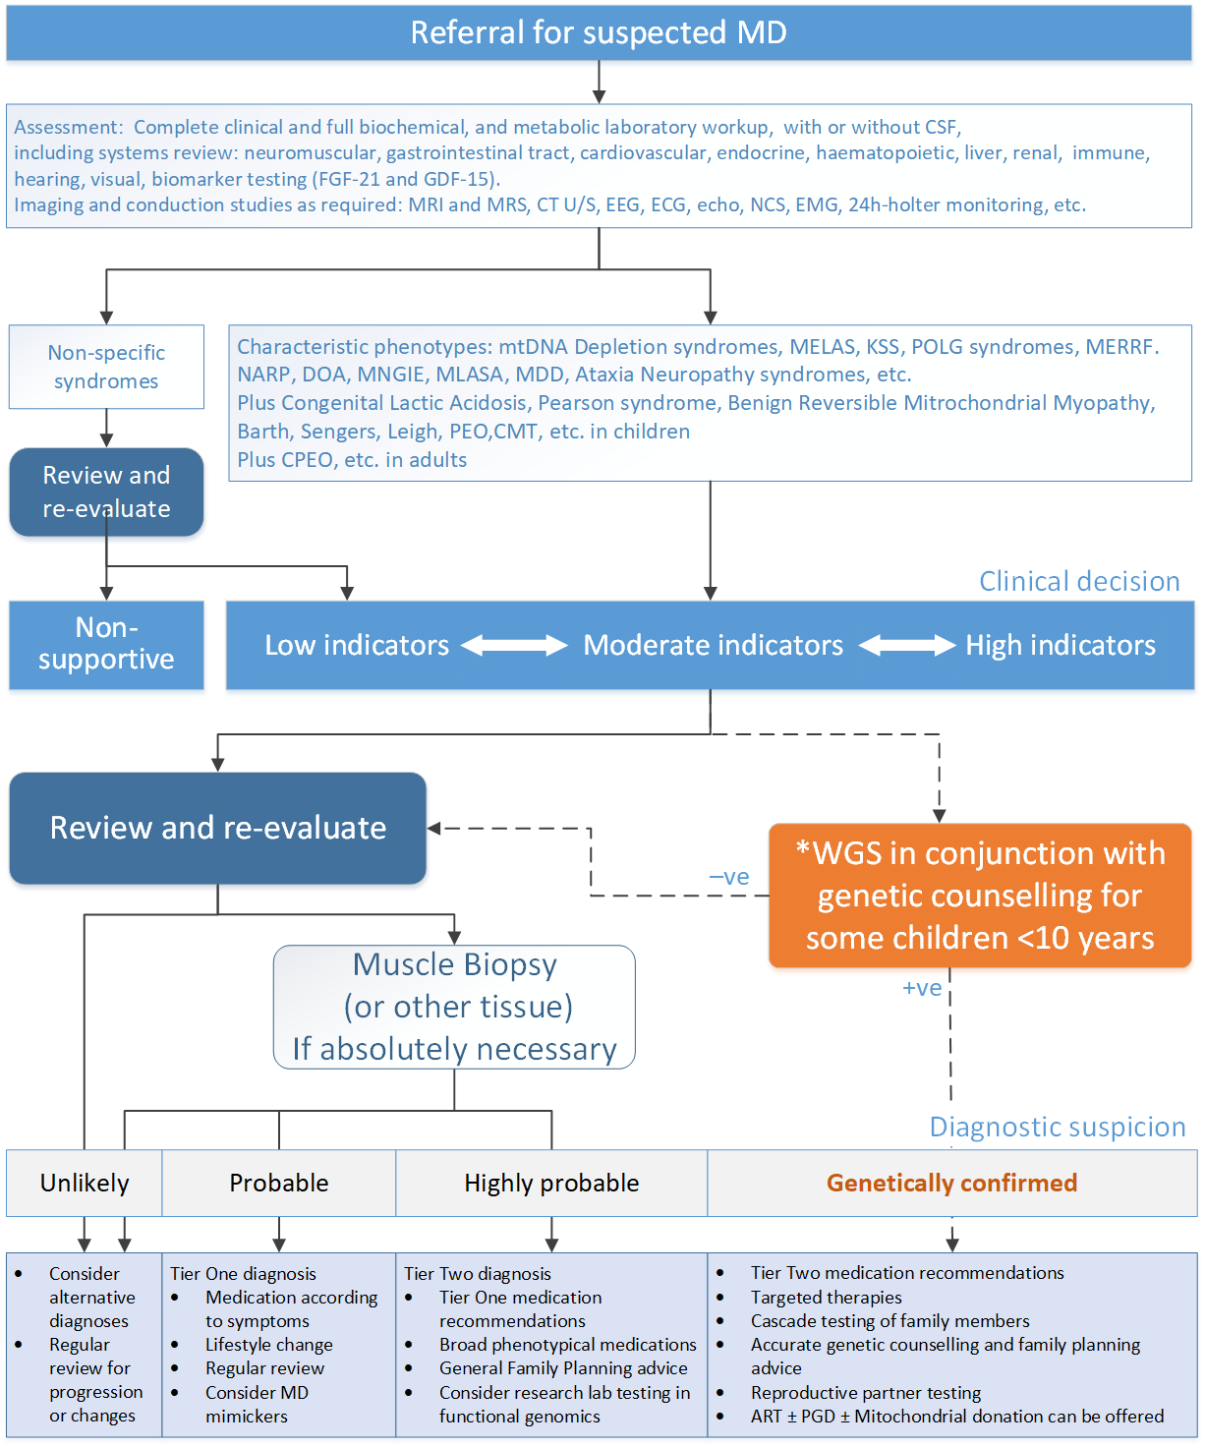
Figure 3 Current clinical management pathway for a patient suspected of having MD
*In some children aged 10 years or younger with dysmorphic facial appearance, intellectual disability, or global developmental delay WGS may be performed using MBS item numbers 73358 or 73359.
Re-analysis of a patient’s WGS data under MBS item CCCC may occur every 18 months
ART = assisted reproductive technology; CPEO = Chronic progressive external ophthalmoplegia; CMT = Charcot-Marie tooth; CSF = CT = computed tomography; DOA = dominant optic atrophy; ECG = electrocardiogram; echo = echocardiogram; EEG = electroencephalography; EMG = electromyography; FGF-21 = fibroblast growth factor 21; GDF-15 = growth differentiation factor 15; KSS = Kearns Sayre Syndrome; MD = mitochondrial disease; MDD = major depressive disorder; MELAS = mitochondrial encephalomyopathy, lactic acidosis, and stroke-like episodes; MERRF = myoclonic epilepsy with ragged red fibres; MLASA = myopathy, lactic acidosis and sideroblastic anaemia; MNGIE = mitochondrial neurogastrointestinal encephalopathy; MRI = magnetic resonance imaging; MRS = magnetic resonance spectroscopy; NARP = neuropathy, ataxia, and retinitis pigmentosa; NCS = nerve conduction study; PEO = progressive external ophthalmoplegia; PGD = Preimplantation Genetic Diagnosis; POLG = DNA polymerase subunit gamma; U/S = ultra sound; WGS = whole genome sequencing

The proposed clinical management pathway
On presentation of acute or chronic symptoms, all patients with suspected MD will still receive a complete clinical workup and full biochemical, haematological and metabolic laboratory investigations. Patients may also receive biomarker testing for FGF-21 and GDF-15. Complete imaging (MRI, CT U/S, etc.) of affected areas may also be required. Patients with clinical indicators supportive of MD would then be eligible for WGS MD testing.
Patients in whom a pathogenic MD gene variant is identified will then receive appropriate targeted and symptom-based treatments, and cascade testing of close family members may result in early detection of MD and enable the delivery of treatment if appropriate, as well as specific family planning advice to both the proband and close family members with the pathogenic variant.
Patients in whom a pathogenic variant is not found will still require a muscle biopsy for diagnosis of probable MD. These patients receive symptom-based treatment and general family planning advice.
In addition, the raw WGS data from testing of these patients can be re-analysed in the future for the presence of newly identified pathogenic MD gene variants.
The proposed clinical pathway (applicable to both children and adults) is shown in Figure 5.
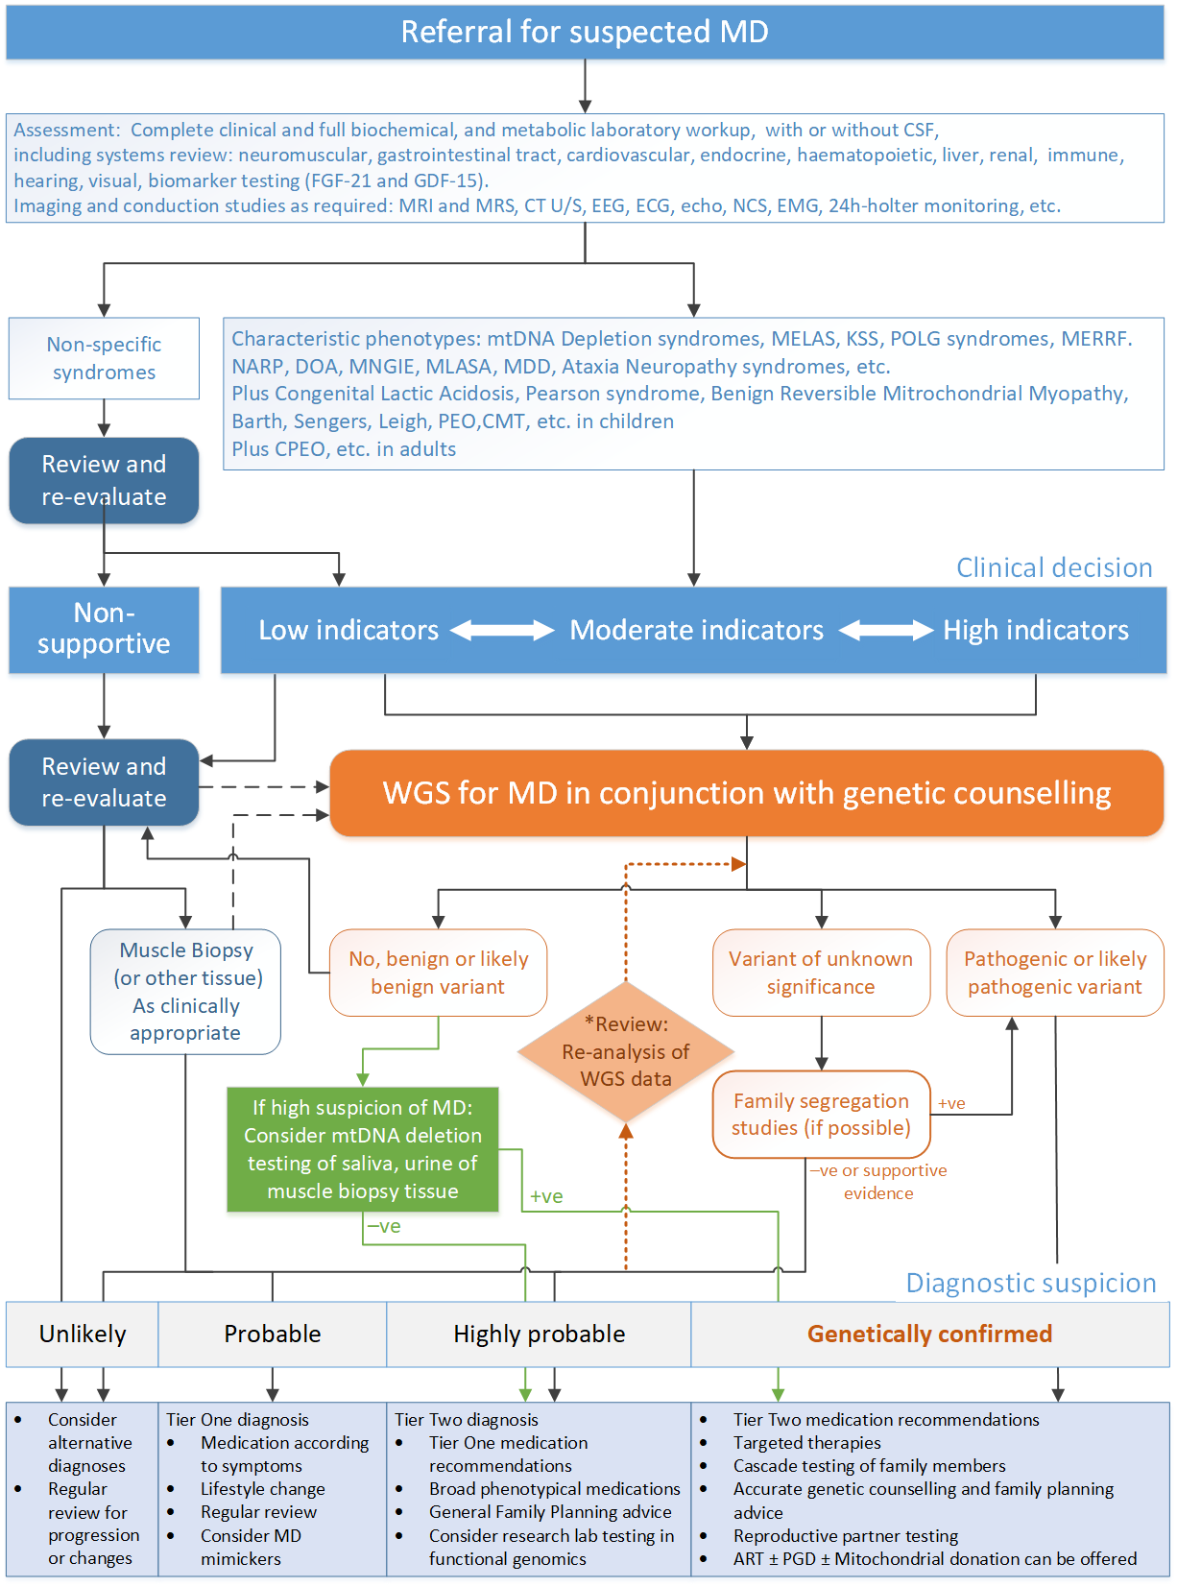
Figure 4 Proposed clinical management pathway for a patient suspected of having MD
**Re-analysis of a patient’s WGS data under MBS item CCCC may occur every 18 months
ART = assisted reproductive technology; CPEO = Chronic progressive external ophthalmoplegia; CMT = Charcot-Marie tooth; CSF = CT = computed tomography; DOA = dominant optic atrophy; ECG = electrocardiogram; echo = echocardiogram; EEG = electroencephalography; EMG = electromyography; FGF-21 = fibroblast growth factor 21; GDF-15 = growth differentiation factor 15; KSS = Kearns Sayre Syndrome; MD = mitochondrial disease; MDD = major depressive disorder; MELAS = mitochondrial encephalomyopathy, lactic acidosis, and stroke-like episodes; MERRF = myoclonic epilepsy with ragged red fibres; MLASA = myopathy, lactic acidosis and sideroblastic anaemia; MNGIE = mitochondrial neurogastrointestinal encephalopathy; MRI = magnetic resonance imaging; MRS = magnetic resonance spectroscopy; mtDNA = mitochondrial DNA; NARP = neuropathy, ataxia, and retinitis pigmentosa; NCS = nerve conduction study; PEO = progressive external ophthalmoplegia; PGD = Preimplantation Genetic Diagnosis; POLG = DNA polymerase subunit gamma; U/S = ultra sound; WGS = whole genome sequencing

The current clinical pathway for biological relatives of an index case
Currently, close relatives of patients diagnosed with MD who are symptomatic would also be assumed to have MD. Conversely, asymptomatic relatives would have an uncertain diagnosis, and need to be closely monitored for the onset of symptoms. Family planning advice would be provided in general terms and the decisions made may still result in the birth of a child affected by MD, as shown in Figure 6.
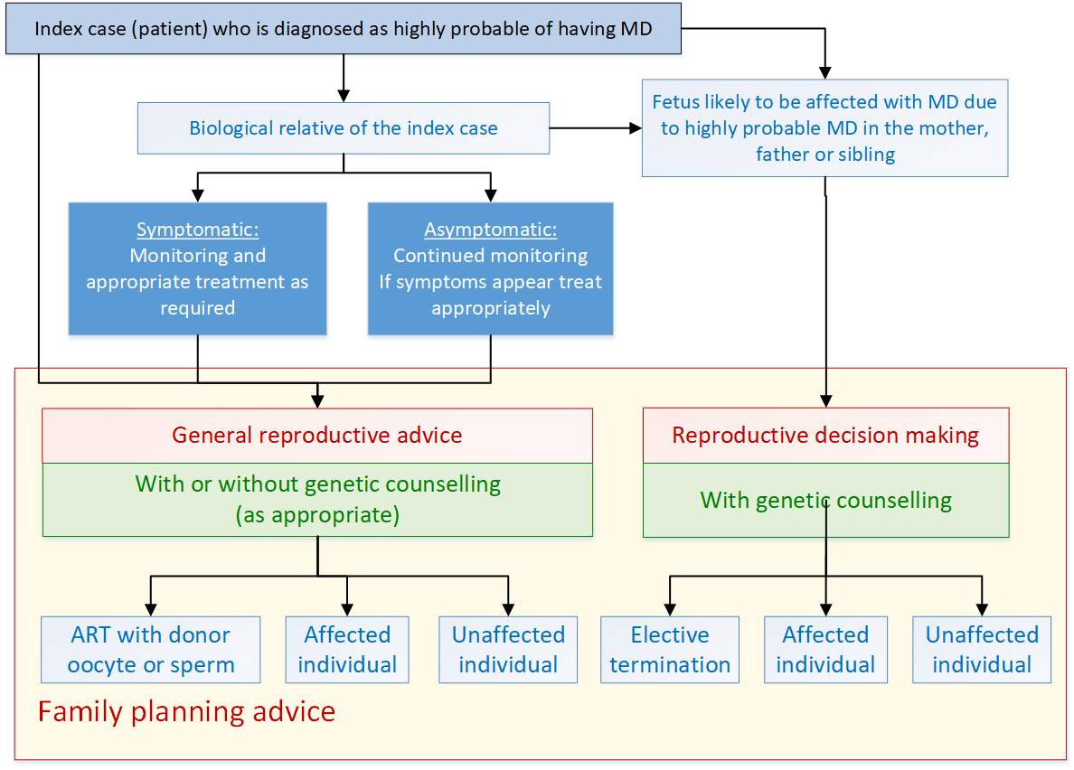
Figure 5 Current clinical management pathway for biological relatives of a patient diagnosed as highly probable of having MD
ART = Assisted reproductive technology; MD = mitochondrial disease

The proposed clinical pathway for biological relatives of a proband
Once a pathogenic MD gene variant is identified in an index patient, cascade testing of close relatives, both symptomatic and asymptomatic, can be conducted for diagnostic, prognostic, segregation and reproductive purposes, as shown in Figure 7.
Confirming the presence of the pathogenic variant improves the clinical management of individuals. Symptomatic probands would be offered optimal treatment options, which may include targeted therapies as well as symptom-based treatments. Asymptomatic probands can be closely monitored for earlier detection of symptom onset, allowing for improved treatment strategies.
Family planning advice would depend on the mode of inheritance of the pathogenic variant. For individuals who have an autosomal dominant or X-linked pathogenic variant, assisted reproductive technologies (ART), including MBS-reimbursed preimplantation genetic diagnosis can be offered. Partners of individuals carrying an autosomal recessive pathogenic variant can be offered whole gene sequencing (of the affected gene) to aid in family planning. In the case of a pathogenic mtDNA variant, ART such as using donor oocytes can be considered.
Cascade testing can also be performed on the fetus if a pathogenic variant in the mother, father or sibling may result in the fetus being affected by MD.
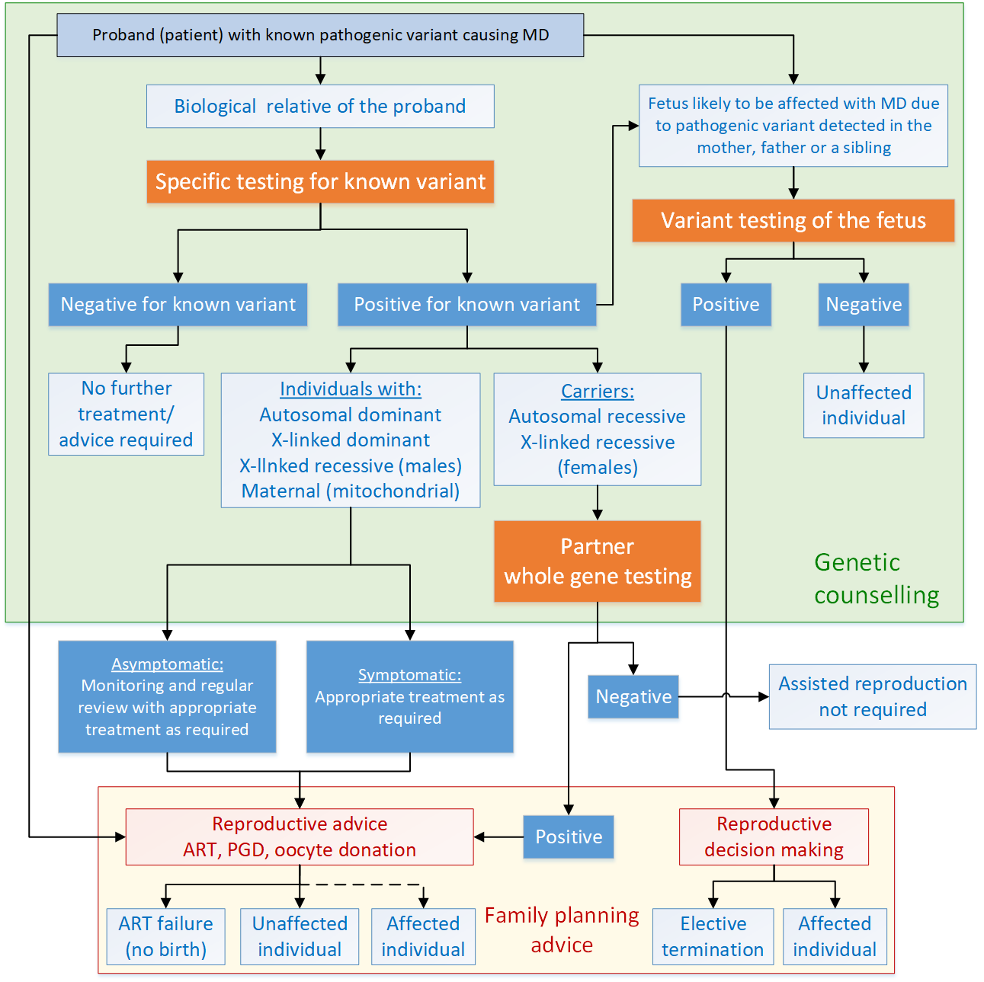
Figure 6 Proposed clinical management pathway for biological relatives of a patient with a known MD pathogenic variant
ART = Assisted reproductive technology; MD = mitochondrial disease; PGD = preimplantation genetic diagnosis
Note: dotted line indicates this pathway would rarely happen

Proposed economic evaluation
The application suggested that WGS for MD in individuals with suspected MD and cascade testing of their first-degree relatives and reproductive partners is superior in effectiveness and superior in safety compared to no genetic testing for the proposed population.
The type of economic evaluation that should be presented based on the assessed evidence profile is given in Table 7. A CEA or CUA can be used as the claim is for superior comparative effectiveness and comparative safety.
In a pre-PASC meeting, the Department recommended that a CEA assessment focus on the proportion of patients who receive prognostic or predictive information from WGS to be consistent with a refined approach previously recommended by the MSAC. The assessment would therefore not go through to health outcomes, and the appropriate economic evaluation would include an analysis of the cost per proband detected, cost per pathogenic/likely pathogenic variant detected, etc (paragraph 12, MSAC Application 1585, Public Summary Document, September 2021).
PASC noted that the MSAC Executive and MSAC had recently reformed the preferred assessment approach for large gene panel tests (e.g. to not disaggregate the panel and population for the assessment, to express cost-effectiveness in pragmatic terms such as ‘cost per proband detected’, and to not require the examination of analytical validity for NGS testing), and that this was the approach supported recently for the assessment of application 1585.
PASC noted that a refined assessment was proposed by the Department and the HTA group in line with MSAC’s reforms, but that the applicants proposed a comprehensive cost-utility analysis including health outcomes associated with targeted therapies, cascade testing, reproductive outcomes, and adverse events avoided, be performed, as they had won an NHMRC grant to collect data allowing the population of a model. This would require a full linked analysis to be performed.
PASC noted the Department’s advice that the assessment should be pragmatic: given the scope of disease presentation and differences in management of each MD type, there would be a risk of the assessment needing to select specific therapies, but not all, thereby introducing bias. PASC considered the assessment should be pragmatic, not disaggregate the panel and population, and focus on prognostic and predictive values, and more qualitative rather than quantitative health outcomes, in line with MSAC’s reformed assessment approach for large genetic panels. PASC advised the appropriate economic evaluation is a cost-effectiveness analysis, including aggregated cost-effectiveness outcomes such as ‘cost per proband detected’.
PASC noted that the passage of Maeve’s law legalising mitochondrial donation in Australia may provide an additional reproductive option for couples in the future, however if the law is passed a 5-10 year clinical trial will commence first – so this potential future medical service is outside the scope of this assessment.
Table 7 Classification of comparative effectiveness and safety of the proposed intervention, compared with its main comparator, and guide to the suitable type of economic evaluation
Comparative safety- |  | Comparative effectiveness
 | Inferior | Uncertainª | Noninferior^{b} | Superior
Inferior | Health forgone: need other supportive factors | Health forgone possible: need other supportive factors | Health forgone: need other supportive factors | ? Likely CUA
Uncertainª | Health forgone possible: need other supportive factors | ? | ? | ? Likely CEA/CUA
Noninferior^{b} | Health forgone: need other supportive factors | ? | CMA | CEA/CUA
Superior | ? Likely CUA | ? Likely CEA/CUA | CEA/CUA | CEA/CUA
CEA=cost-effectiveness analysis; CMA=cost-minimisation analysis; CUA=cost-utility analysis
? = reflect uncertainties and any identified health trade-offs in the economic evaluation, as a minimum in a cost-consequences analysis
ª ‘Uncertainty’ covers concepts such as inadequate minimisation of important sources of bias, lack of statistical significance in an underpowered trial, detecting clinically unimportant therapeutic differences, inconsistent results across trials, and trade-offs within the comparative effectiveness and/or the comparative safety considerations
^{b} An adequate assessment of ‘noninferiority’ is the preferred basis for demonstrating equivalence

Proposal for public funding
Currently, there are six MBS items related to WGS for the detection of monogenic disorders that enable publicly funded genetic testing for MD to occur in some children aged 10 years or younger. Three relate to children aged 10 years or younger with certain symptoms and three relate to cascade testing of relatives and family planning. These MBS item numbers are listed in Appendix A.
Based on the wording of these existing items, the applicant has listed eight proposed MBS item numbers for WGS or WES to detect pathogenic variants for MD in suspected patients, cascade testing of relatives and for family planning as listed below. An additional MBS item number was added for whole gene testing of the reproductive partners of someone with a pathogenic recessive gene variant for MD.
- For patients (children and adults) who are suspected of having either acute or chronic MD
  - Either singleton testing of the affected individual (proposed item AAAA) or trio testing of the affected individual and their biological parents for segregation analysis (proposed item BBBB).
- For re-analysis of WGS data (proposed item CCCC)
- Cascade testing of first degree relatives for diagnostic purposes (proposed item DDDD)
- Cascade testing of first-degree relatives for reproductive decision making (proposed item EEEE)
- Testing of close biological relatives for the purposes of segregation testing (proposed item FFFF)
- Cascade testing of a fetus for diagnostic purposes (proposed item GGGG)
- mtDNA deletion testing for diagnosis of those strongly suspected of having MD in whom WGS testing was non-informative (proposed item HHHH)
- Testing of reproductive partners of someone with a pathogenic recessive gene variant for MD (proposed item IIII)
PASC advised that the panel test item descriptors (AAAA and BBBB) did not need to include a gene list, though testing should at minimum include the ‘green genes’ on the PanelApp Australia or PanelApp UK panel (additions to item descriptors in green text). This means that there is a high level of evidence for gene-disease association, and variants in this gene are reportable in the diagnostic setting.
PASC considered the intervention for the population tested by AAAA and BBBB to be “whole genome sequencing or whole exome sequencing combined with mitochondrial DNA sequencing”, as above. However, since PASC had also considered sequential mtDNA and nDNA testing may be appropriate where WES is used for AAAA/BBBB, it recommended a separate item descriptor be developed for mtDNA sequencing. PASC noted VCGS charges $1200 for mitochondrial DNA sequencing. The HTA group has drafted an item descriptor (JJJJ) for consideration.
PASC considered that the applicant’s provided revised list of disease characteristics better encompassed adult presentations of MD and advised these should be incorporated into the item descriptors AAAA, BBBB and HHHH. The revised lists have been included in the item descriptors. The applicant also recommended ‘or variant’ be added to item HHHH. Blue text indicates these, and other changes proposed by PASC.
PASC noted that no fee had been proposed for mtDNA deletion testing (item HHHH). PASC noted that the RCPA had advised a fee of approximately $450 for long-range PCR and qRT-PCR, and considered that since Southern blotting was an obsolete method, the appropriate fee for HHHH would likely be approximately $450.
PASC advised that the requestor for HHHH should be consistent with other items in this application (restricted to a specialist or consultant physician experienced in the treatment of MD, or a specialist or consultant physician practising as a neurologist (paediatric or adult), metabolic physician, clinical or metabolic geneticist, or ophthalmologist who have experience in the treatment of mitochondrial disease), as this would assist in avoiding leakage to non-target populations. PASC advised that the requestor for IIII should also be consistent with other items in this application, to enable continuity of care for couples that are eligible for item IIII.
PASC noted that proposed items DDDD, EEEE and FFFF all provide single variant testing, with the same fee – differing only in the intended purpose of testing. PASC advised that these item descriptors should be combined. PASC considered that for segregation testing in particular, widening the scope of testing from first degree relatives (FDRs) to biological relatives was appropriate, and therefore advised this should be the scope for the merged item (see descriptor KKKK below).
PASC noted that some items include the requirement that the relevant variant or gene has been “confirmed by laboratory findings” (e.g. MBS item 73348, and BBBB from application 1599), rather than listing a set of specific MBS items, one of which must have identified the relevant variant or gene. PASC considered that the item descriptors did not need to specify a list of prior tests and advised that “confirmed by laboratory findings” was appropriate.
PASC noted that a fee of $1200 for reproductive partner gene sequencing (IIII) is higher than that for partner testing for cystic fibrosis, though this is justified by other genes being more complex to sequence than CFTR, and is consistent with similar tests recently supported by MSAC.
PASC noted the proposed fees of $2100 (AAAA, singleton) and $2900 (BBBB, trio), but considered that the fees for virtual panel WES/WGS items are currently being reviewed by MSAC, and that the appropriate fee for items AAAA and BBBB should align with the outcome of that consideration.
PASC considered that a generic MBS item for data re-analysis would be appropriate for this application and noted MSAC has already supported this under application 1599, though it remains to be implemented.
To clarify methodologies that are considered suitable for detecting pathogenic MD gene variants, the wording in red text has been suggested. Other changes suggested by the HTA group and the Department are also in red text. The HTA group drafted reproductive partner test item IIII, mitochondrial sequencing item JJJJ, and combined cascade/segregation testing item KKKK.
Table 8 Proposed MBS items for patients suspected of having MD, their relatives and reproductive partners
Category 6 – PATHOLOGY SERVICES
MBS item AAAA
Characterisation via whole genome sequencing or whole exome sequencing and analysis of germline variants, from a phenotypically driven gene list including at least the ‘green genes’ on the relevant PanelApp Australia or PanelApp UK panel present in nuclear DNA (and also those present in mitochondrial DNA if captured by the methodology) of a patient with a strong suspicion of a mitochondrial disease based on the following criteria:
(a) the characterisation is:
(i) requested by a specialist or consultant physician experienced in the treatment of mitochondrial disease; or
(ii) requested by a specialist or consultant physician practising as a neurologist (paediatric or adult), metabolic physician, clinical or metabolic geneticist, or ophthalmologist who have experience in the treatment of mitochondrial disease; and
(b) if a methodology that does not include sequencing the mitochondrial genome is used, then the characterisation must be performed following the performance of mitochondrial sequencing for the patient in a service to which item JJJJ applies, and for which the results were non-informative; and
(c) onset of one or more clinical features indicative of mitochondrial disease inclusive of at least one or more of the following:
(i) meeting the clinical criteria with a score of 5 or more in the Nijmegen Mitochondrial Disease Scoring System, for children <16 years, and/or
(ii) evident mitochondrial dysfunction or decompensation, and/or
(iii) unexplained hypotonia or weakness, profound hypoglycaemia or ‘failure to thrive’ in the presence of a metabolic acidosis, and/or
(iv) unexplained single or multi-organ dysfunction or fulminant failure (in particular but not limited to neuropathies, myopathies, hepatopathy, pancreatic and/or bone marrow failure), and/or
(v) refractory or atypical seizures, developmental delays or cognitive regression, or progressive encephalopathy or progressive encephalomyopathy, and/or
(vi) cardiomyopathy and/or cardiac arrythmias, and/or
(vii) rapid hearing or painless visual loss or ptosis , and/or
(viii) stroke-like episodes or nonvasculitic strokes, and/or
(ix) ataxia, encephalopathy, seizures, muscle fatigue or weakness, and/or
(x) external ophthalmoplegia, and/or
(xi) hearing loss, diabetes, unexplained short stature, or endocrinopathy, and/or
(xii) family history of mitochondrial disease, or any of the above; and
(d) the characterisation is not performed in conjunction with a service to which items BBBB, 73358 or 73359 applies
Applicable only once per lifetime
Fee: $2,100.00 Benefit: 75% = $1,575.00 85% = $2,012.10
MBS item BBBB
Characterisation via whole genome sequencing or whole exome sequencing combined with mitochondrial DNA sequencing and analysis, of germline variants, from a phenotypically driven gene list including at least the ‘green genes’ on the relevant PanelApp Australia or PanelApp UK panel present in nuclear DNA (and also those present in mitochondrial DNA if captured by the methodology) of a patient with a strong suspicion of a mitochondrial disease based on the following criteria:
(a) the characterisation is:
(i) requested by a specialist or consultant physician experienced in the treatment of mitochondrial disease; or
(ii) requested by a specialist or consultant physician practising as a neurologist (paediatric or adult), metabolic physician, clinical or metabolic geneticist, or ophthalmologist who have experience in the treatment of mitochondrial disease ; and
(b) if a methodology that does not include sequencing the mitochondrial genome is used, then the characterisation must be performed following the performance of mitochondrial sequencing for the patient in a service to which item JJJJ applies, and for which the results were non-informative; and
(c) the request for the characterisation states that singleton testing is inappropriate; and
(d) onset of one or more clinical features indicative of mitochondrial disease inclusive of at least one or more of the following:
(i) meeting the clinical criteria with a score of 5 or more in the Nijmegen Mitochondrial Disease Scoring System, for children <16 years, and/or
(ii) evident mitochondrial dysfunction or decompensation, and/or
(iii) unexplained hypotonia or weakness, profound hypoglycaemia or ‘failure to thrive’ in the presence of a metabolic acidosis, and/or
(iv) unexplained single or multi-organ dysfunction or fulminant failure (in particular but not limited to neuropathies, myopathies, hepatopathy, pancreatic and/or bone marrow failure), and/or
(v) refractory or atypical seizures, developmental delays or cognitive regression, or progressive encephalopathy or progressive encephalomyopathy, and/or
(vi) cardiomyopathy and/or cardiac arrythmias, and/or
(vii) rapid hearing or painless visual loss or ptosis , and/or
(viii) stroke-like episodes or nonvasculitic strokes, and/or
(ix) ataxia, encephalopathy, seizures, muscle fatigue or weakness, and/or
(x) external ophthalmoplegia, and/or
(xi) hearing loss, diabetes, unexplained short stature, or endocrinopathy, and/or
(xii) family history of mitochondrial disease, or any of the above; and
(e) the characterisation is performed using a sample from the patient and a sample from each of the patient’s biological parents; and
(f) the characterisation is not performed in conjunction with a service to which item AAAA, 73358 or 73359 applies.
Applicable only once per lifetime
Fee: $2,900.00 Benefit: 75% = $2,175.00 85% = $2,812.10
MBS item CCCC
Re-analysis of whole genome or whole exome plus mitochondrial DNA data obtained in performing a service to which item AAAA, BBBB or HHHH (and also JJJJ where applicable) applies, for characterisation of previously unreported germline variants related to the clinical phenotype, if:
(a) the re-analysis is:
i) requested by a specialist or consultant physician experienced in the treatment of mitochondrial disease; or
(ii) requested by a specialist or consultant physician practising as a neurologist (paediatric or adult), metabolic physician, clinical or metabolic geneticist, or ophthalmologist who have experience in the treatment of mitochondrial disease; and
(b) the patient is strongly suspected of having a monogenic mitochondrial disease; and
(c) the re-analysis is performed at least 18 months after:
(i) a service to which item AAAA or BBBB applies; or
(ii) a service to which this item applies
Applicable for the duration of the patient’s illness or until a diagnosis is confirmed.
Fee: $500.00 Benefit: 75% = $375.00 85% = $425.00
MBS item DDDD
Testing of a person (the person tested) for the detection of a single gene variant for diagnostic purposes, if:
(a) the person tested has a biological relative with a known mitochondrial disease variant that can be plausibly shared between them; and
(b) a service described in item AAAA, BBBB, CCCC, or HHHH has identified the causative variant for the biological relative’s condition; and
(c) the results of the testing performed for the person tested are made available for the purpose of providing the detection; and
(d) the detection is:
(i) requested by a specialist or consultant physician experienced in the treatment of mitochondrial disease; or
(ii) requested by a specialist or consultant physician practising as a neurologist (paediatric or adult), metabolic physician, clinical or metabolic geneticist, or ophthalmologist who have experience in the treatment of mitochondrial disease; and
(e) the detection is not performed in conjunction with a service to which item EEEE, FFFF, 73361, 73362 or 73363 applies
Applicable only once per variant per lifetime
Fee: $400.00 Benefit: 75% = $300.00 85% = $340.00
MBS item EEEE
Testing of a person (the person tested) for the detection of a single gene variant for the purpose of reproductive decision making, if:
(a) the patient has a biological relative with a known monogenic mitochondrial disease variant that can be plausibly shared between them; and
(b) a service to which item numbers AAAA, BBBB, CCCC, or HHHH, applies has identified the causative variant for the relative; and
(c) the results of the testing performed for the relative are made available for the purpose of providing the detection for the patient; and
(d) the detection is requested by a consultant physician or specialist experienced in the treatment of mitochondrial disease; and
(e) the detection is not performed in conjunction with item numbers DDDD, FFFF, 73361, 73362, or 73363
Applicable only once per variant per lifetime
Fee: $400.00 Benefit: 75% = $300.00 85% = $340.00
MBS item FFFF
Testing of a person (the person tested) for the detection of a single gene variant for segregation analysis in relation to another person (the patient), if:
(a) the patient has a known phenotype of mitochondrial disease; and
(b) the single gene variant can be plausibly shared between the biological relative and the patient who has known or suspected monogenic mitochondrial disease; and
(c) a service to which item AAAA, BBBB, CCCC, or HHHH has identified a potentially causative variant for the patient; and
(d) the person tested is a biological parent or other biological relative of the person; and
(e) a sample from the person tested has not previously been tested in relation to the patient for a service to which item BBBB or 73359 applies; and
(f) the results of the testing of the person tested for this service are made available for the purpose of providing the detection for the patient; and
(g) the detection is:
(i) requested by a specialist or consultant physician experienced in the treatment of mitochondrial disease; or
(ii) requested by a specialist or consultant physician practising as a neurologist (paediatric or adult), metabolic physician, clinical or metabolic geneticist, or ophthalmologist who have experience in the treatment of mitochondrial disease; and
(h) the detection is not performed in conjunction with item DDDD, EEEE, 73361, 73362 or 73363.
Applicable only once per variant per lifetime
Fee: $400.00 Benefit: 75% = $300.00 85% = $340.00
MBS item GGGG
Testing of a pregnant patient for detection of gene variant/s present in the parents for diagnostic purpose, in the fetus, if
(a) the gene variant/s has been:
(i) identified in the biological mother and is of mitochondrial genome lineage; or
(ii) identified in both biological parents within the same gene, present in the Mendeliome as autosomal recessive; or
(iii) identified in either biological parent, present in the Mendeliome as autosomal dominant; or
(iv) identified in a biological sibling of the fetus; and
(b) a service described in item AAAA, BBBB, CCCC, HHHH, 73358, 73359 or 73360 has identified the causative variant/s for the condition of the fetus’s first-degree relative have been confirmed by laboratory findings; and
(c) the results of the testing performed for the first-degree relative are made available for the purpose of providing the detection for the fetus; and
(d) the detection is:
(i) requested by a specialist or consultant physician experienced in the treatment of mitochondrial disease; or
(ii) requested by a specialist or consultant physician practising as a neurologist (paediatric or adult), metabolic physician, clinical or metabolic geneticist, or ophthalmologist who have experience in the treatment of mitochondrial disease; and
(e) the detection is not performed in conjunction with a service to which item DDDD, EEEE, FFFF KKKK, 73361, 73362 or 73363 applies
Applicable only once per fetus
Fee: $400.00 Benefit: 75% = $300.00 85% = $340.00
MBS item HHHH
Characterisation of a single mitochondrial DNA deletion or variant for diagnostic purposes in a patient suspected to have mitochondrial disease based on the following criteria:
(a) the characterisation is:
(i) requested by a specialist or consultant physician experienced in the treatment of mitochondrial disease; or
(ii) requested by a specialist or consultant physician practising as a neurologist (paediatric or adult), metabolic physician, clinical or metabolic geneticist, or ophthalmologist who have experience in the treatment of mitochondrial disease ; and
(b) onset of one or more clinical features indicative of mitochondrial disease inclusive of at least one or more of the following:
(i) meeting the clinical criteria with a score of 5 or more in the Nijmegen Mitochondrial Disease Scoring System, for children <16 years, and/or
(ii) evident mitochondrial dysfunction or decompensation, and/or
(iii) unexplained hypotonia or weakness, profound hypoglycaemia or ‘failure to thrive’ in the presence of a metabolic acidosis, and/or
(iv) unexplained single or multi-organ dysfunction or fulminant failure (in particular but not limited to neuropathies, myopathies, hepatopathy, pancreatic and/or bone marrow failure), and/or
(v) refractory or atypical seizures, developmental delays or cognitive regression, or progressive encephalopathy or progressive encephalomyopathy, and/or
(vi) cardiomyopathy and/or cardiac arrythmias, and/or
(vii) rapid hearing or painless visual loss or ptosis , and/or
(viii) stroke-like episodes or nonvasculitic strokes, and/or
(ix) ataxia, encephalopathy, seizures, muscle fatigue or weakness, and/or
(x) external ophthalmoplegia, and/or
(xi) hearing loss, diabetes, unexplained short stature, or endocrinopathy, and/or
(xii) family history of mitochondrial disease, or any of the above; and
(c) the characterisation is performed following the performance for the patient of a service to which items 73292, AAAA, BBBB, 73358 or 73359 applies for which the results were non-informative; and
Applicable only once per lifetime
Fee: $450.00 Benefit: 75% = $337.50 85% = $382.50
MBS item IIII
Whole gene testing of a person for the characterisation of germline gene variant(s) within the same gene in which the person’s reproductive partner has a documented pathogenic germline recessive gene variant for mitochondrial disease identified by item AAAA, BBBB, CCCC, DDDD, EEEE or HHHH confirmed by laboratory findings; and the characterisation is:
(a) requested by a specialist or consultant physician experienced in the treatment of mitochondrial disease; or
(b) requested by a specialist or consultant physician practising as a neurologist (paediatric or adult), metabolic physician, clinical or metabolic geneticist, or ophthalmologist who have experience in the treatment of mitochondrial disease.
Applicable only once per gene per partner per lifetime
Fee: $1200.00 Benefit: 75% = $900.00; 85% = 1,115.30

Post-PASC
After the PASC meeting, the following item descriptors were drafted by the HTA group in line with PASC’s advice: to enable mtDNA sequencing to be conducted sequentially and prior to WES, if WES rather than WGS is to be used in AAAA or BBBB (item JJJJ), and to combine variant-specific testing items DDDD, EEEE and FFFF (item KKKK). Alterations to items AAAA, BBBB, CCCC, GGGG, HHHH and IIII to reflect PASC’s advice (including the addition of JJJJ and KKKK) are also in blue in the above section.
MBS item JJJJ
Characterisation via mitochondrial DNA sequencing and analysis, of germline variants, from a phenotypically driven gene list including at least the ‘green genes’ on the relevant PanelApp Australia or PanelApp UK panel present in mitochondrial DNA of a patient with a strong suspicion of a mitochondrial disease based on the following criteria:
(a) the characterisation is:
(i) requested by a specialist or consultant physician experienced in the treatment of mitochondrial disease; or
(ii) requested by a specialist or consultant physician practising as a neurologist (paediatric or adult), metabolic physician, clinical or metabolic geneticist, or ophthalmologist who have experience in the treatment of mitochondrial disease ; and
(b) onset of one or more clinical features indicative of mitochondrial disease inclusive of at least one or more of the following:
(i) meeting the clinical criteria with a score of 5 or more in the Nijmegen Mitochondrial Disease Scoring System, for children <16 years, and/or
(ii) evident mitochondrial dysfunction or decompensation, and/or
(iii) unexplained hypotonia or weakness, profound hypoglycaemia or ‘failure to thrive’ in the presence of a metabolic acidosis, and/or
(iv) unexplained single or multi-organ dysfunction or fulminant failure (in particular but not limited to neuropathies, myopathies, hepatopathy, pancreatic and/or bone marrow failure), and/or
(v) refractory or atypical seizures, developmental delays or cognitive regression, or progressive encephalopathy or progressive encephalomyopathy, and/or
(vi) cardiomyopathy and/or cardiac arrythmias, and/or
(vii) rapid hearing or painless visual loss or ptosis , and/or
(viii) stroke-like episodes or nonvasculitic strokes, and/or
(ix) ataxia, encephalopathy, seizures, muscle fatigue or weakness, and/or
(x) external ophthalmoplegia, and/or
(xi) hearing loss, diabetes, unexplained short stature, or endocrinopathy, and/or
(xii) family history of mitochondrial disease, or any of the above; and
Applicable only once per lifetime
Fee: $1200.00 Benefit: 75% = $900.00; 85% = 1,112.10
MBS item KKKK
Testing of a person (the person tested) for the detection of a single gene variant for diagnostic purposes, segregation analysis in relation to another person, or for the purpose of reproductive decision making, if:
(a) the person tested has a biological relative with a known mitochondrial disease variant confirmed by laboratory findings that can be plausibly shared between them; and
(b) the results of the testing performed for the person tested are made available for the purpose of providing the detection; and
(c) the detection is:
(i) requested by a specialist or consultant physician experienced in the treatment of mitochondrial disease; or
(ii) requested by a specialist or consultant physician practising as a neurologist (paediatric or adult), metabolic physician, clinical or metabolic geneticist, or ophthalmologist who have experience in the treatment of mitochondrial disease; and
(d) the detection is not performed in conjunction with a service to which item 73361, 73362 or 73363 applies
Applicable only once per variant per lifetime
Fee: $400.00 Benefit: 75% = $300.00 85% = $340.00

Proposed fees
The fees for the proposed MBS items AAAA to FFFF were based on fees for MBS items 73358 to 77363.
The application listed the clinical diagnostic laboratories providing WGS services, and their costs, as given below:
Victorian Clinical Genetic Services
WGS (overall cost from receipt of patient sample, DNA sequencing, informatics analysis through to provision of clinical report, and includes cascade testing if required for variant interpretation)
- $3000 for 101-400 genes + Inclusive of both nDNA and mtDNA analysis and
- $4300 for >400 genes + Inclusive of both nDNA and mtDNA analysis
Please Note: WGS includes mtDNA analysis in addition to variant calling in nDNA; this includes running the raw data through an additional mtDNA variant calling program and additional bioinformatic analysis of mtDNA. (Hence the additional costs over item numbers 73358 and 73359).
Cascade testing of single variant = approximately $450
Re-analysis of WGS data:
- Production of a report where there are no new findings = $350
- Production of a report including curation of new variants = $650
SEALS-NSW Pathology
Only offering ‘Whole Exome Sequencing’ and so currently not a viable option for a comprehensive mitochondrial disease analysis,
- $2000 (singleton - nDNA analysis only)
- $2800 (triome - nDNA analysis only)
Cascade testing of single nuclear DNA variant: $350
Re-analysis of whole exome data:
- Production of a report (irrespective of no or new variants being detected): $420

Summary of public consultation input
Responses to the targeted consultation process were received from the following eight (8) organisations and one (1) individual:
- Murdoch Children’s Research Institute (MCRI)
- Australian Pathology (AP)
- GUARD Collaborative Australia (GUARD)
- Childhood Dementia Initiative (CDI)
- Human Genetics Society of Australasia (HGSA)
- Public Pathology Australia (PPA)
- Rare Voices Australia (RVA)
- Mito Foundation (Mito)
The feedback was supportive of the application. PASC noted some public consultation comments were concerned about the disadvantages including accessibility of WGS and were more supportive of WES plus mtDNA sequencing.
Benefits
MCRI, Mito, RVA, PA and, HGSA stated that the main benefit of this application is that genomic diagnosis can remove the need for invasive testing as genomic sequencing is less costly and more effective when compared to conventional care. MCRI, HGSA and GUARD added that the reduction in invasive testing would lead to savings in hospital and pathology costs. Mito added that the proposed intervention would provide the opportunity to avoid risks and pain associated with current testing methods.
MCRI, CDI, RVA, Mito, HGSA and, GUARD stated that confirmed genetic diagnosis facilitated access to disability services, enables enrolment in clinical trials and, allows for appropriate patient management measures, improving quality of life for patients.
MCRI, CDI, RVA, Mito, HGSA, PA and, GUARD stated that the proposed intervention would shorten the diagnostic odyssey, restore reproductive confidence, allow institution of surveillance measures for complications associated with mitochondrial disease and, provide equity of access.
GUARD and RVA stated that the proposed intervention would improve patient confidence in diagnosis and cited the value of knowing.
RVA stated that publicly funding the proposed intervention is necessary to ensure consistent service and equitable access.
Mito stated that the proposed intervention would create a foundation for more accurate information on prognosis for patients.
Mito and RVA stated that the proposed intervention could lead to improved care by confirming an alternate diagnosis to mitochondrial disease.
PA stated that publicly funding the proposed intervention may provide an incentive for laboratories to invest in genomic testing, increasing providers of the service.
Disadvantages
MCRI noted that there are few diagnostic laboratories that can offer RCPA/NATA accredited analysis of the whole genome sequencing data. PA stated that publicly funding this item could de-centralise the provision of care and dilute the expertise of managing clinicians.
MCRI stated that limiting panel testing to known mitochondrial disease genes may result in false negatives for patients with causative variants in a non-mitochondrial gene.
MCRI were concerned that the ability for exome analysis to detect mtDNA variants was variable. GUARD, Mito and, PPA agreed stating that WGS has demonstrated advantages over WES in detection of causative genes of mitochondrial disease.
RVA and Mito stated that restrictions of providers is likely to limit the population.
HGSA listed the emotional burden of diagnosis and the chance of recurrence.
Other Comments
Other services identified in the feedback are genetic counselling, metabolic physicians, psychological services and, social workers.
MCRI stated that the proposed intervention should be offered to anyone regardless of age, however, suggested the use of Nijmegen criteria for those <16 years and that those >16 year with more than one feature associated with mitochondrial disease be used to define the population.
MCRI and HGSA suggested that, to avoid test creep, ordering this item should be done in consultation with a physician with specialist knowledge of mitochondrial disorders. Similarly, MCRI suggested that prenatal testing should be made in consultation with a clinical geneticist and /or other clinician experienced in pre-natal testing.
MCRI recommended the addition of mtDNA mutant load testing either as a standalone item or as part of item H. It also suggested that item D should be applied for relevant first-degree relatives and not just siblings. MCRI stated that Item G should also include X-linked disorders and should be expanded to include pre-implantation testing. PPA suggested clarification of Item G as the application states the test is limited to “once per lifetime” however fetal testing is generally registered as a maternal sample in pathology laboratories.
PPA stated that the setting of the service should be changed to accredited pathology laboratories.
PPA stated that WES should not be used to calculate the cost of the proposed intervention, as WGS is more costly.
HGSA suggested that admitted patients be included in the population as patients often present to hospital in acute decompensation.

Next steps
PASC noted that the applicant was uniquely positioned to provide data to populate the MD model for the DCAR, and had offered to be involved in the assessment. This will involve bringing the applicant and the HTA group together to see how the applicants can provide data for the HTA group’s modelling. PASC noted there will need to be transparency, and that as much information as possible should be in public domain. PASC advised the applicant that any confidential information provided for the assessment must be clearly identified as such when it is first provided, because MSAC publishes the data that are the basis for its decisions in the PSD, except for any agreed redactions under redaction guidelines matching those used to inform PBAC redactions.
PASC concluded that if there is a shared approach, then the principles for collaboration need to be established when the DCAR is contracted. The Department commented that project planning meetings offer an opportunity to discuss the way forward in more detail.
PASC noted the Department had raised queries around matters such as genomic data storage, national security, and privacy risks. PASC considered that these issues are not unique to this application. The Department advised that other areas of the Department are working to address these broader issues.

Applicant Comments on PICO Confirmation
Nil.

References
Anderson, S, Bankier, AT, Barrell, BG, de Bruijn, MHL, Coulson, AR, Drouin, J, Eperon, IC, Nierlich, DP, Roe, BA, Sanger, F, Schreier, PH, Smith, AJH, Staden, R & Young, IG 1981, 'Sequence and organization of the human mitochondrial genome', Nature (London), vol. 290, no. 5806, pp. 457-465.
Bottani, E, Lamperti, C, Prigione, A, Tiranti, V, Persico, N & Brunetti, D 2020, 'Therapeutic Approaches to Treat Mitochondrial Diseases: “One-Size-Fits-All” and “Precision Medicine” Strategies', Pharmaceutics, vol. 12, no. 11, p. 1083.
Davis, R, Kumar, K, Puttick, C, Liang, C, Ahmad, K, HildeBrand, F, Park, J-S, Minoche, AE, Gayevskiy, V, Mallawaarachchi, A, Christodoulou, J, Schofield, D, Dinger, M, Cowley, MJ & Sue, CM 2021, 'Whole genome sequencing of blood simplifies mitochondrial disease diagnosis', Annals of Neurology, vol. submitted.
Distelmaier, F, Haack, TB, Wortmann, SB, Mayr, JA & Prokisch, H 2017, 'Treatable mitochondrial diseases: cofactor metabolism and beyond', Brain, vol. 140, no. 2, pp. e11-e11.
Gorman, GS, Chinnery, PF, DiMauro, S, Hirano, M, Koga, Y, McFarland, R, Suomalainen, A, Thorburn, DR, Zeviani, M & Turnbull, DM 2016, 'Mitochondrial diseases', Nature reviews. Disease primers, vol. 2, no. 1, pp. 1-22.
Gorman, GS, Schaefer, AM, Ng, Y, Gomez, N, Blakely, EL, Alston, CL, Feeney, C, Horvath, R, Yu-Wai-Man, P, Chinnery, PF, Taylor, RW, Turnbull, DM & McFarland, R 2015, 'Prevalence of nuclear and mitochondrial DNA mutations related to adult mitochondrial disease', Annals of Neurology, vol. 77, no. 5, pp. 753-759.
Keshavan, N & Rahman, S 2018, 'Natural history of mitochondrial disorders: a systematic review', Essays in Biochemistry, vol. 62, no. 3, pp. 423-442.
Liang, C, Ahmad, K & Sue, CM 2014, 'The broadening spectrum of mitochondrial disease: shifts in the diagnostic paradigm', Biochimica et Biophysica Acta (BBA)-General Subjects, vol. 1840, no. 4, pp. 1360-1367.
McCormick, EM, Zolkipli-Cunningham, Z & Falk, MJ 2018, 'Mitochondrial disease genetics update: recent insights into the molecular diagnosis and expanding phenotype of primary mitochondrial disease', Current opinion in pediatrics, vol. 30, no. 6, pp. 714-724.
Ng, YS, Bindoff, LA, Gorman, GS, Klopstock, T, Kornblum, C, Mancuso, M, McFarland, R, Sue, CM, Suomalainen, A, Taylor, RW, Thorburn, DR & Turnbull, DM 2021, 'Mitochondrial disease in adults: recent advances and future promise', The Lancet Neurology, vol. 20, no. 7, 2021/07/01/, pp. 573-584.
Parikh, S, Karaa, A, Goldstein, A, Bertini, ES, Chinnery, PF, Christodoulou, J, Cohen, BH, Davis, RL, Falk, MJ, Fratter, C, Horvath, R, Koenig, MK, Mancuso, M, McCormack, S, McCormick, EM, McFarland, R, Nesbitt, V, Schiff, M, Steele, H, Stockler, S, Sue, C, Tarnopolsky, M, Thorburn, DR, Vockley, J & Rahman, S 2019, 'Diagnosis of ‘possible’ mitochondrial disease: an existential crisis', Journal of Medical Genetics, vol. 56, no. 3, pp. 123-130.
Richards, S, Aziz, N, Bale, S, Bick, D, Das, S, Gastier-Foster, J, Grody, WW, Hegde, M, Lyon, E, Spector, E, Voelkerding, K, Rehm, HL & on behalf of the, ALQAC 2015, 'Standards and guidelines for the interpretation of sequence variants: a joint consensus recommendation of the American College of Medical Genetics and Genomics and the Association for Molecular Pathology', Genetics in Medicine, vol. 17, no. 5, 2015/05/01, pp. 405-423.
Riley, LG, Cowley, MJ, Gayevskiy, V, Minoche, AE, Puttick, C, Thorburn, DR, Rius, R, Compton, AG, Menezes, MJ, Bhattacharya, K, Coman, D, Ellaway, C, Alexander, IE, Adams, L, Kava, M, Robinson, J, Sue, CM, Balasubramaniam, S & Christodoulou, J 2020, 'The diagnostic utility of genome sequencing in a pediatric cohort with suspected mitochondrial disease', Genetics in Medicine, vol. 22, no. 7, 2020/07/01, pp. 1254-1261.
Skladal, D, Halliday, J & Thorburn, DR 2003, 'Minimum birth prevalence of mitochondrial respiratory chain disorders in children', Brain, vol. 126, no. 8, pp. 1905-1912.
Stenton, SL & Prokisch, H 2020, 'Genetics of mitochondrial diseases: Identifying mutations to help diagnosis', EBioMedicine, vol. 56, 2020/06/01/, p. 102784.
Tan, J, Wagner, M, Stenton, SL, Strom, TM, Wortmann, SB, Prokisch, H, Meitinger, T, Oexle, K & Klopstock, T 2020, 'Lifetime risk of autosomal recessive mitochondrial disorders calculated from genetic databases', EBioMedicine, vol. 54, 2020/04/01/, p. 102730.
Theunissen, TEJ, Nguyen, M, Kamps, R, Henickx, AT, Sallevelt, SCEH, Gottschalk, RWH, Calis, CM, Stassen, APM, de Koning, B, Mulder-den Hartog, ENM, Schoonderwoerd, K, Fuchs, SA, Hilhorst-Hofstee, Y, de Visser, M, Vanoevelen, J, Szklarczyk, R, Gerards, M, de Coo, IFM, Hellebrekers, DMEI & Smeets, HJM 2018, 'Whole exome sequencing is the preferred strategy to identify the genetic defect in patients with a probable or possible mitochondrial cause', Frontiers in genetics, vol. 9, no. OCT, pp. 400-400.
Vandebona, H, Mitchell, P, Manwaring, N, Griffiths, K, Gopinath, B, Wang, JJ & Sue, CM 2009, 'Prevalence of mitochondrial 1555A→ G mutation in adults of European descent', New England Journal of Medicine, vol. 360, no. 6, pp. 642-644.
Watson, E, Davis, R & Sue, CM 2020, 'New diagnostic pathways for mitochondrial disease', Journal of Translational Genetics and Genomics, vol. 4, no. 3, pp. 188-202.

Appendix A MBS items for monogenic disorders

Category 6 – PATHOLOGY SERVICES
MBS Item Number 73358
Characterisation, via whole exome or genome sequencing and analysis, of germline variants known to cause monogenic disorders, if:
(a) the characterisation is:
(i) requested by a consultant physician practising as a clinical geneticist; or
(ii) requested by a consultant physician practising as a specialist paediatrician, following consultation with a clinical geneticist; and
(b) the patient is aged 10 years or younger and is strongly suspected of having a monogenic condition, based on the presence of:
(i) dysmorphic facial appearance and one or more major structural congenital anomalies; or
(ii) intellectual disability or global developmental delay of at least moderate severity, as determined by a specialist paediatrician; and
(c) the characterisation is performed following the performance for the patient of a service to which item 73292 applies for which the results were non-informative; and
(d) the characterisation is not performed in conjunction with a service to which item 73359 applies

Applicable only once per lifetime
Fee: $2,100.00 Benefit: 75% = $1,575.00 85% = $2,015.30
MBS Item Number 73359
Characterisation, via whole exome or genome sequencing and analysis, of germline variants known to cause monogenic disorders, if:
(a) the characterisation is:
(i) requested by a consultant physician practising as a clinical geneticist; or
(ii) requested by a consultant physician practising as a specialist paediatrician, following consultation with a clinical geneticist; and
(b) the request for the characterisation states that singleton testing is inappropriate; and
(c) the patient is aged 10 years or younger and is strongly suspected of having a monogenic condition, based on the presence of:
(i) dysmorphic facial appearance and one or more major structural congenital anomalies; or
(ii) intellectual disability or global developmental delay of at least moderate severity, as determined by a specialist paediatrician; and
(d) the characterisation is performed following the performance for the patient of a service to which item 73292 applies for which the results were non-informative; and
(e) the characterisation is performed using a sample from the patient and a sample from each of the patient’s biological parents; and
(f) the characterisation is not performed in conjunction with a service to which item 73358 applies

Applicable only once per lifetime
Fee: $2,900.00 Benefit: 75% = $2,175.00 85% = $2,815.30
MBS item 73360
Re-analysis of whole exome or genome data obtained in performing a service to which item 73358 or 73359 applies, for characterisation of previously unreported germline gene variants related to the clinical phenotype, if:
(a) the re-analysis is:
(i) requested by a consultant physician practising as a clinical geneticist; or
(ii) requested by a consultant physician practising as a specialist paediatrician, following consultation with a clinical geneticist; and
(b) the patient is aged 15 years or younger and is strongly suspected of having a monogenic condition; and
(c) the re-analysis is performed at least 18 months after:
(i) a service to which item 73358 or 73359 applies; or
(ii) a service to which this item applies

Applicable only twice per lifetime
Fee: $500.00 Benefit: 75% = $375.00 85% = $425.00
MBS item 73361
Detection of a single gene variant for diagnostic purposes, if:
(a) the detection is:
(i) requested by a consultant physician practising as a clinical geneticist; or
(ii) requested by a consultant physician practising as a specialist paediatrician, following consultation with a clinical geneticist; and
(b) the patient has a biological sibling with a known monogenic condition; and
(c) a service to which item 73358, 73359 or 73360 applies has identified the causative variant for the sibling’s condition; and
(d) the results of the testing performed for the sibling are made available for the purpose of providing the detection for the patient; and
(e) the detection is not performed in conjunction with a service to which item 73362 or 73363 applies

Applicable only once per variant per lifetime
Fee: $400.00 Benefit: 75% = $300.00 85% = $340.00
MBS item 73362
Detection of a single gene variant for the purpose of reproductive decision making, if:
(a) the detection is requested by a consultant physician or specialist; and
(b) the patient has a first-degree relative with a known monogenic condition; and
(c) a service to which item 73358, 73359 or 73360 applies has identified the causative variant for the relative; and
(d) the results of the testing performed for the relative are made available for the purpose of providing the detection for the patient; and
(e) the detection is not performed in conjunction with item 73361 or 73363

Applicable only once per variant per lifetime
Fee: $400.00 Benefit: 75% = $300.00 85% = $340.00
MBS item 73363
Detection of a single gene variant for segregation purposes in relation to a person, if:
(a) the detection is:
(i) requested by a consultant physician practising as a clinical geneticist; or
(ii) requested by a consultant physician practising as a specialist paediatrician, following consultation with a clinical geneticist; and
(b) the patient:
(i) is a biological parent or other biological relative of the person and has a known phenotype of the person; or
(ii) is a biological parent of the person and has a suspected monogenic condition; and
(c) a sample has not previously been tested for the patient for a service to which item 73359 applies; and
(d) a service to which item 73358, 73359 or 73360 applies has identified a potentially causative variant for the person; and
(e) the results of the testing performed for the patient are made available for the purpose of providing the detection for the person; and
(f) the detection is not performed in conjunction with item 73361 or 73362

Applicable only once per variant per lifetime
Fee: $400.00 Benefit: 75% = $300.00 85% = $340.00

PanelApp UK available at URL: https://panelapp.genomicsengland.co.uk/panels/112/. Accessed 24 October 2021
PanelApp Australia. URL:https://panelapp.agha.umccr.org/
Medicare Item Reports available at http://medicarestatistics.humanservices.gov.au/statistics/mbs_item.jsp. Accessed 01 November 2021
PanelApp Australia. URL:https://panelapp.agha.umccr.org/

