Population
Describe the population in which the proposed health technology is intended to be used:

All patients from children to the elderly who require major limb or joint surgery, open abdominal or thoracic procedures, patients who have painful conditions following trauma, or other surgical procedures expected to result in significant post-operative pain which is amenable to continuous regional nerve block, and in whom epidural analgesia would either be inappropriate, contraindicated or ineffective due to anatomical considerations.

Specify any characteristics of patients with the medical condition, or suspected of, who are proposed to be eligible for the proposed health technology, describing how a patient would be investigated, managed and referred within the Australian health care system in the lead up to being considered eligible for the technology:

Typical patients eligible for this treatment are those requiring joint arthroplasty, orthopaedic/and or significant soft tissue (muscle, tendon, ligaments, skin) reconstructive surgery, major limb vascular surgery, and patients undergoing trunk surgery, or management of trauma. These patients are selected/recommended for surgery by surgeons, or presenting as trauma victims to hospital. Further investigations to determine eligibility are unnecessary, some patients may qualify for this technique when conventional analgesic modalities are inadequate for a number of reasons including opiate sensitivity, opiate dependence, or co-morbidities rendering parenteral opiate administration inappropriate.

Provide a rationale for the specifics of the eligible population:

This intervention is suitable for patients (as listed above) to facilitate enhanced recovery, early mobilisation, reduced hospital stay, reduced opiate requirement, reduced complication from opiate use and dependence. The use of regional anaesthesia catheter technique is supported by ANZCA Position Statement 41 (PS41 (G)) on acute pain management.

Are there any prerequisite tests?
No

Intervention
Name of the proposed health technology:

Continuous nerve block using catheter technique (regional analgesia)

Describe the key components and clinical steps involved in delivering the proposed health technology:

Key components:
- Needle with catheter kit,
- Local anaesthetic drugs,
- Sterile dressing pack including catheter fixation devices,
- Appropriate ultrasound device (ultrasound machine and ultrasound probe for EG) for insertion (reusable),
- Sterile ultrasound probe cover,
- Local anaesthetic infusion device (typically a single use elastomeric or electric pump with a patient control device).
Clinical steps:
- Consultation and obtaining informed consent from patient for recommended procedure,
- Establishing intravenous access, and administration of procedural sedation as appropriate,
- Ultrasound examination of relevant anatomy to identify optimal approach to nerve(s) to be blocked,
- Sterile preparation and draping of insertion site,
- Performance of block and placement of nerve catheter,
- Injection of local anaesthetic drug through catheter to confirm correct placement,
- Securing catheter (often using a tunnelled technique).
Follow up of the patient post operatively to ensure catheter efficacy with trouble shooting as appropriate, and subsequent follow-up as required. Patient will remove the catheter on day 3-5 post operatively as recommended by the treating physician. In line with ANZCA guideline PG03 (Guideline for the management of major regional analgesia).

Identify how the proposed technology achieves the intended patient outcomes:

As per Item 22041 it blocks conduction of nervous impulses using the application of reversible sodium channel blocking agents (known as local anaesthetics) next to nerves responsible for transmitting pain impulses. These drugs bind the sodium channels for a defined time (depending on their pharmacological properties) and once they are cleared by the body their effects wear off and pain returns. For many procedures this duration is long enough to allow the pain to have reduced to acceptable levels so that the patient is comfortable. For some conditions once the block wears off there is a rebound pain which has been shown to be worse that if there was no block at all. Currently there are no drugs (with or without additives) that can reliably produce a block duration of more than 12 hours. For the conditions described above (e.g., knee arthroplasty or multiple rib fractures) the only ways to prolong the pain relief is to either:
1 repeat the block using ultrasound (this would attract both the nerve block number (18213-18288) and use of ultrasound (55054) and the time taken by the practitioner to perform, only after the patient has had to deal with the rebound pain – often in the middle of the night, or
2 Introduce a continuous catheter at the time of initial performance of the block to provide continuous administration of the sodium channel blocking drug to the target nerve until the pain has subsided to the point where the block is no longer required. This can be tested without stopping the block by stopping the infusion without removing the catheter, thus allowing the block to be re-established if required.
The use of continuous catheters permits early discharge from hospital of patients undergoing painful surgery by stopping the pain and permitting the patient to be cared for at home. As such use of this approach will result in shorter bed stays and lower utilisation of nursing and ancillary staff in hospital, the reduction of overnight stays and ward beds.

Does the proposed health technology include a registered trademark component with characteristics that distinguishes it from other similar health components?
No

Are there any proposed limitations on the provision of the proposed health technology delivered to the patient (For example: accessibility, dosage, quantity, duration or frequency):
No

Provide details and explain:

N/A

If applicable, advise which health professionals will be needed to provide the proposed health technology:

Other
Specialist anaesthetist

Under specialist anaesthetist category General Practitioner who has undertaken accredited and certified anaesthesia training (in accordance to Joint Consultative Committee on Anaesthesia (JCCA) to provide anaesthesia) to perform this procedure is also included.

If applicable, advise whether delivery of the proposed health technology can be delegated to another health professional:

No

If applicable, advise if there are any limitations on which health professionals might provide a referral for the proposed health technology:

Specialist anaesthetist

Referral would require medical assessment of the patient as to the suitability of the procedure, establishing informed consent and determining contraindications for the procedure.
Is there specific training or qualifications required to provide or deliver the proposed service, and/or any accreditation requirements to support delivery of the health technology?
Yes

Provide details and explain:

Training qualifications would be FANZCA or equivalent (General Practitioner with Joint Consultative Committee on Anaesthesia accreditation and has undertaken further training in general anaesthesia)

Indicate the proposed setting(s) in which the proposed health technology will be delivered: (select all relevant settings)

Consulting rooms
Day surgery centre
Emergency Department
Inpatient private hospital
Inpatient public hospital
Laboratory
Outpatient clinic
Patient’s home
Point of care testing
Residential aged care facility
Other (please specify)

Patients undergoing elective surgery or emergency surgery in a private hospital. Use of regional catheter for post-operative pain relief, and also to facilitate ongoing wound care.

Patients undergoing elective surgery or emergency surgery in a public hospital. Use of regional catheter for post-operative pain relief, and also to facilitate ongoing wound care. Regional catheter analgesia also maintains analgesia during inter hospital patient transfer.

Is the proposed health technology intended to be entirely rendered inside Australia?
Yes

Please provide additional details on the proposed health technology to be rendered outside of Australia:

N/A

Comparator
Nominate the appropriate comparator(s) for the proposed medical service (i.e. how is the proposed population currently managed in the absence of the proposed medical service being available in the Australian health care system). This includes identifying health care resources that are needed to be delivered at the same time as the comparator service:

Comparator name | Comparator type
Perioperative introduction of a plexus or nerve block proximal to the lower leg or forearm for post operative pain management (2 basic units) | MBS

List any existing MBS item numbers that are relevant for the nominated comparators:
Comparator 1 - MBS
Type: MBS
MBS Item: 22041
MBS Item descriptor: Perioperative introduction of a plexus or nerve block proximal to the lower leg or forearm for post operative pain management (2 basic units)
Please provide a description of the comparator: Perioperative introduction of a plexus or nerve block proximal to the lower leg or forearm for post operative pain management.

Please provide a rationale for why this is a comparator:

Single dose nerve blocks are administered in association with surgery (Item 22041), with the subsequent appropriate post-operative pain management (which may include intravenous opioid via patient-controlled analgesia (PCA pump), oral opioids, and other oral/IV/topical/sublingual/subcutaneous analgesia medication) as follow-up when block wears off. The patient usually remains in hospital until adequate oral analgesia has been achieved and the patient can be safely discharged from medical facility.

Pattern of substitution – Will the proposed health technology wholly replace the proposed comparator, partially replace the proposed comparator, displace the proposed comparator or be used in combination with the proposed comparator? (please select your response)

None – used with the comparator
Displaced – comparator will likely be used following the proposed technology in some patients
Partial – in some cases, the proposed technology will replace the use of the comparator, but not in all cases
Full – subjects who receive the proposed intervention will not receive the comparator

Please outline and explain the extent to which the current comparator is expected to be substituted:

Current comparator is expected to be substituted for the new catheter procedure for those patients that experience significant post-operative pain of a prolonged nature.
It will also be substituted for trauma patients with prolonged pain, and will facilitate ongoing wound management on the ward and may reduce the requirement for wound dressing management in the operating theatre,
It may also be used for pain management for patients (paediatric and adults) in Intensive Care Units (ICU) to help facilitate early extubation and earlier discharge from ICU.

Outcomes
Outcome no. | Outcome type | Outcome name
1 | Resources | Earlier hospital discharge/Reduced length of stay in hospital
2 | Health benefits | Reduced opiate use and addiction potential
3 | Health benefits | Greater mobility following surgery
4 | Health benefits | Improved recovery from other surgeries/injuries (e.g. mastectomy or fractured ribs)
5 | Health benefits | Improved health outcomes for patient as the result of the better pain management

Outcome 1 - Earlier hospital discharge/Reduced length of stay in hospital

List the key health outcomes (major and minor – prioritising major key health outcomes first) that will need to be measured in assessing the clinical claim for the proposed medical service/technology (versus the comparator): (please select your response)

Health benefits
Health harms
Resources
Value of knowing

Outcome description – please include information about whether a change in patient management, or prognosis, occurs as a result of the test information:

For patients suffering from post-operative pain, the insertion of continuous nerve block catheter post-operatively will allow for a continuous infusion of pain medicine with a patient controlled component. That means that suitable patients may be discharged from the hospital the same day or day 1 post-operative as opposed day 2-5 post major joint arthroplasty. Therefore freeing up hospital beds/capacity. The patient can remove catheter on day 3-5 as directed and commence simple (non-opiate) analgesia as required.

Outcome 2 - Reduced opiate use and addiction potential

List the key health outcomes (major and minor – prioritising major key health outcomes first) that will need to be measured in assessing the clinical claim for the proposed medical service/technology (versus the comparator):

Health benefits
Health harms
Resources
Value of knowing

Outcome description – please include information about whether a change in patient management, or prognosis, occurs as a result of the test information:

Reduced opioid consumption

Outcome 3 - Greater mobility following surgery

List the key health outcomes (major and minor – prioritising major key health outcomes first) that will need to be measured in assessing the clinical claim for the proposed medical service/technology (versus the comparator):

Health benefits
Health harms
Resources
Value of knowing

Outcome description – please include information about whether a change in patient management, or prognosis, occurs as a result of the test information:

Improved mobility and recovery from major orthopaedic surgery and trauma

Outcome 4 - Improved recovery from other surgeries/injuries (e.g. mastectomy or fractured ribs)

List the key health outcomes (major and minor – prioritising major key health outcomes first) that will need to be measured in assessing the clinical claim for the proposed medical service/technology (versus the comparator): (please select your response)

Health benefits
Health harms
Resources
Value of knowing

Outcome description – please include information about whether a change in patient management, or prognosis, occurs as a result of the test information:

Improved recovery from other surgeries/injuries (e.g. mastectomy or fractured ribs)

Outcome 5 - Improved health outcomes for patient as the result of the better pain management

List the key health outcomes (major and minor – prioritising major key health outcomes first) that will need to be measured in assessing the clinical claim for the proposed medical service/technology (versus the comparator): (please select your response)

Health benefits
Health harms
Resources
Value of knowing

Outcome description – please include information about whether a change in patient management, or prognosis, occurs as a result of the test information:

For patients suffering from post-operative pain, the insertion of continuous nerve block catheter post-operatively will allow for a continuous infusion of pain medicine with a patient-controlled component. That means that patient can be discharged from the hospital the same day. The patient can remove catheter on day 3-5 as directed and commence simple (non-opiate) analgesia as required.

Proposed MBS items
How is the technology/service funded at present? (for example: research funding; State-based funding; self-funded by patients; no funding or payments):

Please provide at least one proposed item with their descriptor and associated costs, for each population/Intervention: (please copy the below questions and complete for each proposed item)

Proposed item details

MBS item number (where used as a template for the proposed item)
Category | THERAPEUTIC PROCEDURES
Group | RELATIVE VALUE GUIDE FOR ANAESTHESIA - MEDICARE BENEFITS ARE ONLY PAYABLE FOR ANAESTHESIA PERFORMED IN ASSOCIATION WITH AN ELIGIBLE SERVICE
Proposed item descriptor | Perioperative introduction of a continuous nerve block including an insertion of a catheter proximal to the lower leg or forearm for postoperative pain management.
Proposed MBS fee | $104.75
Indicate the overall cost per patient of providing the proposed health technology | $303.56
Please specify any anticipated out of pocket expenses | $0.00
Provide any further details and explain | The catheter kits are already in use and being funded by the hospitals. The proposal is highly unlikely to lead to any increased usage of the existing technology or equipment. No tests are necessary. No additional consultation is necessary – this is not a ‘free-standing’ procedure as proposed, it will always be in association with anaesthesia. No additional anaesthesia will be required – the patients are already being provided with appropriate anaesthesia. No additional follow-up appointments are required – existing routine post anaesthesia care covers all requirements  We costed the additional Medicare funding by assuming a usage rate of around 5%, but it's likely to be based on 2% usage and 5% usage of the Australia wide usage of catheter techniques as a percentage of all blocks (excluding eye) that are currently funded by Medicare. The estimated additional annual Medicare costs can be calculated by multiplying the number of blocks in a 12 month period (using item 22041) by 75% of the Medicare RVG unit value by the number of additional units being proposed (3).  The patient's out of pocket is therefore likely to be 0.

Algorithms
Preparation for using the health technology
Define and summarise the clinical management algorithm, including any required tests or healthcare resources, before patients would be eligible for the proposed health technology:

The clinical algorithm would follow a simple path:
- Patients undergoing painful elective procedures where pain exceeds the utility of a single shot block
- Patients who have suffered injuries that are very painful and are unsuitable for simple parenteral opiate regimens (e.g., the very young, the elderly, the cognitively impaired, the physically impaired, or those where co-morbidities preclude simple techniques)
- For patients undergoing painful elective procedures where the plan is for short stay postoperative care (e.g., day only joint arthroplasty).
- No tests are routinely required to determine eligibility (for some specific blocks there may be a requirement to undertake an FBC, COAGS - highly likely these tests would have already been performed)
The continuous catheter is placed at the same time as a single dose block would have been performed, or in the case of trauma patients as required in an appropriate procedural setting or intensive care. Once catheter efficacy is established the patient then had an infusion commenced either as a continuous infusion possible with a patient-controlled component (depending on the clinical situation).

The patient is then discharged from hospital (unless there are other clinical reasons to remain.
The patient self-removes catheter day 3-5 (as directed) and commences simple (non-opiate) analgesia as required.

Is there any expectation that the clinical management algorithm before the health technology is used will change due to the introduction of the proposed health technology?
Yes

Describe and explain any differences in the clinical management algorithm prior to the use of the proposed health technology vs. the comparator health technology:

Only in as much as when the old technology fails and the patient comes to harm, the new technology provides an opportunity to rescue and avoid admission to intensive care, development of complications, opiate dependence or death.

Use of the health technology

Explain what other healthcare resources are used in conjunction with delivering the proposed health technology:

The other technology for this technique is a different single use kit which includes the nerve block needle and the catheter, connector, filter and fixation device for establishing the block initially. The other resource is the local anaesthetic delivery device which may be an existing electric pump, or a number of commercial devices designed for the purpose.
The other technology to reliably perform this technique is a current generating point of care ultrasound device to ensure safe positioning of the delivery catheter.
Anaesthesia for surgery and surgical procedure for patients undergoing surgery. Procedural sedation for patients having catheter placed for pain management following trauma.

Explain what other healthcare resources are used in conjunction with the comparator health technology:

Anaesthesia for surgery and surgical procedure for patients undergoing surgery. The comparator will require nursing staff and doctor to care for the patient in hospital (this includes ongoing patient observations, documentation of nursing and medical care, dispensing administration of medication and provision of meals).

Describe and explain any differences in the healthcare resources used in conjunction with the proposed health technology vs. the comparator health technology:

The only differences are the more advance needle-catheter system and the local anaesthetic delivery device. Both items already exist in most surgical healthcare facilities. The health facility and doctor will be responsible for management of patient's analgesia at home whilst the regional catheter technique is being used. The comparator will require nursing staff and doctor to care for the patient in hospital (this includes ongoing patient observations, documentation of nursing and medical care, dispensing administration of medication and provision of meals).

Clinical management after the use of health technology

Define and summarise the clinical management algorithm, including any required tests or healthcare resources, after the use of the proposed health technology:

Management post insertion is routine follow-up to ensure efficacy of the catheter delivery system in providing analgesia. Rarely either the delivery system malfunctions (needing manipulation or replacement) or the catheter becomes dislodged resulting loss of effect (managed by replacement, or if the patient tolerates cessation of care). These patients may be discharged home with the catheter and infusion system running to be self-caring. Typically, removal is completed at home after a specified time (typically 3-4 days postoperatively). This is easily accomplished by untrained personnel. No tests are required.

Define and summarise the clinical management algorithm, including any required tests or healthcare resources, after the use of the comparator health technology:

The only comparator is either:
- continuous or intermittent parenteral opiates requiring admission to hospital with comprehensive nursing care for S8 drugs (in accordance with ANZCA PS41), or
- repeating blocks utilizing a 24/7 service.
This requires appropriately trained specialist anaesthetist, equipment, location and monitoring in accordance with ANZCA PG 37A. Also specialist's attendance remuneration via industrial reward provision or appropriate MBS items for pain management. Ongoing patient review is required via acute pain service.
No tests required.

Describe and explain any differences in the healthcare resources used after the proposed health technology vs. the comparator health technology:

The new technology provides ongoing analgesia, at the same time utilizing fewer resources and personnel, permits much earlier hospital discharge and reduces the requirement for systemic opiates and consequent opiate dependence.

Algorithms
Insert diagrams demonstrating the clinical management algorithm with and without the proposed health technology:

Clinical algorithm without device
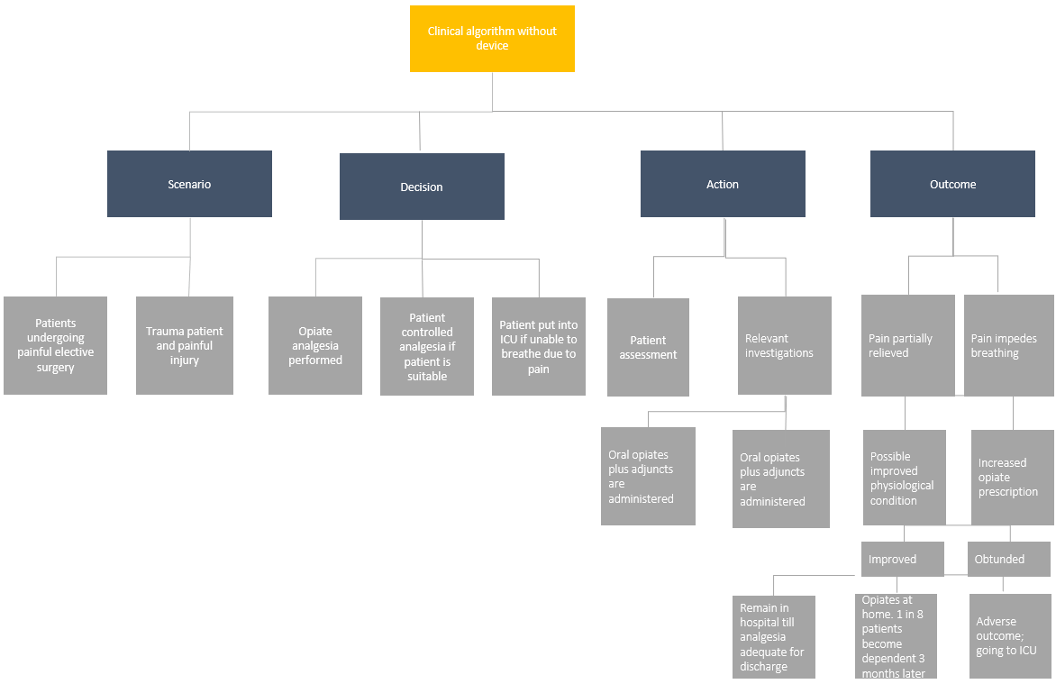
Clinical algorithm with device
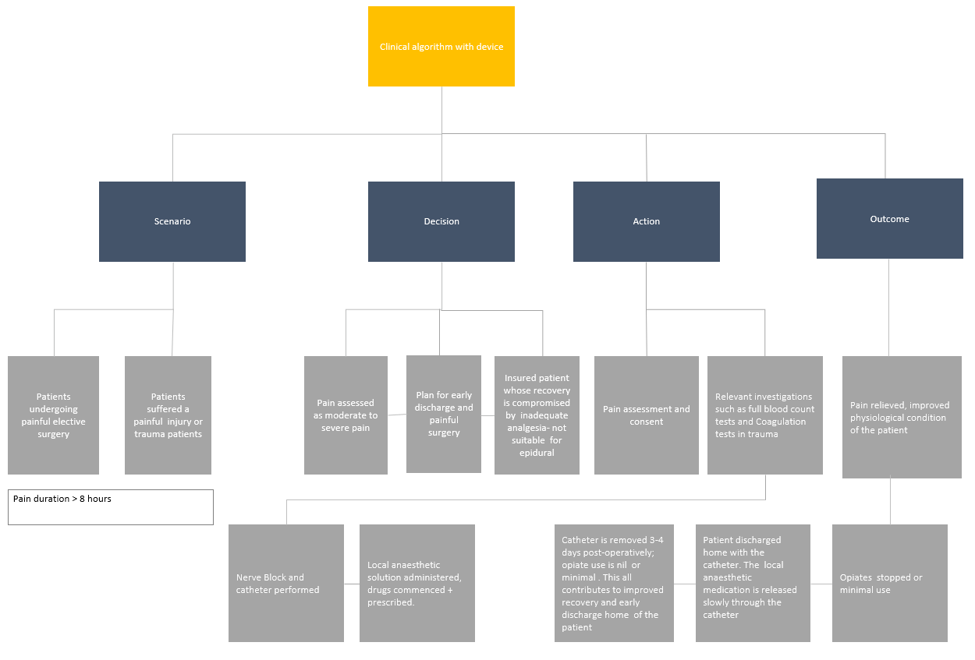
Claims
In terms of health outcomes (comparative benefits and harms), is the proposed technology claimed to be superior, non-inferior or inferior to the comparator(s)? (please select your response)
Superior
Non-inferior
Inferior

Please state what the overall claim is, and provide a rationale:

- reduced length of stay in hospital
- better pain management, ongoing analgesia
- reduced opiate use and dependence potential
- improved mobility and recovery from major orthopaedic surgery and trauma
- improved recovery from other surgeries/injuries (eg mastectomy or fractured ribs)
- frees up the resources (hospital beds, nursing staff, PCA pumps, physio etc) that can be used for other patients

In terms of the immediate costs of the proposed technology (and immediate cost consequences, such as procedural costs, testing costs etc.), is the proposed technology claimed to be more costly, the same cost or less costly than the comparator? (please select your response)
More costly
Same cost
Less costly

Provide a brief rationale for the claim:

Since the kits required to provide the continuous catheter technique are more expensive and the delivery device (particularly if the patient is to be sent home early) cost in the order of $300, there will be a small increase in establishment costs. All other equipment for this is unchanged. However, if day only discharge is included in costs, then there are substantial savings to be gained from shorter hospital stay.

Summary of Evidence
Provide one or more recent (published) high quality clinical studies that support use of the proposed health service/technology. At ‘Application Form lodgement’, please do not attach full text articles; just provide a summary (repeat columns as required).
Identify yet-to-be-published research that may have results available in the near future (that could be relevant to your application). Do not attach full text articles; this is just a summary (repeat columns as required).

Evidence no. | Citation | Published? | Attached file
1 | Joshi G, Gandhi K, Shah N, Gadsden J, Corman SL. Peripheral nerve blocks in the management of postoperative pain: challenges and opportunities. J Clin Anesth. 2016 Dec;35:524-529. doi: 10.1016/j.jclinane.2016.08.041. Epub 2016 Oct 20. PMID: 27871587. | Published | Yes
2 | Singh NP, Makkar JK, Kuberan A, Guffey R, Uppal V. Efficacy of regional anesthesia techniques for postoperative analgesia in patients undergoing major oncologic breast surgeries: a systematic review and network meta-analysis of randomized controlled trials. Can J Anaesth. 2022 Apr;69(4):527-549. English. doi: 10.1007/s12630-021-02183-z. Epub 2022 Jan 31. PMID: 35102494. | Published | No
3 | Ilfeld BM, Morey TE, Enneking FK. Continuous infraclavicular brachial plexus block for postoperative pain control at home: a randomized, double-blinded, placebo-controlled study. Anesthesiology. 2002 Jun;96(6):1297-304. doi: 10.1097/00000542-200206000-00006. PMID: 12170039. | Published | Yes
4 | Ilfeld BM. Continuous peripheral nerve blocks in the hospital and at home. Anesthesiol Clin. 2011 Jun;29(2):193-211. doi: 10.1016/j.anclin.2011.04.003. PMID: 21620338. | Published | No
5 | Hattammaru Y, Mio Y, Hascilowicz T, Utsumi I, Murakami Y, Omi S. Reduction of leakage from insertion site during continuous femoral nerve block with catheter-through-needle versus catheter-over-needle technique for postoperative analgesia after total knee arthroplasty: a randomized controlled trial. BMC Anesthesiol. 2022 Jan 5;22(1):11. doi: 10.1186/s12871-021-01554-9. PMID: 34986793; PMCID: PMC8728999. | Published | Yes
6 | Jones, Mark R, Julie A Petro, Matthew B Novitch, Adeel A Faruki, Jeffrey B Bice, Omar Viswanath, Paragi H Rana, and Alan D Kaye. 2019. “Regional Catheters for Outpatient Surgery—a Comprehensive Review.” Current Pain and Headache Reports 23 (4): 1–9. https://doi.org/10.1007/s11916-019-0762-4. | Published | No

Evidence 1
Evidence number: 1
Type of evidence/study design: Meta-analyses of randomized controlled trials
Published? Published
Citation: Joshi G, Gandhi K, Shah N, Gadsden J, Corman SL. Peripheral nerve blocks in the management of postoperative pain: challenges and opportunities. J Clin Anesth. 2016 Dec;35:524-529. doi: 10.1016/j.jclinane.2016.08.041. Epub 2016 Oct 20. PMID: 27871587.
Description and relevance of citation: The study showed superior pain control and reductions in opioid consumption in patients receiving PNB compared with those receiving intravenous opioids in a variety of upper and lower extremity surgical procedures. Continuous infusion via a perineural catheter (cPNB) has also been associated with a reduction in time to discharge readiness compared with single injection (sPNB).
Publication date/ estimated publication date: 01/10/2016
Please select whether the evidence is an attachment or a website link: Attachments
Attached file(s): Peripheral nerve blocks in the management of postoperative pain_ challenges and opportunities _ Elsevier.pdf
Evidence 2
Evidence number: 2
Type of evidence/study design: A systematic review and network meta-analysis of randomized controlled trials
Published? Published
Citation: Singh NP, Makkar JK, Kuberan A, Guffey R, Uppal V. Efficacy of regional anesthesia techniques for postoperative analgesia in patients undergoing major oncologic breast surgeries: a systematic review and network meta-analysis of randomized controlled trials. Can J Anaesth. 2022 Apr;69(4):527-549. English. doi: 10.1007/s12630-021-02183-z. Epub 2022 Jan 31. PMID: 35102494.
Description and relevance of citation: Continuous paravertebral block and serratus anterior plane block had a high probability of reducing pain at 24 hr after major oncologic breast surgery.
Publication date/ estimated publication date: 31/01/2022
Please select whether the evidence is an attachment or a website link: Website
Website link: https://pubmed.ncbi.nlm.nih.gov/35102494/
Evidence 3
Evidence number: 3
Type of evidence/study design: A randomized, double-blinded, placebo-controlled study
Published? Published
Citation: Ilfeld BM, Morey TE, Enneking FK. Continuous infraclavicular brachial plexus block for postoperative pain control at home: a randomized, double-blinded, placebo-controlled study. Anesthesiology. 2002 Jun;96(6):1297-304. doi: 10.1097/00000542-200206000-00006. PMID: 12170039.
Description and relevance of citation: After moderately painful orthopaedic surgery of the upper extremity, ropivacaine infusion using a portable, mechanical pump and an infraclavicular brachial plexus perineural catheter at home decreased pain, sleep disturbances, narcotic use and related side effects, and improved overall satisfaction.
Publication date/ estimated publication date: 01/06/2002
Please select whether the evidence is an attachment or a website link: Attachments
Attached file(s): Continuous infraclavicular brachial plexus block for postoperative pain control at home.pdf
Evidence 4
Evidence number: 4
Type of evidence/study design: Review
Published? Published
Citation: Ilfeld BM. Continuous peripheral nerve blocks in the hospital and at home. Anesthesiol Clin. 2011 Jun;29(2):193-211. doi: 10.1016/j.anclin.2011.04.003. PMID: 21620338.
Description and relevance of citation: The study showed that a continuous peripheral nerve block (CPNB) results in decreased pain, opioid requirements, opioid-related side effects, and sleep disturbances; in some cases, accelerating resumption of tolerated passive joint range-of-motion and increasing patient satisfaction. Ambulatory perineural infusion may be provided using a portable infusion pump, in some cases resulting in decreased hospitalization duration and related costs.
Publication date/estimated publication date: 01/06/2011
Please select whether the evidence is an attachment or a website link: Website
Website link: https://pubmed.ncbi.nlm.nih.gov/21620338/
Evidence 5
Evidence number: 5
Type of evidence/study design: Randomized controlled trial
Published? Published
Citation: Hattammaru Y, Mio Y, Hascilowicz T, Utsumi I, Murakami Y, Omi S. Reduction of leakage from insertion site during continuous femoral nerve block with catheter-through-needle versus catheter-over-needle technique for postoperative analgesia after total knee arthroplasty: a randomized controlled trial. BMC Anesthesiol. 2022 Jan 5;22(1):11. doi: 10.1186/s12871-021-01554-9. PMID: 34986793; PMCID: PMC8728999.
Description and relevance of citation: The purpose of this study was to compare the incidence of leakage from the catheter insertion site during the continuous femoral nerve block while using a conventional needle and catheter-over-needle (CON) for postoperative analgesia after total knee arthroplasty. The results of the trial showed that the CON group had a significantly lower incidence and degree of leakage from the catheter insertion site.
Publication date/ estimated publication date: 05/01/2022
Please select whether the evidence is an attachment or a website link: Attachments
Attached file(s): Reduction of leakage from insertion site during continuous femoral nerve block with catheter-through-needle versus catheter-over-needle technique.pdf
Evidence 6
Evidence number: 6
Type of evidence/study design: Review
Published? Published
Citation: Jones, Mark R, Julie A Petro, Matthew B Novitch, Adeel A Faruki, Jeffrey B Bice, Omar Viswanath, Paragi H Rana, and Alan D Kaye. 2019. “Regional Catheters for Outpatient Surgery—a Comprehensive Review.” Current Pain and Headache Reports 23 (4): 1–9. https://doi.org/10.1007/s11916-019-0762-4.
Description and relevance of citation: Continuous catheter blockade (CCB) allows for faster recovery time, decreased rates of opioid abuse, and better pain control in patients post-operatively.Outpatient surgical settings continue to focus on efficiency, quality, and safety, including strategies to prevent post-operative nausea, vomiting, and pain. Regional catheters are a valuable tool and help achieve all of the well-established endpoints of enhanced recovery after surgery (ERAS). CCB is growing in popularity with wide indications for a variety of surgeries, and has demonstrated improved patient satisfaction, outcomes, and reductions in many unwanted adverse effects in the outpatient setting.
Publication date/ estimated publication date: 01/01/2019
Please select whether the evidence is an attachment or a website link: Website
Website link: https://anzca.on.worldcat.org/oclc/8022478677

