Public Summary Document

Report to the Medical Services Advisory Committee on real world outcomes of Application 1161: Epidermal growth factor receptor (EGFR) mutation testing in patients non-small cell lung cancer (NSCLC) for access to Pharmaceutical Benefits Scheme (PBS) listed getfitinib, and Application 1173: EGFR status in patients with locally advanced (stage IIIB) or metastatic (stage (IV)) non-small cell lung cancer for access to erlotinib
Medicare Benefits Schedule (MBS) item considered: 73337
Dates of MSAC consideration: 24-25 November 2016
Context for decision: MSAC makes its advice in accordance with its Terms of Reference, see the MSAC Website.

Purpose
The purpose of the report presented to the Medical Services Advisory Committee (MSAC) was to inform MSAC of the real world impacts on the outcomes of Applications 1161 and 1173. The MSAC then uses this information to ensure that the new item/s resulting from this application/s is being used as intended.
The report is not intended to be a review of the clinical information covered during the application process.

MSAC’s advice
After considering the real world impacts of the outcomes of applications 1161 and 1173 for epidermal growth factor receptor (EGFR) mutation testing in patients with non-small cell lung cancer (NSCLC) for PBS access to gefitinib or erlotinib, MSAC identified a potential issue with inappropriate co-claiming of in-situ hybridisation (ISH) testing for breast cancer and recommended referral to the department to investigate further.

Summary of consideration and rationale for MSAC’s advice
MSAC considered the real world impacts of the outcome of applications 1161 and 1173 for EGFR mutation testing in patients with non-small cell lung cancer (NSCLC) for access to two tyrosine kinase inhibitors (gefitinib or erlotinib) by examining available data for MBS item number 73337. Available data for MBS item number 30710 — endobronchial ultrasound guided biopsy used to obtain the sample for EGFR testing — was also reviewed.
MSAC noted that utilisation of item 73337 was significantly lower than expected. The number of patients claiming this item has levelled out at between 2,500 and 3,000 per annum. MSAC considered that patient numbers may have been overestimated in the initial application if it had been assumed that all eligible patients would be tested. MSAC also noted that the amount of tissue required for mutation testing is decreasing because of newer testing methods and that this may result in increasing rates of testing in the future. MSAC considered that additional data provided on the number of patients receiving tyrosine kinase inhibitors indicated that prevalence of EGFR mutations in the tested and treated NSCLC population is similar to predicted.
MSAC recalled that utilisation of item 30710 was expected to rise due to an increase in the need for re-biopsies with the listing of item 73337. However, MSAC noted that this item was growing significantly before 73337 was listed and concluded that it is difficult to determine how much of the growth is due to this listing.
MSAC noted that there was marked variation in the bulk billing rates and the fees charged for item 73337 and suggested that the data on the fee charged may be of interest to consumers and other payers.
In considering the setting for use of item 73337 MSAC noted that there were more services provided in hospital than anticipated with variation evident across states.
MSAC noted that there was some evidence of retesting of EGFR status when reviewing patient breakdown data. MSAC considered that this may occur where patients have developed resistance to tyrosine kinase inhibitor treatment, which was not in the original intention of the item. MSAC suggested that continuing monitoring of retesting rates for this item may be appropriate.
In considering the co-claiming data, MSAC noted that in 2015–16 there were approximately 50 occasions where item 73337 was co-claimed with item 73332 for in-situ hybridisation (ISH) testing for breast cancer. MSAC noted that this was unusual and suggested it may be related to testing in the setting of metastatic cancer where the primary is unknown. MSAC concluded that this co-claiming should be investigated by the department.

Methodology
An application is selected for consideration if the resulting new item(s) or item amendment(s) have been on the MBS for approximately 24 months or longer or if there were particular concerns about utilisation such that MSAC requested to consider it earlier. The specific applications for each MSAC meeting are selected by the MSAC Executive which is composed of the Chairs of MSAC and its sub-committees.
A report on the utilisation is developed by the Department of Health (the department) with information on a number of metrics including state variation, patient demographics, services per patient, practitioner’s providing the service, data on fees and co-claiming of services. The number of metrics included in a report is dependent on the annual service volume for the MBS item(s) under consideration i.e. an item with very low utilisation will have less data to analyse. Where service volumes are too low, information is suppressed to protect patient privacy.
Where possible the report compares data on real world utilisation to the assumptions made during the MSAC assessment. Most of these assumptions are drawn from the assessment report.
Relevant stakeholders are provided an opportunity to comment on the findings in the report before it is presented to the MSAC. It is intended that stakeholders are given at least three weeks to consider the reports.
The stakeholder version of the report does not contain information on assumptions from the MSAC consideration if this information is not already publicly available. This is to protect the commercial in confidence of the original applicants. The same principle is applied to this document.
Once MSAC has considered the report its advice is made available online at the MSAC Website.

Results

Utilisation
Utilisation of item 73337 appears to have levelled out at just fewer than 3,000 services per annum by 2015-16 (Table 1). Based on the current growth pattern it does not appear that utilisation will change significantly in the near future (Figure 1). This utilisation is below the utilisation expected during the MSAC consideration. In 2013-14, the very low utilisation may have been the result of overlap with item 73328 which was superseded by item 73337 but not removed until 31 October 2014.
It was assumed that there would be an increase in lung biopsies (item 30710) as a result of the listing of item 73337. Item 30710 was growing significantly before item 73337 was listed (28% annual increase in utilisation) and consequently it is difficult to know how much of the item’s growth can be attributed to the new listing (Figure 2).
The majority of utilisation occurs in NSW and VIC.

Table 1: Services and benefits paid per state for MBS item 73337 from 2013-14 to 2015-16
Item # | Financial year |  | NSW | VIC | QLD | SA | WA | TAS | NT | ACT | Australia
73337 | 2014-15 | Services | 1,162 | 894 | 415 | 124 | 167 | np | np | np | 2,828
 |  | Benefits | $386,425 | $297,910 | $131,007 | $39,658 | $52,330 | np | np | np | $929,501
 | 2015-16 | Services | 1,098 | 1,029 | 472 | 105 | 188 | np | np | np | 2,959
 |  | Benefits | $364,080 | $340,695 | $148,328 | $33,499 | $59,091 | np | np | np | $968,400
73328 | 2013-14 | Services | 505 | 226 | 194 | 91 | 112 | np | np | np | 1,182
 |  | Benefits | $169,074 | $74,529 | $60,701 | $29,902 | $35,074 | np | np | np | $387,101.42
 | 2014-15 | Services | np | np | np | np | np | np | np | np | 275
 |  | Benefits | np | np | np | np | np | np | np | np | $89,148
NP = not published due to low volumes
Source: Department of Health

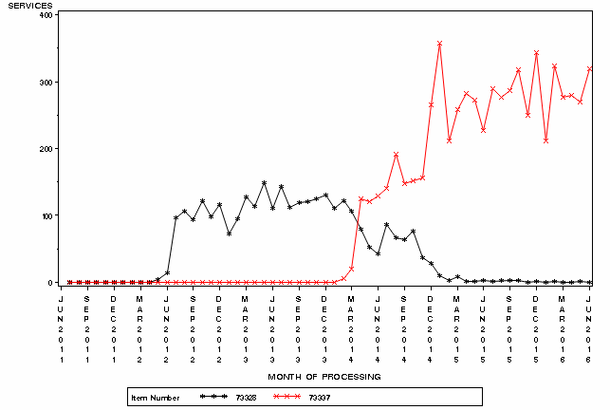

Figure 1: Month by month comparison of service volume for MBS items 73337 and 73328 from June 2011 to July 2016
Source: Medicare Statistics Online

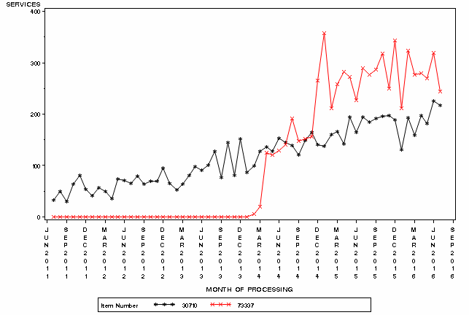 Figure 2: Actual services of MBS items 73337 and 30710, month by month from June 2011 to August 2016
Source: Medicare Statistics Online

In and out of hospital
There is high variation between states on whether this service is provided in or out of hospital. In QLD, SA and WA a high proportion of services are provided in hospital, 49-68% in 2015-16, compared to NSW and VIC where 20% or less of services were provided in hospital in 2015-16.

Table 2: Percentage of services provided in hospital for item 73337 in 2014-15 to 2015-16
 | NSW | VIC | QLD | SA | WA | TAS | NT | ACT | Australia
2014-15 | 14% | 14% | 56% | 45% | 64% | np | np | np | 24%
2015-16 | 18% | 20% | 61% | 49% | 68% | np | np | np | 29%
NP = not published due to low volumes
Source: Department of Health

Patient breakdown
The submission for application 1161 was for patients with Stages III and IV NSCLC. However, MSAC advised that diagnosis should be for any non-squamous NSCLC with no stage specified. It was expected at the time of listing that the patient population would be between 10,000 and 50,000, by the fifth year of listing (MSAC PSD, app 1161, August 2013). The number of patients currently accessing this test is significantly below this estimation at just under 3,000 patients per annum and based on current growth unlikely to reach 10,000 patients per annum by the fifth year of listing (Table 5).
Most of the patient uptake of item 73337 has been in NSW and VIC (Table 3).
The re-test rate for item 73337 appears to be increasing slightly per annum the longer the item is listed. In 2015-16, 8% of patients claimed item 73337 at least twice, compared to 6% in 2014-15 (Table 4).
The gender ratio for item 73337 is split relatively evenly between males and females in 2014-15 and 2015-16. The item is claimed most by patients in the 65-74 age bracket (Figure 3).

Table 3: Actual number of patients who received item 73337 at least once in 2014-15 to 2015-16
Number of Patients | NSW | VIC | QLD | SA | WA | TAS | NT | ACT | Australia
2014-15 | 1,095 | 864 | 377 | 121 | 156 | np | np | np | 2,651
2015-16 | 1,012 | 982 | 423 | 104 | 182 | np | np | np | 2,748

Table 4: Number of services per patient in 2013-14 to 2015-16
 | Services | # of patients | % of patients
2013-14 | 1 | 693 | 99%
 | 2+ | 10 | 1%
 | Total | 703 | 100%
2014-15 | 1 | 2,482 | 94%
 | 2+ | 169 | 6%
 | Total | 2,651 | 100%
2015-16 | 1 | 2,541 | 92%
 | 2+ | 207 | 8%
 | Total | 2,748 | 100%
Source for tables 2-5: Department of Health
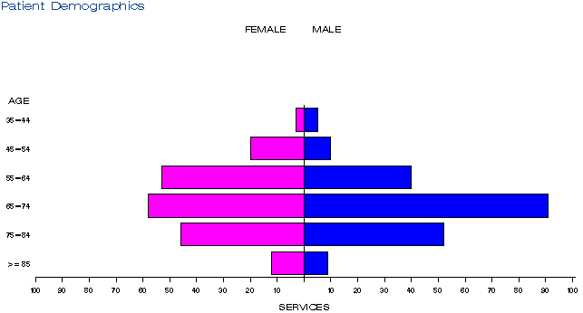
a)
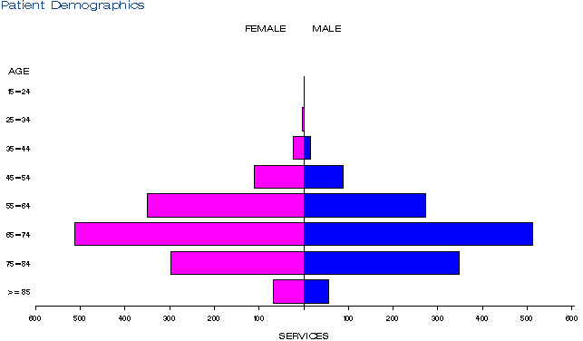
b))
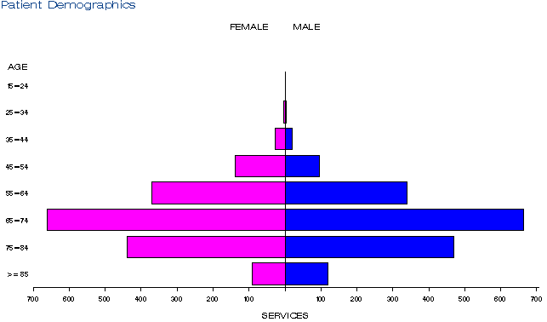
c)

Figure 3: Demographic profile for MBS item 73337 for 2013-14 (a), 2014-15 (b) and 2015-16 (c).
Source: Medicare Statistics Online

Practitioner breakdown
From 2013-14 to 2015-16, the number of practitioners providing this service grew from 25 to 57 (Table 5). The majority of practitioners are pathologists.
Of the 57 practitioners providing this service in 2015-16, 20% were providing 75% of services (Table 6).

Table 5: Number of practitioners providing this service in 2013-14 to 2015-16
Financial year | Australia
2013-14 | 25
2014-15 | 47
2015-16 | 57

Table 6: Cumulative percentage of medical practitioners providing MBS item 73337 and how many services each percentile accounts for in 2013-14 to 2015-16
 | 2013-14 | 2014-15 | 2015-16
10% | 54% | 65% | 59%
20% | 77% | 76% | 75%
30% | 88% | 85% | 85%
40% | 95% | 91% | 92%
50% | 97% | 94% | 96%
60% | 98% | 98% | 98%
70% | 99% | 99% | 99%
80% | 99% | 100% | 99%
90% | 100% | 100% | 100%
100% | 100% | 100% | 100%
Source for tables 5 & 6: Department of Health

Co-claiming
Item 73337 was predominantly claimed by itself in 2013-14 (Table 7). However, from 2014-15 onwards the item is frequently co-claimed with 73940 for the receipt of a pathology specimen from one pathology clinic to another, 73938 for the collection of a specimen and 72846 for immunohistochemical examination of biopsy material by immunofluorescence (Tables 8 & 9).
In 2015-16, there were 35 occasions in the top 10 instances of co-claiming where item 73337 was co-claimed with item 73332 for ISH testing for breast cancer (Table 9). This claiming is unusual and may be related to testing in the setting of metastatic cancer where the primary is unknown.

Table 7: Top 10 instances of co-claiming with MBS item 73337 in 2013-14
# | Items | Episodes | Number of Services | Schedule Fee for Combination | % of total episodes | Cumulative %
1 | 73337 | 221 | 221 | $87,814 | 31% | 31%
2 | 73337,73940 | 175 | 350 | $71,330 | 25% | 56%
3 | 73337, 73938 | 148 | 297 | $60,382 | 21% | 77%
4 | 73337, 73939 | 20 | 40 | $7,995 | 3% | 80%
5 | 73337, 72846, 73940 | 14 | 42 | $6,541 | 2% | 82%
6 | 73337, 72846, 73939. | 13 | 39 | $5,972 | 2% | 84%
7 | 73337, 72846 | 10 | 20 | $4,570 | 1% | 85%
8 | 73337, 72823, 72847, 73926 | np | np | np | np
9 | 73337, 72823,72846,73926. | np | np | np | np
10 | 73337, 65120,73930 | np | np | np | np
NP = not published due to low volumes

Table 8: Top 10 instances of co-claiming with MBS item 73337 in 2014-15
# | Items | Episodes | Number of Services | Schedule Fee for Combination | % of total episodes | Cumulative %
1 | 73337, 73940. | 608 | 1,217 | $247,831 | 22% | 22%
2 | 73337, 72846, 73940. | 458 | 1,378 | $214,455 | 16% | 38%
3 | 73337, 73938. | 269 | 538 | $109,026 | 10% | 48%
4 | 73337 | 255 | 258 | $102,516 | 9% | 57%
5 | 73337, 73939. | 141 | 282 | $56,365 | 5% | 62%
6 | 73337, 72846, 73939. | 70 | 210 | $32,155 | 2% | 64%
7 | 73337, 72846. | 64 | 128 | $29,245 | 2% | 66%
8 | 73337, 72823, 72847, 73926. | 35 | 140 | $20,724 | 1% | 67%
9 | 73337, 72846, 73938. | 35 | 105 | $16,272 | 1% | 68%
10 | 73337, 72823, 72846, 73926. | 29 | 116 | $16,307 | 1% | 69%

Table 9: Top 10 instances of co-claiming with MBS item 73337 in 2015-16
# | Items | Episodes | Number of Services | Schedule Fee for Combination | % of total episodes | Cumulative %
1 | 73337, 72846, 73940. | 497 | 1,501 | $233,462 | 15% | 15%
2 | 73337, 73940. | 319 | 638 | $130,024 | 10% | 25%
3 | 73337, 73939. | 256 | 513 | $102,733 | 8% | 33%
4 | 73337 | 222 | 222 | $88,212 | 7% | 40%
5 | 73337, 73938. | 182 | 364 | $73,765 | 6% | 46%
6 | 73337, 72846. | 148 | 296 | $67,629 | 5% | 51%
7 | 73337, 72846, 73939. | 118 | 354 | $54,203 | 4% | 55%
8 | 73337, 72846, 73938. | 80 | 240 | $37,192 | 2% | 57%
9 | 73337, 72836, 72847, 73924. | 36 | 144 | $33,070 | 1% | 58%
10 | 73337, 73332, 73938. | 35 | 106 | $25,622 | 1% | 59%
Source for Tables 7-9: Department of Health

Data on fee charged
The average fee charged for item 73337 across Australia was $489 in 2015-16 (Table 10). The highest fee charged was $546 in WA and WA also had the lowest rate of bulk billing at 25%. The fee charged in the 95th percentile in WA in 2015-16 is $1,073 which is higher compared to the other states and territories with 95th percentile fees ranging from $579 to $650.

Table 10: Statistics on fees charged for MBS item 73337 for 2014-15 to 2015-16
 |  | Provider State/Territory
 |  | NSW | VIC | QLD | SA | WA | TAS | NT | ACT | Australia
2014-15 | Average Fee Charged | $479 | $438 | $511 | $475 | $515 | np | np | np | $486
 | Std Deviation | $78 | $84 | $98 | $67 | $154 | np | np | np | $105
 | Median Fee Charged | $480 | $397 | $517 | $513 | $529 | np | np | np | $240
 | 75th Percentile | $517 | $514 | $552 | $517 | $556 | np | np | np | $350
 | 95th Percentile | $644 | $596 | $610 | $575 | $603 | np | np | np | $500
 | Bulk-billing Rate | 83% | 85% | 43% | 55% | 21% | np | np | np | 73%
2015-16 | Average Fee Charged | $483 | $448 | $504 | $457 | $546 | np | np | np | $489
 | Std Deviation | $82 | $218 | $87 | $71 | $159 | np | np | np | $141
 | Median Fee Charged | $514 | $397 | $517 | $397 | $556 | np | np | np | $514
 | 75th Percentile | $517 | $514 | $542 | $513 | $556 | np | np | np | $542
 | 95th Percentile | $650 | $640 | $616 | $579 | $1,073 | np | np | np | $616
 | Bulk-billing Rate | 80% | 79% | 38% | 49% | 25% | np | np | np | 69%
NP = not published due to low volumes
Source: Department of Health

Background

Application 1161
In July 2004, the Pharmaceutical Benefits Advisory Committee (PBAC) recommended PBS listing of getfitinib, which was listed from 1 December 2004. The EGFR testing to determine getfitinib eligibility was not listed on the MBS at this time.
In December 2010, MSAC recommended public funding for ‘testing in the limited circumstance of determining tumour EGFR activating mutation status to contribute to a determination of eligibility for currently PBS-subsidised getfitinib for a patient with locally advanced or metastatic non-small cell lung cancer’. EGFR testing was MBS listed in May 2012.
In November 2010, PBAC rejected PBS listing of getfitinib for the first-line treatment of patients with locally advanced or metastatic NSCLC (Stage IIIb/IV) who have an activating mutation in the EGFR gene, on the basis of unacceptably high and uncertain cost effectiveness.
In November 2012, MSAC and PBAC reviewed a co-dependent submission for EGFR mutation testing and access to getfitinib for the first-line treatment of locally advanced or metastatic NSCLC patients expressing activating mutations of the EGFR gene. The submission was rejected by PBAC, and MSAC deferred the application for the requested MBS item until such time as PBAC recommended the corresponding PBS listing of getfitinib.
The sponsor lodged a major resubmission to PBAC for the listing of first-line getfitinib on the PBS for consideration at the July 2013 PBAC meeting. The sponsor was advised that a minor resubmission to MSAC was required to address outstanding testing issues raised in the November 2012 getfitinib MSAC minutes.
MSAC supported the listing of the service at an out of session meeting in October 2013.

Application 1173
In 2008, PBAC recommended the use of erlotinib as a monotherapy in unselected patients with non-small cell lung cancer (NSCLC) who had failed prior chemotherapy.
In December 2010, MSAC recommended public funding for ‘testing in the limited circumstance of determining tumour EGFR activating mutation status to contribute to a determination of eligibility for currently PBS-subsidised getfitinib for a patient with locally advanced or metastatic non-small cell lung cancer’. EGFR testing for access to getfitinib in the second-line setting has been MBS listed since May 2012.
Erlotinib was proposed for the first-line treatment of patients with advanced (stage IIIb) or metastatic (stage IV) NSCLC with activating epidermal growth factor receptor (EGFR) mutations in 2012. A co-dependent submission for public funding of erlotinib and the EGFR mutation test was considered by PBAC in July 2012 and MSAC in August 2012.
At the August 2012 meeting, MSAC did not support the listing of EGFR mutation testing for determining eligibility for erlotinib treatment as a first-line therapy in patients with locally advanced or metastatic NSCLC. MSAC ‘advised the Minister that it does not support public funding for this indication on the basis of insufficient evidence to determine the comparative performance and costs across the testing options and their consequences for the comparative effectiveness and cost-effectiveness of erlotinib’.
In October 2012, a Stakeholder Meeting was jointly convened by MSAC and PBAC to resolve outstanding issues related to i) EGFR mutation testing, and ii) the clinical place of tyrosine kinase inhibitors (TKIs) in the treatment of locally advanced (Stage IIIb) or metastatic (Stage IV) NSCLC.
Following the November 2012 MSAC meeting, which discussed Application 1161 (EGFR mutation testing for first-line treatment with getfitinib), and taking the advice received from the stakeholder meeting, the MSAC outcome was more supportive of EGFR testing than reflected in the previous (August 2012) MSAC minutes for Application 1173 in relation to EGFR testing for access to erlotinib, as many concerns raised previously were resolved during the stakeholder meeting.
MBS item 73328 for a test of tumour from a non-small cell lung cancer (NSCLC) to determine EGFR gene status was removed on 1 November 2014, superseded by item 73337.

Item descriptor
73328 | A test of tumour tissue from a patient with locally advanced or metastatic non-small cell lung cancer requested by, or on behalf of, a specialist or consultant physician to determine if the requirements relating to epidermal growth factor receptor (egfr) gene status for access to getfitinib under the pharmaceutical benefits scheme (pbs) are fulfilled.  Fee: $397.35 Benefit: 75% = $298.05 85% = $337.75
73337 | A test of tumour tissue from a patient diagnosed with non-small cell lung cancer, shown to have non-squamous histology or histology not otherwise specified, requested by, or on behalf of, a specialist or consultant physician, to determine if the requirements relating to epidermal growth factor receptor (EGFR) gene status for access to erlotinib or getfitinib under the Pharmaceutical Benefits Scheme (PBS) are fulfilled.  Fee: $397.35 Benefit: 75% = $298.05 85% = $337.75
30710 | ENDOBRONCHIAL ULTRASOUND GUIDED BIOPSY(S) (bronchoscopy with ultrasound imaging, with or without associated fluoroscopic imaging) to obtain one or more specimens by either:  (a) transbronchial biopsy(s) of peripheral lung lesions; or  (b) fine needle aspiration(s) of a mediastinal mass(es); or  (c) fine needle aspiration(s) of locoregional nodes to stage non-small cell lung carcinoma  not being a service associated with another item in this subgroup or to which items 30696, 41892, 41898, and 60500 to 60509 applies (Anaes.)  (See para T8.21 of explanatory notes to this Category)  Fee: $563.30 Benefit: 75% = $422.50 85% = $483.80

Applicant’s comments on MSAC’s public summary document
Nil response

Further information on MSAC
MSAC Terms of Reference and other information are available on the MSAC Website.

The 95th percentile fee charged represents that 95% of the time the fee is below this amount but in 5% of cases, the fee is higher than this.

