RATIFIED
PICO CONFIRMATION

Application 1192.3
Reduction of mitral regurgitation (MR) through tissue approximation using transvenous/transseptal techniques (MitraClip)
Summary of PICO/PPICO criteria to define the question(s) to be addressed in an Assessment Report to the Medical Services Advisory Committee (MSAC)
Component | Description
Patients | Population 1: Degenerative mitral regurgitation (DMR)  Patients with moderate-severe or severe DMR (i.e. mitral regurgitation [MR] grading of 3+ [moderate-severe] or 4+ [severe]), as determined by echocardiography, as well as objective and subjective measures, who have left ventricular ejection fraction (LVEF) ≥20%, who are symptomatic (New York Heart Association [NYHA] functional class II or greater), who are determined by a multi-disciplinary heart team (MDHT) to be ineligible for surgical intervention but suitable for the MitraClip procedure.
Intervention | Transcatheter mitral valve repair (TMVr ) through percutaneous reconstruction through tissue approximation using transvenous/transseptal techniques (MitraClip), in addition to continued medical management with maximally tolerated GDMT.
Comparator | Medical management with maximally tolerated GDMT.
Outcomes | Efficacy/effectiveness  - Survival  - Freedom from MR grade 3+ or 4+  - Freedom from surgery for valve dysfunction  - Quality of life (QoL)  - Severity of post-treatment mitral regurgitation  - Procedure time  - Time taken to resume normal activities  - Post-procedural hospitalisation duration  - Post-procedural patient recovery time  - Clinical measures of benefit (NYHA functional class, LVEF function,  re-hospitalisation for chronic heart failure [CHF])  Safety  - Clinical adverse events  - Migration of device  - Non-elective cardiovascular surgery for adverse events  Healthcare resources  - Cost to deliver TMVr intervention  - Costs to identify eligible population for MitraClip  - Costs to provide for medical management with maximally tolerated GDMT  Total Australian Government Healthcare costs  - Total cost to the Medicare Benefits Schedule (MBS)  - Total cost to the Pharmaceutical Benefits Scheme (PBS)  - Total cost to other healthcare services

Component | Description
Patients | Population 2: Functional mitral regurgitation (FMR)  Patients with disproportionally moderate-severe or severe FMR, as determined by echocardiography, as well as objective and subjective measures (i.e. MR grading of 3+ [moderate-severe] or 4+ [severe]), who have left ventricular (LV) ejection fraction (LVEF) ≥20% and severe LV dilatation (defined asleft ventricular end systolic dimension (LVESD) ≤70mm) considered by the MDHT to be ineligible for surgical intervention, and whose symptoms (NYHA functional class II or greater) persist despite maximally tolerated guideline directed medical therapy (GDMT) as determined by the MDHT.
Intervention | Transcatheter mitral valve repair (TMVr ) through percutaneous reconstruction through tissue approximation using transvenous/transseptal techniques (MitraClip), in addition to continued medical management with maximally tolerated GDMT.
Comparator | Medical management with maximally tolerated GDMT.
Outcomes | Efficacy/effectiveness  - Survival  - Freedom from MR grade 3+ or 4+  - Freedom from surgery for valve dysfunction  - Quality of life (QoL)  - Severity of post-treatment mitral regurgitation  - Procedure time  - Time taken to resume normal activities  - Post-procedural hospitalisation duration  - Post-procedural patient recovery time  - Clinical measures of benefit (NYHA functional class, LVEF function,  re-hospitalisation for chronic heart failure [CHF])  Safety  - Clinical adverse events  - Migration of device  - Non-elective cardiovascular surgery for adverse events  Healthcare resources  - Cost to deliver TMVr intervention  - Costs to identify eligible population for MitraClip  - Costs to provide for medical management with maximally tolerated GDMT  Total Australian Government Healthcare costs  - Total cost to the Medicare Benefits Schedule (MBS)  - Total cost to the Pharmaceutical Benefits Scheme (PBS)  - Total cost to other healthcare services

PICO or PPICO rationale for therapeutic and investigative medical services only

Population
There are two patient populations proposed for this medical service, described under separate headings below. The PICO Advisory Sub-Committee (PASC) noted the DMR population (Population 1) is more straightforward than FMR (Population 2). FMR is often the result of heart failure and enlargement, with varying degrees of severity.
In the FMR population (Population 2), PASC noted the criteria for severe FMR differed between the COAPT trial and MITRA-FR trial. PASC recommended both trial criteria be included.
The regurgitant volume (RV) thresholds and effective regurgitant orifice area (EROA) in COAPT were RV > 45 ml/beat and EROA >30 mm².
The regurgitant volume (RV) thresholds and effective regurgitant orifice area (EROA) in MITRA-FR were RV > 30 ml/beat and EROA > 20 mm².
In the COAPT study, patients had to have sufficient cardiac reserve (left ventricular end systolic dimension [LVESD] ≤70 mm). The MITRA-FR study did not include a criteria to ensure patients with sufficient cardiac reserve were included.
PASC noted the relationship between mitral regurgitation (MR) severity (disproportionate or proportionate) and degree of left ventricular (LV) dilatation. Those with disproportionally severe MR may be likely to benefit from MitraClip [COAPT trial population], compared with those with non-severe MR (and proportionate to LV dilatation) who may be unlikely to benefit from MitraClip [MITRA-FR trial population].
PASC considered this important for determining which FMR patients would most likely benefit from MitraClip.
PASC recommended the FMR population should have moderate-severe or severe FMR (MR ≥3+), as determined by echocardiography and objective and subjective measures (as per ASE criteria), but some cardiac reserve (left ventricular end systolic dimension (LVESD) ≤70mm and an EF of >20%).
PASC recommended splitting the two populations of FMR and DMR, as many DMR patients would meet the heart size and EF criteria alone.
PASC noted the large number of registries from which to draw data for the DMR group.
Population 1: Degenerative mitral regurgitation (DMR)
Patients with moderate-severe or severe DMR (i.e. mitral regurgitation [MR] grading of 3+ [moderate-severe] or 4+ [severe]), as determined by echocardiography and objective and subjective measures, who have left ventricular ejection fraction (LVEF) ≥20%, who are symptomatic (New York Heart Association [NYHA] functional class II or greater) and who are determined by a multi-disciplinary heart team (MDHT) to be ineligible for surgical intervention but suitable for the MitraClip procedure.
Population 2: Functional mitral regurgitation (FMR)
Patients with moderate-severe or severe FMR as determined by echocardiography and objective and subjective measures (i.e. MR grading of 3+ [moderate-severe] or 4+ [severe]), who have left ventricular ejection fraction (LVEF) ≥20% and left ventricular end systolic dimension (LVESD) ≤70 mm considered by the MDHT to be ineligible for surgical intervention, and whose symptoms (NYHA functional class II or greater) persist, despite maximally tolerated guideline-directed medical therapy (GDMT), as determined by the MDHT.
Multi-disciplinary heart team (MDHT)
For both populations 1 and 2, patients will be screened by an MDHT, to determine those ineligible for conventional open-chest heart surgery, and those whose existing comorbidities would not preclude the expected benefits of MR correction.
The MDHT will assess patients’ suitability by combining eligibility considerations, such as surgical risk assessment, frailty, major organ system dysfunction and procedure-specific impediments. Other eligibility considerations for the MDHT include a patient’s anatomical suitability for MitraClip. To be eligible for transcatheter mitral valve repair (TMVr) - based on the proposed FMR population - the MDHT must also determine that a patient’s MR is disproportionate to their left ventricular end-diastolic volume (LVEDV).
The applicant has proposed that a Consensus/Position Statement be prepared by a Working Group, including a multi-disciplinary team of Key Opinion Leaders (with representatives from the Cardiac Society of Australia and New Zealand [CSANZ], and the Australian and New Zealand Society of Cardiac and Thoracic Surgeons [ANZSCTS]), that defines TMVr hospitals, practitioners and patients.
Mitral regurgitation (MR)
The mitral valve permits the flow of blood from the left atrium to the left ventricle. MR occurs when the leaflets (or flaps) of the heart’s mitral value do not close properly, and therefore leak. The mitral valve is a one-way valve that separates the left atrium (a chamber in the heart which collects blood from the lungs) from the left ventricle (a chamber in the heart which pumps blood to the rest of the body).
During pumping, the leak in the mitral valve causes blood to flow backwards (MR) into the left atrium, thereby decreasing blood-flow to the body. To maintain blood flow to the body and compensate for the MR, the left ventricle must pump harder. Back-flow due to MR places an extra burden on the left ventricle and lungs. Eventually, this burden can cause other problems, such as: stroke, sudden death, irregular heartbeat, increasing damage to the heart muscle (progressive myocardial injury), and inability to maintain adequate circulation of blood (congestive heart failure).
There are two aetiologies of chronic MR, being DMR and FMR. Alternative terms used for DMR and FMR are primary MR and secondary MR. For the purpose of this application, DMR and FMR are used.
In DMR, a disorder of the valvular apparatus, where pathology of at least one of the components of the valve (including the leaflets, chordae tendineae, papillary muscles and annulus) cause the valve to be incompetent, with consequential MR. The most common cause of DMR is mitral valve prolapse, with other less common causes including infective endocarditis, connective tissue disorders and rheumatic heart disease. Prolonged volume overload of DMR causes myocardial damage, heart failure and ultimately patient death. However, once the valve is corrected, the condition is corrected[1].
In contrast, with FMR, regurgitation is caused by left ventricular (LV) dilatation and dysfunction. That is, the regional wall motion abnormalities, displacement of papillary muscles and dilatation of the mitral annulus pull on the mitral valve, which in turn prevents it from sealing tight (coapting) and allows blood to leak back into the left atrium. Severe LV dysfunction is caused by underlying coronary artery disease (CAD), related myocardial infarction or idiopathic myocardial disease. Ischaemic secondary MR is a subtype of FMR which is caused by CAD. Non-ischaemic MR refers to FMRs caused by non-CAD-related conditions. Because MR is only one component of the disease, simply fixing the valve to ensure coapting is not by itself curative [1].
The primary imaging used to determine severity of MR is Doppler echocardiography (transthoracic echocardiography). However, it should be noted that no single Doppler and echocardiographic parameter is sufficiently precise for MR to be quantified in an individual patient. An integrated approach is needed to determine severity of MR [2] .
Table 1 Grading of the severity of chronic MR by echocardiography (ASE)
 | MR severity *
 | Mild | Moderate |  | Severe
Structural
MV morphology | None or mild leaflet abnormality (e.g., mild thickening, calcifications or prolapse, mild tenting) | Moderate leaflet abnormality or moderate tenting |  | Severe valve lesions (DMR: flail leaflet, ruptured papillary muscle, severe retraction, large perforation; FMR: severe tenting, poor leaflet coaptation)
LV and LA size ª | Usually normal | Normal or mild dilated |  | Dilated ^{b}
Qualitative Doppler
Colour flow jet area ^{c} | Small, central, narrow, often brief | Variable |  | Large central jet (>50% of LA) or eccentric wall-impinging jet of variable size
Flow convergence ^{d} | Not visible, transient or small | Intermediate in size and duration |  | Large throughout systole
CWD jet | Faint/partial/parabolic | Dense but partial or parabolic |  | Holosystolic/dense/triangular
Semi-quantitative
VCW (cm) | < 0.3 | Intermediate |  | ≥ 0.7 (> 0.8 for biplane) ^{e}
Pulmonary vein flow ^{f} | Systolic dominance (may be blunted in LV dysfunction or AF) | Normal or systolic blunting ^{f} |  | Minimal to no systolic flow / systolic flow reversal
Mitral inflow ^{g} | A-wave dominant | Variable |  | E-wave dominant (>1.2 m/sec)
Quantitative ^{h, i}
 | Mild | Moderate | Moderate to Severe | Severe
EROA, 2D PISA (cm2) | < 0.2 | 0.20-0.29 | 0.30-0.39 | ≥ 0.40 (may be lower in FMR with elliptical ROA)
Regurgitant volume (mL/beat) | < 0.30 | 30-44 | 45-59 ^{h} | ≥ 60 (may be lower in low flow conditions)
RF (%) | < 30 | 30-39 | 40-49 | ≥ 50
Abbreviations: AF, atrial fibrillation; CWD, Continuous wave Doppler, DMR, degenerative mitral regurgitation; EROA, Effective regurgitant orifice area, FMR, functional mitral regurgitation; LA, Left atrium, atrial, LV, Left ventricle, ventricular; MR, mitral regurgitation; PISA, Proximal isovelocity surface area; RF, Regurgitant fraction; VCW, Vena contracta width.
Bolded qualitative and semiquantitative signs are considered specific for their MR grade.
*All parameters have limitations, and an integrated approach must be used that weighs the strength of each echocardiographic measurement. All signs and measures should be interpreted in an individualised manner that accounts for body size, sex, and all other patient characteristics
ª This pertains mostly to DMR
^{b} LV and LA can be within the ‘‘normal’’ range for patients with acute severe MR or with chronic severe MR who have small body size, particularly women, or with small LV size preceding the occurrence of MR.
^{c} With Nyquist limit 50-70 cm/sec.
^{d} Small flow convergence is usually <0.3 cm, and large is $ 1 cm at a Nyquist limit of 30-40 cm/sec.
^{e} For average between apical two- and four-chamber views.
^{f} Influenced by many other factors (LV diastolic function, atrial fibrillation, LA pressure).
^{g} Most valid in patients >50 years old and is influenced by other causes of elevated LA pressure.
^{h} Discrepancies among EROA, RF, and regurgitant volume may arise in the setting of low or high flow states.
^{i} Quantitative parameters can help subclassify the moderate regurgitation group.
Source: Zhogbi et al., (2017), table 8.

There are several MBS items related to mitral valve and MR procedures. Figure 1 outlines that separations for MR procedures have increased at an average rate of approximately 125 separations per year. Over this time period, mitral valve replacement procedures (MBS items 338488 and 38489) have comprised roughly half of all MR procedures and have been the main driver in the increase in total number of services. These data are useful in so far as describing the current context for MR procedures in the Australian setting. However, these services data do not specify the type or severity of mitral valve condition being treated, or the number of procedures per patient. Also, the MBS utilisation data is applicable to patients suitable for surgery, and not for the proposed populations of patients that are ineligible for surgery. As such, these data do not isolate patients with severe MR who are eligible for TMVr.
Figure 1 Total services for MBS items related to MR surgery by item category (A) and financial year (B) from 2008 to 2018
Notes: MBS Item Numbers grouped by category: mitral repair- 34480, 34481; mitral annuloplasty - 38475, 38477; mitral replacement- 38488, 38489.
Source: Medicare Australia, MBS statistics.

The prevalence of MR in a prospective study of 79,043 patients who, between 2001 and 2011, were referred to a community open-access echocardiography service for suspected heart failure (HF) was 12.5%, which represented the most common left-sided valve pathology [3]. Disease progression commonly leads to severe symptomatic MR. A study of heart valve disease, conducted in multiple centres in Europe [4], reported that 45% of patients presenting with MR were severe and symptomatic. These patients present with HF symptoms due to MR, which persist despite either or both revascularization and optimization of medical therapy, as well as decreased exercise tolerance and exertional dyspnoea[5].
The applicant provided estimates, based on a pragmatic review of the literature to identify a range of epidemiological inputs. The epidemiological inputs are derived from large cohorts, the majority of which are specific to the Australian setting. It was estimated there are approximately REDACTED patients with severe, symptomatic MR in Australia of which approximately REDACTED are eligible for TMVr. The number of TMVr expected in the first year is estimated to be REDACTED.
Table 2 presents estimates for the proportion of severe MR patients eligible for TMVr who are at high risk of complications with surgical intervention and anatomically suitable for implantation.
Table 2 Epidemiological inputs for determining proportion of severe DMR and FMR patients eligible for MitraClip
Parameter | Value | Source
Severe DMR population
Proportion of with severe symptomatic DMR patients who have LVEF ≥30% | 85% | Mirabel (2007)[4], 85.2% of patients had LVEF >30%, Table 2.
Proportion of severe symptomatic DMR patients who are at high risk of complications with surgical intervention | 50% | Mirabel (2007) [4], 50% of patients with LVEF 40-50% were given the decision not to operate.
Proportion of severe symptomatic MR patients who are anatomically suitable for TMVr (MitraClip implantation) | REDACTED | Assumption
Severe FMR population
Proportion of severe symptomatic FMR patients who have LVEF 20% - 50% | 58% | Mirabel (2007) [4] 58% of patients who did not receive surgery had LVEF 20-50%.
Proportion of severe symptomatic FMR patients who are at high risk of complications with surgical intervention | 64% | Goel (2014)[6] 64% (520 of 814) were medically managed.
Proportion of severe symptomatic MR patients who are anatomically suitable for TMVr (MitraClip implantation) | REDACTED | Assumption
Abbreviations: DMR, degenerative mitral regurgitation; FMR, functional mitral regurgitation; MR, mitral regurgitation.

Rationale
This application is a resubmission of MSAC applications 1192, 1192.1 and 1192.2[7-9]. The populations considered for applications 1192 and 1192.1 are consistent with the population for the current application (1192.3), with the exception that the patients considered in 1192 and 1192.1 did not explicitly include those considered ineligible for surgery. Thus, surgery was considered a comparator for these applications. Consequently, MSAC concluded for 1192.2 that there was “uncertain comparative safety, effectiveness and cost-effectiveness due to limited direct comparative data. MSAC considered it was difficult to define a clinical need in terms of the patient population likely to benefit.” [7]
As a result of these recommendations, the subsequent resubmission (MSAC application 1192.2) proposed a population for which there may be an indication for TMVr in patients with DMR, wherein they added the additional proviso for the population to only consist of those “considered high-risk for surgery”. However, there was still continued evidence uncertainty, due to lack of direct comparative evidence, and therefore MSAC application 1192.2 was not approved for Medicare Benefits Schedule (MBS) listing. However, MSAC did recognise (in the Public Summary Document (PSD) for 1192.2), that “there is a clinical need in a small patient population identified as being eligible for the intervention”[9]. The rationale for the population in this current application (resubmission 1192.3) is that these patients would comprise the small patient population that are eligible.
In addition to the evidence discussed for population 1 and 2 below, the applicant has provided details of three studies [10-12], consisting of both the DMR and FMR populations, which were published prior to previous application 1192.2, and which were included in the assessment of application 1192.2. The evidence in these three studies was indirect to application 1192.2 and therefore would be considered indirect to the population for current application 1192.3 (because the population of the current application is consistent with the population for earlier application 1192.2). Additionally, these studies are small, non-randomised, low level of evidence (NHMRC level III-3 evidence) and have previously been assessed as having a high risk of bias.

Population 1: DMR
The proposed population for DMR in current application 1192.3 is consistent with that for DMR in earlier MSAC application 1192.2. The applicant advised that, in addition to the MSAC recommendation detailed above, clinician feedback highlighted an unmet clinical need in patients with DMR who are determined to be at high risk of complications if they have surgical intervention.
The applicant provided one non-comparative study on registry data[13], which has been published since application 1192.2 was considered, and is applicable to the DMR population. The registry study included patients who received MitraClip and were enrolled in the Society of Thoracic Surgery/American College of Cardiology Transcatheter Valve Therapy (STS/ACC TVT) Registry. The study reported in-hospital, 30-day, and 1-year outcomes. The applicant was not aware of any additional studies and no comparative studies were known of in the DMR population. A search of clinicaltrials.gov noted one upcoming retrospective cohort on MitraClip in DMR, due to be published at the end of 2020. Another two trials were identified on clinicaltrials.gov that had been terminated, one due to small population size, in the DMR population. The MDHT will provide a key role in determining which patients are ineligible for surgical intervention and that would benefit from the TMVr procedure.
The proposed DMR population for this assessment is consistent with those recommended for TMVr in the European Society of Cardiology/European Association for Cardio-Thoracic Surgery (ESC/EACTS) (2017)[14] and the American Heart Association/American College of Cardiology (AHA/ACC) (2017) guidelines[5]. ESC/EACTS (2017) recommend TMVr procedure in patients with symptomatic severe DMR who are inoperable or at high surgical risk. ESC/EACTS acknowledge that although a general recommendation for TMVr cannot be made yet, they state that the TMVr procedure is safe and may improve symptoms in patients who are ineligible for surgery. Similarly, the AHA/ACC (2017) guidelines recommend TMVr procedure in severely symptomatic patients (NYHA class III to IV) despite optimal medical management, with severe DMR who have a prohibitive surgical risk of surgery. The Food and Drug Authority (FDA) approved the use of MitraClip in the DMR population in 2013[15].
The current guideline recommendations for DMR and FMR are summarised in Table 3.
Table 3 Indications for TMVr (MitraClip): ACC/AHA (2017) and ESC/EACTS (2017 guidelines)
Population | ACC/AHA | ESC/EACTS
DMR | TMVr may be considered for severely symptomatic patients (NYHA class III to IV) with chronic severe DMR (stage D) who have favourable anatomy for the repair procedure and a reasonable life expectancy, but who have a prohibitive surgical risk because of severe comorbidities and remain severely symptomatic despite optimal guideline-direct medications for heart failure. | TMVr may be considered in patients with symptomatic severe primary mitral regurgitation who fulfil the echocardiographic criteria of eligibility and are judged inoperable or at high surgical risk by the Heart Team, avoiding futility.
FMR | Not recommended:  TMVr provides a less invasive alternative to surgery but is not approved for clinical use for this indication in the United States. The results of RCTs examining the efficacy of TMVr in patients with secondary MR are needed to provide information on this patient group. | When revascularisation is not indicated and surgical risk is not low, a TMVr procedure may be considered in patients with severe FMR and left ventricular ejection fraction (LVEF) >30% who remain symptomatic despite optimal medical management (including cardiac resynchronisation therapy (CRT) if indicated) and who have a suitable valve morphology by echocardiography, avoiding futility.
 |  | In patients with severe FMR and LVEF <30% who remain symptomatic despite optimal medical management (including CRT if indicated) and who have no option for revascularization, the Heart Team may consider TMVr or valve surgery after careful evaluation for a ventricular assist device or heart transplant, according to individual patient characteristics.
Source: AHA/ACC 2017 Section 7.3.3, pg e1169; ESC/EACTS (2017) guidelines pg 2760

Population 2: FMR
The severity of FMR can be characterised as proportionate or disproportionate to LVEDV, thereby subdividing the FMR population based on the concept that the effective regurgitant orifice area (EROA) is dependent on LVEDV. Based on this relationship, a patient in whom MR severity is consistent with the amount of LV dilatation would fall close to the line of proportionality (blue area in Figure 2). In this patient, the MR can be entirely explained by left ventricular enlargement that in turn leads to distortions in the valve function, and as such we would not expect this patient to improve following interventions directed towards fixing the mitral valve. In contrast, a patient with a disproportionately large degree of MR compared with the degree of LV enlargement (pink area in Figure 2), could be expected to respond to a mitral valve repair intervention that works to directly ameliorate the degree of MR. In this patient, it is the disease process within the left ventricle itself that disproportionally injure the ventricular muscles that support normal mitral valve coaptation. The green area in Figure 2 represents patients with an EROA to LVEDV ratio well below the line of proportionality, consistent with non-severe MR that is unlikely to benefit from a procedure that is aimed at fixing the mitral valve.
Figure 2 Relationship between EROA and LVEDV illustrating domains that define disproportionately severe, proportionately severe and non-severe FMR

The AHA/ACC (2017) do not recommend the TMVr procedure for the treatment of FMR[5]. However, the FDA recently (March 2019) approved the use of MitraClip in patients with FMR. The population approved was those with continuing moderate-to-severe or severe FMR, despite optimal medical treatment [15].
The approval was announced following the results of the COAPT trial [16], which is a trial for the FMR population that was published after publication of AHA/ACC (2017) guidance (and since application 1192.2). The COAPT trial reported a decreased risk of death and of re-hospitalisation in the MitraClip group, compared to the control group receiving continued optimal medical therapy[16].
In addition to the COAPT trial, the MITRA-FR trial [17] has been published since application 1192.2 for the FMR population. However, the MITRA-FR trial population is less applicable to population 2 of this application, as the MR of the patients included in the MITRA-FR trial was proportionate to the degree of LV dilatation (see Figure 2 above). The MITRA-FR trial reported that the LVEDV and clinical outcomes of patients were not significantly different to those on optimal medical management. There were differences in inclusion criteria for LVEF between the MITRA-FR, which required an LVEF between 15% and 40% and COAPT, which required an LVEF between 20 to 50%.In Australia, the National Heart Foundation of Australia and Cardiac Society of Australia and New Zealand: Guidelines for the Prevention, Detection, and Management of Heart Failure in Australia 2018, recommends “Percutaneous MV repair or replacement may be considered in patients with moderate to severe functional mitral regurgitation in association with heart failure who remain symptomatic despite guideline-directed medical and cardiac device therapy, particularly in those who are at high surgical risk to improve symptoms.” (9.4.1.2. Percutaneous Mitral Valve Procedures)[18] This was published prior to knowledge of the results of the COAPT trial and was a weak recommendation based on low quality of evidence.
The applicant also advises that the proposed restriction of the FMR population is consistent with feedback from clinicians, who expressed a clinical need for TMVr in FMR patients considered to be at high risk of surgical complications, and who are symptomatic despite maximal doses of guideline-directed medical therapy.

Intervention
The intervention for the proposed medical service is percutaneous reconstruction of an insufficient mitral valve, through tissue approximation using transvenous/transseptal techniques (TMVr). The proposed medical service includes a device component as part of the procedure, being implantation of MitraClip(s). The procedure is a new item that is proposing a way of clinically delivering a service that is new to the MBS. The procedure is performed using a catheter-based device that enables physicians to perform percutaneous, transvenous/transseptal mitral valve repair in patients with MR while the heart is beating. The procedure would be given in addition to continued treatment with maximally tolerated GDMT.
The MitraClip procedure is based on the principle of edge-to-edge repair (also known as the ‘Alfieri technique’) but a mechanical clip is used in place of a suture to allow permanent coaptation (‘approximation’) of the two mitral valve leaflets. The Alfieri technique is an accepted surgical technique for the treatment of MR. The suture (or Clip) is placed through the middle scallops of the mitral leaflets to form a double orifice valve. The double orifice structure enables adequate blood flow through the valve during diastole, but as the overall area is less, there is reduced regurgitant flow. The suture (or Clip) assures the two leaflets come together, as required, during systole.
TMVr using MitraClip is performed under general anaesthesia by an interventional cardiologist and/or cardiothoracic surgeon in facilities with real-time intraoperative echocardiographic and fluoroscopic guidance. The procedure is performed while the heart is beating, which allows better the identification of the origin of MR. The guide catheter and Clip Delivery System are introduced through the femoral vein and into the left atrium after transseptal puncture. The Clip is then advanced into the left atrium and steered until positioned over the origin of the regurgitant jet. The Clip arms are opened and advanced into the left ventricle and then retracted until both leaflets are grasped. Closure of the Clip draws the mitral leaflets together.
Echocardiographic and fluoroscopic guidance is used throughout the procedure to visualise the device position. Leaflet coaptation and MR reduction is assessed prior to final deployment of the MitraClip device. If the implant is not positioned properly, or the MR has not been adequately reduced, the Clip can be reopened, leaflets released, and the Clip repositioned. When adequate reduction of MR has been achieved, the Clip is deployed from the delivery catheter.
If placement of one MitraClip device does not result in acceptable reduction in MR, a second MitraClip device may be placed using the same Steerable Guide Catheter. After Clip deployment, the Delivery System and Catheter are withdrawn, and the venous puncture site is closed.
Currently there are four Australian Register of Therapeutic Goods (ARTG) listed different brands of MitraClip available in Australia (Table 4).
Table 4 List of ARTGs for MitraClip
ARTG | Functional description | Intended purpose | Manufacturer
309700  Date: 26/09/2018 | Mitral valve tissue repair system  The MitraClip NTR/XTR Systems consists of the Clip Delivery System (CDS) and the Steerable Guide Catheter (SGC). The CDS is introduced into the body through a SGC which includes a dilator. The CDS is used to advance and manipulate the MitraClip NTR/XTR device for proper positioning and placement on the mitral valve leaflets. | The MitraClip System is intended for reconstruction of the insufficient mitral valve through tissue approximation | Abbott Vascular
309701  Date: 26/09/2018 | Mitral valve clip  The MitraClip NTR/ XTR Clip Delivery System (CDS0602) consists of three major components: the Delivery Catheter, the Steerable Sleeve and the MitraClip Device. The MitraClip NTR/XTR device is a percutaneously implantable mechanical Clip that grasps and coapts the mitral valve leaflets resulting in fixed approximation of the mitral leaflets throughout the cardiac cycle. | The MitraClip NTR/XTR CDS is used to advance and manipulate the MitraClip device which is intended for reconstruction of the insufficient mitral valve through tissue approximation | Abbott Vascular
289168  Date: 19/05/2017 | Mitral valve clip  The MitraClip NT Clip Delivery System (CDS0502) consists of three major components: the Delivery Catheter, the Steerable Sleeve and the MitraClip NT Device. The MitraClip NT device is a percutaneously implantable mechanical Clip that grasps and coapts the mitral valve leaflets resulting in fixed approximation of the mitral leaflets throughout the cardiac cycle. | The MitraClip NT CDS is used to advance and manipulate the MitraClip NT device which is intended for reconstruction of the insufficient mitral valve through tissue approximation | Abbott Vascular
289167  Date: 19/05/2017 | Mitral valve tissue repair system  The MitraClip NT System consists of the Clip Delivery System (CDS) and the Steerable Guide Catheter (SGC). The CDS is introduced into the body through a SGC which includes a dilator. The CDS is used to advance and manipulate the MitraClip NT device for proper positioning and placement on the mitral valve leaflets | The MitraClip NT System is intended for reconstruction of the insufficient mitral valve through tissue approximation | Abbott Vascular

PASC noted the complexity of the procedure.
PASC noted the different outcomes from RCTs comparing MitraClip with OMT. The applicant stated this is mostly explained by the targeting of different patient populations.
PASC queried whether the current Australian guidelines were sufficient to guide a funding decision, as they may be out of date and contain low-grade evidence.
The applicant confirmed that heart failure is a complex disease, with multiple manifestations, of which secondary MR is one. The applicant explained that the role of secondary MR in heart failure progression is likely governed by severity of MR, and that COAPT and MITRA-FR are complementary studies.
Rationale
ESC/EACTS (2017) recommend the TMVr procedure in patients with symptomatic severe DMR who are inoperable or at high surgical risk. ESC/EACTS acknowledge that a general recommendation for TMVr cannot be made, however state that the TMVr procedure is safe and can improve symptoms in patients who are ineligible for surgery. Similarly, the AHA/ACC (2017) guidelines recommend the TMVr procedure for severely symptomatic patients (NYHA class III to IV), despite optimal medical therapy, who have severe DMR and a prohibitive risk of surgery.

The AHA/ACC (2017) do not recommend the TMVr procedure for the treatment of FMR[5]. However, the FDA recently (March 2019) approved the use of MitraClip in patients with FMR. The population approved was those with continuing moderate-to-severe or severe FMR, despite optimal medical treatment [15].

Comparator
The appropriate comparator for the proposed medical service is maximally tolerated GDMT, as currently the proposed patient populations are managed with medical management, due to their ineligibility for surgery. As such, the proposed medical service involves a new approach towards management in the proposed populations. The main difference between the proposed intervention and the comparator, is that the objective of the proposed medical service is to repair the mitral valve, whereas the proposed comparator provides symptom relief only. TMVr provides a treatment option for patients deemed ineligible for surgery.
PASC noted the historical approach to heart failure surgery, which has not been subject to rigorous HTA processes.
Rationale
The standard treatment of patients with severe DMR (grade 3+ or 4+) is surgical repair (or replacement, if repair is not feasible). However, the population proposed for the current application are those who have already been deemed ineligible for surgical repair, with their only alternative treatment option being medical management (as directed in the Australian NHFA 2018 Guidelines [18]). Therefore, the appropriate comparator in these patients is medical management.
This application is a resubmission of MSAC applications 1192, 1192.1 and 1192.2. Applications 1192 and 1192.1 did not explicitly include those considered ineligible for surgery[7, 8]. Thus, surgery was considered a comparator for these applications. The subsequent application (1192.2) and the current application is only considering a population that is ineligible for surgery, therefore surgery would not be an appropriate comparator and would not be considered as a comparator for the current application.

Outcomes
PASC noted the use of MitraClip in FMR had different outcomes from pivotal trials.
Relative to optimal medical management, the COAPT trial results reported favourable outcomes (decreased risk of death and of re-hospitalisation) in the MitraClip group, compared with the MITRA-FR trial results, which reported outcomes that were not significantly different between the MitraClip and OMT arms in the MITRA-FR study.
Thus, PASC considered the evidence for the FMR population to be less certain overall.
Patient-relevant outcomes
- Survival
- Freedom from MR grade 3+ or 4+
- Freedom from surgery for valve dysfunction
- QoL
- Severity of post-treatment mitral regurgitation
- Procedure time
- Time taken to resume normal activities
- Post-procedural hospitalisation duration
- Post-procedural patient recovery time
- Clinical measures of benefit (NYHA functional class, LVEF function, re-hospitalisation for CHF)
- Safety outcomes, including patient mortality (procedural), clinical adverse events (such as myocardial infarction, wounds, septiciemia), procedure-specific adverse events (clip embolism, chordal rupture, clip detachment, vascular complication needing reintervention), migration of device, non-elective cardiovascular events surgery for adverse events
- Measures of technical success, including MR reduction by two grades or more at discharge; clip placement (1 or 2 clips placed or removed and failure to place successfully), need for reintervention, post-procedural hospitalisation duration, post-procedural patient recovery time, procedure time
Healthcare system outcomes
Healthcare resources (TMVr)
Proposed resources to identify eligible population for MitraClip: transthoracic echocardiogram (TTE), transoesophageal echocardiography (TOE), anaesthesiology for TOE, electrocardiography, chest x-ray, cardiac catheterisation, cardiology consultation, surgical consultation, anaesthetic consultation, heart team consultation.
Proposed resources to deliver proposed intervention: MitraClip procedure (incl. two operators), surgical assistant, MitraClip device and delivery system, TOE, anaesthesiology, catheterisation/hybrid lab, theatres, intensive care unit, coronary care unit, TTE, cardiology consultation, pharmaceuticals.
Healthcare resources for maximally tolerated GDMT
Resources provided to identify eligible population: TTE, TOE, anaesthesiology for TOE, electrocardiography, chest x-ray, cardiac catheterisation, cardiology consultation, surgical consultation, heart team consultation.
Resources provided to deliver comparator: TOE, anaesthesiology for TOE, coronary care unit, TTE, cardiology consultation, pharmaceuticals.

Rationale
The outcomes are consistent with those assessed in previous application 1192.2. Additionally, they are consistent with the outcomes assessed by the FDA when they recommended the approval of MitraClip for those with continuing moderate-to-severe or severe FMR, despite optimal medical treatment [15]. The approval was announced following the results of the COAPT trial, which reported decreased risk of death and of re-hospitalisation, in the MitraClip group, compared to the control group receiving continued optimal medical therapy[16]. However, the MITRA-FR trial reported that the LVEDV and clinical outcomes of patients were not significantly different to those on optimal medical management. Thus, the need for the certainty of the evidence overall to be assessed.

Current clinical management algorithm for identified population
Current clinical management algorithm for population 1: DMR
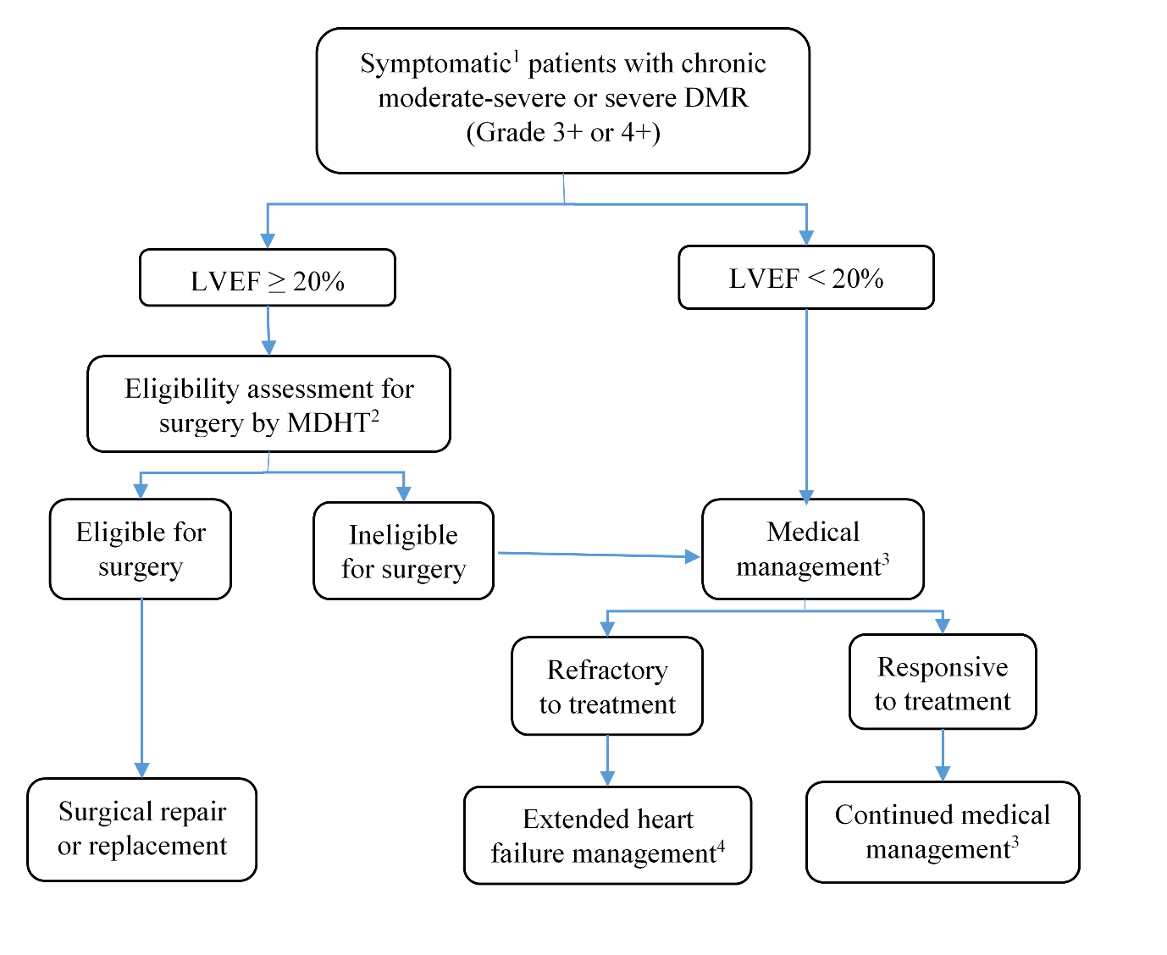
DMR, degenerative mitral regurgitation; MR, mitral regurgitation; NYHA, New York Heart Association; LVEF, left ventricular ejection fraction.
¹ Symptomatic = NYHA functional class II or greater
² Patients considered ineligible for surgery as determined by a multidisciplinary heart team, combining surgical risk assessment, frailty, major organ system dysfunction, and procedure-specific impediments.
³ Medical management refers to maximally tolerated guideline-directed medical therapy (GDMT)
⁴ Extended heart failure management includes cardiac resynchronisation therapy, ventricular assist devices, cardiac restraint devices and heart transplant

Current clinical management algorithm for population 2: FMR
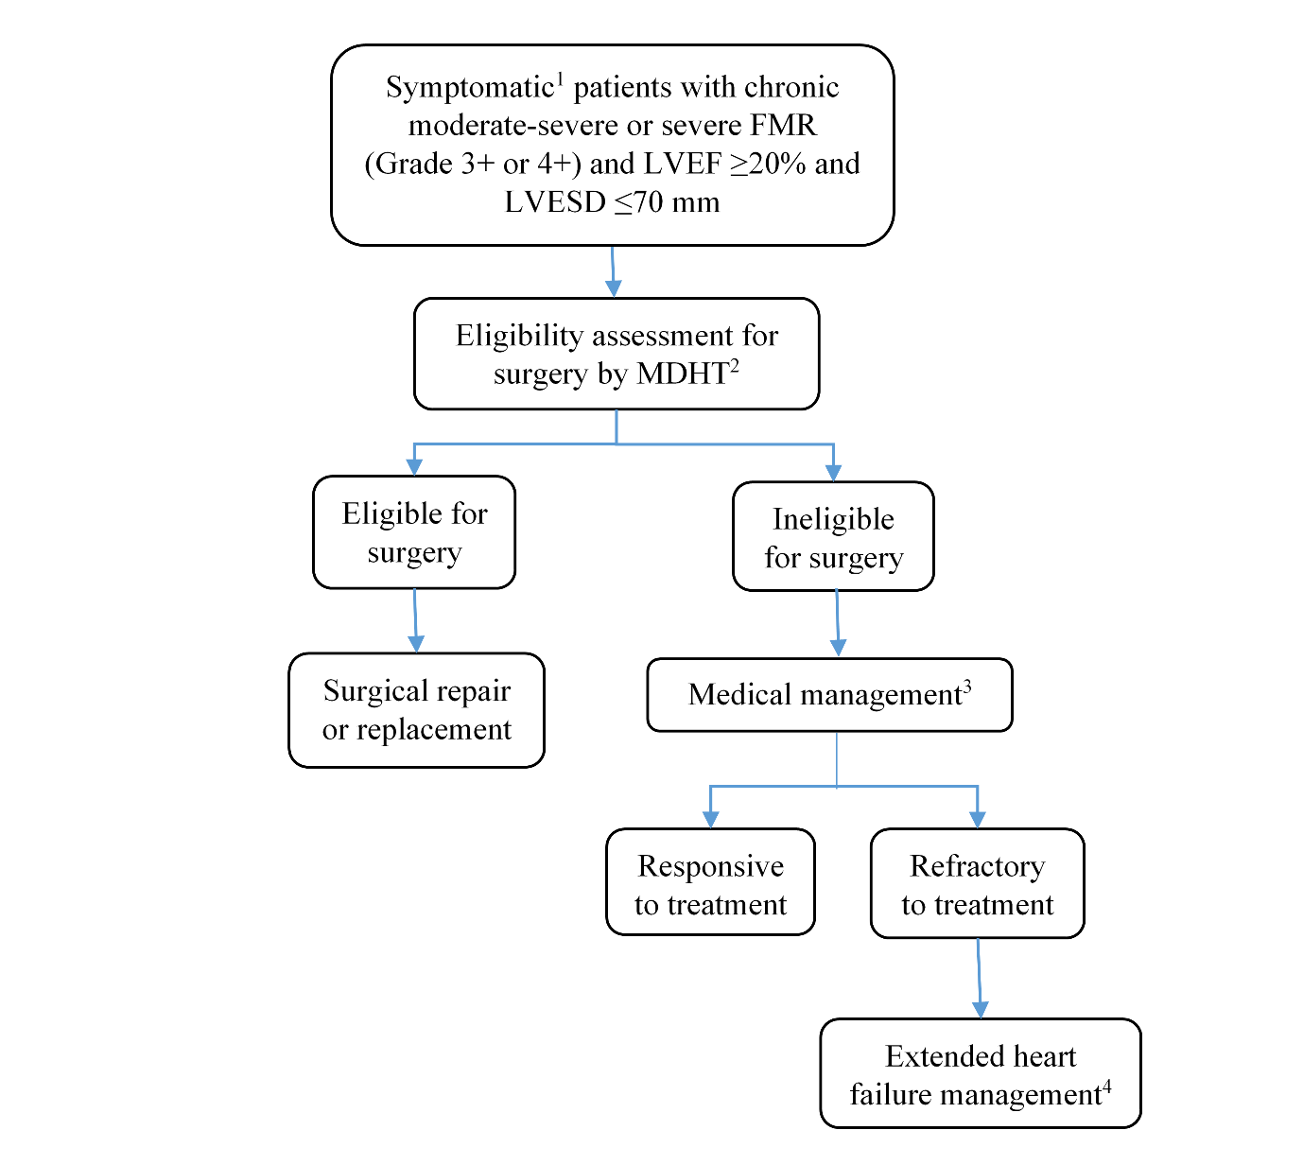
FMR, functional mitral regurgitation; MR, mitral regurgitation; NYHA, New York Heart Association; LVEF, left ventricular ejection fraction, ; LVESD, left ventricular end systolic dimension
¹ Symptomatic = NYHA functional class II or greater
² Patients considered ineligible for surgery as determined by a multidisciplinary heart team, combining surgical risk assessment, frailty, major organ system dysfunction, and procedure-specific impediments.
³ Medical management refers to maximally tolerated guideline-directed medical therapy (GDMT)
⁴ Extended heart failure management includes cardiac resynchronisation therapy, ventricular assist devices, cardiac restraint devices and heart transplant

Proposed clinical management algorithm for identified population
PASC recommended the following changes be made to the algorithms (which are now reflected in this PICO):
- For population 1, deletion of the “refractory to treatment” box leading from medical management to surgery; clinically, such patients would not undergo surgery.
- For population 2, the “surgical repair or replacement” box now sits under “eligible for surgery”, not alongside it.

LVESD has been added to FMR algorithms (current and proposed). PASC noted LVESD is the accepted measure to identify and assess dilatation.
Proposed clinical management algorithm for population 1: DMR
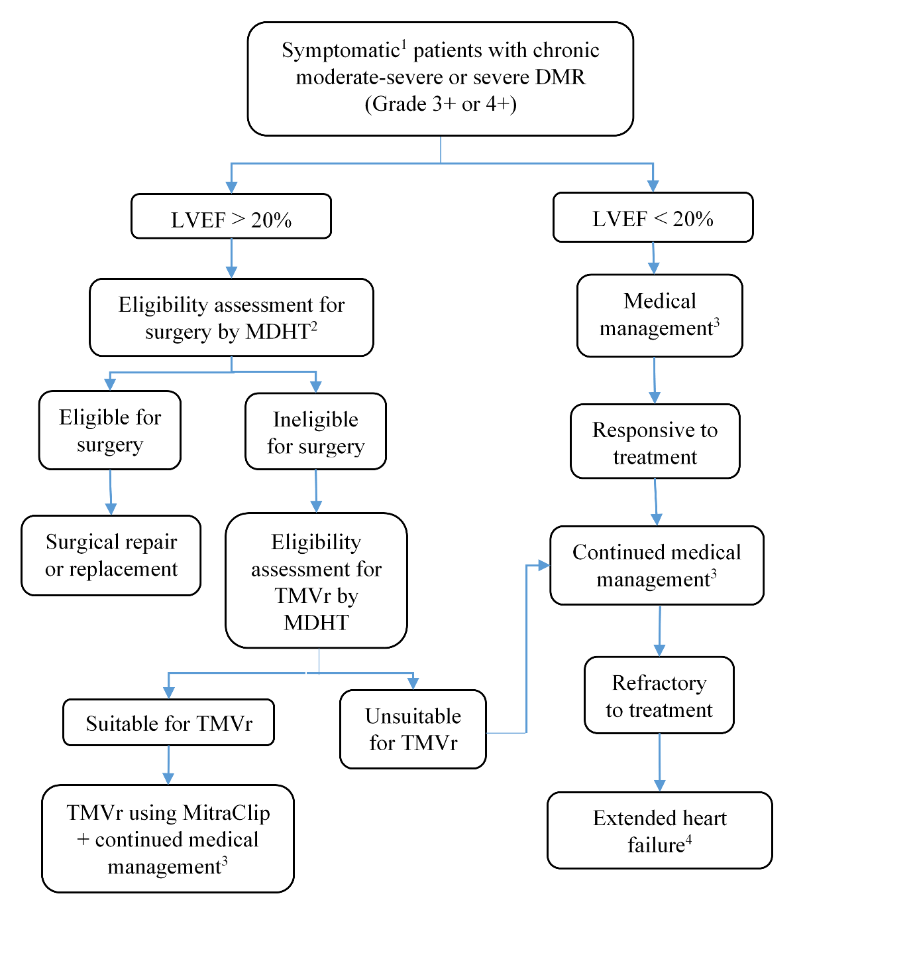
DMR, degenerative mitral regurgitation; MR, mitral regurgitation; NYHA, New York Heart Association; LVEF, left ventricular ejection fraction;,MDHT, multidisciplinary heart team, TMVr; transcatheter mitral valve repair
¹ Symptomatic = NYHA functional class II or greater
² Patients considered ineligible for surgery as determined by a multidisciplinary heart team (MDHT), combining surgical risk assessment, frailty, major organ system dysfunction, and procedure-specific impediments.
³ Medical management refers to maximally tolerated guideline-directed medical therapy (GDMT)
⁴ Extended heart failure management includes cardiac resynchronisation therapy, ventricular assist devices, cardiac restraint devices and heart transplant

Proposed clinical management algorithm for population 2: FMR
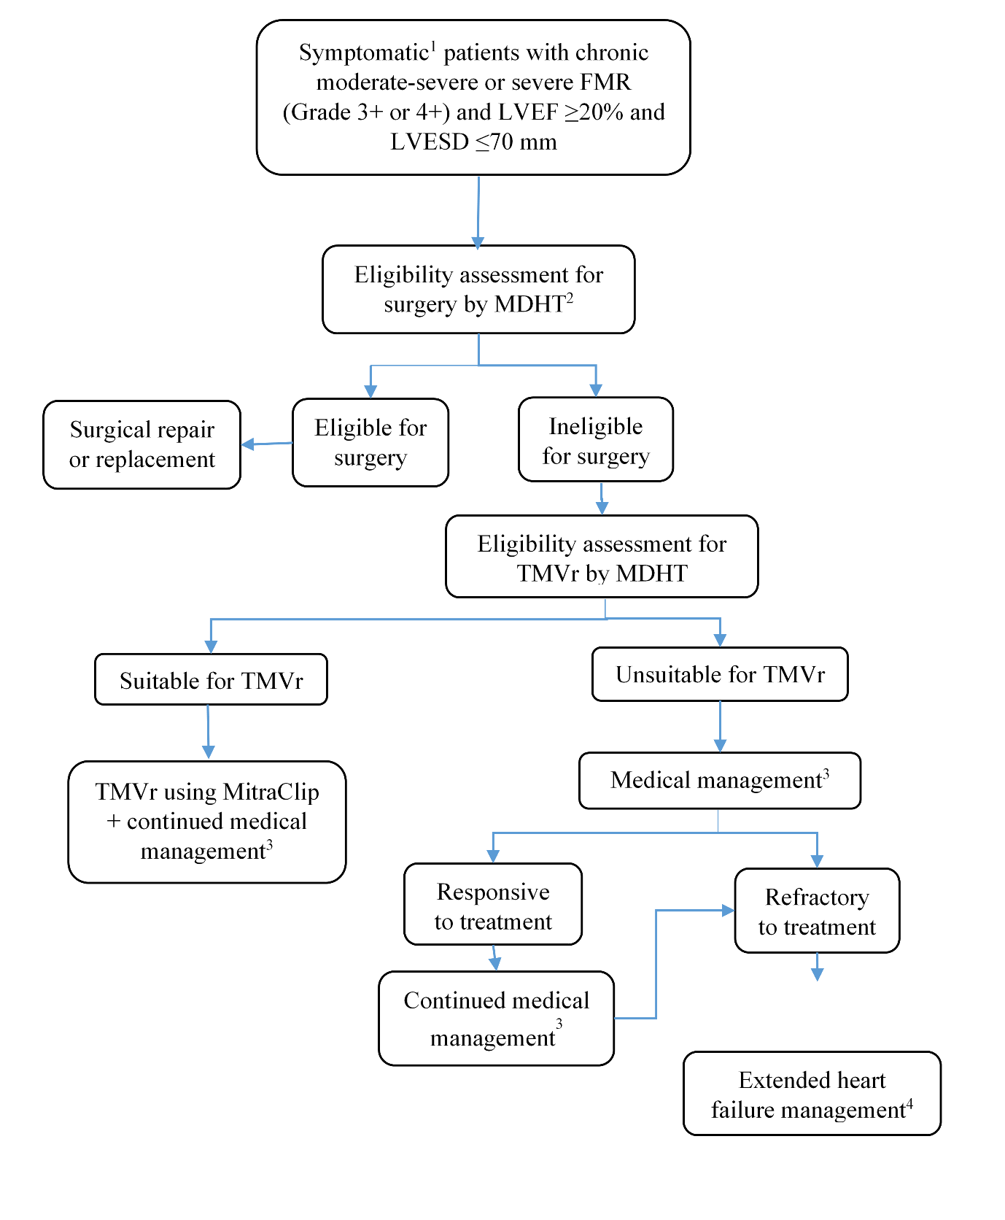
FMR, functional mitral regurgitation; MR, mitral regurgitation; NYHA, New York Heart Association; LVEF, left ventricular ejection fraction; MDHT, multidisciplinary heart team; LVESD, left ventricular end systolic dimension
¹ Symptomatic = NYHA functional class II or greater
² Patients considered ineligible for surgery as determined by a multidisciplinary heart team, combining surgical risk assessment, frailty, major organ system dysfunction, and procedure-specific impediments.
³ Medical management refers to maximally tolerated guideline-directed medical therapy (GDMT)
⁴ Extended heart failure management includes cardiac resynchronisation therapy, ventricular assist devices, cardiac restraint devices and heart transplant

Proposed economic evaluation
The clinical claim is that TMVr is non-inferior in safety and superior in clinical effectiveness to medical management in patients with DMR and FMR. According to the Technical Guidelines for preparing assessment reports for the Medical Services Advisory Committee: Investigative the required economic analysis is therefore a cost-utility or a cost-effectiveness analysis. However, if the evidence does not prove superiority or non-inferiority, then a cost-consequence model may be more appropriate.
In relation to Budget/financial impact, Extended Medicare Safety Net (EMSN) risk would need to be assessed during the evaluation phase, given out-of-hospital (non-admitted patient) 85% rebates are proposed for MitraClip.

Proposed MBS item descriptor and MBS fee
The proposed MBS item descriptors for TMVr (see below) are modelled on the transcatheter aortic valve implantation (TAVI) descriptor (MBS item 38495). It is also expected that explanatory notes, like those for item 38495, be included for the TMVr items.
Consistent with TAVI, it is proposed that there be two additional items relating to the case conference (to be listed for multidisciplinary planning of the TMVr service). The proposed MBS items are provided below, with fees based on existing fees for MBS case conference items 6080 and 6081.
Since the August 2019 PASC meeting, the applicant has confirmed the proposed MBS fee was benchmarked to existing MBS item 38487 (Open valvotomy of mitral valve). MBS fees for this item, TAVI and associated case conference items increased in July 2019 (as part of the regular MBS fee increases). These increased MBS fees are reflected in the draft item descriptors below.
The proposed MitraClip descriptors are based on TAVI (MBS item 38495), which has both in and out-of-hospital [non-admitted patient] MBS rebates. However, the proposed fees are based on open mitral valvotomy (item 38487), which is an in-hospital (admitted patient-only) procedure, with a $293 higher fee. Similar to TAVI, both in and out-of-hospital rebates are proposed for MitraClip.
While MitraClip would need to be performed in an appropriate hospital (similar to TAVI), patients without private health insurance may elect to be treated as non-admitted patients in a private hospital (or as a private patient in a public hospital). This would give them access to the Extended Medicare Safety Net (EMSN) to cover out-of-pocket costs. EMSN risk would need to be assessed during the evaluation phase.

Category 3 – Therapeutic procedures
MBS item #####
Transvenous/transseptal techniques for permanent coaptation of mitral valve leaflets using 1 or more tissue approximation devices in patients with moderate-severe or severe symptomatic degenerative mitral regurgitation (Grade 3+, 4+) as determined by echocardiography, as well as objective and subjective measures, who have left ventricular ejection fraction (LVEF) ≥20%, who are symptomatic (New York Heart Association [NYHA] functional class II or greater), who are determined by a multi-disciplinary heart team (MDHT), which includes a heart failure specialist, to be ineligible for surgical intervention but suitable for the MitraClip procedure, in a transmitral valve repair (TMVr) hospital on a TMVr patient by a TMVr practitioner – includes all intraoperative diagnostic imaging that the TMVr practitioner performs on the TMVr patient
(Not payable more than once per patient in a five-year period)
(See paragraph XX, XX of explanatory notes to this Category)
MBS Fee: $1,748.45 Benefit 75% = $1,311.35 85% = $1,665.05 (Greatest Permissible Gap = $83.40 for out-of-hospital services that have MBS fees of $556.30 or more)
MBS item #####
Transvenous/transseptal techniques for permanent coaptation of mitral valve leaflets using 1 or more tissue approximation devices in patients with disproportionally moderate-severe or severe FMR, as determined by echocardiography, as well as objective and subjective measures (i.e. MR grading of 3+ [moderate-severe] or 4+ [severe]), who have left ventricular (LV) ejection fraction (LVEF) ≥20% and severe LV dialation (defined asleft ventricular end systolic dimension (LVESD) ≤70mm) considered by the MDHT to be ineligible for surgical intervention, and whose symptoms (NYHA functional class II or greater) persist despite maximally tolerated guideline directed medical therapy (GDMT) as determined by the MDHT, which includes a heart failure specialist, in a transmitral valve repair (TMVr) hospital on a TMVr patient by a TMVr practitioner – includes all intraoperative diagnostic imaging that the TMVr practitioner performs on the TMVr patient
(Not payable more than once per patient in a five-year period)
(See paragraph XX, XX of explanatory notes to this Category)
MBS Fee: $1,748.45 Benefit 75% = $1,311.35 85% = $1,665.05 (Greatest Permissible Gap = $83.40 for out-of-hospital services that have MBS fees of $556.30 or more)
MBS item #####
Coordination of a TMVr Case Conference by a TMVr practitioner, where the TMVr Case Conference has a duration of 10 minutes or more
(Not payable more than once per patient in a five-year period)
MBS Fee: $51.70 Benefit 75% = $38.80 85% = $43.95
MBS item #####
Attendance at a TMVr Case Conference by a specialist or consultant physician (including a heart failure specialist) who does not also perform the service described in the item above for the same case conference, where the TMVr Case Conference has a duration of 10 minutes or more
(Not payable more than once per patient in a five-year period)
MBS Fee: $38.55 Benefit 75% = $28.95 85% = $32.80

Consultation feedback
Stakeholder consultation on this application indicated cautious support from two professional bodies, and support from a consumer organisation. Consequently, it is recommended that additional consumer input from a relevant patient advocacy organisation be pursued during the assessment phase.
NEXT STEPS
Once PICO 1192.3 is updated and ratified, the application can proceed to the pre-Evaluation Sub-Committee (ESC) stage, with the applicant electing to prepare its own ADAR (applicant-developed assessment report).
PASC recommended that the offer of additional consumer input from a relevant patient advocacy organisation be pursued during the assessment phase.

References
1. Nishimura Rick, A., et al., 2014 AHA/ACC Guideline for the Management of Patients With Valvular Heart Disease. Circulation, 2014. 129(23): p. e521-e643.
2. Zoghbi, W.A., et al., Recommendations for Noninvasive Evaluation of Native Valvular Regurgitation: A Report from the American Society of Echocardiography Developed in Collaboration with the Society for Cardiovascular Magnetic Resonance. J Am Soc Echocardiogr, 2017. 30(4): p. 303-371.
3. Marciniak, A., K. Glover, and R. Sharma, Cohort profile: prevalence of valvular heart disease in community patients with suspected heart failure in UK. BMJ Open, 2017. 7(1): p. e012240.
4. Mirabel, M., et al., What are the characteristics of patients with severe, symptomatic, mitral regurgitation who are denied surgery? Eur Heart J, 2007. 28(11): p. 1358-65.
5. Nishimura RA, O.C., Bonow RO, Carabello BA, Erwin JP 3rd, Fleisher LA, Jneid H, Mack MJ, McLeod CJ, O’Gara PT, Rigolin VH, Sundt TM 3rd, Thompson A. , 2017 AHA/ACC Focused Update of the 2014 AHA/ACC Guideline for the Management of Patients With Valvular Heart Disease. 2017.
6. Goel, S.S., et al., Prevalence and outcomes of unoperated patients with severe symptomatic mitral regurgitation and heart failure: comprehensive analysis to determine the potential role of MitraClip for this unmet need. J Am Coll Cardiol, 2014. 63(2): p. 185-6.
7. MSAC, Public Summary Document. Application No. 1192.1 – The reduction of severe mitral regurgitation through tissue approximation using transvenous/transseptal techniques. 2014: Canberra, Australia.
8. MSAC, Public Summary Document. Application No. 1192 – Reduction of Mitral Regurgitation through Tissue Approximation using Transvenous / Transseptal Techniques. 2012: Canberra, Australia.
9. MSAC, Public Summary Document. Application No. 1192.2 – The reduction of mitral regurgitation through tissue approximation using transvenous/transeptal techniques. 2016: Canberra, Australia.
10. Glower, D., et al., EVEREST II randomized clinical trial: predictors of mitral valve replacement in de novo surgery or after the MitraClip procedure. J Thorac Cardiovasc Surg, 2012. 143(4 Suppl): p. S60-3.
11. Swaans, M.J., et al., Survival of transcatheter mitral valve repair compared with surgical and conservative treatment in high-surgical-risk patients. JACC Cardiovasc Interv, 2014. 7(8): p. 875-81.
12. Velazquez, E.J., et al., The MitraClip and survival in patients with mitral regurgitation at high risk for surgery: A propensity-matched comparison. Am Heart J, 2015. 170(5): p. 1050-1059.e3.
13. Sorajja, P., et al., Outcomes With Transcatheter Mitral Valve Repair in the United States: An STS/ACC TVT Registry Report. J Am Coll Cardiol, 2017. 70(19): p. 2315-2327.
14. Baumgartner, H., et al., 2017 ESC/EACTS Guidelines for the management of valvular heart disease. Eur Heart J, 2017. 38(36): p. 2739-2791.
15. FDA, FDA approves new indication for valve repair device to treat certain heart failure patients with mitral regurgitation, in FDA News Release. 2019, Food and Drug Administration: US.
16. Stone, G.W., et al., Transcatheter Mitral-Valve Repair in Patients with Heart Failure. New England Journal of Medicine, 2018. 379(24): p. 2307-2318.
17. Obadia, J.-F., et al., Percutaneous Repair or Medical Treatment for Secondary Mitral Regurgitation. New England Journal of Medicine, 2018. 379(24): p. 2297-2306.
18. Atherton, J.J., et al., National Heart Foundation of Australia and Cardiac Society of Australia and New Zealand: Guidelines for the Prevention, Detection, and Management of Heart Failure in Australia 2018. Heart, Lung and Circulation, 2018. 27(10): p. 1123-1208.

