

Application Form

(New and Amended

Requests for Public Funding)

(Version 2.4)

This application form is to be completed for new and amended requests for public funding (including but not limited to the Medicare Benefits Schedule (MBS)). It describes the detailed information that the Australian Government Department of Health requires in order to determine whether a proposed medical service is suitable.

Please use this template, along with the associated Application Form Guidelines to prepare your application. Please complete all questions that are applicable to the proposed service, providing relevant information only. Applications not completed in full will not be accepted.

Should you require any further assistance, departmental staff are available through the Health Technology Assessment Team (HTA Team) on the contact numbers and email below to discuss the application form, or any other component of the Medical Services Advisory Committee process.

Phone: +61 2 6289 7550

Fax: +61 2 6289 5540

Email: [hta@health.gov.au](mailto:hta@health.gov.au)

Website: [www.msac.gov.au](http://www.msac.gov.au/)

# PART 1 – APPLICANT DETAILS

## Applicant details (primary and alternative contacts)

Corporation / partnership details (where relevant): Insert corporation/partnership details here if relevant

Corporation name: Redacted

ABN: Redacted

Business trading name: Redacted

**Primary contact name: Redacted**

Primary contact numbers

Business: Redacted

Mobile: Redacted

Email: Redacted

**Alternative contact name: Redacted**

Alternative contact numbers

Business: Redacted

Mobile: Redacted

Email: Redacted

## (a) Are you a lobbyist acting on behalf of an Applicant?

Yes

No

## If yes, are you listed on the Register of Lobbyists?

Yes

No

# PART 2 – INFORMATION ABOUT THE PROPOSED MEDICAL SERVICE

## Application title

Endoscopic Sleeve Gastroplasty (ESG) for the treatment of patients with Class I and Class II obesity with comorbidities who have failed first-line treatments.

## Provide a succinct description of the medical condition relevant to the proposed service (no more than 150 words – further information will be requested at Part F of the Application Form)

According to the Australian Institute of Health and Welfare, 63% of Australian adults were overweight or obese in 2014-15 [1]. Of this population, 28% are obese, equating to roughly six million Australians with a body mass index (BMI) of 30 and above. Current studies show that around 70% of obese individuals have at least one established morbidity, including but not limited to type-2 diabetes, heart disease, sleep apnoea, hypertension, stroke, and musculoskeletal diseases [2]. Obesity has also been linked to various cancers and it is estimated that 3.6% of all new cancers globally are attributable to overweight and obesity [3]. From an economic perspective, obese individuals have medical costs that are roughly 30% greater than their normal weight peers [4]. The latest PricewaterhouseCoopers report estimated that the direct and indirect costs of obesity in Australia is $8.65 billion, creating a large financial burden on Australia’s healthcare system as well as tying up valuable healthcare resources to treat this chronic disease [5].

## Provide a succinct description of the proposed medical service (no more than 150 words – further information will be requested at Part 6 of the Application Form)

Endoscopic Sleeve Gastroplasty is an incisionless, minimally invasive procedure developed for bariatric treatment. ESG is delivered in a single endoscopic session using commercially available equipment. ESG reduces gastric capacity between 70% and 85% by creating a restrictive sleeve through a series of endoscopically placed full-thickness sutures. This imbrication of the greater curvature of the stomach is similar to but not identical to sleeve gastrectomy in shape. The gastroplasty is created using an endoscopic suturing device fitted to an endoscope. An oesophageal overtube is using during the procedure as well as a tissue helix device to ensure full-thickness bites. The procedure is performed under general anaesthesia with endotracheal intubation.

## ****(a) Is this a request for MBS funding?****

Yes

No

## ****If yes, is the medical service(s) proposed to be covered under an existing MBS item number(s) or is a new MBS item(s) being sought altogether?****

Amendment to existing MBS item(s)

New MBS item(s)

## ****If an amendment to an existing item(s) is being sought, please list the relevant MBS item number(s) that are to be amended to include the proposed medical service:****

Insert relevant MBS item numbers here

## ****If an amendment to an existing item(s) is being sought, what is the nature of the amendment(s)?****

1. **An amendment to the way the service is clinically delivered under the existing item(s)**
2. **An amendment to the patient population under the existing item(s)**
3. **An amendment to the schedule fee of the existing item(s)**
4. **An amendment to the time and complexity of an existing item(s)**
5. **Access to an existing item(s) by a different health practitioner group**
6. **Minor amendments to the item descriptor that does not affect how the service is delivered**
7. **An amendment to an existing specific single consultation item**
8. **An amendment to an existing global consultation item(s)**
9. **Other (please describe below):**

Insert description of 'other' amendment here

## ****If a new item(s) is being requested, what is the nature of the change to the MBS being sought?****

1. **A new item which also seeks to allow access to the MBS for a specific health practitioner group**
2. **A new item that is proposing a way of clinically delivering a service that is new to the MBS (in terms of new technology and / or population)**
3. **A new item for a specific single consultation item**
4. **A new item for a global consultation item(s)**

## ****Is the proposed service seeking public funding other than the MBS?****

Yes

No

## ****If yes, please advise:****

Insert description of other public funding mechanism here

## What is the type of service:

Therapeutic medical service

Investigative medical service

Single consultation medical service

Global consultation medical service

Allied health service

Co-dependent technology

Hybrid health technology

## For investigative services, advise the specific purpose of performing the service *(which could be one or more of the following)*:

1. To be used as a screening tool in asymptomatic populations
2. Assists in establishing a diagnosis in symptomatic patients
3. Provides information about prognosis
4. Identifies a patient as suitable for therapy by predicting a variation in the effect of the therapy
5. Monitors a patient over time to assess treatment response and guide subsequent treatment decisions

## Does your service rely on another medical product to achieve or to enhance its intended effect?

Pharmaceutical / Biological

Prosthesis or device

No

## (a) If the proposed service has a pharmaceutical component to it, is it already covered under an existing Pharmaceutical Benefits Scheme (PBS) listing?

Yes

No

## If yes, please list the relevant PBS item code(s):

Insert PBS item code(s) here

## If no, is an application (submission) in the process of being considered by the Pharmaceutical Benefits Advisory Committee (PBAC)?

Yes (please provide PBAC submission item number below)

No

Insert PBAC submission item number here

## If you are seeking both MBS and PBS listing, what is the trade name and generic name of the pharmaceutical?

Trade name: Insert trade name here

Generic name: Insert generic name here

## (a) If the proposed service is dependent on the use of a prosthesis, is it already included on the Prostheses List?

Yes

No

## If yes, please provide the following information (where relevant):

Billing code(s): ER279, ER280

Trade name of prostheses: OverStitch™ Endoscopic Suturing System and Tissue Helix; OverStitch™ Polypropylene Suture and OverStitch™ Suture Cinch

Clinical name of prostheses: OverStitch™ Endoscopic Suturing System and Tissue Helix; OverStitch™ Polypropylene Suture and OverStitch™ Suture Cinch

Other device components delivered as part of the service:

Overtube Endoscopic Access System

## If no, is an application in the process of being considered by a Clinical Advisory Group or the Prostheses List Advisory Committee (PLAC)?

Yes

No

## Are there any other sponsor(s) and / or manufacturer(s) that have a similar prosthesis or device component in the Australian market place which this application is relevant to?

Yes

No

## If yes, please provide the name(s) of the sponsor(s) and / or manufacturer(s):

Insert sponsor and/or manufacturer name(s) here

## Please identify any single and / or multi-use consumables delivered as part of the service?

Single use consumables:

* Examination gloves
* Mouth guard
* Gel lubricant

Multi-use consumables:

* No specific items but as required for a procedure of this type

# PART 3 – INFORMATION ABOUT REGULATORY REQUIREMENTS

## (a) If the proposed medical service involves the use of a medical device, in-vitro diagnostic test, pharmaceutical product, radioactive tracer or any other type of therapeutic good, please provide the following details:

Type of therapeutic good: Medical Device Included Class IIa

Manufacturer’s name: Redacted

Sponsor’s name: Redacted

## Is the medical device classified by the TGA as either a Class III or Active Implantable Medical Device (AIMD) against the TGA regulatory scheme for devices?

Class III

AIMD

N/A

## (a) Is the therapeutic good to be used in the service exempt from the regulatory requirements of the *Therapeutic Goods Act 1989*?

Yes (If yes, please provide supporting documentation as an attachment to this application form)

No

## If no, has it been listed or registered or included in the Australian Register of Therapeutic Goods (ARTG) by the Therapeutic Goods Administration (TGA)?

Yes (if yes, please provide details below)

No

|  |  |  |  |
| --- | --- | --- | --- |
| **ARTG listing, registration or inclusion**  **number:** | **Registered item** | **TGA approved indication(s), if applicable:** | **TGA approved purpose(s), if applicable:** |
| 237774 | OverStitch Endoscopic Suturing System | N/A | A sterile, manually-operated device intended for endoscopic placement of suture(s) to be used in combination with a compatible flexible endoscope (e.g. gastroscope, laparoscope) to mechanically approximate soft tissue, typically during a gastrointestinal (GI) procedure. It is typically loaded with a needle/suture assembly and attached to the working end, or inserted through the working channel, of the endoscope. The device will also knot and cut sutures as they are stitched. Some types may also carry and/or knot a ligature. This is a single-use device. |
| 237773 | OverStitch Tissue Helix | N/A | A device used in combination with a dedicated endoscope during endotherapy. It is used for mechanical work, e.g. grasping tissue or foreign bodies. It functions without electricity, including e.g. high frequency, electromagnetic, ultrasonic or laser energy. It is disposable. |
| 245894 | OverStitch 2-0 Polypropylene Suture | N/A | The Demetech non-absorbable polypropylene suture is indicated for use in general soft tissue approximation and/or ligation, including use in ophthalmic procedures. Product is intended for use over 30 days. The product is not intended to be used on the heart or with the central circulatory and central nervous system. |
| 236906 | OverStitch Suture Cinch | N/A | The OverStitch Suture Cinch is intended to secure suture(s). The OverStitch Suture Cinch is part of the OverStitch Endoscopic Suturing System (ESS), which is intended for endoscopic placement of suture(s) and approximation of soft tissue. |
| 236427 | Overtube Endoscopic Access System | N/A | The overtube is intended to be used in conjunction with an endoscope for foreign body removal or endoscopic procedures requiring multiple insertions of the endoscope into the lower or upper gastrointestinal tract. |

## If the therapeutic good has not been listed, registered or included in the ARTG, is the therapeutic good in the process of being considered for inclusion by the TGA?

Yes (please provide details below)

No

Date of submission to TGA: Insert date of submission here

Estimated date by which TGA approval can be expected: Insert estimated date here

TGA Application ID: Insert TGA Application ID here

TGA approved indication(s), if applicable: If applicable, insert description of TGA approved indication(s) here

TGA approved purpose(s), if applicable: If applicable, insert description of TGA approved purpose(s) here

## If the therapeutic good is not in the process of being considered for listing, registration or inclusion by the TGA, is an application to the TGA being prepared?

Yes (please provide details below)

No

Estimated date of submission to TGA: Insert date of submission here

Proposed indication(s), if applicable: If applicable, insert description of proposed indication(s)

Proposed purpose(s), if applicable: If applicable, insert description of proposed purpose(s) here

# PART 4 – SUMMARY OF EVIDENCE

## Provide an overview of all key journal articles or research published in the public domain related to the proposed service that is for your application (limiting these to the English language only). *Please do not attach full text articles, this is just intended to be a summary.*

|  | Type of study design* | Title of journal article or research project (including any trial identifier or study lead if relevant) | Short description of research (max 50 words)** | Website link to journal article or research (if available) | Date of publication*** |
| --- | --- | --- | --- | --- | --- |
| 1 | Case report | Endoscopic Sleeve Gastroplasty of the Remnant Stomach in Roux-en-Y Gastric Bypass: A Novel Approach to a Gastrogastric Fistula with Weight Regain | A case report of a 56-year-old man with a previous RYGB but who presented with weight regain of 100 pounds over a one year period due to a 3cm gastrogastric fistula. An ESG was performed on the remnant stomach to shunt oral intake away from the fistula and into the repaired remnant stomach. The procedure was completed without complications. | https://www.thieme-connect.de/products/ejournals/abstract/10.1055/s-0044-101829 | 1 June 2018 |
| 2 | Systematic review and meta-analysis | Efficacy of Endoscopic Interventions for Management of Obesity: A Meta-Analysis to Compare Endoscopic Sleeve Gastroplasty, Aspire Assist, and POSE | A meta-analysis was conducted on 12 total studies of ESG, Aspire, and POSE. Main outcomes evaluated were excess weight loss and total body weight loss. ESG and AA were found to have no difference in EWL% and ESG was found to have a significant amount more sustained weight loss than POSE. | https://www.giejournal.org/article/S0016-5107(18)30328-6/fulltext | 30 May 2018 |
| 3 | Single-centre prospective case study | Endoscopic Vertical Gastroplasty is an Effective and Safe Technique for Body Weight Loss in Obese Patients | 72 obese patients received an endoscopic vertical gastroplasty as an alternative treatment to bariatric surgery. Patients were followed up for a 12-month period, post-procedure. At 12 months, %EBWL was 81.84% and there were no serious adverse events recorded. | https://www.giejournal.org/article/S0016-5107(18)32576-8/pdf | 30 May 2018 |
| 4 | Single-centre prospective case study | Weight Loss and Improvement in Hepatic Steatosis Index After Endoscopic Sleeve Gastroplasty | Endoscopic Sleeve Gastroplasty was performed on 47 patients with non-alcoholic fatty liver disease (NAFLD) as a component of a comprehensive weight loss program. Liver enzymes were tested before the procedure and again six months post-procedure. Average ALT levels decreased from 32 to 24 and average AST levels decreased from 27 to 22. The number of patients with NAFLD decreased from 47 to 43 over the six-month follow-up period. | https://www.gastrojournal.org/article/S0016-5085(18)31708-6/fulltext | 30 May 2018 |
| 5 | Single-centre retrospective case study | Weight Outcomes of Laparoscopic Sleeve Gastrectomy versus Endoscopic Sleeve Gastroplasty: A Case Control Study | 86 patients underwent either an LSG (n= 65) or ESG (n=21) and a retrospective analysis was done to compare weight outcomes and adverse event profiles. Study authors noted that both ESG and LSG achieved significant %TBWL at six months. LSG achieved greater %TBWL than ESG, particularly in patients with BMI > 40. It was noted that ESG may be an effective alternative to LSG but not in morbidly obese patients. | https://www.sciencedirect.com/science/article/pii/S0016510718325719 | 30 May 2018 |
| 6 | Single-centre prospective case study | Bariatric Endoscopy Effectiveness in Health-Related Quality of Life | 107 patients were treated with two bariatric endoscopy procedures, intragastric balloon or endoscopic sleeve gastroplasty. Health Related Quality of Life was measured before the procedure and at follow-up of 8-12 months. At follow-up, all scales had statistically significant improvements except for mental health. | https://www.gastrojournal.org/article/S0016-5085(18)32321-7/abstract | 1 May 2018 |
| 7 | Single-centre retrospective case study | Endoscopic Sleeve Gastroplasty is Safe and Effective in Morbid Obesity | 12 patients with a BMI >35 were treated with endoscopic sleeve gastroplasty. Mean weight loss at six months was 16kg (14.4% of initial weight). | https://www.thieme-connect.de/products/ejournals/abstract/10.1055/s-0038-1637196 | 1 April 2018 |
| 8 | Single-centre prospective case study | Endoscopic Sleeve Gastroplasty using Apollo OverStitch as a Bridging Procedure for Superobese and High Risk Patients | A small case study reporting results of ESG performed on five superobese patients. All patients were ineligible for open or laparoscopic bariatric procedures due to surgical contraindications or were considered too-high risk. The case study reported no perioperative complications and mean weight loss at 3 months of 34.5kg. | https://www.thieme-connect.de/DOI/DOI?10.1055/s-0043-119685 | 1 March 2018 |
| 9 | Single-centre retrospective case study | Modified Endoscopic Gastroplasty for the Treatment of Obesity | A retrospective study of 148 patients who underwent ESG. %TWL was 17.53 in 12 months and 18.5 in 18 months indicating durability of the procedure. | https://link.springer.com/article/10.1007%2Fs00464-018-6133-0 | 28 February 2018 |
| 10 | Multi-centre retrospective case study | Endoscopic Sleeve Gastroplasty (ESG) Is a Reproducible and Effective Endoscopic Bariatric Therapy Suitable for Widespread Clinical Adoption: a Large, International Multicenter Study | A multi-centre retrospective analysis of 112 ESG patients to examine the reproducibility, efficacy, and safety in three centres across two countries. At 6 months post-ESG, 81% of patients attained greater than 10% TBWL and 86.5% of patients attained greater than 25% EWL. | https://link.springer.com/article/10.1007%2Fs11695-018-3135-x | 15 February 2018 |
| 11 | Single-centre retrospective case study | Endoscopic Sleeve Gastroplasty, Laparoscopic Sleeve Gastrectomy, and Laparoscopic Band for Weight Loss: How Do They Compare? | A retrospective analysis was performed on case files from 278 obese patients who were treated with ESG, LSG, or LAGB. %TBWL at 12-month follow-up was 29.28 for LSG, 13.30 for LAGB and 17.57% for ESG; however, ESG had a significantly lower rate of morbidity compared to LSG and LAGB as well as a shorter Length of Stay. | https://link.springer.com/article/10.1007%2Fs11605-017-3615-7 | 6 November 2017 |
| 12 | Multi-centre prospective study | Endoscopic Sutured Gastroplasty: Procedure Evolution from First-in-Man | Prospective trial performed at centres in five countries and in three phases evaluating safety, technical feasibility, efficiency, and weight loss outcomes. Phase III conformed to a standardised ESG technique with subjects losing 17.4% TWL at 12 months and no significant adverse events post-procedure or during the follow-up period. | https://link.springer.com/article/10.1007%2Fs00464-017-5869-2 | 26 October 2017 |
| 13 | Single-centre prospective case study | Endoscopic Sleeve Gastroplasty: The Learning Curve | 21 cases of ESG were performed by one endoscopist between February and November 2016. Key measurements for the study were to measure length of procedure (LOP) and number of plications. LOP decreased significantly across procedures with a learning plateau of 101.5 minutes and a learning rate of 7 cases. The number of plications decreased with a plateau at 8 sutures. | https://www.thieme-connect.de/products/ejournals/abstract/10.1055/s-0043-115387 | 1 September 2017 |
| 14 | Single-centre prospective case study | Early Experience with Endoscopic Sleeve Gastroplasty and Hints at Mechanisms of Action | An analysis was performed on the case files of 128 patients who underwent ESG at a tertiary care academic medical centre. The purpose was to describe the learning curve for performing ESG. Efficiency for ESG was attained after 38 cases, with mastery after 55 procedures. | https://www.giejournal.org/article/S0016-5107(17)32196-X/abstract | 24 August 2017 |
| 15 | Multi-centre retrospective case review | Endoscopic Sleeve Gastroplasty: A New Tool to Manage Obesity | A review of nine original studies describing ESG with a total sample size of 172 subjects. Of the 65 subjects with follow-up data, 95.4% had intact gastric sleeve confirmed at the end of the study follow-up interval. Statistically significant weight loss was reported in seven of the eight studies with available data. | https://www.e-ce.org/journal/view.php?doi=10.5946/ce.2017.032 | 13 June 2017 |
| 16 | Multi-centre retrospective study | Endoscopic Sleeve Gastroplasty for Obesity: a Multicenter Study of 248 Patients with 24 Months Follow-up | A retrospective analysis was performed across three centres, encompassing 248 ESG patients. Of the 92 patients who completed 24-month follow-up, % TBWL was 18.6% without significant difference between the centres. 84% of patients achieved > 10% TBWL at 24 months. Weight loss at 6 months highly predicted weight maintenance and weight loss at 24 months. | <https://www.nwls.com.au/pdf/endoscopic-sleeve-gastroplasty.pdf> | 27 April 2017 |
| 17 | Case report | Technical Aspects of Endoscopic Sleeve Gastroplasty | Case report of a 35-year-old woman who underwent an ESG procedure after failing to lose weight by conventional obesity management methods. The author of the case report set out to determine the ideal suture patter, how many sutures should be used, how much of the fundus should remain, and what is the mechanism of action for an ESG. | https://endoscopedia.com/2017/03/31/technical-aspects-of-endoscopic-sleeve-gastroplasty/ | 1 March 2017 |
| 18 | Single-centre prospective study | Endoscopic Sleeve Gastroplasty Alters Gastric Physiology and Induces Loss of Body Weight in Obese Individuals | A prospective study of 25 obese patients to investigate the durability of ESG procedure and its effects on body weight and gastrointestinal function. Subjects lost 54% EWL at 12 months and physiological analyses showed delayed gastric emptying and a decrease in caloric consumption. | https://www.cghjournal.org/article/S1542-3565(15)01714-0/fulltext#sec2.5 | 1 January 2017 |
| 19 | Single-centre prospective study | Endoscopic Sleeve Gastroplasty Significantly Reduces Body Mass Index and Metabolic Complications in Obese Patients | ESG was performed on 91 patients. All patients had a BMI greater than 30 kg/m2 and had failed non-invasive weight loss measures,or had a BMI greater than 40 kg/m2 and were not considered as surgical candidates or refused surgery. At 12 months post-ESG, patients had lost 17.6% total body weight and showed statistically significant reductions in haemoglobin A1c, systolic blood pressure, waist circumference, and serum triglycerides. | https://www.cghjournal.org/article/S1542-3565(16)31236-8/fulltext | 22 December 2016 |
| 20 | Single-centre prospective study | Endoscopic Sleeve Gastroplasty for Obesity: Two Years of Experience | A prospective study of 154 patients to evaluate ESG for effectiveness, safety, weight evolution, and two-year outcomes. At two years, there was a mean BMI change from 38.3 to 30.8kg/m2. %TBWL and %EWL were 19.5% and 60.4% with 85.7% of patients achieving the goal of >25% %EWL. | http://www.scielo.br/scielo.php?script=sci_arttext&pid=S0102-67202017000100018&lng=en&tlng=en | 6 December 2016 |
| 21 | Case report | Endoscopic Sleeve Gastroplasty- Minimally Invasive Therapy for Primary Obesity Treatment | Case study reporting the details of an ESG being performed on a 56-year-old male patient with BMI 35.17 kg/m2. The patient had been treated for the previous two years by a multidisciplinary team but failed clinical/drug treatment for obesity. ESG procedure time was 50 minutes and the patient was discharged from the hospital on the second day after surgery. | http://www.scielo.br/scielo.php?script=sci_arttext&pid=S0102-67202016000600095&lng=en&tlng=en | 5 April 2016 |
| 22 | Single-centre prospective study | Endoscopic Sleeve Gastroplasty with 1-Year Follow-up: Factors Predictive of Success | 25 patients were treated with endoscopic sleeve gastroplasty with results being recorded at one year after the procedure. Post-procedure care was provided by a multidisciplinary team. There was a correlation between the frequency of nutritional and psychological contacts and greater total body weight loss. | https://www.thieme-connect.de/DOI/DOI?10.1055/s-0041-110771 | 1 February 2016 |
| 23 | Single-centre prospective study | Endoscopic Sleeve Gastroplasty: How I Do it? | 50 patients were treated with endoscopic sleeve gastroplasty and details given regarding procedural time as well as post-procedure outpatient care. At one year, 100% of sleeves were intact and patients experienced mean %TBWL of 19.0. There was a reduction in BMI from a starting point of 37.7 to 30.9 kg/m2. | https://link.springer.com/article/10.1007%2Fs11695-015-1714-7 | 24 May 2015 |
| 24 | Single-centre prospective study | Endoscopic Sleeve Gastroplasty for the Treatment of Obesity | 20 obese patients were treated with endoscopic sleeve gastroplasty to reduce gastric volume endoluminally. There were no adverse events and all patients were discharged in less than 24 hours. At 6 months, mean body weight was reduced by 17.8%. | https://www.thieme-connect.de/DOI/DOI?10.1055/s-0034-1390766 | 1 May 2015 |
| 25 | Single-centre prospective study | Initial Experience with Endoscopic Sleeve Gastroplasty: Technical Success and Reproducibility in the Bariatric Population | 10 patients were treated for obesity with ESG. At 6 months post-procedure, excess weight loss of 30% was observed and mean loss was recorded as 33 kg | https://www.thieme-connect.de/DOI/DOI?10.1055/s-0034-1390773 | 2 September 2014 |
| 26 | Multi-centre First-in-Human Case Study | Endoscopic Sleeve Gastroplasty for Primary Therapy of Obesity: Initial Human Cases | Review of the first-in-human ESG cases performed in India, Panama, and the Dominican Republic to evaluate safety, technical feasibility, procedure technique, and patient outcomes. Over the course of 28 procedures, technique was significantly refined with the final method achieving gastric volume reduction and improvements in procedure time. | https://www.gastrojournal.org/article/S0016-5085(14)62071-0/pdf | 1 January 2014 |
| 27 | Single-centre, pilot feasibility study | Endoscopic Sleeve Gastroplasty: A Potential Endoscopic Alternative to Surgical Sleeve Gastrectomy for Treatment of Obesity | Feasibility study to demonstrate technical feasibility of transoral endoscopic gastric volume reduction with an endoscopic suturing device. Endoscopic gastroplasty was successfully completed in 100% of test subjects thereby mimicking the anatomic manipulations created by surgical sleeve gastrectomy endoscopically. | https://www.giejournal.org/article/S0016-5107(13)01865-8/fulltext | 28 May 2013 |

*\* Categorise study design, for example meta-analysis, randomised trials, non-randomised trial or observational study, study of diagnostic accuracy, etc.*

*\*\*Provide high level information including population numbers and whether patients are being recruited or in post-recruitment, including providing the trial registration number to allow for tracking purposes.*

*\**\*\* *If the publication is a follow-up to an initial publication, please advise.*

## Identify yet to be published research that may have results available in the near future that could be relevant in the consideration of your application by MSAC (limiting these to the English language only). *Please do not attach full text articles, this is just intended to be a summary.*

|  | Type of study design* | Title of research (including any trial identifier if relevant) | Short description of research (max 50 words)** | Website link to research (if available) | Date*** |
| --- | --- | --- | --- | --- | --- |
| 1. | Single-centre prospective randomised case study | NCT03206905; Safety, Tolerability, and Sustained Weight Loss of Endoscopic Sleeve Gastroplasty with Diet Modification and Exercise | On-going clinical trial enrolling 34 participants to compare the effect of ESG with diet and exercise, to diet and exercise alone, to see which is better in weight loss reduction. A comparison of resolution or improvements in comorbidities will also be studied between the two cohorts. Patients are currently being recruited for this trial. | https://clinicaltrials.gov/ct2/show/NCT03206905 | 31 July 2019 |
| 2. | Single-centre observational prospective case study | NCT02948621; Endoscopic Sleeve Gastroplasty (Endosleeve) | On-going clinical trial enrolling 20 participants to assess weight loss after ESG in patients with morbid obesity. Primary outcomes are weight loss, excess weight loss, and body mass index variation. Patients are currently being recruited for this trial. | https://clinicaltrials.gov/ct2/show/NCT02948621 | October 2019 |
| 3. | Multi-centre randomised prospective study | NCT03493620; Efficacy and Results of Endoscopic Gastroplasty Using OverStitch in Patients with Class I and II Obesity | On-going clinical trial enrolling 60 participants to evaluate the effect of ESG on patients with Class I or II obesity, without comorbidities. The primary outcome is weight loss with secondary outcomes of weight maintenance at two years as well as surgical related complications. Patients are currently being recruited for this trial. | https://clinicaltrials.gov/ct2/show/NCT03493620 | 1 August, 2020 |
| 4. | Multi-centre randomised interventional trial | NCT03406975; Multicenter ESG Randomized Interventional Trial (MERIT) | On-going clinical trial enrolling up to 200 participants across eight locations in the United States. The purpose of the trial is to compare how effective ESG if for achieving long-term weight loss when compared to lifestyle modification only. Patients are currently being recruited for this trial. | https://clinicaltrials.gov/ct2/show/NCT03406975 | 31 December, 2020 |

*\* Categorise study design, for example meta-analysis, randomised trials, non-randomised trial or observational study, study of diagnostic accuracy, etc.*

*\*\*Provide high level information including population numbers and whether patients are being recruited or in post-recruitment.*

*\**\*\**Date of when results will be made available (to the best of your knowledge).*

# PART 5 – CLINICAL ENDORSEMENT AND CONSUMER INFORMATION

## List all appropriate professional bodies / organisations representing the group(s) of health professionals who provide the service (please attach a statement of clinical relevance from each group nominated):

Australian & New Zealand Metabolic and Obesity Surgery Society (ANZMOSS).

## List any professional bodies / organisations that may be impacted by this medical service (i.e. those who provide the comparator service):

Australian & New Zealand Metabolic and Obesity Surgery Society (ANZMOSS)

## List the relevant consumer organisations relevant to the proposed medical service (please attach a letter of support for each consumer organisation nominated):

None

## List the relevant sponsor(s) and / or manufacturer(s) who produce similar products relevant to the proposed medical service:

None

## Nominate two experts who could be approached about the proposed medical service and the current clinical management of the service(s):

Name of expert 1: Redacted

Telephone number(s): Redacted

Email address: Redacted

Justification of expertise: Redacted

Name of expert 2: Redacted

Telephone number(s): Redacted

Email address: Redacted

Justification of expertise: Redacted

*Please note that the Department may also consult with other referrers, proceduralists and disease specialists to obtain their insight.*

# PART 6 – POPULATION (AND PRIOR TESTS), INDICATION, COMPARATOR, OUTCOME (PICO)

PART 6a – INFORMATION ABOUT THE PROPOSED POPULATION

## Define the medical condition, including providing information on the natural history of the condition and a high level summary of associated burden of disease in terms of both morbidity and mortality:

Obesity is a chronic medical condition in which excess body fat has accumulated to the extent that it may have a negative effect on health [9]. Obesity is defined by a body mass index (BMI) of over 30 kg/m2 and can also be measured in terms of fat distribution via the waist-hip ratio and total cardiovascular risk factors [10]. Obesity is a growing global pandemic which can be caused by diet and sedentary lifestyle as well as other factors including genetics, medical conditions, and social determinants [11]. Obesity currently affects roughly 28% of the Australian population, with Australia coming in as the fifth most obese country globally according to the latest report from the Organisation for Economic Co-operation and Development (OECD) [12].

**Morbidity**

It is well-documented that obesity greatly increases the prevalence of co-morbid conditions [13]. Figure 1 shows the difference in co-morbid conditions between normal weight patients and obese patients.

*Figure 1: Source: ABS (Australian Bureau of Statistics) 2015. National Health Survey: first results, 2014–15. ABS cat no. 4364.0.55.001. Canberra: ABS*

Having an elevated body mass index (BMI) has a major effect on a person’s health and wellbeing, because it is associated with diseases such as cardiovascular disease, diabetes, stroke and several cancers. Elevated BMI also has a significant effect on health costs for governments and the private sector.

In 2011–12, cardiovascular disease and type 2 diabetes accounted for approximately $16 billion of the total expenditure on health services in Australia. This figure is expected to increase to $58 billion, or 14%, of current health expenditure in 2031–32 [15].

Overall, current expenditure for cardiovascular disease and type 2 diabetes is expected to increase by more than two and a half times by 2031–32. Of the cardiovascular expenditure of $14.2 billion in 2011–12, about one-fifth ($2.7 billion) is estimated to be attributable to elevated BMI. In 2031–32, $11.5 billion of cardiovascular expenditure of $51.1 billion will be attributable to elevated BMI. This is an extra $8.8 billion or an increase of 322% from 2011–12 to 2031–32. Of the type 2 diabetes expenditure of $1.7 billion in 2011–12, over two-thirds ($1.2 billion) is attributable to elevated BMI. In 2031–32, $5.4 billion of the type 2 diabetes expenditure of $6.8 billion will be attributable to elevated BMI, an increase of $4.2 billion, or 352% from 2011–12 to 2031–32. For cardiovascular disease, overweight people contribute about one-third of costs attributable to BMI and obese people contribute about two-thirds. In 2011–12, cardiovascular expenditure attributable to elevated BMI per overweight person was $141 and per obese person it was $369.

Approximately one in three obese people had measured hypertension (high blood pressure), compared to about one in eight underweight people or people of normal weight.

Self-reported type 2 diabetes was eight times more prevalent among obese adults than among normal-weight and underweight adults.

Self-reported prevalence of heart disease was approximately three times higher in people classified as obese as among those in the underweight and normal weight category.

**Mortality**

According to the Australian Burden of Disease Study 2011, overweight and obesity were one of the leading risk factors for ill health and death, with 5.5% of all disease and injury burden related to high body mass index. [16]. Of this 5.5%, 74% was fatal burden from a number of linked diseases. Figure 2 below details the top eight diseases linked to high body mass index and the burden outcome.

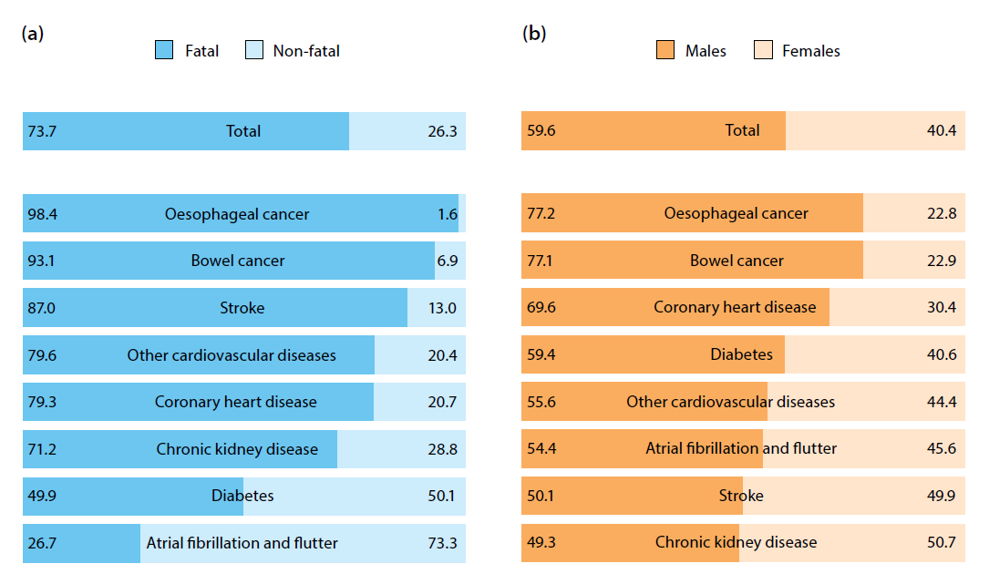  
*Figure 2. Source Australian Burden of Disease Study 2011.*

## Specify any characteristics of patients with the medical condition, or suspected of, who are proposed to be eligible for the proposed medical service, including any details of how a patient would be investigated, managed and referred within the Australian health care system in the lead up to being considered eligible for the service:

Patients 18 years of age or over who have

* BMI ≥30<40 kg/m2 who have comorbidities and who have failed first line treatment options.

To be considered for this medical service, patients as described above should initially visit their GP to discuss their weight and weight loss options that are available to them. Early stage interventions can include diet, exercise, medically managed weight loss and pharmacotherapy. If first line interventions fail to facilitate weight loss and improvement in comorbid conditions, patients should be referred to a bariatric specialist for further treatment options.

## Define and summarise the current clinical management pathway *before* patients would be eligible for the proposed medical service (supplement this summary with an easy to follow flowchart [as an attachment to the Application Form] depicting the current clinical management pathway up to this point):

Two main options are available, and the choice of therapies should be guided by patient BMI, previous weight loss interventions and response.

1. Very Low Energy Diet (VLED) is an initial option for individuals who have not tried this previously and are willing to use meal replacements. If effective in achieving adequate weight loss, the meal replacements can be reduced, and the diet can be replaced with a weight maintenance diet. If weight is regained the VLED can be reintroduced.
2. Pharmacotherapy can be considered in individuals who do not have an adequate initial response to the VLED, or who regain weight once the VLED is relaxed.

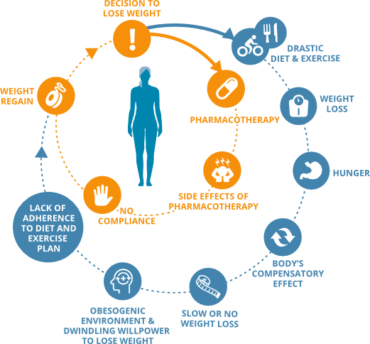

Figure 3. Current treatment algorithm for weight loss

Describes the treatment pathway administered before the proposed medical service.


PART 6b –

INFORMATION ABOUT THE INTERVENTION

## Describe the key components and clinical steps involved in delivering the proposed medical service:

Upon referral to a bariatric surgeon or gastroenterologist, patients will be assessed for their suitability for an endoscopic sleeve gastroplasty. Patients may be excluded from having the procedure if a contraindication is confirmed during the pre-procedure assessment. Contraindications include but are not limited to: family history of stomach cancer, cirrhosis, pregnancy, prior gastric surgery, gastric ulceration, anticoagulation, or any active medical condition that would preclude a safe endoscopic suturing procedure [6,7].

Patients deemed suitable for the procedure are instructed to begin a course of PPI one week preceding the procedure. On the day preceding the procedure, a liquid diet is prescribed with NPO after midnight. Patients are prescribed Emend (Aprepitant) to be taken on the day of the procedure as well as the day after [7].

In most cases, endoscopic sleeve gastroplasty has been performed as a day surgery, with no overnight hospitalisation required. This may vary depending on the physician’s follow-up preference or hospital guidelines.

The procedure is performed under general anaesthesia with the patient in the left lateral position. An overtube is placed with a diagnostic scope during the initial evaluation of the pylorus and to obtain GE junction measurements. Argon plasma coagulation (APC) may be used to mark the anterior wall and posterior wall of the greater curvature. The use of APC may be eliminated in future procedures as the physician becomes more proficient in endoscopic suturing and gains more familiarity with the procedure. A full-thickness endoscopic suturing system is then inserted via a therapeutic gastroscope. An initial row of sutures is placed distally to proximally from the anterior wall to the greater curve to the posterior wall in a triangular pattern. Five to six bites of tissue are taken with the suturing device before the suture needle, or anchor, is released. Upon release of the anchor, a cinching device is used to cut the suture and proximate the tissue by releasing a secondary T tag. A second row of sutures is placed in the opposite direction from anterior to posterior, ensuring that full-thickness bites are taken to avoid the creation of gastric pockets [7]. A tissue grasper or helix may be used to maximise the amount of tissue sutured in each bite. The numbers of sutures and cinches will vary in each procedure based on patient anatomy, as well as physician preference and experience. The fundus should be left un-sutured and sutures should be placed until the endoscope begins to retroflex uncomfortably [8]. Following completion of the procedure, the endoscopic suturing device should be removed from the endoscope and a quick endoscopy performed to ensure there is no bleeding and to check for completeness of the sleeve. Upon completion, stomach volume is reduced by up to 70% [8]

Post-procedure, ESG patients are instructed to follow a standard post-bariatric procedure diet, including a transition from liquids to pureed foods then to solids foods over the course of several weeks. Medications are also prescribed to manage pain, nausea, and heartburn.

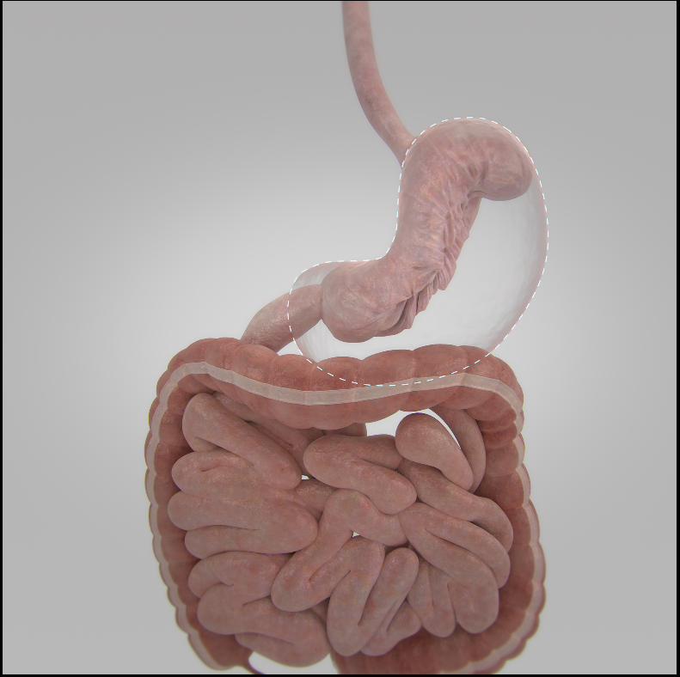  
ESG versus native stomach. Image provided by Apollo Endosurgery Inc.

## Does the proposed medical service include a registered trademark component with characteristics that distinguishes it from other similar health components?

OverStitch Endoscopic Suturing System is a trademarked device involving the placement of full-thickness sutures using an endoscopic curved needle arm and anchor exchange device.

## If the proposed medical service has a prosthesis or device component to it, does it involve a new approach towards managing a particular sub-group of the population with the specific medical condition?

## Endoscopic Sleeve Gastroplasty does not require a new treatment plan or approach pre or post-operatively, but the procedure itself is different in that it is an incisionless and minimally invasive procedure utilising an endoscopic, rather than laparoscopic or open, approach developed for bariatric treatment.

## If applicable, are there any limitations on the provision of the proposed medical service delivered to the patient (i.e. accessibility, dosage, quantity, duration or frequency):

The proposed medical service is recommended for obese patients with a minimum BMI of 30 kg/m2. In addition, this medical service is contraindicated for patients who:

* Have a family history of stomach cancer
* Have cirrhosis
* Are pregnant or who are planning to become pregnant in the next 12 months
* Have gastric ulcers
* Have a coagulation disorder or are chronic users of anticoagulants
* Have had prior gastric surgery
* Have any active medical condition that would preclude a safe endoscopic suturing procedure.

## If applicable, identify any healthcare resources or other medical services that would need to be delivered at the same time as the proposed medical service:

Service delivery would require an anaesthetist to provide patient sedation and patient monitoring during the course of the service. Such services would include:

MBS Code: 17610 Pre-anaesthesia consultation, limited examination, up to 15 minutes

MBS Code: 20791 Initiation of management of anaesthesia for bariatric surgery in a patient with clinically severe obesity

MBS Code: 23083 Anaesthesia time – 1:56 hours to 2:00 hours

## If applicable, advise which health professionals will primarily deliver the proposed service:

Endoscopic Sleeve Gastroplasty will primarily be delivered by gastroenterologists, and surgeons, predominantly Bariatric, General, or Upper GI surgeons.

## If applicable, advise whether the proposed medical service could be delegated or referred to another professional for delivery:

Delivery should be restricted to gastroenterologists or surgeons.

## If applicable, specify any proposed limitations on who might deliver the proposed medical service, or who might provide a referral for it:

Endoscopic Sleeve Gastroplasty would be limited to:

* Surgeons, predominantly Bariatric, General or Upper GI surgeons
* Gastroenterologists

Referrals for this proposed medical service would be provided by:

* General Practitioners
* Surgeons without the necessary endoscopy skills

## If applicable, advise what type of training or qualifications would be required to perform the proposed service as well as any accreditation requirements to support service delivery:

If applicable, insert advice regarding training or qualifications

## (a) Indicate the proposed setting(s) in which the proposed medical service will be delivered (select all relevant settings):

Inpatient private hospital

Inpatient public hospital

Outpatient clinic

Emergency Department

Consulting rooms

Day surgery centre

Residential aged care facility

Patient’s home

Laboratory

Other – please specify below

Specify further details here

1. **Where the proposed medical service is provided in more than one setting, please describe the rationale related to each:**

Currently, treatment is generally provided in the private hospital setting. Data from [AIHW](https://www.aihw.gov.au/reports/overweight-obesity/ahs-2014-15-weight-loss-surgery/contents/table-of-contents) indicates that 7 in 8 weight loss surgeries takes place in a private hospital setting [17].

The proposed medical service will take place primarily in a theatre situated in either a day surgery centre or full-service hospital. The facility must have access to general anaesthesia to perform the proposed medical service.

## Is the proposed medical service intended to be entirely rendered in Australia?

Yes

No – please specify below

Specify further details here

PART 6c – INFORMATION ABOUT THE COMPARATOR(S)

## Nominate the appropriate comparator(s) for the proposed medical service, i.e. how is the proposed population currently managed in the absence of the proposed medical service being available in the Australian health care system (including identifying health care resources that are needed to be delivered at the same time as the comparator service):

**Comparator One**- For obese patients with a BMI ≥30<35 kg/m2 - Lifestyle modification including diet and exercise and/or pharmacotherapy. Health care resources include general practitioners, dieticians, exercise physiologists, and psychologists.

**Comparator Two**- For obese patients with a BMI ≥35<40 kg/m2- Adjustable Gastric Banding. Health care resource include general practitioners, psychologists, dieticians, exercise physiologists, general or bariatric surgeons, anaesthetists, and nursing staff.

## Does the medical service that has been nominated as the comparator have an existing MBS item number(s)?

**Comparator One**

Yes (please provide all relevant MBS item numbers below)

No

**Comparator Two**

Yes (please provide all relevant MBS item numbers below)

No

Category 3 – THERAPEUTIC PROCEDURES

31569

Adjustable gastric band, placement of, with or without crural repair taking 45 minutes or less, for a patient with clinically severe obesity (Anaes.) (Assist.)

Multiple Services Rule

Fee: $849.55 Benefit: 75% = $637.20

(See para [TN.8.29](http://www9.health.gov.au/mbs/fullDisplay.cfm?type=note&qt=NoteID&q=TN.8.29) of explanatory notes this this Category)

## Define and summarise the current clinical management pathways that patients may follow *after* they receive the medical service that has been nominated as the comparator (supplement this summary with an easy to follow flowchart [as an attachment to the Application Form] depicting the current clinical management pathway that patients may follow from the point of receiving the comparator onwards including health care resources):

**Comparator One**

The treatment algorithm for the comparator is depicted in Figure 4. Currently people with BMI≥30<35 kg/m2 continue to cycle through diet/exercise and pharmacotherapy options (first line treatment options) or give up trying to lose weight – they have no other alternatives.

Figure 4. Current treatment options for weight loss

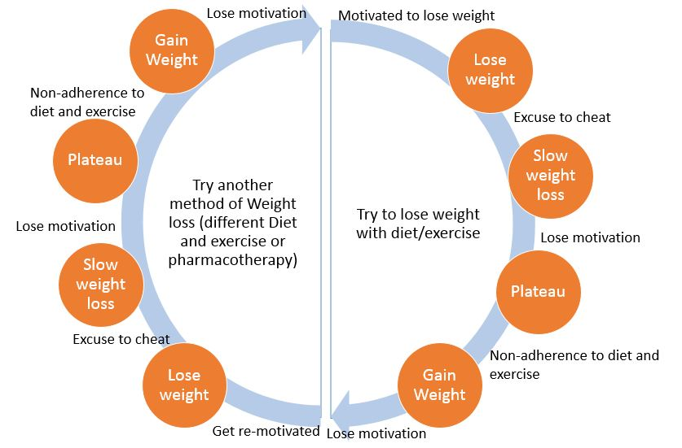

**Comparator Two**

For patients with a BMI over 35 kg/m2, who elect to have adjustable gastric banding surgery, they will need to follow a strict after-care program throughout their lives (or for the duration of band placement). This program will include visits to dieticians, psychologists, exercise physiologists, as well as band adjustments up to 12 times in the first year post-operatively and four times per year, or as necessary, in subsequent years [18].

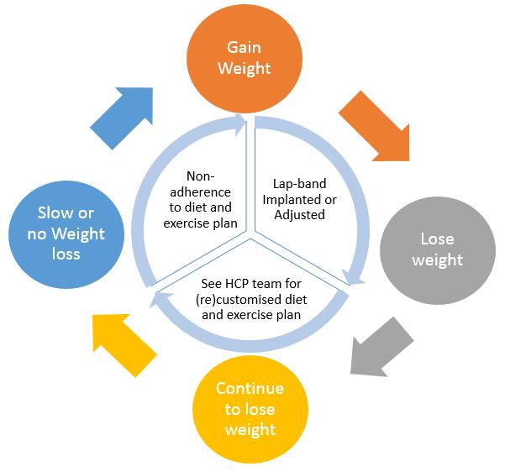

## (a) Will the proposed medical service be used in addition to, or instead of, the nominated comparator(s)?

Yes

No

## If yes, please outline the extent of which the current service/comparator is expected to be substituted:

Comparator One- Lifestyle modification including diet and exercise – ESG will be used in addition to Comparator 1.

Comparator Two- Adjustable Gastric Band – ESG will replace patients in BMI ≥30<40 kg/m2 who have comorbidities and who do not want a surgical weight loss procedure.

## Define and summarise how current clinical management pathways (from the point of service delivery onwards) are expected to change as a consequence of introducing the proposed medical service including variation in health care resources (Refer to Question 39 as baseline):

In patients with a BMI over 35 kg/m2 who have one or more comorbidities, the current clinical management pathway will remain unchanged as these patients are currently eligible for Medicare-funded bariatric surgery. The proposed medical service could be discussed with these patients at the same time other currently funded bariatric procedures are discussed with them by their GP or once they have been referred to a specialist, as per the flowchart below [14].

Diagram showing the clinical decision pathway   
Source- MSAC Public Summary Document- Application 1180r- Review of Items for the Surgical Treatment of Obesity

In patients with a BMI≥30<35 kg/m2 who have one or more comorbidities, the proposed medical service will be introduced as presented in Figure 3 below.

Figure 3: Change in the treatment algorithm with the reimbursement of Endoscopic Sleeve Gastroplasty

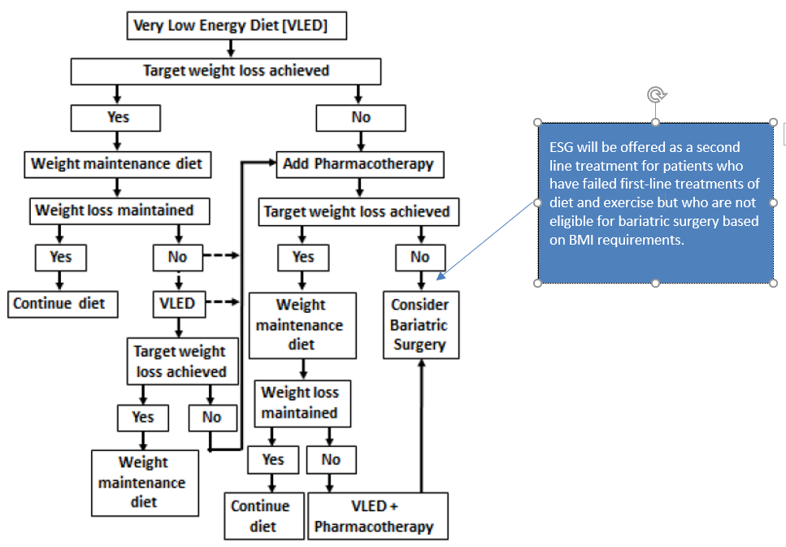

In all patients who receive the proposed medical service, an aftercare program will be necessary and will match that provided to patients undergoing bariatric surgery. Patients will need to follow a post-procedure diet and will require visits with various allied health professionals including nutritionists, exercise physiologists, and psychologists as needed. It is at a minimum during these visits that further information regarding the long-term success of the program are communicated and enhanced. The post-operative care programs that are in place may vary slightly depending on the clinic/hospital but essentially include education, support to change a person’s lifestyle and eating habits.

PART 6d – INFORMATION ABOUT THE CLINICAL OUTCOME

## Summarise the clinical claims for the proposed medical service against the appropriate comparator(s), in terms of consequences for health outcomes (comparative benefits and harms):

**Comparator One- Lifestyle modification**

Diet and exercise have long been prescribed as the first options for patients who present with weight-related comorbidities. Whilst these lifestyle modifications can produce short-term successes of up to 10% total body weight loss, most patients tend to regain two-thirds of the weight within one year and almost all of the weight within five years [19]. Other studies have shown that a significant number of patients, up to 97%, regain most or all of the weight loss in the years following a behavioural weight loss program [20].

In comparison, weight loss with endoscopic sleeve gastroplasty has been shown to produce an average of 18.6% total body weight loss at 24 months [21]. As with any comparison between non-surgical and surgical treatment options, there will always be inherently more risk in the surgical group. Most reported adverse events for ESG have been limited to mild events including abdominal pain, nausea, and vomiting. Currently, there have been no reports of mortality in association with ESG and the benefits of the sustained weight loss of ESG, compared to lifestyle modification, may provide a much-needed solution to the ever-growing obese population and therefore outweigh the risks.

Please advise if the overall clinical claim is for:

Superiority

Non-inferiority

**Comparator Two- Adjustable Gastric Banding**

As adjustable gastric banding has been available for over 20 years, there are numerous studies showing a variety of clinical and safety outcomes. In a head-to-head study conducted between 2012 and 2016, obese patients were treated with endoscopic sleeve gastroplasty or laparoscopic adjustable gastric banding (LAGB) [22]. In this study, ESG patients had %TBWL of 17.5% at 12 months whilst LAGB patients had %TBWL of 14.46%. Post-procedure length of stay was also significantly less for the ESG group at .13 versus that of the LAGB group at 1.68 days respectively.

In a recently completed clinical trial involving 652 participants, adjustable gastric banding produced 16.26% serious adverse events, compared to the 2% as seen by Lopez-Nava, et al [23, 21]. In this trial, %TBWL at 24 months was 18.7% for gastric banding, thus producing 14% more adverse events for a .1% increase in %TBWL as compared to the Lopez-Nava 24-month data [23,21].

Please advise if the overall clinical claim is for:

Superiority

Non-inferiority

## Below, list the key health outcomes (major and minor – prioritising major key health outcomes first) that will need to be specifically measured in assessing the clinical claim of the proposed medical service versus the comparator:

**Clinical Effectiveness Outcomes:**

**Primary Outcomes:** Total body andexcess weight loss; Impact on metabolic comorbidities (systolic blood pressure, diabetes (measured by HbA1c), hyperlipidaemia, cardiovascular disease, steatohepatitis)

**Secondary Outcomes:** Improvement in Quality of Life (IQoL Life) score

**Safety Outcomes:**

**Adverse event rates** (primary adverse events are abdominal pain, nausea, vomiting, and device-related AE’s)

**Complications** (e.g. injury to gastrointestinal tract or stomach, bleeding)

**Other Outcomes:**

**Healthcare resources**

**Cost-effectiveness**

**Australian Government healthcare costs**

# PART 7 – INFORMATION ABOUT ESTIMATED UTILISATION

## Estimate the prevalence and/or incidence of the proposed population:

## 27.9% of Australian Population is Obese

## Class 1 Obesity = 3,700, 000

## Class 2 Obesity = 1,037, 000

## Estimate the number of times the proposed medical service(s) would be delivered to a patient per year:

The proposed medical service would be delivered to a patient no more than once per year.

## How many years would the proposed medical service(s) be required for the patient?

Endoscopic sleeve gastroplasty is a single procedure delivered in one surgical appointment. In rare cases, a follow-up endoscopy may be required to apply additional sutures should patients lose satiety or begin to regain weight.

## Estimate the projected number of patients who will utilise the proposed medical service(s) for the first full year:

The Initial uptake of the proposed medical service in Year 1 will be limited by the number of physicians who are trained and certified to perform the procedure in Australia (currently 25 bariatric surgeons and/or gastroenterologists).

The target population for the proposed medical service falls into the Obese: Class 1 & Class 2 category

Table 1: Estimated eligible patient numbers for the proposed medical service

|  | % of Population | Number of Potential Patients | Source of Data |
| --- | --- | --- | --- |
| Australian Population |  | 24,130,000 | ABS – population clock |
| Obese Population | 27.9% | 6,732,270 | ABS - 3235.0 |
| Proportion of Patients that have a BMI ≥30<40 kg/m2 with at least one diagnosed comorbidity | 55.1% | 3,366,135 | AIHW 2011-13 Health Survey |

Current Surgical Obesity Procedural Statistics represent 0.6% of Patients in the BMI ≥30kg/m2, with at least one diagnosed comorbidity.

| 2016/17 Bariatric Procedures  Sleeve Gastrectomy, Gastric Banding,  Roux-en-Y Gastric Bypass |  | LSG -16990  LAGB -1650,  RYGB 2576  Total 21,216 | BSR MBS Data FY16/17  Page 16 Fifth Annual Report June 2017 |
| --- | --- | --- | --- |

Calculation to determine estimated number of procedures based on 25 Trained Physicians in Year 1 will realise converting 3.5% of the current Bariatric Procedures to ESG in Year 1

|  | % of Bariatric Procedures | Number of Potential Patients | Source of Data |
| --- | --- | --- | --- |
| **Year 1 Lower ESG Procedure Limit Estimate**  BMI ≥30<40 kg/m2 | 3.5% | 739 procedures per annum | 25 Trained Physicians |

## Estimate the anticipated uptake of the proposed medical service over the next three years factoring in any constraints in the health system in meeting the needs of the proposed population (such as supply and demand factors) as well as provide commentary on risk of ‘leakage’ to populations not targeted by the service:

|  | % of Bariatric Procedures | Number of Potential Patients | Source of Data |
| --- | --- | --- | --- |
| **Year 2 ESG Procedure Estimate** | 5% | 1056 | 35 Trained Physicians |
| **Year 3 ESG Procedure Estimate** | 7.5 % | 1591 | 50 Trained Physicians |
| **Year 4 ESG Procedure Estimate** | 10% | 2121 | 75 Trained Physicians |

Constraints for growth would be related to training physicians with credentialed endoscopic skills sufficient to ensure successful procedural outcomes.

In terms of leakage, there is potential for ESG to be used outside of the proposed population, but this risk is no more so than with other bariatric surgical procedures. It is anticipated that ESG may result in a reduction of more invasive bariatric surgery procedures and therefore could potentially translate into a saving to the Medicare budget based on hospital length of stay and the avoidance of costly surgical complications.

# PART 8 – COST INFORMATION

## Indicate the likely cost of providing the proposed medical service. Where possible, please provide overall cost and breakdown:

|  |  |  |
| --- | --- | --- |
| **Resource item** | **Unit cost** | **Source / notes** |
| ***Pre-operative*** | | |
| Pre-operative assessment for complex medical problems | $85.55 | MBS 17615# |
| ***Device costs*** | | |
| Endoscopic Suturing System | Redacted | Redacted |
| Tissue Helix | Redacted | Redacted |
| Overtube | Redacted | Redacted |
| Polypropylene Suture (8 units)* | Redacted | Redacted |
| Suture Cinch (8 units)* | Redacted | Redacted |
| Subtotal (devices) | Redacted | Calculated |
| ***Surgical implantation*** | | |
| Endoscopic Sleeve Gastroplasty | $849.55 | Proposed fee |
| Assistance | $209.08 | MBS item 51303 for bariatric surgery assistance |
| Subtotal (surgery) | $1058.63 | Calculated |
| ***Anaesthetics*** | | |
| Pre-anaesthesia consultation | $43.00 | MBS 17610# |
| Initiation of anaesthesia for bariatric surgery in a patient with clinically severe obesity | $198.00 | MBS 20791# |
| Anaesthesia time units | $158.40 | MBS item 23083#; Anaesthesia time units; 1:56 hours to 2:00 hours |
| Subtotal (anaesthetics) | $399.40 | Calculated |
| ***Post-operative*** | | |
| Post-operative gastroscopy | 177.10 | MBS 30473# |
|  | | |
| Est. total per procedure | Redacted |  |

* Based on procedural average observed in 2017  
# Medicare Benefits Schedule Book - 1st May 2018

## Specify how long the proposed medical service typically takes to perform:

Total procedure time varies from physician to physician and is based on experience level with the endoscopic suturing system. However, for an experienced physician, the procedure typically takes between one hour and 1.5 hours to complete.

## If public funding is sought through the MBS, please draft a proposed MBS item descriptor to define the population and medical service usage characteristics that would define eligibility for MBS funding.

The item descriptor proposed in this application is based on the item code for the placement of an adjustable gastric band, provided as one of the comparator options.

Category 3 – THERAPEUTIC PROCEDURES

XXXXX

Endoscopic Sleeve Gastroplasty for patients 18 years of age or over with a BMI 30.0-39.9kg/m2 and comorbidities.

Multiple Services Rule

(Anaes.) (Assist.)

Fee: $849.55 Benefit: 75% = $637.20

(See para [TN.8.29](http://www9.health.gov.au/mbs/fullDisplay.cfm?type=note&qt=NoteID&q=TN.8.29) of explanatory notes this this Category)

# PART 9 – FEEDBACK

The Department is interested in your feedback.

## How long did it take to complete the Application Form?

Two months

## (a) Was the Application Form clear and easy to complete?

Yes

No

## If no, provide areas of concern:

Describe areas of concern here

## (a) Are the associated Guidelines to the Application Form useful?

Yes

No

## If no, what areas did you find not to be useful?

Insert feedback here

## (a) Is there any information that the Department should consider in the future relating to the questions within the Application Form that is not contained in the Application Form?

Yes

No

## If yes, please advise:

Insert feedback here

# References

1. Australian Institute of Health and Welfare “An Interactive Insight into Overweight and Obesity in Australia”. 24 November 2017. <https://www.aihw.gov.au/reports/overweight-obesity/interactive-insight-into-overweight-and-obesity/contents/how-many-people-are-overweight-or-obese>
2. Australian Medical Association Obesity Position Statement. 7 November 2016. <https://ama.com.au/position-statement/obesity-2016>
3. Australian Government, Cancer Australia Overweight and Obesity Position Statement. Accessed 4 June 2018. <https://canceraustralia.gov.au/publications-and-resources/position-statements/lifestyle-risk-factors-and-primary-prevention-cancer/lifestyle-risk-factors/overweight-and-obesity>
4. Withrow, D and Alter, DA. “The Economic Burden of Obesity Worldwide: A Systematic Review of Direct Costs of Obesity.” Obesity Review, February 2011. <https://www.ncbi.nlm.nih.gov/pubmed/20122135>
5. PWC, “Weighing the Cost of Obesity: A Case for Action”. 2015. <https://www.pwc.com.au/pdf/weighing-the-cost-of-obesity-final.pdf>
6. Wilson, E. “Outlet Revisions and ESG Introduction”. Physician presentation available upon request.
7. Hill, C, et al. “Endoscopic Sleeve Gastroplasty: the Learning Curve”. 13 September 2017. Endoscopy International Open. <https://www.ncbi.nlm.nih.gov/pmc/articles/PMC5597932/>
8. Kumbhari, V, et al. “Technical Aspects of Endoscopic Sleeve Gastroplasty”. March 2017. GIE Journal. <https://www.videogie.org/article/S2468-4481(17)30006-1/fulltext?code=vgie-site>
9. World Health Organization “Obesity and Overweight” fact sheet. 18 October 2017. <http://www.who.int/en/news-room/fact-sheets/detail/obesity-and-overweight>
10. Sweening, HN. “Measurement and Definitions of Obesity in Childhood and Adolescence: a Field Guide for the Uninitiated”. October 2007. Nutrition Journal. <https://nutritionj.biomedcentral.com/articles/10.1186/1475-2891-6-32>
11. Yach, D, et al. “Epidemiologic and Economic Consequences of the Global Epidemics of Obesity and Diabetes”. January 2006. Nature Medicine. <https://www.researchgate.net/publication/7373370_Epidemiologic_and_economic_consequences_of_the_global_epidemics_of_obesity_and_diabetes>
12. Organisation for Economic Co-operation and Development “Obesity Update 2017”. 2017. <https://www.oecd.org/els/health-systems/Obesity-Update-2017.pdf>
13. ABS (Australian Bureau of Statistics) 2015. National Health Survey: first results, 2014–15. ABS cat no. 4364.0.55.001. Canberra: ABS. <http://www.abs.gov.au/ausstats/abs@.nsf/mf/4364.0.55.001>
14. Medical Services Advisory Committee. Public Summary Document. “Application 1180r- Review of Items for the Surgical Treatment of Obesity”. November 2011. <http://www.health.gov.au/internet/msac/publishing.nsf/Content/7249121840E2563DCA25821200823415/$File/1180r%20Public%20Summary%20Document.pdf>
15. National Heart Foundation of Australia “Heart Foundation Reveals Weighty Issue this Christmas as we head for Worsening Obesity Crisis”. 21 December 2015. <https://www.heartfoundation.org.au/news/heart-foundation-reveals-weighty-issue-this-christmas-as-we-head-for-worsening-obesity-crisis>
16. Australian Institute of Health And Welfare. “Australian Burden of Disease Study: Impact and Causes of Illness and Death in Australia 2011. May 2016. <https://www.aihw.gov.au/getmedia/d4df9251-c4b6-452f-a877-8370b6124219/19663.pdf.aspx?inline=true>
17. Australian Institute of Health and Welfare. “Weight Loss Surgery in Australia 2014-15: Australian Hospital Statistics”. 26 May 2017. <https://www.aihw.gov.au/reports/overweight-obesity/ahs-2014-15-weight-loss-surgery/contents/table-of-contents>
18. Ponce, J. “Laparoscopic Gastric Band Adjustments”. Bariatric Times. 2 May 2007. <http://bariatrictimes.com/laparoscopic-gastric-band-adjustments/>
19. American Association of Clinical Endocrinologists (AACE)/American College of Endocrinology (ACE). “Statement on the Prevention, Diagnosis, and Treatment of Obesity”. 1998 Revision. <http://citeseerx.ist.psu.edu/viewdoc/download?doi=10.1.1.177.3176&rep=rep1&type=pdf>
20. Kramer, FM et al. “Long-term Follow-up of Behavioural Treatment for Obesity: Patterns of Weight Regain Among Men and Women”. International Journal of Obesity. 1989. <https://www.ncbi.nlm.nih.gov/pubmed/?term=Long-term+follow-up+of+behavioral+treatment+for+obesity%3A+patterns+of+weight+regain+among+men+and+women.+Int+J+Obes+1989>
21. Lopez-Nava, G, et al. “Endoscopic Sleeve Gastroplasty for Obesity: A Multi-Centre Retrospective Study of 248 Patients with 24 Months Follow-Up”. Obesity Surgery Journal. 27 April 2017. <https://www.nwls.com.au/pdf/endoscopic-sleeve-gastroplasty.pdf>
22. Novikov, A, et al. “Endoscopic Sleeve Gastroplasty, Laparoscopic Sleeve Gastroplasty, and Laparoscopic Band for Weight Loss, How do They Compare?”. Gastroenterology Journal. April 2017. <https://www.gastrojournal.org/article/S0016-5085(17)34021-0/pdf>
23. Dixon, J et al. “HERO Study: Helping Evaluate Reduction in Obesity”. 8 March 2018. <https://www.clinicaltrials.gov/ct2/show/results/NCT00953173?term=NCT00953173&rank=1&sect=X30156#othr>