**Applicant Submitted Protocol**

**for**

**Cardiac Contractility Modulation (CCM) therapy for patients with Chronic Heart Failure**

**Medical Services Advisory Committee**

**Application 1387**

**Final Protocol**

**February 2015**

Table of Contents

1) Title of Application 1

2) Purpose of application 1

3) Population and medical condition eligible for the proposed medical services 2

4) Intervention – proposed medical service 3

5) Co-dependent information (if not a co-dependent application go to Section 6) 8

6) Comparator – clinical claim for the proposed medical service 8

7) Expected health outcomes relating to the medical service 9

8) Fee for the proposed medical service 11

9) Clinical Management Algorithm - clinical place for the proposed intervention 15

10) Regulatory Information 17

11) Decision analytic 17

12) Healthcare resources 20

13) Questions for public funding 20

# Title of Application

Cardiac Contractility Modulation (CCM) therapy for patients with chronic heart failure.

# Purpose of application

This application requests the MBS listing of cardiac contraction modulation (CCM) therapy for the treatment of chronic heart failure (CHF).

It is proposed that this protocol should guide the assessment of the safety, effectiveness and cost-effectiveness of CCM therapy in the requested populations to inform MSACs decision-making regarding public funding of the procedure.

The CCM device is a novel device that applies non-excitatory signals to the cardiac muscle during the absolute refractory period in patients with chronic heart failure. These signals modulate the strength of cardiac muscle contraction, which leads to improved exercise tolerance as well as quality of life (QoL). The OPTIMIZER™ IVs is the only device available for CCM therapy in patients with chronic heart failure.

There are currently no published systematic reviews on CCM therapy in patients with heart failure. The primary clinical evidence for CCM therapy is devised from three randomised, controlled trials:

* FIX-CHF-4 (Borggrefe, Lawo et al. 2008);
* FIX-HF-5 Phase I (Neelagaru, Sanchez et al. 2006);
* FIX-HF-5 Phase II (Kadish, Nademanee et al. 2011) (Abraham, Nademanee et al. 2011).

The inclusion criteria for the above three trials stipulated the enrolment of a total of 641 patients with NYHA class III or IV HF and ejection fraction (EF) ≤35%. In practice, however, approximately 18% of the FIX-5 trial sub-population (Abraham, Nademanee et al. 2011) reported an EF of >35% (average 40%; range 35% to 45%) (Borggrefe and Burkhoff 2012). In this subgroup, peak VO2 was 2.96 mL/kg/min greater (P=0.03), VAT was 0.57 mL/kg/min greater (P = NS), and MLWHFQ score was 18 points better (P=0.06) in the treatment group than the control group. Although not all of these differences were statistically significant in view of the small sample size, the trends showed even greater effects than in the group of patients with EF between 25 and 35%. ((Burkhoff 2011) In addition, an on-going open label registry currently includes 27/138 with an EF >35%. Results from this registry will be included in the MSAC submission. MBS listing is being sought for the following subgroup of patients who have the greatest clinical benefit:

* Symptomatic heart failure due to systolic left ventricular dysfunction despite failed Optimal Medical Therapy;
* NYHA Class III Heart Failure;
* ≥ 18 years;
* Normal QRS duration (<120ms);
* Left Ventricular Ejection Fraction (LVEF) ≥25% and ≤45%.

A full analysis for this subgroup is currently taking place, and at this stage results are not available. A comprehensive subgroup analysis for all efficacy endpoints in the three trials outlined above will be presented in the final MSAC submission-based assessment. The results from all treated patients can be extracted from the publications presented above.

# Population and medical condition eligible for the proposed medical services

Heart failure (HF) is characterised by an underlying structural abnormality or cardiac dysfunction that impairs the ability of the ventricle of the heart to fill with or eject blood, particularly during physical activity. Chronic HF (CHF) occurs in 1.5–2.0%[1] of Australians, and represents a major burden to the MBS, affecting 10% of people aged ≥65 years and over 50% of people aged ≥85 years. HF is one of the most common reasons for hospital admission and GP consultations in people aged 70 and older (2011)

The prognosis for patients with CHF remains very poor. About half of people who develop heart failure die within 5 years of diagnosis ([Heart Failure Fact Sheet|Data & Statistics|DHDSP|CDC](http://www.cdc.gov/dhdsp/data_statistics/fact_sheets/fs_heart_failure.htm)). Whilst medical therapy has improved in recent years, many patients with advanced HF are refractory to medical therapy especially those with low left ventricular ejection fraction. (Improved medical therapy or the presence of HF refractory to medical therapy) has given rise to a host of device-based therapies, including Cardiac Resynchronisation Therapy (CRT), which is indicated for patients with NYHA class III or IV HF, with LVEF of ≤45% and wide QRS duration (≥120ms). The main limitation of CRT is that approximately 80% of patients with HF have a normal QRS duration (Shenkman, Pampati et al. 2002).

There is therefore a clear medical need for a new device-based treatment for patients with normal QRS duration and persistent symptoms despite optimal medical treatment (OMT). Impulse Dynamics[2] have developed a cardiac contractility modulation (CCM) device for this group of patients.

Impulse Dynamics are seeking the MBS listing of CCM therapy for the following patient population:

* Symptomatic heart failure due to systolic left ventricular dysfunction despite failed Optimal Medical Therapy;
* NYHA Class III Heart Failure;
* ≥ 18 years;
* Normal QRS duration (<120ms);
* LVEF ≥25% and ≤45%.

As outlined above, the OPTIMIZER™ IVs is currently the only treatment option for approximately 80% of HF patients with advanced HF symptoms who are inadequately controlled on optimal medical therapy and have normal QRS duration. These patients are not suitable for CRT, as CRT is indicated for symptomatic HF patients with a wide QRS duration (≥120ms). Therefore, should CCM therapy not be available on the MBS, this group of patients would continue to have symptomatic and deteriorating HF.

Table 1 provides a preliminary estimate of the prevalent pool of patients who are potential candidates for CCM therapy on the MBS. These preliminary estimates suggest a prevalent pool of approximately 3,233 patients who could be eligible for CCM therapy in Australia.

The uptake of CCM therapy has not been considered for the proposed population, and this analysis will be included in the MSAC submission-based assessment.

Table 1 Estimation of prevalent pool of potential candidate patients for CCM therapy

|  |  |  |  |
| --- | --- | --- | --- |
| **CCM therapy** **inclusion criteria** | **Estimated prevalence1** | **Number in Australia** | **Source** |
| ≥ 18 years |  | 17,898,348 | ABS (2013) 3101.0 Australian demographic Statistics; Table 59 |
| Symptomatic heart failure | 1.75% | 313,221 | Heart Foundation (2011); Guidelines for the prevention, detection and management of chronic heart failure in Australia |
| Systolic left ventricular dysfunction | 78% | 245,130 | (Davies, Hobbs et al. 2001) |
| Failed medical therapy | 26.5% | 64,959 | (McMurray, Packer et al. 2014) |
| Normal QRS duration (<120ms) | 79% | 51,318 | (Shenkman, Pampati et al. 2002) |
| NYHA Class III | 15% | 7,698 | (Davies, Hobbs et al. 2001); Table 2 |
| LVEF ≥ 25% ≤ 45%b | 42% | 3,233 | (Shenkman, Pampati et al. 2002) |

1. These preliminary estimates of the eligible population are indicative only at this stage. A more detailed estimate utilising a more extensive search of the literature will be provided in the MSAC application.

# Intervention – proposed medical service

The proposed medical service being requested is the implantation, removal, replacement and interrogation of a cardiac contractility modulation device.

The features of the implanted device are outlined below.

The OPTIMIZERTM IVs delivers Cardiac Contractility Modulation (CCM) therapy. CCM signals are non-excitatory signals which, when applied during the absolute refractory period, enhance the strength of left ventricular (LV) contraction. These signals do not initiate a new contraction or modify activation sequence as is the case with other therapies such as CRT or pacemaker therapy. Rather, CCM signals increase the heart’s force of contraction by improving the function of the cardiac muscle cells. CCM therapy is delivered at regular intervals throughout the day.

The OPTIMIZER™ IVs Implantable Pulse Generator (IPG) is a microprocessor-controlled implantable device that includes intracardiac electrogram sensing circuits, control logic, and communications circuitry to generate the Cardiac Contractility Modulation (CCM) signals intended to improve cardiac function. Intracardiac electrogram signals are detected from, and CCM signals are delivered to, the heart using standard chronically-implantable bipolar pacing leads. The device’s safety algorithms continuously assess the electrical state of the heart and determine when it is appropriate to deliver CCM signals to the myocardium. This is accomplished by ensuring that the delivery of CCM signals is inhibited on suspected ectopic or arrhythmic beats.

The OPTIMIZER™ IVs IPG is programmable, allowing attending medical personnel to program the device to meet the patient’s needs. Programming of the IPG is done through the OMNI II Programmer. This programmer is a portable instrument with a user-friendly graphical interface, which provides attending medical personnel with all of the information and controls required to control the IPG under a diversity of clinical settings. The OPTIMIZER™ IVs IPG and the OMNI II Programmer communicate via telemetry.

The OMNI II Programmer performs the following functions:

* Interrogates the OPTIMIZER™ IVs IPG. This involves downloading information such as the serial number, operational status, battery charge state and programmed parameters.
* Retrieves statistics accumulated by the IPG device as it operates. The device downloads information from IPG related to the number of cardiac events sensed, number of cardiac cycles where the CCM signal was delivered and changes in operational status.
* Stores standard programs for future use
* Logs the activity of the OPTIMIZER™ IVs IPG device
* Displays real-time telemetry along the patient’s surface ECG signal
* Performs real-time diagnostics to aid clinical evaluation and setup of the IPG (e.g. lead impedance measurement and setting IPG’s sensitivity to intracardiac electrogram signals)
* Programs threshold levels to issue requests for follow-up by activating “Call Doctor” indicator in Optimizer Mini Charger
* Programs and modifies IPG operating parameters (e.g. mode, IEGM sensitivities and refractory times)
* Programs and modifies CCM therapy parameters (e.g. CCM pulse train characteristics and number of hours of CCM therapy per day)
* Programs the IPG device to safe parameter values in emergency situations

The OMNI II Programmer is commonly used by clinicians and specialist nursing staff involved in the implantation of the IPG and care of the patient after implant. This could be either a cardiologist or an electrophysiology (EP) nurse.

The OPTIMIZER™ IVs IPG is powered by an implantable-grade rechargeable lithium-ion battery. The OPTIMIZER™ IVs mini charger, allows patients to recharge the battery of the OPTIMIZER™ IVs at home. Transmission of energy between the OPTIMIZER™ IVs mini charger and the IPG is accomplished painlessly and non-invasively, via a resonant inductive coupling. The charger should be used on a weekly basis and charging sessions typically last about 45 minutes. The technology used in the battery, Quallion’s lithium-ion chemistry, has been designed to last 25 years implanted in the human body. <http://www.quallion.com/sub-mm-implantable.asp>

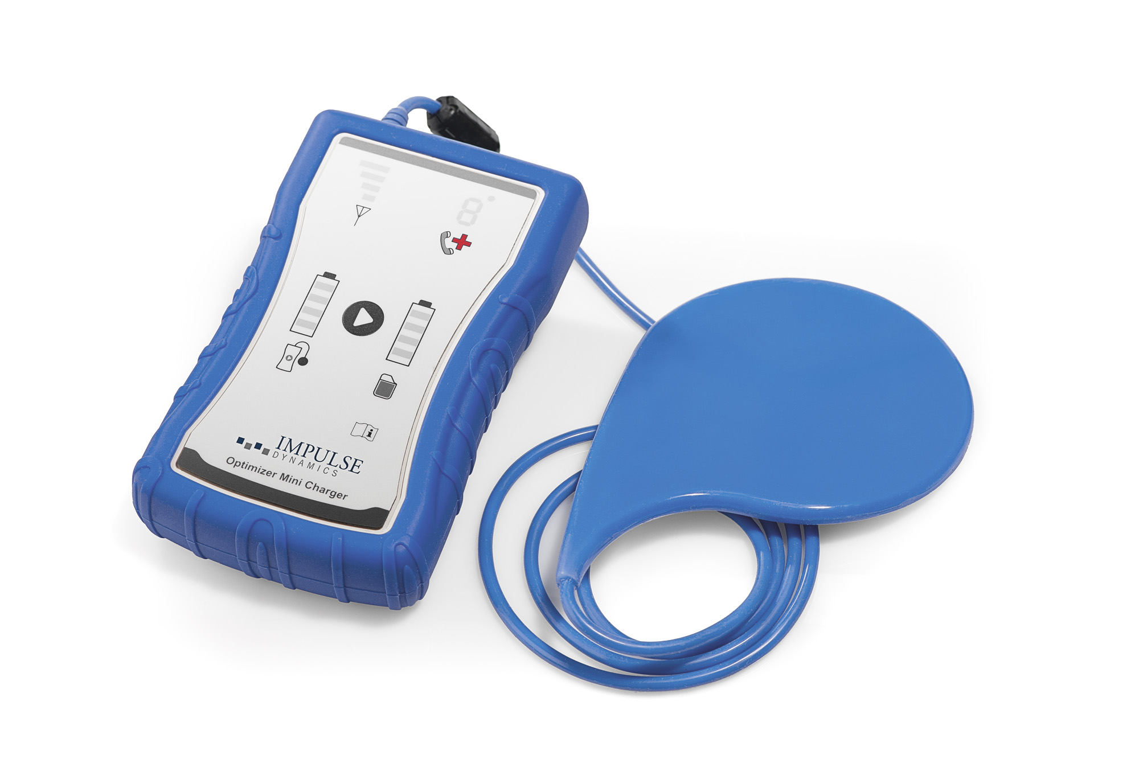

Figure 1 *Mini charger*

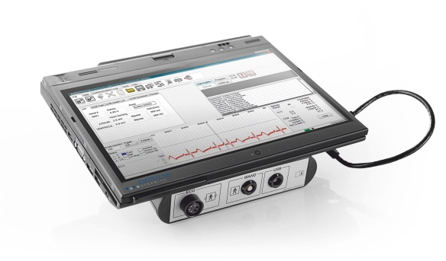 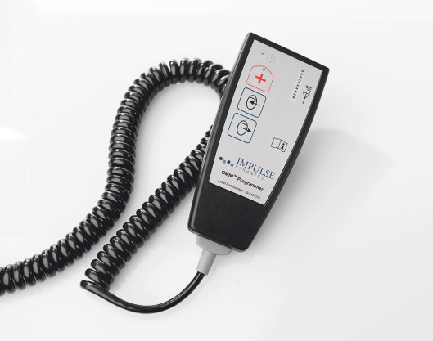

Figure 2 *OMNI II programmer and wand*

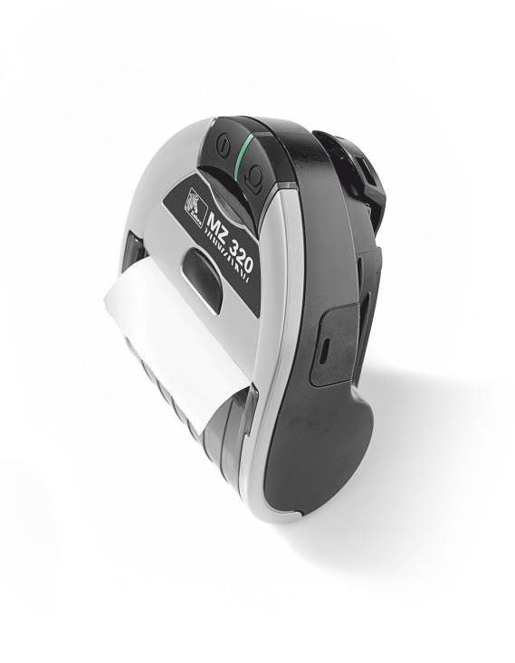

Figure 3 *Printer*

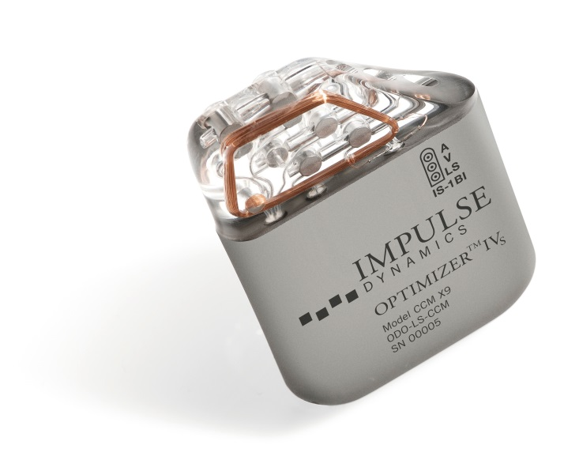

Figure 4 OPTIMIZER™ IVs

Table 2 Dimensions forOPTIMIZER™ IVs

|  |  |
| --- | --- |
| Characteristic | Dimension |
| Width | 65.4 ± 1.0 mm |
| Height | 47.5 ± 0.5 mm |
| Thickness | 11.5 ± 0.5 mm |
| Volume | 30.0 ± 0.2 cm3 |
| Mass | 46 ± 3 g |

Generally, the CCM device IPG is implanted in the right pectoral region. Subclavian venous access is preferred. The atrial lead is typically positioned in the right atrial appendage (RAA), and two right ventricular leads are placed for CCM signal delivery. One of these is inserted preferably in an anterior septal and the other in a posterior septal location. Placing both leads in anterior or posterior septal location is acceptable, provided the leads are separated by at least 2cms.

The placement service provision does not have a registered trademark associated with it. The treating Physician uses a trademarked programmer and wand for interrogating and programming of the IPG. The OMNI II Programming System allows the physician to interrogate and program the OPTIMIZER™ IVs IPG. The programmer software runs on a Lenovo Touch screen Laptop connected to a Programmer Interface box. Communication between the Programmer Interface and the OPTIMIZER™ IVs IPG is accomplished with a Programming Wand placed directly over the implant site. The Programming Wand communicates via magnetic induction telemetry with the OPTIMIZER™ IVs IPG implanted in the patient. Impulse Dynamics will provide information in the MSAC application to justify why a separate MBS item number is required for the interrogation of the device; who performs the interrogation, the benefits to the patient, including how this will be communicated to the patient.

It is proposed that the insertion of the OPTIMIZER™ IVs device will be delivered in either an inpatient private or public hospital setting, and requires one overnight hospital stay. As this is a cardiac procedure, an overnight stay is suggested to allow for initial monitoring of the patient post-surgery. The OPTIMIZER™ IVs is implanted via a minimally invasive procedure usually under local anaesthetic. The procedure is performed by a cardiologist, and takes approximately 60 minutes to complete. For the purpose of this application cardiologist is defined as physician who is a fellow of the [Royal Australasian College of Physicians](http://www.racp.edu.au/) (FRACP) with specialty training in cardiology. This could include physicians with specialist training in electrophysiology or interventional cardiology.

In line with other cardiac devices, such as CRT, medical personnel will receive peer to peer training from experts who have experience and are competent in inserting and programming the OPTIMIZER™ IVs device. Insertion of the OPTIMIZER™ IVs device is similar to insertion of all current CRT and ICD devices, therefore, peer to peer training will be sufficient. Ongoing training support will be provided by the sponsor in the form of visits by an international clinician expert; provision of demonstration videos and training material. This will be further detailed in the MSAC application. The procedures will only be undertaken in a hospital capable of providing cardiac surgery.

The OPTIMIZER™ IVs IPG will be inserted into the subcutaneous pocket.

The cardiologist would coil any excess lead and place these coils around the IPG or in the pocket inferior to the device. They would ensure that the leads form not more than a gentle curve where they exit the IPG connector terminal and that they are not under traction or strain. The IPG is secured to the fascia with a non-absorbable suture and close the pocket.

Patients should receive standard post-operative care for a minimum of 24 hours prior to discharge. The use of narcotics for pain relief should be minimised.

The OPTIMIZER™ IVs device requires the insertion of three (3) bipolar leads, one is inserted into the right atrium and two are inserted into right ventricle. The OPTIMIZER™ IVs is compatible with standard bipolar leads equipped with IS-1 connectors. The implanting physician can select any atrial lead according to their preference. The appropriate ventricular leads have to be used. These include the St. Jude Medical Tendril® 1388T/1688T/1788T/1888T/2088T/LPA1200M, Biotronik Setrox S / Siello S / Solia S or Boston Scientific Dextrus leads.

There is a set procedure to determine whether the device is working correctly on implantation. After the leads are inserted and connected to the IPG, a testing cable is used to program, verify and store the treatment protocol for the device. Therapy is then commenced and this is confirmed by ECG. During implant all placements (leads and IPG) will be checked by fluoroscopy.

After the implantation of the device, there is normal post-surgical follow-up. Generally 1 day post implant, an X-ray is performed to ensure the device and leads are in place and no pneumothorax was caused by the procedure.Thereafter, normal medical management of the patient will revert to the treating cardiologist. The application will address the likelihood of surgical revisions.

The mini charger interrogates the OPTIMIZER™ IVs automatically.  The device only needs interrogation if the charger (which is functioning as a “home base”) transmits an alert; this occurs infrequently.   Most centres use a “Needs Based Follow Up”, that is, only follow up when the charger communicates a problem.

# Co-dependent information (if not a co-dependent application go to Section 6)

Not applicable.

# Comparator – clinical claim for the proposed medical service

As outlined previously, there are no alternative treatment options for the patient population with normal QRS duration, and patients would continue to have symptomatic heart failure that may worsen if not managed appropriately. Therefore, the appropriate comparator is failed Optimal Medical Therapy (OMT).

Failed optimal medical management would include the use of diuretics followed by an ACE inhibitor and a beta-blocker. For those patients who cannot tolerate an ACE inhibitor, an ARB would be added. Some patients will also be treated with an add-on aldosterone antagonist or eplerenone. (Ref National Heart Foundation Chronic Heart Failure Guidelines 2011, p33). See figure below.

Treatment failure is indicated by a continued deterioration in NYHA and LVEF measures Medical treatment is continued in patients suffering from treatment failure.

For patients to have deemed to have failed OMT, they would be required to have been initiated on OMT at least three months prior to insertion of the device. This would cover patients who have been on therapy and progressed, and also patients who could not tolerate OMT.

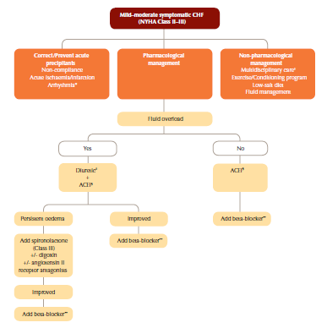

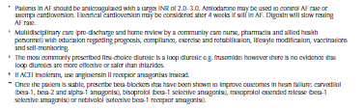

Figure 5 Pharmacological treatment of systolic heart failure (LVEF < 40%) (NYHA Class II/III)

National Heart Foundation of Australia (2011), p 33

# Expected health outcomes relating to the medical service

If CCM therapy is recommended for public funding, the expected patient-relevant outcomes would be:

* Improvement in exercise tolerance quantified by peak VO2 and 6 minute hall walk test;
* Improvement in quality of life, quantified by the MLWHFQ and utilities / QALYs[3];
* Improvement in heart failure severity, by NYHA class classification and LVEF;
* Improvement in hospitalisation rates;
* Improvement in all-cause mortality;
* Improvement in mortality due to heart failure;
* Device and surgery-related side-effects

The pivotal trials did not directly measure the change in LVEF. However, a three month study, using accurate 3D echocardiography, evaluating the impact of CCM therapy on left ventricular (LV) structure shows that treatment with CCM therapy improves global LV systolic function, and results in a clinically and statistically significant improvement in ejection fraction (p<0.001) (Yu, Chan et al. 2009). This will be explored more in the MSAC application.

There are minimal risks associated with CCM therapy, and the adverse events of CCM therapy are transient and are associated with the surgical implantation of the device. The clinical trial data suggests that adverse events are infrequent and of low severity. In the pivotal FIX-5 study, the most commonly reported adverse events were lead fracture or displacement. The total incidence of lead complications was 14 (7%) (Kadish, Nademanee et al. 2011), p 333

The proposed clinical claim for CCM therapy in the treatment of symptomatic HF inadequately controlled despite optimal medical therapy is:

* CCM therapy offers superior clinical efficacy compared to *failed optimal medical therapy (OMT)*; and
* CCM therapy is non-inferior in terms of heart failure treatment safety compared to *failed optimal medical therapy (OMT).*

Based on these claims, a cost-effective or cost-utility analysis is appropriate as outlined in Table 2. Note that in the absence of a full analysis of the clinical data (to be completed in the final submission) the sponsor is pre-empting the results that would form the basis of the economic evaluation.

Table 3 Classification of an intervention for determination of economic evaluation to be presented

|  |  |  |  |  |  |  |
| --- | --- | --- | --- | --- | --- | --- |
|  | | **Comparative effectiveness versus comparator** | | | | |
| Superior | | Non-inferior | Inferior | |
| **Comparative safety versus comparator** | Superior | CEA/CUA | | CEA/CUA | Net clinical benefit | CEA/CUA |
| Neutral benefit | CEA/CUA* |
| Net harms | None^ |
| Non-inferior | **CEA/CUA** | | CEA/CUA* | None^ | |
| Inferior | **Net clinical benefit** | **Comparison with failed OMT**  **CEA/CUA** | None^ | None^ | |
| Neutral benefit | CEA/CUA* |
| Net harms | None^ |

Abbreviations: CEA = cost-effectiveness analysis; CMA = cost-minimisation analysis; CUA = cost-utility analysis

^ No economic evaluation needs to be presented; MSAC is unlikely to recommend government subsidy of this intervention

*May be reduced to cost-mimisation analysis

# Fee for the proposed medical service

The proposed MBS item descriptors for CCM therapy are presented in Table 3. Separate item descriptors are suggested for the following:

* Insertion, removal or replacement of the CCM IPG;
* Insertion, removal or replacement of the three (3) bipolar leads;
* Interrogation of the CCM IPG device.

The sponsor is seeking MBS listing for the following patient population:

* Symptomatic heart failure due to systolic left ventricular dysfunction despite failed Optimal Medical Therapy;
* NYHA Class III Heart Failure;
* ≥ 18 years;
* Normal QRS duration (<120ms);
* LVEF ≥25% and ≤45%.

*We believe that this should remain in this section*

It should be noted that the insertion and removal of both the CCM IPG and bipolar leads will require approximately the same technical complexity and duration. As such, the proposed MBS fees for the process of insertion and removal should be set at the same level.

There are currently no reimbursed CCM therapies on the MBS. It is proposed that the implantation of the CCM IPG device and bipolar leads are similar to those associated with Implantable Cardiac Devices and cardiac electrodes (leads) (MBS item numbers 38353, 38356, 38365, 38368, 38654 and 11721). These MBS item numbers are appropriate, as they are representative of the technical characteristics of the insertion, removal or replacement of the CCM IPG and bipolar leads and follow-up interrogation. This is outlined in further detail in Table 4.

The interrogation of the device should be eligible to be claimed by the treating cardiologist who manages the patient’s chronic heart failure. The results of the test would be communicated to the patient at the time that the interrogation is performed.

Table 4 Proposed MBS item descriptors

|  |
| --- |
| Category 3 - THERAPEUTIC PROCEDURES |
| MBS Item number XXXX  Permanent Cardiac Contractility Modulation (CCM) Implantable Pulse Generator (IPG) device insertion, removal or replacement of, for a patient with all of the following:   1. Symptomatic heart failure due to systolic left ventricular dysfunction despite failed Optimal Medical Therapy; 2. NYHA Class III; 3. ≥ 18 years; 4. Normal QRS duration (<120ms); 5. LVEF ≥25% and ≤45%.   Fee: $255.45 Benefit: 75% = $191.60  MBS Item number XXXXX  The permanent insertion, removal or replacement of three (3) bipolar leads, one in the right atrium and two (2) leads in the right ventricle. All three (3) leads are connected to the Cardiac Contractility Modulation (CCM) Implantable Pulse Generator (IPG).  Fee: $1,224.60 Benefit: 75% = $918.45  MBS Item number XXXXX  Interrogation of the Cardiac Contractility Modulation (CCM) Implantable Pulse Generator (IPG) device for the following:   1. Interrogate the IPG device parameters as currently programmed; 2. Modify the IPG device parameters; 3. Read ECG signals from patient and display for analysis; 4. Retrieve statistics accumulated by the IPG device as it operates; 5. Log the activity of the IPG device; 6. Store standard programs for future use; 7. Program the IPG device to safe parameter values in emergency situations.   **Fee:** $69.75 **Benefit:** 75% = $52.35 85% = $59.30 |

Table 5 Comparison of Schedule fees for MBS items relating to Implantable Cardiac Devices and cardiac electrodes (leads)

|  |  |  |
| --- | --- | --- |
| **Description** | **Item code** | **Value** |
| 38353 | PERMANENT CARDIAC PACEMAKER, insertion, removal or replacement of, not for cardiac resynchronisation therapy, including cardiac electrophysiological services where used for pacemaker implantation | $255.45 |
| 38365 | Permanent cardiac synchronisation device (including a cardiac synchronisation device that is capable of defibrillation), insertion, removal or replacement of, for a patient | $255.45 |
| 38368 | Permanent transvenous left ventricular electrode, insertion, removal or replacement of through the coronary sinus, for the purpose of cardiac resynchronisation therapy, including right heart catheterisation and any associated venogram of left ventricular veins, other than a service associated with a service to which item 35200 or 38200 applies, for patients | $1,224.60 |
| 38654 | Permanent left ventricular electrode, insertion, removal or replacement of via open thoracotomy, for the purpose of cardiac resynchronisation therapy, for a patient | $1,224.60 |
| 38356 | DUAL CHAMBER PERMANENT TRANSVENOUS ELECTRODES, insertion, removal or replacement of, including cardiac electrophysiological services where used for pacemaker implantation | $837.35 |
| 11721 | IMPLANTED PACEMAKER TESTING of atrioventricular (AV) sequential, rate responsive, or antitachycardia pacemakers, including reprogramming when required, not being a service associated with a service to which Item 11700 or 11718 applies | $69.75 |

The following costs are relevant to CCM therapy, and will therefore be included in the economic evaluation:

* Insertion, removal or replacement of CCM IPG device;
* Insertion, removal or replacement of the bipolar leads;
* CCM IPG device;
* Bipolar leads;
* Anaesthesia;
* Cardiologist;
* Cardiac monitoring;
* Hospital stay;
* Ongoing interrogation of device;
* Prophylactic antibiotics;
* Cardiologist consultation;
* GP consultation;
* Outpatient visits;
* Heart Failure medications;
* Management of adverse events/complications;
* Emergency service;
* Interrogation during emergency service utilisation.

# Clinical Management Algorithm - clinical place for the proposed intervention

Figure 6 outlines the current treatment algorithm and the proposed place of CCM therapy should it be listed on the MBS.

The CCM device is currently the only treatment option for approximately 80% of HF patients with advanced HF symptoms who are inadequately controlled on optimal medical therapy and have normal QRS duration. These patients are not suitable for Cardiac Resynchronization Therapy (CRT), as CRT is indicated for symptomatic HF patients with QRS duration of ≥120ms.

The final MSAC application will assess the treatment effect of CCM therapy in patients with LVEF between 25-45% as well as sub-groups between 25-35%, and 35-45%.

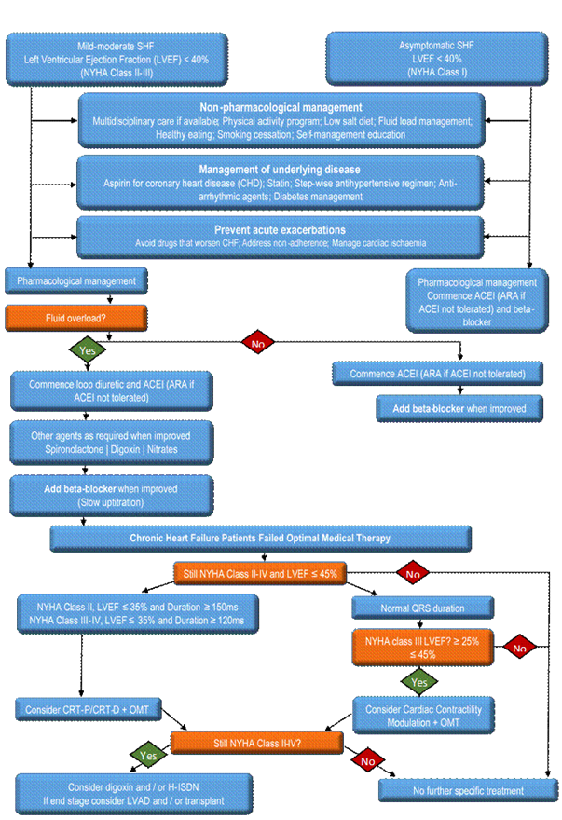

Figure Treatment Algorithm

Note: Outcomes for patient subgroups with LVEF 25-35% and 35-45% will be explored in the MSAC application.

# Regulatory Information

The OPTIMIZER™ IVs has been approved by the Therapeutics Goods Administration (TGA). The indication is as follows:

*“The OPTIMIZER™ IVs system is indicated for use in patients who are older than 18 years of age with symptomatic heart failure due to systolic left ventricular dysfunction despite appropriate medical therapy. The OPTIMIZER™ IVs system delivers non-excitatory CCM signals to the heart and has no pacemaker or ICD functions”.*

The proposed MSAC listing currently is narrower than the TGA indication. This is the population for which the best quality clinical data are currently available.

# Decision analytic

Table 5 summarises the population, intervention, comparator and outcomes of CCM therapy for the proposed population.

Table 6 Summary of extended PICO to define research question that assessment will investigate

| **Patients** | **Intervention** | **Comparator** | **Outcomes to be assessed** | **Healthcare resources to be considered** |
| --- | --- | --- | --- | --- |
| Patient must meet all of the following criteria:  (a) Symptomatic heart failure due to systolic left ventricular dysfunction despite failed Optimal Medical Therapy;  (b) NYHA Class III  (c) ≥ 18 years;  (d) Normal QRS duration (<120ms);  (e) LVEF ≥25% ≤45% | Cardiac contractility modulation therapy + OMT | Failed optimal medical therapy (OMT) | * Peak VO2 * Improvement in quality of life (MLWHF) * Improvement in NYHA classification; and LVEF * Mean change in 6 minute hall walk test * All-cause mortality and all-cause hospitalisations. * Death or hospitalisation due to HF * Device and surgery-related side effects * Serious adverse events * Incremental cost per life year saved * Incremental cost per QALY gain | Insertion, removal or replacement of CCM IPG device  Insertion, removal or replacement of the bipolar leads  CCM IPG device  Device related costs  Bipolar leads  Anaesthesia  Cardiologist  Cardiac monitoring  Hospital stay  Ongoing interrogation of device  Prophylactic antibiotics  Cardiologist visit  GP visits  Outpatient visits  Heart Failure medications  Management of adverse events/complications  Outpatient visits  Emergency service |

Outcomes for the economic model may include:

Primary Efficacy Outcomes

* QALY
* Overall survival

Safety Outcomes

* Adverse Events
* Lead Failure

An example of a decision analytic model is provided below. There are no published cost effectiveness models available for CCM although published economic evaluations exist for CHF. A model will be prepared for the MSAC application.



Figure 7: Indicative decision diagram for cost effectiveness model

# Healthcare resources

See below.

# Questions for public funding

* What are the medical and financial implications of inadequately controlled systolic left ventricular dysfunction in patients with chronic HF?
* What is the ideal patient population that would get the maximum benefit from CCM therapy?
* Which clinical group will be initiating treatment with CCM therapy?
* What proportion of patients with normal QRS duration (<120ms), receiving optimal medical therapy still have uncontrolled heart failure?

Table 7 List of resources to be considered in the economic analysis

|  | **Provider of resource** | **Setting in which resource is provided** | **Proportion of patients receiving resource** | **Number of units of resource per relevant time horizon per patient** | **Disaggregated unit cost** | | | | | |
| --- | --- | --- | --- | --- | --- | --- | --- | --- | --- | --- |
| **MBS** | **Safety nets\*** | **Other govt budget** | **Private health insurer** | **Patient** | **Total cost** |
| Resources provided to identify eligible population | | | | | | | | | | |
| None over and above current standard practice |  |  |  |  |  |  |  |  |  |  |
| Resources provided to deliver proposed intervention | | | | | | | | | | |
| Insertion, removal or replacement of IPG device | Surgeon/ specialist | Private/public hospital | 100% | TBD | $255.45 | TBD |  |  |  | TBD |
| Insertion, removal or replacement of the bipolar leads | Surgeon/ specialist | Private/public hospital | 100% | TBD | $1,224.60 | TBD |  |  |  | TBD |
| IPG device | Manufacturers | Private/public hospital | 100% | TBD |  |  | TBD | TBD |  | TBD |
| Bipolar leads | Manufacturers | Private/public hospital | 100% | TBD |  |  | TBD | TBD |  | TBD |
| Anaesthesia | Specialist | Private/public hospital | 100% | TBD | TBD |  |  |  |  | TBD |
| Cardiologist | Surgeon/ specialist | Private/public hospital | 100% | TBD | TBD | TBD |  |  |  | TBD |
| Cardiac monitoring | Hospital | Private/public hospital | 100% | TBD | TBD |  |  |  |  | TBD |
| Hospital stay | Hospital | Private/public hospital | 100% | TBD | TBD |  | TBD |  |  | TBD |
| Ongoing interrogation of device | Hospital | Private/public hospital | 100% | TBD | $69.75 |  |  |  |  | TBD |
| Prophylactic antibiotics | Hospital/PBS | Private/public hospital | 100% | TBD |  |  | TBD |  | TBD | TBD |
| Resources associated with the outcomes of therapy | | | | | | | | | | |
| Cardiologist visit | Specialist | Private/public hospital | 100% | TBD | TBD |  |  |  | TBD | TBD |
| GP visits | GP | Community | TBD | TBD |  |  | TBD |  | TBD | TBD |
| Outpatient visits | Specialist | Private/public hospital | TBD | TBD |  |  | TBD |  |  | TBD |
| Hospital stay | Private hospital | Private/public hospital | TBD | TBD |  |  | TBD |  |  | TBD |

|  | **Provider of resource** | **Setting in which resource is provided** | **Proportion of patients receiving resource** | **Number of units of resource per relevant time horizon per patient** | **Disaggregated unit cost** | | | | | |
| --- | --- | --- | --- | --- | --- | --- | --- | --- | --- | --- |
| **MBS** | **Safety nets\*** | **Other govt budget** | **Private health insurer** | **Patient** | **Total cost** |
| Emergency service | Hospital | Private/public hospital | TBD | TBD |  |  | TBD |  |  | TBD |
| Inpatient nights | Surgeon/specialist | Private/public hospital | TBD | TBD |  |  | TBD | TBD |  | TBD |
| Heart Failure medications | PBS | Community | TBD | TBD |  |  | TBD |  | TBD | TBD |
| Resources provided in association with comparator | | | | | | | | | | |
| Cardiologist visit | Specialist | Private/public hospital | 100% | TBD | TBD |  |  |  | TBD | TBD |
| GP visits | GP | Community | TBD | TBD |  |  | TBD |  | TBD | TBD |
| Outpatient visits | Hospital | Private/public hospital | TBD | TBD |  |  | TBD |  |  | TBD |
| Hospital stay | Hospital | Private/public hospital | TBD | TBD |  |  | TBD |  |  | TBD |
| Emergency service | Hospital | Private/public hospital | TBD | TBD |  |  | TBD |  |  | TBD |
| Inpatient nights | Hospital | Private/public hospital | TBD | TBD |  |  | TBD | TBD |  | TBD |
| Heart Failure medications | PBS | Community | TBD | TBD |  |  | TBD |  | TBD | TBD |
| Resources used to manage patients successfully and unsuccessfully treated with the proposed intervention | | | | | | | | | | |
| Ongoing heart failure management, including GP and specialists consultations, A&E visits, hospitalisations as required (likely to vary according to outcomes achieved) |  |  |  |  |  |  |  |  |  |  |
| Resources used to manage patients successfully and unsuccessfully treated with the proposed comparator | | | | | | | | | | |
| Ongoing heart failure management, including GP and specialists consultations, A&E visits, hospitalisations as required (likely to vary according to outcomes achieved) |  |  |  |  |  |  |  |  |  |  |

**References:**

Quallion. from <http://www.quallion.com/sub-mm-implantable.asp>. downloaded 13 October 2014

(2011). Guidelines for the prevention, detection and management of chronic heart failure in Australia. National Heart Foundation of Australia and the Cardiac Society of Australia and New Zealand.

Abraham, W. T., K. Nademanee, K. Volosin, S. Krueger, S. Neelagaru, N. Raval, O. Obel, S. Weiner, M. Wish, P. Carson, K. Ellenbogen, R. Bourge, M. Parides, R. P. Chiacchierini, R. Goldsmith, S. Goldstein, Y. Mika, D. Burkhoff, A. Kadish, F.-H.-. Investigators and Coordinators (2011). "Subgroup analysis of a randomized controlled trial evaluating the safety and efficacy of cardiac contractility modulation in advanced heart failure." J Card Fail **17**(9): 710-717.

Borggrefe, M. and D. Burkhoff (2012). "Clinical effects of cardiac contractility modulation (CCM) as a treatment for chronic heart failure." Eur J Heart Fail **14**(7): 703-712.

Borggrefe, M. M., T. Lawo, C. Butter, H. Schmidinger, M. Lunati, B. Pieske, A. R. Misier, A. Curnis, D. Bocker, A. Remppis, J. Kautzner, M. Stuhlinger, C. Leclerq, M. Taborsky, M. Frigerio, M. Parides, D. Burkhoff and G. Hindricks (2008). "Randomized, double blind study of non-excitatory, cardiac contractility modulation electrical impulses for symptomatic heart failure." Eur Heart J **29**(8): 1019-1028.

Burkhoff, D. (2011). "Does contractility modulation have a role in the treatment of heart failure?" Curr Heart Fail Rep **8**(4): 260-265.

Davies, M., F. Hobbs, R. Davis, J. Kenkre, A. K. Roalfe, R. Hare, D. Wosornu and R. J. Lancashire (2001). "Prevalence of left-ventricular systolic dysfunction and heart failure in the Echocardiographic Heart of England Screening study: a population based study." Lancet **358**(9280): 439-444.

Kadish, A., K. Nademanee, K. Volosin, S. Krueger, S. Neelagaru, N. Raval, O. Obel, S. Weiner, M. Wish, P. Carson, K. Ellenbogen, R. Bourge, M. Parides, R. P. Chiacchierini, R. Goldsmith, S. Goldstein, Y. Mika, D. Burkhoff and W. T. Abraham (2011). "A randomized controlled trial evaluating the safety and efficacy of cardiac contractility modulation in advanced heart failure." Am Heart J **161**(2): 329-337 e321-322.

McMurray, J. J., M. Packer, A. S. Desai, J. Gong, M. P. Lefkowitz, A. R. Rizkala, J. L. Rouleau, V. C. Shi, S. D. Solomon, K. Swedberg, M. R. Zile, P.-H. F. I. the and Committees (2014). "Angiotensin-Neprilysin Inhibition versus Enalapril in Heart Failure." N Engl J Med **371**(11): 993-1004.

Neelagaru, S. B., J. E. Sanchez, S. K. Lau, S. M. Greenberg, N. Y. Raval, S. Worley, J. Kalman, A. D. Merliss, S. Krueger, M. Wood, M. Wish, D. Burkhoff and K. Nademanee (2006). "Nonexcitatory, cardiac contractility modulation electrical impulses: feasibility study for advanced heart failure in patients with normal QRS duration." Heart Rhythm **3**(10): 1140-1147.

Shenkman, H. J., V. Pampati, A. K. Khandelwal, J. McKinnon, D. Nori, S. Kaatz, K. R. Sandberg and P. A. McCullough (2002). "Congestive heart failure and QRS duration: establishing prognosis study." Chest **122**(2): 528-534.

Vardas, P. E., A. Auricchio, J.-J. Blanc, J.-C. Daubert, H. Drexler, H. Ector, M. Gasparini, C. Linde, F. B. Morgado, A. Oto, R. Sutton, M. Trusz-Gluza, A. Vahanian, J. Camm, R. De Caterina, V. Dean, K. Dickstein, C. Funck-Brentano, G. Filippatos, I. Hellemans, S. D. Kristensen, K. McGregor, U. Sechtem, S. Silber, M. Tendera, P. Widimsky, J. L. Zamorano, S. G. Priori, C. Blomström-Lundqvist, M. Brignole, J. B. Terradellas, J. Camm, P. Castellano, J. Cleland, J. Farre, M. Fromer, J.-Y. Le Heuzey, G. Y. Lip, J. L. Merino, A. S. Montenero, P. Ritter, M. J. Schalij and C. Stellbrink (2007). "Guidelines for cardiac pacing and cardiac resynchronization therapy: The Task Force for Cardiac Pacing and Cardiac Resynchronization Therapy of the European Society of Cardiology. Developed in Collaboration with the European Heart Rhythm Association." Europace **9**(10): 959-998.

1. The midpoint of this range is included in Table 1 Estimation of prevalent pool (1.75%)
2. Please note that MetaCure Australia Pty Ltd is the Australian sponsor for Impulse Dynamic, the developers of OPTIMIZER™ IVs
3. The clinical trials demonstrated improvements in NYHA and MLWHF. A number of studies have demonstrated the relationship between these outcomes and QALYS /survival.