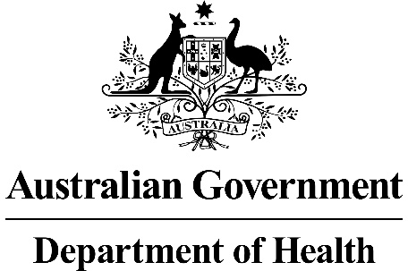

Application Form
Transcatheter aortic valve implantation via transfemoral delivery using the SAPIEN 3 balloon-expandable valve system for patients at low risk for surgery

This application form is to be completed for new and amended requests for public funding (including but not limited to the Medicare Benefits Schedule (MBS)). It describes the detailed information that the Australian Government Department of Health requires in order to determine whether a proposed medical service is suitable.
Please use this template, along with the associated Application Form Guidelines to prepare your application. Please complete all questions that are applicable to the proposed service, providing relevant information only. Applications not completed in full will not be accepted.
Should you require any further assistance, departmental staff are available through the Health Technology Assessment Team (HTA Team) on the contact numbers and email below to discuss the application form, or any other component of the Medical Services Advisory Committee process.
Phone: +61 2 6289 7550
Fax: +61 2 6289 5540
Email: hta@health.gov.au
Website: www.msac.gov.au

PART 1 – APPLICANT DETAILS

Applicant details (primary and alternative contacts)
Corporation / partnership details (where relevant): Edwards Lifesciences Pty Ltd
Corporation name:
ABN: 77 098 873
Business trading name: Edwards Lifesciences Pty Ltd

Primary contact name: REDACTED
Business:
Mobile:
Email:

Alternative contact name: REDACTED
Alternative contact numbers
Business:
Mobile:
Email:

(a) Are you a lobbyist acting on behalf of an Applicant?
Yes
No

If yes, are you listed on the Register of Lobbyists?
Yes
No

PART 2 – INFORMATION ABOUT THE PROPOSED MEDICAL SERVICE

Application title
Transcatheter aortic valve implantation (TAVI) via transfemoral delivery using the SAPIEN 3 balloon-expandable valve (BEV) system for patients at low risk for surgery.

Provide a succinct description of the medical condition relevant to the proposed service (no more than 150 words – further information will be requested at Part F of the Application Form)
Severe aortic stenosis (AS) is characterised by narrowing of the aortic valve leading to restriction of blood flow. AS is often caused by a build-up of calcium on the valve leaflets, causing them to become stiff and reducing their ability to open and close efficiently. It is associated with high pressure inside the left ventricle and as a result of the excessive workload, the left ventricle hypertrophies, which further leads to inefficiency in blood circulation. Symptoms include angina, dyspnoea and syncope. Left untreated, heart failure develops, and the risk of death is increased.
This application is relevant to patients with severe, symptomatic AS classified as being at low risk for surgery (low surgical risk), defined by a predicted 30-day risk of surgical mortality of less than 4%, based on the Society of Thoracic Surgeons Predicted Risk of Mortality (STS-PROM) score.

Provide a succinct description of the proposed medical service (no more than 150 words – further information will be requested at Part 6 of the Application Form)
TAVI involving the SAPIEN 3 BEV involves minimally invasive transfemoral insertion of a prosthetic heart valve that is positioned within the aortic annulus using the SAPIEN 3 system. Once in situ, the valve is expanded while the heart is rapidly paced. The procedure is performed using fluoroscopic and transoesophageal guidance and under general or local anaesthesia.

(a) Is this a request for MBS funding?
Yes
No

If yes, is the medical service(s) proposed to be covered under an existing MBS item number(s) or is a new MBS item(s) being sought altogether?
Amendment to existing MBS item(s)
New MBS item(s)

If an amendment to an existing item(s) is being sought, please list the relevant MBS item number(s) that are to be amended to include the proposed medical service:
Not applicable.

If an amendment to an existing item(s) is being sought, what is the nature of the amendment(s)?
Not applicable.

If a new item(s) is being requested, what is the nature of the change to the MBS being sought?
- A new item which also seeks to allow access to the MBS for a specific health practitioner group
- A new item that is proposing a way of clinically delivering a service that is new to the MBS (in terms of new technology and / or population)
- A new item for a specific single consultation item
- A new item for a global consultation item(s)

NB1: There is an existing MBS item number (38495) for TAVIs: “TAVI, for the treatment of symptomatic severe aortic stenosis, performed via transfemoral delivery, unless transfemoral delivery is contraindicated or not feasible, in a TAVI Hospital on a TAVI Patient by a TAVI Practitioner – includes all intraoperative diagnostic imaging that the TAVI Practitioner performs upon the TAVI Patient”. However, as per note TN.8.135, the item is currently restricted to patients who have been “assessed as having an unacceptably high risk for surgical aortic valve replacement”. The current proposal seeks a new MBS item for the TAVI with the SAPIEN 3 BEV system among patients at low risk for surgery.

REDACTED

Is the proposed service seeking public funding other than the MBS?
Yes
No

If yes, please advise:

What is the type of service:
Therapeutic medical service
Investigative medical service
Single consultation medical service
Global consultation medical service
Allied health service
Co-dependent technology
Hybrid health technology

For investigative services, advise the specific purpose of performing the service (which could be one or more of the following):
- To be used as a screening tool in asymptomatic populations
- Assists in establishing a diagnosis in symptomatic patients
- Provides information about prognosis
- Identifies a patient as suitable for therapy by predicting a variation in the effect of the therapy
- Monitors a patient over time to assess treatment response and guide subsequent treatment decisions

Does your service rely on another medical product to achieve or to enhance its intended effect?
Pharmaceutical / Biological
Prosthesis or device
No

(a) If the proposed service has a pharmaceutical component to it, is it already covered under an existing Pharmaceutical Benefits Scheme (PBS) listing?
Not applicable.
Yes
No

If yes, please list the relevant PBS item code(s):
Not applicable.

If no, is an application (submission) in the process of being considered by the Pharmaceutical Benefits Advisory Committee (PBAC)?
Not applicable.

If you are seeking both MBS and PBS listing, what is the trade name and generic name of the pharmaceutical?
Not applicable.

(a) If the proposed service is dependent on the use of a prosthesis, is it already included on the Prostheses List?
Yes
No

If yes, please provide the following information (where relevant):
Billing code(s): EL063.
Trade name of prosthesis: Edwards SAPIEN 3 Transcatheter Heart Valve.
Clinical name of prosthesis: Transcatheter, balloon expanded aortic heart valve with Commander delivery system.
Other device components delivered as part of the service: The prostheses listing includes the valve and delivery system.

If no, is an application in the process of being considered by a Clinical Advisory Group or the Prostheses List Advisory Committee (PLAC)?
Not applicable.

Are there any other sponsor(s) and / or manufacturer(s) that have a similar prosthesis or device component in the Australian market place which this application is relevant to?
Yes
No
NB: Other TAVI devices (St Jude Medical and Medtronic) do not involve balloon-expandable valves. Rather, they involve self-expanding valves, which are currently not TGA-approved for low risk patients.

If yes, please provide the name(s) of the sponsor(s) and / or manufacturer(s):
Not applicable.

Please identify any single and / or multi-use consumables delivered as part of the service?
Single use consumables: angioplasty kit which includes drapes, manifolds and extensions tubing.
Small and large bore vascular access sheaths
Lock syringes
3 way taps x 2
3 x bowls
2 x galley pots
Temporary pacing wire
Variety of pre-shaped catheters
Variety of standard or speciality wires
Multi-use consumables: temporary pacing cable, temporary pacing box and transthoracic or transoesophageal probe

PART 3 – INFORMATION ABOUT REGULATORY REQUIREMENTS

(a) If the proposed medical service involves the use of a medical device, in-vitro diagnostic test, pharmaceutical product, radioactive tracer or any other type of therapeutic good, please provide the following details:
Type of therapeutic good: transfemoral - aortic transcatheter heart valve bioprosthesis, stent-like framework.
Manufacturer’s name: Edwards Lifesciences LLC.
Sponsor’s name: Edwards Lifesciences Pty Ltd.

Is the medical device classified by the TGA as either a Class III or Active Implantable Medical Device (AIMD) against the TGA regulatory scheme for devices?
Class III
AIMD
N/A

(a) Is the therapeutic good to be used in the service exempt from the regulatory requirements of the Therapeutic Goods Act 1989?
Yes (If yes, please provide supporting documentation as an attachment to this application form)
No

If no, has it been listed or registered or included in the Australian Register of Therapeutic Goods (ARTG) by the Therapeutic Goods Administration (TGA)?
Yes (if yes, please provide details below)
No

ARTG listing, registration or inclusion number: 284496.

REDACTED

If the therapeutic good has not been listed, registered or included in the ARTG, is the therapeutic good in the process of being considered for inclusion by the TGA?
REDACTED

If the therapeutic good is not in the process of being considered for listing, registration or inclusion by the TGA, is an application to the TGA being prepared?

Not applicable.

PART 4 – SUMMARY OF EVIDENCE

Provide an overview of all key journal articles or research published in the public domain related to the proposed service that is for your application (limiting these to the English language only). Please do not attach full text articles, this is just intended to be a summary.
 | Type of study design* | Title of journal article or research project | Short description of research (max 50 words)** | Website link to journal article or research | Date of publication***
1. | Multi-centre randomised clinical trial. | Mack MJ, et al. Transcatheter Aortic-Valve Replacement with a Balloon-Expandable Valve in Low-Risk Patients. N Engl J Med. 2019; 380(18): 1695-1705. | PARTNER 3 randomised 950 low risk patients with severe AS to either TAVI with the SAPIEN 3 BEV (n=496) or surgery (n=454). The primary composite end point of death, stroke, or rehospitalisation at 1 year was significantly lower in the TAVI group (8.5% vs 15.1%; 95% CI −10.8 to −2.5; P<0.001 for noninferiority; hazard ratio, 0.54, 95% CI 0.37 - 0.79; P=0.001 for superiority). At 30 days, TAVR resulted in a lower rate of stroke (P=0.02), death or stroke (P=0.01) and new-onset atrial fibrillation (P<0.001). TAVR also resulted in a shorter index hospitalisation than surgery (P<0.001). There were no significant differences in major vascular complications, new permanent pacemaker insertions, or moderate or severe paravalvular regurgitation. | https://www.ncbi.nlm.nih.gov/pubmed/30883058 | May 2019
2 | Multi-centre randomised clinical trial. | Baron SJ, et al. Health status after transcatheter versus surgical aortic valve replacement in low-risk patients with aortic stenosis. J Am Coll Cardiol. 2019; 74(23):2833-42. | This study compared the health status of patients in the PARTNER 3 clinical trial. Based on the Kansas City Cardiomyopathy Questionnaire (KCCQ) score, TAVR was associated with significantly better health status at 1 month (mean difference in KCCQ-OS 16.0 points; p < 0.001), 6 months (mean difference in KCCQ-OS 2.6 points; p < 0.04), and 1 year (mean difference in KCCQ-OS 1.8 points; p < 0.04). | https://www.ncbi.nlm.nih.gov/pubmed/31577923 | Dec 2019
3 | Prospective, multi-centre single-arm study. | Waksman R, et al. TAVR in low-risk patients: 1-year results from the LRT trial. JACC: Cardiovasc Interv. 2019; 12(10):901-7. | The investigator-initiated prospectively enrolled 200 low risk AS patients and treated them with TAVR at 11 centers. Patients underwent TAVR with either BEV SAPIEN 3 or a self-expanding TAVR device. At 30 days and 1-year, respectively, mortality was 0% and 3.0%, stroke was 0% and 2.1%, and PPM was 5.0% and 7.3%. | https://www.ncbi.nlm.nih.gov/pubmed/30170075 | May 2019
* Categorise study design, for example meta-analysis, randomised trials, non-randomised trial or observational study, study of diagnostic accuracy, etc.
**Provide high level information including population numbers and whether patients are being recruited or in post-recruitment, including providing the trial registration number to allow for tracking purposes.
*** If the publication is a follow-up to an initial publication, please advise.

Identify yet to be published research that may have results available in the near future that could be relevant in the consideration of your application by MSAC (limiting these to the English language only). Please do not attach full text articles, this is just intended to be a summary.
In November 2019, a study was presented at the American Heart Association (AHA) Scientific Meeting in New Orleans, LO, USA. The abstract was published (Circulation. 2019; 140: A14484. Available at: https://www.ahajournals.org/doi/10.1161/circ.140.suppl_1.14484), and is reproduced below. The study is currently under review for publication as a full manuscript.

Cost-Effectiveness of Transcatheter versus Surgical Aortic Valve Replacement in Low-Risk Patients With Severe Aortic Stenosis
Jennifer Y Zhou , Danny Liew , Stephen J Duffy , Antony Walton , Nay Htun , Dion Stub
Background: Recent studies indicate that transcatheter aortic valve replacement (TAVR) is non-inferior to surgical aortic valve replacement (SAVR) in low-risk patients with severe symptomatic aortic stenosis (AS). However, the cost-effectiveness of TAVR in these patients is unknown. We aimed to perform a cost-effectiveness analysis comparing balloon-expandable and self-expanding TAVR to SAVR in patients with severe AS at low surgical risk.
Methods: A Markov model with monthly cycles was constructed to estimate the cost-effectiveness of TAVR compared to SAVR over a ten-year horizon. The perspective was that of the Australian healthcare system. Key data inputs for the model were drawn from the PARTNER 3 trial for balloon-expandable TAVR, and from the Evolut Low Risk trial for self-expanding TAVR. Deterministic and probabilistic sensitivity analyses were performed to assess model uncertainty.
Results: Although procedural costs were higher for TAVR than SAVR, overall costs for TAVR were lower due to a shorter length of hospital and intensive care stay, lower acute complication costs and reduced need for rehabilitation. Over ten years, balloon-expandable TAVR lowered costs by AUD$3,085 (USD$2,141) and increased quality-adjusted life years (QALYs) by 0.15 compared to SAVR, while self-expanding TAVR lowered costs by AUD$425 (USD$295) and increased QALYs by 0.07. Thus, from a health economic perspective, TAVR was dominant over SAVR. Results were robust to sensitivity analyses, with balloon-expandable TAVR being dominant in 61% of 10,000 Monte Carlo iterations and cost-effective in 85% of iterations (at an incremental cost-effectiveness ratio threshold of AUD$50,000 per QALY saved). Self-expanding TAVR was dominant in 51% of iterations and cost-effective in 67% of iterations.
Conclusions: Among low-risk patients with severe symptomatic AS, both balloon-expandable and self-expanding TAVR are likely to be cost-effective relative to SAVR.

PART 5 – CLINICAL ENDORSEMENT AND CONSUMER INFORMATION

List all appropriate professional bodies / organisations representing the group(s) of health professionals who provide the service (please attach a statement of clinical relevance from each group nominated):
Cardiac Society of Australia and New Zealand (CSANZ) – statement pending
Australian and New Zealand Society of Cardiac and Thoracic Surgeons (ANZSCTS) - statement pending

List any professional bodies / organisations that may be impacted by this medical service (i.e. those who provide the comparator service):
Australian and New Zealand Society of Cardiac and Thoracic Surgeons (ANZSCTS).
Cardiac Society of Australia and New Zealand (CSANZ).

List the relevant consumer organisations relevant to the proposed medical service (please attach a letter of support for each consumer organisation nominated):
Consumer Health Forum.

List the relevant sponsor(s) and / or manufacturer(s) who produce similar products relevant to the proposed medical service:
REDACTED

Nominate two experts who could be approached about the proposed medical service and the current clinical management of the service(s):
Name of expert 1: REDACTED
Name of expert 2: REDACTED

PART 6 – POPULATION (AND PRIOR TESTS), INDICATION, COMPARATOR, OUTCOME (PICO)

PART 6a – INFORMATION ABOUT THE PROPOSED POPULATION

Define the medical condition, including providing information on the natural history of the condition and a high level summary of associated burden of disease in terms of both morbidity and mortality:
Aortic stenosis (AS) is one of the most common and serious valve diseases. It is characterised by a narrowing of the aortic valve opening, which restricts blood flow from the left ventricle to the aorta and causes pressure build-up in the left ventricle and consequent left ventricular hypertrophy. Furthermore, stenotic aortic valves may not close fully, resulting in regurgitation back into the left ventricle.
The most common cause of AS is age-related calcification of the aortic valve. Less common causes are congenital bicuspid aortic valves and rheumatic heart disease. Other than calcification, the pathophysiological features of AS are inflammation, lipid accumulation and subendothelial thickening.

AS is a progressive disease that is asymptomatic until late stages. Symptomatic severe AS is classified as Stage D, and has the following features: symptoms (see below); calcified valve leaflets with reduced opening; jet velocity (V_{max}) ≥4 m/s; and mean gradient ≥40 mm Hg. Variations in valve haemodynamics and the presence of symptoms are used to further subclassify symptomatic severe AS.² Symptoms of AS include exertional dyspnoea, decreased exercise tolerance, exertional angina and exertional syncope or presyncope. Left untreated, patients will progress to heart failure. Patients are then at high risk for sudden death. Prognosis is poor once there is a mean aortic valve gradient greater than 40mmHg. Severe AS is associated with death rates of 38%, 32% and 18% at one, five years and ten years, respectively. Without aortic valve replacement, the survival of these patients can be as low as 50% at two years and 20% at five years.
This application is relevant to patients with severe, symptomatic AS classified as being at low risk of surgery. Low risk is historically defined by predicted risk of surgical mortality of <4% at 30 days, based on the STS-PROM score.

Specify any characteristics of patients with the medical condition, or suspected of, who are proposed to be eligible for the proposed medical service, including any details of how a patient would be investigated, managed and referred within the Australian health care system in the lead up to being considered eligible for the service:
Patients with severe AS are typically elderly, although those with a congenital malformation of the valve may present earlier. Patients may present with symptoms or be diagnosed incidentally. Regardless of presentation, an echocardiograph is needed to confirm the diagnosis of AS. Echocardiographic criteria for severe AS are as follows.
Valve area (cm²) | <1.0
Indexed valve area (cm²/m² body surface area) | <0.6
Mean gradient (mmHg) | >40.0
Maximum jet velocity (m/s) | >4.0
Velocity ratio | <0.25
Other investigations that may be conducted include cardiac magnetic resonance imaging (MRI), exercise echocardiography, multi-slice computed tomography and coronary angiography. Valvular regurgitation is also assessed. Functional status is assessed by the New York Heart Association (NYHA) functional class system.
The present application pertains to patients who are determined to be at low risk of surgery, defined by predicted risk of surgical mortality of <4% at 30 days, based on the STS-PROM score.
In practice, suitability of patients for TAVI (and other treatment modalities) are assessed by the multidisciplinary ‘Heart Team’ within each healthcare facility. In contemporary Australian practice, although categorisation of surgical risk into ‘low’, ‘intermediate’ and ‘high’ categories is undertaken, many other factors, including patient choice, are considered by the Heart Team when it determines optimal management pathways for patients.
REDACTED

Define and summarise the current clinical management pathway before patients would be eligible for the proposed medical service (supplement this summary with an easy to follow flowchart [as an attachment to the Application Form] depicting the current clinical management pathway up to this point):
At present, patients with severe symptomatic AS at low risk of surgery are managed medically and/or undergo surgical aortic valve replacement (SAVR). Medical management consists of pharmacological treatment to alleviate symptoms. These do not alter the disease course nor improve survival. Some patients undergo balloon aortic valvuloplasty to enlarge the aortic valve opening, but this procedure also does not alter the disease course nor survival.

PART 6b – INFORMATION ABOUT THE INTERVENTION

Describe the key components and clinical steps involved in delivering the proposed medical service:
In Australia, TAVI is performed in a cardiac catheterisation or an operating room. TAVI is performed under general anaesthesia or local anaesthesia with sedation. For transfemoral delivery (relevant to this application), the latter is often sufficient. The procedure is performed without cardio-pulmonary bypass.
TAVI is usually performed under the guidance of fluoroscopy and transoesophageal echocardiography (TOE). Aortography may also be used. A percutaneous sheath is inserted into the femoral artery with a guide wire that is pushed passed the aortic valve. The aortic valve is predilated via balloon valvuloplasty while the heart is rapidly paced. The SAPIEN 3 BEV is mounted on a balloon catheter and is inserted percutaneously over the guidewire until it crosses the aortic valve. Optimum positioning is confirmed by fluoroscopy. Once the correct position is confirmed, the heart is again rapidly paced and the balloon is expanded until the device meets the native annular walls. The balloon is then deflated and the catheter and guidewire are removed.
Immediately following the procedure, aortography and TOE are again performed to assess the location and the degree of any aortic regurgitation, and the functioning of the coronary arteries.
Patients are then transferred for monitoring to either a coronary care, high dependency or intensive care unit.

Does the proposed medical service include a registered trademark component with characteristics that distinguishes it from other similar health components?
SAPIEN 3 is a registered trademark of Edwards Lifesciences Corporation or its affiliates.

If the proposed medical service has a prosthesis or device component to it, does it involve a new approach towards managing a particular sub-group of the population with the specific medical condition?
TAVI using the SAPIEN 3 BEV system is currently included on the MBS for patients with symptomatic severe aortic stenosis who are at high risk for surgery or who are inoperable.
REDACTED

If applicable, are there any limitations on the provision of the proposed medical service delivered to the patient (i.e. accessibility, dosage, quantity, duration or frequency):
It is anticipated that in nearly all cases, TAVI using the SAPIEN 3 BEV system would be delivered only once in a patient’s lifetime.

If applicable, identify any healthcare resources or other medical services that would need to be delivered at the same time as the proposed medical service:
It is not anticipated that additional resources or medical services would be delivered at the same time, other than those that would occur during the TAVI.

If applicable, advise which health professionals will primarily deliver the proposed service:
An interventional cardiologist or a cardiothoracic surgeon must perform the procedure.

If applicable, advise whether the proposed medical service could be delegated or referred to another professional for delivery:
The service cannot be delegated.

If applicable, specify any proposed limitations on who might deliver the proposed medical service, or who might provide a referral for it:
MBS funding is only available for cardiothoracic surgeons or interventional cardiologists who are accredited TAVI practitioners.

If applicable, advise what type of training or qualifications would be required to perform the proposed service as well as any accreditation requirements to support service delivery:
Cardiothoracic surgeons must have completed the Cardiothoracic Surgery Program and be eligible to be a Fellow of the Royal Australasian College of Surgeons, or otherwise qualified to practice cardiothoracic surgery in Australia.
Interventional cardiologists must have completed the Advanced Training Curriculum in Cardiology and be eligible to be a Fellow of the Royal Australasian College of Physicians or otherwise qualified to practice interventional cardiology in Australia.
Additionally, the interventional cardiologist or cardiothoracic surgeon must be an accredited TAVI practitioner. Accreditation is conducted by the Accreditation Committee appointed by Cardiac Accreditation Services Limited.

(a) Indicate the proposed setting(s) in which the proposed medical service will be delivered (select all relevant settings):
Inpatient private hospital
Inpatient public hospital
Outpatient clinic
Emergency Department
Consulting rooms
Day surgery centre
Residential aged care facility
Patient’s home
Laboratory
Other – please specify below
The service must be provided in a hospital that has been endorsed for undertaking TAVIs.
- Where the proposed medical service is provided in more than one setting, please describe the rationale related to each:
The service may be provided in either a public or private hospital, as long as it is endorsed (see above).

Is the proposed medical service intended to be entirely rendered in Australia?
Yes
No – please specify below

PART 6c – INFORMATION ABOUT THE COMPARATOR(S)

Nominate the appropriate comparator(s) for the proposed medical service, i.e. how is the proposed population currently managed in the absence of the proposed medical service being available in the Australian health care system (including identifying health care resources that are needed to be delivered at the same time as the comparator service):
The comparator is SAVR with a bioprosthetic or mechanical aortic valve. As with TAVI with the SAPIEN 3 BEV, it is not anticipated that other resources would be required at the same time other than those that are provided during the SAVR procedure.

Does the medical service that has been nominated as the comparator have an existing MBS item number(s)?
Yes (please provide all relevant MBS item numbers below)
No
38488
VALVE REPLACEMENT with BIOPROSTHESIS OR MECHANICAL PROSTHESIS
Fee: $1,940.15

38489
VALVE REPLACEMENT with allograft (subcoronary or cylindrical implant), or unstented xenograft
Fee: $2,307.40

Define and summarise the current clinical management pathways that patients may follow after they receive the medical service that has been nominated as the comparator (supplement this summary with an easy to follow flowchart [as an attachment to the Application Form] depicting the current clinical management pathway that patients may follow from the point of receiving the comparator onwards including health care resources):
Patients receiving SAVR receive an echocardiogram at one month, six months and one year after the procedure. Complications of SAVR include stroke, heart failure, permanent pacemaker implantation, and other cardiovascular events. Re-operation may be needed, but this is rare. See the attached ‘Clinical Pathway after SAVR’.
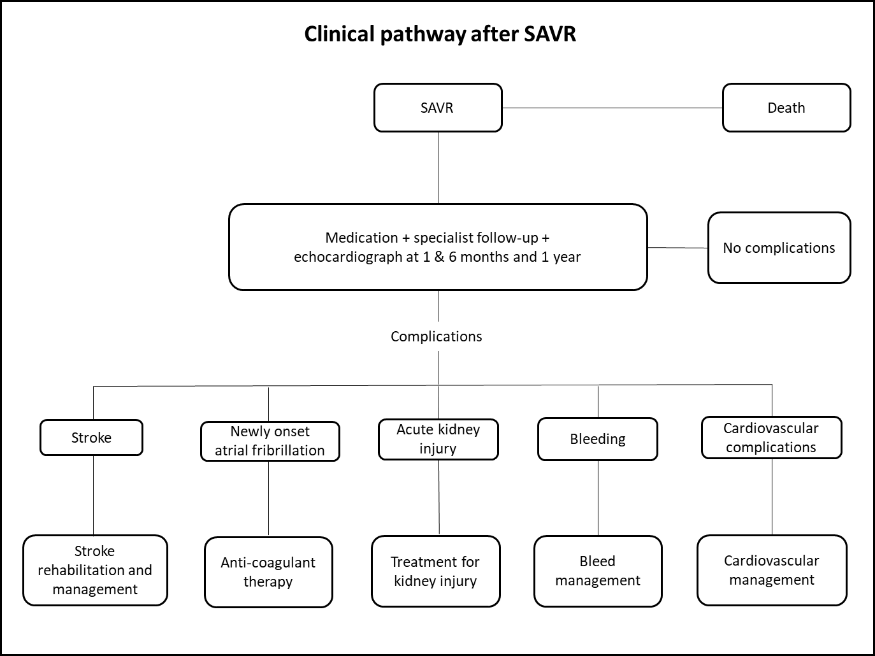

(a) Will the proposed medical service be used in addition to, or instead of, the nominated comparator(s)?
It will be instead of the nominated comparator.
Yes
No

If yes, please outline the extent of which the current service/comparator is expected to be substituted:
It is currently unknown what proportion of low risk patients will access TAVI BEV should the service be included on the MBS. The proportion may be up to 80%; please see responses to Questions 49 and 50 for further information.

Define and summarise how current clinical management pathways (from the point of service delivery onwards) are expected to change as a consequence of introducing the proposed medical service including variation in health care resources (Refer to Question 39 as baseline):
The clinical outcomes will be the same after TAVI with the SAPIEN 3 BEV as for SAVR, but the likelihood of outcomes will differ. Efficacy data suggest that survival at one year is higher for TAVI with the SAPIEN 3 BEV (99.0% vs 97.5%) and stroke is lower (1.2% vs 3.1%). However, pacemaker implantation is higher (7.5% vs 5.5%). It should also be noted that SAVR requires open chest surgery, and hence typically involves a longer hospital stay, including in the intensive care unit (ICU) or high dependency unit compared to TAVI BEV. Recovery time is also likely to be longer post SAVR, meaning a delay in return to function.

PART 6d – INFORMATION ABOUT THE CLINICAL OUTCOME

Summarise the clinical claims for the proposed medical service against the appropriate comparator(s), in terms of consequences for health outcomes (comparative benefits and harms):
Among patients with symptomatic severe AS and at low risk of surgery, TAVI with the SAPIEN 3 BEV is superior to SAVR in terms of the composite endpoint of death, stroke, or rehospitalization. TAVI with the SAPIEN 3 BEV also results in significantly lower rates for new onset atrial fibrillation (AF) and major bleeding events.

Clinical effectiveness outcome: composite of death, stroke and rehospitalisation
In the pivotal randomised clinical trial (PARTNER 3), 950 low risk patients with severe AS were randomised to either TAVI with the SAPIEN 3 BEV (n=496) or surgery (n=454). SAPIEN 3 was superior to SAVR with respect to the primary composite endpoint of death, stroke and rehospitalisation, with a hazard ratio of 0.54 (95% confidence interval [CI] 0.37-0.79). Figure 6.1, reproduced from the publication of PARTNER 3, depicts the Kaplan-Meier curves for the primary outcome.

Figure 6.1 Kaplan-Meier curves for the primary outcome (composite of death, stroke and rehospitalisation) from PARTNER 3.
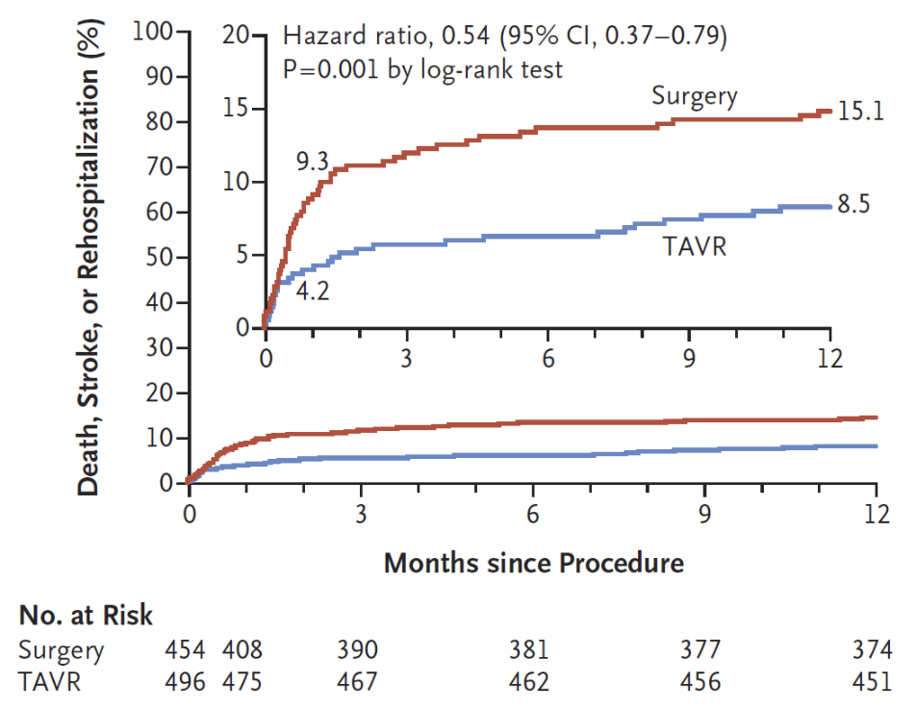

Health related quality of life
In PARTNER 3, quality of life, as measured by the Kansas City Cardiomyopathy Questionnaire (KCCQ) overall summary (OS), was observed to be statistically significantly improved for TAVI at both 30 days and 1 year (Table 6.1).
Table 6.1. Quality of life outcomes observed in PARTNER 3.
 | TAVI using the SAPIEN 3 BEV | SAVR | Treatment effect
KCCQ-OS Score 30 days | 18.5 ± 0.83 | 2.5 ± 1.05 | 16.1 [14.2, 18.0]
KCCQ-OS Score 1 year | 19.4 ± 0.87 | 17.4 ± 0.99 | 1.8 [0.2, 3.4]
KCCQ-OS: Kansas City Cardiomyopathy Questionnaire Overall Summary.

Safety outcomes
In PARTNER 3, rates of life-threatening/disabling, or major bleeding and new onset of atrial fibrillation were statistically significantly lower in the TAVI group compared to the SAVR group. However, TAVI patients had higher rates of major vascular complications, new left bundle branch block and new permanent pacemaker than SAVR. Lastly, lower rates of myocardial infarction were observed for TAVI. Table 6.2 summarises the safety outcomes, for which only those with a rate of 1% or more are reported.

Table 6.2. Safety outcomes observed in PARTNER 3 at 1 year.
 | TAVI using the SAPIEN 3 BEV | SAVR | Treatment effect
Life-threatening / disabling, or  major bleeding | 7.7% | 25.9% | 0.25 [0.17, 0.37]
Major vascular complications | 1.0% | 2.3% | 1.83 [0.74, 4.55]
Myocardial infarction | 1.2% | 2.2% | 0.54 [0.20, 1.49]
New left bundle branch block | 23.7% | 8.0% | 3.43 [2.32, 5.08]
New permanent pacemaker | 7.3% | 5.4% | 1.39 [0.83, 2.33]
New onset atrial fibrillation | 7.0% | 40.9% | 0.13 [0.09, 0.20]

Please advise if the overall clinical claim is for:
Superiority
Non-inferiority

Below, list the key health outcomes (major and minor – prioritising major key health outcomes first) that will need to be specifically measured in assessing the clinical claim of the proposed medical service versus the comparator:
Clinical Effectiveness Outcomes:
Composite of death, stroke and rehospitalisation
Death
Stroke
Rehospitalisation
Health-related quality of life

Safety Outcomes:
Life-threatening / disabling, or major bleeding
Major vascular complications
Myocardial infarction
New left bundle branch block
New permanent pacemaker
New onset atrial fibrillation

Healthcare resources:
Cost of valvular prosthesis
Cost associated with changes in clinical management (testing required before the procedure, length of stay, post-discharge rehabilitation)

Cost-effectiveness:
Cost per life-year gained
Cost per QALY gained

Total Australian Government healthcare costs:
Total cost to the Medical Benefits Schedule (MBS)

PART 7 – INFORMATION ABOUT ESTIMATED UTILISATION

Estimate the prevalence and/or incidence of the proposed population:
Osnabrugge estimated that 3.4% of the population aged over 75 years have severe AS. Of those, 75.6% would be symptomatic. It is estimated that 79.1% of patients with severe symptomatic AS are at low risk of surgery. Thourani et al estimated that 79.9% of patients who underwent SAVR were of low risk.
It was assumed that the same prevalence of severe AS (3.4%) would apply to people aged 65 years and above as those aged 75 years and above. Table 7.1 lists the estimated Australian population aged 65 years and above.
Table 7.1. Australian population over 65 years.
 | 2019 | 2020 | 2021
Australian Population over 65 years of age | 4,026,056 | 4,145,275 | 4,271,505
An estimate of the number of patients who would be eligible for the proposed service can be derived from the number of MBS item numbers that have been claimed for SAVR procedures. TAVI became available on the MBS in November 2017. This is likely to have reduced the overall population that received SAVR since this date. Therefore, Medicare statistics prior to November 2017 were accessed to avoid underestimating the population.
In the time from Quarter 4 2016 to Quarter 3 2017, MBS Item 38488 was claimed 2601 times and MBS Item 38489 was claimed 90 times. Eighty percent of these patients were aged over 65 years and likely to be eligible for TAVI.
According to Australian Institute of Health and Welfare statistics, 1827 patients received TAVI in Australia in 2017/2018. It is possible that some of these patients would have been treated in private hospitals should the option have been available. To avoid underestimation of the population, it was assumed that all these patients would have been treated in the private sector if TAVI had been available.
The following estimates are made using the utilisation of MBS item numbers 38488 and 38489 as a proportion of the population aged 65 years and over. The same method is applied to TAVI procedures. Only 80% of patients receiving SAVR under these item numbers are for those aged 65 and over, so this is likely to be a conservative estimate.
The estimations for utilisation are summarised in Table 7.2.

Table 7.2. Estimations of health service utilisation.
 |  | 2018 | 2019 | 2020 | 2021 | 2022
A | Australian population aged over 65 years | 3,909,104 | 4,026,056 | 4,145,275 | 4,271,505 | 4,397,463
B | MBS item numbers 38488 and 38489 | 2775 | 2858 | 2943 | 3032 | 3122
C | TAVI procedures | 1884 | 1940 | 1998 | 2059 | 2119
D | Total AVR population (B+C) | 4659 | 4799 | 4941 | 5091 | 5241
E | Low risk group (79.9%* D) | 3723 | 3834 | 3948 | 4068 | 4188

Estimate the number of times the proposed medical service(s) would be delivered to a patient per year:
As this intervention is usually performed late in life, it is anticipated that the service would only be delivered once per patient.

How many years would the proposed medical service(s) be required for the patient?
Once in a lifetime.

Estimate the projected number of patients who will utilise the proposed medical service(s) for the first full year:
It is estimated that 4188 patients would be eligible for the proposed service in 2022. However, it is unlikely that all these patients would access TAVI. Therefore, this figure is likely to be an overestimate.
Osnabrugge estimated that 80% of high risk/inoperable patients eligible for TAVI received the procedure. If this figure is applied to low risk patients who are eligible, then in 2022, 3350 patients will receive TAVI using the SAPIEN 3 BEV.

Estimate the anticipated uptake of the proposed medical service over the next three years factoring in any constraints in the health system in meeting the needs of the proposed population (such as supply and demand factors) as well as provide commentary on risk of ‘leakage’ to populations not targeted by the service:
A TAVI must be performed by a TAVI practitioner in a ‘TAVI-endorsed’ hospital. It is possible that there will be capacity constraints if there are insufficient facilities and trained staff to meet demand. It is likely that capacity will increase in coming years. However, assuming that capacity is available to meet demand, the uptake outlined in Table 7.3 is likely.
Table 7.3. Projected uptake.
 |  | 2022 | 2023 | 2024
A | Australian population aged over 65 years | 4,397,463 | 4,526,677 | 4,656,293
B | Eligible population | 4,188 | 4,311 | 4,434
C | Patients accessing TAVI  80%*B | 3,350 | 3449 | 3,547

As access to TAVI is determined by the TAVI heart team, it is unlikely that there will be leakage to populations outside of the eligible population.

PART 8 – COST INFORMATION

Indicate the likely cost of providing the proposed medical service. Where possible, please provide overall cost and breakdown:
REDACTED
Other cost items include the MBS items listed in Table 8.1.
Table 8.1. Relevant MBS items.
Cost Item | MBS Item Number | 100% MBS Fee | 75% Benefit
TAVI Case Conference Organiser | 6080 | $51.70 | $38.80
TAVI Case Conference Attendance * 3 | 6081 | $38.55 | $28.95
TAVI Procedure including all intraoperative diagnostic imaging | XXXX | $1,455.10  (Same as MBS item 38495) | $1091.35
Assistant | 51303 | “one fifth of the established fee for the operation or combination of operations”
Initiation of Anaesthesia | 21941 | $140.70 | $105.55
ICU Attendance | 13870 | $367.90 | $275.95
Transthoracic echocardiography | 55113 | $230.65 | $173.00

Specify how long the proposed medical service typically takes to perform:
The procedure typically takes 1 to 1.5 hours.

If public funding is sought through the MBS, please draft a proposed MBS item descriptor to define the population and medical service usage characteristics that would define eligibility for MBS funding.
Category 3 – Therapeutic Procedures – Surgical Operations
TAVI using the SAPIEN 3 balloon-expandable valve system, for the treatment of symptomatic severe aortic stenosis, performed via transfemoral delivery, or an alternate access route if transfemoral delivery is contraindicated or not feasible, in a TAVI Hospital on a TAVI Patient by a TAVI Practitioner – includes all intraoperative diagnostic imaging that the TAVI Practitioner performs upon the TAVI Patient

NB: The same explanatory notes (AN.33.1 and TN.8.135) for MBS item 38495 would apply for the new MBS item, except that the description of the ‘TAVI Patient’ would be changed to: “A TAVI Patient means a patient who, as a result of a TAVI Case Conference, has been assessed as having an unacceptably high low risk for surgical aortic valve replacement and is recommended as being suitable to receive the service described in item XXXX.”

Thaden J.J. et al ‘The Global Burden of Aortic Stenosis’ Prog. CardVasc. Dis 56 (2014) 565-571
Nishamura R A., et al ‘2014 AHA/ACC Guideline for the Management of Patients with Valvular Heart Disease: Executive Summary.’ JACC Vol 63, Iss 22, 2014
Varadarajan P et al ‘Clinical profile and natural history of 453 nonsurgically managed patients with severe aortic stenosis’ Ann Thorac Surg. 2006 Dec; 82(6):2111-5
Otto CM. Timing of aortic valve surgery. Heart. 2000;84:211-8.
Andeotti F et al ‘Guidelines on the management of valvular heart disease (version 2012): The Joint Task Force on the Management of Valvular Heart Disease of the European Society of Cardiology (ESD) and the European Association for Cardio-Thoracic Surgery (EACTS) Eur Heart Journ Vol 33, Iss 19, 1 Oct 2012
http://tavi.org.au/
Mack MJ, et al. Transcatheter Aortic-Valve Replacement with a Balloon-Expandable Valve in Low-Risk Patients. N Engl J Med. 2019; 380(18): 1695-1705.
Osnabrugge MS et al ‘Aortic Stenosis in the Elderly. Disease Prevalence and Number of Candidates for Transcatheter Aortic Valve Replacement: A Meta-Analysis and Modelling Study’ JACC 2013 Vol. 62, No 11, 2013
Thourani VH et al ‘Contemporary real-world outcomes of surgical aortic valve replacement in 141,905 low-risk, intermediate-risk, and high-risk patients.’ Ann Thorac Surg 2015;99:55-61
Australian Bureau of Statistics Population Projections Australia 2017. Series B
http://medicarestatistics.humanservices.gov.au/statistics/mbs_item.jsp
Australian Institute of Health and Welfare, Procedures and healthcare interventions (ACHI 9th edition), Australia, 2017-18

