MSAC Application 1671:
Targeted carrier testing for severe monogenic conditions

Ratified
PICO Confirmation

Summary of PICO/PPICO criteria to define question(s) to be addressed in an Assessment Report to the Medical Services Advisory Committee (MSAC)
Table 1 PICO for targeted carrier testing for severe monogenic conditions in people at high risk of being a heterozygous genetic carrier of a severe monogenic condition: PICO Set 1
Component | Description
Populations | This application proposes testing in the Ashkenazi Jewish population, as reflected in the below identified subpopulations.  - Asymptomatic individuals with a >10% a priori aggregate personal risk of being a heterozygous genetic carrier of a variant in the following autosomal recessive and X-linked genes: HEXA, ASPA, ELP1, MCOLN1, G6PC1, SLC37A4, FANCA, FANCC, FANCG, GBA, SMPD1, BLM  - Reproductive partners of individuals described in population 1, where either partner is in the first trimester of pregnancy.  - Reproductive partners of individuals described in population 1, where carrier status of an autosomal recessive condition associated with pathogenic or likely pathogenic variants of the genes described in (1) has been confirmed.  - First trimester diagnostic testing of the potentially affected singleton fetus in a couple identified from any of (1), (2) and (3) as both being carriers of an autosomal condition, or one partner is a carrier of an X-linked condition, associated with pathogenic or likely pathogenic variants of the genes described in (1).
Prior tests | No prior tests as all populations for testing are asymptomatic
Intervention | An in vitro carrier testing panel to identify the carriers of variants associated with nine severe monogenic disorders. The gene panel will comprise HEXA, ASPA, ELP1, MCOLN1, G6PC1 and SLC37A4, FANCA and FANCC and FANCG, GBA, SMPD1, BLM that cause Tay Sachs Disease (TSD), Canavan disease (CD), Familial dysautonomia (FD), Mucolipidosis Type IV (MLD), Glycogen storage disease type 1 (GSD1), Fanconi anaemia type C (FA), Gaucher disease (GD), Niemann Pick Disease type A (NPD), and Bloom Syndrome (BS), resp ectively.  Panel testing in practice will also include CFTR, SMN1 and FMR1, however these are not included in the intervention for assessment as they have already been supported by MSAC. Note that any analyses using the alternative comparator of ‘no genetic testing’ should also include testing for variants in CFTR, SMN1 and FMR1 in the intervention.  The partner test is to be gene sequencing in the base case, and in a sensitivity analysis only the panel variants within the relevant gene(s).  The fetal test is to be testing for the variant(s) known to be present in the parents.
Comparator/s | The base case comparator should be genetic carrier testing for spinal muscular atrophy (SMA), cystic fibrosis (CF), and fragile-X syndrome (FXS), as supported by MSAC for Application 1573. PASC recognised that 1573 testing has not yet been supported by Government, so an alternative comparator would be ‘No genetic testing’.
Reference standard | Not applicable  Where other genetic testing is used, the choice of reference standard will be dependent on the diagnostic testing technology used.
Outcomes | Outcomes that relate to the direct safety of the health technology or comparator:  - Physical and/or psychological harms from genetic testing or no genetic testing, adverse events from testing  - Risk of not undertaking subsequent testing for general population risk conditions due to false sense of security from negative small panel test result.  Test accuracy outcomes:  - Assessment of diagnostic/test accuracy: sensitivity, specificity, number of false positives, number of false negatives, number of inconclusive results (noting that the diagnostic accuracy of next generation DNA sequencing tests have been established by MSAC, and therefore only if available). Any other technologies that are used for detecting the genes in the population, will be provided by the applicant. The analytical validity will be assessed for all these technologies if their diagnostic accuracy has not already been established.  - Clinical utility:  - Diagnostic yield of carrier testing:  - Proportion of tested individuals who are carriers  - Proportion of tested couples who are both carriers for the same recessively inherited disease  - Change in reproductive decisions made where panel testing is performed antenatally  - For women already pregnant: rate of termination of pregnancy due to the detection of a variant  - In addition, PASC agreed that the downstream costs also include the costs of caring for a child who has inherited the severe disabling inheritable diseases.  Societal outcomes:  - Healthcare resource use:  - Number of carrier tests and cost of gene carrier testing (in total, and per carrier identified)  - Number and cost of additional medical practitioner consultations  - Cost-effectiveness outcomes & financial impact:  - Population 1 and 2 – number of tests expected, cost of carrier testing  - Cost per individual identified with a pathogenic or likely pathogenic variant  - Cost per informed reproductive decision  - Costs per additional IVF & preimplantation genetic diagnosis event  - Population 4 – number of terminations and cost per termination  - Cost per identified affected fetus  - Total healthcare costs:  - Number and cost of additional medical practitioner consultations  - Reduction in costs of associated therapies (where applicable)
Assessment questions | What is the safety, effectiveness and cost-effectiveness of targeted carrier testing for nine severe monogenic conditions versus existing genetic carrier testing (for CF, FXS, and SMA) in individuals at a >10% personal risk of being a heterozygous genetic carrier of a clinically significant disorder associated with pathogenic or likely pathogenic variants of the genes in the testing panel?

Purpose of application
An application requesting Medicare Benefits Schedule (MBS) listing of targeted carrier testing to identify individuals who are carriers of severe monogenic conditions, was received from the Royal College of Pathologists of Australasia (RCPA), by the Department of Health.
The clinical claim made in the application form is that the use of the carrier testing results in superior health outcomes compared to the no carrier testing.

PICO criteria

Population
The testing populations
PASC advised that the population is people with a >10% risk of being a heterozygous genetic carrier of gene variants responsible for nine severe monogenic and X-linked conditions: TSD, CD, FD, MLD, GSD1, FA, GD, NPD and BS. PASC noted that MBS funding for testing this new gene panel will provide additive benefits to genetic screening for X-linked and autosomal recessive genes responsible for SMA, CF, and FXS— supported in recent MSAC application 1573.
PASC considered further work was needed to define the populations. A post-PASC meeting was held between the applicant and the Department, where the applicant agreed this application is to be restricted to the Ashkenazi Jewish population (though other ethnicities that confer a >10% personal risk of being a carrier for specific gene variants may be the subject of future applications).
PASC agreed that the populations who qualify for testing should consist of:
- Asymptomatic individuals with a >10% a priori aggregate personal risk of being a heterozygous genetic carrier for variants in the following autosomal recessive and X-linked genes: HEXA, ASPA, ELP1, MCOLN1, G6PC1, SLC37A4, FANCA, FANCC, FANCG, GBA, SMPD1, BLM.
- Reproductive partners of individuals described in population 1, where either partner is in the first trimester of pregnancy.
- Reproductive partners of individuals described in population 1, where carrier status of an autosomal recessive condition associated with pathogenic or likely pathogenic variants of the genes described in (1) has been confirmed.
- First trimester diagnostic testing of the potentially affected singleton fetus in a couple identified from any of (1), (2) and (3) as both being carriers of autosomal condition, or one partner is a carrier of an X-linked condition, associated with pathogenic or likely pathogenic variants of the genes described in (1).
- Cascade testing of first-degree relative of an individual found to be a carrier of an autosomal recessive or X-linked condition as described in (1). However, at the post-PASC meeting, the applicant agreed that a separate population/item for the cascade testing of FDRs is not needed as by definition this population have >10% personal risk of being a carrier and so are already captured under population 1.
Preconception genetic testing is preferable to antenatal testing in order to provide greater reproductive decision options to potential parents. However, if testing takes place during pregnancy, carrier testing of both parents should occur concurrently without delay in order to provide the maximum time to consider the test results. Published studies have demonstrated successful health outcomes such as fewer than expected TSD cases, and significant decrease in the number of TSD-affected children born to parents previously tested by a combination of high school genetic testing programs, outreach community programs, opportunistic testing by medical practitioners and preconception testing (Lew et al., 2012).
PASC considered the merits of limiting the population to individuals of reproductive age or to individuals planning reproduction. PASC considered that this restriction would lead to fewer counselling events downstream, and may prove to be more cost-effective, and/or avoid anxiety in individuals not planning a pregnancy. However, such testing among Ashkenazi Jews in the past has been proven to be successful in identifying the carriers and avoiding births of children with these severe diseases, and the applicant stated that testing reduces anxiety. PASC suggested the applicant should revisit this issue out of session.
At the post-PASC meeting, the applicant stated it remains supportive of testing long in advance of reproductive decision-making, though acknowledged that the items are more likely to be utilised at the point of conception or in early pregnancy. The applicant requested the DCAR examine both options for the timing of testing.
Population with the genetic variants
This application will address the Ashkenazi Jewish population, as this population is likely to benefit from genetic carrier testing. To date, there is a considerable volume of clinical literature describing genetic testing for autosomal recessive genetic variants in the Ashkenazi Jewish population. Table 2 describes the estimated carrier frequencies and clinical features of the disorders commonly found among the Ashkenazi Jewish populations.
In 2016, Australia’s total Jewish population was estimated to be 117,903, with the majority identifying as Ashkenazi Jews (Graham & Narunsky, 2019). The overwhelming majority of the Australian Ashkenazi Jewish population live in the urban centres of Melbourne and Sydney (83.9%). In the five years between 2011 and 2016, the recorded Jewish population in Australia grew by only one per cent, a sharp decrease in growth compared to 2006-2011, when six per cent growth was recorded (Graham & Narunsky, 2019). This might be due to changes in population growth, changes in self-identification as Jewish, or loss of knowledge of Jewish ancestry.
Overall, more than 80 per cent of Australian Ashkenazi Jewish individuals in the reproductive age group have not had, or no longer have, the opportunity to participate in existing Jewish high school-based screening programs. This is because the school-based program is now only offered in New South Wales (the Victorian program having ceased operation due to financial constraints) in the six schools with the highest numbers of Ashkenazi Jewish student enrolments. In Australian Jewish communities living outside of Melbourne and Sydney, where no high school-based screening programs were conducted, the proportion of unscreened Ashkenazi Jewish individuals of reproductive age is likely to be even higher (HGSA, 2015).
A small number of recessive genetic conditions are responsible for significant morbidity and mortality in the Ashkenazi Jewish population. Although some of these conditions are considered rare in the general Australian population, approximately one in five (20%) of Ashkenazi Jewish individuals who undergo genetic testing will be carriers for one or more of these conditions. The clinical characteristics, mode of inheritance and prevalence of the conditions recommended to be tested for are summarised in Table 2. Given the prevalence of these conditions in the Ashkenazi Jewish population, and the current state of the evidence base this application will consider testing of the genes associated with nine severe monogenic disorders: TSD, CD, FD, MLD, GSD1, FA, GD, NPD and BS. It should be noted that CFTR and SMN1 are equally prevalent in the non-Ashkenazi Jewish Australian population, and publicly funded carrier testing for these genes (plus FXS) has already been supported by MSAC (MSAC application 1573).
Further, the Human Genetics Society of Australasia (HGSA) (HGSA, 2015)) and the Royal Australian and New Zealand College of Obstetricians and Gynaecologists (RANZCOG) (RANZCOG, 2019) recommend offering Ashkenazi Jews access to testing for TSD, CF, NPD, FA, FD, BS, CD and MLD, because of the relatively high prevalence of these diseases among Ashkenazi Jews compared to the general population.

Table 2 Characteristics of disorders recommended to be tested for in individuals with a >10% personal risk of being a heterozygous genetic carrier
Condition | Clinical features | Mode of inheritance and cause of condition | Treatment and/or management | Prevalence and carrier frequency in Ashkenazi Jewish population | Carrier testing
Tay-Sachs disease (TSD), a lysosomal storage disorder (NIH, 2012b) | Typically appears in infants aged 3-6 months, when normal development slows, and muscles used for movement weaken, resulting in a loss of motor skills such as turning over, sitting, and crawling. Disease progression is a result of neurons in the brain and spinal cord gradually being destroyed, with symptoms including an exaggerated startle reaction to loud noises, seizures, vision and hearing loss, intellectual disability, and paralysis/spasticity. Children with severe infantile form of TSD usually only live into early childhood (<4 years). Although there are other milder, late-onset forms of TSD that may occur in childhood, adolescence, or adulthood, these forms are extremely rare (NIH, 2012b). | Autosomal recessive. Carriers typically do not show signs or symptoms of TSD.  Caused by variants in the HEXA gene, which is required for the production of beta-hexosaminidase A, a key lysosomal enzyme needed to breakdown GM2 gangliosides. Without functional beta-hexosaminidase A, GM2 gangliosides accumulate to toxic levels causing progressive damage to neurons within the brain and spinal cord.(NIH, 2008)  Individuals with TSD have two null alleles with no HEXA enzymatic activity (Kaback & Desnick, 2011). | No cure.  Treatment is mostly supportive. Seizures may be controlled using conventional antiepileptic drugs such as benzodiazepines, phenytoin, and/or barbiturates; however, seizures are progressive and can change in type and severity (Kaback & Desnick, 2011). | Incidence in unscreened Jewish populations is  1:3,900 births (Lew et al., 2012)  Carrier frequency in Ashkenazi Jewish population  1:25  Carrier frequency in general population 1:250 (HGSA, 2015) | More than 120 variants in the HEXA gene described that reduce or eliminate the functional activity of beta-hexosaminidase A, resulting in TSD (NIH, 2008).  Targeted analysis of the 6 most common pathogenic variants:  3 null alleles: p.Tyr427IlefsTer5  c.1421+1G>C  c.1073+G>A  Adult onset  p.Gly269Ser  2 pseudo-deficiency alleles  p.Arg247Trp  p.Arg249Trp (Kaback & Desnick, 2011)
Canavan disease (CD) | Neonatal/infantile CD is the most common and most severe form of the condition. Affected infants appear normal for the first few months of life; however, a loss of motor skills begins to develop by 3-5 months. Affected infants have difficulty with turning over, controlling head movement, and sitting without support. Other common features include hypotonia, macrocephaly, and irritability. Feeding and swallowing difficulties, seizures, and sleep disturbances may also develop (NIH, 2015b). | Autosomal recessive. Carriers typically do not show signs or symptoms of CD.  Caused by variants in the ASPA gene, which codes for aspartoacylase, an enzyme that breaks down N-acetyl-L-aspartic acid (NAA). NAA is found predominantly in neurons in the brain; however, its role is currently unclear. Mutations in the ASPA gene reduce the function of aspartoacylase, preventing the breakdown of NAA, leading to a build-up of NAA and subsequent impairment of enzyme activity. High levels of NAA build up in the neonatal/infantile form of CD, with lower levels in the milder, juvenile form. The build-up of NAA leads to the progressive destruction of existing myelin sheaths, causing malfunction of nerves, which disrupts normal brain development (NIH, 2015b). | No cure.  The average life expectancy for infants affected with neonatal/infantile CD is 18 months, although some individuals may survive into adolescence or beyond (HGSA, 2015).  The milder, juvenile form does not usually result in a shortened lifespan (NIH, 2015b).  Once diagnosed, patients will usually undergo a brain MRI and neurologic, developmental and ophthalmologic assessments (Matalon, Delgado, & Michals-Matalon, 2018).  Treatment of neonatal/infantile CD is supportive, aiming to provide adequate nutrition and hydration, managing infectious diseases, and protecting the airway. Physical therapy may minimise contractures and maximise motor function. Seizures can be treated with antiepileptic drugs (Matalon et al., 2018). | Prevalence  1 in 6,400 to 13,500 (NIH, 2015b)  Carrier frequency  1:40 (HGSA, 2015) | In Ashkenazi Jewish populations, 97% of CD is caused by 2 pathogenic variants in the ASPA gene:  Missense mutation c.854A>C  (p.Glu285Ala)  Nonsense mutation c.693C>A  (p.Tyr231ter) (HGSA, 2015)
Familial dysautonomia (FD) | FD affects cells of the autonomic nervous system, responsible for controlling involuntary actions such as digestion, breathing, tear production, and regulation of blood pressure and body temperature. FD also affects the sensory nervous system, which controls activities such as taste and the perception of pain, heat, and cold (NIH, 2013a).  FD usually manifests during infancy, with early symptoms including hypotonia, feeding difficulties, poor growth, lack of tears, frequent lung infections, and difficulty maintaining body temperature. Developmental and motor milestones, such as walking and speech, may be delayed due to hypotonia, with some children experiencing learning disabilities. Increased difficulty with balance and walking may occur with increasing age. By adolescence, 95% of individuals with FD will have some evidence of scoliosis (NIH, 2013a). Persons with FD are more likely than the general population to develop end-stage renal disease (at age 25 years FD 19% vs general population 0.1%) (Shohat & Weisz Hubshman, 2014). | Autosomal recessive.  Carriers typically do not show signs or symptoms of FD.  Mutations in the ELP1 gene cause FD. ELP1 codes for a protein that is found in a variety of cells throughout the body, including brain cells. Nearly all individuals with FD have 2 copies of the same ELP1 variant, which disrupts production of ELP1 protein. Reduced levels of ELP1 protein in the brain disrupts critical activities, leading to the signs and symptoms of FD (NIH, 2013a). | Life expectancy is reduced, with affected individuals living up to 40 years of age. Treatment aims to ameliorate symptoms by providing adequate nutrition; measures to avoid aspiration; treatment of gastroesophageal reflux; daily chest physiotherapy; possible high-frequency chest-wall oscillation; hydration, elastic stockings, leg exercises, counter-manoeuvres to treat orthostatic hypotension; pacemaker for bradyarrhythmia and/or syncope; and artificial tear solutions for corneal healing. An annual spine examination for scoliosis should be conducted, with spinal fusion performed as needed (Shohat & Weisz Hubshman, 2014). | Birth prevalence  1 in 3,700 (NIH, 2013a)  Carrier frequency  1:30 (HGSA, 2015) | In Ashkenazi Jewish populations, 99% of CD is caused by 2 pathogenic variants in the ELP1 gene:  Major founder variant c.2204+6T>C  Rare variant  p.Arg696Pro (Shohat & Weisz Hubshman, 2014)
Niemann Pick disease type A (NPD) | There are 4 main types of NPD, classified based on genetic cause, and signs and symptoms of the condition: types A, B, C1 and C2 (NIH, 2015d). Type A is also known as neuronopathic NPD, with death occurring in early childhood. NPD type B is also known as non-neuronopathic (Wasserstein & Schuchman, 2015).  Infants with NPD type A usually develop hepatosplenomegaly by 3 months and fail to thrive, with psychomotor regression occurring at 12 months. Interstitial lung disease also develops, causing recurrent lung infections leading to respiratory failure.(NIH, 2015d).  NPD type B usually presents in mid-childhood, with milder symptoms similar to type A, with affected individuals surviving into adulthood. Patients with NPD type B often have hepatosplenomegaly, recurrent lung infections, and thrombocytopenia. They also have short stature, slowed mineralisation of bone, and approximately 1/3 may have neurological impairment (NIH, 2015d).  Symptoms of NPD types C1 and C2 can develop at any time but usually become apparent in childhood. Affected individuals may survive into adulthood. Symptoms include ataxia, vertical supranuclear gaze palsy, dystonia, severe liver disease, and interstitial lung disease. Affected Individuals also have problems with speech and swallowing that worsen over time, eventually interfering with feeding. In addition, a progressive decline in intellectual function is common, and about 1/3 have seizures (NIH, 2015d). | Autosomal recessive. Carriers typically do not show signs or symptoms of NPD.  NPD types A and B are caused by mutations in the SMPD1 gene, which codes for the enzyme acid sphingomyelinase. Acid sphingomyelinase is found in lysosomes, and converts the lipid, sphingomyelin, into ceramide. Mutations in SMPD1 lead to a shortage of acid sphingomyelinase, which results in the reduced breakdown, and accumulation of, sphingomyelin, in cells. As a result, cells malfunction and eventually die. Over time, cell loss impairs function of tissues and organs including the brain, lungs, spleen, and liver (NIH, 2015d).  NPD type C is caused by variants in either the NPC1 or NPC2 genes. These variants lead to a shortage of functional protein, which prevents movement of cholesterol and other lipids, leading to their accumulation in cells. As a result, many normal cell functions that require these lipids, such as cell membrane formation, are impaired. The accumulation of lipids as well as the cell dysfunction eventually leads to cell death, resulting in the tissue and organ damage observed in NPD types C1 and C2 (NIH, 2015d). | NPD-A: Progressive neurologic disease. Physical and occupational therapy to maximise function and to prevent contractures is appropriate. Regular consultation with a dietician should be provided, and the use of nasogastric tube feeding, or surgical placement of a feeding tube may be required. Medications for sleep disturbance may be needed (Wasserstein & Schuchman, 2015).  NPD-B: Most affected individuals have thrombocytopenia and blood transfusion may be required. Partial splenectomy may be considered for individuals with severe hypersplenism. Total splenectomy should be avoided as the removal of the spleen will exacerbate pulmonary disease. Patients with symptomatic pulmonary disease may require supplemental oxygen. Adults with hyperlipidaemia should be treated to bring the serum concentration of total cholesterol into the normal range. Dietary assessment is indicated in all cases to assure that calorie intake is adequate to prevent growth retardation (Wasserstein & Schuchman, 2015).  Orthotopic liver transplantation in infants with NPD-A and amniotic cell transplantation in several individuals with NPD-B have been attempted with little or no success (Wasserstein & Schuchman, 2015). | Population prevalence estimated to be 1:250,000 (Wasserstein & Schuchman, 2015)  Carrier frequency  1:80 (HGSA, 2015) | 3 founder point variants account for 97% of Ashkenazi Jewish carriers:  c.911T>C  p.Leu304Pro  c996delC  c.1493G>T  p.Arg498Leu (HGSA, 2015)  Note that many current-generation diagnostic assays only test for type A. More modern genomic technologies may be able to test for the other types.
Bloom syndrome | Bloom syndrome is characterised by:  - short stature, with individuals rarely exceeding 5 feet tall in adulthood;  - excessive photosensitivity with facial lupus-like skin lesions, characterised by the presence of telangiectasias. Hypopigmentation or hyperpigmentation may occur on skin not exposed to the sun; and  - an increased risk of multiple cancers (especially leukaemia and lymphoma), that arise earlier in life than they do in the general population (NIH, 2015a).  In addition, individuals with Bloom syndrome have a high-pitched voice and distinctive facial features including a long, narrow face; a small lower jaw; and prominent nose and ears. Learning disabilities, an increased risk of diabetes, chronic obstructive pulmonary disease, and mild immune system abnormalities leading to recurrent infections of the upper respiratory tract, ears, and lungs during infancy, have also been noted. Hypo-gonadism is also a feature, with males usually infertile. Females have reduced fertility and experience menopause at an earlier age than usual (NIH, 2015a). | Autosomal recessive.  Bloom syndrome is caused by mutations in the BLM gene, which codes for the protein RECQL3, a RecQ helicase, required for DNA replication and repair during cell division (NIH, 2015a).  In the absence of the BLM protein the frequency of sister chromatid exchange is 10-fold higher than average. Chromosome breakage occurs more frequently in affected individuals, resulting in gaps and breaks in the DNA. In addition, a lack of DNA repair, especially damage caused by UV light, results in increased sun sensitivity. The high rate of genomic instability leads to cells dividing uncontrollably, leading to cancer (NIH, 2015a). | A multidisciplinary approach is important in management of these patients. Due to the rarity of this condition and its complexities, there is no consensus for management or treatment.  Annual breast, cervix and colon cancer screenings are recommended as adults with cancer may benefit from surgical resection of carcinomas at an early stage. Due to the high risk of chromosomal breakage, radiation exposure should be avoided for both diagnosis (MRI and Ultrasound instead of CT) and for treatment. In addition, chemotherapy doses should be adjusted to reduce toxicity, which may result in high levels of DNA fragmentation. The mean age of cancer diagnosis in Bloom syndrome patients is 23 years, with death occurring before 30 years of age (Hafsi, Badri, & Rice, 2020). | Prevalence: Rare  Carrier frequency  1:102 (HGSA, 2015) | A single pathogenic variant in BLM gene, known as BLMAsh, is responsible for over 90% cases of Bloom syndrome in the Ashkenazi Jewish population - a 6-bp deletion/7-bp insertion in exon 10 of BLM  c.2207_2212delinsTAGATTC (Flanagan & Cunniff, 2019).
Mucolipidosis type IV | Mucolipidosis type IV (95% of cases) is characterised by severe psychomotor delay that usually becomes apparent during the first year of life. Affected individuals have intellectual disability, limited or absent speech, difficulty chewing and swallowing, hypotonia that gradually turns into spasticity and difficulty controlling hand movements. Vision becomes increasingly impaired over time, and by early teens, affected individuals have severe vision loss or blindness caused by a combination of corneal clouding and retinal degeneration (NIH, 2013b).  About 5% of cases have atypical mucolipidosis type IV, associated with milder symptoms (NIH, 2013b). | Autosomal recessive. Carriers typically do not show signs or symptoms.  Mucolipidosis type IV is caused by mutations in the MCOLN1 gene, coding for the protein mucolipin-1, which is located in the membranes of lysosomes and endosomes. The role of mucolipin-1 is not fully understood; however, a lack of functional mucolipin-1 impairs the transport of lipids and proteins, causing a build up inside lysosomes. Most variants of the MCOLN1 gene result in the production of a non-functional protein or prevent protein production (NIH, 2013b).  Mucolipin-1 is important for the development and maintenance of the brain and retina. In addition, this protein is likely critical for normal functioning of the cells in the stomach that produce digestive acids (NIH, 2013b). | Evaluations following diagnosis:  Ophthalmic examination  Brain MRI  Iron studies  Neurologic evaluation, including EEG  Consultation with a clinical geneticist and/or genetic counsellor  Treatment:  Speech therapy  Physical therapy & rehabilitation for motor dysfunction (spasticity and ataxia)  Ankle-foot orthotics in individuals with hypotonia and weakness of ankle dorsiflexion  Antiepileptic drugs  Topical lubricating eye drops, artificial tears, gels, or ointments for management of the intermittent ocular irritation seen frequently in younger children  Surgical correction of strabismus (Schiffmann, Grishchuk, & Goldin, 2015) | Prevalence  1 in 40,000 (NIH, 2013b)  Carrier frequency  1:100 (HGSA, 2015)  Most affected individuals are non-Ashkenazi Jews (Schiffmann et al., 2015) | 2 pathogenic variants in the MCOLN1 gene account for 95% of all cases of mucolipidosis type IV in the Ashkenazi Jewish population  The splice pathogenic variant  c.406-2A>G  is 3x more common than the deletion pathogenic variant  6.4 kb del, also known as g.511_6943del.(Schiffmann et al., 2015)
Glycogen storage disease type 1 (GSD1) | GSD1 is characterised by the accumulation of glycogen and fat in the liver and kidneys, resulting in hepatomegaly and renomegaly. Untreated neonates may present with severe hypoglycaemia; more commonly, however, untreated infants present at 3-4 months with hepatomegaly, lactic acidosis, hyperuricaemia, hyperlipidaemia, hyper-triglyceridaemia, and/or hypoglycaemic seizures. Deposits of cholesterol in the skin (xanthoma) and diarrhoea may be present. Impaired platelet, neutrophil and monocyte function as well as chronic neutropenia is observed. Long-term complications of untreated GSDI include growth retardation resulting in short stature, osteoporosis, delayed puberty, gout, renal disease, pulmonary hypertension, hepatic adenomas with potential for malignant transformation, polycystic ovaries, pancreatitis, and changes in brain function. Most affected individuals live into adulthood (Bali, Chen, Austin, & Goldstein, 2016). | Autosomal recessive. Carriers typically do not show signs or symptoms.  GSD1 is caused by pathogenic variants in 2 genes, G6PC1 and SLC37A4, coding for the enzyme glucose-6-phosphatase (G6Pase). These variants prevent the breakdown of glucose-6-phosphate to glucose, decreasing available energy to the body. As a result, toxic levels of glycogen and fat build up within cells, damaging organs and tissues throughout the body, but in particular, the liver and kidneys (NIH, 2015c). | Medical nutritional therapy to maintain normal blood glucose levels, allopurinol to prevent gout; lipid-lowering medications; citrate supplementation to prevent urinary calculi or ameliorate nephrocalcinosis; ACE inhibitors to treat microalbuminuria; kidney transplantation for end-stage renal disease; surgery or other interventions for hepatic adenomas; liver transplantation for those individuals refractory to medical treatment; and treatment with human granulocyte colony-stimulating factor (G-CSF) for recurrent infections.  Surveillance: from >10 years of age annual kidney US, monitor for hepatic adenomas with ultrasound, MRI or CT depending on age every 12-24 months; hepatic profile (AST, ALT, albumin, bilirubin, PT/INR, aPTT) and serum creatinine every 6-12 months; complete blood count every 3 months for those on G-CSF; imaging with measurement of the spleen for those on G-CSF; > 10 years age screen for pulmonary hypertension with ECG every 3 years; routine monitoring of vitamin D levels.  Diet should be low in fructose and sucrose; galactose and lactose intake should be limited. Combined oral contraception should be avoided in women, particularly those with adenomas (Bali et al., 2016). | Overall incidence of GSD1 =1:100,000  Disease prevalence in Ashkenazi Jewish population 1:20,000 (Bali et al., 2016)  Carrier frequency  1:64 (Wilson et al., 2016) | Biallelic pathogenic variants in  G6PC1 (GSDIa) (80%) chromosome locus 17q21.31  OR  SLC37A4 (GSDIb) (20%) chromosome locus 11q23.3 (Bali et al., 2016)
Fanconi anaemia (FA) | Approximately 90% of individuals with FA have impaired bone marrow function leading to aplastic anaemia. This results in fatigue and anaemia, frequent infections due to neutropenia, and thrombocytopenia. Patients with FA may also develop myelodysplastic syndrome, where immature blood cells fail to develop (NIH, 2012a).  Individuals with FA also tend to have hypopigmentation, malformed thumbs or forearms and other skeletal problems including short stature; malformed or absent kidneys and other defects of the urinary tract; gastrointestinal abnormalities; heart defects; eye abnormalities such as small or abnormally shaped eyes; and malformed ears and hearing loss. Abnormal genitalia or malformations of the reproductive system are also observed, resulting in infertility. Hydrocephalus and microcephaly have also been reported (NIH, 2012a).  Individuals with FA have an increased risk (10-30%) of developing acute myeloid leukemia or tumours of the head, neck, skin, gastrointestinal system, or genital tract (NIH, 2012a). | FA is most often inherited as an autosomal recessive condition, but rarely can be X-linked (NIH, 2012a).  Mutations in at least 15 genes can cause FA, however, 80-90% of cases are due to mutations in one of 3 genes: FANCA (60-70%), FANCC (14%), and FANCG (10%). Proteins produced from these genes are involved in a cell process known as the FA pathway or complex, which is activated when DNA replication is blocked due to DNA damage.  Pathogenic variants in any of these genes will produce a non-functional complex, disrupting the FA pathway. As a result, DNA damage is not repaired efficiently and inter-strand cross-links build up, stalling DNA replication. This ultimately results in  i) abnormal cell death due to an inability make new DNA molecules. Cells that are particularly affected are those that divide quickly, such as bone marrow cells and cells of the developing fetus. The death of these cells results in the decrease in blood cells and the physical abnormalities characteristic of FA; or  ii) uncontrolled cell growth due to a lack of DNA repair processes. The build-up of errors in DNA leads to uncontrolled cell growth, with affected individuals developing acute myeloid leukaemia or other cancers (NIH, 2012a). | Treatments have potential significant toxicity: oral androgens improve blood counts in approximately 50% of individuals with FA; administration of G-CSF improves the neutrophil count in some; haematopoietic stem cell transplantation is the only curative therapy for the haematologic manifestations of FA, but the high risk for solid tumours remains and may increase in those undergoing HSCT.  Surveillance: annual evaluation by endocrinologist; regular blood counts; at least annual bone marrow aspirate/biopsy to evaluate morphology, cellularity, and cytogenetics; for those receiving androgen therapy, monitoring liver function tests and regular ultrasound of liver; monitoring for solid tumours.  Avoid transfusions of red cells or platelets for persons who are candidates for HSCT; family members as blood donors if HSCT is being considered; blood products that are not leuko-depleted or irradiated; toxic agents that have been implicated in tumorigenesis; unsafe sex practices, which increase the risk of HPV-associated malignancy; radiographic studies in the absence of clinical indications (Mehta & Tolar, 2018). | Prevalence  1:160,000 (NIH, 2012a)  Carrier frequency  1:80 (HGSA, 2015) | FANCA  16q24.3  FANCB  Xp22.2  FANCC  9q22.32  FANCD2  3p25.3  FANCE  6p21.31  FANCF  11p14.3  FANCG  9p13.3  FANCI  15q26.1  FANCL  2p16.1  FANCM  14q21.2 (Mehta & Tolar, 2018)  Note that many current diagnostic tests only examine for FANCC
Gaucher disease (GD) Type 1  Note: Carrier testing for GD is not routinely included in all carrier testing programs | GD varies in clinical presentation; however, it is characterised by hepatosplenomegaly, cytopenia, sometimes severe bone involvement and, in some forms, neurological impairment.  The clinical presentation of type 1 is variable, ranging from asymptomatic throughout life to early-onset forms presenting in childhood. Initial symptoms vary considerably, and patients can be diagnosed at any age. Fatigue, growth retardation and delayed puberty are common. Splenomegaly, hepatomegaly and thrombocytopenia is observed in > 90%, 60–80% and 60-90% of patients, respectively (Stirnemann et al., 2017).  GD type 2 and 3 are characterised by the presence of primary neurologic disease. GD type 2: onset before age 2 years, limited psychomotor development, and a rapidly progressive course with death by age 2-4 years. GD type 3: onset before age 2 years with slower progression and survival into the third or fourth decade (Pastores & Hughes, 2018). | Autosomal recessive.  There are several types of GD, all caused by a mutation in the beta-glucocerebrosidase (GBA) gene, categorised by the absence (type 1, most common) or presence (types 2 & 3) of neurological impairment. These variants result in the decreased activity of the lysosomal enzyme glucocerebrosidase (GCase), which hydrolyses glucosylceramide into ceramide and glucose. A decrease in GCase leads to an accumulation of glucosylceramide in macrophages, transforming them into Gaucher cells, which then infiltrate bone marrow, the spleen, liver and other organs (Stirnemann et al., 2017). | All GD patients require regular monitoring. Enzyme replacement therapy (ERT) and substrate reduction therapy (SRT) are not justified in all cases. However, once it has been initiated, treatment must generally be administered for life. Treatment should commence before the onset of complications, the sequelae of which are disabling or not improved by further treatment, including massive fibrous splenomegaly, secondary osteoarthritis, vertebral compression and other fractures, hepatic fibrosis and lung fibrosis. ERT with intravenous recombinant enzyme products supplies the GCase lacking in the cells. This strategy supplies sufficient exogenous enzyme to overcome the block in the catabolic pathway, clearing the stored substrate, GL1, and in so doing, reversing haematologic and liver/spleen involvement. There is no evidence that ERT has reversed, stabilised, or slowed the progression of neurological involvement. Therefore, none of the ERTs are indicated for GD2 as treatment has no impact on the rapid progression of its severe neurological symptoms. Specific treatment with ERT should be considered for all GD3 patients, but only for those GD1 patients who have symptomatic clinical or biological abnormalities. SRT aims to reduce excess cell glucosylceramides (GlcCer) by decreasing its production in Gaucher cells. Some SRTs are used as a second-line treatment when ERT can no longer be tolerated (Pastores & Hughes, 2018; Stirnemann et al., 2017).  In Australia, people with GD1 also have access to the Life Saving Drugs Program (LSDP), which provides four subsidised medicines: imiglucerase, velaglucerase, taliglucerase and miglustat. Under the LSDP the patients are required to remain in the same medicine for at least 12 months (Department of Health, 2018).  Patients should be managed by a multidisciplinary team. For persons not receiving ERT or SRT, symptomatic treatment includes partial or total splenectomy for massive splenomegaly and thrombocytopenia. Supportive care may include: transfusion of blood products for severe anaemia and bleeding; analgesics for bone pain; joint replacement surgery for relief from chronic pain and restoration of function; and anti-bone resorptive agents, calcium, and vitamin D for osteoporosis. The use of anticoagulants in individuals with severe thrombocytopenia and/or coagulopathy should be discussed with a haematologist to avoid the possibility of excessive bleeding (Pastores & Hughes, 2018). | Prevalence in general population:  Type 1 GD 1:30,000 to  1:40,000  Type 2 & 3 GD <1:100,000 (Jaffe et al., 2019)  Incidence in Ashkenazi Jewish population:  1:850 (Stirnemann et al., 2017)  Carrier frequency  1:18 (Wilson et al., 2016) | More than 300 GBA mutations have been described in the GBA1 gene.  4 pathogenic variants in the GBA gene account for 90% of all Ashkenazi Jewish cases and 50-60% of cases in the general population  c.84dupG  c.115+1G>A  p.Asn409Ser  p.Leu483Pro (Stirnemann et al., 2017)
CD= Canavan disease; CF=Cystic fibrosis; CT= Computerised tomography; DPMQ= Dispensed Price for Maximum Quantity; ECG= Electrocardiogram; EEG= Electroencephalogram; ERT= Enzyme replacement therapy; FA= Fanconi anemia; FD= Familial dysautonomia; GBA= beta-glucocerebrosidase; G-CSF= Granulocyte - colony stimulating factor; GD= Gaucher Disease; GSD1= Glycogen storage disease type 1; HPV= Human Papillomavirus; HSCT= Haematopoietic stem cell transplantation; Lung Tx= Lung transplant; MLPA= Multiplex ligation-dependent probe amplification; MRI= Magnetic resonance imaging; mRNA= messenger RNA; NAA= N-acetyl-L-aspartic acid; NPD= Niemann Pick disease type A; PBS= Pharmaceutical Benefits Scheme; SRT= substrate reduction therapy; SMA= Spinal muscular atrophy; TSD=Tay-Sachs disease

Intervention
PASC agreed that the proposed intervention will be an in vitro testing panel to identify the carriers of pathogenic or likely pathogenic genetic variants associated with nine severe monogenic disorders for which the Ashkenazi Jewish population are at increased risk. The gene panel will comprise HEXA, ASPA, ELP1, MCOLN1, G6PC1 and SLC37A4, FANCA and FANCC and FANCG, GBA, SMPD1, BLM genes, that cause TSD, CD, FD, MLD, GSD1, FA, GD, NPD and BS, respectively. Testing in practice will also include CFTR, SMN1 and FMR1, however these are not included in the panel intervention for assessment as they have already been supported by MSAC. Often the technologies used for such testing are next generation DNA sequencing (NGS) methodologies. PASC agreed with the applicant’s suggestion that the technology used will remain agnostic and will be up to the individual pathology laboratory to decide which method they would use.
PASC considered limiting the intervention to the nine severe monogenic disorders described previously as highly prevalent in the Ashkenazi Jewish population in Australia, as opposed to testing for a broader panel of genes, noting assessment of gene panels for other higher risk ethnicities may not be practicable. PASC suggested the applicant should revisit this issue in its revised PICO, to be submitted to PASC out of session. At the post-PASC meeting, the applicant agreed this application is to be restricted to the Ashkenazi Jewish population (though other ethnicities that confer a >10% personal risk of being a carrier for specific gene variants may be the subject of future applications).
The links between the pathogenic variants of these genes and their respective diseases are well established in literature. However, evidence supporting the downstream improvements among the offspring of the carriers of these genes is required. Further, identifying the carrier status of the individuals can help couples make informed reproductive decisions. Such informed choice may not be possible in absence of such testing. Finally, there is evidence that carrier testing in the Ashkenazi Jewish population preconceptionally and antenatally results in fewer children born with the disorders tested for.
It is noted that the prevalence of variants in the genes other than the HEXA is much lower in the general as well as Ashkenazi Jewish population, compared with HEXA. The inclusion of these additional genes on the panel is not expected to increase the utilisation of the panel as they would only be tested in individuals with a risk of >10% of being a carrier based on their hereditary predisposition. The management of individuals carrying variants in the facilitated genes is unlikely to be different from those carrying HEXA and hence the downstream costs and consequences are likely to be the same.
PASC agreed that the definition of downstream costs be changed to include the costs for caring for a child with a severe disorder in addition to the previously proposed definition that only included costs and resource use up to the possible birth of a child, or the management to avoid a birth.
Genetic carrier testing for CF is currently available through the MBS under certain circumstances (MBS items 73345, 73346, 73347, 73349). Additionally, in July 2020 the MSAC supported public funding for reproductive carrier testing to detect CF, SMA and FXS for pregnant women, women planning pregnancy or partners of women who are identified as carriers. If supported by Government and listed on the MBS, this testing will be available to all couples planning pregnancy, without a restriction on >10% a priori risk of being a carrier.
Biallelic variants in the autosomal recessive HEXA gene give rise to TSD, an autosomal recessive monogenic disease that typically appears in infants aged three to six months, when normal development slows, and muscles used for movement weaken, resulting in a loss of motor skills such as turning over, sitting, and crawling. TSD results in progressive damage to neurons within the brain and spinal cord.
Among the Ashkenazi Jewish population, approximately one in 3,900 babies are born with TSD (Lew et al., 2012), with one in 25 people being carriers of a pathogenic HEXA gene variant (HGSA, 2015). The disease is rarer in the general Australian population with a carrier frequency of one in 250 (HGSA, 2015). Based on an estimate of 1,224 births among Ashkenazi Jewish population in 2016 (Graham & Narunsky, 2019), approximately one baby in three years will be born with TSD among the Ashkenazi Jewish population in Australia. Based on the 2016 census of the total Jewish population of 117,903 in Australia (Graham & Narunsky, 2019), approximately 4,717 people are carriers of the pathogenic HEXA variant.
As described under the ‘population’ section, the population considered for this study will be individuals of Ashkenazi Jewish ancestry in Australia. A small number of recessive genetic conditions are responsible for significant morbidity and mortality in this sub-population, with some of these conditions being almost exclusive to the Ashkenazi Jewish population (e.g., FD), some being more common in the Ashkenazi Jewish population (e.g. TSD), and some being as common as in the general population (e.g., CF) (HGSA, 2015). A 2013 population screening study reported that 30.2% of individuals with Ashkenazi Jewish ancestry were carriers for at least one condition, but 10.1% were carriers for two and 2.5% were carriers for three conditions (Lazarin et al., 2013). Therefore, although individual conditions may be rare in themselves, about 1 in 5 (20%) Ashkenazi Jewish individuals screened with a relatively small gene panel will be carriers for one or more of these conditions, including: TSD (variants in the HEXA gene), CF (CFTR), CD (ASPA), FD (ELP1), NPD (SMPD1), BS (BLM), MLD (MCOLN1), GS (G6PC1), FA (FANCA, FANCC, FANCG), SMA (SMN1) and GD (GBA) (Dor Yeshorim, 2019; HGSA, 2015). Although CFTR and SMN1 may be included in the panel test, they are excluded from the intervention in this assessment as they have already been supported by MSAC and so form part of the comparator (except for any analyses using the alternative comparator of ‘no genetic testing’).
The partner test is to be gene sequencing of all variants within the relevant gene(s) in the base case, and in a sensitivity analysis only the panel variants within the relevant gene(s).
At the post-PASC meeting, the applicant agreed that a separate item for the cascade testing of FDRs is not needed as this population have >10% personal risk and so are already captured under AAAA.
PASC also supported a data re-analysis item, and a fetal testing item, which is to be testing for the variant(s) known to be present in the parents.
Timing of testing: Antenatal and preconception
Although genetic testing could, in principle, be performed at either the preconception or antenatal reproductive decision points, there are important practical considerations as to why offering only one route rather than both would be suboptimal and might result in poorer healthcare outcomes. Access only via antenatal genetic testing may raise ethical and/or religious issues that may cause some not to access the service. Preconception testing also provides a wider range of reproductive options to at risk individual and couples, as some of those options are necessarily ruled out if the couple is already pregnant. Finally, antenatal testing necessitates strict requirements on turn-around time (“TAT”) for test results, placing stress on the healthcare system and often resulting in higher testing costs due to the need for a fetal genetic test to be performed, and occasionally in failure to complete testing within the time available for intervention. The ideal framework for access to testing would be a combination of opportunistic preconception testing for these conditions in the primary care setting, with supplementary antenatal testing for those who had not availed themselves of the preconception testing opportunity. This would ensure equitable access to this service.
PASC considered the merits of providing testing to individuals of reproductive age or limiting testing to individuals/couples planning reproduction and suggested the applicant should revisit this issue out of session. At the post-PASC meeting, the applicant remained supportive of testing long in advance of reproductive decision-making, though acknowledged that the items are more likely to be utilised at the point of conception or in early pregnancy. The applicant requested the DCAR examine both options for the timing of testing.

Comparator(s)
PASC advised that the base case comparator for the proposed carrier testing should be genetic carrier testing for SMA, CF, and FXS, as supported by MSAC for Application 1573 (Table 3). PASC recognised that the 1573 testing has not yet been supported by Government, so an alternative comparator would be ‘No genetic testing’.
Carrier testing in the Ashkenazi Jewish population is currently undertaken by individuals either on a user-pays basis, or in small-scale programs funded by private organisations, which are mostly limited to high school students.
Table 3 The comparator: MBS items supported by MSAC for Application 1573
Category 6 (Pathology Services) – Group P7 Genetics
Item number: XXXXX
Testing of a patient who is planning pregnancy to identify carrier (heterozygous) status for pathogenic variants in the cystic fibrosis transmembrane conductance regulator (CFTR), survival motor neuron 1 (SMN1) and fragile X mental retardation 1 (FMR1) genes, for the purpose of determining reproductive risk of these conditions.
One test per lifetime.
Fee: $400
Category 6 (Pathology Services) – Group P7 Genetics
Item number: YYYYY
Testing of a pregnant patient to identify carrier (heterozygous) status for pathogenic variants in the cystic fibrosis transmembrane conductance regulator (CFTR), survival motor neuron 1 (SMN1) and fragile X mental retardation 1 (FMR1) genes, for the purpose of determining reproductive risk of these conditions.
One test per lifetime.
Fee: $400
Category 6 (Pathology Services) – Group P7 Genetics
Item number: ZZZZZ
Testing of the reproductive partner of a patient who has been found to be a carrier of an autosomal recessive pathogenic variant identified by item XXXXX or YYYYY, for the purpose of determining the couple’s reproductive risk of this condition.
One test per condition per lifetime.
Fee: $400
Practice note:
The laboratory used to undertake tests for items XXXXX and YYYYY must use a methodology appropriate to the clinical setting with:
(a) sufficient diagnostic range and sensitivity to detect at least 95% of pathogenic variants likely to be present in the patient; and
(b) at least 50 of the most frequently encountered CFTR variants in the Australian population.
Not to be claimed in conjunction with items 73300, 73305, 73345, 73346, 73347, 73348, 73349 and 73350.
Source: Public Summary Document for MSAC Application 1573, page 2, MSAC-supported MBS item descriptors.

Reference standard (for investigative technologies only)
A reference standard to assess diagnostic accuracy of the intervention would not be required for this assessment. As per the pre-PASC meeting, it was noted that the analytical validity of genetic tests that use next generation DNA sequencing (NGS) methodologies has been accepted by MSAC.
Where other genetic testing is used, the choice of reference standard will be dependent on the diagnostic testing technology used by the laboratory.

Outcomes
Outcomes need to be assessed that are:
- directly relevant to the individual identified as a carrier
- directly relevant to the couple both identified pre-pregnancy as carriers for the same autosomal recessive condition, or one is identified pre-pregnancy as a carrier for an X-linked condition
- Outcomes from first trimester fetal testing in a couple who are both carriers for the same autosomal recessive condition, or one is identified as a carrier for an X-linked condition
The following outcomes have been proposed for evaluating the clinical effectiveness and safety of targeted carrier testing for severe monogenic conditions:
Outcomes that relate to the direct safety of the health technology or comparator:
- Physical and/or psychological harms from genetic testing or no genetic testing, adverse events from testing
Test accuracy outcomes:
- Assessment of diagnostic/test accuracy: sensitivity, specificity, number of false positives, number of false negatives, number of inconclusive results (noting that the diagnostic accuracy of next generation DNA sequencing tests have been established by MSAC, and therefore only if available). Any other technologies that are used for detecting the genes in the population, will be provided by the applicant. The analytical validity will be assessed for all these technologies if their diagnostic accuracy has not already been established.
- Clinical utility:
  - Diagnostic yield of carrier testing in the Ashkenazi Jewish population:
    - Proportion of tested individuals who are carriers
    - Proportion of tested couples who are both carriers for the same recessively inherited disease
  - Change in reproductive decisions made where panel testing is performed antenatally
  - For women already pregnant: rate of termination of pregnancy due to the detection of a variant
  - In addition, PASC agreed that the downstream costs also include the costs of caring for a child who has inherited the severe disabling inheritable diseases.
Societal outcomes:
  - Healthcare resource use:
  - Number of carrier tests and cost of gene carrier testing (in total, and per carrier identified)
  - Number and cost of additional medical practitioner consultations
- Cost-effectiveness outcomes & financial impact:
  - Population 1 and 2 – number of tests expected, cost of carrier testing
  - Cost per individual identified with a pathogenic or likely pathogenic variant
  - Cost per informed reproductive decision
  - Costs per additional IVF & preimplantation genetic diagnosis event
  - Population 4 – number of terminations and cost per termination
  - Cost per identified affected fetus
- Total healthcare costs:
  - Number and cost of additional medical practitioner consultations
  - Reduction in costs of associated therapies (where applicable))
One key point for the assessment to consider is that each recessive disease tested for on the panel needs to be considered separately in the calculation of couple risk (and couple diagnostic yield). If both partners in a couple are carriers of risk variants but for different diseases, then their potential children are not at increased risk. Increased risk of having a child with a disease occurs only where both individuals in a couple are found to be carriers of variants for the same disease.
Unlike cancer screening programs, carrier testing is directed at people who are not likely to develop the disease themselves, but rather at those who are at risk of having children who will be affected by a serious inherited genetic disorder. The goal of carrier testing is to provide information to individuals and couples about the risk of a clinically significant genetic condition with associated morbidity and/or mortality in their offspring. Providing this information enables informed reproductive choices to be made, in order that pregnancy with a child with a serious incurable childhood-onset disorder may be minimised or avoided. Ultimately, the benefits of carrier testing should outweigh any potential harms (Beard, Amor, Di Pietro, & Archibald, 2016; Cancer Council Australia, 2018). This contrasts with newborn screening programs, which seek to identify affected children at an early age to expedite interventions that could modify the disease course.
The introduction of carrier testing for severe monogenic disorders might result in an increase in the use of pre-implantation genetic diagnosis, prenatal diagnosis and in vitro fertilisation, with a concomitant reduction in the number of severely clinically affected children born over time. The Australian evidence for preconception testing derives predominantly from the evaluation of school-based TSD testing programs in the Ashkenazi Jewish population. Long-term follow-up found that the testing program was acceptable to students and parents with high levels of participation (>98%) and low levels of anxiety associated with diagnosis of TSD carrier status. Over a 17-year evaluation period, no Australian testing program participant has had a TSD-affected child, representing 100% disease prevention and 100% health outcomes effectiveness in this cohort (Curd et al., 2014; HGSA, 2015; Lew, Burnett, Proos, & Delatycki, 2015; Lew et al., 2012). The RANZCOG recommends that all women who are considering a pregnancy, or who are in early pregnancy, should be offered carrier testing for common disorders (RANZCOG, 2019). These are not novel considerations and have been widely discussed in the international literature and recognised by clinicians providing antenatal screening for genetic disorders. Genetic carrier testing should be offered in conjunction with appropriate information to allow informed reproductive choice, including for reproductive partners who are identified as carriers of the same autosomal recessive condition (Wilson et al., 2016).

Assessment framework (for investigative technologies)
PASC agreed with the assessment framework.
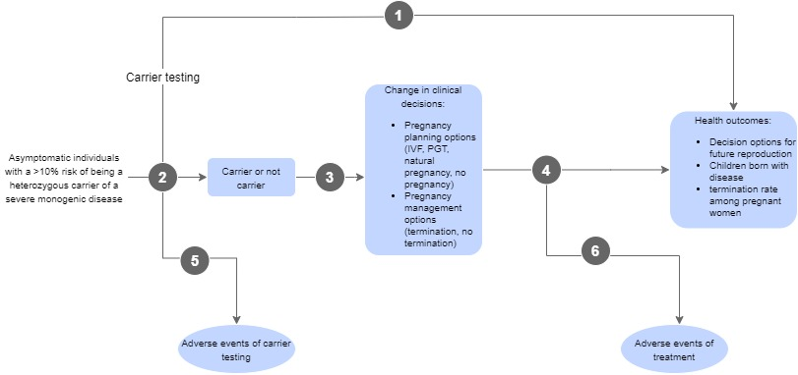The assessment framework is presented in Figure 1.
Figure 1 Assessment framework showing the links from the test population to health outcomes
Figure notes: 1: direct from test to health outcomes evidence; 2: test accuracy; 3: change in diagnosis/treatment/management; 4: influence of the change in management on health outcomes; 5: adverse events due to testing; 6: adverse events due to treatment

Clinical management algorithms
Current clinical management algorithm for identified population
PASC advised that the current algorithm should be either no carrier testing or the carrier testing for CF, SMA and FXS (supported for public funding by MSAC), as per the base case comparator. The clinical management algorithm for the latter is provided in the figures.
The current clinical management pathway for individuals prior to receiving the intervention is the pathway for genetic carrier testing for detection of CF, SMA and FXS, among patients planning a pregnancy or those who are pregnant (MSAC application 1573) (Figure 2, Figure 3). As the testing supported for 1573 would be available to the whole population planning pregnancy or pregnant (and their reproductive partners), the relatives of those found to be carriers of a variant in the genes associated with CF, SMA or FXS would also be eligible for testing under the supported items when they are allocated by the MBS.
Carrier testing is designed to identify individuals at-risk of having offspring affected by the autosomal recessive or X-linked inherited condition(s) tested for. Carrier testing for conditions such as beta thalassaemia (although noting that testing for thalassaemia trait and disease is usually performed by non-genetic proxy means,) prior to conception or in early pregnancy is already an integral part of reproductive care with women and, as necessary, their reproductive partners. Preconception carrier testing is currently recommended as standard practice by the Royal Australian College of General Practitioners (RACGP) (Delatycki et al., 2019) and RANZCOG (RANZCOG, 2019).
In Australia, genetic testing for severe monogenic disorders in the exemplar population, such as those described in this application, is currently accessible to some at-risk individuals in the Ashkenazi Jewish population via the following pathways:
- cohort high-school-based preconception testing
- preconception testing prior to marriage (generally only utilised by the very religiously observant)
- antenatal testing early in pregnancy
These programs are well established and are organised by the Ashkenazi Jewish community itself, funded either by individuals paying fully out-of-pocket expenses, or via charitable organisations within the communities. Note that the cohort high-school testing program in the Ashkenazi Jewish community is only available in New South Wales, and then only to students in selected high schools, resulting in significant inequity of access to testing.
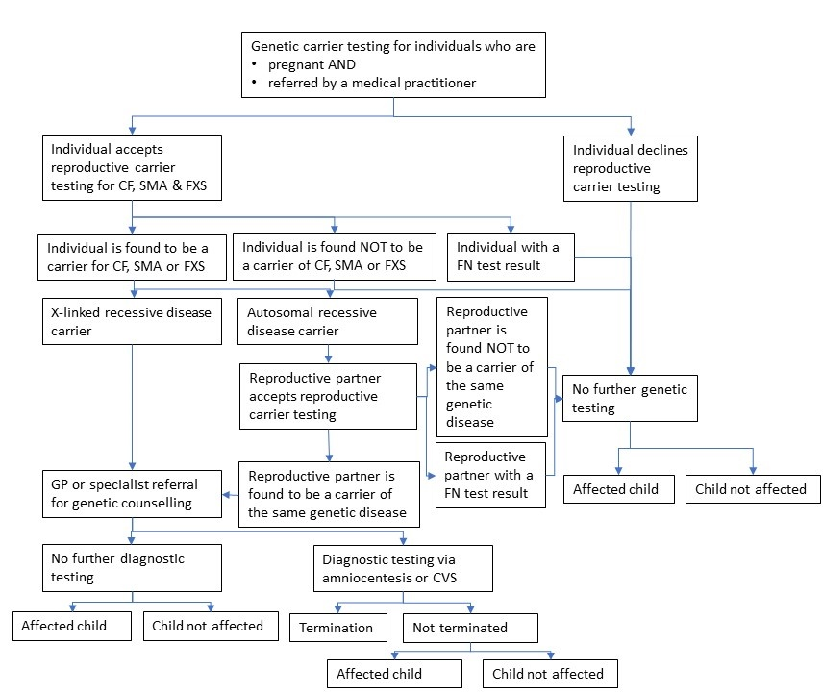
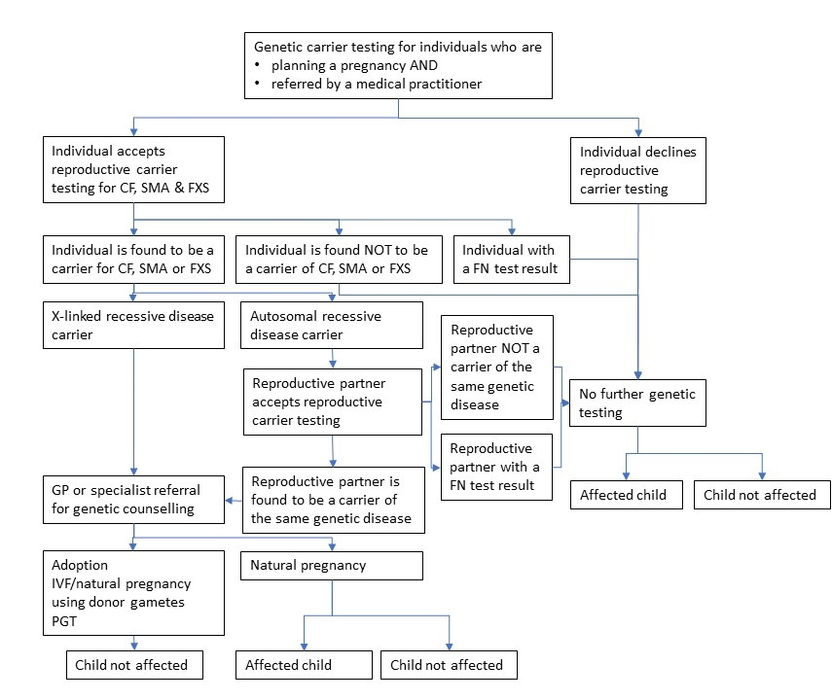
Figure 2 Current clinical management algorithm for individuals who are pregnant
Figure 3 Current clinical management algorithm for individuals planning a pregnancy

Proposed clinical management algorithm for identified population
Figure 4 to Figure 6 present the proposed clinical management algorithms for genetic carrier testing for autosomal recessive monogenic diseases for the population of interest. The difference between the current and proposed clinical algorithm is access of the populations of interest to genetic carrier testing for severe monogenic conditions such as TSD, in addition to CF, SMA and FXS, that is MBS-subsidised (proposed clinical management algorithm).

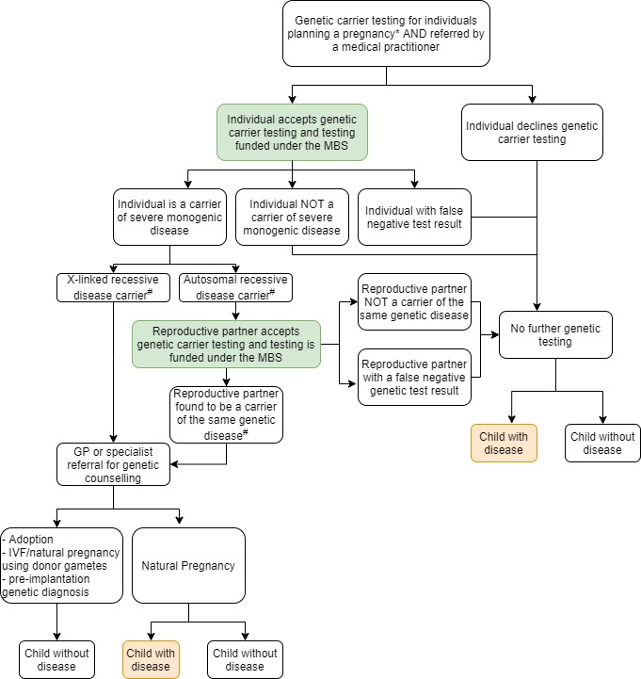
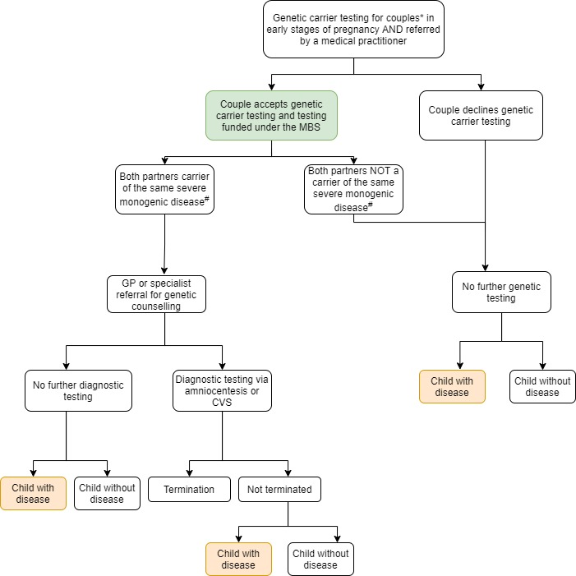
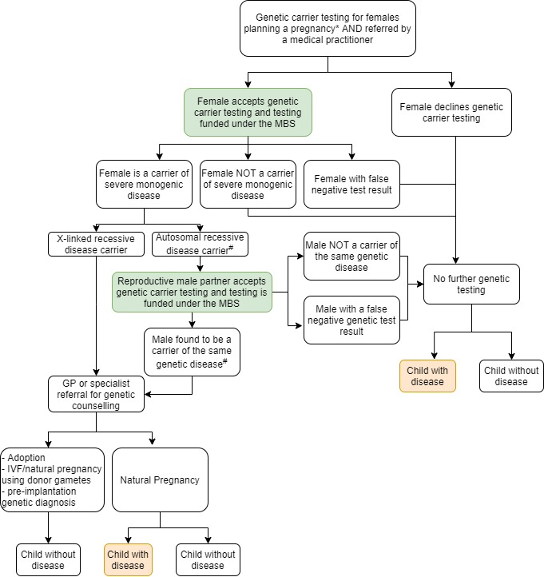
*Note: Individuals who are pregnant or planning a pregnancy are eligible for the genetic carrier testing only if they have a >10% a priori aggregate personal risk of being a heterozygous genetic carrier of a clinically significant disorder associated with pathogenic or likely pathogenic variants of the genes in the testing panel. Reproductive partners are eligible for the test only if their partner has the >10% a priori aggregate personal risk of being a heterozygous genetic carrier of a clinically significant disorder associated with pathogenic or likely pathogenic variants of the genes in the testing panel.
#Testing of first-degree biological relatives for the familial gene variant is recommended when the individual is found to be a carrier.
CVS=chorionic villus sampling; GP=general practitioner; IVF=in vitro fertilisation; MBS=Medical Benefits Schedule
Figure 4 Proposed clinical management algorithm for couples in early stages of pregnancy
Figure 5 Proposed clinical management algorithm for individuals who are planning a pregnancy, and their reproductive partners

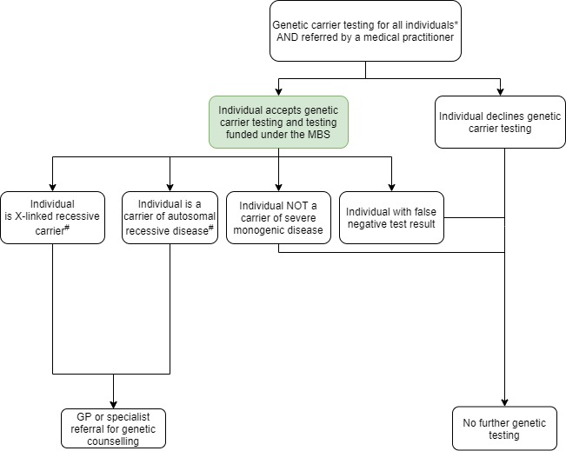
Figure 6 Proposed clinical management algorithm for all eligible individuals for genetic carrier testing
*Note: individuals are eligible for the genetic carrier testing only if they have a >10% a priori aggregate personal risk of being a heterozygous genetic carrier of a clinically significant disorder associated with pathogenic or likely pathogenic variants of the genes in the testing panel.
#Testing of first-degree biological relatives for the familial gene variant is recommended when the individual is found to be a carrier.
CVS=chorionic villus sampling; GP=general practitioner; MBS=Medical Benefits Schedule

This assessment is expected to provide the following additional components compared with previous MSAC Application 1573:
- Population: this assessment will consider a population (both males and females) of reproductive age (approximately aged between 12 to 60 years). While there will be some overlap with the population considered in MSAC Application 1573 (pregnant individuals, and individuals planning a pregnancy and their reproductive partners), the current application also includes those who are not planning a pregnancy.
- Genetic panel: This application considers a panel of genes that can cause nine additional severe monogenic diseases than those considered in MSAC Application 1573. The assessment will assess the benefit of testing for presence of the gene variants responsible for these nine diseases for subpopulations at a high ethnic risk (>10% risk) of inheriting variants in these genes.

Proposed economic evaluation
PASC agreed that the clinical claim is that targeted genetic carrier testing for severe monogenic diseases is superior in terms of clinical effectiveness and inferior in terms of safety to genetic carrier testing for CF/FXS/SMA only. The suggested economic evaluation is a cost-effectiveness analysis.
The assessment of the costs to Government will be based on the costs of determining the carrier status of the individual and enabling making an informed reproductive decision.
However, PASC advised that the downstream treatment costs (after birth costs) avoided must also be included in the economic and financial evaluation because the costs of care for children born with these diseases are significant.
PASC agreed that the costs of testing will vary from laboratory to laboratory. The applicant assumed that testing for genes proposed in the panel in addition to CFTR, SMN1 and FXS will incur extra costs, and therefore proposed a fee for testing ($600) higher than that supported for the previous MSAC assessment 1573 ($400). PASC advised that the proposed fees should be justified based on the cost to conduct the test, as some appear to be higher than the cost of similar testing with private providers (e.g. $330 for an eight gene Ashkenazi Jewish panel). PASC also advised the fee for GGGG (fetal testing for a known familial variant) may need to be increased.
At the post-PASC meeting, the Department noted that MSAC has recently supported reproductive partner gene sequencing items for $1200. If this is indeed the fee, this has implications for the choice of test in reproductive partners of couples who undergo a two-step approach to reproductive carrier testing (where the couple is not already pregnant). The applicant stated it would likely cost less than $600 to sequence one gene from this panel and committed to confirm its proposed fees. An expert consulted by PASC advised that reproductive partner testing will require gene sequencing to capture all variants within the gene(s) in question. The applicant disagreed and proposed the partner test encompass only the genes and variants included in the panel test, and at the same fee as the panel test ($425), which the Department requested be accommodated as a sensitivity analysis for the partner testing item in the DCAR.
PASC suggested that the gene panel be restricted to genes for the nine severe monogenic disorders described previously as being highly prevalent in the Ashkenazi Jewish population in Australia, as opposed to testing for a broader panel of genes. This is a fairly well-defined subpopulation with extensive evidence available on genetic carrier testing. However financial assessment of other gene panels for other higher risk ethnicities, as proposed in the Application Form, may not be similarly well-evidenced and practicable. Therefore, for this assessment, PASC suggested that the financial assessment only consider the Ashkenazi Jewish population and, more broadly, suggested that the applicant consider limiting the application to the Ashkenazi Jewish population. PASC suggested the applicant should revisit this issue in its revised PICO, to be submitted to PASC out of session.
PASC further suggested that using a stepped funding approach, future applications may be made to add other gene panels to encompass other populations at a 10% or higher a priori risk of being a carrier of other relevant genetic variants. At the post-PASC meeting, the applicant agreed this application is to be restricted to the Ashkenazi Jewish population (though other ethnicities that confer a >10% personal risk of being a carrier for specific gene variants may be the subject of future applications).
PASC considered the merits of providing testing to individuals of reproductive age or limiting testing to individuals/couples planning reproduction and suggested the applicant should revisit this issue out of session. At the post-PASC meeting, the applicant remained supportive of testing long in advance of reproductive decision-making, though acknowledged that the items are more likely to be utilised at the point of conception or in early pregnancy. The applicant requested the DCAR examine both options for the timing of testing.
Table 4 Classification of comparative effectiveness and safety of the proposed intervention, compared with its main comparator, and guide to the suitable type of economic evaluation
Comparative safety- |  | Comparative effectiveness
 | Inferior | Uncertainª | Noninferior^{b} | Superior
Inferior | Health forgone: need other supportive factors | Health forgone possible: need other supportive factors | Health forgone: need other supportive factors | ? Likely CUA
Uncertainª | Health forgone possible: need other supportive factors | ? | ? | ? Likely CEA/CUA
Noninferior^{b} | Health forgone: need other supportive factors | ? | CMA | CEA/CUA
Superior | ? Likely CUA | ? Likely CEA/CUA | CEA/CUA | CEA/CUA
CEA=cost-effectiveness analysis; CMA=cost-minimisation analysis; CUA=cost-utility analysis
? = reflect uncertainties and any identified health trade-offs in the economic evaluation, as a minimum in a cost-consequences analysis
ª ‘Uncertainty’ covers concepts such as inadequate minimisation of important sources of bias, lack of statistical significance in an underpowered trial, detecting clinically unimportant therapeutic differences, inconsistent results across trials, and trade-offs within the comparative effectiveness and/or the comparative safety considerations
^{b} An adequate assessment of ‘noninferiority’ is the preferred basis for demonstrating equivalence

Proposal for public funding
The applicant is proposing the expanded reproductive carrier testing to be publicly funded through the MBS. Six MBS item descriptors were proposed by the applicant (described in detail below): one each for testing an individual of reproductive age, their reproductive partner, a first-degree biological relative of an individual found to be a carrier, re-analysis of genetic test results to identify previously unreported pathogenic or likely pathogenic variants in the panel genes, and interpretation of test results previously performed on two individuals for the purpose of determining the couple’s reproductive risk of the condition.
The applicant estimates testing an individual, or a pregnant woman or a pregnant woman’s male reproductive partner would cost approximately $600 each; all other testing or re-analysis would cost $100 each.
PASC agreed with the following items:
- Item AAAA
- Item CCCC
- Item DDDD
- Item EEEE
- Item GGGG
At the post-PASC meeting the applicant agreed this application is to be restricted to the Ashkenazi Jewish population (though other ethnicities that confer a >10% personal risk of being a carrier for specific gene variants may be the subject of future applications). Item AAAA will therefore be for the testing of the genes specified in this application for the Ashkenazi Jewish population (plus CFTR, SMN1 and FMR1 in the item descriptor and actual testing conducted, though not the economic analysis as they are part of the base case comparator). The practice notes for item CCCC therefore no longer need to include other ethnicities.
PASC removed the applicant’s proposed item BBBB, testing of pregnant patients, on the basis that pregnant patients are of reproductive age and so would be able to access publicly funded testing under proposed item AAAA.
PASC removed Item FFFF, interpretation of genetic carrier test results, on the basis that it would be unnecessary to support medical practitioners in providing advice to couples.
At the post-PASC meeting, the applicant agreed that a separate item for the cascade testing of FDRs (DDDD) is not needed as this population have >10% personal risk and so are already captured under AAAA.
PASC advised that the proposed fees should be justified based on the cost to conduct the test, as some appear to be higher than the cost of similar testing with private providers (e.g. $330 for an eight gene Ashkenazi Jewish panel). PASC also advised the fee for GGGG (fetal testing for a known familial variant) may need be increased.

Applicant’s proposed item descriptors
Category 6 (Pathology Services) – Group P7 Genetics
MBS item AAAA

Testing of asymptomatic individuals of reproductive age, who are able to provide informed consent, for the presence of a pathogenic or likely pathogenic variant(s) in order to ascertain their carrier status, in a panel of genes that must include variants in the cystic fibrosis transmembrane conductance regulator (CFTR), survival motor neuron 1 (SMN1), fragile X mental retardation 1 (FMR1) genes in addition to at least other genes relevant to the ancestry of that individual, requested by or on behalf of a medical practitioner who manages the treatment of the patient.

Individuals must have a >10% personal risk of being a genetic carrier of serious clinical disorders associated with pathogenic or likely pathogenic variants of genes in the testing panel.

One test per lifetime.
Fee: $600

Category 6 (Pathology Services) – Group P7 Genetics
MBS item BBBB

Testing of a pregnant female for the presence of a pathogenic or likely pathogenic variant(s) in order to ascertain their carrier status, in a panel of genes that must include variants in the cystic fibrosis transmembrane conductance regulator (CFTR), survival motor neuron 1 (SMN1), fragile X mental retardation 1 (FMR1) genes in addition to at least 3 other genes relevant to the ancestry of that individual, requested by or on behalf of a specialist or medical practitioner who manages the treatment of the patient.

Pregnant women must have a >10% personal risk of being a genetic carrier of serious clinical disorders associated with pathogenic or likely pathogenic variants of genes in the testing panel.

One test per lifetime.
Fee: $600

Category 6 (Pathology Services) – Group P7 Genetics
MBS item CCCC

Concurrent prenatal genetic testing, regardless of pre-test risk, of the male reproductive partner of a pregnant female who has a >10% personal risk of being a heterozygous genetic carrier of serious clinical disorders associated with pathogenic or likely pathogenic variants of genes as described in in BBBB, for the purpose of determining the couple’s reproductive risk of this condition. Requested by or on behalf of a specialist or consultant physician who manages the treatment of the patient.

One test per lifetime.
Fee: $600

Note 1: For individuals of Ashkenazi Jewish ancestry, the panel of genes must also include HEXA and should also include at least the following genes: ELP1, SMPD1, ASPA, FANCC, BLM and MCOLN1. Additional genes may also be included in the panel using standardised pathology lists of genes ethnic risk.
Note 2: For individuals of Asian, African, or Mediterranean ancestry, the panel of genes must at least include genes relevant to the individual’s risk for Thalassaemia and haemoglobinopathy. Additional genes may be included in the panel, using standardised pathology lists of genes ethnic risk.
Category 6 (Pathology Services) – Group P7 Genetics
MBS item DDDD

Genetic testing in a first-degree biological relative of a patient found to be a genetic carrier of an autosomal recessive pathogenic or likely pathogenic variant(s) identified by items AAAA or BBBB, requested by or on behalf of a specialist or consultant physician who manages the treatment of the patient.

One test per lifetime.
Fee: $100

Category 6 (Pathology Services) – Group P7 Genetics
MBS item EEEE

Reanalysis of genetic test results arising from testing previously performed under Items AAAA, BBBB or CCCC, for the purpose of identifying previously unreported pathogenic or likely pathogenic variants in any genes included in the gene panel to determine genetic carrier status, where the pathogenicity of these variants might not have been known at the time of the previous analysis.

One test per five years.
Fee: $ 100

Category 6 (Pathology Services) – Group P7 Genetics
MBS item FFFF

Interpretation of genetic carrier test results previously performed on two individuals under items AAAA, DDDD or EEEE, for the purpose of determining the couple’s reproductive risk of this condition. Requested by, or on behalf of, a medical practitioner.

One test per reproductive couple per five years.
Fee: $ 100

Department’s proposed revisions to the applicant’s item descriptors
The Department proposes the below changes for PASC’s consideration, including removing items BBBB (as this is redundant with AAAA) and FFFF, and adding a fetal testing item (GGGG).
Category 6 (Pathology Services) – Group P7 Genetics
MBS item AAAA

Testing of asymptomatic individuals of reproductive age, for the presence of a pathogenic or likely pathogenic variant(s) in order to ascertain their carrier status, in a panel of genes that must include variants in the cystic fibrosis transmembrane conductance regulator (CFTR), survival motor neuron 1 (SMN1), fragile X mental retardation 1 (FMR1) genes in addition to at least 3 other genes relevant to the ancestry of that individual, requested by or on behalf of a medical practitioner who manages the treatment of the patient.

Individuals must have a >10% personal risk of being a genetic carrier of serious clinical disorders associated with pathogenic or likely pathogenic variants of genes in the testing panel.

One test per lifetime.
Fee: $600
At the post-PASC meeting the applicant agreed this application is to be restricted to the Ashkenazi Jewish population. Item AAAA will therefore be for the testing of the genes specified in this application for the Ashkenazi Jewish population (plus CFTR, SMN1 and FMR1 in the item descriptor – though not the economic analysis as they are part of the base case comparator).
After the post-PASC meeting, the applicant revised their proposed fee for item AAAA from $600 to $425.
A revised item AAAA descriptor is proposed below.
Category 6 (Pathology Services) – Group P7 Genetics
MBS item AAAA

Testing of asymptomatic individuals of reproductive age, for the presence of pathogenic or likely pathogenic variants in order to ascertain their carrier status, in a panel of genes causing severe monogenic disorders that must include the CFTR, SMN1, FMR1, HEXA, ASPA, ELP1, MCOLN1, G6PC1, SLC37A4, FANCA, FANCC, FANCG, GBA, SMPD1, and BLM genes, requested by or on behalf of a medical practitioner who manages the treatment of the patient.

Individuals must have a >10% personal risk of being a genetic carrier of any of the clinical disorders associated with pathogenic or likely pathogenic variants of genes in the testing panel, namely Cystic Fibrosis, Spinal Muscular Atrophy, Fragile X Syndrome, Tay Sachs Disease, Canavan disease, Familial dysautonomia, Mucolipidosis Type IV, Glycogen storage disease type 1, Fanconi anaemia type C, Gaucher disease, Niemann Pick Disease type A, and Bloom Syndrome.

One test per lifetime.
Fee: $425

Category 6 (Pathology Services) – Group P7 Genetics
MBS item CCCC

Genetic testing, regardless of pre-test personal risk, of the reproductive partner of an individual who has a >10% personal risk of being a heterozygous genetic carrier of serious clinical disorders associated with pathogenic or likely pathogenic variants of genes as described in AAAA, for the purpose of determining the couple’s reproductive risk of this condition. Requested by or on behalf of a specialist or consultant physician who manages the treatment of the patient

One test per couple per lifetime.
Fee: $600
Practice Note 1: For individuals of Ashkenazi Jewish ancestry, the panel must also include HEXA, ELP1, SMPD1, ASPA, FANCC, BLM and MCOLN1. For individuals of Asian, African, or Mediterranean ancestry, the panel must also include genes relevant to the individual’s risk e.g. for thalassaemia or sickle cell disease. Additional genes may also be included in the panel using standardised pathology lists of genes according to ethnic risk. The reference source for these gene lists will be provided by the applicant.
At the post-PASC meeting the applicant agreed this application is to be restricted to the Ashkenazi Jewish population. The practice notes for item CCCC therefore no longer need to include other potentially high risk ethnicities.
Practice Note 2: where the couple is already pregnant, concurrent testing of any partner(s) not already tested is recommended.
At the post-PASC meeting, the Department noted that MSAC has recently supported reproductive partner gene sequencing items for $1200. If this is indeed the fee, this has implications for the choice of test in reproductive partners of couples who undergo a two-step approach to reproductive carrier testing. The applicant stated it would likely cost less than $600 to sequence one gene from this panel and committed to confirm its proposed fees.
After the post-PASC meeting the applicant proposed that reproductive partners be tested for only the same variants as are included in the panel test to be used for AAAA, at the same cost as AAAA ($425), rather than gene sequencing (for which a proposed fee was not provided). However, an expert consulted by PASC advised that since reproductive partners who are themselves of Ashkenazi Jewish ethnicity will meet the personal risk eligibility criterion for the panel test in their own right, the reproductive partner testing item will be used only by those partners not within the population eligible for the panel test, such as the non-Ashkenazi Jewish reproductive partners of Ashkenazi Jewish individuals. The expert therefore considered that the specific variants that are included on the panel test based on their known increased prevalence within the Ashkenazi Jewish population are not relevant to the partner population, and that reproductive partner testing will require gene sequencing to capture all variants within the gene(s) in question. The expert noted that there may be more than one gene for which the reproductive partner should be tested, given carrier frequencies within the Ashkenazi Jewish population. The expert advised that next generation sequencing (NGS) methods would be chosen by most laboratories (and increasingly so into the future), and that a reasonable fee to sequence and interrogate as many genes on the panel as are required for that partner using NGS methods would be $1200. The applicant responded that it disagreed partner testing should use gene sequencing, and that the cost of testing for panel variants in one or more genes in partners should be the same as the cost of the panel test (revised to $425). The Department proposes to PASC that the applicant’s proposal for the partner test method and fee be accommodated as a sensitivity analysis in the assessment report.
The applicant also proposed that a gene sequencing partner test could also be used by partners who were Ashkenazi Jewish and ‘wished to have the best possible reassurance’. The Department suggests it would be more appropriate for partners who are Ashkenazi Jewish to receive the panel test than gene sequencing (or both a panel test and a gene sequencing partner test), and so revised the proposed wording of CCCC to exclude partners who have received a panel test under AAAA.
A revised item CCCC descriptor is proposed below, incorporating the specification that the test interrogate all variants within the relevant gene(s) and the corresponding appropriate fee for gene sequencing, as well as the restriction that partners must not previously have received the panel test.
Category 6 (Pathology Services) – Group P7 Genetics
MBS item CCCC

Genetic testing of the reproductive partner of an individual who has a >10% personal risk of being a heterozygous genetic carrier of serious clinical disorders associated with pathogenic or likely pathogenic variants of genes as described in AAAA, for all variants within the relevant gene(s) in which their reproductive partner carries a variant, for the purpose of determining the couple’s reproductive risk of this condition. The tested individual must not have received a service described in AAAA. Requested by or on behalf of a specialist or consultant physician who manages the treatment of the patient.

One test per couple per lifetime.
Fee: $1200
The applicant responded that it disagreed partner testing should use gene sequencing, and that the cost of testing for variants in one or more panel genes in partners would be the same as the cost of the panel test (revised to $425). The Department proposes to PASC that the applicant’s proposal for the partner test method and fee be accommodated as a sensitivity analysis in the assessment report.
The applicant also proposed that the partner test could also be used by partners who were Ashkenazi Jewish and ‘wished to have the best possible reassurance’. The Department suggests it would be more appropriate for partners who are Ashkenazi Jewish to receive the panel test than gene sequencing, and so revised the proposed wording of CCCC to exclude partners who have received a service described in AAAA.
Category 6 (Pathology Services) – Group P7 Genetics
MBS item DDDD

Characterisation of one or more pathogenic or likely pathogenic germline gene variants within the genes mentioned in item AAAA, in an individual who is a first-degree biological relative of an individual with an autosomal recessive pathogenic or likely pathogenic variant confirmed by laboratory findings, requested by or on behalf of a specialist or consultant physician who manages the treatment of the patient.

One test per variant per lifetime.
Fee: $100
At the post-PASC meeting, the applicant agreed that a separate item for the cascade testing of FDRs (DDDD) is not needed as this population have >10% personal risk and so are already captured under AAAA.
Category 6 (Pathology Services) – Group P7 Genetics
MBS item EEEE

Re-analysis of genetic test results arising from testing previously performed under Items AAAA, for the purpose of identifying previously unreported pathogenic or likely pathogenic variants in genes included on the gene panel to determine genetic carrier status, where the pathogenicity of these variant(/s) was not known at the time of the previous analysis.

Performed at least five years after a service to which AAAA, BBBB, or DDDD applies.
Applicable only twice per lifetime.
Fee: $ 100
Because it was agreed at the post-PASC meeting that DDDD is not required, the descriptor for EEEE will need to be amended for the DCAR to remove reference to it.
Category 6 (Pathology Services) – Group P7 Genetics
MBS item GGGG

Testing of a pregnant patient, where one or both prospective parents are known to be affected by or carriers of known pathogenic variant/s causative of a disease tested for in AAAA, for the purpose of determining whether familial variants are present in the fetus, if:
(a) The pregnancy is a singleton pregnancy; and
(b) The detection is requested by a consultant physician practising as a clinical geneticist; and
(c) The fetus is at 25% or more risk of inheriting a monogenic variant known to cause a disease tested for in AAAA.

One test per pregnancy.
Fee: $ 100
PASC advised the fee for GGGG (fetal testing for a known familial variant) will need be increased.

Summary of public consultation input
Input was received from one individual and one organisation, the Victorian Clinical Genetics Service (VCGS). Feedback was mixed, with both supportive and unsupportive perspectives received, however both responses did not agree with testing eligibility being defined by ethnicity.
The advantages of the proposed testing were stated to be:
- Preconception genetic testing may facilitate disease prevention and, in the context of IVF, may avoid suffering and child loss.
- MBS funding of preconception genetic testing would promote equity of access.
- MBS funding of preconception genetic testing may reduce the cost of caring for children with severe disease.
The disadvantages of the proposed testing were stated to be:
- It is difficult to gauge an individual’s risk of severe monogenic disorders.
- Defining the population by ethnic ancestry may become ineffective as some patients may not know their ethnic ancestry, may be from multiethnic backgrounds or, may have a partner of a different ethnicity that is not captured in the proposed population.
The following other points were raised:
- The population may be extended to include all prospective parents or other ethnicities with high risk for severe monogenic conditions.
- The targeted gene panel should be broad to target common autosomal recessive conditions.
- In the prenatal test setting both partners should be screened concurrently.

PASC noted that input was received from one individual and one organisation, the Victorian Clinical Genetics Service (VCGS). Feedback was mixed, with both supportive and unsupportive perspectives received, however both responses did not agree with testing eligibility being defined by ethnicity

Next steps
PASC advised that the PICO required substantial revision. The applicant may resubmit the PICO to PASC out of session.

Applicant Comments on the PICO Confirmation
Comparator
The applicant stated genetic carrier testing for spinal muscular atrophy (SMA), cystic fibrosis (CF), and fragile-X syndrome (FXS), as supported by MSAC for Application 1573 cannot be considered the true comparator, as this item number, although approved by the MSAC, is not currently listed on the MBS.
The applicant further stated the comparator for 1573 was “No opportunistic genetic carrier testing”, and expressed that they believe this should be the case for the current application.
The applicant added that they envisaged that this current application will be additive to 1573, as described by the draft item numbers, which state that “in a panel of genes that must include variants in the cystic fibrosis transmembrane conductance regulator (CFTR), survival motor neuron 1 (SMN1), fragile X mental retardation 1 (FMR1) genes in addition to at least (*3) other genes relevant to the ancestry of that individual” (*noting that the number of genes was omitted in item number AAAA but included in BBBB in the application).

References
Bali, D. S., Chen, Y. T., Austin, S., & Goldstein, J. L. (2016). Glycogen Storage Disease Type I. GeneReviews®. Retrieved from https://www.ncbi.nlm.nih.gov/books/NBK1312/
Beard, C. A., Amor, D. J., Di Pietro, L., & Archibald, A. D. (2016). "I'm Healthy, It's Not Going To Be Me": Exploring experiences of carriers identified through a population reproductive genetic carrier screening panel in Australia. Am J Med Genet A, 170(8), 2052-2059. doi:10.1002/ajmg.a.37697
Cancer Council Australia. (2018). Principles of screening - National Cancer Control Policy. Retrieved from https://wiki.cancer.org.au/policy/Principles_of_screening
Curd, H., Lewis, S., Macciocca, I., Sahhar, M., Petrou, V., Bankier, A., . . . Delatycki, M. B. (2014). High school Tay-Sachs disease carrier screening: 5 To 11-year follow-up. Journal of Community Genetics, 5(2), 139-146. doi:10.1007/s12687-013-0163-z
Delatycki, M., Laing, N., Moore, S., Emery, J., Archibald, A., Massie, J., & Kirk, E. (2019). Preconception and antenatal carrier screening for genetic conditions. Australian Journal for General Practitioners, 48, 106-110. Retrieved from https://www1.racgp.org.au/ajgp/2019/march/preconception-and-antenatal-carrier-screening-for
Department of Health. (2018). Life Saving Drugs Program – Gaucher disease (type 1) – Guidelines. Retrieved from https://www.health.gov.au/resources/publications/lsdp-gaucher-guidelines
Dor Yeshorim. (2019). Standard Ashkenazi Panel. Retrieved from https://doryeshorim.org/tests/
Flanagan, M., & Cunniff, C. M. (2019). Bloom Syndrome. GeneReviews®. Retrieved from https://www.ncbi.nlm.nih.gov/books/NBK1398/
Graham, D., & Narunsky, L. (2019). The Jewish population of Australia- Key findings from the 2016 census. Retrieved from Sydney, Australia: https://jca.org.au/wp-content/uploads/2020/06/Census-Report-2016-1.1.pdf
Hafsi, W., Badri, T., & Rice, A. S. (2020). Bloom Syndrome (Congenital Telangiectatic Erythema) Retrieved from https://www.ncbi.nlm.nih.gov/books/NBK448138/
HGSA. (2015). Ashkenazi Jewish Population Screening. Retrieved from Alexandria, NSW: https://www.hgsa.org.au/documents/item/6092
Jaffe, D. H., Flaks-Manov, N., Benis, A., Gabay, H., DiBonaventura, M., Rosenbaum, H., . . . Leventer-Roberts, M. (2019). Population-based cohort of 500 patients with Gaucher disease in Israel. BMJ Open, 9(1), e024251. doi:10.1136/bmjopen-2018-024251
Kaback, M. M., & Desnick, R. J. (2011). Hexosaminidase A Deficiency. GeneReviews®. Retrieved from https://www.ncbi.nlm.nih.gov/books/NBK1218/pdf/Bookshelf_NBK1218.pdf
Lazarin, G. A., Haque, I. S., Nazareth, S., Iori, K., Patterson, A. S., Jacobson, J. L., . . . Srinivasan, B. S. (2013). An empirical estimate of carrier frequencies for 400+ causal Mendelian variants: results from an ethnically diverse clinical sample of 23,453 individuals. Genet Med, 15(3), 178-186. doi:10.1038/gim.2012.114
Lew, R. M., Burnett, L., Proos, A. L., & Delatycki, M. B. (2015). Tay-Sachs disease: current perspectives from Australia. Appl Clin Genet, 8, 19-25. doi:10.2147/tacg.S49628
Lew, R. M., Proos, A. L., Burnett, L., Delatycki, M., Bankier, A., & Fietz, M. J. (2012). Tay Sachs disease in Australia: reduced disease incidence despite stable carrier frequency in Australian Jews. Med J Aust, 197(11), 652-654. doi:10.5694/mja12.11010
Matalon, R., Delgado, L., & Michals-Matalon, K. (2018). Canavan Disease. GeneReviews®. Retrieved from https://www.ncbi.nlm.nih.gov/books/NBK1234/
Mehta, P. A., & Tolar, J. (2018). Fanconi Anemia. GeneReviews®. Retrieved from https://www.ncbi.nlm.nih.gov/books/NBK1401/
NIH. (2008). HEXA gene. Genetics Home Reference. Retrieved from https://ghr.nlm.nih.gov/gene/HEXA#location
NIH. (2012a). Fanconi anemia. Genetics Home Reference. Retrieved from https://ghr.nlm.nih.gov/condition/fanconi-anemia
NIH. (2012b). Tay-Sachs disease. Genetics Home Reference. Retrieved from https://ghr.nlm.nih.gov/condition/tay-sachs-disease
NIH. (2013a). Familial dysautonomia. Genetics Home Reference. Retrieved from https://ghr.nlm.nih.gov/condition/familial-dysautonomia
NIH. (2013b). Mucolipidosis type IV. Genetics Home Reference. Retrieved from https://ghr.nlm.nih.gov/condition/mucolipidosis-type-iv
NIH. (2015a). Bloom syndrome. Genetics Home Reference. Retrieved from https://ghr.nlm.nih.gov/condition/bloom-syndrome
NIH. (2015b). Canavan disease. Genetics Home Reference. Retrieved from https://ghr.nlm.nih.gov/condition/canavan-disease
NIH. (2015c). Glycogen storage disease type I. Genetics Home Reference. Retrieved from https://ghr.nlm.nih.gov/condition/glycogen-storage-disease-type-i
NIH. (2015d). Niemann-Pick disease. Genetics Home Reference. Retrieved from https://ghr.nlm.nih.gov/condition/niemann-pick-disease
Pastores, G. M., & Hughes, D. A. (2018). Gaucher Disease. GeneReviews®. Retrieved from https://www.ncbi.nlm.nih.gov/books/NBK1269/
RANZCOG. (2019). Genetic carrier screening. Retrieved from https://ranzcog.edu.au/RANZCOG_SITE/media/RANZCOG-MEDIA/Women%27s%20Health/Statement%20and%20guidelines/Clinical-Obstetrics/Genetic-carrier-screening(C-Obs-63)New-March-2019_1.pdf?ext=.pdf
Schiffmann, R., Grishchuk, Y., & Goldin, E. (2015). Mucolipidosis IV. GeneReviews®. Retrieved from https://www.ncbi.nlm.nih.gov/books/NBK1214/
Shohat, M., & Weisz Hubshman, M. (2014). Familial Dysautonomia. GeneReviews®. Retrieved from https://www.ncbi.nlm.nih.gov/books/NBK1180/
Stepanov, V. A. (2010). Genomes, populations and diseases: ethnic genomics and personalized medicine. Acta naturae, 2(4), 15-30. Retrieved from https://pubmed.ncbi.nlm.nih.gov/22649660
https://www.ncbi.nlm.nih.gov/pmc/articles/PMC3347589/
Stirnemann, J., Belmatoug, N., Camou, F., Serratrice, C., Froissart, R., Caillaud, C., . . . Berger, M. G. (2017). A Review of Gaucher Disease Pathophysiology, Clinical Presentation and Treatments. Int J Mol Sci, 18(2). doi:10.3390/ijms18020441
Wasserstein, M. P., & Schuchman, E. H. (2015). Acid Sphingomyelinase Deficiency. GeneReviews®. Retrieved from https://www.ncbi.nlm.nih.gov/books/NBK1370/
Wilson, R. D., De Bie, I., Armour, C. M., Brown, R. N., Campagnolo, C., Carroll, J. C., . . . Van Karnebeek, C. (2016). Joint SOGC-CCMG Opinion for Reproductive Genetic Carrier Screening: An Update for All Canadian Providers of Maternity and Reproductive Healthcare in the Era of Direct-to-Consumer Testing. J Obstet Gynaecol Can, 38(8), 742-762.e743. doi:10.1016/j.jogc.2016.06.008

The majority of Jewish Australians are of Ashkenazi Jewish ancestry, with populations originating Central and Eastern Europe (HGSA, 2015).

