1194:

Final decision analytic protocol (DAP) to guide the assessment of single dose stereotactic radiosurgery for benign and malignant intracranial lesions

January 2013

Table of Contents
MSAC and PASC 3
Purpose of this document 3
Purpose of application 4
Background 4
Current arrangements for public reimbursement 4
Regulatory status 5
Intervention 6
Description 6
Delivery of the intervention 9
Prerequisites 12
Co-administered and associated interventions 12
Listing proposed and options for MSAC consideration 13
Proposed MBS listing 13
Clinical place for proposed intervention 14
Comparator 22
Whole brain radiotherapy 22
Surgery 22
Observation 22
Radiotherapy 22
Chemotherapy 22
Clinical claim 23
Outcomes and health care resources affected by introduction of proposed intervention 24
Clinical outcomes 24
Health care resources 24
Proposed structure of economic evaluation (decision-analytic) 30
References 35

MSAC and PASC

The Medical Services Advisory Committee (MSAC) is an independent expert committee appointed by the Minister for Health and Ageing (the Minister) to strengthen the role of evidence in health financing decisions in Australia. MSAC advises the Minister on the evidence relating to the safety, effectiveness, and cost-effectiveness of new and existing medical technologies and procedures and under what circumstances public funding should be supported.

The Protocol Advisory Sub-Committee (PASC) is a standing sub-committee of MSAC. Its primary objective is the determination of protocols to guide clinical and economic assessments of medical interventions proposed for public funding.

Purpose of this document

This document is intended to provide a draft decision analytic protocol that will be used to guide the assessment of an intervention for a particular population of patients. The draft protocol that will be finalised after inviting relevant stakeholders to provide input to the protocol. The final protocol will provide the basis for the assessment of the intervention.

The protocol guiding the assessment of the health intervention has been developed using the widely accepted “PICO” approach. The PICO approach involves a clear articulation of the following aspects of the research question that the assessment is intended to answer:

Patients – specification of the characteristics of the patients in whom the intervention is to be considered for use
Intervention – specification of the proposed intervention and how it is delivered
Comparator – specification of the therapy most likely to be replaced by the proposed intervention
Outcomes – specification of the health outcomes and the healthcare resources likely to be affected by the introduction of the proposed intervention

Purpose of application

A proposal for an application requesting MBS listing of “Single dose stereotactic radiosurgery for benign and malignant intracranial tumours” was received from Macquarie University Hospital by the Department of Health and Ageing in January 2012. The technology is currently reimbursed through the MBS under a general item for stereotactic radiosurgery (MBS 15600). The proposed MBS Item number is for a single dose course of treatment of stereotactic radiosurgery, which would be used in patients with cerebral neoplasms and arteriovenous malformations. This proposal fits within the current item. The application has been interpreted as a request for a review of the existing funding structure.

The NHMRC Clinical Trials Centre, as part of its contract with the Department of Health and Ageing, drafted this decision analytical protocol to guide the assessment of the safety, effectiveness and cost- effectiveness of single dose stereotactic radiosurgery in order to inform MSAC’s decision-making regarding public funding of the intervention.

Background

Current arrangements for public reimbursement

Single dose stereotactic radiosurgery is currently funded on the MBS under item number 15600. This is a general listing for stereotactic radiosurgery that does not specify the type of technology used to deliver the treatment. It does not currently attract Radiation Oncology Health Program Grant payments and includes all radiation oncology consultations, planning, simulations, dosimetry and treatment. The applicant claims that multidose treatment is being performed under this item. However, it is likely that this is only for the treatment of patients with extracranial lesions. The applicant states that single dose stereotactic radiosurgery minimises the risk of human error and radiation toxicity, while optimizing accuracy and dose conformance. The procedure is delivered as an out-patient service.

Existing MBS funding for external beam conformal radiation therapy (eg whole brain) has specific Item numbers for the various stages of the therapy e.g. simulation, dosimetry, treatment and treatment verification.

MSAC has previously reviewed public funding for Gamma Knife radiosurgery in 2000 (application
1028; MSAC 2001) and 2006 (reference 34; MSAC 2006). In 2000 the use of Gamma Knife radiosurgery for arteriovenous malformations, cerebral metastases and acoustic neuromas was reviewed. At this time MSAC determined that there was insufficient evidence on comparative safety, effectiveness and cost-effectiveness pertaining to Gamma Knife radiosurgery, and that additional public funding for this procedure should not be supported. In 2006 the use of Gamma knife radiosurgery was reviewed for six indications including benign and malignant intracranial lesions. At this time MSAC concluded that Gamma Knife radiosurgery was safe and appeared to be effective, but was not cost effective when compared with linear accelerator (Linac) stereotactic radiosurgery. A partial economic costing indicates that an adapted Linac unit would provide the least costly method of SRS treatment in Australia. The review stated that further evidence about the effectiveness of Gamma

Knife radiosurgery versus alternatives such as adapted Linac systems is required in order to undertake a full economic analysis. MSAC recommended that the funding arrangements not be changed. The
current application does not refer to any new clinical evidence for Gamma Knife radiosurgery.

Table 1: Current MBS item descriptor for item 15600
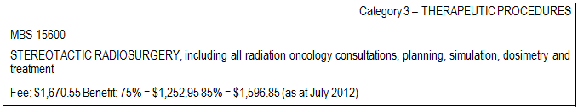

There were 237 claims made against MBS Item 15600 in the 2010-11 Financial Year.

The applicant states that it is probable that due to the limitation of the currently funded Linac stereotactic radiosurgery that the majority of patients with multiple (> 2 or 3) cerebral metastases are being treated with whole brain radiotherapy. The two relevant MBS Item numbers for whole brain
radiotherapy are:

Table 2: Current MBS item descriptor for items 15257 & 15272
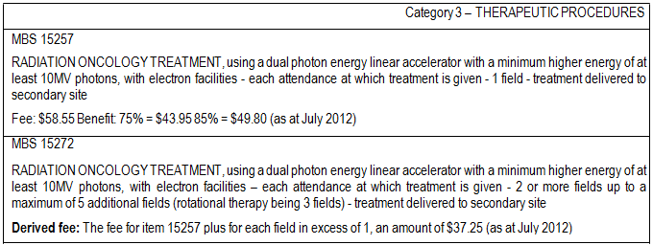

Item 15257 had 11,276 claims and item 15272 69,198 claims in the 2010-11 Financial Year.

Regulatory status

Gamma Knife

Gamma Knife is currently listed as a medical device on the ARTG. It has been approved by the TGA
for the radiation treatment of cancer.

The relevant ARTG numbers for Gamma Knife are:

• 111760 Elekta Pty Ltd - Accelerator system, linear
• 156176 Elekta Pty Ltd - Stereotactic surgery system, neurological
• 156177 Elekta Pty Ltd - Radionuclide system, therapeutic, teletherapy
• 157324 Elekta Pty Ltd - Stereotactic surgery system, neurological
• 157929 Elekta Pty Ltd - Generator, lesion, radio frequency
• 158043 Elekta Pty Ltd - Radionuclide system, therapeutic, stereotactic radiosurgery, application program software
• 165039 Elekta Pty Ltd - Digital imager, radiation therapy
• 165040 Elekta Pty Ltd - Digital imager, radiation therapy
• 165041 Elekta Pty Ltd - Collimator, accelerator system, motorized, automatic aperture control
• 165042 Elekta Pty Ltd - Collimator, accelerator system, motorized, automatic aperture control
• 165043 Elekta Pty Ltd - Collimator, accelerator system, motorized, automatic aperture control
• 165044 Elekta Pty Ltd - Patient monitoring system, respiratory, radiation procedure
• 165045 Elekta Pty Ltd - Table, radiotherapy couch
• 165097 Elekta Pty Ltd - Electroencephalograph
• 179266 Elekta Pty Ltd - Patient positioning device, diagnostic imaging/radiotherapy, laser
• 180456 Elekta Pty Ltd - Patient positioning device, diagnostic imaging/radiotherapy, moulding system, vacuum

CyberKnife

CyberKnife was also identified as being capable of SRS. The Therapeutic Goods Administration (TGA)
registration number for CyberKnife is Australian Register of Therapeutic Goods (ARTG) Number
155887 with an ARTG start date of 10th October 2008. The sponsor is Device Technologies Australia Pty Ltd. The device is described as a linear accelerator system. The intended purpose of the device is: “A system intended to provide treatment planning, image-guided stereotactic radiosurgery for lesions, tumours and conditions anywhere in the body where radiation treatment is indicated. The system operates on the principle of linear acceleration of electrons, providing a predictable radiation field in a beam of well-defined dimensions.”(Australian Register of Therapeutic Goods, 2008).

CyberKnife is the subject of another MSAC application – number 1158.

Intervention

Description

Stereotactic radiosurgery

Stereotactic radiosurgery (SRS) involves the use of an external, three-dimensional frame of reference to locate and target intracranial lesions for treatment by a large single fraction of ionising radiation. SRS can be delivered by one of three methods – linear accelerator (Linac), Gamma Knife, or charged- particle irradiation.

SRS is a four-step procedure:

1. application of the stereotactic frame (for some methods and indications)

2. acquisition of images

3. dose planning

4. delivery of radiation.

The Linac method is an extension of external beam conformal radiation therapy and can utilise a number of arcs used to achieve rapid dose fall-off in all directions, or fixed beams. The Gamma Knife uses 201 fixed, highly collimated 60Co sources distributed on a sphere and aimed at the target point. A stereotactic head frame is used for target localisation and head support during treatment. The frame provides the basis for determining target coordinates and is used to immobilise and position the patient’s head within the collimator helmet during treatment. Dose planning is based on stereotactic images, which are usually generated by angiography, computed tomography (CT) or magnetic resonance imaging (MRI). A series of images is taken and electronically transferred to the treatment planning system. The target is localised in three dimensions and its x, y and z coordinates are determined. For the actual radiation delivery, the patient is placed on a moveable couch with their head positioned in the appropriate collimator helmet (according to coordinates). The stereotactic frame is used to position the lesion at the focal point of the 201 cobalt beams. The bed moves into the gamma unit to initiate treatment.

The Gamma Knife installed in the Macquarie University Hospital is the most recent model of Gamma Knife (Perfexion model), which incorporated an automated built-in collimation system and no longer uses the helmet based system.

CyberKnife and TomoTherapy are evolutions of Linac technology which do not require a head frame. CyberKnife involves the delivery of radiation via a robotic system. The CyberKnife system corrects for motion effects due to respiration or other patient movement in real time. TomoTherapy uses Linac and a CT gantry and delivers radiation to the tumour in ‘slices’ instead of the tumour as a whole.

Where stereotactic application of radiation was once only possible in a single dose, improvements in immobilisation of patients and repeat fixation has meant that fractionated delivery is now possible with some delivery systems. This fractionated stereotactic radiotherapy can be performed using Linac or Gamma Knife. This technique divides the radiation dose over multiple treatment sessions similar to conventional radiotherapy treatments, however fewer sessions are required. Fractionated stereotactic radiotherapy is generally only performed for extra-cranial lesions.

Stereotactic radiosurgery is intended to treat malignant and benign intracranial lesions (including pericranial lesions from the base of skull to C2). The specific indications to be considered are:

1. ≤4 cerebral metastases
2. arteriovenous malformations (AVMs) unsuitable for surgery or interventional radiology

3. benign intracranial tumours a. acoustic neuroma
b. meningioma
c. pituitary adenomas where patients are ineligible for, or refractory to medical or surgical management.
4. residual intracranial and pericranial tumours following surgical treatment.
5. focally recurrent gliobastoma multiforme (GBM)

Stereotactic radiosurgery is used as an alternative to surgery in patients with tumours that are surgically inaccessible or sited in regions of the brain related to motor or sensory function.

Cerebral Metastases

Many primary cancers are associated with the development of secondary cancers in the brain (cerebral metastases). Cancer can spread to the brain via blood vessels or, very rarely, by direct extension from adjacent extracranial cancers. The most common primary cancer types associated with cerebral metastases in adults are lung, breast, colorectal, melanoma and renal cell, with the highest rate for those aged 55 to 65 years (Patchell 2003; Westphal, Heese, & de Wit 2003).

Arteriovenous Malformations (AVMs)

The cause of cerebral arteriovenous malformation (AVM) is unknown. The condition occurs when arteries in the brain connect directly to nearby veins without having the normal vessels (capillaries) between them. Arteriovenous malformations vary in size and location in the brain. An AVM rupture occurs because of pressure and damage to blood vessel tissue. This allows blood to leak into the brain or surrounding tissues, and reduces blood flow to the brain. Stereotactic radiosurgery may be used to ablate these vascular lesions, thus avoiding the occurrence of rupture.

Acoustic neuroma

An acoustic neuroma is a slow-growing tumour of the nerve that connects the ear to the brain. This nerve is called the vestibular cochlear nerve. It is behind the ear right under the brain. An acoustic neuroma is not cancerous (it is benign), which means it does not spread to other parts of the body. However, it can damage several important nerves as it grows.

Meningioma

Meningiomas account for between 14 to 18 per cent of all intracranial neoplasms (Nakamura et al
2003). Patients may present with seizures, headaches and neurological deficits, including of the cranial nerves, depending on the site of the tumour (Black 1995).

Pituitary adenoma

Most pituitary tumours are non-malignant (benign). Up to 20% of people have pituitary tumours. However, many of these tumours do not cause symptoms and are never diagnosed during the person's lifetime.

Glioblastoma multiforme (GBM)

Gliomas are the most common primary central nervous system cancers; glioblastoma multiforme (GBM) comprise 52% of all gliomas (Cancer Council Australia, Australian Cancer Network and Clinical Oncological Society of Australia Inc). GBM are a grade IV malignancy; most arise de novo but they may also arise from progression of astrocytomas that progress. After resection, median survival is about one year for patients with GBM. Younger age, good preoperative performance status and gross macroscopic resection are associated with longer survival.

Low grade gliomas are not considered an indication for SRS as they are usually managed by surgical resection.

Primary intracranial cancers

Medical expert advice is that primary intracranial cancers are not currently treated with stereotactic radiosurgery as a first line treatment. Therefore this is not considered as an indication for the current assessment.

Delivery of the intervention

Gamma Knife is delivered in an outpatient setting as follows: Step 1- Fitting of the head frame (except Perfexion model),
An essential component to the Gamma Knife treatment procedure is the use of a specialised precision
head frame. The head frame performs two important functions. Firstly it allows the doctors to very precisely and accurately pinpoint the target or area requiring treatment. Secondly by wearing the frame during treatment it ensures that the patient remains completely still throughout the procedure. The head frame is attached to the patient’s head via four pins using local anaesthetic. Note that the Gamma Knife installed in the Macquarie University Hospital (Perfexion model) does not use this helmet based system.

Step 2 - Target localisation

Once the head frame has been fitted a series of tests will be performed, this includes imaging techniques such as MRI, CT or angiography. This is to determine the exact size and location of the target area.

Step 3 - Treatment planning

This step is performed without the patient. The information gained from the imaging in Step 2 is used by the Neurosurgeon and Radiation Oncologist with the assistance of a Medical Physicist and Radiation Therapists to develop an accurate and customised treatment plan. Every plan is unique and tailored to the specific requirements of each patient.

Step 4 - Gamma Knife treatment

With the head frame attached the patient is positioned on the treatment couch. The procedure is completely painless and the patient remains awake throughout the procedure with the treatment team monitoring the patient the whole time. The length of the treatment will vary from patient to patient and depends on the size and shape of the target area. The treatment time may only be as long as a few minutes or up to an hour.

In the majority of cases there would only need to be one treatment session per patient. Step 5 - Post Treatment (not for Perfexion model)
Following treatment, the head frame and pins are removed.

Step 6 - Follow up

An appointment will be made for the patient to see their doctor after their treatment. The effectiveness of the Gamma Knife treatment will be evaluated over time. The radiation treatment is designed to stop the growth of tumours or dysfunctional tissue, therefore it may take weeks or even months before the full benefit of the treatment may be realised. It may be necessary to have follow- up imaging such as MRI or CT to assess the patient’s progress over time as would be the case for other SRS treatments.

Cerebral Metastases

Cerebral metastases occur in about 20 to 40 per cent of all cancer patients (Patchell 2003). This figure may be increasing due to the use of advanced imaging techniques such as MRI for early detection and improved treatment regimens leading to prolonged patient survival. Approximately 70 per cent of cerebral metastases present as multiple lesions (Patchell 2003).

Arteriovenous Malformations (AVMs)

A population-based epidemiological study from the United States has estimated an annual detection rate of 1.34 per 100,000 population, of which approximately half may present with haemorrhage (Stapf et al 2003). Based on this figure, approximately 270 new cases of cerebral AVM may be expected to be detected in Australia each year.

Between July 2009 and June 2010, 623 hospital separations were recorded in Australia with a principal diagnosis of cerebral AVM (Q28.2; AIHW). The proportion of those admissions that may be eligible for SRS cannot be determined.

Acoustic neuroma

Acoustic neuromas account for approximately 6 per cent of primary intracranial tumours, with an annual incidence of 0.3 to 1.3 per 100,000 individuals reported internationally (Lin et al 2005; Tos et al 2004). Based on these figures, up to 265 new cases of acoustic neuroma a year may be expected in

Australia. Findings from a large MRI series in the United States estimated the prevalence of incidental acoustic neuromas at 2 per 10,000 individuals (Lin et al 2005).

Between July 2009 and June 2010, 662 hospital separations were recorded in Australia with a principal diagnosis of benign cranial nerve tumour (D33.3), with a further 17 separations being recorded for malignant neoplasms: other and unspecified cranial nerves (C72.5) (AIHW). The proportion of those admissions that were due to acoustic neuroma and may be eligible for SRS cannot be determined.

Meningioma

A population-based epidemiological study from the United States estimated an incidence of symptomatic disease in 2 per 100,000 population per year, with a higher figure when patients with incidental and autopsy diagnosis are included (Radhakrishnan et al 1995).

Between July 2009 and June 2010, 2,858 hospital separations were recorded in Australia with a principal diagnosis of benign meningioma (ICD-10AM code D32; AIHW). The proportion of these admissions that may be eligible for SRS cannot be determined.

Pituitary adenoma

Pituitary adenomas account for between 10 and 20 per cent of all primary brain tumours (Sheehan et al 2005). A population-based epidemiological study from the United States has estimated the incidence of symptomatic presentations at 2.4 per 100,000 population per year for pituitary adenomas (Radhakrishnan et al 1995). Based on these figures, approximately 490 new symptomatic cases of pituitary adenomas a year may be expected in Australia. This figure is higher for patients with subclinical disease. A systematic review and meta-analysis has estimated the prevalence of pituitary adenomas at 16.7 per cent based on radiological and autopsy findings (Ezzat et al 2004).

Between July 2009 and June 2010, 1,297 hospital separations were recorded in Australia with a principal diagnosis of pituitary adenoma (ICD-10-AM D35.2; AIHW). The proportion of these admissions that may be eligible for SRS is not known.

Glioblastoma multiforme (GBM)

Between July 2009 and June 2010, 5,580 hospital separations were recorded in Australia with a principal diagnosis of malignant neoplasm of the brain (ICD-10-AM C71; AIHW). GBM comprises approximately 52 per cent of all primary central nervous system cancers (Cancer Council Australia, Australian Cancer Network and Clinical Oncological Society of Australia Inc), which would equate to approximately 2,900 separations. The proportion of these admissions that would be for focally recurrent GBM and may be eligible for SRS is not known.

Prerequisites

Stereotactic radiosurgery is delivered by a team headed up by a Radiation Oncologist and/or a Neurosurgeon. The team would comprise a Radiation Oncologist, Neurosurgeron, a Medical Physicist, a Radiation Therapist and a nurse.

The applicant states that delivery of single dose stereotactic radiosurgery is limited to a hospital with specific facilities, but does not elaborate further.

Appropriate quality control measures need to be in place at centres delivering single dose stereotactic radiosurgery.

The high cost of the capital equipment and the expertise of the staff limit the installation of Gamma
Knife to major urban centres.

Co-administered and associated interventions

Patients require imaging before the administration of radiosurgery. This is likely to be via CT scan, MRI or angiography.

The applicant states that if the tumour exceeds 3.5cm surgery performed by a neurosurgeon may precede radiosurgery.

Listing proposed and options for MSAC consideration

Proposed MBS listing

Table 3: Proposed MBS item descriptor for single dose stereotactic radiosurgery
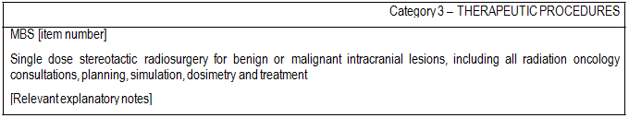
The applicant has not included a proposed fee in the application. The applicant has stated that “The market price is highly dependent on throughput. It is estimated that a throughput of less than 150 patients per year would result in an average market price per patient of $25,000. An increase of throughput to 250 patients per year would decrease this average market price to $16,000. This amount covers the whole service, that is, application of the stereotactic frame, acquisition of images, dose planning and, delivery of radiation.” Currently the use of Gamma Knife, which is claimable under existing item 15600, leads to large out of pocket costs which are captured by the extended Medicare safety net. The applicant has indicated that they will conduct a detailed costing of the Gamma Knife Unit at Macquarie Hospital as part of the submission. The applicant will also include a costing of the existing item.

Any fee proposed by the applicant must comply with Departmental requirements for input-based fee determination. A proposed increase in fee for item 15600 would need to be accompanied with justification in terms of clinical evidence. It should be made clear whether treatment of multiple cerebral metastases would be considered to be covered under a single claim of the proposed item. The applicant’s submitted fee & costing will be used as the basis for any cost-effectiveness analysis in the assessment.

The current 15600 item number has a capped fee for an entire course of treatment, including all radiation oncology consultations, planning, simulation, dosimetry and treatment sessions.

The applicant states that existing MBS funding for external beam conformal radiation therapy (eg whole brain) has specific item numbers for the various stages of the therapy (e.g. simulation, dosimetry, treatment and treatment verification) and that it is possible that the funding for single dose stereotactic radiosurgery may best be itemised in a similar fashion, that is separated for application of the stereotactic frame, acquisition of images, dose planning and delivery of radiation. The Australian Government Department of Health and Ageing preference is for funding to remain a single item for the entire course of treatment. Any alternative in terms of separated item funding must comply with Departmental requirements for input-based fee determination and be explored within the cost- effectiveness analysis.

If there is potential for an overall cost difference between a per-attendance and per-course of treatment fee structure the consequences of this difference should be modelled as part of the cost- effectiveness analysis.

Consideration should be made regarding possible repeated treatment of lesions and what the minimum timelapse should be before a second treatment is considered. An estimate of the proportion of patients likely to receive retreatment should be made.

A sensitivity analysis should consider at what point there is a clinical advantage of treating acoustic neuromas with SRS over watchful waiting

The proposed listing is consistent with the TGA approved indications.

Clinical place for proposed intervention

The flowcharts provided by the applicant were taken directly from the 2006 MSAC review. These did not correspond with the comparator & population groups as proposed by the applicant in C29 (PICO table).

The following flowcharts are modified from those provided by the applicant. The PICO table (Table 5) has been interpreted from the flowcharts. Expert advice is that SRS is rarely used for primary malignant intracranial lesions and therefore this indication has been omitted.

Cerebral Metastases

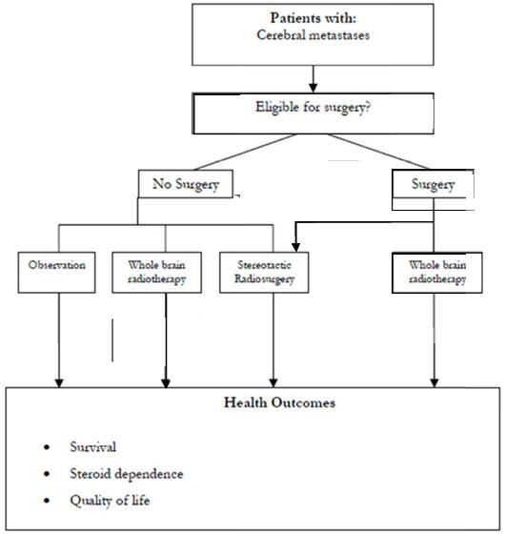

This flowchart indicates that stereotactic radiosurgery would be performed as a replacement for

surgery; or less often whole brain radiotherapy or observation in patients with cerebral metastases not eligible for focal treatment.

Arteriovenous malformations
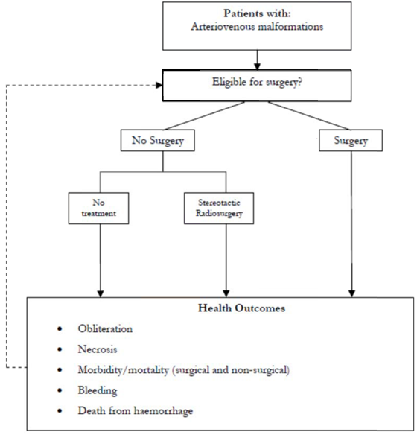

This flowchart indicates that stereotactic radiosurgery would be performed instead of no treatment

(observation) in patients with arteriovenous malformations ineligible or focal treatment.

Acoustic neuroma

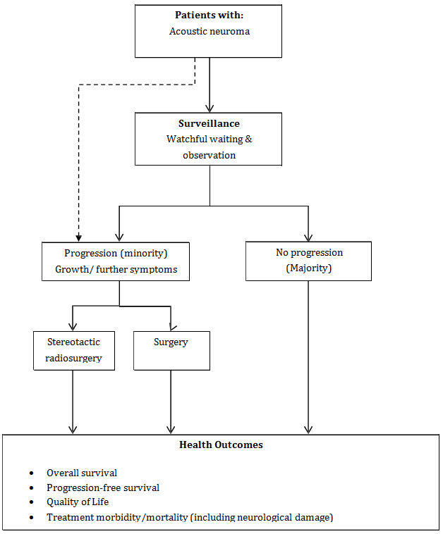This flowchart indicates that stereotactic radiosurgery would be performed instead of surgery in patients with acoustic neuromas eligible for treatment. However, the majority of patients would be observed and not receive any treatment.

Meningiomas
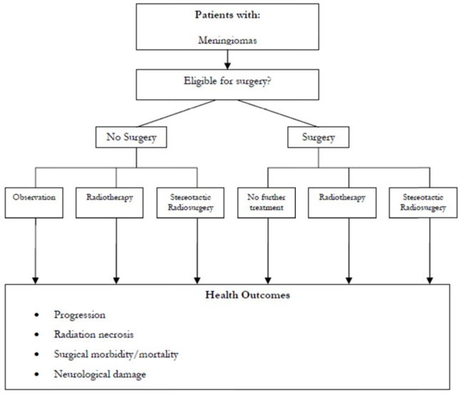
This flowchart indicates that stereotactic radiosurgery (±surgery) would be performed instead of
radiotherapy (±surgery), surgery or observation in patients with meningioma.

Pituitary adenomas
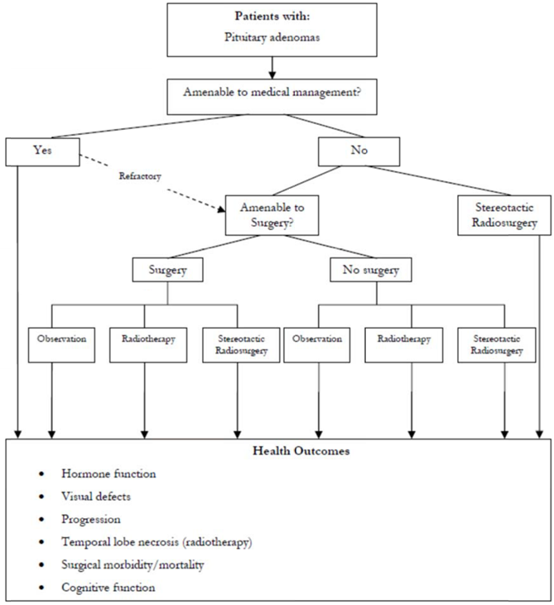
This flowchart indicates that stereotactic radiosurgery (± surgery) would be performed instead of

radiotherapy (± surgery), surgery or observation in patients with pituitary adenoma ineligible for, or refractory to, medical management.

Stereotactic radiosurgery adjunctive to surgery

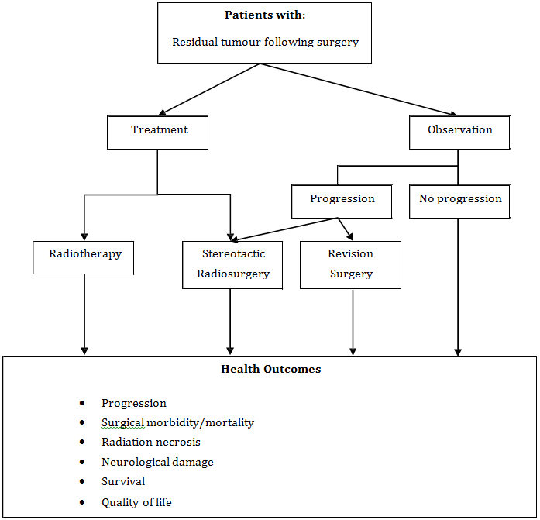This flowchart indicates that stereotactic radiosurgery would be performed instead of radiotherapy or observation (with revision surgery as necessary) in patients with residual tumour following surgery.

Focally recurrent glioblastoma multiforme (GBM)

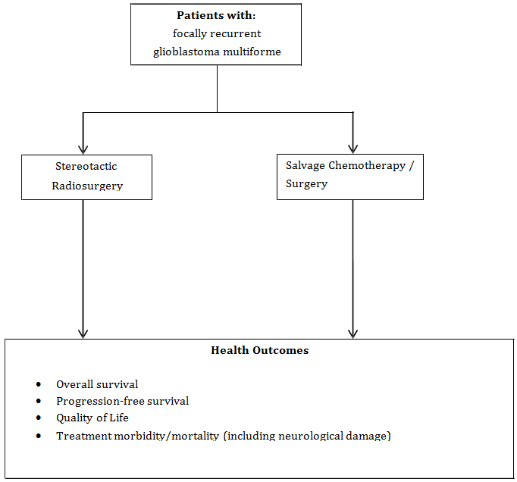The flowchart indicates that stereotactic radiosurgery would be performed instead of salvage
(palliative) chemotherapy or surgery.

Comparator

The comparators considered for various indications are

• surgery
• observation
• whole brain radiotherapy
• radiotherapy
• chemotherapy

Whole brain radiotherapy

Whole brain radiotherapy (WBRT) is considered a comparator for patients with >3 cerebral metastases or those with lesions inaccessible for surgery. WBRT is performed by external beam conformal radiation therapy and currently funded under MBS items 15550, 15562, 15257, 15272 &
15700 plus Radiation Oncology Health Program Grant (ROHPG) funding.

Surgery

Surgery is considered a comparator for ≤3 cerebral metastases and acoustic neuroma. Costs need to consider bed fees and anaesthetic.

Observation

Observation, or surveillance, is considered a comparator for arteriovenous malformations, meningioma, pituitary adenoma, cerebral metastases ineligible for focal treatment and residual tumours following surgical treatment. This would generally comprise the following (post diagnosis):

• periodic MRI and outpatient visits (at 3 months, then decreasing frequency)
• for small to medium acoustic neuromas a follow up MRI/audiogram at 6 months, then an annual review appointment, a contrast enhanced MRI scan and possibly a hearing test

Radiotherapy

Radiotherapy of the tumour bed is considered a comparator for meningioma, pituitary adenoma and when stereotactic radiosurgery is performed as an adjunct to surgery for residual tumours following treatment.

Chemotherapy

Salvage chemotherapy is considered a comparator for focally recurrent glioblastoma multiforme
(GBM).

Clinical claim

The clinical claim is one of reduced toxic side effects (relative to whole brain radiotherapy) and at least non-inferiority in terms of clinical effectiveness.

The changes in health outcomes include:

• Improved quality of life due to the reduction in adverse neurological side effects such as permanent memory and speech problems associated with whole brain radiotherapy for patients with multiple brain metastases.
• Improved quality of life due to a reduction in surgical morbidity (compared to surgery)
• Improved patient access and improved short-term quality of life due to the decreased number of treatment sessions (relative to whole brain radiotherapy or radiotherapy)
• Improved survival and progression-free survival relative to observation

Given these clinical claims the appropriate type of economic evaluation would be a cost-utility analysis.

However, it is uncertain whether quantitative evidence for non-inferiority of clinical effectiveness will be identified, rather than a lack of evidence of superiority. In the case of a lack of evidence of superiority/ equivalence of clinical effectiveness, conducting a cost-effectiveness or cost-utility analysis in the absence of quantitative data on comparative effectiveness may not be possible. Any other approach adopted following the review of evidence will have to be justified in the assessment.

Table 4: Classification of an intervention for determination of economic evaluation to be presented
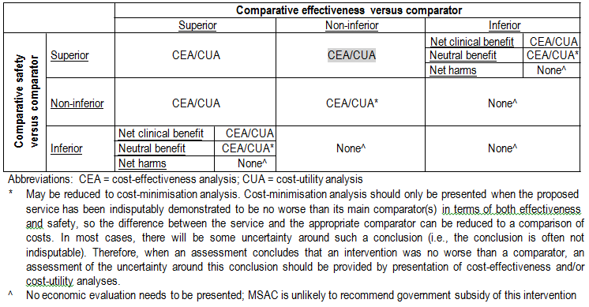

Outcomes and health care resources affected by introduction of proposed intervention

Clinical outcomes

Effectiveness:

• Survival (overall, progression-free)
• quality of life
• tumour control
• lesion ablation (AVMs)
• stage progression

Safety:

• morbidity/mortality including haemorrhage for AVMs
• neurological damage including to permanent memory, neurocognitive function, speech impairment, hearing loss, facial palsy, visual defects
• toxic side effects
• steroid dependence

Health care resources

The MSAC 2006 Gamma Knife review includes a cost analysis of Gamma Knife, CyberKnife and Linac SRS considering different patient throughputs per annum. This information may prove useful in considering alternate costings for item 15600 in an assessment, but is not a fully inclusive list of healthcare resources that will be used (eg, anaesthesia, assistant surgeons, hospital costs etc).

Both Gamma Knife and Linac based stereotactic radiosurgery are funded under MBS 15600.
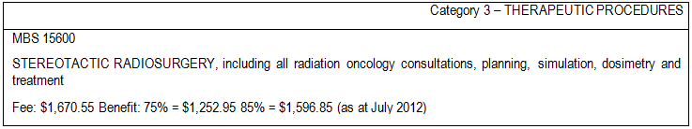

Surgery

Relevant surgical items for intra-cranial neoplasms

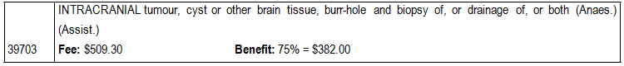

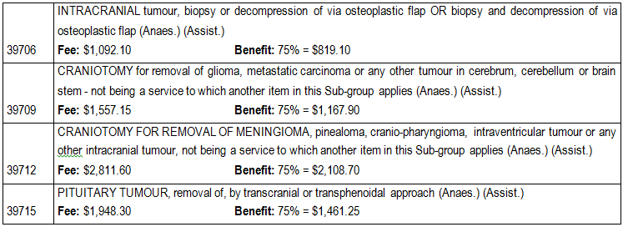

Relevant surgical items for acoustic neuroma
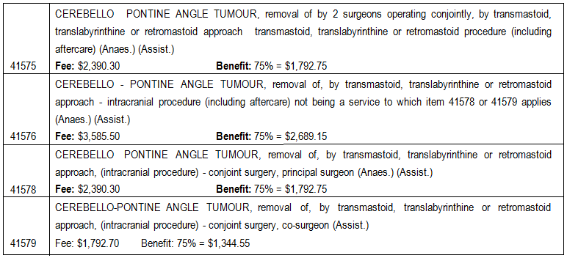

Whole brain radiotherapy is a four-step procedure:

• Simulation;

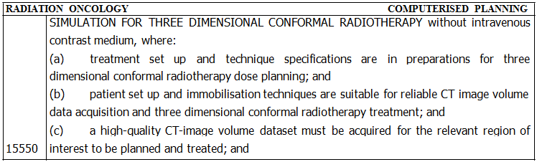

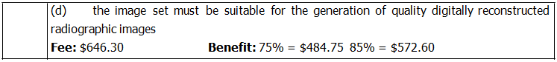

• Dosimetry;

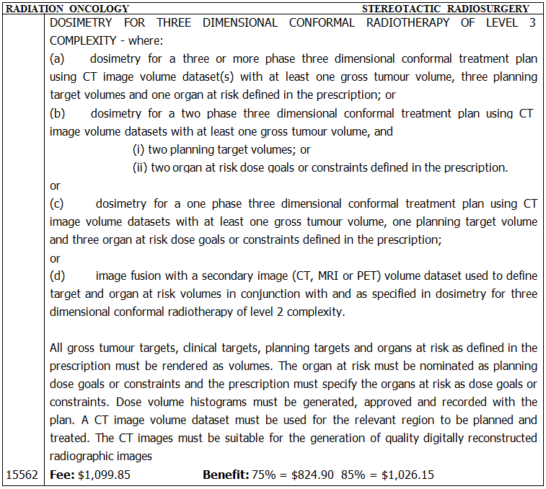

• Treatment;

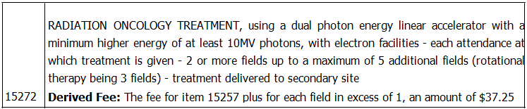

• Treatment verification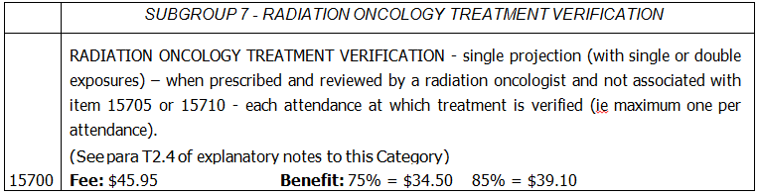

Items and fees used in whole brain radiotherapy (with a four field treatment), including ROHPG
payments

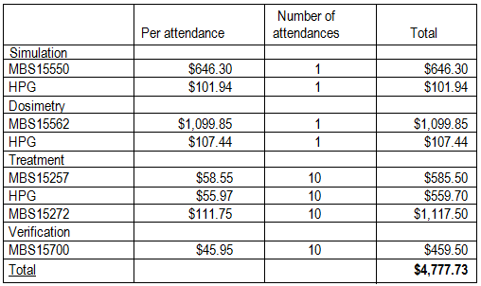

Single dose stereotactic radiosurgery with Gamma Knife uses the following resources:

• CT scanner –one of the following items

56001 | HEAD  COMPUTED TOMOGRAPHY - scan of brain without intravenous contrast medium, not being a service to which item 57001 applies (R) (K) (Anaes.)  Fee: $195.05 Benefit: 75% = $146.30 85% = $165.80
56007 | COMPUTED TOMOGRAPHY - scan of brain with intravenous contrast medium and with any scans of the brain  prior to intravenous contrast injection, when undertaken, not being a service to which item 57007 applies (R) (K) (Anaes.)  Fee: $250.00 Benefit: 75% = $187.50 85% = $212.50
56010 | COMPUTED TOMOGRAPHY - scan of pituitary fossa with or without intravenous contrast medium and with or  without brain scan when undertaken (R) (K) (Anaes.)  Fee: $252.10 Benefit: 75% = $189.10 85% = $214.30

• MRI unit – one of the following items
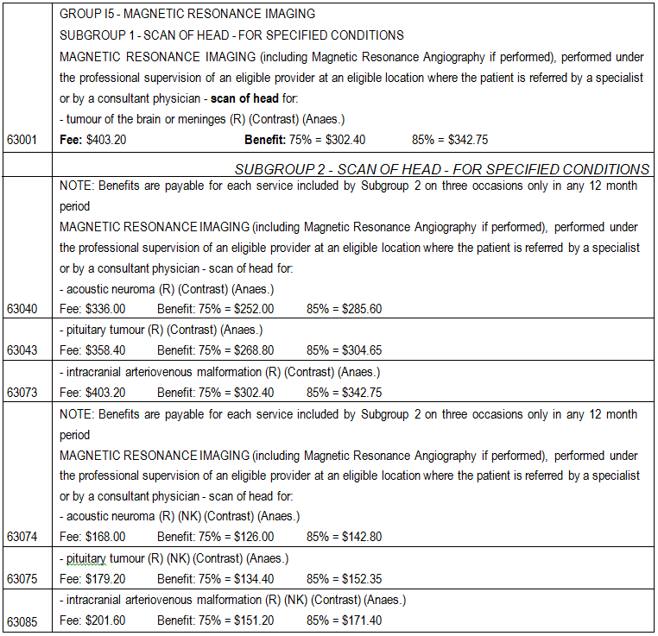

• Frame

• Team headed up by a neurosurgeon and including a radiation oncologist, medical physicist, radiation therapist and a nurse.

• Gamma Knife unit.

The applicant indicates that the market price of delivery of the Gamma Knife service is highly dependent on throughput. It is estimated that a throughput of less than 150 patients per year would result in an average market price per patient of $25,000. An increase of throughput to 250 patients

per year would decrease this average market price to $16,000. This amount covers the whole service, that is, application of the stereotactic frame, acquisition of images, dose planning and delivery of radiation.

The applicant will conduct a detailed costing of the Gamma Knife Unit at Macquarie Hospital as part of the submission.

CyberKnife

CyberKnife therapy is currently undergoing assessment for extracranial lesions. CyberKnife is not currently funded under the MBS.

Proposed structure of economic evaluation (decision-analytic)

Table 5: Summary of extended PICO to define research question that assessment will investigate
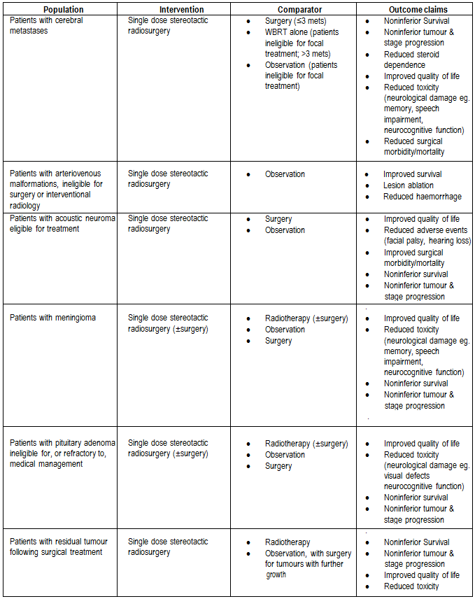

Patients with focally recurrent glioblastoma multiforme | Single dose stereotactic radiosurgery | • Chemotherapy  • Surgery | • Improved quality of life  • Reduced toxicity (neurological damage eg. visual defects neurocognitive function)  • Noninferior survival  • Noninferior tumour &  stage progression
Primary questions for public funding

What is the safety, effectiveness, and cost-effectiveness of single dose stereotactic radiosurgery in patients with cerebral metastases compared with surgery; or whole brain radiotherapy or observation in patients ineligible for focal treatment?

What is the safety, effectiveness, and cost-effectiveness of single dose stereotactic radiosurgery in patients with arteriovenous malformations who are ineligible for surgery compared with observation?

What is the safety, effectiveness, and cost-effectiveness of single dose stereotactic radiosurgery in patients with acoustic neuroma eligible for treatment, compared with surgery or observation?

What is the safety, effectiveness, and cost-effectiveness of single dose stereotactic radiosurgery in patients with meningioma, or pituitary adenoma ineligible for or refractory to medical management compared, with radiotherapy, surgery or observation?

What is the safety, effectiveness and cost-effectiveness of single dose stereotactic radiosurgery performed as an adjunctive therapy to surgery for residual intracranial lesions following treatment compared with radiotherapy or observation (with surgery for tumours with further growth)?

What is the safety, effectiveness and cost-effectiveness of single dose stereotactic radiosurgery in patients with focally recurrent glioblastoma multiforme, compared with salvage chemotherapy or surgery?

Secondary questions for public funding

Is there evidence of one modality of single dose stereotactic radiosurgery having greater safety, effectiveness and cost-effectiveness than the others?

The following decision-analytic trees are generic and are provided for the purposes of supplementing

the information given in the PICO tables
and clinical algorithms
and may
not reflect
the cost-

effectiveness models required in the final assessment.

Decision tree for stereotactic radiosurgery vs. comparator treatment
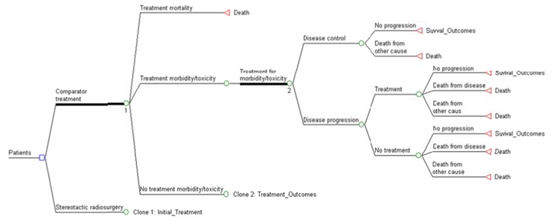

Decision tree for stereotactic radiosurgery vs. observation

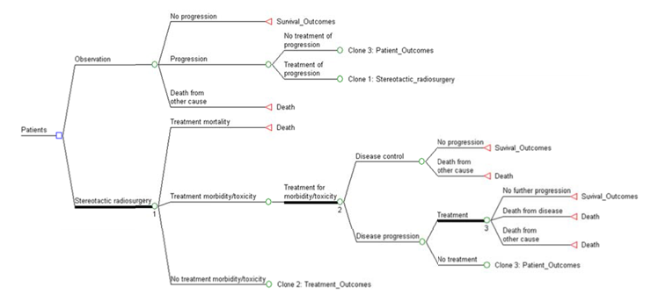

Table 6: List of resources to be considered in the economic analysis
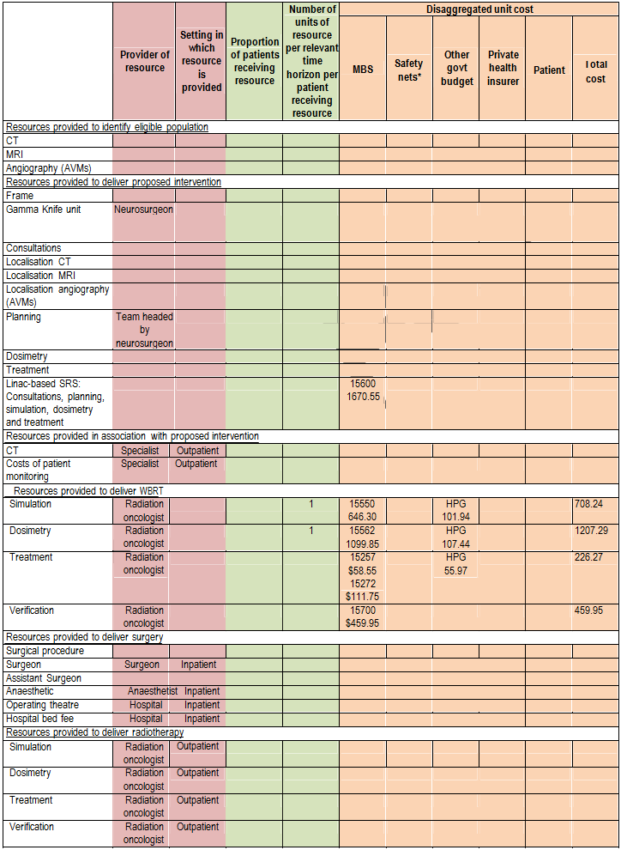

 | Provider of resource |  | Setting in which resource is provided | Proportion of patients receiving resource | Number of units of resource  per relevant time  horizon per patient receiving resource | Disaggregated unit cost
 |  |  |  |  |  | MBS | Safety nets* | Other govt budget | Private health insurer | Patient | Total cost
Resources provided to deliver observation/surveillance
MRI | Specialist | Outpatient
Consultations | Specialist | Outpatient
Resources used to manage patients who are unsuccessfully treated
Costs of treating recurrence
Costs of treating toxicity
* Include costs relating to both the standard and extended safety net.

Abbreviations: HPG = Health Program Grants

References

AIHW, ‘Cancer incidence data cube, 1982 to 2008’, accessed 20/07/2012, http://www.aihw.gov.au/cancer-data-cube/

AIHW, ‘Separation statistics by principal diagnosis in ICD−10−AM, Australia, 2008−09 to 2009−10’,
accessed 20/07/2012, http://www.aihw.gov.au/hospitals-data-cube/

Black, P.M. 1995. ‘Benign brain tumors. Meningiomas, pituitary tumors, and acoustic neuromas’,
Neurologic Clinics, 13 (4), 927–952.

Australian Cancer Network Adult Brain Tumour Guidelines Working Party. Clinical Practice Guidelines for the Management of Adult Gliomas: Astrocytomas and Oligodendrogliomas. Cancer Council Australia, Australian Cancer Network and Clinical Oncological Society of Australia Inc., Sydney 2009.

Ezzat, S., Asa, S.L., Couldwell, W.T., Barr, C.E., Dodge, W.E., Vance, M.L., & McCutcheon, I.E. 2004.
‘Prevalence of pituitary adenomas: A systematic review’, Cancer, 101 (3), 613–619.

Levin, V.A., Leibel, S.A., & Gutin, P.H. 2001, ‘Neoplasms of the central nervous system.’ In Cancer: Principles and Practice of Oncology, 6th edn, V. T. J. DeVita, S. Hellman, & S. A. Rosenberg, eds., Lippincott Williams & Wilkins, Philadelphia, pp. 2100-2160.

Lin, D., Hegarty, J.L., Fischbein, N.J., & Jackler, R.K. 2005. ‘Prevalence of “incidental” acoustic neuroma’, Archives of Otolaryngology—Head & Neck Surgery, 131 (3), 241–244.

MSAC 2001, Gamma knife radiosurgery, Medical Services Advisory Committee, Commonwealth of
Australia, Canberra.

MSAC 2006, Gamma knife radiosurgery, Medical Services Advisory Committee, Commonwealth of
Australia, Canberra.

Nakamura, M., Roser, F., Michel, J., Jacobs, C., & Samii, M. 2003. ‘Natural history of incidental meningiomas’, Neurosurgery, 53 (1), 62–70; discussion 70–71.
Patchell, R.A. 2003. ‘Management of brain metastases’, Cancer Treatment Reviews, 29 (6), 533–540. Radhakrishnan, K., Mokri, B., Parisi, J.E., O’Fallon, W.M., Sunku, J., & Kurland, L.T. 1995. ‘Trends in
incidence of primary brain tumors in the population of Rochester, Minnesota’, Annals of Neurology, 37
(1), 67–73.

Sheehan, J.P., Niranjan, A., Sheehan, J.M., Jane, J.A., Jr., Laws, E.R., Kondziolka, D., Flickinger, J., Landolt, A.M., Loeffler, J.S., & Lunsford, L.D. 2005. ‘Stereotactic radiosurgery for pituitary adenomas: an intermediate review of its safety, efficacy, and role in the neurosurgical treatment armamentarium’, Journal of Neurosurgery, 102 (4), 678–691.

Stapf, C., Mast, H., Sciacca, R.R., Berenstein, A., Nelson, P.K., Gobin, Y.P., PileSpellman, J., Mohr, J.P., & New York Islands AVM Study Collaborators 2003. ‘New York Islands AVM Study: Design, study progress, and initial results’, Stroke, 34 (5), e29–33.

Tos, M., Stangerup, S.E., CayeThomasen, P., Tos, T., & Thomsen, J. 2004. ‘What is the real incidence of vestibular schwannoma?’, Archives of Otolaryngology—Head & Neck Surgery, 130 (2), 216–220.

Westphal, M., Heese, O., & de Wit, M. 2003. ‘Intracranial metastases: therapeutic options’, Annals of
Oncology, 14, 4–10.

