Application 1575:
Autologous fat grafting (AFG) by injection, for defects arising from breast surgery, cancer treatment/prevention or congenital deformity

Ratified PICO Confirmation
(To guide a new application to MSAC)
(Version 1.0)

Summary of PICO criteria to define the question(s) to be addressed in an Assessment Report to the Medical Services Advisory Committee (MSAC)
There are four patient groups, each with different forms of breast defects or deformities, described in this document. A summary of the PICO criteria is provided for each one individually below.
Table 1 Summary PICO criteria - post mastectomy without reconstruction
Component | Description
Patients | Post mastectomy without reconstruction
Intervention | - AFG alone, to treat pain resulting from scarring and/or tightness of the skin following mastectomy;  - AFG, followed by reconstruction: to improve skin flaps post-mastectomy (with or without radiation therapy), in order to facilitate prosthetic reconstruction  - AFG alone, for patients suitable for AFG reconstruction
Comparator | - For the treatment of pain - Best supportive care (i.e. no specific intervention)  - For the treatment of poor quality skin post mastectomy (with or without radiation therapy) – no reconstruction (BSC) or reconstruction with poor quality skin  - For AFG reconstruction alone – no reconstruction (BSC) or an alternative method of reconstruction
Outcomes | Efficacy  - Post mastectomy pain relief  - Health related quality of life, measured with BREAST-Q (measures breast satisfaction, psychosocial, physical and sexual well-being)  - Proportion of patients who become suitable for prosthetic reconstruction  - Proportion of patients who achieve reconstruction with AFG alone  Safety  - Locoregional recurrence of cancer (LRR)  - Distant or systemic recurrence of cancer  - Complications (severity graded, according to Clavien-Dindo scale):  - Donor site:  - Local infection;  - Deep vein thrombosis  - Abdominal organ injury  - Haematoma/bleeding  - Change to skin sensation  - Scarring  - Breast complications:  - Fat necrosis  - Cysts  - Infection  - Post-operative pain  - Scarring  - Radiological abnormalities:  - Suspicious image lesions  Economic outcomes  - Number of fat grafting sessions  - Quality adjusted life years (QALYs)  - Costs of post mastectomy symptom relief  - Costs of prosthetic reconstruction (when applicable)

Table 2 Summary PICO criteria - Post mastectomy with reconstruction
Component | Description
Patients | Post mastectomy with suboptimal outcomes following autologous or prosthetic reconstruction
Intervention | - AFG alone: to improve contour defects, , volume differences and rippling  - AFG followed by additional surgery: used to improve skin flaps to extend coverage of a prosthesis
Comparator | - Best supportive care (i.e. no specific intervention)  - Revision surgery
Outcomes | Efficacy  - Patient and surgeon satisfaction  - Health-related quality of life, measured with BREAST-Q (measures breast satisfaction, psychosocial, physical and sexual well-being)  - Aesthetic outcome, measured with Harvard scale (measures size, shape and texture, including thickening, scar tissue and fluid accumulation)  - Post-mastectomy pain relief  - Volume retention: % of volume gain relative to injected volume  - Irregularities of surface or contour  Safety  - Locoregional recurrence of cancer (LRR)  - Distant or systemic recurrence of cancer  - Complications (severity graded according to Clavien-Dindo scale):  - Donor site:  - Local infection;  - Deep vein thrombosis  - Abdominal organ injury  - Haematoma/bleeding  - Change to skin sensation  - Scarring  - Breast complications:  - Fat necrosis  - Cysts  - Infection  - Post-operative pain  - Scarring  - Radiological abnormalities:  - Suspicious image lesions  Economic  - Number of fat grafting sessions  - Costs of revision surgeries  - Quality-adjusted life years (QALYs)

Table 3 Summary PICO criteria - Post breast conserving surgery for benign or malignant neoplasms
Component | Description
Patients | Suboptimal outcome following breast conserving surgery for benign or malignant neoplasms
Intervention | AFG alone, to improve contour defects, volume differences and rippling.
Comparator | - Best supportive care  - Mastectomy and reconstruction  - Contralateral breast reduction to correct asymmetry  - Other corrective surgery (e.g. local perforated flaps)
Outcomes | Efficacy  - Patient and surgeon satisfaction  - Health related quality of life, measured with BREAST-Q (measures breast satisfaction, psychosocial, physical and sexual well-being)  - Aesthetic outcome, measured with Harvard scale (measures size, shape and texture, including thickening, scar tissue and fluid accumulation)  - Post mastectomy pain relief  - Volume retention: % of volume gain relative to injected volume  - Irregularities of surface or contour  Safety  - Locoregional recurrence of cancer (LRR)  - Distant or systemic recurrence of cancer  - Complications (severity graded, according to Clavien-Dindo scale):  - Donor site:  - Local infection;  - Deep vein thrombosis  - Abdominal organ injury  - Haematoma/bleeding  - Change to skin sensation  - Scarring  - Breast complications:  - Fat necrosis  - Cysts  - Infection  - Post-operative pain  - Scarring  - Radiological abnormalities:  - Suspicious image lesions  Economic  - Number of fat grafting sessions  - Costs of comparator surgeries  - Quality adjusted life years (QALYs)

Table 4 Summary PICO criteria – Developmental breast asymmetry
Component | Description
Patients | Developmental breast abnormalities defined as congenital tuberous breasts or unilateral hypomastia causing asymmetry with a >20% difference to the contralateral side
Intervention | Intervention may be AFG alone (multistep procedure), or in association with an implant, skin flap or other minor procedure (e.g. minor skin procedure or ptosis procedure).
Comparator | - Best supportive care  - Corrective breast surgery
Outcomes | Efficacy  - Patient and surgeon satisfaction  - Health related quality of life, measured with BREAST-Q (measures breast satisfaction, psychosocial, physical and sexual well-being)  - Aesthetic outcome, measured with Harvard scale (measures size, shape and texture, including thickening, scar tissue and fluid accumulation)  - Volume retention: % of volume gain relative to injected volume  - Irregularities of surface or contour  Safety  - Complications (severity graded, according to Clavien-Dindo scale):  - Donor site:  - Local infection;  - Deep vein thrombosis  - Abdominal organ injury  - Haematoma/bleeding  - Change to skin sensation  - Scarring  - Breast complications:  - Fat necrosis  - Cysts  - Infection  - Post-operative pain  - Scarring  - Radiological abnormalities:  - Suspicious image lesions  Economic  - Number of fat grafting sessions  - Costs of comparator surgeries (when applicable)  - Quality adjusted life years (QALYs)

PICO rationale for the therapeutic medical service
This application is for Medicare Benefits Schedule (MBS) listing of autologous fat grafting (AFG) to correct suboptimal outcomes of breast cancer or cancer risk-reduction surgery, or for correction of developmental breast disorders.
AFG corrects defects due to volume deficit, improves vascularisation of overlying structures to reduce skin tightness and pain, and improves skin quality to allow the use of additional surgical treatments. AFG may therefore be additional to current treatment, a substitute for additional treatment or a precursor to an additional treatment. AFG can also be used to correct defects in women with developmental breast abnormalities.
Population
The intervention is proposed in Australia for the use in four patient populations. These can be considered as two broader populations herein referred to as population A and B.
Population A: Women who have had previous surgery for breast cancer treatment or risk reduction for the treatment of post-mastectomy pain and/or to improve post mastectomy skin quality (with or without radiation therapy).
This population can be further divided into the following subgroups:
A1 – Post-mastectomy without reconstruction
A2 – Post mastectomy with suboptimal outcomes after autologous or prosthetic reconstruction
A3 – Suboptimal outcomes following breast conserving surgery (BCS) for benign or malignant neoplasms.
While sub-populations A1, A2 and A3 are mutually exclusive at any one time, it is important to note that an individual patient may move through more than one of these groups over time.
Given that population A1 is broad, PASC suggested that reasons for performing AFG should be specified in the population descriptor. These different reasons for performing AFG would also form subgroups for consideration in the assessment report, given the alternative comparators.
It was also suggested that the reasons for delayed reconstruction (e.g. inadequate donor site volumes for autologous flap reconstruction, patient medically unfit at the time of mastectomy, a change in patient preference for reconstruction) should be included in the patient description to minimise leakage; however, the applicant expressed concern that narrowing the subgroups too much would make it difficult to obtain enough evidence to make recommendations.
Population B: Women with developmental breast abnormalities defined as congenital tuberous breasts or unilateral hypomastia causing asymmetry with a >20% difference to the contralateral side.
These populations and subgroups are discussed individually below.

Population A: Breast cancer
Breast cancer is the most commonly occurring cancer affecting women in Australia representing 28% of all cancers diagnosed in women (Cancer council, 2016). It is estimated that 17,586 women were diagnosed with breast cancer in 2017 (AIHW, 2017) and these numbers are expected to continue to rise. One in 8 women will be diagnosed by the age of 85 (Wong et al., 2014).
The majority of women diagnosed with breast cancer undergo surgery with curative intent, either mastectomy or breast conserving surgery (BCS). Increasingly there is a trend towards BCS over mastectomy with approximately 40% of patients undergoing mastectomy as part of the surgical treatment of their breast cancer and the remaining 60% opting for BCS (Agha et al., 2015).
Mastectomy can have a negative impact on body image and sexual function (Turk et al., 2018). Breast reconstruction has been shown to decrease negative emotional and psychological consequences of mastectomy, thereby reducing anxiety, improving self-esteem and enhancing the quality of life of these patients (Wehrens et al., 2005). Consequently, current clinical guidelines worldwide recommend that breast reconstruction be offered to all suitable women requiring or choosing mastectomy (NICE, 2009; NCCN, 2013, Cancer Australia, 2001). Breast reconstruction may be performed as an immediate or delayed procedure, using breast implants, autologous tissue or a combination of the two.
Population A1: Post mastectomy without reconstruction
A large proportion of women (40%) will not undergo a breast reconstruction. The main reasons for this are:
- Patient preference (costs and/or extensive recovery time being prohibitive for many)
- Poor quality skin from radiotherapy preventing prosthetic reconstruction to be performed
- Inadequate donor site volumes for autologous flap reconstruction
- Being medically unfit for surgery/other contraindications
For some of these patients post mastectomy scarring or tight/thin skin flaps are a source of severe pain and discomfort with post mastectomy pain syndrome occurring in 20- 30% of women who have had mastectomies or breast conserving surgery (Couceiro et al, 2014). The 2015 guiding statement of the ASPRS Executive Committee guidance on AFG now states the evidence suggests AFG is a useful modality for alleviating post mastectomy pain syndrome (ASPS, 2015).
Furthermore, the evidence suggests AFG is a viable option for improving the quality of irradiated skin present enabling some women to pursue a prosthetic reconstruction when they would otherwise not have been able to. In a small minority of women, reconstruction with AFG alone may be possible. There is no data with which to inform how many women who choose not to have an autologous flap reconstruction would elect to have a prosthetic reconstruction if this were available to them.
PASC queried whether the potential for AFG to improve outcomes of a delayed reconstruction would result in a group of patients (who previously chose not to have reconstruction) choosing to have reconstruction later, based on reduced risk and change in preference. However, the applicant explained that AFG is an additional tool, which is unlikely to change a patient’s decision about whether to have a reconstruction or not. The reasons for choosing not to have a reconstruction are generally health-, socially- or culturally- based, and not related to waiting for a better reconstruction option.
Population A2: Post mastectomy with suboptimal outcomes after autologous or prosthetic reconstruction
A retrospective clinical review of all women that had undergone a mastectomy within a multidisciplinary breast cancer treatment centre in Australia between 2009 and 2011 showed that 41% of women who had undergone a mastectomy had elected to have a breast reconstruction. This is in line with a report on the trend in breast reconstruction post mastectomy in the US which demonstrated 35.1% of women elected to have a breast reconstruction post mastectomy in 2014. Of note, the study demonstrated a steady increase in the uptake of breast reconstructions over a 5-year period, a reflection of increased access to surgery with an increase in reconstruction surgeries being performed in outpatient settings and greater access to delayed reconstruction. Based on advances in surgical approaches, it is likely that the uptake of breast reconstruction will increase over time.
Table 5 presents the number of mastectomy related procedures recorded by The National Hospital Morbidity Database (NHMD). NHMD is a collection of summary records for separations in both public and private hospitals in Australia. The following procedures are not entirely specific to oncology, however, make up the majority of individuals undergoing a mastectomy.
Table 5 Number of procedures related to mastectomy in 2015-2016, NHMD
Code | Procedure | 2015-16 | 2016-17
1747 | Subcutaneous mastectomy
31524-00 | Subcutaneous mastectomy, unilateral | 1,686 | 1,639
31524-01 | Subcutaneous mastectomy, bilateral | 1,842 | 1,927
1748 | Simple mastectomy
31518-00 | Simple mastectomy, unilateral | 6,263 | 6,072
31518-01 | Simple mastectomy, bilateral | 1,428 | 1,460
1753 | Augmentation mammoplasty
45527-00 | Augmentation mammoplasty, following mastectomy, unilateral | 450 | 453
45527-01 | Augmentation mammoplasty, following mastectomy, bilateral | 388 | 412
1756 | Reconstruction procedures on breast
45530-02 | Reconstruction of breast using flap | 2,446 | 2,511
45533-00 | Reconstruction of breast using breast sharing technique, first stage | 52 | 59
45536-0 | Reconstruction of breast using breast sharing technique, second stage | 27 | 19
45539-00 | Reconstruction of breast with insertion of tissue expander | 2,945 | 2,692

Based on the NHMD data in Table 5, the number of patients undergoing a simple or subcutaneous mastectomy in the 2016-2017 period is 11,098 (sum of codes 1747 and 1748) representing approximately 63% of cases based on the estimated number of women diagnosed in 2017 (11,098/17,586). The number of reconstructions using a flap procedure was 2,511 in the same year. This is expected to be limited to patients who have undergone a mastectomy for the treatment, or prophylactic treatment, of breast cancer. Similarly, the vast majority of patients who have undergone a reconstruction of the breast with the insertion of tissue expanders are also expected to comprise patients who have undergone mastectomy for the treatment of breast cancer who are undergoing prosthetic reconstruction. This was shown to be 2,692 patients in the 2016-2017 period. Based on these assumptions, 5,203 patients are expected to undergo a reconstruction representing 47% of all patients who have had a mastectomy.
The literature demonstrates that the majority of patients who have undergone reconstructive surgery are satisfied with their breast reconstruction (Wehrens et al., 2005; BCNA, 2010). For some women however, reconstructions may result in complications and suboptimal outcomes resulting from asymmetry and/or issues around contour and shape. An audit of breast reconstructions in the UK showed that as many as 30% of patient remain dissatisfied with their reconstructed breasts and may seek revisional surgery (Jeevan et al., 2011). Patients dissatisfied with their prosthetic reconstructions may choose to remove these and utilise autologous reconstruction.
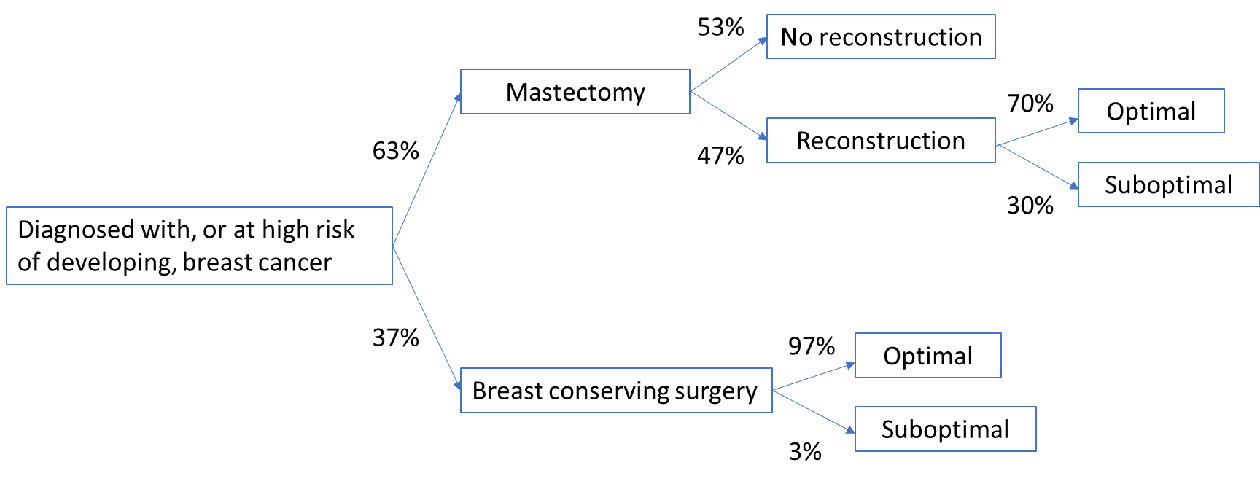
Figure 1 Patient outcomes following surgical intervention for the treatment, or prophylactic treatment, of breast cancer.
Note: Proportion of patients undergoing mastectomy and the uptake rate of reconstruction is based on the 2016-2017 NHMD data presented in Table 5.
Population A3: Suboptimal outcomes following breast conserving surgery (BCS) for benign or malignant neoplasms
Breast conserving surgery involves removing the breast cancer and a small amount of healthy tissue around it (called the surgical margin). Breast conserving surgery is an option if the breast cancer is small enough compared to the size of the breast to allow removal of the cancer and some healthy tissue around it and still give an acceptable appearance. Radiotherapy to the breast is usually recommended after breast conserving surgery. As previously described approximately 60% of Australian women with early stage breast cancer will opt for BCS over a mastectomy reflecting the less invasive surgery required, shorter recovery time and greater patient satisfaction following surgery. A study to determine the aesthetic result after breast-conserving therapy in Swedish women found only 3% of women rated their satisfaction follow BCS as “poor” (Dahlback et al., 2017). These findings were comparable to a long terms study which also found that 3.4% of BCS had outcomes rated as “poor” (Hennigs et al., 2015).
Dissatisfaction from BCS is typically a result of asymmetry and issues of shape and contour. In the absence of AFG, these patients may elect to have a breast reduction on the contralateral side to increase symmetry or elect to undergo mastectomy followed by reconstruction. There is little data to inform the population size for this group. Additional expert advice should be sought to provide more accurate population estimates.
Rationale:
A number of studies indicate that for patients with breast cancer, body image satisfaction is positively related to quality of life (Falk et al., 2010; Avis et al., 2005). Mastectomy can have a negative impact on body image and sexual function (Giene et al., 2012). Breast reconstruction has been shown to decrease negative emotional and psychological consequences of mastectomy, thereby reducing anxiety, improving self-esteem and enhancing the quality of life of these patients (Wehrens et al., 2010).
A large proportion of women who undergo breast reconstruction are dissatisfied with their reconstruction and may seek revisional surgery. For women who have undergone BCS, resulting in asymmetry or defects in breast contour and shape may require breast reductions on the contralateral side or full mastectomy with reconstruction.
For these women, AFG may provide an effective alternative to revision surgery avoiding the costs and long recovery periods associated with reconstruction surgeries while improving body satisfaction and quality of life.
As previously described, some women may not be able to undergo breast reconstruction because they are unable to pursue a prosthetic reconstruction due to poor quality skin post radiotherapy. AFG in this instance may be used to sufficiently improve the skin quality to enable a prosthetic reconstruction to be performed.
All surgical interventions for the treatment of breast cancer may result in scarring and tightening of the skin causing pain and discomfort to the patient for which there is no treatment available. AFG has been shown to soften scar tissue thereby decreasing tension and reducing pain and has been shown to be a viable modality in the treatment of post mastectomy pain syndrome.
Patients who have undergone a surgical intervention for the treatment of, or prophylactic treatment of, breast cancer who require revision surgery will be managed under their continuing treatment plan. The approach to future surgical planning and decision making for these patients is dependent on the surgical intervention used (mastectomy or BCS) and whether the patient has undergone, or wishes to undergo, breast reconstruction. Population A1: For patients post-mastectomy without reconstruction, AFG is proposed for:
- Treatment of post-mastectomy pain resulting from scarring and/or tightness of skin
- Improvement of skin flaps post-mastectomy (with or without radiation therapy) to facilitate prosthetic reconstruction
- Patients suitable for reconstruction with AFG alone (a rare indication)
Population A2: For patients post-mastectomy with breast reconstruction (immediate or delayed), AFG is proposed for the treatment of an unsatisfactory reconstruction. Specifically:
- Correction of contour defects, rippling of prostheses or breast asymmetry (>20 difference to contralateral side)
- Improvement of skin flaps requiring further coverage of prosthesis
Population A3: For patients who have undergone BCS, AFG is proposed for the treatment of an unsatisfactory reconstruction. Specifically:
- Correction of contour defects, rippling of prostheses or breast asymmetry (>20 difference to contralateral side)
All patients would require a suitable donor site for fat harvest to be eligible for AFG.
PASC noted that the estimated size of population A is about 3000 per year based on the National Hospital Morbidity Database data for 2015–16; however, this only represents the incident population. A much larger group has had previous mastectomy or BCS, so the prevalent population is larger. Additional expert advice should be sought to provide more accurate population estimates (although noting that subjective criteria make it difficult to determine the exact sizes of the populations). The applicant also noted that the population may reduce over time, as reconstructive surgery and BCS improve.
Population B: Women with developmental breast abnormalities.
Developmental breast asymmetry is often congenital and is most commonly caused by breast hypoplasia, tuberous breast deformities and Poland’s syndrome. The proportion of women affected by developmental breast asymmetry is largely unknown on the basis that many women do not seek surgery. Among 128 adolescent and young adult females presenting to a specialist breast clinic between 2007–2018, 3 (2.3%) patients showed a significant asymmetry of ≥2 cup sizes and 1 patient presented with tuberous breasts (Brennan and Spillane, 2019). In the general female population, the prevalence of these conditions is likely to be much lower. The applicant estimates the number of women seeking surgical intervention for congenital breast defects would be 20 to 30 cases per year, however, PASC considered this to be a significant underestimation. Additional expert advice should be sought to provide more accurate population estimates. PASC also expressed concern about potential item leakage (especially for population B), with potential misuse of an AFG item for cosmetic purposes.
Rationale
Developmental breast asymmetry negatively impacts the psychological quality of life of those affected (Birtchnell et al., 1990). Severe developmental breast asymmetry can be a source of severe social and aesthetic handicap (Rintala and Nordstrom, 1990). Surgery to correct asymmetry in these patients has been shown to significantly improve health-related quality of life and self-esteem (Neta et al., 2007).
Current strategies for patients in the management of developmental breast anomalies typically require complex surgeries requiring prosthetic breast augmentation with or without mastopexy depending on the severity of the condition. AFG can be used as an alternative to therapy in these patients to correct the shape and asymmetry without the need for corrective surgery.
AFG is proposed to be used in patients with:
- Congenital tuberous breasts, or
- Unilateral hypomastia causing asymmetry with a >20% difference to the contralateral side
Eligibility for AFG would require patients to have a suitable donor site for fat harvest.
Intervention
Autologous fat grafting (AFG) is the harvesting, preparation, and re-injection of autologous fat, with or without specialised fat grafting equipment. It includes live fat or adipose tissue being harvested from a donor site on the patient, typically the thigh, lower abdomen or flank, and transferred to another site via injection.
Coleman (1997) established a method for autologous fat transfer (AFT) involving harvesting fat with atraumatic liposuction, purifying adipocytes with centrifugation and then injection in another body site (breast, face, burn or scar). Other methods have been developed, that refine some of these core elements such as additional washing of the aspirate, or which propose the use of additives including insulin, platelet rich plasma, endogenous stem cells, and thyroid hormone, or harvesting of the fat at multiple sessions (Illouz et al., 2009).
The approach relies on the fat stem cells remaining viable in the transferred site. The viability of adipocytes has been shown to decrease with increased suction, excessive handling, refrigeration or major trauma during tissue collection or processing (Chan et al., 2008). Whilst the preparation can be performed manually there is now commercially available technology that uses systems to streamline the graft preparation process by selectively washing lipoaspirate while draining any unwanted tumescent fluid, free lipid, and debris has been developed. These systems can prepare 50 to 250 ml of graft in a closed, sterile environment in less than 15 minutes and allow the user to define the hydration level of the final graft (Wetterau et al., 2016).
Fat transfer, or fat grafting, allows wider use of prosthetic breast reconstruction by promoting skin quality post radiation. It can also minimise the need for extensive revisional surgery for volume and shape defects after breast reconstruction. AFG has also shown to be useful in the alleviation of pain due to scarring and/or PMPS. In patients with developmental breast abnormalities, AFG can be used to avoid the need for extensive surgery to correct tuberous breast or asymmetry.
Volumes grafted for breast reconstruction are typically in the range of 40-150 ml. The harvest and transplant procedures can usually be completed within two hours.
AFG is to be used in an operating theatre as a day-case surgical procedure or part of a more extensive procedure requiring a longer admission. Depending on the population and outcomes of the procedure, up to 5 sessions (per breast) may be required with an estimated median of 2 sessions. There is usually a 3-month interval between procedures. This was supported by feedback from two professional bodies supporting the application, including comments that the procedure involves day surgery, with minimal recovery time, and that AFG is currently included in the education program for practitioners.
Fat grafting has become an essential tool in the management of breast cancer patients yet currently has no item number and is often coded simply as “scar-revision”. AFG is more complex than scar revision and an item number will improve resource allocation and monitoring of use.
There is currently no MBS item for the use of AFG for the treatment of scars. This is addressed within a separate application (1577).
Rationale
AFG can be used for the treatment of burns scars and for the treatment of craniofacial deformities. The use of AFG in these indications is addressed within a separate application (1577)
The application of AFG differs depending on the population and purpose of treatment
Population A1:
AFG alone, to treat pain resulting from scarring and/or tightness of the skin following mastectomy;
AFG, followed by reconstruction: to improve skin flaps post-mastectomy (with or without radiation therapy), in order to facilitate prosthetic reconstruction;
AFG alone, for patients suitable for AFG reconstruction.
Population A2:
AFG alone, to improve contour defects, volume differences and rippling;
AFG followed by additional surgery to improve skin flaps to extend coverage of a prosthesis.
Population A3:
AFG alone, to improve contour defects, volume differences and rippling.
For population B, the intervention may be AFG alone (multistep procedure), or in association with an implant, skin flap or other minor procedure (e.g. minor skin procedure or ptosis procedure). A proportion of population B may no longer need implants (to correct an abnormality), if AFG is approved.
PASC noted AFG can be repeated at three month (12 week) intervals. The applicant has asked for more flexible frequency (i.e. 6 to 12 weeks), but this will need to be examined during the assessment phase.
Comparator
As above, the use and position of AFG in clinical practice will depend on the patient population.
Patients in population A requiring relief from pain associated with scarring and skin tightness as a consequence of surgical intervention for the treatment of, or prophylactic treatment of, breast cancer, AFG will be used in addition to best supportive care.
Additional comparators for each sub-population is provided below:
Population A1: Best supportive care
In patients who are post mastectomy without reconstruction, AFG may be used in conjunction with best supportive care, in order to improve skin quality to enable future reconstruction with or without prosthesis.
Additional comparators that could be considered appropriate include:
- For the treatment of poor quality skin post mastectomy (with or without radiation therapy) – no reconstruction or reconstruction with poor quality skin
- For AFG reconstruction alone – no reconstruction or an alternative method of reconstruction
Population A2: Best supportive care or revision surgery
In patients who are post mastectomy with suboptimal outcomes after reconstruction, AFG is to be used in place of, or in conjunction with, revision surgery. It is noted that some patients would not elect to undergo revision surgery based on the invasive nature of the procedure and extensive recovery time but may pursue AFG. In this scenario, AFG would be used in addition to best supportive care.
Population A3: Best supportive care, mastectomy and reconstruction, or contralateral breast reduction. Other corrective surgery (e.g. local perforated flaps) may also be an alternative to AFG.
For patients who have undergone breast conserving surgery with suboptimal outcomes, current practice may include mastectomy and reconstruction or, contralateral breast reduction. It is expected that AFG in these patients would replace the need for surgical intervention.
• Population B: Best supportive care and corrective surgery
In current practice, patients with developmental breast abnormalities would either elect to do nothing or undergo surgery to achieve symmetry. For most patients electing surgery, this requires the use of a tissue expander followed by prosthetic implant. AFG for these patients is expected to be in addition to best supportive care (in those who would otherwise elect to do nothing) or is expected to replace corrective surgery.
Outcomes
A range of patient and health system related outcomes expected to be affected by the introduction of the proposed service were identified from the extant literature.
Patient-relevant outcomes
The relevant outcomes are specific to the clinical management plan for each population.
Population A1
For patients post mastectomy who choose not to undergo reconstruction, AFG may be used to alleviate symptoms such as pain and discomfort from scarring or post mastectomy pain syndrome. Outcomes relevant to this patient group include:
- Post mastectomy pain relief
- Health related quality of life, measured with BREAST-Q (measure breast satisfaction, psychosocial, physical and sexual well-being)
Patients who are treated with AFG to improve skin quality in order to become suitable for prosthetic reconstruction, relevant outcomes may include:
- Proportion of patients who become suitable for prosthetic reconstruction
- Proportion of patients who achieve reconstruction with AFG alone
Populations A2, A3 and B
Patients with suboptimal outcomes post-mastectomy with reconstruction or breast conserving surgery, or who have developmental breast abnormalities, patient relevant outcomes relate to patient and surgeon satisfaction, quality of life, volume retention, irregularities of surface or contour and aesthetic outcome. These are listed below
- Patient and surgeon satisfaction
- Health related quality of life, measured with BREAST-Q (measures breast satisfaction, psychosocial, physical and sexual well-being)
- Aesthetic outcome, measured with Harvard scale (measures size, shape and texture, including thickening, scar tissue and fluid accumulation)
- Post mastectomy pain relief
- Volume retention: % of volume gain relative to injected volume
- Irregularities of surface or contour
Safety
Relevant safety outcomes for the intervention also differ slightly between the two broad populations. For population A, who have had surgical interventions for the treatment of breast cancer, locoregional recurrence and distant or systemic recurrence of cancer are relevant outcomes.
For all populations, relevant safety outcomes include radiological abnormalities and complications such as calcifications, necrosis and infection. The severity of complications can be graded using the Clavien-Dindo grading scale.
- Locoregional recurrence of cancer (LRR)
- Distant or systemic recurrence of cancer
All populations:
- Complications (severity graded according to Clavien-Dindo scale):
  - Donor site:
    - Local infection;
    - Deep vein thrombosis
    - Abdominal organ injury
    - Haematoma/bleedingChange to skin sensation
    - Scarring
  - Breast complications:
    - Fat necrosis
    - Cysts
    - Infection
    - Post-operative pain
    - Scarring
- Radiological abnormalities:
- Suspicious image lesions
Economic outcomes:
All populations:
- Number of fat grafting sessions
- Quality adjusted life years (QALYs)
Economic outcomes relevant to each individual population are listed below:
Population A1:
- Cost of post-mastectomy symptom relief
- Cost of prosthetic reconstruction (when applicable)
Population A2:
- Cost of revision operations
Population A3:
- Cost of comparator operations
Population B:
- Cost of comparator operations (when applicable)
PASC advised that BREAST-Q is a patient-reported outcome measure and therefore should not naively be included in the cost-utility analysis without transformation to a utility score.
Changes in outcome measures and quality of life over time should be considered and long-term outcomes will need to be modelled and assumptions made. The applicant stated that there is some evidence to predict quality of life in the longer term. PASC advised that outcomes at 1 year may be predictive of longer-term outcomes.
Donor site complications and the cost of investigating suspicious lesions should also be included in outcomes.
Healthcare system
AFG can be performed in an operating theatre as a day-case surgical procedure or part of a more extensive procedure, requiring longer admission. It usually takes 30 to 60 minutes of operating theatre time. Depending on the population and outcomes of the procedure, up to six sessions may be required, with a median of two sessions. There is usually a three-month (12 week) interval between procedures. The AFG procedure requires staffing similar in composition to other breast surgeries, being a nursing team, a surgeon and an anaesthetist. The resources required are typical of breast cancer (and breast reconstructive surgeries more generally) and, as such, there should be no specific access issues for AFG should it be included on the MBS.
The likely consequences of AFG for the healthcare system, including changes in patterns of healthcare resource provision, are described below with respect to each of the main patient populations identified above in Tables 1 to 4.
Post mastectomy without reconstruction
AFG will likely add to utilisation of health care services in patients currently electing not to undergo reconstruction following mastectomy. Additional healthcare resources include the AFG procedure itself, and in some cases, a prosthetic reconstruction that would not have been able to have been performed in the absence of AFG.
Resources required to manage the pain and discomfort of the mastectomy scar could be expected to be reduced following a successful AFG procedure.
Post mastectomy with reconstruction
Two alternative comparators for patients with a suboptimal outcome following mastectomy are nominated in Table 2. Each comparison has different implications for the healthcare system. For the comparison with best supportive care, whereby the patient elects to have no further intervention (given currently available options), AFG will likely add to the utilisation of health care services for the AFG procedure itself.
However, in many cases, the suboptimal outcomes of reconstructive surgery, will require a form of re-intervention. This could include another autologous reconstruction (MBS items 45564 or 45562/45504/45505) or revisional surgery to excise capsule and/or replace implants (MBS item 45552 or 45553). See Clinical Algorithm in Figure 5.
In patients receiving AFG with (or after) a prosthetic reconstruction, there is also the potential for AFG to extend the life of the prosthetic reconstruction by decreasing the rate of capsule contracture.
Post breast conserving surgery
Following breast conserving surgery, a key objective of any further intervention, including AFG, is to achieve symmetry with the contralateral breast. In the absence of AFG, current options which could be expected to be substituted by AFG include complete mastectomy and autologous reconstruction or, reduction mammaplasty (MBS item 45520) of the contralateral breast.
Developmental breast asymmetry
As with the post mastectomy population, two alternative comparators for patients with developmental breast asymmetry are nominated in Table 4. Each comparison has different implications for the healthcare system. For the comparison with best supportive care, whereby the patient elects to have no further intervention (given currently available options), AFG will likely add to the utilisation of health care services for the AFG procedure itself.
However, in many cases patients will have placement of a tissue expander and then prosthetic implant to achieve symmetry. As is the case for all prosthetic reconstructive options in this population and for other patient populations described above, the longer-term health care resource utilisation includes a commitment to further revision surgery due to the inherent limitations and lifespan of breast prostheses.
Rationale
Outcomes of interest are based on the outcomes presented in the pivotal systematic reviews (Krastev 2018, Waked 2017, Agha 2015, Groen 2015, Kronowitz 2015, Bennet 2017, van Turnhout 2017, Missana 2007). Outcomes of interest include both structural and patient reported outcomes. Mean follow-up time for outcome assessment ranged from 12-26 months in the pivotal systematic reviews.
The applicant suggested that AFG demonstrates “aesthetic improvement and is also a useful modality for alleviating post mastectomy pain syndrome” (MSAC application pg. 39). The provided systematic reviews used a range of scoring systems to measure aesthetic outcome and patient satisfaction, including; BREAST-Q and The Harvard Scale (Bennet 2017, van Turnhout 2017). No measure for post mastectomy pain relief was identified in the provided systematic reviews, however Caviggioli et al. (2011) assessed the clinical effectiveness of AFG in the treatment of postmastectomy pain syndrome using a visual analogue scale.
Important safety endpoints suggested by the applicant and identified in the provided systematic reviews include locoregional recurrence and complications listed above. These safety outcomes are considered important endpoints and are included as recommended outcomes. The Clavien-Dindo scale was identified in the provided systematic review, Agha et al. (2015), as a scale to grade severity of complications.
Additional outcomes that are not related to clinical efficacy or safety include duration of surgery, length of hospital stay, and time to recovery from the procedure and surgeries. While not specifically patient relevant, these outcomes are relevant to the assessment of cost effectiveness.

Current clinical management algorithm for identified population
A clinical management algorithm for patients within population A (i.e. patients diagnosed with, or at high risk of, breast cancer requiring surgery), is provided in Figure 2. The algorithm depicts current practice in the absence of public funding for the proposed medical service. For this population, BSC refers to ongoing symptomatic management without surgical intervention including pain and psychological attendances.

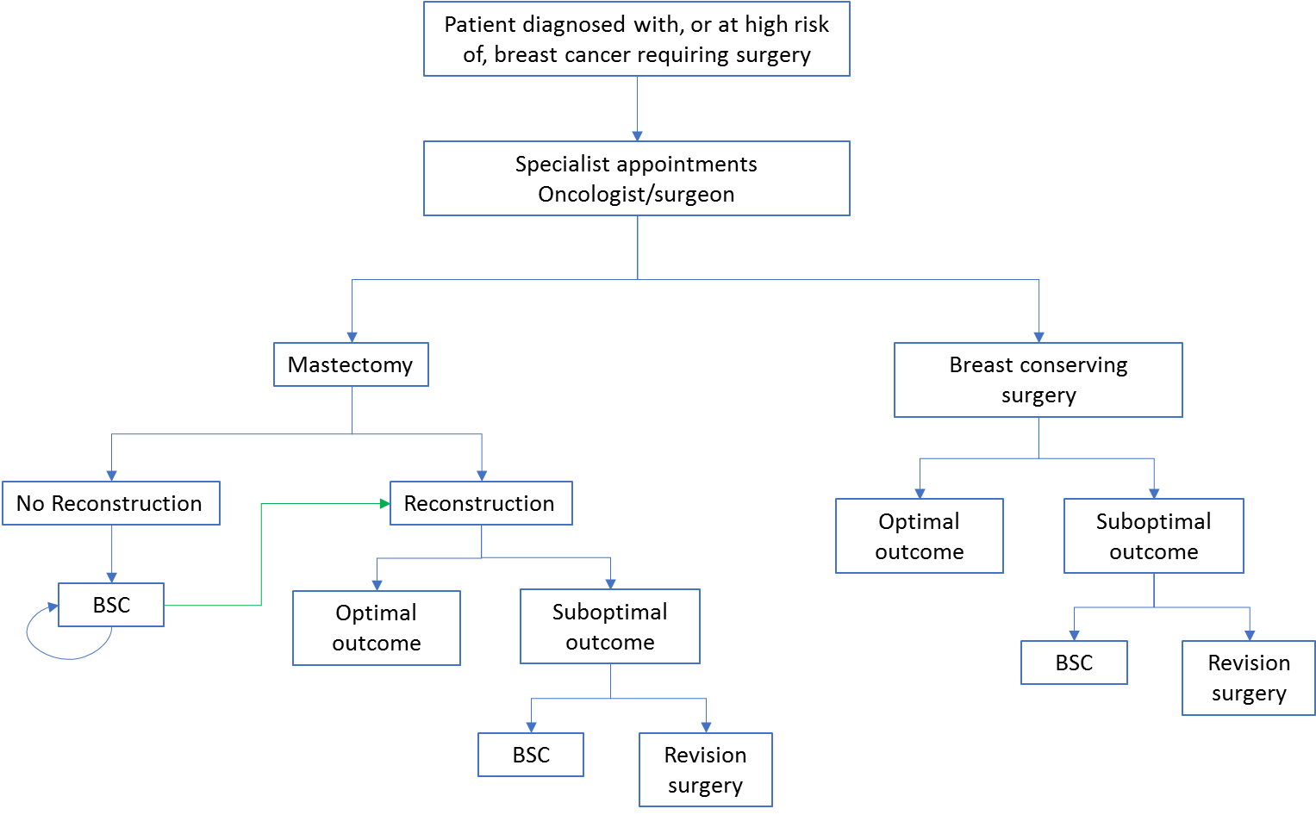
Figure 2 Clinical management pathway of current clinical practice - Population A
Note: the green line represents patients who initially elect to have no reconstruction but who have a change in preference over time.
Patients who do not have reconstruction (because they are medically unfit) are likely to continue with best supportive care. PASC advised this should be tested in the sensitivity analysis.
Figure 3 presents the current clinical algorithm for patients with development breast abnormalities (population B). While simplistic, the figure depicts the limit treatment options available to the patient. That is to choose extensive surgery to correct the abnormality or to do nothing.
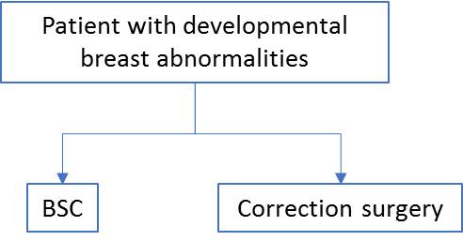
Figure 3 Clinical management pathway of current clinical practice - Population B

Proposed clinical management algorithm for identified population
The proposed clinical management for population A is presented for each subgroup individually.

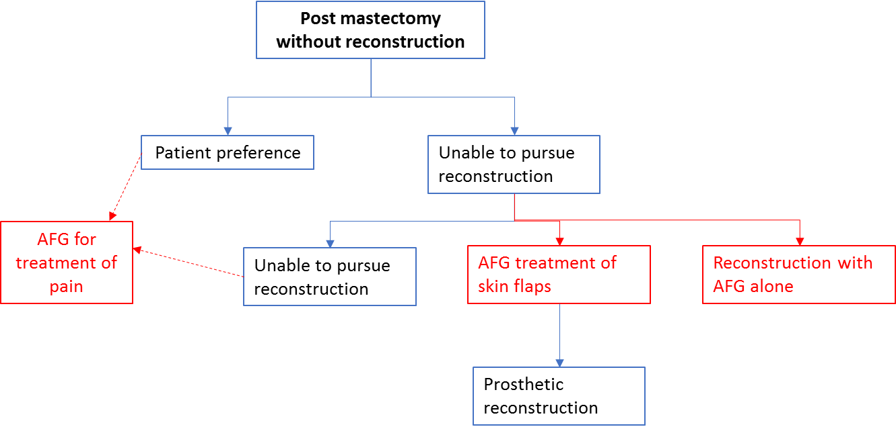
Figure 4 Proposed clinical algorithm in patients post mastectomy without reconstruction

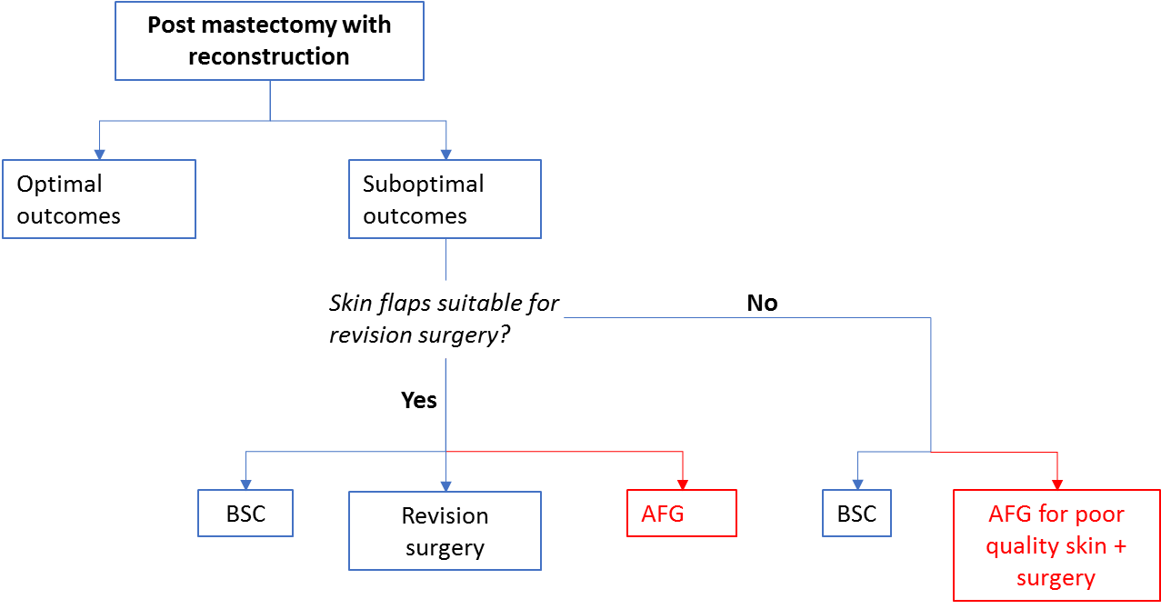
Figure 5 Proposed clinical algorithm in patients post mastectomy with reconstruction
Note: For patients with poor quality skin flaps or where coverage of the prothesis is inadequate, patients may undergo treatment with AFG to improve skin quality followed by further surgery

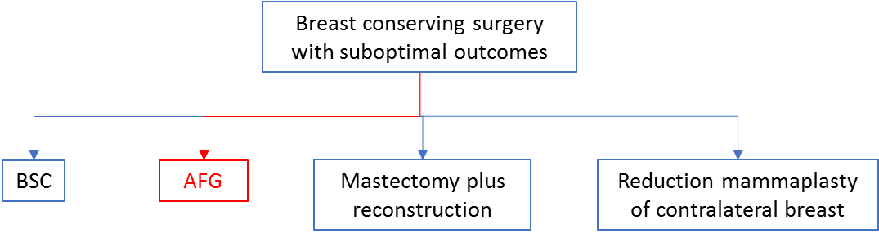
Figure 6 Proposed clinical algorithm in patients post breast conserving treatment resulting in suboptimal outcomes

The proposed clinical management for population B is presented in Figure 7.
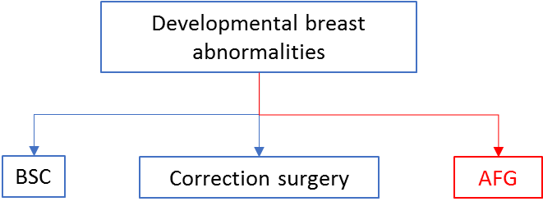
Figure 7 Proposed clinical algorithm in patients with developmental breast abnormalities

Proposed economic evaluation
The appropriate form of economic evaluation is described below with respect to each of the four main patient populations and the implications of AFG in each of these populations to patient relevant health outcomes and the impact on the health care system.
In each of the populations, where the comparator is best supportive care (i.e. no specific intervention and the patient lives with abnormality they otherwise would like treated), the appropriate clinical claim for AFG is likely to be one of superior effectiveness and the appropriate form of economic evaluation will be cost-utility analysis.
PASC confirmed that cost-utility analysis is appropriate and acknowledged the difficulty of determining the exact population size.
Where AFG is to be compared to alternative surgeries or repeat/revisional surgeries it is not yet possible to determine an appropriate clinical claim.
Post mastectomy without reconstruction
Cost utility analysis will be an appropriate form of economic evaluation to capture the benefits of AFG relative to best supportive care (i.e. living with the mastectomy scar) in terms of both improved management of symptoms and the benefits of a prosthetic reconstruction that would not have been able to have been performed in the absence of AFG. Cost utility analysis would also capture the resources required to manage the pain and discomfort of the mastectomy scar that could be expected to be reduced following a successful AFG procedure. Where additional reconstruction comparators are considered (i.e. reconstruction on poor quality skin or, in the case of patients suitable for reconstruction with AFG, any alternative reconstruction), the form of economic evaluation will largely depend upon the comparative safety and effectiveness of AFG and the surgical alternatives.
Post mastectomy with reconstruction
For the comparison with best supportive care, cost utility analysis is the appropriate form of economic evaluation. In best supportive care, patients will be living with suboptimal breast reconstruction outcomes (poor symmetry, contour defects) and the consequent impact this has on psychological outcomes and quality of life.
For the comparison against repeat/revisional surgery, the form of economic evaluation will largely depend upon the comparative safety and effectiveness of AFG and repeat/revisional surgery. Assuming similar outcomes then a comparative cost- or cost-minimisation analysis could be appropriate. Such a cost analysis would need to include the costs of any downstream resources. For instance, it is anticipated AFG could be less costly overall than a repeat surgical procedure, however, it might also be the case that AFG does not successfully resolve the defect(s) and surgery may still be required. It would be reasonable for the cost-analysis to include consideration of these possibilities.
Post breast conserving surgery
In the absence of AFG, current options which could be expected to be substituted by AFG include mastectomy and reconstruction or, reduction mammaplasty (MBS item 45520) of the contralateral breast. Other corrective surgery (e.g. local perforated flaps) may also be an alternative option for these patients. The form of economic evaluation to compare AFG with these options will largely depend upon the comparative safety and effectiveness of AFG. As for the post mastectomy with reconstruction population, assuming similar outcomes then a comparative cost- or cost-minimisation analysis could be appropriate. Such a cost analysis would need to include the costs of any downstream resources.
Developmental breast asymmetry
The form of economic evaluation for this population is analogous to the post mastectomy with reconstruction population. That is, cost utility analysis against best supportive care for the proportion of this population electing (in current practice) to live with the developmental deformity or cost-minimisation analyses depending on the comparative outcomes of AFG with the alternatives.

Proposed item descriptor and MBS fee
The item descriptor proposed by the applicant is presented below (which includes some, but not all, modifications recommended by PASC – see dot points below). The descriptor includes the four patient populations described in this PICO document. However, accurate and objective definition of these patients in an MBS item descriptor is difficult.
The MBS fee for AFG (proposed by the applicant) is based on the MBS fee for liposuction (MBS items 45584 and 45585), applies to each session (i.e. operation), and reflects the surgeon’s professional input, as well as equipment costs. According to the applicant, this is considered a reasonable fee, because they state that AFG requires slightly more time and use of additional equipment for re-injection of fat. A more detailed break-down of costs per session/operation will be needed from the applicant during the assessment phase.
Another aspect of the liposuction item descriptor (which is relevant to AFG) is the requirement for photographic and/or imaging evidence demonstrating the clinical (non-cosmetic) need for this service to be documented in patient notes. Such a requirement will serve as a method to ensure AFG is only used for patients where it is warranted, given difficulties with objectively defining an eligible patient population described above. Similar wording is also used in MBS items 45060, 45061 and 45062 for correction of developmental breast abnormality.
PASC queried whether ‘suboptimal’ outcomes would need to be defined. PASC noted the applicant’s statement in their response to the Draft PICO that ‘several of the suboptimal outcomes are difficult to define objectively and are by definition subjective’.
Due to difficulties in obtaining photographic evidence for some defects, where the defects are hard to capture in a photo, or the defect may have functional signs and symptoms and/or cause pain (e.g. contraction on the chest wall) without being visible, PASC advised it would be reasonable to require photographic evidence for developmental abnormalities to prove asymmetry or deformation, but not for defects after mastectomy or BCS.
In reviewing the applicant’s proposed MBS item descriptor, PASC made the following observations and recommendations:
- the item does not describe the lifetime number of sessions a patient might have, as a patient may have multiple indications over time;
- the item should include clarity about the ‘per operation’ number of sessions (i.e. services), because sessions/services may be separated by three or more months;
- a bilateral service item should be developed, to align with other MBS items;
- the item descriptor for this service, if supported, would need to clearly outline restrictions, to avoid benefits being paid for cosmetic procedures; and
- while the applicant’s proposed descriptor included “patients with contour defects, or who are deemed at risk of contour defects”, PASC did not accept “or who are deemed at risk of contour defects”. PASC determined it would be difficult to objectively define this. The applicant has stated that removal of this “at risk of” group will slightly narrow the treatment population

Following the PASC meeting, the applicant confirmed the most common treatment and billing scenario will be a single session (i.e. service) on a single side (i.e. breast) on a single day. If second or more services are needed, these would be provided 1-3 months after the initial service.
The creation of a separate bilateral service item (for billing on a single occasion of service when both sides [breasts] are treated) would align with the principle of a complete medical service.
PASC queried whether it is possible to perform AFG at the time of mastectomy. The applicant explained that, because AFG relies on strands of fat being injected into a well-vascularised envelope, AFG at the time of cancer excision (or total or partial mastectomy) is not currently performed. Doing AFG at the time of mastectomy would also preclude post-mastectomy radiation. AFG is therefore currently only done as a delayed procedure. However, feedback from applicant suggests that this may change over time as surgeons gain more experience in this technique.
PASC queried whether minimum or maximum timeframes should be defined for use of AFG after mastectomy. The applicant advised there is little evidence to inform this, and patients with a defect should not be excluded based on an arbitrary maximum time.
PASC-modified proposed item descriptor (subject to further resolution and inclusion of issues mentioned above). The final descriptor of this item (and a separate bilateral service item) will need more detail to limit use of the item:
Category 3 – THERAPEUTIC PROCEDURES
Autologous fat grafting (harvesting, preparation and injection of adipocytes) as an independent procedure or in conjunction with another procedure, if:

- the autologous fat grafting is for

- correction of defects arising from treatment and prevention of breast cancer in patients with contour defects, >=20% volume asymmetry, post-treatment pain or poor prosthetic coverage, up to a total of 3 services per side (for total treatment of a single breast), but only one service to be billed on a single occasion of service, OR

- preparation of post-mastectomy thin/irradiated skin flaps in patients intending to have breast reconstruction, up to a total of 3 services per side (for total treatment of a single breast), but only one service to be billed on a single occasion of service, OR

- breast reconstruction in suitable patients, up to 5 services per side (for total treatment of a single breast), but only one service to be billed on a single occasion of service, OR

- correction of developmental disorders of the breast, up to 3 services per side (for total treatment of a single breast), but only one service to be billed on a single occasion of service; and

- photographic and/or imaging evidence demonstrating the clinical need for this service is documented in patient notes

Multiple Operation Rule

(Anaes.)

MBS Fee: $631.75 Benefit: 75% = $473.85

References
Agha R, Fowler A, Herlin C, et al. Use of autologous fat grafting for breast reconstruction: A systematic review with meta-analysis of oncological outcomes. International Journal of Surgical Reconstruction. 2015;68:143-161.
Australian Institute of Health and Welfare 2017. Cancer in Australia 2017. Cancer series no.101. Cat. no. CAN 100. Canberra: AIHW.
American Society of Plastic Surgeons, Executive Committee 2015 Post-Mastectomy Fat Graft/Fat Transfer ASPS Guiding Principles. https://www.plasticsurgery.org/Documents/Health-Policy/Principles/principle-2015-post-mastectomy-fat-grafting.pdf
Avis NE, Crawford S, Manuel J. Quality of life among younger women with breast cancer. J Clin Oncol. 2005;23:3322–3330.
Bennet K, Qi J, Kim H, et al. Association of Fat Grafting With Patient-Reported Outcomes in Postmastectomy Breast Reconstruction. JAMA Surg.2017 Oct 1;152(10):944-950.
Birtchnell S Whitefield P Lacey JH Motivational factors in women requesting augmentation and reduction mammaplasty J Psychosom Rev 1990;34:509
Breast Cancer Network Australia. Breast Reconstruction Survey November 2010. http://www.bcna.org.au/sites/default/files/breast-reconstruction-report.pdf
Brennan, ME, Spillane AJ. Breast symptoms in adolescents and young adults presenting to a specialist breast clinic. AJFO; Vol 48(3), 146-151
Cancer Australia. Clinical Practice Guidelines for the Management of Early Brast Cancer (2nd edn) 2001. [Cited 2 April 2012.] http:// canceraustralia.gov.au/publications-resources/cancer-australia -publications/clinical-practice-guidelines-management-early
Cancer council Australia. Understanding Breast Cancer A guide for people with cancer, their families and friends. 2016. https://www.cancer.org.au/content/about_cancer/ebooks/cancertypes/Understanding_Breast_Cancer_booklet_July_2016.pdf
Caviggioli F, Maione L, Forcellini D, et al. Autologous fat graft in postmasectomy pain syndrome. Plast Reconst Surg. 2011;128(2):349-52
Chan CW, MacMillan RD. Autolgous fat transfer: a review of the literature with a focus on breast cancer surgery. Journal of Plastic, Reconstructive & Aesthetic Surgery, 2008; 61, 1438-1448.
Coleman SR. Facial recontouring with lipostructure. Clin Plast Surg. 1997; 24, 347-67.
Couceiro TC, ValenÃ§a MM, Raposo MC, Orange FA, Amorim MM. Prevalence of post-mastectomy pain syndrome and associated risk factors: a cross-sectional cohort study. Pain Manag Nurs. 2014 Dec;15(4):731-7.
Dahlbäck, C., Ullmark, J. H., Rehn, M., Ringberg, A., & Manjer, J. (2017). Aesthetic result after breast-conserving therapy is associated with quality of life several years after treatment. Swedish women evaluated with BCCT.core and BREAST-Q™. Breast cancer research and treatment, 164(3), 679-687.
Falk Dahl CA, Reinertsen KV, Nesvold IL, et al. A study of body image in long-term breast cancer survivors. Cancer. 2010; 116:3549–3557.
Gieni M, Avram R, Dickson L et al. Local breast cancer recurrence after mastectomy and immediate breast reconstruction for invasive cancer: a meta‐analysis. Breast 2012; 21: 230–236.
Groen J, Krastev T, Hommes J, et al. Autologous fat transfer for facial rejuvenation: A systematic review on technique, efficacy and satisfaction. Plast Reconst Surf Glob Open. 2017;5(12):e1606.
Hennigs A, Hartmann B, Rauch G, Golatta M, Tabatabai P, Domschke C, Schott S, Schutz F, Sohn C, Heil J. Long-term objective esthetic outcome after breast-conserving therapy. Breast Cancer Res Treat. 2015;153(2):345–351.
Illouz YG, 2009. Autolgous fat transplantation to the breast: a personal technique with 25 years of experience. Aesthetic Plastic Surgery, 2009; 33, 706-715.
Jeevan, R., Cromwell, D. & Browne, J., 2011. Fourth annual report of the national mastectomy and breast reconstruction audit. 2011. NHS Information Centre.
Kronowitz S, Mandujano C, Liu j et al. Lipofilling of the Breast Does Not Increase the Risk of Recurrence of Breast Cancer: A Matched Controlled Study. Plast Reconstr Surg. 2016 Feb;137(2):385-93.
Missana M, Larent I, Barreau L, et al. Autologous fat transfer in reocnstructuve breast surgery: indications, technique and results. Eur J Surg Oncol. 2007;33(6):685-90.
National Institute for Health and Care Excellence (NICE) Guidelines. Breast Cancer (Early & Locally Advanced) February 2009. [Cited 2 April 2012.] http://www.nice.org.uk/guidance/CG80 4.
National Comprehensive Cancer Network. NCCN Guidelines Version 3. 2013. Breast Cancer. [Cited 2 April 2012.] http://www.nccn.org/ professionals/physician_gls/pdf/breast.pdf 5.
Neta et al Quality of Life and Self-Esteem After Breast Asymmetry Surgery, Aesthetic Surgery Journal, Volume 27, Issue 6, 1 November 2007, Pages 616–621
Riaz A. Agha, Mimi R. Borrelli, Naeem Dowlut, Mohsin F. Butt, Sam Freeman, Ter-Er Orkar, Dennis P. Orgill. Use of autologous fat grafting in reconstruction following mastectomy and breast conserving surgery: An updated systematic review protocol. International Journal of Surgery Protocols. 2017. Volume 5, p22-26.
Rintala AE Nordström REA Treatment of severe developmental asymmetry of the female breast Scand J Plast Reconstr Surg 1989;23:231
Türk, K. E., & Yılmaz, M. (2018). The Effect on Quality of Life and Body Image of Mastectomy Among Breast Cancer Survivors. European journal of breast health, 14(4), 205-210. doi:10.5152/ejbh.2018.3875
Van Turnhout A, Fuchs S, Lisabeth-Brone K, et al. Surgical Outcome and Cosmetic Results of Autologous Fat Grafting After Breast Conserving Surgery and Radiotherapy for Breast Cancer: A Retrospective Cohort Study of 222 Fat GraftingSessions in 109 Patients. Aesthatic Plast Surg. 2017;41(6):1334-1341.
Waked K, Colle J, Doornaert M, et al. Systematic review: The oncological safety of adipose fat transfer after breast cancer surgery. Breast.2017 Feb;31:128-136.
Wehrens K, Cuyper W, Boeckx W et al. Psychological profile of women seeking breast reconstruction and quality of life assessment after surgery. Eur J Plast Surg. 2005; 28: 264–7.
Wetterau M, Szpalski C, Hazen A, Warren S. Autologous Fat Grafting and Facial Reconstruction. Plast Reconstr Surg. 2016; Jan 137(1):31e-43e.
Wong A, Snook K, Brennan M, Flitcroft K, Tucker M, Hiercz D, Spillane A.Increasing breast reconstruction rates by offering more women a choice. ANZ J Surg. 2014 Jan-Feb;84(1-2):31-6.

