

Application Form

(New and Amended

Requests for Public Funding)

(Version 2.4)

This application form is to be completed for new and amended requests for public funding (including but not limited to the Medicare Benefits Schedule (MBS)). It describes the detailed information that the Australian Government Department of Health requires in order to determine whether a proposed medical service is suitable.

Please use this template, along with the associated Application Form Guidelines to prepare your application. Please complete all questions that are applicable to the proposed service, providing relevant information only. Applications not completed in full will not be accepted.

Should you require any further assistance, departmental staff are available through the Health Technology Assessment Team (HTA Team) on the contact numbers and email below to discuss the application form, or any other component of the Medical Services Advisory Committee process.

Phone: +61 2 6289 7550

Fax: +61 2 6289 5540

Email: [hta@health.gov.au](mailto:hta@health.gov.au" \o "click here to email the Department of Health HTA Team)

Website: [www.msac.gov.au](http://www.msac.gov.au/)

# PART 1 – APPLICANT DETAILS

## Applicant details (primary and alternative contacts)

Corporation / partnership details (where relevant): REDACTED

Corporation name: REDACTED

ABN: REDACTED

Business trading name: REDACTED

**Primary contact name:** REDACTED

**Alternative contact name:** REDACTED

## (a) Are you a consultant acting on behalf of an Applicant?

Yes

No

**(b) If yes, what is the Applicant(s) name that you are acting on behalf of?**

Abiomed Inc.

## (a) Are you a lobbyist acting on behalf of an Applicant?

Yes

No

## If yes, are you listed on the Register of Lobbyists?

Yes

No – NOT APPLICABLE

# PART 2 – INFORMATION ABOUT THE PROPOSED MEDICAL SERVICE

## Application title

Application for funding for the transluminal insertion, management, repositioning, and removal of an intravascular microaxial blood pump (Impella®), for patients requiring mechanical circulatory support.

## Provide a succinct description of the medical condition relevant to the proposed service (no more than 150 words – further information will be requested at Part F of the Application Form)

Impella® is indicated for clinical use in cardiology and cardiac surgery to support patients with compromised ventricular function, i.e. patients experiencing advanced heart failure, heart attack (myocardial infarction), cardiogenic shock and undergoing high risk cardiac procedures.

Coronary heart disease is the most common form of cardiovascular disease and approximately half of deaths from coronary heart disease result from an acute myocardial infarction (1). An acute myocardial infarction may also result in heart failure. Cardiogenic shock is a life-threatening situation that can develop because of a myocardial infarction, and occurs when the heart’s ability to function causes organs in the body to begin to fail.

Heart failure occurs when the heart is unable to maintain strong enough blood flow to meet the body’s needs (2), it is considered advanced when conventional heart therapies and symptom management strategies no longer work and the patient is symptomatic at rest.

## Provide a succinct description of the proposed medical service (no more than 150 words – further information will be requested at Part 6 of the Application Form)

The proposed medical service is for the insertion, removal and or repositioning of an Impella® ventricular assist device. Impella® is a transluminal ventricular assist device that is inserted percutaneously or surgically. The device has a small microaxial pump at one end of a thin, flexible catheter that pumps blood from the ventricle, through an inlet area near the tip and expels blood into the ascending aorta/pulmonary artery. The other end of the tube is connected to an automated control system outside the body that controls the pump rate.

The Impella® technology is part of the latest generation of cardiac assist devices and represents a significant advancement in cardiac assist device technology. The device stabilises haemodynamics, unloads the ventricle, augments peak coronary flow, perfuses the end organs and allows for recovery of the native heart. It is indicated for clinical use in cardiology and cardiac surgery for supporting the native heart in patients with reduced ventricular function. Specifically, the Impella® can help maintain blood flow and blood pressure during high-risk heart procedures (e.g. protected PCI) and when the heart suddenly cannot pump enough blood (e.g. cardiogenic shock).

## ****(a) Is this a request for MBS funding?****

Yes

No

## ****If yes, is the medical service(s) proposed to be covered under an existing MBS item number(s) or is a new MBS item(s) being sought altogether?****

Amendment to existing MBS item(s)

New MBS item(s)

## ****If an amendment to an existing item(s) is being sought, please list the relevant MBS item number(s) that are to be amended to include the proposed medical service:****

NOT APPLICABLE.

## ****If an amendment to an existing item(s) is being sought, what is the nature of the amendment(s)?** NOT APPLICABLE**

1. **An amendment to the way the service is clinically delivered under the existing item(s)**
2. **An amendment to the patient population under the existing item(s)**
3. **An amendment to the schedule fee of the existing item(s)**
4. **An amendment to the time and complexity of an existing item(s)**
5. **Access to an existing item(s) by a different health practitioner group**
6. **Minor amendments to the item descriptor that does not affect how the service is delivered**
7. **An amendment to an existing specific single consultation item**
8. **An amendment to an existing global consultation item(s)**
9. **Other (please describe below):**

## ****If a new item(s) is being requested, what is the nature of the change to the MBS being sought?****

1. **A new item which also seeks to allow access to the MBS for a specific health practitioner group**
2. **A new item that is proposing a way of clinically delivering a service that is new to the MBS (in terms of new technology and / or population)**
3. **A new item for a specific single consultation item**
4. **A new item for a global consultation item(s)**

## ****Is the proposed service seeking public funding other than the MBS?****

Yes

No

## ****If yes, please advise****

The applicant will be seeking DRG/prostheses listing at a later stage as well as an AR-DRG.

## What is the type of service:

Therapeutic medical service

Investigative medical service

Single consultation medical service

Global consultation medical service

Allied health service

Co-dependent technology

Hybrid health technology

## For investigative services, advise the specific purpose of performing the service *(which could be one or more of the following)*: NOT APPLICABLE

1. To be used as a screening tool in asymptomatic populations
2. Assists in establishing a diagnosis in symptomatic patients
3. Provides information about prognosis
4. Identifies a patient as suitable for therapy by predicting a variation in the effect of the therapy
5. Monitors a patient over time to assess treatment response and guide subsequent treatment decisions

## Does your service rely on another medical product to achieve or to enhance its intended effect?

Pharmaceutical / Biological

Prosthesis or device

No

## (a) If the proposed service has a pharmaceutical component to it, is it already covered under an existing Pharmaceutical Benefits Scheme (PBS) listing?

Yes

No - NOT APPLICABLE

## If yes, please list the relevant PBS item code(s):

NOT APPLICABLE

## If no, is an application (submission) in the process of being considered by the Pharmaceutical Benefits Advisory Committee (PBAC)?

Yes (please provide PBAC submission item number below)

No – NOT APPLICABLE

## If you are seeking both MBS and PBS listing, what is the trade name and generic name of the pharmaceutical?

NOT APPLICABLE

## (a) If the proposed service is dependent on the use of a prosthesis, is it already included on the Prostheses List?

Yes

No

## If yes, please provide the following information (where relevant): NOT APPLICABLE

Billing code(s): Insert billing code(s) here

Trade name of prostheses: Insert trade name here

Clinical name of prostheses: Insert clinical name here

Other device components delivered as part of the service: Insert description of device components here

## If no, is an application in the process of being considered by a Clinical Advisory Group or the Prostheses List Advisory Committee (PLAC)?

Yes

No

## Are there any other sponsor(s) and / or manufacturer(s) that have a similar prosthesis or device component in the Australian market place which this application is relevant to?

Yes

No

## If yes, please provide the name(s) of the sponsor(s) and / or manufacturer(s):

NOT APPLICABLE.

## Please identify any single and / or multi-use consumables delivered as part of the service?

Please see Attachment 1, for full details of the consumables delivered as part of the service.

Single use consumables included in the Impella® set:

Impella® Catheter pump  
Sterile Purge cassette

Sterile connector cable   
Introducer kit  
Guidewire  
Infusion set

Multi-use consumables include:  
Automated Impella® controller (AIC)

# PART 3 – INFORMATION ABOUT REGULATORY REQUIREMENTS

## (a) If the proposed medical service involves the use of a medical device, in-vitro diagnostic test, pharmaceutical product, radioactive tracer or any other type of therapeutic good, please provide the following details:

Type of therapeutic good: Medical Device

Manufacturer’s name: Abiomed Inc

Sponsor’s name: Abiomed Inc

## Is the medical device classified by the TGA as either a Class III or Active Implantable Medical Device (AIMD) against the TGA regulatory scheme for devices?

Class III

AIMD

NOT APPLICABLE

## (a) Is the therapeutic good to be used in the service exempt from the regulatory requirements of the *Therapeutic Goods Act 1989*?

Yes (If yes, please provide supporting documentation as an attachment to this application form)

No

## If no, has it been listed or registered or included in the Australian Register of Therapeutic Goods (ARTG) by the Therapeutic Goods Administration (TGA)?

Yes – The Automated Impella ® Controller (AIC) was approved on 09/05/2017, see details below.

No – The Impella® CP and 5.0 are undergoing TGA registration (as per question 16 below). Applications for the Impella® RP and 2.5 are expected to made in the next few weeks (as per question 17 below).

ARTG listing, registration or inclusion number: 288729 (AIC)

TGA approved indication(s), if applicable: NOT APPLICABLE.

TGA approved purpose(s), if applicable: The Automated Impella® Controller (AIC) is intended for exclusive use of Impella® catheters and accessories. The AIC controls the Impella catheter, provides the general user interface and provides purge to the Impella® catheter.

## If the therapeutic good has not been listed, registered or included in the ARTG, is the therapeutic good in the process of being considered for inclusion by the TGA?

Yes (please provide details below)

No

Date of submission to TGA: Impella® 5.0: 26/06/2017; and Impella® CP: 06/07/2017.

Estimated date by which TGA approval can be expected: ~9-12 months from date of submission

TGA Application ID: Impella® 5.0: DV-2017-DA-05278-1; and Impella® CP: DV-2017-DA-05334-1

### Device: Impella® CP

TGA proposed indication(s), if applicable: intended for clinical use in cardiology and in cardiac surgery for up to 5 days for the following indications, as well as others:

* The Impella is a circulatory support system for patients with reduced left ventricular function, eg, post- cardiotomy, low output syndrome, cardiogenic shock after acute myocardial infarction, or for myocardial protection after acute myocardial infarction
* The Impella® may also be used as a cardiovascular support system during coronary bypass surgery on the beating heart, particularly in patients with limited preoperative ejection fraction with a high risk of postoperative low output syndrome
* Support during high risk percutaneous coronary intervention (PCI)
* Post PCI.

TGA proposed purpose(s), if applicable: Impella CP® set is an intracardiac pump set for supporting the left ventricle; it is intended for clinical use in cardiology and in cardiac surgery for up to 5 days for supporting the native heart in patients with reduced left ventricular function.

### Device: Impella® 5.0

TGA proposed indication(s), if applicable: intended for clinical use in cardiology and in cardiac surgery for up to 10 days for the following indications, as well as others:

* The Impella® 5.0 is a cardiovascular support system for patients with reduced left ventricular function, eg, post- cardiotomy, low output syndrome, cardiogenic shock after acute myocardial infarction120
* The Impella® 5.0 may also be used as a cardiovascular support system during coronary bypass surgery on the beating heart, particularly in patients with limited preoperative ejection fraction with a high risk of postoperative low output syndrome

TGA proposed purpose(s), if applicable: Impella® 5.0 set is an intracardiac pump for supporting the left ventricle; it is intended for clinical use in cardiology and in cardiac surgery for up to 10 days.

## If the therapeutic good is not in the process of being considered for listing, registration or inclusion by the TGA, is an application to the TGA being prepared?

Yes (please provide details below)

No

Estimated date of submission to TGA: Impella® RP and 2.5: 30/11/2017

Proposed indication(s), if applicable: The Impella® is an intracardiac pump designed to support the ventricle, its intended use “in cardiology and cardiac surgery for supporting the native heart in patients with reduced ventricular function”.

Proposed purpose(s), if applicable:

### Device: Impella® 2.5

The proposed purpose/ indication for Impella® 2.5 is the same as Impella® CP; refer to question 16 above.

### Device: Impella® RP

**Indications for Use:** The Impella® RP System (percutaneous pump for right ventricular support) is intended for clinical use in cardiology, in cardiac surgery, and intensive care unit for up to 14 days for the following indications, as well as others:

* Acute or transient reduction of the right ventricular function (e.g. postcardiotomy and low output syndrome)
* Cardiogenic shock as a consequence of a posterior myocardial infarction with right ventricular heart failure
* Right heart support during coronary beating heart bypass surgery, especially for patients with a reduced preoperative cardiac output or for patients having a high risk of developing a postoperative low output syndrome for other reasons
* Right ventricular heart failure after implantation of a left ventricular assist device
* Therapy unresponsive arrhythmias with a reduction of right ventricular output
* Heart failure and/or cardiogenic shock as a consequence of refractory ventricular arrhythmias, as well as a consequence of sustained supraventricular arrhythmias, causing haemodynamic compromise.

# PART 4 – SUMMARY OF EVIDENCE

## Provide an overview of all key journal articles or research published in the public domain related to the proposed service that is for your application (limiting these to the English language only). *Please do not attach full text articles, this is just intended to be a summary.*

|  | Type of study design | Title of journal article or research project (including any trial identifier or study lead if relevant) | Short description of research (max 50 words) | Website link to journal article or research (if available) | Date of publication |
| --- | --- | --- | --- | --- | --- |
|  | High-risk PCI | (including protected PCI) |  |  |  |
| 1. | Meta analysis | Meta-Analysis of Usefulness of Percutaneous Left Ventricular Assist Devices for High-Risk Percutaneous Coronary Interventions  Briasoulis *et al* 2016 (3) | Included 12 studies (n = 1,346) with Impella® 2.5 and 8 cohort studies (n = 205) with TandemHeart device.  Primary outcomes: 30 day all-cause mortality, 30 day myocardial infarction rates, periprocedural major bleeding, vascular complications.  Short-term mortality rates were 3.5% and 8% and major bleeding rates were 7.1% and 3.6% with Impella® and TandemHeart, respectively. | https://www.ncbi.nlm.nih.gov/pubmed/27265673 | 2016, August |
| 2. | Randomised controlled trial (RCT) | A prospective, randomized clinical trial of hemodynamic support with Impella® 2.5 versus intra-aortic balloon pump in patients undergoing high-risk percutaneous coronary intervention: the PROTECT II study  O’Neill *et al* 2012 (4)  PROTECT II NCT00562016 | Patients were randomly assigned to IABP (n = 226) or Impella®2.5 (n = 226). Impella®provided superior hemodynamic support in comparison with IABP (maximal decrease in CPO from baseline of -0.04±0.24 W vs -0.14±0.27 W for IABP (P=0.001). The 30-day incidence of major AEs was not statistically different (P=0.277).  The 90-day incidence of major AEs was statistically different in Impella® 2.5-supported patients compared with IABP: 40.0% vs. 51% in PP population, respectively. | https://www.ncbi.nlm.nih.gov/pubmed/22935569 | 2012, October |
| 3. | Retrospective, comparative, single-arm study | Percutaneous left ventricular assist device for high-risk percutaneous coronary interventions: Real-world versus clinical trial experience.  Cohen *et al* 2015 (5)  USPella registry and PROTECT II trial data  NCT00562016 | Compared outcomes from patients in multicentre registry (who would have met trial enrolment criteria for PROTECT II trial; n = 339) with patients in Impella® arm of PROTECT II (n = 216).  Registry patients had higher risk (older, co-morbidities) but clinical outcomes appeared to be favourable and consistent with the RCT. | https://www.ncbi.nlm.nih.gov/pubmed/26542494 | 2015, November |
| 4. | Multicentre, Registry study | Real-world use of the Impella® 2.5 circulatory support system in complex high-risk percutaneous coronary intervention: the USpella Registry  Maini *et al* 2012 (6) | Included N = 175 consecutive patients who underwent high-risk PCI with prophylactic support of the Impella® 2.5.  Primary safety endpoint: incidence of major adverse cardiac events at 30 days.  Use of Impella® 2.5 appeared feasible and safe in the real-world setting. It resulted in favourable short- and midterm angiographic, procedural and clinical outcomes. | https://www.ncbi.nlm.nih.gov/pubmed/22105829 | 2012, November |
| 5. | Retrospective, multicentre, registry study | Supported high-risk percutaneous coronary intervention with the Impella® 2.5 device the Europella registry  Sjauw *et al* 2009 (7) | Included N = 144 consecutive patients Safety and feasibility end points: incidence of 30-day AEs, successful device function. Patients were older (62% >70 years of age), 54% had an LVEF ≤ 30%, and the prevalence of comorbidities was high. The study supported safety, feasibility and usefulness of hemodynamic support with Impella® 2.5. | https://www.ncbi.nlm.nih.gov/pubmed/20082934 | 2009, December |
|  | Cardiogenic shock |  |  |  |  |
| 1. | RCT, multicentre | A randomized clinical trial to evaluate the safety and efficacy of a percutaneous left ventricular assist device versus intra-aortic balloon pumping for treatment of cardiogenic shock caused by myocardial infarction  Seyfarth *et al* 2008 (8) ISAR-SHOCK trial NCT00417378 | Included N = 26 patients presenting with cardiogenic shock from myocardial infarction, randomised to either IABP or Impella® 2.5.  Impella® was associated with superior augmentation of cardiac index and mean arterial pressure with lower serum lactate levels. However, there were no differences in 30-day mortality or complications. | http://www.sciencedirect.com/science/article/pii/S073510970802826X?via%3Dihub | 2008, November |
| 2. | Prospective, single arm trial | The RECOVER I: A multicenter prospective study of Impella 5.0/LD for postcardiotomy circulatory support  Griffith *et al* 2013 (9)  RECOVER I NCT00596726 | Haemodynamics improved immediately after initiation of 16 patients with mechanical support (1.65 vs. 2.7 l/min/m2 (p=0.0001). For the primary efficacy endpoint, recovery of native heart function was achieved in 93% of patients discharged, with bridge to other therapy in 7%. Survival at 30 days, 6 months and 1 year was 94%, 81% and 75%, respectively. | http://www.sciencedirect.com/science/article/pii/S0022522312001663 | 2012, January |
| 3. | Retrospective review | The Impella Device for Acute Mechanical Circulatory Support in Patients in Cardiogenic Shock  Lemaire *et al* 2014 (10) | Of the 47 patients 38 (80%) received Impella® 5.0 and rest received Impella® 2.5. Ventricular function recovered in 34 of 47 patients (72%), and the device was removed, with 4 patients (8%) transitioned to long term VADs. The 30-day mortality was 25%. | http://www.annalsthoracicsurgery.org/article/S0003-4975(13)01664-0/fulltext | 2016, July |
|  | Right heart failure |  |  |  |  |
| 1. | Prospective, multi centre trial | Benefits of a novel percutaneous ventricular assist device for right heart failure: The prospective RECOVER RIGHT study of the Impella® RP device.  Anderson *et al* 2015 (11) RECOVER RIGHT NCT01777607. | Two cohorts: 18 patients with Right ventricular failure after left ventricular assist device implantation (Cohort A) and 12 patients with right ventricular failure after cardiotomy or myocardial infarction (Cohort B). The primary end point was survival to 30 days or hospital discharge. Impella RP was safe, easy to deploy, and reliably resulted in immediate hemodynamic benefit. | https://www.ncbi.nlm.nih.gov/pubmed/26681124 | 2015, December |

AE = adverse event; CPO = cardiac power output; IABP = Intra-aortic balloon pump; LV = left ventricular; LVEF = left ventricular ejection fraction; PCI = percutaneous coronary intervention; PP = per protocol; RCT = randomised controlled trial

## Identify yet to be published research that may have results available in the near future that could be relevant in the consideration of your application by MSAC (limiting these to the English language only). *Please do not attach full text articles, this is just intended to be a summary.*

|  | Type of study design | Title of research (including any trial identifier if relevant) | Short description of research (max 50 words) | Website link to research (if available) | Date |
| --- | --- | --- | --- | --- | --- |
|  | High-risk PCI | (including protected PCI) |  |  |  |
| 1. | RCT, multi-centre, open label | Coronary interventions in high-risk patients using a novel percutaneous leaft ventricular support device (SHIELD II)  NCT02468778 | Currently recruiting patients to evaluate the use of HeartMate PHP with Impella® 2.5 as the active comparator, for both the elective and urgent indications | https://clinicaltrials.gov/ct2/show/NCT02468778?term=NCT02468778&rank=1 | Suspended |
| 2. | Prospective, multi-centre, single-arm study | PROTECTED PCI STUDY: A Prospective Clinical Trial For Patients Undergoing Protected Percutaneous Coronary Intervention With IMPELLA® 2.5 System NCT02831881 | Observational study measuring the composite rate of following intra-procedural and post-procedural major adverse events at 90 days post index procedure. | https://clinicaltrials.gov/ct2/show/NCT02831881?term=NCT02831881&rank=1 | Currently recruiting. Estimated primary completion - November 2020. |
|  | Cardiogenic shock |  |  |  |  |
| 1. | RCT, interventional, parallel assignment, Phase 3 | Danish Cardiogenic Shock Trial (DanShock)  NCT01633502 | Seeks to compare Impella® with conventional circulatory support for cardiogenic shock following ST-elevation myocardial infarct (MI). The trial has been expanded to include German sites and aims to recruit 360 patients by 2021 with all cause mortality at 6 months as the primary outcome measure. | https://clinicaltrials.gov/ct2/show/NCT01633502?term=NCT01633502&rank=1 | Currently recruiting. Expected to complete in 2021 |

# PART 5 – CLINICAL ENDORSEMENT AND CONSUMER INFORMATION

## List all appropriate professional bodies / organisations representing the group(s) of health professionals who provide the service (please attach a statement of clinical relevance from each group nominated):

The relevant professional bodies include:

* Australia and New Zealand and Thoracic Surgeons (ANZCTS) - Cardiac Surgeons
* Cardiac Society of Australia and New Zealand (CSANZ) – Cardiology
* Australia and New Zealand Intensive Care Society (ANZICS) - Intensive Care Unit (ICU).

A statement of clinical relevance from leading physicians from these nominated groups has been requested and will be submitted to the Department upon completion. If required in the interim, contact details for the physicians can be provided.

Currently, Impella® devices are supported in eight international clinical guidelines and expert consensus statements including six cardiac societies providing documented support:

* Society for Cardiac Angiography and Interventions (SCAI)
* American College of Cardiology Foundation (ACCF)
* Heart Failure Society of America (HFSA)
* Society of Thoracic Surgeons (STS)
* International Society for Heart & Lung Transplant (ISHLT)
* Heart Rhythm Society (HRS) (12-17)

## List any professional bodies / organisations that may be impacted by this medical service (i.e. those who provide the comparator service):

Relevant professional bodies include:

* ANZCTS - Cardiac Surgeons
* CSANZ – Cardiology
* ANZICS - ICU

## List the relevant consumer organisations relevant to the proposed medical service (please attach a letter of support for each consumer organisation nominated):

The National Heart Foundation of Australia (NHFA).

The letter of support from NHFA is pending and will be submitted to the Department upon completion.

## List the relevant sponsor(s) and / or manufacturer(s) who produce similar products relevant to the proposed medical service:

None

## Nominate two experts who could be approached about the proposed medical service and the current clinical management of the service(s):

REDACTED

*Please note that the Department may also consult with other referrers, proceduralists and disease specialists to obtain their insight.*

# PART 6 – POPULATION (AND PRIOR TESTS), INDICATION, COMPARATOR, OUTCOME (PICO)

PART 6a – INFORMATION ABOUT THE PROPOSED POPULATION

## Define the medical condition, including providing information on the natural history of the condition and a high level summary of associated burden of disease in terms of both morbidity and mortality:

Impella® is indicated for clinical use in cardiology and cardiac surgery for supporting the native heart in reduced ventricular function, i.e. patients experiencing advanced heart failure, heart attack, cardiogenic shock and undergoing high-risk procedures.

### Population supported in cardiology

Coronary heart disease is the leading cause of death in Australia, representing 13% (n = 19,800) of all deaths (2). The prevalence of coronary heart disease increases markedly with age and is higher in males than females (1); it is the leading cause of burden of disease for men aged 45 and over, and is among the top two causes of burden for women 65 years and over (2).

There are two major clinical forms of coronary heart disease: heart attack (myocardial infarction) and angina. A heart attack occurs when there is a sudden and complete blockage to the heart; it is an acute life threatening event requiring prompt treatment (2). Revascularisation treatments for coronary heart disease include open-heart surgery (i.e. coronary artery bypass graft (CABG)) and PCI, with PCI increasingly being offered (17).

Data on the epidemiology of advanced heart failure, including acute and chronic cases, is limited in Australia. Current estimates are that 30,000 patients are diagnosed with incident heart failure annually and 300,000 people are living with chronic heart failure in Australia (approximately 1.5 to 2.0% of the population). The prognosis of patients with heart failure is poor with five per cent in hospital mortality due to decompensated heart failure following admissions, and approximately 25 and 50 % having died within 1 year and 5 years of diagnosis(18).

Cardiogenic shock occurs when the heart suddenly cannot pump enough blood, generally it is defined as a state of end-organ hypoperfusion caused by left ventricular, right ventricular, or biventricular myocardial injury resulting in systolic and/or diastolic myocardial pump failure (19). Cardiogenic shock occurs secondary to multiple aetiologies including left ventricular systolic dysfunction, right ventricular systolic dysfunction, valvular heart disease, pericardial disease and vasodilatory abnormalities. These conditions, in our patient population, most often present in patients with acute myocardial infarction, out-of-hospital cardiac arrest, and patients with a history of congestive heart failure and/or advanced valvular heart disease. While cardiogenic shock is one of the more fatal complications of acute myocardial infarction, it is relatively rare occurring in about 7% of all acute myocardial infarctions (20-22). Even with prompt reperfusion therapy with primary PCI, mortality rates still range from 30% to 50% (23). The SHOCK (SHould we emergently revascularize Occluded Coronaries for cardiogenic shocK) trial (22) outlined clinical and hemodynamic criteria to define cardiogenic shock (see Table 1 below).

Table 1: Hemodynamic Criteria for Cardiogenic Shock (Table 1 from Atkinson et al 2016 (17))

|  |
| --- |
| TABLE 1 Hemodynamic Criteria for Cardiogenic Shock |
| Clinical |
| SBP <90 mm Hg for 30 min  Supportive measures needed to maintain SBP >90 mm Hg End-organ hypoperfusion  Cool extremities  UOP <30 ml/h  HR >60 beats/min |
| Hemodynamic |
| Cardiac index <2.2 ml/min/m2 PCWP >15 mm Hg |
| The SHOCK trial de*ﬁ*ned cardiogenic shock according the clinical and hemodynamic criteria listed (11).  HR ¼ heart rate; PCWP ¼ pulmonary capillary wedge pressure; SBP ¼ systolic blood pressure; UOP ¼ urine output. |

While it was noted that the definition for cardiogenic shock varied within the literature, generally it is characterized by: a self-propagating cascade of falling cardiac output, falling left ventricular end diastolic pressure, and reduced end-organ and coronary perfusion. Adverse outcomes, such as high mortality and morbidity, continue to drive demand for improved therapeutic options for patients with cardiogenic shock. Patients in profound cardiogenic shock might not respond to other usual treatment options such as increasing doses of inotropes or intra-aortic balloon pump (IABPs) (24). Early identification and rapid intervention is critical to optimize treatment efficacy in this patient population, with the aim to reverse the cascade of cardiogenic shock.

### Population supported in cardiac surgery

PCI, also known as coronary angioplasty, is a nonsurgical technique for treating obstructive coronary artery disease, including unstable angina, and myocardial infarction. PCI is the most common revascularization modality and is applied to patients with increased lesion complexity and comorbidities with 51% of all PCI performed in patients >65 years of age (25). In addition, the advent of transcatheter techniques for the treatment of patients with valvular heart disease has resulted in older patients with severe coronary disease and left ventricular systolic dysfunction undergoing high-risk PCI (HR-PCI). Patients with poor left ventricular function undergoing HR-PCI can develop myocardial ischaemia (inadequate blood supply). This can cause hypotension, and decreased cardiac output and can result in poor blood circulation in the heart (coronary hypoperfusion), heart failure, and haemodynamic collapse (26).

Multiple variables define HR-PCI including clinical presentation, coronary anatomy, hemodynamic status, electrical instability and end organ function (4). PCI in patients with factors such as impaired left ventricular systolic function defined as ejection fraction <35%, unprotected left main disease, severe 3-vessel disease (SYNTAX score >33), or last patent vessel are associated with in-hospital mortality rates between 5% and 15% (22) (Table 2).

Table 2: High-Risk PCI (Table 3 from Atkinson et al 2016 (17))

|  |
| --- |
| TABLE 2 High-Risk PCI |
| Clinical  LVEF <35%  Electrical instability  Congestive heart failure |
| Comorbidities  Severe aortic stenosis Severe mitral regurgitation  Chronic obstructive pulmonary disease Chronic kidney disease  Diabetes Cerebrovascular disease  Peripheral vascular disease Age >75 yrs  Acute coronary syndrome |
| Coronary anatomy Last patent vessel UPLMN  3 vessel disease, SYNTAX score >33  Target vessel providing collaterals to a territory, which supplies  >40% of the myocardium Distal left main bifurcation |
| High-risk percutaneous coronary intervention (PCI) is de*ﬁ*ned in multiple clinical trials according to several key clinical features, comorbidities, and anatomical features that have shown to cause increased morbidity and mortality during PCI Adapted with permission from Myat et al. (43).  LVEF ¼ left ventricular ejection fraction; UPLMN ¼ unprotected left main coronary artery. |

## Specify any characteristics of patients with the medical condition, or suspected of, who are proposed to be eligible for the proposed medical service, including any details of how a patient would be investigated, managed and referred within the Australian health care system in the lead up to being considered eligible for the service:

Mechanical circulatory support devices (i.e. Impella®) are used primarily in three populations: high-risk PCI, cardiogenic shock, and cardiac arrest (22). Patients in cardiogenic shock represent an extremely ‘high-risk’ group in which mortality has remained high despite revascularisation and pharmacologic therapies. Early placement of an appropriate mechanical circulatory support device may be considered in those who fail to stabilize or show signs of improvement quickly after initial interventions (17).

The left sided Impella® intravascular microaxial blood pumps (2.5, CP, 5.0) and the right-sided Impella RP® are indicated for clinical use in cardiology and cardiac surgery. In addition, all Impella® devices are indicated for use in intensive care. Impella® 2.5 and Impella® CP are indicated for up to five days; and Impella® 5.0 is indicated for use up to 10 days; and Impella® RP is indicated for use up to 14 days (Table 3).

Table 3 Proposed indications for Impella®

| **Proposed indications** | **Impella device** |
| --- | --- |
| **Reduced left ventricular function** (e.g., postcardiotomy, low output syndrome, cardiogenic shock after acute myocardial infarction) | Impella® 2.5  Impella® CP  Impella® 5.0 |
| **Acute or transient reduction of the right ventricular function** (eg, postcardiotomy low output syndrome) | Impella® RP |
| As a cardiovascular support system **during coronary bypass** surgery on the beating heart, particularly in patients with limited preoperative ejection fraction with a high risk of postoperative low output syndrome. | Impella® 2.5  Impella® CP Impella® 5.0 |
| As bridge to decision or bridge to next therapy (i.e. LVAD or transplant) | Impella® 5.0 |
| To provide support **during high-risk percutaneous coronary intervention** (PCI) | Impella® 2.5  Impella® CP |
| **Post PCI** | Impella® 2.5  Impella® CP |
| In **cardiogenic shock** as a consequence of a posterior myocardial infarction with right ventricular heart failure | Impella® RP |
| As right heart support **during coronary beating heart bypass surgery**, especially for patients with a reduced preoperative cardiac output or for patients having a high risk of developing a postoperative low output syndrome for other reasons | Impella® RP |
| In **right ventricular heart failure** after implantation of a left ventricular assist device | Impella® RP |
| In **therapy unresponsive arrhythmias** with a reduction of right ventricular output | Impella® RP |

The 2015 SCAI/ACC/HFSA/STS guidelines (17) state, that although there is no single definition for ‘high –risk’ PCI, there are key variables that contribute to elevated risk during PCI:

* patient specific (i.e. increased age, impaired left ventricular ejection fraction (LVEF) etc)
* lesion specific (i.e. unprotected left main stenosis, chronic total occlusions etc); and
* clinical presentation (i.e. acute coronary syndrome or cardiogenic shock).

The need for mechanical circulatory support depends upon the haemodynamic condition of patient at time of PCI, the anticipated risk of haemodynamic compromise during procedure, and the need for haemodynamic support after revascularisation. Impella® support is utilised as an adjunct to PCI, to protect against haemodynamic instability, which can result from repeat episodes of reversible myocardial ischaemia that occur during procedure-related temporary coronary occlusions. “Protected PCI” is a strategy that may reduce peri and post-procedural adverse events.

The CSANZ in general endorses the SCAI/ACC/HFSA/STS guidelines for PCI (27).

Management of patients with acute heart failure typically includes oxygen, diuretics, vasodilators, morphine, positive inotropes, continuous positive airway pressure, assisted ventilation, IABPs and in extreme cases ventricular assist device (VAD) therapy (28)

## Define and summarise the current clinical management pathway *before* patients would be eligible for the proposed medical service (supplement this summary with an easy to follow flowchart [as an attachment to the Application Form] depicting the current clinical management pathway up to this point):

Patients under cardiogenic shock, high-risk PCI, and cardiac arrest represent a wide spectrum of disease that requires tailored therapy to improve individual hemodynamic derangements. First, prompt recognition of patients with cardiogenic shock and identification of patients with high-risk features for PCI is essential (22). A typical diagnostic workup that’s could assess for myocardial ischaemia could include blood examination (i.e. troponin levels) chest X-ray, electrocardiogram (ECG; i.e. ST segment elevation myocardial infarction (STEMI), or non STEMI), echocardiography, computed tomography angiography, and angiography. Once diagnosed with angiography, a multidisciplinary ‘heart team’ approach is typically used (22, 29).

Patients with end-stage and acute heart failure who do not respond to optimal medical management are those who become suitable for mechanical circulatory support.

### ‘Heart team’ approach

The treatment of patients with cardiogenic shock and/or patients undergoing ‘high-risk PCI’ and/or with heart attack is complex and time critical, and is typically based upon algorithm developed by a multidisciplinary ‘heart team’. The multidisciplinary heart team would typically be comprised of interventional cardiologists and cardiothoracic surgeons.

In the setting of cardiogenic shock, the multidisciplinary heart team should expand to include advanced heart failure and intensive care physicians who will play an essential role in the post-procedure management. The potential benefits of the heart team have not been evaluated or clearly defined in a clinical trial, but may include improved patient outcomes and system based outcomes. Due to the emergent nature of cardiogenic shock and requirement for quick intervention, a heart team approach is not always feasible (22) (Figure 1).

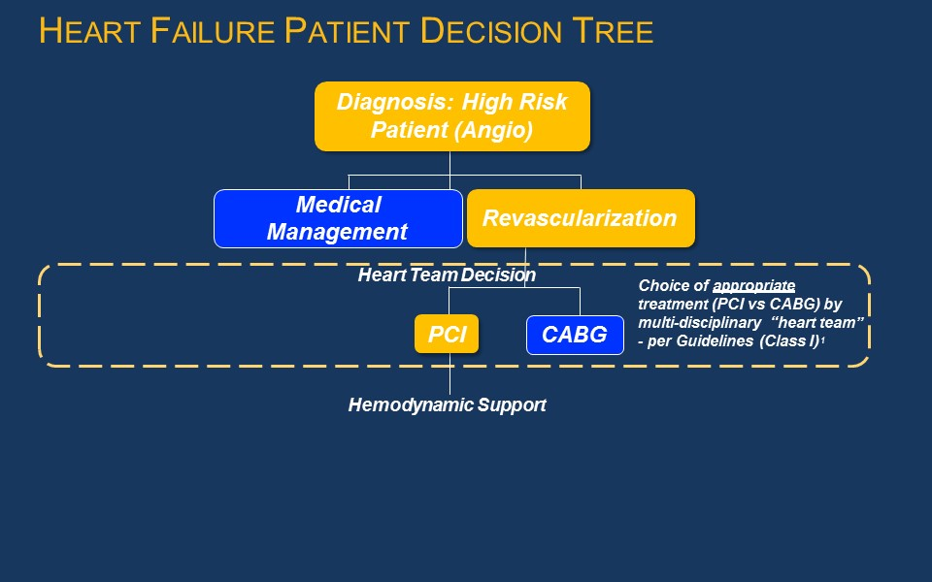

Figure 1 Deciding eligibility for mechanical circulatory support- ‘Heart team’

CABG = coronary artery bypass graft; PCI = percutaneous coronary intervention; angio = angiogram

1. Levine GN, et al. J Am Coll Cardiol, 2011 Dec 6;58(24):e44-122

### Best Practices in Cardiogenic Shock

Early diagnosis, stabilization, revascularization, and assessment of myocardial recovery in patients with cardiogenic shock is vital. Protocol development is increasing at institutions in the United States, and some hospitals have developed a coordinated strategy including “shock teams”. These structures are being developed to mimic best practices in trauma, STEMI, and acute pulmonary embolism care. If the hospital cannot provide early revascularization for the cardiogenic shock patient, rapid transfer to a facility that can provide early revascularization is recommended. A multistep strategy to identification and treatment of cardiogenic shock is provided (Figure 2).

Descritpion of best practices associated with patients in cardiogenic shock

Figure 2 Best practices in cardiogenic shock

PART 6b – INFORMATION ABOUT THE INTERVENTION

## Describe the key components and clinical steps involved in delivering the proposed medical service:

### Key components of the medical device

The Impella® Ventricular Support System consists of a family of percutaneous heart pumps. To accommodate a range of cardiac output requirements, different sized Impella® Support Catheters are available. The Impella® family consists of four models relevant to this application, including three left-ventricular devices (Impella® 2.5, CP, and 5.0), and one right-sided ventricular device (Impella® RP):

* 1. Impella® 2.5: a 12-Fr (French) catheter-based device with maximal flow rates of 2.5 L/min, placed through a femoral percutaneous approach – via a standard catheterization procedure through the femoral artery, into the ascending aorta, across the valve and into the left ventricle.
  2. Impella® CP (cardiac power): a 14-Fr catheter-based device maximal flow rates of 3.5 L/min, placed through a femoral percutaneous approach – via a standard catheterization procedure through the femoral artery, into the ascending aorta, across the valve and into the left ventricle.
  3. Impella® 5.0: a 21-Fr catheter-based device with maximal flow rates of 5.0 L/min; placed via femoral cut down or through the axillary artery and goes through the ascending aorta, across the valve and into the left ventricle.
  4. Impella® RP: a 22 Fr catheter-based device with maximal flow rate up to 4.0L/min; placed through a femoral percutaneous approach - through a standard catheterization procedure via the femoral vein, into the right atrium, across the tricuspid and pulmonic valves, and into the pulmonary artery.

All of the Impella® Catheters consist of a micro-axial rotary blood pump mounted on a drive catheter, which is connected to an external controller, the Automatic Impella® Controller. The Impella® 2.5 is shown as an example in Figure 3.

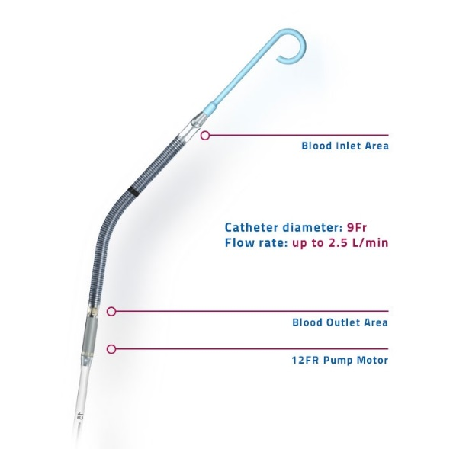

Figure 3 Example of Impella® Ventricular support catheter (Impella® 2.5)

The Automatic Impella® Controller generates signals required to power the drive motor of the Impella® Catheters and provides a user interface. The Automatic Impella Controller also incorporates the disposable Impella® Purge Cassette system, which provides a fluid pressure barrier to prevent blood from entering the Impella® Catheters’ drive motor. A dextrose (5-40% with 50 Units/ml of heparin added) solution is used as a purge fluid. The Automatic Impella® Controller is portable and has been qualified for use for patient transport by trained healthcare professionals within healthcare facilities and during medical transport between hospitals (i.e., ambulance, helicopter or fixed-wing aircraft) in the US. The Automatic Impella® Controller and Impella® purge cassette are shown in Figure 4. The AIC is used by operators to monitor the correct positioning and functioning of the Impella®.

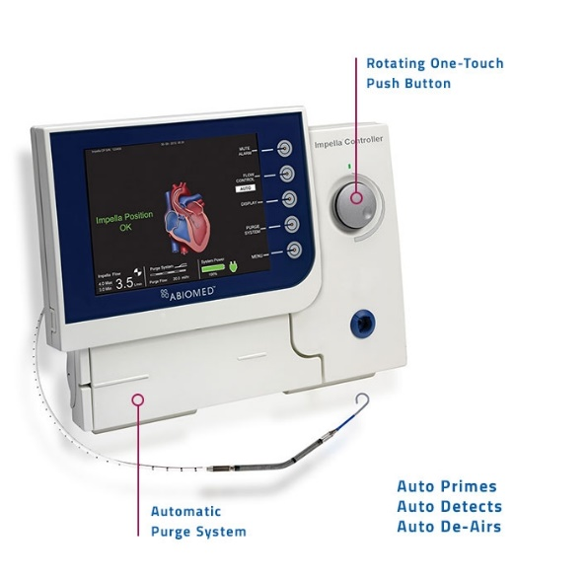

Figure 4 AIC controller and Impella® purge system

Source: http://www.abiomed.com/Impella/automated-Impella-controller

Impella® favourably alters the balance of myocardial oxygen demand and supply, improving myocardial ischaemic reserve. During normal physiological systole, blood is propelled by contraction of the left ventricle through the aortic valve to the systemic circulation via the ascending aorta, blood also enters the left and right coronary arteries via the coronary ostia to perfuse the heart. Impella® generates haemodynamic support by providing active forward flow that increases net cardiac output. By supplementing active forward flow and systemic aortic pressure there is an effective increase in mean arterial pressure and overall cardiac output. As a result, the Impella® devices can assist in maintaining end organ perfusion, and facilitate myocardial recovery from insult.

Figure 5 summarises the mechanism of action of Impella®.

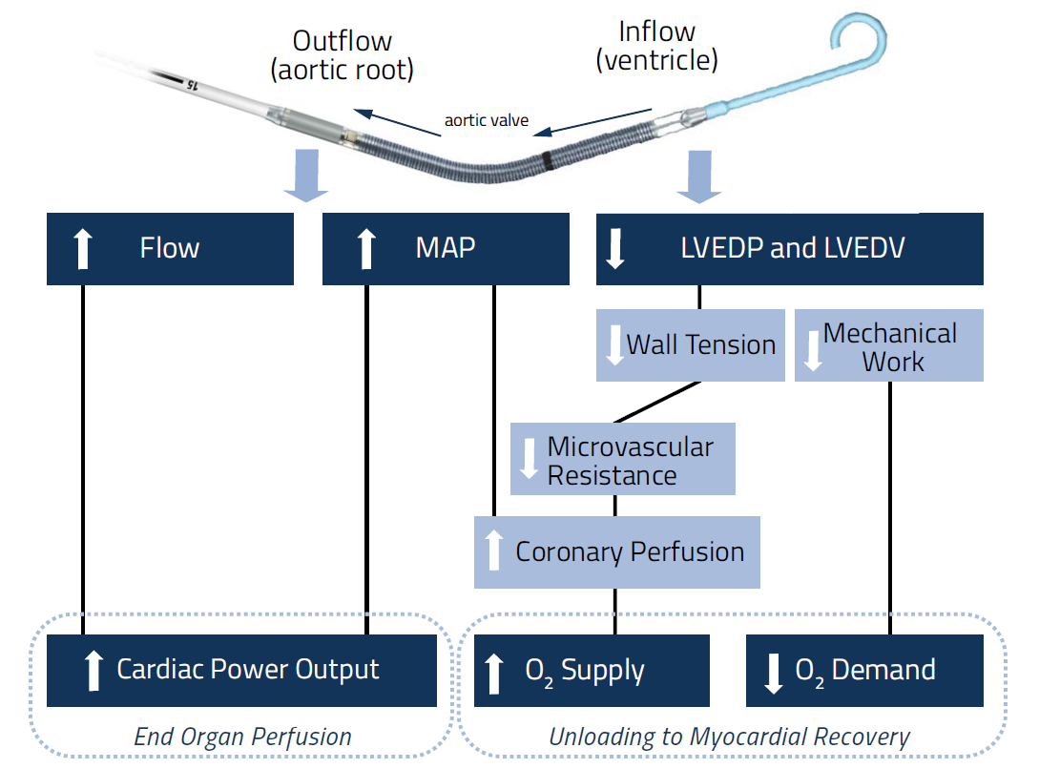

Figure 5 Mechanism of action of Impella®

### Clinical steps involved in delivering the proposed medical service

The left sided Impella® devices are inserted retrogradely via a standard catheterisation procedure or cut down through the femoral artery (Impella® 2.5, CP, 5.0) or the axillary artery (Impella® 5.0) into the ascending aorta, across the aortic valve and into the left ventricle. The right sided Impella® RP is inserted retrogradely via a standard catheterisation procedure through the femoral vein into the right atrium, across the tricuspid and pulmonic valves and into the pulmonary artery.

## Does the proposed medical service include a registered trademark component with characteristics that distinguishes it from other similar health components?

Impella® is a registered trade mark.

## If the proposed medical service has a prosthesis or device component to it, does it involve a new approach towards managing a particular sub-group of the population with the specific medical condition?

Yes, Impella® therapy would represent a new approach for supporting the native heart in reduced ventricular function.

## If applicable, are there any limitations on the provision of the proposed medical service delivered to the patient (i.e. accessibility, dosage, quantity, duration or frequency):

The CSANZ recognises that rural patients have lower access to diagnostic angiography and interventional procedures (30). As the Impella® is minimally invasive and can be performed in many PCI centres, it is expected that accessibility and equality of care for rural patients could be improved. For example, a patient in in critical cardiogenic shock could be stabilised with the Impella® before being moved to nearby tertiary centres improving health outcomes.

## If applicable, identify any healthcare resources or other medical services that would need to be delivered at the same time as the proposed medical service:

The co-administered medical services associated with the Impella® would be expected to be similar to standard percutaneous procedures performed in catheterisation laboratories, i.e. left heart catheterisation (MBS # 38203). For example, co-administered services could include: anaesthesia associated with cardiac catheterisation (MBS # 21941), fluoroscopy or echocardiography (MBS # 55113) to guide placement/repositioning of Impella® (MBS # 60504), and surgical assist item (MBS # 51303). It was noted that some jurisdictions require the attendance of an anaesthetist for conscious sedation.

Hospitals must provide their own diagnostic catheter (diagnostic angiogram) and a 5 to 8 Fr introducer (31).

## If applicable, advise which health professionals will primarily deliver the proposed service:

The health professionals that will primarily deliver the proposed service are cardiovascular surgeons and interventional cardiologists.

Interventional cardiologists and cardiovascular surgeons would be responsible for the implant and removal, while general intensivists and advanced heart failure cardiologists would be responsible for ongoing care (31).

## If applicable, advise whether the proposed medical service could be delegated or referred to another professional for delivery:

Not applicable

## If applicable, specify any proposed limitations on who might deliver the proposed medical service, or who might provide a referral for it:

Refer to #36 below.

## If applicable, advise what type of training or qualifications would be required to perform the proposed service as well as any accreditation requirements to support service delivery:

Operators of Impella® would require specific training to use and manage the Impella® devices. Abiomed Inc., the maker of the Impella®, offers a thorough training program for both physicians and hospital staff that are going to use the Impella® system. Training covers the full spectrum of therapy, from an overview of the technology, controller, and system set-up and insertion, through patient management topics. In addition, local clinical support will be available.

It is likely that any facility that meets the CSANZ guidelines for coronary angiography and PCI would be capable of inserting an Impella® device. The CSANZ guidelines on support facilities for coronary angiography and PCI (2016) (32) states that coronary interventional procedures (such as PCI) are preferably performed in hospitals with on-site surgical support (similar to CSANZ). However, the Society believes that centres without on-site surgical backup can provide coronary interventional procedures in accordance with the following standards for elective PCI:

* All operators and centres should meet the minimum requirements set in the Society’s “Guidelines for competency in PCI”
* Hospitals should accredit cardiologists individually to perform PCIs
* Should be a minimum of two appropriately trained interventional cardiologists in centres providing elective PCI
* Facilities providing only elective PCI should have on-call team available to deal with post procedural complications
* There should be access to coronary care facilities for routine post procedure management and intensive care unit to facilitate management of mechanically ventilated patients. All units should have the ability to provide support IABP insertion
* Individual hospitals would have a written policy covering these issues
* The Society believes that under certain circumstances, coronary interventions can be performed as a day case procedure.

For primary (urgent) PCI, the Society believes that a policy of primary PCI should only be performed after an elective PCI program has been established and shown to perform with acceptable morbidity and mortality.

### CSANZ

The CSANZ states that training in PCI is separate and not part of core advanced Fellow of the Royal Australasian College of Physicians (FRACP) training. A trainee in coronary angioplasty should have completed FRACP recognised training in cardiology or its equivalent, and only undertake interventional training following completion of training in coronary angiography. Training in coronary interventional procedures should be carried out as full time fellowship of at least 12 months, with at least 400 PCIs, and including 200 PCIs performed as primary operator (30).

For support staff (i.e. nursing and technical staff), there are no nationally recognised training standards in coronary angiography or angioplasty. The CSANZ recognises that such training will be individualised in each institution (27).

### ANZCTS

The ANZCTS has adopted the 2014 ESC/FACTS guidelines (29) on myocardial revascularisation:

* Physicians training in interventional cardiology should complete formal training according to a 1–2 year curriculum at institutions with at least 800 PCIs per year and an established 24-hour/7-day service for the treatment of patients with acute coronary syndrome.
* Physicians training in interventional cardiology should have performed at least 200 PCI procedures as first or only operator with one-third of PCI procedures in emergency or acute coronary syndrome patients under supervision before becoming independent.
* PCI for acute coronary syndrome should be performed by trained operators with an annual volume of at least 75 procedures at institutions performing at least 400 PCI per year with an established 24-hour/7-day service for the treatment of patients with acute coronary syndrome.
* PCI for stable coronary artery disease should be performed by trained operators with an annual volume of at least 75 procedures at institutions performing at least 200 PCI per year
* Institutions with an annual volume of fewer than 400 PCI should consider collaboration in networks with high-volume institutions (more than 400 PCI per year), with shared written protocols and exchange of operators and support staff.
* Non-emergency high-risk PCI procedures, such as distal LM disease, complex bifurcation stenosis, single remaining patent coronary artery, and complex chronic total occlusions, should be performed by adequately experienced operators at centres that have access to mechanical circulatory support and intensive care treatment, and preferentially have cardiovascular surgery on-site.

## (a) Indicate the proposed setting(s) in which the proposed medical service will be delivered (select all relevant settings):

Inpatient private hospital

Inpatient public hospital

Outpatient clinic

Emergency Department

Consulting rooms

Day surgery centre

Residential aged care facility

Patient’s home

Laboratory

Other – please specify below

The proposed service will primarily be performed in hospital cardiac catheterisation laboratories.

1. **Where the proposed medical service is provided in more than one setting, please describe the rationale related to each:**

Impella® may also be delivered in operating theatres with imaging capabilities, it may be required in this setting if a patient is discovered to require additional cardiac support.

Impella® may also be delivered in intensive care with medical imaging capabilities, it is unlikely that insertion of an Impella® device would occur in intensive care; however, monitoring and repositioning of the Impella ® device could be required in this setting.

## Is the proposed medical service intended to be entirely rendered in Australia?

Yes

No – please specify below

PART 6c – INFORMATION ABOUT THE COMPARATOR(S)

## Nominate the appropriate comparator(s) for the proposed medical service, i.e. how is the proposed population currently managed in the absence of the proposed medical service being available in the Australian health care system (including identifying health care resources that are needed to be delivered at the same time as the comparator service):

The current therapies (standard of care) used to provide circulatory support include medical management with intravenous inotropes and vasopressors, and/or IABP. Extra-corporeal membrane oxygenation (ECMO) and percutaneous ventricular assist devices (pVADs) may also be used if greater haemodynamic support is required.

### Circulatory support: pharmacological

Inotropic therapy aims to improve pump function by acutely increasing contractility. Inotropic drugs acutely improve stroke volume, cardiac output, filling pressures and systemic and pulmonary vascular resistance, leading to some symptomatic improvement (28) . Commonly prescribed inotropes include dobutamine (Dobutrex) or milrinone (Primacor). Vasopressor drugs are also used to provide positive inotropic effects. Commonly prescribed vasopressor drugs include norepinephrine (Levophed), phenylephrine (Neo-Synephrine), or high-dose dopamine.

The use of intravenous inotropic drugs to treat cardiogenic shock remains a common practice. However, evidence suggests that in-hospital mortality increases with increasing number of inotropes. In one study of 3,462 patients who received open heart surgery, the hospital mortality for patients successfully separating from CPB on no inotropes, low-dose, moderate-dose, one high-dose, two high-dose, and three high-dose inotropes were approximately 2.0%, 3.0%, 7.5%, 21%, 42%, and 80% respectively (33).

### Circulatory support: mechanical

Three main devices are commonly utilized to provide circulatory and left ventricular support: the IABP, ECMO and pVADs (Table 4).

Table 4 Description of IABP, ECMO and pVAD

| **Item** | **IABP**  Picture of IABP in situ | **ECMO**  Picture of ECMO | **pVAD i.e. Tandem Heart**  Picture of TandemHeart (pVAD) |
| --- | --- | --- | --- |
| Cardiac flow | 0.3-0.5L/min | 3-7L/min | 2.5-5L/min |
| Mechanism | Aorta | Right atrium-aorta | Left ventricle-aorta |
| Maximum implant days | Weeks | Weeks | 2 weeks |
| Femoral artery size | >4mm | 8mm | 8mm |
| Cardiac synchrony/stable rhythm | 7-8 Fr | 15-17 Fr: arterial  21 Fr: venous | 14-16 Fr: arterial  18-21 Fr: venous |
| Cardiac flow, power, MAP | ↑ | ↑↑ | ↑↑ |
| Myocardial oxygen demand | ↓ | ↓↔ | ↔ |

Source: ACC publication on practical approach to MCS (Modified from Atkinson *et al* 2016 (22))

ACC = American College of Cardiology; IABP = intra-aortic balloon pump; ECMO = extra-corporeal membrane oxygenation; MAP = mean arterial pressure; pVAD = percutaneous ventricular assist device; VA = veno-arterial; Fr = French

#### IABP

The IABP has been used to provide counterpulsation therapy, either with or without inotropes. The IABP is the most commonly used MCS device, although it provides minimal haemodynamic support. The main contraindications include aortic valve regurgitation of greater than mild degree, and severe peripheral arterial or aortic disease. Vascular complications can occur including stroke, limb ischaemia or vascular trauma. Anticoagulation can be given with IABP therapy; however, its use is variable and usually site specific (17).

Currently in Australia, IABP support is indicated in patients with acute left ventricular systolic failure and cardiogenic shock whose management remains partially complex and characterised by high mortality rates. Clinical practice guidelines have been interpreted to support IABP placement in patients with acute myocardial infarction with cardiogenic shock (34). However, the benefits of IABP remain uncertain with the NHFA/SCANZ guidelines for acute coronary syndromes stating that routine IABP use in cardiogenic shock complicating STEMI treated by primary PCI has not been shown to reduce 30-day or 6-month mortality and should be avoided(27).

#### ECMO

ECMO provides temporary cardiopulmonary support for patients whose heart and lungs can no longer provide adequate physiologic support. ECMO can be either veno-veno (V-V) for oxygenation only or veno-arterial (V-A) for oxygenation and circulatory support. In cases of biventricular failure, V-A ECMO is the MCS of choice for patients in cardiogenic shock and impaired oxygenation, as it provides full cardiopulmonary support. The main contraindications include contraindication to anticoagulation and severe peripheral arterial disease. Complications include bleeding and thromboembolic events, as well as haemolysis. Anticoagulation is essential to prevent thrombsosis of the membrane oxygenator (17).

VA-ECMO may be used to provide circulatory support in acute or refractory cardiogenic shock or cardiac arrest. ECMO support may be continued until either the patient recovers or receives a long-term ventricular assist device as a bridge to orthotopic heart transplant. Whilst VA-ECMO has been demonstrated to confer a survival benefit in both short and long term outcomes in applications such as cardiopulmonary resuscitation, survival rate in patients receiving VA-ECMO for cardiac arrest, severe cardiogenic shock or failure to wean from cardiopulmonary bypass is approximately 20-30% (35).

#### pVAD

Currently, only one left atrial—aorta assist device is commercially available, TandemHeart. This VAD is a percutaneously inserted circulatory assist device that pumps blood extra-corporeally from the left atrium to the iliofemoral arterial system via a transseptally placed left atrial cannula, thereby bypassing the left ventricle. The main contraindications include severe peripheral arterial disease and contraindication to anticoagulation. Complications include vascular trauma and limb ischaemia. Anticoagulation with continuous infusion of heparinised saline is important to prevent thromboembolism or in situ thrombosis (17).

This type of left pVAD, which is non-implantable, is typically used in the high-risk setting. The Heartmate PHP is another type of pVAD that has undergone trials in cardiogenic shock (18).

## Does the medical service that has been nominated as the comparator have an existing MBS item number(s)?

Yes (please provide all relevant MBS item numbers below)

No

The current MBS items for the nominated comparators are summarised in the Table below.

Table 5 Description of MBS items associated with nominated comparators

| **MBS #s** | **IABP** | **ECMO** | **VAD** |
| --- | --- | --- | --- |
| Insertion | 38362 (percutaneous)  38609 (arteriotomy) | ─ | 38615 (right or left),  38618 (right and left) |
| Removal | 38612 (suture)  38613 (patch) | ─ | 38621 (right or left),  38624 (right and left) |
| Adjustment | ─ | 38627 (cannulae) | 38627 (VAD cannulae) |

IABP = intra-aortic balloon pump; ECMO = extra-corporeal membrane oxygenation; MBS = Medicare Benefits Schedule; VAD = ventricular assist device

## Define and summarise the current clinical management pathways that patients may follow *after* they receive the medical service that has been nominated as the comparator (supplement this summary with an easy to follow flowchart [as an attachment to the Application Form] depicting the current clinical management pathway that patients may follow from the point of receiving the comparator onwards including health care resources):

Currently, there are no standardised pathways for the treatment of patients requiring mechanical circulatory support. The nominated comparator was standard of care, which included a basket of comparators (i.e. pharmacological therapy and/or IABP, ECMO, pVAD). Following their use, the ‘heart team’ would assess for myocardial and haemodynamic recovery, and the requirement for further revascularisation (Figure 8).

Following device removal, the physician would close arterial access.

Post procedural care is a critical aspect to mechanical circulatory support and could include hospital services performed in intensive care and coronary care units. Another important consideration is anticoagulation management and haemolysis (22).

Weaning protocols are at the discretion of the physician and should be created at each institution. In the setting of high-risk PCI, device weaning and removal would be expected to occur in the cardiac catheterisation laboratories. In the intensive care unit (ICU) setting, weaning is best accomplished over several hours, and should begin immediately in patients that demonstrate hemodynamic improvement with mechanical circulatory support and have good end organ perfusion and function. After the device has been removed, the patient is vulnerable and may require reinsertion of a device, which can be difficult if all access sheaths are removed (22).

## (a) Will the proposed medical service be used in addition to, or instead of, the nominated comparator(s)?

Yes

No

## If yes, please outline the extent of which the current service/comparator is expected to be substituted:

The proposed medical service (i.e. Impella® therapy) will be used in addition to current percutaneous coronary interventions, as an adjunct to help maintain haemodynamic stability in patients at high-risk, and in addition to treatment for cardiogenic shock, as a short term solution. However, the Impella® devices could also replace these nominated comparators (see Figure 8).

## Define and summarise how current clinical management pathways (from the point of service delivery onwards) are expected to change as a consequence of introducing the proposed medical service including variation in health care resources (Refer to Question 39 as baseline):

The current clinical management pathway is presented in question 39. Figure 6 below outlines expected changes as a consequence of introducing Impella® (circled in red) as suggested in the STATEMENT FROM THE INTERVENTIONAL COUNCIL OF THE ACC, 2016.

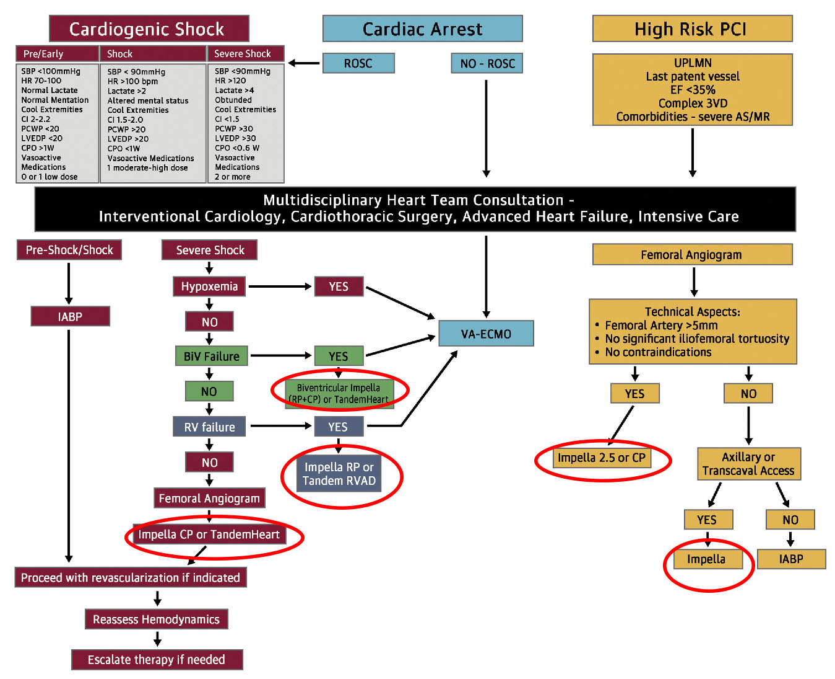

Figure Algorithm for Percutaneous MCS Device Selection

Source: Atkinson, T.M. *et al*. J Am Coll Cardiol Intv. 2016;9(9):871–83 (22)

3VD = 3 vessel coronary artery disease; AS = aortic stenosis; BiV = biventricular; CI = cardiac index; CPO = cardiac power; EF = ejection fraction; HR = heart rate; HR-PCI = high-risk percutaneous coronary intervention; IABP = intra-aortic balloon pump; LVEDP = left ventricular end-diastolic pressure; MCS = mechanical circulatory support; MR = mitral regurgitation; PCI = percutaneous coronary intervention; PCWP = pulmonary capillary wedge pressure; ROSC = return of spontaneous circulation; RVAD = right ventricular assist device; SBP = systolic blood pressure; UPLMN = unprotected left main artery; VA-ECMO = venoarterial extracorporeal membrane oxygenation.

Red circles mark areas where Impella® would be implemented in the clinical management algorithm

PART 6d – INFORMATION ABOUT THE CLINICAL OUTCOME

## Summarise the clinical claims for the proposed medical service against the appropriate comparator(s), in terms of consequences for health outcomes (comparative benefits and harms):

The overall clinical claim is that the proposed technology (Impella®) is superior in terms of comparative effectiveness versus standard of care in patients requiring mechanical circulatory support. This was based on:

* reduced rate of major adverse cardiac and cerebral events (MACCE) (36)
* lower rates of acute kidney injury (AKI) and reduce need for dialysis (37)
* improvement in LVEF (38)
* reduced Heart Failure Symptoms and New York Heart Association (NYHA) Class (36)
* reduced readmissions (6, 10)
* reduced Length of Stay in hospital (39)
* improved survival and native heart recovery (8, 10)

## Please advise if the overall clinical claim is for:

Superiority

Non-inferiority

## Below, list the key health outcomes (major and minor – prioritising major key health outcomes first) that will need to be specifically measured in assessing the clinical claim of the proposed medical service versus the comparator:

**Safety Outcomes:**

Major adverse events:

Myocardial infarction,

Stroke/ TIA

Repeat revascularisation

Vascular complications

Major bleeding

**Clinical Effectiveness Outcomes:**

30 day mortality

Length of hospital stay

Improved haemodynamic results: i.e maximum cardiac power output (CPO) increase from baseline

Change in NYHA functional status

Rate of in hospital events

Quality of life

# PART 7 – INFORMATION ABOUT ESTIMATED UTILISATION

## Estimate the prevalence and/or incidence of the proposed population:

Based on current information to date, the best estimate of the population to be tested is based on Australian Institute of Health and Welfare (AIHW) procedure data for insertion of IABP and VADs (left and right), which Impella® therapy could replace. In addition, ECMO utilisation was taken from AR-DRG data from the most recent National Hospital Cost Data Collection report (40). Table 6 and Table 7 below summarises the estimated eligible population for Impella therapy for patients with cardiogenic shock and undergoing high-risk PCI in Australia, respectively.

Table 6 Estimated eligible population in 2018 (from AIHW data); Cardiogenic shock

| Projected number of procedures for IABP (2017/18) a | 1,507 |
| --- | --- |
| Proportion that is cardiogenic shock | 20% b |
| **Patients treated with IABP in cardiogenic shock** | **299** |
| Projected number of procedures for VAD a,c | 95 |
| Proportion with VAD in cardiogenic shock d | 15% |
| **Patient treated with VAD in cardiogenic shock** | **15** |
| Projected number of procedures for ECMO (2017/18) e | 284 |
| Proportion with ECMO in cardiogenic shock | 28% f |
| **Patient treated with ECMO in cardiogenic shock** | **80** |
| **Patients in cardiogenic shock and eligible for Impella® therapy** | **394** |

AIHW = Australian Institute of Health and Welfare; ECMO = extracorporeal membrane oxygenation; ECPR = extracorporeal cardiopulmonary resuscitation; ECLS = extracorporeal life support; IABP = intra-aortic balloon pump; INTERMACS = Interagency Registry for Mechanically Assisted Circulatory Support; PCI = percutaneous coronary intervention; VAD = ventricular assist device

a Applied 7.63% growth rate based on AIHW procedure cube utilisation for IABP and VAD: 2011/12-2014/15 (41)

b Based on IABP utilisation from large US registry (n=19,636) (42)

c Utilisation for left and right VAD support. It was noted that VAD were used for right sided heart support in 19.72% of cases in 2013/14, and 32.10% in 2014/15.

d Based on 15% classified with critical cardiogenic shock (INTERMACS 1)(18)

e Based on utilisation (separations) from NHCDC, Round 19, 2014-15 report (40)

f Based onpatients requiring ECPR support (ECLS Registry) (43)

Table Estimated eligible population in 2018 (from AIHW data); High-risk PCI

| Projected number of procedures for IABP (2017/18) a | As above (1,507) |
| --- | --- |
| Proportion that is ‘high-risk’ PCI | 20% b |
| **Patients that are high-risk treated with IABP** | **299** |
| Projected number of PCIs (based on coronary angioplasty with stent) c | 52,079 |
| Proportion that is ‘high-risk’ | 0.2%-5% d |
| **Patients receiving high-risk PCI and eligible for Impella® therapy** | **104-2,604** |
| **Total eligible patients for high-risk PCI** | **403-2,903** |

AIHW = Australian Institute of Health and Welfare; IABP = intra-aortic balloon pump; PCI = percutaneous coronary intervention; VAD = ventricular assist device

a Applied 7.63% growth rate based on AIHW procedure cube utilisation for IABP and VAD: 2011/12-2014/15 (41)

b Based on IABP utilisation from large US registry (n=19,636) (42)

c Applied 8.87% growth rate based on AIHW procedure cube utilisation for PCI (transluminal coronary angioplasty): 2011/12-2014/15 (41)

d Based on estimate from NICE report (31)

The estimated patient population based on MBS data for is presented in Attachment 2. The AIHW data was considered more robust to estimate the eligible population, due to known under-reporting of MBS utilisation data.

## Estimate the number of times the proposed medical service(s) would be delivered to a patient per year:

It is proposed that Impella® therapy would be delivered once to a patient requiring mechanical circulatory support.

## How many years would the proposed medical service(s) be required for the patient?

Currently, Impella® provides mechanical circulatory support up to 5 days (Impella® 2.5 and Impella CP®); 10 days (Impella CP®); and 14 days (Impella® RP) (Impella® 2.5 and Impella® CP) for the aforementioned indications.

## Estimate the projected number of patients who will utilise the proposed medical service(s) for the first full year:

The total eligible population for Impella® for the above indications is expected to be 797 to 3,297.

Based on global experience with Impella®, the estimated uptake rate in Year 1 is expected to be 5%, resulting in total estimated Impella® use of ~40 to 165 patients

## Estimate the anticipated uptake of the proposed medical service over the next three years factoring in any constraints in the health system in meeting the needs of the proposed population (such as supply and demand factors) as well as provide commentary on risk of ‘leakage’ to populations not targeted by the service:

Impella® therapy is not expected to experience significant constraints in supply and demand over the first three years of listing. There are no anticipated constraints in the supply of Impella® devices for mechanical circulatory support. Given that the indicated population is small and specific, the applicant does not forsee any major risk of leakage to populations not indicated for the proposed service.

# PART 8 – COST INFORMATION

## Indicate the likely cost of providing the proposed medical service. Where possible, please provide overall cost and breakdown:

The proposed fee for the insertion, and for the removal of Impella® devices is yet to be clarified, but may be expected to be similar to other related MBS items. In addition, the mode of ventricular support provided (left and/or right), and the method of insertion for Impella® will guide the proposed fees. Consultation with physicians who perform these procedures indicated the proposed fee would be similar to these MBS items:

* MBS # 38362 - Percutaneous insertion only ~$384.95
* Between cut down IABP (MBS # 38609) and left VAD (MBS # 38615) - Surgical cut down insertion (arteriotomy):~ $1,480. Of note, this method requires accessing axillary artery, sewing on graft, inserting device, closing over device- estimated time 1 hour)
* MBS # 38612 - Surgical removal: ~$740. Of note, this method is slightly more complicated than, insertion, IABP removal and vessel closure.
* MBS # 13847 – IABP management in ICU (i.e. repositioning) ~$156.10

REDACTED

## Specify how long the proposed medical service typically takes to perform:

All Impella® devices may be inserted using a minimally invasive standard catheterization procedure through the femoral artery or vein and the procedure overall is expected to take no more than 5-10 minutes in a catheterisation lab. In some circumstances, Impella® devices may need to be inserted surgically by arteriotomy would be expected to take longer (in some cases up to 60 mins).

For patients requiring ongoing support with Impella®, these patients may be managed in ICU. In addition, these patients could require repositioning of Impella®, which would be performed under ultrasound guidance (e.g. echocardiography).

## If public funding is sought through the MBS, please draft a proposed MBS item descriptor to define the population and medical service usage characteristics that would define eligibility for MBS funding.

The six proposed draft MBS item descriptors are provided below.

Category 3 – Therapeutic Procedures

Proposed item descriptor:

Percutaneous insertion of a left or right intravascular microaxial blood pump

Fee: $(insert proposed fee here)

Category 3 – Therapeutic Procedures

Proposed item descriptor:

Surgical insertion of a left or right intravascular microaxial blood pump by arteriotomy

Fee: $(insert proposed fee here)

Category 3 – Therapeutic Procedures,

Proposed item descriptor:

Management on the first day including initial and subsequent consultations and monitoring of parameters of the controller for a left or right intravascular microaxial blood pump

Fee: $(insert proposed fee here)

Category 3 – Therapeutic Procedures,

Proposed item descriptor:

Adjustment and repositioning, in patients supported by of a left or right intravascular microaxial blood pump

Fee: $(insert proposed fee here)

Category 3 – Therapeutic Procedures,

Proposed item descriptor:

Percutaneous removal of a left or right intravascular microaxial blood pump

Fee: $(insert proposed fee here)

Category 3 – Therapeutic Procedures,

Proposed item descriptor:

Surgical removal of a left or right intravascular microaxial blood pump

Fee: $(insert proposed fee here)

# PART 9 – FEEDBACK

The Department is interested in your feedback.

## How long did it take to complete the Application Form?

1-2 weeks.

## (a) Was the Application Form clear and easy to complete?

Yes

No

## If no, provide areas of concern:

## (a) Are the associated Guidelines to the Application Form useful?

Yes

No

## If no, what areas did you find not to be useful?

## (a) Is there any information that the Department should consider in the future relating to the questions within the Application Form that is not contained in the Application Form?

Yes

No

## If yes, please advise:

Provision of supportive documents for question 20 and question 22.

**References**

1. Australian Institute of Health and Welfare (AIHW). Cardiovascular disease: Australian facts 2011. Cardiovascular disease series. Cat. no. CVD 53. Canberra: AIHW; 2011.

2. Australian Institute of Health and Welfare (AIHW). Australia's health 2016. Australia's health series no. 15. Cat. no. AUS 199. Canberra: AIHW; 2016.

3. Briasoulis A, Telila T, Palla M, Mercado N, Kondur A, Grines C, et al. Meta-Analysis of Usefulness of Percutaneous Left Ventricular Assist Devices for High-Risk Percutaneous Coronary Interventions. The American Journal of Cardiology. 2016;118(3):369-75.

4. O'Neill WW, Kleiman NS, Moses J, Henriques JP, Dixon S, Massaro J, et al. A prospective, randomized clinical trial of hemodynamic support with Impella 2.5 versus intra-aortic balloon pump in patients undergoing high-risk percutaneous coronary intervention: the PROTECT II study. Circulation. 2012;126(14):1717-27.

5. Cohen M, Matthews R, Maini B, Dixon S, Vetrovec G, Wohns D, et al. Percutaneous left ventricular assist device for high-risk percutaneous coronary interventions: Real-world versus clinical trial experience. American heart journal [Internet]. 2015; 170(5):[872-9 pp.]. Available from: http://onlinelibrary.wiley.com/o/cochrane/clcentral/articles/074/CN-01169074/frame.html.

6. Maini B, Naidu SS, Mulukutla S, Kleiman N, Schreiber T, Wohns D, et al. Real‐world use of the Impella 2.5 circulatory support system in complex high‐risk percutaneous coronary intervention: The USpella Registry. Catheterization and Cardiovascular Interventions. 2012;80(5):717-25.

7. Sjauw KD, Konorza T, Erbel R, Danna PL, Viecca M, Minden H-H, et al. Supported High-Risk Percutaneous Coronary Intervention With the Impella 2.5 Device: The Europella Registry. Journal of the American College of Cardiology. 2009;54(25):2430-4.

8. Seyfarth M, Sibbing D, Bauer I, Frohlich G, Bott-Flugel L, Byrne R, et al. A randomized clinical trial to evaluate the safety and efficacy of a percutaneous left ventricular assist device versus intra-aortic balloon pumping for treatment of cardiogenic shock caused by myocardial infarction. Journal of the American College of Cardiology. 2008;52(19):1584-8.

9. Griffith BP, Anderson MB, Samuels LE, Pae WE, Naka Y, Frazier OH. The RECOVER I: a multicenter prospective study of Impella 5.0/LD for postcardiotomy circulatory support. The Journal of thoracic and cardiovascular surgery. 2013;145(2):548-54.

10. Lemaire A, Anderson MB, Lee LY, Scholz P, Prendergast T, Goodman A, et al. The Impella device for acute mechanical circulatory support in patients in cardiogenic shock. The Annals of thoracic surgery. 2014;97(1):133-8.

11. Anderson MB, Goldstein J, Milano C, Morris LD, Kormos RL, Bhama J, et al. Benefits of a novel percutaneous ventricular assist device for right heart failure: The prospective RECOVER RIGHT study of the Impella RP device. The Journal of heart and lung transplantation : the official publication of the International Society for Heart Transplantation. 2015;34(12):1549-60.

12. Levine GN, Bates ER, Blankenship JC, Bailey SR, Bittl JA, Cercek B, et al. 2011 ACCF/AHA/SCAI Guideline for percutaneous coronary intervention. Circulation. 2011:CIR. 0b013e31823ba622.

13. Feldman D, Pamboukian SV, Teuteberg JJ, Birks E, Lietz K, Moore SA, et al. The 2013 International Society for Heart and Lung Transplantation Guidelines for mechanical circulatory support: executive summary. The Journal of Heart and Lung Transplantation. 2013;32(2):157-87.

14. Yancy CW, Jessup M, Bozkurt B, Butler J, Casey DE, Drazner MH, et al. 2013 ACCF/AHA guideline for the management of heart failure: executive summary: a report of the American College of Cardiology Foundation/American Heart Association Task Force on practice guidelines. Journal of the American College of Cardiology. 2013;62(16):1495-539.

15. O'Gara PT, Kushner FG, Ascheim DD, Casey DE, Chung MK, De Lemos JA, et al. 2013 ACCF/AHA guideline for the management of ST-elevation myocardial infarction. Circulation. 2012:CIR. 0b013e3182742cf6.

16. Peura JL, Colvin-Adams M, Francis GS, Grady KL, Hoffman TM, Jessup M, et al. Recommendations for the use of mechanical circulatory support: device strategies and patient selection. Circulation. 2012;126(22):2648-67.

17. Rihal CS, Naidu SS, Givertz MM, Szeto WY, Burke JA, Kapur NK, et al. 2015 SCAI/ACC/HFSA/STS clinical expert consensus statement on the use of percutaneous mechanical circulatory support devices in cardiovascular care (Endorsed by the American Heart Association, the Cardiological Society of India, and Sociedad Latino Americana de Cardiologia Intervencion; Affirmation of Value by the Canadian Association of Interventional Cardiology - Association Canadienne de Cardiologie d'intervention). Journal of Cardiac Failure. 2015;21(6):499-518.

18. Health Policy Advisory Committee on Technology. New and Emerging Health Technology Report. High-cost Assistive Technologies in Critical Care. Queensland; 2016.

19. Kar B, Basra SS, Shah NR, Loyalka P. Percutaneous circulatory support in cardiogenic shock: interventional bridge to recovery. Circulation. 2012;125(14):1809-17.

20. Goldberg RJ, Gore JM, Alpert JS, Osganian V, De Groot J, Bade J, et al. Cardiogenic shock after acute myocardial infarction: incidence and mortality from a community-wide perspective, 1975 to 1988. New England Journal of Medicine. 1991;325(16):1117-22.

21. Hochman JS, Sleeper L, Webb J, Sanborn T, White H, Talley JD, et al. Early revascularization in acute myocardial infarction complicated by cardiogenic shock. New England Journal of Medicine. 1999;341(9):625.

22. Atkinson TM, Ohman EM, O’Neill WW, Rab T, Cigarroa JE, of the American ISC, et al. A practical approach to mechanical circulatory support in patients undergoing percutaneous coronary intervention: an interventional perspective. JACC: Cardiovascular Interventions. 2016;9(9):871-83.

23. Thiele H, Zeymer U, Neumann F-J, Ferenc M, Olbrich H-G, Hausleiter J, et al. Intra-aortic balloon counterpulsation in acute myocardial infarction complicated by cardiogenic shock (IABP-SHOCK II): final 12 month results of a randomised, open-label trial. The Lancet. 2013;382(9905):1638-45.

24. Kar B, Gregoric ID, Basra SS, Idelchik GM, Loyalka P. The percutaneous ventricular assist device in severe refractory cardiogenic shock. Journal of the American College of Cardiology. 2011;57(6):688-96.

25. MEMBERS WG, Go AS, Mozaffarian D, Roger VL, Benjamin EJ, Berry JD, et al. Heart disease and stroke statistics—2014 update: a report from the American Heart Association. circulation. 2014;129(3):e28.

26. Dixon S, Henriques JP, Mauri L, Sjauw KD, Civitello A, Kar B, et al. A prospective feasibility trial investigating the use of Impella 2.5 system in patients undergoing high-risk percutaneous coronary intervention (The PROTECT I Trial). JACC: Cardiovascular Interventions. 2009;2(2):91-6.

27. Chew DP, Scott IA, Cullen L, French JK, Briffa TG, Tideman PA, et al. National Heart Foundation of Australia and Cardiac Society of Australia and New Zealand: Australian clinical guidelines for the management of acute coronary syndromes 2016. Med J Aust. 2016;205(3):128-33.

28. National Heart Foundation of Australia and Cardiac Society of Australia and New Zealand. Guidelines for the prevention, detection, and managment of chronic heart failure in Australia. Australia; 2011.

29. Windecker S, Kolh P, Alfonso F, Collet J-P, Cremer J, Falk V, et al. 2014 ESC/EACTS Guidelines on myocardial revascularizationThe Task Force on Myocardial Revascularization of the European Society of Cardiology (ESC) and the European Association for Cardio-Thoracic Surgery (EACTS)Developed with the special contribution of the European Association of Percutaneous Cardiovascular Interventions (EAPCI). European Heart Journal. 2014;35(37):2541-619.

30. The Cardiac Society of Australia and New Zealand. Guidelines for competency in percutaneous coronary intervention (PCI). 2010.

31. National Institute of Clinical Excellence (NICE). Impella 2.5 for haemodynamic support during high-risk percutaneous coronary interventions. 2016.

32. The Cardiac Society of Australia and New Zealand (CSANZ). Guidelines on Support Facilities for Coronary Angiography and Percutaneous Coronary Intervention (PCI) includingGuidelines on the Performance of Procedures in Rural Sites. 2016.

33. Samuels LE, Kaufman MS, Thomas MP, Holmes EC, Brockman SK, Wechsler AS. Pharmacological criteria for ventricular assist device insertion following postcardiotomy shock: experience with the Abiomed BVS system. Echocardiography. 1985;2(4):288-93.

34. Health Policy Advisory Committee on Tecnology. Technology brief. Appropriate use of intra-aortic balloon pumps (IABP). Queensland; 2016.

35. Combes A, Leprince P, Luyt C-E, Bonnet N, Trouillet J-L, Léger P, et al. Outcomes and long-term quality-of-life of patients supported by extracorporeal membrane oxygenation for refractory cardiogenic shock. Critical care medicine. 2008;36(5):1404-11.

36. O'Neill W, Kleiman N, Moses J, Henriques J, Dixon S, Massaro J, et al. A prospective, randomized clinical trial of hemodynamic support with Impella 2.5 versus intra-aortic balloon pump in patients undergoing high-risk percutaneous coronary intervention: the PROTECT II study. Circulation [Internet]. 2012; 126(14):[1717-27 pp.]. Available from: http://onlinelibrary.wiley.com/o/cochrane/clcentral/articles/950/CN-00967950/frame.html.

37. Flaherty MP, Pant S, Patel SV, Kilgore T, Dassanayaka S, Loughran JH, et al. Hemodynamic Support With a Microaxial Percutaneous Left Ventricular Assist Device (Impella) Protects Against Acute Kidney Injury in Patients Undergoing High-Risk Percutaneous Coronary InterventionNovelty and Significance. Circulation research. 2017;120(4):692-700.

38. Casassus F, Corre J, Leroux L, Chevalereau P, Fresselinat A, Seguy B, et al. The use of Impella 2.5 in severe refractory cardiogenic shock complicating an acute myocardial infarction. Journal of interventional cardiology. 2015;28(1):41-50.

39. Maini B, Scotti DJ, Gregory D. Health economics of percutaneous hemodynamic support in the treatment of high-risk cardiac patients: a systematic appraisal of the literature. Expert review of pharmacoeconomics & outcomes research. 2014;14(3):403-16.

40. Independent Hospital Pricing Authority (IHPA). National Hospital Cost Data Collection, Public Hospitals Cost Report, AR-DRG version 8, Round 19 (2014-15) 2017 [Available from: https://www.ihpa.gov.au/publications/national-hospital-cost-data-collection-public-hospitals-cost-report-round-19-financial.

41. (AIHW) AIoHaW. Procedure data cubes 2017 [Available from: https://www.aihw.gov.au/reports/hospitals/procedures-data-cubes/contents/data-cubes.

42. Cohen M, Urban P, Christenson JT, Joseph DL, Freedman Jr RJ, Miller MF, et al. Intra-aortic balloon counterpulsation in US and non-US centres: results of the Benchmark® Registry. European Heart Journal. 2003;24(19):1763-70.

43. Extracorporeal Life Support Organisation. ECLS Registry Report. International Summary. United States; 2017.

44. Medicare Australia Statistics. Medicare item reports: Australian Government. Department of Human Services; 2017 [Available from: http://medicarestatistics.humanservices.gov.au/statistics/mbs_item.jsp.

### Attachment 1:

REDACTED

### Attachment 2: Estimated eligible population for Impella® therapy: MBS utilisation

Table 9 Estimated eligible population in 2018 (from MBS data (44)); Cardiogenic shock

| Projected number of services for IABP (2017/18) | 311 |
| --- | --- |
| Proportion that is cardiogenic shock | 20% |
| **Patients treated with IABP in cardiogenic shock** | **62** |
| Projected number of services for VADs | 34 |
| Proportion that is cardiogenic shock | 15% |
| **Patients treated with VAD in cardiogenic shock** | **5** |
| Projected number of procedures for ECMO (2017/18) | 69 |
| Proportion with ECMO in cardiogenic shock | 28% |
| **Patient treated with ECMO in cardiogenic shock** | **19** |
| **Patients in cardiogenic shock and eligible for Impella® therapy** | **87 \*** |

ECMO = extracorporeal membrane oxygenation; IABP = intra-aortic balloon pump; MBS = Medicare Benefits Schedule; VAD = ventricular assist device

*rounding

Table 10 Estimated eligible population in 2018 (from MBS data(44)); High-risk PCI

| Projected number of procedures for IABP (2017/18) | 311 |
| --- | --- |
| Proportion that is ‘high-risk’ PCI | 20% |
| **Patients supported with IABP under high-risk** | **62** |
| Projected number of PCIs (based on coronary angioplasty w/wo stent) | 30,794 |
| Proportion that is ‘high-risk’ | 0.2%-5% |
| **Patients receiving protected PCI and eligible for Impella® therapy** | **62-1,540** |

IABP = intra-aortic balloon pump; MBS = Medicare Benefits Schedule; PCI = percutaneous coronary intervention

*rounding