

Public Summary Document

Application No. 1533 – Genome-wide microarray testing for pregnancies with major fetal structural abnormalities detected by ultrasound

**Applicant: The Royal College of Pathologists of Australasia (RCPA)**

**Date of MSAC consideration: MSAC 77th Meeting, 28-29 November 2019**

Context for decision: MSAC makes its advice in accordance with its Terms of Reference, [visit the MSAC website](http://www.msac.gov.au/)

# Purpose of application

A proposal to extend the existing Medicare Benefits Schedule (MBS) listing ofgenome-wide microarray (GWMA) testing to include pregnancies with major fetal structural abnormalities detected by ultrasound, was referred from the Genetics Working Group (GWG) of the MBS Reviews Taskforce. The RCPA agreed to act as the applicant for this application.

# MSAC’s advice to the Minister

After considering the strength of the available evidence in relation to comparative safety, clinical effectiveness and cost-effectiveness, MSAC supported the creation of a new MBS item for genome-wide microarray (GWMA) testing to include pregnancies with major fetal structural abnormalities detected by ultrasound on the basis that GWMA detects more chromosomal abnormalities than karyotyping. MSAC noted some uncertainties associated with the economic modelling and financial estimates, but considered GWMA to have acceptable cost-effectiveness and budget impact.

MSAC advised that a new MBS item be created so its use can be more easily tracked. MSAC suggested that the service be reviewed after listing, to determine the proportion of tests which are associated with a subsequent claim for termination of pregnancy services, and the association with post-natal microarray testing where women elect to continue a pregnancy.

Consumer summary

The Genetics Working Group of the MBS Review Taskforce recommended extending public funding through the Medicare Benefits Schedule (MBS) for a type of genetic testing that would be done during pregnancy. The test, called genome-wide microarray, would be done if a pregnant woman had an ultrasound that has shown the unborn baby has a major structural abnormality (sometimes called a birth defect).

Currently, these structural abnormalities are further assessed by a type of genetic test called karyotyping. Genome-wide microarray is a new pathology laboratory tool used to analyse large numbers of genes at one time. The evidence provided demonstrated that it can identify a wider range of genetic abnormalities than karyotyping and usually gives a faster result. When needed, the test is usually conducted about three months into a pregnancy.

For the genome-wide microarray test (as for karyotyping), the doctor needs to collect a sample of the baby’s DNA. DNA (deoxyribonucleic acid) provides the genetic code of a person. The DNA sample is collected by amniocentesis (using a needle to get a sample of the fluid around the baby) or chorionic villus sampling (taking a sample from the placenta – where the baby and the mother’s blood supply connect).

MSAC’s advice to the Commonwealth Minister for Health

MSAC supported public funding of genome-wide microarray for pregnant women who have had an ultrasound that has shown the unborn baby has a major structural abnormality. MSAC advised that genome-wide microarray is better than karyotyping at assessing the genetic basis for these structural abnormalities, and will result in better information for managing this situation and overall cost-savings to the healthcare system.

# Summary of consideration and rationale for MSAC’s advice

MSAC noted this application – to extend the existing MBS listing of GWMA testing to include pregnancies with major fetal abnormalities detected by ultrasound – was a referral from the GWG of the MBS Review Taskforce. The RCPA acted as the applicant.

MSAC noted the minor errors in the PICO:

Genetic malformations should not be a comparator, because the diagnosis is made on ultrasound, not karyotyping. GWMA is not replacing ultrasound.

Amniocentesis/chorionic villus sampling (CVS) are typically outpatient services, not in-hospital services in otherwise uncomplicated pregnancies.

However, MSAC considered these minor errors did not materially affect its conclusions or advice.

MSAC discussed the proposed MBS item descriptor and whether “major structural abnormalities” should be further defined. MSAC considered that this descriptor was suitable as proposed and that there was no advantage of being more prescriptive. MSAC considered that there was sufficient evidence to support listing GWMA for one or more major fetal structural abnormalities. MSAC considered the risk of leakage beyond the intent of the item to be low, as the test was proposed in pregnancies with an affected fetus and amniocentesis and CVS carry some risk, thus would not be used inappropriately. MSAC agreed that those requesting the test would be well qualified to make the decision to request this test based on ultrasound results.

MSAC suggested the following amendments to the proposed MBS item descriptor (in red), and that the service should have the same fee as MBS item 73292. MSAC preferred creating a new item number so the service could be tracked.

| Category 6 Pathology Services | Group P7 – Genetics |
| --- | --- |
| 732XX  Analysis of chromosomes by genome-wide microarray, of a sample from amniocentesis or chorionic villus sampling, including targeted assessment of specific regions for constitutional genetic abnormalities in diagnostic studies of a fetus where one or more major fetal structural abnormalities have been detected on ultrasound or when nuchal translucency >3.5 mm (including a service in item 73287).  - 1 ~~or more tests~~ test per affected fetus  Fee: $589.90 Benefit: 75% = $442.45 85% = $506.50 | |

MSAC noted that karyotype analysis in pregnancy is currently funded on the MBS for this indication. MSAC noted that GWMA is the recommended standard of care according to the Royal Australian and New Zealand College of Obstetricians and Gynaecologists and the American College of Obstetricians and Gynecologists. MSAC accepted that karyotyping is technology that is being superseded in most cases by GWMA; there remains a place for karyotyping for balanced chromosomal translocations. MSAC noted the applicant’s pre-MSAC response regarding clinical utility, and that “microarray has an increased diagnostic yield over karyotype for pathogenic abnormalities, regardless of indication” (Silva et al. 2019). MSAC also noted a French study (Egloff et al. 2018), which showed that, out of 599 fetuses with pathogenic copy number variations (CNVs), 1.8% of these CNVs were cryptic (that is, not visible by karyotyping), supporting GWMA’s superior effectiveness.

MSAC noted the applicant’s pre-MSAC response clarifying that it is intended that GWMA would ultimately replace, not complement, karyotyping.

MSAC noted the concern of the Contracted Assessment (CA) and the Critique regarding the sensitivity and specificity of GWMA compared with karyotyping. The applicant’s pre-MSAC response indicated that the questionable data come from studies using comparative genomic hybridisation (CGH), which is not as accurate as single nucleotide polymorphism (SNP) data. Current guidelines indicate that SNP should be used, not CGH (Rack et al. 2019, Schoumans et al. 2016). MSAC agreed with the pre-MSAC response that most Australian laboratories use SNP arrays, which has accepted sensitivity and specificity.

MSAC noted that women with a fetus with major structural abnormalities who choose prenatal testing (by any method) are likely to terminate affected pregnancies in this situation, and that women who would not wish to terminate an affected pregnancy may choose to not have prenatal diagnostic testing as amniocentesis or chorionic villus sampling risks pregnancy loss. MSAC noted the aim of GWMA testing is to provide information for pregnancy management, not to mandate a decision on termination.

MSAC noted the economic evaluation was a cost-effectiveness evaluation that resulted in dominant incremental cost-effectiveness ratios (ICERs), in other words, ICERs which predict net cost-savings and more effectiveness. MSAC noted the key driver of the model was the cost following the birth of a child with a genetic abnormality. MSAC considered that GWMA would detect more abnormalities than karyotyping, thus resulting in overall cost savings to the healthcare system.

MSAC considered some of the key structural assumptions in the model were reasonable; however, MSAC noted there remained some uncertainty in the economic modelling:

the 100% uptake of genetic testing is unjustified (MSAC considered that it would be closer to 80–90%)

the outcome of pregnancy after diagnosis (MSAC considered that the termination of pregnancy [ToP] rates would be similar for an abnormal test by karyotyping and GWMA – that is, the result, not the type of test, influences ToP rates)

the whole-of-systems cost is not included in the model

the reduction in postnatal GWMAs if the prenatal karyotype is normal.

Overall, MSAC considered that GWMA would detect more abnormalities than karyotyping, and if these modelling uncertainties were accounted for, it would result in even more favourable ICERs.

MSAC also advised that, accepting the epidemiological approach in Table 12, the financial impact to the MBS of listing GWMA was likely modest, given that net costs to the MBS could be less due to reduced uptake of genetic testing (100% rather than 80%-90%), and reduced postnatal GWMA services (not accounted for in the financial model).

MSAC considered that any genetic counselling would be done prior to the GWMA testing, as occurs currently with karyotype testing, and thus is not an additional cost accrued after this test if listed.

MSAC noted issues around reporting variants of unknown significance (VUSs). MSAC considered that each laboratory should have their own policy around reporting VUSs, but that it does not need to be standard across all laboratories. MSAC also noted that the testing method or accreditation is not an issue, as all laboratories need to be accredited by the National Association of Testing Authorities, Australia (NATA) to provide MBS services.

MSAC considered that, although karyotyping is to be largely superseded by GWMA, it should remain on the MBS for a transition period to allow laboratories to implement GWMA.

MSAC considered that this service should be reviewed after listing, to determine the proportion of tests which are associated with a subsequent claim for ToP services.

## **Other discussion**

MSAC discussed the item being used to test miscarried fetuses with antenatally diagnosed major structural abnormalities. MSAC agreed that the test was intended to guide decisions to manage an ongoing pregnancy, not to diagnose causes of fetal death. MSAC considered that the item should also not be used for cascade testing of relatives (including parents). However, MSAC considered that this issue could not be addressed as part of MSAC’s terms of reference, and that the MBS item descriptor wording should remain as supported.

# Background

This is the first consideration ofGMWA testing for pregnancies with major fetal structural abnormalities detected by ultrasound. MSAC has not previously considered this application.

In 2017, the MBS Review Taskforce GWG of the Pathology Clinical Committee (PCC) requested advice from the MSAC Executive on extending access to GWMA testing to the following two additional populations beyond those currently specified in MBS item 73292. These are in antenatal testing, when invasive testing is undertaken to investigate a pregnancy where there are major fetal ultrasound abnormalities, in lieu of karyotyping; and for two specific chronic haematological malignancies, chronic lymphocytic leukaemia (CLL) and multiple myeloma (MM).

The Department, informed by members of the GWG and the HTA assessment group, subsequently recognised the need to divide the two additional populations into separate applications (1533 and 1544), and develop a PICO for each patient group, which were submitted to PASC. This Application 1533 is for the prenatal testing population.

# Prerequisites to implementation of any funding advice

The National Pathology Accreditation Advisory Council (NPAAC) advice to MSAC indicated that there are external quality assurance (EQA) programs available for the proposed service.

# Proposal for public funding

The CA proposed an update to the MBS item descriptor for MBS item 73292 presented in Table 1.

**Table 1: Proposed MBS item**

Category 6 – (Group P7 Genetics) – Pathology services

**73292 (Proposed)**

Analysis of chromosomes by genome-wide micro-array in diagnostic studies of a pregnancy where one or more major fetal structural abnormalities have been detected on ultrasound (including a service in item 73287, if performed)

- 1 or more tests.

Fee: $589.90 Benefit: 75% = $442.45 85% = $506.50.

Source: Table 1, p2 of the Contracted Assessment

The Critique stated that the proposed update to the existing MBS item 73287 is inappropriate as this would lead to those patients currently being covered (person with developmental delay, intellectual disability, autism, or at least two congenital abnormalities) not having access to the service. PASC considered a new item for this population was preferred and MBS item73287 remain unchanged given the different definitions for each test population.

The item descriptor presented in the CA was also not the same as the ratified PICO or the ratified PASC outcomes (both of which differ). The item proposed by the ratified PASC outcomes is presented in Table 2.

**Table 2: MBS item proposed by the ratified PASC outcomes**

| Category 6 Pathology Services – Group P7 Genetics |
| --- |
| Item XXXXX  Analysis of chromosomes by genome-wide microarray including targeted assessment of specific regions for constitutional genetic abnormalities in diagnostic studies of a fetus where one or more major fetal structural abnormalities have been detected on ultrasound (including a service in item 73287).  - 1 or more tests |
| Fee: $589.90 Benefit: 75% = $442.45 85% = $506.50 |

Source: p3 of the Ratified PASC Outcome 1533 (22 January 2019)

MBS = Medicare Benefits Services; PASC = PICO Confirmation Advisory Sub-Committee

The Critique noted that this descriptor did not include a sample type (as some others do) and there may be a risk of leakage to other sources of genetic material; e.g. prenatal carrier screening of the mothers could technically be covered with the current wording. MSAC may wish to consider including specifics for the sample type. The Critique proposed an alternative item descriptor (Table 3).

**Table 3: Critique-revised proposed MBS item descriptor**

| Category 6 Pathology Services – Group P7 Genetics |
| --- |
| 732XX  Analysis of chromosomes by genome-wide microarray, of a sample from amniocentesis or chorionic villus sampling, including targeted assessment of specific regions for constitutional genetic abnormalities in diagnostic studies of a fetus where one or more major fetal structural abnormalities have been detected on ultrasound (including a service in item 73287).  - 1 or more tests |

Source: Table 3, p29 of the Critique

## Pre-MSAC response

The applicant proposed a revised MBS item descriptor:

**Table 4 Applicant-revised proposed MBS item descriptor**

| Category 6 Pathology Services – Group P7 Genetics |
| --- |
| 732XX  Analysis of chromosomes by genome-wide microarray, of a sample from amniocentesis or chorionic villus sampling, including targeted assessment of specific regions for constitutional genetic abnormalities in diagnostic studies of a fetus where one or more major fetal structural abnormalities have been detected on ultrasound or when NT>3.5mm (including a service in item 73287).  - 1 or more tests |

Source: Table 4, p4 of the pre-MSAC response

# Summary of Public Consultation Feedback/Consumer Issues

The Royal Australian and New Zealand College of Obstetricians and Gynaecologists (RANZCOG) provided consultation feedback for this application, indicating that GWMA testing is current best practice for chromosomal assessment of a fetus diagnosed with major structural abnormalities.

# Proposed intervention’s place in clinical management

The CA’s current and proposed clinical management algorithms for prenatal patients with major fetal abnormalities detected on ultrasound with karyotyping or GWMA is presented in Figure 1 and Figure 3, respectively. The key difference between the current and proposed clinical management algorithm is the use of GWMA performed in lieu of karyotyping.

However, ESC proposed an amendment to the current (Figure 2) and proposed clinical management algorithm (Figure 4), which would require re-working of the assessment.

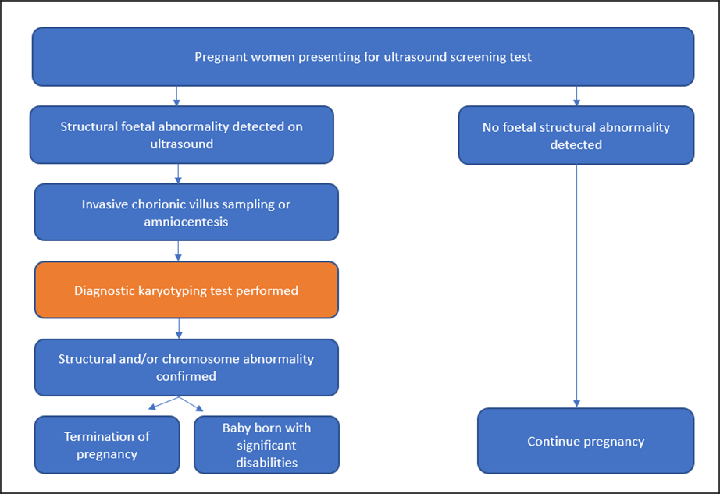

**Figure 1: Clinical algorithm presented in the PICO Confirmation**

Source: Section A6 Figure 1 p19 of the CA

Notes: a. Ultrasound screening is predominantly performed in the first trimester as part of combined first trimester screening (CFTS). Combined first trimester screening (CFTS) is performed at 11+0 to 13+6 weeks by incorporating maternal age, ultrasound measurement of the fetal nuchal translucency, and maternal serum markers levels to generate an overall figure for the likelihood of trisomy disorders. 332nd and 3rd trimester ultrasound is also recommended.

b. Pre-post-test prenatal/genetic counselling is offered when a structural abnormality is detected.

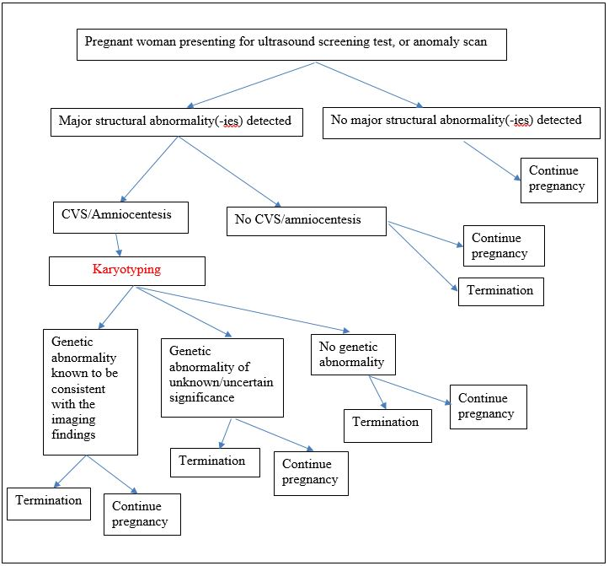

**Figure 2: Proposed amendment to the current clinical management algorithm-following ESC advice**

*Note: requires re-working of the assessment*

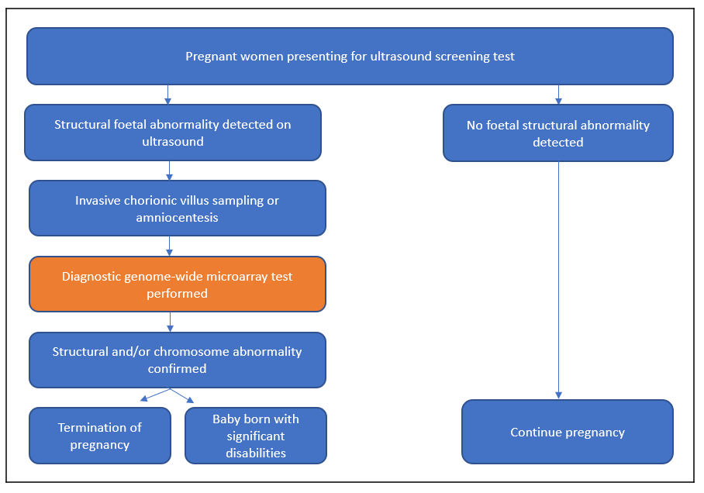

**Figure 3: Clinical management algorithm for the proposed new test relative to current clinical practice**

Notes: a. Ultrasound screening is predominantly performed in the first trimester as part of combined first trimester screening (CFTS). Combined first trimester screening (CFTS) is performed at 11+0 to 13+6 weeks by incorporating maternal age, ultrasound measurement of the fetal nuchal translucency, and maternal serum markers levels to generate an overall figure for the likelihood of trisomy disorders. 332nd and 3rd trimester ultrasound is also recommended.

b. Pre-post-test prenatal/genetic counselling is offered when a structural abnormality is detected.

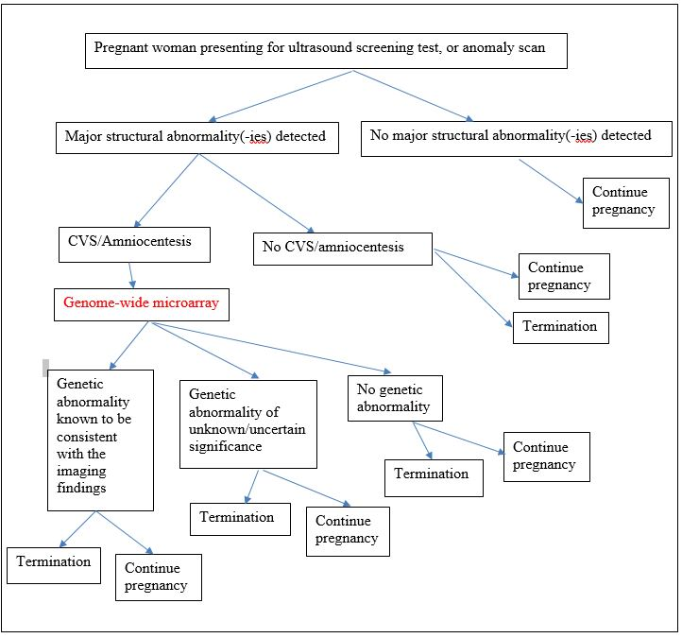

**Figure 4: Proposed amendment to the proposed clinical management algorithm- following ESC advice**

Note: requires re-working of the assessment

# Comparator

Conventional cytogenetic karyotype testing (or karyotyping) is the comparator used in current practice, it is currently MBS listed and it would be replaced by GWMA in this context.

The Critique stated that GWMA and karyotype testing detect some similar and some different genotypes, therefore it is probable that these two diagnostics are complementary. Karyotyping has been the gold standard in detecting changes in the number of chromosomes consistent with trisomies such as 21 (Down syndrome), 18 (Edward syndrome) and 13 (Patau syndrome), and Turner syndrome. GWMA also detects changes in the structure of chromosomes such as deletions and duplications, in addition to the number of chromosomes. GWMA detects a wider range of variants and is thus able to detect a “higher yield” of chromosomal variations than karyotyping; however, a proportion of these have unknown clinical significance. GWMA is unable to detect conditions such as single base pair variations, triplet repeat disorders, some mosaicism and balanced chromosomal rearrangements.

In its pre-MSAC response, the applicant stated that sequential testing is not standard clinical practice and would only occur in the extremely rare circumstance when a karyotype might determine the structure of an imbalance detected by microarray. In effect GWMA would replace karyotyping.

# Comparative safety

No direct evidence was identified and a linked evidence approach was undertaken.

Sixteen empirical studies were included in the evidence base. Studies were prospective (k=10; n=1,942) and retrospective cohort studies (k=5; n=519) and cross-sectional studies (k=1; n=89). There were no randomised controlled trials. Overall, the quality of the evidence for the included studies was very low. Key issues that reduced the quality of the evidence base, apart from the risk of bias, were the inconsistency of the evidence (of the 10 studies that presented sufficient data to generate 2x2 tables, eight favoured microarray and two favoured karyotyping) and the indirectness of the evidence (seven studies used additional tests such as fluorescent *in-situ* hybridisation [FISH] to confirm or as an alternative to microarray or karyotyping results while the remaining nine did not use additional tests). Where additional tests were implemented, the results of the secondary assays were not necessarily reported.

It was proposed that no additional safety issues arise relating to GWMA when compared to conventional karyotyping. Safety issues relate to spontaneous abortion due to amniocenteses or chronic villus sampling (CVS), and maternal anxiety due to the reporting of variations of unknown significance (VUS) – the proportion of tests with VUS may vary according to test methodology. As both GWMA and conventional karyotype testing are preceded by amniocentesis or CVS, safety issues from obtaining the sample for testing are the same.

# Comparative effectiveness

## Accuracy

### Analytical validity

The CA stated that the reference standard for analytical validity is conventional karyotyping. The Critique considered that it was not appropriate to present sensitivity and specificity for the studies, either individually or pooled, as the reference standard conventional karyotyping is an imperfect reference standard. Thus, it cannot be confidently stated that the abnormal cases identified by GWMA but not conventional karyotyping are ‘false positives’.

The Critique identified a systematic review by Saldarriaga et al. 2015 (identified, considered but excluded in the CA) that conducted a meta-analysis of sensitivity and specificity based on studies that compared tests results of the individual tests with the combined test as reference standard (Table 4). Overall the systematic review was of high quality with a medium risk of bias due to heterogeneity in the included studies.

**Table 4: Results of key accuracy trials comparing whole genome-wide microarray and conventional karyotype testing against whole genome-wide microarray plus conventional karyotype testing**

| **Method of GWMA pathology** | **Result** | **Genome-wide microarray**  **[95%CI] (heterogeneity)** | **Conventional karyotype testing**  **[95%CI] (heterogeneity)** |
| --- | --- | --- | --- |
| including VUS | Sensitivity | 94.5% [83.7%, 98.3%] (I2 = 84%) | 67.3% [35.1%, 88.6%] (I2 = 96%) |
| including VUS | Specificity | 98.7% [97%, 99.4%] (I2 = 81%) | 99% [99.8%, 100%] (I2 = 0%) |
| excluding VUS | Sensitivity | 94.2% [83.7%, 98.1%] (I2 = 83%) | 67.3% [35.1%, 88.6%] (I2 = 96%) |
| excluding VUS | Specificity | 99.9% [99.8%, 100%] (I2 = 0%) | 99.9% [99.8%, 100%] (I2 = 0%) |

Source: Compiled during evaluation from Table 3 p 330.e7 of Saldarriaga et al. (2015)

The Rejoinder stated that it was not considered appropriate to use a composite of GWMA and conventional karyotyping as the reference standard, when evaluating either karyotyping alone or GWMA alone. Using such a reference standard would result in incorporation bias and likely lead to overestimation of diagnostic accuracy.

### Clinical validity

The CA stated that the reference standard for clinical validity is phenotypical abnormality confirmed postnatally or at post-mortem. Only two studies were identified that reported GWMA testing and conventional karyotyping against a post-natal or post-mortem phenotype and the quality of the evidence was very low. The two studies were highly heterogeneous and it was not considered appropriate to conduct a meta-analysis. One study was prospective and one was retrospective. In the former study, only 20 abnormal fetuses were evaluable. In the latter, the participants were restricted to those diagnosed with Wolf-Hirschhorn syndrome. However, the two studies indicated that microarray was superior to conventional karyotyping.

**Table 5: Summary statistics for genome-wide microarray test compared to comparator conventional karyotyping, against reference standard phenotypical abnormality diagnosed postnatally or at post-mortem (clinical validity)**

| Study ID | Accuracy | Genome-wide microarray | Conventional karyotyping |
| --- | --- | --- | --- |
| Kan, et al., 201419  (N=20a)- | Sensitivity % [95% CI] | 100% [82.3%, 100%] | 73.7% [48.8%, 90.9%] |
| Specificity, % [95% CI] | 0% [0%, 97.5%] | 100% [2.5%, 100%] |
| Positive predictive value, % [95% CI] | 95% [95%, 95%] | 100%** |
| Negative predictive value, % [95% CI] | Not able to estimate | 16.7% [8.6%, 29.8%] |
| Xing, et al., 201821  (N=10)- | Sensitivity % [95% CI] | 100% [69.2%, 100%] | 80% [44.4%, 97.5%] |
| Specificity, % [95% CI] | Not able to estimate | Not able to estimate |
| Positive predictive value, % [95% CI] | 100%** | 100%** |
| Negative predictive value, % [95% CI] | Not able to estimate | 0%* |

*As per MedCalc; RevMan 5.3 states these values could not be estimated.

**No confidence intervals provided.

a There were 77 with ultrasound abnormalities but only 20 were evaluable with postnatal/post-mortem findings

The Critique stated that overall, the estimates of diagnostic accuracy based on Kan et al. (2014) are uncertain due to low powered sample (only 20 patients with ultrasound abnormalities). In addition, Xing et al. (2018) only examined one disease (prenatal diagnosis of Wolf-Hirschhorn syndrome) which is difficult to interpret in this multi disease test setting as per the proposed population.

## Therapeutic efficacy (change in management)

The CA stated that GWMA results in the same patient management and health outcomes as conventional karyotyping, with the benefit of faster turn-around times as cells do not need to be cultured. Identifying the patient as having genetic abnormalities by GWMA would not translate to a net change in clinical management when compared to conventional karyotyping.

Patients are screened by ultrasound and would only undergo the proposed MBS item test on presenting with major fetal structural abnormalities.

## Therapeutic effectiveness (health benefit from change in management)

The CA stated that performing whole GWMA testing would not result in a change in management resulting from the test, when compared to conventional karyotype testing. ESC noted this assumption would only be valid if the genetic diagnosis is diagnosable by both testing methods. According to the clinical management algorithm, the subsequent actions on receiving a positive result from either test are the same.

However, if there is a differential diagnostic yield between karyotyping and GWMA, there would be an expected resultant difference in pregnancy management.

However, ESC noted, this fails to consider, as a result of GWMA:

* increased number of pregnancies potentially eligible for termination;
* increased need for counselling;
* possible need for genetic counselling to interpret:
  + VUS;
  + actionable unsolicited (“incidental”) findings.

Furthermore, ESC considered a key management question: “How will GMWA (or karyotype) vs. morphoplogy (‘major fetal structural abnormality/ies detected on ultrasound’) influence a decision for termination of pregnancy (ToP?)” – was not addressed.

**Clinical claim**

On the basis of the benefits and harms reported in the evidence base, it was claimed by the CA that, relative to karyotyping, GWMA has non-inferior safety and superior effectiveness.

The Critique stated the claim for non-inferior safety was reasonable since the risk of amniocentesis and chorionic villus sampling affect GWMA and karyotype testing equally and there is no evidence for the effect of increased diagnosis on parental health and wellbeing. However, the claim for superior effectiveness was uncertain. Sensitivity and specificity data suggest a marginal difference relating to a trend in higher sensitivity for GWMA microarray versus karyotyping, but how this relates to the severity of the diagnosis is not available in the clinical evidence. A systematic review by Hillman et al (2013) showed that the excess rate of detection for GWMA over karyotype testing ranged from 0.4 to 50%. Also, conventional karyotyping revealed an extra 0.6% genetic abnormality rate with a 95% CI of 0.2%–1.6% when GWMA results were normal. When the analysis focused on patients with structural abnormality on ultrasound the excess rate of detection was 10% (95% CI = 8.4%-13.1%) for GWMA over karyotype testing and 0.8% (0.2-2.4%) for karyotype testing over GWMA. These values confirm that karyotype testing and GWMA are not mutually exclusive.

# Economic evaluation

The CA presented a cost-effectiveness analysis, using a stepped economic evaluation. Step 1 was a trial-based evaluation calculating the incremental cost per pathogenic copy number variant (CNV) detected. Step 2 involved considering the choice to terminate the pregnancy in response to the information from the genomic testing, and calculated the incremental cost per abnormal birth avoided as the outcome (Table 6). The Critique stated that no trial exists to conduct a trial-based evaluation.

**Table 6: Summary of the economic evaluation; as summarised by the Critique and edited by ESC**

| **Perspective** | Direct health care system costs |
| --- | --- |
| **Comparator** | Karyotyping |
| **Type of economic evaluation** | Cost-effectiveness |
| **Sources of evidence** | Systematic literature review, general literature review |
| **Time horizon** | Step 1: trial-based  Step 2: up to one month after birth (however, the “time horizon” is dictated by the length of stay in hospital due to neonatal care and the upper bound DRG is almost 6 months) |
| **Outcomes** | Step 1: cost per pathogenic CNV detected  Step 2: cost per ~~complex birth~~ avoideda |
| **Methods used to generate results** | Decision tree |
| **Discount rate** | Not applicable as model duration is less than one year |
| **Software packages used** | Microsoft Excel 2016 |

Source: Table 7, p20 of the Critique

a *ESC noted this term (‘~~complex birth~~’) is not correct. This should be amended to ‘child with major structural abnormality/ties’*

Key structural assumptions of the model were:

* that there would be no terminations if a fetus was found to be free of genetic abnormalities based on both genetic testing. The Critique considered this acceptable. However, ESC considered this assumption was incorrect as terminations are currently permitted (depending on State legislation) for severe structural abnormalities which are known to be lethal e.g. anencephaly, renal agenesis or pulmonary hypoplasia), in the absence of genetic testing.
* all GWMA results are true.
* the probability that an elective termination (94.7%) is chosen is equal regardless of whether the abnormality is detected by GWMA or karyotyping. The Critique stated that this assumption may not be appropriate. There are some variations in the test that may cause these to differ. An intervention with superior diagnostic accuracy may lead to more patients opting for termination compared to a comparator of inferior diagnostic accuracy; however, in this setting as the diseases detected differ somewhat across the tests, patients may have differing preferences for termination depending on the severity of the diagnosis. In its pre-MSAC response, the applicant considered the rate of termination (94.7%) extremely high and unlikely to be generalisable to the current Australian clinical practice and testing with GWMA. Termination rates from a large Scottish study from 2000 to 2011 were markedly lower and varied by diagnosis: 85.2% for trisomy (Down, Edwards and Patau syndromes) and 65.4% for other aneuploidy anomalies (Jacobs et al. 2016). Specifically, the applicant stated a more realistic scenario would use a lower termination rate of between 85.2% and 65.4%.

The Critique stated there were other key assumptions:

* The GWMA arm did not have an option for a genetic test negative affected fetus whereas karyotype testing did. The Critique stated this was because the CA assumed that GWMA was 100% sensitive, which was not appropriate.
* The decision tree followed a trial-based approach where only diagnostic yield was used and outcomes were based on this. However, this was not appropriate as there was no evidence from any supporting study. A traditional structure where sensitivity and specificity form the major decisions would have been more appropriate, given the linked evidence approach in the clinical evaluation.

## Cost per pathogenic CNV detected (Step 1)

The CA’s costs and outcomes, and incremental costs and outcomes as calculated for the testing strategy and comparative testing strategy in the model (“Step 1”), and using the base case assumptions, are shown in Table 7.

**Table 7: Results of the cohort costing presented by the CA based on an ICER of cost per pathogenic CNV detected**

| **Test** | **Cost** | **Incremental cost** | **Effectiveness (CNV detected)** | **Incremental effectiveness** | **Incremental cost per CNV detected** |
| --- | --- | --- | --- | --- | --- |
| **Genome-wide microarray** | $589,900 | $197,545 | 98 | 38 | $5,258 |
| **Karyotyping** | $392,355 |  | 61 |  |  |

Source: Section D5.1, Table 52 of the CA

CNV=Copy number variant

Results from one-way sensitivity analyses are presented in tornado diagram in Figure 5.

Tornado diagram: Step 1

**Figure 5: Tornado diagram: Cost per pathogenic CNV avoided (Step 1)**

## Cost per abnormal birth avoided (Step 2; base case)

The CA’s overall costs and outcomes, and incremental costs and outcomes as calculated for the testing strategy and comparative testing strategy in the model (“Step 2”), and using the base case assumptions, are shown in Table 8.

**Table 8: Results of the base case economic evaluation (ICER of cost per complex birth avoided)**

| **Test** | **Cost** | **Incremental cost** | **Effectiveness (Complex births avoided)** | **Incremental effectiveness** | **Incremental cost per CNV detected** |
| --- | --- | --- | --- | --- | --- |
| **Genome-wide microarray** | $9,198,081 | -$4,675,423 | 93 | 36 | -$131,421 (dominant) |
| **Karyotyping** | $13,873,504 |  | 58 |  |  |

Source: Section D5.1, Table 52 of the CA

CNV=Copy number variant

Results from one-way sensitivity analyses are presented in tornado diagram in Figure 6.

Tornado diagram: Step 2

**Figure 6: Tornado diagram: Cost per abnormal birth avoided (Step 2)**

The CA stated the modelled results were by far the most sensitive to the cost of a birth with a genetic abnormality, with other key drivers being the detection rate of genome-wide microarray, and the costs of GWMA and karyotyping. GWMA was dominant in all scenarios.

However, the Critique stated that the greatest source of uncertainty in the CA is the structural uncertainty arising from the decision tree presented in the Ratified PICO Confirmation. The most important parameters to explore in the model are the sensitivity and specificity of the GWMA and karyotype testing which were not included in the current structure of the model and therefore could not be explored with sensitivity analysis in the CA economic calculation. This was a key requirement as, according to the published cost effectiveness models, a cost driver in the model is how VUS are handled in the model (e.g. treated as T[test]+ or T[test]-).

## Rejoinder to Critique

An economic analysis was re-run to address the Critique’s concerns as additional sensitivity analyses (Table 9). The Rejoinder stated that the new scenario analysis indicated that GWMA dominated (lower total cost with fewer disabled births) over a range of values (prevalence rates from 10% to 80%; and karyotyping sensitivity from 70% to 90%).

**Table 9: Cost-effectiveness of karyotype testing vs. GWMA**

| **Scenario** | **Difference in disability deliveries** | **Cost difference** | **ICER** | **Accuracy of karyotyping** | **Accuracy of GWMA** |
| --- | --- | --- | --- | --- | --- |
| Base case (prevalence 10%, termination 95% | -23.75 | -$128,201.36 | Dominant | 98.1% | 98.6% |
| Meta-analysis (Saldarriaga 2015) | -26.60 | -$91,707.34 | Dominant | 95.8% | 95.6% |
| Prevalence 7.5% | -16.88 | -$65,511.80 | Dominant | 96.8% | 98.7% |
| Termination 90% | -25.20 | -$111,057.08 | Dominant | 96.1% | 98.6% |
| Karyotyping sensitivity 90% | -4.75 | $16,506.08 | $3,474.96 | 91.8% | 95.6% |
| Lower abnormal birth cost | -23.75 | -$57,403.00 | Dominant | 98.1% | 98.6% |
| VUS not pathologic | -25.56 | -$80,344.05 | Dominant | 98.6% | 99.4% |
| VUS pathologic | -25.84 | -$164,424.90 | Dominant | 96.6% | 98.3% |

Source: Table 14, p40 of Rejoinder

Abbreviations: GMWA, genome-wide microarray; ICER, incremental cost effectiveness ratio; VUS, variations of unknown significance

The Rejoinder also compared economics results from two different methods:

1. Decision analysis using sensitivity and specificity values (approach suggested in the Critique);
2. Diagnostic yield using test results (approach performed in CA).

In brief, the Rejoinder stated both methods (sensitivity and specificity meta-analysis and diagnostic yield) have their limitations and yielded similar results (Table 10; Table 11).

**Table 10: Comparison of costs and consequences by method: DY or S&S**

| **Scenario** | **Intervention** | **Test** | **Terminations** | **Prenatal care** | **Normal births** | **Disabled births** | **Total** |
| --- | --- | --- | --- | --- | --- | --- | --- |
| DY | Karyotyping | 1000 | 57.8 | 942.24 | 903.48 | 38.76 |  |
| S&S | Karyotyping | 1000 | 72.2 | 927.8 | 891.45 | 36.4 |  |
| Difference |  |  | **14.5** | **-14.5** | **-48.25** | **-5.9** |  |
| DY | GWMA | 1000 | 93.7 | 906.3 | 901.4 | 6.8 |  |
| S&S | GWMA | 1000 | 98.8 | 901.2 | 891.45 | 9.8 |  |
| Difference |  |  | **5.1** | **-5.1** | **-9.95** | **3** |  |
| DY | Karyotyping | $787,000 | $46,846 | $927,164 | $6,974,866 | $414,771 | $9,150,646 |
| S&S | Karyotyping | $786,910 | $58,557 | $912,955 | $6,881,994 | $389,516 | $9,029,398 |
| Difference |  | **$90** | **$11,711** | **($14,209)** | **($92,872)** | **($25,255)** | **($121,248)** |
| DY | GWMA | $984,450 | $75,816 | $892,016 | $6,962,251 | $50,016 | $8,964,549 |
| S&S | GWMA | $984,450 | $80,131 | $886,781 | $6,881,994 | $104,870 | $8,938,226 |
| Difference |  | **0** | **$4,136** | **($5,018)** | **($76,814)** | **$54,854** | **($26,323)** |

Source: Table 15, p41 of Rejoinder

Abbreviations: DY, diagnostic yield; GMWA, genome-wide microarray; ICER, incremental cost effectiveness ratio; S&S, sensitivity and specificity; VUS, variations of unknown significance

*Note ($) appears to indicate negative values*

**Table 11: Disaggregated results of DY or S&S**

| **Methodology** | **Difference in disabled deliveries** | **Difference in costs** | **ICER** |
| --- | --- | --- | --- |
| Sensitivity and specificity | **-26.6** | **-$91,172** | **Dominant** |
| *Diagnostic yield* | **-31.96** | **-$186,097** | **Dominant** |

Source: Table 16, p42 of Rejoinder

# Financial/budgetary impacts

An epidemiological approach was used to estimate the financial implications of the introduction of GMWA testing for prenatal abnormalities (Table 12).

**Table 12: Total costs to the MBS associated with GWMA and karyotype testing**

| **-** | **2019** | **2020** | **2021** | **2022** | **2023** |
| --- | --- | --- | --- | --- | --- |
| Pregnancies with fetal structural abnormalities | 10,441 | 10,487 | 10,532 | 10,578 | 10,623 |
| Change in cost related to genome-wide microarraya | $5,122,449 | $5,144,707 | $5,166,964 | $5,189,222 | $5,211,479 |
| Change in costs related to other medical services |  |  |  |  |  |
| Cost of karyotyping*b* | -$3,408,298 | -$3,423,107 | -$3,437,917 | -$3,452,726 | -$3,467,535 |
| Costs related to terminations*c* | $163,880 | $164,592 | $165,304 | $166,016 | $166,728 |
| Costs related to continuations of pregnancy*d* | -$153,683 | -$154,350 | -$155,018 | -$155,686 | -$156,354 |
| Total change in use and cost of other medical services | -$3,398,101 | -$3,412,865 | -$3,427,630 | -$3,442,395 | -$3,457,160 |
| **Net cost to the MBS** | **$1,724,349** | **$1,731,841** | **$1,739,334** | **$1,746,826** | **$1,754,319** |
| **Critique’s net cost to the MBSe** | $1,714,151 | $1,721,600 | $1,729,047 | $1,736,496 | $1,743,944 |

Source: compiled from Table 10 of the Critique and Table 66 of the CA

a Critique statedbased on weighted benefit of 83% for MBS items 73287 and 73293

b The CA stated GMWA replaces karyotyping at 1:1 (100% substitution)

c The CA statedapproximately 95% of pregnancies with a pathogenic CNV detected are expected to be terminated, and as GMWA detects more pathogenic CNVs than karyotyping (see Table 2), this will result in an increase in the number of terminations.

d The CA stated an increase in the number of terminations is expected to result from the funding of genome-wide microarray testing for prenatal abnormalities. This will have the effect of decreasing the number of services related to the continuation of pregnancy.

e Critique only included cost offsets of 100% substitution with karyotyping (did not include the cost offsets related to terminations, and continuations of pregnancy)

The Critique stated that there is potential for the net cost/year to the MBS to be less than estimated in the CA as the number of expected services is greater than twice the number of services associated with amniocentesis (MBS item 16600) and CVS (MBS item 16603). The Critique conducted a sensitivity a using a market-share approach and assuming other cost offsets (costs related to terminations, costs related to continuations of pregnancy) would not be realised (Table 13).

**Table 13: Estimate cost to MBS due to listing of GWMA (Critique’s sensitivity analysis)**

| **Item** | **2020** | **2021** | **2022** | **2023** | **2024** |
| --- | --- | --- | --- | --- | --- |
| No of eligible patientsa | 3,789 | 3,748 | 3,707 | 3,666 | 3,625 |
| Cost of karyotyping (assuming 85% benefit $335.36) | $1,270,679 | $1,256,929 | $1,243,180 | $1,229,430 | $1,215,680 |
| Cost of GWMA (assuming 85% benefit $506.50) | $1,919,129 | $1,898,362 | $1,877,596 | $1,856,829 | $1,836,063 |
| **Net cost to MBS** | **$648,449** | **$641,433** | **$634,416** | **$627,399** | **$620,383** |

Source; calculated during evaluation (Table 11 of the Critique)

a Number of amniocentesis (MBS item 16600) and number of CVS (MBS item 16603)

# Key issues from ESC for MSAC

| ESC key issue | ESC advice to MSAC |
| --- | --- |
| Diagnostic accuracy | Genome-wide microarray (GWMA) testing appears to be more accurate than karyotyping, but this is based on low-level and poor-quality evidence. Currently, Australians are paying out-of-pocket for GWMA testing due to its inclusion in Australian and international guidelines, which raises access issues. |
| Clinical utility | The incremental value of GWMA compared with finding ≥ 1 ‘major fetal structural abnormality’ on ultrasound in deciding pregnancy outcome has not been established. This had implications to the economics (see below). |
| Cost-effectiveness not informative | ESC also noted the revised economic model in the Rejoinder was more appropriate using sensitivity and specificity of the test (which considers false negatives and false positives), rather than diagnostic yield in the original base case of the Contracted Assessment. However, the current economic model was not considered informative as it did not capture the change in clinical management or health outcomes associated with addition of GWMA test (e.g. cause for abnormality/ies and decision for termination of pregnancy). |
| Comparator, replaced by or added to GWMA? | The CA assumed that karyotyping would be 1:1 replaced by GWMA. However, if GWMA and karyotype testing are used as complementary tests (e.g. sequential testing in any cases), this will increase cost of testing and have flow-on effects to the economic model and financial estimates (not considered in estimates). |
| Descriptor | Several descriptor issues remain:   * How should ‘major structural abnormality’ be defined? * Should abnormalities associated with major abnormalities, such as nuchal translucency, be excluded in the definition? * Should other forms of antenatal imaging other than just ultrasound be included in the item descriptor, as diagnostic MRI may be required to confirm US findings? * Should we exclude cell-free fetal DNA from the sample? * Should the descriptor prevent use of GWMA *plus* karyotyping? * Should there be a limit on the number of tests per fetus? If GWMA is used more than once per fetus, this will increase the costs of the testing. * Should the descriptor specify the platform of GWMA to be used? Are any additional tests required. |
| Variants of unknown significance (VUS) | The CA did not specify whether VUS will be reported. Additional costs may be incurred if VUS are pathogenic or likely pathogenic. In addition, more in-depth counselling, and parent testing/re-testing may be required if VUS are reported. |

## **ESC discussion**

ESC noted some uncertainties around the MBS item descriptor. ‘Major fetal structural abnormality is not defined, and ESC queried whether this should exclude ultrasound findings such as nuchal translucency of >3.5 mm as this is not in itself a major abnormality but an antenatal sign associated with trisomies and other congenital abnormalities. The nuchal translucency is measured early in the pregnancy (10 to 12 weeks) at which time the fetus is so immature that most major structural abnormalities are not yet apparent. A potential definition of “major fetal abnormality” is: “An anatomical structural variant which is known to: be potentially lethal, be known to be associated with significant impairment of normal function of organ(s), or be associated with significant long-term handicap.”

ESC also queried whether cell-free fetal deoxyribonucleic acid (cffDNA) should be excluded from being used as a source of fetal DNA, as the Contracted Assessment (CA) did not consider cffDNA.

ESC considered whether the item descriptor should specify the platform to be used for genome-wide microarray (GWMA), such as comparative genomic hybridisation arrays and single nucleotide polymorphism (SNP) arrays. These platforms have different resolutions, turnaround times, ability to detect VUS and costs compared with karyotyping, which would affect other aspects of the application. For example, ESC noted that some platforms might require sex-matched controls, and queried whether other complementary tests would then be required, such as fetal sex determination. Alternatively, the laboratory could use XY DNA as a control; however, this could miss aneuploidies on the sex chromosomes, and thus could not report – for example – a diagnosis of a fetus with Turner syndrome (monosomy XO). ESC noted that using SNP arrays would address some of these issues.

ESC suggested that the applicant could provide further advice on these item descriptor issues in its pre-MSAC response.

ESC discussed that if a pregnancy continues, severe structural abnormalities diagnosed antenatally may be further characterised postnatally in terms of diagnosis, prognosis and therapeutic options, including the use of genetic testing. This provides clinicians with accurate information to inform the management of other pregnancies with similar antenatal findings.

ESC noted that the CA did not consider variants of unknown significance (VUS) or detection of an unsolicited pathogenic mutation (e.g. *BRCA*). The model assumes that VUS are not pathogenic, but additional costs may be incurred if patients with VUS are re-tested postnatally. In addition, more in-depth genetic counselling and parent testing/re-testing will be required where VUS are reported. ESC noted that the Rejoinder stated that the mandated reporting of VUS is outside the scope of the CA. Most laboratories are conservative in their reporting of VUS in the prenatal setting and may choose not to report.

ESC queried whether some of these issues regarding the item descriptor and VUS were adequately covered under MBS item 73292 as part of the accreditation and quality assurance requirements.

ESC noted that if GWMA is used more than once per fetus, this would increase the costs of testing. There is no evidence base for testing more than once per fetus in a pregnancy.

ESC noted that the applicant’s claim of superiority for GWMA testing compared with karyotyping was based on low-level and poor-quality evidence. ESC agreed with the Critique that the diagnostic accuracy of GWMA appeared to be different than karyotyping, but not necessarily superior. This supports the idea that GWMA complements, rather than replaces, karyotyping. ESC agreed with the Critique that GWMA could be used with karyotyping, which would affect the economics and financials and should be addressed.

ESC also noted the revised economic model in the Rejoinder to the Critique was more appropriate using sensitivity and specificity of the test (which considers false negatives and false positives), rather than diagnostic yield in the original base case of the CA.

However, ESC noted the lack of evidence around how GWMA (or karyotype) results will affect the decision for termination of pregnancy (ToP) compared with ToP based on the finding of one or more major fetal abnormalities on ultrasound. This uncertainty flowed on into the economics as the current models did not capture the clinical utility of the test (e.g. how tests results will affect clinical management and subsequent pregnancy outcomes [e.g. ToP rates]), which meant the results of the economic model were not informative. Similarly, the impact on the need for pre-implantation genomic diagnosis in assisting future pregnancy choices following a genetic diagnosis with risk of recurrence also needs to be addressed.

ESC discussed the access to appropriate pregnancy management for a woman whose fetus has a major structural abnormality in the context of the addition of GWMA testing. ESC noted that, where a fetus has a major structural abnormality, the pregnancy is currently typically managed through a tertiary fetal management unit which includes, but is not limited to, access to specialist obstetricians, neonatologists, surgeons, cardiologists or clinical geneticists. This was not appropriately captured in the economics.

ESC queried the decision to assume that all confirmed abnormalities will lead to an increased difficulty of delivery compared to a fetus without a major structural anomaly. The assessment did not account for the need for specialist neonatal care immediately at, or beyond delivery, nor did the model account for the medical costs of care for infants with major congenital malformations, all which could be significant because resource use is a key driver of the model. However, ESC noted this term ‘complex delivery’ is not correct in this context. ESC also queried the decision to remove the costs of post-delivery care of the infant and anticipated lifespan, depending on the syndrome diagnosed, from the revised model, and considered that these should be factored in.

ESC noted the consumer issues raised for the application including: parental anxiety with test results; uncertain results impacting decision making regarding termination; requirements of parental counselling and if further counselling is required after a decision is made; workforce supply of genetic counsellors in Australia; and equity of access issue as rural /remote patients may have trouble accessing all services related to the test.

# Other significant factors

Nil.

# Applicant’s comments on MSAC’s Public Summary Document

The applicant had no comment.

# Further information on MSAC

MSAC Terms of Reference and other information are available on the MSAC Website:   
[visit the MSAC website](http://www.msac.gov.au/)