MSAC Application 1734
Intravascular lithotripsy for the treatment of moderately or severely calcified peripheral artery disease
This application form is to be completed for new and amended requests for public funding (including but not limited to the Medicare Benefits Schedule (MBS)). It describes the detailed information that the Australian Government Department of Health requires to determine whether a proposed medical service is suitable.
Please use this template, along with the associated Application Form Instructions to prepare your application. Please complete all questions that are applicable to the proposed service, providing relevant information only. Applications not completed in full will not be accepted. The separate MSAC Guidelines should be used to guide health technology assessment (HTA) content of the Application Form
Should you require any further assistance, departmental staff are available through the Health Technology Assessment Team (HTA Team) on the email below to discuss the application form, or any other component of the Medical Services Advisory Committee process.
Email: hta@health.gov.au
Website: www.msac.gov.au

PART 1 – APPLICANT DETAILS

Applicant details (primary and alternative contacts)
Corporation / partnership details (where relevant):
Corporation name: Shockwave Medical Inc (Manufacturer); Diverse Devices Pty Ltd (Distributor)
ABN: 77605565400
Business trading name: Diverse Devices
Primary contact name: REDACTED
Primary contact numbers
Business: Shockwave Medical Inc
Mobile: REDACTED
Email: REDACTED
Alternative contact name: REDACTED
Alternative contact numbers
Business: REDACTED
Mobile: REDACTED
Email: REDACTED

Are you a consultant acting on behalf on an applicant?
Yes
No

Are you a lobbyist acting on behalf of an Applicant?
Yes
No

PART 2 – INFORMATION ABOUT THE PROPOSED MEDICAL SERVICE

Application title
Intravascular lithotripsy for the treatment of moderately or severely calcified peripheral artery disease

Provide a succinct description of the medical condition relevant to the proposed service (no more than 150 words – further information will be requested at Part 6 of the Application Form)
Peripheral artery disease (PAD) is a condition in which the build-up of fatty deposits (also called plaque) results in narrowed arteries and reduced blood flow to the arms or legs. The build-up of plaque can cause the arteries to stiffen or calcify. PAD most commonly affects the arteries leading to the legs or feet. This application pertains only to patients with lower limb PAD.
The reduction in blood flow to the peripheral limbs can cause pain or discomfort when walking or performing activities of daily living, and in more severe cases pain while at rest. This results in significant impairment in physical function, emotional wellbeing and quality of life.
The reported prevalence of PAD in Australia and other Western countries is 15%, with prevalence increasing with age (Conte and Vale, 2018). Risk factors for PAD include smoking, hypertension, diabetes and hypercholesterolaemia.
Calcification in PAD is independently associated with more severe PAD (Zettervall et al., 2018), poorer prognosis of traditional treatment, and increased all-cause mortality (Chowdhury et al., 2017; Fanelli et al., 2014).

Provide a succinct description of the proposed medical service (no more than 150 words – further information will be requested at Part 6 of the Application Form)
Intravascular lithotripsy (IVL) is a novel technique which utilises multiple emitters mounted on a traditional angioplasty balloon catheter, that provide pulsatile acoustic pressure energy to fracture superficial and deep calcium without affecting local soft tissue.
IVL can be used as a standalone treatment, or as a vessel preparation strategy prior to treatment with a drug coated balloon (DCB) or stent. This strategy results in a significant reduction in residual stenosis and significantly reduces the rate of stent placement compared to traditional balloon angioplasty.

(a) Is this a request for MBS funding?
Yes
No

If yes, is the medical service(s) proposed to be covered under an existing MBS item number(s) or is a new MBS item(s) being sought altogether?
Amendment to existing MBS item(s)
New MBS item(s)

If an amendment to an existing item(s) is being sought, please list the relevant MBS item number(s) that are to be amended to include the proposed medical service/technology:
N/A

If an amendment to an existing item(s) is being sought, what is the nature of the amendment(s)?
N/A

If a new item(s) is being requested, what is the nature of the change to the MBS being sought?
A new item which also seeks to allow access to the MBS for a specific health practitioner group
A new item that is proposing a way of clinically delivering a service that is new to the MBS (in terms of new technology and / or population)
A new item for a specific single consultation item
A new item for a global consultation item(s)

Is the proposed service seeking public funding other than the MBS?
Yes
No

If yes, please advise:
N/A

What is the type of medical service/technology?
Therapeutic medical service
Investigative medical service
Single consultation medical service
Global consultation medical service
Allied health service
Co-dependent technology
Hybrid health technology

For investigative services, advise the specific purpose of performing the service (which could be one or more of the following):
To be used as a screening tool in asymptomatic populations
Assists in establishing a diagnosis in symptomatic patients
Provides information about prognosis
Identifies a patient as suitable for therapy by predicting a variation in the effect of the therapy
Monitors a patient over time to assess treatment response and guide subsequent treatment decisions

Does your service rely on another medical product to achieve or to enhance its intended effect?
Pharmaceutical / Biological
Prosthesis or device
No

(a) If the proposed service has a pharmaceutical component to it, is it already covered under an existing Pharmaceutical Benefits Scheme (PBS) listing?
N/A

If yes, please list the relevant PBS item code(s):
N/A

If no, is an application (submission) in the process of being considered by the Pharmaceutical Benefits Advisory Committee (PBAC)?
N/A

If you are seeking both MBS and PBS listing, what is the trade name and generic name of the pharmaceutical?
N/A

(a) If the proposed service is dependent on the use of a prosthesis, is it already included on the Prostheses List?
Yes
No

If yes, please provide the following information (where relevant):
While IVL is not reliant on stent insertion to deliver its intended effect, IVL can be used prior to stent insertion. Various stents are currently included on the Prostheses List for PAD, under Subcategory 10.01 – Vascular Stents, including bare metal (10.01.01) and drug eluting (10.01.02) stents. DCBs are not included on the Prostheses List, as they are non-implantable.

If no, is an application in the process of being considered by a Clinical Advisory Group or the Prostheses List Advisory Committee (PLAC)?
Yes
No

Are there any other sponsor(s) and / or manufacturer(s) that have a similar prosthesis or device component in the Australian marketplace which this application is relevant to?
Yes
No

If yes, please provide the name(s) of the sponsor(s) and / or manufacturer(s):
N/A

Please identify any single and / or multi-use consumables delivered as part of the service?
Single use consumables: The Shockwave S4 and M5 IVL catheters are intended for single use only. The catheter contains an inflation lumen, a guidewire lumen and the lithotripsy emitters. The IVL catheter is available in multiple sizes to address a range of vessel diameters.
Multi-use consumables: The IVL generator and connecter cable are rechargeable and reusable.

PART 3 – INFORMATION ABOUT REGULATORY REQUIREMENTS

(a) If the proposed medical service involves use of a medical device, in-vitro diagnostic test, pharmaceutical product, radioactive tracer, or any other type of therapeutic good, please provide details
Type of therapeutic good: Medical device
Manufacturer’s name: Shockwave Medical Inc
Sponsor’s name: AA-Med Pty Ltd

Has it been listed on the Australian Register of Therapeutic Goods (ARTG) by the Therapeutic Goods Administration (TGA)? If the therapeutic good has been listed on the ARTG, please state the ARTG identification numbers, TGA-approved indication(s), and TGA-approved purpose(s).
ARTG ID: 388192, 320482
TGA approved indication(s), if applicable: Calcified, stenotic peripheral arteries
TGA approved purpose(s), if applicable: The Shockwave S4 Peripheral IVL System is indicated for lithotripsy-enhanced, low-pressure balloon dilatation of calcified, stenotic peripheral arteries, in patients who are candidates for percutaneous therapy. Not for use in the coronary, cerebral, aortic, or common iliac vasculature.
The Shockwave M5 catheter is indicated for lithotripsy enhanced, low pressure balloon dilation of calcified peripheral stenotic arteries in patients who are candidates for percutaneous therapy. The catheters are not indicated for coronary or central vascular systems.

If a medical device is involved, has the medical device been classified by TGA as a Class III OR Active Implantable Medical Device (AIMD) under the TGA regulatory scheme for devices?
No, classified as Class IIb

Is the therapeutic good classified by TGA for Research Use Only (RUO)?
No

(a) If not listed on the ARTG, is the therapeutic good to be used in the service exempt from the regulatory requirements of the Therapeutic Goods Act 1989?
N/A
- If the therapeutic good is not ARTG listed, is the therapeutic good in the process of being considered by TGA?
N/A
- If the therapeutic good is NOT in the process of being considered by TGA, is an application to TGA being prepared?
N/A

PART 4 – SUMMARY OF EVIDENCE

Provide one or more recent (published) high quality clinical studies that support use of the proposed health service/technology. At ‘Application Form lodgement’, please do not attach full text articles; just provide a summary.
 | Type of study design | Title of journal article or research project | Short description of research | Website link to journal article or research | Date of publication
1. | Multicentre, single-blind, randomised controlled trial. | Disrupt PAD III RCT  NCT02923193 | Patients with moderate or severe calcified femoropopliteal lesions received either IVL (n=153) or PTA (n=153). Procedural success was greater in IVL arm and percentage of lesions with residual stenosis <30% was greater in IVL group. 12 month primary patency was significantly greater in the IVL arm and remained at 2 years follow up.  Status: post-recruitment | Intravascular Lithotripsy for Peripheral Artery Calcification: Mid-term Outcomes From the Randomized Disrupt PAD III Trial – Journal of the Society for Cardiovascular Angiography & Interventions (jscai.org)  Intravascular Lithotripsy for Peripheral Artery Calcification: 30-Day Outcomes From the Randomized Disrupt PAD III Trial – PubMed (nih.gov) | May 2022 (1 & 2-year results)  June 2021 (30-day results)
2. | Propsective, non-randomised, multicentre, single-arm observational study | Disrupt PAD III Observational Study  NCT02923193 | The PAD III Observational Study (OS) was designed to assess real-world acute performance of peripheral IVL in the treatment of calcified, stenotic, peripheral arteries that did not qualify for inclusion in the PAD III RCT study.  The observational study enrolled 1373 subjects followed through discharge. Several interim analyses have been published.  Status: post-treatment. | Intravascular Lithotripsy for Treatment of Calcified Lower Extremity Arterial Stenosis: Initial Analysis of the Disrupt PAD III Study – PubMed (nih.gov)  Intravascular Lithotripsy for Treatment of Calcified Infrapopliteal Lesions: Results from the Disrupt PAD III Observational Study – PubMed (nih.gov)  Intravascular Lithotripsy for Treatment of Calcified, Stenotic Iliac Arteries: A Cohort Analysis From the Disrupt PAD III Study – PubMed (nih.gov) | June 2020 (interim analyis; first 200 patients)  Aug 2021 (infrapopliteal cohort; n=101)  Oct 2020 (iliac cohort; n=118)
3. | Non-randomised, multicentre study | Disrupt PAD II  NCT02369848 | Enrolled 60 patients with complex, calcified peripheral arterial stenosis at eight sites. Patients were treated with IVL and followed for 12 months.  The final residual stenosis was 24.2%, with an average acute gain of 3.0mm. 30-day MAE rate was 1.7%. Primary patency at 12 months was 54.5%, TLR at 12 months was 20.7%.  Status: closed | Primary outcomes and mechanism of action of intravascular lithotripsy in calcified, femoropopliteal lesions: Results of Disrupt PAD II – PubMed (nih.gov) | Feb 2019
4. | Prospective, non-randmosied, single-arm study | Disrupt PAD I  NCT02071108 | 35 patients were prospectively enrolled with calcified, stenotic, de novo femoropopliteal arterial lesions. Primary perfromance endpoint was procedural succes defined as post-treatment resdiual stenosis of <50%.  Procedural success occurred in all patients, and final residual stenosis was 23.4% with an acute gain of 2.9mm.  Status: closed | Safety and Performance of Lithoplasty for Treatment of Calcified Peripheral Artery Lesions – PubMed (nih.gov) | Aug 2017
5. | Propsective non-randmosied, multicenter, feasibility, and safety trial | Disrupt PAD BTK  NCT02911623 | 20 patients at 3 participating sites. All patients had moderate to severe below-the-knee arteria calcification. Primary safety endpoint was MAE through 30 days. The primary effectiveness endpoint wasacute reduction in the diameter stenosis.  30 day MAE was 0%. Reduction in diameter stenosis of target lesions was 46.5%. All patients achieved residual stenosis <50%.  Status: closed | Safety and Feasibility of Intravascular Lithotripsy for Treatment of Below-the-Knee Arterial Stenoses – PubMed (nih.gov) | Aug 2018

Identify yet-to-be-published research that may have results available in the near future (that could be relevant to your application). Do not attach full text articles; this is just a summary.
 | Type of study design | Title of research | Short description of research | Website link to research | Date
1 | Propsective, non-randomised, multicentre, single-arm observational study | Disrupt PAD III Observational Study: Gender Analysis  NCT02923193 | Analysis of acute results stratified by gender | https://clinicaltrials.gov/ct2/show/NCT02923193 | Results expected in 2022
2 | Propsective, non-randomised, multicentre, single-arm observational study | Disrupt PAD III Observational Study: Full Cohort  NCT02923193 | Analysis of full PAD III OS cohort (n=1373) | https://clinicaltrials.gov/ct2/show/NCT02923193 | Results for full cohort expected in 2023
3 | Prospective, multi-center, single-arm study study of the Shockwave M5+ IVL Catheter | Disrupt PAD+  NCT04585763 | A total of 37 subjects were enrolled from 8 centers in New Zealand, Australia and the US, and a total of 52 target lesions were treated with the M5+ catheter. Interim results presented in Charing Cross conference in 2022 showed no MAE at 30-days. Technical Success was achieved in 89.6% (43/48) of target lesions with no flow-limiting dissections at the final timepoint.  Status: post-recruitment | https://clinicaltrials.gov/ct2/show/NCT04585763 | Publication of 1-year results expected in 2023
4 | Post-market, prospective, multicentre, single-arm study | Disrupt PAD BTK II  NCT05007925 | A 250-patient study designed to assess the continued safety, effectiveness, and optimal clinical use of the Shockwave Medical Peripheral IVL System for the treatment of calcified stenotic below-the-knee arteries.  Status: recruiting | Disrupt PAD BTK II Study With the Shockwave Peripheral IVL System – Full Text View – ClinicalTrials.gov | Results expected 2024

PART 5 – CLINICAL ENDORSEMENT AND CONSUMER INFORMATION

List all appropriate professional bodies/organisations representing the health professionals who provide the service. For MBS-related applications ONLY, please attach a brief ‘Statement of Clinical Relevance’ from the most relevant college/society.
Australian and New Zealand Society of Vascular Surgeons
Interventional Radiology Society of Australasia

List any professional bodies / organisations that may be impacted by this medical service (i.e. those who provide the comparator service):
Australian and New Zealand Society of Vascular Surgeons

List the consumer organisations relevant to the proposed medical service (noting there is NO NEED to attach a support letter at the ‘Application Lodgement’ stage of the MSAC process):
Heart Foundation
Diabetes Australia

List the relevant sponsor(s) and / or manufacturer(s) who produce similar products relevant to the proposed medical service:
N/A

Nominate two experts that can be contacted about the proposed medical service, and current clinical management of the condition:
Name of expert 1: REDACTED
Telephone number(s): REDACTED
Email address: REDACTED
Justification of expertise: REDACTED

Name of expert 2: REDACTED
Telephone number(s): REDACTED
Email address: REDACTED
Justification of expertise: REDACTED

PART 6 – POPULATION (AND PRIOR TESTS), INTERVENTION, COMPARATOR, OUTCOME (PICO)

PART 6a – INFORMATION ABOUT THE PROPOSED POPULATION

Define the medical condition, including providing information on the natural history of the condition and a high level summary of associated burden of disease (in terms of both morbidity and mortality):
Lower extremity PAD is a manifestation of systematic atherosclerotic disease, where fatty deposits build up on the blood vessels, restricting blood flow to the lower extremities. Fatty deposits may also cause the blood vessels to stiffen, and deposition of extra osseous calcium salt may cause arterial calcification. PAD is a major contributor to the mortality and morbidity of patients with atherosclerosis in Australia. In contrast to ischaemic heart disease and stroke, which are decreasing in global prevalence and disease-related mortality, the burden of disease associated with PAD as increased over the last three decades (Eid et al., 2021). Despite the substantial burden of PAD, it remains under-recognised and undertreated (Conte and Vale, 2018).
Prevalence estimates for PAD vary, with studies showing up to 10% of patients in primary care settings have a diagnosis of PAD (Aitken, 2020), and up to 30% when studying older populations (Conte and Vale, 2018). The age-adjusted rate of PAD is 1.6 times greater in Indigenous Australians compared to non-Indigenous Australians (Australian Institute of Health and Welfare, 2021). Risk factors for the development of PAD are similar to those for cardiovascular disease, and include smoking, diabetes, hypertension and hypercholesterolaemia (Aitken, 2020).
Although PAD is asymptomatic in approximately 50% of cases (Conte and Vale, 2018), symptomatic PAD is associated with a reduction in functional capacity and quality of life. Patients with PAD, including asymptomatic patients, are also at higher risk of cardiovascular morbidity and mortality, and increased risk of stroke (Conte and Vale, 2018).
American College of Cardiology/American Heart Association (ACC/AHA) guidelines categorise PAD patients into four categories depending on their symptoms: asymptomatic, intermittent claudication (IC), chronic limb ischaemia (CLI), and acute limb ischaemia (ALI) (Gerhard-Herman et al., 2017). Asymptomatic patients can be well treated with risk-factor modification, although studies show that adherence to preventative therapies is low (Conte and Vale, 2018).
Patients with IC represent approximately 25% of PAD patients, and experience pain which is typically brought on by exercise and relieved by rest (Conte and Vale, 2018). They have significantly reduced quality of life, however, the disease is relatively stable. Five-year natural history data show that the majority of IC patients remain stable, with only 10-20% having worsening claudication, and only 1-3% of patients requiring an amputation (Conte and Vale, 2018).
Patients with CLI experience pain even at rest, and may have ulceration with or without tissue necrosis. Overall, nearly 25% of patients with CLI require an amputation within 12 months of diagnosis. CLI also represents a substantial mortality burden, with 1-, 5-, and 10-year overall survival of 25-40%, 40-70%, and 80-95% respectively (Conte and Vale, 2018).
Calcified PAD is independently associated with more severe disease (Zettervall et al., 2018). In patients with calcified PAD, calcification is associated with adverse limb events, poor prognosis of traditional treatment, and increased all-cause mortality (Chowdhury et al., 2017; Fanelli et al., 2014). Vascular calcification may interfere with endovascular therapies such as balloon angioplasty, where it causes suboptimal vessel expansion, increased risk of complications, and reduced long-term patency (Tepe et al., 2022). The prevalence of moderate or severe calcification in PAD is not well reported.

Specify the characteristics of patients with (or suspected of having) the medical condition, who would be eligible for the proposed medical service/technology (including details on how a patient would be investigated, managed and referred within the Australian health care system, in the lead up to being eligible for the service):
ACC/AHA guidelines for clinical assessment of PAD recommend clinical history, review of symptoms and a physical examination including lower extremity pulse examination, vascular bruit, and inspection of the legs and feet (Gerhard-Herman et al., 2017). If these findings suggest PAD, diagnostic testing should be conducted.
The initial diagnostic test to be conducted is the ankle-brachial index (ABI), which is a non-invasive measurement of systolic blood pressure in the ankle and forearm using a Doppler device (Gerhard-Herman et al., 2017). An ABI <0.9 is indicative of PAD, with lower values indicating more severe disease. Depending on the clinical presentation and the resting ABI values, additional testing may be conducted including a treadmill test and post-exercise ABI testing, toe-brachial index, and additional perfusion assessment measures (Gerhard-Herman et al., 2017).
PAD is commonly classified using the Rutherford classification system, which ranges from class 0 (asymptomatic) to class 6 (major tissue loss). The Rutherford classification criteria for patients with chronic limb ischaemia are presented in Table 1.
Table 1 Rutherford classification for chronic limb ischaemia
Grade | Classification | Clinical description | Objective criteria
0 | 0 | Asymptomatic – no haemodynamically significant occlusive disease | Normal treadmill or reactive hyperaemia test
 | 1 | Mild claudication | Completes treadmill exercise; AP after exercise > 50 mm Hg but at least 20 mm Hg lower than resting value
I | 2 | Moderate claudication | Between categories 1 and 3
 | 3 | Severe claudication | Cannot complete standard treadmill exercise, and AP after exercise < 50 mm Hg
II | 4 | Ischaemic rest pain | Resting AP < 40 mm Hg, flat or barely pulsatile ankle or metatarsal PVR; TP < 30 mm Hg
III | 5 | Minor tissue loss – non-healing ulcer, focal gangrene with diffuse pedal ischaemia | Resting AP < 60 mm Hg, ankle or metatarsal PVR flat or barely pulsatile; TP < 40 mm Hg
 | 6 | Major tissue loss – extending above TM level, functional foot no longer salvageable | Same as category 5
Abbreviations: AP, ankle pressure; PVR, pulse volume recording; TM, transmetatarsal; TP, toe pressure
Source: Adapted from (Hardman et al., 2014)
In patients who are being considered for revascularisation, anatomical imaging (e.g. ultrasounds, computed tomography angiography (CTA), or magnetic resonance angiography (MRA)), invasive angiography) may be used (Gerhard-Herman et al., 2017). These methods may also be used to detect and grade arterial calcification (Rocha-Singh et al., 2014).
The Peripheral Academic Research Consortium (PARC) provide lesion and vessel characteristics and definitions for PAD. Definitions for degree of calcification are presented in Table 2.
Table 2 PARC lesion and vessel characteristics and definitions
Degree of calcification | Definition
Focal | <180° (1 side of vessel) and less than one-half of the total lesion length
Mild | <180° and greater than one-half of the total lesion length
Moderate | ≥180° (both sides of vessel at same location) and less than one-half of the total lesion length
Severe | >180° (both sides of the vessel at the same location) and greater than one-half of the total lesion length
Abbreviations: PARC, Peripheral Academic Research Consortium
Source: Adapted from (Patel et al., 2015)
The proposed patient population for this application are patients with PAD, Rutherford classification ≥2, and at least moderate calcification, in line with the pivotal trial Disrupt PAD III RCT, which will be presented in this application.

PART 6b – INFORMATION ABOUT THE INTERVENTION

Describe the key components and clinical steps involved in delivering the proposed medical service/technology:
The proposed medical service is intravascular lithotripsy as a standalone treatment for PAD, or as a vessel preparation strategy prior to stent insertion or treatment with drug coated balloon.
A calcified arterial lesion is crossed with a 0.014” guidewire and the IVL catheter, sized at 1.1:1 relative to the reference vessel diameter, is then advanced across the lesion. The lithotripsy balloon is inflated to 4 atm using mixed contrast and saline solution. The generator is activated, producing 3 kV of energy that travels to the lithotripsy emitters at 1 pulse per second, providing pulsatile acoustic pressure waves that safely pass through soft tissue and facilitate superficial and deep calcium disruption.
The key procedural steps for IVL treatment are outlined below:
Preparation
- Select a balloon catheter size that is 1.1:1 based on balloon compliance chart and reference vessel diameter.
- Prepare the balloon using standard technique. Fill a 20cc syringe with 5cc of 50/50 saline/contrast medium. Attach syringe to inflation port on catheter hub. Pull vacuum at least 3 times, releasing vacuum to allow the fluid to replace the air in the catheter. Fill indeflator device with 10cc of 50/50 saline/contrast medium. Disconnect syringe and connect indeflator to inflation port of catheter hub ensuring no air is introduced to the system.
- Remove the protection sheath from the catheter. Wet the balloon and distal shaft with sterile saline in order to activate the hydrophilic coating.
- Insert the IVL Connector Cable into a sterile sleeve or probe cover. Remove the cap from the proximal end and attach the IVL Catheter’s connector to the IVL Connector Cable. Attach the other side of the same IVL Connector Cable to the IVL Generator.
Delivering the IVL Catheter to the treatment site
- Advance the 0.014” guidewire across the treatment site.
- Load the IVL Catheter over the exchange length (300cm) 0.014” guidewire and through the sheath and advance balloon to the treatment site.
- Position the balloon at the treatment site using the marker bands to aid in positioning.
Treating the site with lithotripsy
- Once the IVL Catheter is in place, record position using fluoroscopy. If position is incorrect, adjust the IVL balloon to the correct position.
- Inflate IVL balloon to 4 atm.
- Deliver the IVL System treatment sequence per the IVL System Sequence Chart.
- Inflate balloon per balloon compliance chart and record lesion response on fluoroscopy.
- Following lithotripsy treatment, deflate balloon and wait 30 seconds to re-establish blood flow.
- Repeat steps 9-12 to complete a single treatment with 30 pulses. Additional treatments can be performed if deemed necessary.
- Perform a completion arteriogram to assess post intervention result.

Does the proposed medical service include a registered trademark component with characteristics that distinguishes it from other similar health components?
The submission does not pertain to a specific trademarked device.

If the proposed medical service has a prosthesis or device component to it, does it involve a new approach towards managing a particular sub-group of the population with the specific medical condition?
This application pertains to a sub-group of patients with PAD, specifically those with moderately or severely calcified PAD. Calcification is independently associated with more severe PAD (Zettervall et al., 2018), and poorer prognosis of traditional treatment (Chowdhury et al., 2017; Fanelli et al., 2014).
The Shockwave IVL device modifies both superficial and deep calcium to enable improved vascular compliance, resulting in a safe and effective treatment strategy for these patients.

If applicable, are there any limitations on the provision of the proposed medical service delivered to the patient (i.e. accessibility, dosage, quantity, duration or frequency)?
N/A
Intravascular lithotripsy is not intended to be used as an ongoing medical service.

If applicable, identify any healthcare resources or other medical services that would need to be delivered at the same time as the proposed medical service:
The proposed medical service will be provided and billed in place of the existing MBS items for balloon angioplasty (35300, 35303). It is proposed that the medical service be eligible for delivery alongside MBS items for stent insertion (35306, 35309) where necessary.
In this regard, the proposed service will be delivered in a similar manner to peripheral arterial atherectomy (MBS item 35312).

If applicable, advise which health professionals will primarily deliver the proposed service:
The proposed medical service is intended to be delivered by vascular surgeons or interventional radiologists trained in endovascular techniques.

If applicable, advise whether the proposed medical service could be delegated or referred to another professional for delivery:
N/A

If applicable, specify any proposed limitations on who might deliver the proposed medical service, or who might provide a referral for it:
The proposed medical service is intended to be delivered by vascular surgeons or interventional radiologists trained in endovascular techniques. Eligibility for the proposed medical service should be determined by a trained vascular surgeon.

If applicable, advise what type of training or qualifications would be required to perform the proposed service, as well as any accreditation requirements to support service delivery:
No specific additional training or qualifications are required to deliver the proposed service. Clinicians who are currently able to provide standard balloon angioplasty will be able to provide IVL without any additional training.

(a) Indicate the proposed setting(s) in which the proposed medical service will be delivered (select ALL relevant settings):
Inpatient private hospital (admitted patient)
Inpatient public hospital (admitted patient)
Private outpatient clinic
Public outpatient clinic
Emergency Department
Private consulting rooms - GP
Private consulting rooms – specialist
Private consulting rooms – other health practitioner (nurse or allied health)
Private day surgery clinic (admitted patient)
Private day surgery clinic (non-admitted patient)
Public day surgery clinic (admitted patient)
Public day surgery clinic (non-admitted patient)
Residential aged care facility
Patient’s home
Laboratory
Other – please specify below
- Where the proposed medical service is provided in more than one setting, please describe the rationale related to each:
The service can be provided to admitted hospital patients, either public or private.

Is the proposed medical service intended to be entirely rendered in Australia?
Yes
No – please specify below

PART 6c – INFORMATION ABOUT THE COMPARATOR(S)

Nominate the appropriate comparator(s) for the proposed medical service (i.e. how is the proposed population currently managed in the absence of the proposed medical service being available in the Australian health care system). This includes identifying health care resources that are needed to be delivered at the same time as the comparator service):
ACC/AHA guidelines recommend that patients with PAD receive a comprehensive program of guideline-directed medical therapy, including structured exercise and lifestyle modification to reduce cardiovascular disease risk and improve functional status (Gerhard-Herman et al., 2017). This includes smoking cessation in patients who continue to smoke, glycaemic control in patients with diabetes, and pharmacotherapy including antiplatelet agents, statins, and antihypertensive agents.
While only a minority of patients with IC (10-15% over 5 years) will progress to CLI, revascularisation is important to improve symptoms, functional status and consequently quality of life. Patients with CLI are at increased risk of amputation and should be considered for revascularisation. Endovascular revascularisation has emerged as the primary revascularisation strategy, with RCT evidence showing that it is equivalent to surgical bypass surgery for the endpoint of amputation-free survival while being considerably less invasive (Bradbury et al., 2010). Although surgical interventions may result in improved patency compared to endovascular treatment, they are associated with increased adverse perioperative events (Gerhard-Herman et al., 2017).
Endovascular techniques include standard balloon dilation (angioplasty), atherectomy, drug-coated balloon angioplasty, drug-eluting stent insertion, and cutting balloons. MBS utilisation data from 2019-2021 shows that balloon angioplasty is the most common revascularisation strategy in Australia, accounting for approximately 58% of services for PAD. The remaining patients predominantly receive stent insertion (32%), atherectomy (5%) or bypass surgery (4%).
Australian clinicians have indicated that the preferred treatment approach consists firstly of balloon dilation. Following balloon dilation, subsequent treatment may include a drug-coated balloon or stent insertion, depending on the level of residual stenosis or the presence of a flow-limiting dissection. Some patients will receive no further intervention. The MBS item descriptors enable this approach, as the item descriptor for stent insertion include associated balloon dilation. As such, only one MBS item is claimed per course of treatment (either balloon angioplasty or stent insertion).
As such, the proposed comparator for this application is a combination of balloon angioplasty and stent insertion. Atherectomy and bypass surgery are not considered relevant comparators due to their low rates of use.

Does the medical service (that has been nominated as the comparator) have an existing MBS item number(s)?
Yes (please list all relevant MBS item numbers below)
No
35300 - TRANSLUMINAL BALLOON ANGIOPLASTY of 1 peripheral artery or vein of 1 limb, percutaneous or by open exposure, excluding associated radiological services or preparation, and excluding aftercare.
35303 - TRANSLUMINAL BALLOON ANGIOPLASTY of aortic arch branches, aortic visceral branches, or more than 1 peripheral artery or vein of 1 limb, percutaneous or by open exposure, excluding associated radiological services or preparation, and excluding aftercare.
35306 - TRANSLUMINAL STENT INSERTION, 1 or more stents, including associated balloon dilatation for 1 peripheral artery or vein of 1 limb, percutaneous or by open exposure, excluding associated radiological services or preparation, and excluding aftercare.
35309 - TRANSLUMINAL STENT INSERTION, 1 or more stents, including associated balloon dilatation for visceral arteries or veins, or more than 1 peripheral artery or vein of 1 limb, percutaneous or by open exposure, excluding associated radiological services or preparation, and excluding aftercare.

(a) Will the proposed medical service/technology be used in addition to, or instead of, the nominated comparator(s)?
In addition to (i.e. it is an add-on service)
Instead of (i.e. it is a replacement or alternative)

IVL is proposed to be used as an alternative to standard balloon angioplasty in eligible patients. In a small proportion of cases, after the initial IVL treatment, clinicians may determine that a stent is still required. In these patients, IVL will be used as an add-on procedure. Based on data from the pivotal Disrupt PAD III RCT, the proportion of patient who will require IVL as an add on service to stent insertion is expected to be less than 5%.

If yes, please outline the extent to which the current service/comparator is expected to be substituted
IVL is proposed for use in PAD patients with at least moderate calcification, defined by PARC criteria. The prevalence of calcification in PAD is not well reported, although studies have shown that calcification is independently associated with more severe PAD (Zettervall et al., 2018). Clinicians have indicated that while the majority of patients with PAD will experience some degree of calcification, the use of IVL would be limited to those with more severe calcification, and in vessel beds where outcomes such as dissection and stenting need to be avoided. The common femoral artery, tibial and below the knee arteries, and arterial branch points have been noted as sites of particular interest for IVL treatment.
Results from the pivotal study supporting this application, the Disrupt PAD III RCT, demonstrate that treatment with IVL significantly reduces the rate of stent insertion, compared to balloon angioplasty. Patients receiving standard balloon angioplasty were four times as likely to require stent placement compared to patients treated with IVL. As such, there is expected to be a reduction in the utilisation of stent insertion items, with these items being replaced by IVL alone.
It is assumed that approximately 10% of patients who are currently treated with balloon angioplasty or stent insertion would be treated with IVL, should it become available on the MBS, based on clinical feedback and experience in other markets.

PART 6c CONTINUED – INFORMATION ABOUT ALGORITHMS (CLINICAL MANAGEMENT PATHWAYS)s

Define and summarise the CURRENT clinical management pathway (algorithm) that patients follow when they receive the COMPARATOR service (i.e. the landscape before the proposed service is introduced). An easy-to-follow flowchart is preferred, depicting the current clinical management pathway), but dot-points would be acceptable. Please include health care resources used in the current landscape (e.g. pharmaceuticals, diagnostics and investigative services, etc.).
Under the current clinical management pathways (Figure 1), patients diagnosed with PAD receive guideline-directed medical therapy (GDMT) as a primary treatment. Patients with persistent lifestyle-limiting claudication or CLI are indicated for revascularisation, either endovascular or surgical. Anatomic assessment of the vessel including ultrasound, CTA, MRA or invasive angiography may be performed to determine the optimal treatment strategy.
Patients who are suitable for endovascular revascularisation receive balloon angioplasty followed by either a drug-coated balloon or stent insertion, depending on the results of the initial angioplasty. Some patients will receive no further intervention after the initial angioplasty.
Figure 1 Current clinical management algorithm
Pi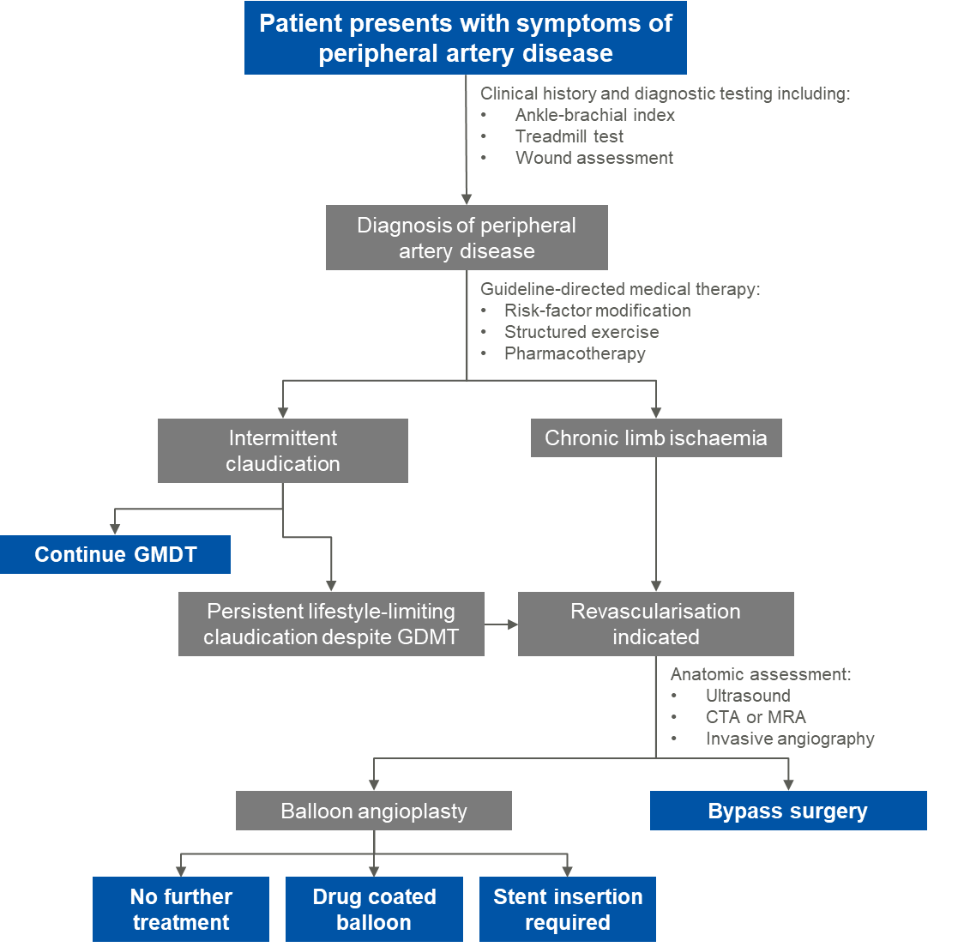
Abbreviations: CTA, computed tomography angiography; GDMT, guideline-directed medical therapy; MRA, magnetic resonance angiography
Source: Adapted from (Gerhard-Herman et al., 2017) Figures 1 and 2

Define and summarise the PROPOSED clinical management pathway (algorithm) that patients would follow after the proposed service/technology is introduced, including variation in health care resources.
The proposed clinical management algorithm is depicted in Figure 2. If anatomic assessment reveals at least moderate calcification, the patient would be eligible for treatment with IVL in place of balloon angioplasty. After treatment with IVL, the Disrupt PAD III trial demonstrated that significantly fewer patient would require stent insertion and would instead receive either no further treatment or treatment with DCB.
Figure 2 Proposed clinical management algorithm
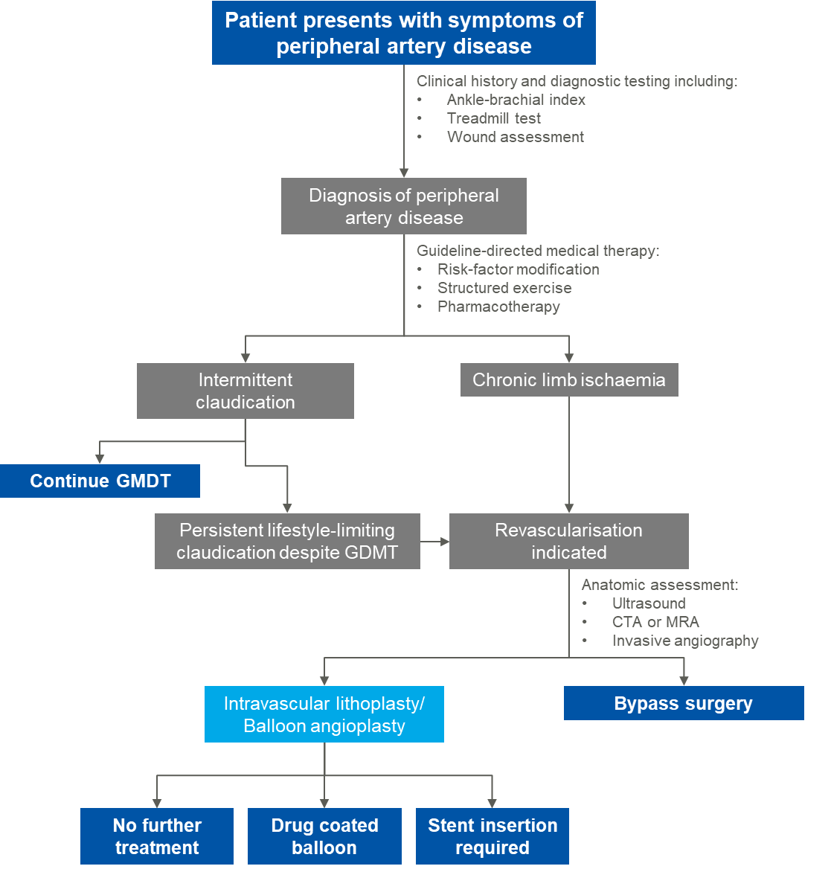
Abbreviations: CTA, computed tomography angiography; GDMT, guideline-directed medical therapy; MRA, magnetic resonance angiography

PART 6d – INFORMATION ABOUT CLINICAL OUTCOMES

Summarise the clinical claims for the proposed medical service against the appropriate comparator(s), in terms of consequences for health outcomes (comparative benefits and harms):
The clinical claim presented in this submission is that treatment with IVL results in superior procedural success (defined as residual stenosis ≤30% without flow-limiting dissection) compared to balloon angioplasty alone.
IVL is superior at avoiding stent placement, and primary patency at 1- and 2-years compared to treatment with balloon angioplasty.
IVL is non-inferior to balloon angioplasty with respect to safety, measured by major adverse events, defined as unplanned surgical revascularisation or major (above ankle) amputation of the target limb, symptomatic thrombus or embolus requiring treatment, and perforation requiring stent placement or other treatment.

Please state what the overall clinical claim is:
The clinical claim to be presented in this application is that treatment with IVL results in superior effectiveness and non-inferior safety when compared with balloon angioplasty alone.

List the key health outcomes (major and minor – prioritising major key health outcomes first) that will need to be measured in assessing the clinical claim for the proposed medical service/technology (versus the comparator):
 | Outcome | Definition | Clinical claim
Primary effectiveness | Procedural success | Residual stenosis ≤30% without flow-limiting dissection (≥type D). | Superior
Primary safety | Major adverse events | Unplanned surgical revascularisation or major (above ankle) amputation of the target limb, symptomatic thrombus or embolus requiring treatment, and perforations requiring provisional stent placement or other treatment. | Non-inferior
Secondary effectiveness | Primary patency at 12 months | Freedom from clinically-driven target lesion revascularisation and freedom from restenosis as determines by duplex ultrasound or angiogram ≥50% stenosis. Per protocol, acute procedural failure requiring stent placement was considered a loss of primary patency. | Superior
Secondary effectiveness | Walking performance | Measured with Walking Impairment Questionnaire, a subjective measure of patient-perceived walking performance developed for individuals with PAD. | Non-inferior
Secondary effectiveness | PAD severity | Measured with ankle-brachial index. | Non-inferior
Source: (Tepe et al., 2022)

PART 7 – INFORMATION ABOUT ESTIMATED UTILISATION

Estimate the prevalence and/or incidence of the condition in the proposed population:
Peripheral artery disease affects about 10% of people in primary care settings in Australia, with prevalence increasing with age (Conte and Vale, 2018).
In 2021, 15,969 patients received either balloon angioplasty (N=8,805) or stent insertion (N=7,164), according to MBS utilisation statistics for MBS items 35300, 35303, 35306 and 35309.
The proportion of patients who would have sufficient calcification to warrant treatment with IVL has been estimated at approximately 10-20%. Therefore, the total number of eligible patients was calculated between 1,597 and 3,194.

Estimate the number of times the proposed medical service/technology would be delivered to a patient per year:
N/A - Intravascular lithotripsy is not intended to be used as an ongoing medical service.

How many years would the proposed medical service/technology be required for the patient?
N/A
Intravascular lithotripsy is not intended to be used as an ongoing medical service.

Estimate the projected number of patients who will utilise the proposed medical service(s) for the first full year:
As IVL is an acute procedure, the number of services is expected to closely reflect the number of eligible patients. Uptake is not expected to be immediate as clinicians familiarise themselves with the new technology. Based on experience in other markets, the applicant estimates that in the first year, uptake would be approximately 15%.
The total number of procedures expected in the first year would range between 239 to 479.

Estimate the anticipated uptake of the proposed medical service/technology over the next three years, factoring in any constraints in the health system in meeting the needs of the proposed population (such as supply and demand factors), as well as provide commentary on risk of ‘leakage’ to populations not targeted by the service.
IVL is expected to grow at the same rate as the existing services for balloon angioplasty and stent insertion, and is not expected to cause market growth, as clinicians have indicated that the vast majority of patients requiring endovascular revascularisation would currently receive treatment.
The growth rate of MBS items 35300, 35303, 35306 and 35309 averaged 3.5% between 2019-2021. The uptake rate for IVL is expected to grow from 15% in the first year, to 100% of eligible patients receiving the service.
If 10% of currently treated patients (either by balloon angioplasty or stent insertion) are eligible for IVL under the proposed restrictions, and the uptake rate grows to 50% by year 3, the total number of services provided in year 3 is expected to be 914. This includes patients receiving IVL alone, and a small proportion (less than 5%) who may receive subsequent stent insertion.

PART 8 – COST INFORMATION

Indicate the likely cost of providing the proposed medical service. Where possible, please provide overall cost and breakdown:
Although not considered a relevant comparator for the purposes of this application, the proposed fee for IVL has been calculated based on the current fee for peripheral atherectomy. This is due to the fact that the procedure will be performed by similar health professionals, with a similar level of skill required to perform the procedure. The reported procedure time for peripheral atherectomy is approximately 2 hours (Cleveland Clinic, 2019).
The fee for the existing MBS item for peripheral atherectomy (35312) is $913.40. The proposed fee for IVL is based on the difference in predicted procedure time between the two services, with IVL taking approximately 25% less time that atherectomy.
An alternative method for calculating the proposed fee utilises the existing fee for transluminal balloon angioplasty of 1 vessel of 1 limb (MBS item 35300) and the time difference reported in the Disrupt PAD III RCT. Based on the procedure time reported in the clinical trial (89.9 mins for IVL vs 66.5 mins for balloon angioplasty), IVL is estimated to take approximately 35% longer than balloon angioplasty.
Therefore, this application proposes a fee between $685.05 and $736.25.
In addition to the MBS fee for provision of the service, the proposed medical service involves the use of consumables. As outlined in Question 13, the single-use consumables required for this service are the Shockwave S4 or M5 catheter. The IVL generator and connector cable are multi-use.
REDACTED

Specify how long the proposed medical service/technology typically takes to perform:
Procedure time reported in the Disrupt PAD III RCT was 89.9 (±39.6) minutes in the IVL arm.

If public funding is sought through the MBS, please draft a proposed MBS item descriptor to define the population and usage characteristics that defines eligibility for the medical service/technology.
Category 3 – Therapeutic Procedures
Proposed item descriptor:
PERIPHERAL INTRAVASCULAR LITHOTRIPSY including associated balloon dilation of 1 peripheral artery of 1 lower limb, in patients who:
- Have at least moderate calcification, and
- Have Rutherford class at least 2,
excluding associated radiological services or preparation, and excluding aftercare.

If public funding is sought through an alternative (non-MBS) funding arrangement, please draft a service description to define the population and usage characteristics that defines eligibility for the service/technology.

N/A
References
Aitken, S. 2020. Peripheral artery disease in the lower limbs: The importance of secondary risk prevention for improved long-term prognosis. Australian Journal for General Practitioners, 49, 239-244.
Australian Institute of Health and Welfare 2021. Heart, stroke and vascular disease—Australian facts. Canberra: AIHW.
Bradbury, A. W. B. M. D. M. B. A. F., Adam, D. J. M. D. F., Bell, J. P., et al. 2010. Bypass versus Angioplasty in Severe Ischaemia of the Leg (BASIL) trial: An intention-to-treat analysis of amputation-free and overall survival in patients randomized to a bypass surgery-first or a balloon angioplasty-first revascularization strategy. Journal of vascular surgery, 51, 5S-17S.
Chowdhury, M. M., Makris, G. C., Tarkin, J. M., et al. 2017. Lower limb arterial calcification (LLAC) scores in patients with symptomatic peripheral arterial disease are associated with increased cardiac mortality and morbidity. PLOS ONE, 12, e0182952.
Cleveland Clinic. 2019. PAD: Atherectomy [Online]. Available: https://my.clevelandclinic.org/health/treatments/17310-pad-atherectomy [Accessed 15 July 2022.
Conte, S. M. & Vale, P. R. 2018. Peripheral Arterial Disease. Heart, Lung and Circulation, 27, 427-432.
Eid, M. A., Mehta, K., Barnes, J. A., et al. 2021. Global Burden of Disease of Peripheral Artery Disease. Journal of Vascular Surgery, 74, e255.
Fanelli, F., Cannavale, A., Gazzetti, M., et al. 2014. Calcium Burden Assessment and Impact on Drug-Eluting Balloons in Peripheral Arterial Disease. CardioVascular and Interventional Radiology, 37, 898-907.
Gerhard-Herman, M. D., Gornik, H. L., Barrett, C., et al. 2017. 2016 AHA/ACC Guideline on the Management of Patients with Lower Extremity Peripheral Artery Disease: Executive Summary. Vascular Medicine, 22, NP1-NP43.
Hardman, R. L., Jazaeri, O., Yi, J., et al. 2014. Overview of classification systems in peripheral artery disease. Semin Intervent Radiol, 31, 378-88.
Patel, M. R., Conte, M. S., Cutlip, D. E., et al. 2015. Evaluation and treatment of patients with lower extremity peripheral artery disease: consensus definitions from Peripheral Academic Research Consortium (PARC). J Am Coll Cardiol, 65, 931-41.
Rocha-Singh, K. J., Zeller, T. & Jaff, M. R. 2014. Peripheral arterial calcification: prevalence, mechanism, detection, and clinical implications. Catheter Cardiovasc Interv, 83, E212-20.
Tepe, G., Brodmann, M., Bachinsky, W., et al. 2022. Intravascular Lithotripsy for Peripheral Artery Calcification: Mid-term Outcomes From the Randomized Disrupt PAD III Trial. Journal of the Society for Cardiovascular Angiography & Interventions.
Zettervall, S. L., Marshall, A. P., Fleser, P., et al. 2018. Association of arterial calcification with chronic limb ischemia in patients with peripheral artery disease. Journal of vascular surgery, 67, 507-513.

