MSAC Application 1752

Anal human papillomavirus (HPV) and cytology testing in high-risk populations to determine access to high-resolution anoscopy and ablative treatment to prevent anal cancer

PART 1 – APPLICANT DETAILS
- Applicant details (primary and alternative contacts)
Corporation / partnership details (where relevant): Corporation name: St Vincent’s Hospital, Sydney, NSW ABN: 49 389 819 484
Business trading name: St Vincent’s Hospital
- (a) Are you a lobbyist acting on behalf of an Applicant?
No

If yes, are you listed on the Register of Lobbyists?
No

PART 2 – INFORMATION ABOUT THE PROPOSED MEDICAL SERVICE

Application title
Co-dependent application: Anal human papillomavirus (HPV) and reflex cytology testing to determine access to high-resolution anoscopy (HRA) and ablative treatment in high-risk populations.

Provide a succinct description of the medical condition relevant to the proposed service (no more than 150 words – further information will be requested at Part F of the Application Form)
Anal cancer, although relatively rare in Australia, has been rapidly rising in terms of incidence and mortality, with rates increasing over time in both men and women. Anal high-grade squamous intraepithelial lesions¹ (HSIL) are the precursor of squamous cell carcinoma of the anus (SCCA) (Berry et al 2014). Like cervical cancer, human papillomavirus (HPV) infection, primarily HPV type 16, causes approximately 90 per cent of SCCA cases (Berenson et al 2022; Palefsky et al 2011). However, in people living with HIV, approximately 30% of SCCA is caused by non-HPV16 high-risk HPV types (Lin et al 2018). Due to the histological and biological similarities between cervical and anal cancer, HPV vaccination² is expected to be the long-term solution to SCCA prevention; however, the full impact of vaccination programmes will not be felt for decades (Clifford et al 2021).
Individuals with abnormal HPV and cytology tests (see clinical algorithm) would be referred to undergo high- resolution anoscopy (HRA), and if persistent histological HSIL is found, would then undergo treatment, which, like cervical cancer, would significantly reduce anal cancer incidence (Palefsky et al 2022).

Provide a succinct description of the proposed medical service (no more than 150 words – further information will be requested at Part 6 of the Application Form)
This application proposes sampling of the anal canal for HPV testing +/- cytology in populations at high-risk for HSIL and SCCA, including all people living with human immunodeficiency virus (HIV) (both male and female), HIV-negative men who have sex with men (MSM), women diagnosed with HPV-related vulval precancerous lesions or cancer, and solid-organ (e.g. kidney) transplant recipients (Albuquerque 2020; Clifford et al 2021).
Anal HPV testing should be conducted first, with reflex anal cytology only conducted on those patients testing positive for HPV. HPV testing and cytology can be performed on the same sample but should not routinely be conducted at the same time.
Individuals with high-risk anal HPV detected will be referred for diagnostic HRA, depending in some cases on their reflex liquid-based cytology result (see elsewhere). Biopsies for histological evaluation will be collected during HRA to determine the grade of any abnormality. Ablative treatment will be recommended for those individuals with persistent HSIL.

(a) Is this a request for MBS funding?
Yes

If yes, is the medical service(s) proposed to be covered under an existing MBS item number(s) or is a new MBS item(s) being sought altogether?
Amendment to existing MBS item(s) New MBS item(s)

If an amendment to an existing item(s) is being sought, please list the relevant MBS item number(s) that are to be amended to include the proposed medical service:
N/A

1 Also referred to as anal intraepithelial neoplasia (AIN)
2 Noting that the best time to be immunised against HPV is before individuals become sexually active. People who have had sexual contact may already be infected with some types of HPV already, and as such the vaccine will not protect against HPV-related cancers and disease caused by that HPV type.

If an amendment to an existing item(s) is being sought, what is the nature of the amendment (s)?
    - An amendment to the way the service is clinically delivered under the existing item(s)
    - An amendment to the patient population under the existing item(s)
    - An amendment to the schedule fee of the existing item(s)
    - An amendment to the time and complexity of an existing item(s)
    - Access to an existing item(s) by a different health practitioner group
    - Minor amendments to the item descriptor that does not affect how the service is delivered
    - An amendment to an existing specific single consultation item
    - An amendment to an existing global consultation item(s)
    - Other (please describe below):

If a new item(s) is being requested, what is the nature of the change to the MBS being sought?
    - A new item which also seeks to allow access to the MBS for a specific health practitioner group
    - A new item that is proposing a way of clinically delivering a service that is new to the MBS (in terms of new technology and / or population)
    - A new item for a specific single consultation item
    - A new item for a global consultation item(s)

Is the proposed service seeking public funding other than the MBS?
No

If yes, please advise:
N/A

What is the type of service:
Therapeutic medical service Investigative medical service
Single consultation medical service
Global consultation medical service
Allied health service
Co-dependent technology Hybrid health technology
- For investigative services, advise the specific purpose of performing the service (which could be one or more of the following):
- To be used as a screening tool in asymptomatic populations
- Assists in establishing a diagnosis in symptomatic patients
- Provides information about prognosis
- Identifies a patient as suitable for therapy by predicting a variation in the effect of the therapy
- Monitors a patient over time to assess treatment response and guide subsequent treatment decisions

Does your service rely on another medical product to achieve or to enhance its intended effect?
Pharmaceutical / Biological Prosthesis or device
No

(a) If the proposed service has a pharmaceutical component to it, is it already covered under an existing Pharmaceutical Benefits Scheme (PBS) listing?
No

If yes, please list the relevant PBS item code(s):
N/A

If no, is an application (submission) in the process of being considered by the Pharmaceutical Benefits Advisory Committee (PBAC)?
Yes (please provide PBAC submission item number below)
No

If you are seeking both MBS and PBS listing, what is the trade name and generic name of the pharmaceutical?
Trade name: N/A Generic name: N/A

(a) If the proposed service is dependent on the use of a prosthesis, is it already included on the Prostheses List?
No

If yes, please provide the following information (where relevant):
N/A

If no, is an application in the process of being considered by a Clinical Advisory Group or the Prostheses List Advisory Committee (PLAC)?
No

Are there any other sponsor(s) and / or manufacturer(s) that have a similar prosthesis or device component in the Australian market place which this application is relevant to?
No

If yes, please provide the name(s) of the sponsor(s) and / or manufacturer(s):
N/A

Please identify any single and / or multi-use consumables delivered as part of the service?
Single use laboratory and sampling consumables.

PART 3 – INFORMATION ABOUT REGULATORY REQUIREMENTS

Diagnostic
The National Association of Testing Authorities (NATA) and the Royal College of Pathologists Australasia (RCPA) oversee the regulation of pathology testing for clinical purposes. Laboratories require accreditation by a joint NATA/RCPA process to ISO 15189, and specifically accredited to provide genetic testing. This accreditation process covers the technical aspects of the sample reception and processing, laboratory sequencing, analysis pipelines, curation (or interpretation) of results and production of the report to a clinical standard. There are no requirements for use of specific manufacturer’s reagents, equipment or analysis pipelines.
Note: A non-commercial IVD is required to be regulated but not to be listed on the ARTG: testing using an IVD would be delivered only by Approved Practising Pathologists in NATA Accredited Pathology Laboratories (as defined in MBS Pathology table) by referral in line with other tests in the MBS Pathology Table .

(a) If the proposed medical service involves the use of a medical device, in-vitro diagnostic test, pharmaceutical product, radioactive tracer or any other type of therapeutic good, please provide the following details:
Diagnostic high-resolution anoscopy
Type of therapeutic good: Colposcope
Manufacturer’s name: There are a number of colposcopes registered on the TGA that are used for other indications. This application does not support the use of any one device, leaving the choice of device up to the treating specialist.
Sponsor’s name: N/A
Type of therapeutic good: Disposable anoscope
Manufacturer’s name: There are a number of anoscopes that are used in conjunction with colposcopes, registered on the TGA. This application does not support the use of any one device, leaving the choice of device up to the treating specialist.
Sponsor’s name: N/A
Treatment
Type of therapeutic good: ablation systems
Manufacturer’s name: There are a number of ablation systems, including electrocautery, registered on the TGA that are used for other indications. This application does not seek to use a new treatment option but to use established treatment systems to deliver the same type of treatment to a different population. This application does support the use of any one device, leaving the choice of device up to the treating specialist.
Sponsor’s name: N/A

Is the medical device classified by the TGA as either a Class III or Active Implantable Medical Device (AIMD) against the TGA regulatory scheme for devices?
Class III IVD AIMD
N/A

(a) Is the therapeutic good to be used in the service exempt from the regulatory requirements of the
Therapeutic Goods Act 1989?
No

If no, has it been listed or registered or included in the Australian Register of Therapeutic Goods (ARTG) by the Therapeutic Goods Administration (TGA)?
Yes (if yes, please provide details below)
There are a number of electrocautery systems (treatment) registered on the TGA. This application does not support the use of any one device, or indeed type of device leaving the choice of device up to the treating specialist’s preference.

ARTG listing, registration or inclusion number: EMT Healthcare Pty Ltd - Electrocautery system handpiece (420510), Medtronic Australasia Pty Ltd - Electrocautery system, line-powered (411691, 411692, 393532, 393533, 231283), The O R Company Pty Ltd - Electrocautery hand piece and insert - Electrocautery system, line-powered (342792, 352423, 352411, 352426, 342791), Mara Aesthetics – Electrocautery system, battery-powered (328521), INKA Surgical - Electrocautery system handpiece (305497), C R Kennedy & Co Pty Ltd – Electrocautery system electrode (220230), KLS Martin Australia Pty Ltd - Electrocautery system electrode (311513), Olympus Australia Pty Ltd - Electrocautery system electrode (219879), Big Green Surgical Company Pty Ltd – Electrocautery system handpiece (326010), Sonita Medic Enterprises Pty Ltd - Electrocautery system electrode (267029), Promis Medical Australia Pty Ltd - Electrocautery system electrode (212008, 211818)
TGA approved indication(s), if applicable: N/A TGA approved purpose(s), if applicable: N/A

If the therapeutic good has not been listed, registered or included in the ARTG, is the therapeutic good in the process of being considered for inclusion by the TGA?
N/A

Date of submission to TGA: N/A
Estimated date by which TGA approval can be expected: N/A TGA Application ID: N/A
TGA approved indication(s), if applicable: N/A
TGA approved purpose(s), if applicable: N/A

If the therapeutic good is not in the process of being considered for listing, registration or inclusion by the TGA, is an application to the TGA being prepared?
N/A

Estimated date of submission to TGA: N/A Proposed indication(s), if applicable: N/A Proposed purpose(s), if applicable: N/A

PART 4 – SUMMARY OF EVIDENCE
- Provide an overview of all key journal articles or research published in the public domain related to the proposed service that is for your application (limiting these to the English language only). Please do not attach full text articles, this is just intended to be a summary.

Type of study design* | Title of journal article | Short description of research (max 50 words)** | Website link to journal article or research (if available)
Diagnostic
Guideline | International Anal | IANS consensus guidelines to inform anal cancer screening use among various | https://pubmed.ncbi.nlm.nih
International (Stier et al 2024) | Neoplasia Society (IANS)'s consensus guidelines for anal cancer screening | high-risk groups. Anal cancer incidence estimates by age among risk groups provided the basis to identify risk thresholds to recommend screening. Guided by risk thresholds, screening initiation at age 35 years was recommended for MSM and transgender women with HIV. For other people with HIV and MSM and TW not with HIV, screening initiation at age 45 years was recommended. For solid organ transplant recipients, screening initiation beginning from 10 years post-  transplant was recommended. For persons with a history of vulvar precancer or | .gov/38297406/
cancer, screening initiation was recommended starting within 1 year of diagnosis
of vulvar precancer or cancer. Persons aged ≥45 years with a history of
cervical/vaginal HSIL or cancer, perianal warts, persistent (>1 year) cervical HPV16, or autoimmune conditions could be considered for screening with shared decision -
making, provided there is adequate capacity to perform diagnostic procedures
(high-resolution anoscopy [HRA]). Anal cytology, high-risk (hr) human papillomavirus (HPV) testing (including genotyping for HPV16), and hrHPV-cytology
 |  | co-testing are different strategies currently used for anal cancer screening that show acceptable performance.
Cohort | The Natural History of Anal | 617 HIV-positive and HIV-negative GBM aged ≥35 years were enrolled. Anal | https://pubmed.ncbi.nlm.nih
Australia (2021) (Poynten et al 2021) | High-grade Squamous Intraepithelial Lesions in Gay and Bisexual Men | cytology and HRA were performed at baseline and 3 annual visits. A composite HSIL diagnosis (cytology ± histology) was used. 124 incident cHSIL cases occurred over 1097.3 person-years (PY) follow-up. Significant bivariate predictors of higher incidence included age <45 years (HR 1.64), HIV positivity (HR 1.43), prior SIL  diagnosis (P-trend < .001) and HPV16 (HR 3.39). Over 695.3 PY follow-up, 153 HSIL | .gov/32342984/

 |  | cleared (clearance 22.0 per 100 PY). Predictors were age < 45 years (HR 1.52), anal intraepithelial neoplasia (AIN)2 rather than AIN3 (HR 1.79), smaller lesions (HR 1.62) and no persistent HPV16 (HR 1.72). There was one progression to cancer (incidence 0.224). Not all anal HSIL detected in screening requires treatment. Men with persistent HPV16 were less likely to clear HSIL and were more likely to benefit from effective HSIL treatments.
Systematic | A systematic review and | A total of 39 articles were included. The prevalence of HSIL (AIN2+) was 20% (95% | https://pubmed.ncbi.nlm.nih
review and | meta-analysis of cytology | CI, 17-29%), and ranged from 22% in MSM living with HIV to 13% in women and | .gov/35793241/
meta-analysis  USA (2022)  (Clarke et al 2022) | and HPV-related biomarkers for anal cancer screening among different risk groups | 12% in MSM without HIV. The sensitivity and specificity of cytology and HPV testing were 81% and 62% and 92% and 42%, respectively, and 93% and 33%, respectively for cytology and HPV co-testing.
Systematic | The Accuracy of Anal | From a total of 22 studies, using cytology with a cut-off of any SIL to detect HSIL | https://pubmed.ncbi.nlm.nih
review and meta-analysis  Netherlands (2019) (Dias  Gonçalves Lima et al 2019) | Swab-Based Tests to Detect High-Grade Anal Intraepithelial Neoplasia in HIV-Infected Patients: A Systematic Review and Meta-analysis | sensitivity was 82% and specificity was 45%; with the cut-off of HSIL, sensitivity was 44% and specificity was 79%. For HPV testing, sensitivity was 91% and specificity was 27%. For MSM, the PPV of cytology with a cut-off of any SIL was 36% and NPV was 87%, whereas cytology with a cut-off of HSIL had a PPV of 62% and an NPV of 78%. The PPV of HR-HPV detection was 37% and NPV was 87%. | .gov/31123696/
Comparative | The performance of anal | At baseline, all participants underwent a liquid-based anal cytology test and the | https://pubmed.ncbi.nlm.nih
Australia (2016) (Jin et al 2016) | cytology as a screening test for anal HSILs in homosexual men | diagnostic test, high-resolution anoscopy (HRA) at the same time. Biopsies were obtained for histological assessment if lesions suspicious for HPV infection were visible during HRA. Overall, the sensitivity of cytology was 83.2%, specificity 52.6%, the PPV 45.8%, and the NPV 86.7%. Specificity improved with increasing age. | .gov/26915346/
Observational | Effect of the introduction | Among 28,175 individuals in HIV care (59·7% MSM), 227 primary anal cancer cases | https://pubmed.ncbi.nlm.nih
cohort | of screening for cancer | were diagnosed. Despite the increasing average age of the cohort, crude incidence | .gov/36640800/
Netherlands (2023)  van der Zee et al | precursor lesions on anal cancer incidence over time in people living with HIV: a nationwide cohort study | rates of anal cancer in MSM declined slowly over time, from 107·0 per 100 000 person-years in 1996–2005 to 93·7 per 100 000 person-years in 2013–20 (p=0·49). Crude incidence rates in men who do not have sex with men (non-MSM) and women were generally lower than in MSM, but increased slightly over time, from 51·08 to 67·82 (p=0·52) per 100 000 person-years in non-MSM and from 8·09 to

 |  | 24·95 (p=0·29) per 100 000 person-years in women. Anal cancer-related mortality was 3·7% in all men who had been screened and 24·0% in men who had not been screened (p=0·023).
Comparative | Comparison of four assays | A total of 475 participants had baseline results available for all 4 assays (166, | https://www.sciencedirect.c
cohort | for human papillomavirus | 35.0% HIV positive), and 169 participants had a diagnosis of cytological and/or | om/science/article/abs/pii/S
Australia (2022) (Poynten et al 2022) | detection in the anal canal | histological HSIL.HPV16 and any HRHPV detection were highest with Anyplex II HPV28 (+) (156, 32.8% 95% CI 28.6-37.2 and 359, 75.6%, 95% CI 71.5-79.4  respectively). For detection of concurrent HSIL and HPV16, the assay sensitivity was similar ranging from 49.1%, 95% CI 41.4-56.9 (Anyplex II HPV28 ++) to 55.0%, 95% CI 47.2-62.7 (Anyplex II HPV28 +). For concurrent HSIL and any HRHPV  detection, EuroArray was more specific than Anyplex II HPV28 (+) (45.9% 95% CI 40.2-51.7 vs 36.7%, 95% CI 31.3-42.4, p=0.021) and had comparable specificity | 1198743X22003421
 |  | with Anyplex II HPV28 (++) (45.9% vs 47.2%, 95% CI 41.5 -53.0, p=0.75). All assays had high sensitivities for predicting HPV16 detected on LCM (92.5 -97.5%). Anyplex II HPV28 and EuroArray were significantly more sensitive than LA for lesions caused by non-HPV16 HRHPV types on LCM
Comparative | Prevalence and risk factors | At the baseline visit all men underwent anal swabbing for cytology and HPV | https://pubmed.ncbi.nlm.nih
Australia (2016) (Machalek et al 2016) | associated with high-grade anal squamous intraepithelial lesions (HSIL)-AIN2 and HSIL-AIN3  in homosexual men | genotyping, followed by high resolution anoscopy. Composite-HSIL prevalence was 47% and 32% among 220 HIV-positive and 396 HIV-negative men, respectively.  HSIL-AIN3 (37.7% versus 24.7%; p<0.001), but not HSIL-AIN2 (9.5% versus 7.6%;  p=0.395) was more common in HIV-positive men. Recent receptive anal partners (p-trend=0.045), and increasing number of high-risk (HR)-HPV types (p- trend<0.001) were associated with HSIL-AIN2. Lifetime receptive partners (p-  trend<0.001), HIV status (OR 1.74) and HPV16 (OR 3.00) were associated with | .gov/29074193/
HSIL-AIN3. HPV16 was the most common HR-HPV type detected in men with HSIL- AIN3, both HIV-negative (61.1%) and HIV-positive (54.9%). HPV16 was less commonly detected in men with HSIL-AIN2. Given the strong link between HPV16
and anal cancer, men with HSIL-AIN3 and HPV16 are likely to be at greatest risk of
 |  | cancer.
Cost- effectiveness  USA (2017) | Management of precancerous anal intraepithelial lesions in  human immunodeficiency | A decision analytic model of the natural history of anal carcinoma and HSIL management strategies was constructed for HIV-positive MSM who were 27 years old or older. Outcomes included the lifetime cost, life expectancy, quality-adjusted  life expectancy, cumulative risk of cancer and cancer-related deaths, and cost- | https://pubmed.ncbi.nlm.nih  .gov/28950043/

(Deshmukh et al 2017) | virus-positive men who have sex with men: Clinical effectiveness and cost- effectiveness | effectiveness from a societal perspective. Active monitoring was the most effective approach in patients 29 years or younger; thereafter, HSIL treatment plus adjuvant qHPV vaccination became most effective. When cost-effectiveness was considered, do nothing was cost-effective until the age of 38 years, and HSIL treatment plus adjuvant qHPV vaccination was cost-effective beyond the age of 38 years. The ICER decreased as the age at HSIL management increased. Outcomes were sensitive to the rate of HSIL regression or progression and the cost of high- resolution anoscopy and biopsy.
Cohort | 5-Year Prospective | 363 HIV+ MSM had anal cytology and a high-resolution anoscopy at baseline. For | https://pubmed.ncbi.nlm.nih
USA (2019)  (Clarke et al 2019) | Evaluation of Cytology, Human Papillomavirus Testing, and Biomarkers for Detection of Anal Precancer in Human Immunodeficiency Virus-  Positive Men Who Have | each biomarker (HPV16/18, HPV E6/E7 mRNA, and p16/Ki-67), baseline sensitivity and specificity for a combined endpoint of HSIL and anal intraepithelial neoplasia grade 2 or more severe diagnoses (HSIL/AIN2+), were calculated. 2- and 5-year cumulative risks of HSIL/AIN2+ were calculated. 129 men were diagnosed with HSIL/AIN2+ during the study. HR-HPV testing had the highest positivity and sensitivity of all assays, but the lowest specificity. HPV16/18 and HPV E6/E7 mRNA  had high specificity, but lower sensitivity. The 2- and 5-year risks of HSIL/AIN2+ | .gov/30418518/
 | Sex With Men | were highest for those testing HPV16/18- or HPV E6/E7 mRNA-positive, followed by those testing dual stain-positive. Those testing HR-HPV- or dual stain-negative  had the lowest 2- and 5-year risks of HSIL/AIN2+. HPV-related biomarkers provide
 |  | long-term risk stratification for anal precancers.
Cohort | Anal Cancer Screening in | 723 HIV-infected and 788 HIV-uninfected MSM with ACyt, with a second ACyt | https://pubmed.ncbi.nlm.nih
USA (2016)  (DʼSouza et al  2016) | Men Who Have Sex With Men in the Multicenter AIDS Cohort Study | collected 2 years later. A referral for high-resolution anoscopy was suggested for abnormal ACyt. Prevalence of any abnormal ACyt was 25% in HIV-uninfected MSM and increased to 38% -47% among HIV-infected MSM. Anal HPV16 DNA was also more common in HIV-infected than HIV-uninfected MSM (25% versus 16%, P < 0.001). Abnormal baseline ACyt together with prevalent HPV16 DNA detection was present in only 7% of HIV-uninfected MSM compared to 18% of HIV-infected MSM  with current CD4 < 350, P < 0.001. 19% of untreated HIV-infected men with ASC- | .gov/26656784/
H/HSIL cytology maintained that same grade of cytology in their second test approximately 2 years later, and 15% with ASC-US/LSIL "progressed" to ASC-
H/HSIL. Abnormal ACyt had high sensitivity (96%) but low specificity (17%) for
 |  | biopsy-proven HSIL.

Comparative | Comparing Anal Cancer | Comparison of anal cytology to high-risk human papillomavirus (hrHPV) DNA | https://pubmed.ncbi.nlm.nih
USA (2021)  (Gaisa et al 2021) | Screening Algorithms Using Cytology and Human Papillomavirus DNA Testing in 3 High-Risk Population | testing and 2 novel cytology/hrHPV co-testing algorithms among 3 high-risk populations: 1837 participants (1504 HIV-infected men who have sex with men (MSM), 155 HIV-uninfected MSM, and 178 HIV-infected women).  Performance to detect HSIL/cancer was compared between 4 strategies.  Histological HSIL/cancer was detected in 756 (41%) participants. Cytology had the lowest sensitivity (0.76-0.89) but highest specificity (0.33-0.36) overall and for each | .gov/33388757/
subgroup. Algorithm B was the most sensitive strategy overall (0.97) and for MSM (HIV-infected 0.97; HIV-uninfected 1.00). For women, hrHPV testing and both algorithms yielded higher sensitivity than cytology (0.96, 0.98, and 0.96).
Specificity was low for all strategies/subgroups (range, 0.16-0.36). Cytology and
 |  | hrHPV testing significantly increased sensitivity but decreased specificity to detect anal precancer/cancer among high-risk populations.
Retrospective | Performance of Anal Cytology Compared With High-Resolution Anoscopy and Histology in Women With Lower Anogenital Tract Neoplasia | Retrospective study of 636 anal cytology samples and 323 biopsies obtained from | https://pubmed.ncbi.nlm.nih
cohort  United Kingdom (2018)  (Albuquerque et al 2018) |  | 278 women with a previous history of anogenital neoplasia with concomitant anal cytology and high-resolution anoscopy with or without biopsies. Overall sensitivity and specificity of "any abnormality" on anal cytology to predict any abnormality in histology was 47% and 84%, respectively. For detecting high-grade squamous intraepithelial lesions (HSIL)/cancer, sensitivity was 71% and specificity was 73%. There was a poor concordance between cytological and histological grades (κ = 0.147). Cytology had a higher sensitivity to predict HSIL/cancer in immunosuppressed vs non-immunosuppressed patients (92% vs 60%, P = .002). A  previous history of vulvar HSIL/cancer (OR 1.71), immunosuppression (OR 1.88 ), | .gov/29659752/
 |  | and concomitant genital HSIL/cancer (OR 2.51) were risk factors for abnormal cytology.
Retrospective | Detection of oncogenic | Retrospective chart review of men who have sex with men undergoing anal | https://pubmed.ncbi.nlm.nih
comparative  USA (2009)  (Goldstone et al 2009) | human papillomavirus and other predictors of anal high-grade dysplasia in men who have sex with  men with abnormal | screening with atypical squamous cells of undetermined significance cytology, Hybrid-Capture(R) II testing, and biopsy. A total of 597 men who have sex with men enrolled and had 1,015 atypical squamous cells of undetermined significance cytology results: 185 (18.2 percent) had HSIL and 156 (84 percent) HPV+. The rates  for sensitivity, specificity, positive predictive value, and negative predictive value | .gov/19273953/
 | cytology | were 84, 53, 29, and 94 percent, respectively. Of 390 low-grade squamous  intraepithelial lesion cytology results, HSIL was found in 141 and 127 (90%) were

HPV+. Those with previous HSIL or human immunodeficiency virus had increased risk of HSIL (hazard ratio = 2.2 and 1.95, respectively).
Referring only those with oncogenic human papillomavirus for biopsy reduces the number requiring this by almost half but some HSIL are missed.
Case series | Evaluation of HPV-Related | The association between high-risk (hr)HPV DNA, HPV16/18 DNA, hrHPV E6/E7 | https://pubmed.ncbi.nlm.nih
Italy (2021) (Rollo et al 2021) | Biomarkers in Anal Cytological Samples from HIV-Uninfected and HIV- Infected MSM | mRNA, and p16/Ki-67 with cytological abnormalities (any grade) and high-grade intraepithelial lesions (HSIL) was assessed in HIV-uninfected and HIV-infected MSM. 150 cytological samples in PreservCyt (Hologic), negative to HSIL report, were analysed. In HIV-infected MSM, positivity for all the biomarkers significantly increased with the cytological grade. In both populations, the association of hrHPV E6/E7 mRNA and p16/Ki-67 positivity with HPV16 did not differ significantly  compared to hrHPVs other than HPV16. In HIV-uninfected MSM, the odds of | .gov/34358038/
having an HSIL increased approximately six times for the p16/Ki-67 positive cases. In HIV-infected individuals, all the biomarkers showed a significant association
with HSIL, except for hrHPV DNA, with the strongest association observed for p16/Ki-67. The odds of HSIL increased almost 21 times in those positive for this
 |  | biomarker.
Case series | Anal Cytological Lesions | 1021 MSM, 38.0% were HIV-infected Anal cytological lesions were observed in | https://pubmed.ncbi.nlm.nih
Italy (2018) (Donà et al 2018) | and HPV Infection in Individuals at Increased Risk for Anal Cancer | 32.5% and 53.2% of the HIV-uninfected and HIV-infected individuals, respectively (P<.0001). The highest ASCUS1 prevalence was observed among >45-year-old HIV- uninfected MSM (37.3%) and 25-to 29-year-old HIV-infected MSM (66.7%). High- grade squamous intraepithelial lesions (HSILs) peaked in >45-year-old HIV- uninfected subjects and 35- to 39-year-old HIV-infected subjects. Individuals with  anal infections with high-risk (HR) HPV types were 3 to 4 times more likely to have | .gov/29694716/
an ASCUS1 report. An HPV-16 and/or HPV-18 infection increased the odds of HSIL or more severe cytology (HSIL1) for HIV-infected MSM almost 4 times. MSM
concurrently infected with HR and low risk HPVs were significantly more likely to have low-grade squamous intraepithelial lesions or more severe cytology (LSIL1)
 |  | than those infected with only HR types.
Retrospective case series | Screening for Squamous Cell Anal Cancer in HIV | A retrospective study on 204 HIV patients who underwent a screening program for SCC with digital anorectal examination, anal Pap test, including HPV test and cytology, and high-resolution video-proctoscopy (HR-VPS) with and without acetic  acid 3%. Depending on macroscopic appearance and biopsies, patients underwent | https://pubmed.ncbi.nlm.nih  .gov/28644711/

Italy (2018) (Santorelli et al 2018) | Positive Patients: A Five- Year Experience | observation or treatment. Median follow-up was 36 months. Cytologic abnormalities (Cyt+) for high-risk HPV genotypes were recorded in 34% of patients. HR-VPS was positive in 59 patients (29%), of whom 13 patients (22%) were positive for warts; the rest have typical features of anal intraepithelial neoplasia (AIN).  Sixteen (8%) patients had AIN (AIN I-III) and underwent wide local excision, ablation, or imiquimod. Absence of progression was recorded. Fourteen patients (7%) had SCC: eight (57%) with no evidence of recurrence, two (14%) had recurrence, and four (29%) died from metastatic disease.
Treatment
RCT | Treatment of Anal High- | 4,459 persons living with HIV (>35 years of age) with biopsy-proven anal HSIL were | https://pubmed.ncbi.nlm.nih
USA (2022)  (Palefsky et al 2022) | Grade Squamous Intraepithelial Lesions to Prevent Anal Cancer | randomly assigned, in a 1:1 ratio, to receive either HSIL treatment or active monitoring without treatment. Treatment included office-based ablative procedures, ablation or excision under anaesthesia, or the administration of topical fluorouracil or imiquimod. With a median follow-up of 25.8 months, 9 cases were diagnosed in the treatment group (173 per 100,000 person-years) and 21 cases in the active monitoring group (402 per 100,000 person-years). The rate of  progression to anal cancer was lower in the treatment group than in the active | .gov/35704479/
 |  | monitoring group by 57% (95% CI, 6 to 80; p = 0.03).
RCT | A Randomized Clinical Trial | 120 HIV-infected adults aged ≥27 years with 1-3 biopsy-proven anal HSILs were | https://pubmed.ncbi.nlm.nih
USA (2019)  (Goldstone et al 2019) | of Infrared Coagulation Ablation Versus Active Monitoring of Intra-anal High-grade Dysplasia in Adults With Human  Immunodeficiency Virus | randomised 1:1 to HSIL ablation with IRC (treatment) or no treatment (active monitoring). Complete index HSIL clearance occurred more frequently in the treatment group than in the AM (62% vs 30%, p < .001). Complete or partial  clearance (clearance of ≥1 index HSIL) occurred more commonly in the treatment group (82% vs 47%; p < .001). Having a single index lesion, compared with having 2-3 lesions, was significantly associated with complete clearance (relative risk, | .gov/30060087/
 | Infection: An AIDS Malignancy Consortium Trial | 1.96).
Cohort  Canada (Walker et al 2024) | Anal Cancers in Previously Screened Versus Unscreened Patients: | Targeted screening programs for patients at high risk for anal squamous-cell carcinoma. Patients diagnosed through a high-risk screening program were compared to those who did not undergo screening. A total of 612 patients with  anal SCC were included, with 26 of those patients diagnosed through a screening | https://pubmed.ncbi.nlm.nih  .gov/37787557/

 | Tumor Stage and Treatment Outcomes | program. Patients with screen-detected cancers had greater odds of presenting with T1N0M0 tumors compared to unscreened patients (18 [69.2%] vs 84 [14.3%]; adjusted OR 9.95; 95% CI,3.95–25.08). A propensity score–matched sensitivity analysis found similar results (OR 11.13; 95% CI, 4.67– 26.52). Screened patients had greater odds of treatment with wide local excision alone, as opposed to any combination of chemotherapy, radiation therapy, and surgery (3 [12.5%] vs 18 [3.2%]; OR 4.38; 95% CI, 1.20 -16.04).
Retrospective cohort  USA (2019)  (Kobayashi et al 2019) | Anal Cancer Precursor Lesions in HIV-Infected Persons: Tissue Human Papillomavirus Type Distribution and Impact on Treatment Response | Seventy-nine HIV-infected patients with a diagnosis of anal high-grade squamous intraepithelial lesions. Of 79 anal high-grade squamous intraepithelial lesions, 71 (90%) tested positive for ≥1 human papillomavirus type; 8 (10%) had no human papillomavirus detected. The most common type was 16 (39%), followed by 33 (15%). Human papillomavirus type 18 was seen in 3%. Sixty-one patients (77%) underwent electrocautery ablation and had subsequent surveillance biopsies.  Surveillance biopsies yielded benign findings or low-grade squamous intraepithelial lesions in 31 (51%) of 61 and recurrent high-grade squamous intraepithelial lesions in 30 (49%) of 61 patients (mean follow-up: 35 mo) | https://pubmed.ncbi.nlm.nih  .gov/30570548/
Prospective case series  USA (2017)  (Goldstone et al 2017) | A trial of radiofrequency ablation for anal intraepithelial neoplasia | 21 HIV-negative participants with HSIL occupying ≤ half the anal canal circumference were treated with hemi-circumferential anal canal RFA. Participants were assessed every 3 months for 12 months with high-resolution anoscopy; recurrence in the treatment zone was re-treated with focal RFA. Six (29 %) participants had recurrent HSIL within the treated hemi-circumference within 1 year. Four participants (19 %) had persistence of an index lesion at 3 months. One  (2.9 %) index HSIL persisted again at 12 months. No participants had more than two RFA treatments. Predicted HSIL-free survival within the treatment zone at 1 year was 76 % (95 % CI 52-89 %). Comparing the first 7 and last 14 participants, the  predicted 1-year HSIL-free survivals are 43 % (95 % CI 10-73 %) and 93 % (95 % CI 59-99 %), respectively (p = 0.008), suggesting a learning curve with the treating physician. | https://pubmed.ncbi.nlm.nih  .gov/27770248/
Retrospective case series  USA (2020) | Electrocautery ablation of anal high-grade squamous intraepithelial lesions: Effectiveness and key | A total of 330 people living with HIV with de novo intra-anal HSIL who were treated with electrocautery ablation were studied retrospectively. Approximately 88% of participants were men who have sex with men and approximately 49% had multiple index HSILs (range, 2-6 index HSILs). At a median of 12.2 months post-  ablation (range, 6.3-20.9 months post-ablation), approximately 45% of participants | https://pubmed.ncbi.nlm.nih  .gov/31977082/

(Gaisa et al 2020) | factors associated with outcomes | had developed local recurrence whereas 60% had developed overall recurrence. Current cigarette smoking, HIV viremia (HIV-1 RNA ≥100 copies/mL), and multiple index HSILs were found to be predictive of local recurrence. Overall recurrence was more common in current smokers and those with multiple index lesions. In multivariable models that included human papillomavirus (HPV) genotypes, baseline and persistent infections with HPV-16 and/or HPV-18 were found to be significantly associated with both local and overall recurrence.
Retrospective | Outcomes of | Retrospective analysis of 12 patients with impaired immune function and anal | https://pubmed.ncbi.nlm.nih
case series  Mexico (2021)  (Vergara- Fernandez et al 2021) | radiofrequency ablation for anal high-grade squamous intraepithelial lesions | HSILs who underwent RFA. Patients were assessed for recurrence at 3-month intervals with high-resolution anoscopy (HRA) and targeted biopsy. At 12 months, HRA showed that 7/12 (58.3%) patients were normal, 3/12 patients had recurrent HSILs, and 2/12 had a persistent lesion. Lesions were treated with electrocautery, and reached complete response in the following the 6 months. Targeted plus circumferential RFA had a 58.3% efficacy rate for the treatment of anal HSIL in immunocompromised patients, achieving 100% eradication after adding electrocautery ablation. | .gov/33590436/

- Identify yet to be published research that may have results available in the near future that could be relevant in the consideration of your application by MSAC (limiting these to the English language only). Please do not attach full text articles, this is just intended to be a summary.

 | Type of study design* | Title of research (including any trial identifier if relevant) | Short description of research (max 50 words)** | Website link to research (if available) | Date***
Diagnostic
 | Comparative | The potential role of | The reflex use of anal liquid-based cytology (LBC) in addition to HPV testing in | Available on
 | cohort  Unpublished study  Australia | reflex anal cytology testing in anal cancer screening using human papillomavirus (HPV) testing in gay and  bisexual men (GBM). | detection of persistent anal high-grade intraepithelial lesion (HSIL) in a cohort of GBM in Sydney, Australia. 503 participants had valid HPV, cytological, and histological results, 180 (35.8%) were HIV-positive. Among them, 170 (33.8%) tested HPV16 positive at baseline and 173(34.4%) had persistent non-16 HRHPV infection. Guided by HPV screening alone, the theoretical referral rate,  sensitivity and specificity for detection of persistent HSIL (n=93, 18.5%) was | request
 |  | Jin et al | 68.2%, 97.8%, and 38.5%, respectively. This was compared with 58.8%, 89.2% and 48.0% using anal LBC alone. The reflex use of anal LBC in addition to HPV testing resulted in markedly lower referral (48.5%), improved specificity (60.2%) and maintained high sensitivity (87.1%).
 | Chort | Seville Cohort of People | 3,000 patients: cohort comprising HIV-infected men who have sex with men, | NCT03713229 | Estimated
 | Spain | Living With HIV at Risk for Anal Cancer (SeVIHanal) | HIV-infected men and HIV-infected women undergoing diagnostic testing for anal squamous intraepithelial lesions digital-anorectal exam, liquid-based cytology, human papillomavirus testing, high-resolution anoscopy. |  | study completion  31-12-2030
 | Single arm, | Screening Women With | 300 HIV uninfected women with a history of genital neoplasia (ie., cervical | NCT05217940 | Estimated
 | case series | Prior HPV for Anal | intraepithelial neoplasia grade 2-3, vaginal intraepithelial neoplasia grade 2-3 or |  | study
 | USA | Neoplasia (SWAN) | vulvar intraepithelial neoplasia grade 2-3) or early stage cervical or vulvar cancer to evaluate the test characteristics of anal cancer screening tests  (cytology, HPV testing and high resolution anoscopy) and determine the |  | completion  11-2026
 |  |  | prevalence and incidence of anal high-grade squamous intraepithelial lesions in this population. Participants will undergo evaluation at baseline and then at 12 and 24 months.

 | Type of study design* | Title of research (including any trial identifier if relevant) | Short description of research (max 50 words)** | Website link to research (if available) | Date***
Diagnostic and treatment
 | Case series Canada | Screening for Anal Cancer in Women With High- grade Vulvar Dysplasia or Vulvar Cancer. | 110 women with existing gynaecological lesions undergo anal Pap smears, followed by High Resolution Anoscopy (HRA) and appropriate treatment procedures on those with abnormal anal cells. | NCT03061435 | Estimated study completion 01-02-2023

PART 5 – CLINICAL ENDORSEMENT AND CONSUMER INFORMATION

List all appropriate professional bodies / organisations representing the group(s) of health professionals who provide the service (please attach a statement of clinical relevance from each group nominated):
Royal Australasian College of Physicians, Sexual Health Chapter Royal Australasian College of General Practitioners
Colorectal Surgical Society of Australia and New Zealand Royal Australasian College of Surgeons
Royal Australian and New Zealand College of Obstetricians and Gynaecologists

List any professional bodies / organisations that may be impacted by this medical service (i.e. those who provide the comparator service):
N/A

List the consumer organisations relevant to the proposed medical service (please attach a letter of support for each consumer organisation nominated):
Australasian Society for HIV, Viral Hepatitis and Sexual Health Medicine (ASHM) https://ashm.org.au/ Mardi Gras https://www.mardigras.org.au/
Positive Life NSW https://www.positivelife.org.au/
National Association of People with HIV Australia (NAPWHA) https://napwha.org.au/ ACON https://www.acon.org.au/
Health Equity Matters https://healthequitymatters.org.au/about-us/
Transplant Australia https://transplant.org.au/
Bowel Cancer Australia https://www.bowelcanceraustralia.org/

List the relevant sponsor(s) and / or manufacturer(s) who produce similar products relevant to the proposed medical service:
N/A. This application is not seeking MBS funding for a specific test.

PART 6 – POPULATION (AND PRIOR TESTS), INTERVENTION, COMPARATOR, OUTCOME (PICO)
PART 6a – INFORMATION ABOUT THE PROPOSED POPULATION

Define the medical condition, including providing information on the natural history of the condition and a high-level summary of associated burden of disease in terms of both morbidity and mortality:
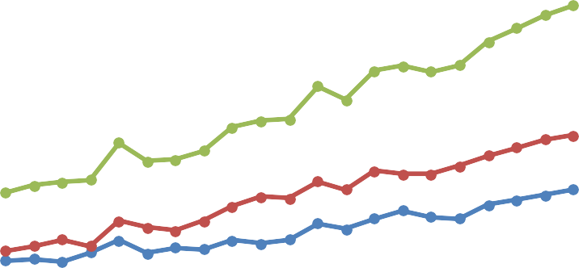
Anal cancer, although relatively rare in Australia, has been rapidly rising in terms of incidence and mortality, with both rates increasing over time (Figure 1 to Figure 4). Although more often regarded as a cancer associated with gay and bisexual men, especially those who are human immunodeficiency virus (HIV)-positive, the incidence in Australian women is higher than in men and increasing (Lum et al 2020; Palefsky et al 2022). Women diagnosed with HPV-related gynaecological pre-cancerous lesions or cancer, as well as solid organ transplant recipients and patients with autoimmune diseases such as systemic lupus erythematosus, ulcerative colitis or Crohn's disease, are at higher-than-average risk of anal cancer (Clifford et al 2021).
700

600

500

400
Males
Females Persons
300

200

100

0
Year
Number of new cases

Figure 1 The number of new anal cancer cases in Australia (2001-2021)(AIHW 2021a)
2001
2002
2003
2004
2005
2006
2007
2008
2009
2010
2011
2012
2013
2014
2015
2016
2017
2018
2019
2020
2021
The natural history of anal cancer is not as well characterised as that of cervical cancer; however, there are similarities. Persisting high-risk HPV infection can lead to the development of HSIL (categorised as AIN 2 and 3). Persisting infection with low-risk HPV genotypes can lead to the development of low grade squamous intraepithelial lesions (LSIL or AIN 1), which are not usually associated with progression to invasive malignancy (Lum et al 2020). HSIL are the precursor of squamous cell carcinoma of the anus (SCCA), which represent approximately 70-80% of all anal cancers (Berry et al 2014; Lum et al 2020). Human papillomavirus (HPV) infection has a causal relationship in over 90 per cent of SCCA cases (Berenson et al 2022; Palefsky et al 2011). HIV co-infection markedly increases the risk of HPV-associated anal SCC, particularly in those individuals with low CD4 counts (Lum et al 2020).

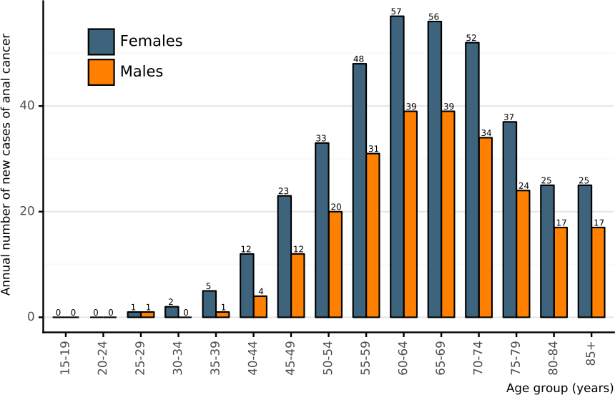

Figure 2 Estimated number of new cases of anal cancer in Australia for 2020) by sex and age (Bruni et al 2021)
2.5

2.0

1.5

1.0

0.5
Males
Females Persons
0.0
Year
Rate per 100,000

Figure 3 Rate of new anal cancer cases (per 100,000) in Australia (2001-2021) (AIHW 2021a)
2001
2002
2003
2004
2005
2006
2007
2008
2009
2010
2011
2012
2013
2014
2015
2016
2017
2018
2019
2020
2021
Anal cancer is among the limited number of cancer types, including cervical and colon cancer, that are potentially preventable through treatment of known cancer precursors. Programs that identify HSIL early enable the early detection, prevention, and treatment of anal cancer. Due to the histological and biological similarities between SCC of the anus and cervix, and the causal association with infection with HPV, like cervical cancer, the treatment (most often by ablation) of HSIL significantly reduces the progression to anal
cancer (Palefsky et al 2022). Patients treated for anal HSIL (primarily office-based electrocautery) have rates of progression to anal cancer approximately 60% lower than those who only undergo active monitoring without treatment (Palefsky et al 2022).
Like cervical cancer, gender-neutral HPV vaccination is expected to be the long-term primary prevention strategy to SCCA; however, the full impact of vaccination programmes will not be felt for decades (Clifford et al 2021).

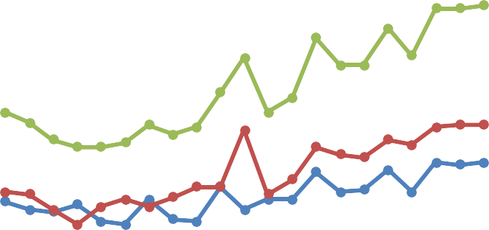
Figure 4 Number of deaths per year from anal cancer in Australia, by sex (2011-2021)(AIHW 2021b)
120

100

80

60
Males
Females
Persons
40

20

0
Number of Deaths
2001
2002
2003
2004
2005
2006
2007
2008
2009
2010
2011
2012
2013
2014
2015
2016
2017
2018
2019
2020
2021

Specify any characteristics of patients with the medical condition, or suspected of, who are proposed to be eligible for the proposed medical service, including any details of how a patient would be investigated, managed and referred within the Australian health care system in the lead up to being considered eligible for the service:
Revised population:
- Men who have sex with men (MSM) and transgender women (TW) living with HIV (LHIV), commencing age 35 years
- Non-MSM LHIV, MSM and TW without HIV, commencing age 45 years
- Women with previous vulval SCC/HSIL (HPV-associated), commencing within 1 year of diagnosis
- Solid organ transplant recipient (SOTR), commencing 10 years post-transplant
- People outside these above groups with incidental HSIL eg lesions found at haemorrhoidectomy, colonoscopy or during the diagnosis of other anal conditions
- People being followed up after treatment for anal cancer (chemoradiotherapy/surgery)
In 2024, international consensus, evidence-based, guidelines for anal cancer testing in high-risk populations were published (Stier et al 2024). The International Anal Neoplasia Society (IANS) assembled a task force of 17 international experts, including three members from Australia, representing six countries with a wide range of expertise in the field. The IANS taskforce determined the populations that should be tested based on the evaluation of anal cancer incidence in different populations, optimal testing tools, and developed triage algorithms.
A sub-group of the IANS taskforce undertook a literature review and meta-analysis of anal cancer incidence in groups at established elevated anal cancer risk (Clifford et al 2021). An anal cancer risk scale was developed (Figure 7), demonstrating that MSM living with HIV have the highest incidence of anal cancer. A recent publication on anal cancer testing in MSM with HIV aged between 18 and 35 years found no anal cancer despite high rates of HRHPV and HSIL (Liu et al 2024). This supports an age-based anal cancer testing strategy for MSM LHIV.
High-risk individuals would normally undergo standard clinical care until they are symptomatic of an anal cancer. For example, a person living with HIV would have a regular CD4+ count and a transplant patient would have regular organ function tests.

Define and summarise the current clinical management pathway before patients would be eligible for the proposed medical service (supplement this summary with an easy to follow flowchart [as an attachment to the Application Form] depicting the current clinical management pathway up to this point):

Patients would receive routine clinical care, which would vary according to their risk profile. Men who have sex with men would be monitored under the care of their general practitioner, or a sexual health physician. Individuals may choose to undergo testing for HIV antibodies in addition to any routine health checks. People living with HIV would be monitored under the care of their general practitioner, or a sexual health practitioner. HIV positive patients typically undergo viral load testing. and have their CD4+ counts taken to monitor therapy effectiveness or disease progression . Organ transplant recipients may have regular quarterly clinical examinations with their transplant specialist, where routine blood tests are conducted including a full blood examination and biochemistry, lipid studies, viral screens (polyomaviruses, cytomegalovirus) and testing levels of immunosuppressive agents. In addition, imaging, and clinical examination should be conducted including regular bone density scans (3 years), skin cancer checks (2 years), with kidney transplant patients undergoing regular renal function tests. Women with previous HPV-related lower genital tract cancer or cervical HSIL receive regular follow-up by their gynaecologist, surgeon or general practitioner. This includes cervical cytology, pelvic examination and HPV testing. People with previous anal cancer receive regular follow up by their surgeon, oncologist or radiation oncologist. This includes imaging and clinical examination.
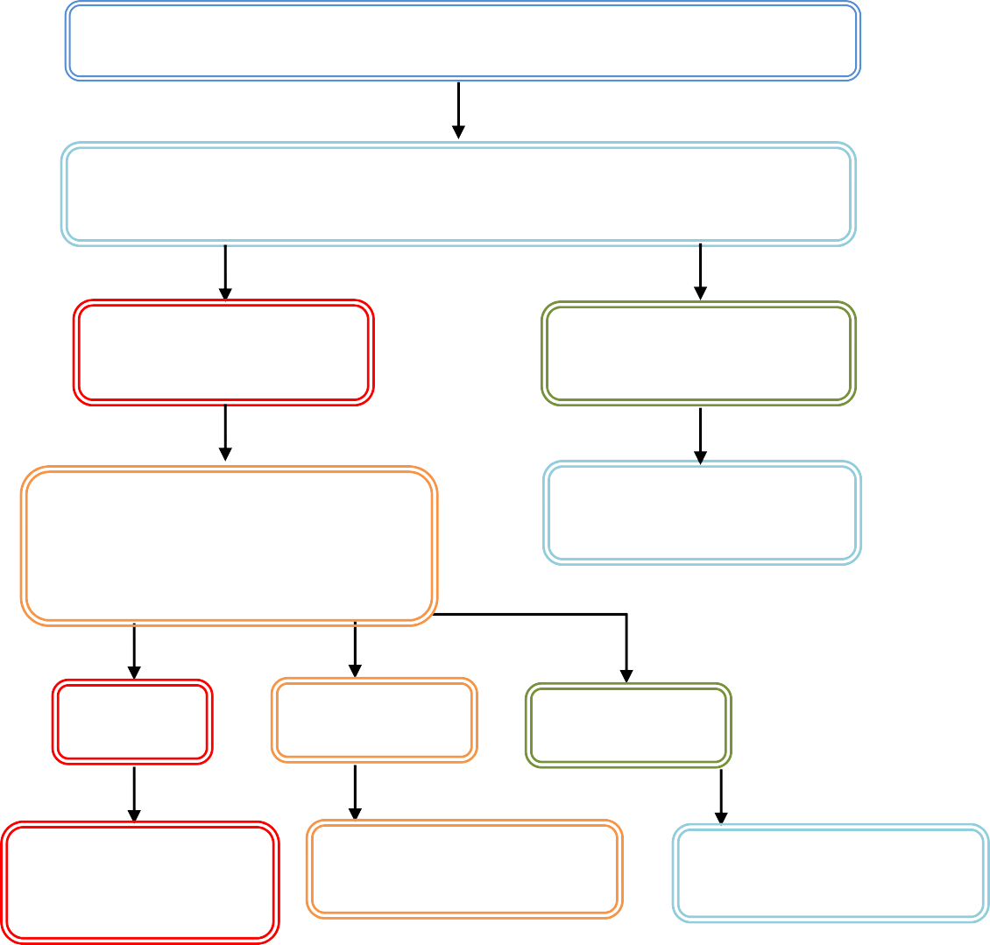
Patients at increased risk of anal cancer
Routine clinical care, including diagnostics tests depending on
at-risk group
Symptomatic of anal
cancer
Non-symptomatic of
anal cancer
Routine clinical care
Surgical biopsy
Cancer
HSIL
Normal
Standard cancer
treatment
Follow-up biopsy
Routine clinical care

Figure 5 Clinical management algorithm without intervention
PWLHIV are the only group who are recommended to have digital anal rectal examinations (DAREs), which have the potential to detect cancers. However, this rarely happens in clinical practice, due to other
pressing matters, stigma and embarrassment of both the patient and the practitioner (Feeney et al 2019). Thus, a large majority of people in the high-risk categories present when symptomatic, with an average
cancer size of 3cm (i.e. a “T2”) (Wong et al 2023).

PART 6b – INFORMATION ABOUT THE INTERVENTION

Describe the key components and clinical steps involved in delivering the proposed medical service: Targeted testing
Anal sampling is routinely performed without visualisation of the anal canal, with no bowel preparation
or use of anoscope required. After placing the patient in a lateral decubitus position, a moistened Dacron swab or cytology brush is inserted about 4 cm into the non-lubricated anal canal, ideally up to the estimated location of the distal rectal canal. The swab is slowly withdrawn over 20-30 seconds using a spiral movement, applying gentle lateral pressure. The swab is then vigorously eluted in a specific transport medium. HPV PCR is performed, using one of a number of available commercial platforms. If indicated (see algorithm), liquid-based cytology can be performed using one of two commercially available technologies, in which the slide is machine made and then examined by a cytology scientist and a cytopathologist (Albuquerque 2020; Repiso Jiménez et al 2017).

Extended HPV testing for the 14 most common genotypes should be conducted first, with reflex cytology (conducted on the same sample) conducted depending on HPV status. The minimum requirement for expanded genotyping would include the14 most common high-risk genotypes found in the cervix and anus: 16, 18, 31, 33, 35, 39, 45 ,51, 52, 56, 58, 59, 66, 68 (Lin 2018, Clifford 2021). All at-risk individuals in Groups 1-6 should receive full genotyping.

Individuals with abnormal HPV and cytology tests (see clinical algorithm) would be referred to undergo high-resolution anoscopy (HRA), and if persistent histological HSIL is found, would then undergo treatment, which, like cervical cancer, would significantly reduce anal cancer incidence (Palefsky et al 2022).
- Individuals who test HPV negative will not receive cytology, and will not go on to receive HRA, unless there are other clinical concerns.
- Any individual found to be HPV16 at baseline will undergo cytology and be referred for high-
resolution anoscopy. Those with PHSIL/HSIL will be urgently triaged to HRA, which will also alert the HRA practitioner of the likelihood of finding HSIL.
- Any individual found to be positive to a HR-HPV type other than HPV16 (hereafter called non16 HR-HPV positive) will be triaged to receive cytology testing (on the same specimen). If the result of this cytology is PHSIL or HSIL, referral for HRA will occur. Individuals with any other cytology result will be asked to return for repeat testing at 12 months. A repeat positive test to the same non16 HR-HPV type would represent chronic infection, and these individuals would be referred for HRA.
Patients may be required to undergo repeat HRA, as well as repeat high-risk HPV testing and cytology to assess response to treatment (Palefsky et al 2022).
Diagnosis and Treatment
HRA does not require bowel preparation. After insertion of the anoscope a colposcope is used to examine the squamocolumnar junction, the anal canal including the transformation zone and the perianal skin in a systematic manner. Inspection should be conducted without staining in the first instance, followed by the topical application of acetic acid that assists in lesion identification and characterisation. Most of the examination is done under 16 × magnification, and once specific areas of interest are visualised, they should be examined under 25 × magnification (Albuquerque 2015). This is a highly technical and specialised procedure, which aims to determine the presence/absence of abnormal appearing mucosa to be biopsied for confirmation/exclusion of HSIL or worse.

Does the proposed medical service include a registered trademark component with characteristics that distinguishes it from other similar health components?
N/A

If the proposed medical service has a prosthesis or device component to it, does it involve a new approach towards managing a particular sub-group of the population with the specific medical condition?
N/A

If applicable, are there any limitations on the provision of the proposed medical service delivered to the patient (i.e. accessibility, dosage, quantity, duration or frequency):
The IANS taskforce assigned recommendation strength (A-E) and quality of evidence (I-III) using the same grading system applied to the US multi-organisational cervical cancer screening and management guidelines (Perkins 2020) and have developed consensus guidelines to identify individuals at high-risk of developing anal cancer by risk category and age at commencement of targeted testing. Testing is recommended for individuals in Risk Category A, where the incidence of anal cancer is ≥10 -fold that of the general population (1.7 per 100,000).
Testing is not recommended for individuals in Risk Category B, where the incidence of anal cancer is less than 10-fold that of the general population (Table 1) (Stier et al 2024).
Individuals with high-risk anal HPV detected will be referred for diagnostic HRA. Biopsies for histological evaluation will be collected during HRA to determine the grade of any abnormality. Individuals with HSIL deemed to be at high risk of progression to SCCA will be offered treatment. Patients may be required to undergo repeat HRA, as well as repeat high-risk HPV testing and cytology, to assess response to treatment (Palefsky et al 2022).
Table 1 Populations identified for anal cancer testing, IANS guidelines (Stier et al 2024)

Population – Risk category | Testing initiation | Anal cancer incidence (Clifford 2021, Deshmukh 2023)
Risk Category A: Incidence ≥10-fold compared to the general population
Men who have sex with men and transgender women living with HIV | Age 35 | >70/100,000 at age 30-44  >100/100,000 age 45+
Women living with HIV | Age 45+ | >25/100,00 age 45+
Men who have sex with women living with HIV | Age 45 | >40/100,000 age 45+
Men who have sex with men and transgender women (without HIV) | Age 45 | >18/100,000 age 45-60  >34/100,000 age 60+
People with a history of vulvar HSIL or cancer | Within 1 year of diagnosis | >40/100,000
Solid organ transplant recipients | 10 years post-transplant | >25/100,000
Risk Category B: Incidence less than 10-fold higher compared with the general population
Cervical/Vaginal Cancer | *Shared decision age 45 | 9/100,000
Cervical/Vaginal HSIL | Shared decision age 45 | 8/100,000
Perianal warts (male or female) | Shared decision age 45 | unknown
Persistent cervical HPV 16 (>1 year) | Shared decision age 45 | unknown
Other immunosuppression (RA, Lupus,  Crohn’s, UC, on systemic steroid therapy) | Shared decision age 45 | 6/100,000
Vulvar warts | Do not test | unknown
Incidence among the general population : 1.7 per 100,000 (Deshmukh et al 2023)
HSIL = high-grade squamous intraepithelial lesions, RA = rheumatoid arthritis, UC = ulcerative colitis

If applicable, identify any healthcare resources or other medical services that would need to be delivered at the same time as the proposed medical service:
N/A

If applicable, advise which health professionals will primarily deliver the proposed service:
Diagnosis: This service requires collection of patient swab samples primarily by a general practitioner or sexual health practitioner; however, specialists already involved in a patient’s care may also conduct sampling e.g colorectal surgeons, transplant physicians, and gynaecologists. HPV testing and cytological examination will be delivered by trained scientists in an accredited laboratory. Testing would be requested by the treating clinician and provided by Approved Practising Pathologists in line with other tests on the MBS Pathology Table.
Treatment: High resolution anoscopy and treatment would be performed by a suitably trained and certified health practitioner.

If applicable, advise whether the proposed medical service could be delegated or referred to another professional for delivery:
N/A

If applicable, specify any proposed limitations on who might deliver the proposed medical service, or who might provide a referral for it:
Diagnosis: HPV testing, cytological and histopathological analyses will be delivered by trained scientists in an accredited laboratory. Testing would be requested by the treating clinician and provided by Approved Practising Pathologists in line with other tests on the MBS Pathology Table.
Treatment: Patients found to be HPV positive would be referred on for diagnostic high resolution anoscopy, to determine the extent (if any) of HSIL is present. Those patients with histologically-confirmed persistent HSIL would be referred to an appropriate clinician to undergo treatment and for further follow up until cured.

If applicable, advise what type of training or qualifications would be required to perform the proposed service, as well as any accreditation requirements to support service delivery:
The sensitivity of the HPV testing technology, together with the use of internal controls suggests that only instructions rather than specific training will be required for the swab sample collection.
Diagnosis
Testing would be delivered only by Approved Practising Pathologists (appropriately qualified cytologists and histopathologists who are Fellows of the RCPA) in NATA Accredited Pathology Laboratories (as defined in MBS Pathology table) by referral only by registered Medical Practitioners in line with other tests in the MBS Pathology Table.
Treatment
Given the importance and difficulties of identification of anal HSIL, consideration should be given to restricting diagnostic and treatment HRA to suitably trained and certificated practitioners. The International Anal Neoplasia Society has recently launched an international certification process, upon which local guidelines could be based.

(a) Indicate the proposed setting(s) in which the proposed medical service will be delivered (select ALL relevant settings):
Diagnosis
Inpatient private hospital (admitted patient) Inpatient public hospital (admitted patient) Private outpatient clinic
Public outpatient clinic Emergency Department
Private consulting rooms - GP
Private consulting rooms – specialist
Private consulting rooms – other health practitioner (nurse or allied health) Private day surgery clinic (admitted patient)
Private day surgery clinic (non-admitted patient)
Public day surgery clinic (admitted patient)
Public day surgery clinic (non-admitted patient) Residential aged care facility
Patient’s home
Laboratory
Other – please specify below

Sample collection, HRA diagnosis, HRA Treatment and ablation (treatment)
Inpatient private hospital (admitted patient) Inpatient public hospital (admitted patient) Private outpatient clinic
Public outpatient clinic Emergency Department
Private consulting rooms - GP Private consulting rooms – specialist
Private consulting rooms – other health practitioner (nurse or allied health)
Private day surgery clinic (admitted patient) Private day surgery clinic (non-admitted patient) Public day surgery clinic (admitted patient) Public day surgery clinic (non-admitted patient)
Residential aged care facility
Patient’s home
Laboratory
Other – please specify below

Where the proposed medical service is provided in more than one setting, please describ e the rationale related to each:
At-risk populations are likely to attend all of the above settings, where sample collection could take place. HPV testing, cytological and histological analyses are conducted in a pathology laboratory.
Diagnostic HRA and treatment could be performed in a number of private and public settings, but usually in an outpatient setting. Treatment may be conducted in an inpatient setting (including in theatres and endoscopy suites) if the patient requires pain management and monitoring; however, this would occur in the minority of cases.

Is the proposed medical service intended to be entirely rendered in Australia?
Yes

PART 6c – INFORMATION ABOUT THE COMPARATOR(S)

Nominate the appropriate comparator(s) for the proposed medical service, i.e. how is the proposed population currently managed in the absence of the proposed medical service being available in the Australian health care system (including identifying health care resources that are needed to be delivered at the same time as the comparator service):
There is no direct comparator for either the diagnostic or treatment pathways of this service. The different at-risk patient groups would experience different routine health care until symptomatic of an anal cancer.

- People living with HIV: patients would be monitored under the care of their general practitioner, or a sexual health practitioner. When on anti-retroviral therapy, HIV positive patients may undergo viral load testing or HIV genotyping. In addition, patients may have their CD4+ counts taken to monitor therapy effectiveness or disease progression.
MBS item number 69378 (P3 – Microbiology)
Quantitation of HIV viral RNA load in plasma or serum in the monitoring of a HIV sero-positive patient not on antiretroviral therapy - 1 or more tests
Fee: $180.25 Benefit: 75% = $135.20 85% = $153.25
MBS item number 69381 (P3 – Microbiology)
Quantitation of HIV viral RNA load in plasma or serum in the monitoring of antiretroviral therapy in a HIV sero-positive patient - 1 or more tests on 1 or more specimens
Fee: $180.25 Benefit: 75% = $135.20 85% = $153.25
MBS item number 69380 (P3 – Microbiology)
Genotypic testing for HIV antiretroviral resistance in a patient with confirmed HIV infection if the patient's viral load is greater than 1,000 copies per ml at any of the following times:
- at presentation; or
- before antiretroviral therapy: or
- when treatment with combination antiretroviral agents fails;
maximum of 2 tests in a 12-month period
Fee: $770.30 Benefit: 75% = $577.75 85% = $677.10
MBS item number 73802 (P9 - Simple Basic Pathology Tests)
Leucocyte count, erythrocyte sedimentation rate, examination of blood film (including differential leucocyte count), haemoglobin, haematocrit or erythrocyte count - 1 test
Fee: $4.55 Benefit: 75% = $3.45 85% = $3.90
- Men who have sex with men: patients would be monitored under the care of their general practitioner, or a sexual health practitioner. Individuals may undergo testing for HIV antibodies or p24 antigen in addition to any routine health checks (recommended for up to 4 times a year). Many individuals may opt to use point of care rapid HIV test self-testing; however, approved self-tests that are purchased by the end user are not eligible for an MBS rebate. At-risk individuals may have their CD4+ counts taken in order to identify those who would benefit from an early HIV diagnosis.
MBS item number 69384 (P3 – Microbiology)
Quantitation of 1 antibody to microbial antigens not elsewhere described in the Schedule - 1 test (This fee applies where a laboratory performs the only antibody test specified on the request form or performs 1 test and refers the rest to the laboratory of a separate APA)
Fee: $15.65 Benefit: 75% = $11.75 85% = $13.35
MBS item number 73802 (P9 - Simple Basic Pathology Tests)
Leucocyte count, erythrocyte sedimentation rate, examination of blood film (including differential leucocyte count), haemoglobin, haematocrit or erythrocyte count - 1 test
Fee: $4.55 Benefit: 75% = $3.45 85% = $3.90
- Women with previous anogenital HPV cancer or cervical HSIL: Women with previous HPV- related lower genital tract cancer or cervical HSIL receive regular follow-up by their gynaecologist, surgeon or general practitioner. This includes cervical cytology, pelvic examination and HPV testing. There is no current anal HPV/ cytology test routinely offered by medical practitioners to these patients. It is only when a woman develops symptoms /signs of anorectal cancer (PR bleeding, mass) that they are referred for assessment.

- People with previous anal cancer: receive regular follow up by their surgeon, oncologist or radiation oncologist. This includes naked eye examination, simple anoscopy, clinical examination and imaging.
- Organ transplant recipients: require regular quarterly check-ups with their specialist, where routine blood tests are conducted including a full blood examination and biochemistry, lipid studies, viral screens (polyomaviruses, cytomegalovirus) and testing levels of immunosuppressive agents. In addition, regular bone density scans (3 years) and skin cancer
checks (2 years) should be conducted, with kidney transplant recipients undergoing regular renal function testing.

Does the medical service (that has been nominated as the comparator) have an existing MBS item number(s)?
No

Define and summarise the current clinical management pathway/s that patients may follow after they receive the medical service that has been nominated as the comparator (supplement this summary with an easy to follow flowchart [as an attachment to the Application Form] depicting the current clinical management pathway that patients may follow from the point of receiving the comparator onwards, including health care resources):
Q42 describes the clinical algorithm with HPV testing followed by treatment of high-risk individuals.

(a) Will the proposed medical service be used in addition to, or instead of, the nominated comparator(s)?
In addition to (i.e. it is an add-on service)
Instead of (i.e. it is a replacement or alternative)

If instead of (i.e. alternative service), please outline the extent to which the current service/comparator is expected to be substituted:
There are currently no MBS item numbers for anal HPV testing or cytology. At-risk patients are either managed in private settings or in state-based sexual health clinics until symptomatic of an anal cancer.

Define and summarise how current clinical management pathways (from the point of service delivery onwards) are expected to change as a consequence of introducing the proposed medical service, including variation in health care resources (Refer to Question 39 as baseline):

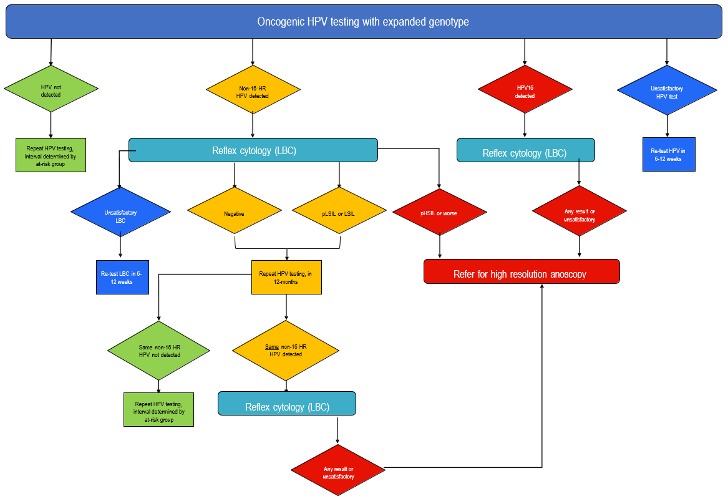Oncogenic HPV t Figure 6 Proposed clinical management algorithm with reflex cytology testing after a positive HPV testing with Any result or unsatisfactory

PART 6d – INFORMATION ABOUT THE CLINICAL OUTCOME

Summarise the clinical claims for the proposed medical service against the appropriate comparator(s), in terms of consequences for health outcomes (comparative benefits and harms):
Anal cancer is among the limited number of cancers, including cervical and colon cancer that are potentially preventable through treatment of known cancer precursors. Identifying HSIL early enables the early detection, prevention and treatment of anal cancer. Patients treated for anal HSIL (primarily office- based electrocautery) have rates of progression to anal cancer approximately 60% lower than those who only undergo active monitoring without treatment (Palefsky et al 2022).
In addition, if cancer (rather than HSIL) is established, the early detection of cancer through testing will result in better patient outcomes, with a reduction in the associated morbidity and mortality. This is particularly likely to occur in the early stages of the program, when prevalent cases are likely to be identified at much earlier stages than would have otherwise occurred.
Please advise if the overall clinical claim is for:
Superiority
Non-inferiority

Below, list the key health outcomes (major and minor – prioritising major key health outcomes first) that will need to be specifically measured in assessing the clinical claim of the proposed medical service versus the comparator:
Diagnosis
Safety
- Harms associated with testing/not testing
Clinical effectiveness
- Impact on clinical management
- Morbidity associated with anal carcinoma
- Mortality due to anal carcinoma
- Health-related quality of life
- Other patient-relevant outcomes
Clinical validity
- Clinical sensitivity and specificity
- Positive and negative predictive values
- Prognostic value
Healthcare resource use
- Number of events, and cost associated with anal carcinoma (e.g. hospitalisation; specialist visits; requirements for subsequent therapy; cost of testing)
- Cost-effectiveness of HPV testing and cytology
- Total Australian Government healthcare costs

Treatment
Safety
- Harms associated with treatment eg pain, bleeding, complications
- Repeat procedures
- Hospitalisation
Clinical effectiveness
- Morbidity associated with treatment
- Mortality associated with treatment

- Treatment failure rate
- Re-treatment rate
- Recurrence of HSIL
- Missed cancer rate
- HSIL-free survival
- Health-related quality of life
- Other patient-relevant outcomes
Healthcare resource use
- Number of treatments and costs associated with treatment (e.g. cost of treatment, specialist visits, requirements for subsequent treatment, hospitalisation)
- Cost-effectiveness of treatment
- Total Australian Government healthcare costs

PART 7 – INFORMATION ABOUT ESTIMATED UTILISATION

Estimate the prevalence and/or incidence of the proposed population:
Although there are good data on the prevalence and rate of anal cancer in Australia (Figure 1 and Figure 3), these figures do not give an indication of the number of individuals at risk of developing HSIL or anal cancer. Certain population groups are known to have higher than average anal cancer risk including people living with HIV (PLHIV), men who have sex with men (MSM), women diagnosed with human papillomavirus (HPV)-related gynaecological precancerous lesions or cancer, solid organ transplant recipients (SOTRs) and patients with autoimmune diseases. Figure 7 describes the level of risk for each of these groups by age, with PLHIV, especially those ages >45 years, being at greatest risk (Clifford et al 2021).
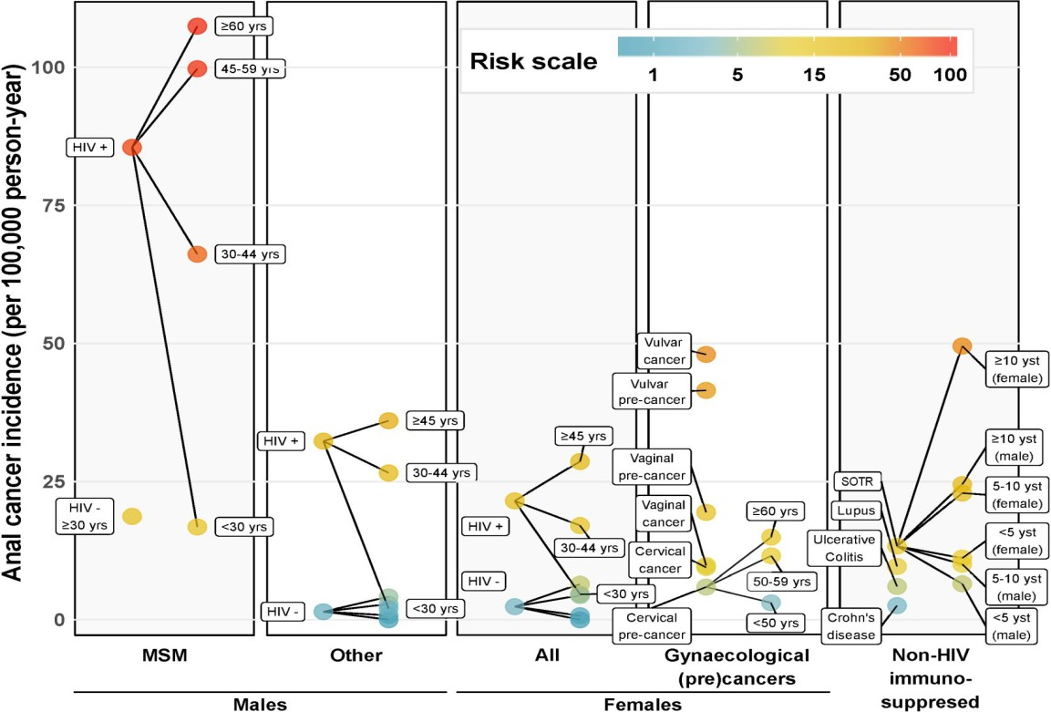
Figure 7 Anal cancer incidence rates by specific risk groups (Clifford et al 2021)

In Australia the number of HIV notifications with a first ever diagnosis declined markedly in 2021 to 552, compared to 1,068 notifications in 2012. The decrease before 2020 was related to increasing levels of HIV treatment as prevention, and since 2016 increasing levels of use of HIV pre -exposure prophylaxis. A further decrease during COVID-19 was likely due to public health measures placed on travel and movement, social activity, and lack of access to HIV testing. It may reasonably be expected that the number of HIV notifications will increase post-COVID. MSM are the major HIV risk exposure group in Australia, accounting for 378 (68%) HIV notifications in 2021, with heterosexual sex reported for 148 (27%) notifications, and injection drug use for 9 (less than 2%) notifications (King et al 2022).
In 2021, the prevalence of people living with HIV in Australia was estimated to be 29,460 people, and of these, 21,530 are established to have acquired HIV through male-to male sex. It has been estimated that approximately 1:10 of MSM are HIV positive, therefore the total ‘prevalent’ MSM population would be estimated to be 215,300 (including HIV positive and HIV negative men) (King et al 2022). Testing of MSM living with HIV should be performed every 3-years (Group 1), and every 5-years for non-MSM living with HIV, and MSM and transgender women who are non-HIV positive (Group 2).

There were 591 new cases of anal cancer reported in Australian in 2021 , with approximately 60 per cent having a 5-year survival. Patients with a previous case of anal cancer should undergo repeat testing every 6-months for 3-5 years following completion of their initial treatment (Group 6).
Women with previous anogenital HPV cancer, including cancer of the vulva and vagina, but excluding anal cancer, are also considered a high-risk group. Cancers of the vulva and vagina are rare, with an estimated number of incident cases in Australia of 456 and 95 in 2020, respectively, with an age-standardised incident rate of 1.83 and 0.38, respectively (Bruni et al 2021). Testing in women with previous vulvar HSIL/cancer should be performed every 5-years (Group 3).

Solid organ transplant recipients, most commonly kidney transplant but could include liver, intestines, heart, lung and pancreas, are also considered to be at risk of anal cancer. In Australia in 2021 a total of 1,371 solid organs were transplanted, the majority of which were kidneys (n=668) and the 5-year survival rate for solid organ transplants is approximately 83% (ANZOD Registry 2019; ANZOD Registry 2022). As a rough estimate of organ transplant recipients who may require monitoring for risk of anal cancer, in 2019 the number of individuals living with a functioning kidney transplant in Australia was 12,815 (Wyld et al 2021). As kidney transplants represent approximately 50 per cent of all solid organ transplants, the number of patients requiring testing may be 26,000. Testing in these patients should be conducted every 3-years (Group 4).

Although there is a lack of peer-reviewed evidence supporting these testing intervals, these testing frequencies (Table 2) are based on Australian clinical practice/consensus opinion and by extrapolation from the Australian cervical screening program algorithms.

- MSM and TW LHIV, commencing age 35 years
- Non-MSM LHIV, MSM and TW without HIV, commencing age 45
- Women with previous vulval SCC/HSIL (HPV-associated), commencing within 1 year of diagnosis
- SOTR, commencing 10 years post-transplant
- People outside these above groups with incidental HSIL e.g. hemorrhoidectomy, lesion found at colonoscopy, and patients presenting with symptoms suggestive of cancer
- People post-treatment for anal cancer, commencing 6 months after completion of treatment, and
lasting for three years, or until any residual disease has been eradicated.

Table 2 HPV testing frequencies for at-risk populations

 | Group 1 | Group 2 | Group 3 | Group 4 | Group 5 | Group 6
HPV testing interval if previously HPV negative | 3 years | 3/5 years* | 5 years | 3 years | 5 years | 6 months
Triage test | Cytology
HRA | - HPV16 +ve HRA regardless of cytology result  - Type-specific non-16 HR HPV (with negative cytology/PLSIL /LSIL) at baseline and at 12 months, HRA regardless of cytology result  - Exception – baseline cytology is PHSIL, HSIL or carcinoma – immediate HRA
HPV testing interval after negative HRA | 1 year | 1 year | 1 year | 1 year | 1 year | 1 year
* For PLHIV individuals testing should be every 3 years, non-PLHIV testing should be conducted every 5 years

Estimate the number of times the proposed medical service(s) would be delivered to a patient per year:
Targeted testing (diagnosis): As described above, repeat HPV/cytology testing should be performed at
different intervals depending on the individual’s risk.

Treatment: Diagnostic HRA will follow a positive HPV result. Treatment will follow in patients where HSIL is identified on biopsy. Patients may be required to undergo repeat HRA, as well as repeat high-risk HPV testing and cytology, to assess for disease progression and response to ablative treatment (Palefsky et al 2022).

How many years would the proposed medical service(s) be required for the patient?
For some at-risk individuals, testing would only need to commence after 35 years of age, with frequency of testing as described above in Q45. For other at-risk individuals, such as women with previous anogenital HPV cancer, testing may begin at any age and would continue for life.

Estimate the projected number of patients who will utilise the proposed medical service(s) for the first full year:
See Table 3.

Estimate the anticipated uptake of the proposed medical service over the next three years factoring in any constraints in the health system in meeting the needs of the proposed population (such as supply and demand factors) as well as provide commentary on risk of ‘leakage’ to populations not targeted by the service:
See Q 45. It has been estimated that the number of patients tested every year will remain reasonably steady, with the exception of incident HIV cases, where it may reasonably be expected that cases will rise post-COVID. People living with HIV should be tested every 3-years, therefore the prevalent population has been divided by three. HIV negative MSM should be tested every 5 years, therefore the prevalent population has been divided by five. Solid organ transplant recipients should be tested every 3-years, therefore the prevalent population has been divided by three. People treated for anal cancer will be HPV tested every 6 months for the first five years following completion of cancer treatment.
Although rates will vary greatly between the six groups, taken as a whole, approximately 55% of at-risk individuals tested for HPV would undergo cytology. Of these, approximately 40% would be referred on for diagnostic HRA and 25% of these would need treatment for persistent HSIL (expert advice).

Table 3 Estimated uptake of HPV and cytology testing in Australia 2023-2026

 | 2022 | Expected 2023 | Expected 2024 | Expected 2025 | Expected 2026
HPV testing
People living with HIV, prevalent population | 29,460  552  193,770  26,000  800  11,000  300 | 9,820  607  38,754  8,667  800  2,200  300  58,148 | 9,820  667  38,754  8,667  1600  2,200  300  58,208 | 9,820  734  38,754  8,667  1600  2,200  300  58,275 | 9,820  807  38,754  8,667  1600  2,200  300  58,348
age >35 years (every 3-years)
People living with HIV, incident population*
Men who have sex with men >45 years**
(every 5-years)
Organ transplant recipients***
(every 3 years)
People with previous anal cancer‡
(every 6-months)
Women with vulval SCC/HSIL (HPV-
associated)¥ (every 5 years)
People with incidental HSIL
Number of patients undergoing HPV
testing in any one year
Reflex cytology testing
Number of HPV positive patients undergoing cytology testing in any one year |  | 31,981 | 32,014 | 32,051 | 32,091
Treatment
HRA |  | 12,792 | 12,806 | 12,820 | 12,837
Treatment |  | 3,198 | 3,201 | 3,205 | 3,209

The number tested in each subsequent year after 2022 is estimated to be the prevalent number divided by the frequency of testing ie 1/3 of people LWHIV will be tested each year
* HIV notifications fell during COVID restrictions. An increase of 10% in the number of notifications per year has been factored in.
** The number of HIV positive MSM has been subtracted from the total to avoid double counting – 215,300 MSM minus 21,530 (HIV+)
*** The number of surviving kidney transplant recipients has been used as a proxy for all organ transplant recipients
‡ Assume 60% 5-year survival, approximately 600/year and 2-yearly testing
¥ Assume average 20-year survival, approximately 1100/year and 2-yearly testing
€ Assume average 40-year survival, approximately 1500/year and 2-yearly testing

PART 8 – COST INFORMATION

Indicate the likely cost of providing the proposed medical service. Where possible, please provide overall cost and breakdown:
It is estimated that costings associated with the collection and testing of anal samples will be similar to those described by the cervical screening items.
Diagnosis
Table 4 Costings breakdown for HPV genotyping

Reagent | Cost/pack | Tests/pack |  | Cost/reaction
DNA Extraction costs |  |  |  | $4.00
HPV28 PCR Reagent kit | $1,200.00 | 100 |  | $12.00
Consumable - Plates | $225.00 | 50 |  | $4.50
Consumable - Plate seals | $230.00 | 100 |  | $2.30
Consumable - Tips | $80.97 | 10 | 2 box | $0.17
PCR Cost/test (Reagents + Consumables) |  |  |  | $18.80
Total Cost/ test (PCR + Extraction) |  |  |  | $22.80
Controls | 3/batch | Batch of 30 |  | $25.08
Estimated 5% repeats |  |  |  | $26.33
Labour | $40.00 | 2hr/run |  | $2.00
Pre- and Post-Analytical costs (including swab, transport, specimen and data handling, waste management) * |  |  |  | $20.00
Total cost (including labour) | $48.33
Total cost including pathologist | $70

Diagnosis and treatment:

The fee for Diagnostic HRA and treatment are based on the fees for the colposcopy and treatment MBS items listed for the cervical screening program. The average time to conduct a colposcopy is 5-10 minutes, with treatment taking 10-15 minutes. Data from the SPANC trial indicates that the time to conduct a diagnostic HRA is approximately 15 minutes, noting that the increased fee compared to cervical item 35614 is based on the increased complexity and length of procedure, and the higher number of biopsies taken (on average). Similarly, the anal HSIL treatment fee is higher than Item number 35645 for cervical ablation based on the length of time required for the procedure , due to the complex anatomy of the anus.

Specify how long the proposed medical service typically takes to perform:
Anal swab taking takes approximately 15 minutes.
Testing would take approximately one week to analyse and report. Diagnostic HRA takes approximately one hour to perform.
Most treatments would be same-day (1-1.5 hour) with the exception of those rare inpatient cases who require pain relief and monitoring.

If public funding is sought through the MBS, please draft a proposed MBS item descriptor to define the population and medical service usage characteristics that would define eligibility for MBS funding.

Diagnosis:

Sample collection

PROFESSIONAL ATTENDANCES Category 1 – Professional attendances
AAAA
Professional attendance at consulting rooms by a treating physician:
- involving taking a short patient history and, if required, limited examination and management; and
- at which a specimen for an anal targeted testing service is collected from the patient:
  - if the patient has no history of biopsy-proven anal high-grade squamous intraepithelial lesions (HSIL) or cancer
  - is human immunodeficiency virus (HIV) negative
  - is at least 45 years of age; and
  - has not been provided with an anal screening service or an anal smear service in the last 5 years.
OR
- at which a specimen for an anal screening service is collected from the patient:
  - if the patient has no history of biopsy-proven anal high-grade squamous intraepithelial lesions (HSIL) or cancer
  - is human immunodeficiency virus (HIV) positive
  - is at least 35 years of age; and
  - has not been provided with an anal screening service or an anal smear service in the last 3 years.
OR
- at which a specimen for an anal screening service is collected from the patient;
  - if the patient has a history of biopsy-proven anal high-grade squamous intraepithelial lesions (HSIL) or anal cancer and
  - has not been provided with an anal screening service or an anal smear service in the last6-months
MBS fee $17.90

Genotyping
BBBB
Expanded genotyping of 14 oncogenic human papillomavirus genotypes (16, 18, 31, 33, 35, 39, 45 ,51, 52,
56, 58, 59, 66, 68) that may be associated with anal pre-cancer or cancer:
- performed on a liquid based anal specimen; and
- for an asymptomatic patient who is at least 35 years and has satisfied the conditions of sample collection using MBS item AAAA
MBS fee $70.00
Category P7 – Genetics PATHOLOGY SERVICES
CCCC
Expanded genotyping of 14 oncogenic human papillomavirus genotypes (16, 18, 31, 33, 35, 39, 45 ,51, 52,
56, 58, 59, 66, 68) performed on a liquid based anal specimen:
- for the investigation of a patient in a specific population that appears to have a higher risk of anal pre‑cancer or cancer; or
- for the follow‑up management of a patient with a previously detected oncogenic human papillomavirus infection or anal pre‑cancer or cancer; or
- for the investigation of a patient with symptoms suggestive of anal cancer
MBS fee $70.00
Category P7 – Genetics PATHOLOGY SERVICES
DDDD
Expanded genotyping of 14 oncogenic human papillomavirus genotypes (16, 18, 31, 33, 35, 39, 45 ,51, 52,
56, 58, 59, 66, 68) performed if:
- the test is a repeat of a test to which item BBBB, CCCC or this item applies; and
- the specimen collected for the previous test is unsatisfactory MBS fee $70.00
Category P7 – Genetics PATHOLOGY SERVICES

EEEE
Cytology of a liquid based anal specimen found to be HPV positive by item numbers BBBB, CCCC or DDDD, where the stained cells are examined microscopically or by automated image analysis by or on behalf of a pathologist, if:
(a) the cytology is associated with the detection of oncogenic human papillomavirus infection by:
(i) a test to which item BBBB applies; or
(ii) a test to which item CCCC applies for a patient mentioned in paragraph (a) or (b) of that item; or
(b) the cytology is associated with a test to which item CCCC applies for a patient mentioned in paragraph
(c) of that item; or
(c) the test is a repeat of a test to which this item applies, if the specimen collected for the previous test is unsatisfactory
MBS fee $70.00

Category P6 – Cytology PATHOLOGY SERVICES
High-resolution anoscopy (HRA) – diagnostic
FFFF
Examination of the anal canal and perianus using a high resolution anoscopy in a patient who:
(a) has a human papilloma virus (HPV) related anal/perianal indication; or
(b) has symptoms or signs suspicious of anal/perianal malignancy; or
(c) is undergoing follow-up treatment anal/perianal malignancy; or
(d) is undergoing assessment or surveillance of an anal/perianal premalignant or malignant disease; or
(e) is undergoing assessment or surveillance as part of an identified at-risk population.
Fee: $140.60
Category 3 - THERAPEUTIC PROCEDURES

Note: benefit will not be paid except in the following circumstances:
- where the patient has had an anal HPV test result using MBS item AAAA; or
- where the patient has been referred by another medical practitioner with suspicion of anal cancer. Diagnostic HRA performed no more than four times per year.
HRA must be performed by a suitably trained and qualified practitioner.
Noting that the increased fee compared to cervical item 35614 is based on the increased length of procedure, anatomical complexity and the higher number of biopsies taken (on average). For item FFFF, it is proposed that the cervical model should be followed, and charge separately for biopsies.

High-resolution anoscopy (HRA) – treatment
GGGG
Anal HSIL ablation or cryotherapy, with high-resolution anoscopy, including any local anaesthesia or biopsies, for previously biopsy confirmed HSIL using item number FFFF;
Up to a maximum of 6 ablative treatments per episode, until clearance of HSIL is achieved. Fee: $701.60
Category 3 - THERAPEUTIC PROCEDURES

Note: benefit will not be paid except in the following circumstances:
(a) where the patient has histological confirmation of anal HSIL using MBS item CCCC; or
(b) where the patient has been referred by another medical practitioner with suspicion of anal cancer.
HRA must be performed by a suitably trained and qualified practitioner.
Noting that the increased fee compared to cervical item 35644 is based on the increased length of procedure.

References
AIHW (2021a) Australian Institute of Health and Welfare Canberra. AIHW (2021b) Australian Institute of Health and Welfare Canberra.
Albuquerque, A. (2015). 'High-resolution anoscopy: Unchartered territory for gastroenterologists?', World J Gastrointest Endosc, 7 (13), 1083-1087.
Albuquerque, A. (2020). 'Cytology in Anal Cancer Screening: Practical Review for Clinicians', Acta Cytol, 64 (4), 281-287.
Albuquerque, A., Sheaff, M. et al (2018). 'Performance of Anal Cytology Compared With High -Resolution Anoscopy and Histology in Women With Lower Anogenital Tract Neoplasia', Clin Infect Dis, 67 (8), 1262-1268.
ANZOD Registry (2019). 2019 Annual Report, Section 12: Deceased Organ Transplant Outcome Data , Adelaide, Australia.
ANZOD Registry (2022). ANZOD Annual Report 2022, Adelaide, Australia.
Berenson, A. B., Guo, F. & Chang, M. (2022). 'Association of Human Papillomavirus Vaccination With the Incidence of Squamous Cell Carcinomas of the Anus in the US', JAMA Oncol.
Berry, J. M., Jay, N. et al (2014). 'Progression of anal high-grade squamous intraepithelial lesions to invasive anal cancer among HIV-infected men who have sex with men', Int J Cancer, 134 (5), 1147-1155.
Bruni, L., Albero, G. et al (2021). Human Papillomavirus and Related Diseases in Australia, HPV Information Centre, Barcelona, Spain.
Clarke, M. A., Cheung, L. C. et al (2019). '5-Year Prospective Evaluation of Cytology, Human Papillomavirus Testing, and Biomarkers for Detection of Anal Precancer in Human Immunodeficiency Virus-Positive Men Who Have Sex With Men', Clin Infect Dis, 69 (4), 631-638.
Clarke, M. A., Deshmukh, A. A. et al (2022). 'A systematic review and meta-analysis of cytology and HPV- related biomarkers for anal cancer screening among different risk groups', Int J Cancer.
Clifford, G. M., Georges, D. et al (2021). 'A meta-analysis of anal cancer incidence by risk group: Toward a unified anal cancer risk scale', Int J Cancer, 148 (1), 38-47.
Deshmukh, A. A., Chiao, E. Y. et al (2017). 'Management of precancerous anal intraepithelial lesions in human immunodeficiency virus-positive men who have sex with men: Clinical effectiveness and cost-effectiveness', Cancer, 123 (23), 4709-4719.
Deshmukh, A. A., Damgacioglu, H. et al (2023). 'Human Papillomavirus-Associated Anal Cancer Incidence and Burden Among US Men, According to Sexual Orientation, Human Immunodeficiency Virus Status, and Age', Clin Infect Dis, 77 (3), 419-424.
Dias Gonçalves Lima, F., Viset, J. D. et al (2019). 'The Accuracy of Anal Swab-Based Tests to Detect High-Grade Anal Intraepithelial Neoplasia in HIV-Infected Patients: A Systematic Review and Meta-analysis', Open Forum Infect Dis, 6 (5), ofz191.
Donà, M. G., Benevolo, M. et al (2018). 'Anal cytological lesions and HPV infection in individuals at increased risk for anal cancer', Cancer Cytopathol, 126 (7), 461-470.
DʼSouza, G., Wentz, A. et al (2016). 'Anal Cancer Screening in Men Who Have Sex With Men in the Multicenter
AIDS Cohort Study', J Acquir Immune Defic Syndr, 71 (5), 570-576.
Feeney, L., Poynten, M. et al (2019). 'Awareness and knowledge of anal cancer in a community-recruited sample of HIV-negative and HIV-positive gay and bisexual men', Sex Health, 16 (3), 240-246.
Gaisa, M. M., Liu, Y. et al (2020). 'Electrocautery ablation of anal high-grade squamous intraepithelial lesions: Effectiveness and key factors associated with outcomes', Cancer, 126 (7), 1470-1479.
Gaisa, M. M., Sigel, K. M. et al (2021). 'Comparing Anal Cancer Screening Algorithms Using Cytology and Human Papillomavirus DNA Testing in 3 High-Risk Populations', J Infect Dis, 224 (5), 881-888.

Goldstone, R. N., Hasan, S. R. et al (2017). 'A trial of radiofrequency ablation for anal intraepithelial neoplasia',
Int J Colorectal Dis, 32 (3), 357-365.
Goldstone, S. E., Enyinna, C. S. & Davis, T. W. (2009). 'Detection of oncogenic human papillomavirus and other predictors of anal high-grade dysplasia in men who have sex with men with abnormal cytology', Dis Colon Rectum, 52 (1), 31-39.
Goldstone, S. E., Lensing, S. Y. et al (2019). 'A Randomized Clinical Trial of Infrared Coagulation Ablation Versus Active Monitoring of Intra-anal High-grade Dysplasia in Adults With Human Immunodeficiency Virus Infection: An AIDS Malignancy Consortium Trial', Clin Infect Dis, 68 (7), 1204-1212.
Jin, F., Grulich, A. E. et al (2016). 'The performance of anal cytology as a screening test for anal HSILs in homosexual men', Cancer Cytopathol, 124 (6), 415-424.
King, J., McManus, H. et al (2022). HIV, viral hepatitis and sexually transmissible infections in Australia: Annual surveillance report 2022, The Kirby Institute Sydney.
Kobayashi, T., Sigel, K. et al (2019). 'Anal Cancer Precursor Lesions in HIV-Infected Persons: Tissue Human Papillomavirus Type Distribution and Impact on Treatment Response', Dis Colon Rectum, 62 (5), 579-585.
Lin, C., Franceschi, S. & Clifford, G. M. (2018). 'Human papillomavirus types from infection to cancer in the anus, according to sex and HIV status: a systematic review and meta-analysis', Lancet Infect Dis, 18 (2), 198- 206.
Liu, Y., Bhardwaj, S. et al (2024). 'Anal cancer screening results from 18 -to-34-year-old men who have sex with men living with HIV', Int J Cancer, 154 (1), 21-27.
Lum, C., Prenen, H. et al (2020). 'A 2020 update of anal cancer: the increasing problem in women and expanding treatment landscape', Expert Rev Gastroenterol Hepatol, 14 (8), 665-680.
Machalek, D. A., Jin, F. et al (2016). 'Prevalence and risk factors associated with high-grade anal squamous intraepithelial lesions (HSIL)-AIN2 and HSIL-AIN3 in homosexual men', Papillomavirus Res, 2, 97-105.
Palefsky, J. M., Giuliano, A. R. et al (2011). 'HPV vaccine against anal HPV infection and anal intraepithelial neoplasia', N Engl J Med, 365 (17), 1576-1585.
Palefsky, J. M., Lee, J. Y. et al (2022). 'Treatment of Anal High-Grade Squamous Intraepithelial Lesions to Prevent Anal Cancer', N Engl J Med, 386 (24), 2273-2282.
Poynten, I. M., Jin, F. et al (2022). 'Comparison of four assays for human papillomavirus detection in the anal canal', Clinical Microbiology and Infection.
Poynten, I. M., Jin, F. et al (2021). 'The Natural History of Anal High-grade Squamous Intraepithelial Lesions in Gay and Bisexual Men', Clin Infect Dis, 72 (5), 853-861.
Repiso Jiménez, J. B., Padilla España, L. et al (2017). 'Screening for Anal Intraepithelial Neoplasia: High - Resolution Anoscopy-Guided Biopsy of the Anal Canal', Actas Dermosifiliogr, 108 (1), 65-66.
Rollo, F., Latini, A. et al (2021). 'Evaluation of HPV-Related Biomarkers in Anal Cytological Samples from HIV- Uninfected and HIV-Infected MSM', Pathogens, 10 (7).
Santorelli, C., Leo, C. A. et al (2018). 'Screening for Squamous Cell Anal Cancer in HIV Positive Patients: A Five - Year Experience', J Invest Surg, 31 (5), 378-384.
Stier, E. A., Clarke, M. A. et al (2024). 'International Anal Neoplasia Society's consensus guidelines for anal cancer screening', Int J Cancer.
Vergara-Fernandez, O., Solórzano-Vicuña, D. et al (2021). 'Outcomes of radiofrequency ablation for anal high- grade squamous intraepithelial lesions', Tech Coloproctol, 25 (6), 701-707.
Walker, R. J. B., Easson, A. M. et al (2024). 'Anal Cancers in Previously Screened Versus Unscreened Patients: Tumor Stage and Treatment Outcomes', Dis Colon Rectum, 67 (1), 32-41.
Wong, J., Allwright, M. et al (2023). 'Anal cancer: a 20-year retrospective study from Australia', ANZ J Surg, 93 (11), 2697-2705.
Wyld, M. L. R., Wyburn, K. R. & Chadban, S. J. (2021). 'Global Perspective on Kidney Transplantation: Australia',
Kidney360, 2 (10), 1641-1644.

