Public Summary Document

Application 1269 – Computed Tomography Colonography for the diagnosis or exclusion of colorectal neoplasia

Applicant: Abdominal Radiology Group of Australia and New Zealand (ARGANZ)

Date of MSAC consideration: 62nd MSAC Meeting 26-28 November 2014

Context for decision: MSAC makes its advice in accordance with its Terms of Reference, see at www.msac.gov.au

Purpose of application and links to other applications

An application requesting an extension of the indications for the MBS listing of computed tomography colonography (CTC) was received from the Abdominal Radiology Group of Australia and New Zealand (ARGANZ) by the Department of Health in December 2011.
The application proposed a change to the descriptor of the current MBS item numbers (56552 and 56554) under which CTC is funded to allow for reimbursement of CTC services provided for the exclusion of diagnosis of colorectal neoplasia in symptomatic patients who have a contraindication to colonoscopy, or in high risk, asymptomatic patients who have had an incomplete or technically difficult colonoscopy.

Under current listing arrangements, MBS item number 56552 stipulates incomplete colonoscopy must have occurred no more than three months prior to CTC, with the date of incomplete colonoscopy set out on the scan request. MBS item 56554 limits contraindications specifically to suspected perforation of the colon and complete or high grade obstruction that will not allow passage of the scope.

In addition to MBS item changes, a new item was proposed for patients with inadequate access to colonoscopy, such as to cause delay in diagnosis.

MSAC’s advice to the Minister

After considering the available evidence in relation to safety, clinical effectiveness and cost-effectiveness, MSAC supported public funding of a new consolidated MBS item (derived from current MBS items 56552 and 56554) for CTC for the diagnosis or exclusion of colorectal neoplasia in symptomatic high risk patients with a history of incomplete colonoscopy or medical and/or technical contraindication(s) to colonoscopy.

MSAC considered the MBS item descriptor should retain the requirement that an incomplete colonoscopy must have occurred no more than three months prior to CTC. MSAC agreed that the eligibility for CTC could be widened by extending the list of medical and technical contraindications to colonoscopy included in the associated explanatory notes. MSAC also considered that the new MBS item should be limited to one CTC scan per patient every three years and the MBS fee should be negotiated commensurate with the current MBS fees for abdominal CT and double contrast barium enema (DCBE).

MSAC did not support public funding for a new MBS item to provide CTC for patients with limited access to colonoscopy because of the uncertain clinical impact of delayed diagnosis of CRC given current triaging practice, uncertain potential volume of additional CTC services and considerable potential for use outside the intended population.

Summary of consideration and rationale for MSAC’s advice

MSAC considered the application for MBS funding of CTC for the diagnosis or exclusion of colorectal neoplasia. CTC is less invasive than colonoscopy or DCBE. The procedure does not require an endoscope and pain relief and anaesthesia is usually not necessary. A multidetector CT scanner (minimum 8 rows) with dedicated post-processing soft-ware is required and patients still need to undergo bowel preparation involving laxation.

MSAC agreed that CTC could not be considered a replacement for colonoscopy and could not be used as a primary screening tool. MSAC noted that colonoscopy is considered the gold standard for diagnosis or exclusion of CRC. The proposed changes would broaden access to items 56552 and 56554 to include a larger population of symptomatic and high risk patients who have contraindications to colonoscopy such as active colitis, large abdominal aneurisms and patients with coagulopathies. MSAC noted the proposed item descriptors require significant amendments, including the explanatory notes, especially for high risk patients. MSAC also considered a reduced fee for this item to help reduce expenses and leakage.

MSAC considered the safety, efficacy and cost effectiveness of CTC compared to the proposed comparator, DCBE, in patients who are clinically unsuitable for colonoscopy and identified by incomplete or technically difficult colonoscopy; or who are contraindicated to colonoscopy; or delayed colonoscopy for patients who have limited access to colonoscopy services. MSAC noted that the reference standard for diagnosis or exclusion of CRC is optical colonoscopy with 95% sensitivity for polyps and precancerous lesions.

Overall, MSAC noted that the results of the limited available evidence showed that CTC is at least as safe as DCBE with equivalent rates of serious adverse events and fewer minor adverse events. The reported radiation dose is lower with CTC however, there is a large amount of variation in dose so the clinical relevance is uncertain. Based on the limited evidence presented, the 4 year survival rate of patients receiving CTC is the same as those receiving DCBE. MSAC noted that CTC would be more acceptable to patients than DCBE particularly with willingness to repeat the procedure.

No evidence was presented comparing the safety of CTC with delayed colonoscopy. For symptomatic or high risk patients who have limited access to colonoscopy, no evidence was presented that demonstrated access to CTC improved health outcomes compared to delayed colonoscopy. MSAC noted that in the absence of clinical evidence of efficacy no economic analysis was presented for this population.

MSAC noted that the economic analysis was based on a decision analytic model developed from a randomised controlled trial. This trial showed no clinical differences between DCBE and CTC and therefore, cost-utility was not shown as it would result in an unacceptable degree of uncertainty in the outcomes. However, differences in test accuracy were used to estimate the incremental cost-effectiveness ratio (ICER) per additional CRC diagnosed or large polyp identified in patients who have had a positive screening faecal occult blood test result. These ICERs for CTC compared with DCBE were calculated as $26,260 per CRC or large polyp and $19,380 per large polyp diagnosed.

MSAC noted that the patient population for the proposed new MBS item number was poorly defined and considered there is potential for use outside the restriction. Additional CTC services for patients with limited access to colonoscopy are estimated at 18,316 in 2015 rising to 19,308 in 2019. The projected estimated cost to the MBS of these additional services is $9,913,328 in 2019. However, MSAC noted that the considerable risk for use outside the restriction means that there is high uncertainty in this estimate.

Background

MBS items 56552 and 56554 were added to the schedule on 1 July 2007 following the completion of a previous review on CTC on behalf of MSAC, which was published in 2006. Under current listing arrangements MBS item 56552 stipulates that an incomplete colonoscopy must have occurred not more than 3 months prior to CTC, with the date of the incomplete colonoscopy set out on the scan request. Item 56554 limits contraindications specifically to suspected perforation of the colon, and complete or high-grade obstruction that will not allow passage of the endoscope.

Prerequisites to implementation of any funding advice

Under the Therapeutic Goods Act 1989, CT Scanners are classified as medical devices and are required to be registered as such. Legislation for medical devices is administered by the Officer of Device Authorisation (ODA) for pre-market regulation. The proposed medical service does not involve any changes to the medical device (CT scanner) or associated services used for items 56552 or 56554. There are currently several CT systems registered with the TGA.

Computed tomography is a form of diagnostic radiology and its usage is also overseen by the Australian Radiation Protection and Nuclear Safety Agency.

The Royal Australian and New Zealand College of Radiologists (RANZCR) has also developed guidelines for the training and practice of CTC and has recently published their requirements for practice of the procedure (RANZCR 2012). The publication provides a statement of training requirements for practitioners, and facility requirements.
Practices that perform Medicare eligible CT services must be accredited under the Diagnostic Imaging Accreditation Scheme (DIAS). To achieve accreditation, practices must submit an application, including documentary evidence in support of compliance with the full suite of standards to the accreditor of their choice. The accreditor performs an off-site desk-top audit to determine the extent of the practice’s compliance with the Standards. Those practices that demonstrate compliance are granted accreditation for 4 years. Those granted accreditation then enter the accreditation maintenance program, which requires practices to be re-accredited every 4 years.

Proposal for public funding

The application proposed changes to MBS items 56552 and 56554. The item changes are highlighted in the tables below. The changes will broaden access to items 56552 and 56554 to include a larger population of symptomatic and high risk patients who have contraindications to colonoscopy such as:
- Active colitis;
- Large abdominal aortic aneurysms;
- Recent myocardial infarction or pulmonary embolism;
- Coagulopathies, including therapeutic anticoagulation;
- Patients unable to tolerate adequate bowel preparation for colonoscopy;
- Frail patients of advanced age;
- Abdominal large bowel hernias; and
- Splenomegaly.

The application claimed that the proposed changes reflect the current demand for CTC from referring clinicians. Patients who require ongoing monitoring for polyps or neoplasia but underwent an incomplete colonoscopy more than three months previously, or underwent a colonoscopy with difficulties due to poor patient tolerance or technical problems would benefit from the changes to items 56552 and 56554.
Proposed MBS item descriptor for 56552
Category 5 – Diagnostic Imaging Services
56552
COMPUTED TOMOGRAPHY OF COLON for exclusion or diagnosis of colorectal neoplasia in symptomatic or high risk patients if:
a) the patient has had an incomplete or technically difficult colonoscopy; and
b) the service is not a service to which items 56301, 56307, 56401, 56407, 56409, 56412, 56501, 56507, 56801,
56807 or 57001 applies (R) (K) Bulk bill incentive
(Anaes.)
Fee: $600.00 Benefit: 75% = $450.00 85% = $526.30 (See para DIL, DIQ of explanatory notes to this Category)
Proposed MBS item descriptor for 56554
Category 5 – Diagnostic Imaging Services
56554
COMPUTED TOMOGRAPHY OF COLON for exclusion or diagnosis of colorectal neoplasia in symptomatic or high risk patients if:
a) a contraindication to colonoscopy exists
b) the service must not be a service to which item 56301, 56307, 56401, 56407, 56409, 56412, 56501, 56507,
56801, 56807 or 57001 applies (R) (K) Bulk bill incentive
(Anaes.)
Fee: $600.00 Benefit: 75% = $450.00 85% = $526.30 (See para DIL, DIQ of explanatory notes to this Category)
The application further proposed a new item which will provide access to CTC for patients with limited access to colonoscopy, particularly those in rural and regional areas. It is expected that patients in remote or rural areas are more likely to have access to facilities which provide CTC than those which provide colonoscopy. This new item is described below:
Proposed new MBS item descriptor
Category 5 – Diagnostic Imaging Services
[item number]
COMPUTED TOMOGRAPHY OF COLON for exclusion or diagnosis of colorectal neoplasia in symptomatic or high risk patients if:
(a) there is limited access to colonoscopy such as to cause delay in diagnosis
(b) the service must not be a service to which item 56301, 56307, 56401, 56407, 56409, 56412, 56501, 56507, 56801, 56807 or 57001 applies (R)
(K) Bulk bill incentive
(Anaes.)
Fee: $600.00 Benefit: 75% = $450.00 85% = $526.30 (See para DIL, DIQ of explanatory notes to this Category)
The MBS item descriptors restrict CTC being performed with other CT items.

Summary of Public Consultation Feedback/Consumer Issues

Seven responses were received to the public consultation (one consumer body; three specialists; and two professional bodies). Feedback was generally supportive of the application, but noted that there is currently a long waiting list for colonoscopy.

Professional body feedback supported the removal of the “within 3 months” requirement from the item descriptor as patients who have had an incomplete colonoscopy by a credentialed colonoscopist are likely to remain unsuitable for optical colonoscopy (OC). Therefore, patients requiring regular colonoscopic surveillance for neoplasia should have access to CTC. The professional body feedback also noted that some patients undergoing colonoscopy with conscious sedation poorly tolerate the procedure. However, they were concerned that large numbers of patients may be inappropriately deemed to “have tolerated colonoscopy poorly” in order to obtain access to CTC. The feedback argued that CTC should be reserved for those patients who have had previous incomplete colonoscopy – many of these patients will have “tolerated colonoscopy poorly”. Patients who have had unpleasant experiences with complete colonoscopy could be offered OC with general anaesthesia. Concern was expressed that determination of a contraindication, an incomplete technically difficult or poorly tolerated procedure and investigation of colorectal neoplasia in symptomatic patients where there is a limited availability to colonoscopy should all be limited to an accredited colonoscopist.

Feedback from the consumer body noted that this would address inequity of access between public and private patients as well as allow people in rural or remote locations access to a CTC closer to home and more readily than a colonoscopy. It would also assist patients by reducing delays in diagnosis, therefore patients and their families would not have to go through the prolonged anxiety of waiting to have symptoms investigated to find out if cancer is the cause for the symptoms.

Feedback from the specialists agreed that CTC is a less invasive procedure which would lead to earlier diagnosis of bowel cancer and potentially decrease waiting lists for investigation at significantly less cost than a colonoscopy.

Consumer representatives noted that there is limited access to the proposed intervention and that the treatment regime is disruptive and may incur travel and accommodation costs for the patient. Due to the travel costs, consumer representatives also noted that there would be a subsequent loss of productivity. The lack of evidence regarding comparators was unhelpful to consumers and their deliberation process. Consumer representatives also questioned whether consumers would have to repeat or combine treatments.

Consumer representatives also noted that although the long term impact/benefit for consumers had been identified, they were concerned that the higher cost of the intervention when the cost of subsequent confirmatory investigations are included was not justified.

Consumer representatives also noted that the consumer impact should be balanced against the national screening program as this would be important for those with genetic links to colorectal cancer.

Proposed intervention’s place in clinical management

Epidemiological data shows colorectal (bowel) cancer (CRC) is the second most frequently occurring cancer and the second most common cause of cancer-related death after lung cancer (10.7% and 19.0% of cancer deaths, respectively, in 2005). The AIHW have reported that CRC incidence has been gradually increasing in women with a rise in new cases of 30% predicted between 2001 and 2011.

CRC is a relatively slow developing disease, which can arise from de novo lesions, but most often develops from benign adenomas which can vary in size from tiny nodules to polyps 12mm across. Benign adenomatous polyps develop in the lining of the bowel, and are considered to have malignant potential, so that removal of polyps at an early stage is recommended.

CTC involves the use of a computed tomography (CT) scanner to image the patient’s colon. This is a preferable alternative to a barium enema and an alternative to colonoscopy when the latter is considered potentially dangerous for the patient or if a colonoscopy has been unable to examine the whole of the colon. Although there are variations in the technique used, CTC nearly always involves laxative preparation of the bowel beforehand, followed by distension of the colon with air or gas while the patient is on the CT scanner. The scan is then performed without sedation (usually taking only a few minutes or less), and the images obtained are subsequently examined by the radiologist using special computer software to enable a diagnosis.

CTC is currently Medicare funded for the exclusion or diagnosis of colorectal neoplasia in symptomatic high risk patients if:
- the patient has had an incomplete or technically difficult colonoscopy; or
- a contraindication to colonoscopy exists.

It is proposed that CTC also be Medicare funded for the exclusion or diagnosis or colorectal neoplasia in symptomatic high risk patients where:
- there is limited access to colonoscopy such as to cause delay in diagnosis.

The role of CTC for the diagnosis or exclusion of CRC indicates that CTC is a replacement for DCBE or delayed colonoscopy in the defined patient groups.

CTC for exclusion of colorectal neoplasia in symptomatic or asymptomatic high risk patients is currently available as a publicly reimbursed alternative to colonoscopy where a previous colonoscopy has been incomplete or colonoscopy is contraindicated. To be eligible, the patient must satisfy two main criteria as determined by documentation with the scan request. As per the current MBS item descriptors (56552 and 56554), the request for scan must indicate that:
1. the date at which the patient has undergone a previous incomplete colonoscopy is within the previous three months;
2. the patient is contraindicated for colonoscopy due to suspected perforation of the colon, or complete or high-grade obstruction that will not permit passage of the scope.

The application proposed changes to item numbers 56552 and 56554 in order to broaden the clinical indications under which CTC is publicly reimbursed. The changes would result in eligibility for CTC among patients who have undergone a previous incomplete or technically difficult colonoscopy at any time, and those who have contraindications to colonoscopy as determined by their clinician. In addition, the application suggested eligibility of patients for whom access to colonoscopy is limited such as to cause delay in diagnosis, regardless of whether or not they have had a previous difficult (or even successful) OC. These proposed arrangements are predicted to lead to a decrease in the use of double contrast barium enema (DCBE) which is the alternative diagnostic intervention for patients who have contraindications to colonoscopy but do not meet the current eligibility criteria for CTC.

The management algorithms provided in Figure 1 to 3 summarise the patient pathways under current MBS arrangements (as shown in green), and the pathway as proposed by the applicant (blue), divided by indication.

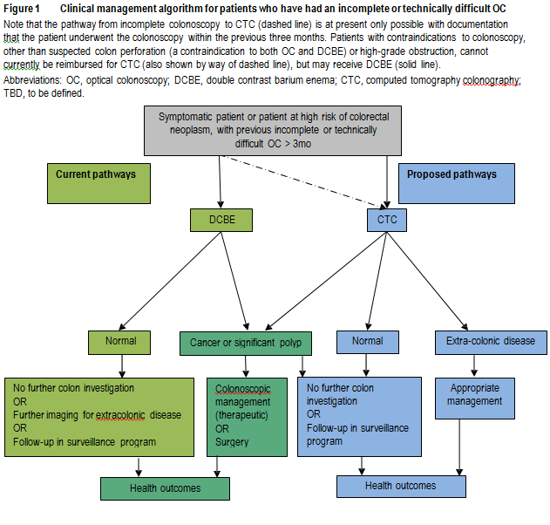
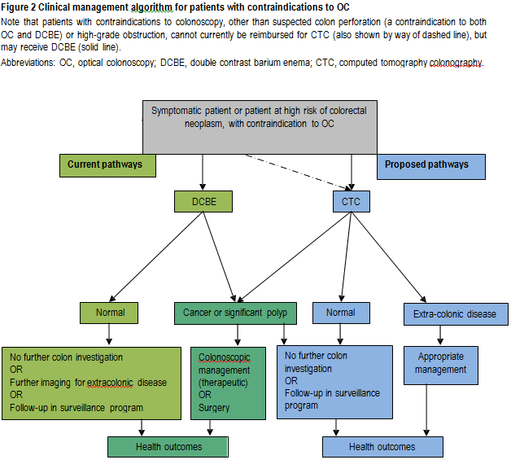

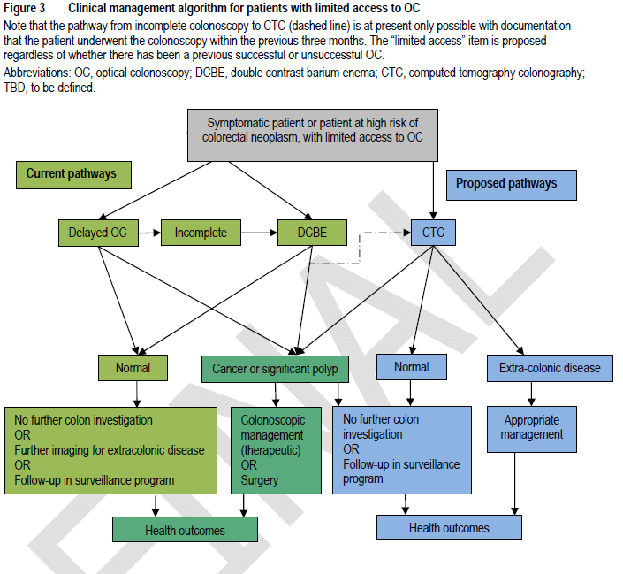

Comparator

The role of CTC for the diagnosis or exclusion of CRC indicates that CTC is a replacement for DCBE or delayed colonoscopy in the defined patient groups.

If the MBS items for CTC are broadened to the eligible population in line with the applicant’s proposal, it is envisaged that uptake of CTC services would slowly increase, with a consequent downward turn in DCBE services until it becomes obsolete.

For patients who are: (a) clinically unsuitable for colonoscopy, as identified by an incomplete or technically difficult colonoscopy, or (b) contraindicated to colonoscopy, the appropriate comparator is DCBE.

For patients with limited access to colonoscopy, the nominated and appropriate comparators are DCBE and ‘delayed colonoscopy’, although if access to colonoscopy is limited it has been suggested that access to DCBE would also be limited.

Comparative safety

Two articles reporting on one randomised controlled trial (Halligan et al. 2013; von Wagner et al. 2011) compared CTC and DCBE with respect to primary and secondary safety outcomes. No studies comparing the safety of CTC and delayed colonoscopy were identified.

Halligan et al 2013 reported that there was no difference in serious adverse events (requiring hospitalisation) between DCBE and CTC. In both groups adverse events were rare: four events versus one event in the DCBE and CTC groups, respectively (RR=1.00, 95% CI 0.99, 1.00). Similarly, any deaths reported were not considered attributable to the imaging received.

Neri et al. 2010 compared the radiation dose required for CTC and DCBE and found that the radiation dose required for DCBE was almost double that for CTC (4.12 ± 0.17 mSv vs 2.17 ± 12 mSv, respectively; p<0.001).

CTC is as safe as, or safer than, DCBE, with equivalent rates of serious adverse events and fewer minor adverse events. Repeat testing due to clinical uncertainty or inadequate examination was more frequent after DCBE than CTC. However, the risk of an additional investigation due to visualisation of suspected polyps was higher for those undergoing CTC than for DCBE (an indicator of increased sensitivity).

No safety data were identified comparing CTC against delayed colonoscopy.

CTC is more acceptable to patients than DCBE, and is associated with less discomfort and worry, higher satisfaction and a higher proportion of patients who would be willing to undergo the procedure again.

There was no evidence available to determine acceptance by patients of CTC compared with delayed colonoscopy, but one systematic review on CTC versus colonoscopy with no specified time delay, reported that the majority of studies found more patients preferred CTC to colonoscopy.

Comparative effectiveness

Studies reporting effectiveness of CTC compared with DCBE in patients symptomatic or at high risk of CRC
Study | Study design and quality appraisal | Population | Effectiveness outcomes assessed
Halligan et al. (2013) | Level II evidence  Multi-centre, two-armed randomised controlled trial  Quality: Moderate | N=3,838  55 years of age or older, symptomatic for CRC | Death rates at 48-month follow-up  Detection rates of cancer and polyps ≥10 mm  Patient preference and tolerance
CTC – computed tomography colonography; DCBE – double contrast barium enema; CRC – colorectal cancer

One (1) study reported that all-cause mortality was the same in the four years after patients received either a CTC or a DCBE procedure (RR=1.00, 95%CI 0.97, 1.03, p=0.94); Halligan et al. (2013).

No evidence comparing the effectiveness of CTC with delayed colonoscopy was identified.

There were no studies that assessed the comparative accuracy of CTC and DCBE in patiens who either failed a previous colonoscopy or were contraindicated for colonoscopy. However, in patients at high risk or symptomatic for CRC (without necessarily having contraindications to colonoscopy), five studies were identified (Halligan et al. 2013; Johnson et al. 2004; Rockey et al. 2005; Sofic et al. 2010; Thomas, Atchley & Higginson 2009). These studies indicated that CTC was more sensitive and slightly less specific than DCBE.

Five studies were identified that provided information on the accuracy of CTC alone within the target populations—i.e. cross-classified against a clinical reference standard, but there was no comparison with DCBE—(Duff et al. 2006; Kealey et al. 2004; Ng et al. 2008; Robinson, Burnett & Nicholson 2002; Saunders et al. 2013). The accuracy of CTC at identifying CRC lesions in people who have either failed colonoscopy or are contraindicated for colonoscopy was similar to that observed in the broader populations specified above (i.e. at high risk or symptomatic for CRC but able to have colonoscopy). This suggests that the better sensitivity and similar, or slightly poorer, specificity of CTC relative to DCBE is likely to be the same in patients who have failed or are contraindicated to colonoscopy. The high negative predictive value associated with CTC (96–100%) also suggests that, for the majority of patients undergoing CTC, a negative result will accurately indicate that the presence of any lesions can be ruled out. This means that these patients are able to avoid having a subsequent, more invasive, colonoscopy.

Economic evaluation

For symptomatic or high risk patients who have limited access to colonoscopy such as it may cause delay in diagnosis, there was no evidence available to demonstrate that prompt access to CTC would result in an improvement to the health of patients compared with receiving a delayed colonoscopy. Given the absence on the effectiveness and safety of CTC compared with delayed colonoscopy, the lack of reliable data on clinical consequences of a delay in diagnosis in symptomatic patients, and the considerable potential for use of this item outside the requested MBS listing, the assessment report considered that qualifying health outcomes and costs in an economic evaluation would be speculative and misleading. Therefore no economic evaluation was presented for this population.

A simple decision-analytic model was used to estimate the incremental cost effectiveness of CTC compared with DCBE for the exclusion or diagnostic of colorectal neoplasia in symptomatic high risk patients, in terms of the ‘incremental cost per additional CRC diagnosed or large polyp identified’.

The model was developed from a study-based evaluation using the outcomes in the RCT reported in Halligan et al. (2013). In this trial, symptomatic patients who were considered to be unsuitable for diagnostic colonoscopy by the consulting clinician were randomised to investigation by either CTC or DCBE. Unless diagnosed with inoperable CRC, all patients who tested positive for any lesion were referred for further colonic investigation (mainly colonoscopy or surgery) to confirm diagnosis and/or for treatment. At the discretion of the clinician, patients for whom no lesions were detected could also be referred for further colonic investigation.

The economic analysis estimated the costs and diagnostic outcomes associated with CTC and DCBE over the entire diagnostic process, including follow-up diagnostic procedures. Costs of subsequent treatment and the impact on survival were not considered in the economic evaluation. In addition, the difference in costs associated with the reassessment and treatment of people receiving a false negative test result from the initial diagnostic process are not included; this is a conservative approach, favouring DCBE over CTC. Given the pragmatic design of this trial, the clinical outcomes reflect both the accuracy of the diagnostic tests and the clinical decision-making over the entire diagnostic process.

The following assumptions were made in the model:
- As colonoscopy is considered the gold standard procedure for detection of colorectal neoplasia, it has a diagnostic accuracy of 100%.
- A contraindication for diagnostic colonoscopy does not necessarily preclude confirmatory or therapeutic colonoscopy.
- All patients referred directly to surgery had been diagnosed as having CRC on the basis of their initial test results.
- All colorectal cancers subsequently diagnosed during the 3-year follow-up were present either as CRC or large polyps at the time of initial investigation; that is, they were false negative outcomes.
- All CRCs missed at the time of the initial diagnostic procedure would have been subsequently diagnosed during the 3-year follow-up.

The cost-effectiveness of CTC compared with DCBE improves as the prevalence of colorectal neoplasia increases. In the base-case scenario, in which the prevalence of CRC and large polyps was estimated at 3.1% and 6.7%, respectively, the average cost per patient including initial and subsequent investigations was $752 for patients assigned to CTC, compared with $254 for patients assigned to DCBE. The incremental cost per additional CRC or large polyp diagnosed for CTC compared with DCBE was $19,380. CTC was relatively less cost-effective in patients presenting with more general clinical symptoms. The ICER increased to $26,260/additional CRC or large polyp diagnosed as a result of the lower prevalence of large polyps in this patient group (3.6%); however, the reported prevalence of colorectal neoplasia in this population is likely to be an underestimate.

For the changes to the current CTC items 56552 and 56554 the fee is proposed to remain the same at $600. For the additional item the applicant has suggested the fee also be $600 consistent with the current CTC fees.

The average out of pocket cost, over 4 years for the current CTC items (56552 & 56554) is $64.61.

There were approximately 5395 CTC services provided in 2012/13 and the average bulk billing rate was approximately 70%.

Removal of the greatest permissible gap and changes to the Medicare Safety Net may affect out-of-pocket expenses.

Financial/budgetary impacts

The table below shows the estimated volume of additional CTC services for patients with limited access to colonoscopy.

- | 2015 | 2016 | 2017 | 2018 | 2019
Projected population | 7,004,913 | 7,097,835 | 7,192,028 | 7,287,512 | 7,384,303
Number of additional CTC services: | 18,316 | 18,559 | 18,806 | 19,055 | 19,308

The table below shows the predicted additional services for the proposed changes to the two existing CTC MBS items for patients contraindicated to colonoscopy.

- | 2014–15 | 2015–16 | 2016–17 | 2017–18 | 2018–19
Total number of services per year | 4,893 | 4,351 | 3,866 | 3,427 | 3,026

Assuming that CTC completely replaces DCBE for the diagnosis of colorectal neoplasia, it has been estimated that there would be an additional 4,900 CTC services in the first year of the revised listing, declining to an additional 3,000 services in the fifth year.

The application proposed that there would be no limitations on the number of services per patient and that the frequency of CTC investigations for each patient would differ according to the clinical context. Under the proposed extended population funding arrangements, patients who undergo regular surveillance for colorectal neoplasm would be likely to require CTC every 1–3 years, provided they fulfil the MBS conditions. CTC could be performed as a once-off procedure in some patients such as the symptomatic elderly, although a repeat procedure within a short interval may be required when the outcome of a first procedure is not definitive.

For the proposed additional item, for patients with limited access to colonoscopy, the table below shows the estimated cost to the MBS and patients over 5 years.

- | 2015 | 2016 | 2017 | 2018 | 2019
Number of additional CTC services: ª | 18,316 | 18,559 | 18,806 | 19,055 | 19,308
Total cost to MBS ^{b} | $9,404,001 | $9,528,748 | $9,655,201 | $9,783,386 | $9,913,328
Patient co-payments | $1,585,773 | $1,606,809 | $1,628,132 | $1,649,748 | $1,671,660
Total cost | $10,989,774 | $11,135,556 | $11,283,334 | $11,433,134 | $11,584,987
ª Difference between regional/remote and metropolitan CTC services
^{b} Assumes that 16% of services are performed in-hospital and 84% are out-of-hospital
CTC – computed tomography colonography; MBS – Medicare Benefits Schedule

Due to the limited data on the number of patients who could meet the eligibility criteria and the loosely defined population, there is potential for use outside the intended purpose.

For the proposed additional item for patients with limited access to colonoscopy, the estimated financial impact on the MBS is $9,440,401 in 2015 increasing to $9,913,328 in 2019.

For the proposed changes to the current CTC listing the table below shows the estimated financial impact on the MBS.
 | 2014-15 | 2015-16 | 2016-17 | 2017-18 | 2018-19
Total number of services per year ª | 4893 | 4351 | 3866 | 3427 | 3026
Cost to MBS
Excluding safety net impacts:
Cost of CTC | $2,512,266 | $2,233,790 | $1,984,685 | $1,759,342 | $1,553,620
Less cost of substituted DCBE | -$556,643 | -$494,941 | -$439,747 | -$389,818 | -$344,236
Net cost to MBS | $1,955,623 | $1,738,849 | $1,544,938 | $1,369,524 | $1,209,384
ª Projected value based on existing Medicare data reports for DCBE over the past 6 financial year, showing annual decline in use of services.
For the proposed changes to the current MBS items 56552 and 56554 the estimated financial impact on the MBS is $1,955,623 in 2014-15 decreasing to $1,209,384 in 2018-19.

For the proposed changes to the current MBS items 56552 and 56554, the table below shows the estimated net costs to the MBS, associated with changes in the use of CTC and DCBE.

- | 2014–15 | 2015–16 | 2016–17 | 2017–18 | 2018–19
Total number of services per year | 4,893 | 4,351 | 3,866 | 3,427 | 3,026
Cost (excluding safety net impacts): | - | - | - | - | -
Cost of CTC | $2,512,266 | $2,233,790 | $1,984,685 | $1,759,342 | $1,553,620
Cost offset from DCBE | $556,643 | $494,941 | $439,747 | $389,818 | $344,236
Net cost | $1,955,623 | $1,738,849 | $1,544,938 | $1,369,524 | $1,209,384
Cost (including safety net impacts): | - | - | - | - | -
Cost of CTC | $2,667,945 | $2,372,213 | $2,107,671 | $1,868,364 | $1,649,894
Cost offset from DCBE | $604,324 | $537,337 | $477,415 | $423,209 | $373,722
Safety net payments | $107,998 | $96,027 | $85,318 | $75,631 | $66,788
Net cost | $2,063,621 | $1,834,876 | $1,630,256 | $1,445,155 | $1,276,172
The highest yearly net increase in cost to the MBS, of approximately $2,064,000 and inclusive of safety net impacts, would occur in the first year of the revised listing. Assuming the trend of decreasing DCBE continues and also applies to substitutable CTC, expenditure on this would decline to approximately $1,276,000 by the fifth year.

Key issues from ESC for MSAC

ESC considered that the proposed amendments to existing items and the proposed new item descriptor presented considerable potential for use outside the intended patient population due to:
- poor definition of access within the proposed descriptor; and
- the removal of the requirement for item 56552 to be provided within 3 months after an incomplete colonoscopy.

ESC noted that CTC is associated with a lower radiation risk and better overall safety profile than DCBE. CTC is less invasive, and ESC noted that it would likely be the preferred option for many patients.

ESC also noted that there was considerable variation in radiation exposure. The discussant highlighted the Neri et al. 2010 study which found that found that even though the radiation dose required for DCBE was almost double that for CTC, there was still a range of ± 12 mSv for CTC, compared to ± 0.17 mSv for DCBE. This large range infers a variation in CTC protocol that may incur substantial additional radiation burden compared with the point estimate. Therefore CTC may give a much higher radiation dose than DCBE in these circumstances.

ESC also noted that the lifetime risk from radiation increases exponentially as age reduces.

ESC noted there was a lack of evidence to directly support the proposed item and amendments. There was no evidence to support the proposed list of contraindications, and no direct comparison of CTC with delayed colonoscopy. The clinical impact of delayed diagnosis of CRC within a symptomatic population was unclear, and a survival benefit had not been substantiated.

ESC did not consider extracolonic pathology outcomes in its deliberations as there was no effectiveness data.

ESC noted that the evidence supported higher sensitivity and lower specificity of CTC compared with DCBE. ESC also noted a lack of data directly comparing CTC with DCBE specifically for the proposed patient populations.

ESC noted that OC remained the gold standard for diagnosis of CRC globally, and in many cases may remain the appropriate procedure after an incomplete colonoscopy.

ESC also noted that much of the data could reflect effective triage practices, and support repeat OC for most instances of incomplete colonoscopy.

ESC considered that the question of whether CTC should remain part of the same episode of care as an incomplete OC was key to the application. If MSAC viewed this as important, retaining the requirement for CTC to be conducted within three months may be necessary.

ESC noted that the incremental cost per additional CRC/large polyp diagnosed by CTC compared with DCBE varies depending on the prevalence of CRC in the target population. The cost-effectiveness of CTC compared with DCBE improves as the prevalence of colorectal neoplasia in the target population increases.

ESC noted that, in patients with a positive screening FOBT result, the estimated incremental cost of CTC compared with DCBE is $19,380. In the more generalised population of patients presenting with other clinical symptoms, the incremental cost is estimated at $26,258.

ESC noted the uncertainty regarding the number of additional CTC services under the proposed criteria. If CTC replaced all use of DCBE, the minimum net cost to the MBS would be approximately $2.6 million per year. Beyond substitution for DCBE, there is considerable uncertainty about the volume of use in patients without access to colonoscopy.

ESC discussed the potential for MSAC to consider introducing a limit on the number of times a benefit is available for CTC each year.

ESC expressed some reservations about the current and proposed fee for CTC and noted that no justification of the proposed fee was provided.

ESC noted that CTC was associated with a very high NPV, significantly lower service cost than OC, and low invasiveness. While the potential to use CTC as a first line diagnostic test was alluded to in the application, ESC noted that this was beyond the scope of the current application and that OC remains the gold standard and first line test worldwide.

Other significant factors

Nil.

Applicant’s comments on MSAC’s Public Summary Document

The applicants believe that many of the arguments against the use of CTC within this document are severely flawed. Of major importance is the list of contraindications to colonoscopy which constitute indications for CTC. There are significant omissions as well as inclusions which are also contraindications to CTC (eg active colitis).

The application for a new item allowing a rebate for CT Colonography (CTC) when optical colonoscopy (OC) is of limited availability has been denied. We understand that the decision was in part:
(1) due to lack of evidence that early CTC was better than delayed OC for symptomatic patients. We contend that it is unlikely that any such data will ever be available – such a trial would need to be very large to reach any statistical validity and be of dubious ethicality. As noted by MSAC, in a symptomatic population there is an association between early diagnosis or treatment of colorectal cancer and worse survival. The applicants believe that this is sufficient evidence to infer that early CTC provides advantages over delayed colonoscopy.

(2) the MSAC report suggests that the failure to clearly define what constitutes a ‘limited access to colonoscopy such as to cause delay in diagnosis’, may lead to considerable potential for use of this item outside the intended purpose. There is not enough evidence to confirm or deny this statement. It is unknown how many DCBEs are currently being done to bypass the OC waiting list – as stated above, there is no limitation on GPs to be able to do this. The statement “…if access to colonoscopy is limited it has been suggested that access to DCBE would also be limited “ is incorrect. However, even this option will shortly no longer be available as DCBEs become obsolete.

(3) the economic analysis suggests that CTC is slightly more expensive than diagnostic OC. MSAC does not appear to take into account patient costs or costs to the community (eg time off work after anaesthesia for colonoscopy, patient transport costs – bearing in mind CTC can be done remotely from the radiologist, etc), nor, importantly, the savings on OCs which are no longer needed after negative CTC. A normal CTC can exclude the need for OC in 70% of those on the waiting list, or more with discretionary reporting of small polyps. Evidence of such use of CTC has come from Canada and New Zealand (accompanied by risk stratification methods) and has not been included in the MSAC report.

(4) the statement “…CTC could not be considered a replacement for colonoscopy and could not be used as a primary screening tool” is misleading and incorrect. Firstly, it is not being suggested that CTC be used for screening, and secondly, CTC is certainly considered a replacement for OC in selected patients in many international jurisdictions.

The applicant will address these issues in a resubmission.

Further information on MSAC

MSAC Terms of Reference and other information are available on the MSAC Website at: www.msac.gov.au.

