Guidelines for preparing

assessments for the

Medical Services Advisory Committee

Summary for stakeholders

Introduction and purpose of this document
The revised Guidelines for preparing assessments for the Medical Services Advisory Committee (the guidelines) were published in May 2021. The guidelines describe the requirements for preparing applications, PICO confirmations and assessment reports of health technologies for consideration by the Medical Services Advisory Committee (MSAC).
This document is a summary for stakeholders of the guidelines and their purpose.

Health technologies
Health technology is a broad term that means something that is intended to:
- prevent, diagnose or treat medical conditions
- promote health
- provide rehabilitation, or
- organise health care delivery.
Health technologies include:
- tests
- medical devices
- medicines
- vaccines
- blood products
- procedures
- programs or systems involved in health care.

MSAC process
The Australian health care system includes public funding for some health technologies. This aims to allow all Australians to have affordable and fair access to health care.
The Australian Government can fund health technologies in several ways. For health technologies that are not medicines, the main way of funding is through the Medicare Benefits Schedule (MBS). MSAC may also provide advice for technologies funded through other programs or arrangements.
Steps in funding a health technology on the MBS and other funding programs:
- The Department of Health receives an application form for funding and assesses it.
- A PICO confirmation is developed to guide the application. This is reviewed and confirmed by the PICO Advisory Sub-Committee (PASC).
- A health technology assessment (HTA) is done to check whether the health technology is safe, effective and good value for society. The assessment report is reviewed and discussed by the Evaluation Sub-Committee (ESC).
- MSAC reviews and discusses the HTA report and ESC advice. MSAC advises the Minister for Health about whether the health technology should be funded on the MBS or another funding program.
The following figure outlines the MSAC process. It also shows the parts of the process that are informed by the guidelines.
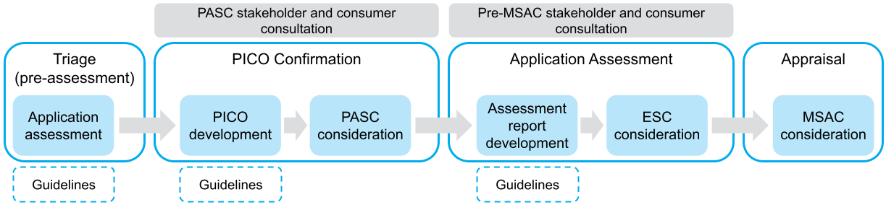

Health technology assessment
HTA is a multidisciplinary process to determine the value of a health technology. The main purpose of HTA is to inform policy decision-making.
In the context of the guidelines, the main policy decision is whether a health technology should be publicly funded.
The goal of HTA is to identify the highest-quality evidence of the benefits, harms and costs of the health technology, and to analyse and interpret the findings to determine value. Value involves:
- clinical effectiveness – does the health technology work?
- safety – is it safe to use?
- costs – how much will it cost to use?
- economic implications – is it good value for money?
- information encompassing the value of knowing, ethical, organisational, patient and social, legal or environmental aspects, and whether a rule of rescue applies – are there other important aspects of the health technology that might influence the decision to fund it?
Health impacts and costs are measured against what is already used (called the comparator). This helps decide whether the extra benefits from a new health technology are enough to justify any extra costs to the health care system.
The HTA is provided as an assessment report for MSAC to consider.

Factors that influence MSAC decisions
MSAC provides advice to the Minister for Health about whether health technologies should be funded on the MBS. MSAC also provides advice to other decision-makers such as the Health Council and the National Blood Authority.
When MSAC considers a health technology, it is mainly informed by:
- the clinical need for the new health technology
- improvements in health as a result of the health technology, often measured as longer life or better quality of life, or both
- the cost of the health technology relative to how much it improves health (cost-effectiveness), and
- the cost of making the health technology available (financial impact).
MSAC also considers other relevant factors:
- Equity – will funding the health technology improve access to health care for all people or will it favour a group of people? Will this increase or decrease fairness in the health care system?
- Value of knowing – does the medical test provide information to make treatment decisions? If not, does it provide information that is valued by patients, families or carers in some other way?
- Alternatives – is there an effective alternative already available?
- Organisational issues – is the health care system ready to provide the health technology? Are there barriers such as lack of an appropriately trained workforce, poor communication systems or suboptimal patient referral processes?
- Ethical and social concerns – are there any issues about privacy, respect or autonomy? Does the health technology produce the same type of benefits as those that are valued by patients and their families?
To fully evaluate the value of a health technology, input is needed from:
- research studies, clinical evidence and analyses – this is described in the guidelines
- a range of stakeholders, including consumers, practitioners and experts – this helps MSAC decide about the value of the health technology.

Purpose of the guidelines
The guidelines help explain how to create assessments to inform MSAC’s decisions. Documents that are informed by the guidelines include the:
- application form
- PICO confirmation
- assessment report
- commentary (if MSAC asks for a commentary).

Application form
The key components of an application form are known as the PICO:
- Population – the group(s) of people that the health technology will be funded for, including characteristics of the condition(s)
- Intervention – the description of the health technology and how it is used
- Comparator – what is currently used
- Outcomes – how the impact of the health technology should be measured.
Other information sought during the application process includes:
- a clinical claim – whether the health technology is better or no worse than the comparator
- a summary of available evidence
- estimated use of the health technology
- information about the cost of the health technology.

PICO confirmation
The PICO confirmation is a document that is prepared before the assessment report is developed. It establishes the appropriate population(s), comparator(s) and outcomes for the proposed intervention (health technology). It is informed by the application form, and by any extra searches and input from stakeholders and the applicant.
The PICO confirmation may result in more than one PICO set if the health technology can be used in different populations or for different reasons.
PASC reviews the PICO confirmation before the assessment report is developed.

Assessment report
Assessment reports aim to synthesise the highest quality evidence of the safety, effectiveness and cost-effectiveness of the health technology. This is specific for the population and indication in the PICO confirmation. The assessment report discusses the strengths and uncertainties of the evidence. It takes a structured approach to:
- describing the health technology, what it will replace and who it is intended for
- searching for evidence
- including relevant studies
- assessing whether included studies are of a high standard
- combining and comparing results from studies
- converting study findings and other data to include in an economic model
- estimating the number of people who will receive the health technology, and the cost of this
- including evidence of other factors that may influence decision-making.
Assessment reports are developed either:
- by the applicant (called applicant-developed assessment reports, or ADARs)
- by an assessment group that is contracted by the Department on behalf of the applicant (called Department-contracted assessment reports, or DCARs).
Both types of assessment reports follow the same process. The templates for the main body of the assessment are identical.
Assessment reports include an executive summary, and this differs for ADARs and DCARs:
- For ADARs, the executive summary is a brief overview of the clinical claim and value of the health technology. The applicant can explain why they are seeking public funding of the proposed technology and how it is expected to benefit people.
- For DCARs, the executive summary summarises the key findings of the assessment report. The format reflects the structure of ESC’s advice to MSAC. This in turn forms the basis of the MSAC public summary document for that assessment.

Commentary
A commentary is a critical review of an assessment report. This is done by an independent assessment group. The commentary evaluates the approach taken and the results presented in the ADAR. It also includes an executive summary in the same format as the DCAR executive summary.

Templates
Templates are available for a PICO confirmation, ADAR, DCAR and the executive summary of the commentary. The sections in the templates match the structure of the guidelines and include cross-references to the guidelines. This aims to help applicants and assessment groups develop useful and complete information for MSAC.

Structure of the guidelines
The guidelines have 5 main sections and 12 appendixes. Each section considers different information that helps with decision-making. Each section is divided into subsections called Technical Guidance. The Technical Guidance subsections are numbered as TG 1, TG 2, etc.
Not all TG subsections will be relevant to every assessment report. The people writing the assessment report can refer to the relevant TG subsections, and skip those that are not relevant. In this way, the guidelines are more like a manual than a template.

Section 1: Context
This section provides guidance relevant to the application form, the PICO confirmation and the first part of an assessment report. A clear understanding of the context helps to find and interpret relevant evidence about the safety, effectiveness and cost-effectiveness of the technology.
Section 1 provides guidance for presenting:
- the purpose of the application (TG 1)
- the PICO: what the technology is, who it is intended for and what other technologies it might replace (TG 2)
- how the technology is proposed to be funded (TG 3)
- a summary of previous MSAC considerations (if relevant) (TG 4)
- whether an abbreviated assessment is possible for some parts of complicated genetic tests that involve many genes (TG 5).

Section 2A: Clinical evaluation – assessment of therapeutic technologies
Therapeutic technologies are medical interventions (such as services, surgery, procedures, radiotherapy or blood products) that are intended to directly impact on health.
Section 2A describes the process of presenting clinical evidence for therapeutic technologies. It provides guidance for presenting:
- the effectiveness of therapeutic technologies (TG 6)
- the safety of therapeutic technologies (TG 7)
- an interpretation of the therapeutic evidence (TG 8).
This section is supported by Appendixes 2–5, which describe methods for:
- searching the literature for evidence relevant to the assessment (Appendix 2)
- assessing the risk of bias for included studies (Appendix 3)
- describing the certainty of the evidence (Appendix 4)
- presenting the characteristics of studies, including baseline characteristics of study participants, details of how the health technology was used in the studies, and how the outcomes were measured and reported (Appendix 5).
The methods are presented in the appendixes because they are relevant to both Section 2A and Section 2B.

Section 2B: Clinical evaluation – assessment of investigative technologies
Investigative technologies are tests that might be used for diagnosis, prognosis, screening or monitoring.
Section 2B describes the process of presenting clinical evidence for investigative technologies. It provides guidance for presenting the effectiveness and safety of tests, and is organised by the type of evidence that is being presented. It provides guidance for appraising and reporting on:
- studies that report on health outcomes after a test is used, referred to as direct from test to health outcomes evidence (TG 10)
- studies that report on the accuracy of a test (TG 11)
- studies that report on the ability of a test to change clinical management (TG 12)
- studies that report on the possible impact of changes in clinical management (TG 13)
- the safety of investigative technologies (TG 14)
- additional considerations when assessing special cases, such as screening, monitoring, codependent technologies, and algorithms and adaptive tests (TG 15)
- an interpretation of the investigative evidence (TG 16).
Not all these sections will be relevant for each assessment. The relevant sections mainly depend on:
- the available evidence
- whether the assessment can be reduced to a comparison of test accuracy.
This section is also supported by Appendixes 2–5.

Assessment framework for investigative technologies
TG 9 in Section 2B introduces the assessment framework. This framework helps determine the appropriate approach for assessing investigative technologies. The guidelines explain what type of information needs to be included for each numbered step in the framework.
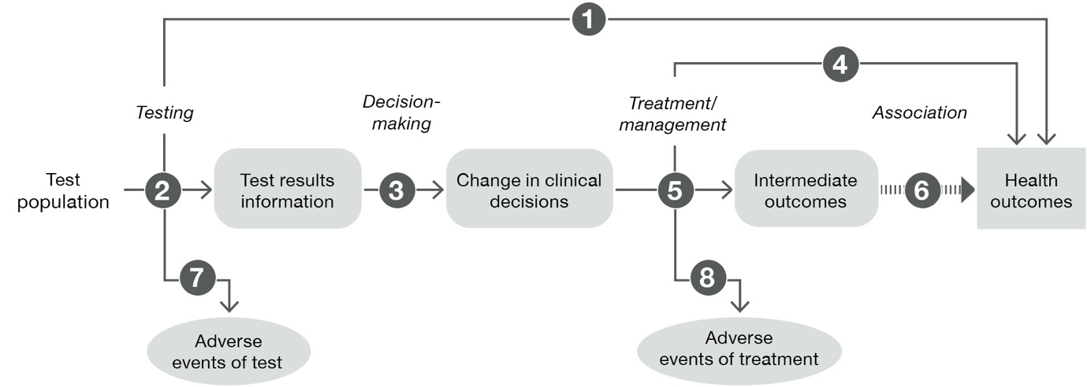
For a test to improve health, it usually needs to be more accurate than the existing test. The patient and their practitioner can then use this information to change treatment or management, which should improve health outcomes. For this reason, it is rarely appropriate to only assess test accuracy (although there are some exceptions, such as when a test is proposed to replace an existing test).
The assessment framework is intended to ensure that all the steps are clear, from testing to health outcomes. This is called a linked evidence approach.
Sometimes studies are available where participants receive a test and they are followed up until health outcomes are reported. This is called direct from test to health outcomes evidence.
Each link in the assessment framework (direct to health outcomes, testing, decision-making, treatment/management) corresponds to a TG subsection in the guidelines.

Section 3A: Economic evaluation – cost-effectiveness analysis
This section describes the process of presenting evidence for the cost-effectiveness of health technologies. A health technology that costs more than the technology it is seeking to replace will usually need an analysis that shows how much extra benefit would be gained for that extra cost. This section provides the following guidance:
- description of the analysis and approach (TG 17)
- model structure and development (TG 18)
- population and setting included in the model or analysis (TG 19)
- variables that explain how patients move through the model (TG 20)
- variables that explain how health outcomes are captured in the model (TG 21)
- costs and resources included in the model (TG 22)
- ways to validate the economic model (TG 23)
- how to present the results of the analysis (TG 24)
- how to identify and explore uncertainties in the analysis (TG 25).
Section 3A includes guidance for modelling both therapeutic and investigative technologies.

Section 3B: Economic evaluation – cost minimisation
This section describes a cost-minimisation approach. This approach is used if the proposed technology has similar (noninferior) health outcomes to the comparator. It establishes that the use of the proposed technology results in the same overall cost as the use of the comparator.
The guidance discusses how to present health care resource use and costs for the proposed health technology, and how to compare this with the comparator (TG 26).

Section 4: Use of the health technology in practice
This section estimates how much the proposed health technology will be used (uptake) and the overall cost to the health care system (and/or payer). The guidance includes how to:
- estimate the use of the proposed technology and of the technology it will displace
- estimate the net cost
- identify uncertainty in the analyses.

Section 5: Options to present additional relevant information
This section contains 2 Technical Guidance subsections.
TG 28 is called ‘Value of knowing’ and is specifically for investigative technologies. The value of knowing is most likely to be relevant when a test provides accurate information of a diagnosis or prognosis, but there is currently no known treatment or way to change the course of the disease. This means it is difficult to show whether the test will result in improved health outcomes, but the results of the test may have some value to patients, family members or carers. TG 28 explains how to present the nonhealth benefits and harms associated with test results.
TG 29 is called ’Other relevant considerations’. It is relevant for both investigative and therapeutic technologies. This section provides guidance on how to identify and report other factors that may influence decision-making. These include ethical issues, patient issues, organisational issues, legal issues and environmental issues. The issues of most relevance are those that:
- are unique to the proposed technology (or how it is used), so MSAC is unlikely to have considered the factors before (or in the same setting)
- affect the way the clinical or economic evidence is interpreted
- were included in the ratified PICO confirmation for further assessment (these are also likely to meet one or both of the above criteria).

Consumer evidence and input
When MSAC considers a health technology for public funding, it receives information from many sources. The assessment report, which is informed by the guidelines, is one source of evidence.
The assessment report is mainly guided by research studies and clinical evidence. It is common for these studies to have involved patients to help design the studies or to help determine the most relevant impacts of the health technology.
Economic analyses in the assessment use published information on quality of life or health impacts as reported by patients. These are valued according to the perspective of society. Where the assessment report includes other relevant considerations, this may include published evidence of consumer values and perspectives.
MSAC also receives evidence and input from consumers (patients, family members, carers) and other stakeholders through pathways other than the assessment report process. These include:
- a formal targeted public consultation at the start of an MSAC application
- consumer comments provided at any point before the health technology is considered. The applications scheduled for consideration by MSAC and its subcommittees (ESC and PASC) are published before each meeting.
Consumers are important in MSAC considerations. MSAC is committed to understanding consumer values, experiences and preferences, and integrating them into its consideration of a health technology.
Applicants are encouraged to inform consumers (such as consumer or patient groups) before or during the application process. A consumer perspective from a relevant organisation may be provided when the application is submitted, or at a later time.
The HTA Consumer Evidence and Engagement Unit (HTAconsumerengagement@health.gov.au) can provide specific details about how and when consumer evidence can be provided.

HTAglossary.net; http://htaglossary.net/health+technology?highlight=health+technology
HTAglossary.net; http://htaglossary.net/health+technology+assessment?highlight=health+technology+assessment

