RATIFIED PICO
MSAC Application 1651:
Integrated, closed-system, extracorporeal photopheresis (ECP) systems for the treatment of chronic graft-versus-host disease (cGVHD)

Summary of PICO criteria to define the question(s) to be addressed in an Assessment Report to the Medical Services Advisory Committee (MSAC)
Component | Description
Patients | Patients with chronic graft versus host disease (cGVHD) following haematopoietic stem cell transplantation (HSCT) who are steroid-refractory or steroid-dependent or steroid-intolerant. ECP can be used as a second-line therapy or as a third- or later-line therapy for patients for have not previously used ECP.
Intervention | Extracorporeal photopheresis (ECP) is a leukapheresis-based, immunomodulatory therapy in which a patient’s leukocytes are collected and treated ex vivo with methoxsalen injection for extracorporeal circulation via photopheresis and ultraviolet A (UVA) light and then returned to the patient. Integrated, closed ECP systems complete the processes of cell separation, photo activation with methoxsalen, and reinfusion of the treated cells back into the patient within an automated and fully integrated process.  In second-line therapy, ECP can be used in combination with a systemic therapy such as a steroid or other treatment. For the steroid-dependent and steroid-refractory populations, steroids will continue, and potentially additional systemic therapy may be used (mycophenolate mofetil or a calcineurin inhibitor). For the steroid-intolerant population, ECP may be used alone or with additional systemic therapy (mycophenolate mofetil or a calcineurin inhibitor). For patients starting ECP as a third- or later-line therapy, ECP may also be added to systemic therapy of steroids and/or other treatment.
Comparator | Continued systemic steroid use in combination with mycophenolate mofetil or a calcineurin inhibitor except for steroid intolerant population, for which systemic steroids are not an appropriate comparator.
Outcomes | Clinical and patient-relevant outcomes  - Objective response, complete and partial response  - Steroid sparing  - Other immunosuppressant sparing (‘steroid intolerant’ patients)  - Change in total skin score (TSS)  - Change in quality of life (QoL)  - Change in functional capacity  - Survival (GVHD-related and overall)  - Change in NIH Score  - Other time-to-event information (e.g. survival without progressive impairment (SWOPI) or Failure free survival (FFS))  Safety  - Adverse events  - Serious adverse events  - Treatment related adverse events  Healthcare resources  - Average length of time on treatment with ECP (disaggregated to initiation and continuation)  - Frequency of ECP for initiation and continuation  - Confirmation that the existing fee per service applies also to this indication  - Displacement or replacement of later lines of therapy (would ECP continue into later line?)  - Time-to-event information– time without new systemic treatment  Cost-effectiveness  - Incremental cost-utility analysis  PASC noted that for total Australian Government healthcare costs, a comment on potential movement of State to Commonwealth financing might be useful.

PICO or PPICO rationale for therapeutic and investigative medical services only
Population
The population for whom MBS funding is sought are patients with chronic graft versus host disease (cGVHD) following haematopoietic stem cell transplantation (HSCT) who are steroid-refractory, steroid-dependent or steroid-intolerant (based on the Application; response to Question 25).
Graft versus host disease (GVHD)
GVHD is a common, serious and sometimes fatal immune-mediated disease resulting from a complex interaction between donor and recipient adaptive immunity after HSCT [Ferrara 2009; Welniak 2007]. Activated donor T cells attack the tissues of the transplant recipient as antigenic differences cause the immune response to recognise host tissues as antigenically foreign. The resulting inflammatory cytokines cause tissue damage, with the most commonly involved organs including the liver, skin, mucosa, and the gastrointestinal tract.
Acute versus chronic GVHD
Prior to 2005, alloimmunity that resulted in clinical manifestations before day 100 following transplantation was referred to as acute GVHD, whereas clinical alloimmunity after day 100 was considered cGVHD [Lee 2017]. In 2005, the 2005 National Institutes of Health (NIH) Consensus Conference redefined acute and chronic GVHD as distinct clinical syndromes without a time restriction, and no longer relied on the 100 day distinction.
According to the 2005 NIH consensus (reaffirmed in the 2014 consensus [Jagasia 2015]), classic acute GVHD occurs before day 100 and is staged according to the percentage of body surface area with rash, total bilirubin elevation, and volume of diarrhoea. Late acute GVHD occurs after day 100 and is defined as signs and symptoms of acute GVHD without cGVHD. Late acute GVHD is further subdivided into “persistent” if it is a continuation of classic acute GVHD, “recurrent” if classic acute GVHD resolves then recurs after day 100, or “de novo” if initial onset is after day 100 without any prior acute GVHD.
The 2005 NIH Consensus Conference also recommended a new category called “overlap chronic GVHD” when concurrent acute and chronic GVHD are present.
Figure 1 illustrates the diagnosis of GVHD after 2005.
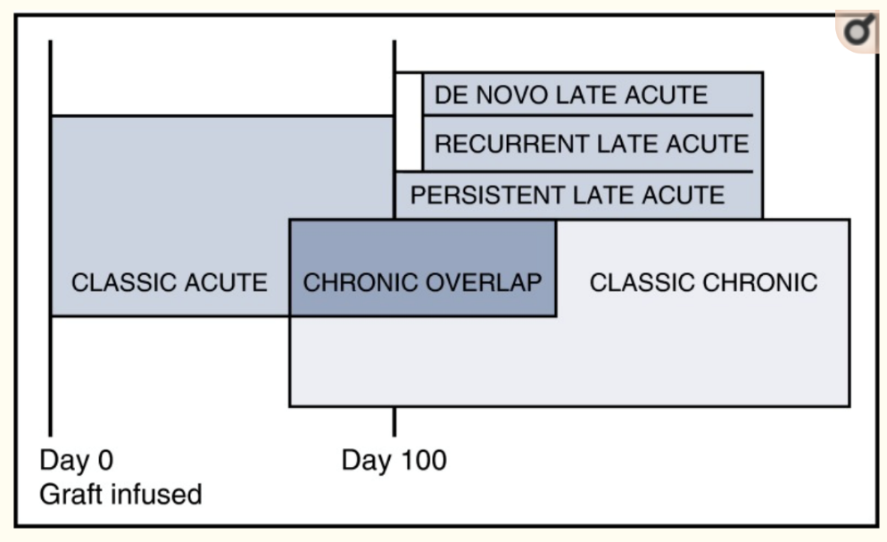
Figure 1: Acute, late acute, chronic overlap and classic chronic GVHD as per NIH 2005 consensus
Source: Figure 1, Lee (2017)
Note: box sizes do not reflect prevalence
cGVHD
The diagnosis of cGVHD is based on a specific set of clinical features for different organs which are outlined in the NIH Consensus Development Project on Criteria for Clinical Trials in Chronic Graft-versus-Host Disease [Jagasia 2015].
A detailed synopsis of the clinical features of cGVHD for different organs from the NIH consensus report is presented in Table A in the Appendix.
However, most practitioners view using the NIH cGVHD recommendations in their entirety as too burdensome for use in routine clinical practice [Duarte 2014; Lee 2017]. Given the differences in how chronic versus acute GVHD have been defined in the past 15 years, there is a potential for use beyond cGVHD in patients with acute GVHD. As per the figure, cGVHD can arise directly from acute GVHD (progressive disease), following resolved acute disease, or de novo. All acute GVHD patients will have to have been treated with steroids prior to being considered for ECP. There is also a risk of leakage to use in patients with GVHD following solid organ transplant. PASC confirmed that the population is those with chronic graft-versus-host disease (cGVHD) and considered that the “chronic” aspect is sufficiently well defined acknowledging the wider consensus amongst treating clinicians in recent times based on the NIH criteria.
The Application states that despite the advances in transplant practice, the incidence of cGVHD is increasing. Major reasons are increased use of allogenic HSCT in older recipients and improvements made in treatments post allogenic HSCT prolonging survival [van der Wagen 2018].
In NSW, it is estimated that 69% of allogenic HSCT patients develop cGVHD [Gifford 2016]. cGVHD-related mortality is estimated at between 20% to 40% of affected patients depending on severity [Berger 2015].
Affected patients require long-term use of immunosuppressive drugs associated with the development of severe side effects and low ongoing quality of life (QoL) that parallel systemic autoimmune diseases [van der Wagen 2018; Wood 2018]. The greater comorbidity burden is associated with higher rates of non-relapse mortality and inferior overall survival [Wood 2018].
The Application proposes a population for cGVHD based on clinical guidelines, TGA indication and pivotal trial evidence for ECP.
For a patient to receive the proposed medical service, clinicians assess patient response to first-line therapy and define the clinical need for second-line treatment. ECP can also be used as a third- or later-line therapy for patients for have not previously used ECP. Patient assessment of first-line therapy depends on the severity of patient condition, where milder cases are reviewed monthly and the more severe presentations on a weekly basis.
Patients who would be eligible for the proposed medical service are adults with cGVHD following HSCT who are steroid-refractory, or steroid-dependent, or steroid-intolerant. The 2014 NIH Consensus [Jagasia 2015] define cGVHD patients who are steroid-refractory or steroid-dependent as the following:
- Steroid-refractory when manifestations progress despite the use of a regimen containing prednisone at >1 mg/kg/day for at least 1 week or persist without improvement despite continued treatment with prednisone at >0.5 mg/kg/day or 1 mg/kg every other day for at least 4 weeks.
- Steroid-dependent when prednisone doses >0.25 mg/kg/day or >0.5 mg/kg every other day are needed to prevent recurrence or progression of manifestations as demonstrated by unsuccessful attempts to taper the dose to lower levels on at least two occasions, separated by at least 8 weeks.
In addition, steroid-intolerance is defined as when patients who are unable to tolerate the side effects of adequate doses of systemic steroids [Das-Gupta 2014].
Clinician follow-up duration also varies depending on the severity of the cases presented. Most respondents use the NIH consensus criteria for diagnosing and scoring the severity of cGVHD, but clinicians also consider patient QoL, the long-term implications of steroid use and if patient response to first-line treatment is unclear, partial, or mixed. These considerations aid respondents to define the clinical need for second-line therapy.
Table 1 presents the scoring for severity of chronic GVHD according to the 2014 NIH consensus [Jagasia 2014].
Table 1: NIH Global Severity of chronic GVHD
Mild chronic GVHD
1 or 2 organs involved with no more than a score of 1 PLUS
Lung score of 0
Moderate chronic GVHD
3 or more organs involved with no more than a score of 1 OR
At least 1 organ (not lung) with a score of 2 OR
Lung score of 1
Severe chronic GVHD
At least 1 organ with a score of 3 OR
Lung score of 2 or 3
Key points:
In skin: higher of the 2 scores to be used for calculating global severity. In lung: FEV1 is used instead of clinical score for calculating global severity.
If the entire abnormality in an organ is noted to be unequivocally explained by a non-GVHD documented cause, that organ is not included for calculation of the global severity.
If the abnormality in an organ is attributed to multifactorial causes (GVHD plus other causes) the scored organ will be used for calculation of the global severity regardless of the contributing causes (no downgrading of organ severity score).
Source: Table 2, p399 of Jagasia [2014]
Correspondence from the Applicant provided additional detail of the estimated population with cGVHD. The incidence of cGVHD in adults is estimated from associated publications from the Australasian Bone Marrow Transplant Recipient Registry (ABMTRR). In 2018, 509 allogeneic HSCTs were performed in patients aged 16 years and over in Australia (614 in all age groups). The cumulative incidence of cGVHD in Australia between 2014 and 2018 was 47.1% following allogeneic HSCT. It is estimated that 40% of patients achieve a complete or partial response to first-line treatment. Therefore, it is estimated that up to 143 patients (i.e. 509 x 47.1% x 60%) could be eligible for ECP treatment per year (173 patients if all age groups are considered). This is likely an upper range given that the cGVHD data collected in the ABMTRR represents all forms of cGVHD and not all will have clinically significant cGVHD that requires treatment.
Rationale
In 2016, an Application to MSAC was initiated for ECP in acute and chronic GVHD in adult and paediatric populations, but was not completed. The current Application appropriately limits use to adult patients with cGVHD, which is consistent with the TGA-approved indication for methoxsalen for extracorporeal administration with the THERAKOS CELLEX Photopheresis System:
treatment of steroid-refractory and steroid-intolerant chronic graft versus host disease (cGVHD) in adults following allogeneic HSC transplantation.
PASC noted three subpopulations, advising that more objective criteria for these should be added in the proposed item descriptors (see related box below):
- population a, steroid-refractory
- population b, steroid-dependent
- population c, steroid-intolerant.
The proposed item descriptor specifies ‘adult’ as 18 years or older. Further communication with the Applicant indicated that the ‘adult’ population includes any patients aged 12 years or older. The Applicant noted the following in support of this contention:
- the TGA Product Information (PI) for methoxsalen only states “adults” but does not specify a specific age;
- guidelines consider treatment of patients from 12 years of age similarly to adults; and
- the age range of patients in the Flowers [2008] randomised controlled trial (comparing ECP and systemic steroids with/out immunosuppressants, which will likely form the primary evidence base for any submission/application), was from 13 years of age.
PASC advised that the item descriptor and codependent PBS restriction for methoxsalen should omit reference to the age of the patient rather than specifying an age or using a term such as “adolescent”.
Methoxsalen for extracorporeal administration with the THERAKOS CELLEX Photopheresis System is also TGA approved for use in palliative treatment of the skin manifestations of cutaneous T-cell lymphoma (CTCL) that is unresponsive to other forms of treatment. ECP was recommended by MSAC in 2020 for the treatment of patients with steroid-refractory CTCL (Application 1420.1) and recently listed on the MBS under items 14247 (initial) and 14249 (continuing). Methoxsalen was recommended by the PBAC in 2020 for the treatment of CTCL and concurrently listed on the Pharmaceutical Benefits Scheme (PBS) under items 12156T and 12162D (initial) and 12154Q and 12173Q (continuing).
Intervention
ECP is a leukapheresis-based, immunomodulatory therapy in which a patient’s leukocytes are collected and treated ex vivo with methoxsalen injection for extracorporeal circulation via photopheresis and ultraviolet A (UVA) light and then returned to the patient. Integrated, closed ECP systems complete the processes of cell separation, photoactivation of methoxsalen, and reinfusion of the treated cells back into the patient within an automated and fully integrated process [Knobler 2014]. All components of the treatment are validated for use together.
During the integrated, closed-system ECP procedure, white blood cells are separated from whole blood via apheresis, combined with a photoactive drug, methoxsalen and then exposed to UVA light. All blood components, including the treated white blood cells are returned to the patient. Figure 2 provides an overview of the integrated, closed-system ECP procedure.
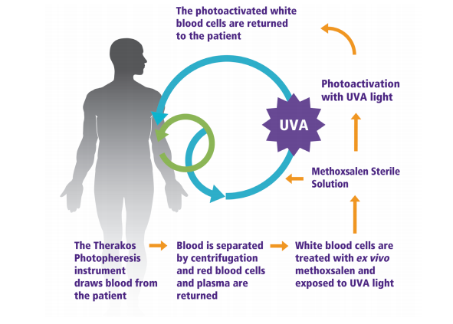Figure 2: Overview of ECP.
Blood is removed from the patient, and the red blood cells (RBC) and white blood cells (WBC) are separated. RBC are immediately returned to the patient, whereas WBC are treated with methoxsalen (8-MOP) and ultraviolet-A (UVA) radiation to photoactivate the drug; photoactivated WBC are then returned to the patient.
Photopheresis is also performed with open systems, also known as two-step methods, which are characterised by different devices for cell separation and drug photo activation [Knobler 2014; Alfred 2017]. In these systems the combination of the device for separation and the device for photoactivation has not been approved for use together or specifically approved for photopheresis [Knobler 2014; Alfred 2017]. The two-step approach also increases the potential risk of patient reinfusion error, infection and cross-contamination [Knobler 2014; Pierelli 2013]. Open systems are only recommended for use in centres that have approval for handling blood components separately [Knobler 2014]. Upon consultation with Australian clinical experts, it has been concluded that open systems are no longer in use in Australia for treatment of GVHD.
PASC noted that the intervention is the same integrated, closed-system, extracorporeal photopheresis (ECP) system as previously considered by MSAC and that it involves ex vivo methoxsalen as the same codependent technology.
Unless otherwise noted, ECP in this document refers to integrated, closed ECP.
Methoxsalen dosage is calculated according to the treatment volume of the separated buffy coat (which is displayed on the display panel of the instrument) and the complete photopheresis procedure is up to 3 hours in duration.
Though ECP therapy may be used to reduce or eliminate systemic steroid use (see Outcomes section) in patients who are dependent or refractory to steroids, second-line treatment in cGVHD is often initiated concomitantly with corticosteroids. ECP (or the nominated comparators) will often be administered with corticosteroids with the goal of tapering steroid use. Consequently, ECP will be administered in combination with methoxsalen, and often times a corticosteroid and/or a non-steroidal immunosuppressive agent (for example, mycophenolate mofetil or a calcineurin inhibitor).
PASC noted that ECP can be used in combination with a systemic therapy such as a steroid or other treatment. For the steroid-dependent and steroid-refractory populations, steroids will continue, and potentially additional systemic therapy may be used (mycophenolate mofetil or a calcineurin inhibitor). For the steroid-intolerant population, ECP may be used alone or with additional systemic therapy (mycophenolate mofetil or a calcineurin inhibitor).
ECP may be started in combination with systemic therapy of steroids and/or other treatment for prevalent patients initiating ECP as a third- or later-line therapy following failure of a different second-line therapy. In this case, ECP will be used with the intention to wean or reduce the steroid and other systemic therapy.
Flowers [2008], a randomised controlled trial (RCT) comparing ECP in combination with immunosuppressants (including steroids) to standard care (steroids and/or immunosuppressants) included patients who had to be receiving a standard corticosteroid dose for at least two weeks before randomisation and were:
- corticosteroid-refractory (defined as lack of response or disease progression after administration of at least 1 mg/kg of methylprednisolone equivalent);
- corticosteroid-dependent (requiring more than 10 mg methylprednisolone equivalent to control skin manifestations); or
- corticosteroid-intolerant (including avascular necrosis, severe myopathy, uncontrolled diabetes mellitus, systemic viral or fungal infections).
The proposed medical service is currently only delivered at the Royal Prince Alfred Hospital and the Victorian Comprehensive Cancer Centre by two primary users through state ad hoc funding. The Application stated that, as for Application 1420.1 for CTCL, it is proposed that treatment must be under supervision of a consultant haematologist. The Application further noted that ECP could be delegated or referred to nursing staff under the supervision of a consultant haematologist.
Frequency and duration of ECP therapy
Three ECP treatments are conducted in the first week followed by two ECP treatments per week for at least 12 weeks, or as clinically indicated.
In Flowers [2008], for patients in the ECP arm, ECP treatment was administered three times during Week 1, and then twice weekly on consecutive days during Weeks 2 through 12. Responding patients in the ECP group could continue two ECP treatments every 4 weeks until Week 24.
The Application did not specify a specific duration of treatment or any specific stopping criteria. For patients in the Foss [2005] prospective, non-randomised study, ECP was administered for two consecutive days every 2 weeks in 17 patients and once a week in eight patients until best response or stable disease. The median duration of therapy was 9 months (range 3–24 months).
In its consideration of ECP in CTCL, the ESC considered the impact of limiting treatment duration with ECP but queried the rationale for stopping a treatment that continues to be effective. ESC also considered that treatment with ECP in CTCL would be longer than 12 months [1420.1 PSD].
The explanatory note in the MBS item descriptor for ECP in CTCL (MBS item 14249) states:
“A response, for the purposes of administering MBS item 14249, is defined as attaining a reduction of at least 50% in the overall skin lesion score from baseline, for at least 4 consecutive weeks. Refer to the Product Information for methoxsalen for directions on calculating an overall skin lesion score. The definition of a clinically significant reduction in the Product Information differs to the 50% requirement for MBS-subsidy. Response only needs to be demonstrated after the first six months of treatment”.
Though patient disposition and prognosis is categorically different in CTCL than in cGVHD, the Application has not proposed a clear framework for continuing treatment beyond 12 weeks.
PASC noted that the initial treatment cycle would be 12 weeks, then review and continue with another 12-week treatment cycle if the patient is responding. PASC noted that clinicians review the treatment every 12 weeks before continuing. PASC noted that the initial 12-week treatment cycle is twice per week, and the second 12-week cycle is twice per month. PASC noted that patients who do not respond sufficiently to ECP after the initial 12-week cycle should not continue with the treatment.
PASC noted that occasionally the duration of the treatment can be quite long (for example, up to 330 days) and therefore requires long-term venous access, although most patients do not need to be treated this long.
PASC noted that patients can relapse after ECP treatment. If the relapse was a longer than 8 weeks from cessation of ECP, the patient would be treated with steroids again as a first-line treatment before considering retreatment with ECP using the initiation regimen. If the relapse was within 8 weeks from the cessation of ECP, the patient would be retreated with ECP re-using the initiation regimen. Allowance for the possibility of either type of retreatment will be needed in the drafting of the item descriptor for initiation of ECP and the related PBS restriction for methoxsalen.
Comparator
The Application considered that, based on a treatment survey and clinician interviews, the nominated comparator is continued steroid use in combination with mycophenolate or a calcineurin inhibitor.
The Application stated that guidelines do not specify what second-line therapy to use in treating cGVHD, therefore the treatment algorithm is not standardised and is dependent on physician experience, ease of use, need for monitoring, risk of toxicity and pre-existing comorbidities.
The NCCN guidelines for Hematopoietic Cell Transplantation (Version 2.2020; Saad 2020) have suggested systemic agents for steroid-refractory GVHD. The NCCN guidelines caution that there is insufficient evidence to recommend one systemic agent as preferred over another. The NCCN guidelines considered that the selection of systemic agents should be based on institutional preferences, physician experience, agent’s toxicity profile, the effect of prior treatment, drug interactions, convenience/accessibility, and patient tolerability.
Consistent with the NCCN guidelines, the Application considered that clinician insight suggested a broad range of second-line therapies.
The Application noted that MSAC has a clear preference for comparator therapies that are listed on the PBS. Mycophenolate mofetil, prednisone, tacrolimus and ciclosporin have unrestricted listings on the PBS. Therefore, considering accessible reimbursed treatments, contemporary second-line reimbursed treatment in Australia (and thus the nominated comparator) is proposed to be continued systemic steroid use in combination with mycophenolate or a calcineurin inhibitor.
The Application stated that, in cGVHD, progression to third-line therapy is considered after assessing patient response to second-line therapy and defining the clinical need for third-line therapy. This is dependent on the severity of the patient’s condition and their response to second-line treatment. Patient assessment and establishment for the clinical need of third-line therapy follows the same assessment resulting in first- to second-line therapy.
The Application noted that clinicians also considered patient QoL and the long-term adverse effects of steroid use. Importantly, guidelines do not specify what third-line therapy to use, therefore the treatment algorithm is not standardised and is dependent on physician experience, ease of use, need for monitoring, risk toxicity and pre-existing comorbidities. Also, by third-line therapy, any treatment not previously used in first- or second-line treatment for cGVHD may be considered.
The Application stated that integrated, closed-system ECP for the treatment of cGVHD reduces the use of other second- and third-line treatments potentially associated with severe adverse events.
Since ECP could be used in combination with any of the recommended systemic therapies, ECP is considered an add-on therapy that would likely not replace any therapies. The therapies most likely to be used are PBS listed (mycophenolate mofetil, prednisone, tacrolimus, ciclosporin), these therapies are more likely to be added on to than replaced.
The comparator in the Flowers [2008] trial was standard systemic therapy, which included steroids, mycophenolate mofetil, ciclosporin, or tacrolimus.
Figure 3 presents the suggested systemic agents for steroid-refractory GVHD according to the NCCN guidelines.
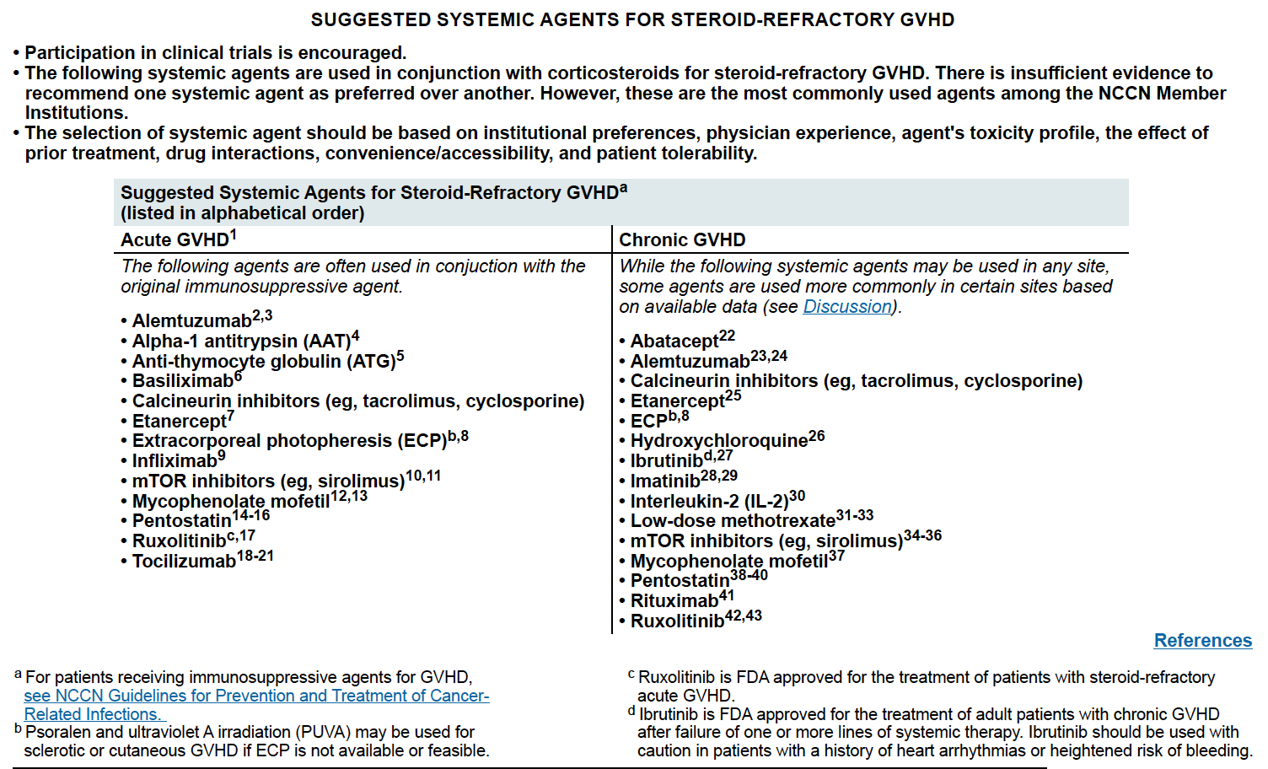
Figure 3: NCCN guidelines suggested systemic agents for steroid-refractory GVHD
Rationale
Other alternative therapies considered by clinicians in the second-line setting are rituximab, ruxolitinib, and ibrutinib, none of which have been TGA-approved for this purpose. Clinicians also indicated that these therapies should be added-on to the existing first-line therapies, with a goal to wean patients off systemic steroid therapy. While a preference for ruxolitinib and ibrutinib is noted by clinicians because of prospective evidence demonstrating effectiveness, the Application noted that these therapies are not reimbursed on the PBS and are only available through clinical trials or compassionate access from their respective manufacturers. Hence, neither they nor rituximab would be considered a comparator option as MSAC has a clear preference for comparator therapies that are listed on the PBS.
Ruxolitinib and ibrutinib have recently been approved for GVHD by the U.S. Food & Drug Administration (FDA). Consequently, these could potentially be considered near market comparators.
PASC noted that the comparators listed in the PICO are appropriate for populations a and b. ECP is mostly expected to add to and then partially replace systemic steroids.
PASC advised that the nominated comparators were not appropriate for the relatively small population c because ‘steroid-intolerant’ should not be able to continue steroids; further clarity is needed around the current standard of care in Australia for this group. For example, to ascertain whether mycophenolate or a calcineurin inhibitor would be used without steroids.
PASC noted that currently subsidised treatments would be the most appropriate comparators because they are more likely to be used currently than non-subsidised treatments. PASC noted that many of the treatments listed in Figure 3 are not subsidised in Australia and that the applicant had accepted that ruxolitinib and ibrutinib were not PBS-listed for the proposed population. Therefore the PICO should not retain any implication that non-subsidised treatments are also appropriate comparators.
Outcomes
Patient relevant
The Application proposed a clinical claim of superiority in terms of response, steroid-sparing effect, QoL, overall survival, TSS, steroid dose reduction, adverse events, serious adverse events, and treatment-related adverse events.
Lee [2015] provides the NIH consensus on defining response in clinical trials for cGVHD. A synopsis of response by organ type is presented in Table B in the Appendix.
The primary end point of Flowers [2008] was the median percentage change in the TSS after 12 weeks of treatment compared with the baseline (pre-treatment) value using a validated ordinal 50-point whole body scoring system.
The Application’s table of preliminary evidence is provided in Table C in the Appendix.
Though unclear to what extent these may be expected to occur in clinical practice, potential displacement or replacement of second- and third-line therapies may be considered relevant health care resource use outcomes.
Healthcare system
As previously stated, ECP is currently only delivered at the Royal Prince Alfred Hospital and the Victorian Comprehensive Cancer Centre by two primary users through State ad hoc funding. The Application considered that a listing of ECP on the MBS would help facilitate broader access to ECP.
In the context of its decision regarding ECP for CTCL, MSAC accepted that equity of access for ECP is an issue, but that this would remain an issue whether ECP was listed on the MBS or not [1420.1 PSD].
PASC noted the final list of outcomes as follows:
Clinical and patient-relevant outcomes
Objective response, complete and partial response
Steroid sparing
Other immunosuppressant sparing (‘steroid intolerant’ patients)
Change in total skin score (TSS)
Change in quality of life (QoL)
Change in functional capacity
Survival (GVHD-related and overall)
Change in NIH Score
Other time-to-event information (e.g. survival without progressive impairment (SWOPI) or Failure free survival (FFS)
Safety
Adverse events
Serious adverse events
Treatment related adverse events
Healthcare resources
Average length of time on treatment with ECP (disaggregated to initiation and continuation)
Frequency of ECP for initiation and continuation
Confirmation that the existing fee per service applies also to this indication
Displacement or replacement of later lines of therapy (would ECP continue into later line?)
Time-to-event information– time without new systemic treatment
Cost-effectiveness
Incremental cost-utility analysis
PASC noted that for total Australian Government healthcare costs, a comment on potential movement of State to Commonwealth financing might be useful.

Current and proposed clinical management algorithm for identified population
Figure 4 presents the recommended treatment algorithm for chronic GVHD as per the NCCN Hematopoietic Cell transplantation guidelines.
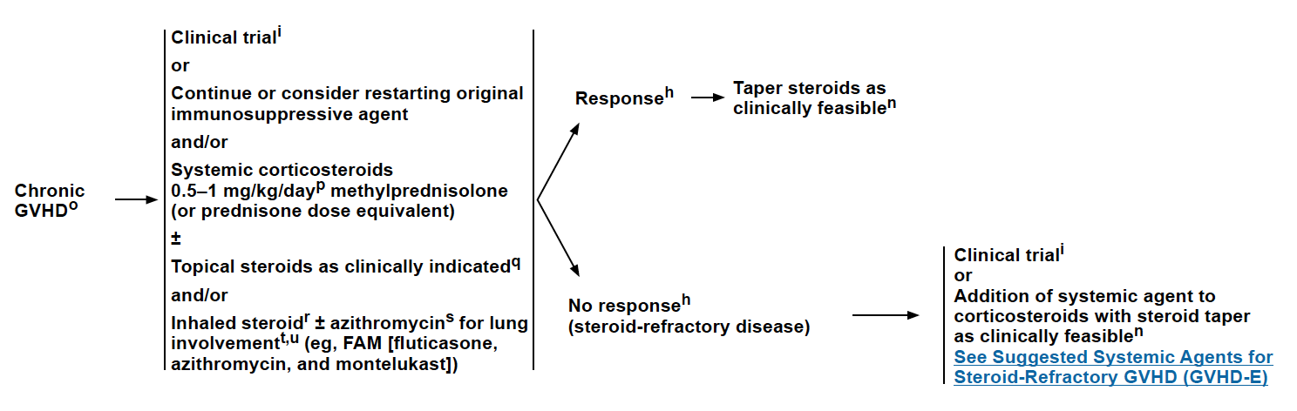
Figure 4: cGVHD algorithm as per NCCN GVHD guidelines
Source: NCCN guidelines, Version 2.2020 Hematopoietic Cell transplantation, pGVHD-4
PASC confirmed that first-line treatment is steroids and that the proposed second-line treatment is ECP and weaning off steroids against the current second-line of continuing steroids and an additional systemic agent. If the patient is steroid-intolerant, then the proposal is that they would just receive ECP with or without another agent (with any weaning of the other agent) against the presumed current second-line of possibly receiving another systemic agent. PASC advised that this should be made clear in the algorithm.
Figure 6 and Figure 7 present a more detailed current and proposed treatment algorithm, respectively, updated to reflect PASC’s advice. Although ECP is expected to be mostly used as a second-line therapy as reflected in the proposed algorithm, ECP may also be used as a third- or later-line therapy by prevalent patients who used systemic agents in second-line therapy. In this group of patients, ECP may be added to systemic steroids and/or other therapies with the aim of weaning both steroids and the other therapies.
Figure 6: Current management algorithm
systemic agent = calcineurin inhibitor (e.g. tacrolimus and ciclosporin) or mycophenolate mofetil
Figure 7: Proposed management algorithm
systemic agent = calcineurin inhibitor (e.g. tacrolimus and ciclosporin) or mycophenolate mofetil
Note: For some patients starting ECP as third-line and later-line, ECP may also be added to systemic steroids and/or other treatment, with the aim of weaning both steroids and other therapy.
ª Response = the initial treatment cycle would be 12 weeks, then review and continue with another 12-week treatment cycle if the patient is responding. PASC noted that clinicians review the treatment every 12 weeks before continuing. PASC noted that the initial 12-week treatment cycle is twice per week, and the second 12-week cycle is twice per month. PASC noted that the definition of “response” was limited to an improvement in cGVHD symptoms. PASC advised that for the steroid-dependent population, the definition of “response” might also appropriately include a reduction in use of concomitant therapy (with a reduction of steroid dose being the most expected response)
^{b} No response = patients who do not respond sufficiently to ECP after the initial 12-week cycle should not continue with the treatment
^{c} From cessation of ECP
^{d} Re-using the initiation regimen for ECP (12-week treatment cycle, twice per week)

Proposed economic evaluation
The Application considered that a claim of superiority will be supported based on improvements in outcomes of response, QoL, survival, TSS and adverse events.
The Advisory Committee on Medicines (ACM) [AusPAR Report November 2019] advised, however, that “the efficacy of ECP with Uvadex [methoxsalen] has not been adequately demonstrated in the treatment of chronic GvHD. However, the ACM noted that opportunities for large RCTs are unlikely to occur, the safety profile is considered acceptable and that ECP with Uvadex has been available for several years under the SAS [Special Access Scheme]. Based on these factors and the seriousness of the condition, the ACM advised that ECP with Uvadex should be approved for the treatment of chronic GvHD.”
The only RCT for second-line cGVHD in the Application’s preliminary supporting evidence did not demonstrate any statistically significant differences in the key endpoints between ECP and standard therapy alone, which included mycophenolate mofetil, cyclosporin A, and/or tacrolimus.
PASC did not advise any change to the proposed economic evaluation.
PASC advised that, consistent with the clinical assessment, subsided treatments would be the most appropriate comparators to include in the economic evaluation.

Proposed item descriptor
The proposed item descriptor presented in the Application is provided below. REDACTED These amendments are reflected in the item descriptor below.
Category 3 – Therapeutic procedures
MBS 38xxx
INTEGRATED, CLOSED- EXTRACORPOREAL PHOTOPHERESIS SYSTEMS for the ECP treatment of chronic graft-versus-host disease (cGVHD) in adults following allogeneic HSC transplantation, if all the following criteria are met:

(a) Patient must be refractory to prior systemic treatment for this condition. A refractory patient is defined as having had disease recurrence while on treatment or experienced intolerance to or toxicity from treatment
(b) Treatment must be in combination with injectable methoxsalen
(c) Treatment must be under supervision of a consultant haematologist.
Caution: Patient must not be pregnant or breastfeeding. Patients and their partners must each be using an effective form of contraception if of child-bearing age.
Treatment includes a specialist consultation and continuous monitoring with nurse attendance under the supervision of a consultant physician.
Fee: REDACTED Benefit: 75% = REDACTED 85% = REDACTED
PASC advised that, consistent with the current MBS listing (and codependent PBS listing of methoxsalen), there should be an initiation MBS item and a continuation MBS item for this application. PASC noted that the intent is for treatment to be assessed in 12-week intervals, requiring a 12-week initiation period and subsequent 12-week continuation periods.
Proposed PBS and MBS listings are expected to be provided by the applicant for consideration in the assessment report.
PASC advised omitting reference to the age of the patient in the item descriptor. This has been amended in the item descriptor above.
PASC noted that the definition of “response” was limited to an improvement in cGVHD symptoms. PASC advised that for the steroid-dependent population, the definition of “response” might also appropriately include a reduction in use of concomitant therapy (with a reduction of steroid dose being the most expected response).
PASC noted that the definition of steroid-refractory or steroid-dependent disease in relation to the initiation of ECP was updated to include specific detail:
- A lack of response or disease progression after a minimum of prednisone 1 mg/kg/day or equivalent for at least 1 week, OR
- Disease persistence without improvement despite continued treatment with prednisone at >0.5 mg/kg/day or 1 mg/kg/every other day or equivalent for at least 4 weeks, OR
- Increase to prednisolone dose to >0.25 mg/kg/day or equivalent after 2 unsuccessful attempts to taper the dose. PASC noted there were some minor inconsistencies between the proposed definitions and the NCCN definitions.
This update to the definition of steroid-refractory and steroid-dependent disease is based on a recent trial in GVHD, is reflective of current clinical practice, and is designed to reduce steroid burden and its associated toxicity in patients.

Consultation feedback
Consultation feedback from one organisation and one individual was received. The feedback was supportive of ECP systems for the treatment for patients with chronic GVHD.
PASC noted the positive consultation feedback.
PASC noted that some current problems with equity of access will persist even if the item is listed.
PASC noted the potential for substantial residual out-of-pocket costs beyond MBS funding associated with travel to the few centres capable of providing the service.

Next steps
PASC noted that it would like to see the PICO document out of session before it is ratified to confirm the changes in the clinical management algorithm.
PASC noted, that consistent with all codependent applications requiring consideration by the PBAC, the applicant has elected to progress its application as an ADAR (applicant developed assessment report).
PASC advised that, upon ratification of the post-PASC PICO, the application can proceed to the Evaluation Sub-Committee (ESC) stage of the MSAC process.

Applicant comments
The applicant advised they had no further comments to provide following the PASC meeting.

References:
Alfred, A., et al., The role of extracorporeal photopheresis in the management of cutaneous T‐cell lymphoma, graft‐versus‐host disease and organ transplant rejection: a consensus statement update from the UK Photopheresis Society. British Journal of Haematology, 2017. 177(2): p. 287-310.
AusPAR Report November 2019. Australian Public Assessment Report for Methoxsalen – TGA. www.tga.gov.au › files › auspar-methoxsalen-191114
Berger, M., et al., Extracorporeal photopheresis for graft‐versus‐host disease: the role of patient, transplant, and classification criteria and hematologic values on outcome—results from a large single‐center study. Transfusion, 2015. 55(4): p. 736-747.
Das-Gupta, E., et al., Extracorporeal photopheresis for treatment of adults and children with acute GVHD: UK consensus statement and review of published literature. Bone Marrow Transplantation, 2014. 49(10): p. 1251-1258.
Duarte RF, Greinix H, Rabin B, et al. Uptake and use of recommendations for the diagnosis, severity scoring and management of chronic GVHD: an international survey of the EBMT-NCI Chronic GVHD Task Force. Bone Marrow Transplant. 2014;49(1):49-54.
Ferrara, J. L., Levine, J. E., et al., Graft-versus-host disease. Lancet, 2009. 373(9674): p. 1550-61.
Flowers, M.E., et al., A multicenter prospective phase 2 randomized study of extracorporeal photopheresis for treatment of chronic graft-versus-host disease. Blood, The Journal of the American Society of Hematology, 2008. 112(7): p. 2667-2674.
Foss, F., et al., Prospective study of extracorporeal photopheresis in steroid-refractory or steroid-resistant extensive chronic graft-versus-host disease: analysis of response and survival incorporating prognostic factors. Bone Marrow Transplantation, 2005. 35(12): p. 1187-1193.
Jagasia, M.H., et al., National Institutes of Health consensus development project on criteria for clinical trials in chronic graft-versus-host disease: I. The 2014 diagnosis and staging working group report. Biology of Blood and Marrow Transplantation, 2015. 21(3): p. 389-401. e1.
Knobler, R., et al., Guidelines on the use of extracorporeal photopheresis. Journal of the European Academy of Dermatology and Venereology, 2014. 28: p. 1-37.
Lee SJ. Classification systems for chronic graft-versus-host disease. Blood. 2017 Jan 5;129(1):30-37. doi: 10.1182/blood-2016-07-686642. Epub 2016 Nov 7. PMID: 27821503; PMCID: PMC5216262.
Pierelli, L., et al., Extracorporeal photopheresis for the treatment of acute and chronic graft‐versus‐host disease in adults and children: best practice recommendations from an Italian Society of Hemapheresis and Cell Manipulation (SIdEM) and Italian Group for Bone Marrow Transplantation (GITMO) consensus process. Transfusion, 2013. 53(10): p. 2340-2352.
Saad, A., de Lima, M., Anand, S., et al. A. Hematopoietic Cell Transplantation, Version 2.2020, NCCN Clinical Practice Guidelines in Oncology, Journal of the National Comprehensive Cancer Network 2020. 18(5), 599-634.
van der Wagen, L., et al., Prospective evaluation of sequential treatment of sclerotic chronic graft versus host disease with rituximab and nilotinib. Bone Marrow Transplantation, 2018. 53(10): p. 1255-1262.
Welniak, L. A., Blazar, B. R., et al., Immunobiology of allogeneic hematopoietic stem cell transplantation. Annu Rev Immunol, 2007. 25: p. 139-70.
Wood, W.A., et al., Comorbidity burden in patients with chronic GVHD. Bone Marrow Transplantation, 2013. 48(11): p. 1429-1436.
Appendix
Table A: Signs and symptoms of chronic GVHD as per NCCN guidelines and NIH consensus (2014)
Signs and symptoms of chronic GVHDª
Organ Site | Diagnostic  (sufficient to establish the diagnosis of chronic GVHD) | Distinctive^{b}  (seen in chronic GVHD, but insufficient to establish a diagnosis) | Other features for unclassified entities^{c} | Common^{d}  (seen with both acute and chronic GVHD)
Skin | - Poikiloderma  - Lichen planus-like features  - Sclerotic features  - Morphea-like features  - Lichen sclerosis-like features | - Depigmentation  - Papulo-squamous lesions | - Sweat impairment  - Ichthyosis  - Keratosis pilaris  - Hypopigmentation  - Hyperpigmentation | - Erythema  - Maculopapular rash  - Pruritus
Nails |  | - Dystrophy  - Longitudinal ridging, splitting or brittle features  - Onycholysis  - Pterygium unguis  - Nail loss (usually symmetric, affects most nails)
Scalp and Body Hair |  | - New onset of scarring or non-scarring scalp alopecia(after recovery from chemoradiotherapy)  - Loss of body hair  - Scaling | - Thinning scalp hair, typically patchy, coarse or dull (not explained by endocrine or other causes)  - Premature gray hair
Mouth | - Lichen planus-like changes | - Xerostomia  - Mucoceles  - Mucosal atrophy  - Ulcers  - Pseudo-membranes |  | - Gingivitis  - Mucositis  - Erythema  - Pain
Eyes |  | - New onset dry, gritty, or painful eyes  - Cicatricial conjunctivitis  - Keratoconjunctivitis sicca  - Confluent areas of punctate keratopathy | - Photophobia  - Periorbital hyperpigmentation  - Blepharitis (erythema of the eye lids with edema)
Genitalia | - Lichen planus-like features  - Lichen sclerosis- like features  - Vaginal scarring or clitoral/labial aglutination (females)  - Phimosis or urethral/meatus scarring or stenosis (males) | - Erosions  - Fissures  - Ulcers
GI Tract | - Oesophageal web  - Strictures or stenosis in the upper to mid third of the oesophagus |  | - Exocrine pancreatic insufficiency | - Anorexia  - Nausea  - Vomiting  - Diarrhoea  - Weight loss  - Failure to thrive (infants and children)
Liver |  |  |  | - Total bilirubin, alkaline phosphatase  - ALT >2x upper limit of normal
Lung | - Bronchiolitis obliterans diagnosed with lung biopsy  - Bronchiolitis obliterans syndrome(BOSe) | - Air trapping and bronchiectasis on chest CT | - Cryptogenic organizing pneumonia (COP)  - Restrictive lung disease
Muscles, Fascia, Joints | - Fasciitis  - Joint stiffness or contractures secondary to fasciitis or sclerosis | - Myositis or polymyositis | - Oedema  - Muscle cramps  - Arthralgia or arthritis
Hematopoietic and Immune |  |  | - Thrombocytopenia  - Eosinophilia  - Lymphopenia  - Hypo- or hyper-gammaglobulinemia  - Autoantibodies (AIHA, ITP)  - Raynaud's phenomenon
Other |  |  | - Pericardia! or pleural effusions  - Ascites  - Peripheral neuropathy  - Nephrotic syndrome  - Myasthenia gravis  - Cardiac conduction abnormality or cardiomyopathy
ª Jagasia MH, Greinix HT, Arora M, et al. National Institutes of Health Consensus Development Projection Criteria for Clinical Trials in Chronic Graft -versus-Host Disease: The 2014 Diagnosis and Staging Working Group Report. Biol BloodMarrow Transplant; 2015,21:389-401.
^{b} In all cases, infection, drug effect, malignancy, or other causes must be excluded.
^{c} Can be acknowledged as part of the chronic GVHD manifestations diagnosis is confirmed.
^{d} Common refers to shared features by both acute and chronic GVHD.
^{e} BOS can be diagnostic for lung chronic GVHD only if distinctive signs or symptoms of chronic GVH Dare present in another organ. BOS diagnosis requires the following criteria:
- FEV1N C ratio < 0.7 or the fifth percentile predicted.
- FEV1 < 75% ofpredictedwith.:10% decline within 2 years.FEV1 should not be corrected to>75% of predicted after albuterol inhalation, and the absolute decline for the corrected values should still remain at 10% over 2years.
- Absence of infection in the respiratory tract, documented with investigations directed by clinical symptoms, such as chest radiographs, computed tomographic (CT) scans, or microbiologic cultures(sinus aspiration, upper respiratory tract viral screen, sputum culture, bronchoalveolar lavage).
- One of the 2 supporting features of BOS: Evidence of air trapping by expiratory CT or small airway thickening or bronchiectasis by high resolution chest CT; or evidence of air trapping by PFTs: residual volume> 120% of predicted or residual volume/total lung capacity elevated outside the 90% confidence interval. If a patient already carries the diagnosis of chronic GVHD by virtue of organ involvement elsewhere, then only the first 3 criteria above are necessary to document chronic GVHD lung involvement.
^{f} Pulmonary entities under investigation or unclassified.
^{g} Diagnosis of chronic GVHD requires biopsy.

Table B: Chronic GVHD steroid response criteria / definitions
Organ | Complete Response | Partial Response | Progression
Skin | NIH Skin Score 0 after previous involvement | Decrease in NIH Skin Score by 1 or more points | Increase in NIH Skin Score by 1 or more points, except 0 to 1
Eyes | NIH Eye Score 0 after previous involvement | Decrease in NIH Eye Score by 1 or more points | Increase in NIH Eye Score by 1 or more points, except 0 to 1
Mouth | NIH Modified Oral Mucosa Rating Score 0 after previous involvement | Decrease in NIH Modified Oral Mucosa Rating Score of 2 or more points | Increase in NIH Modified Oral Mucosa Rating Score of 2 or more points
Esophagus | NIH Esophagus Score 0 after previous involvement | Decrease in NIH Esophagus Score by 1 or more points | Increase in NIH Esophagus Score by 1 or more points, except 0 to 1
Upper GI | NIH Upper GI Score 0 after previous involvement | Decrease in NIH Upper GI Score by 1 or more points | Increase in NIH Upper GI Score by 1 or more points, except 0 to 1
Lower GI | NIH Lower GI Score 0 after previous involvement | Decrease in NIH Lower GI Score by 1 or more points | Increase in NIH Lower GI Score by 1 or more points, except from 0 to 1
Liver | Normal ALT, alkaline phosphatase, and Total bilirubin after previous elevation of one or more | Decrease by 50% | Increase by 2x ULN
Lungs | - Normal % FEV1 after previous involvement  - If PFTs not available, NIH Lung Symptom Score 0 after previous involvement | - Increase by 10% predicted absolute value of %FEV1  - If PFTs not available, decrease in NIH Lung Symptom Score by 1 or more points | - Decrease by 10% predicted absolute value of %FEV1  - If PFTs not available, increase in NIH Lung Symptom Score by 1 or more points, except 0 to 1
Joints and Fascia | Both NIH Joint and Fascia Score 0 and P-ROM score 25 after previous involvement by at least one measure | Decrease in NIH Joint and Fascia Score by 1 or more points or increase in P-ROM score by 1 point for any site | Increase in NIH Joint and Fascia Score by 1 or more points or decrease in P-ROM score by 1 point for any site
Global | Clinician overall severity score 0 | Clinician overall severity score decreases by 2 or more points on a 0- 10 scale | Clinician overall severity score increases by 2 or more points on a 0- 10 scale
Source: Lee SJ, Wolff D, Kitko C, et al. Measuring therapeutic response in chronic graft-versus-host disease: National Institutes of Health Consensus Development Project on Criteria for Clinical Trials in Chronic Graft-Versus-Host Disease: IV. The 2014 Response Criteria Working Group Report. Biol Blood Marrow Transplant 2015;21:984-99. 9

Table C: Application’s preliminary evidence table
Author, year | Type | Description | Web link
Flowers 2008 | RCT | This study (N=100) compared ECP plus standard therapy with standard therapy alone in refractory cGVHD. The skin assessment revealed a significant improvement in favour of ECP (P <0.001). ECP was generally well-tolerated and may have a steroid-sparing effect in the treatment of cGVHD. (NCT00054613). | https://ashpublications.org/blood/article/112/7/2667/24720/A-multicenter-prospective-phase-2-randomized-study
Dignan 2014 | Non-randomised trial | This single-centre prospective study assessed a total of 52 consecutive patients commenced ECP treatment for cGVHD in the UK. 70% of patients achieved a complete or partial response. Improvements in QoL and reductions in immunosuppression doses were also observed. | https://www.nature.com/articles/bmt201421
Gandelman 2018 | Single-arm trial | A prospective multicentre clinical trial to assess ECP response rates in 83 patients with cGVHD in the US. ECP treatment induced an overall response rate of 62% by investigator response and significant reduction in steroid dose from baseline. | https://www.bbmt.org/article/S1083-8791(18)30384-7/fulltext
Meier 2010 | Review | The consensus conference summarised the literature on diagnosis and topical treatment options for oral cGVHD and to provide recommendations for clinical practice. Optimal treatment involves interdisciplinary teamwork, and the treatment plan should address the type of oral cGVHD manifestation. | https://link.springer.com/article/10.1007/s00784-010-0450-6
Malik 2014 | Systematic review | The search generated 312 studies, of which 18 met the selection criteria (N=595). ECP was found to be an effective therapy for oral, skin, and liver cGVHD, with modest activity in lung and gastrointestinal cGVHD. | https://www.ncbi.nlm.nih.gov/pmc/articles/PMC4090330/
Abu-Dalle 2014 | Systematic review | The search identified 9 studies, including 1 RCT, that met the inclusion criteria (N=323). The studies showed encouraging responses after ECP treatment, particularly in cutaneous, gastrointestinal, hepatic, and oral mucosa. | https://www.sciencedirect.com/science/article/pii/S1083879114003152
Jagasia 2019 | RCT | 60 patients were enrolled to investigate ECP use as first-line therapy in cGVHD. The results suggest that ECP with methoxsalen is a well-tolerated first-line treatment of cGVHD in patients who have undergone HSCT. (NCT01380535) | https://www.ncbi.nlm.nih.gov/pmc/articles/PMC6650730/
Seaton 2003 | Non-randomised trial | 28 patients were treated with ECP, to investigate clinical and laboratory parameters in cGVHD. Encouraging responses were seen for skin scores and systemic immunosuppression was stable or reduced. Overall, baseline parameters predicted a modest response to ECP. | https://ashpublications.org/blood/article/102/4/1217/17103/Influence-of-extracorporeal-photopheresis-on
Foss 2005 | Non-randomised trial | Enrolled 25 patients with extensive, steroid-refractory cGVHD in a prospective trial evaluating the efficacy of ECP. In summary, the authors reported improvement in skin and/or visceral cGVHD in 71% overall and 61% of high risk patients. | https://www.nature.com/articles/1704984
Source: pp8-10 of the Application.
cGVHD = chronic GVHD; ECP = extra corpororal photophoresis; HSCT = haemapoietic stem cell transplantation; RCT = randomised controlled trial
Table D: Item descriptor MBS 14247
Category 3 – Therapeutic procedures
MBS 14247
Extracorporeal photopheresis for the treatment of erythrodermic stage III-IVa T4 M0 cutaneous T-cell lymphoma; if
a. the service is provided in the initial six months of treatment; and
b. the service is delivered using an integrated, closed extracorporeal photopheresis system; and
c. the patient is 18 years old or over; and
d. the patient has received prior systemic treatment for this condition and experienced either disease progression or unacceptable toxicity while on this treatment; and
e. the service is provided in combination with the use of Pharmaceutical Benefits Scheme-subsidised methoxsalen; and
f. the service is supervised by a specialist or consultant physician in the speciality of haematology.
Applicable once per treatment cycle
Fee: $1,908.35 Benefit: 75% = $1,431.30 85% = $1,823.65

Table E: Item descriptor MBS 14249
Category 3 – Therapeutic procedures
MBS 14249
Extracorporeal photopheresis for the continuing treatment of erythrodermic stage III-IVa T4 M0 cutaneous T-cell lymphoma; if
a. in the preceding 6 months:
(i) a service to which item 14247 applies has been provided; and
(ii) the patient has demonstrated a response to this service; and
(iii) the patient requires further treatment; and
b. the service is delivered using an integrated, closed extracorporeal photopheresis system; and
c. the patient is 18 years old or over; and
d. the service is provided in combination with the use of Pharmaceutical Benefits Scheme-subsidised methoxsalen; and
e. the service is supervised by a specialist or consultant physician in the speciality of haematology.
Applicable once per cycle
Note: A response, for the purposes of administering MBS item 14249, is defined as attaining a reduction of at least 50% in the overall skin lesion score from baseline, for at least 4 consecutive weeks. Refer to the Product Information for methoxsalen for directions on calculating an overall skin lesion score. The definition of a clinically significant reduction in the Product Information differs to the 50% requirement for MBS-subsidy. Response only needs to be demonstrated after the first six months of treatment.
Fee: $1,908.35 Benefit: 75% = $1,431.30 85% = $1,823.65

