Application 1686
¹⁷⁷Lutetium PSMA i&t for metastatic castrate resistant prostate cancer
This application form is to be completed for new and amended requests for public funding (including but not limited to the Medicare Benefits Schedule (MBS)). It describes the detailed information that the Australian Government Department of Health requires to determine whether a proposed medical service is suitable.
Please use this template, along with the associated Application Form Instructions to prepare your application. Please complete all questions that are applicable to the proposed service, providing relevant information only. Applications not completed in full will not be accepted. The separate MSAC Guidelines should be used to guide health technology assessment (HTA) content of the Application Form
Should you require any further assistance, departmental staff are available through the Health Technology Assessment Team (HTA Team) on the email below to discuss the application form, or any other component of the Medical Services Advisory Committee process.

Email: hta@health.gov.au
Website: www.msac.gov.au

PART 1 – APPLICANT DETAILS

Applicant details (primary and alternative contacts)
Partnership details (where relevant): REDACTED (Group of four clinicians)
Corporation name:

Primary contact name: REDACTED
Primary contact numbers
Business: REDACTED
Mobile: REDACTED
Email: REDACTED

Alternative contact name: REDACTED
Alternative contact numbers
Business: REDACTED
Mobile: REDACTED
Email: REDACTED

(a) Are you a consultant acting on behalf on an applicant?
Yes
No
(b) If yes what is the Applicant(s) name that you are acting on behalf of?
Not applicable

(a) Are you a lobbyist acting on behalf of an Applicant?
Yes
No

If yes, are you listed on the Register of Lobbyists?
Not applicable

Have you engaged a consultant on your behalf?
Yes
No

PART 2 – INFORMATION ABOUT THE PROPOSED MEDICAL SERVICE

Application title
Lu ¹⁷⁷ PSMA i&t for men with metastatic castrate resistant prostate cancer

Provide a succinct description of the medical condition relevant to the proposed service (no more than 150 words – further information will be requested at Part F of the Application Form)
Prostate cancer is one of the commonest cancers in Australia with one in every 6-8 men diagnosed in their lifetimes and subsequently despite therapy, progressive disease termed “metastatic castrate resistant prostate cancer” is responsible for the deaths of approximately 3000 Australian men every year. Once in the castrate resistant state, 5-year survival is around 20%. While there has been an expansion of effective therapies in this space (androgen signalling inhibitors, PARP inhibitors, chemotherapy) their efficacy is often short lived, morbidity remains high and life expectancy short. Pain and marrow failure related to bone metastases is a particular issue, as is renal impairment and sepsis from ureteric obstruction from enlarging lymph nodes. Many new treatments only target a small proportion of this population, leaving the majority with persistently limited treatment options.

Provide a succinct description of the proposed medical service (no more than 150 words – further information will be requested at Part 6 of the Application Form)
PSMA targeted radionuclide therapy is an emerging new class of therapy for the treatment of metastatic castrate resistant prostate cancer. The treatment is a targeted intravenous radiotherapy which enters the cancer cell via the PSMA receptor, which is overexpressed in prostate cancer, with expression increasing in metastatic and castrate resistant disease. Recent randomised trials in this class of treatments have demonstrated improved overall survival compared to standard of care treatment, and improved treatment responses (PSA and radiographic), pain control and quality of life compared to cabazitaxel chemotherapy. Importantly, toxicity is low, and the treatment is well tolerated by around 80% of men with mCRPC.
To date all prospective trials have been undertaken using 177Lu PSMA-617 which is under patent with Novartis (REDACTED). PSMA 617 and PSMA i&t are almost identical peptides with equivalent clinical responses and toxicities. GLP produced Lu PSMA i&t is currently being offered around Australia under the SAS and is approved by DVA for veterans. There is no available formal funding, leading to inequitable access to treatment in this effective class of drugs for men suffering from a painful lethal condition.
Lu PSMA i&t is a non-pharma supported (feasible) off-patent product with equivalent clinical responses to an un-available well-validated highly effective new treatment for men with mCRPC (Lu PSMA 617).

(a) Is this a request for MBS funding?
Yes
No

If yes, is the medical service(s) proposed to be covered under an existing MBS item number(s) or is a new MBS item(s) being sought altogether?
Amendment to existing MBS item(s)
New MBS item(s)

If an amendment to an existing item(s) is being sought, please list the relevant MBS item number(s) that are to be amended to include the proposed medical service/technology:
Not applicable

If an amendment to an existing item(s) is being sought, what is the nature of the amendment(s)?
Not appliable

If a new item(s) is being requested, what is the nature of the change to the MBS being sought?
- A new item which also seeks to allow access to the MBS for a specific health practitioner group
- A new item that is proposing a way of clinically delivering a service that is new to the MBS
- A new item for a specific single consultation item
- A new item for a global consultation item(s)

Is the proposed service seeking public funding other than the MBS?
Yes
No

What is the type of medical service/technology?
Therapeutic medical service
Investigative medical service
Single consultation medical service
Global consultation medical service
Allied health service
Co-dependent technology
Hybrid health technology

For investigative services, advise the specific purpose of performing the service (which could be one or more of the following):
Not applicable

Does your service rely on another medical product to achieve or to enhance its intended effect?
Pharmaceutical / Biological
Prosthesis or device
No

(a) If the proposed service has a pharmaceutical component to it, is it already covered under an existing Pharmaceutical Benefits Scheme (PBS) listing?
Yes
No

If yes, please list the relevant PBS item code(s):
Not applicable

If no, is an application (submission) in the process of being considered by the Pharmaceutical Benefits Advisory Committee (PBAC)?
Yes (please provide PBAC submission item number below)
No

If you are seeking both MBS and PBS listing, what is the trade name and generic name of the pharmaceutical?
Not applicable

(a) If the proposed service is dependent on the use of a prosthesis, is it already included on the Prostheses List?
Yes
No

If yes, please provide the following information (where relevant):
Not applicable

If no, is an application in the process of being considered by a Clinical Advisory Group or the Prostheses List Advisory Committee (PLAC)?
Yes
No

Are there any other sponsor(s) and / or manufacturer(s) that have a similar prosthesis or device component in the Australian market place which this application is relevant to?
Yes
No

If yes, please provide the name(s) of the sponsor(s) and / or manufacturer(s):
Not applicable

Please identify any single and / or multi-use consumables delivered as part of the service?
None

PART 3 – INFORMATION ABOUT REGULATORY REQUIREMENTS

(a) If the proposed medical service involves use of a medical device, in-vitro diagnostic test, pharmaceutical product, radioactive tracer, or any other type of therapeutic good, please provide details
Type of therapeutic good: ¹⁷⁷ Lu PSMA i&t
Manufacturer’s name: GLP compliant production using a network of academic centres across Australia REDACTED
Sponsor’s name: Academic submission – no sponsor

Has it been listed on the Australian Register of Therapeutic Goods (ARTG) by the Therapeutic Goods Administration (TGA)? If the therapeutic good has been listed on the ARTG, please state the ARTG identification numbers, TGA-approved indication(s), and TGA-approved purpose(s).
ARTG ID: Insert ID number here. Not listed
Production of 177 Lu PSMA i&t is currently through the TGA exemption for production of radiopharmaceuticals in public or private hospitals for local use and not for on-sale

If a medical device is involved, has the medical device been classified by TGA as a Class III OR Active Implantable Medical Device (AIMD) under the TGA regulatory scheme for devices?
Class III
AIMD
N/A

Is the therapeutic good classified by TGA for Research Use Only (RUO)?
No

(a) If not listed on the ARTG, is the therapeutic good to be used in the service exempt from the regulatory requirements of the Therapeutic Goods Act 1989?
Yes (If yes, please provide supporting documentation as an attachment to this application form)
No

Production of 177 Lu PSMA i&t is currently through the TGA exemption for production of radiopharmaceuticals in public or private hospitals for local use and not for on-sale. A network of academic Theranostics departments across Australia have undergone accreditation for production of GLP compliant Lu PSMA for trial purposes.

This method of production was successfully used in the recent publication of the TheraP trial (Lancet Feb 2021) with patients treated with GLP academic radio-pharmacy produced Lu PSMA across 11 sites around Australia – safely with no SAE or significant events related to production.

Multiple prospective randomised trials with 177Lu PSMA 617 are currently open across Australia utilising the ARTnet accredited radio-pharmacy network developed between and across academic centres.

GLP compliant production is routinely used in nuclear medicine departments for radio-pharmacy production across Australia and has been a safe, cost effective, highly accessible model for production of radiopharmaceuticals. It is proposed that the production of 177Lu PSMA i&t be continued along this model of production.

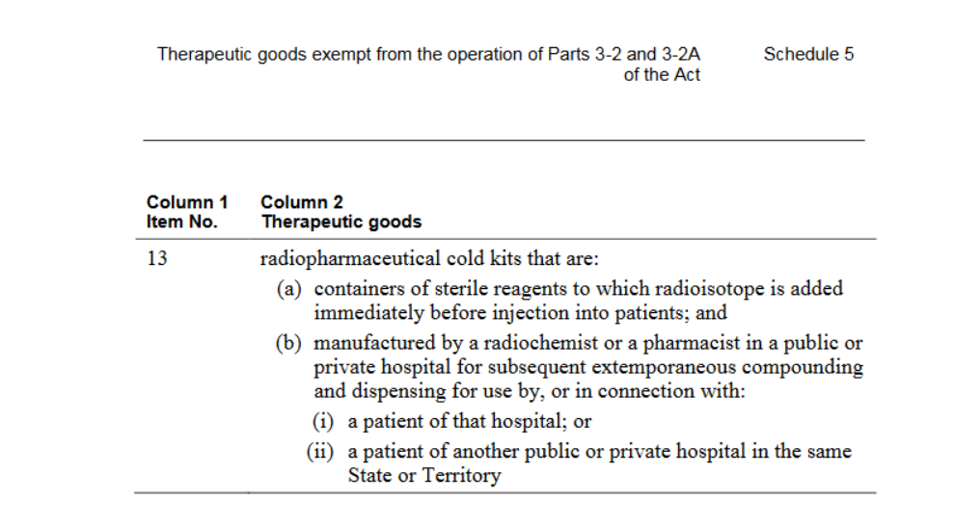
Importantly, there is significant precedent as the production of TGA exempt GLP radiopharmaceutical use is widespread across Australia and is already receiving Medicare reimbursement for a number of indications including:
- Ga 68 DOTATATE for imaging of neuroendocrine malignancy
- All Tc labelled products.
- 177 Lu DOTA therapy is also funded across Australia using a variety of state government funded initiatives and is produced using TGA exemption for GLP production of radiopharmaceuticals in hospital settings.

If the therapeutic good is not ARTG listed, is the therapeutic good in the process of being considered by TGA?

Yes
No
- If the therapeutic good is NOT in the process of being considered by TGA, is an application to TGA being prepared?
Yes
No

PART 4 – SUMMARY OF EVIDENCE

Provide one or more recent (published) high quality clinical studies that support use of the proposed health service/technology. At ‘Application Form lodgement’, please do not attach full text articles; just provide a summary. .
 | Type of study design | Title of journal article or research project | Short description of research | Website link to journal article or research | Date of publication
Lu PSMA i&t evidence
1 | Retrospective | Factors affecting overall survival and progression -free survival in patients with metastatic castration resistant prostate cancer received 177Lu PSMA i&t  Ogen Bulbul et al  Hell J Nucl Med 2020;23(3):229-239 | 45 men with mCRPC treated with 164 cycles Lu PSMA i&t at 6-8 weekly intervals. PSA response rate (>50% decline) was 33%. Median OS and PFS 17.1 months and 7.4 months² | 10.1967/s002449912201 | 2020
2. | Retrospective | Treatment Outcome, Toxicity, and Predictive Factors for Radioligand Therapy with ¹⁷⁷Lu-PSMA-I&T in Metastatic Castration-resistant Prostate Cancer³  Heck et al; European Urology Volume 75 Issue 6 June 2019 920-926 | Clinical experience with RLT using 177-lutetium–labeled PSMA-I&T in 100 patients were treated under a compassionate use protocol with 319 cycles (median two cycles, range 1–6). Eligibility criteria were abiraterone or enzalutamide, previous taxane-based chemotherapy or chemoineligibility, and positive PSMA-ligand uptake at positron-emission tomography scan. The ¹⁷⁷Lu-PSMA-I&T was given 6–8 weekly with an activity of 7.4 GBq up to six cycles. Prostate-specific antigen decline of ≥50% was achieved in 38 patients (38%), median clinical progression-free survival (cPFS) was 4.1 mo, and median overall survival (OS) was 12.9 mo. Treatment-emergent hematologic grade 3/4 toxicities were anemia (9%), thrombocytopenia (4%), and neutropenia (6%). Grade 3/4 nonhematologic toxicities were not observed. RLT with ¹⁷⁷Lu-PSMA-I&T showed good activity in more than one-third of patients with late-stage mCRPC at low toxicity. | https://www.sciencedirect.com/science/article/abs/pii/S030228381830873X?via%3Dihub | June 2019
 | Retrospective | 177Lu-Labeled Prostate-Specific Membrane Antigen Radioligand Therapy of Metastatic Castration-Resistant Prostate Cancer: Safety and Efficacy Richard P. Baum*1, Harshad R. Kulkarni*1, Christiane Schuchardt1, Aviral Singh1, Martina Wirtz2, Stefan Wiessalla1, Margret Schottelius2, Dirk Mueller1, Ingo Klette1, and Hans-Jürgen Wester. The journal of nuclear medicine. Vol. 57 No.7 July 2016¹ | 56 mCRPC patients underwent PSMA radioligand therapy (RLT) with 177Lu-PSMA. 68Ga-PSMA PET/CT was used for patient selection and follow-up after PSMA RLT. Dosimetry was performed in 30 patients. Results: 177Lu-PSMA demonstrated high absorbed tumor doses (median, 3.3 mGy/MBq). All patients tolerated the therapy without any acute adverse effectsThe severity of pain was significantly reduced in 2 of 6 patients (33.3%). A decrease in prostate-specific antigen levels was noted in 45 of 56 patients (80.4%).The median progression-free survival was 13.7 mo, and the median overall survival was not reached during follow-up for 28 mo. | 10.2967/jnumed.115.168443 | 2016
4. | Retrospective | Clinical Outcomes of ¹⁷⁷ Lu-PSMA Radioligand Therapy in Earlier and Later Phases of Metastatic Castration-Resistant Prostate Cancer Grouped by Previous Taxane Chemotherapy. Thomas W Barber , Aviral Singh , Harshad R Kulkarni , Karin Niepsch , Baki Billah , Richard P Baum . J Nucl Med2019 Jul;60(7):955-962⁴ | 167 patients with mCRPC who underwent ¹⁷⁷Lu-PRLT. Clinical outcome for taxan-pre-treated and taxane-naïve patients was assessed by overall survival (OS), radiographic progression-free survival, and prostate-specific antigen (PSA) response rate. Of the 167 patients treated with ¹⁷⁷Lu-PRLT, 83 were Taxane-pretreated and 84 were Taxane-naïve. Median OS was 10.7 mo for T-pretreated patients and 27.1 mo for T-naïve patients. Median radiographic progression-free survival was 6.0 mo for T-pretreated patients and 8.8 mo for T-naïve patients. PSA response assessment was evaluable in 132 patients and seen in 25 of 62 (40%) Taxane-pretreated patients and 40 of 70 (57%) Taxane-naïve patients. | 10.2967/jnumed.118.216820 | 2019
 | Meta-analysis of Lu PSMA i&t and Lu PSMA-617 | Lutetium-177-labelled anti-prostate-specific membrane antigen antibody and ligands for the treatment of metastatic castrate-resistant prostate cancer: a systematic review and meta-analysis. R J S Calopedos , V Chalasani , R Asher , L Emmett, H Woo. Prostate Cancer Prostatic Dis 2017 Sep;20(3):352-360⁵ | A systematic review was conducted using electronic databases up to December 2016. The main outcome of interest was anti-tumour biochemical response of ¹⁷⁷Lu-PSMA, analysing two measures: 'any PSA decline' and '>50% decline' from baseline. Abstracts and proportions were summarised by chemical type (¹⁷⁷Lu-J591/DKZ/I&T). The pooled proportion of patients with any PSA decline was 68% (95% confidence interval (CI): 61-74). The pooled proportion of patients with >50% PSA decline was 37% (95% CI: 22-52). | 10.1038/pcan.2017.23 | 2017
Lu PSMA-617 Evidence
5. | Randomised Phase III | Lutetium-177-PSMA-617 for Metastatic Castration-Resistant Prostate Cancer. Oliver Sartor , Johann de Bono , Bernd J Krause , VISION Investigators.⁶  N Engl J Med. 2021 Jun 23. doi: 10.1056/NEJMoa2107322.  PMID: 34161051 | International, open-label, phase 3 trial evaluating ¹⁷⁷Lu-PSMA-617 in patients with mCRPC previously treated with a positive (⁶⁸Ga)-labeled PSMA-11 PET scans. Patients were randomly assigned in a 2:1 ratio to ¹⁷⁷Lu-PSMA-617 (7.4 GBq every 6 weeks for four to six cycles) or standard care. Primary end points were imaging-based progression-free survival and 831 patients randomized. ¹⁷⁷Lu-PSMA-617 significantly prolonged progression-free survival (median, 8.7 vs. 3.4 months; P<0.001) and overall survival (median, 15.3 vs. 11.3 months; P<0.001). | https://pubmed.ncbi.nlm.nih.gov/34161051/ | June 2021
 | Randomised Phase II | [ ¹⁷⁷ Lu]Lu-PSMA-617 versus cabazitaxel in patients with metastatic castration-resistant prostate cancer (TheraP): a randomised, open-label, phase 2 trial Michael S Hofman , Louise Emmett , Ian D Davis Lancet 2021 Feb ⁷  27;397(10276):797-804. | Multicentre, unblinded, randomised phase 2 trial at 11 centres in Australia. Men with mCRPC for whom cabazitaxel was considered the standard treatment. Men underwent [⁶⁸Ga]Ga-PSMA-11 and 2-flourine-18[¹⁸F]FDG) PET with PET eligibility criteria for the trial PSMA-positive disease, and no discordant FDG-sites. 160 men randomised(1:1) to [¹⁷⁷Lu]Lu-PSMA-617 (6·0-8·5 GBq intravenously every 6 weeks for up to six cycles) or cabazitaxel (20 mg/m²) Primary endpoint was prostate-specific antigen (PSA) response. PSA responses were more frequent among men in the [¹⁷⁷Lu]Lu-PSMA-617 group than in the cabazitaxel group (65 vs 37 PSA responses; 66% vs 37% by intention to treat; difference 29% p=0·0016). Grade 3-4 adverse events occurred in 33% with [¹⁷⁷Lu]Lu-PSMA-617 53% with cabazitaxel. Lu-PSMA-617 is a new effective class of therapy and a potential alternative to cabazitaxel. | NCT03392428.  https://pubmed.ncbi.nlm.nih.gov/33581798/ | February 2021
 | Prospective single centre | [ ¹⁷⁷ Lu]-PSMA-617 radionuclide treatment in patients with metastatic castration-resistant prostate cancer (LuPSMA trial): a single-centre, single-arm, phase 2 study ⁸.Michael S Hofman John Violet , Shahneen Sandhu Lancet Oncol 2018 Jun;19(6):825-833 | Single-arm, single-centre, phase 2 trial, men with progressive mCRPC. Patients underwent screening with PSMA and FDG-PET/CT to confirm high PSMA-expression. Eligible patients received up to four cycles of intravenous [¹⁷⁷Lu]-PSMA-617, at six weekly intervals. The primary endpoint was PSA response. 43 men were screened to identify 30 patients eligible for treatment. The mean administered radioactivity was 7·5 GBq per cycle. 17 (57%) of 30 patients (95% CI 37-75) achieved a PSA decline of 50% or more. No treatment-related deaths. The most common toxic effects were grade 1 dry mouth 87%, grade 1 transient nausea 50%, and G1-2 fatigue in(50%). Objective response in nodal or visceral disease was reported in 82%). | https://www.ncbi.nlm.nih.gov/pubmed/29752180 | Australian New Zealand Clinical Trials Registry, number 12615000912583.
 | Prospective single centre phase I/II | Phase I/II Trial of the Combination of ¹⁷⁷ Lutetium Prostate specific Membrane Antigen 617 and Idronoxil (NOX66) in Men with End-stage Metastatic Castration-resistant Prostate Cancer (LuPIN)⁹  Megan Crumbaker Sarennya Pathmanandavel, Louise Emmett  Eur Urol Oncol 2020 Aug 2; S2588-9311(20)30093-6 | 32 men with progressive mCRPC previously treated with taxane-based chemotherapy (91% treated with both docetaxel and cabazitaxel) and abiraterone. Screening with ⁶⁸Ga PSMA and ¹⁸FDG PET. Men received up to six cycles of LuPSMA-617 (7.5 GBq) on day 1, with escalating doses of NOX66 on days 1-10 of a 6-wk cycle. Common AEs included xerostomia, fatigue, and anaemia. Anal irritation attributable to NOX66 occurred in 28%. PSA responses: 91% (29/32) had any PSA response and 62.5% (20/32) had a PSA fall of >50% (95% CI 45-77). Median PSA progression-free survival 6.1 mo (95% CI 2.8-9.2) and median overall survival 17.1 mo (95% CI 6.5-27.1). | https://www.ncbi.nlm.nih.gov/pubmed/32758400

Identify yet-to-be-published research that may have results available in the near future (that could be relevant to your application). Do not attach full text articles; this is just a summary.
 | Type of study design | Title of research | Short description of research | Website link to research | Date
1. | Randomised phase 3 treatment trial | SPLASH trial  A Phase 3, Open-Label, Randomized Study Evaluating Metastatic Castrate Resistant Prostate Cancer Treatment Using PSMA [Lu-177]-i&t Therapy After Second-line Hormonal Treatment. | The primary objective of the study is to determine the efficacy of [Lu-177]-PNT2002 ([Lu-177]-PSMA-I&T) versus abiraterone or enzalutamide in delaying radiographic progression in patients with mCRPC. The study will randomize treatment in 390 patients in a 2:1 ratio to receive either [Lu-177]-PSMA i&t (Arm A), or enzalutamide or abiraterone (Arm B). Patients in Arm B who experience radiographic progression per central review and meet protocol defined eligibility, may crossover to receive [Lu-177]-PNT2002. All patients will be followed in long-term follow-up for at least 5 years from the first therapeutic dose, death, or loss to follow up (Part 3). | https://www.clinicaltrials.gov/ct2/show/NCT04647526 | Commenced February 2021  Expected to finalise results  2029.
2. | Prospective Phase II Randomised trial | ENZA-p trial protocol: a randomized phase II trial using prostate-specific membrane antigen as a therapeutic target and prognostic indicator in men with metastatic castration-resistant prostate cancer treated with enzalutamide (ANZUP 1901)¹⁰ Louise Emmett Shalini Subramaniam , Ian D Davis  BJU Int 2021 May 24.doi: 10.1111/bju.15491 | ENZA-p (ANZUP 1901) is an open-label, randomized, two-arm, multicentre, phase 2 trial. Participants are randomly assigned (1:1) to treatment with enzalutamide 160 mg daily alone or enzalutamide plus ¹⁷⁷ Lu-PSMA-617 7.5 GBq on Days 15 and 57. Two additional ¹⁷⁷ Lu-PSMA-617 doses are allowed, informed by Day-92 Gallium-68 (⁶⁸ Ga)-PSMA positron emission tomography (PET; up to four doses in total). The primary endpoint is prostate-specific antigen (PSA) progression-free survival (PFS). Other major endpoints include radiological PFS, PSA response rate, overall survival, health-related quality of life, adverse events and cost-effectiveness. | https://www.ncbi.nlm.nih.gov/pubmed/34028967 | Commenced August 2020
3. | Prospective Phase II randomised trial | UpFrontPSMA: a randomized phase 2 study of sequential ¹⁷⁷ Lu-PSMA-617 and docetaxel vs docetaxel in metastatic hormone-naïve prostate cancer (clinical trial protocol)¹¹  Nattakorn Dhiantravan, Louise Emmett , Michael S Hofman , Arun A Azad BJU Int 2021 Mar 7.doi: 10.1111/bju.15384 | UpFront PSMA is an open-label, randomized, multicentre, phase 2 trial, recruiting 140 patients at 12 Australian centres. Key eligibility criteria include: prostate cancer with a histological diagnosis within 12 weeks of screening commencement; PSA >10 ng/mL at diagnosis; ≤4 weeks on ADT; high-volume prostate-specific membrane antigen (PSMA)-avid disease with a maximum standardized uptake value >15; Patients are randomized 1:1 to experimental treatment, Arm A (¹⁷⁷ Lu-PSMA-617 7.5GBq q6w × 2 cycles followed by docetaxel 75 mg/m² q3w × 6 cycles), or standard-of-care treatment, Arm B (docetaxel 75 mg/m² q3w × 6 cycles). | (NCT04343885) | Commenced April 2020

PART 5 – CLINICAL ENDORSEMENT AND CONSUMER INFORMATION

List all appropriate professional bodies/organisations representing the health professionals who provide the service. For MBS-related applications ONLY, please attach a brief ‘Statement of Clinical Relevance’ from the most relevant college/society.
Australian Association of Nuclear Medicine

List any professional bodies / organisations that may be impacted by this medical service (i.e. those who provide the comparator service):
There is no direct comparator service. This is a new class of agents for the treatment of prostate cancer.

List the consumer organisations relevant to the proposed medical service (noting there is NO NEED to attach a support letter at the ‘Application Lodgement’ stage of the MSAC process):
Prostate Cancer Foundation Australia
Movember Foundation
ANZUP Cancer Trials Group consumer panel.
Parliamentarians for prostate cancer

List the relevant sponsor(s) and / or manufacturer(s) who produce similar products relevant to the proposed medical service:
Lu PSMA 617 is a patented product owned by Novartis – which is almost identical to Lu PSMA i&t chemically. This has not been registered in Australia. REDACTED
- Nominate two experts that can be contacted about the proposed medical service, and current clinical management of the condition:
Name of expert 1: REDACTED
Telephone number(s): REDACTED
Email address: REDACTED
Justification of expertise: REDACTED
Name of expert 2: REDACTED
Telephone number(s): REDACTED
Email address: REDACTED
Justification of expertise: REDACTED

PART 6 – POPULATION (AND PRIOR TESTS), INTERVENTION, COMPARATOR, OUTCOME (PICO)

PART 6a – INFORMATION ABOUT THE PROPOSED POPULATION

Define the medical condition, including providing information on the natural history of the condition and a high level summary of associated burden of disease (in terms of both morbidity and mortality):
Metastatic castrate refractory prostate cancer is a disease that was responsible for the deaths of over 3000 men in Australia in 2020. The natural history of prostate cancer varies with its presentation and features. At one extreme is men who present with de novo metastatic disease (known as mHSPC – metastatic hormone sensitive prostate cancer). These men compromise about 10% of all the initial presentations of prostate cancer annually. These men are usually treated with ADT (Androgen deprivation therapy) that remove physiological testosterone from their body to control their cancer, before considering the need for further therapies such as high potency testosterone antagonists /synthesis inhibitors such as enzalutamide/ abiraterone or the consideration of chemotherapy (docetaxel, cabazitaxel) used as needed as the disease progresses. Recent data from large studies in this mHSPC population suggests that median OS in this population exceeds 4 years
However, the majority of men with metastatic castrate refractory prostate cancer (mCRPC) are men who have had their primary prostate cancer previously treated (either by surgery or radiation therapy, or both) and who have had PSA relapse and the development of metastases. These men will thereafter be treated with ADT, with its ensuing side-effects relating to testosterone depletion (hot flashes, loss of bone/ muscle mass, loss of libido, increased risk of dementia) and thereafter a combination of agents as above over a course of 3-7 years of treatment on average (5 year survival is poor).
Aside from the morbidity associated with mCRPC, with is the lethal disease state, there is also significant morbidity associated with treatment-refractory disease exacerbated by the bone-tropic pattern of spread in the cancer as it progresses. Generally, approximately 30% of men with prostate cancer require the use of opioid analgesia during the course of their disease for metastases. Indeed, skeletal-related events (SREs) have clinically meaningful and significant impact on health-related QOL, with physical, emotional, and functional wellbeing all declining after pathologic fractures and radiation therapy.
It is envisaged that 177 Lu PSMA i&t will be funded for men with metastatic castrate resistant prostate cancer who have already failed an androgen signalling inhibitor and first line chemotherapy and have progressive or symptomatic disease.

Specify the characteristics of patients with (or suspected of having) the medical condition, who would be eligible for the proposed medical service/technology (including details on how a patient would be investigated, managed and referred within the Australian health care system, in the lead up to being eligible for the service):
It is proposed that men eligible for the proposed treatment would be required to have received at least 1 ASI (Androgen Receptor Signalling Inhibitor – Abiraterone/ Enzalutamide/ Darolutamide via PBS/ RPBS) as well as at least 1 line of chemotherapy (Docetaxel +/- Cabazitaxel via PBS/RPBS) in the setting of metastatic castrate refractory prostate cancer.
The nature of the patient population will vary depending on emerging indications for these drugs under the PBS. The 4 common pathways that currently exist (without cabazitaxel) would be
- ADT/Abiraterarone/Enzalutamide (RPBS only) -> Docetaxel
- ADT alone -> Abiraterone/Enzalutamide (predicted intolerance) -> Docetaxel
- ADT/Docetaxel -> Abiraterone/Enzalutamide
- ADT -> Docetaxel -> Abiraterone/Enzalutamide
In any of the examples above, the criteria for progression off the last line of therapy to consider Lu-PSMA would generally be a combination of PSA progression, symptomatic progression and radiological progression (on CT/bone scan or PSMA PET). A PSMA-PET scan would be required to assess the baseline suitability for Lu-PSMA treatment. It would therefore also be required that the men have disease characteristics on PSMA- PET scans that “in the opinion of a nuclear medicine physician would warrant benefit from PSMA-radioligand therapy”. Over 80% of men in this clinical stage have disease ‘deemed suitable for Lu PSMA therapy’ on PSMA PET imaging.
Patients being considered for Lu PSMA therapy will be referred by their oncology specialist for clinical and imaging assessment and therapy administration with an accredited theranostics specialist in an accredited theranostics facility as defined by the position statement for minimum standards for theranostics by the Australian association of nuclear medicine specialists. Theranostics specialists will liaise closely with the oncology specialists to ensure optimal quality and seamless health care provision.
Management of the patients on Lu-PSMA (in current trials up to 6 doses) will follow standard assessment procedures - the combination of biochemical (PSA), SPECT and PET molecular imaging and symptomatic assessments will define the appropriateness (or not) of continuing the treatment until the patient is no longer clinically benefiting.

PART 6b – INFORMATION ABOUT THE INTERVENTION

Describe the key components and clinical steps involved in delivering the proposed medical service/technology:
177 Lu PSMA i&t is a targeted radionuclide therapy that is administered within accredited nuclear medicine departments as an outpatient service. It involves an intravenous injection and there is no specific preparation on behalf of the patient.
An oncology specialist will identify a patient with progressive metastatic prostate cancer as one who will benefit from, and appropriate for, Lu PSMA therapy.
Screening with PSMA PET and FDG PET will determine if the patient has an adequate level of PSMA ‘target’ at all sites of measurable disease such that they will be expected to derive significant benefit from the treatment. Currently this is felt to be an SUV max > 15 at a single site and > 10 at all sites of measurable disease on the PSMA PET scan with no sites of FDG mismatch, where SUV is a measure of intensity of PSMA uptake on a PET scan and FDG mismatch is indicative of prostate cancer metastases that are not going to be treated by the drug.
Other requirements include platelets > 75 and rising, Hb > 80 and eGFR > 40 mls/min
Once a patient has been identified as appropriate for Lu PSMA therapy based on both PET imaging characteristics, stage in the patient journey, and haematologic and biochemical results (appropriateness will be decided by a theranostics specialist) – a dose of Lu PSMA is booked (it takes approximately 2 weeks to order and have delivered the Lutetium to label chemically to PSMA i&t – which must be done within an accredited radiochemistry facility).
The procedure itself takes some hours in an outpatient setting in an accredited nuclear medicine facility. A cannula is placed in a vein, and the Lu PSMA is administered as a slow intravenous injection. An oral dose of 8mg dexamethasone is also administered at the time of injection to minimise the chance of nausea or transient increase in pain.
The patient will stay isolated in the nuclear medicine facility, encouraged to drink water, until radiation levels reduce to the safe government limit for discharge (25uSv /hour at one metre). The patient is given full radiation safety education on limiting radiation dose to the public, family and caregivers.
Radiation safety guidelines are developed with theranostics physicists according to the AANMS Theranostics position statement.
Imaging (Lu PSMA SPECT CT) involving a whole-body scan is acquired 24 hours following injection – to confirm uptake at tumour sites, and to allow serial imaging quantitation of treatment response.
Repeat doses of Lu PSMA occur at 6 weekly intervals for an average of 6 doses – until the patient is no longer clinically benefiting or they do not have significant persistent disease to target with Lu PSMA therapy.
On cessation of Lu PSMA therapy, after the patient is no longer clinically benefiting, the patients oncology specialist will determine the next appropriate treatment options based on disease volume and phenotype, patient age, co-morbidities and patient informed decision.

Does the proposed medical service include a registered trademark component with characteristics that distinguishes it from other similar health components?
No

If the proposed medical service has a prosthesis or device component to it, does it involve a new approach towards managing a particular sub-group of the population with the specific medical condition?
No

If applicable, are there any limitations on the provision of the proposed medical service delivered to the patient (i.e. accessibility, dosage, quantity, duration or frequency)?
Yes, currently the recommendation is for 6 doses of Lu PSMA therapy at 6 weekly intervals. No trials to date have gone beyond the 6 dose intervals.
Dose per cycle is currently set at between 7.5-8.5 Gbq Lu PSMA intravenously – although recent dose escalation phase 1 trials have found no dose limiting toxicity at significantly higher doses. Previous doses calculations have been set based on estimated delivered radiation dose to non-target organs such as the kidney and salivary glands. However, these dose calculations were undertaken using external beam set limits and it is likely that these calculations have been overestimating dose estimates to non-target organs. It is possible that the radiation dose per injection will be increased in men with higher volume disease in the future.

If applicable, identify any healthcare resources or other medical services that would need to be delivered at the same time as the proposed medical service:
No

If applicable, advise which health professionals will primarily deliver the proposed service:
Lu PSMA will be administered by nuclear medicine specialists (FAANMS).

If applicable, advise whether the proposed medical service could be delegated or referred to another professional for delivery:
Lu PSMA is a radionuclide and involves administering unsealed source radiotherapy which requires the appropriate licencing through the EPA.

If applicable, specify any proposed limitations on who might deliver the proposed medical service, or who might provide a referral for it:
Referrals for Lu PSMA therapy will come from medical oncologists, radiation oncologist or oncologic surgeons, with the procedure undertaken by appropriately licenced nuclear medicine specialists.

If applicable, advise what type of training or qualifications would be required to perform the proposed service, as well as any accreditation requirements to support service delivery:
The nuclear medicine association has recently developed guidelines for the safe delivery of radionuclide therapy, including minimum safety guidelines for involved organisations and minimal training recommendations for specialists (see appendix). These guidelines have been ratified by the joint specialist advisory committee.

(a) Indicate the proposed setting(s) in which the proposed medical service will be delivered (select ALL relevant settings):
Inpatient private hospital (admitted patient)
Inpatient public hospital (admitted patient)
Private outpatient clinic
Public outpatient clinic
Emergency Department
Private consulting rooms - GP
Private consulting rooms – specialist
Private consulting rooms – other health practitioner (nurse or allied health)
Private day surgery clinic (admitted patient)
Private day surgery clinic (non-admitted patient)
Public day surgery clinic (admitted patient)
Public day surgery clinic (non-admitted patient)
Residential aged care facility
Patient’s home
Laboratory
Other – please specify below
Nuclear medicine departments
- Where the proposed medical service is provided in more than one setting, please describe the rationale related to each:
Not applicable

Is the proposed medical service intended to be entirely rendered in Australia?
Yes
No

PART 6c – INFORMATION THE COMPARATOR(S)

Nominate the appropriate comparator(s) for the proposed medical service (i.e. how is the proposed population currently managed in the absence of the proposed medical service being available in the Australian health care system). This includes identifying health care resources that are needed to be delivered at the same time as the comparator service):
- The appropriate comparator for Lu PSMA therapy in the proposed metastatic castrate resistant prostate cancer space is cabazitaxel chemotherapy.
The Australian phase II randomised TheraP trial (Lancet Feb 2021) was a head-on comparison of cabazitaxel chemotherapy to Lu PSMA 617 in men with progressive mCRPC. This study showed an improved treatment response rate for Lu PSMA 617 compared to cabazitaxel (66% vs 37% > 50% reduction in PSA). There was also an improvement in rPFS and in both pain scores and quality of life for Lu PSMA 617 to cabazitaxel chemotherapy. The study was not powered for overall survival and these results are not yet available.
A large multinational trial (VISION trial NEJM June 2021) of 850 men randomised Lu PSMA 617 to standard of care (excluding chemotherapy) in men who had previously undergone both androgen signalling inhibitor and docetaxel chemotherapy This study found a 40% improvement in overall survival and a 60% improvement in rPFS compared to standard of care in the mCRPC space.
Based on this evidence Lu PSMA therapy appears optimally placed after at least 1 line of chemotherapy (docetaxel) chemotherapy AND an androgen signalling inhibitor (abiraterone or enzalutamide).
Cabazitaxel chemotherapy is current standard of care treatment for men with mCRPC who have failed first line chemotherapy and androgen signalling inhibition.

- The other key comparator is ¹⁷⁷Lu PSMA 617. (PSMA -617). PSMA-617 is a PSMA targeted radionuclide (peptide) that is chemically almost identical to PSMA-i&t (Figure 1).
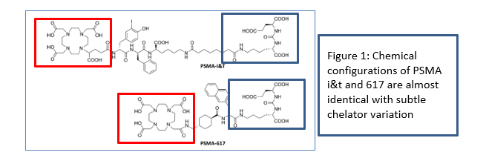
There has been no application for registration of this peptide in Australia by Novartis – although it has been awarded breakthrough designation with the FDA following the VISION trial with expected registration in Europe and the USA.
BIO-EQUIVALENCE OF Lu PSMA i&t and Lu PSMA 617
Radiation dose delivery of Lu PSMA i&t and Lu PSMA 617 in men with prostate cancer is nearly identical. Comparative work on the 2 compounds undertaken in Germany demonstrate clinically equivalent radiation dose delivery to metastatic tumour deposits in addition to non target organs such as salivary glands and kidneys.
The near identical physical and biological properties of these 2 radionuclide peptides suggest that they will have a similar treatment response in vivo. This has been the clinical experience of Australian sites that are currently using the 2 agents extensively for clinical (Lu PSMA i&t) and trial (Lu PSMA 617) work.
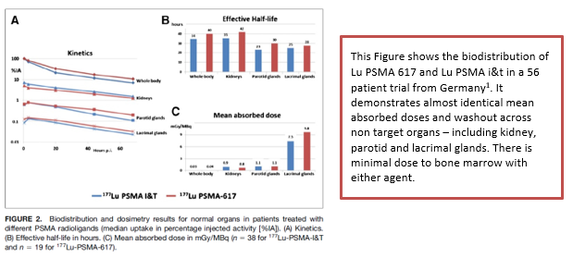

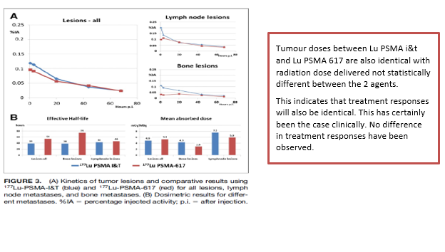
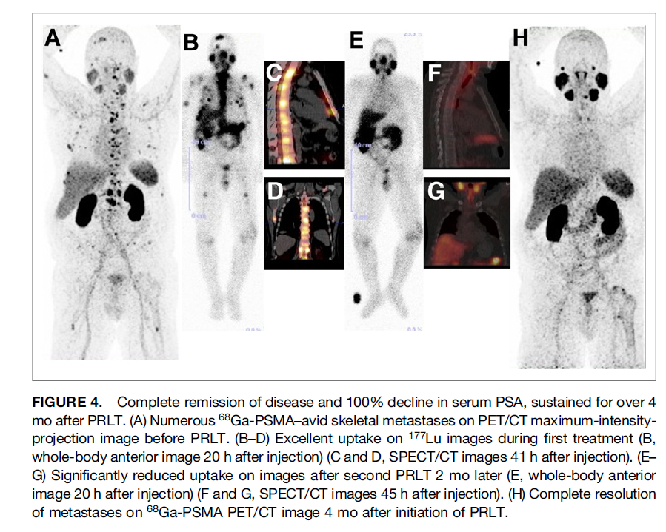
A case of complete metabolic response to Lu PSMA i&t therapy¹. This experience has been repeated multiple times in our department in men treated clinically with SAS scheme Lu PSMA i&t therapy, and across Australia for men with DVA approved treatments, or who are able to self-fund.

Does the medical service (that has been nominated as the comparator) have an existing MBS item number(s)?
Yes (please list all relevant MBS item numbers below)
No

(a) Will the proposed medical service/technology be used in addition to, or instead of, the nominated comparator(s)
In addition to cabazitaxel and instead of 177 Lu PSMA 617

If yes, please outline the extent to which the current service/comparator is expected to be substituted
177 Lu PSMA i&t is proposed as an alternative to 177 Lu PSMA 617 which now has level 1 evidence for efficacy and safety in mCRPC – but is not registered REDACTED.
GLP compliant produced 177LuPSMA i&t is a cost effective, feasible, effective, safe alternative to 177Lu PSMA 617 in Australia.

PART 6c CONTINUED – INFORMATION ABOUT ALGORITHMS (CLINICAL MANAGEMENT PATHWAYS)s

Define and summarise the CURRENT clinical management pathway (algorithm) that patients follow when they receive the COMPARATOR service (i.e. the landscape before the proposed service is introduced). An easy-to-follow flowchart is preferred, depicting the current clinical management pathway), but dot-points would be acceptable. Please include health care resources used in the current landscape (e.g. pharmaceuticals, diagnostics and investigative services, etc.).
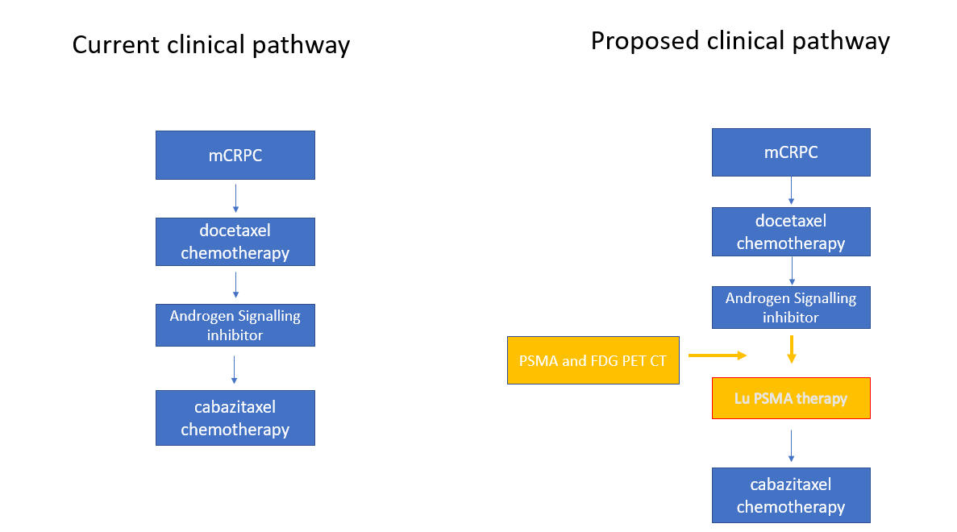

Define and summarise the PROPOSED clinical management pathway (algorithm) that patients would follow after the proposed service/technology is introduced, including variation in health care resources.
On cessation of Lu PSMA therapy, after the patient is no longer clinically benefiting, the patients’ oncology specialist will determine the next appropriate treatment options based on disease volume and phenotype, patient age, co-morbidities and patient informed decision.

PART 6d – INFORMATION ABOUT CLINICAL OUTCOMES

Summarise the clinical claims for the proposed medical service against the appropriate comparator(s), in terms of consequences for health outcomes (comparative benefits and harms):
Comparator 1. Cabazitaxel chemotherapy (Evidence for 177Lu PSMA 617 from the TheraP trial – Lancet 2021)
- Improved treatment response rates (66% vs 37%) for Lu PSMA compared to cabazitaxel⁷
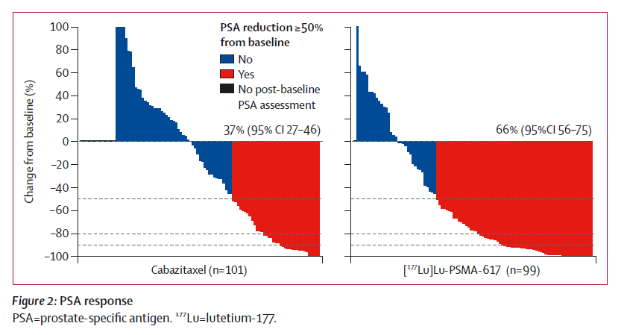
- Improved progression free survival at 12 months with 19% progression free with Lu PSMA vs 3% with cabazitaxel.
- Deterioration-free survival for global health status at 6 months was better for Lu-PSMA at 29% vs 13%
for cabazitaxel.
No direct prospective comparison has been undertaken between cabazitaxel and 177 Lu PSMA i&t.

Please state what the overall clinical claim is:
Lu PSMA therapy improves overall survival by 40% and progression free survival by 60% compared to standard of care in mCRPC post docetaxel and androgen signalling inhibition 6
While the level 1 evidence for Lu PSMA has been undertaken with Lu PSMA 617 – Lu PSMA i&t is chemically almost identical to Lu PSMA 617 with evidence to show the comparative radiation dose delivered to tumour deposits and non-target organs is not significantly different1. Treatment response rates for Lu PSMA 617 and Lu PSMA i&t are also very similar, and are treated equivalently in the EANM guidelines for 177 Lu PSMA therapy12
Lu PSMA i&t is a non-pharma supported off patent peptide that is available to the Australian prostate cancer community. It is already being used extensively across Australia as an available alternative to Lu PSMA 617, with excellent clinical effect. Lu PSMA i&t is now funded through DVA for veterans under the SAS special access scheme, and a clinical service is provided at many centres at direct cost to the patient. This is creating significant inequity of access to treatment that prolongs life and improves morbidity due to the lack of generally available funding.

List the key health outcomes (major and minor – prioritising major key health outcomes first) that will need to be measured in assessing the clinical claim for the proposed medical sservice/technology (versus the comparator):
- Progression free survival/treatment response
- Key quality of life indicators
- Pain score improvement
- Patient related outcomes measuring improved quality of life parameters
- Bioequivalence for Lu PSMA i&t and Lu PSMA 617

PART 7 – INFORMATION ABOUT ESTIMATED UTILISATION

Estimate the prevalence and/or incidence of the condition in the proposed population:
3000 men die from prostate cancer every year in Australia

Estimate the number of times the proposed medical service/technology would be delivered to a patient per year:
An average of 4 doses will be delivered for each patient treated

How many years would the proposed medical service/technology be required for the patient?
Doses are generally delivered within the course of one year

Estimate the projected number of patients who will utilise the proposed medical service(s) for the first full year:
Based on current trial enrolment and clinical demand – 500 men per year would utilise Lu PSMA therapy

Estimate the anticipated uptake of the proposed medical service/technology over the next three years, factoring in any constraints in the health system in meeting the needs of the proposed population (such as supply and demand factors), as well as provide commentary on risk of ‘leakage’ to populations not targeted by the service.
Demand would be expected to increase by 10-15% per year until it reaches capacity, which would be 60% of the men who die from metastatic prostate cancer each year (1800 men per year)

PART 8 – COST INFORMATION

Indicate the likely cost of providing the proposed medical service. Where possible, please provide overall cost and breakdown:
Cost of provision of GLP compliant 177 Lu PSMA i&t service within a credentialed nuclear medicine facility. This will need to encompass:
- Production cost
- Cost of the treatment visit to the facility and cost of the treatment chair.
- Cost of post therapy SPECT imaging.
Production costs for GLP compliant production will include radiochemist time, equipment, facility maintenance costs, Lutetium 177 cost and peptide costs.
Estimated cost $5500/patient dose 177 Lu PSMA i&t
Cost of treatment visit and post therapy SPECT scan (including medical consult, physicist, nuclear medicine technologist and nursing care)
Estimated cost $ 1500/patient visit
Expected cost of treatment $7000/ treatment or $42,000 for a course of 6 treatments over 30 weeks
The estimated costs above are based on a GLP compliant production method. It would be expected that a GMP compliant production method with centralised production through a commercial company would significantly increase cost of delivery of product and would also significantly delay availability of product in the medium term. REDACTED
The authors advocate for GLP compliant product as is currently occurring across Australia as a highly cost -effective method for service delivery and production with thousands of doses administered safely both in a trials setting and clinically using the SAS access scheme.
REDACTED

Specify how long the proposed medical service/technology typically takes to perform:
Each treatment requires approximately 4 hours in a theranostics facility

If public funding is sought through the MBS, please draft a proposed MBS item descriptor to define the population and usage characteristics that defines eligibility for the medical service/technology.
Category XXXX
Proposed item descriptor: Lu PSMA therapy for treatment of men with progressive metastatic castrate resistant prostate cancer after disease progression on chemotherapy and at least one androgen signalling inhibitor.
Fee: To be determined

If public funding is sought through an alternative (non-MBS) funding arrangement, please draft a service description to define the population and usage characteristics that defines eligibility for the service/technology.

Not applicable
REFERENCES
1. Baum RP, Kulkarni HR, Schuchardt C, et al. 177Lu-Labeled Prostate-Specific Membrane Antigen Radioligand Therapy of Metastatic Castration-Resistant Prostate Cancer: Safety and Efficacy. J Nucl Med. 2016;57(7):1006-1013.
2. Bulbul O, Unek IT, Kefi A, Tuna EB, Bekis R. Factors affecting overall survival and progression-free survival in patients with metastatic castration resistant prostate cancer received (177)Lu PSMA I&T therapy. Hell J Nucl Med. 2020;23(3):229-239.
3. Heck MM, Tauber R, Schwaiger S, et al. Treatment Outcome, Toxicity, and Predictive Factors for Radioligand Therapy with (177)Lu-PSMA-I&T in Metastatic Castration-resistant Prostate Cancer. Eur Urol. 2019;75(6):920-926.
4. Barber TW, Singh A, Kulkarni HR, Niepsch K, Billah B, Baum RP. Clinical Outcomes of (177)Lu-PSMA Radioligand Therapy in Earlier and Later Phases of Metastatic Castration-Resistant Prostate Cancer Grouped by Previous Taxane Chemotherapy. J Nucl Med. 2019;60(7):955-962.
5. Calopedos RJS, Chalasani V, Asher R, Emmett L, Woo HH. Lutetium-177-labelled anti-prostate-specific membrane antigen antibody and ligands for the treatment of metastatic castrate-resistant prostate cancer: a systematic review and meta-analysis. Prostate Cancer Prostatic Dis. 2017;20(3):352-360.
6. Sartor O, de Bono J, Chi KN, et al. Lutetium-177-PSMA-617 for Metastatic Castration-Resistant Prostate Cancer. N Engl J Med. 2021.
7. Hofman MS, Emmett L, Sandhu S, et al. [(177)Lu]Lu-PSMA-617 versus cabazitaxel in patients with metastatic castration-resistant prostate cancer (TheraP): a randomised, open-label, phase 2 trial. Lancet. 2021;397(10276):797-804.
8. Hofman MS, Violet J, Hicks RJ, et al. [(177)Lu]-PSMA-617 radionuclide treatment in patients with metastatic castration-resistant prostate cancer (LuPSMA trial): a single-centre, single-arm, phase 2 study. Lancet Oncol. 2018.
9. Crumbaker M, Pathmanandavel S, Yam AO, et al. Phase I/II Trial of the Combination of (177)Lutetium Prostate specific Membrane Antigen 617 and Idronoxil (NOX66) in Men with End-stage Metastatic Castration-resistant Prostate Cancer (LuPIN). Eur Urol Oncol. 2020.
10. Emmett L, Subramaniam S, Joshua AM, et al. ENZA-p trial protocol: a randomized phase II trial using prostate-specific membrane antigen as a therapeutic target and prognostic indicator in men with metastatic castration-resistant prostate cancer treated with enzalutamide (ANZUP 1901). BJU Int. 2021.
11. Dhiantravan N, Emmett L, Joshua AM, et al. UpFrontPSMA: a randomized phase 2 study of sequential (177) Lu-PSMA-617 and docetaxel vs docetaxel in metastatic hormone-naive prostate cancer (clinical trial protocol). BJU Int. 2021.
12. Kratochwil C, Fendler WP, Eiber M, et al. EANM procedure guidelines for radionuclide therapy with (177)Lu-labelled PSMA-ligands ((177)Lu-PSMA-RLT). Eur J Nucl Med Mol Imaging. 2019;46(12):2536-2544.

