MSAC Application 1713
Cardiac MRI in the diagnosis of myocarditis
This application form is to be completed for new and amended requests for public funding (including but not limited to the Medicare Benefits Schedule (MBS)). It describes the detailed information that the Australian Government Department of Health requires to determine whether a proposed medical service is suitable.
Please use this template, along with the associated Application Form Instructions to prepare your application. Please complete all questions that are applicable to the proposed service, providing relevant information only. Applications not completed in full will not be accepted. The separate MSAC Guidelines should be used to guide health technology assessment (HTA) content of the Application Form.
Should you require any further assistance, departmental staff are available through the Health Technology Assessment Team (HTA Team) on the email below to discuss the application form, or any other component of the Medical Services Advisory Committee process.

Email: hta@health.gov.au
Website: www.msac.gov.au

PART 1 – APPLICANT DETAILS

Applicant details (primary and alternative contacts)
Corporation / partnership details (where relevant):
Corporation name: Cardiac Society of Australia and New Zealand (CSANZ)
ABN: 23 003 635 505
Business trading name: Cardiac Society of Australia and New Zealand

Primary contact name: REDACTED
Primary contact numbers
Business: REDACTED
Mobile: REDACTED
Email: REDACTED
Alternative contact name: REDACTED
Alternative contact numbers
Business: REDACTED
Mobile: REDACTED
Email: REDACTED

(a) Are you a consultant acting on behalf on an applicant?
Yes
No
(b) If yes what is the Applicant(s) name that you are acting on behalf of?

(a) Are you a lobbyist acting on behalf of an Applicant?
Yes
No

If yes, are you listed on the Register of Lobbyists?
Yes
No

Have you engaged a consultant on your behalf?
Yes
No

PART 2 – INFORMATION ABOUT THE PROPOSED MEDICAL SERVICE

Application title
Cardiac MRI in the diagnosis of myocarditis

Provide a succinct description of the medical condition relevant to the proposed service (no more than 150 words – further information will be requested at Part F of the Application Form)
Myocarditis in an inflammatory condition of the heart characterised by acute infiltration of the heart muscle with inflammatory cells as well as myocyte necrosis (cell death). Myocarditis may be triggered by a number of infective and auto-immune processes, which includes drug reactions. Myocarditis has been reported in a significant proportion of patients with Covid-19 infection, and recently mRNA vaccination has been linked to a significant risk of myocarditis. Patients with myocarditis generally present with one of two clinical syndromes, either as an acute onset cardiomyopathy with left ventricular dysfunction and symptoms of heart failure or as a mimic of an acute coronary syndrome with chest pain and/or breathlessness. Both presentations are often coupled with elevated cardiac enzymes (troponin) when performed in a timely fashion and there can be significant overlap between the two presentations.

Provide a succinct description of the proposed medical service (no more than 150 words – further information will be requested at Part 6 of the Application Form)
Cardiac MRI is a non-invasive imaging technique that uses magnetic resonance to develop images of the heart as well as characterise cardiac tissue. It does not use ionising radiation. Its contrast imaging utilizes gadolinium-based agents that have a favourable side effect profile compared to iodinated contrast agents used in X-Ray and CT imaging. Cardiac MRI generates high resolution images of the heart that are more accurate than other cardiac imaging techniques such as echocardiography (ultrasound) in the assessment of cardiac structure and function. However, the major benefit of cardiac MRI over existing cardiac imaging techniques is its capacity to characterise myocardial tissue using both non-contrast and contrast-enhanced techniques to define areas of myocardial inflammation, scar and/or necrosis within an accuracy of a few grams of myocardial tissue. Cardiac MRI is now recognized by most international cardiac societies as the gold standard for the non-invasive diagnosis of myocarditis.

(a) Is this a request for MBS funding?
Yes
No

If yes, is the medical service(s) proposed to be covered under an existing MBS item number(s) or is a new MBS item(s) being sought altogether?
Amendment to existing MBS item(s)
New MBS item(s)

If an amendment to an existing item(s) is being sought, please list the relevant MBS item number(s) that are to be amended to include the proposed medical service/technology:
N/A

If an amendment to an existing item(s) is being sought, what is the nature of the amendment(s)?
N/A

If a new item(s) is being requested, what is the nature of the change to the MBS being sought?
A new item which also seeks to allow access to the MBS for a specific health practitioner group
A new item that is proposing a way of clinically delivering a service that is new to the MBS (in terms of new technology and / or population)
A new item for a specific single consultation item
A new item for a global consultation item(s)

Is the proposed service seeking public funding other than the MBS?
Yes
No

If yes, please advise:
N/A

What is the type of medical service/technology?
Therapeutic medical service
Investigative medical service
Single consultation medical service
Global consultation medical service
Allied health service
Co-dependent technology
Hybrid health technology

For investigative services, advise the specific purpose of performing the service (which could be one or more of the following):
To be used as a screening tool in asymptomatic populations
Assists in establishing a diagnosis in symptomatic patients
Provides information about prognosis
Identifies a patient as suitable for therapy by predicting a variation in the effect of the therapy
Monitors a patient over time to assess treatment response and guide subsequent treatment decisions

Does your service rely on another medical product to achieve or to enhance its intended effect?
Pharmaceutical / Biological
Prosthesis or device
No

(a) If the proposed service has a pharmaceutical component to it, is it already covered under an existing Pharmaceutical Benefits Scheme (PBS) listing?
Yes
No

If yes, please list the relevant PBS item code(s):
N/A

If no, is an application (submission) in the process of being considered by the Pharmaceutical Benefits Advisory Committee (PBAC)?
N/A

If you are seeking both MBS and PBS listing, what is the trade name and generic name of the pharmaceutical?
N/A

(a) If the proposed service is dependent on the use of a prosthesis, is it already included on the Prostheses List?
Yes
No

If yes, please provide the following information (where relevant):
N/A

If no, is an application in the process of being considered by a Clinical Advisory Group or the Prostheses List Advisory Committee (PLAC)?
Yes
No

Are there any other sponsor(s) and / or manufacturer(s) that have a similar prosthesis or device component in the Australian market place which this application is relevant to?
Yes
No

If yes, please provide the name(s) of the sponsor(s) and / or manufacturer(s):
N/A

Please identify any single and / or multi-use consumables delivered as part of the service?
Single use consumables: Administration of gadolinium-based contrast agent.
Multi-use consumables: Nil

PART 3 – INFORMATION ABOUT REGULATORY REQUIREMENTS

(a) If the proposed medical service involves use of a medical device, in-vitro diagnostic test, pharmaceutical product, radioactive tracer, or any other type of therapeutic good, please provide details
Type of therapeutic good: Clinical MRI imaging system including cardiac coil and cardiac sequences.
Manufacturer’s name: Numerous manufacturers, all currently registered with the ARTG (234 entries).
Sponsor’s name: N/a

Has it been listed on the Australian Register of Therapeutic Goods (ARTG) by the Therapeutic Goods Administration (TGA)? If the therapeutic good has been listed on the ARTG, please state the ARTG identification numbers, TGA-approved indication(s), and TGA-approved purpose(s).
ARTG ID: Insert ID number here: There are 234 ID numbers for clinical MRI systems currently registered.
TGA approved indication(s), if applicable: The intended purpose is to enable quality imaging of anatomical structures and pathologies. Coils are used to aid in diagnostic imaging for MRI.
TGA approved purpose(s), if applicable: As above

If a medical device is involved, has the medical device been classified by TGA as a Class III OR Active Implantable Medical Device (AIMD) under the TGA regulatory scheme for devices?
Class III
AIMD
N/A

Is the therapeutic good classified by TGA for Research Use Only (RUO)?
-

(a) If not listed on the ARTG, is the therapeutic good to be used in the service exempt from the regulatory requirements of the Therapeutic Goods Act 1989?
N/A

If the therapeutic good is not ARTG listed, is the therapeutic good in the process of being considered by TGA?
N/A
- If the therapeutic good is NOT in the process of being considered by TGA, is an application to TGA being prepared?
N/A

PART 4 – SUMMARY OF EVIDENCE

Provide one or more recent (published) high quality clinical studies that support use of the proposed health service/technology. At ‘Application Form lodgement’, please do not attach full text articles; just provide a summary.
 | Type of study design | Title of journal article or research project | Short description of research | Website link to journal article or research | Date of publication
1. | Multinational network cohort study | Characterising the background incidence rates of adverse events  of special interest for covid-19 vaccines in eight countries; multinational network cohort study | Study demonstrating background rates of acute myocarditis in the (non-vaccinated) community, as well as large variations in the observed rates of Covid-10 vaccine associated myocarditis by age group and sex, showing the need for stratification or standardisation before using background rates for safety surveillance. | https://pubmed.ncbi.nlm.nih.gov/33791732/ | 2021
2. | Multicentre cohort study | Predictors of Mortality in Patients With Biopsy-Proven Viral Myocarditis: 10-Year Outcome Data | This is the first study evaluating mortality and predictive value of LGE-CMR parameters in patients with biopsy-proven viral myocarditis at 10-year follow-up.  There was a high 10-year mortality rate (39.3%), mainly attributable to cardiac reasons (27.3%). | https://pubmed.ncbi.nlm.nih.gov/32787653/ | 2021
3. | Clinical guideline | ESC Scientific Document Group. 2016 ESC guidelines for the diagnosis and treatment of acute and chronic heart failure: the Task Force for the diagnosis and treatment of acute and chronic heart failure of the European Society of Cardiology (ESC) developed with the special contribution of the Heart Failure Association (HFA) of the ESC | ESC guideline for the diagnosis and treatment of heart failure. Recommends cardiac MRI as a first line investigation (Class I indication) for acute myocarditis | https://pubmed.ncbi.nlm.nih.gov/27207191/ | 2016
4. | Clinical guideline | National Heart Foundation of Australia and Cardiac Society of Australia and New Zealand: Guidelines for the Prevention, Detection, and Management of Heart Failure in Australia 2018 | Australian guideline for the diagnosis and treatment of heart failure. Makes STRONG recommendation for cardiac MRI in the diagnosis acute myocarditis in new onset heart failure | https://pubmed.ncbi.nlm.nih.gov/30077227/ | 2018
5. | Clinical Guideline | Guidance on Myocarditis and Pericarditis after mRNA COVID-19 Vaccines | Australian Government guideline for the diagnosis of vaccine associated myocarditis, with direct reference to the Brighton Collaboration for the definition of vaccine associated myocarditis | https://www.health.gov.au/sites/default/files/documents/2021/12/covid-19-vaccination-guidance-on-myocarditis-and-pericarditis-after-mrna-covid-19-vaccines_0.pdf | 2021
6. | Clinical Guideline | 2013 ACCF/AHA Guideline for the Management of Heart Failure: Executive Summary | American heart failure guidelines stating the role of myocardial biopsy in the evaluation of patients with suspected myocarditis (Class IIa indication) | https://pubmed.ncbi.nlm.nih.gov/23741057/ | 2013
7. | Case control study | Diagnostic Performance of Cardiovascular Magnetic  Resonance in Patients With Suspected Acute Myocarditis  Comparison of Different Approaches | Seminal paper demonstrating the utility and diagnostic accuracy in the diagnosis of acute myocarditis | https://pubmed.ncbi.nlm.nih.gov/15936612/ | 2005
8. | Clinical Guideline | Cardiovascular Magnetic Resonance in Nonischemic Myocardial Inflammation Expert Recommendations | Updated clinical guideline for the diagnosis of acute myocarditis with cardiac MRI | https://pubmed.ncbi.nlm.nih.gov/30545455/ | 2018
9. | Meta-analysis | Diagnostic Accuracy of Cardiovascular Magnetic Resonance in Acute Myocarditis A Systematic Review and Meta-Analysis | Meta-analysis of cardiac MRI studies for the diagnosis of acute myocarditis, confirming a diagnostic accuracy >80%, which improved to ~95% with newer T1 mapping techniques. | https://pubmed.ncbi.nlm.nih.gov/29454761/ | 2018
10 | Clinical guidelines | Cardiovascular magnetic resonance in myocarditis: A JACC White Paper | Summary by International Consensus Group on cardiovascular magnetic resonance in myocarditis. | https://pubmed.ncbi.nlm.nih.gov/19389557/ | 2009
11. | Non-randomised trial | Cardiac MR with Late Gadolinium Enhancement in Acute Myocarditis With Preserved Systolic Function: ITAMY Study | This study - ITAMY (ITalian multicenter study on Acute MYocarditis) evaluated CMR results from 386 patients with acute myocarditis and showed that those with late gadolinium enhancement (scar) had a worse prognosis. | https://pubmed.ncbi.nlm.nih.gov/29025554/ | 2017
12. | Non-randomised trial | Prognostic Value of Cardiac Magnetic Resonance Tissue Characterization in Risk Stratifying Patients with Suspected Myocarditis | Clinical trial of 670 patients with suspected myocarditis underwent CMR with late gadolinium enhancement and follow-up for major adverse cardiovascular events. CMR tissue characterization provided effective risk stratification in patients with suspected myocarditis | https://pubmed.ncbi.nlm.nih.gov/29025553/ | 2017
13. | Case control study | Native T1-mapping detects the location, extent and patterns of acute myocarditis without the need for gadolinium contrast agents | Clinical trial of 60 patients with suspected myocarditis and 50 controls all underwent CMR. It showed that native T1-mapping can detect acute myocarditis without the need for contrast agents. Plus, T1-mapping can detect extra cases, as compared to CMR with contrast agents (late gadolinium enhancement imaging). | https://pubmed.ncbi.nlm.nih.gov/24886708/ | 2014

Identify yet-to-be-published research that may have results available in the near future (that could be relevant to your application). Do not attach full text articles; this is just a summary.
None identified

PART 5 – CLINICAL ENDORSEMENT AND CONSUMER INFORMATION

List all appropriate professional bodies/organisations representing the health professionals who provide the service. For MBS-related applications ONLY, please attach a brief ‘Statement of Clinical Relevance’ from the most relevant college/society.
Cardiac Society of Australia and New Zealand (CSANZ)
Royal Australian and New Zealand College of Radiology (RANZCR)

List any professional bodies / organisations that may be impacted by this medical service (i.e. those who provide the comparator service):
Cardiac Society of Australia and New Zealand (CSANZ)
Royal Australian and New Zealand College of Radiology (RANZCR)

List the consumer organisations relevant to the proposed medical service (noting there is NO NEED to attach a support letter at the ‘Application Lodgement’ stage of the MSAC process):
The Royal Australasian College of Physicians
CSANZ
RANZCR
The Australian Technical Advisory Group on Immunisation (ATAGI)
Victorian Incident Management Team (IMT) for Cardiology – vaccine associated myocarditis

List the relevant sponsor(s) and / or manufacturer(s) who produce similar products relevant to the proposed medical service:
N/A
- Nominate two experts that can be contacted about the proposed medical service, and current clinical management of the condition:

Name of expert 1: REDACTED
Telephone number(s): REDACTED
Email address: REDACTED
Justification of expertise: REDACTED

Name of expert 2: REDACTED
Telephone number(s): REDACTED
Email address: REDACTED
Justification of expertise: REDACTED

Please note that the Department may also consult with other referrers, proceduralists and disease specialists to obtain their insight.

PART 6 – POPULATION (AND PRIOR TESTS), INTERVENTION, COMPARATOR, OUTCOME (PICO)

PART 6a – INFORMATION ABOUT THE PROPOSED POPULATION

Define the medical condition, including providing information on the natural history of the condition and a high level summary of associated burden of disease (in terms of both morbidity and mortality):
Myocarditis is an inflammatory condition of the heart muscle, characterised histologically by inflammatory cell infiltrate and regions of myocyte necrosis. Myocarditis usually occurs as a response to a number of viral infections (including Covid-19), however it can also occur following bacterial, fungal or parasitic infections, as a complication of autoimmune disorders, and as a consequence of drug reactions or environmental toxins. Recently, myocarditis has been demonstrated to be a significant and relatively frequent complication following mRNA vaccination for Covid-19. Whilst the background incidence of myocarditis varies with both age and sex, overall the incidence in the community has been estimated at approximately 30 per 100,000-person years. In those receiving a mRNA Covid-19 vaccine, the incidence of vaccine associated myocarditis may be as high as 1 in 25,000 vaccine doses.
Patients with myocarditis generally present with one of two clinical syndromes, however there can be considerable overlap. The first clinical syndrome of myocarditis is that of acutely developing cardiomyopathy, usually over the course of a few weeks or less. Patients typically present with symptoms of heart failure such as breathlessness, orthopnoea and peripheral oedema. Cardiac function is usually found to be significantly impaired and cardiac enzymes (such as troponin) are often elevated although this depends on how early in the disease process blood sampling was undertaken. All patients in this group undergo assessment of cardiac function (typically with transthoracic echocardiography [TTE]) and endomyocardial biopsy is frequently obtained in line with international guidelines for the diagnosis of acute myocarditis. Patients with this clinical presentation may be severely unwell, with nearly all requiring admission to hospital for acute therapy and some developing cardiogenic shock. In addition to therapy for acute decompensated heart failure, high dose steroid and other immunological therapy are often prescribed.
The second way patients with myocarditis present clinically is as a mimic of an acute coronary syndrome. These patients typically develop acute onset chest pain and/or breathlessness, and present to the emergency department where they are usually triaged into an acute chest pain pathway. Whist TTE is not always performed in this patient group, cardiac function is usually normal. Cardiac enzymes are usually elevated and nearly all patients ultimately undergo assessment for coronary artery disease, usually with invasive angiography or coronary CT when available. In very mild cases a functional test for coronary artery disease such as stress echocardiography may be performed. The diagnosis of myocarditis is typically one of exclusion following the demonstration of normal coronary arteries, and most cases settle with non-steroidal anti-inflammatory therapy and/or colchicine, although in some instances myocarditis may be recurrent.
Whilst the majority of patients with myocarditis respond well to therapy, the development of severe heart failure and/or cardiogenic shock is associated with high risk of death, leading to an overall in-hospital mortality rate of approximately 10% for those presenting with an acute cardiomyopathy, with a much higher percentage of patients requiring ongoing maintenance heart failure therapy. However, longer term data in patients with myocarditis suggest even those with a more benign course are at significant risk of late mortality, with one study demonstrating a 10-year mortality rate of nearly 40% in those with biopsy proven myocarditis. Importantly, the presence of cardiac scarring identified by cardiac MRI was the strongest predictor of future cardiac death in this study, and was associated with a greater than 2-fold increase risk in future cardiac death.

Specify the characteristics of patients with (or suspected of having) the medical condition, who would be eligible for the proposed medical service/technology (including details on how a patient would be investigated, managed and referred within the Australian health care system, in the lead up to being eligible for the service):
As discussed above, patients with myocarditis usually present with one of two clinical syndromes. For both presentations the prodrome is relatively short (days to weeks), with a clinical history of viral infection (including Covid-19) often occurring within that time period. An increasingly observed phenomenon in Australia and around the world is that of Covid-19 mRNA vaccine associated myocarditis, which occurs at a similar timeframe to other types of myocarditis. Whilst the incidence of this condition is not completely elucidated, it may be as high as 1 in 25,000 vaccine doses. Other patient characteristics vary according to the type of myocarditis presentation.
- Acute cardiomyopathy
Patients with myocarditis leading to acute cardiomyopathy develop symptoms of acute heart failure, with breathlessness, orthopnoea, peripheral oedema and other symptoms and signs of fluid overload. Most require treatment in hospital as well as therapies for acute decompensated heart failure such as intravenous diuretic therapy and administration of inotropes. In severe cases, advanced cardiac support such as extra-corporeal membrane oxygenation (ECMO) left ventricular assist device (LVAD) and even cardiac transplantation may be required. The vast majority undergo initial clinical evaluation in the inpatient setting, with TTE and cardiac enzymes routinely performed in hospital. Those who can be successfully stabilised on medical therapy are often discharged home on medical therapy with further definitive evaluation (such as cardiac MRI or cardiac biopsy) performed in the outpatient setting. Those with severe decompensation require ongoing investigation during their inpatient stay and further evaluation and therapy is carried out in this setting.
- Acute coronary syndrome mimic
Those patients in whom myocarditis has resulted in symptoms of acute chest pain and/or breathlessness suggestive of an acute coronary syndrome typically present to the emergency department where clinical evaluation and other investigations such as chest X-Ray and bloods sampling for elevated cardiac enzymes are performed. Usually these patients are triaged into an acute chest pain pathway, which often results in admission to a day stay or short stay ward. The primary focus of care in this patient group is the exclusion of coronary artery disease, with many undergoing invasive coronary angiography as an inpatient or as an expedited outpatient investigation, although coronary CT is an increasingly utilized investigation for this purpose when available. Whilst lower risk chest pain patients may undergo a functional test such as stress echocardiography, most clinicians would not advise this as a pathway for those with elevated cardiac enzymes which is usually observed in patients with myocarditis. The diagnosis of myocarditis, in the absence of a definitive test such as cardiac MRI (or less frequently cardiac biopsy in this group), is usually made after exclusion of coronary artery disease.

PART 6b – INFORMATION ABOUT THE INTERVENTION

Describe the key components and clinical steps involved in delivering the proposed medical service/technology:
Cardiac MRI is performed on either a 1.5T or 3T clinical MRI system. Most commercially available MRI systems have the capacity to perform cardiac MRI, although specific cardiac sequence licences and a cardiac coil are usually required. Most cardiac MRI examinations also administer gadolinium-based contrast during the study. The cardiac MRI examination can be performed in both inpatient and outpatient settings, however currently in Australia the vast majority of cardiac MRI examinations are performed as an outpatient. Patients are screened for potential complications (typically the presence of non-MRI compatible implants or pacemakers) prior to the study, and the study usually takes 45 minutes to one hour, depending on local expertise and the complexity of the study. A conjoint committee with representation from both CSANZ and RANZCR has been established for the certification of cardiac MRI providers. In Australia there are currently 144 accredited cardiac MRI providers (84 cardiologists and 60 radiologists), with representation across every state and many major regional centres.
For existing cardiac MRI rebates, such as item 63395 for the diagnosis of ARVC, patients must be referred by a cardiologist or consultant physician and the scan must be performed by an accredited cardiac MRI provider, to be eligible to claim the MBS rebate. The scan must also be performed on an MRI system with a full a partial Medicare licence. We would propose a similar framework for the performance of cardiac MRI as an investigation for myocarditis in this submission.

Does the proposed medical service include a registered trademark component with characteristics that distinguishes it from other similar health components?
No.

If the proposed medical service has a prosthesis or device component to it, does it involve a new approach towards managing a particular sub-group of the population with the specific medical condition?
No.

If applicable, are there any limitations on the provision of the proposed medical service delivered to the patient (i.e. accessibility, dosage, quantity, duration or frequency)?
In a small proportion of patients (<1%), it is not safe to undergo MRI scanning due to the presence of non-MRI compatible implants or cardiac devices (pacemakers, defibrillators). In addition, patients with end stage kidney disease may not be able to receive gadolinium-based contrast as part of the examination due to the risk of nephrogenic systemic fibrosis, although with the cyclic gadolinium chelate contrast agents the risk of this serious condition in end stage kidney disease is much lower. Finally, a small proportion (<5%) of patients who are claustrophobic may have difficulty undergoing cardiac MRI, however in the vast majority of these patients a small amount of light sedation enables successful completion of the scan.

If applicable, identify any healthcare resources or other medical services that would need to be delivered at the same time as the proposed medical service:
Gadolinium based contrast administration is usually required during the cardiac MRI examination. This is currently funded by the MBS, under item number 63491.

If applicable, advise which health professionals will primarily deliver the proposed service:
The cardiac MRI scan is carried out by MRI-trained radiographers, usually under the direct supervision of a cardiac MRI accredited cardiologist or radiologist. Most large cardiac MRI services also have imaging fellows (specialist physician in training in cardiac imaging) to assist with the cardiac MRI examination. Reporting of the cardiac MRI is carried out by accredited cardiologists and radiologists and imaging trainees. As stated above, CMR certification in Australia is carried out by a conjoint committee from CSANZ and RANZCR.

If applicable, advise whether the proposed medical service could be delegated or referred to another professional for delivery:
N/A

If applicable, specify any proposed limitations on who might deliver the proposed medical service, or who might provide a referral for it:
Referral limited to cardiologists and consultant physicians. Provision of cardiac MRI to be limited to accredited cardiac MRI providers.

If applicable, advise what type of training or qualifications would be required to perform the proposed service, as well as any accreditation requirements to support service delivery:
The parent bodies of the Conjoint Committee for Certification in Cardiac MRI, Royal Australian and New Zealand College of Radiology (RANZCR) and the Cardiac Society of Australia and New Zealand (CSANZ) have approved the Position Statement on Initial Certification and Maintenance of Recognition in Cardiac MRI. The position statement focuses on optimal health outcomes and best practice while reflecting on the complexities of two different medical specialties and the need for robust yet practical training and ongoing competency requirements. The Conjoint Committee membership consists of equal representation from RANZCR and CSANZ who are recognised experts in the field. The Secretariat and administration for this Committee is impartially supported by RANZCR.

(a) Indicate the proposed setting(s) in which the proposed medical service will be delivered (select ALL relevant settings):
Inpatient private hospital (admitted patient)
Inpatient public hospital (admitted patient)
Private outpatient clinic
Public outpatient clinic
Emergency Department
Private consulting rooms - GP
Private consulting rooms – specialist
Private consulting rooms – other health practitioner (nurse or allied health)
Private day surgery clinic (admitted patient)
Private day surgery clinic (non-admitted patient)
Public day surgery clinic (admitted patient)
Public day surgery clinic (non-admitted patient)
Residential aged care facility
Patient’s home
Laboratory
Other – please specify below
- Where the proposed medical service is provided in more than one setting, please describe the rationale related to each:
Access to cardiac MRI as an investigation for myocarditis is required in both the inpatient and outpatient setting, as well as both public and private settings.

Is the proposed medical service intended to be entirely rendered in Australia?
Yes
No – please specify below

PART 6c – INFORMATION ABOUT THE COMPARATOR(S)

Nominate the appropriate comparator(s) for the proposed medical service (i.e. how is the proposed population currently managed in the absence of the proposed medical service being available in the Australian health care system). This includes identifying health care resources that are needed to be delivered at the same time as the comparator service):
- Acute cardiomyopathy pathway
Myocardial biopsy is performed in the absence of cardiac MRI for the diagnosis of acute cardiomyopathy. In addition to the MBS fee, patients undergoing myocardial biopsy also require admission to hospital, usually in a short stay ward.
- Acute coronary syndrome mimic pathway
The usual diagnostic test performed in this pathway in the absence of cardiac MRI is invasive coronary angiography. In centres where cardiac CT is available this may be performed as an alternative to invasive angiography to rule out coronary artery disease.

Does the medical service (that has been nominated as the comparator) have an existing MBS item number(s)?
Yes (please list all relevant MBS item numbers below)
No
- Acute cardiomyopathy pathway
MBS Item 38275
Myocardial biopsy, by cardiac catheterisation
- Acute coronary syndrome mimic pathway
MBS Item 38244
Selective coronary angiography:
(a) for a patient who is eligible for the service under clause 5.10.17A; and
(b) with placement of one or more catheters and injection of opaque material into native coronary arteries; and
(c) with or without left heart catheterisation, left ventriculography or aortography; and
(d) including all associated imaging

MBS Item 57360
Computed tomography of the coronary arteries performed on a minimum of a 64 slice (or equivalent) scanner if:
(a) the request is made by a specialist or consultant physician; and
(b) the patient has stable or acute symptoms consistent with coronary ischaemia; and
(c) the patient is at low to intermediate risk of an acute coronary event, including having no significant cardiac biomarker elevation and no electrocardiogram changes indicating acute ischaemia (R)

(a) Will the proposed medical service/technology be used in addition to, or instead of, the nominated comparator(s)?
In addition to (i.e. it is an add-on service)
Instead of (i.e. it is a replacement or alternative)

If yes, please outline the extent to which the current service/comparator is expected to be substituted
- Acute cardiomyopathy pathway
It is expected that in the vast majority (~80%) of patients an invasive myocardial biopsy will not be required if cardiac MRI is performed. In some instances, where the cardiac MRI suggests acute myocarditis but the patient is severely unwell and a specific aetiology of myocarditis (such as giant cell myocarditis) is sought, an invasive biopsy may be performed to direct a more aggressive immunosuppressive regime. However, in many patients (up to 50%) who currently undergo invasive myocardial biopsy the histology is non-specific and, in these instances, cardiac MRI is often performed (when available) to provide diagnostic certainty.
- Acute coronary syndrome mimic pathway
In patients presenting in this pathway, cardiac MRI is the current gold standard for the diagnosis of myocarditis. There will be a small number (<10% of cases), where the cardiac MRI demonstrates cardiac scarring that is more typical of coronary artery disease and these patients will likely then proceed with some form of coronary imaging.

PART 6c CONTINUED – INFORMATION ABOUT ALGORITHMS (CLINICAL MANAGEMENT PATHWAYS)s

Define and summarise the CURRENT clinical management pathway (algorithm) that patients follow when they receive the COMPARATOR service (i.e. the landscape before the proposed service is introduced). An easy-to-follow flowchart is preferred, depicting the current clinical management pathway), but dot-points would be acceptable. Please include health care resources used in the current landscape (e.g. pharmaceuticals, diagnostics and investigative services, etc.).
As mentioned above, myocarditis typically presents as one of two clinical syndromes, although there can be significant overlap between presentations. In both instances patients usually present via the hospital inpatient system, although apart from those with severe cardiac dysfunction most patients undergo brief hospital admissions, often through short stay areas, and some with outpatient investigation for definitive diagnosis.

1. Acute cardiomyopathy pathway
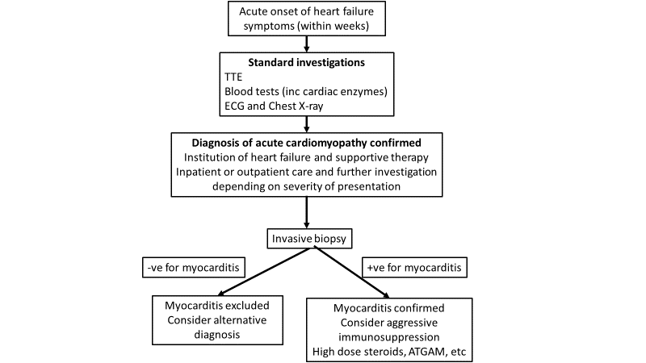

2. Acute coronary syndrome mimic pathway
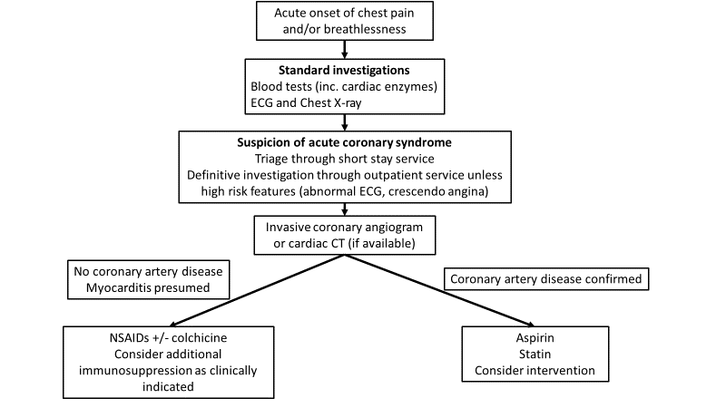

Define and summarise the PROPOSED clinical management pathway (algorithm) that patients would follow after the proposed service/technology is introduced, including variation in health care resources.

Acute cardiomyopathy pathway
1. Acute Cardiomyopathy pathway
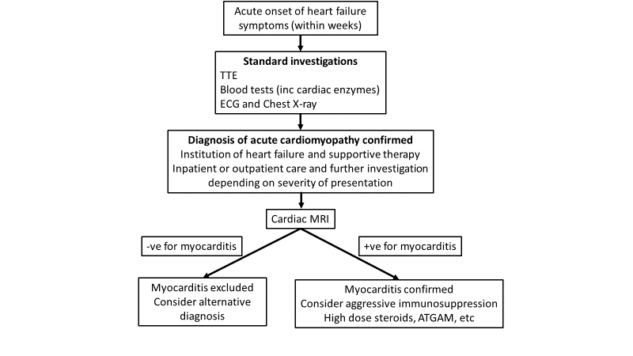

2. Acute coronary syndrome mimic pathway
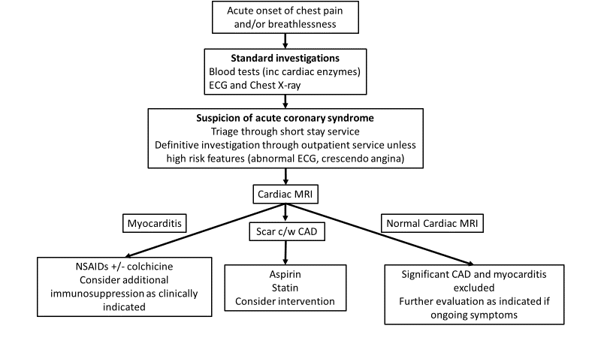

PART 6d – INFORMATION ABOUT CLINICAL OUTCOMES

Summarise the clinical claims for the proposed medical service against the appropriate comparator(s), in terms of consequences for health outcomes (comparative benefits and harms):
- Acute cardiomyopathy pathway
In the diagnostic algorithm for acute cardiomyopathy, cardiac MRI represents a safer alternative to invasive myocardial biopsy, which has the known risks of vascular access complications, malignant arrhythmia and cardiac perforation which whilst rare usually requires emergent cardiac surgery and may be fatal. Furthermore, due to sampling error the invasive myocardial biopsy may be non-diagnostic in over 50% of cases. In contrast cardiac MRI is more sensitive for the diagnosis of acute myocarditis as the entire heart is assessed. In addition to the higher diagnostic yield for acute myocarditis, cardiac MRI provides highly accurate measures of cardiac function and the extent and distribution of cardiac scarring has important prognostic benefits.

- Acute coronary syndrome pathway
Compared to the currently-used diagnostic algorithm for acute myocarditis, which essentially is a presumptive diagnosis myocarditis after the exclusion of coronary artery disease, cardiac MRI identifies inflammatory features and scarring that are diagnostic of myocarditis with a high level of accuracy (sensitivity and specificity of around 90%). An important failing of the current diagnostic algorithm is that patients who undergo invasive angiography or cardiac CT may have minor coronary artery disease or coronary calcification and may be falsely diagnosed as an acute coronary syndrome when the real diagnosis was acute myocarditis. These patients may then be inappropriately treated with lifelong secondary preventive therapies for coronary artery disease which is minor and asymptomatic (as their symptoms were secondary to acute myocarditis).

Therefore, a diagnostic pathway incorporating cardiac MRI will lead to greater diagnostic certainty which will likely to lead to more appropriate delivery of therapies. This would include the administration of non-steroidal anti-inflammatory drugs and/or colchicine for those diagnosed with acute myocarditis with cardiac MRI, compared to many patients who may be inappropriately be treated with anti-atherosclerotic therapy (with aspirin and lipid lowering agents) evaluated by the current pathway.

This new pathway can also avoid invasive coronary angiography which carries known risks of heart attack, stroke, vascular access complications and bleeding, arrhythmias, allergic reactions to dye or kidney injury, or death. A serious risk is estimated at 1 in 1000.

Please state what the overall clinical claim is:
The main aim of cardiac MRI in the diagostic algorithm is to provide a more accute diagnosis of myocarditis whilst avoiding a potentially risky invasive procedure. Many international cardiac societies already recommend cardiac MRI as the first line investigation in the diagnosis of acute myocardits, however in Australia due to a lack of Medicare funding for this indication access to this important diagnostic test is limited. In addition to the greater level of diagnostic certainty, cardiac MRI is a non-invasive test which utilzes a non-nephrotoxic contrast agent, so its safety profile is superior to current comparators such as invasive myocardial biopsy and invasive coronary angiography. Finally, by achieving a more accurate diagnosis it is expected that a greater number of patients will receive the appropariate therapy for myocarditis leading to better resolution of symptoms and a lower incidence of potential lifelong anti-athersclerotic therapies in thise incorrectly diagnosed as symptomatic coronary artery disease.
An important consideration in the Covid-19 environment is the ability of cardaic MRI to accutely diagnose acute myocarditis that may be related to mRNA vaccines or Covid-19 infection itself. In the current definitions used by ATAGI for the diagnosis of mRNA vaccine associated myocarditis (the Brighton Colloboration Case Definition), cardiac MRI is the only imaging technique that can definitively diagnose myocarditis in the absence of left ventricular dysfunction, which is a late sign in vaccine associated myocarditis. In this setting cardiac MRI will provide a greater level of diagnostic certainty, most importantly in those patients where myocarditis is either “probable” or “possible”, in whom considerable uncertainty exists as to the future safety of mRNA vaccine administration.

List the key health outcomes (major and minor – prioritising major key health outcomes first) that will need to be measured in assessing the clinical claim for the proposed medical service/technology (versus the comparator):
- Higher diagnostic accuracy leading to improved patient care and lower rates of inappropriate therapy.
- Improved safety due to a lower rate of invasive cardiac biopsy or invasive coronary angiography.
- More accurate definition of mRNA vaccine associated myocarditis, leading to a greater understanding of the incidence of this condition and greater public confidence in mRNA vaccine leading to lower vaccine hesitancy.
- A greater understanding of the incidence and severity of Covid-19 related myocarditis.

PART 7 – INFORMATION ABOUT ESTIMATED UTILISATION

Estimate the prevalence and/or incidence of the condition in the proposed population:
Overall the incidence of myocarditis in the community has been estimated at approximately 30 per 100,000-person years. In those receiving a mRNA Covid-19 vaccine, the incidence of vaccine associated myocarditis may be as high as 1 in 25,000 vaccine doses.

Estimate the number of times the proposed medical service/technology would be delivered to a patient per year:
In most patients cardiac MRI would be performed only once. However, in some patients, particularly those with cardiac dysfunction, a follow up scan may be required to demonstrate resolution of inflammatory changes.

How many years would the proposed medical service/technology be required for the patient?
The vast majority of patients will only undergo cardiac MRI in a single year.

Estimate the projected number of patients who will utilise the proposed medical service(s) for the first full year:
Approximately 10,000 scans, based on the above incidences.

Estimate the anticipated uptake of the proposed medical service/technology over the next three years, factoring in any constraints in the health system in meeting the needs of the proposed population (such as supply and demand factors), as well as provide commentary on risk of ‘leakage’ to populations not targeted by the service.
The most recent landscape survey of cardiac MRI activity was performed in 2017 by RANZCR in conjunction with CSANZ, and this found that approximately 15,000 cardiac MRI scans were performed in the calendar year. With the advent of new cardiac MRI item numbers there has been a significant expansion in cardiac MRI provision, both with respect to total numbers of scans and improved access. There are now accredited cardiac MRI providers performing cardiac MRI in every state of Australia, as well as in may larger regional centres. There are plans for RANZCR to repeat the cardiac MRI landscape survey to obtain updated data, as based on provider feedback the number of cardiac MRI scans per year has roughly doubled since the creation of new cardiac MRI item numbers and greater availability of cardiac MRI services. As mentioned above, in Australia there are currently 144 accredited cardiac MRI providers (84 cardiologists and 60 radiologists).
It is therefore anticipated that whilst the creation of a new item number for cardiac MRI for the diagnosis of myocarditis will result in a significant growth in cardiac MRI numbers, this growth will be roughly in line with the recent growth trend after the introduction of ARVC item numbers 4 years ago and within the growing supply capacity for cardiac MRI in Australia. Furthermore, the more widespread availability of cardiac MRI will ensure adequate equity of service delivery. As the two clinical pathways leading to the diagnosis of myocarditis are well described it is not expected that a significant amount of leakage to populations outside the target populations for this service, assuming the item number descriptors reflect the diagnostic pathways outlined above.

PART 8 – COST INFORMATION

Indicate the likely cost of providing the proposed medical service. Where possible, please provide overall cost and breakdown:
There is a currently a temporary MBS item number for the diagnosis of mRNA associated myocarditis (item 63399). The fee for this service is $855.20, and given the cardiac MRI sequences performed for the proposed item number will be identical the same cost of $855.20 per scan will apply.

Specify how long the proposed medical service/technology typically takes to perform:
The service takes 45-60 minutes.

If public funding is sought through the MBS, please draft a proposed MBS item descriptor to define the population and usage characteristics that defines eligibility for the medical service/technology.
Category Category 5 – DIAGNOSTIC IMAGING SERVICES – Group I5 – Magnetic resonance imaging
Proposed item descriptor: MRI–scan of cardiovascular system for the assessment of myocardial structure and function and characterisation, if the service is requested by a consultant physician who has assessed the patient, and the request for the scan indicates:
(a) the patient has suspected myocarditis and would otherwise require myocardial biopsy or coronary angiography to confirm the diagnosis; OR
(b) the patient has suspected myocarditis after receiving a mRNA COVID-19 vaccine with symptom onset within 21 days of a mRNA COVID-19 vaccine administration; AND
(c) the results from the following examinations are inconclusive to form a diagnosis of myocarditis:
(i) echocardiogram; and
(ii) troponin; and
(iii) chest X-ray.
(R) (Anaes.) (Contrast)
Fee: $855.20

If public funding is sought through an alternative (non-MBS) funding arrangement, please draft a service description to define the population and usage characteristics that defines eligibility for the service/technology.
N/A

