Public Summary Document
Application No. 1163 - Assessment of HER2 gene amplification for use of trastuzumab in gastric cancer

Sponsor/Applicant/s: Roche Products Pty Limited

Date of MSAC consideration: 29-30 November 2012

1. Purpose of application
In February 2011, an application from Roche Products Pty Limited was received by the Department of Health and Ageing requesting a Medicare Benefits Schedule (MBS) listing for HER2 testing in advanced adenocarcinoma of the stomach or gastro-oesophageal junction –henceforth described as gastric cancer. This application related to a test already funded on the MBS (immunohistochemistry (IHC) to detect over-expression of the human epidermal growth factor receptor 2 [HER2]) as well as a new test (in-situ hybridisation for detection of amplification of the HER2 gene).

This application was deemed to propose a co-dependent package of two types of health technology (a pathology test and a medicine) subsidised through two different programs and therefore required advice from MSAC to be coordinated with that of the Pharmaceutical Benefits Advisory Committee (PBAC).

The first application proposed a base case for patients with evidence of HER2 overexpression as described by a 2+ IHC score, subsequently confirmed as exhibiting HER2 gene amplification by ISH, or HER2 overexpression as described by a 3+ IHC score
(i.e. IHC 2+/ISH+ or IHC3+) to determine trastuzumab eligibility.
The resubmission proposed an updated base case for patients with evidence of HER2 overexpression as described by a 2+ or 3+ IHC score, subsequently confirmed as exhibiting HER2 gene amplification by ISH (i.e. IHC 2+/ISH+ or IHC3+/ISH) to determine trastuzumab eligibility.

People with inoperable locally advanced or metastatic gastric cancer, including cancer of the gastro-oesophageal junction, who are eligible for trastuzumab treatment would be tested to determine HER2 status. HER2 testing would be restricted to patients who had not received prior chemotherapy for the treatment of their metastatic gastric cancer.

2. Background
Data regarding the utilisation of HER2 testing relate primarily to the use of IHC in breast cancer. Currently, IHC testing is Medicare-funded for breast cancer and the MBS descriptor (MBS 72848) also allows testing for oestrogen or progesterone receptors.
HER2 testing is a co-dependent technology with the purpose of identifying patients with inoperable locally advanced or metastatic gastric cancer who are likely to benefit from treatment with trastuzumab. Patients who test positive for HER2 would receive the regimen tested in the ToGA trial (Bang et al 2010), namely trastuzumab by intravenous infusion at a dose of 8 mg/kg on day 1 of the first chemotherapy cycle, followed by 6 mg/kg every 3 weeks until disease progression or unacceptable toxicity.
Trastuzumab was being considered by the Pharmaceutical Benefits Advisory Committee (PBAC) for listing on the PBS for the treatment of HER2 positive patients with advanced (equivalent to stage III or IV) gastric cancer. Trastuzumab has been available through the PBS and the Herceptin Program, for early and late stage breast cancer respectively. In the setting of advanced gastric cancer, trastuzumab may be delivered in either an inpatient or outpatient setting and is TGA-approved to be co-administered in addition to cisplatin and a fluoropyrimidine.

3. Prerequisites to implementation of any funding advice
IHC testing should be performed in a National Association of Testing Authorities accredited laboratory. The low volume of cases and range of unique gastric cancer-specific issues (such as heterogeneity of expression within tumour samples) ideally would require laboratory participation in the Royal College of Pathologists of Australasia quality assurance program. Given the heterogeneity of receptor expression in tissue samples, experts recommend that ISH is performed with access to the IHC test/slide to guide the direction of reading (where possible).

4. Proposal for public funding

Proposed MBS listing
Category 6 - Pathology services
[MBS item number]
A test of tumour tissue from a patient with inoperable, locally advanced or metastatic, gastric or gastro-oesophageal (GE) junction cancer, to determine if the requirements relating to amplification of c-erb-B2 (HER2) in biopsy material, by in situ hybridisation techniques, for access to trastuzumab under the Pharmaceutical Benefits Scheme (PBS) are fulfilled.
Fee: $315.40

The ESC report noted from the previous PBAC Minutes, it stated that “any reconsideration of trastuzumab in gastric cancer should be limited to those with metastatic (stage IV) disease” (PBAC Ratified Minutes 6.9.43); however this is not reflected in this resubmission. The Pre-Sub-Committee Response (PSCR) indicated a preparedness to accept the conclusion of PBAC (and presumably MSAC).

MSAC considered that the definition of HER2 “positive” in a PBS restriction for trastuzumab in metastatic gastric cancer should be both (a) either IHC2+ or IHC3+ and then (b) ISH results showing >6 copies of HER2 and the ratio of HER2:chromosome 17 being >2.

The application suggested that ordering of HER2 testing be restricted to surgeons, gastroenterologists or oncologists once a diagnosis of inoperable locally advanced or metastatic gastric cancer had been established.

Delivery of the intervention and reporting of the results would be provided by a pathologist with knowledge and expertise in testing for gastric cancer and IHC and/or ISH testing. As a consequence, billing of the intervention would be done by the pathologist.
Testing is provided by several reference laboratories in Australia and is available to private and public patients.

5. Consumer Impact Statement
No issues identified.

6. Proposed intervention’s place in clinical management
The clinical management algorithms for previously untreated advanced gastric cancer indicated that the proposal is to add HER2 testing before chemotherapy is started, with patients shown to be HER2 positive offered trastuzumab instead (and patients shown to be HER2 negative still being offered chemotherapy instead). Trastuzumab would be added to the currently available cisplatin-based doublet chemotherapy regimens, and replace epirubicin in triplet regimens.

7. Other options for MSAC consideration
Not applicable.

8. Comparator to the proposed intervention
The resubmission noted that the appropriate comparator for testing is usual care (cisplatin and either 5-FU or capecitabine (CF)) without HER2 testing.

The PBAC Minutes from the July 2011 Meeting did not accept CF as the appropriate comparator. Rather, they suggested triplet therapy such as epirubicin, cisplatin and either 5-FU or capecitabine (ECF) was more appropriate, and identified the use of CF alone as a source of uncertainty in the previous submission.

The resubmission nominated CF (i.e. the comparator in the main clinical trial, ToGA) as the comparator despite ECF being the standard treatment in this patient group. The justification for the selection was that the body of clinical evidence and Australian and international expert opinion suggested there to be no overall survival benefit from the addition of epirubicin to CF, citing Pozzo and Ohashi (2009), Yun et al. (2010) and Price et al. (2012) as evidence of no difference in treatment effect. Therefore, CF was assumed to be a valid proxy for ECF. It was noted that the Yun et al. (2010) study is underpowered to show a difference between (or equivalence of) the two regimens.

9. Comparative safety
IHC and ISH testing are in vitro diagnostic procedures that pose very few safety issues, and that samples would be collected and analysed according to standard protocols which are well established in Australia. Standard clinical practice in Australia is to initially sample enough of the tumour to allow for retesting in the event of failure. However, there may be instances where insufficient or no sample is obtained, and further sampling from the patient may be required; this would pose further harms to the patient. These harms were not addressed in the resubmission.

10. Comparative effectiveness

Evidence for the test performance
Prognostic evidence | One prospective cohort study and one retrospective cohort study | k=2 n=464
Comparative analytical performance | Two studies that compared different testing methodologies from archival specimens or samples from randomised controlled trials. Concordance data were presented. | k=2 n=3415
k=number of studies, n=number of patients

Key results of testing

1. Prognostic evidence
Table 3: Results of the most relevant studies included as evidence of the prognostic impact of HER2
Study | N | Univariate analysis |  |  |  |  |  | Multivariate analysis
 |  | Median survival (months) | Survival rate (%) |  |  |  | P-value | P-value
 |  |  | 3 months | 6 months | 12 months | 24 months
Song (2010)
IHC | 58 | 12.6 | 100.0 | 100.0 | 51.0 | 23.2 | 0.021
HER2-
HER2+ | 25 | 5.9 | 88.2 | 49.1 | 41.6 | 6.5
ISH | 54 | 12.6 | 96.8 | 93.5 | 53.0 | 17.7 | 0.028
HER2-
HER2+ | 29 | 5.5 | 88.5 | 44.7 | 37.8 | 11.8
Werner (2011)
HER2- | 303 | 11.4 |  |  |  |  | 0.047 | 0.3
HER2+ | 78) | 13.9
Abbreviations: HER2=human epidermal growth factor 2; IHC=immunohistochemistry; ISH=in situ hybridisation

The resubmission claimed that the evidence is inconclusive regarding the prognostic effect of HER2 positivity in gastric cancer. This conclusion was reasonable as many of the included studies showed no significant difference in the prognosis of HER2 positive and HER2 negative patients. As noted previously by PBAC, this has implications for the biological and pharmacological rationale for using trastuzumab. The resubmission argued that the treatment effect of adding trastuzumab from ToGA is independent of the prognostic impact of the biomarker because both trial arms were HER2 positive.

2. Comparative analytical performance
Table 4: Comparative analytic validity of HER2 IHC testing compared to ISH testing, with IHC 3+ definition of HER2 positivity
Concordance comparison of IHC and FISH test results: IHC positive (IHC3+)
 | HER2 positive  (IHC3+); FISH+ | HER2 negative  (IHC0/IHC1+/IHC2+); FISH- | Total
ToGA, Chung (2009)  Tafe (2011) | 354/373 (94.9%)  16/16 (100%) | 2505/2907 (86.2%)  105/112 (93.8%) | 2859/3280 (87.2%)  121/128 (94.5%)
ToGA, Chung (2009)  Tafe (2011) | Mean kappa (95% CI)* 0.560 (0.521–0.599)  Mean kappa (95% CI)* 0.789 (0.638–0.941)
* Unweighted kappa coefficient as a group measure of pairwise agreement between IHC and FISH
Abbreviations: CI= confidence interval; FISH=fluorescence in situ hybridisation; HER2=human epidermal growth factor receptor 2; IHC=immunohistochemistry

Table 5: Comparative analytic validity of HER2 IHC testing compared to ISH testing, with IHC 2+ and IHC 3+ definition of HER2 positivity
Concordance comparison of IHC and FISH test results: IHC positive (IHC2+ or IHC3+)
 | HER2 positive  (IHC2+/IHC3+); FISH+ | HER2 negative  (IHC0/IHC1+); FISH- | Total
ToGA, Chung (2009)  Tafe (2011) | 566/761 (74.4%)  20/24 (83.3%) | 2329/2519 (92.5%)  101/104 (97.1%) | 2895/3280 (88.3%)  121/128 (94.5%)
ToGA, Chung (2009)  Tafe (2011) | Mean kappa (95% CI)* 0.670 (0.639–0.701)  Mean kappa (95% CI)* 0.818 (0.686–0.949)
* Unweighted kappa coefficient as a group measure of pairwise agreement between IHC and FISH
Abbreviations: CI= confidence interval; FISH=fluorescence in situ hybridisation; HER2=human epidermal growth factor receptor 2; IHC=immunohistochemistry

The ToGA-based analyses were based on optimal laboratory practice, with all tests conducted in a single laboratory using both IHC and guided FISH testing on all samples. The GaTHER study suggested that the ToGA trial results cannot be used as an indicator of test performance in the Australian setting. The PSCR referred to Powell et al. (2009 and 2010) to provide further information on assay performance (comparing two IHC kits, a FISH kit and a SISH kit) and across different stages of gastric cancer. However the Joint ESCs advised that the risk of bias in this study was unknown given that it had been neither published nor peer-reviewed.

The data presented in the resubmission indicated a higher level of concordance for assay results from different laboratories if more stringent IHC criteria for a positive test were applied. No other comparative analytical data were presented across different test strategies defined by the six listed scenarios. The inability of the sensitivity analyses to assess the impact of differences in test strategy performance in terms of false positives and false negatives across the various strategies defined by the six listed scenarios on cost-effectiveness reduced confidence in the results of the economic evaluation.

The application claimed that the use of HER2 testing, to identify patients with HER2 positive advanced gastric cancer for treatment with trastuzumab, indirectly resulted in a clinically relevant and statistically significant improvement in overall survival, progression-free survival, response rates, time to progression, duration of response and clinical benefit rate in a disease with a uniformly poor prognosis. The application claimed that HER2 testing and treatment with trastuzumab are safe and well tolerated.

It is claimed that trastuzumab, when used in combination with standard chemotherapy for the treatment of patients with HER2 positive advanced gastric cancer, is significantly more effective than standard chemotherapy alone and is no worse than standard chemotherapy in terms of comparative safety.
These claims suggest that HER2 testing, to identify patients who would benefit from trastuzumab, would result in superior health outcomes for individuals found to be HER2 positive. Relative to the comparator of usual care without HER2 testing, HER2 testing followed by trastuzumab in HER2 positive patients and usual care in HER2 negative or untested patients would therefore be considered non-inferior in terms of safety and superior in terms of effectiveness.

The submission relied on biological rationale rather than presenting evidence to show that being HER2 positive or not predicts different effects of adding trastuzumab to chemotherapy in advanced gastric cancer. It relied on post hoc subgroup analyses to support the claim that varying definitions of being HER2 positive (Scenarios 1-6) predict variations in this incremental effect.

It is uncertain which testing strategies combining IHC and ISH testing (Scenarios 1-6) provides the best test performance in determining test positivity, because:
- no direct comparison of test performance was presented across the strategies;
- the overall risk of bias present in the available evidence base may be high, as studies included for the effectiveness of the test were not assessed for bias;
- the patient populations in many studies were not consistent with that proposed for MBS and PBS use of the test and drug, and included patients with gastric cancers who were not restricted to advanced stage disease;
- the definition of HER2 positivity may not have been consistent between included studies; and
- studies that included a patient population consistent with the DAP and utilised the same scoring criteria, also conducted testing centrally. Consequently, there may be issues applying reported concordance to a multi-centre testing setting.

In the context of clinical practice, it is likely that Scenarios 5 and 6 are most clinically appropriate. The Joint ESCs reiterated the comment, made by the PBAC for the previous submission, that the results of the ToGA trial represented ideal test conditions and that testing in a realistic Australian setting would very likely reduce the incremental benefit observed in the trial results due to variability in determination of HER2 positivity.

11. Economic evaluation
The resubmission presented a stepped economic evaluation based on the clinical superiority of adding trastuzumab. The resubmission presented an incremental cost-effectiveness ratio (ICER) in the range of $45,000 - $75,000 per quality adjusted life year (QALY) gained (resubmission base case), based on efficacy data from the ToGA trial, applied to HER2 positive patients in the proposed and comparator arms and extrapolated to 5 years. Utility weights gathered in ToGA and from literature (Curran, et al., 2009) were applied; and drug usage was estimated from both the ToGA trial and Synovate Healthcare 2012 data.

Using a cost-utility/cost-effectiveness analysis, presenting the cost per QALY and the cost per LYG, was considered appropriate. However, there were substantial uncertainties regarding the model structure and inputs. Although the PBAC has previously recommended that any reconsideration of trastuzumab for this indication should be limited to patients with metastatic disease, the resubmission did not present an economic evaluation of patients with metastases only.

The model was a simplified decision-tree model to include only HER2 positive patients.

(redacted information -----------)

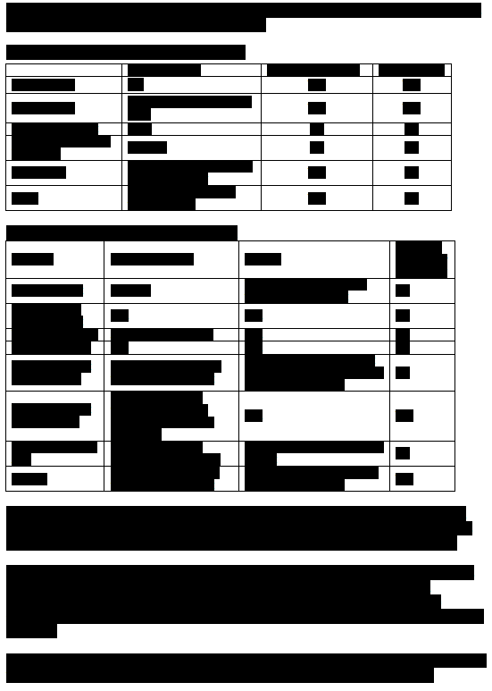
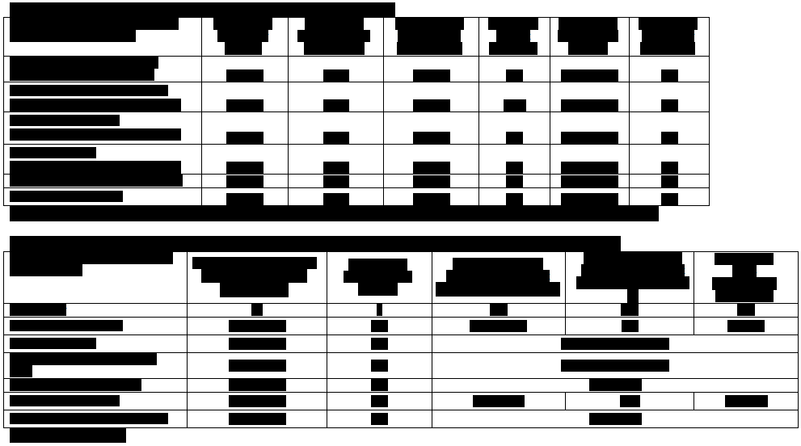

12. Financial/budgetary impacts
An estimated total of (redacted) less than 5,000 patients will be tested with IHC and (redacted) less than 2,000 patients will be tested with ISH testing over the first 5 years in the resubmission base-case scenario. There would be an estimated total of (redacted) less than 1,000 patients tested with ISH in Scenario 3 (base case in the previous submission), and (redacted) less than 1,000 in Scenario 6. All patients who undergo IHC testing would be tested with ISH in Scenario 1 (DAP base case).
The adverse effects associated with biopsy and the cost for consultations regarding test results was excluded. Fees for PEI (patient episode initiation) and P11 (specimen referred) were not included.

The resubmission estimated the net costs to the MBS would be an additional cost of (redacted) less than $1.3 million over the first 5 years in the base case scenario.

While estimating the financial implications to the MBS, the resubmission did not consider the patients who require additional biopsy or potential ISH retesting for HER2 negative results. The cost for consultations regarding test results or additional test was not included in the analysis. In addition, the MBS costs for IV-administration and any adverse events associated with the treatment of trastuzumab were not included in the analysis.

In the resubmission, the multiple gated acquisition (MUGA) scan (MBS item 61313, $303.35) was not considered in the analysis, despite being recommended for consideration by the DAP. This favours trastuzumab as it would occur predominantly in those receiving HCF.

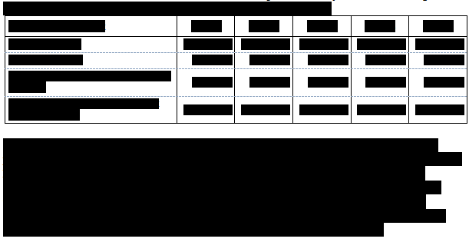13. Key issues for MSAC from ESC
Main issues around the proposed eligible population for public funding and/or the proposed main comparator?
- The proposed MBS item descriptor for HER2 ISH testing may need to be modified to identify the circumstances in which patients with gastric cancer would be eligible for MBS subsidy for HER2 ISH testing and to be consistent with a corresponding PBS restriction.
Main issues around the evidence and conclusions for clinical effectiveness?
- There is uncertainty regarding which combination of IHC and/or ISH testing will predict the optimal treatment effect of adding trastuzumab (clinical utility). Further, in the absence of an agreed reference standard, there is uncertainty regarding which combination of IHC and/or ISH testing will have optimal comparative analytical performance in terms of reducing false positive and false negative test results (analytical validity). IHC testing should precede and guide use of ISH testing in gastric cancer due to heterogeneous HER2 expression and subjectivity of IHC testing.
- FISH testing is less commonly performed in Australia (approximately 5%) due to technical and economic issues, consequently, CISH and SISH testing would be more frequently used. Evidence was presented that suggested a high agreement between the testing platforms; however, these were performed in patient populations that are not consistent with the proposed MBS patient population. Comparative performance for CISH, SISH and FISH in this patient population is uncertain. The resubmission has not considered the effect of this on the cost-effectiveness of the co-dependent package.
- It is unclear what, if any, prognostic impact HER2 status has in advanced gastric cancer.
Main economic issues and areas of uncertainty?
- The model structure does not allow sensitivity analysis to be conducted to assess adequately the consequences on cost-effectiveness of the varying performance of the proposed test strategies in terms of false positive and false negative test results.
- For example, the simplification of the model to include only FISH-tested HER2 positive patients favours trastuzumab to an unknown extent. In Australia, patients will mostly be tested with CISH and SISH.
- Given the known heterogeneity of HER2 expression in gastric cancer tissue, Australian pathology laboratories would very likely conduct multiple tests in different sites of a single patient resection sample (where possible) and across multiple or large biopsies for a patient. Each individual test would attract a separate fee, which was not considered in the resubmission.
Any other important areas of uncertainty (e.g. budget impact, translation of clinical evidence into the economic evaluation, linkage between an investigative intervention and a subsequent therapeutic intervention and outcomes?
- Uncertainties remain regarding the estimates of the net MBS costs, given that:
  - MBS items associated with IV administration are excluded.
  - The resubmission does not include MBS costs associated with treatment of adverse events.
  - Multiple Gated Acquisition (MUGA) Scan is excluded.
  - While the cost of retesting pre-existing samples is included in the list price, the costs of any additional biopsies and subsequent HER2 testing are not.

14. Other significant factors
Not applicable.

15. Summary of consideration and rationale for MSAC’s advice

Whom to test?
MSAC considered that the eligible patient population for HER2 testing would have Stage IV (metastatic) adenocarcinoma of the stomach or gastro-oesophageal junction (metastatic gastric cancer) and that there was no need or basis to further enrich the population eligible for testing.

When to test?
MSAC considered that there was no need to consider testing a patient who has not yet reached Stage IV (metastatic) gastric cancer because most patients present with metastatic gastric/gastro-oesophageal cancer, and testing of the metastasis is preferred over testing the primary tumour (see what to test below). The expected turnaround time of five days for the test results is reasonable in the context of the time to decide on treatment for the medical condition.

What to test?
MSAC considered that the proposed item descriptor should limit HER2 testing to biopsy or resection specimens, and thus exclude the possibility of testing of cytology specimens, due to the evidence of frequent heterogeneity within a tumour sample and the lack of data to support the use of cytology specimens according to the submission.

Cytology samples are not recommended for HER2 testing due to the small sample size and frequency of heterogeneity of HER2 status. However, if no other more suitable specimen is available then paraffin embedded cell blocks may be used. In these cases ISH should be used as the first line test. This technique is likely to give a more reliable result as it avoids the complication of cell membrane damage that may occur in some cytology samples. HER2 testing should not be performed on cytology direct smears.

Although testing the primary tumour should not be excluded, MSAC considered that testing of the metastasis is preferred over testing the primary tumour because of the acknowledged incidence of heterogeneity of HER2 status within and between tumour samples. As most patients present with metastatic gastric cancer, few patients would be disadvantaged by this preference.

MSAC agreed with the base case scenario in the resubmission and considered that in situ hybridisation (ISH) testing for human epidermal growth factor receptor 2 (HER2) in the context of metastatic gastric cancer should only be performed when prerequisite immunohistochemistry (IHC) testing for HER2 overexpression is scored at 2+ or 3+ using scoring guidelines reflecting the approach which was standardised for the key randomised trial of trastuzumab (ToGA). MSAC noted that different scoring systems were required for assessment of HER2 overexpression on resection compared with biopsy specimens. Given the heterogeneity of HER2 overexpression, MSAC considered that IHC was a necessary prerequisite to ISH testing. IHC allowed the pathologist to identify the areas within a tumour which should be examined for HER2 gene amplification by ISH. For this reason, it was important that the same laboratory undertook both IHC and ISH testing. This approach maximised the analytical performance of the overall testing strategy.

MSAC considered that the definition of HER2 “positive” in a PBS restriction for trastuzumab in metastatic gastric cancer should be both (a) either IHC2+ or IHC3+ and then (b) ISH results showing >6 copies of HER2 and the ratio of HER2:chromosome 17 being >2. Both ISH criteria need to be fulfilled. This definition of HER2 amplification reduces the rate of false positives by ensuring that there are enough copies of HER2 to be confident of the ratio result and excludes instances where the two copies of chromosome 17 are not seen. It conforms to likely Australian practice based on the approach which was standardised for the ToGA trial. MSAC noted that Australian practice relies on biopsy specimens to a greater extent than resection specimens compared to the ToGA trial, and the likelihood of having a positive HER2 ISH result in the ToGA trial was greater with biopsy specimens than with resection specimens.

To support this preferred approach, MSAC advised that Australian pathology practice should be optimised to ensure HER2 testing for metastatic gastric cancer is limited to laboratories with expertise and back-up by requiring that the one laboratory performs both IHC and ISH testing on the specimen. This centralised approach would also facilitate the collation of data on the IHC score, the HER2 copy number and the ratio of HER2 to chromosome 17. For the purposes of informing future decisions, MSAC considered the collection of these data were highly desirable.

However, MSAC advised that the estimate of trastuzumab incremental effectiveness in the economic evaluation presented to PBAC should reflect the intention-to-treat (ITT) results of the ToGA trial because the Committee considered that pathology practice in Australia could not be optimised to the extent that was achieved for the ToGA trial. For this reason, the subgroup analyses conducted to inform the various scenarios in the application do not form a sufficiently robust basis to support the claimed improvements in the incremental effectiveness of trastuzumab over that shown by the ITT results.

MSAC noted that its preference not to specify a type of ISH test means that an assessment of comparative analytical performance is required across available ISH test options. Silver in situ hybridisation (SISH) is more commonly used in Australia than fluorescence in situ hybridisation (FISH), which was the evidentiary standard ISH test used in the ToGA trial. Further, it would be expected that unstained slides of metastatic gastric cancer would be sent to a laboratory, which would usually conduct a SISH test. If this did not resolve the HER2 diagnosis, the specimen would likely be sent to a FISH reference laboratory and be billed as a new episode given the 14-day rule applying in the Pathology Services Table of the MBS.

The applicant’s response to the Joint ESC Report provided reassurance that repeat sampling for HER2 in gastric cancer would not be a common occurrence because between six and eight biopsies would be extracted via one endoscopic procedure and tested at the same time maximising the likelihood of recognising possible heterogeneity in the tumour. MSAC therefore agreed that the re-sampling (new biopsy or new testing of resected tissue) rate would be low. MSAC considered that a re-testing rate of 5% would reasonably reflect the rate of indeterminate results from an initial test, for example, due to marked heterogeneity, and thus requiring referral for FISH or further biopsy. MSAC further considered that repeat testing would not be needed, as HER2 status was not informative for purposes other than determining eligibility for trastuzumab. Specifically, HER2 status was not informative for monitoring response to treatment or disease progression, assessing the development of resistance, concordance testing across multiple tumour sites, or assessing mutation stability over time.

The different ISH test options would also have consequences for the submission’s implicit assumption for modelling purposes of 100% sensitivity and 100% specificity for testing as conducted in the ToGA trial, which MSAC considered would overestimate the likely test performance across test options and pathology laboratories in Australia. Despite the absence of an agreed reference standard, MSAC noted that the applicant usefully provided additional information in response to the Joint ESC Report on the issues of both comparative analytical performance of SISH and FISH and the importance of reconstructing the modelled economic evaluation to assess the consequences of reduced sensitivity and specificity. However the comparative analytical performance data were from the ToGA trial rather than Australian data from the GaTHER study (such as that provided in Table 7 of the Joint ESC Report). Further the unevaluated sensitivity analyses in this response could not be assessed because the consequences of worsening sensitivity or specificity should be an increase in incremental costs and a decrease in incremental QALYs gained, as well as an increase in incremental cost per extra QALY gained as reported. In addition, it is not clear whether the response included the corrected number of tests and test cost per treated patient provided in the Supplementary Table of the Joint ESC Report (but also adjusting for a 5% re-testing rate). Overall, MSAC advised that the impact of test uncertainty on overall clinical effectiveness and cost-effectiveness needed to be incorporated in the economic evaluation presented for PBAC consideration.

MSAC considered that the range of uncertainty in the estimate of prevalence was sufficiently reflected in the range across the scenarios presented in the submission based on a simple average across the ToGA prevalence data and the GaTHER prevalence data, with a base case of 18.3% and a range for the sensitivity analyses of 14.0% to 22.7%.

Other considerations
MSAC agreed that the nominated comparator of usual care without HER2 testing was appropriate, and that a comparison of analytical performance of the alternative ISH test options was also appropriate.

MSAC concluded that the primary co-dependency claim had been established based on a biological argument rather than direct evidence, because no comparative assessment of trastuzumab’s effectiveness in HER2 negative patients has been presented. Compared to breast cancer, the biological argument is weak and is not supported to the same extent by in vitro data. Nevertheless, it has some plausibility and has been widely accepted elsewhere. Given that between 14% and 23% of patients with metastatic gastric cancer are HER2 positive, this means that trastuzumab would only be eligible for this minority of patients. MSAC also concluded that this co-dependency claim could not be clearly distinguished from the unresolved question of whether HER2 status indicates a different prognosis in gastric cancer. MSAC advised that there were no other purposes for HER2 testing in gastric cancer.

MSAC noted that the considerations above and advice below addressed the matters referred to it by the November 2012 PBAC meeting.

MSAC advised that, in the absence of any reason not to do so, the current MBS fee should apply to any expansion of eligibility for MBS funding of HER2 ISH testing.

16. MSAC’s advice to the Minister
After considering the strength of the available evidence in relation to the safety, clinical effectiveness and cost-effectiveness of in situ hybridisation (ISH) testing for human epidermal growth factor receptor 2 (HER2) to include metastatic adenocarcinoma of the stomach or gastro-oesophageal junction to help determine eligibility for proposed PBS-subsidised trastuzumab, MSAC deferred the application for the requested MBS item until such time as PBAC makes a decision regarding the corresponding PBS listing of trastuzumab. In doing so, PBAC will take into account responses to the questions it had posed to MSAC and the following advice:
- the proposed MBS item descriptor should indicate a preference for testing the metastasis rather than the primary tumour, noting that most patients present with Stage IV disease in clinical practice, although testing the primary tumour should not be excluded
- the proposed MBS item descriptor should require that HER2 ISH testing in the context of metastatic gastric cancer be performed on the same specimen in the same laboratory and only when prerequisite immunohistochemistry (IHC) testing for HER2 overexpression is scored at 2+ or 3+ using scoring guidelines reflecting the approach which was standardised for the ToGA trial of trastuzumab
- the proposed MBS item should therefore be made a pathologist determinable service to allow HER2 ISH testing to be guided by the “hot spots” revealed by the prerequisite IHC test result (the heterogeneity of IHC staining across a sample of tumour and the difficulty of scanning a slide for positive cells using ISH alone), rather than the pathologist being interrupted to get a referral from a clinician to do so
- the proposed MBS item descriptor should allow any accepted type of ISH testing and should refer to dual probe rather than single probe testing
- the proposed MBS item descriptor should limit HER2 testing to biopsy or resection specimens, and thus exclude the possibility of testing of cytology specimens. However, if no other more suitable specimen is available then paraffin embedded cell blocks may be used, in which case ISH should be used as the first line test. HER2 testing should not be performed on cytology direct smears
- the definition of HER2 test positive in a PBS restriction for trastuzumab in metastatic gastric cancer should be both (a) IHC2+ or IHC3+ and then (b) ISH results based on both >6 copies of HER2 and the ratio of HER2:chromosome 17 being >2
- the economic evaluations and financial analyses presented to PBAC should include a re-sampling (new biopsy or new extraction from resected tissue) rate of 5% to reflect the rate of indeterminate results from the initial test, for example, due to excessive heterogeneity
- the economic evaluations and financial analyses presented to PBAC should include the costs of patient retrieval for re-sampling as required, such as professional attendance fees
- the economic evaluations and financial analyses presented to PBAC need not include any other repeat testing
- the economic evaluations and financial analyses presented to PBAC should include the full costs of testing, such as patient episode initiation and specimen retrieval, storage or enrichment
- the sensitivity analyses of the economic evaluation presented to PBAC should appropriately examine the likely extent of proportions of false positive test results and false negative test results in Australia compared with those of the evidentiary standard because these proportions will have clinical and cost-effectiveness consequences due to the resulting misallocation of treatment
- pathology practice should be optimised to ensure HER2 testing for metastatic gastric cancer is limited to laboratories with expertise and back-up by requiring that the one laboratory performs both the IHC and ISH testing on the specimen
- this centralised approach should also be developed to facilitate the collation of data across standardised reports to the requesting oncologists on the IHC score, the number of HER2 copies and the ratio of HER2 to chromosome 17
- the estimate of trastuzumab incremental effectiveness in the economic evaluation presented to PBAC should reflect the intention-to-treat (ITT) results of the ToGA trial, acknowledging the fact that pathology practice in Australia cannot be optimised to the extent that was achieved for the ToGA trial.

If further relevant matters require reconsideration, MSAC will expedite this process. If PBAC subsequently decides to recommend to the Minister that trastuzumab be listed on the PBS for the treatment of metastatic gastric cancer, MSAC will support an expedited process for reconsideration to align MSAC support for public funding of HER2 ISH testing according to the circumstances recommended by PBAC. The purposes of the reconsideration would be to review the wording of the proposed MBS item descriptor, and consider changes in the estimates of costs to the MBS.

17. Applicant’s comments on MSAC’s Public Summary Document
Roche is disappointed with this decision and is exploring whether a Resubmission is possible to address the issues identified by MSAC.

18. Context for decision
This advice was made under the MSAC Terms of Reference.

MSAC is to:

Advise the Minister for Health and Ageing on medical services that involve new or emerging technologies and procedures and, where relevant, amendment to existing MBS items, in relation to:
- the strength of evidence in relation to the comparative safety, effectiveness, cost-effectiveness and total cost of the medical service;
- whether public funding should be supported for the medical service and, if so, the circumstances under which public funding should be supported;
- the proposed Medicare Benefits Schedule (MBS) item descriptor and fee for the service where funding through the MBS is supported;
- the circumstances, where there is uncertainty in relation to the clinical or cost-effectiveness of a service, under which interim public funding of a service should be supported for a specified period, during which defined data collections under agreed clinical protocols would be collected to inform a re-assessment of the service by MSAC at the conclusion of that period;
- other matters related to the public funding of health services referred by the Minister.
Advise the Australian Health Ministers’ Advisory Council (AHMAC) on health technology assessments referred under AHMAC arrangements.
MSAC may also establish sub-committees to assist MSAC to effectively undertake its role. MSAC may delegate some of its functions to its Executive sub-committee.

19. Linkages to other documents
MSAC’s processes are detailed on the MSAC Website at: www.msac.gov.au.

