MSAC Application 1158:

Final Decision Analytic Protocol (DAP) to guide the assessment of robotic image-guided stereotactic precise beam radiosurgery and radiotherapy for primary non-small cell lung cancer and lung metastasis from other controlled primary sites

January 2012

Table of Contents
MSAC and PASC 3
Purpose of this document 3
Purpose of application 4
Intervention 4
Description 4
Administration, dose, frequency of administration, duration of treatment 9
Co-administered interventions 12
Background 13
Current arrangements for public reimbursement 13
Regulatory status 16
Patient population 17
Proposed MBS listing 17
Clinical place for proposed intervention 18
Comparator 24
Clinical claim 26
Outcomes and health care resources affected by introduction of proposed intervention 28
Outcomes 28
Health care resources 28
Proposed structure of economic evaluation 31
References 35
Appendix 1 36
Full MBS item descriptors plus explanatory notes 36
Appendix 2 40
7th edition of American Joint Committee on Cancer TNM classification for lung cancer 40
Appendix 3 43
Decision trees to supplement information provided in PICO tables and clinical algorithms. 43

MSAC and PASC

The Medical Services Advisory Committee (MSAC) is an independent expert committee appointed by the Minister for Health and Ageing (the Minister) to strengthen the role of evidence in health financing decisions in Australia. MSAC advises the Minister on the evidence relating to the safety, effectiveness, and cost-effectiveness of new and existing medical technologies and procedures and under what circumstances public funding should be supported.

The Protocol Advisory Sub-Committee (PASC) is a standing sub-committee of MSAC. Its primary objective is the determination of protocols to guide clinical and economic assessments of medical interventions proposed for public funding.

Purpose of this document

This document is intended to provide a decision analytic protocol that will be used to guide the assessment of an intervention for a particular population of patients.

The protocol guiding the assessment of the health intervention has been developed using the widely accepted “PICO” approach. The PICO approach involves a clear articulation of the following aspects of the research question that the assessment is intended to answer:

Patients – specification of the characteristics of the patients in whom the intervention is to be considered for use;

Intervention – specification of the proposed intervention

Comparator – specification of the therapy most likely to be replaced by the proposed intervention

Outcomes – specification of the health outcomes and the healthcare resources likely to be affected by the introduction of the proposed intervention.

Purpose of application

An application requesting Medicare Benefits Schedule (MBS) listing of radiotherapy delivered by the CyberKnife® robotic radiosurgery system (from herein referred to as CyberKnife® for brevity) for patients with lung, prostate, breast, and other less common extracranial cancers (e.g. in the spine, kidney, liver, and pancreas) was received from Device Technologies Australia by the Department of Health and Ageing in March 2011.

This protocol will consider the CyberKnife® robotic radiosurgery system for patients with primary lung cancer and lung metastases only. Other cancers will be considered in separate documents.

NHMRC Clinical Trials Centre (CTC), as part of its contract with the Department of Health and Ageing, drafted an earlier version of this DAP to guide the assessment of the safety, effectiveness and cost- effectiveness of robotic radiosurgery system for patients with primary lung cancer and lung metastases in order to inform MSAC’s decision-making regarding public funding of the intervention.

Intervention

Description

External beam radiotherapy (EBRT) is a cancer treatment that delivers high-energy radiation to tumour sites with the primary goal of killing and stopping the division of tumour cells. The delivery of radiation to tumour cells can take place during a single session or over a series of sessions. For clarification on the terminology used in this protocol, radiosurgery refers to radiation treatment that is delivered in a single session, whereas radiotherapy refers to radiation treatment that is delivered over multiple sessions.

When treatment is delivered over several sessions it is important to account for small variations in the position and movement of the tumour. These movements are the result of normal physiologic processes such as breathing or the differential arrangement of internal organs. In order to better target the tumour during radiation therapy, individual treatment sessions can be guided using imaging information collected from x-rays, CT, ultrasound or similar imaging technologies. The use of imaging technologies as part of the planning and delivery of a course of radiation therapy allows for the more accurate delivery of radiation to the tumour thus reducing radiation exposure to surrounding healthy tissue. This strategy is known as image-guided radiation therapy (IGRT).

There are numerous systems capable of delivering IGRT (e.g. Axesse™ by Elekta and Novalis TX™ by BrainLAB/Varian Medical Systems). According to clinical experts, CyberKnife® has different capabilities to other IGRT technologies currently available. The primary differentiating feature of CyberKnife® compared to other EBRT systems is the robotic manipulator. The robotic manipulator allows for a greater range of treatment delivery angles and higher accuracy than alternative systems.

Another feature of the CyberKnife® system is that it delivers radiation employing continual image guidance. The continual image guidance allows intra-fraction motion tracking where every beam position can be automatically corrected for any target motion without user intervention or treatment interruptions (Accuray Inc., 2009). This motion tracking system along with the robotic manipulator

allows for the delivery of a large number of non-isocentric non-coplanar beams without the need to reposition the patient for each beam. This is claimed to enable CyberKnife® to treat tumours from many angles throughout the body, with sub-millimetre accuracy, and precision.

While the Department of Health and Ageing acknowledges that there are currently numerous systems available that deliver IGRT it has come to a position that the CyberKnife® system is sufficiently unique as to warrant an assessment as a stand-alone technology. Should other manufacturers wish to have IGRT delivered with alternate platforms listed on the MBS they are invited to submit an application.

The claimed accuracy or advantage of the CyberKnife® system allows treatment to be hypofractionated, which means higher doses of radiation may be delivered per treatment thus reducing the total number of treatment sessions required. Radiotherapy treatment for lung cancer delivered using the CyberKnife® system is typically performed over three or four sessions, whereas conventional EBRT may require up to 30 sessions.

While the number of treatment sessions required when radiotherapy is delivered by CyberKnife® is reduced, individual treatment sessions last longer. Treatment with conventional radiotherapy treatment lasts 15-20 minutes whereas CyberKnife® treatment times are typically 45-60 minutes. The increase in treatment time is a function of the radiation field delivered by CyberKnife® being smaller than conventional radiotherapy systems and the use of intra fraction motion tracking throughout treatment delivery. As a result of the increased treatment times required per patient whereas a standard radiation therapy system has an annual patient throughput of around 400 patients even the most efficient CyberKnife® centres in Europe and the US system treat 200-300 patients annually (Accuray Inc., pers. comm., 31 August 2011). An outline of the platforms expected patient throughput and referral patterns must be presented in the final assessment.

Equipment and software of the CyberKnife® system:

The CyberKnife® system consists of a number of pieces of equipment and software. For completeness the key pieces of physical equipment and software involved in treating a range of cancers and not just lung cancer are listed:

Physical equipment:

- Robotic manipulator - a high precision robotic manipulator capable of repeatable sub- millimetre accuracy;

- Linear accelerator (linac) - a lightweight and compact 1000MU/min 6MV X-band linac;

- X-ray sources - low-energy x-ray sources that generate orthogonal x-ray images; and

- Image detectors to capture the high-resolution images throughout the treatment. The continual feeding of images to the CyberKnife® software programmes allows the latest digital radiographs to be compared to ones previously generated. This allows the software programme to determine the real-time patient positioning and tumour location.

Optional pieces of equipment are:

- RoboCouch® patient position system, which can align patients precisely with six degrees of freedom;

- Synchrony® respiratory tracking system, which allows the beam to move with the motion of a tumour throughout the respiratory cycle;

- Xchange® robotic collimator changer (only in the CyberKnife® VSI™ system), which automatically exchanges the collimators; and

- Iris™ variable aperture collimator (only in the CyberKnife® VSI™ system) enables multiple field sizes to be combined within each treatment.

Software is the other key part of the CyberKnife® system. Software includes:

- A time-based imaging programme that allows users to dynamically optimise intra-fraction imaging frequency, without interrupting treatment, based on the condition of the patient;

- MultiPlan® treatment planning system designed for the CyberKnife® system that creates simple and complex treatment plans;

- Monte Carlo dose calculation that can be done in minutes (instead of hours or days as with other systems);

- CyberKnife® data management system;

- InTempo™ adaptive imaging system for prostate tracking (only in the CyberKnife® VSI™system), automatically adapts imaging frequency to optimally track the prostate for motion;

- Sequential optimisation algorithm for rapidly developing treatment plans for each patient(only in the CyberKnife® VSI™ system);

- AutoSegmentation™ programme that can automatically generate accurate contours from patient image data for prostate, rectum, bladder, seminal vesicles, and femoral heads with minimal user input (only in the CyberKnife® VSI™ system);

- QuickPlan programme that automatically generates treatment plans (only in the CyberKnife® VSI™ system);

- 6D skull tracking system, non-invasively calculates tumour location and displacement in 6D using image properties and bony anatomy reference points;

- 4D treatment optimisation and planning system, that considers movement of the tumour as well as the movement and deformation of surrounding healthy tissues;

- Xsight® spine tracking system, a fiducial-less method, using the bony anatomy of the spine as reference points, for locating and tracking tumours in the spine; and

- Xsight® lung tracking system, a fiducial-less method for identifying and tracking tumour targets in the lung.

Excluded technologies:

This protocol excludes other treatment modes such as GammaKnife (which is primarily for tumours in the brain and cranial nerves, an indication not being investigated in this protocol), Tomotherapy (which delivers radiation to the tumour in ‘slices’ instead of the tumour as a whole), and proton beam radiotherapy machines.

As outlined above, IGRT delivered by any other system aside from CyberKnife® is excluded from this protocol.

Primary Lung cancer:

Lung cancers make up a sizable proportion of cancer incidence and deaths in Australia. In 2007 lung cancer was the fourth most diagnosed cancer both in males (5,948 cases) and in females (3,755 cases). Lung cancer was the leading cause of mortality of all cancers in 2007 in Australia with 7,626 deaths. Approximately 75% of lung cancers in Australia are non-small cell lung cancer (NSCLC) (Australian Institute of Health and Welfare, 2010). Table 1 shows the statistics for incidence and deaths from lung cancers in 2007.

Table 1. Incidence and deaths from lung cancers in 2007 (Australian Institute of Health and Welfare & Australasian Association of Cancer Registries, 2010).

As outlined by NICE (2011) 14% of NSCLC patients are diagnosed with stage I. These patients represent the groups most likely to receive curative treatment. While surgery is the preferred treatment approach for stage I disease, radiotherapy should be considered for those patients who have co-morbidities which preclude surgery (National Health and Medical Research Council, 2004).

Around 48% of all lung cancer patients are diagnosed with stage IV (metastatic) disease on presentation (NICE, 2011). The treatment for this group is of palliative rather than curative intent. As the use of CyberKnife® to deliver palliative radiotherapy is not considered in this protocol the treatment of primary lung cancer patients with stage IV disease will not be expanded upon.

The TNM classification and staging system used in this protocol is that presented by (American Joint
Committee on Cancer, 2010). An overview of this classification system is given at Appendix 2.

Due to the movement of the lungs while the patients breathes, accurate delivery of radiotherapy is crucial when treating lung cancer. The ability of the CyberKnife® system to monitor the movement of the lungs in real time and deliver radiation beams with sub-millimetre accuracy leads to this system having the potential to avoid damage to tissue surrounding the tumour during treatment. In turn, this

may lead to reduced adverse events from radiotherapy in patients who receive treatment using this technology over conventional EBRT systems that require a greater margin of error during treatment.

Pulmonary metastases of extrapulmonary cancers:

The lungs are one of the most common sites for metastatic lesions from extrapulmonary tumours to form. It is reported that sarcomas and epithelial malignancies, particularly colorectal, are particularly likely to spread to the lung and form metastatic lesions (Siva et al., 2010). Where the lungs are the sole site of metastases, pulmonary metastectomy should be considered when the primary tumour is under control, the metastatic disease is able to be completely resected and the patient is able to tolerate the procedure.

Recent studies have shown that for patients who are not suitable to receive surgery there is the potential to treat pulmonary metastatic lesions using stereotactic radiotherapy (Ricardi et al., 2011, Rusthoven et al., 2009). Thus, in those patients who are not suitable to undergo surgery, CyberKnife® may provide an alternative treatment approach to surgery in the treatment of pulmonary metastatic lesions.

Research into the treatment of metastatic disease has explored the concept of ‘oligometastases’, a state intermediate between localised disease and widespread metastatic disease. Central to the concept of oligometastases is that the number and site of metastatic lesions are limited (Weichselbaum et al., 2011). This clinical implication of the oligometastatic state is that localised forms of treatment can be given to patients with potentially curative intent.

The term oligometastasis will not be used throughout this protocol as it is yet to be widely adopted in the literature. However, in order to explore the role that radiotherapy may play in treating pulmonary metastatic lesions that fall into what is broadly considered to be an oligometastatic state, the following criteria have been established.

For patients with pulmonary metastatic lesions to be considered for treatment using radiotherapy the following criteria should be met:

- The primary tumour is under treatment and control.

- The pulmonary metastatic lesions are surgically resectable or likely to respond to radiotherapy..

- The presence of metastatic lesions at other sites of the body has been excluded.

Administration, dose, frequency of administration, duration of treatment
Administration:

The administration of radiotherapy is carried out by a team including radiation oncologists, medical physicists, and radiation therapists. Depending on the site to be treated, additional expertise involved in the treatment planning and delivery may include a diagnostic radiologist, anaesthetist, dosimetrist or surgeon.

The same patient referral procedure for conventional EBRT will apply to CyberKnife®. There will be no changes to the treatment procedures or to the providers of those procedures.

Treatment with the CyberKnife® system, as with any EBRT method, requires five stages:

- Simulation

- Planning

- Treatment

- Treatment verification

- Patient follow-up

The exact procedures required in each stage will and should vary depending on individual patient circumstances, however a general protocol for EBRT that is also applicable to CyberKnife® is described below.

Simulation: Prior to treatment, the patient undergoes imaging procedures to determine the size, shape and location of the tumour. A simulation study begins with a standard high-resolution CT scan, however other imaging techniques, such as MRI, angiography or PET, may also be used. Patients undergo simulation in the same position as treatment will be delivered.

Planning: Imaging data are digitally transferred to a planning workstation where the treating physician identifies the exact size, shape and location of the tumour to be targeted as well as the surrounding vital structures to be avoided. A qualified physician and/or radiation oncologist or physicist then generates a treatment plan to provide the desired radiation dose to the identified tumour location while avoiding damage to the surrounding healthy tissue.

Treatment: A special vest can be worn during treatment that enables the CyberKnife® robot to correlate chest movement and breathing patterns with the tumour position, and thus allows precise radiotherapy delivery to the tumour. During the procedure, the patient lies on the treatment table, which automatically positions the patient, and the custom-fit body cradle. The treatment, which generally lasts between 45 and 60 minutes, typically involves the administration of between 100 and 200 radiation beams delivered from different directions, each lasting from 10 to 15 seconds.

When treatment is being delivered using the CyberKnife® system (or any other IGRT system) imaging information is captured and compared to the original imaging data collected during the simulation stage. The implantation of fiducial markers prior to patient simulation enhances the accuracy of the imaging information collected both during simulation and IGRT treatment. Comparing the images collected during treatment with original imaging information allows for the correction of any movement of the patient and tumour throughout the treatment and ensures precise delivery of radiation to the tumour target.

Treatment verification: Follow-up imaging, generally CT, is performed throughout the course of treatment to assess the status of the tumour. When radiotherapy is delivered using conventional EBRT a patient may have treatment verification performed up to 15 times (approximately once every two treatment sessions). Due to the higher radiation doses delivered with CyberKnife® treatment verification would occur after each session.

Patient follow up: Follow-up imaging, generally with CT and/or PET, is usually performed in the weeks and months following the treatment to assess the status of the treated tumour. Patient follow up upon completion of a course of radiation treatment is undertaken at six weeks, 12 weeks, six months, 12 months and then every 6 months.

Dose:

Primary Lung cancer:

The dose and fractionation will depend on the size and location of the tumour to be treated but is recommended to be 48-60 Gy delivered in three to four sessions (CyberKnife Society, 2010). This is broadly consistent with the recent National Comprehensive Cancer Network (NCCN) guidelines on NSCLC treatment with radiotherapy which are given in Table 2 below for reference.

Table 2. Commonly used doses for stereotactic body radiotherapy in the treatment of primary lung cancers
(National Comprehensive Cancer Network, 2011).
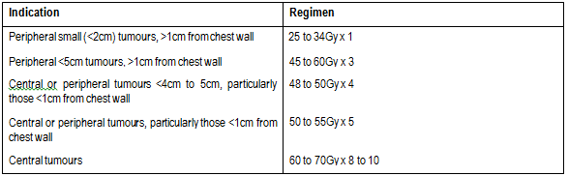
Pulmonary metastases of extrapulmonary cancers:

The use of stereotactic radiotherapy for the treatment of lung metastases is still under development and, as such, there is not yet a consensus on the dose and fractionation regimens that should be used (Ben-Josef and Lawrence, 2009; Siva et al., 2010). However, results from a phase I/II trial presented by (Rusthoven et al., 2009) reported acceptable patient tolerability when doses were

escalated from 48Gy to 60Gy delivered over three treatment sessions. As such, a similar dose and fractionation scheme will most likely be used for the treatment of primary lung cancer and pulmonary metastatic lesions.

Frequency of administration:

Radiotherapy treatment for lung cancer using CyberKnife® generally requires between three and four individual treatment sessions. This figure may be higher for central tumours in an effort to spare the proximal major airways or tumours close to the chest wall in an effort to avoid rib fractures. It may also be reduced for very small peripheral tumours. Treatment sessions using the CyberKnife® system are typically given daily or on alternate days.

Duration of treatment:

An individual treatment session can take between 45 to 60 minutes. The total course of treatment is between four to 10 days depending on the number and spacing of individual treatment sessions.

Training and accreditation requirements:

Some training and accreditation will be required before using the CyberKnife® system. Staffing requirements and quality assurance programs would be similar to facilities providing conventional EBRT.

Facility requirements and geographic limitations:

Treatment will be given primarily in an outpatient setting and would be carried out in the same specially designed bunkers as conventional EBRT. The capital equipment for the CyberKnife® system replaces the equipment for the conventional EBRT.

Similarly to other IGRT systems, access to CyberKnife® would most likely be limited to speciality facilities located in capital cities and potentially major regional centres.

The location of facilities to deliver IGRT primarily in capital cities can impose hardship and costs on those patients who do not live near a treatment centre as they often need to travel long distances or live away from home for the duration on their treatment. Further, patients living in rural or remote areas that need to travel to receive conventional EBRT, which may take up to seven weeks, typically need to live away from home during their treatment period. The reduced duration of treatment with the CyberKnife® system may play a role in reducing costs and hardship for patients who need to travel in order to be able to access treatment in major centres.

Co-administered interventions

The same tests are used in the lead up and monitoring of treatment whether a patient receives treatment with the CyberKnife® or alternative EBRT systems.

Resources used for patient simulation and dosimetry are equivalent whether treatment is provided using CyberKnife® or alternative EBRT systems. These procedures are currently publicly reimbursed under existing MBS item numbers and are summarised in Table 3.

Table 3. MBS item numbers for all radiotherapy treatment protocols requiring patient simulation and dosimetry.
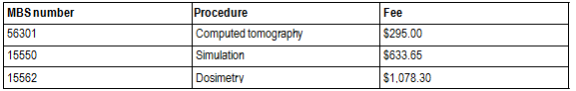
Some lung cancer patients may require implantation of fiducial markers when undergoing treatment with the CyberKnife®. Expert clinical opinion has recommended that fiducial markers would be inserted if: tumours were not visible on imaging, tumours which move in irregular or random patterns, for re-treatments, or for patients under the age of 55. Depending on the size and location of the tumour, three to five fiducial markers will be implanted within the lung guided by CT, bronchoscopically or ultrasound. There is no standard method for fiducial marker implantation, rather implantation methods are dependent on the preference of the treating surgeon and/or radiologist and the equipment available at the time.

It should be noted that there are currently no MBS item numbers specifically for the placement of fiducial markers in the lung. Clinical experts have indicated that procedures used in the implantation of fiducial markers into the lung will vary depending on local practice. A summary of the MBS item numbers associated with the implantation of fiducial markers into the lung is given in Table 4 for reference.

Table 4. MBS item numbers associated with implantation of fiducial markers into the lung.

MBS number | Procedure | Fee
20520 | Anaesthesia | $114.30
41889 | Bronchoscopy | $171.30
58506 | Radiographic examination | $60.75
56301 | Computed tomography scan | $295.00
30710 | Endobronchial ultrasound guided biopsy | $541.95

MBS item numbers 20520 and 41889 for bronchoscopy apply as part of marker insertion. MBS item numbers 58506 is used to assess marker position during insertion, whereas item number 56301 would be used to assess marker position post-insertion. A biopsy of the tumour may be taken as part

of the fiducial marker implantation procedure. A endobronchial ultrasound guided bronchoscopic biospsy is covered by MBS item number 30710.

During the assessment phase an estimation of the proportion of patients requiring fiducial marker implantation, as well as the costs associated with the insertion of these markers, must be presented and incorporated into the economic evaluation.

Chemotherapy in primary lung cancer:

Clinical guidelines recommend that when a patient with primary NSCLC is to receive curative intent radiotherapy that a combination of cisplatin-based chemotherapy and radiotherapy be delivered and that these treatments be delivered concurrently rather than sequentially (National Health and Medical Research Council, 2004). The use of a combination of chemotherapy and radiation therapy is often referred to as chemoradiotherapy or systemic therapy.

The Pharmaceutical Benefit Schedule (PBS) numbers associated with cisplatin-based chemotherapeutic agents are 2578Q, 2579R and 2580T.

Background

Current arrangements for public reimbursement

The CyberKnife® system is currently not in use in Australia and thus not currently publicly reimbursed. Radiotherapy delivered by other systems is currently delivered in capital cities and major regional centres by a combination of public and private clinics. An audit of Australian cancer treatment services (Cancer Australia and Cancer Council Australia, 2010) showed that the bulk of radiotherapy services are provided on an outpatient basis and that most radiotherapy treatments are billed through Medicare. Given the high capital cost and specialty treatments delivered by the CyberKnife® system, it is most likely that access to this technology would initially be limited to major hospitals in capital cities.

Treatment verification is another procedure performed when a patient undergoes radiotherapy. The
MBS items associated with patient treatment and verification are provided in Table 5.

Table 5. MBS item numbers for radiation treatment and verification using a single photon linear accelerator in the treatment of lung cancer.

MBS number | Procedure | Fee
15215 | Radiation oncology treatment (1 field) | $57.40
15233 | Radiation oncology treatment (2-5 fields) | $57.40 + $36.50 per extra field
15705 | Verification | $76.60

The applicant has proposed that 1,349 lung cancer patients (based on item utilisation divided by average number of treatments) received conventional EBRT in 2009/2010 and that these patients would be eligible for treatment with CyberKnife®. A more robust claim of the population estimate will be required in the assessment of evidence.

As the introduction of CyberKnife® may result in an increase the number of lung cancer patients that receive radiotherapy- a function of radiotherapy delivered by CyberKnife® being an alternative to surgery in some patients- an estimation of the potential increased number of lung cancer patients receiving radiotherapy will be required in the assessment phase.

Finally, an estimation of the number of patients that would receive radiotherapy delivered by
CyberKnife® for the treatment of lung metastases will be required.

The simulation, dosimetry and verification steps involved in the planning and delivery of radiotherapy are currently reimbursed through the MBS. The figures presented in Table 6 represent claims relating to the treatment of all types of cancer. Usage figures specifically for lung cancer are not able to be obtained from the Medicare Australia item reports service. However, as each patient that undergoes radiation treatment will require treatment simulation and dosimetry the number of claims for these procedures will be almost equivalent. A small number of patients who undergo the radiotherapy planning process elect not to go through the treatment process and will seek alternative therapeutic options. Advice from clinical experts indicates that this number will be small and, as such, will not have a major impact on the economic assessment of introducing CyberKnife®.

As fewer treatment sessions are required when radiotherapy is delivered using the CyberKnife® system there would likely be a corresponding reduction in the number of treatment verification claims required with the use of CyberKnife® over conventional EBRT systems. Expert clinical opinion has indicated that the frequency of verification for EBRT treatment of lung cancer is unknown and variable, with some centres able to image as little as only once per course. Data are required to verify the estimates for the use of verification in the treatment of lung cancer patients.

Table 6. Usage (number of claims) for MBS items common to all protocols for simulation, dosimetry, and verification. Source: MBS Item Reports online, accessed 28 July 2011.

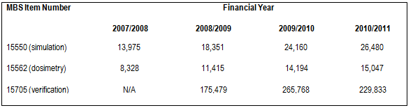
The Department of Health and Ageing (DoHA) runs the Radiation Oncology Health Program Grants (ROHPG) to contribute towards the capital costs incurred by radiation oncology providers for major radiation oncology equipment. Payments through this scheme are made on a ‘per service’ basis to eligible service providers that successfully applied for support. A summary of applicable MBS items upon which a ROHPG may be paid, as well as the level of payment, is given in Table 7.

Table 7. MBS items eligible for additional payments for capital equipment purchase under the ROHPG program.
A summary of the resource use for the use of single photon energy linac (as used by CyberKnife®) system is given in Table 8 below. As not all treatment centres may receive ROHPG payments, the costs to DoHA with and without these payments is presented.
Table 8. Summary of costs for the current radiation treatment of lung cancer with a single photon energy linac. Number of treatments = 30 using 5 fields. Source: MBS Book operating from 1 July 2011.
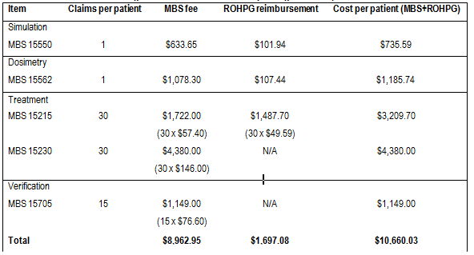
Expert clinical opinion notes that verification is usually not performed after every treatment and it has been estimated that the upper limit may be 15 verification procedures per patient over the course of treatment.

A comparative course of treatment using 30 sessions delivered by EBRT with a dual photon energy linac is provided in Table 9.

The fees for a course of treatment using EBRT presented in Table 8 and Table 9 differ by $1,339.97 due to the following factors:

1. The fees in Table 8 were calculated on the basis that a patient receiving radiotherapy delivered with a conventional delivery system would only undergo treatment verification after every second treatment session rather than every session.

a. Input from clinical experts suggests that this situation best reflects current clinical practice. It was also suggested that treatment verification would take place after each treatment session if delivery was made using CyberKnife®.

b. The difference in the number of treatment verification procedures performed has the biggest impact on the difference (-$1,149) in calculated costs for a course of radiotherapy.

2. The ROHPG grant amounts presented in Table 8 relate to treatment delivered using a single photon energy linac (as used by CyberKnife®) instead of a dual photon energy linac as used in the calculation of fees in Table 9.

Table 9. MBS items numbers and utility figures for the current radiotherapy of lung cancer with a dual photon energy linac. Number of treatments = 30 using 5 fields. Source: Applicant supplied data.
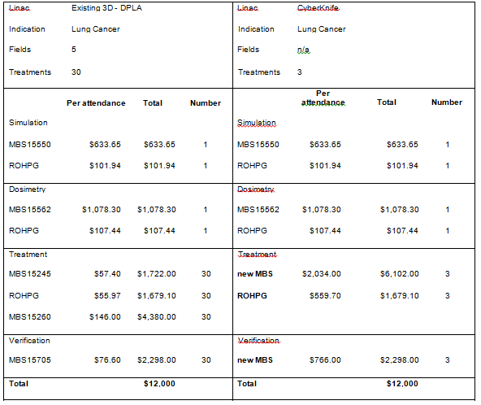

Regulatory status

The Therapeutic Goods Administration (TGA) registration number is Australian Register of Therapeutic Goods (ARTG) Number 155887 with an ARTG start date of 10th October 2008. The sponsor is Device Technologies Australia Pty Ltd. The device is described as a linear accelerator system. The intended purpose of the device is: “A system intended to provide treatment planning, image-guided stereotactic radiosurgery for lesions, tumours and conditions anywhere in the body where radiation treatment in indicated. The system operates on the principle of linear acceleration of electrons, providing a predictable radiation field in a beam of well defined dimensions.”(Australian Register of Therapeutic Goods, 2008)

The proposed MBS listing is consistent with the TGA approved indication.

Patient population

Proposed MBS listing

The proposed MBS item for the CyberKnife® system would fall under Category 3 – Therapeutic Procedures, which is the case for currently listed radiotherapy services. It is proposed that treatment with CyberKnife® should be rebated in the same way as current procedures for radiotherapy. Separate fees have been proposed for the treatment and verification stages of delivering radiotherapy using the CyberKnife® system.

As currently proposed, this MBS item number descriptor does not include pulmonary metastases and a separate item may be required for this indication. An outline of an MBS item number for the treatment of pulmonary metastases is given below for reference.

Table 10. Proposed MBS item fee and descriptor for radiation therapy using the CyberKnife® system in lung cancer.
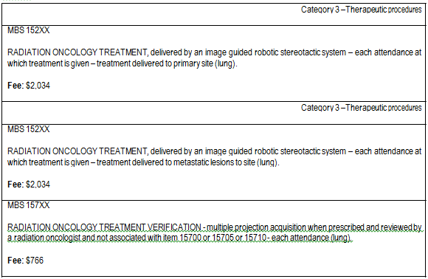
Figures used by the applicant in the calculation of the fees are provided in Table 9. The fee for radiation oncology treatment was calculated on the basis of cost-neutrality for the treatment component across an entire course of treatment be it delivered by CyberKnife® or existing radiotherapy platforms.

As currently presented, the Department of Health and Ageing does not accept the fee proposed by the applicant for radiation oncology treatment on the basis that it does not comply with Departmental requirements for input-based fee determination. The applicant is requested to either amend or justify

the existing fee in a fashion that meets to Departments guidelines for input-based fee determination. Appropriate documentation must be submitted to the Department for an assessment of the proposed fee ahead of the final assessment in order to allow the Department to scrutinise the proposed fee for compliance with Departmental guidelines. If the fee proposed in the original application requires amendment only the amended fee is to be used in the cost-effectiveness analysis.

The Department further notes that the proposed fee for treatment verification is $689.40 higher than the existing MBS item number (15705) although no justification for this difference is given. As with the radiation oncology treatment fee the Department requires justification or amendment of the proposed treatment verification fee such that Departmental requirements for input-based fee determination are met.

The proposed fee structure is based on a per-treatment service delivery model. Given the relatively high fee in comparison to that of existing EBRT the Department has raised concerns regarding the potential for high overall treatment costs should there be unrestricted funding regarding the number of radiotherapy treatment sessions delivered by CyberKnife®. In order to address these concerns it is requested that a capped fee for an entire course of treatment be explored and take into account the expected patient throughput and referral patterns. This fee is to include all radiation oncology consultations, planning, simulation, dosimetry and treatment sessions similar to MBS item 15600. If there is potential for an overall cost difference between a per-attendance and per-course of treatment fee structure the consequences of this difference are to be modelled as part of the cost-effectiveness analysis.

Clinical place for proposed intervention

Diagnosis and clinical assessment of lung cancer will typically involve the performance of a chest x- ray with supplementary CT scanning. Other supplementary diagnostic techniques used may include PET, sputum cytology, fibreoptic bronchoscopy and fine needle aspiration (National Health and Medical Research Council, 2004).

After diagnostic imaging to determine if a patient has lung cancer, accurate histological diagnosis should precede staging procedures (whether it is clinical or pathological staging). This may involve bronchoscopy, thoracoscopy, or mediastinoscopy.

In line with the clinical practice guidelines published by the National Health and Medical Research Council (NHMRC) and the CyberKnife® Society and after consultation with clinical experts, it has been determined that use of the CyberKnife® system to deliver radiotherapy is most applicable for the following patient groups:

• Definitive treatment for non-metastastic (N0 and M0) NSCLC that is ≤5cm in greatest diameter (T1 or T2a). This equates to stage IA and IB NSCLC patients under the TNM classification published by (American Joint Committee on Cancer, 2010).

o This protocol will assess the use of CyberKnife® in two separate contexts in this patient group:

1. As an alternative to surgery as the primary treatment for stage I NSCLC
patients.

2. As a replacement for EBRT as the secondary treatment option for stage I NSCLC patients who are unsuitable for, or who refuse, surgery.

• Treatment of metastatic lesions in the lung when the primary tumour is under treatment and control and the lung is the sole sight of metastatic lesions.

The location of the tumour may have an impact on the decision to undertake radiotherapy in lung cancer patients with peripherally based tumours being more likely to be considered for treatment with radiotherapy than centrally based tumours. However, as treatment decisions should and will be made upon weighing up individual patient circumstances, this protocol considers radiotherapy as a valid treatment option in stage I lung cancer patients regardless of the location of the tumour.

Small cell lung cancer (SCLC) and other stages of NSCLC will not be considered in this protocol as
CyberKnife® is not explicitly recommended in these populations (CyberKnife® Society, 2010).

The current standard of care for stage I lung cancer is generally accepted to be surgery. Given the ability of CyberKnife® to precisely delivery very high doses of radiation to a tumour there is the potential for radiotherapy delivered by CyberKnife® to be used as an alternative treatment to surgery. An estimation of the number of patients expected to undergo treatment with CyberKnife® as an alternative to surgery should it become available must be presented in the assessment. Figure
1 shows a clinical management algorithm for the treatment of stage I NSCLC using CyberKnife® as an alternative to surgery.

Figure 1. Clinical management algorithm comparing CyberKnife® to surgery for the primary treatment of patients with stage I NSCLC. The treatment algorithm for radiotherapy delivered by CyberKnife® is highlighted grey.
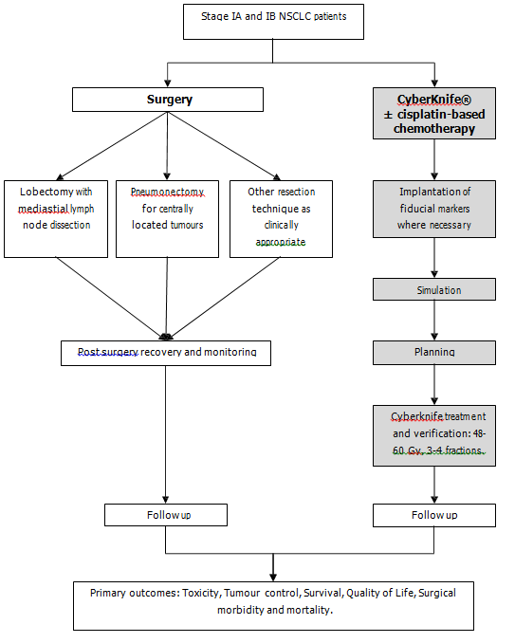

While surgery is the current standard of care for stage I NSCLC, some patients are unsuitable for surgery or refuse the procedure. In these cases radiotherapy with curative intent may be delivered to stage I NSCLC patients as the secondary treatment option. Currently radiotherapy in this patient population is delivered using existing EBRT systems. In the context of delivering radiotherapy to stage I NSCLC patients who are unsuitable for, or have refused, surgery the use of CyberKnife® would be a replacement for radiotherapy delivered by other EBRT systems.

Figure 2. Clinical management algorithm comparing CyberKnife® to EBRT for stage IA and IB lung cancer patients who are unsuitable for, or refuse, surgery. The treatment algorithm for radiotherapy delivered by CyberKnife® is highlighted grey.

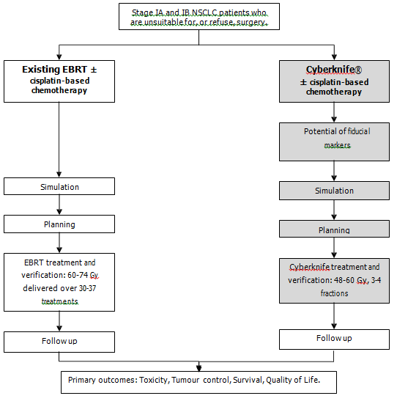

The treatment of pulmonary metastatic lesions is primarily carried out using surgical resection. Similar to the treatment of stage I lung cancer, where a patient is not considered suitable for surgery the treatment of metastatic lung disease with radiotherapy has been investigated. In this case the use of conventional EBRT is not considered, rather it is only the use of stereotactic radiotherapy (which may be delivered using the CyberKnife® system) that is used in treating lung metastases.

Regardless of whether a surgical resection or stereotactic radiotherapy approach is taken the treatment of pulmonary metastatic lesions should only be carried out when:

1. The primary tumour is under treatment and control.

2. The pulmonary metastatic lesions are surgically resectable or likely to respond to radiotherapy.

3. The presence of metastatic lesions at other sites of the body has been excluded.

In the treatment of pulmonary metastatic lesions stereotactic radiotherapy delivered using the
CyberKnife® system would be an alternative for surgery.

Figure 3. Clinical management algorithm comparing CyberKnife® to surgery for the treatment of patients with pulmonary metastatic lesions. The treatment algorithm for radiotherapy delivered by CyberKnife® is highlighted grey.
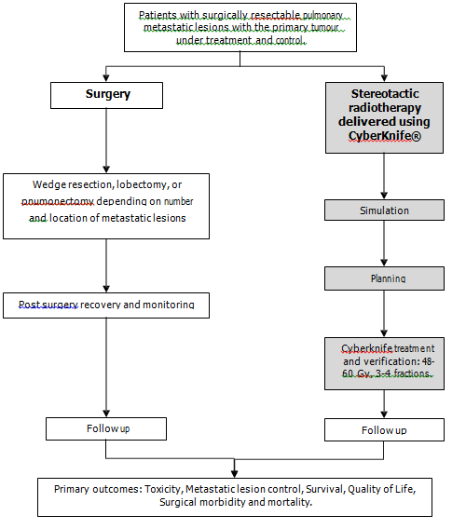

Comparator

There are two comparators considered in this protocol – surgery and EBRT. These comparators are used for distinctively different populations of patients.

1. The standard of care for stage I NSCLC is generally accepted to be surgery for patients with good performance status and lung function and is the comparator for this patient group. Surgery is also the comparator for the treatment of pulmonary metastatic lesions.

2. Radiotherapy with curative intent is considered for stage I NSLC patients if they are not suitable for or refuse surgery. EBRT is the comparator for this patient group.

Surgery

Where surgery is undertaken in the treatment of lung cancer patients a lobectomy, pneumonectomy, segmental, wedge, or sleeve resection may be performed to remove the primary lung or metatstatic lung lesions (National Cancer Institute, 2011).

The appropriate surgical technique is highly variable and will be tailored to an individual patients circumstances. However, as a general guideline, lobectomy is preferred to limited resection in patients with operable early stage NSCLC. According to Australian clinical practice guidelines “limited resections are not appropriate for patients with stage I NSCLC who have adequate pulmonary function for lobectomy” and that “Lobectomy with mediastinal lymph node dissection is now the gold standard for surgical resection of NSCLC. Pneumonectomy is appropriately reserved for those patients with centrally placed primary tumours crossing the interlobar fissure, involving the main stem bronchi or main pulmonary arteries or in the presence of malignant hilar nodal disease in stage II NSCLC” (National Health and Medical Research Council, 2004)

The operative approach for lobectomy has traditionally been via a thoracotomy. However, more recently video-assisted thoracoscopic techniques (VATS) have also been utilised for pulmonary resections including regional lymph node assessment.

Expert clinical opinion has indicated that concurrent chemotherapy (cisplatin-based or carboplatin- based chemotherapy) is not usually given as a co-administered treatment with surgery for patients with Stage I NSCLC. Subsequently, this protocol will not consider adjuvant chemotherapy with surgery.

MBS item numbers for resources and procedures used in surgical treatment of NSCLC are shown in
Table 11.

Table 11. Current MBS item descriptors for surgical treatment of NSCLC.

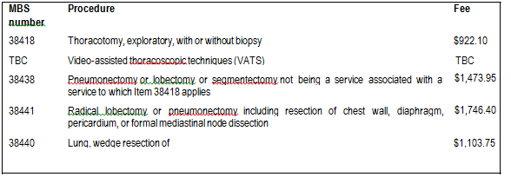

External Beam Radiotherapy

The other comparator is radiotherapy delivered using conventional EBRT systems. For the purposes of this protocol this will include systems designed to enhance the accuracy of the delivery of EBRT such as 3D conformal radiotherapy (3DCRT) and intensity-modulated radiotherapy (IMRT). Details on enhanced EBRT systems are given below.

• 3D conformal radiotherapy: The system works using complex software and a multileaf collimator to manipulate the profile of radiation beams allowing them to be shaped to fit the profile of the target tumour.

• Intensity-modulated radiotherapy: A variant of 3DCRT, IMRT uses sophisticated software and hardware to vary the shape and intensity of radiation delivered to different parts of the treatment area. The goal of IMRT is to increase the radiation dose to the areas that need it and reduce radiation exposure in sensitive areas of surrounding normal tissue.

The delivery of EBRT is currently listed on the MBS (Table 5). For the purposes of this protocol, the
CyberKnife® system is considered as a replacement to other systems that deliver EBRT.

Cisplatin-based chemotherapy will be considered as a co-administered treatment with EBRT for this protocol. Recent NICE guidelines, the Australian clinical practice guidelines and the NCCN Guidelines all state that chemoradiotherapy is beneficial (NICE, 2011; Australian Cancer Network Management of Lung Cancer Guidelines Working Party, 2004; National Comprehensive Cancer Network, 2011).

Clinical claim

The clinical claim stated in the application is given in bold below.

External beam robotic image guided radiosurgery delivered by CyberKnife is at least as effective, safe and cost- effective as the currently MBS funded 3D EBRT delivered by a conventional linear accelerator.

Surgery as comparator

Compared to surgery with curative intent, CyberKnife® has the following potential benefits for treating primary lung cancer or pulmonary metastases:

- Non-inferior rates of primary lung tumour control.

- Non-inferior rates of pulmonary metastatic lesion control.

- Ability to make treatment more acceptable to patients through being a non-invasive procedure.

- Elimination of surgical morbidity and improved quality of life.
Compared to surgery, Cyberknife® has the following potential harms:
- Possible reduced rates of primary lung tumour control.

- Possible reduced rates of pulmonary metastatic lesion control.

- Toxicities associated with radiotherapy.

On the basis of this, the clinical claim for CyberKnife® is that it may have non-inferior effectiveness and safety compared to surgery.

External Beam Radiotherapy as comparator

Compared to conventional EBRT, radiotherapy delivered by CyberKnife® has the following potential
benefits:

- Ability to deliver radiotherapy more accurately which may lead to:

- Reduced toxicity.

- Improved primary tumour control.

- The potential to make treatment more acceptable to patients through its ability to hypofractionate and the reduced number of treatment sessions.

Compared to EBRT, Cyberknife® has the following potential harms:

- Possible reduced rates of primary lung tumour control.

On the basis of this, the clinical claim for CyberKnife® is that it may have both superior effectiveness and superior safety compared to other EBRT systems.

Table 12. Classification of an intervention for determination of economic evaluation to be presented
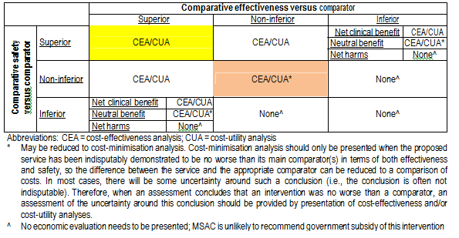As stated in the application:

“The economic evaluation with (sic) be a cost-minimisation analysis based on the claim that external beam robotic image guided radiosurgery delivered by CyberKnife® is at least as safe and effective (non-inferior) and thus cost- effective as the comparator.”

As per the guidelines established by DoHA a “cost-minimisation analysis should only be presented when the proposed service has been indisputably demonstrated to be no worse than its main comparator(s) in terms of both effectiveness and safety, so the difference between the service and the appropriate comparator can be reduced to a comparison of costs.”

PASC agreed that a cost-effectiveness analysis be conducted.

Outcomes and health care resources affected by introduction of proposed intervention

Outcomes

The outcome measures applicable to assessing the response to radiotherapy of primary lung cancer or pulmonary metastatic lesions to radiotherapy are:

Safety:

Rates of acute and long-term toxicity events, including skin irritation or damage at regions exposed to the radiation beams, radiation pneumonitis, fatigue, nausea, oesophagitis, spinal cord injury (for treating lung carcinomas that are near the spine), and lung fibrosis and death.

Effectiveness:

- Primary lung cancer or pulmonary metastatic lesion response determined by the targets physical reaction to treatment.

- Local control as determined by the cessation of primary lung tumour and pulmonary metastatic lesion growth.

- Progression free survival rates.

- Overall survival rates.

- Quality of life.

The outcome measures applicable to assessing the response to surgical treatment of lung cancer are rates and grade of surgical morbidity and mortality as well as measures of overall survival, progression-free survival, local / regional tumour control and quality of life.

Due to the relatively recent development of the CyberKnife® system, there is likely to be a relatively low number of publications reporting on the effectiveness of this technology. A literature review presented by Tipton et al.(2011) showed that trials reporting on the use of stereotactic body radiotherapy in the treatment of tumours in the lung or thorax had a mean follow-up time of 71.1 months (range two weeks to 107 months). Subsequently, the majority of outcomes that could be assessed in a cost-effectiveness analysis will be of short-term outcomes or proxy markers for long- term effects.

Health care resources

As previously outlined the main difference in resource utilisation between radiotherapy delivered by the CyberKnife® system and conventional EBRT will be in the number of treatment sessions required. Whereas current EBRT treatment is given in up to 30 treatment sessions, treatment with CyberKnife® is typically completed in three or four sessions.

As radiotherapy treatment for multiple types of cancer are performed using conventional EBRT systems, and there is an expected increase in demand for access to these systems in the future, the introduction of CyberKnife® is unlikely to have an impact on the overall utilisation of existing EBRT infrastructure as the transfer of lung cancer patients onto the CyberKnife® system will free up access opportunities for other patients.

Should treatment with the CyberKnife® system result in change in the rates of acute and long-term toxicities, there would be corresponding change in the utilisation of the health care resources used to treat or manage these complications. Similar changes in the rates of recurrence would result in a corresponding change in the utilisation of the health care resources used to treat or manage this.

The potentially greater use of fiducial markers when radiotherapy is delivered using the CyberKnife® may lead to an increase in the use of MBS item numbers associated with their implantation should CyberKnife® become available. It should be noted here that there are currently no MBS item numbers specifically for the implantation of fiducial markers into the lung.

Should treatment with CyberKnife® replace surgery in some patients there would be a corresponding decrease in all resource use associated with surgery and the treatment of any adverse events.

The nature and utilisation rates of health care resources used to identify eligible patients for treatment using the CyberKnife® system, conventional EBRT systems, or surgery are equivalent and would not be altered with the potential introduction of CyberKnife®.

Table 13. List of resources to be considered in the economic analysis.

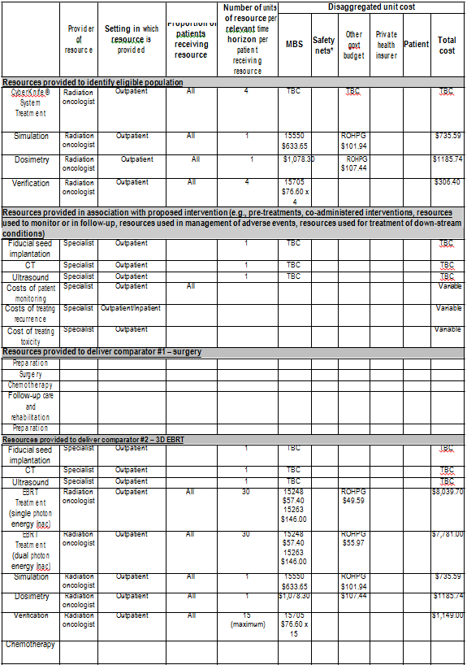

Proposed structure of economic evaluation

PASC agreed that a cost-effectiveness analysis be performed instead of a cost-minimisation analysis. This recommendation is made on the grounds that:

- There is not a consensus view that radiotherapy delivered by CyberKnife® is indisputably recognised as being no worse than conventional EBRT.

- There is not a consensus view that radiotherapy delivered by CyberKnife® is indisputably recognised as being no worse than surgical treatment.

- In comparison to radiotherapy delivered by EBRT the technology has the potential for superior effectiveness.

- In comparison to radiotherapy delivered by EBRT and surgery the technology has the potential for superior safety.

Table 14. PICO Criteria and decision option for the use of CyberKnife® as an alternative to surgery as the primary treatment option for patients with stage IA and IB NSCLC.
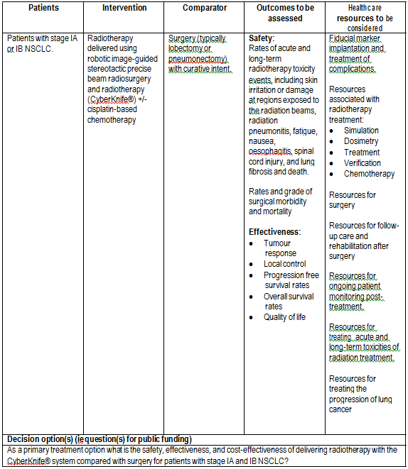

Table 15. PICO Criteria and decision option for the delivery of radiotherapy using CyberKnife® compared to existing EBRT systems as the secondary treatment option in patients with stage IA and IB NSCLC that are unsuitable for, or refuse, surgery.
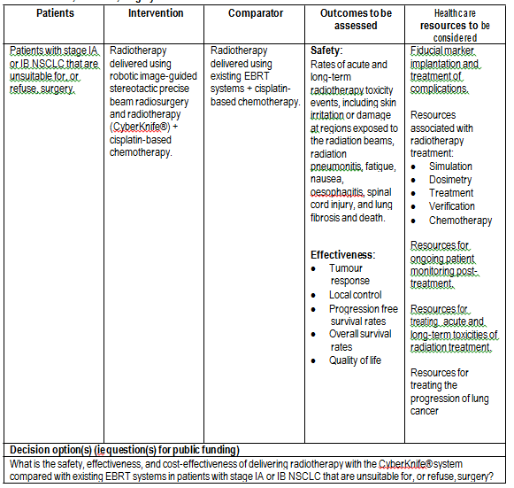

Table 16. PICO Criteria and decision option for the use of CyberKnife® compared to surgery to treat patients with pulmonary metastatic lesions where the primary tumour is under treatment and control.
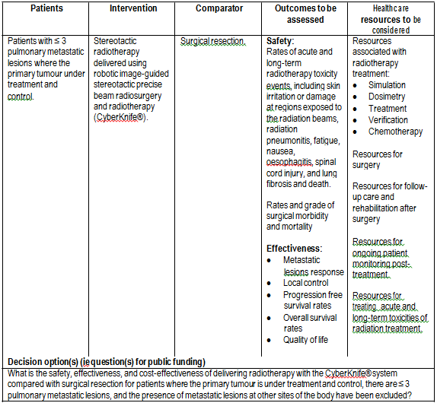

For a graphical representation of each of the PICO tables given above please refer to appendix three. Please note that the decision trees are provided for the purposes of supplementing the information given in the PICO tables and clinical algorithms and may not reflect the cost-effectiveness models required in the final assessment.

References

AccurayInc, 2009, CyberKnife® System product information brochure, Date accessed: 27th June
2011. (A) URL: http://www.accuray.com/products/index.aspx

American Joint Committee on Cancer 2010. AJCC cancer staging manual, Springer, New York

Australian Institute of Health and Welfare (AIHW) & Australasian Association of Cancer Registries,
2010, Cancer in Australia: an overview, 2010. Cancer series. no. 60. Cat. no. CAN 56. Canberra: AIHW

Ben-Josef, E and Lawrence, T.S. 2009. Using a bigger hammer: the role of sterotactic body radiotherapy in the management of oligometastases. Journal of clinical oncology, 27 (10), 1537-1539.

Cancer Australia and Cancer Council Australia 2010, Review of national cancer control activity in
Australia. Cancer Australia, Canberra.

CyberKnife Society, 2010, “WHITE PAPER - SRS for Non Small Cell Lung Cancer”. URL: http://www.cksociety.org/clinician-resources/default.aspx (full white paper obtained by asking the CyberKnife Society).

National Comprehensive Cancer Network, 2011, NCCN Clinical Practice Guidelines in Oncology: Non- Small Cell Lung Cancer. Version 1. 2012.

National Health and Medical Research Council 2004, Clinical practice guidelines for the prevention, diagnosis and management of lung cancer. National Health and Medical Research Council

NICE, 2011, Clinical guideline CG121. Lung cancer. The diagnosis and treatment of lung cancer
(update). April 2011. URL: http://www.nice.org.uk/guidance/index.jsp?action=byID&amp;o=13465

Ricardi, U., Filippi, A.R., Guarneri, A., Ragona, R., Mantovani, C., Giglioli, F., Botticella, A., Ciammella, P., Iftode, C., Buffoni, L., Ruffini, E. & Scagliotti, G.V. 2011. Stereotactic body radiation therapy for lung metastases. Lung Cancer.

Rusthoven, K.E., Kavanagh, B.D., Burri, S.H., Chen, C., Cardenes, H., Chidel, M.A., Pugh, T.J., Kane, M., Gaspar, L.E. & Schefter, T.E. 2009. Multi-institutional phase I/II trial of stereotactic body radiation therapy for lung metastases. J ClinOncol, 27, 1579-84.

Rusthoven, K.E., Kavanagh, B.D., Burri, S.H., Chen, C., Cardenes, H., Chidel, M.A., Pugh, T.J., Kane, M., Gaspar, L.E. &Schefter, T.E. 2009. Multi-institutional phase I/II trial of stereotactic body radiation therapy for lung metastases. J ClinOncol, 27, 1579-84.

Siva, S., Macmanus, M. & Ball, D. 2010. Stereotactic radiotherapy for pulmonary oligometastases: a systematic review. J ThoracOncol, 5, 1091-9.

Tipton, K., Launders, J.H., Inamdar, R., Miyamoto, C. & Schoelles, K. 2011. Stereotactic Body
Radiation Therapy: Scope of the Literature. Annals of Internal Medicine, 154, 737.

Weichselbaum, R.R. & Hellman, S. 2011. Oligometastases revisited. Nature Reviews Clinical Oncology,
8, 378-382

Wulf, J., Haedinger, U., Oppitz, U., Thiele, W., Mueller, G. &Flentje, M. 2004. Stereotactic radiotherapy for primary lung cancer and pulmonary metastases: A noninvasive treatment approach in medically inoperable patients. International Journal of Radiation Oncology*Biology*Physics, 60,
186-196.

Appendix 1

Full MBS item descriptors plus explanatory notes

MBS item numbers for all radiotherapy treatment protocols requiring patient simulation, dosimetry and verification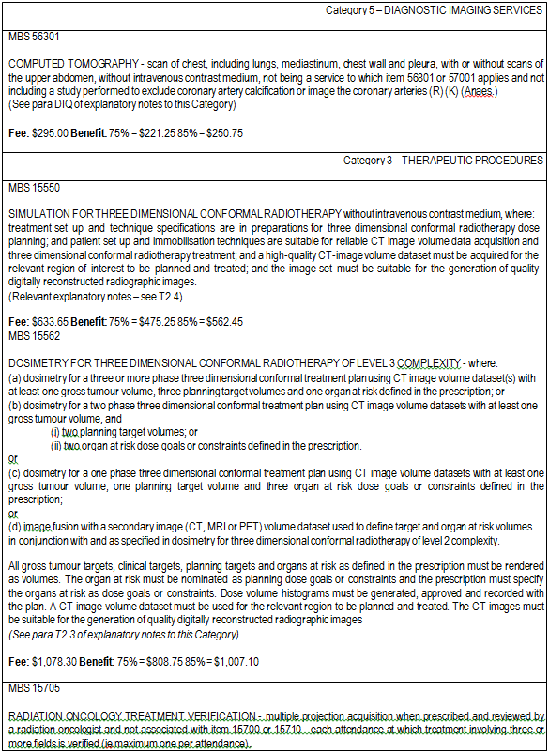

MBS item descriptors potentially associated with fiducial marker implantation into the lung. It It should be noted here that there are currently no MBS item numbers
specifically for the implantation of fiducial markers into the lung.

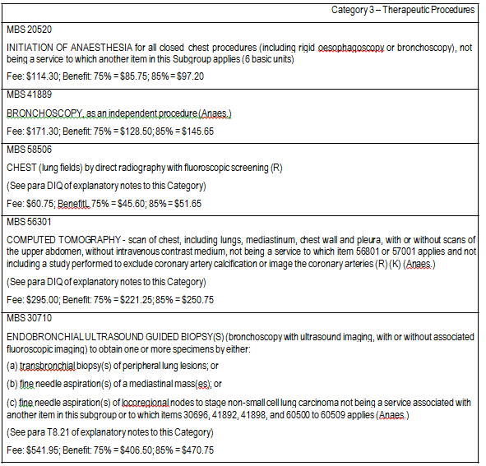

MBS item numbers for radiotherapy using a single photon linear accelerator in the treatment of lung cancer.
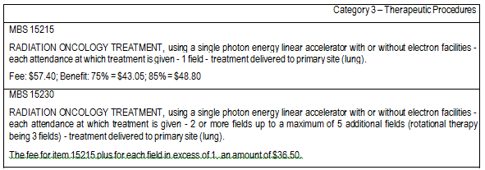

MBS item number for stereotactic radiosurgery.

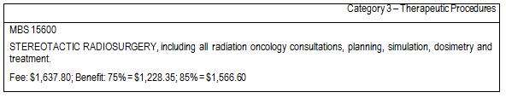
MBS item descriptors for surgical treatment of NSCLC.
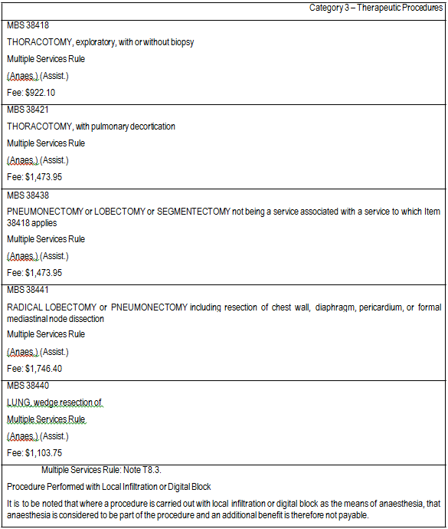

Appendix 2

7th edition of American Joint Committee on Cancer TNM classification for lung cancer
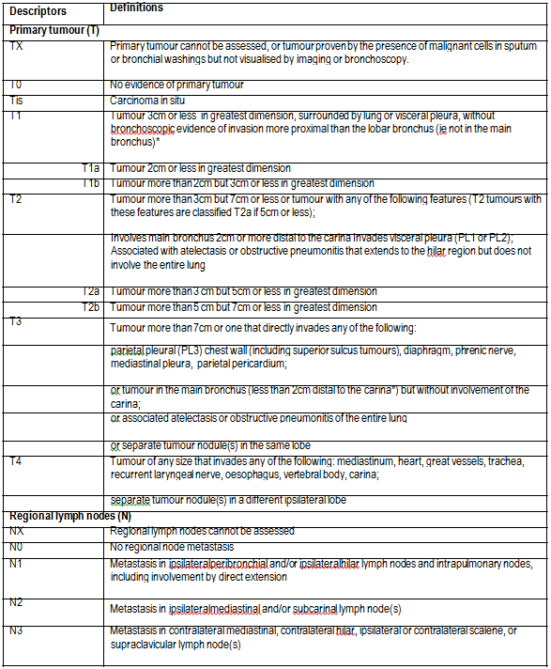

Distant metastasis (M)
M0 | No distant metastasis
M1 | Distant metastasis
M1a | Separate tumour nodule(s) in a contralateral lobe;
 | tumour with pleural nodules or malignant pleural (or pericardial) effusion**
M1b | Distant metastasis

* The uncommon superficial spreading tumour of any size with its invasive component limited to the bronchial wall, which may extend proximally to the main bronchus, is also classified as T1a.

** Most pleural (and pericardial) effusions with lung cancer are due to tumour. In a few patients, however, multiple cytopathologic examinations of pleural (pericardial) fluid are negative for tumour, and the fluid is non-bloody and is not an exudate. Where these elements and clinical judgement dictate that the effusion is not related to the tumour, the effusion should be excluded as a staging element and the patient should be classified as M0.

TNM elements included in the stage groups
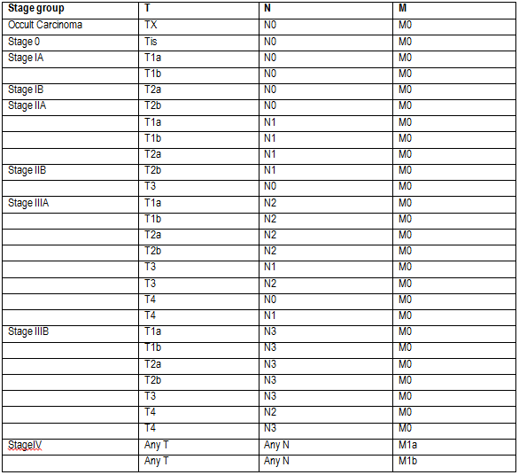

Appendix 3

Decision trees to supplement information provided in PICO tables and clinical algorithms.

Please note that the decision trees given here are provided for the purposes of supplementing the information given in the PICO tables and clinical algorithms and may not reflect the cost-effectiveness models required in the final assessment.

Decision tree representing treatment options in patients with stage IA or IB NSCLC who are eligible for surgery.
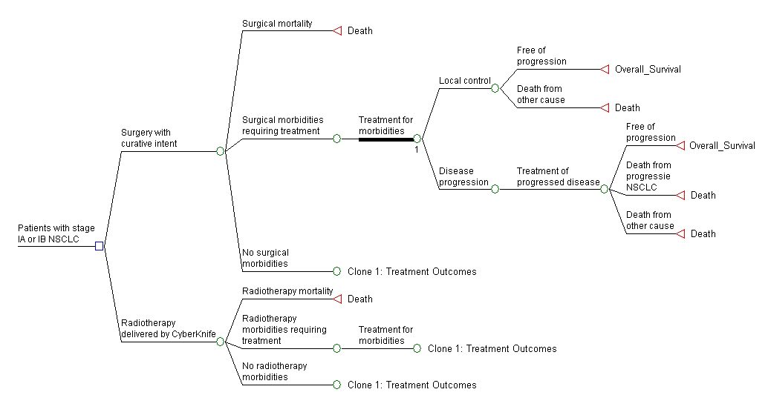

Decision tree representing treatment options in patients with stage IA or IB NSCLC who are ineligible for or refuse surgery.
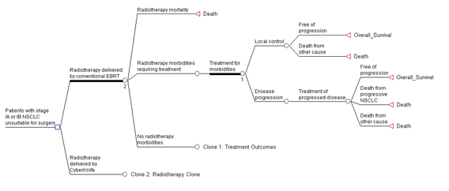

Decision tree representing treatment options in patients with surgically resectable pulmonary metastatic lesions.
