Public Summary Document
Application No. 1434 – Anti-Müllerian hormone testing
Applicant: Kids Cancer Centre
Date of MSAC consideration: MSAC 72nd Meeting, 28-29 March 2018
Context for decision: MSAC makes its advice in accordance with its Terms of Reference, visit the MSAC website

Purpose of application
An application requesting Medicare Benefits Schedule (MBS) listing of Anti-Müllerian hormone (AMH) testing was received from the Kids Cancer Centre by the Department of Health.
The proposed population is female pre-menopausal patients who will be having, or have had, gonadotoxic treatment. Gonadotoxic treatment includes any treatment which is associated with a risk of ovarian damage or sterility. AMH is a glycoprotein present in blood, believed to represent non-cyclical, continuous primordial follicle growth and is an indirect measure of the resting ovarian follicle pool, i.e. the ovarian reserve. In women undergoing gonadotoxic therapy or surgery, the primordial follicles in the ovaries can be damaged, which may lead to ovarian failure, infertility and early menopause. Usually AMH levels drop during gonadotoxic treatment, with the possibility of some recovery after finishing treatment.

MSAC’s advice to the Minister
After considering the strength of the available evidence in relation to comparative safety, clinical effectiveness and cost-effectiveness, MSAC did not support MBS funding of AMH testing in women who will or have received gonadotoxic treatment, due to highly uncertain therapeutic efficacy, incremental clinical benefit and cost-effectiveness when used in addition to existing assays in the target population.
MSAC noted that AMH testing has limited value in predicting ovarian functioning, and that there was no significant relationship between AMH levels and pregnancy rate. MSAC further noted the lack of standardisation and the high variability between AMH assays and between laboratories for the same AMH assay. MSAC also noted the lack of evidence around AMH testing informing a change in patient management or decision making in the target population.
MSAC advised that any resubmission would need to include:
- evidence on how this test would change patient management and thus improve health outcomes,
- consensus guidelines to standardise test performance across laboratories, and
- justification of the proposed cost.
MSAC advised that any resubmission would need to be considered by ESC.

Summary of consideration and rationale for MSAC’s advice
MSAC noted that in women undergoing gonadotoxic therapy or surgery, the primordial follicles in the ovaries can be damaged, which may lead to ovarian failure, infertility and early menopause. Usually AMH levels drop during gonadotoxic treatment, with the possibility of some recovery after finishing treatment. Indirect markers to measure ovarian reserve include AMH, follicle-stimulating hormone (FSH), estradiol (E2), inhibin B, antral follicle count (AFC), and measurement of ovarian volume, as ovarian reserve cannot be measured directly.
MSAC considered the applicant’s claim that the listing may:
- lead to better assessments of ovarian function prior to gonadotoxic treatment;
- enable better prediction of the return of reproductive function following gonadotoxic treatment; and
- improve decision-making regarding the need for fertility preservation following or prior to gonadotoxic treatment.
The PICO Confirmation listed basal FSH, E2 and inhibin B measurement and AFC as valid comparators.
MSAC considered that AMH testing would be performed before and/or after gonadotoxic treatment in addition to the current standard tests (FSH, E2 and AFC ultrasound if post-pubertal) for measuring ovarian reserve, and is unlikely to replace any of the standard tests.
MSAC noted that in the pre-MSAC response the applicant stated that AFC was not commonly performed in Australia just for follicle count, although they provided no evidence to substantiate the claim.
MSAC noted that no direct evidence was identified to determine the safety and incremental effectiveness of AMH testing in addition to, or compared with, other standard tests in the target population. MSAC noted that in the absence of direct evidence, a linked evidence approach was undertaken to evaluate the evidence.
MSAC considered there were no significant safety issues in regard to AMH testing, as the test is conducted through a routine blood test which is generally considered safe. MSAC discussed concerns about the potential for psychological distress in women with low AMH levels - particularly given the high variability in AMH assays - although this was also considered to be applicable to other tests measuring ovarian reserve.
MSAC noted that several different commercial assays are available to measure serum AMH. MSAC considered the newer second generation AMH assays to be more sensitive for follicular detection than the older first generation assays.
MSAC considered that studies which used menstrual status as the reference standard found that the accuracy of AMH testing varied substantially between different assays. MSAC noted that a study comparing the diagnostic accuracy of pico-AMH enzyme-linked immunosorbent assay (ELISA) with enzyme immunoassay (EIA) AMH/MIS assay found the sensitivity of the pico-AMH ELISA to be significantly higher (71% compared to 11%) than the older EIA AMH/MIS assay (Decanter C et al 2014). The specificity for both tests – pico-AMH/ELISA assay and EIA AMH/MIS assay – was 93% at the 3-month follow-up.
MSAC observed that even with the newer second generation assays, about one in three women who resumed menstruation after treatment had undetectable AMH.
Despite two studies showing good correlation between the newer generation AMH assays, MSAC reiterated ESC’s concerns about high variability between assays and between laboratories for the same assay - reported to be 40% in one study. MSAC concluded that lack of standardisation complicated the interpretation of AMH values.
MSAC noted that a study which conducted a Receiver Operator Characteristic (ROC) analysis of the various ovarian function tests including AFC, AMH, FSH and inhibin B, found only the AFC test to have an area under curve (AUC) above 0.8, indicating good accuracy (Su HI et al 2011). MSAC noted that the combination of AFC test with the AMH or FSH tests indicated improved accuracy compared to the AFC test alone. However, MSAC considered AFC to be a superior test compared to AMH test for measuring ovarian reserve, as this study also found AFC to be more specific than the AMH, FSH and inhibin B tests. The sensitivity of the AFC, AMH and FSH tests, however, did not vary greatly.
MSAC noted that AMH testing had some value in predicting ovarian functioning prior to receiving gonadotoxic treatment, although this was based on low quality evidence. The majority of the included studies reporting baseline AMH values, showed significantly lower baseline AMH levels in women with chemotherapy-related amenorrhoea (CRA) at follow-up. MSAC considered this information may influence whether women undergo fertility preservation prior to treatment. However, MSAC noted lower AFC count was also found to be associated with CRA at follow-up.
MSAC considered that the incremental value of post-treatment AMH testing could not be determined due to limited evidence in the target population. The limited evidence, however, indicated that a woman with detectable AMH post-chemotherapy, measured by pico-AMH ELISA, is likely to have ongoing menses for at least three years, while one with undetectable AMH is likely to continue having amenorrhoea.
MSAC observed that although AMH testing may assist in predicting which women will have amenorrhoea or menses, no significant relationship between AMH levels and pregnancy rate was identified. In a large retrospective study (n = 180), including women with endometriosis undergoing ovarian endometrial ablation, the probability of pregnancy within 12 months was 50% and 65% in women with a low (<2 ng/ml) and high (>2 ng/ml) AMH value, respectively (Stochino-Loi E et al 2017).
MSAC noted that a study which presented an ROC curve, showed that AMH testing had moderate (0.7–0.8 AUCs) to good (0.8–0.9 AUCs) test performance at predicting oocyte in response to ovarian stimulation (Sonigo C et al 2016). AFC test also had good (0.8-0.9 AUCs) test performance similar to the AMH test.
MSAC considered that a positive AMH test result was only clinically useful in patients undergoing treatment associated with higher risk (70–80%) of ovarian failure, whereas a negative AMH test result was only useful in patients undergoing treatment associated with lower risk (20–30%) of ovarian failure.
In regards to therapeutic efficacy, MSAC noted that no evidence was found that AMH testing changed management or health outcomes in women undergoing gonadotoxic treatment.
On the basis of the above evidence, MSAC considered AMH testing to have non-inferior safety and uncertain incremental effectiveness when compared to other standard ovarian reserve tests.
MSAC noted that the economic evaluation presented was limited to a cost analysis. The use of the proposed AMH test would increase the cost of the current practice by $100 per patient (i.e. the proposed fee for the AMH test). MSAC considered this fee to be higher than that charged by some providers offering the service to privately funded patients (commercial costs of AMH testing were observed to range from $50–$105). MSAC suggested reducing or justifying the proposed $100 fee for the AMH testing.
MSAC noted uncertainty regarding the estimated number of AMH tests performed. MSAC noted that the available evidence suggested that the uptake of AMH testing in female oncology patients - currently about 50% - would increase to 90% if the service were made available without out-of-pocket costs to patients. MSAC noted the estimated costs of AMH testing to the MBS to be approximately $570,000 each year.
MSAC considered that AMH testing would be performed in addition to the current standard tests and noted the opinion of the Practice Committee of American Society for Reproductive Medicine 2015 that ‘combined ovarian reserve test models do not consistently improve predictive ability over that of single ovarian reserve tests’ (American Society for Reproductive Medicine 2015).
MSAC also noted that despite the poor evidence for its use, AMH testing is widely used in practice. MSAC raised concerns that a negative/undetectable AMH test results may cause psychological distress to the patient. MSAC suggested the need for provision of appropriate information to consumers and clinicians in this regard.
MSAC discussed that AMH testing is conducted in multiple settings which raised concerns for leakage outside the proposed item descriptor. MSAC, however, considered that restricting the AMH testing to patients with an oncologist referral will manage the risk of leakage outside the proposed item descriptor.
MSAC noted the lack of a definition of ‘suitable trained and accredited fertility specialist’ in the application. MSAC noted that this item could only be claimed for ‘in-house’ testing by an oncofertility service if the service is an accredited pathology laboratory recognised under the rules governing the Pathology Services Table (PST). MSAC highlighted the lack of standardisation for the various assays and the need for a quality assurance program for the development of standardised clinically relevant thresholds for AMH testing in Australia.
MSAC advised that any resubmission would need to include:
- evidence on how the AMH test would change patient management and thus improve health outcomes;
- consensus guidelines to standardise test performance across laboratories; and
- justification of the proposed cost.
MSAC advised that any resubmission would need to be considered by ESC.

Background
MSAC has not previously considered AMH testing.

Prerequisites to implementation of any funding advice
Different commercial assays are used in clinical practice to measure serum AMH levels the results of which are not necessarily comparable, so when interpreting AMH values, clinicians should be aware of which AMH assay was used.
The test will be performed in an accredited laboratory. A good quality assurance program would be essential for implementation and development of standardised clinically relevant thresholds for AMH testing in Australia.

Proposal for public funding
The proposed MBS item descriptor is summarised in Table 1. The applicant has proposed that the scheduled fee for an AMH test should be $100. This is higher than the fee currently charged by many providers offering the service to privately funded patients.
Table 1 Proposed MBS item descriptor
Category 6 - Pathology services
MBS [item number]
Anti-Müllerian hormone (AMH) for female patients who will or have received gonadotoxic treatment.
Fee: $100
Explanatory notes:
Diagnosis requiring treatment with gonadotoxic therapy
Female patient aged 0–45 years of age will eligible for this service.
Maximum of one AMH test in female prior to initial or relapse treatment with gonadotoxic treatment for malignant or non-malignant disease.
Assessment of ovarian reserve with a maximum of one AMH test per year following treatment in patients who have had gonadotoxic treatment to assess the gonadotoxic effects of treatment, to assess pubertal delay, to assess ovarian failure, to assess the need for fertility preservation following treatment and to assess the need for assisted reproductive treatment for family planning.

Summary of Public Consultation Feedback/Consumer Issues
Consultation feedback was received from specialists, researchers, organisations, peak bodies, consumers, care givers and others. Of the responses received, most were supportive of AMH testing. A number of advantages and disadvantages, or issues that would need to be addressed, were emphasised during the public consultation period.
The benefits suggested via public consultation were that:
- AMH testing is seen as a way to provide vital information to young patients with regard to their fertility status, allowing them to make informed decisions about potential fertility interventions
- AMH tests can measure the risk for premature ovarian failure and this makes the implementation of early interventions possible, such as HRT or oocyte cryopreservation
- AMH testing could potentially reduce costs by allowing targeted fertility interventions
- listing AMH testing on the MBS would lead to equitable fertility monitoring for all patients, not only the people who can afford it
- listing AMH testing on the MBS could lead to reduced anxiety and improved psychological wellbeing due to improved understanding and less uncertainty around potential fertility function in the future and in relation to medical costs.
The disadvantages, or issues suggested for address, as determined by public consultation were that:
- AMH levels don’t predict the quality of the oocytes in reserve
- AMH test results may cause psychological distress for the patient (if levels are low or undetectable)
- pre-test counselling would be critical to minimise the negative psychological impact of an unexpected or negative result.
In addition, one clinician responded that AMH results are difficult to interpret in pre-pubertal children. There is more evidence required to prove that there is a correlation between AMH levels and fertility reserve in this population. It was stated that for “paediatric patients AMH is important in long-term follow-up to assess return of reproductive function and assess need for intervention. It may be useful pre-treatment in selective cases but is not required routinely.”

Proposed intervention’s place in clinical management
Figure 1 shows the current and proposed clinical management algorithm for females prior to gonadotoxic treatment. The proposed intervention is shown in red. The proposed clinical management algorithm for females following the completion of gonadotoxic treatment is shown in Figure 2. In most cases, the AMH test will be done in addition to current ovarian reserve tests, i.e. FSH, E2 and AFC.
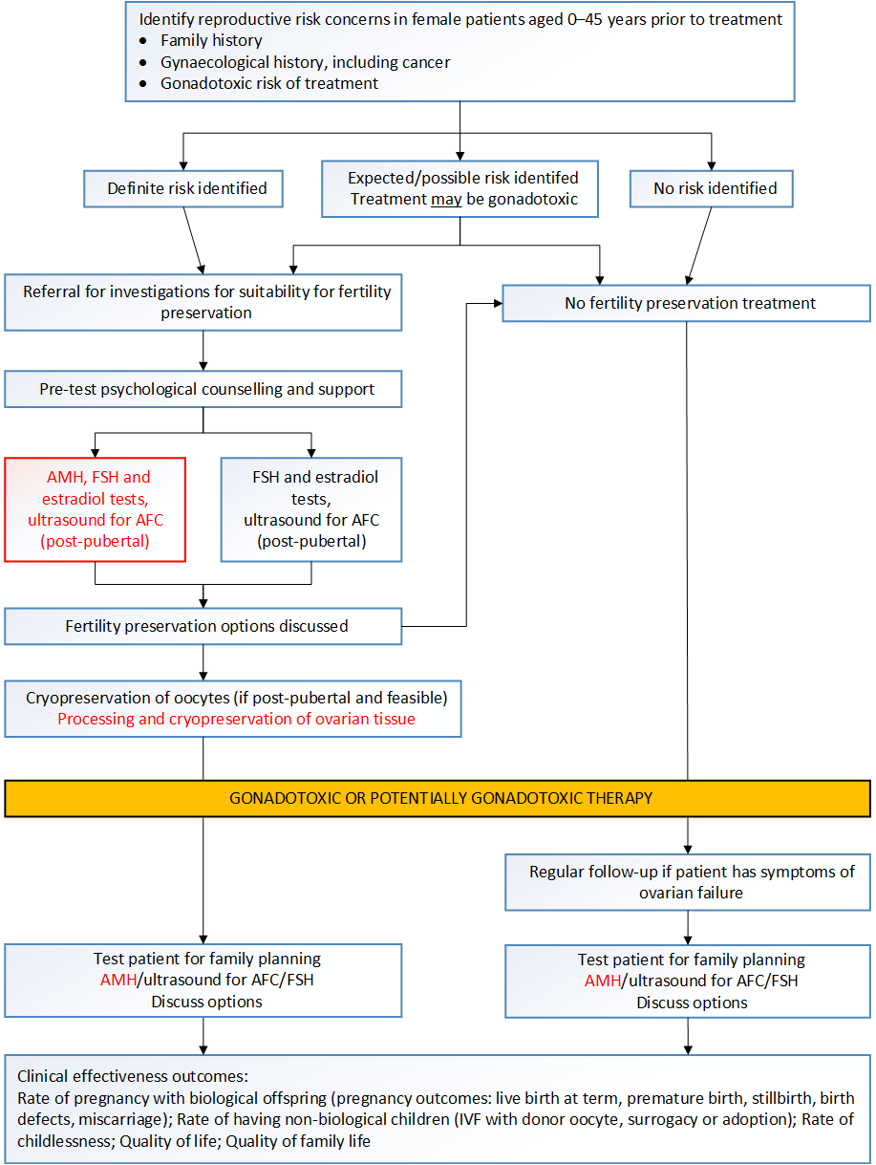
Figure 1 Clinical management algorithm for assessment of ovarian reserve and cryopreservation of oocytes or ovarian tissue. Pathway showing cryopreservation of oocytes is current practice in post-pubertal cases. Pathway showing cryopreservation of ovarian tissue is for the proposed service. The relevant population for both pathways includes females aged 0 to 45 years, pre-gonadotoxic treatment
AFC = antral follicle count, AMH = anti-Müllerian hormone, FSH = follicle-stimulating hormone
Source: Adapted from algorithm 4 from the final protocol for MSAC application 1434.
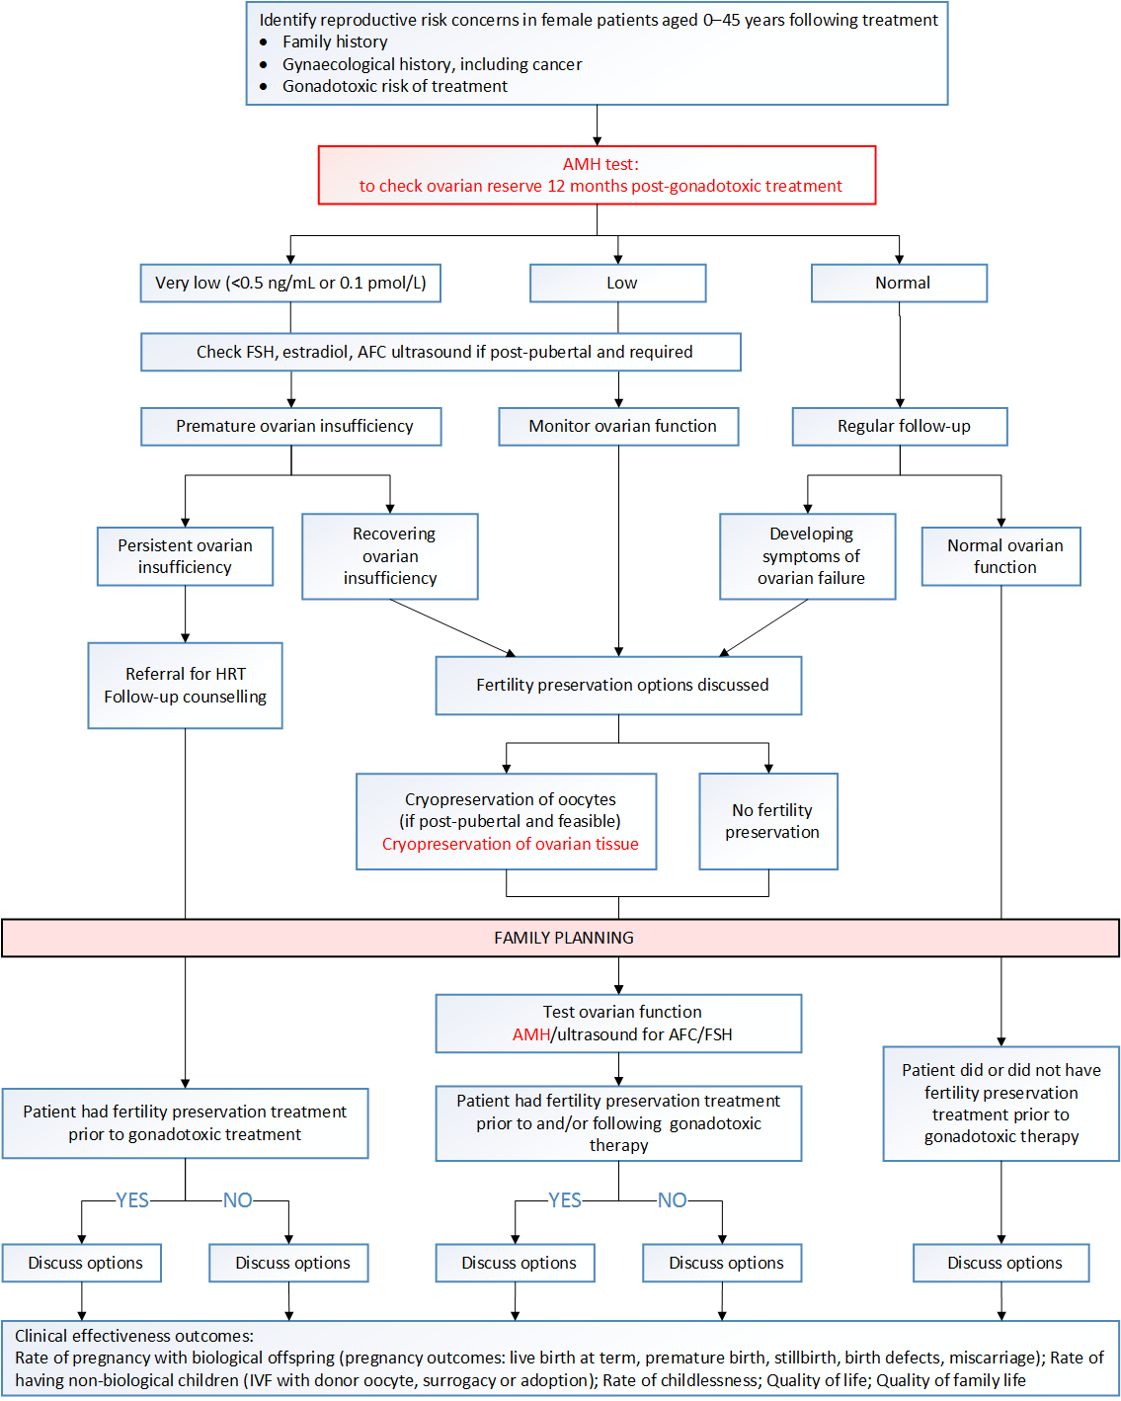
Figure 2 Proposed clinical management algorithm for the assessment of ovarian reserve and cryopreservation of oocytes or ovarian tissue for females aged 0 to 45 years, following completion of gonadotoxic treatment
The proposed test (AMH) is shown in red, current practice included the cryopreservation of oocytes. The proposed intervention for cryopreservation of ovarian tissue (MSAC application 1435 Part B) is also highlighted in red.
AFC = antral follicle count, AMH = anti-Müllerian hormone, FSH = follicle-stimulating hormone, HRT = hormone replacement therapy
Source: Adapted from algorithm 4 from the final protocol for MSAC application 1434.

Comparator
AMH testing would be done in addition to the current standard tests for measuring ovarian reserve. Ovarian reserve tests include both biochemical tests and ovary ultrasound imaging. The PICO Confirmation listed basal FSH, E2 and inhibin B measurement and AFC as valid comparators.
The measurement of inhibin B is currently not listed on the MBS, however FSH and E2 tests are listed under MBS number 66695. AFC using ultrasound is listed under MBS item number 55065.
In the pre-MSAC response, the applicant considered that it was not accurate to say that “AMH testing would be conducted in addition to the current standard tests for measuring ovarian reserve” as inhibin testing is not used any more in this context. AFC is performed as part of a comprehensive evaluation of pelvic anatomy, and is rarely performed just for follicle count.

Comparative safety
The test is done through a routine blood test and generally considered safe.

Comparative effectiveness

Direct effectiveness
No direct evidence was identified to determine the effectiveness of AMH testing in addition to other standard tests, compared to other standard tests alone, in patients prior to or following completion of gonadotoxic therapy.

Effectiveness from linked evidence

Analytical validity
The information on the analytical validity of the AMH test focused on whether the test results are reliable, and how they correlate with other tests which are currently in clinical practice. Studies which used menstrual status as the reference standard found that the accuracy of AMH testing varied substantially between different assays, and that about one in three women who resumed menstruation after treatment had undetectable AMH.
One study reported on the diagnostic accuracy of the pico-AMH ELISA (enzyme-linked immunosorbent assay test and the EIA AMH/MIS assay compared to menstrual status, i.e. the absence or presence of menses, as a clinical reference standard. The sensitivity of the pico-AMH ELISA was significantly higher (71% compared to 11%) than the older EIA AMH/MIS assay (with detectable AMH as the cut-off). The large difference in sensitivity between the two AMH tests is likely due to the 40-fold difference in the level of AMH detectable by these tests with the pico-AMH ELISA test being more sensitive.
Two studies compared the AMH Gen II ELISA test with the Ansh Labs AMH ELISA, Ultrasensitive AMH ELISA, and pico-AMH ELISA, as well as the Ultrasensitive AMH ELISA with the pico-AMH ELISA. There was a high degree of correlation between these four tests. However, there is concern that although different AMH assays are highly correlated, the results are not generalisable. One study showed that while each laboratory showed good reproducibility when using a single test, the between-laboratory variability, even using the same assay, was 40%.
The major challenge for clinicians attempting to interpret AMH values for use in clinical care is the lack of standardisation. It is recommended that clinicians should always use the same laboratory to avoid problems with result interpretation. It is also critical to understand how that laboratory calibrates their clinical thresholds to ensure accurate interpretation of the result. A good quality assurance program would be essential for implementation and development of standardised clinically relevant thresholds for AMH testing in Australia.
ROC analysis comparing AMH serum levels and AFC with the menstrual status of women after chemotherapy found that the area under the curve (AUC) for the first generation AMH assay, the Diagnostics Systems Lab (DSL) ACTIVE® AMH/MIS ELISA and AFC were 0.71 and 0.82, respectively. This means the DSL ACTIVE® AMH/MIS ELISA test showed moderate performance in detecting the menstrual status of women, compared with a good performance for AFC, against the common reference standard used. The AUCs for the comparators, FSH and inhibin B were 0.72 (moderate performance) and 0.63 (poor performance), respectively.
In the pre-MSAC response, the applicant noted that the criticisms of analytical validity are less relevant in the context of the current third generation platforms as there is far better standardisation with these platforms. The literature relates mainly to the older/superseded platforms.

Prognostic and predictive value

Prognostic value of AMH in predicting ovarian function - Pre-treatment AMH testing
AMH testing was considered to be mainly of prognostic and predictive value. Eleven studies were identified which considered whether AMH values could predict ovarian function at follow-up in the target population. These studies included mostly women with breast cancer. Six out of seven studies that reported mean or median baseline AMH values stated that the group of women with chemotherapy-related amenorrhea (CRA) at follow-up had statistically significantly lower baseline AMH levels, i.e. levels measured before treatment. Follow-up was six months to five years after enrolment or treatment. Higher mean age and lower AFC count were also associated with CRA at follow-up (in 4/4 studies and 2/2 studies, respectively). The other comparator tests were less convincing (FSH was different in 2/4 studies; E2 in 1/2 studies; inhibin B in 1/3 studies).
Univariate analysis alone is insufficient to determine the incremental prognostic value of AMH testing. AMH levels decrease with age and correlate with other hormone tests. In the multivariate analyses, AMH remained a significant predictor for continuation or resumption of ovarian function in four out of five studies. The largest study reported that women with an AMH above 0.7 ng/mL had three times greater probability of a shorter time to ovarian recovery than women with an AMH under 0.7 ng/mL over a median of 163 days. FSH (≤10 IU/L) and age (<40 years) were also predictive for shorter time to ovarian recovery, with hazard ratios of 4.7 (95%CI 1.3, 16.8) and 3.39 (95%CI 1.74, 6.60), respectively.
Two studies were included that presented a ROC curve to assess the accuracy of AMH for predicting ovarian function and to determine the optimal cut-off point for AMH values. Both studies reported an AUC for AMH of >0.8 which indicates good test performance. One study showed AMH values ≥3.32 ng/mL were protective for the occurrence of oligomenorrhea or amenorrhea after treatment, with a sensitivity of 85% and a specificity of 75% (n=52). The cut-off for AFC was <13 follicles to predict oligo- or amenorrhea, having a higher risk at six-month follow-up with a sensitivity of 83% and a specificity of 62%. In the study by Anderson et al., a classification mosaic chart including age (38.6 years as a cut-off) and AMH score (3.8 pmol/L as a cut-off) gave a 98.2% and a specificity of 80.0% in predicting amenorrhea after two years for breast cancer patients (n=75).
The lack of standardisation makes it hard to interpret AMH values. Determining standardised clinically relevant thresholds for AMH testing in Australia may improve the prognostic value of the test in clinical practice.

Prognostic value of AMH in predicting ovarian function - Post-treatment AMH testing
There is limited evidence available to determine the prognostic value of post-treatment AMH testing in the patient population (k=2). The incremental value of AMH testing could not be determined. However, the limited evidence does indicate that a woman with detectable AMH, measured by pico-AMH ELISA post-chemotherapy, is very likely to have ongoing menses for at least three years, whereas a woman with undetectable AMH is likely to continue to have amenorrhoea due to the lack of ovarian reserve.

Prognostic value of AMH in predicting pregnancy
Most studies (5/6) did not find a predictive relationship between AMH levels and pregnancy rate. All women underwent a gonadotoxic treatment for endometriosis, breast cancer or lymphoma, and wanted to fall pregnant. Follow-up was >1 year in all studies. Five studies reported AMH thresholds and showed how many women achieved pregnancy when divided into groups based on AMH score. Only one small study found a lower pregnancy rate in the group with low AMH levels.
These studies showed that the difference between those with low and high AMH is not large enough to inform clinical decisions. Even women with undetectable and critically low AMH values had given birth during follow-up in multiple studies. This raised the hypothesis that the relationship between low AMH levels and reproductive outcomes may differ in cancer survivors compared to women from the general population (Hamre et al. 2012). However the study populations may have been too small to find a relationship between pregnancy and AMH levels.

Predictive value of AMH in predicting response to ovarian stimulation
One study including 340 cancer patients investigated the association between the number of in vitro matured oocytes cryopreserved and AFC and AMH levels using ROC curve analysis. In this study, the AMH test had moderate (0.7 to 0.8) to good (0.8 to 0.9) test performance at predicting oocyte yield. AFC ultrasound had a good (0.8 to 0.9) test performance.
Three studies looked at the correlation between oocytes retrieved and AMH, AFC, inhibin B and/or E2 values. A moderate linear relationship between AMH and oocyte yield was found. Moderate relationships were also found for AFC and inhibin B with oocyte yield in one study. An inverse correlation was found for FSH and age with oocyte yield.
An association was found between AMH levels and ovarian response to hyperstimulation in women undergoing gonadotoxic treatment. However, there was insufficient evidence to determine whether the AMH test had an incremental predictive value in addition to other standard tests to determine response to ovarian stimulation. When looking at the broader population of otherwise healthy women undergoing in vitro fertilisation (IVF) or intracytoplasmic sperm injection (ICSI), Broer et al. stated that combining the results of AFC and AMH did not improve prediction of poor response. This supports the findings by the Practice Committee of the American Society for Reproductive Medicine in 2015, which stated that combined ovarian reserve test models do not consistently improve predictive ability over that of single ovarian reserve tests, and that there is insufficient evidence to indicate that a combination of tests are more useful than each test alone in ovarian reserve testing in a broad population. Tobler et al. (2015) stated that the predictive value of AMH testing on the outcomes of ART has yet to be definitively established, and the exact role of the use of AMH testing for fertility treatments still needs to be determined. There is a need for AMH cut-off values related to patient relevant outcomes, e.g. pregnancy, oocyte yield, and return of menstruation, as evidence on these outcomes is still lacking. However, it is considered a first-line test of ovarian reserve in Australia and is reported to have direct value in the management of IVF cycles in the general population (Tobler et al. 2015).

Clinical validity
The evidence that was included in the analytical validity and the prognostic section and provided sensitivity/specificity or 2 × 2 data was included in the clinical validity section to determine how the test would perform in women undergoing gonadotoxic treatment of different levels of gonadotoxicity. This gives an indication of the usefulness of the test when it is used before or after treatments with low risk (20–30%), intermediate risk (40–70%) and high risk (70–80%) of ovarian failure.
Three studies reported on the accuracy of AMH testing prior to gonadotoxic treatment in predicting the resumption of menses after treatment. First generation test EIA AMH/MIS ASSAY and DSL ACTIVE® MIS/AMH ELISA showed some lack of utility for AMH measured both prior to and after treatment compared to resumption of menses. A pre-treatment or post-treatment test result above a certain threshold only offered useful information to women having treatment associated with intermediate to high risk of ovarian failure. At least 76% of women with a ≥50% risk of ovarian failure receiving a pre-treatment AMH result above the cut-off used in the study and 79 to 94% of women with a post-treatment AMH test result above the cut-off who underwent high-risk treatment resumed menses. On the other hand, a negative pre- or post-treatment test result only offers useful information to women having low-risk treatment, where the negative predictive value (NPV) indicated that 88 to 95% and 71 to 88% of women with a low or undetectable levels would not have resumption of menses, respectively. Of women having treatment with a high risk of ovarian failure, 44 to 68% and 21 to 45% with a low or undetectable pre- or post-treatment test result would have amenorrhea at follow-up (after treatment), respectively. This is equivalent to chance and not clinically useful.
AMH Gen II ELISA and the pico-AMH ELISA tests performed much better. In women undergoing treatment with a low risk of ovarian failure, 63 to 74% with a detectable baseline AMH Gen II ELISA test result would have resumption of menses, and 94 to 96% of women having treatment with a high risk of ovarian failure who have a detectable AMH level would have resumption of menses after treatment. The NPV indicated that 81 to 99% of women undergoing treatment with a low risk of ovarian failure and an undetectable AMH level would not have resumption of their menses (Henry et al. 2014). The pico-AMH ELISA showed that around 90% of women who had a positive post-treatment test result and underwent high-risk treatment would have resumption of menses, with only 47 to 64% having a positive test in women undergoing low risk treatment. A negative test result was only meaningful in the low risk treatment group, with 87 to 97% of women with a negative post-treatment AMH result having amenorrhea. Therefore, the positive test result was only clinically useful at higher prevalence rates of ovarian failure, whereas the negative test result was only useful in the group at low risk of ovarian failure.

Therapeutic efficacy (change in management)
The research questions on clinical utility could not be answered, due to lack of evidence on the impact of AMH on change in clinical management among women undergoing gonadotoxic treatment. The only evidence of impact of AMH testing on change in clinical management was found in a broader population, i.e. healthy women undergoing IVF.
In women undergoing IVF, there is evidence that AMH values may influence the starting dosage of recombinant FSH (rFSH) or hMG during ovarian hyperstimulation for the retrieval of oocytes. However, the studies showed a lack of standardisation or guidelines on how the AMH score was used or should be used.

Therapeutic effectiveness (health benefit from change in management)
No evidence was found to determine how the change in management due to AMH testing impacts health-related outcomes in women undergoing gonadotoxic treatment, the target population. Due to lack of evidence, a non-systematic search was performed to investigate whether individualised dosage of rFSH/hMG based on AMH results lead to better health outcomes in women undergoing IVF/ICSI.
Three studies were identified which investigated whether an individualised starting dosage based on AMH levels impacted IVF outcomes, and all three studies measured a higher rate of optimal oocyte yield in the individualised dosage group. However, only one retrospective study showed a difference in pregnancy or birth rates between groups, and it was not possible to determine which factors were contributing to these outcomes. This was the case due to the before- and after design of the study and the introduction of a number of organisational and procedural changes alongside the introduction of AMH-tailored dosing. The two clinical trials did not find a difference in pregnancy or birth rates between standard dosage and individualised dosage informed by AMH.
Even though there was insufficient effectiveness evidence regarding pregnancy and birth outcomes, two out of the three studies indicated that there was a significant reduction in the incidence of ovarian hyperstimulation syndrome (OHSS) and/or preventive interventions for OHSS using the AMH-tailored dosage protocol, compared to a standardised dosage in a population of healthy women undergoing IVF. One of these trials compared a standard dose of follitropin alpha with an AMH and bodyweight-tailored dose of follitropin delta (Nyboe Andersen et al. 2017). It is unknown whether the outcome differences between groups in this trial were due to the individualised dosage or due to the different follitropin used.
Notably, the studies discussed in the clinical utility section did not meet the PICO criteria and mostly excluded patients at the extremes of ovarian reserve. The nomogram that was used in two of the studies to determine dosage only gives an input for women aged 25 to 40 years old and may not be very useful if the AMH levels are extremely low. This nomogram has not been validated in some of the proposed MBS populations (women <25 years old and/or with low or undetectable AMH), and therefore the generalisability of this evidence is unknown.

Clinical Claim
The early consultation PICO Confirmation indicated AMH testing would be used to: (1) assess ovarian function prior to cancer treatment; (2) estimate the return of reproductive function following gonadotoxic treatment; (3) assess the need for fertility preservation prior to or following gonadotoxic treatment, or to recommend the start of ART in patients planning to start a family. The final PICO Confirmation did not make a clear clinical claim. Based on the available information in the PICO Confirmation documents, the evidence, and the consultation feedback, the assessment group identified that AMH testing is used for several purposes.
Prior to gonadotoxic treatment, an AMH test is used to provide prognostic information about risk of infertility, thereby informing the decision whether to undergo fertility preservation. Or, in other words, whether fertility is likely to be sufficient after gonadotoxic therapy such that fertility preservation is unnecessary, versus a scenario requiring that patients are counselled that they are likely to have a low number of oocytes, and that the chance of conception is low. Pre-gonadotoxic treatment, an AMH test may also be used to predict the response to superovulation, thereby enabling the yield of good quality oocytes to be maximised while reducing the risk of ovarian hyperstimulation by adjusting starting doses of rFSH.
Following gonadotoxic treatment, an AMH test is used to monitor the level of ovarian function. Monitoring ovarian function may inform whether patients are candidates for natural conception or may need ART, using previously cryopreserved ovarian tissue, oocytes or embryos to conceive. Other claimed benefits of monitoring ovarian function include the ability to guide HRT based on information on ovarian reserve (i.e. is there premature ovarian insufficient), to diagnose ovarian failure, and to assist with counselling and supportive care of early menopause.

Economic evaluation
On the basis of the conclusion of the clinical evaluation that relative to other ovarian reserve tests alone, additional AMH testing has non-inferior safety and uncertain incremental effectiveness, economic modelling of outcomes was not appropriate. Therefore a cost-analysis was conducted for the economic evaluation.
A summary of the key characteristics of the economic evaluation is provided in Table 2.
Table 2 Summary of the economic evaluation
Perspective | Australian health care
Comparator | AFC, FSH and E2 tests
Type of economic evaluation | Cost-analysis
Sources of evidence | Systematic review
Outcomes | No health outcomes, cost per patient estimated only
Methods used to generate results | Investigative pathway cost-comparison
Software packages used | Microsoft Excel 2013
AFC = antral follicle count; E2 = estradiol; FSH = follicle-stimulating hormone
The overall costs and incremental costs as calculated for the proposed use of AMH and the comparator are shown in Table 3. The use of the proposed AMH test would be expected to increase the cost of current practice by $100 per patient, if listed at the proposed fee and the test was only used once.
Table 3 Costs associated with testing ovarian reserve, and incremental cost (per patient)
 | AMH + current practiceª | Current practice
Specialist consultations for referral and review | $128.55 | $128.55
Test costs | $266.74 | $166.74
Total cost per patient | $395.29 | $295.29
Incremental cost per patient |  | $100.00
AMH = anti-Müllerian hormone; AFC = antral follicle count; E2 = estradiol; FSH = follicle-stimulating hormone
ª AFC and FSH+E2 measurements are considered as current practice for ovarian reserve testing and the intervention includes all these tests and AMH.
The base case analysis assumes AMH is used as an additional test to the current practice (AFC and FSH+E2). However, alternative scenarios are costed where AMH replaces one of the existing tests used to estimate ovarian reserve. If AMH were to replace AFC in the current practice it would result in a cost saving of $17 per patient compared to existing practice. However, if AMH were used to replace FSH+E2, i.e. the proposed intervention being use of AMH and AFC, it would result in a net cost increase.

Financial/budgetary impacts
An epidemiological approach has been used to estimate the eligible population. Uptake rates and the use of multiple tests per patient are also incorporated into the overall estimates of the financial implications of the proposed MBS funding of AMH testing to inform fertility management in female patients preceding or following gonadotoxic treatment.
The applicant has proposed the scheduled fee for an AMH test is $100. This is higher than the fee currently charged by many providers offering the service to privately funded patients, ranging from $55 to $98.
Table 4 summarises the estimated costs of AMH testing to the MBS, i.e. government expenditure, and patients, i.e. out-of-pocket expenditure. The base case analysis estimates that AMH testing will cost approximately $570,000 to the MBS each year.
Table 4 Estimated costs of AMH testing, 2018–19 to 2022–23
 | 2018–2019 | 2019–2020 | 2020–2021 | 2021–2022 | 2022–2023
Projected number of AMH tests | 6,682 | 6,706 | 6,730 | 6,754 | 6,779
Cost of AMH to the MBS | $567,961 | $570,005 | $572,057 | $574,117 | $576,184
Cost of AMH to the patients | $100,228 | $100,589 | $100,951 | $101,315 | $101,679
Total cost of AMH test | $668,189 | $670,595 | $673,009 | $675,432 | $677,863
AMH = anti-Müllerian hormone; MBS = Medicare Benefits Schedule
Sensitivity analyses around referral and uptake rates, restricted population size, potential leakage and proposed intervention as a replacement test are presented in the Contracted Assessment Report Section E.6. Lower referral/uptake rates and restricting the target population to women aged 25 to 39 years decreases estimated costs to the MBS. Cost impact to the MBS due to potential leakage is very high.

Key issues from ESC for MSAC
The submission requested the listing of Anti-Müllerian hormone (AMH) testing on the Medicare Benefits Schedule (MBS). The target population is pre-menopausal women who have had or will have gonadotoxic treatment. The applicant claimed that the successful listing of the technology in the target population may:
- lead to better assessments of ovarian function prior to gonadotoxic treatment;
- enable better prediction of the return of reproductive function following gonadotoxic treatment; and
- improve decision-making regarding the need for fertility preservation following or prior to gonadotoxic treatment.
ESC noted that no direct evidence was identified to determine the safety and incremental effectiveness of AMH testing in addition to, or compared with, other standard tests in the target population. ESC noted that in the absence of direct evidence, a linked evidence approach was undertaken.
ESC noted that while the PASC-ratified PICO Confirmation requested information be presented in three age groups (0–14 years, 15–25 years and 26–40 years), the lack of evidence (particularly in young girls) meant results were separated into pre-pubertal and post-pubertal females instead.
ESC noted no significant safety issues in regards to AMH testing. The test is conducted through a routine blood test which is generally considered safe. ESC noted there may be issues around psychological distress in women with low results — particularly given the high variability in AMH assays.
ESC raised concerns about the low quality of available evidence supporting the linked evidence approach, the lack of true reference standards, and uncertainty around analytical and clinical validity. ESC observed that in the many studies which used amenorrhoea as the reference standard, the accuracy of AMH testing varied between assays and that about 30% of women who had resumed menstruation had undetectable AMH levels.
ESC considered the lack of standardisation as a major challenge for clinicians attempting to interpret AMH values.
ESC noted that while different AMH assays correlated highly with each other, there are concerns about inter-laboratory variability — reported to be 40% in one study — and the need to use the same laboratory to avoid problems with interpretation of results. ESC observed that the AMH Gen II ELISA and the pico-AMH ELISA tests appeared to perform better than other tests.
ESC noted that AMH testing would be conducted in addition to the current standard tests for measuring ovarian reserve — including basal follicle stimulating hormone (FSH), oestradiol (E2), inhibin B and antral follicle count (AFC) — and is unlikely to replace any of the standard tests. ESC noted that some of these tests have issues related to inter-observer variability and cyclical variability. ESC noted that the combination of the AFC test with the AMH test (or FSH test) improved performance compared to each test alone, in identifying women with chemotherapy-related amenorrhoea based on the receiver operator characteristic analysis (Su HI et al 2011).
ESC noted that AMH testing had some prognostic value in predicting ovarian functioning prior to receiving gonadotoxic treatment, although there were uncertainties around its incremental value above other tests. There was limited evidence to determine the prognostic value of post-treatment AMH testing. ESC observed no predictive relationship between AMH levels and the ultimate outcome of pregnancy.
ESC questioned the clinical utility of AMH testing. ESC noted the lack of evidence demonstrating the impact of AMH testing on change in clinical management in the target population. Evidence of impact of AMH testing on change in clinical management was found in the broader population i.e. healthy women undergoing in vitro fertilisation (IVF) but none was found in the target population.
ESC considered AMH testing to be a triage test for follicular storage. ESC suggested the test may be of limited use in clinical decision making for the target population. ESC did not consider the test to be useful in patients about to undergo high risk treatment (i.e. chemotherapy) as cryopreservation would be most likely conducted regardless of test result. ESC discussed that the test probably had some potential benefit in patients with low AMH who are undergoing low risk treatment, and could possibly help in changing management (i.e. lead to cryopreservation). ESC, however, noted the need for further information on the proportion of eligible women (with low ovarian reserve) who would benefit from this testing.
ESC queried the benefits of AMH testing post-gonadotoxic treatment. ESC also noted that the test is likely to produce false positive results if performed too early after treatment.
ESC noted that a cost analysis was conducted for the economic evaluation as no clear benefits could be shown in the absence of incremental outcome data. ESC suggested a cost-effectiveness model in the population most likely to benefit from AMH testing (i.e. women with low ovarian reserve) would be helpful for decision making.
ESC observed that the addition of the AMH test to the existing test schedule will increase the cost of current practice by $100 per patient if the test were only used once. Based on the sensitivity analysis, if AMH was to replace AFC in current practice, it would result in a cost saving of $17 per patient, and if AMH was to replace FSH+E2, there would be a net increase in the cost of $50 per person.
ESC considered the proposed $100 fee for the AMH test to be high, especially as it is higher than other hormone tests on the MBS - item 66695 for oestradiol or progesterone attracts a fee of $30.50 while item 73529 for human chorionic gonadotropin attracts a fee of $28.65.
ESC noted uncertainty regarding the estimated number of AMH tests performed.
ESC queried the clinical expert advice - indicating three AMH tests per patient on average - which was used in the estimation. ESC noted the lack of evidence regarding the impact of repeat testing or monitoring AMH levels on changes to patient management.
ESC discussed the applicant’s comments regarding the almost universal use of AMH testing in fertility clinics worldwide, which raised concerns about potential for use of AMH testing in populations outside those in the proposed MBS item descriptor.
ESC suggested that the item descriptor specify that a fertility specialist or oncologist request the test. ESC discussed the proposed limiter of ‘less than 45 years old’ and acknowledged that ideally an MBS item for AMH testing would be consistent with age limits specified in MBS items for assisted reproduction.
ESC highlighted the need for a good quality assurance program for the implementation and development of standardised clinically relevant thresholds for AMH testing in Australia should it be recommended.
ESC Key ISSUES | ESC ADVICE
Test | Who should be conducting the test? The lab or the fertility specialist?  Issue with lack of standardisation and a QA program
Fee | ESC considered the proposed $100 fee for the AMH test to be high
Potential for leakage | ESC noted the applicant’s comments regarding the almost universal use of AMH testing in fertility clinics worldwide, which raised concerns for leakage outside the proposed Item Descriptor

Other significant factors
Nil

Applicant’s comments on MSAC’s Public Summary Document
We are very unhappy about the lack of support for this application and feel that based on the comments; we should have an opportunity to provide further evidence answering these comments in a positive manner:
1) COMPARATORS
• As we have documented, there is no genuine comparator for assessment of ovarian reserve: FSH, E2 and inhibin B are not markers of ovarian reserve. lnhibin B is completely outdated and not requested except in some specific situations e.g. for granulosa cell tumour monitoring.
• AFC is not performed in pre-pubertal girls because of inaccuracy of trans abdominal view for measuring follicle number. It is recognised as having large inter- and intra-observer error rates. Therefore AFC, E2 and inhibin B would NOT be performed for assessment of ovarian function or reserve.
• FSH is an indicator of immediate ovarian "robustness" and fluctuates from month to month so is not utilised for same reason. We have documented this and provided literature in our submission and responses.
2) ASSAYS
• Variability between assays was marked in the non-automated assays and the current fully automated assays now do NOT have materially significant differences. So it is incorrect to assert that this is a major challenge for clinicians. We have previously provided references supporting the currently used platforms with coefficient of variances for each platform and our report provides range of normal. There is no more variability than other endocrine testing platforms e.g. for testosterone, thyroxine etc. Therefore we assert that this concern is completely outdated and unsubstantiated.
• The comment regarding second generation assays and undetectable AMH in menstruating women is irrelevant given that AMH is not a predictor of current function but a marker of ovarian reserve. So of course there are many women with AMH which is undetectable who still menstruate and ovulate but have severely diminished ovarian reserve.
3) RELATIONSHIP BETWEEN AMH AND PREGNANCY RATE
• This is, as we have pointed out in previous responses, irrelevant
4) IMPACT OF AMH ON MANAGEMENT OF WOMEN WITH GONADOTOXICITY
• Anderson 2013, Barnabei 2015 and Freour 2017 (previously submitted references) demonstrate clearly that AMH levels will impact on choices for pubertal induction, decisions re need for fertility preservation, and dosing regimens for fertility preservation and ART.
• Given that the test has not been widely available for more than 5 years, and given that the cost has precluded use in many settings, the numbers of patients studied in the FPS context is not as substantial as for the use of AMH testing in general fertility trials. We can, however, acknowledge the vast number of studies and hence robust body of evidence, supporting the use of AMH to predict oocyte yield at retrieval, and to inform dosing schedules for maximum number and quality of yield.
• The assertion by MSAC that “a positive AMH test result was only clinically useful in patients undergoing treatment with a higher risk of ovarian failure, whereas a negative AMH test result was only useful...In lower risk of ovarian failure” is incorrect. Firstly there is no "positive" or negative" AMH result, it is an absolute level in context of age and prior history. Secondly the utilisation of AMH level for decision making is outside the context of low and high risk gonadotoxic treatment
• We have previously provided supporting documentation for estimation that AMH testing will reduce unnecessary cycles of IVF for preservation, reduce dosages and hence costs of medications used in IVF cycles, and reduce additional and potential unnecessary and unnecessarily frequent markers of current ovarian function e.g. FSH and AFC
5) COST OF AMH TESTING
• The casting's we provided were based on calculations made by two independent centres currently performing a large number of assays
• We would be happy to request further costings from a larger number of units and resubmit estimations.
• We did previously submit details of the breakdown of consumables, and other expenses associated with the testing
6) PUBLIC CONSULTATION
• We were unsurprised and reassured by the overwhelmingly positive comments regarding the usefulness of AMH in the fertility preservation setting especially from patients who find the additional information helpful in decision making.
In summary we do not have a current genuine comparator and the modelling done for this application uses parameters that are not clinically relevant. AMH testing provides invaluable information to inform fertility preservation for young cancer patients.
Cost savings expected with a reduction in unnecessary testing of other non-useful endocrine parameters, a reduction in unnecessary high dose gonadotrophin usage in IVF cycles, a reduction in attempts at fertility preservation where yield is unlikely to be materially useful and an improvement in the psychological wellbeing of patients who are provided with clear history based on testing and following consultation that aids decision making.

Further information on MSAC
MSAC Terms of Reference and other information are available on the MSAC Website:
visit the MSAC website

See websites (access date: 2 November 2017): IVF Australia (https://www.ivf.com.au/ovarian-reserve-amh-test), $80; Fertility North (http://www.fertilitynorth.com.au/amh-test/), $55; Repromed (http://repromed.com.au/what-to-expect/preliminary-investigations/amh-blood-test/), $98; Clinpath Pathology (http://www.clinipathpathology.com.au/media/96085/anti-mullerian%20hormone%20(amh).pdf), $60; i-screen (https://www.i-screen.com.au/app/register/amh-test), $85.

