MSAC Application 1690
Ciltacabtagene autoleucel, a B-cell maturation antigen-directed chimeric antigen receptor T cell to treat refractory or relapsed multiple myeloma
This application form is to be completed for new and amended requests for public funding (including but not limited to the Medicare Benefits Schedule (MBS)). It describes the detailed information that the Australian Government Department of Health requires to determine whether a proposed medical service is suitable.
Please use this template, along with the associated Application Form Guidelines to prepare your application. Please complete all questions that are applicable to the proposed service, providing relevant information only. Applications not completed in full will not be accepted.
Should you require any further assistance, departmental staff are available through the Health Technology Assessment Team (HTA Team) on the contact numbers and email below to discuss the application form, or any other component of the Medical Services Advisory Committee process.

Email: hta@health.gov.au
Website: www.msac.gov.au

PART 1 – APPLICANT DETAILS

Applicant details (primary and alternative contacts)
Corporation / partnership details (where relevant): Janssen Australia and New Zealand (Janssen-Cilag Pty Ltd)
Corporation name: Janssen Australia and New Zealand (Janssen-Cilag Pty Ltd)
ABN: 47 000 129 975
Business trading name: Janssen-Cilag Pty Ltd

Primary contact name: REDACTED
Primary contact numbers
Business: Janssen Australia and New Zealand (Janssen-Cilag Pty Ltd)
Mobile: REDACTED
Email: REDACTED
Alternative contact name: REDACTED
Alternative contact numbers
Business: Janssen Australia and New Zealand (Janssen-Cilag Pty Ltd)
Mobile: REDACTED
Email: REDACTED

(a) Are you a lobbyist acting on behalf of an Applicant?
Yes
No

If yes, are you listed on the Register of Lobbyists?
Yes
No

PART 2 – INFORMATION ABOUT THE PROPOSED MEDICAL SERVICE

Application title
Ciltacabtagene autoleucel (referred to as cilta-cel herein) for the treatment of adult patients with refractory or relapsed multiple myeloma who have received at least 3 prior lines of therapy (including a proteasome inhibitor, an immunomodulatory agent and an anti-CD38 antibody).

Provide a succinct description of the medical condition relevant to the proposed service (no more than 150 words – further information will be requested at Part F of the Application Form)
Multiple myeloma (MM) is a cytogenetically heterogeneous clonal plasma cell proliferative disorder characterised by an abnormal serum and/or urine immunoglobulin (known as M protein). As MM progresses and patients relapse following initial treatment, the presence of sub-clonal populations of malignant plasma cells becomes increasingly prevalent. Typical clinical features include bone disease (and bone loss) with skeletal pain, impaired renal function, anaemia, fatigue, hypercalcaemia, recurrent and/or persistent bacterial infection, and/or hyperviscosity of the blood (Quach et al 2019). Together, these symptoms are associated with significant morbidity and can result in death in patients who are unable to receive or no longer responsive to available therapies.
MM follows a relapsing and remitting course as patients receive multiple lines of therapy. Although current standard treatments for MM may result in remission, most patients will relapse as there is no cure for the disease. The duration of response and remission typically gets shorter with each line of therapy, and is the result of plasma cell clonal evolution, acquiring mutations that can confer high risk features and resistance to standard therapy. Furthermore, there is significant patient attrition at each line, as patients become unsuitable for further therapy and succumb to the disease (Zhao et al 2019)

Provide a succinct description of the proposed medical service (no more than 150 words – further information will be requested at Part 6 of the Application Form)
Ciltacabtagene autoleucel [referred herein as cilta-cel] is a chimeric antigen receptor T (CAR-T) cell therapy that will address a high unmet clinical need for effective therapies in patients with heavily pre-treated (>3 prior lines) and refractory MM where few treatment options remain.
Cilta-cel is a B cell maturation antigen (BCMA)-directed genetically modified autologous T cell immunotherapy. Cilta-cel is prepared from the patient’s peripheral blood mononuclear cells obtained via a leukapheresis. The mononuclear cells are enriched for T-cells and genetically modified ex vivo by transduction with a replication incompetent lentiviral vector to express a chimeric antigen receptor (CAR) comprising an anti-BCMA targeting domain. The transduced anti-BCMA CAR T-cells are then expanded and infused and formulated into a suspension prior to infusion back into the patient, where the anti-BCMA CAR T-cells can recognise and eliminate BCMA expressing target cells.
Janssen notes that other CAR-T therapies have already been approved by the TGA and MSAC for use in acute lymphoblastic leukaemia (ALL), diffuse large B-cell lymphoma (DLBCL) and primary mediastinal B cell lymphoma (PMBCL). These therapies target CD-19.

(a) Is this a request for MBS funding?
Yes
No

In accordance with CAR-Ts that have been previously evaluated by MSAC and are currently funded (i.e., Kymriah®), Janssen understands that cilta-cel will not be funded through the MBS but the National Health Reform Agreement (NHRA) (see response to Part (g)).

If yes, is the medical service(s) proposed to be covered under an existing MBS item number(s) or is a new MBS item(s) being sought altogether?
Not applicable

If an amendment to an existing item(s) is being sought, please list the relevant MBS item number(s) that are to be amended to include the proposed medical service:
Not applicable

If an amendment to an existing item(s) is being sought, what is the nature of the amendment(s)?
Not applicable

If a new item(s) is being requested, what is the nature of the change to the MBS being sought?
Not relevant

Is the proposed service seeking public funding other than the MBS?
Yes
No

If yes, please advise:
The public funding mechanism determined for previous CAR-T therapies (Yescarta and Kymriah) is the National Health Reform Agreement (NHRA) which includes funding from both the Commonwealth Government (50%) and the governments of the relevant states and territories (50%). The same joint funding mechanism is requested for cilta-cel.

What is the type of service:
Therapeutic medical service
Investigative medical service
Single consultation medical service
Global consultation medical service
Allied health service
Co-dependent technology
Hybrid health technology

For investigative services, advise the specific purpose of performing the service (which could be one or more of the following):
Not applicable

Does your service rely on another medical product to achieve or to enhance its intended effect?
Pharmaceutical / Biological
Prosthesis or device
No

(a) If the proposed service has a pharmaceutical component to it, is it already covered under an existing Pharmaceutical Benefits Scheme (PBS) listing?
Yes
No

Lymphodepletion
A lymphodepleting chemotherapy regimen consisting of cyclophosphamide 300 mg/m2 intravenously daily and fludarabine 30 mg/m2 intravenously is administered daily for 3 days. Cilta-cel infusion is administered 5 to 7 days after the start of the lymphodepleting regimen.

Management of severe adverse reactions
Tocilizumab (8 mg/kg intravenously over 1 hour; max 800 mg) or corticosteroids (methylprednisolone 1 mg/kg intravenously twice daily or equivalent dexamethasone for Grade 1-3; methylprednisolone 1000 mg intravenously per day for 3 days for Grade 4) may be administered for the management of cytokine release syndrome (CRS), a severe adverse reaction that may occur following treatment with cilta-cel. The use of tocilizumab to manage CRS is consistent with previously recommended CAR-T cell therapies.

Tocilizumab (8 mg/kg intravenously over 1 hour; max 800 mg) or corticosteroids (10 mg IV dexamethasone every 6 hours (Grade 1-3) or IV methylprednisolone 1000 mg per day for 3 days (Grade 4)) may be administered for the management of Immune Effector Cell-Associated Neurotoxicity Syndrome (ICANS), a severe adverse reaction that may occur following treatment with cilta-cel.

It is noted that tocilizumab is not PBS funded for the above uses.

If yes, please list the relevant PBS item code(s):
Table 1: List of relevant PBS item codes for medicines that may be required for the delivery of cilta-cel
Pharmaceutical | Usage | PBS item code
Cyclophosphamide | Chemotherapy for public hospital use, alkylating agent | 4327R (unrestricted item)
Fludarabine | Chemotherapy for public hospital use, antimetabolite | 4393F (unrestricted item)
Tocilizumab | Treatment of cytokine release syndrome (CRS) and Immune Effector Cell-Associated Neurotoxicity Syndrome (ICANS) | Funding costs based on PBS codes:1056G, 1058J, 10060L, 10064Q, 10068X, 10071C, 10072D, 10073E, 10077J, 10078K, 10079L, 10081N  Note: The above PBS item numbers are not indicated for CRS or ICANS.
Methylprednisolone | Treatment of cytokine release syndrome (CRS) and Immune Effector Cell-Associated Neurotoxicity Syndrome (ICANS) | 5263B (unrestricted item)  11739W (unrestricted item)  5264C (unrestricted item)

If no, is an application (submission) in the process of being considered by the Pharmaceutical Benefits Advisory Committee (PBAC)?
Not applicable

If you are seeking both MBS and PBS listing, what is the trade name and generic name of the pharmaceutical?
Not applicable

(a) If the proposed service is dependent on the use of a prosthesis, is it already included on the Prostheses List?
Not applicable

If yes, please provide the following information (where relevant):
Not applicable

If no, is an application in the process of being considered by a Clinical Advisory Group or the Prostheses List Advisory Committee (PLAC)?
Not applicable

Are there any other sponsor(s) and / or manufacturer(s) that have a similar prosthesis or device component in the Australian market place which this application is relevant to?
Not applicable

If yes, please provide the name(s) of the sponsor(s) and / or manufacturer(s):
Not applicable

Please identify any single and / or multi-use consumables delivered as part of the service?
Cilta-cel is prepared from the patient’s peripheral blood mononuclear cells, which are obtained via a standard leukapheresis procedure. A replication incompetent lentiviral vector is used to introduce an anti-BCMA CAR gene into patient derived human T-cells. The CAR-T process for cilta-cel is consistent with what currently has been considered by MSAC for other CAR-T cells therapy, such as Kymriah® and Yescarta®.
The diagram presented in Figure 1 below summarises the steps involved in the proposed medical service (also included in the response to Q27). Most of the medical service will be rendered in Australia. The exception Is the manufacturing of cilta-cel CAR-T product which occurs in the Janssen manufacturing centre in Raritan (NJ, USA). The steps involved and resources used at each step are similar for cilta-cel to previously approved CAR-Ts. The consumables for each step are presented below:
- Step 1 – Apheresis: a standard leukapheresis procedure is used to obtain a patient’s peripheral blood mononuclear cells. Various specialised apheresis systems are available for this process. The apheresis machine is a multi-use consumable. Single-use consumables include tubing, sets, bowls, anticoagulant and replacement fluids.
- Step 2 – Manufacture of cilta-cel: The mononuclear cells are enriched for T-cells and genetically modified ex vivo by transduction with a replication incompetent lentiviral vector to express a chimeric antigen receptor (CAR) comprising an anti-BCMA targeting domain. The transduced anti-BCMA CAR T-cells are expanded in cell culture, washed, formulated into a suspension and cryopreserved. The product must pass a sterility test before release for shipping as a frozen suspension in a patient-specific infusion bag. The drug product infusion bag is individually packed in an aluminium cryo cassette prior to cryopreservation. Once the CAR-T product is manufactured, it will undergo full QA release at Raritan, then transported directly to hospital in Australia.
- Step 3 – Conditioning (lymphodepletion): A lymphodepleting chemotherapy regimen consisting of cyclophosphamide 300 mg/m2 intravenously daily and fludarabine 30 mg/m2 intravenously is administered daily for 3 days. Cilta-cel infusion is administered 5 to 7 days after the start of the lymphodepleting regimen. Standard single-use consumables for an IV infusion include sterile alcohol wipes, plastic wrap, film dressing, gauze wipes, tubing adhesive tape, spill kit, preparation mats, labels, transport bag, and latex gloves.

- Step 4 – Cilta-cel infusion: Cilta-cel infusion includes standard single-use consumables typical to an IV infusion, as listed above.
- Step 5 – Monitoring after infusion: As outlined in the response to Q10, tocilizumab or methylprednisolone may be administered via IV infusion for the management of CRS or ICANS. Standard single-use consumables for an IV infusion will be required, as listed above.
Figure 1: REDACTED.

PART 3 – INFORMATION ABOUT REGULATORY REQUIREMENTS

(a) If the proposed medical service involves the use of a medical device, in-vitro diagnostic test, pharmaceutical product, radioactive tracer or any other type of therapeutic good, please provide the following details:
Type of therapeutic good: Class 4 biological product
Manufacturer’s name: Janssen
Sponsor’s name: Janssen

Is the medical device classified by the TGA as either a Class III or Active Implantable Medical Device (AIMD) against the TGA regulatory scheme for devices?
Class III
AIMD
N/A

(a) Is the therapeutic good to be used in the service exempt from the regulatory requirements of the Therapeutic Goods Act 1989?
Yes (If yes, please provide supporting documentation as an attachment to this application form)
No

If no, has it been listed or registered or included in the Australian Register of Therapeutic Goods (ARTG) by the Therapeutic Goods Administration (TGA)?
Yes (if yes, please provide details below)
No

If the therapeutic good has not been listed, registered or included in the ARTG, is the therapeutic good in the process of being considered for inclusion by the TGA?
REDACTED

If the therapeutic good is not in the process of being considered for listing, registration or inclusion by the TGA, is an application to the TGA being prepared?
Not applicable

PART 4 – SUMMARY OF EVIDENCE

Provide an overview of all key journal articles or research published in the public domain related to the proposed service that is for your application (limiting these to the English language only). Please do not attach full text articles, this is just intended to be a summary.
 | Type of study design | Title of journal article or research project | Short description of research | Website link to journal article or research | Date of publication
1 | PIVOTAL STUDY  Phase Ib/II, Single arm, open label, multi-center study in patients with relapsed/refractory multiple myeloma (RRMM) (i.e., patients who received ≥3 prior lines of therapy (including PI, iMiD and anti-CD38 antibody) or double refractory to PI and iMiD). | CARTITUDE-1  Clinical trial identifier: NCT03548207  Berdeja, J. G., Madduri, D., Usmani, S. Z., Jakubowiak, A., Agha, M., Cohen, A. D., ... & Jagannath, S. (2021). Ciltacabtagene autoleucel, a B-cell maturation antigen-directed chimeric antigen receptor T-cell therapy in patients with relapsed or refractory multiple myeloma (CARTITUDE-1): a phase 1b/2 open-label study. The Lancet. Published online June 24, 2021 https://doi.org/10.1016/S0140-6736(21)00933-8 | Evaluation of efficacy and safety of cilta-cel in patients with RR MM (n=19 in Phase 1b; n=68 in Phase 2).  Primary endpoint: Phase 1b- incidence and severity of adverse events; Phase 2- overall response rate, defined as the proportion of patients who achieved a partial response or better according to the IMWG criteria.  Median follow-up was 12·4 months (IQR 10·6-15·2) | Primary Publication (also included in the TGA application)  https://doi.org/10.1016/S0140-6736(21)00933-8 | June 24, 2021
2 |  | Berdeja, Jesus G., et al. "Update of CARTITUDE-1: A phase Ib/II study of JNJ-4528, a B-cell maturation antigen (BCMA)-directed CAR-T-cell therapy, in relapsed/refractory multiple myeloma." (2020): Journal of Clinical Oncology 38, no. 15_suppl 8505-8505. |  | https://ascopubs.org/doi/abs/10.1200/JCO.2020.38.15_suppl.8505  (Previous interim publication; conference abstract) | May 20, 2020
3 |  | Usmani, Saad Zafar, et al. "Ciltacabtagene autoleucel, a B-cell maturation antigen (BCMA)-directed chimeric antigen receptor T-cell (CAR-T) therapy, in relapsed/refractory multiple myeloma (R/R MM): Updated results from CARTITUDE-1." (2021): 8005-8005. ASCO 2021 conference. Data cut-off Feb 11, 2021. | Publication is a follow-up to the initial publications (1 and 2). Follow-up was reported after median of 18.0 months. Data presented in the abstract was updated ahead of its presentation at ASCO 2021 (see Q43 for a top-line overview of the results). | https://ascopubs.org/doi/abs/10.1200/JCO.2021.39.15_suppl.8005  (Conference abstract) | May 28, 2021

Identify yet to be published research that may have results available in the near future that could be relevant in the consideration of your application by MSAC (limiting these to the English language only). Please do not attach full text articles, this is just intended to be a summary.
 | Type of study design | Title of research | Short description of research | Website link to research | Date
1 | REDACTED | REDACTED | REDACTED | REDACTED | REDACTED

PART 5 – CLINICAL ENDORSEMENT AND CONSUMER INFORMATION

List all appropriate professional bodies / organisations representing the group(s) of health professionals who provide the service (please attach a statement of clinical relevance from each group nominated):
- Australia and New Zealand Transplant and Cellular Therapies (ANZTCT)
- Haematology society of Australia and New Zealand (HSANZ)
- Myeloma Australia’s Medical and Scientific Advisory Group (MSAG)
Statements of clinical relevance and support for the application are provided as attachments.

List any professional bodies / organisations that may be impacted by this medical service (i.e. those who provide the comparator service):
Same as above

List the consumer organisations relevant to the proposed medical service (please attach a letter of support for each consumer organisation nominated):
- Myeloma Australia
- Leukaemia Foundation
Letters of support are provided as attachments to this application.

List the relevant sponsor(s) and / or manufacturer(s) who produce similar products relevant to the proposed medical service:
There are no relevant sponsors or manufacturers who produce similar products relevant to cilta-cel in MM. However, MSAC has previously considered other CAR-T therapies before (Yescarta® [Gilead Sciences] and Kymriah® [Novartis]) and others are currently in the process (Tecartus® [Gilead Sciences]).

Nominate two experts who could be approached about the proposed medical service and the current clinical management of the service(s):
REDACTED

PART 6 – POPULATION (AND PRIOR TESTS), INTERVENTION, COMPARATOR, OUTCOME (PICO)

PART 6a – INFORMATION ABOUT THE PROPOSED POPULATION

Define the medical condition, including providing information on the natural history of the condition and a high-level summary of associated burden of disease in terms of both morbidity and mortality:
Multiple myeloma (MM) is a malignant tumour characterised by proliferation of plasma cells in bone marrow, often with the presence of monoclonal Ig in serum/urine sample. A diagnosis of multiple myeloma is based on the clinical assessment of myeloma-related end-organ impairment in the presence of an M-protein and/or monoclonal plasma cells (Rajkumar et al., 2016).
Patients with MM typically present with the following clinical features; bone disease (and bone loss) with skeletal pain, impaired renal function, anaemia, fatigue, hypercalcaemia, recurrent and/or persistent bacterial infection, and/or hyperviscosity of the blood. These symptoms are associated with significant morbidity and can result in mortality in patients who are unable to receive or no longer responsive to available therapies.
MM follows a relapsing and remitting course as patients receive multiple lines of therapy. Although current standard treatments for MM may result in remission, most patients will relapse as there is no cure for the disease. Therefore, additional effective treatment options for this disease remains critical for prolonging patient survival. Relapsed MM is defined as the reoccurrence of the disease after partial or complete remission and refractory MM is defined as disease that is nonresponsive while on primary or salvage therapy, or progresses within 60 days of last therapy. Nonresponsive disease is defined as either failure to achieve minimal response or development of progressive disease while on therapy. Further the in the PBS restrictions for MM therapies, progressive disease is defined as at least 1 of the following:
(a) at least a 25% increase and an absolute increase of at least 5 g per L in serum M protein (monoclonal protein); or
(b) at least a 25% increase in 24-hour urinary light chain M protein excretion, and an absolute increase of at least 200 mg per 24 hours; or
(c) in oligo-secretory and non-secretory myeloma patients only, at least a 50% increase in the difference between involved free light chain and uninvolved free light chain; or
(d) at least a 25% relative increase and at least a 10% absolute increase in plasma cells in a bone marrow aspirate or on biopsy; or
(e) an increase in the size or number of lytic bone lesions (not including compression fractures); or
(f) at least a 25% increase in the size of an existing or the development of a new soft tissue plasmacytoma (determined by clinical examination or diagnostic imaging); or
(g) development of hypercalcaemia (corrected serum calcium greater than 2.65 mmol per L not attributable to any other cause).
This application focuses on late stage MM, after a person’s myeloma has been treated with at least three prior lines of therapies (i.e. fourth line plus). Compared with the number of patients diagnosed and receiving first line treatment for MM, the number of patients reaching the fourth line setting is small and is the result of significant rates of attrition at each line of therapy (as indicated above in Q4). The treatment options available on the PBS in this setting are extremely limited for Australian patients and include pomalidomide, carfilzomib, lenalidomide, bortezomib and thalidomide. However, by the time patients reach fourth-line therapy they have previously been treated with most of these therapies. Further, as the duration of response and remission typically gets shorter with each line of therapy (as discussed in response to Q4), the benefits of currently available therapies in the fourth line plus setting are very limited.
Multiple data sources from clinical trials and the real world (in Australia and overseas) support that survival prognosis in this setting is very short. REDACTED. This is further supported by other data, including the pomalidomide clinical trial (which was conducted in patients who had previously received and failed bortezomib and lenalidomide) and real world outcomes in the MAMMOTH study in the US which included a cohort of patients who were refractory to a PI, IMiD and an anti-CD38 inhibitor (consistent with the proposed indication). Both the pomalidomide clinical trial and MAMMOTH study included populations who had received a similar number of prior lines of therapy to those enrolled in CARTITUDE-1. In these data sources the estimated median overall survival of these patients is approximately 9 to 13 months (see Figures 3 and 4).
Increasing resistance to previously used therapies is an important problem in the treatment of patients with relapsed and refractory (RR) MM. There remains an ongoing need for novel therapies with new mechanisms of action that are effective in the treatment of late stage RRMM that can extend survival. Further, cilta-cel is a one-off procedure and thus patients with RRMM will no longer need to receive continuous therapy until progression.

Figure 2: REDACTED

Figure 3: Kaplan–Meier estimates for overall survival based on the pivotal pomalidomide MM-003 trial
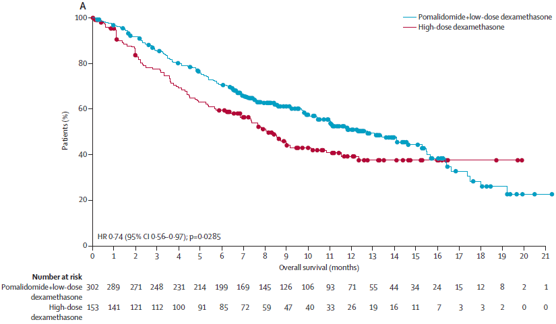
Note: Median OS for POM + LoDex was 12.7 months. Abbreviations: CI, confidence interval; HiDEX, high-dose dexamethasone; LoDEX, low-dose dexamethasone; OS, overall survival; POM, pomalidomide.
Source: Miguel et al. 2013. Pomalidomide plus low-dose dexamethasone versus high-dose dexamethasone alone for patients with relapsed and refractory multiple myeloma (MM-003): a randomised, open-label, phase 3 trial. Lancet Oncol 2013; 14: 1055–66.
Figure 4: Kaplan–Meier estimates for overall survival of MM patients refractory to anti-CD38s according to refractoriness to PIs and IMiDs (United States MAMMOTH study)
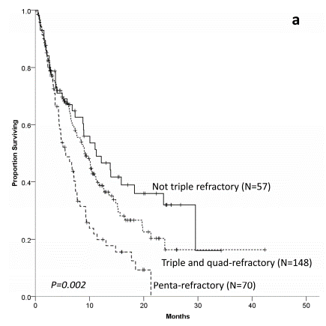
Note: Median follow-up (from T0) of survivors was 10.6 months (range 1.9–42.3 months). The median OS (mOS) from T0 for the entire cohort was 8.6 months (95% C.I. 7.2–9.9). OS according to refractoriness group is shown in the Figure. mOS was 11.2 months (95% C.I. 5.4–17.1) for “not triple-refractory” group, 9.2 months (95% C.I. 7.1–11.2) for “triple-and quad-refractory” and 5.6 months (95% C.I. 3.5–7.8) for “penta-refractory” groups.
Source: Gandhi et al. 2019. Outcomes of patients with multiple myeloma refractory to CD38-targeted monoclonal antibody therapy. Leukemia 2019 Sep;33(9):2266-2275. doi: 10.1038/s41375-019-0435-7

Specify any characteristics of patients with the medical condition, or suspected of, who are proposed to be eligible for the proposed medical service, including any details of how a patient would be investigated, managed and referred within the Australian health care system in the lead up to being considered eligible for the service:
Referral for cilta-cel
Patients will be monitored by their haematologists throughout MM treatment to determine remission and relapse status (determined using objective measurement of response, as per the PBAC rules for continuation and cessation; refer to Q24 for the definition of progressive disease [MM] included in PBS restrictions for MM therapies). If patients reach the fourth line setting, they may be assessed for eligibility for cilta-cel and referred to a treating public hospital by their haematologist or haematological oncologist. Further, patient selection and referral decisions will be determined by a MDT.

Define and summarise the current clinical management pathway before patients would be eligible for the proposed medical service (supplement this summary with an easy to follow flowchart [as an attachment to the Application Form] depicting the current clinical management pathway up to this point):
The management of patients with MM is individualised and many factors are considered in making treatment decisions determined by age, comorbidities, frailty, and disability. At diagnosis, patients with MM are classified into transplant eligible and transplant ineligible. Eligibility for autologous transplantation is assessed on age, comorbidities and frailty. The upper age limit for transplantation is generally 70–75 years in Australia. A treatment algorithm is presented below in Figure 5 that is informed by the Australian MSAG guidelines and the PBS restrictions.
Currently available myeloma therapies in Australia include three classes of therapeutic agents – proteosome inhibitor (PI [e.g. bortezomib, carfilzomib]), immunomodulator drugs (IMiDs [e.g. thalidomide, lenalidomide, pomalidomide]) and monoclonal antibody (anti-CD38 e.g. daratumumab) (Quach et al 2019; Tomlinson et al, 2018).
As of 1 June 2020, bortezomib, lenalidomide plus dexamethasone (BLd) was PBS listed for newly diagnosed multiple myeloma irrespective of transplant eligibility; and lenalidomide maintenance was also PBS listed in April 2020. Most transplant eligible patients will receive a BLd and go on to receive lenalidomide maintenance after transplantation. Further, most patients ineligible for stem cell transplant will also receive BLd as first-line therapy. Other options on the PBS include Bd or Rd alone as first-line therapy. However, with the availability of BLd and lenalidomide maintenance on the PBS (and which were accepted by the PBAC as superior to other first line regimens) it is expected that most patients will receive this combination including both bortezomib and lenalidomide therapies in the first line setting.
The type of prior therapy received and response to prior therapy are important factors which determine treatment of relapsed/refractory patients in the second line setting (as shown in Figure 5). As bortezomib is administered for a finite number of cycles, many patients who receive a bortezomib-based regimen will experience a period where no further treatment is necessary (i.e a treatment free interval). Consequently, provided patients achieved at least a partial response to their first course of bortezomib without unacceptable toxicity, patients remain responsive to bortezomib in the relapsed/re-treatment setting. Additionally, with the PBS listing of carfilzomib and dexamethasone (Cd) in January 2018, patients relapsing after prior bortezomib may receive treatment with an alternative proteasome inhibitor (PI), Cd, in the relapsed setting as the ENDEAVOR trial demonstrated that Cd is effective in patients who had previously received (but were not refractory to) bortezomib.
Treatments PBS listed for patients with RRMM include lenalidomide, bortezomib, carfilzomib, pomalidomide and thalidomide. These treatments, may or may not be used in combination with chemotherapies and/or corticosteroids (most commonly dexamethasone). Lenalidomide, bortezomib, carfilzomib and thalidomide have line agnostic PBS listings in the RRMM setting. Most recently, daratumumab, bortezomib and dexamethasone (DBd) was PBS listed on 1 January 2021 for second-line MM only (i.e. not a line agnostic PBS listing). DBd is a clinically appropriate treatment option for most second line MM patients. DBd is also appropriate for patients who had previously received bortezomib-based therapy (unless patients are refractory, intolerant or contraindicated to bortezomib) or an IMiD, typically lenalidomide, as first line treatment. In recommending DBd for a second-line MM listing, it was noted that the uptake of DBd would be high (given its superior efficacy to other available therapies). As such, DBd is likely to be used at second-line in the majority of patients.
The availability, and response to previous therapies received plays a major role in treatment selection in the late stage setting. PBS data indicates that in the third-line MM setting, lenalidomide or carfilzomib are generally prescribed in Australian clinical practice. Due to the recent PBS listings in the first-line and second-line MM settings referred to above, it is anticipated that the use of lenalidomide will reduce in the third-line setting and that there will be an increase in the use of carfilzomib in the third-line setting as it will have been displaced in the second-line setting by DBd. For fourth-line MM, the PBS data supports that pomalidomide and carfilzomib are generally prescribed in Australian clinical practice. Further, the PBS data indicates that pomalidomide is the most commonly prescribed of these two treatment options in the fourth-line setting (i.e. the population of interest to this application) and this is expected to increase over time due to the changes in the clinical algorithm in the last 12 months. Pomalidomide, is an IMiD, and is PBS listed for patients who have failed treatment with both bortezomib and lenalidomide. As PBS treatment options at the fourth line plus setting of RR MM are extremely limited and response rates are low, clinicians are likely to explore other options for access to alternative medicines, such as clinical trial programs, compassionate use programs or private funding. Thus, this outlines the need for new, alternative treatment options for the fourth line plus setting in Australia in which the survival prognosis is extremely poor.
Figure 5: Current clinical management pathway
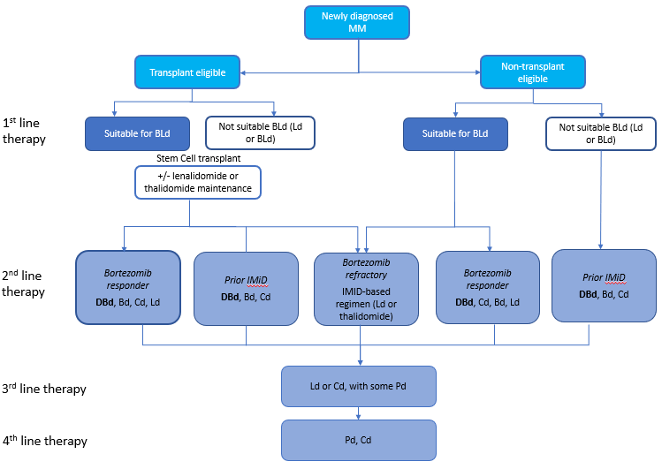
Abbreviations: Bd = bortezomib and dexamethasone; BLd = bortezomib, lenalidomide and dexamethasone; Cd = carfilzomib and dexamethasone; DBd = daratumumab, bortezomib and dexamethasone; IMiDs = immunomodulator drugs; Ld = lenalidomide and dexamethasone; MM = multiple myeloma; Pd = pomalidomide and dexamethasone.

PART 6b – INFORMATION ABOUT THE INTERVENTION

Describe the key components and clinical steps involved in delivering the proposed medical service:
Cilta-cel is prepared from the patient’s peripheral blood mononuclear cells, which are obtained via a standard leukapheresis procedure. A replication incompetent lentiviral vector is used to introduce an anti-BCMA CAR gene into patient derived human T-cells. The CAR-T process for cilta-cel is consistent with what currently has been considered by MSAC for other CAR-T cells therapy, such as Kymriah® and Yescarta®.
The diagram presented in Figure 6 below summarises the steps involved in the proposed medical service:
Step 1 – Apheresis: Once diagnosed eligible for cilta-cel, the patients will undergo a standard apheresis process to collect white blood cells (WBC). The T cells from apheresis will be collected for transduction and undergo expansion to manufacture cilta-cel. REDACTED.
REDACTED
Bridging therapy: The patients may receive bridging therapy as per clinical indication to maintain disease stability during the period of production of cilta-cel. Bridging therapy will be a short-term treatment (i.e. approximately up to 6 weeks) and currently funded on the PBS.
Step 2 – Manufacture of cilta-cel: The mononuclear cells are enriched for T-cells and genetically modified ex vivo by transduction with a replication incompetent lentiviral vector to express a chimeric antigen receptor (CAR) comprising an anti-BCMA targeting domain. The transduced anti-BCMA CAR T-cells are expanded in cell culture, washed, formulated into a suspension and cryopreserved. The product must pass a sterility test before release for shipping as a frozen suspension in a patient-specific infusion bag. The drug product infusion bag is individually packed in an aluminium cryo cassette prior to cryopreservation. Once the CAR-T product is manufactured, it will undergo full QA release at Raritan, then transported directly to hospital in Australia.
Step 3 – Conditioning (lymphodepletion) regimen: Approximately 4 to 5 weeks after apheresis, after the completion of manufacture and quality testing of cilta-cel, the patients are subjected to a conditioning regimen of IV cyclophosphamide 300 mg/m2 and fludarabine 30 mg/m2 at three daily doses. The conditioning regimen will lead to lymphodepletion and help promote cilta-cel cell expansion in the patients. Cyclophosphamide 300 mg/m2 and fludarabine 30 mg/m2 before cilta-cel infusion (Day 1) is consistent with the lymphodepletion regimen used in the marketed CAR-T products Kymriah and Yescarta. The dose of fludarabine should be reduced to 24 mg/m2 for subjects with an eGFR of 30 to 70 mL/min/1.73m2.
Step 4 – Infusion of cilta-cel: Cilta-cel is a single infusion product. Cilta-cel will be administered 5 to 7 days after start of the conditioning regimen at a public hospital. Pre-infusion medications are administered to all patients (REDACTED) prior to cilta-cel infusion which include antipyretics and an antihistamine. Further, before the infusion and during the recovery period, tocilizumab and emergency equipment will need to be available for use.
The patient’s identity with the patient identifiers on the infusion bag need to be confirmed before infusion. Cilta-cel should not be infused if the information on the patient-specific label does not match the intended patient.
Once thawed, the entire contents of the cilta-cel bag must be administered by IV REDACTED using infusion sets fitted with an in-line filter and not a leukodepleting filter. The contents of the bag should be gently mixed during cilta-cel infusion to disperse cell clumps. After the entire content of the product bag is infused, the administration line inclusive of the in-line filter should be flushed, with sodium chloride 9 mg/mL (0.9%) solution (normal saline) to ensure all product is delivered.
The patients will be evaluated for safety on the day of cilta-cel infusion. Infusion of cilta-cel will be delayed:
- If there are any signs of infection (patients requiring anti-microbial treatment, or with temperature ≥ 38.0 Celsius within 48 hours before infusion of cilta-cel.
- In case of Grade ≥3 non-hematologic toxicities of cyclophosphamide and fludarabine conditioning (except for Grade 3 nausea, vomiting, diarrhea, or constipation) occurs.
Step 5 – Monitoring after infusion: Following the infusion, there is likely to be a period of monitoring required. As the regulatory processes with the TGA are ongoing, the recommended monitoring requirements after the infusion are still to be confirmed. However, the monitoring requirements for cilta-cel are not expected to be any different from any other CAR-T therapies, including those considered by MSAC (i.e. Kymriah® and Yescarta®).
Figure 6: REDACTED

Does the proposed medical service include a registered trademark component with characteristics that distinguishes it from other similar health components?
Cilta-cel is not yet TGA registered. However, it is proposed that ciltacabtagene autoleucel will be supplied as a trademarked class 4 biological product; REDACTED.
Cilta-cel consists of autologous CAR-T cells designed to target the biomarker, B cell maturation antigen (BCMA) which is a type III membrane protein and a part of the tumour necrosis receptor superfamily. BCMA is stably expressed in malignant multiple myeloma plasma cells in almost all patients with MM. Expression of BCMA in non-malignant cells is minimal and limited to plasma cells and a small subset of B cells. BCMA also facilitates MM plasma cell survival. This BCMA target distinguishes it from other CAR-T products currently approved by MSAC (Yescarta® and Kymriah® which target CD-19 in lymphomas).

If the proposed medical service has a prosthesis or device component to it, does it involve a new approach towards managing a particular sub-group of the population with the specific medical condition?
Not applicable.

If applicable, are there any limitations on the provision of the proposed medical service delivered to the patient (i.e. accessibility, dosage, quantity, duration or frequency):
The following limitations are applied to the proposed medical service:
Dosing: Cilta-cel is to be administered as a single dose for infusion per patient containing a suspension of chimeric antigen receptor (CAR)-positive viable T-cells. The dose is 0.5-1.0×10⁶ CAR-positive viable T-cells per kg of body weight, REDACTED. The infusion should be given 5 to 7 days after the start of the lymphodepleting regimen.
Number of CAR-T treatments in a lifetime: Consistent with the MSAC recommendation for Kymriah® in DLBCL, PMBCL and TFL (November 2019) and Yescarta® in these same indications as well as HGBCL (January 2020), it is proposed that patients would be limited to one successful CAR-T infusion per lifetime. A successful infusion is when the patient with RRMM has been infused with the optimal cilta-cel dosage as per the recommend dose above.
Prescriber: Treatment will be prescribed and monitored by an experienced haematologist working in a multidisciplinary team specialising in the provision of CAR-T cell therapy.
Treatment centre: Treatment with cilta-cel initially is likely to be limited to a small number of key specialist public hospital centres across the Australian states and territories. Several hospitals are currently trial centres for cilta-cel and three of these are also delivering Kymriah, and thus would have relevant clinical experience and protocols for delivering this medical service

If applicable, identify any healthcare resources or other medical services that would need to be delivered at the same time as the proposed medical service:
The proposed medical service includes leukapheresis, followed by lymphodepleting chemotherapy and then infusion of cilta-cel. These are performed sequentially and not at the same time as each other (refer to the process described above in Q27).

If applicable, advise which health professionals will primarily deliver the proposed service:
Infusion of cilta-cel will be delivered by a nurse and supervised by a haematologist in a hospital setting. This is consistent with the administration of the currently approved CAR-T therapies, Yescarta® and Kymriah®.

If applicable, advise whether the proposed medical service could be delegated or referred to another professional for delivery:
It is not appropriate for this medical service to be delegated to another professional for delivery.

If applicable, specify any proposed limitations on who might deliver the proposed medical service, or who might provide a referral for it:
Cilta-cel will be prescribed and delivered by specialised haematologists and nurses in Janssen-accredited treatment centres (public hospitals) equipped to deliver CAR-T therapies. This is explained in Q30 above and is consistent with currently approved CAR-T cell therapies.

If applicable, advise what type of training or qualifications would be required to perform the proposed service, as well as any accreditation requirements to support service delivery:
Cilta-cel will be prescribed and delivered by physicians experienced in the treatment of haematological malignancies in selected accredited treatment centres. There will be some form of accreditation required. These requirements are expected to be defined by the TGA during the ongoing regulatory processes. However, Janssen anticipate that the accreditation requirements for cilta-cel will be similar to those already approved by the TGA for other CAR-T therapies.

(a) Indicate the proposed setting(s) in which the proposed medical service will be delivered (select ALL relevant settings):
Inpatient private hospital (admitted patient)
Inpatient public hospital (admitted patient)
Private outpatient clinic
Public outpatient clinic
- Where the proposed medical service is provided in more than one setting, please describe the rationale related to each:
Patients would be admitted as an inpatient for the following steps of the cilta-cel medical service: delivery of the infusion and potentially a period of monitoring (to be determined through regulatory processes). This post infusion monitoring is standard practice and will be consistent with the currently approved CAR-T cell therapies.
Patients would be seen in an out patient setting for the following steps of the cilta-cel medical service: apheresis, bridging therapy and conditioning, routine follow-up once monitoring after discharge from inpatient infusion.

Is the proposed medical service intended to be entirely rendered in Australia?
Yes
No – please specify below
Most of the medical service will be rendered in Australia. The exception Is the manufacturing of cilta-cel CAR-T product which occurs in the Janssen manufacturing centre in Raritan (NJ, USA).
These steps are shown in the figurer presented in Q27.

PART 6c – INFORMATION ABOUT THE COMPARATOR(S)

Nominate the appropriate comparator(s) for the proposed medical service, i.e. how is the proposed population currently managed in the absence of the proposed medical service being available in the Australian health care system (including identifying health care resources that are needed to be delivered at the same time as the comparator service):
As noted in Q15, the proposed indication for cilta-cel is for the treatment of patients with RRMM previously with 3 prior lines of therapy including a PI, an IMiD and an anti-CD38 inhibitor. Thus, the earliest patients can receive cilta-cell will be as a fourth line MM treatment. Further, as described in Q26, prior to the fourth line setting, patients will have typically received regimens which include lenalidomide (an IMiD), bortezomib (a PI) and daratumumab (an anti-CD38 inhibitor) in Australian clinical practice.
Based on PBS utilisation data of fourth line MM therapies, the most appropriate comparator for cilta-cel is considered to be pomalidomide in combination with dexamethasone, followed by carfilzomib in combination with dexamethasone
Figure 7: REDACTED

Does the medical service (that has been nominated as the comparator) have an existing MBS item number(s)?
Yes (please list all relevant MBS item numbers below)
No
The nominated comparator is PBS listed and not an MBS service.

Define and summarise the current clinical management pathway/s that patients may follow after they receive the medical service that has been nominated as the comparator (supplement this summary with an easy to follow flowchart [as an attachment to the Application Form] depicting the current clinical management pathway that patients may follow from the point of receiving the comparator onwards, including health care resources):
There are few treatment options for patients who have received and progressed following at least three lines of treatment and which includes lenalidomide, bortezomib and daratumumab, and no options which offer a different mechanism of action to those previously received. In the absence of cilta-cel and the availability of the current therapies in this setting, after the patients have tried and failed pomalidomide and carfilzomib, patients may receive best supportive care, palliative care or enrol in a clinical trial. Therapies on the PBS for MM at fifth line or beyond are considered generally ineffective at this stage because a patient will have received a PI, IMiD and an anti-CD38 previously.
Figure 8: Clinical management pathway after the proposed comparator (i.e. fifth-line plus)
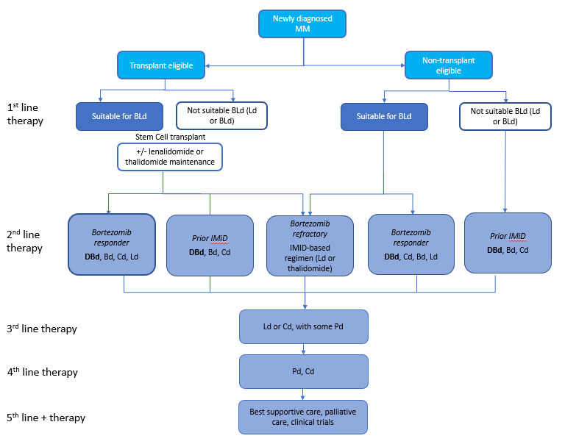
Abbreviations: Bd = bortezomib and dexamethasone; BLd = bortezomib, lenalidomide and dexamethasone; Cd = carfilzomib and dexamethasone; DBd = daratumumab, bortezomib and dexamethasone; IMiDs = immunomodulator drugs; Ld = lenalidomide and dexamethasone; MM = multiple myeloma; Pd = pomalidomide and dexamethasone.

(a) Will the proposed medical service be used in addition to, or instead of, the nominated comparator(s)?
In addition to (i.e. it is an add-on service)
Instead of (i.e. it is a replacement or alternative)

If instead of (i.e. alternative service), please outline the extent to which the current service/comparator is expected to be substituted:
Despite high efficacy shown in clinical trials, as not all patients will be eligible or be able to tolerate cilta-cel, it will only partially replace the nominated comparator. Uptake of cilta-cel will be moderated by the fact that:
- Only patients who have received prior anti-CD38 can receive cilta-cel. Daratumumab was only reimbursed on the PBS from January 2021 for second-line multiple myeloma. In the pivotal trial for DBd, CASTOR, a median PFS of 27.0 months was reported for DBd in this setting. Thus there will be a delay in the timings of when all Australian RRMM patients meet the proposed clinical criteria for cilta-cel. However, the CASTOR reported a range of PFS across the recruited population and thus some patients will progress quickly through lines of MM therapy. Further, daratumumab is the only anti-CD38 available on the PBS and therefore patients must receive it at second-line to be eligible for cilta-cel.
- Only a portion of patients will be able to tolerate or be fit enough for treatment and can travel to the treatment site which may be interstate.

Define and summarise how current clinical management pathways (from the point of service delivery onwards) are expected to change as a consequence of introducing the proposed medical service, including variation in health care resources (Refer to Question 39 as baseline):
Due to the limited treatment options on the PBS for RRMM and because patients will have been previously treated with a PI, IMiD and anti-CD38 at the point of cilta-cel therapy, the clinical management pathway following cilta-cel will not be any different to that currently seen in clinical practice (refer to Q40).

PART 6d – INFORMATION ABOUT THE CLINICAL OUTCOME

Summarise the clinical claims for the proposed medical service against the appropriate comparator(s), in terms of consequences for health outcomes (comparative benefits and harms):
The clinical claims are based on the results of the CARTITUDE-1 study.
The efficacy data from CARTITUDE-1 is reported after a median duration of follow-up of 18.0 months (clinical cut-off 11 February 2021). Treatment with cilta-cel resulted in a highly effective and clinically meaningful response in patients with RRMM. Notably, 97.9% of patients (n=97) achieved a response (partial response or better [overall response rate, ORR]) of which 92 patients (94.8%) achieved a response of VGPR or better and 80.4% of patients achieved a best response of sCR as adjudicated by Independent Review Committee (IRC). Further, in 61 evaluable patients for MRD status, 91.8% of these were MRD-negative which is highly sensitive measure of effectiveness of therapy in MM, and a proxy for absence of disease. Historically this depth and level of response has not been attained in RRMM. For example, in the pivotal phase 3 study of pomalidomide, MRD status was not analysed, and only 31% of the population treated with pomalidomide achieve an ORR, in which most of these patients achieved a partial response (Miguel et al. 2013; see Figure 9). Only 1% of those treated with pomalidomide achieved a complete or stringent complete response (Miguel et al. 2013; see Figure 9).
Cilta-cel also demonstrated a rapid onset of response, with a median time to first response of 0.95 months (range: 0.9 to 10.7 months) and a median time to best response of 2.6 months (range 0.9 to 15.2 months). Cilta-cel also demonstrated a durable response with the median duration of response of 21.8 months.
Figure 9: Naïve comparison of best response rates for cilta-cel [left] and pomalidomide [right]
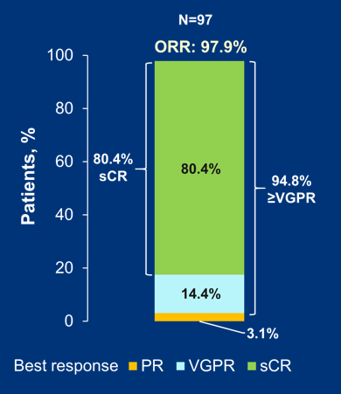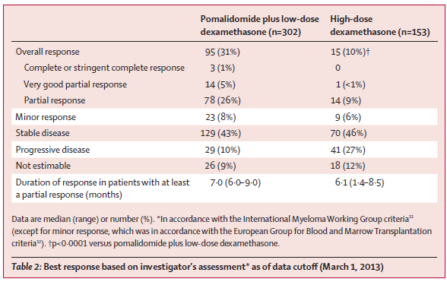
Source (s): Usmani SZ et al. 2021. Ciltacabtagene Autoleucel, a B-cell Maturation Antigen–directed Chimeric Antigen Receptor T-cell Therapy, in Relapsed/Refractory Multiple Myeloma: Updated Results From CARTITUDE-1. ASCO 2021 conference.. Data cut-off Feb 11, 2021. Miguel et al. 2013. Pomalidomide plus low-dose dexamethasone versus high-dose dexamethasone alone for patients with relapsed and refractory multiple myeloma (MM-003): a randomised, open-label, phase 3 trial. Lancet Oncol 2013; 14: 1055–66.
After a median follow up of 18.0 months, 65 patients (67.0%) had their PFS data censored at the clinical cut-off. The overall median PFS based on the IRC response assessment was 22.8 months (95% CI: 22.80, NE; see Figure 10). The median PFS (mPFS) for patients who achieved CR/sCR was not reached. Thus, the median PFS for cilta-cel is longer than the median OS seen with current therapies which has reported between 9 and 25 months (see Q24, Figures 2 to 4). Further, the comparison of CARTITUDE-1 and the survival data for fourth-line therapy on the PBS is heavily biased against cilta-cel because the median number of prior lines of therapies in the CARTITUDE-1 study was 6. Thus, this demonstrates the superiority of cilta-cel compared with current therapies in the RRMM setting. The 18-month OS rate for all patients in CARTITUDE-1 was 80.9% (95% CI, 71.04-87.6). Thus, the results of CARTITUDE-1 emphasise that cilta-cel represents a significant step change in treating this heavily pre-treated RRMM population.
Figure 10: Naïve comparison of PFS for cilta-cel [top] and OS for pomalidomide [bottom] in RRMM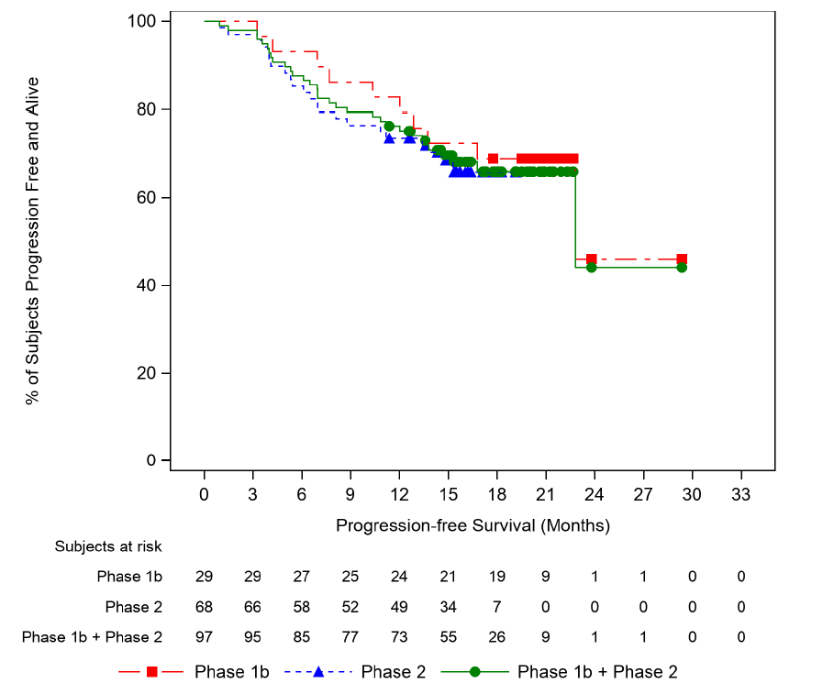
Source (s): Usmani SZ et al. 2021. Ciltacabtagene Autoleucel, a B-cell Maturation Antigen–directed Chimeric Antigen Receptor T-cell Therapy, in Relapsed/Refractory Multiple Myeloma: Updated Results From CARTITUDE-1. ASCO 2021 conference.. Data cut-off Feb 11, 2021. Miguel et al. 2013. Pomalidomide plus low-dose dexamethasone versus high-dose dexamethasone alone for patients with relapsed and refractory multiple myeloma (MM-003): a randomised, open-label, phase 3 trial. Lancet Oncol 2013; 14: 1055–66.
Patients participating in HRQoL evaluations in CARTITUDE-1 reported significant improvements in functional status and wellbeing including those related to the cancer-specific EORTC-QLQ30 and general health EQ-5D-5L. Patients also experienced reduction in pain and fatigue with an improvement in future perspective. Patients who participated in the optional qualitative interviews described their experience as exclusively better than their previous treatment experiences. All of these measures suggest improved HRQoL following treatment with cilta-cel. Thus, the high efficacy of cilta-cel is achieved while improving HRQoL and therefore cilta-cel can address an area of high unmet medical need for Australian patients in which there are limited options and a poor prognosis.
CARTITUDE-1 also demonstrated that cilta-cel has a manageable safety profile (see Table 2). All 97 patients who received cilta-cel infusion experienced one or more treatment emergent adverse events. Serious adverse events were reported for 53 patients (54.6%), 42 patients (43.3%) experienced serious TEAEs related to cilta-cel.Table 2: Summary of cilta-cel safety profile
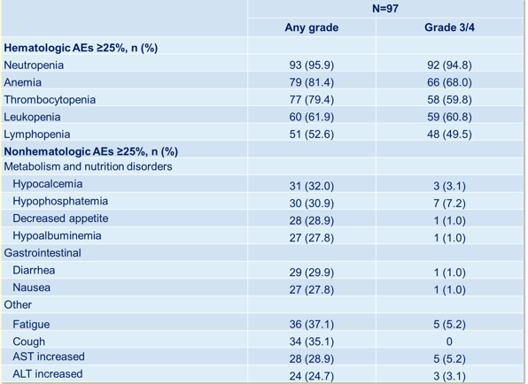
Source (s): Usmani SZ et al. 2021. Ciltacabtagene Autoleucel, a B-cell Maturation Antigen–directed Chimeric Antigen Receptor T-cell Therapy, in Relapsed/Refractory Multiple Myeloma: Updated Results From CARTITUDE-1. ASCO 2021 conference.. Data cut-off Feb 11, 2021.
CAR-T related adverse events were common. However, most were of low grade (i.e. grade 1 or 2). Cytokine release syndrome (CRS) occurred in 92 (94.8%) patients, of which most (n=87, 95%) were grade 1 or 2. CAR-T neurotoxicity was observed in 20 (20.6%) of patients which included Immune Effector Cell-Associated Neurotoxicity Syndrome (ICANS) in 16.5% overall (2.1% grades 3 and 4), and other neurotoxicity in 12.4% overall (9.3% grades 3 and 4).
Table 3: Summary of CAR-T related adverse events
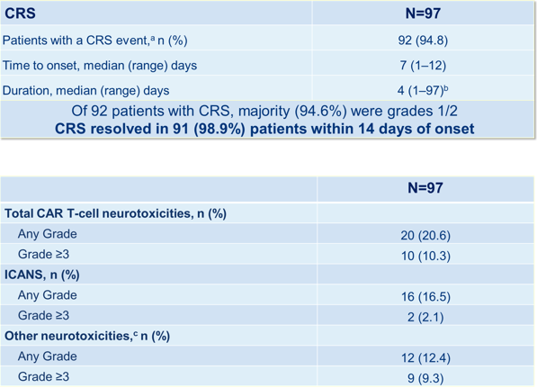
Source (s): Usmani SZ et al. 2021. Ciltacabtagene Autoleucel, a B-cell Maturation Antigen–directed Chimeric Antigen Receptor T-cell Therapy, in Relapsed/Refractory Multiple Myeloma: Updated Results From CARTITUDE-1. ASCO 2021 conference.. Data cut-off Feb 11, 2021.

Please advise if the overall clinical claim is for:
Superiority
Non-inferiority

Below, list the key health outcomes (major and minor – prioritising major key health outcomes first) that will need to be specifically measured in assessing the clinical claim of the proposed medical service versus the comparator:
Clinical Effectiveness Outcomes: Complete response/stringent complete response (CR/sCR), overall response rate (ORR), very good partial response (VGPR) or better response rate, duration of response, time to response, minimal residual disease (MRD) negativity, progression free survival (PFS), overall survival (OS), health-related quality of life.
Safety Outcomes: Rate of adverse events (AE) and serious adverse events (SAE), incidence of AEs of special interest, incidence of CRS, incidence of neurological toxicity- CAR-T cell-related neurotoxicity (ICANS) and other neurological toxicities, incidence of tumour lysis syndrome, incidence of cytopenia, incidence of hypogammaglobulinemia.

PART 7 – INFORMATION ABOUT ESTIMATED UTILISATION

Estimate the prevalence and/or incidence of the proposed population:
REDACTED

Estimate the number of times the proposed medical service(s) would be delivered to a patient per year:
Cilta-cel treatment regimen is a single successful infusion per lifetime, consistent with other CAR-T therapies considered by MSAC.

How many years would the proposed medical service(s) be required for the patient?
Cilta-cel treatment regimen is a single successful infusion per lifetime, consistent with other CAR-T therapies considered by MSAC.

Estimate the projected number of patients who will utilise the proposed medical service(s) for the first full year:
REDACTED

Estimate the anticipated uptake of the proposed medical service over the next three years factoring in any constraints in the health system in meeting the needs of the proposed population (such as supply and demand factors) as well as provide commentary on risk of ‘leakage’ to populations not targeted by the service:
REDACTED

PART 8 – COST INFORMATION

Indicate the likely cost of providing the proposed medical service. Where possible, please provide overall cost and breakdown:
Cilta-cel qualifies as a high cost, highly specialised therapy. Cilta-cel will be a TGA approved therapy delivered in public hospitals where the therapy and its conditions of use are recommended by MSAC or PBAC.
Janssen’s Global Headquarters has not yet established the price of cilta-cel, but the average annual treatment cost at the commencement of funding will exceed AU$200,000 per patient (including supportive care, ancillary services, infusion, toxicity management and logistics), which is the threshold as described in the Addendum for a high cost, specialised therapy. Further information regarding costs will be provided in the submission.

Specify how long the proposed medical service typically takes to perform:
It is generally REDACTED from apheresis to infusion of cilta-cel (see Q27).
Cilta-cel is provided as a single-dose for infusion containing a suspension of chimeric antigen receptor (CAR)-positive viable T-cells. The dose is 0.5-1.0×106 CAR-positive viable T-cells per kg of body weight, REDACTED. Once thawed, the cilta-cel infusion must be administered and completed REDACTED at room/ambient temperature (20°C to 25°C).
Following the infusion, there is likely to be a period of monitoring required. As the regulatory processes with the TGA are ongoing, the recommended monitoring requirements after the infusion are still to be confirmed. However, the monitoring requirements for cilta-cel are not expected to be any different from any other CAR-T therapies, including those considered by MSAC (i.e. Kymriah® and Yescarta®).

If public funding is sought through the MBS, please draft a proposed MBS item descriptor to define the population and medical service usage characteristics that would define eligibility for MBS funding.
Not applicable.
Category Not applicable - See Part 2, Question 6.g. – (insert proposed category description here)

Proposed item descriptor: insert proposed item descriptor here
Fee: $(insert proposed fee here)

References
Berdeja, J G., Madduri, D., Usmani, S. Z., Jakubowiak, A., Agha, M., Cohen, A. D., ... & Jagannath, S. (2021). Ciltacabtagene autoleucel, a B-cell maturation antigen-directed chimeric antigen receptor T-cell therapy in patients with relapsed or refractory multiple myeloma (CARTITUDE-1): a phase 1b/2 open-label study. The Lancet. Published online June 24, 2021 https://doi.org/10.1016/S0140-6736(21)00933-8
Berdeja, J G., et al. Update of CARTITUDE-1: A phase Ib/II study of JNJ-4528, a B-cell maturation antigen (BCMA)-directed CAR-T-cell therapy, in relapsed/refractory multiple myeloma. (2020): Journal of Clinical Oncology 38, no. 15_suppl 8505-8505.
Gandhi et al. Outcomes of patients with multiple myeloma refractory to CD38-targeted monoclonal antibody therapy. Leukemia 2019 Sep;33(9):2266-2275. doi: 10.1038/s41375-019-0435-7
Mateos, M V., Sonneveld, P., Hungria, V., Nooka, A K., Estell, J A., Barreto, W., ... & Spencer, A Daratumumab, bortezomib, and dexamethasone versus bortezomib and dexamethasone in patients with previously treated multiple myeloma: three-year follow-up of CASTOR. Clinical Lymphoma Myeloma and Leukemia 2020, 20(8), 509-518.
Miguel et al. Pomalidomide plus low-dose dexamethasone versus high-dose dexamethasone alone for patients with relapsed and refractory multiple myeloma (MM-003): a randomised, open-label, phase 3 trial. Lancet Oncol 2013; 14: 1055–66.
Quach H. and Prince H.M. on behalf of MSAG 2019. Clinical Practice Guideline. Multiple Myeloma. Updated 2019 https://myeloma.org.au/wp-content/uploads/2019/10/myeloma_clinical_practice_guideline_oct19.
Rajkumar, SV. Updated Diagnostic Criteria and Staging System for Multiple Myeloma, American Society of Clinical Oncology Educational Book 2016 :36, e418-e423 doi: 10.1200/EDBK_159009 https://ascopubs.org/doi/pdf/10.1200/EDBK_159009
Tomlinson R. Multiple myeloma: Updated approach to management in 2018. Aust J Gen Pract 2018 Aug;47(8):526-529. doi: 10.31128/AJGP-01-18-4473. PMID: 30114882.
Usmani, S Z, et al. Ciltacabtagene autoleucel, a B-cell maturation antigen (BCMA)-directed chimeric antigen receptor T-cell (CAR-T) therapy, in relapsed/refractory multiple myeloma (R/R MM): Updated results from CARTITUDE-1. (2021): 8005-8005. ASCO 2021 conference. Data cut-off Feb 11, 2021.
Zhao J et al. Real-world treatment patterns in relapsed/refractory multiple myeloma in Australia: results from the Myeloma and Related Diseases Registry. Abstract presented (O051) at Blood 2019 on 21/10/2019, Perth Convention & Exhibition Centre, 20 - 23 October 2019.
https://www.hsanz.org.au/resources/Documents/Blood%20Abstract%20Supplement/Blood%202019%20abstract%20supplement.pdf

