Application 1707
Detection of minimal residual disease in patients with acute lymphoblastic leukaemia using next generation sequencing
This application form is to be completed for new and amended requests for public funding (including but not limited to the Medicare Benefits Schedule (MBS)). It describes the detailed information that the Australian Government Department of Health requires to determine whether a proposed medical service is suitable.
Please use this template, along with the associated Application Form Instructions to prepare your application. Please complete all questions that are applicable to the proposed service, providing relevant information only. Applications not completed in full will not be accepted. The separate MSAC Guidelines should be used to guide health technology assessment (HTA) content of the Application Form
Should you require any further assistance, departmental staff are available through the Health Technology Assessment Team (HTA Team) on the email below to discuss the application form, or any other component of the Medical Services Advisory Committee process.

Email: hta@health.gov.au
Website: www.msac.gov.au

PART 1 – APPLICANT DETAILS

Applicant details (primary and alternative contacts)
Corporation / partnership details (where relevant):
Corporation name: Adaptive BiotechnologiesTM
ABN: Not applicable
Business trading name: Adaptive Biotechnologies Corporation

Primary contact name: REDACTED
Primary contact numbers
Business: REDACTED
Mobile: REDACTED
Email: REDACTED

Alternative contact name: REDACTED
Alternative contact numbers
Business: REDACTED
Mobile: REDACTED
Email: REDACTED

(a) Are you a consultant acting on behalf on an applicant?
Yes (Health Technology Analysts)
No
(b) If yes what is the Applicant(s) name that you are acting on behalf of?
Adaptive BiotechnologiesTM

(a) Are you a lobbyist acting on behalf of an Applicant?
Yes
No

If yes, are you listed on the Register of Lobbyists?
Yes
No

Have you engaged a consultant on your behalf?
Yes
No

PART 2 – INFORMATION ABOUT THE PROPOSED MEDICAL SERVICE

Application title
Measuring minimal residual disease (MRD) in acute lymphoblastic leukaemia (ALL) using next generation sequencing (NGS) based assays to guide treatment decisions.

Provide a succinct description of the medical condition relevant to the proposed service (no more than 150 words – further information will be requested at Part F of the Application Form)
ALL is characterised by the aberrant and uncontrolled proliferation of lymphoid precursor cells as a result of the acquisition of chromosomal alterations and driver mutations in critical genes (Jabbour 2005, Brown 2021). ALL is the most common malignancy of childhood, with 5-year survival rates of 90% (Brown 2021, Leukaemia Foundation 2021). ALL is less common in adults however, adult ALL patients have a dismal prognosis with 5-year survival rates less than 40% (Brown 2021). This discrepancy is mainly due to the different genomic landscapes, comorbidities, and lower tolerance of adults to prolonged intensified chemotherapy (Abuasab 2021, Iacobucci 2021). The clinical management of patients with ALL relies on precise risk-assignment systems that accurately predict relapse hazard to guide therapy (Faham 2012). The ability to accurately determine the degree and speed of leukaemia cell clearance is a powerful predictor of subsequent relapse (Stow 2010).

Provide a succinct description of the proposed medical service (no more than 150 words – further information will be requested at Part 6 of the Application Form)
This MSAC application for MRD testing using NGS-based assays (specifically the clonoSEQ® Assay) is submitted concurrently with a MSAC submission by the Royal College of Pathologists Australasia (RCPA) for MRD testing in haematological malignancies. Based on consultations it is understood the RCPA MSAC submission is likely to be technology agnostic, but the proposed rebate will likely encourage multiparameter flow cytometry (mpFC) as the predominate technology for MRD testing.
The purpose of this application is to show the incremental benefit of NGS-based assay testing for MRD, specifically the clonoSEQ® Assay, over traditional tools such as mpFC. Compared to mpFC, which is highly subjective, NGS-based assays are sensitive, objective, and standardised. NGS-based assays detect fusion genes, clonal rearrangements in immunoglobulin (Ig) heavy chain genes, and/or T-cell receptor (TCR) genes. The clonoSEQ® Assay is an in vitro diagnostic NGS-based assay which uses a proprietary multiplex polymerase chain reaction (PCR) and NGS platform to identify specific sequences within a malignant lymphocyte in a given patient sample, and to quantify MRD over time in these patients (Faham 2012, Carlson 2013). Specifically, the assay can precisely identify and quantify the following DNA sequences associated with ALL: rearranged IgH (VDJ), IgH (DJ), IgK, and IgL receptor gene sequences, as well as translocated BCL1/IgH (J) and BCL2/IgH (J) sequences, using NGS at a sensitivity of 10⁻⁶ in DNA extracted from bone marrow and peripheral blood from patients with ALL. As a disease burden assessment tool, the clonoSEQ® Assay leverages NGS to allow observation of the disease itself following treatment and to guide treatment decisions, and therefore differs from NGS comprehensive genomic panels intended to only identify candidacy for a targeted therapy.

(a) Is this a request for MBS funding?
Yes
No

If yes, is the medical service(s) proposed to be covered under an existing MBS item number(s) or is a new MBS item(s) being sought altogether?
Amendment to existing MBS item(s)
New MBS item(s)

If an amendment to an existing item(s) is being sought, please list the relevant MBS item number(s) that are to be amended to include the proposed medical service/technology:
Not applicable.

If an amendment to an existing item(s) is being sought, what is the nature of the amendment(s)?
- An amendment to the way the service is clinically delivered under the existing item(s)
- An amendment to the patient population under the existing item(s)
- An amendment to the schedule fee of the existing item(s)
- An amendment to the time and complexity of an existing item(s)
- Access to an existing item(s) by a different health practitioner group
- Minor amendments to the item descriptor that does not affect how the service is delivered
- An amendment to an existing specific single consultation item
- An amendment to an existing global consultation item(s)
- Other (please describe below):
Not applicable.

If a new item(s) is being requested, what is the nature of the change to the MBS being sought?
- A new item which also seeks to allow access to the MBS for a specific health practitioner group
- A new item that is proposing a way of clinically delivering a service that is new to the MBS (in terms of new technology and / or population)
- A new item for a specific single consultation item
- A new item for a global consultation item(s)

Is the proposed service seeking public funding other than the MBS?
Yes
No

If yes, please advise:
Not applicable

What is the type of medical service/technology?
Therapeutic medical service
Investigative medical service
Single consultation medical service
Global consultation medical service
Allied health service
Co-dependent technology
Hybrid health technology

For investigative services, advise the specific purpose of performing the service (which could be one or more of the following):
- To be used as a screening tool in asymptomatic populations
- Assists in establishing a diagnosis in symptomatic patients
- Provides information about prognosis
- Identifies a patient as suitable for therapy by predicting a variation in the effect of the therapy
- Monitors a patient over time to assess treatment response and guide subsequent treatment decisions

Does your service rely on another medical product to achieve or to enhance its intended effect?
Pharmaceutical / Biological
Prosthesis or device
No

(a) If the proposed service has a pharmaceutical component to it, is it already covered under an existing Pharmaceutical Benefits Scheme (PBS) listing?
Yes
No

If yes, please list the relevant PBS item code(s):
Not applicable

If no, is an application (submission) in the process of being considered by the Pharmaceutical Benefits Advisory Committee (PBAC)?
Yes (please provide PBAC submission item number below)
No

If you are seeking both MBS and PBS listing, what is the trade name and generic name of the pharmaceutical?
Trade name: Not applicable
Generic name: Not applicable

(a) If the proposed service is dependent on the use of a prosthesis, is it already included on the Prostheses List?
Yes
No

If yes, please provide the following information (where relevant):
Billing code(s): Not applicable.
Trade name of prostheses: Not applicable.
Clinical name of prostheses: Not applicable.
Other device components delivered as part of the service: Not applicable.

If no, is an application in the process of being considered by a Clinical Advisory Group or the Prostheses List Advisory Committee (PLAC)?
Yes
No

Are there any other sponsor(s) and / or manufacturer(s) that have a similar prosthesis or device component in the Australian market place which this application is relevant to?
Yes
No

If yes, please provide the name(s) of the sponsor(s) and / or manufacturer(s):
Not applicable

Please identify any single and / or multi-use consumables delivered as part of the service?
Single use consumables: General use laboratory consumables such as pipette tips, centrifuge tubes, etc. for sample collection and laboratory testing.
Multi-use consumables: Nil.

PART 3 – INFORMATION ABOUT REGULATORY REQUIREMENTS

(a) If the proposed medical service involves use of a medical device, in-vitro diagnostic test, pharmaceutical product, radioactive tracer, or any other type of therapeutic good, please provide details
Type of therapeutic good: In-vitro diagnostic test
Manufacturer’s name: Adaptive BiotechnologiesTM
Sponsor’s name: Not applicable.

The conduct of NGS-based MRD testing, specifically using the clonoSEQ® Assay, requires the use of several reagents and/or kits for the processing of samples from bone marrow and peripheral blood. The consumables associated with the conduct of NGS-based MRD testing include but are not limited to:
- Nucleic acid isolation reagents
- PCR amplification reagents
- Library preparation reagents
- Enrichment/clean-up of amplified library reagents
- Hybridisation and capture reagents.
Laboratories conducting NGS-based MRD testing would use standard consumable items and equipment during the collection and preparation of bone marrow and peripheral blood samples.
Sequencing of libraries is performed on commercially available NGS sequencing platforms, the Illumina NextSEQ^{tm} 500/550 Systems, which are commonly used instruments in Australian laboratories. Sequencing data and clinical specimen archiving is also undertaken per the operational requirements for NGS laboratories. Therefore, the use of consumables and infrastructure would be shared with tumour samples from other cancer types and not necessarily specific to samples that underwent NGS-based MRD testing.
Further information can be provided if required.

Has it been listed on the Australian Register of Therapeutic Goods (ARTG) by the Therapeutic Goods Administration (TGA)? If the therapeutic good has been listed on the ARTG, please state the ARTG identification numbers, TGA-approved indication(s), and TGA-approved purpose(s).
No.

If a medical device is involved, has the medical device been classified by TGA as a Class III OR Active Implantable Medical Device (AIMD) under the TGA regulatory scheme for devices?
Class III
AIMD
N/A

Is the therapeutic good classified by TGA for Research Use Only (RUO)?

No.

(a) If not listed on the ARTG, is the therapeutic good to be used in the service exempt from the regulatory requirements of the Therapeutic Goods Act 1989?
Yes (If yes, please provide supporting documentation as an attachment to this application form)
No

If the therapeutic good is not ARTG listed, is the therapeutic good in the process of being considered by TGA?

Yes (if yes, please provide details below)
No

- If the therapeutic good is NOT in the process of being considered by TGA, is an application to TGA being prepared?
Yes (please provide details below)
No

REDACTED

PART 4 – SUMMARY OF EVIDENCE

Provide one or more recent (published) high quality clinical studies that support use of the proposed health service/technology. At ‘Application Form lodgement’, please do not attach full text articles; just provide a summary.
Table 1 Studies of relevance to this application
 | Type of study design* | Title of journal article or research project (including any trial identifier or study lead if relevant) | Short description of research (max 50 words)** | Website link to journal article or research (if available) | Date of publication***
1. | Prospective, non-randomised, Phase I/II clinical trial  (Hay 2019) | Hay, K. A. et al. Factors Associated With Durable EFS In Adult B-Cell ALL Patients Achieving MRD Negative CR After CD19 CAR-T-Cell Therapy. Blood 133, 1652-1663, doi:10.1182/blood-2018-11-883710 (2019). | EFS and OS were significantly better in the patients who achieved MRD negative complete response compared with those who did not. Of 45 total patients, 28 patients found to be FC negative were assessed by NGS at 10⁻⁴. 20 concordant MRD results (NGS-/FC-); 8 discordant MRD results (NGS+/FC-). Patients who were clonoSEQ+/FC- had worse EFS outcomes than patients who were MRD negative by clonoSEQ and FC (p= 0.036). | https://ashpublications.org/blood/article/133/15/1652/273303/Factors-associated-with-durable-EFS-in-adult-B | April 2019.  This publication reports the long-term follow-up of an initial publication (Turtle 2016)
2. | Retrospective cohort study  (Wood 2018) | Wood, B. et al. Measurable Residual Disease Detection By High-Throughput Sequencing Improves Risk Stratification For Pediatric B-ALL. Blood 131, 1350-1359, doi:10.1182/blood-2017-09-806521 (2018). | This study compared MRD detection by NGS and FC at the EOI with clinical outcome in a large retrospective cohort of paediatric B-ALL. clonoSEQ identified 55/619 (38.7%) patients with MRD at a level of 10⁻⁴ that were FC negative. These patients had worse outcomes than clonoSEQ-/FC- patients (p=0.036). | https://www.ncbi.nlm.nih.gov/pmc/articles/PMC5865233/#__ffn_sectitle | March 2018
3. | Study of test concordance  (Sala Torra 2017) | Sala Torra, O. et al. Next Generation Sequencing In Adult B-Cell Acute Lymphoblastic Leukemia Patients. Biol Blood Marrow Transplant 23, 691-696, doi:10.1016/j.bbmt.2016.12.639 (2017). | mpFC and NGS for MRD testing were compared in adult ALL patients. Patients who were clonoSEQ+/FC- had an intermediate outcome (p=0.028 and p=0.04 for OS and RFS, respectively) when compared to patients with MRD positive by both mpFC and clonoSEQ. | https://www.ncbi.nlm.nih.gov/pmc/articles/PMC5465962/ | April 2017
4. | Clinical utility study  (Wu 2014) | Wu, D. et al. Detection Of Minimal Residual Disease In B-Lymphoblastic Leukemia By High-Throughput Sequencing Of IGH. Clin Cancer Res 20, 4540-4548, doi:10.1158/1078-0432.Ccr-13-3231 (2014). | This study evaluated the potential for NGS to detect MRD in patients with B-ALL. 62 concordant MRD results (clonoSEQ+/+FC or clonoSEQ-/-FC). 28 discordant MRD results (28 samples clonoSEQ+/FC- and zero samples clonoSEQ- /FC+). | https://www.ncbi.nlm.nih.gov/pmc/articles/PMC5142743/ | September 2014
5. | Study of test concordance  (Pulsipher 2015) | Pulsipher, M. A. et al. IgH-V(D)J NGS-MRD Measurement Pre- And Early Post-Allotransplant Defines Very Low- And Very High-Risk ALL Patients. Blood 125, 3501-3508, doi:10.1182/blood-2014-12-615757 (2015). | This study assessed whether the increased sensitivity of NGS-MRD detection could improve the ability to predict low or absent relapse after transplant. 38 concordant MRD samples (clonoSEQ+/FC+ or clonoSEQ-/FC-). 14 discordant MRD samples (11 samples clonoSEQ+/FC- and three samples clonoSEQ-/FC+). | https://www.ncbi.nlm.nih.gov/pmc/articles/PMC4447864/ | May 2015
6. | Study of test concordance  (Wu 2012) | High-Throughput Sequencing Detects Minimal Residual Disease In Acute T Lymphoblastic Leukemia. | To determine whether NGS could contribute to the clinical management in ALL, this study used NGS to diagnose and detect MRD in patients with T-ALL. NGS was directly compared to mpFC for MRD assessment. 21 concordant MRD results (clonoSEQ+/FC+ or clonoSEQ-/FC-). 10 discordant MRD results (10 samples clonoSEQ+/FC- and zero samples clonoSEQ-/FC+). | https://pubmed.ncbi.nlm.nih.gov/22593176/ | May 2012
7. | Clinical utility study  (Carlson 2013) | Using Synthetic Templates To Design An Unbiased Multiplex PCR Assay. | This study demonstrated a clinical application for the quantitative measurement of clonal TCRG sequences in the context of MRD monitoring of T-ALL patients. 22 concordant MRD results (clonoSEQ +/FC+ or clonoSEQ-/FC). 5 discordant MRD results (all clonoSEQ+/ FC-). | https://pubmed.ncbi.nlm.nih.gov/24157944/ | October 2013
8. | Study of test concordance  (Faham 2012) | Deep Sequencing Approach For Minimal Residual Disease Detection In Acute Lymphoblastic Leukemia. | This study assessed the suitability of NGS (clonoSEQ Assay) to monitor MRD in ALL and compared its capacity to measure MRD with that of FC and ASO-PCR in follow-up samples from more than 100 patients with ALL. 95 concordant MRD results (NGS+/FC+ or NGS -/FC-). 10 discordant MRD results (NGS+/FC-). | https://pubmed.ncbi.nlm.nih.gov/23074282/ | October 2012
9. | Clinical Management Guidelines  (Brown 2020, Brown 2021) | NCCN Clinical Practice Guidelines In Oncology (Adult And Paediatric): Acute Lymphoblastic Leukaemia. | The NCCN guidelines state that MRD is an essential component of patient evaluation over the course of sequential therapy. The most frequently employed methods include at least 6-colour flow cytometry assays, RQ-PCR assays, and NGS-based assays.  Timing of MRD measurement:  - Upon completion of initial induction.  - Additional time points guided by regimen used.  - Baseline sample may be needed or helpful for the MRD assessment to be valid. | https://jnccn.org/view/journals/jnccn/18/1/article-p81.xml and https://jnccn.org/view/journals/jnccn/19/9/article-p1079.xml | January 2020 and September 2021
10. | Prospective observational study  (Muffly 2021) | Concordance Of Peripheral Blood And Bone Marrow Measurable Residual Disease In Adult Acute Lymphoblastic Leukemia. | This study used a NGS-based MRD platform, to evaluate the correlation between peripheral blood (PB) and bone marrow (BM) MRD in adults with ALL receiving cellular therapies (HCT and CAR-T therapies). Among the study cohort (N = 69 patients; 126 paired PB/BM samples), a strong correlation between PB and BM MRD (r = 0.87; P <.001) was found, with a sensitivity and specificity of MRD detection in the PB of 87% and 90%, respectively, relative to MRD in the BM. | https://ashpublications.org/bloodadvances/article/5/16/3147/476581/Concordance-of-peripheral-blood-and-bone-marrow | August 2021
11. | Retrospective study  (Short 2020) | Ultrasensitive Next-Generation Sequencing-Based Measurable Residual Disease Assessment In Philadelphia Chromosome-Negative Acute Lymphoblastic Leukemia After Frontline Therapy: Correlation With Flow Cytometry And Impact On Clinical Outcomes. | This study sought to evaluate the clinical impact of a NGS-based MRD assay compared to mpFC. This study found the 5-year OS rate for patients (total 67) who were MRD negative (neg) by both mpFC and NGS, MRDneg by mpFC but MRD positive (pos) by NGS, and MRDpos by both mpFC and NGS were 100%, 67%, and 38%, respectively (P=0.02 for trend). Similarly, the 5-year cumulative incidence of relapse rates were 13%, 57%, and 63%, respectively. | https://ash.confex.com/ash/2020/webprogram/Paper141971.html | December 2020
12. | Retrospective study  (Friend 2020) | The Impact Of Total Body Irradiation-Based Regimens On Outcomes In Children And Young Adults With Acute Lymphoblastic Leukemia Undergoing Allogeneic Hematopoietic Stem Cell Transplantation. | This study included 57 children and young adults with ALL that received their first myeloablative allogeneic HSCT from 2012 to 2017. The primary endpoint was the cumulative incidence of relapse at 3 years post-transplant. The data suggest that the decision to use either a TBI or non-TBI regimens in ALL should depend on NGS-MRD status. | https://onlinelibrary.wiley.com/doi/10.1002/pbc.28079 | November 2019
13. | Meta-analysis  (Berry 2017) | Association Of Minimal Residual Disease With Clinical Outcome In Pediatric And Adult Acute Lymphoblastic Leukemia. A Meta-Analysis. | This study aimed to determine the role MRD status plays in ALL. The study used prospective inclusion criteria to identify 39 studies with 13 637 patients. For both paediatric and adult patients with ALL, MRD negativity was associated with much better long-term outcome. For example, 10-year event free survival for MRD negativity vs MRD was 77% vs 32% for paediatrics and 64% vs 21% for adults. | https://jamanetwork.com/journals/jamaoncology/fullarticle/2626509 | July 2017
14. | Retrospective study  (Mannis 2016) | Quantification of Acute Lymphoblastic Leukemia Clonotypes in Leukapheresed Peripheral Blood Progenitor Cells Predicts Relapse Risk after Autologous Hematopoietic Stem Cell Transplantation. | This study retrospectively evaluated MRD using NGS in the peripheral blood progenitor cell leukapheresis product of 32 ALL patients who underwent autologous HCT. At a MRD threshold of ≥ 1 × 10⁻⁶, median relapse free survival for MRD positive patients was 6.5 months and was not reached for MRD negative patients (P =0.0005). The findings suggest that NGS-based MRD detection can predict long-term relapse free survival in patients undergoing autologous HCT for high-risk ALL. | https://www.astctjournal.org/article/S1083-8791(16)00109-9/fulltext | February 2016
15. | Retrospective study  (Logan 2014) | Immunoglobulin And T-Cell Receptor Gene High-Throughput Sequencing Quantifies Minimal Residual Disease In Acute Lymphoblastic Leukemia And Predicts Post-Transplant Relapse And Survival. | This study used a NGS-based platform to quantify MRD in 237 samples from 29 adult B-cell ALL patients before and after allogenic HCT. MRD could be quantified in 93% of patients. MRD ≥ 10⁻⁴ before HCT conditioning predicted post-HCT relapse. In post-HCT blood samples, MRD ≥ 10⁻⁶ 100% positive predictive value for relapse with median lead time of 89 days. | https://www.ncbi.nlm.nih.gov/pmc/articles/PMC5259557/ | April 2014
Abbreviations: ALL=acute lymphoblastic leukaemia; ASO-PCCR=allele-specific oligonucleotide polymerase chain reaction; CAR-T= chimeric antigen receptor T-cell; EFS=event free survival; EOI=end of induction; FC=flow cytometry; HCT=haematopoietic cell transplantation; HSCT=haematopoietic stem cell transplantation; HTS=high-throughput sequencing; Ig= immunoglobulin; MRD=minimal residual disease; mpFC= multiparameter flow cytometry; NCCN=National Comprehensive Cancer Network; NGS=next generation sequencing; OS=overall survival; RFS=relapse free survival; RQ-PCR= real-time quantitative polymerase chain reaction; TCR=T-cell receptor; TCRG=T-cell receptor γ; USA=United States of America

Identify yet-to-be-published research that may have results available in the near future (that could be relevant to your application). Do not attach full text articles; this is just a summary.
Table 2 Yet-to-be published research that could be of relevance to this application in the near future
 | Type of study design* | Title of research (including any trial identifier if relevant) | Short description of research (max 50 words)** | Website link to research (if available) | Date***
1. | Non-randomised, open label Phase II pilot study | The Endrad Trial: Eliminating Total Body Irradiation (TBI) For NGS-MRD Negative Children, Adolescents, And Young Adults With B-ALL.  NCT03509961 | This study will evaluate the use of non-TBI conditioning for B-ALL patients with low risk of relapse as defined by absence of NGS-MRD before receiving a HCT. Patients diagnosed with B-ALL who are candidates for HCT will be screened by NGS-MRD on a test of bone marrow done before the HCT. Recruitment has been completed, with 150 participants enrolled. | https://clinicaltrials.gov/ct2  /show/NCT03509961 | Possible publication in February 2022
2. | Randomised, open label, Phase III study | A Study To Investigate Blinatumomab In Combination With Chemotherapy In Patients With Newly Diagnosed B-Lymphoblastic Leukemia.  NCT03914625 | This trial evaluates how well blinatumomab works in combination with chemotherapy in treating patients with newly diagnosed, standard risk B-lymphoblastic leukaemia or B-lymphoblastic lymphoma with or without Down syndrome. This trial also assigns patients into different chemotherapy treatment regimens based on risk (the chance of cancer returning after treatment). The trial is currently recruiting. The study requires an estimated 6,720 participants. | https://clinicaltrials.gov/ct2  /show/NCT03914625 | Estimated primary and study completion date: December 2027.
3. | Phase II single group assignment study | Blinatumomab Bridging Therapy In High-Risk B-Acute Lymphoblastic Leukemia: A Phase 2 Study.  NCT04556084 | This study will determine the effectiveness of delivering 1 to 2 cycles of blinatumomab (Days 1-28) as bridging therapy in children, adolescent, and young adults with relapsed or persistent MRD B-ALL. Centralised MRD assessment will be performed using both flow cytometry and NGS-based MRD (Adaptive Technologies, Seattle, WA). The trial is currently recruiting and requires an estimated 35 participants. | https://clinicaltrials.gov/ct2  /show/NCT04556084 | Estimated primary completion date: October 2023 and estimated study completion date: October 2024
4. | Randomised open label, Phase III study | Treatment Of Newly Diagnosed Acute Lymphoblastic Leukemia In Children And Adolescents.  NCT03020030 | This study will use risk factors such as MRD assessment one month after treatment initiation and MRD assessment 2-3 months post treatment initiation, to decide how strong the treatment will be for a child with ALL. The goal is to better identify those who might benefit from stronger treatment to improve their chance for cure. The trial is currently recruiting and requires an estimated 480 participants. | https://clinicaltrials.gov/ct2  /show/NCT03020030 | Estimated primary completion date: December 2022 and estimated study completion date: December 2026
Abbreviations: ALL=acute lymphoblastic leukaemia; BM=bone marrow; HCT=haemopoietic cell transplant; HTS=high-throughput sequencing; MRD=minimal residual disease; NGS=next generation sequencing; PB=peripheral blood; TBI=Total Body Irradiation

PART 5 – CLINICAL ENDORSEMENT AND CONSUMER INFORMATION

List all appropriate professional bodies/organisations representing the health professionals who provide the service. For MBS-related applications ONLY, please attach a brief ‘Statement of Clinical Relevance’ from the most relevant college/society.
- RCPA
- Pathology Australia
- The Royal Australasian College of Physicians
- The Royal Australasian College of Surgeons
- Clinical Oncology Society of Australia (COSA)
- Human Genetics Society of Australia
- Australasian Leukaemia and Lymphoma Group (ALLG)
- Haematology Society Australia and New Zealand (HSANZ)

List any professional bodies / organisations that may be impacted by this medical service (i.e., those who provide the comparator service):
- RCPA
- The Royal Australasian College of Physicians
- The Royal Australasian College of Surgeons
- COSA
- Peter MacCallum Cancer Centre
- The Kinghorn Cancer Centre
- Sonic Genetics
- Icon Cancer Centre
- Australian & New Zealand Children’s Haematology/Oncology Group
- ALLG
- HSANZ

List the consumer organisations relevant to the proposed medical service (noting there is NO NEED to attach a support letter at the ‘Application Lodgement’ stage of the MSAC process):
- Leukaemia Foundation
- Cancer Voices
- Blood Cancer Task Force

List the relevant sponsor(s) and / or manufacturer(s) who produce similar products relevant to the proposed medical service:
LymphoTrack® MRD Bundled Solution by Invivoscribe® (for Research Use Only and not for use in diagnostic procedure).
- Nominate two experts that can be contacted about the proposed medical service, and current clinical management of the condition:
REDACTED

PART 6 – POPULATION (AND PRIOR TESTS), INTERVENTION, COMPARATOR, OUTCOME (PICO)

PART 6a – INFORMATION ABOUT THE PROPOSED POPULATION

Define the medical condition, including providing information on the natural history of the condition and a high-level summary of associated burden of disease (in terms of both morbidity and mortality):
In Australia, it is predicted that there will be 446 people diagnosed with ALL in 2021 (Australian Institute of Health Welfare 2021). There is a bimodal distribution of the incidence of ALL, with one peak in childhood, and a second peak around 50 years of age (Salvaris 2021). ALL is the most common paediatric malignancy in Australia, with children aged 0-14 years of age representing close to 60% of all ALL cases (Leukaemia Foundation 2021). Advances in ALL therapy over the past few decades, have led to 5-year overall survival rates of 89% in children and 61% in adolescent and young adult patients (Brown 2021). In contrast, survival rates for infants younger than the age of one and adults remains low at 55.8% and 20-40%, respectively (Brown 2021).
ALL is a heterogenous haematologic disease arising from the monoclonal proliferation and expansion of committed B- or T-cell progenitors, aggressively superseding normal haematopoietic cells of the bone marrow, peripheral blood, and other organs (Jabbour 2005, Brown 2021). ALL is classified into subtypes according to lymphocyte lineage (B-cell or T-cell) and the presence of germline and somatic genetic alterations including the Philadelphia chromosome (Ph), all of which help determine prognosis and treatment strategy (Iacobucci 2021). Standard treatment approaches for ALL are designed on an individual patient basis and are based on the subtype of ALL, the patient’s age, performance status, comorbidities, and end-organ function (Brown 2021).
The assessment of tumour burden during staging and over the course of therapy is fundamental to clinical management of ALL. Clinical management guidelines in ALL recommend MRD testing, that is determining the presence of malignant B or T-cells that remain in a patient’s body following treatment, as a reliable indicator of risk stratification, clinical outcome, and response to therapy (Brown 2020, Brown 2021). MRD testing also informs stem cell transplant decisions and eligibility for targeted therapies such as blinatumomab. The clinical relevance of MRD in haematological malignancies is well established, with increasing evidence supporting the use of MRD as an independent prognostic factor and to guide treatment decisions (Health Quality Ontario 2016, Berry 2017, Brüggemann 2017, Bassan 2019).

Specify the characteristics of patients with (or suspected of having) the medical condition, who would be eligible for the proposed medical service/technology (including details on how a patient would be investigated, managed and referred within the Australian health care system, in the lead up to being eligible for the service):
Based on current clinical management guidelines, adult, young adult, adolescent, and paediatric ALL patients would be considered for NGS-based MRD testing (Brown 2020, Brown 2021). Patients diagnosed with ALL at the time of histopathological or morphological review of tumour material and at subsequent time points as determined by treatment regimen would be eligible for this service. Initially, ALL patients would have NGS-based MRD testing performed on a bone marrow aspirate sample, prior to induction therapy to establish a baseline assessment using the clonoSEQ® Assay. This is to ensure the molecular characterisation of the neoplastic clone/s is comprehensive enough to allow for optimal subsequent MRD monitoring. Additional NGS-based MRD assessments, using the clonoSEQ® Assay, performed on either bone marrow aspirate or peripheral blood samples, are recommended upon completion of induction (de novo or relapse), and additional time points as guided by the treatment regimen used (Brown 2021).
Disease staging and histopathological assessment at several timepoints throughout treatment, are part of the routine management of ALL patients. Therefore, there would be no changes in the use of investigative procedures during initial disease staging and subsequent histopathological assessments if MRD assessment using an NGS-based MRD assay, such as the clonoSEQ® Assay, was used to detect and monitor MRD.

PART 6b – INFORMATION ABOUT THE INTERVENTION

Describe the key components and clinical steps involved in delivering the proposed medical service/technology:
The intervention is NGS-based MRD testing, specifically, the clonoSEQ® Assay to quantify and evaluate MRD. A general overview of the clonoSEQ® Assay workflow is provided in Figure 1.
The conduct of NGS-based MRD testing involves the following key steps, with steps that have components unique to the clonoSEQ® Assay underlined:
- Isolation of genomic DNA from bone marrow aspirate or peripheral blood
- Amplification and barcoding of immune receptors using multiplex PCR
- Preparation of sequencing libraries from barcoded amplified DNA
- Sequencing libraries using NGS
- Analysis of raw sequencing data
- Generation of report
Wet lab and dry lab components of the workflow associated with NGS-based MRD testing (including the clonoSEQ® Assay) can be performed on multiple patient samples at the same time. Some of the laboratory components of NGS-based MRD testing benefit from efficiencies from “batch processing” and/or automation of processing clinical samples.
NGS-based MRD testing is a robust, accurate, quantitative platform for determining the repertoire and clonality of B-and/or T-cells in any sample of interest and can be a sensitive measure of response to therapy (Martinez-Lopez 2014, Wood 2018). What differentiates the clonoSEQ® Assay from other NGS-based MRD assays are the advances in chemistry and proprietary bioinformatics. The clonoSEQ® Assay leverages proprietary innovations to solve the ubiquitous problem of PCR amplification bias. Specifically, the clonoSEQ® Assay utilises a library of synthetic molecules that enables the entire immune repertoire to be analysed and equilibrated, every time the test is used (clonoSEQ® Assay Technical Information, Ching 2020). Thus, the assay not only tracks sequences that are identified at diagnosis as markers of disease but is also robustly quantitative. Because the entire repertoire is profiled every time the assay is run it can also detect any dominant clonal sequences that might emerge over time (Kirsch 2015). In addition, the newer versions of the platform (B-cell version 2, TCRBv4) include an in-reaction measure of genomic DNA (gDNA) quality and amplifiability. This is achieved by the inclusion within the reaction of primers that amplify (at roughly the same size amplicon as occurs with the immune receptor sequences) non-immune receptor sequences that exist in diploid copy number in every nucleated cell. Having this capability is very useful for the analysis of sample types in which the DNA may be partially degraded, for example FFPE tissue samples. The denominator of “total cells analysed” which is routinely used for clone quantitation is thus highly accurate. As the outputs of any NGS-based test are millions of raw sequencing reads, a major bottle neck has been how to generate clinically meaningful results from the raw data. The clonoSEQ® Assay overcomes this issue via a bioinformatics analysis pipeline that utilises a series of proprietary algorithms (clonoSEQ® Assay Technical Information, Ching 2020).
The clonoSEQ® Assay is a multiplex PCR and NGS-based IVD assay designed to identify the frequency and distribution of clonal sequences consistent with a malignant lymphocyte in a given patient sample, and to quantify MRD over time in these patients (Faham 2012, Carlson 2013). Multiple V, D and J gene segments exist in the germline genome. Initial receptor diversity is generated by recombination of V, D and J segments; and additional non-templated diversity is introduced at the junctions by insertion of random nucleotides. The clonoSEQ® Assay uses multiplex PCR with forward primers in each V segment and reverse primers in each J segment. Therefore, the assay can precisely identify and quantify specific DNA sequences associated with ALL: rearranged IgH (VDJ), IgH (DJ), IgK, and IgL receptor gene sequences, as well as translocated BCL1/IgH (J) and BCL2/IgH (J) sequences, using NGS at a sensitivity of 10⁻⁶ in DNA extracted from bone marrow and peripheral blood from patients with ALL. Notably, the clonoSEQ® Assay has been FDA cleared for assessing MRD in bone marrow samples in both multiple myeloma (MM) and ALL and in blood and bone marrow samples in chronic lymphocytic leukaemia (CLL). Further, in the U.S, the clonoSEQ® Assay is covered by Medicare for ALL, CLL and MM and covered by the majority of commercial and private payers as well.
The test is indicated for use by qualified healthcare professionals in accordance with professional guidelines for clinical decision making and in conjunction with other clinicopathological features (clonoSEQ® Assay Technical Information). Testing begins with gDNA extracted from the patient’s sample (bone marrow aspirate or peripheral blood). Extracted gDNA quality is assessed and rearranged immune receptors are amplified using a multiplex PCR. Reaction specific index barcode sequences for sample identification are added to the amplified receptor sequences by PCR. Sequencing libraries are prepped from barcoded amplified DNA, which are then sequenced by synthesis using NGS.
Raw sequence data are uploaded from the sequencing instrument to the Adaptive BiotechnologiesTM analysis pipeline. These sequence data are analysed in a multi-step process: first a sample’s sequence data are identified using the sample index sequences. Next, data are processed using a proprietary algorithm with in-line controls to remove amplification bias. When the clonoSEQ® Assay is used for baseline assessment (i.e., prior to induction therapy), the immune repertoire of the sample is checked for the presence of DNA sequences specific to “dominant” clone/s consistent with the presence of a lymphoid malignancy. Each sequence that is being considered for MRD tracking is compared against a B-cell repertoire database and assigned a uniqueness value that together with its abundance relative to other sequences, is used to assign the sequence to a sensitivity bin which will be used in the estimation of the reported limit of detection and limit of quantification on the patient report. During MRD basement (i.e., after induction therapy and at other time points), the complete immunoglobulin receptor repertoire is again assessed, and the previously identified dominant clonotype sequence/s are detected and quantified to determine the sample MRD level.
Following completion of these data processing steps, a report is issued (a sample report is included as an attachment). A clonality report indicates the presence of dominant sequences residing within a presumed malignant lymphocyte clonal population, as identified in the baseline (diagnostic or high disease burden) sample from a patient. After one or more dominant sequence/s have been identified in a baseline sample, subsequent samples from the same patient can be assessed for MRD after which a tracking report is generated. The MRD is expressed as a frequency that quantifies the level of residual disease based on the number of remaining copies of the initially dominant sequence/s relative to the total number of nucleated cells in the sample.
Figure 1 clonoSEQ Assay workflow
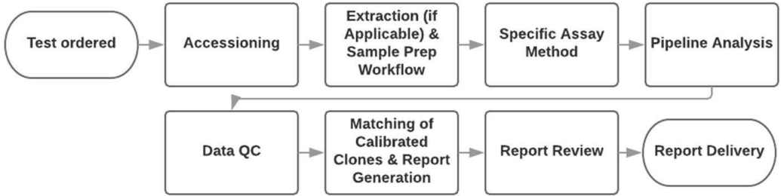
Source: (clonoSEQ® Assay Technical Information)

Does the proposed medical service include a registered trademark component with characteristics that distinguishes it from other similar health components?
Both the clonoSEQ and the clonoSEQ logo are registered trademarks in Australia (Reg Nos. 2034560 and 2034561, respectively).

If the proposed medical service has a prosthesis or device component to it, does it involve a new approach towards managing a particular sub-group of the population with the specific medical condition?
Not applicable.

If applicable, are there any limitations on the provision of the proposed medical service delivered to the patient (i.e. accessibility, dosage, quantity, duration or frequency)?
It is proposed that NGS-based MRD testing using the clonoSEQ® Assay be performed prior to induction treatment to determine MRD baseline assessment. NGS-based MRD testing would then be performed following induction treatment, following consolidation treatment, and in relapsed or refractory disease. Therefore, it is anticipated that on average, patients would receive NGS-based MRD testing up to four times during the initial phase of treatment and one to two times per year on average over the course of their ALL treatment. Additional NGS-based MRD testing using peripheral blood samples, would also be required following transplant or CAR-T therapy, although this would be in a minority of patients.

If applicable, identify any healthcare resources or other medical services that would need to be delivered at the same time as the proposed medical service:
No additional healthcare resources are required when MRD testing is performed using an NGS-based MRD assay.
The handling of ALL patient bone marrow and peripheral blood samples in pathology laboratories is required as part of the preparation of ALL blood and bone marrow specimens for histopathological review and for sample archiving purposes.

If applicable, advise which health professionals will primarily deliver the proposed service:
A request for NGS-based MRD testing in bone marrow or peripheral blood sample from an ALL patient would be initiated by the patient’s managing clinician, most likely a medical oncologist or haematologist.
All steps associated with the conduct of NGS-based MRD testing using the clonoSEQ® Assay will be performed by a trained and qualified scientist/laboratory technician (with the expertise in the conduct of the clonoSEQ® Assay) on the request of the treating clinician, with results of testing being reported back to the treating clinician to guide treatment selection. The proposed service will be conducted at the Molecular Haematology Laboratory, Peter MacCallum Cancer Centre in Melbourne.

If applicable, advise whether the proposed medical service could be delegated or referred to another professional for delivery:
The conduct of NGS-based MRD testing using the clonoSEQ® Assay, would need to be undertaken in a laboratory with expertise in the conduct of NGS-based MRD testing and the clonoSEQ® Assay. Currently, the only laboratory in Australia with the capability is the Molecular Haematology Laboratory, Peter MacCallum Cancer Centre in Melbourne. Additional sites may be included in the future to meet regional needs or as volume increases.

If applicable, specify any proposed limitations on who might deliver the proposed medical service, or who might provide a referral for it:
Consideration should be given to restricting those who can provide a referral for this service to a specialised setting such as a consultant haematologist, oncologist, or related specialists. Further, consideration should be given to restricting those who can deliver this service to a specialised setting with the expertise, capital equipment and reagents (i.e., clonoSEQ® Assay specific reagents and analysis pipeline) required to perform NGS-based MRD testing using the clonoSEQ® Assay.

If applicable, advise what type of training or qualifications would be required to perform the proposed service, as well as any accreditation requirements to support service delivery:
NGS-based MRD testing using the clonoSEQ® Assay would be delivered by a NATA Accredited NGS service at the Molecular Haematology Laboratory, Peter MacCallum Cancer Centre in Melbourne. The Molecular Haematology Laboratory is medically led by Dr. Piers Blombery, a clinical and laboratory haematologist, with multiple expert senior postdoctoral molecular haematology scientific staff.

(a) Indicate the proposed setting(s) in which the proposed medical service will be delivered (select ALL relevant settings):
Inpatient private hospital (admitted patient)
Inpatient public hospital (admitted patient)
Private outpatient clinic
Public outpatient clinic
Emergency Department
Private consulting rooms - GP
Private consulting rooms – specialist
Private consulting rooms – other health practitioner (nurse or allied health)
Private day surgery clinic (admitted patient)
Private day surgery clinic (non-admitted patient)
Public day surgery clinic (admitted patient)
Public day surgery clinic (non-admitted patient)
Residential aged care facility
Patient’s home
Laboratory
Other – please specify below
- Where the proposed medical service is provided in more than one setting, please describe the rationale related to each:
Not applicable

Is the proposed medical service intended to be entirely rendered in Australia?
Yes
No – please specify below
The proposed medical service will be conducted at a centralised laboratory, specifically at the Molecular Haematology Laboratory, Peter MacCallum Cancer Centre in Melbourne. Analysis would be performed on a secure US-based cloud computing platform.

PART 6c – INFORMATION ABOUT THE COMPARATOR(S)

Nominate the appropriate comparator(s) for the proposed medical service (i.e. how is the proposed population currently managed in the absence of the proposed medical service being available in the Australian health care system). This includes identifying health care resources that are needed to be delivered at the same time as the comparator service):
There are no current MBS services for this service. However, in Australian clinical practice, MRD testing is used routinely in the management of ALL, with considerable geographical variability in MRD testing modality. This was acknowledged by the ESC during the PBAC’s consideration of blinatumomab for the treatment of B-cell precursor ALL (B-ALL) (Blinatumomab - B-ALL PSD Jul 2018). The ESC considered MRD testing is routinely conducted in Australian clinical practice at multiple time points in the clinical pathway (para 7.3 and 7.7 Blinatumomab - B-ALL PSD Jul 2018). Further, the PBAC considered appropriate that MRD be measured using PCR or flow cytometry to a level of ≥10⁻⁴ and considered as testing technology improved over time, the level of residual disease detected would decrease (para 2.12 Blinatumomab - B-ALL PSD Jul 2018). Indeed, Sydney predominately uses PCR (Children’s Cancer Institute provides RQ-PCR for paediatric patients, in a non-NATA accredited lab, in a research setting) as the primary method to measure MRD while the rest of Australia uses mpFC. The main difference between the two MRD testing methods is that mpFC is used to detect leukaemia-associated immunophenotypes, while PCR assays such as ASO-PCR, detect fusion genes (e.g., BCR-ABL1).
As alluded to above, there are currently no MRD tests listed on the MBS. However, the preference for MSAC is to include a comparator that is listed on the MBS. As introduced in Question 6, this MSAC application for NGS-based MRD testing using the clonoSEQ® Assay is submitted concurrently with a MSAC application by the RCPA for MRD testing in haematological malignancies. It is understood that the RCPA MSAC submission is likely to be technology agnostic, but the proposed rebate will likely encourage mpFC as the predominate technology for MRD testing. Further, it is understood that the RCPA MSAC submission will propose comparators based on historical evidence such as bone marrow cytogenetics and thus the evidence may not reflect current practice. Importantly, the evidence may have limited applicability to indirectly compare to NGS-based MRD testing. It is therefore more informative to compare NGS-based MRD testing using the clonoSEQ® Assay with mpFC. This also aligns with what is routinely used in Australian clinical practice. Of note, there is an MBS item for flow cytometry, but this is to determine HLAB5701 status prior to initiation of Abacavir therapy and not for MRD monitoring (item number 71203). Therefore, the comparator in this MSAC submission is mpFC.

Does the medical service (that has been nominated as the comparator) have an existing MBS item number(s)?
Yes (please list all relevant MBS item numbers below)
No
Not applicable.

(a) Will the proposed medical service/technology be used in addition to, or instead of, the nominated comparator(s)?
In addition to (i.e. it is an add-on service)
Instead of (i.e. it is a replacement or alternative)

If yes, please outline the extent to which the current service/comparator is expected to be substituted
All patients presenting with ALL should be referred for NGS-based MRD testing instead of traditional MRD testing modalities such as mpFC, at the time of diagnosis, following induction treatment, following consolidation treatment, and at subsequent timepoints as guided by the treatment regimen used.
Current 6-colour mpFC can detect leukemic cells at a sensitivity threshold of <1 x 10⁻⁴ (<0.01%) bone marrow mononuclear cells (MNCs) (Brown 2021). NGS-based MRD methods such as the clonoSEQ® Assay can detect leukemic cells at a sensitivity threshold of 1 x 10⁻⁶ (<0.0001%) bone MNCs (Brown 2021). The concordance rate for detecting between these methods is generally high (>90%) (Brown 2021). Patients who achieve MRD negative status assessed by traditional methods (e.g., mpFC) but have very low levels of persistent leukaemia have a higher risk of relapse than those with no detectable MRD, suggesting that improvements in sensitivity of MRD testing methods improves precision in predicting relapse (Stow 2010). Current mpFC based MRD methods are highly subjective due to the absence of standardisation across laboratories, in particular the interpretation of the data is highly dependent on the expertise of the interpreting hematopathologist and not on a validated objective method (DiGiuseppe 2019, Abou Dalle 2020). Objective and highly standardised NGS-based MRD methods such as the clonoSEQ® Assay overcome this critical issue and as such every patient would have access to the same high quality test, using the same methodology, analytics, reagents, and reporting mechanism to facilitate coordination of care throughout the patient’s journey.

PART 6c CONTINUED – INFORMATION ABOUT ALGORITHMS (CLINICAL MANAGEMENT PATHWAYS)s

Define and summarise the CURRENT clinical management pathway (algorithm) that patients follow when they receive the COMPARATOR service (i.e. the landscape before the proposed service is introduced). An easy-to-follow flowchart is preferred, depicting the current clinical management pathway), but dot-points would be acceptable. Please include health care resources used in the current landscape (e.g. pharmaceuticals, diagnostics and investigative services, etc.).
A simplified flowchart of the current clinical management pathway is presented in Figure 2. There are no current MBS services for this service. However, as discussed above, MRD testing is used routinely in ALL clinical management and also to determine access to targeted therapies such as blinatumomab (Blinatumomab - B-ALL PSD Jul 2019). Generally, the clinical management pathway after the comparator is the selection of consolidation therapy following induction treatment and/or the selection of therapy for relapsed or refractory disease based on the presence of MRD.
It is important to note that the description of the ALL treatment pathway below is simplified and does not incorporate the nuances associated with ALL treatment. The clinical management pathway after the comparator begins when patients are tested for MRD following induction therapy. If a patient is MRD negative, it is recommended that the patient either continues with the initial treatment or undergo allogenic haematopoietic cell transplantation (HCT). If the patient is MRD positive, it is recommended that the patient either continue with the initial treatment (for certain subtypes e.g. Ph positive ALL) or undergo allogenic HCT or receive blinatumomab (B-ALL patients only). Following relapsed or refractory disease, Ph negative B-ALL patients undergo MRD testing again. If a patient is MRD negative, it is recommended that the patient either continues with multiagent chemotherapy or undergo allogenic HCT. If the patient is MRD positive, it is recommended that the patient either undergo allogenic HCT or receive blinatumomab (B-ALL patients only).
See Appendix A Flowcharts for detailed clinical management flowcharts for each ALL subtype.
Figure 2 Current clinical management pathway
Abbreviations: CAR-T=chimeric antigen receptor T-cell therapy; MRD=minimal residual disease

Define and summarise the PROPOSED clinical management pathway (algorithm) that patients would follow after the proposed service/technology is introduced, including variation in health care resources.
A simplified flowchart of the proposed clinical management pathway is presented in Figure 3. The use of NGS-based MRD testing using the clonoSEQ® Assay proposed in this application is an alternative to traditional MRD testing methods currently routinely used in Australian clinical practice, which are not currently listed on the MBS.
The Australian clinical management pathway for ALL tests for MRD after induction treatment and/or in relapsed or refractory disease. However, based on current clinical management guidelines, adult, young adult and paediatric ALL patients should be considered for NGS-based MRD testing at additional time points, as determined by the treatment pathway (Brown 2020, Brown 2021). Further, the guidelines state that treatment decisions for ALL patients should be guided by the MRD test results, including timing of transplant, approach to consolidation, and selection of additional or alternative therapy (Brown 2020, Brown 2021).
Timepoints for NGS-based MRD testing using the clonoSEQ® Assay would include: a baseline assessment prior to induction treatment, a test upon completion of treatment induction, and a test upon completion of consolidation therapy. A baseline assessment is required for baseline characterisation of leukemic clone/s to facilitate subsequent MRD analysis. The leukemic clone/s identified in the baseline assessment are reassessed in subsequent assays, allowing the treating clinician to track the clones and monitor response to therapy. Additional timepoints that are guided by the treatment regimen used, may include testing relapsed or refractory disease and following transplant or chimeric antigen receptor T-cell therapy (CAR-T). Therefore, for a patient with ALL, based on current clinical management guidelines, it is anticipated that on average one baseline NGS-based MRD test and up to three (possibly four in a minority of patients who undergo transplant or CAR-T therapy) follow-up tests will be required during the initial phase of treatment, followed by one to two MRD tests per year on average over the course of the ALL treatment. Notably, bone marrow aspirate samples would be mostly used for NGS-based MRD testing, as this is the type of sample normally collected during routine histopathological assessments and MRD monitoring. However, there is evidence demonstrating that peripheral blood for MRD monitoring is an adequate alternative to bone marrow (Muffly 2021). Further, Adaptive BiotechnologiesTM is currently filing for FDA clearance to assess MRD in peripheral blood samples in ALL using the clonoSEQ® Assay. Therefore, in cases where bone marrow is unavailable, peripheral blood is an acceptable alternative.
It is anticipated that NGS-based MRD testing using the clonoSEQ® Assay would result in more MRD being detected accurately compared to mpFC based MRD testing because it is more sensitive and can detect MRD at lower thresholds (<1 x 10⁻⁴ bone MNCs using mpFC vs 1 x 10⁻⁶ bone MNCs using NGS-based MRD testing) (Brown 2021). Concurrently it is expected that there will be a decrease in false negatives. Therefore, many more ALL patients will be correctly diagnosed with MRD which means they can receive optimal treatment such as access to blinatumomab or CAR-T therapy. This will ultimately lead to better outcomes for ALL patients. The association of MRD with clinical outcome in paediatric and adult ALL was recently demonstrated by a literature based meta-analysis of ALL studies which included 39 publications comprised of 13,637 patients (Berry 2017). The study demonstrated a consistent and strong association in ALL between MRD and clinical outcomes, with results consistent across therapies, methods of and times of MRD assessment, cut-off levels, and disease subtypes (Berry 2017). The event free survival hazard ratio (HR) for achieving MRD negative status was 0.23 (95% Bayesian credible interval [BCI]: 0.18-0.28) for paediatric patients and 0.28 (95% BCI: 0.24-0.33) for adults. The respective HRs in overall survival were 0.28 (95% BCI: 0.19-0.41) and 0.28 (95% BCI: 0.20-0.39).
As alluded to above, MRD testing is routinely used in Australian clinical practice, however it is currently not listed on the MBS. It is assumed MRD testing is funded by hospitals. However, hospital budgets are finite meaning it could be possible that some patients would not be funded, causing inequitable access. The issue of equity was also noted by the PBAC when it considered blinatumomab for B-ALL (Blinatumomab - B-ALL PSD Jul 2018). Specifically, the PBAC considered that MRD testing is not subsidised on the MBS and considered access to MRD testing is not consistently available throughout Australia (para 7.6 Blinatumomab - B-ALL PSD Ju 2018). It is therefore reasonable to assume that inequitable access to MRD testing, results in ALL patients with unknown MRD status and thus these patients may miss out on optimal therapy which may lead to poorer outcomes.
Figure 3 Proposed clinical management pathway
Abbreviations: CAR-T=chimeric antigen receptor T-cell therapy; MRD=minimal residual disease

PART 6d – INFORMATION ABOUT CLINICAL OUTCOMES

Summarise the clinical claims for the proposed medical service against the appropriate comparator(s), in terms of consequences for health outcomes (comparative benefits and harms):
Currently, there is no MBS funding for this medical service.
As described in Question 40, it is foreshadowed that the evidence presented in the Applicant Developed Assessment Report will support a claim that NGS-based MRD testing using the clonoSEQ® Assay is more sensitive and accurate compared to mpFC in identifying and quantifying MRD. This will ultimately lead to improved treatment selection for ALL patients and therefore lead to improved outcomes for ALL patients.

Please state what the overall clinical claim is:
NGS-based MRD testing using the clonoSEQ® Assay is superior to MRD monitoring using mpFC in terms of precision, sensitivity and longitudinal accuracy and non-inferior in terms of safety.

List the key health outcomes (major and minor – prioritising major key health outcomes first) that will need to be measured in assessing the clinical claim for the proposed medical service/technology (versus the comparator):
Safety outcomes: As the collection of bone marrow and peripheral blood is already required as part of the diagnostic work up of ALL patients there are no additional considerations associated with the conduct of NGS-based MRD testing using the clonoSEQ® Assay.
Clinical effectiveness outcomes: The intended use of NGS-based MRD testing using the clonoSEQ® Assay sought through this MSAC application is an alternative to the traditional methods such as mpFC that is sought through the concurrent RCPA MSAC application.
The outcomes relevant to the assessment of the efficacy of NGS-based MRD testing using the clonoSEQ® Assay for the use proposed in this MSAC application are presented in Table 3.

Table 3 Key health outcomes for people with ALL
Outcome | Measurement method | Rationale | Endpoint type
Diagnostic outcomes
Concordance | Concordance with mpFC | Accuracy of MRD detection compared to clinical utility standard. | Primary, secondary
Longitudinal accuracy | Correlation between MRD negative and positive health outcomes and vice versa | Accuracy of MRD test in estimating health outcomes of interest. | Primary, secondary, or exploratory
Clinical utility outcomes
Survival | Overall survival | Impact on health outcomes due to changes in management based on MRD test results. | Primary
Progression | Relapse rate |  | Secondary
 | Progression free survival |  | Secondary
 | Event free survival |  | Secondary
Change in management | Changes in management e.g., treatment selection and frequency/timing of follow-up based on results of MRD test | Impact on clinician decision making based on MRD test results. | Secondary, or exploratory
Abbreviations: MRD=minimal residual disease; mpFC=multiparameter flow cytometry

PART 7 – INFORMATION ABOUT ESTIMATED UTILISATION

Estimate the prevalence and/or incidence of the condition in the proposed population:
The incidence of ALL in Australia in 2017 was 1.5 per 100,000, and is projected to be 1.7 per 100,000 in 2021 (Australian Institute of Health Welfare 2021). It is estimated that in Australia in 2017, there were 364 new cases of ALL diagnosed and it is predicted that there will be 446 new cases of ALL diagnosed in 2021 (Australian Institute of Health Welfare 2021).
Therefore, in 2021 it is estimated that there will be 446 incident cases of ALL in Australia that would be considered for MRD testing.

Estimate the number of times the proposed medical service/technology would be delivered to a patient per year:
The total number and intervals between NGS-based MRD tests would depend upon individual patient treatment regimens. As discussed in Question 40, based on current clinical management guidelines, it is anticipated that one baseline NGS-based MRD test using the clonoSEQ® Assay is required at diagnosis only and up to three (possibly four in a minority of patients who undergo transplant or CAR-T therapy) MRD tests will be required per patient during the initial phase of treatment, followed by one to two MRD tests per year on average over the course of the ALL treatment.

How many years would the proposed medical service/technology be required for the patient?
As discussed above, monitoring of MRD by NGS-based MRD testing is recommended by current clinical management guidelines as part of standard clinical management of ALL (Brown 2020, Brown 2021). Therefore, it is likely testing would be performed over the entire treatment duration.

Estimate the projected number of patients who will utilise the proposed medical service(s) for the first full year:
It is estimated that there will be a 100% uptake rate in paediatric patients. As paediatric patients (children aged 0-14 years old) constitute approximately 60% of all ALL patients this would equate to 271 patients in 2022. It is also estimated that approximately 10% of ALL patients would be unable or unsuitable to receive MRD testing due to age (>80 years of age, approximately 5% of ALL patients), due to comorbidities or dying prior to receiving the test. Therefore, this would mean 18 patients would not receive MRD testing. In total, in 2022 it is estimated that 433 newly diagnosed ALL patients would be eligible for NGS-based MRD test using the clonoSEQ® Assay.

Estimate the anticipated uptake of the proposed medical service/technology over the next three years, factoring in any constraints in the health system in meeting the needs of the proposed population (such as supply and demand factors), as well as provide commentary on risk of ‘leakage’ to populations not targeted by the service.
The current Australian population was 25,704,340 as of 31 March 2021 (Australian Bureau of Statistics 2021). The age-standardised incidence rate of ALL in Australia is projected to be 1.7 per 100,000 in 2021 (Australian Institute of Health Welfare 2021). The Australian Institute of Health and Welfare estimated that there would be 446 newly diagnosed ALL patients in 2021. Applying the population growth rate of 1.6% estimated in September 2018 (latest figure before COVID-19 pandemic) from the Australian Bureau of Statistics, and assuming that there would be on average three tests per patient, it is estimated that there would be 1284 NGS-based MRD tests in 2021, increasing to 1340 tests in 2024 (Table 4).
Leakage to populations not targeted by the service will be constrained by the MBS item number descriptor.
Table 4 Estimated uptake of NGS-based MRD testing
Year | 2021ª | 2022^{b} | 2023^{b} | 2024^{b}
Population to be tested | 428 | 433 | 440 | 447
Total number of tests^{c} | 1284 | 1298 | 1319 | 1340
Note: Data rounded up to the nearest whole number.
ª Based on Cancer in Australia data (projected incidence of ALL in 2021) (Australian Institute of Health Welfare 2021)
^{b} Based on Cancer in Australia data (projected incidence rate of ALL in 2021) and Australian Bureau of Statistics population data (Australian Bureau of Statistics 2021, Australian Institute of Health Welfare 2021)
^{c} Based on assumption of three MRD tests per patient.

PART 8 – COST INFORMATION

Indicate the likely cost of providing the proposed medical service. Where possible, please provide overall cost and breakdown:
REDACTED

Specify how long the proposed medical service/technology typically takes to perform:
NGS-based MRD testing using the clonoSEQ® Assay would take between 7 to 14 days from receiving the sample.

If public funding is sought through the MBS, please draft a proposed MBS item descriptor to define the population and usage characteristics that defines eligibility for the medical service/technology.
Item number XXXX Category 6 – (Pathology Services) – Group P7 Genetics
Proposed item descriptor:
Identification and quantitation of rearranged B-cell receptor gene sequences (including IgH [VDJ], IgH [DJ], IgK, IgL, translocated BCL1/IgH [J] and BCL2/IgH [J] sequences), for the evaluation of measurable/minimal residual disease (MRD) using multiplex polymerase chain reaction (PCR) and massively parallel sequencing (also referred to as next generation sequencing) performed on DNA extracted from bone marrow aspirate or peripheral blood from a patient diagnosed with acute lymphoblastic leukaemia, as requested on behalf of, a specialist or consulting physician, for the purpose of guiding treatment decisions.
Fee: $2,100.00 Benefit: 75% = $1,575.00 85% = $1,785.00

If public funding is sought through an alternative (non-MBS) funding arrangement, please draft a service description to define the population and usage characteristics that defines eligibility for the service/technology.

Not applicable

References
Abou Dalle, I., E. Jabbour and N. J. Short (2020). "Evaluation and management of measurable residual disease in acute lymphoblastic leukemia." Ther Adv Hematol 11: 2040620720910023.3939.
Abuasab, T., J. Rowe and A. Tvito (2021). "Emerging Monoclonal Antibody Therapy for the Treatment of Acute Lymphoblastic Leukemia." Biologics 15: 419-431.2424.
Australian Bureau of Statistics (2021). Population Clock [Online]. https://stat.data.abs.gov.au/Index.aspx?QueryId=313
Australian Institute of Health Welfare (2021). Cancer data in Australia. https://www.aihw.gov.au/reports/cancer/cancer-data-in-australia
Bassan, R., M. Brüggemann, H. S. Radcliffe, E. Hartfield, G. Kreuzbauer and S. Wetten (2019). "A systematic literature review and meta-analysis of minimal residual disease as a prognostic indicator in adult B-cell acute lymphoblastic leukemia." Haematologica 104(10): 2028-2039.1212.
Berry, D. A., S. Zhou, H. Higley, L. Mukundan, S. Fu, G. H. Reaman, B. L. Wood, G. J. Kelloff, J. M. Jessup and J. P. Radich (2017). "Association of Minimal Residual Disease With Clinical Outcome in Pediatric and Adult Acute Lymphoblastic Leukemia: A Meta-analysis." JAMA Oncol 3(7): e170580.1313.
Blinatumomab - B-ALL PSD (Jul 2018). "Public Summary Document for blinatumomab in B-cell precursor acute lymphoblastic leukaemia (B-ALL).".3434.
Blinatumomab - B-ALL PSD (Jul 2019). "Public Summary Document for Blinatumomab in B-cell precursor acute lymphoblastic leukaemia (B-ALL).".3535.
Brown, P., H. Inaba, C. Annesley, J. Beck, S. Colace, M. Dallas, K. DeSantes, K. Kelly, C. Kitko, N. Lacayo, N. Larrier, L. Maese, K. Mahadeo, R. Nanda, V. Nardi, V. Rodriguez, J. Rossoff, L. Schuettpelz, L. Silverman, J. Sun, W. Sun, D. Teachey, V. Wong, G. Yanik, A. Johnson-Chilla and N. Ogba (2020). "Pediatric Acute Lymphoblastic Leukemia, Version 2.2020, NCCN Clinical Practice Guidelines in Oncology." J Natl Compr Canc Netw 18(1): 81-112.2626.
Brown, P. A., B. Shah, A. Advani, P. Aoun, M. W. Boyer, P. W. Burke, D. J. DeAngelo, S. Dinner, A. T. Fathi, J. Gauthier, N. Jain, S. Kirby, M. Liedtke, M. Litzow, A. Logan, S. Luger, L. J. Maness, S. Massaro, R. J. Mattison, W. May, O. Oluwole, J. Park, A. Przespolewski, S. Rangaraju, J. E. Rubnitz, G. L. Uy, M. Vusirikala, M. Wieduwilt, B. Lynn, R. A. Berardi, D. A. Freedman-Cass and M. Campbell (2021). "Acute Lymphoblastic Leukemia, Version 2.2021, NCCN Clinical Practice Guidelines in Oncology." J Natl Compr Canc Netw 19(9): 1079-1109.33.
Brüggemann, M. and M. Kotrova (2017). "Minimal residual disease in adult ALL: technical aspects and implications for correct clinical interpretation." Hematology Am Soc Hematol Educ Program 2017(1): 13-21.1414.
Carlson, C. S., R. O. Emerson, A. M. Sherwood, C. Desmarais, M. W. Chung, J. M. Parsons, M. S. Steen, M. A. LaMadrid-Herrmannsfeldt, D. W. Williamson, R. J. Livingston, D. Wu, B. L. Wood, M. J. Rieder and H. Robins (2013). "Using synthetic templates to design an unbiased multiplex PCR assay." Nat Commun 4: 2680.88.
Ching, T., M. E. Duncan, T. Newman-Eerkes, M. M. E. McWhorter, J. M. Tracy, M. S. Steen, R. P. Brown, S. Venkatasubbarao, N. K. Akers, M. Vignali, M. E. Moorhead, D. Watson, R. O. Emerson, T. P. Mann, B. M. Cimler, P. L. Swatkowski, I. R. Kirsch, C. Sang, H. S. Robins, B. Howie and A. Sherwood (2020). "Analytical evaluation of the clonoSEQ Assay for establishing measurable (minimal) residual disease in acute lymphoblastic leukemia, chronic lymphocytic leukemia, and multiple myeloma." BMC Cancer 20(1): 612.1111.
clonoSEQ® Assay Technical Information. https://www.clonoseq.com/resources-and-support/downloadable-resources/
DiGiuseppe, J. A. and B. L. Wood (2019). "Applications of Flow Cytometric Immunophenotyping in the Diagnosis and Posttreatment Monitoring of B and T Lymphoblastic Leukemia/Lymphoma." Cytometry B Clin Cytom 96(4): 256-265.4040.
Faham, M., J. Zheng, M. Moorhead, V. E. Carlton, P. Stow, E. Coustan-Smith, C. H. Pui and D. Campana (2012). "Deep-sequencing approach for minimal residual disease detection in acute lymphoblastic leukemia." Blood 120(26): 5173-5180.99.
Friend, B. D., M. Bailey-Olson, A. Melton, K. A. Shimano, S. Kharbanda, C. Higham, L. E. Winestone, J. Huang, E. Stieglitz and C. C. Dvorak (2020). "The impact of total body irradiation-based regimens on outcomes in children and young adults with acute lymphoblastic leukemia undergoing allogeneic hematopoietic stem cell transplantation." Pediatr Blood Cancer 67(2): e28079.3636.
Hay, K. A., J. Gauthier, A. V. Hirayama, J. M. Voutsinas, Q. Wu, D. Li, T. A. Gooley, S. Cherian, X. Chen, B. S. Pender, R. M. Hawkins, A. Vakil, R. N. Steinmetz, G. Schoch, A. G. Chapuis, B. G. Till, H. P. Kiem, J. D. Ramos, M. Shadman, R. D. Cassaday, U. H. Acharya, S. R. Riddell, D. G. Maloney and C. J. Turtle (2019). "Factors associated with durable EFS in adult B-cell ALL patients achieving MRD-negative CR after CD19 CAR T-cell therapy." Blood 133(15): 1652-1663.1616.
Health Quality Ontario (2016). "Minimal Residual Disease Evaluation in Childhood Acute Lymphoblastic Leukemia: A Clinical Evidence Review." Ont Health Technol Assess Ser 16(7): 1-52.1515.
Iacobucci, I., S. Kimura and C. G. Mullighan (2021). "Biologic and Therapeutic Implications of Genomic Alterations in Acute Lymphoblastic Leukemia." J Clin Med 10(17).77.
Jabbour, E. J., S. Faderl and H. M. Kantarjian (2005). "Adult acute lymphoblastic leukemia." Mayo Clin Proc 80(11): 1517-1527.44.
Kirsch, I., M. Vignali and H. Robins (2015). "T-cell receptor profiling in cancer." Mol Oncol 9(10): 2063-2070.2929.
Leukaemia Foundation. (2021). "Acute Lymphoblastic Leukaemia (ALL)."
Logan, A. C., N. Vashi, M. Faham, V. Carlton, K. Kong, I. Buño, J. Zheng, M. Moorhead, M. Klinger, B. Zhang, A. Waqar, J. L. Zehnder and D. B. Miklos (2014). "Immunoglobulin and T cell receptor gene high-throughput sequencing quantifies minimal residual disease in acute lymphoblastic leukemia and predicts post-transplantation relapse and survival." Biol Blood Marrow Transplant 20(9): 1307-1313.3838.
Mannis, G. N., T. G. Martin, 3rd, L. E. Damon, C. Andreadis, R. L. Olin, K. A. Kong, M. Faham, J. Hwang, W. Z. Ai, K. M. L. Gaensler, P. H. Sayre, J. L. Wolf and A. C. Logan (2016). "Quantification of Acute Lymphoblastic Leukemia Clonotypes in Leukapheresed Peripheral Blood Progenitor Cells Predicts Relapse Risk after Autologous Hematopoietic Stem Cell Transplantation." Biol Blood Marrow Transplant 22(6): 1030-1036.3737.
Martinez-Lopez, J., J. J. Lahuerta, F. Pepin, M. González, S. Barrio, R. Ayala, N. Puig, M. A. Montalban, B. Paiva, L. Weng, C. Jiménez, M. Sopena, M. Moorhead, T. Cedena, I. Rapado, M. V. Mateos, L. Rosiñol, A. Oriol, M. J. Blanchard, R. Martínez, J. Bladé, J. San Miguel, M. Faham and R. García-Sanz (2014). "Prognostic value of deep sequencing method for minimal residual disease detection in multiple myeloma." Blood 123(20): 3073-3079.2727.
Muffly, L., V. Sundaram, C. Chen, I. Yurkiewicz, E. Kuo, S. Burnash, J. Y. Spiegel, S. Arai, M. J. Frank, L. J. Johnston, R. Lowsky, E. H. Meyer, R. S. Negrin, A. R. Rezvani, S. Sidana, P. Shiraz, J. A. Shizuru, W. K. Weng, M. Liedtke, H. T. Vempaty and D. B. Miklos (2021). "Concordance of peripheral blood and bone marrow measurable residual disease in adult acute lymphoblastic leukemia." Blood Adv 5(16): 3147-3151.3030.
Pulsipher, M. A., C. Carlson, B. Langholz, D. A. Wall, K. R. Schultz, N. Bunin, I. Kirsch, J. M. Gastier-Foster, M. Borowitz, C. Desmarais, D. Williamson, M. Kalos and S. A. Grupp (2015). "IgH-V(D)J NGS-MRD measurement pre- and early post-allotransplant defines very low- and very high-risk ALL patients." Blood 125(22): 3501-3508.2121.
Sala Torra, O., M. Othus, D. W. Williamson, B. Wood, I. Kirsch, H. Robins, L. Beppu, M. R. O'Donnell, S. J. Forman, F. R. Appelbaum and J. P. Radich (2017). "Next-Generation Sequencing in Adult B Cell Acute Lymphoblastic Leukemia Patients." Biol Blood Marrow Transplant 23(4): 691-696.1919.
Salvaris, R. and P. L. Fedele (2021). "Targeted Therapy in Acute Lymphoblastic Leukaemia." J Pers Med 11(8).11.
Short, N. J. K., H.P.; Patel, P.; Kornblau, S.M.; Jorgensen, J.L.; Wang, S.A.; Konopleva, M.; Jain, M.; Kebriaei, P.; Yilmaz, M.; Issa, G.C.; Matthews, J.A.; Noor, M.; Garris, R.; Ravandi, F.; Jabbour, E. (2020). Ultrasensitive Next-Generation Sequencing-Based Measurable Residual Disease Assessment in Philadelphia Chromosome-Negative Acute Lymphoblastic Leukemia after Frontline Therapy: Correlation with Flow Cytometry and Impact on Clinical Outcomes. 62nd ASH Annual Meeting and Exposition, Virtual, American Society of Hematology.
Stow, P., L. Key, X. Chen, Q. Pan, G. A. Neale, E. Coustan-Smith, C. G. Mullighan, Y. Zhou, C. H. Pui and D. Campana (2010). "Clinical significance of low levels of minimal residual disease at the end of remission induction therapy in childhood acute lymphoblastic leukemia." Blood 115(23): 4657-4663.1010.
Turtle, C. J., L. A. Hanafi, C. Berger, T. A. Gooley, S. Cherian, M. Hudecek, D. Sommermeyer, K. Melville, B. Pender, T. M. Budiarto, E. Robinson, N. N. Steevens, C. Chaney, L. Soma, X. Chen, C. Yeung, B. Wood, D. Li, J. Cao, S. Heimfeld, M. C. Jensen, S. R. Riddell and D. G. Maloney (2016). "CD19 CAR-T cells of defined CD4+:CD8+ composition in adult B cell ALL patients." J Clin Invest 126(6): 2123-2138.1717.
Wood, B., D. Wu, B. Crossley, Y. Dai, D. Williamson, C. Gawad, M. J. Borowitz, M. Devidas, K. W. Maloney, E. Larsen, N. Winick, E. Raetz, W. L. Carroll, S. P. Hunger, M. L. Loh, H. Robins and I. Kirsch (2018). "Measurable residual disease detection by high-throughput sequencing improves risk stratification for pediatric B-ALL." Blood 131(12): 1350-1359.1818.
Wu, D., R. O. Emerson, A. Sherwood, M. L. Loh, A. Angiolillo, B. Howie, J. Vogt, M. Rieder, I. Kirsch, C. Carlson, D. Williamson, B. L. Wood and H. Robins (2014). "Detection of minimal residual disease in B lymphoblastic leukemia by high-throughput sequencing of IGH." Clin Cancer Res 20(17): 4540-4548.2020.
Wu, D., A. Sherwood, J. R. Fromm, S. S. Winter, K. P. Dunsmore, M. L. Loh, H. A. Greisman, D. E. Sabath, B. L. Wood and H. Robins (2012). "High-throughput sequencing detects minimal residual disease in acute T lymphoblastic leukemia." Sci Transl Med 4(134): 134ra163.2222.

Appendix A
Flowcharts representing the current clinical management of ALL patients adapted from the ALL NCCN guidelines are presented below (Brown 2020, Brown 2021). Separate flowcharts detail the clinical management of the different ALL patient populations.
Figure 4 Detailed clinical management flowchart for adult and AYA patients (Ph+ ALL)
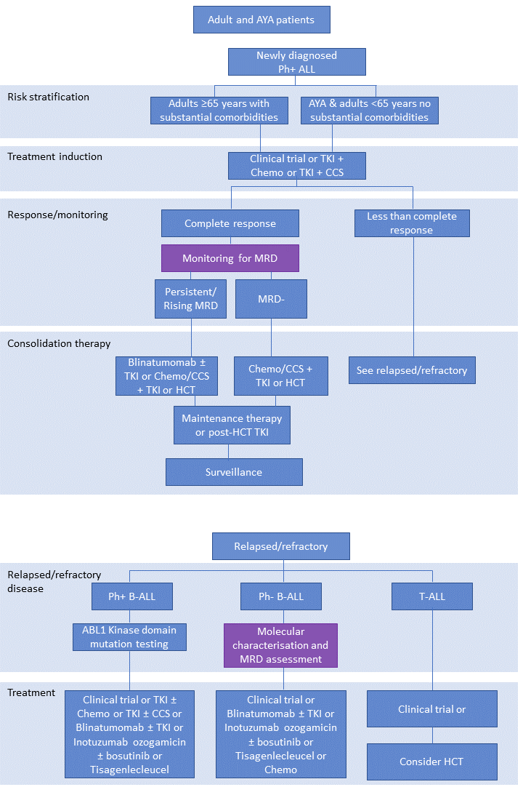
Source: Adapted from Acute Lymphoblastic Leukemia NCCN guidelines version 2.2021 (Brown 2021).
Abbreviations: ALL=acute lymphoblastic leukaemia; AYA=adolescent and young adult; Chemo=chemotherapy; CCS=corticosteroid; HCT=haematopoietic cell transplantation; MRD=minimal residual disease; Ph=Philadelphia chromosome; TKI=tyrosine kinase inhibitor
Figure 5 Detailed clinical management flowchart for adult patients (Ph- ALL)
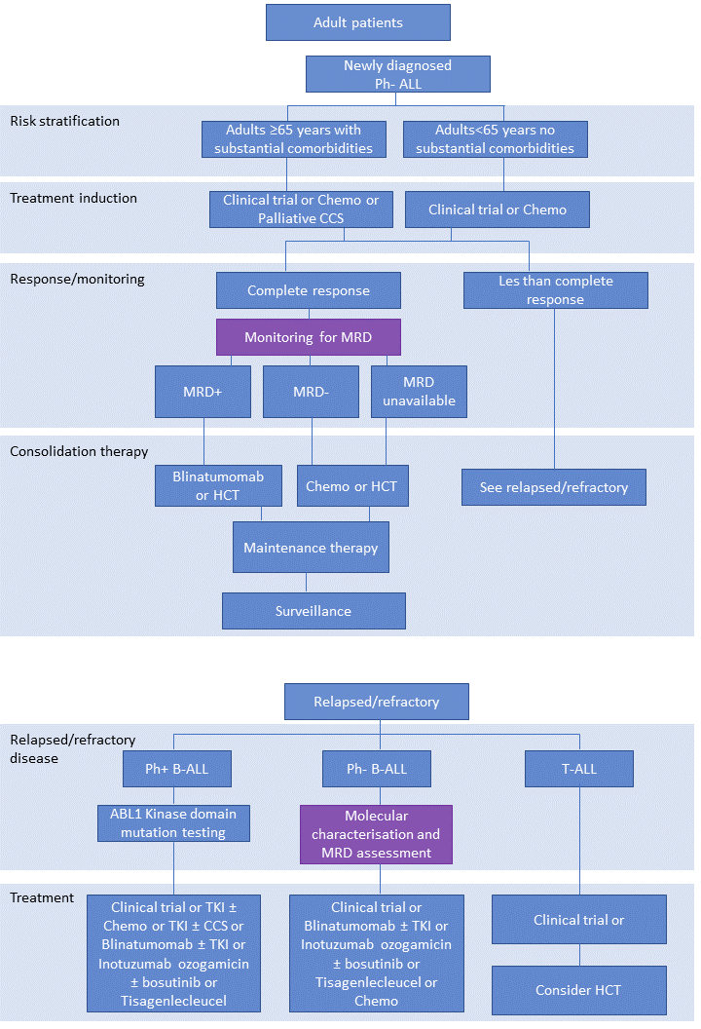
Source: Adapted from Acute Lymphoblastic Leukemia NCCN guidelines version 2.2021 (Brown 2021).
Abbreviations: ALL=acute lymphoblastic leukaemia; Chemo=chemotherapy; CCS=corticosteroid; HCT=haematopoietic cell transplantation; MRD=minimal residual disease; Ph=Philadelphia chromosome; TKI=tyrosine kinase inhibitor

Figure 6 Detailed clinical management flowchart for AYA patients (Ph- ALL)
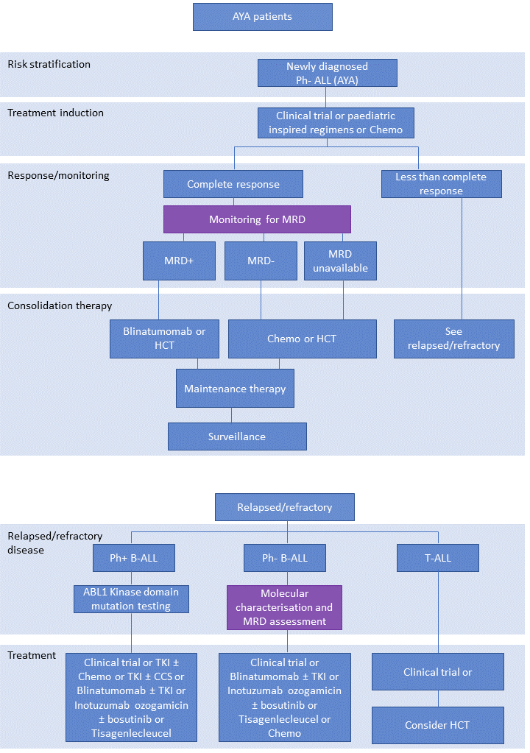
Source: Adapted from Acute Lymphoblastic Leukemia NCCN guidelines version 2.2021 (Brown 2021).
Abbreviations: ALL=acute lymphoblastic leukaemia; AYA=adolescent and young adult; Chemo=chemotherapy; HCT=haematopoietic cell transplantation; MRD=minimal residual disease; Ph=Philadelphia chromosome; TKI=tyrosine kinase inhibitor

Figure 7 Detailed clinical management flowchart for paediatric patients (Ph- or Ph-like B-ALL)
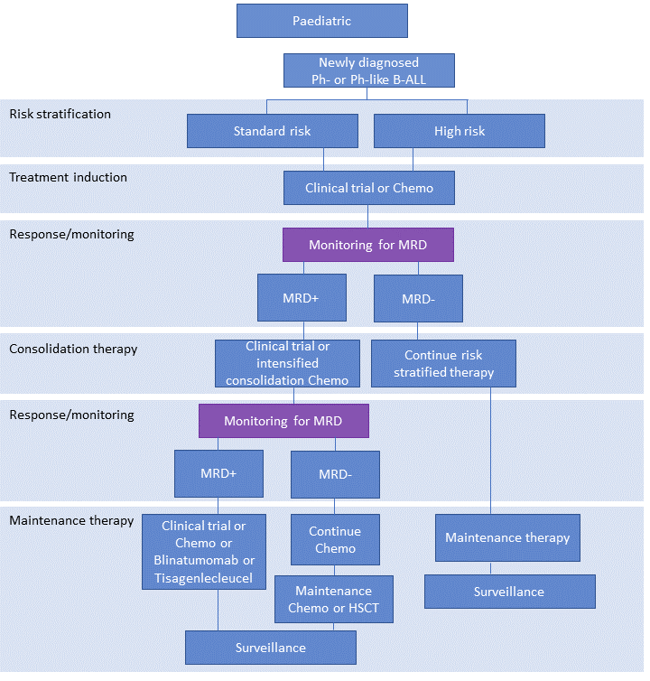
Source: Adapted from Pediatric Acute Lymphoblastic Leukemia NCCN guidelines version 2.2020 (Brown 2020)
Abbreviations: ALL=acute lymphoblastic leukaemia; Chemo=chemotherapy; HSCT=haematopoietic stem cell transplantation; MRD=minimal residual disease; Ph=Philadelphia chromosome

Figure 8 Detailed clinical management flowchart for paediatric patients (Ph+ B-ALL)
Source: Adapted from Pediatric Acute Lymphoblastic Leukemia NCCN guidelines version 2.2020 (Brown 2020)
Abbreviations: ALL=acute lymphoblastic leukaemia; Chemo=chemotherapy; HSCT=haematopoietic stem cell transplantation; MRD=minimal residual disease; Ph=Philadelphia chromosome; TKI=tyrosine kinase inhibitor

Figure 9 Detailed clinical management flowchart for paediatric patients (T-ALL)
Source: Adapted from Pediatric Acute Lymphoblastic Leukemia NCCN guidelines version 2.2020 (Brown 2020)
Abbreviations: ALL=acute lymphoblastic leukaemia; Chemo=chemotherapy; HSCT=haematopoietic stem cell transplantation; MRD=minimal residual disease; Ph=Philadelphia chromosome; TKI=tyrosine kinase inhibitor

Figure 10 Detailed clinical management flowchart for infant patients
Source: Adapted from Pediatric Acute Lymphoblastic Leukemia NCCN guidelines version 2.2020 (Brown 2020)
Abbreviations: ALL=acute lymphoblastic leukaemia; Chemo=chemotherapy; HSCT=haematopoietic stem cell transplantation; MRD=minimal residual disease; Ph=Philadelphia chromosome

