1167

Final Decision Analytic Protocol to guide the assessment of addiction medicine professional attendance and case conferencing items

June 2012

Table of Contents
MSAC and PASC 2
Purpose of this document 2
Summary of key matters for consideration by the applicant 3
Purpose of application 5
Background 6
Current arrangements for public reimbursement 6
Intervention 8
Description 8
Prerequisites 9
Co-administered and associated interventions 10
Listings proposed for MSAC consideration 10
Proposed MBS listing 10
Clinical place for proposed intervention 14
Other relevant considerations 15
Clinical claim 16
Economic analysis 16

MSAC and PASC

The Medical Services Advisory Committee (MSAC) is an independent expert committee appointed by the Minister for Health and Ageing (the Minister) to strengthen the role of evidence in health financing decisions in Australia. MSAC advises the Minister on the evidence relating to the safety, effectiveness, and cost-effectiveness of new and existing medical technologies and procedures and under what circumstances public funding should be supported.

The Protocol Advisory Sub-Committee (PASC) is a standing sub-committee of MSAC. Its primary objective is the determination of protocols to guide clinical and economic assessments of medical interventions proposed for public funding.

Purpose of this document

This document is intended to provide a decision analytic protocol that will be used to guide the assessment of an intervention for a particular population of patients.

Protocols guiding the assessment of the health intervention are typically developed using the widely accepted “PICO” approach. The PICO approach involves a clear articulation of the following aspects of the question for public funding the assessment is intended to answer:

Patients – specification of the characteristics of the patients in whom the intervention is to be considered for use
Intervention – specification of the proposed intervention and how it is delivered
Comparator – specification of the therapy most likely to be replaced by the proposed intervention
Outcomes – specification of the health outcomes and the healthcare resources likely to be affected by the introduction of the proposed intervention

However, as discussed on p.5 below, in the case of addiction medicine professional attendance, complex planning and management, and case conferencing items, PASC resolved that the adoption of the standard PICO approach was not appropriate as an assessment focussed on such an approach may be so narrow that it would not be informative to MSAC.

Summary of key matters for consideration by the applicant

The PASC requests that the applicant note the following issues and address these issues in its assessment:
• An assessment report is sought that presents the overall body of evidence that could inform a judgement as to the overall comparative effectiveness, safety and cost-effectiveness of a model of care involving addiction medicine specialists compared with alternative models of care (e.g., management of patients by psychologists or psychiatrists; or management by multi-disciplinary teams). In addition to considering models of care that differ by provider of medical service, models of care that involve different types of services should also be compared e.g., a model of care involving one-on-one professional attendances (including longer consultations for complex treatment and management) should be compared with a model of care that involves both professional attendances and multi-disciplinary case-conferencing activities and with a model of care involving only multi-disciplinary teams (e.g., as delivered by psychiatrists).
• On the basis of the likely claims of potential clinical equivalence or superiority for the model of care involving addiction medicine specialists compared with alternative models of care, PASC considered that the assessment report would present either a cost-minimisation or cost- effectiveness analysis, respectively.
• Broader considerations besides the impact on a patient’s quality-adjusted survival should be presented in an application requesting the availability of additional addiction medicine MBS items. For example, workforce issues that may be addressed (and the downstream impact on patient outcomes) by availability of such items could be addressed. Similarly, if the claim is made that provision of services by addiction medicine specialists will result in reduced costs of crime and reduced costs for the criminal justice system, then there will need to be a consideration of these impacts. Impacts on family and society more generally could also be included in an economic analysis.
• In addition to a comparison of models of care involving addiction medicine specialists with alternative models of care that are available to patients with addictions, PASC recommended that any assessment presented to MSAC should address a wider set of claims including:
o What evidence is available to demonstrate that there is unmet need for addiction medicine specialists in the private sector, in the public sector and overall (e.g., how long does a patient have to wait to see an addiction medicine specialist; what proportion of patients with addiction problems in whom the services of an addiction specialist are indicated do not access such services; has a shortage of supply been identified by other parties such as state health departments, etc)?
o What evidence is available in relation to the consequences of unmet need?

o To what extent is the failure to access addiction medicine services due to shortage of addiction medicine specialists (i.e., due to workforce shortage)? To what extent is the failure to access addiction medicine services due to other factors (e.g., requirements for a referral, fees)?

o What evidence exists to support the claim that increasing reimbursement for services delivered by addiction medicine specialists in the private sector results in an increase in supply of addiction medicine specialists?
o Will an increase in supply of addiction medicine specialists result in improved access to addiction medicine services (i.e., expansion in number of patients accessing addiction medicine services)? What evidence is available with respect to the effects of different approaches to funding for the various models of care that are possible? To what extent will increased funding in the private sector cause a transfer of services from the public to the private sector? To what extent will increased funding in the private sector result in an overall increase in expenditure on these services?

Purpose of application

An application requesting the listing of four time-tiered professional attendance (consultation) and six time-tiered case conferencing items on the Medicare Benefits Schedule (MBS) to be provided by addiction medicine specialists was progressed by the Department of Health and Ageing (DoHA) in consultation with the Australasian Chapter of Addiction Medicine (AChAM). The AChAM had initially requested access to a greater number of MBS items than DoHA actually proposed to PASC (e.g. items for complex planning and management, and for the purpose of interviewing family members/carers were also requested). DoHA considered that the time-tiered and case conferencing items as proposed could potentially be used for such purposes. PASC determined that the application should be broadened to include items for complex treatment and management planning, but did not determine that family/carer interview items be included. The applicant is seeking a funding model that reflects contemporary addiction medicine practice.

PASC noted that the approach of a traditional MSAC HTA assessment would seek to derive estimates of the comparative effectiveness, safety and cost-effectiveness of MBS of the proposed scenario (where four time-tiered professional attendance items, two complex treatment and management items, and six time-tiered case-conferencing items would be available and claimed) versus the current scenario (where specific MBS professional attendance and case-conferencing items are claimed) using the standard MSAC PICO plus economic evaluation approach.

PASC considered that such an approach was not appropriate in this case for two reasons: (i) the approach was too narrow to permit assessment of various claims made by the AChAM; and (ii) the approach was likely to be unhelpful in informing MSAC about the value of services provided by addiction medicine specialists because data and evidence to inform such a specific approach were unlikely to be available. For example, there were unlikely to be data to answer the question as to what the health outcomes associated with a funding mechanism involving 4 time-tiered services would be compared with a funding mechanism that had only an initial assessment item and a review item. Although PASC considered that MSAC would be unlikely to be able to answer a question as to whether it would be preferable to have four time-tiered professional attendance (consultation) items, two complex treatment and management items, and six time-tiered case conferencing items on the MBS for addiction medicine specialists compared with the currently available and used items, PASC considered that evidence may be available that would permit MSAC to provide advice to the Minister as to the comparative effectiveness, safety and cost-effectiveness of services as delivered by addiction medicine specialists versus alternative models of care for patients with addictions (e.g., delivery of services by psychologists or by psychiatrists) i.e., evidence was likely to be available to permit MSAC to determine a response to the question as to whether dedication of resources to this specialty was worthwhile in a general sense. PASC agreed that the final DAP should reflect this approach.

Background

Current arrangements for public reimbursement

There are currently no specific addiction medicine professional attendance items, complex treatment and management items, or case conferencing items on the MBS.

Addiction medicine was recognised as a speciality in 2009 by the Australian Medical Council. Subsequently, in the 2010 Federal Budget, addiction medicine specialists were granted access to the Group A3 specialist items on the MBS. As of 26 October 2011, only eight addiction medicine practitioners had registered with Medicare Australia to use A3 specialist attendance items. The proposal for an application stated that addiction specialists have tended not to register with Medicare as ‘specialists’ because to do so would limit their patients’ rebates to A3 specialist items; instead, they prefer to have their patients seek Medicare reimbursement for their services in their capacities as GPs, psychiatrists, consultant physicians, other medical practitioners, etc, as set out below. The AChAM advised that the A3 items provide inadequate reimbursement for clinically effective addiction medicine practice.

It is reported that there are currently approximately 160 addiction medicine specialists in Australia. The ratio of specialists working in the public versus private setting varies from State to State. PASC was advised that the Recognition of Medical Specialities Advisory Committee (RoMSAC) reported that
75% of surveyed FAChAM were employed in the public sector. The AChAM provided data suggesting that approximately 25% of FAChAM provide at least some MBS reimbursed services. However, access to MBS items is not consistent across the membership of the AChAM because members have varying qualifications. Some have qualifications in addition to addiction medicine e.g. some are also vocationally registered GPs, some are consultant physicians, and some are consultant psychiatrists. Consultant physicians and psychiatrists are able to claim for services under a wider range of MBS items. Others who have addiction medicine as their only specialty are limited in their options to access reimbursement of services under the MBS.

Reimbursement for services is currently claimed under the following groups of MBS services:

• GROUP A1 – GENERAL PRACTITIONER PROFESSIONAL ATTENDANCES
Figures provided by the AChAM indicate that 29 (~18%) of addiction medicine specialists hold Fellowship of the Royal Australian College of General Practitioners or of the Australian College of Rural and Remote Medicine, and a further 18 (11%) are vocationally registered GPs and are able access to this group of items.
• GROUP A2 – OTHER MEDICAL PRACTITIONER PROFESSIONAL ATTENDANCES
Figures provided by the AChAM indicate that 35 (~22%) of addiction medicine practitioners are non-vocationally registered GPs, specialist trainees or other medical practitioners and are able access to this group of items. A further 17 (~11%) addiction medicine specialists hold Fellowship of the Australasian Faculty of Public Health Medicine and could have access to this group of items.
• GROUP A3 – SPECIALIST PROFESSIONAL ATTENDANCES

have registered with Medicare Australia to use Group A3 specialist attendance items.
• GROUP A4 – CONSULTANT PHYSICIAN PROFESSIONAL ATTENDANCES
Figures provided by the AChAM indicates that 19 (~12%) of addiction medicine specialists hold Fellowship of the Royal Australasian College of Physicians (RACP) and are able to access to this group of items.

• GROUP A8 – CONSULTANT PSYCHIATRIST PROFESSIONAL ATTENDANCES
The Chapter has indicated that 44 (~27%) of addiction medicine specialists hold Fellowship of the Royal Australian and New Zealand College of Psychiatrists (RANZCP) and would have access to this group of items.
• GROUP A13 - PUBLIC HEALTH PHYSICIAN ATTENDANCES TO WHICH NO OTHER
ITEM APPLIES
Figures provided by the AChAM indicate that 17 (~11%) of addiction medicine specialists hold Fellowship of the Australasian Faculty of Public Health Medicine and have access to this group of items.
• GROUP A15 – CASE CONFERENCING
Specialists do not have access to case conferencing items, but addiction medicine specialists who are either vocationally registered or non-vocationally registered GPs (and who have not registered with Medicare Australia as Group A3 ‘specialists’) have access to existing Group A15 care planning and case conferencing items 721-758; consultant physicians have access to case conferencing items 820-858; and consultant psychiatrists have access to case conferencing items 861-880.
• GROUP A20 – GP MENTAL HEALTH TREATMENT
Addiction medicine specialists who are either vocationally registered or non-vocationally registered GPs (numbers as above) have access to this group of GP Mental Health treatment plan items and, depending on their further training, to Focussed Psychological Strategy items.

The application noted that the traditional structure of specialist professional attendances (Groups A3 and A4 of the MBS) provide a more generously rebated item for an initial attendance and a less generously rebated item for a follow-up attendance. The application suggested that this traditional structure does not suit discussion-based, cognitive specialties such as addiction medicine, which rely on time spent with a patient to assess and resolve more complex issues. The application noted that, with the exception of MBS items for professional attendances by specialists in psychiatry, items relating to professional attendances by specialists are generally not claimable under Medicare for ongoing care. It is claimed that, because addictive disorders, like psychiatric disorders, are typically complex, chronic, remitting and relapsing, addiction treatment requires a model that allows ongoing care items for attendances that will vary in terms of both time and complexity. Hence, it was initially proposed that an application requesting listing of four time-tiered professional attendance (consultation) items and six time-tiered case conferencing items be provided on the MBS (for use by addiction medicine specialists) be submitted to MSAC. As discussed in the section titled ‘Purpose of application’ on p.5 above, PASC noted that attempts to derive estimates of the comparative effectiveness, safety and cost-effectiveness of MBS of the proposed scenario (where four time-tiered professional attendance items, two complex treatment and management items, and six case

professional attendance and case-conferencing items are claimed) using the standard MSAC PICO (plus economic evaluation approach) would likely be futile, as there are unlikely to be any data available to answer the question as to what the outcomes would be (where both scenarios are compared).

PASC considered that evidence may be available to permit MSAC to provide advice to the Minister as to the comparative effectiveness, safety and cost-effectiveness of services as delivered by addiction medicine specialists versus alternative models of care for patients with addictions (e.g., delivery of services by psychologists or by psychiatrists) i.e., MSAC could probably determine a response to the question as to whether dedication of resources to this specialty was worthwhile in a general sense.

Intervention

Description

In relation to the professional attendance items and complex planning and management items, an addiction medicine specialist would provide a clinically relevant combination of the following: inpatient or ambulatory withdrawal management (from substances including alcohol, opioids, stimulants, cannabis and benzodiazepine); assessment and management of people with chronic pain and problematic prescription opioid use; motivational enhancement and psychological interventions including but not limited to cognitive based therapy (CBT)-based interventions for substance use disorders and pathological gambling; assessment and management of psychiatric and medical co- morbidities and complications of substance abuse (e.g., viral hepatitis, HIV infection, injecting related infections).

Addiction specialists carry out complex biopsychosocial assessments, however an initial consultation may be opportunistic and directed to immediate problems, and a full detailed assessment may be deferred until a measure of stability is achieved. As both initial and follow-up consultations can be either shorter or longer, depending on a patient’s needs, time-tiered items have been proposed as they would allow addiction medicine specialists to bill the relevant item based on time spent with a patient.

It is claimed that, with the high prevalence of psychiatric and medical co-morbidities and frequently compromised personal and social functioning, multidisciplinary care of a patient is frequently needed, with co-ordination of a number of medical, psychological, social welfare and legal services. Addiction specialists therefore requested access to items for complex care planning, case conferencing, interviewing family/carers, as well as access to allied mental health services, particularly through direct referral rights to clinical psychologists (as do psychiatrists and paediatricians). As stated earlier, PASC determined that the time-tiered items, complex planning and management items, and case conferencing items be considered. In relation to the complex planning and management items, and the case conferencing items, it is proposed these items would only apply to a patient who suffers from at least one medical condition that has been (or is likely to be) present for at least 6 months, or that is terminal, and has complex needs requiring care from a multidisciplinary team.

The proposed requirement, in relation to case conferencing items, that the item could only be claimed for a patient who suffers from at least one medical condition that has been (or is likely to be) present for at least 6 months, or that is terminal, and has complex needs requiring care from a multidisciplinary team, is not included in the proposed item descriptors. In the case of (consultant physician) case conferencing items, a footnote directs physicians to explanatory notes that specify these criteria. PASC presumed a similar note would be included for addiction medicine case conferencing items.

The case conferencing items would enable a multidisciplinary team to carry out the following:

• discuss a patient’s history;
• identify a patient’s multidisciplinary care needs;
• identify outcomes to be achieved by members of the case conference team giving care and service to the patient;
• identify tasks that need to be undertaken to achieve these outcomes, and allocating those tasks to members of the case conference team; and
• assess whether previously identified outcomes (if any) have been achieved.

Prerequisites

REFERRAL

The proposed item descriptors (provided in Table 1) indicate that it is proposed that the patient must be referred for the intervention by a medical practitioner other than the addiction medicine specialist who is to provide the intervention. The referral process will be in accordance with the MBS G6.1
Referral of Patients to Specialist or Consultant Physician.

Although the requirement for referral from a medical practitioner is included in the descriptors for existing professional attendance items, the proposal for time-tiered items noted that, for some marginalised patients, the need to obtain a GP referral may compromise access to timely addiction specialist advice. It is claimed that it may also be counterproductive to require GP referral when people are directed to see an addiction medicine specialist by the courts, authorities such as the Roads and Traffic Authority or treatment agencies. A suggestion was received by PASC that consideration should be given to accepting written referral from such agencies. It was suggested that a precedent for referral from a non-medical practitioner to a specialist did exist (e.g., optometrists can refer patients to ophthalmologist directly). The PASC did not provide on any comment on this suggestion.

TRAINING

It is proposed that only qualified addiction medicine specialists will be able to bill the proposed MBS
items.

To be eligible for registration as an addiction medicine specialist, a practitioner must have completed three years of training at the ‘Advanced Training’ level under the Chapter of Addiction Medicine, 18 months of which must be in accredited drug and alcohol positions. Entry into training is by recognition of background and prior experience of applicants. The training program is overseen by the Chapter's

Education Committee and successful graduates are awarded Fellowship of the Australasian Chapter of
Addiction Medicine (FAChAM).

To enter the training program, applicants must be registered medical practitioners in Australia or New Zealand AND EITHER have completed first part training and examinations for the FRACP OR hold Fellowship of one of these Colleges or Faculties:
• Anaesthetics (FANZCA)
• Emergency Medicine (FACEM)
• General Practice (FRACGP and FRNZCGP)
• Internal Medicine (FRACP)
• Paediatrics & Child Health (FRACP)
• Pain Medicine (FFPMANZCA)
• Psychiatry (FRANZCP)
• Public Health Medicine (FAFPHM)
• Rehabilitation Medicine (FAFRM)
• Australian College of Rural and Remote Medicine (FACRRM)

Co-administered and associated interventions

As noted above, a requirement will be that referral from a medical practitioner (or other approved referring authority) be required prior to the initiation of a course of treatment under these items by an addiction medicine specialist.

No other specific services are required to be administered prior to, with or following the requested medical services. However, follow-up services that might need to be rendered following an addiction medicine service would be discussed during the consultation. An addiction medicine specialist may order various pathology tests or diagnostic imaging services during an initial or subsequent
consultation for assessment of a patient’s substance status or broader health status.

Listings proposed for MSAC consideration

Proposed MBS listing

The proposed MBS item descriptors are provided in Table 1.

Table 1: Proposed MBS item descriptor for proposed addiction medicine services
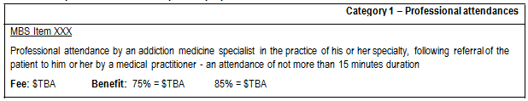

Table 1: Proposed MBS item descriptor for proposed addiction medicine services

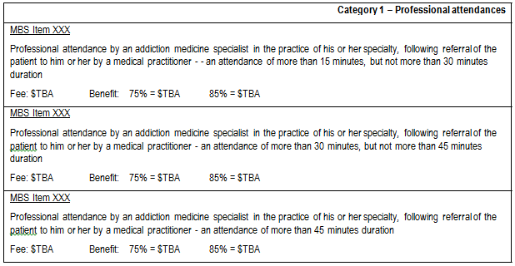
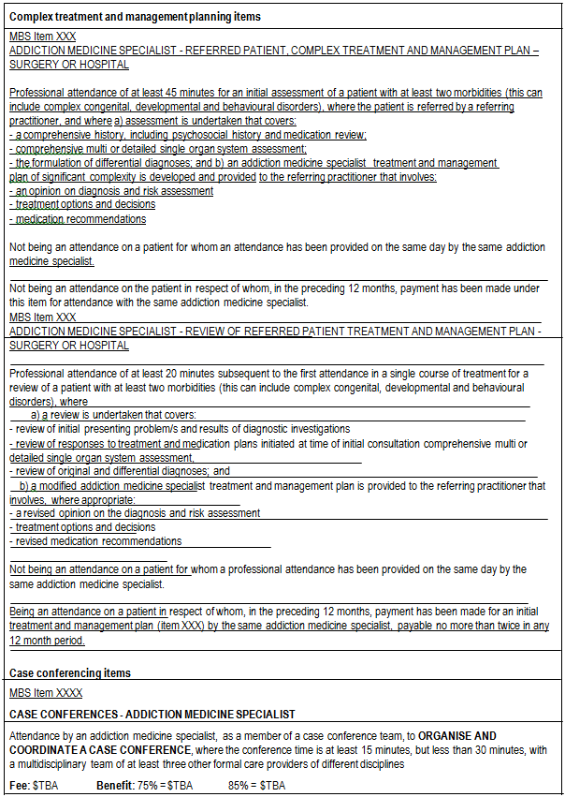

Table 1: Proposed MBS item descriptor for proposed addiction medicine services
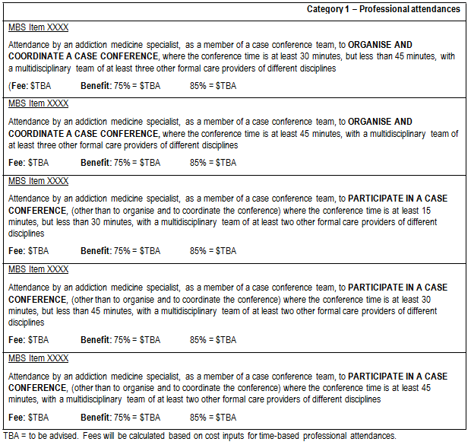

Although the proposed item descriptors do not specify the patient population to whom the items may be delivered, PASC considered it reasonable to assume that an addiction medicine specialist would only be attending to patients with addictions. However, it noted that patients requiring the services of an addiction medicine specialist are a heterogeneous group. PASC agreed that no specification of the patient population to whom the items may be delivered needs to be included in the MBS item descriptors.

As discussed on p.5, PASC resolved that the traditional MSAC HTA assessment approach, which would seek to derive estimates of the comparative effectiveness, safety and cost-effectiveness of MBS of the proposed scenario (where four time-tiered professional attendance and six time-tiered case- conferencing items would be available and claimed) versus the current scenario (where currently available specific MBS professional attendance and case-conferencing items are claimed), was not appropriate for two reasons: (i) the approach was too narrow to permit assessment of various claims made by the AChAM; and (ii) the approach was likely to be unhelpful in informing MSAC about the value of services provided by addiction medicine specialists because data and evidence to inform such a specific approach were unlikely to be available. For example, there were unlikely to be data to

answer the question as to what the health outcomes associated with a funding mechanism involving 4 time-tiered services would be compared with a funding mechanism that had only an initial assessment item and a review item. Although PASC considered that MSAC would be unlikely to be able to answer a question as to whether it would be preferable to have four time-tiered professional attendance (consultation) and six time-tiered case conferencing items on the Medicare Benefits Schedule (MBS) for addiction medicine specialists compared with the currently available and used items, PASC considered that evidence may be available that would permit MSAC to provide advice to the Minister as to the comparative effectiveness, safety and cost-effectiveness of services as delivered by addiction medicine specialists versus alternative models of care for patients with addictions (e.g., delivery of services by psychologists or by psychiatrists) i.e., evidence was likely to be available to permit MSAC to determine a response to the question as to whether dedication of resources to this specialty was worthwhile in a general sense.

Thus, PASC resolved that the “intervention” should be more broadly defined than as proposed above. PASC resolved that it would be appropriate for an assessment report to present the overall body of evidence that could inform a judgement as to the overall comparative effectiveness, safety and cost- effectiveness of a model of care involving addiction medicine specialists compared with alternative models of care (e.g., management of patients by psychologists or psychiatrists; or management by multi-disciplinary teams). In addition to considering models of care that differ by provider of medical service, models of care that involve different types of services should also be compared in any assessment report submitted to MSAC e.g., a model of care involving one-on-one professional attendances could be compared with a model of care that involves both professional attendances and multi-disciplinary case-conferencing activities, and with a model of care involving only multi- disciplinary teams or a model of care involving only group therapy sessions.

Due to the variety of addictions for which patients may seek to consult an addiction medicine specialist, and in recognition that the strength of evidence for some types of addiction conditions may be better than for other types of addiction, PASC recommended that the overall body of evidence should be presented in a systematised manner so that evidence for similar addictions is presented together. For example, evidence relating to withdrawal management (from substances including alcohol, opiates, stimulants, cannabis, benzodiazepines) could be presented separately from evidence involving assessment and management of patients with chronic pain and problematic opiate use; which could be presented separately from evidence relating to psychological interventions for pathological gambling, etc. It was important, however, that the number of classifications remained limited so that conclusions could be drawn that could be considered applicable to other addiction conditions where the evidence was more limited.

Clinical place for proposed intervention

Patients treated by addiction medicine specialists include people of all ages who suffer from various forms of addiction. Addiction medicine involves the assessment, diagnosis and treatment of a variety of addictive behaviours (e.g. substance [including opioid, cannabis, alcohol, stimulants, benzodiazepines, nicotine, etc] use disorders and problem and pathological gambling). Addiction specialists are qualified to manage complex medical and psychosocial comorbidities and consequences associated with these disorders.

The proposal for an application indicated that the clinical place for professional attendance by an addiction medicine specialist occurs at the point at which a general practitioner (or other approved referring authority) makes a clinical judgement that such an attendance is necessary.

The AChAM claims that there is a shortage of medical services for drug and alcohol problems in the community. As an example, it cites unacceptable waiting periods for opioid pharmacotherapies in many outer metropolitan and regional areas and notes that less than 3.5% of all general practitioners are methadone or buprenorphine prescribers. It is claimed that general practitioners lack time, feel too unskilled, or are unwilling, to treat alcohol and other drug problems, particularly those that are more complex or severe. The proposal for an application, however, also acknowledged that some GPs are interested in this area of medical practice and choose to keep up-to-date with addiction medicine
‘best practice’.

Although it is noted that referral from the addiction medicine specialist back to a GP is desirable wherever the GP is willing and able to manage ongoing care, there are cases where, owing to the severity and/or complexity of problems and the preference of the GP, the addiction specialist will need to take substantial responsibility for ongoing care, or shared care. This is particularly the case for patients with complex needs such as acquired brain injuries and co-morbid mental health issues who are more likely to display difficult behaviours. It is anticipated that, under a referral-based model where addiction medicine specialists take referrals from GPs of the more complex end of the spectrum of substance use problems, physical and psychiatric co-morbidities will be the rule rather than the exception. It is suggested that this resembles the situation with patients with psychiatric disorders.

Other relevant considerations

In considering comments received on the Consultation DAP, PASC noted that the fundamental claim made by addiction medicine specialists is that the current MBS rebate structure provides insufficient support to ensure viable private practice specialising in addiction medicine. PASC noted that the fundamental objective of the MBS was not to provide a remuneration system for health practitioners but, instead, the MBS is a public subsidy system intended to ensure that Australian public have equitable access to effective, safe and cost-effective medical services. However, PASC acknowledged that, if a model of care involving addiction medicine specialists, provided incremental health benefits at a reasonable incremental cost compared to other models of care, and if there was currently a shortage of addiction medicine specialists such that patients requiring such care were unable to receive it, then expansion of the number of services provided by addiction medicine specialists in the private sector would be desirable.

In addition to a comparison of models of care involving addiction medicine specialists with alternative models of care that are available to patients with addictions, PASC recommended that any assessment presented to MSAC should address a wider set of claims including:

• What evidence is available to demonstrate that there is unmet need for addiction medicine specialists in the private sector, in the public sector and overall (e.g., how long does a patient have to wait to see an addiction medicine specialist; what proportion of patients with addiction problems in whom the services of an addiction specialist are indicated do not access such

services; has a shortage of supply been identified by other parties such as state health departments, etc)?
• What evidence is available in relation to the consequences of unmet need?

• To what extent is the failure to access addiction medicine services due to shortage of addiction medicine specialists (i.e., due to workforce shortage)? To what extent is the failure to access addiction medicine services due to other factors (e.g., requirements for a referral, fees)?
• What evidence exists to support the claim that increasing reimbursement for services delivered by addiction medicine specialists in the private sector results in an increase in supply of addiction medicine specialists?
• Will an increase in supply of addiction medicine specialists result in improved access to addiction medicine services (i.e., expansion in number of patients accessing addiction medicine services)? What evidence is available with respect to the effects of different approaches to funding for the various models of care that are possible? To what extent will increased funding in the private sector cause a transfer of services from the public to the private sector? To what extent will increased funding in the private sector result in an overall increase in expenditure on these services?

Clinical claim

PASC anticipated that an application considering the comparative effectiveness, safety and cost- effectiveness of a model of care involving addiction medicine specialists with alternative models of care would claim that:
• Patients who are managed by a model of care involving delivery of services by an addiction medicine specialist experience either equivalent or superior quality-adjusted survival compared to patients managed by alternative models of care.
• Appropriate funding (via the listing of the proposed items) for services provided by addiction
medicine specialists is likely to create a financial incentive for addiction medicine specialists to provide additional services to patients with substance use disorders in the community and this will have a positive impact to the community overall.

Economic analysis

On the basis of the likely claims of potential clinical equivalence or superiority for the model of care involving addiction medicine specialists compared with alternative models of care, PASC considered that the assessment report would present either a cost-minimisation or cost-effectiveness analysis, respectively.

An appropriate economic analysis could also incorporate costs and benefits associated with transfer of services delivered under the public system to the private system and also costs and benefits associated with expansion of availability of addiction medicine services through the MBS. Estimates of transfer rates should be supported with evidence.

Broader considerations besides the impact on a patient’s quality-adjusted survival should be presented in an application requesting the availability of additional addiction medicine MBS items. For example,

as discussed in the previous paragraph, workforce issues that may be addressed by availability of such items could be addressed. Similarly, if the claim is made that provision of services by addiction medicine specialists will result in reduced costs of crime and reduced costs for the criminal justice system, then there will need to be a consideration of these impacts. Impacts on family and society more generally could also be included in an economic analysis.

