Application 1566
Immunoglobulin for Myasthenia Gravis (MG)

PICO Confirmation
(to guide a new referral to MSAC)

Phone: +61 2 6289 7550
Email: hta@health.gov.au, Website: http://www.msac.gov.au

Summary of PICO criteria to define the question(s) to be addressed in an Assessment Report to the Medical Services Advisory Committee (MSAC)
Table 1: PICO criteria for indication 1: Myasthenic Crisis
Component | Description
Patients | Patients with MG with:  - myasthenic crisis with respiratory insufficiency requiring intubation and assisted ventilation  OR  - risk of myasthenic crisis displaying symptoms of respiratory insufficiency such as persistent difficulty with speech, difficulty chewing or swallowing and/or shortness of breath on minimal activity  AND  - clinical assessment confirms severe disability as measured by a Myasthenia Gravis Composite (MGC) score of at least four points who are currently eligible for immunoglobulin (Ig) treatment in Australia according to version 3 of the Criteria for the clinical use of immunoglobulin in Australia.
Intervention | Intravenous Immunoglobulin (IVIg)
Comparator | Plasma exchange delivered via  - peripheral or  - central venous access
Outcomes | The outcomes listed are those identified in the development of the PICO. Additional or more specific outcomes identified during the evaluation process that are considered relevant to the intervention or comparator treatment may be addressed in the evaluation report (Contracted Assessment). Broadly the outcomes identified pre assessment and considered in scope are:  Safety Outcomes:  - adverse events associated with administration of the therapy (such as IV line insertion risks, line sepsis)  - side effects of the therapy (such as haemodynamic effects, inflammatory and thrombotic effects)  Clinical effectiveness outcomes:  - mortality  - rates of infection  - change in disability and muscle strength (e.g. Myasthenia Gravis Composite [MGC] score)  - change in quality of life  - rates of remission  - disease stability  - time to relapse  - need for ventilation or other life support systems  Healthcare system resources utilisation  - Changes in health system resource utilisation associated with the intervention  - Ig products,  - Infusion equipment,  - Administrative and clinician time (e.g. resources associated with requesting, and authorising, access to Ig),  - Nursing time (for initiation and monitoring if IVIg)  - Hospitalisation (including use of hospital resources)  - Medication to treat of adverse events (e.g. analgesia or antihistamines)  - Training of patient or carer to provide infusions (SCIg only),  - Product dispensing and disposal of any unused product  - Follow-up and/or monitoring visits, including regular neurology visits  - Change in health system resource utilisation associated with the comparator(s)  - Comparator products  - Resources to deliver the comparator (eg hospital and staff time for IV steroids and plasma exchange, dispensing for oral treatments)  - Hospitalisation  - Management of adverse events  - Follow-up and/or monitoring visits, including regular neurology visits

Table 2: PICO criteria for indication 2: Prior to Surgery
Component | Description
Patients | Patients with advanced MG disease, bulbar symptoms or respiratory involvement, in whom surgery and/or thymectomy is planned who are currently eligible for immunoglobulin (Ig) treatment in Australia according to version 3 of the Criteria for the clinical use of immunoglobulin in Australia
Intervention | Intravenous Immunoglobulin (IVIg)
Comparator | Plasma exchange delivered via  - peripheral or  - central venous access
Outcomes | The outcomes listed are those identified in the development of the PICO. Additional or more specific outcomes identified during the evaluation process that are considered relevant to the intervention or comparator treatment may be addressed in the evaluation report (Contracted Assessment). Broadly the outcomes identified pre assessment and considered in scope are:  Safety Outcomes:  - adverse events associated with administration of the therapy (such as IV line insertion risks, line sepsis)  - side effects of the therapy (such as haemodynamic effects, inflammatory and thrombotic effects)  Clinical effectiveness outcomes:  - mortality  - rates of infection  - change in disability and muscle strength (e.g. Myasthenia Gravis Composite [MGC] score)  - change in quality of life  - rates of remission  - disease stability  - time to relapse  - time to surgery  Healthcare system resources utilisation  - Changes in health system resource utilisation associated with the intervention  - Ig products,  - Infusion equipment ,  - Administrative and clinician time (e.g. resources associated with requesting, and authorising, access to Ig),  - Nursing time (for initiation and monitoring if IVIg)  - Hospitalisation (including use of hospital resources)  - Medication to treat of adverse events (e.g. analgesia or antihistamines)  - Training of patient or carer to provide infusions (SCIg only),  - Product dispensing and disposal of any unused product  - Follow-up and/or monitoring visits, including regular neurology visits  - Change in health system resource utilisation associated with the comparators  - Comparator products  - Resources to deliver the comparator (eg hospital and staff time for IV steroids and plasma exchange, dispensing for oral treatments)  - Hospitalisation  - Management of adverse events  - Follow-up and/or monitoring visits, including regular neurology visits
Table 3: PICO criteria for indication 3: Maintenance Therapy
Component | Description
Patients | Patients with moderate to severe MG as assessed by a Myasthenia Gravis Composite score of at least four points, in whom at least two other treatments have been ineffective or caused intolerable side effects, or are contraindicated or unavailable, who are currently eligible for immunoglobulin (Ig) treatment in Australia according to version 3 of the Criteria for the clinical use of immunoglobulin in Australia
Intervention | Immunoglobulin delivered via  - intravenous administration (IVIg), or  - subcutaneous administration (SCIg)
Comparators | - Oral steroids (such as prednisone, prednisolone, dexamethasone, methylprednisolone)  - Cholinesterase inhibitor (pyridostigmine, very rarely neostigmine IV infusion)  - Immunosuppressant and immunomodulatory drugs (such as azathioprine, methotrexate, cyclophosphamide, cyclosporine, mycophenolate mofetil, rituximab)  - Plasma exchange (delivered via peripheral or central venous access)  - Thymectomy
Outcomes | The outcomes listed are those identified in the development of the PICO. Additional or more specific outcomes identified during the evaluation process that are considered relevant to the intervention or comparator treatment may be addressed in the evaluation report (Contracted Assessment). Broadly the outcomes identified pre assessment and considered in scope are:  Safety Outcomes:  - adverse events associated with administration of the therapy (such as IV line insertion risks, line sepsis)  - side effects of the therapy (such as haemodynamic effects, inflammatory and thrombotic effects)  Clinical effectiveness outcomes:  - mortality  - rates of infection  - change in disability and muscle strength (e.g. Myasthenia Gravis Composite [MGC] score)  - change in quality of life  - rates of remission  - disease stability  - time to relapse  - need for ventilation or other life support systems  Healthcare system resources utilisation  - Changes in health system resource utilisation associated with the intervention  - Ig products,  - Infusion equipment,  - Administrative and clinician time (e.g. resources associated with requesting, and authorising, access to Ig),  - Nursing time (for initiation and monitoring if IVIg)  - Hospitalisation (including use of hospital resources)  - Medication to treat of adverse events (e.g. analgesia or antihistamines)  - Training of patient or carer to provide infusions (SCIg only),  - Product dispensing and disposal of any unused product  - Follow-up and/or monitoring visits, including regular neurology visits  - Change in health system resource utilisation associated with the comparators  - Comparator products  - Resources to deliver the comparator (eg hospital and staff time for IV steroids and plasma exchange, dispensing for oral treatments)  - Hospitalisation  - Management of adverse events  - Follow-up and/or monitoring visits, including regular neurology visits

PICO rationale for therapeutic medical services

Population
Myasthenia Gravis (MG) is a debilitating autoimmune disease affecting the nervous system and causing muscle weakness. MG is associated in the majority of patients (85%) with the presence of antibodies to the acetylcholine receptors (AChR) of the neuromuscular junction. In a smaller proportion of cases, MG is associated with antibodies to muscle specific tyrosine kinase (MuSK), a protein also found at the neuromuscular junction which has a role in AChR function. A very small number of MG patients are sero-negative, that is, they do not have antibodies to either of these two proteins.
Symptoms of muscle weakness are have a common pattern in MG, most commonly causing unilateral or bilateral drooping of the eyelid (ptosis), double vision (diplopia), difficulty swallowing (dysphagia), weakness of the proximal muscles and respiratory system. Disease onset is on average earlier in women at 28 years, whereas in men onset at 42 years on average. Symptoms can appear at any age however, and 10% of cases begin in childhood. Women are affected 50% more often than men. Severity worsens over one to three years to its maximum degree.
MG affects two to seven out of every 10,000 people in Western countries. It occurs about one and a half times more often in women than in men. In about 10 percent of cases, MG begins in childhood (Muscular Dystrophy Foundation Australia 2012). Quality of life is severely impacted by MG with everyday activities made difficult for MG sufferers due to the weakness in muscles, especially in the limbs. Over 30 percent of patients experience very severe symptoms requiring hospitalisation and/or intensive care.
There is evidence that the natural history of MG is characterised by exacerbations and remissions similar to those seen in other autoimmune diseases. The most striking initiating factor of exacerbation has been infection. Respiratory failure is the most common cause of death. Advance technology in artificial ventilation has significantly contributed to the decreased mortality from 40% to 5%. Similarly, improved antibiotics have also reduced mortality from respiratory and other infections in patients with severe exacerbations. More recent publications have reported that most individuals with the condition have normal life expectancy.
Remission occurs in about 20 percent of people with MG. Usually, the remissions are temporary, with an average duration of five years, but some people experience more than one remission during their lifetime. Occasionally permanent remission can occur, lasting over 20 years.
MG is one of the top ten diagnostic groups for use of immunoglobulin (Ig). The National Blood Authority report (2015-16) shows that there has been a 15.7% increase in the use of Ig for MG since 2011-12, with 402, 881 grams of Ig issued for 945 patients with disorder in 2015-16. (National Blood Authority, 2016)
There are three indications in which MG patients may be eligible for Ig therapy, as shown in Figure 1. These indications are set forth in the Criteria for Immunoglobulin Use in Australia, Version 3, from the National Blood Authority (NBA). (National Blood Authority, 2018)
Figure 1: Indications for Ig therapy in patients with MG, according to NBA Criteria, Version 3 (National Blood Authority 2018)
Indication 1: Myasthenic crisis as an alternative treatment to plasma exchange
Initial Qualifying Criteria:
Myasthenic crisis with respiratory insufficiency requiring intubation and assisted ventilation.
OR
Patient at risk of myasthenic crisis displaying symptoms of respiratory insufficiency such as persistent difficulty with speech, difficulty chewing or swallowing and/or shortness of breath on minimal activity.
AND
Clinical assessment confirms severe disability as measured by a Myasthenia Gravis Composite (MGC) score of at least four points.
Indication 2: MG prior to surgery and/or thymectomy in patients with advanced disease, bulbar symptoms or respiratory involvement, as an alternative treatment to plasma exchange
Initial Qualifying Criteria:
Surgery is planned.
AND
The patient has advanced MG disease, bulbar symptoms and/or respiratory involvement.
Indication 3: As maintenance therapy for moderate to severe MG when other treatments have been ineffective or caused intolerable side effects.
Initial Qualifying Criteria:
The patient has moderate to severe MG as assessed by a Myasthenia Gravis Composite (MGC) score of at least four points.
AND
At least two other treatments are ineffective, are contraindicated, unavailable or caused intolerable side effects.
Qualifying postscript
IVIg should be regarded as a stopgap treatment while using short-term drugs such as pyridostigmine and while introducing effective immunotherapy.
IVIg should be used for four months (induction plus three maintenance cycles) before determining whether the patient has responded. If there is no benefit after this treatment, IVIg therapy should be abandoned.
Review by a neurologist is required within four months and annually thereafter.
Documentation of clinical effectiveness is necessary for continuation of IVIg therapy.
For indications 1 and 3, a clinical assessment must confirm a moderate to severe disability using the Myasthenia Gravis Composite (MGC) score, of at least four points. The MGC score is calculated from a 10 question clinical assessment questionnaire (seen in Appendix A).
For access to ongoing Ig treatment for patients using it as maintenance therapy (indication 3), the criteria are listed in Figure 2:

Figure 2: Requirements for continuing Ig therapy in patients with MG, according to NBA Criteria, Version 3 (National Blood Authority 2018)
On review of the initial authorisation period
Improvement in fatigability and weakness as measured by a Myasthenia Gravis Composite (MGC) score of at least three points less than the qualifying score
OR
The patient with severe disease continues to report improvement in symptoms and disability post infusion, with end-of-cycle deterioration
AND
At least two other treatments are being prescribed concurrently
OR
Unable to be prescribed two other treatments concurrently, including:
- Anticholinesterase inhibitor
- Corticosteroids
- Azathioprine
- Methotrexate
- Cyclophosphamide
- Cyclosporin
- Mycoplenolate mofetil
- Monoclonal antibodies
- Plasma exchange
- Thymectomy
On review of a continuing authorisation period
Stability in fatigability and weakness as measured by a Myasthenia Gravis Composite (MGC) score compared to the previous review and less than the qualifying score
OR
The patient with severe disease continues to report improvement in symptoms and disability post infusion, with end-of-cycle deterioration
AND
At least two other treatments being prescribed concurrently
OR
Unable to be prescribed two other treatments concurrently, including:
- Anticholinesterase inhibitor
- Corticosteroids
- Azathioprine
- Methotrexate
- Cyclophosphamide
- Cyclosporin
- Mycoplenolate mofetil
- Monoclonal antibodies
- Plasma exchange
- Thymectomy
AND
A trial of weaning/cessation of Ig therapy is planned for patients who are clinically stable to identify those in remission or a reason provided as to why a trial is not planned

Rationale
These three patient indications are proposed as they are the indications eligible for Ig according to the Criteria for Clinical Use of Immunoglobulin in Australia, Version 3 (National Blood Authority 2018).
Less common scenarios which may be considered for inclusion in the Ig treatment plan, but are not considered here, include:
- Ocular MG (note that pure ocular MG is not eligible for Ig therapy)
- MG with MuSK antibodies
- Thymectomy
- Impending myasthenic crisis
- MG in pregnancy
- Juvenile MG

Intervention
There are two Ig products registered for MG on the ARTG:
Intragam 10 – can only be administered intravenously (IV). It is a domestic product. The price excludes the cost of plasma collection. It is available under the National Blood Arrangements for MG.
Privigen 10%. – can only be administered IV. It is an imported product. It is available in four different doses (5g, 10g, 20g, 40g) and is funded under the National Blood Arrangements for MG.
NBA currently provides Ig by intravenous infusion (IVIg) for a further three products for MG: Flebogamma 5%, Flebogamma 10% and Intragam P. The latter will be removed from the Product List once current stocks expire. It has been replaced by Intragam 10. Cost may be a barrier in accessing these products. The available products and indications are summarised in Table 4.

Table 4: Ig products registered on the ARTG for use in Australia
TGA registered indications including MG | Route of Administration | TGA indication for MG | NBA Funded for MG*
Intragam 10 – CSL Behring Australia P/L | IV | Yes | Yes*
Privigen 10% – CSL Behring Australia P/L | IV | Yes | Yes*
Hizentra – CSL Behring Australia P/L | SC | No | No*
Gamunex 10% – Grifols Australia P/L | IV and SC | No | No
Flebogamma 10% – Grifols Australia P/L | IV | No | Yes*
Flebogamma 5% – Grifols Australia P/L | IV | No | Yes*
Intragam P – CSL Behring Australia P/L | IV | No | Yes*
Panzyga – Octaphama Australia P/L | IV | No | No
Hyqvia – Shire Australia P/L | SC | No | No
Intratect – Pfizer Australia P/L | IV | No | No
Intratect 5% – Pfizer Australia P/L | IV | No | No
Evogam 16% – CSL Behring Australia P/L | SC | No | No
Octagam – Octapharma P/L | IV | No | No
Gammanorm – Octapharma P/L | SC and IM | No | No
Kiovig – Shire Australia P/L | IV and SC | No | No
Cuvitru – Shire Australia P/L | SC | No | No
CSL Normal Immunoglobulin VF- CSL Behring Australia P/L | IM | No | No
*Intragam P will be removed from funded access under the National Blood Arrangements once current inventory reserves have expired
IV – intravenous
SC – subcutaneous
IM – intramuscular

Ig therapy delivered by intravenous infusion requires that patients attend hospital for a day procedure to be infused. Depending on the dose, which may be split over several days, they may (or may not) be required to attend hospital on a number of days (usually consecutive) each month. For patients in myasthenic crisis, they are likely to already be inpatients at the time of receiving IVIg.
Intravenous infusion involves:
- Identification check to ensure the right patient is receiving the right product at the right dose and at the right time. This check is done by two health professionals – usually one must be a doctor or a registered nurse and the other can be either a doctor, registered nurse or an enrolled nurse.
- preparation of equipment (Ig vial/bottle, vented line, aseptic dressing pack, cannula)
- the procedure is explained to the patient and consent is obtained
- cannula is inserted using aseptic technique by a credentialed nurse or doctor
- the IV line is inserted directly into the Ig vial/bottle and the IV line is primed with Ig product (without dilution) and hung in accordance with the local hospital’s protocol
- the patient is monitored for any reactions and the infusion is slowed or stopped depending on the patient’s response.
Subcutaneous administration of Ig (SCIg) means that the patient themselves or their carer can administer the treatment at home. The patient or carer requires education and training on how to administer the product at home. They will undertake more frequent subcutaneous infusions (usually twice weekly) at home. This requires:
- storing the product in accordance with the manufacturer’s advice
- insertion of a butterfly subcutaneous cannula using aseptic techniques into subcutaneous layer just under the skin of the abdomen or thigh;
- drawing up the required dose into a syringe
- connection of the syringe to the subcutaneous line
- pushing the dose into the abdomen at the required rate which will vary depending on the dose size and the patient’s response.
Neurologists primarily care for patients with MG. If patients live in regional or rural areas, they may have ongoing care provided by a general medicine physician and/or neurologist. To be eligible to access IVIg under governance arrangements initially, an AHPRA registered neurologist must diagnose MG in the patient. The reviewing medical officer must also be an AHPRA registered neurologist.
Intravenous administration of Ig requires a treating doctor to determine the dose. The administration of intravenously delivered Ig is undertaken by nursing staff and cannot be delegated. The intravenous infusion is overseen by the hospital medical staff with overarching responsibility held by the treating clinician.
Normally, an IV infusion of Ig would be delivered by a registered nurse in a hospital in-patient or outpatient setting. Some facilities may allow an enrolled nurse under the supervision of a registered nurse. Local hospital policies will vary. All sites that administer blood or blood products should be accredited under the National Safety and Quality Health Service Standard for Blood Management. Patients or their carers can deliver SCIg in an out of hospital setting, where clinically appropriate.

Rationale
SCIg is not currently available for MG under the arrangements described above. The applicant reports that current clinical trials indicate that SCIg may be considered for use in MG in the future. Due to the advanced stage of phase 3 trials, it is anticipated that a Schedule 4 submission is likely to be made in the near future for the use of SCIg in MG. On this basis, SCIg has been included in this assessment, for indication 3. It would not be used in indications 1 and 2 as these patients are already likely to be inpatients of hospital given their advanced and serious health states, and would therefore not be suitable to receive SCIg at home. As there could be differences in response rates between IVIg and SCIg for some of the selected outcomes (adverse events, disability, venous damage), and differences in health service consumption (e.g. outpatient day- admission hospital care v self-care), IVIg and SCIg are noted as intervention subgroups in the PICO. It should also be noted that only those patients receiving maintenance therapy for MG (indication 3) are likely to be considered to receive SCIg should it become available.

Comparator
The comparator for indications 1 and 2 is plasma exchange. Both Ig and plasma exchange are seen as short term therapies to be used to stabilise a patient whilst waiting for other therapies to become effective. Other than the choice of stabilising therapy, other treatment is expected to be the same for both intervention and comparator.
The Ig Review Reference Group noted that the safety and effectiveness of plasma exchange were likely to be different based on how it is delivered (via central or peripheral venous access) and thus these will be considered as subgroups of the comparator in the review.
The applicant stated that plasma exchange is not usually provided on an outpatient basis and cannot be used long term in most places, so it was not suggested as a comparator for indication 3. However it should be noted that the Criteria Version 3 for ongoing use of Ig in this population (from the National Blood Authority) lists plasma exchange as an alternative therapy. Expert advice from the Ig Review Reference Group indicated that plasma exchange should be a comparator in this indication. Thymectomy is also a comparator in indication 3.
For indication 3, patients may or may not be using other treatments at the same time as Ig; these include drugs in the categories of corticosteroids, anticholinesterase inhibitors, immunosuppressants and immunomodulators, as listed in Table 5 (provided by the applicant). Future comparator therapies are Eculizamab and FcRn inhibitors; these are yet to be approved for use in Australia for this indication. To be eligible for Ig for maintenance therapy, at least two other treatments must have been ineffective, be contraindicated, be unavailable or have caused intolerable side effects. Evidence of effectiveness is required for ongoing Ig therapy and other indicated treatments should be trialed concurrently. It should be noted that the NBA Criteria Version 3 state that IVIg “should be regarded as a stopgap treatment while using short-term drugs such as pyridostigmine and while introducing effective immunotherapy”.
Table 5: Drug comparators for patients in indication 3
Generic Name (Brand names) | PBS subsidised for MG | PBS unrestricted, restricted or Authority Required. | PBS item numbers and presentations If available for MG  See Attachment D for ARTG indications
Oral Steroids
Prednisone  (Panafcort, Sone) | Yes | Unrestricted | - 25mg tablet, 30) (1936X)  - 5mg tablet, 60 (1935W)  - 1mg tablet, 100 (1934T)
Prednisolone  (Panafcortelone, Solone) | Yes | Unrestricted | - 25mg tablet, 30) (1916W)  - 5mg tablet, 60 (1917X)  - 1mg tablet, 100 (3152X)
Dexamethasone  (Dexamethasone Mylan, Dexmethsone) | Yes | Unrestricted | - 4mg Tablet, 30 (2507Y)  - 500 mcg tablet, 30 (1292B)
Methylprednisolone  (Solu-Medrol, Methylpred, Methylprednisolone Alphapharm) | Yes | Unrestricted | - 40mg/ml injection, 5x1ml vials (1928L)  - 40mg injection, 5 vials & inert substance diluent, 5x1ml vials (2981X)  - 40mg/ml injection, 5x1ml vials (5148Y)  - 40mg powder for injection, 5 (5263B)  - 1g powder for injection, 1 (5264C)
Immunosuppressant and immunomodulatory drugs
Azathioprine  (APO-Azathioprine, Azathioprine GH, Azathioprine Sandoz, Imuran) | Yes | Unrestricted | - 25mg tablet, 200 (2688L)
Cyclophosphamide  (Cyclonex, Endoxan) | Yes | Unrestricted | - 50mg tablet, 50 (1266P)  - Injection 2,800mg (4327R)  - Injection 2,800mg (7226H)
Ciclosporin  (Neoral, Neoral 25, Neoral 50, Neoral 100, Cyclosporin Sandoz | Yes | Unrestricted For General Schedule listings only  S100 listings are ‘Authority Required’ and do not include MG. | - 10MG capsule, 60 (8657P)  - 25mg capsule, 30 (8659Q)  - 50mg capsule, 30 (8659Q)  - 100mg capsule, 30 (8660T)  - 100mg/mL oral liquid, 50mL (8661W)
Mycophenolate Sandoz, Pharmacor Mycophenolate 250, Mycophenolate AN, Mycophenolate Sandoz, Pharmacore Mycophenolate 500, | No | Authority required in S100 and MG not included. | - 360mg enteric tablet, 120 (2150E)  - 250mg capsule, 100 (8649F)  - 500mg tablet, 50 (8650G)  - 1g/5mL powder for oral liquid, 165 mL (8651H
Methotrexate  (Methoblastin | Yes | Unrestricted in General Schedule | - 2.5mg tablet, 30 (1622J)  - 10mg tablet, 15 (2272N)
Rituximab  (Mabthera) | No | Chemotherapy Items, General Schedule and S100 listings are ‘Authority Required’ and MG not included | N/A
Other drugs
Pyridostigmine  (Mestinon Timespan, Mestinon) | Yes | Unrestricted in General Schedule | - 180mg modified release tablet, 50 (2608G)  - 10mg tablet, 50 (2724J)

Rationale
These are the comparators as per the Criteria, Version 3 (National Blood Authority, 2018). In the absence of Ig, patients would be trialled on one or more of these treatments, where clinically appropriate.

Outcomes
The outcomes listed are those identified in the development of the PICO. Additional or more specific outcomes identified during the evaluation process that are considered relevant to the intervention or comparator treatment may be addressed in the evaluation report (Contracted Assessment). Broadly the outcomes identified pre assessment and considered in scope are:
Safety Outcomes:
  - Adverse events including development of disease or side effects (e.g. infections, diabetes, hypertension, cardiovascular disease)
Clinical effectiveness outcomes:
  - Change in disability and muscle strength: (e.g. Myasthenia Gravis Composite [MGC] score)
  - Change in quality of life
  - Mortality
Healthcare system resources utilisation
- Changes in health system resource utilisation associated with the intervention
- Ig products,
- Infusion equipment ,
- Administrative and clinician time (e.g. resources associated with requesting, and authorising, access to Ig),
- Nursing time (for initiation and monitoring if IVIg)
- Hospitalisation (including use of hospital resources)
- Medication to treat of adverse events (e.g. analgesia or antihistamines)
- Training of patient or carer to provide infusions (SCIg only),
- Product dispensing and disposal of any unused product
- Follow-up and/or monitoring visits, including regular neurology visits
- Change in health system resource utilisation associated with the comparators
- Comparator products
- Resources to deliver the comparator (eg hospital and staff time for IV steroids and plasma exchange, dispensing for oral treatments)
- Hospitalisation
- Management of adverse events
- Follow-up and/or monitoring visits, including regular neurology visits

Current clinical management algorithm for identified population
The clinical management algorithms are provided below in Figures 3 through 5. Note that only patients eligible for Ig treatment are included in the assessment, so prior steps in the clinical algorithm (diagnosis etc) are not included. The criteria referred to are shown in Figures 1 and 2 of this PICO confirmation.
For indications 1 and 2, Ig or plasma exchange therapy is short term, to stabilise patients whilst either other treatments take effect or for surgery. The choice between these is shown on one algorithm (as currently happens in clinical practice). It should be noted that should a patient not respond to their therapy, other therapy will be required to stabilise the patient, and this may mean that non-responders to Ig then have plasma exchange, and non-responders to plasma exchange may have Ig. It should also be noted that a patient who stabilises with the therapy given may then proceed to be eligible for Ig therapy in one of the other indications.

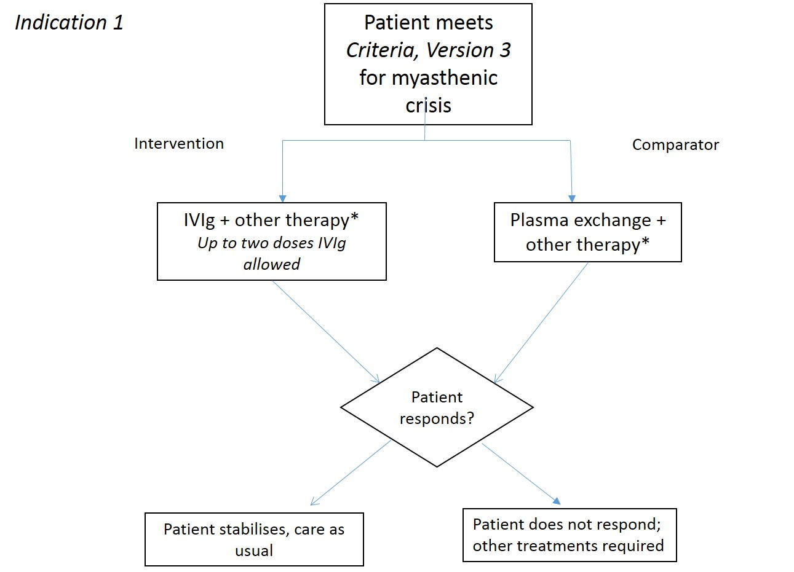
Figure 3: Clinical algorithm for indication 1
*other therapy includes corticosteroids, anticholinesterase inhibitor, and immunotherapy; patients would not receive IVIg and plasma exchange concurrently

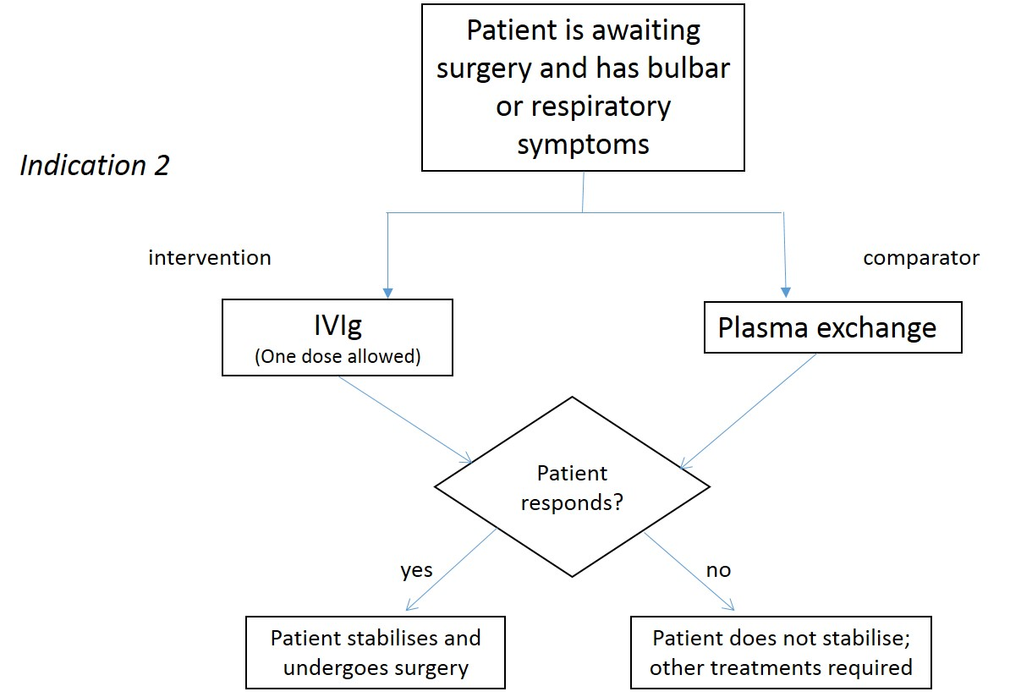
Figure 4: Clinical algorithm for indication 2

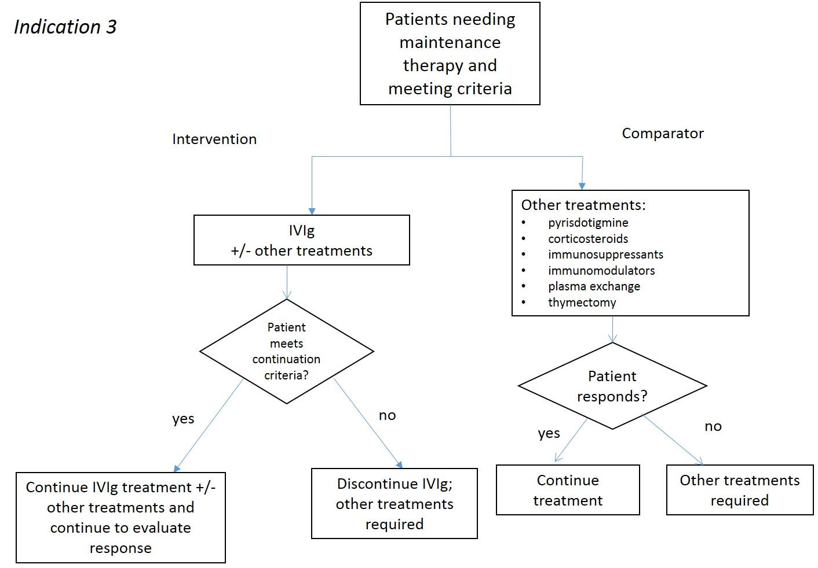
Figure 5: Clinical algorithm for indication 3
Proposed economic evaluation
A non-inferiority claim is proposed in the application. The basis of this claim is two small, short-term clinical trials which compared Ig to prednisolone and plasma exchange. A non-inferiority claim is likely to be appropriate for indications 1 and 2 (where Ig is intended to be used for a limited time frame to manage a patient through a crisis or surgery, and has a direct comparator in plasma exchange).
However in indication 3, where Ig may be used as an adjunct therapy to immunotherapy, there would need to be an additional benefit from the Ig therapy to justify its use (i.e., a superiority claim). This may not apply in all cases where the comparator may be no other treatment.
Resources that should be considered for inclusion in the analysis would be drug costs, IV infusion administration (outpatient setting), health resource use (number of specialist visits, hospital days, ICU admission) and cost of managing adverse events such as severe infusion reactions. Drug costs should include dispensing fees and wastage where applicable.
Table 6 can guide the requirements for economic evaluation based on the findings of the clinical review.

Table 6: Decision algorithm for undertaking an economic evaluation in the setting of the Ig Review (Schubert, C and Merlin T, Adelaide Health Technology Assessment, 2018).
Comparative safety of Ig | Comparative effectiveness of Ig
 | Inferior |  | Uncertain | Non-inferior | Superior
 | No active comparator | Active comparator
Inferior | x | F | ? | F^{b} | Fª
Uncertain | x | Fª | ? | ? | Fª
Non-inferior | x^{c} | F | ? | $ | F
Superior | x^{c} | Fª | ? | F^{b} | F
x = health forgone (at cost). An economic evaluation is not warranted and continued use of Ig should not occur in this circumstance unless there are other supportive factors.
F = undertake a full economic evaluation. These may take the form of cost-utility analyses (preferred if adequate data are available) or cost effectiveness analyses in terms of clinically relevant outcome(s).
? = high levels of uncertainty will occur in an economic evaluation (if it is feasible to construct one). A cost analysis (partial economic evaluation) could be performed.
$ = cost minimisation analysis (partial economic evaluation that explicitly assumes no significant differences in health outcomes, associated with either effectiveness or safety, and analyses cost-differences only).
ª where the conclusions with respect to effectiveness and safety are not congruent, then analyses identifying all relevant health consequences (i.e. effectiveness and safety outcomes in opposing directions of benefit) need to be presented. If a CUA is presented, this should capture effectiveness and safety collectively. If a CUA is not possible, then a single CEA may not capture all health consequences adequately and so a CCA is likely to be required. Where possible, the CCA should be quantitative, but in the absence of adequate data, a minimum qualitative identification of consequences should be presented.
^{b} where effectiveness is assessed as non-inferior but safety differences exist, and in the absence of a CUA being possible, the outcomes component of the analysis should include a clinically relevant outcome which reflects the safety differences between Ig and the comparator.
^{c} The small but unavoidable potential risks associated with administering a blood product means that a conclusion of non-inferior or superior Ig safety relative to no active comparator, should never arise.

Appendix A The Myasthenia Gravis Composite score
Ptosis, upward gaze (physician examination)
- 0 = > 45 seconds
- 1 = 11 - 45 seconds
- 2 = 1 - 10 seconds
- 3 = immediate

Double vision on lateral gaze, left or right (physician examination)
- 0 = > 45 seconds
- 1 = 11 - 45 seconds
- 3 = 1 - 10 seconds
- 4 = immediate

Eye closure (physician examination)
- 0 = Normal
- 0 = Mild weakness (can be forced open with effort)
- 1 = Moderate weakness (can be forced open easily)
- 2 = Severe weakness (unable to keep eyes closed)

Talking (patient history)
- 0 = Normal
- 2 = Intermittent slurring or nasal speech
- 4 = Constant slurring or nasal but can be understood
- 6 = Difficult to understand speech

Chewing (patient history)
- 0 = Normal
- 2 = Fatigue with solid food
- 4 = Fatigue with soft food
- 6 = Gastric tube

Swallowing (patient history)
- 0 = Normal
- 2 = Rare episode of choking or trouble swallowing
- 5 = Frequent trouble swallowing, eg. necessitating changes in diet
- 6 = Gastric tube

Breathing (thought to be caused by MG)
- 0 = Normal
- 2 = Shortness of breath with exertion
- 4 = Shortness of breath at rest
- 9 = Ventilator dependence

Neck flexion or extension (weakest, physician examination)
- 0 = Normal
- 1 = Mild weakness
- 3* = Moderate weakness (ie.~50% weak, ±15%)
- 4 = Severe weakness

Shoulder abduction (physician examination)
- 0 = Normal
- 2 = Mild weakness
- 4* = Moderate weakness (ie.~50% weak, ±15%)
- 5 = Severe weakness

Hip flexion (physician examination)
- 0 = Normal
- 2 = Mild weakness
- 4* = Moderate weakness (ie.~50% weak, ±15%)
- 5 = Severe weakness

Total score (maximum possible score 50)
*Moderate weakness for neck and limb items should be construed as weakness that equals roughly 50% plus or minus 15% of expected normal strength. Any weakness milder than that would be mild and any weakness more severe than that would be classified as severe.
The Myasthenia Gravis Composite score replicated from Burns TM, Conaway M, Sanders DB. The MG composite: a valid and reliable outcome measure for myasthenia gravis. Neurology 2010 May 4; 74(18): 1434–40 Opens new window with permission from T.M.Burns, and located on the Ig governance website of BloodStar (National Blood Authority 2018)
References

Muscular Dystrophy Foundation Australia 2012, Facts about Myasthenia Gravis, viewed Jan 17 2019, <http://mdaustralia.org.au/wp-content/uploads/2012/07/011_myasthenia-gravis-2012.pdf>.
National Blood Authority 2018, Criteria for the clinical use of immunoglobulin in Australia v3.0.1, National Blood Authority, viewed 16 Jan 2018, <https://www.criteria.blood.gov.au/MedicalCondition/View/2549>.
National Blood Authority 2016. Report on the Issue and Use of IVIg 2015-16, viewed Jan 20 2019, https://www.blood.gov.au/data-analysis-reporting

http://nationalstandards.safetyandquality.gov.au/7.-blood-management

