MSAC Application 1737
Newborn bloodspot screening for Sickle Cell Disease and Beta Thalassaemia

PICO Confirmation

A summary of the PICO criteria to define the questions to be addressed in an Assessment Report to the Medical Services Advisory Committee (MSAC) are shown in Table 1 and Table 2.
Table 1 PICO 1 for newborn bloodspot screening for sickle cell disease and β-thalassaemia
Component | Description
Population | All newborns in Australia
Prior tests | No prior testing
Intervention | - Universal newborn bloodspot screening for sickle cell disease (SCD) using High-Performance Liquid Chromatography (HPLC), Isoelectric Focusing (IEF), Capillary Electrophoresis (CE), Matrix Assisted Laser Desorption/Ionization time-of-flight mass spectrometry (MALDI-TOF), and/or Electrospray Ionization tandem mass spectrometry (ESI-MS/MS) or quantitative polymerase chain reaction testing (qPCR) as first and/or second line testing  (Required if positive from one-tier screen, optional if positive after two-tier screening): Diagnosis confirmed by molecular (genetic) testing (HBB gene).  - Universal newborn bloodspot screening for SCD, β-thalassaemia, Haemoglobin E- β-thalassaemia, and δβ-thalassaemia using HPLC, IEF, CE, MALDI-TOF, ESI-MS/MS and/or qPCR as first and/or second line testing  Diagnosis confirmed by molecular (genetic) testing (HBB gene or HBB and HBD genes)
Comparator/s | No newborn bloodspot screening for haemoglobinopathies (Delayed diagnosis to the point of symptom onset)  Secondary comparator: targeted neonatal testing for those infants at known high risk, and no targeted testing in those at general risk.
Reference standard | SCD: All available information.  β-thalassaemia: genetic testing
Outcomes | Safety of testing (physical harms to newborn of screening test, diagnostic test or subsequent treatment)  Effectiveness (including mortality, morbidity, rate of infections, severity of symptoms, quality of life, rate of hospitalisations). In addition:  SCD: neurological complications, cardiopulmonary and kidney complications, painful crises, requirement for stem cell transplantation, requirement for blood or exchange transfusion, initiation of disease-monitoring and prophylactic therapies  β -thalassaemia: blood transfusion, iron overload, effect of chelation therapy, damage to spleen, liver, heart, gallbladder, bones, requirement for stem cell transplantation  Test performance of screening test(s) (sensitivity, specificity, false positive rate, false negative rate, positive predictive value, negative predictive value, diagnostic yield of both disease state and carrier status, diagnosis of other conditions of clinical or unknown significance).  Change in management (time to diagnosis, time to treatment and prophylaxis, initiation of monitoring tests, treatments received) of SCD and β-thalassaemia  Incremental impact of change in management (as per effectiveness outcomes) of SCD and β-thalassaemia  Incremental impact on Health care resources involved in screening, diagnosis and management  Cost-effectiveness  Total incremental impact on Australian Government health care costs  Ethical considerations (equity of access, considerations regarding consent, and notification of carrier status)  Family outcomes (value of knowing, emotional benefits/harms to family, social benefits/harms to family, noting these are secondary to the outcomes delivered to the baby)  Organisational considerations (incremental impact of NBS for haemoglobinopathies on organisations, such as capacity for diagnosis and management, and impact on NBS program itself)
Assessment questions | - What is the comparative safety, effectiveness,cost-effectiveness and total cost of universal newborn bloodspot screening for sickle cell disease versus current practice (no universal NBS) in Australia?  - What is the comparative safety, effectiveness,cost-effectiveness and total cost of universal newborn bloodspot screening for sickle cell disease, β-thalassaemia, Haemoglobin E- β-thalassaemia, and δβ-thalassaemia versus current practice (no universal NBS) in Australia?  Secondary questions: .  - What is the incremental safety, effectiveness and cost-effectiveness of universal newborn bloodspot screening for sickle cell disease , versus targeted newborn testing in those at high risk, and no newborn testing in those at general risk.  - What is the incremental safety, effectiveness and cost-effectiveness of universal newborn bloodspot screening for sickle cell disease, β-thalassaemia, Haemoglobin E- β-thalassaemia, and δβ-thalassaemia, versus targeted newborn testing in those at high risk, and no newborn testing in those at general risk.
CE = capillary electrophoresis; DNA = deoxyribonucleic acid; ESI-MS/MS = Electrospray Ionization tandem mass spectrometry; HPLC = high performance liquid chromatography; IEF = isoelectric focusing; MALDI-TOF = Matrix Assisted Laser Desorption/Ionization time-of-flight mass spectrometry; NBS = newborn bloodspot screening
Table 2 PICO 2 for cascade testing of family members of newborns diagnosed with haemoglobinopathies via the NBS program
Component | Description
Population | Family members of newborns diagnosed with sickle cell disease, β-thalassaemia, Haemoglobin E- β-thalassaemia, or δβ-thalassaemia through universal NBS
Prior tests | Family history
Intervention | Genetic counselling and genetic testing for the known familial P/LP variant(s) in the HBB gene or both the HBB and HBD genes or phenotypic testing for the known familial SCD variant as per the comparator
Comparator/s | Genetic counselling and phenotypic cascade testing of blood for haemoglobinopathies using HPLC, CE, IEF, MALDI-TOF or ESI-MS/MS.
Reference standard | Reference standard for intervention: N/A (genetic testing of known single genetic variants considered to have 100% sensitivity/specificity for variant identification )  Reference standard for comparator: genetic testing
Outcomes | Safety of testing (physical or psychological harms of testing or test results)  Test results (identification of carrier status)Family outcomes (value of knowing, reproductive options, emotional benefits/harms to family, social benefits/harms to family)  Health care resources involved in cascade testing  Cost-effectiveness  Total Australian Government health care costs  Ethical considerations (equity of access, considerations regarding consent, considerations regarding cascade testing, including notification of carrier status)
Assessment questions | What is the comparative safety, effectiveness,cost-effectiveness and total cost of cascade genetic testing of family members at risk of haemoglobinopathies of newborns diagnosed with P/LP variants in HBB or HBB and HBD genes via a universal NBS program, versus phenotypic cascade testing of the family members of individuals diagnosed with haemoglobinopathies?
CE = capillary electrophoresis; DNA = deoxyribonucleic acid; ESI-MS/MS = Electrospray Ionization tandem mass spectrometry; HPLC = high performance liquid chromatography; IEF = isoelectric focusing; MALDI-TOF = Matrix Assisted Laser Desorption/Ionization time-of-flight mass spectrometry; NBS = newborn bloodspot screening; P/LP = pathogenic/likely pathogenic

Purpose of application
An application requesting that sickle cell disease (SCD) be added to the newborn bloodspot screening (NBS) program was received from Australian Sickle Cell Advocacy Inc by the Department of Health and Aged Care. During the initial review stage, the Sickle Cell Disease Expert Working Group recommended that β-thalassaemia, Haemoglobin E- β-thalassaemia and δβ-thalassaemia also be considered as part of the application. These are all haemoglobinopathies, and this collective term will be used throughout this document, despite there being one subtype of haemoglobinopathy that is not proposed to as being included in this application (α-thalassaemia). The proposal is for haemoglobinopathies to be added to Australia’s NBS program.
NBS programs are overseen and managed by state and territory governments and operate independently of each other. The Australian Government contributes funding to hospital services, including those for NBS through the National Health Reform Agreement (NHRA). It also announced funding of $39.0 million under the 2022-23 Budget, some of which wil be provided direct to states and territories to support expansion of NBS programs.
There are five laboratories that conduct tests on bloodspot cards, located in New South Wales, Queensland, South Australia, Victoria and Western Australia. Newborns born in states and territories without NBS testing laboratories have their dried bloodspots sent interstate for testing. All NBS programs are underpinned by the Newborn Bloodspot Screening National Policy Framework (NBS NPF; Appendix A).
Proposals to add conditions to NBS are considered by MSAC. In providing its advice MSAC considers the safety, effectiveness, cost-effectiveness and total cost of proposals for public funding, noting that for NBS applications fulfilment of the NBS NPF criteria (Appendix A) is a key additional policy consideration. Guiding questions from the NBS NPF criteria are shown throughout this PICO in blue text.

2.1: What are the known health benefits from early detection, including early intervention, prevention of symptoms or reduction in condition severity?
The aim of NBS is to improve the health of babies by identifying those at risk of developing a serious condition early, generally before symptoms present, thereby enabling earlier intervention. The claim is that early diagnosis (by universal newborn bloodspot screening) followed by early intervention (e.g. for individuals with sickle cell disease, penicillin prophylaxis, blood transfusions, vaccination against encapsulated bacteria and prompt clinical intervention for infections) results in superior health outcomes (e.g. a reduction in infections and mortality related to splenic sequestration or invasive pneumocccal disease and therefore increased life expectancy) compared to no newborn screening which relies on phenotypic presentations and has a consequent later diagnosis and time to intervention(Gaston et al. 1986; King et al. 2007; Sobota et al. 2015). Since the implementation of universal NBS for SCD in Canada and the United States, mortality has dropped 50% in 1 to 4 year olds, and life expectancy has improved from a median of 14.3 years to between 42 and 53 years in males and 46 to 58.5 years in females (El-Haj & Hoppe 2018).In addition, a genetic diagnosis allows parental education, cascade testing of family members to identify disease- or carrier-state and genetic counselling and pre-implantation genetic diagnosis for future pregnancies. The severity of infection, painful crises and splenic involvement can be reduced through prophylaxis and parental education as better recognition can lead to earlier access to treatment (IHE 2016; NBS 2022).
A secondary comparison is proposed of universal NBS versus targeted testing of high risk newborns.

PICO criteria (PICO set 1)

Population

Criterion 1: The condition should be a serious health problem that leads to significant morbidity or mortality.
The target population for screening is all babies born in Australia who participate in universal newborn bloodspot screening programs. This includes those infants at general risk (no known risk factors) and those at high risk of having SCD (including the homozygous HbSS form, heterozygous HbSC form, or HbSβ-thalassaemia), or β-thalassaemia (including thalassaemia major, thalassaemia intermedia, HbEβ-thalassaemia, or δβ-thalassaemia) due to factors such as ethnicity, family history etc.
The conditions proposed for screening are selected haemoglobinopathies, disorders in the structure or quantity or quality of haemoglobin. Haemoglobin (Hb) is a protein found in red blood cells, which is involved in oxygen transportation. Within each haemoglobin protein are the alpha and beta chains, which are needed for the haemoglobin to bind oxygen. Depending on the type of haemoglobinopathy, people can experience anaemia (too few red blood cells being made or due to increased destruction), episodes of pain, organ damage, and/or hypoxia. The most common haemoglobinopathies are SCD and alpha and β-thalassaemia. Screening for alpha thalassaemia is out of scope of this application. People with severe β-thalassaemia (intermedia and major) can absorb more iron from their food, and are treated with blood transfusions to correct anaemia, both of which contribute to iron-overload (Genetic Science Learning Centre). The normal process of removal of excess iron is overwhelmed in individuals with β -thalassaemia, resulting in iron toxicity and deposition in multiple organs with consequent impairment of function. The adverse effects of iron overload may be ameliorated by cautious use of blood transfusion and repeated iron chelation therapy.
People with SCD have rigid, sickle-shaped red blood cells that can block blood vessels particularly during hypoxia or dehydration, preventing tissue from getting sufficient oxygen. This can cause intense pain, infection, organ damage (lungs, kidneys, spleen and brain) and stroke (Genetic Science Learning Centre). Other effects of SCD on children are dactylitis and acute chest syndrome (NBS 2022).

1.1 What data are there on the incidence of the condition in the Australian population? How is this incidence determined; through screening studies, international programs, cases identified clinically, modelled estimates based on data from variant databases, or some other means?
The true incidence of haemoglobinopathies in Australia is unknown. Between January 2004 and March 2006, paediatricians were asked to report all newly diagnosed cases of children (<15 years) with haemoglobinopathies to the Australian Paediatric Surveillance Unit. In this time, 59 confirmed cases were reported, which corresponds to a national incidence of 0.75 per 100 000 (Argent et al. 2012). These data do not account for any stillbirths or terminations, or deaths prior to diagnosis, so may underestimate the true incidence.
Of those diagnosed with haemoglobinopathies, 35.6% had sickle cell disease, 10.2% had β-thalassaemia major and 25.4% had compound heterozygous conditions. In addition, 28.8% had Haemoglobin H (HbH) disease (moderate to severe α-thalassaemia) (not included in the target population). The estimated incidence of the haemoglobinopathies proposed to be targeted by NBS is therefore 0.53 per 100 000.
A targeted consultation response from PathWest reported that there are 2-3 new cases SCD diagnosed each year (from approximately 35,000 newborns). Using these data, the incidence of SCD may be as high as 8.6 cases per 100 000.
The Queensland Children’s Hospital (QCH) provided data from an audit on sickle cell cases from 2015 to 2019 (Table 3). The total number of patients and admissions per patient increased over this time period from 27 in 2015 to 45 in 2019. The average number of new diagnoses per annum also increased over the same period according to QCH reports (Abt Associates 2022).
Table 3 Number of patients with SCD diagnosis, 2015-2016, QCH
 | 2015 | 2016 | 2017 | 2018 | 2019
Total Number of patients | 27 | 31 | 32 | 38 | 45
Number of patients admitted | 14 | 12 | 13 | 17 | 23
Total number of admissions | 23 | 20 | 25 | 31 | 59
Admissions/patient | 0.85 | 0.65 | 0.78 | 0.82 | 1.31
Avg Length of Stay (days) | 5.13 | 3.45 | 2.8 | 2.34 | 3.0
Source: Table 10, p26 Abt Associates (2022)

1.2 What data exist on the condition from other comparable populations that could inform decision-making?
Globally, over 330,000 infants with haemoglobin disorders are born each year (83% sickle cell disorders, and 17% thalassaemias) (Modell & Darlison 2008). Historically sickle cell disease and thalassaemias were characteristic of the tropics and subtropics, but migration has made them more common worldwide (Weatherall & Clegg 2001). In Australia, the majority of patients with sickle cell disease have reported their background as being Sub-Saharan African (58%), or North African and Middle Eastern (30%). For β-thalassaemia patients, the majority report having ethnicity from South and Eastern Europe (48%).
Abt Associates performed a rapid review of the literature published between 2000 and 2021 that assessed the prevalence of haemoglobinopaties across the world (Table 4).
Table 4 Prevalence of haemoglobinopathies across the world
Country | Incidence or prevalence (reference)
India | -maximum number of patients were of thalassemia trait with the prevalence of 3.7%. B-thalassemia major 0.02%, SCD, 0.2%, HbS with B-thalassemia 0.28% among the general population of 3,465. (Buch, 2016).  - 88 SCD, 536 SCT, 8 other hemoglobinopathies among 8,243 newborns (Jain, 2012).
China | - The overall prevalence of α-thalassemia, β-thalassemia and α + β-thalassemia was 7.88%, 2.21% and 0.48%, respectively in general population of 84,598 (Lai, 2010)  - 1415 cases of a-thalassemia (65.89%), 731 cases of b-thalassemia (33.62%), and 28 cases of a-composite b-thalassemia (1.29%) in 159,535 newborns (Cai, 2021)  - The neonatal thalassemia prevalence in Shenzhen was 9.12%; 6.31% α-thalassemia, 2.37% β-thalassemia, and 0.44% α-/β-thalassemia among 2,028 newborns (Wei-Wen, 2019).  - The birth-rates of individuals with intermediate thalassemia and β-thalassemia major were 0.153% and 0.055% among 18,309 newborns (Tan, 2021).
Malaysia | - In Malaysia, among general population the estimated carrier rate for b-thalassemia (b-thal) is 3.5–4.0% (Abdullah 2020)
Pakistan | Of 175 children with microcytic anaemia, 33 (18.9%) had haemoglobinopathies. Thalassemia trait 18 (10.3%) was the leading cause amongst haemoglobinopathies, followed by thalassemia major 8 (4.6%) and intermedia 5(2.9%). There were 2 (1.1%) patients with haemoglobin D among 175 children (Khan, 2021)

Country | Incidence or prevalence (reference)
Thailand | In Thailand, the prevalence based statistically on phenotype has been estimated at 2.5-10% for alpha0-thalassemia, 1-8 % for Hb Constant Spring and Hb Paksé and 15-20% for alpha+-thalassemia and 3-9% for β-thalassemia. Hb E can be found between 30-50% especially in the north-eastern part of the country. (Chaibunruang, 2018)
Israel | Fourteen (14) couples who carried HbS were detected and 187 prenatal diagnoses were performed in couples at risk for having an offspring with HbS. 54 of those diagnoses revealed affected foetuses among 69,340 pregnant women (1987-2006 – 20 years) (Koren, 2009).
Singapore | The carrier frequency for a-thalassemia mutations was about 6.4% in the Chinese, 4.8% in Malays, and 5.2% in Indians. The carrier frequency for b-thalassemia mutations was 2.7% in the Chinese, 6.3% in Malays, and 0.7% in Indians among 1,116 newborns (Know-Kham, 2004)
Brazil | Brazil has a prevalence of 0.1 to 0.3% of newborns with SCD and 20.0 to 25.0% of heterozygous α2 thalassemia among African Brazilians among 590 newborns (Adorno, 2005).  The prevalence of SCT and SCD were 1.65% and 0.011%, respectively among 181,973 newborns (Ivo, 2014).  SCD prevalence varied in states: in Bahia for every 650 births, 1 child has SCD, followed by Rio de Janeiro (1:1200) and then Pernambuco, Maranhão, and Minas Gerais, with 1:1400 (Silva-Pinto, 2019). The study was conducted in 26 states and more than 85% live births were screened: thus highly reliable.  Among 437,787 newborns, 6391 showed an abnormal Hb pattern. These included 48 cases (0.01%) of sickle cell disorders (33 HbSS [SCD], 7 Hb SC, 7 Hb S/b-thalassemia, 1 Hb SD), 1 neonate who was homozygous for b-thalassemia, 6,272 (1.4%) newborns who were heterozygous for Hb S, C, or D, and 71 (0.02%) neonates who were carriers for rare Hb variants (Wagner, 2010).  In Rio de Janeiro, among 1,217,833 newborns, 49,424 (4.06%) had SCT; 9,874 (0.81%) had other traits; and 912 (0.07%) had haemoglobin profiles compatible with SCD (639 with Hb SS, 201with SC, 26 with SD and 46 with S-bþ-thal) (Lobo, 2014).  162 were found to have SCD, while 10,794 had a SCT, with a prevalence of 0.05% and 3.8%, respectively among 283,003 newborns in Amazon-Savanna Transition Region in the state of Maranhão (Souza, 2019).
Iran | Prevalence of alpha thalassemia, and SCD was 6.4%, and 1%,respectively among 1,000 newborns (Shahriari, 2016).
Turkey and Middle East Islamic countries | Pooled prevalence was 2.6%. For Turkey studies, pooled prevalence of β-thal trait was 2.7%. For other Islamic countries except for Turkey, pooled prevalence of β-thal trait was 2.4% (Tozun, 2018)
Source: Table 9, pp23-24 Abt Associates (2022)

1.3 What is the burden of disease associated with the condition, including morbidity and mortality?
Data on the morbidity and mortality rate of haemoglobinopathies globally are scarce (The Lancet Global 2022). The Haemoglobinopathy Register was established in Australia in 2014 to address this lack of data (Monash University). The Australian Haemoglobinopathy Registry is an academic clinical quality registry, which has also received some industry funding. This voluntary register is still in the pilot stage and not all sites caring for haemoglobinopathy patients participate. Thus, it does not provide a complete snapshot of Australian data (Monash University).
Mortality rates for infants and children with SCD (HbSS, HbSC, or HbSβ) were calculated for infants born in New York from 2000 to 2008, by matching 1,911 sickle cell records with death certificates (Wang et al. 2015). By age group, the all-cause mortality rate in infants aged 28 days to <1 year was 2.84 per 1,000 person-years, for children aged 1 to <2 years was 3.32 per 1,000 person years, and for children aged 2 years the rate was 1.033 per 1,000 person-years. Mortality rates for this American group were statistically significantly higher for children with HbSS or HbSβ⁰ compared to all children born in the state when compared by age group, whereas for those with HbSC there was no difference in mortality rate (Table 5).

Table 5 Postneonatal (>28 days) all-cause mortality by SCD type compared with all live births (New York State Birth Cohort, 2000-2008) (Wang et al. 2015)
Age at death | Live birth mortality rate  (/1,000 PYs) | Total SCD |  |  | HbSS, HbSβ⁰ |  |  | HbSC
 |  | Mortality rate (/1,000 Pys) | Rate ratio | 95% CI | Mortality rate (/1,000 Pys) | Rate ratio | 95% CI | Mortality rate (/1,000 Pys) | Rate Ratio | 95% CI
28 d - <1 y | 1.95 | 2.84 | 1.5 | 0.5, 3.4 | 3.70 | 1.9 | 0.5, 4.9 | 1.64 | 0.8 | 0.0, 4.7
1 - <2 y | 0.33 | 3.32 | 10.0 | 3.6, 21.88 | 5.40 | 16.2 | 5.9, 35.4 | No deaths | - | -
2 – 9 y | 0.15 | 1.033 | 7.0 | 2.8, 14.4 | 1.42 | 9.6 | 3.5, 20.9 | 0.43 | 2.9 | 0.1, 16.1
CI = confidence interval; d = days; HbSβ⁰ = sickle β⁰ thalassaemia; HbSC = sickle-haemoglobin S disease; HbSS = haemoglobin S disease; PY = person years; SCD = sickle cell disease; y = years

Criterion 3: The natural history of the condition, including development from latent to declared disease should be adequately understood.

3.1 What information is known on the natural history of the condition in Australia or comparable international populations?
Sickle cell disease (SCD) symptoms develop in the first year of life, as fetal haemoglobin is replaced by β-chain synthesis and increasing levels of abnormal β-globins. There is variability between individuals in the rate of transition, but in some, pathological levels are reached within 8-10 weeks of birth, and life threatening complications may occur from that time point (Serjeant, G. R. 2013).
In those with SCD, dactylitis (inflammation in the joints of fingers and toes) and splenic infarction can occur between 3 and 6 months of age (Serjeant, G. R. 2013). A higher risk of mortality starts between 6 and 12 months, where overwhelming septicaemia may occur, as may acute splenic sequestration, pulmonary sequestration or cerebrovascular disease.
In the United States of America and Jamaica, the peak incidence of death from SCD is between 1 and 3 years of age, usually due to infection (Serjeant, Graham R. 1997).
Median life expectancies for males with SCD of between 42 and 53 years of age, and for females with SCD between 46 to 58.5 years were reported in a HTA conducted by the Insitute of Health Economic (IHE 2016). There were higher mortality rates under age 10 years and over age 20 years. Infection, acute chest syndrome, cerebrovascular complications and pulmonary hypertension are the most common causes of death in children. In contrast the most common causes of death in adults are chronic end organ dysfunction, thrombotic disease, and treatment related complications (IHE 2016).
When untreated, β-thalassaemia major causes profound anaemia which can result in death before the child reaches 3 years of age (Modell & Darlison 2008). Treatment with regular blood transfusion, iron-chelation therapy, or bone-marrow transplantation can mean that patients with β-thalassaemia have near-normal life expectancy (Modell & Darlison 2008).

3.3 Explore the current knowledge of penetrance of the condition? Are there known benign or milder late-onset forms?
There is varying degree of phenotypic expression in both the thalassaemias and structural Hb disorders, depending on the underlying genetic variant. The penetrance of the relevant genetic variants (i.e., the extent to which having the relevant genotype will result in disease) is to be examined during the assessment.
Each person inherits two copies (alleles) of the HBB gene (one from each parent), which are responsible for providing the instructions for making the β-globin protein, which is a component (subunit) of the protein haemoglobin, or Hb. Adult blood cells contain a mix of different Hbs, each made up of four globin chain subunits. The most common Hb (HbA) is comprised of two α and two β-globin chains (α₂β₂) (Table 6). The HBD gene encodes the delta Hb subunit. HbA₂ is comprised of two α and two δ-globin chains (α₂δ₂), and makes up <1% of the Hb present at birth.
Human fetuses make fetal Hb (HbF), which uses two gamma (γ)-globin proteins rather than β-globin. Shortly before birth, they switch to making β-globin, and HbF is replaced by HbA in the first few months of life (Giordano 2013).
Table 6 Normal haemoglobin types
Haemoglobin name | Sub-units | Production
HbA | α₂ β₂ | 20% at birth, increasing to become the predominant form of adult Hb (>95%)
HbA₂ | α₂ δ₂ | <1% at birth, increasing to approximately 2.6% of adult Hb
HbF | α₂ γ₂ | Fetal Hb, 80% at birth, diminishing over the first few months of life (to <1% in adults)
Source: modified from (Davies SC et al. 2000; Giordano 2013)

Usually, one functioning HBB allele makes sufficient healthy beta-globin protein for red blood cells to effectively bind and transport oxygen. Carriers of one non-functional allele may experience mild anaemia or small alterations to their blood cell indices, but are often symptom free. Therefore, haemoglobin disorders follow a recessive pattern of inheritance, as it takes two non-working alleles to cause the disorders (one from each parent). Sickle cell disease and most forms of β-thalassaemia have autosomal recessive inheritance.
There are more than 1000 different genetic variants identified that result in a haemoglobinopathy (Huisman & et al 2022). The most clinically significant haemoglobinopathies cause defects in either the quantity or structure (and oxygen-binding capability) of haemoglobins produced (Table 7). For example, SCD comes in two main subtypes: HbSS, where a person has two β^{S} alleles, i.e. both their copies of the HBB gene have the HbS variant HBB:p.(Glu7Val); and HbSC, with one copy of the HbS p.(Glu7Val) variant haemoglobin, and one copy of the HbC variant haemoglobin HBB:p.(Glu7Lys). Other haemoglobin phenotypes can be caused by multiple genetic variants, e.g. the β⁰ allele is where no beta-globin is produced, and the β⁺ allele where there is a variable reduction of β-globin chains, which can be caused by a variety of genetic variants. A homozygote is a person with two of the same variant alleles; a compound heterozygote is a person with two different variant alleles. Note, the table below only includes haemoglobinopathies related to β-globins, and not α-globins (α-thalassaemia is not one of the target conditions proposed to be screened for in this application). As outlined in Table 7, the clinical implications of haemoglobinopathies vary considerably.

Table 7 Common haemoglobinopathies and traits related to β-globins
Condition | Affected sub-units | Description (genetic basis; presentation)
Thalassaemias (reduced production of β chains)
β-Thalassaemia major (Cooley’s anaemia) | β⁰β⁰ |  | Disabling point variants causing no (β⁰) or reduced (β⁺) beta chain production; severe anaemia
β-Thalassaemia intermedia | β⁺β⁺ or β⁺β⁰ |  | Two dysfunctional HBB alleles; high clinical variability ranging from mild to severe
β-Thalassaemia minor (trait) | ββ⁺ or ββ⁰ |  | One dysfunctional HBB allele; mild anaemia or asymptomatic
δβ-Thalassaemia | δ⁺β⁺ |  | Compound heterozygote of δ (HBD) and β (HBB) globin gene variants leading to a reduction in both globin chains; mild anaemia but can mask the diagnosis of beta-thalassaemia trait
Hb Lepore | δβ Lepore |  | Lepore is a globin chain produced from a fusion of the δ and β globin genes HBD and HBB, a result of the recombination of the two genes; serious disease similar to thalassaemia intermedia or thalassaemia major, with homozygous inheritance or in compound heterozygotes with HbS or other β variants
Structural Hb disorders (β chains variants interfere with Hb structure)
Hb SS (sickle cell anaemia/disease) | β^{S}β^{S} |  | Biallelic substitution at codon 6 in HBB alleles; vaso-occlusive and haemolytic effects impacting brain, chest, kidneys, bones and spleen
Hb SC (sickle cell/Hb C disease) | β^{S}β^{C} |  | Compound heterozygous for HBB sickle cell and haemoglobin C gene variants; as for Hb SS
Hb SD Punjab disease | β^{S}β^{D} |  | Compound heterozygous for HBB gene variants; as for Hb SS (sickle cell disease)
Hb SO-Arab | β^{S}β^{O} |  | Compound heterozygous for HBB gene variants; as for Hb SS (sickle cell disease)
HbSβ⁰-Thalassaemia | Β^{s}β⁰ |  | Compound heterozygous for HBB sickle cell and thalassaemia variants; as for Hb SS
Hb AS (sickle cell trait) | ββ^{S} |  | One sickle cell HBB allele; usually asymptomatic
Hb Eβ-Thalassaemia | β^{E}β⁺ |  | Compound heterozygous for HBB gene variants; variable clinical picture from thalassaemia intermedia to thalassaemia major
Hb EE | β^{E}β^{E} |  | Biallelic Hb E variants of the HBB gene; mild anaemia
Hb AE | ββ^{E} |  | Carrier of one Hb E variant allele only; not symptomatic
Source: Davies (2000); Tan et al (2016)
Shaded cells not proposed for newborn screening in this application
Hb C (causes low solubility and crystallisation at low oxygen);
Hb D (mild disease in homozygote or when inherited with S or β-Thalassaemia; has same mobility as Hb S and Hb G on alkaline electrophoresis so needs further testing to clarify)
Hb E (increased sensitivity to oxidants; mild disease in homozygotes but serious when inherited with β-Thal)
Hb S (causes low solubility and polymerisation at low oxygen)

Expected utilisation
The utilisation of universal newborn bloodspot screening programs is not expected to alter if SCD and β-thalassaemia are added to the programs. However, it is imperative that the addition of new conditions does not adversely impact existing trust and participation in the programs.
Uptake of universal newborn bloodspot screening is very high in Australia, with over 99% of babies screened. The number of babies born in Australia has been relatively consistent since 2010, with figures varying between 295,976 in 2020, to 312,548 in 2014 (AIHW 2022), as the population size increases, but the fertility rate (births per woman) decreases. The mean number of babies screened between 2016 and 2020 reported by Huynh et al. (2022) is therefore taken as a reasonable estimate from which to project the utilisation of newborn screening in the next six years (Table 8).
Table 8 Number of babies screened in Australia in 2016 to 2020
Screening program | No. of babies screened 2016-2020ª | Mean no. of babies screened per year
Queensland | 316,856 | 63,371
New South Wales | 509,859 | 101,972
Victoria | 393,365 | 78,673
South Australia | 136,281 | 27,256
Western Australia | 167,779 | 33,556
Total | 1,524,140 | 304,828
ªSource: (Huynh et al. 2022)

Intervention
The proposed intervention is to add SCD, β-thalassaemia, Haemoglobin E- β-thalassaemia and δ β-thalassaemia to universal newborn bloodspot screening in Australia. An expert consultant to PASC proposed that different scenarios be assessed: 1) screening for SCD only (base case as per the original application); and 2) scenario analysis of screening for SCD and β-thalassaemia (including Haemoglobin E- β-thalassaemia and δ β-thalassaemia). They also commented that screening for SCD and only the more common β-thalassaemia variants could be relatively cost-effective.
This universal newborn screening would be in addition to targeted preconception and antenatal screening in those at high-risk due to ethnicity or family history. Universal newborn bloodspot screening is an equitable means to identify babies with these conditions whose parents have not received any previous screening, and would replace current targeted newborn screening of families at increased risk for the selected haemoglobinopathies. A negative screening result should not preclude diagnostic testing of clinically symptomatic patients later in life.

Criterion 4: There should be a suitable test protocol to identify the presence of the condition
The test protocol involves blood spots from a neonate heel prick, collected within 48 to 72 hours of birth, dried on filter-paper (Guthrie card) (BetterHealth VIC). Screening then typically occurs in a two-step manner. First-tier screening uses one method, and those who test positive are then tested using a complementary method. If this is also positive, then the newborn is recalled for diagnostic testing on a new blood sample.
Because the range of haemoglobin variants detected by each assay method is slightly different, a complementary confirmation screening test is recommended (either IEF or CE if HPLC is the screening test) in a two-tier screening protocol. The second-tier screening test then has the potential to distinguish between variants that cannot be separated or identified in the initial screening test.
The NBS nomination suggested screening should use high performance liquid chromatography (HPLC). Other test methods for separation of haemoglobin variants or species used by some laboratories are isoelectric focusing (IEF) or capillary electrophoresis (CE). Mass spectrometry may also be used, either Matrix Assisted Laser Desorption/Ionization time-of-flight mass spectrometry (MALDI-TOF), or Electrospray Ionization tandem mass spectrometry (ESI-MS/MS). Targeted consultation responses also suggested that quantitative polymerase chain reaction (PCR) may be used.
For SCD, two different phenotypic tests may be considered sufficient to confirm diagnosis, although a genetic test is still recommended, for the purposes of allowing cascade testing for the familial P/LP variant, and allowing pre-implantation genetic diagnosis (if applicable). For those with phenotypic results indicative of β-thalassaemia or rarer haemoglobinopathies, genetic testing is recommended to diagnose the particular condition.
Older methods such as the sickle cell solubility test, cellulose acetate electrophoresis and citrate agar electrophoresis have disadvantages (such as inability to detect some haemoglobins, lower accuracy with samples eluted from dried blood spots, or labour intensivity) that have seen them decrease in popularity (HTA 2000).
The principle of the phenotypic tests is based on the separation of haemoglobin (Hb) species and quantification of their respective fractions from the dried blood spot. Different techniques separate the haemoglobins by size and electrolytic qualities. Variant globin chains tend to form aberrant haemoglobin sub-units with unusual sizes and affinities, or are produced in decreased quantity. The resultant haemoglobins vary in size and electrolytic qualities from normal haemoglobin (HbA) and can be detected by these qualities. Some assays can quantify the haemoglobin present, or determine the proportions of each type present in a sample. Some methods used commonly in Australia are described in Table 9.
PASC advised that the assessment should include all methods of testing. PASC noted that in relation to MSAC Application 1628 the applicant had claimed that IEF is being phased out of use in Australia due to being a labour-intensive method, however PASC also noted that IEF is commonly used in NBS in the United States. PASC considered that IEF remained in scope for NBS. Examples of other methods to discuss in the assessment include MALDI-TOF, ESI-MS/MS, and qPCR testing.
PASC discussed that although it would be good for the assessment to determine the optimal testing methods or protocol, in practice there is no “one size fits all” approach, and the choice of testing protocol would differ between the state/territory NBS laboratories. PASC considered that MSAC may decline to advise that a specific test protocol must be used, and advised the economic and financial analyses for the assessment should use the most cost-effective test protocol. PASC considered that the assessment report’s assessment of the cost-effectiveness of multiple options would permit informed decision-making on the test protocol to be used by laboratories.
Reported sensitivity and specificity approach 100% for HPLC and IEF for identification of sickle cell disease. While other β-Thalassaemia variants can be detected with these methods, difficulty with accurate quantification and separation of some variants prevents the same level of accuracy for diagnosis of β-Thalassaemia trait, intermedia and compound heterozygotes. A newborn is still producing HbF at the time of screening, adding complexity to the diagnosis.

Table 9 Detection methods for haemoglobins in neonates
Assay | Haemoglobins detected | Disadvantages | Sensitivity | Specificity
HPLCª | Quantifies A2, F  Variant Hb identification including A, F, S, C, E, A2, D-Punjab, O-Arab, Lepore | HbA2 level may be inaccurate if HbS present  Less resolution than IEF | 99%  (HPLC confirmed by IEF) | 99%
IEFª | Varies between systems (e.g. A, F, S, C, E/A2, D-Punjab, O-Arab, others)  Not validated for A2 quantification | Visual inspection, prone to human error  Time-consuming | 100%  (unquantified human error) | 100%  (unquantified human error)
CE^{b} | Detects and relatively quantifies F, A, S, C, A₂, D-Punjab, O-Arab, E, Lepore  Can separate HbE and HbA2 | Quantification of haemoglobin in a sample | TBD^{c} | TBD^{c}
MALDI-TOF | Detection of α, β, δ chains | Accurate for detecting HbS but not other variants | Highly sensitive | High specific
ESI-MS/MS | Detects HbS, HbC, HbD, HbE, HbO-Arab and HbG-Philadelphia (90% of α, β, γ-globin amino acid sequences) | Detection of multiple variants in the same globin chain is difficult. | TBD | TBD
qPCR | Detects point variant responsible for HbS. Targeted assays for HbC, HbD, HbE, HbO-Arab may be available. | Not currently a qPCR option for thalassaemias | TBD | TBD
CE = capillary electrophoresis; ESI-MS/MS = Electrospray Ionization tandem mass spectrometry; Hb = haemoglobin; HPLC = high performance liquid chromatography; IEF = isoelectric focusing; MALDI-TOF = Matrix Assisted Laser Desorption/Ionization time-of-flight mass spectrometry; qPCR = quantitative polymerase chain reaction;TBD = to be determined
Notes: a. Refs: IHE 2016, Frommel 2018. Haemoglobins that can be distinguished from each other are separated by a comma, those that cannot are separated by a forward slash
b. Refs: Tan 2016, Frommel 2018
c. CE is used as a reference standard in many publications

Screening programs from developed countries where SCD is not endemic are shown in Table 10. The most common methods are HPLC and/or IEF, which both provide a presumptive diagnosis, and a diagnosis of a Hb variant can only be confirmed with second-line testing using DNA analysis or mass spectrometry (MS) (Abt Associates 2022).
Table 10 Haemoglobinopathy screening programs around the world
Country | Year of Implementation | Program type | Screening methods
United States | 2005 | Nationwide, neonatal | HPLC/IEF
Canada | — | Nationwide/targeted (based on ethnicity)  Pre-conceptional and antenatal | CBC, HE/HPLC
United Kingdom | 2004 | Nationwide, neonatal | CBC, HPLC/IEF
Netherlands | 2007 | Nationwide, neonatal | HPLC
Belgium | 1994 | Regional (Brussels and Liege’), neonatal | IEF, HPLC
Germany | — | Pilot, neonatal | MS/MS
Australia | — | Regional (varies among states), targeted (based on ethnicity) pre-conceptional and antenatal | CBC, HE/HPLC
Source: (Goonasekera, Paththinige & Dissanayake 2018), cited in Table 12, p40, and Table 16, p54, (Abt Associates 2022)
CBC-Complete Blood Count; HE-Haemoglobin Electrophoresis; HPLC-High-Performance Liquid Chromatography; IEF-Isoelectric Focusing; MS/MS-Tandem Mass Spectrometry; — information not available.

HPLC
In HPLC, haemoglobins are separated in an ion exchange column cartridge with a buffer gradient. After injection into the cartridge, the haemoglobins move through the column and are eluted in a time dependent on their particular ionic strength and the buffer pH. Eluted haemoglobin is detected spectrophotometrically, and retention time is used to identify the species (IHE 2016). HPLC is able to detect and quantify HbA₂ (often diagnostic of beta thalassaemia major or intermedia). However, measurements may be inaccurate if HbS is present in the sample.
HPLC requires only a small fraction of a blood sample, and performs well on samples eluted from dried blood spots. It can be run on automated high through-put systems (Davies 2000), although still requires expertise to interpret (Abt Associates 2022).

IEF
Using the IEF method, haemoglobins are separated on an agarose gel. The gel contains ampholytes – low molecular weight molecules of varying isoelectric points that form a stable pH gradient across the gel when an electric current is applied. Blood samples are loaded at one end of the gel and molecules migrate to their own isoelectric point. Haemoglobin species can be identified by their migration pattern and comparison with band patterns for known species.
IEF can be run using semi-automated systems, and has a higher resolution ability than HPLC, enabling better separation of similar sized haemoglobins. However, IEF requires visual inspection for a final decision on phenotypes, which can introduce human error. It has been commonly used for newborn screening (including dried bloodspot) because of its low cost (Davies 2000). IEF of other proteins has previously been described as a low throughput method, though whether this applies to IEF of haemoglobin is uncertain. IEF of haemoglobin for NBS can be conducted in batches of 90 samples.

CE
In CE, haemoglobins are separated in negatively charged silica capillaries subjected to high voltage. Separation is based on both electrophoretic mobility and electro-osmotic flow. One advantage of CE is that it can quantify the amount of a haemoglobin in a blood sample. It can also separate HbA2 from HbE, which is not usually possible with HPLC. CE is useful as a complementary method with HPLC (Tan 2016) (Frommel 2018). However, it is an expensive technique, and requires skilled technicians (Abt Associates 2022).
A comparison of diagnostic images using HPLC, IEF and CE can be seen in Figures 1 to 3.
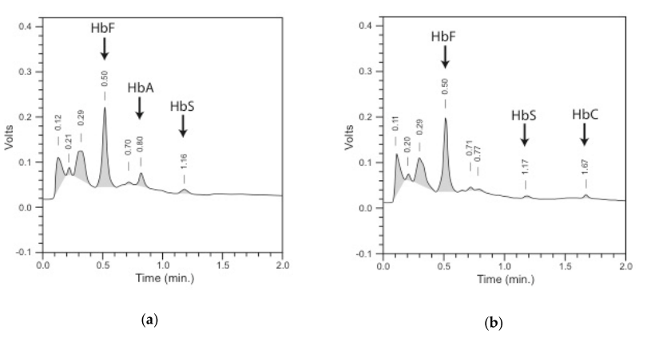
Figure 1 Chromatogram of HPLC (VariantTM newborn screening (NBS), Bio-Rad laboratories, Europe. Retention times are shown above the peaks, and the peaks of Hb variants included in the pattern are named and indicated with an arrow – (a) pattern HbF/HbA/HbS (FAS); (b) pattern of HbF/HbS/HbC (FSC)
Source: (Frommel 2018) Reproduction permitted under Creative Commons Attribution License

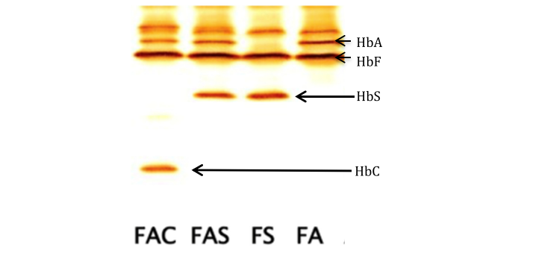
Figure 2 Isoelectric focusing gel picture (RESOLVETM, Perkin Elmer, Finland), from left to right – patterns of FAC, FAS, FS, and FA,
Source: (Frommel 2018) Reproduction permitted under Creative Commons Attribution License

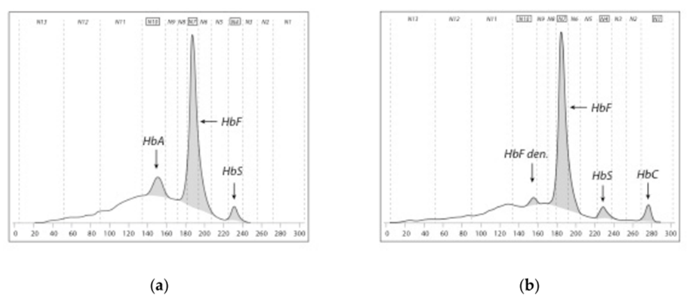
Figure 3 Pherogram of capillary electrophoresis (CE; CapillarysTM neonat fast, Sebia, France); zone from left to right N13-n1. Peaks of Hb variants included in the pattern are named (a) pattern of FAS; (b) pattern of FSC.
Source: (Frommel 2018) Reproduction permitted under Creative Commons Attribution License

Mass spectrometry
Two different types of mass spectrometry (MS) have been used for analysing Hb variants: electrospray ionization MS (ESI-MS) and matrix-assisted laser desorption ionization MS (MALDI-MS).
In ESI, proteins or peptides are mixed with an acidic solution, and sprayed through a fine needle, which has a high voltage applied to it. This produces an aerosol of droplets with a positive charge due to protons from the acidic solution. Droplet evaporation leads to the formation of smaller droplets, from which ions are desorbed (Zanella-Cleon et al. 2009). ESI-MS analysis of globin chains is performed using low resolution quadropole instruments.
Conversely, MALDI ionizes a peptide sample that has been mixed with a dry crystalline matrix, by bombarding it with a laser pulse. The matrix facilitates vaporization and ionization. The laser pulses lead to photochemical and chemical reactions that result in protonation and desorption of protein/peptide molecules. Ions are formed, and the mass analysis determines the mass-to-charge ratio of the produced ions (Zanella-Cleon et al. 2009). One of the common types of mass analysers used with MALDI is a time of flight (TOF) analyser, which is a high-resolution instrument. MALDI-TOF uses an electric field to accelerate the ions through a potential, and measures the time it takes to reach a detector (Dasauni et al. 2021). Ions with smaller mass reach the detector faster.
Presumptive identification of globin chains is made on the basis of their masses (Wild, Green & Stephens 2004). The detection of globin chain variants that have a molecular mass more than 6 Da from the normal β-chain can be made with great confidence. The sickle β-chain (β^{S}) has a mass that is 30 Da lower than the wildtype β-chain (β^{A}), so can easily be distinguished. Several β-chains that interact with β^{S} (such as C, D-Punjab, E and O-Arab) are more difficult to distinguish from β^{A}, although these limitations can be overcome using using trypsin to digest the samples.
Both ESI-MS and MALDI-MS analysers have the capability to analyse in tandem (MS/MS).

Quantitative PCR
All forms of sickle cell disease (including the homozygous HbSS form, heterozygous HbSC form, or HbSβ-thalassaemia) have at least one copy of the variant haemoglobin HbS. Screening for the single genetic point variant responsible for HbS can therefore detect all SCD cases (although not β-thalassaemia). Further testing is required in heterozygous cases.
There are several different PCR-based techniques that can detect β-globin chain variants. These include high resolution melting (HRM) analysis, bi-directional allele-specific amplification (ASA) and a more specific single-tube genotyping, where the point variant of sickle cell disease is sought as a single nucleotide polymorphism (SNP) (Arishi, Alhadrami & Zourob 2021). Amplification-refractory mutation system (ARMS) may also be used to detect point variants or small deletions, using primers with specific sequences to allow amplification of DNA sequence containing the target allele. The signal intensity of the HbS allele can indicate whether the neonate has wildtype, heterozygous or homozygous HbS (Kunz et al. 2016).
The following organisations provided input on screening methodology:
- Department of Haematology, QEII Medical Centre - the centralised reference laboratory for haemoglobinopathy testing for PathWest. It currently performs all testing for haemoglobin disorders for public and private patients (referred to as PathWest).
- Victorian Clinical Genetics Services (VCGS) - the Victorian NBS Laboratory Service
- Sydney Children’s Hospital Network (SCHN) including the NSW Newborn Screening Programme)
- Haematology Society of Australia and New Zealand (HSANZ)
- Australian Haemoglobinopathy Registry (HBR)

PathWest agreed with the proposed use of HPLC or CE methodologies for screening. PathWest stated that it does not have experience with IEF as a confirmatory test.

VCGS considered the current nomination for SCD proposed a two-tier approach that would require significant infrastructure. The feasibility of screening 80,000 babies per annum via the proposed process would require the addition of two different testing technologies (first-tier HPLC, second-tier CE or IEF) to provide the service in Victoria. The first-tier test would require three HPLC instruments for reliability and through-put. This is likely to be expensive, requiring significant lab space, infrastructure and waste disposal. They proposed a single-tier screen using quantitative polymerase chain reaction (qPCR) for SCD. This may not identify other thalassaemias.

The SCHN stated that for SCD most overseas NBS programs use a two-tiered approach, a first tier for differentiating HbS heterozygotes, HbS homozygotes and β-thalassemia from other samples, and a confirmatory second tier. Many overseas services have implemented conventional biochemical methods for newborn screening including HPLC, CE and IEF of an eluate of dried blood spots. However, these analytical platforms identify carriers and other non-clinically significant variants as by-products.

The SCHN commented that more recently, some laboratories have implemented SCD screening using tandem mass spectrometry (MS/MS). The screening protocol detects only the disease states of SCD, using action values based on the ratio between the variant Hb peptide to wildtype peptide
abundances for the HbS, C, DPunjab, OArab, E and Lepore peptides.

For beta thalassaemia major, SCHN proposed establishing an alternative screening approach using Matrix Assisted Laser Desorption Ionization-Time Of Flight mass spectrometry (MALDI-TOF) based on the detection of Hb alpha, beta and gamma chains. MALDI-TOF identifies both the SS and Sβ⁰ sickle syndromes as well as β-Thalassemia (major), Haemoglobin E-β-thalassemia and delta-β thalassemia. An abnormal screening test will require reanalysis with MALDI-TOF on a repeat (recollected) blood spot sample from the infant for sample verification.

HSANZ agreed with the choice of HPLC/CE and IEF/Hb electrophoresis as the primary and secondary screening methods for SCD. HSANZ recommended HPLC as the initial screening test followed by IEF/CE for the thalassaemia testing protocol.

The HBR agreed with the choice of HPLC/CE and IEF/Hb electrophoresis as the primary and secondary screening methods respectively for SCD. The HBR stated that whilst IEF permits high throughput and good differentiation of HbA & HbF, Hb bands can leak from neighbouring samples, be poorly focused, distorted or contaminated thereby inducing laboratory error. Interpretation also requires expertise and there can be interobserver variability as there is a degree of subjectivity in the interpretation. Regarding HPLC and CE, blood spot samples can result in filter paper plugging of the instruments, which would result in a failed test. For β-thalassaemia, HBF recommend HPLC as the 1st tier screening test followed by IEF/CE. HBR advised that the same limitations as for SCD screening apply particularly with regards to β⁺ thalassaemia variants and HbA measurements.

4.3 Can the test protocol be performed on the available dried bloodspot?
HPLC, IEF and CE are routinely used for newborn screening on dried bloodspots (Giordano 2013). Although the process of drying the bloodspot and eluting it degrades the sample slightly, the ratios of HbA and HbS fraction remain the same (Giordano 2013). The samples also degrade with time, but are reliable for up to 3 weeks (Giordano 2013).

4.4 Can the test be multiplexed within existing newborn bloodspot screening panels?
Other metabolic disorders that are addressed in NBS often use MS/MS or photometric assays, whereas testing for haemoglobinopathies uses HPLC, IEF or CE. Therefore, it is unlikely that the proposed addition to NBS can be multiplexed with other panels.
An expert consultant to PASC clarified that although all NBS laboratories have mass spectrometry machines, different protocols are required to test for haemoglobinopathies. Screening for haemoglobinopathies therefore cannot be multiplexed with screening for other diseases.

4.6 Is diagnostic testing readily available and reliable?
Every abnormal screening test will require second-tier screening by a complementary test. If HPLC is the first one performed, CE is a suitable method for second-tier screening. In some cases, genetic testing may be used either as second-tier testing/diagnosis, or as diagnosis after the two-tier screening approach. At the pre-PASC meeting, the applicant provided clinical advice that genetic testing uses a different sample (i.e. the newborn is recalled and a fresh blood sample tested). An expert consultant to PASC clarified that the second-tier testing performed on a second bloodspot is still considered part of screening, and is separate from a diagnostic or confirmatory test.

4.7 Will genetic testing be used as part of the test protocol? If genetic testing is needed:

Will this be by common mutations or sequencing?

Which mutations would be tested?

What is the penetrance of the mutations?

Are there variants of unknown significance?
Genetic diagnosis may occur through sequencing of the relevant globin genes and their adjacent regulatory regions, or through testing of a panel of genetic variants commonly found in the relevant globin genes. The methods used are generally either: restriction fragment length polymorphism (RFLP), allelic discrimination using quantitative real time PCR (qPCR) end point data, or DNA sequencing (Centers for Disease Control Prevention and Association of Public Health Laboratories 2015) cited in (Abt Associates 2022). Genes tested by Monash Health for thalassaemia are HBB and HBD.
PASC noted that most variants in HBD are large deletion variants. PASC advised that multiplex ligation-dependent probe amplification (MLPA) is suitable for detecting large deletions.
Targeted testing (preconception or of the parents) is proposed to continue in addition to universal NBS (i.e. not be replaced by it), therefore should occur in both intervention and comparator arms. Targeted testing is described more comprehensively in the comparator section below.

Comparator(s)
The primary comparator to newborn screening for the haemoglobinopathies, is no newborn screening. In the absence of universal newborn bloodspot screening, those individuals who are affected would only be investigated after presenting with clinical features of a haemoglobinopathy (i.e. the comparator could be described as clinical diagnosis, although some children may die prior to receiving a diagnosis). These investigations include HPLC and CE (with MBS items 65078 and 65081 available), followed by genetic testing. It should be noted that in only testing individuals with clinical features of disease, asymptomatic carriers cannot be identified.
A secondary comparator is also proposed, comparing universal NBS against targeted neonatal testing of neonates known to be at high risk. In one hospital in Western Australia (WA), targeted testing using cord blood is established where both parents are of indigenous African origin, or where at least one parent is known to have sickle cell trait (regardless of ethnicity) (Government of Western Australia 2017). To date, targeted cord blood testing is not offered at any other hospitals in Australia (communicated with Australian haematologists, cited in Abt Associates 2022). Targeted testing of neonates at pre-test known high risk of haemoglobinopathies is not restricted to cord blood samples, and may examine a venous sample from the baby where a cord blood sample is not obtainable.
In relation to the secondary comparator, neonates may also receive targeted testing because they are determined to be high risk based on prior testing of the parents. Testing of the parents that may have established their children as being at high risk of having a haemoglobinopathy includes an assessment of family history of anaemia or haemoglobinopathy, physical examination and assessment for clinical signs indicative of a haemoglobinopathy, or targeted preconception or prenatal testing in those couples at high risk for haemoglobinopathies.
Australian Pregnancy Care Guidelines recommend that the ideal time for testing for haemoglobinopathies in the parents would be preconception (carrier testing), and if this is not possible, as early as possible in pregnancy. The Royal Australian College of General Practitioners recommend that carrier testing should be discussed in the following:
- Those with family history of anaemia or haemoglobinopathy
- Those from the following ethnic backgrounds:
  - Southern European
  - African
  - Middle Eastern
  - Chinese
  - Indian subcontinent
  - Central and south-east Asian
  - Pacific Islander
  - New Zealand Māori
  - South American
  - Caribbean
  - Some northern Western Australian and Northern Territory Aboriginal and Torres Strait Islander communities
- Those with a mean corpuscular volume (MCV) <80 fL or mean corpuscular haemoglobin (MCH) <27 pg
- Male reproductive partners of known female carriers (RACGP 2018).
This targeted preconception or prenatal testing is not expected to change with the proposed introduction of universal neonatal screening for haemoglobinopathies.

3.2 When would the condition usually be detected clinically?
The Australian Haemoglobinopathies Registry was started in 2012, and by April 2022, a total of 356 patients with SCD, 418 patients with β-thalassaemia, and 10 with other haemoglobinopathies were registered (data from 12 hospitals in 5 states). The most relevant data are those from children, who were diagnosed more recently, and more likely to have been born in Australia. On average, children with sickle cell disease were diagnosed prior to symptom onset (median age 8.4 months vs median age 12 months), but well after the recommended age of prophylactic penicillin (by 3 months (Streetly et al. 2018)). Diagnosis prior to symptom onset can take place as a result of targeted testing of high risk neonates, and/or antenatal testing of the parents (i.e. the current targeted testing). The age of symptom onset was not available for patients with β-thalassaemia, although the median age of diagnosis was within the first month of life. It is unknown what proportion of patients who were born in Australia, were only diagnosed after symptom onset.
Table 11 Demographics of patients with haemoglobinopathies in Australia
 | Median age at diagnosis (IQR), years | Median age at symptom onset (IQR), years | Born in Australia
SCD
All patients | (n=228) 1.0 (0.2, 3.2) | (n=169) 2.0 (1.0, 5.0) | 221/326 (67.8%)
Children | (n=156) 0.7 (0.1, 2.2) | (n=105) 1.0 (1.0, 3.0) | 146/176 (83.0%)
Adults | (n=72) 2.5 (0.8, 5.0) | (n=64) 4.0 (1.0, 8.5) | 75/150 (50.0%)
β-thalassaemia
All patients | (n=152) 0.5 (0.0, 2.0) | - | 161/212 (75.9%)
Children | (n=74) 0.0 (0.0, 1.0) | - | 57/71 (80.3%)
Adults | (n=78) 1.0 (0.0, 3.0) | - | 104/141 (73.8%)
Other haemoglobinopathies
All patients | (n=56) 3.0 (1.0, 7.0) | - | 59/66 (89.4%)
Children | (n=41) 2.0 (0.0, 5.0) | - | 42/43 (97.7%)
Adults | (n=15) 11.0 (4.0, 14.0) | - | 17/23 (73.9%)
Source: Haemoglobinopathy Registry brief report, April 2022, cited in Abt Associates (2022), Appendix 4, p5

The Australian Paediatric Surveillance Unit performed a survey of paediatricians, to collect data on the timing of diagnosis of haemoglobinopathies in Australia between January 2004 and March 2006. They reported that the mean age of diagnosis in children born in Australia was 3 years and 2 months (range 0 to 15 years) (Argent et al. 2012). Argent et al. (2012) reported that the haemoglobinopathy screening programs in place in Australia at the time were not effective, and many parents were unaware of their carrier status, despite their ethnicity placing them at risk (Argent et al. 2012). However, the mean age reported by Argent et al. (2012) was substantially older than the median age reported by the Australian Haemoglobinopathies Registry, suggesting that targeted screening may have become better implemented in the intervening time period (2004-2006 vs 2012-2022).

Reference standard (for investigative technologies only)
Existing health technology assessments (HTAs) have identified direct from test to health outcomes evidence on the impact of SCD newborn screening. The health benefit of screening could therefore be assessed by using a direct from test to health outcomes approach rather than using a linked evidence approach (with additional assessments of the applicability of the population, the tests, and change in management). However, the NBS NPF asks for details on the accuracy of the screening test (see questions below). In order to determine the accuracy of screening, a reference standard is required.
PASC advised that for SCD, the reference standard is all available information. However, for β-thalassaemia, the reference standard should be genetic testing.

4.2 When considering the test protocol, what is the clinical and analytic validity based on a consideration of:

Sensitivity;

Specificity;

False positive rate;

False negative rate;

Positive predictive value;

Negative predicative value.
The accuracy of the first-tier screening test will be assessed using the second-tier screening test as the reference standard.
Information on the penetrance of HBB and HBD variants is also relevant.

Outcomes
Outcomes relevant to the newborns being tested, their family members, the organisations involved in screening, diagnosis and treatment, and the broader healthcare system are listed in Table 12. At the pre-PASC meeting, the applicant commented that the primary health benefit from adding haemoglobinopathies to NBS would be in earlier monitoring, detection and earlier treatment, for example penicillin or hydroxyurea preventing septicaemia, pulmonary sequestration pneumonia or strokes. The applicant provided clinical advice that children who receive early intervention are less likely to present to the emergency department and be admitted to hospital, and instead more often receive follow-up as outpatients. The assessment group will attempt to assess the listed outcomes, and answer the guiding questions, in the subsequent Department-Contracted Assessment Report (DCAR).
Table 12 Outcomes relevant for the assessment of NBS for haemoglobinopathies
Type of outcomes | Outcomes proposed to be assessed in the DCAR | Guiding criteria from the NBS National Policy Framework
Patient relevant outcomes | Effectiveness:  Mortality, survival  Rate of infections  Rate of hospitalisations  Severity of symptoms  Quality of life  SCD: neurological complications, cardiopulmonary and kidney complications, pain levels, requirement for transplantation, requirement for transfusion  β-thalassaemia: iron overload, damage to spleen, liver, heart, gallbladder, bones, requirement for transplantation | Criterion 2: There should be a benefit to conducting screening in the newborn period.  2.1 What are the known health benefits from early detection, including early intervention, prevention of symptoms or reduction in condition severity?  2.2 Why is screening for this condition during the newborn period the most beneficial method of early detection?
 | Safety:  Physical harms to newborn of screening test, confirmatory/diagnostic test, or subsequent treatment | 2.5 What harms may arise from screening for the condition in the newborn period?  5.2 What are the potential harms associated with the test protocol?
Test performance outcomes | Sensitivity, specificity, false positive rate, false negative rate, positive predictive value, negative predictive value  Diagnostic yield of other conditions of clinical or unknown significance | Criterion 4: There should be a suitable test protocol to identify the presence of the condition  4.2 When considering the testing protocol:  a) what is the test’s clinical and analytic validity?  b) what is the test’s sensitivity and specificity?  c) what is the test’s false positive rate?  d) what is the test’s false negative rate?  e) what is the test’s positive predictive value?  f) what is the test’s negative predictive value?  5.1 Can the test protocol detect other conditions of clinical or unknown significance?
Incremental change in management | Time to diagnosis  Time to treatment  Treatments received | Criterion 2: There should be a benefit to conducting screening in the newborn period.  Criterion 7: There should be an accepted intervention for those diagnosed with the condition.
Impact of change in management | As per patient relevant outcomes | Criterion 7: There should be an accepted intervention for those diagnosed with the condition  7.1 What accepted intervention(s) is (are) available for newborns that receive an early diagnosis through screening?  7.2 How well is the intervention and treatment pathway understood? Is there agreement on when intervention is required?  7.3 How effective is the intervention? Does it alleviate the symptoms of the condition, or slow or halt its progression? What influence does the intervention have on quality and length of life?  7.4 How urgent is the intervention? Does the intervention need to be initiated before symptoms of the condition present?  7.5 Is the intervention readily available and accessible?  7.6 What are the potential harms associated with the intervention?
Economic/financial outcomes | Health care resources involved in screening, diagnosis and management  Cost-offsets, e.g. targeted testing in high-risk patients replaced by universal screening  Cost-effectiveness  Total Australian Government health care costs | 4.6 What is the cost of the test protocol?  7.7 What is the cost of the intervention? What costs will be incurred for the diagnosis, management and treatment of conditions, including the costs for false positives?

8.4 Are there any additional costs, such as the purchasing of new technology or training, which are associated with screening for this condition?

8.5 What is the economic impact of excluding/including the condition? Do benefits exceed costs? Is it cost-effective to screen? It may be necessary for a detailed economic evaluation to consider this these questions and other relevant economic issues.
Ethical considerations | Equity of access for diagnosis and management  Considerations regarding consent  Considerations regarding ethical complexities of cascade testing (such as notification of carrier status) | 6.3 Is there equitable access to these facilities [for diagnosis and management] for families, including those from rural and remote areas?  7.3 Is the intervention readily available and accessible?  7.8 Is there equitable access to the intervention for families, including those from rural and remote areas?  5.1 Can the test protocol detect other conditions of clinical or unknown significance?  8.2 Is the addition of this condition likely to require ethical considerations that may warrant a separate consent process?
Family outcomes | Value of knowing, e.g.  Reproductive options  Emotional benefits/harms to family  Social benefits/harms to family | 2.3 Does detection of this condition provide families with actionable information that assists them in making informed choices about reproduction in the future?  2.4 Does early detection result in any emotional or social benefits?  2.5 What are the possible harms of early detection?  5.2 What are the potential harms associated with the test protocol?
Organisational considerations | Impact of NBS for haemoglobinopathies on organisation (capacity for diagnosis and management) | Criterion 6: Facilities for diagnosis and management should be available so that these services can be offered if there is an abnormal screening result  6.1 Do current facilities have capacity to support the diagnosis and ongoing management of the condition?  6.2 Are current facilities of sufficient quality to support the diagnosis and ongoing management of this condition?
 | Impact of adding haemoglobinopathies to NBS programs on the programs themselves | Criterion 8: The benefit of screening a condition must be weighed against its impact on the program as a whole  8.1 Can screening for this condition be achieved within the current screening pathway?

8.2 Is the addition of this condition likely to require ethical considerations that may warrant a separate consent process?

8.3 Would it be likely that screening for the condition would impact negatively upon other elements of the program? For example, could it be anticipated that participation rates might fall?
Other relevant considerations | Other relevant considerations | Criterion 9: What other information relevant to decision making should be considered that has not been captured elsewhere?
NBS = newborn bloodspot screening
While the population, intervention and comparator largely do not differ between SCD and β-thalassaemia, some outcomes do differ between these conditions, as illustrated in the separate clinical management algorithms for each condition. The assessment is to clearly identify whether a clinical result applies to SCD, β-thalassaemia, or both. The subsequent analysis is anticipated to examine costs and effectiveness for SCD, and then the incremental costs and effectiveness for screening β-thalassaemia .

PICO criteria (PICO set 2)

Population
2: While the benefit to the baby must always be the first consideration, for some conditions a benefit for the family and/or community, as well as the benefit to the baby, may also be important and warrant consideration.
As the haemoglobinopathies being considered for newborn screening predominantly have a recessive mode of inheritance, both parents of an affected newborn with two pathogenic/likely pathogenic (P/LP) variants can be assumed to be carriers, with one in four chance that future offspring would also be affected. Cascade testing is proposed to allow for further reproductive planning. Siblings of the affected newborn may themselves also be affected or carriers, and should also receive counselling and cascade testing.
PASC noted that given autosomal recessive inheritance, the parents of a baby with biallelic variants are assumed to both be carriers. PASC noted expert advice that for cystic fibrosis NBS family members had increasingly over time desired knowing their carrier status, and considered that first degree relatives would also value knowing whether they are carriers of haemoglobinopathies.
PASC noted that if a patient is diagnosed with SCD by phenotypic testing, then genetic testing is not required to confirm a diagnosis (e.g. a combination of HPLC and CE would be sufficient to diagnose SCD due to the reported high sensitivity and specificity of these approaches for identification of SCD). The population for cascade testing will therefore also include first degree family members of someone with a phenotypic diagnosis, rather than someone with identified P/LP variants.

Intervention
The intervention for family members of a newborn identified through universal NBS with haemoglobinopathy is genetic counselling and cascade testing for the specific familial variants identified in the newborn.
PASC advised cascade testing for β-thalassaemia is to be by genetic testing.
PASC advised that cascade testing for SCD could occur via phenotypic methods, rather than necessarily requiring genetic testing. PASC noted expert advice that genetic testing is required to make use of pre-implantation genetic diagnosis, though considered that not all families would seek to use PGD and so testing may use a mixture of genetic and non-genetic methods.

Comparator
The alternative to cascade testing using a genetic test, is genetic counselling and cascade testing using phenotypic HPLC, CE or IEF.
PASC considered that there is no evidence that uptake of carrier testing would increase if the methods shift from phenotypic testing to genetic testing. However, there will be an increase in the use of cascade testing if NBS for haemoglobinopathies is introduced, as the alternative scenario (diagnostic testing of those symptomatic) would only allow cascade testing in families where someone is diagnosed with a haemoglobinopathy, rather than allowing cascade testing of carriers.

Reference standard (for investigative technologies only)
The methods chosen for genetic testing for identified familial variants can be assumed to be 100% sensitive and specific, so no reference standard is required for genetic testing.
For the comparator, the reference standard is proposed to be genetic testing.
Information on the penetrance of HBB and HBD variants is also relevant.

Outcomes for family members
For most family members tested, the expected test results will be that they either are, or are not a carrier of or affected by a haemoglobinopathy. The major benefit of cascade testing for family members is to inform reproductive decision-making. A small proportion of siblings who did not themselves get tested for haemoglobinopathies through newborn screening (due to being born outside of Australia, or born prior to the introduction of haemoglobinopathies to the NBS program) may be identified as being clinically affected with a haemoglobinopathy due to cascade testing.
PASC discussed whether introducing screening for SCD and β-thalassaemia would increase demand for genetic counselling. PASC considered that haematologists are experienced in providing the required genetic counselling, and so counselling capacity should not be a concern. Similarly, concern was raised regarding whether there was sufficient capacity to reach culturally/linguistically diverse groups, but reassurance was provided by the applicants that there are already many resources provided in a range of languages.
Table 13 Outcomes relevant for the assessment of cascade testing for haemoglobinopathies
Type of outcomes | Outcomes proposed to be assessed in the DCAR | Guiding criteria from the NBS National Policy Framework
Family outcomes | Value of knowing, e.g.  Reproductive options  Emotional benefits/harms to family  Social benefits/harms to family | 2.3 Does detection of this condition provide families with actionable information that assists them in making informed choices about reproduction in the future?  2.4 Does early detection result in any emotional or social benefits?  2.5 What are the possible harms of early detection?  5.2 What are the potential harms associated with the test protocol?
Test performance outcomes | Comparative accuracy
Economic/financial outcomes | Health care resources involved in screening, diagnosis and management  Cost-effectiveness  Total Australian Government health care costs
Ethical considerations | Equity of access for diagnosis and management  Considerations regarding consent  Considerations regarding ethical complexities of cascade testing (such as notification of carrier status)
Other relevant considerations | Other relevant considerations
NBS = newborn bloodspot screening

Assessment framework
The newborn bloodspot screening programs are a form of universal (or population) screening. As universal screening programs are considered to be associated with a high financial risk, MSAC has a clear preference for ‘direct from test to health outcomes’ evidence (MSAC 2021). However,The NBS NPF also provides a set of guiding criteria to be addressed in the assessment of adding or removing conditions from the NBS program that include elements of linked evidence. Therefore, although ‘direct from test to health outcomes’ evidence is known to exist on this topic, a linked evidence approach will also be used.
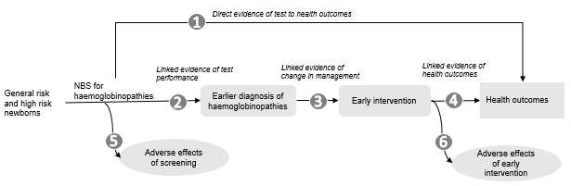
Figure 4 Assessment framework showing the links from the test population to health outcomes
Figure notes: 1: direct from test to health outcomes evidence; 2: test performance; 3: change in diagnosis/treatment/management; 4: influence of the change in management on health outcomes; 5: adverse events due to testing; 6: adverse events due to treatment
A health technology assessment was identified that summarised all the relevant published evidence up until 2014 (IHE 2016). This will be used as the basis for the assessment report for the literature published up to 2014. A systematic review will be performed for literature published since 2014. In addition, all studies included in a recent rapid review (Abt Associates 2022) will be assessed for inclusion.

Other relevant considerations
Proposals considered by MSAC can have aspects that are unique to the proposed technology, circumstances of use or funding arrangement, such that MSAC is unlikely to have considered the factors previously in the same context. Other relevant considerations should be explored in section 5 of the assessment report.
Additional information relevant to decision-making that is not captured elsewhere in the assessment is anticipated to include:
- Whether the proposed testing meets the criteria of the NBS National Policy Framework (see Appendix A). The categorical assessment of alignment against the NBS NPF is to be contained within section 5 of the assessment report, though can be signposted earlier.
- Organisational and infrastructure components that are outside the HTA.
Expert opinion from the Queensland NBS program suggested that the proposed introduction of haemoglobinopathies to the NBS program would require additional laboratory space, new capital equipment, additional staff and training.

Clinical management algorithms
Current clinical management algorithms have been developed for sickle cell disease (Figure 5) and β-thalassaemia (Figure 6). The populations in these algorithms are either identified by their clinical signs/symptoms (which trigger testing for haemoglobinopathies), or through targeted testing of cord blood or venous blood from the newborn. The clinical/signs and symptoms of haemoglobinothies may be mistaken for alternative diagnoses, which may result in delayed diagnosis. After a diagnosis is made, preventative management and treatment can be initiated, although in some cases, permanent damage may have been caused by the disease prior to initiation of treatment. Neonates at general risk of a haemoglobinopathy do not receive targeted testing at present, and without any signs or symptoms would not be tested for clinical reasons.
The proposed clinical management algorithms for sickle cell disease and β-thalassaemia are also shown (Figure 7 and Figure 8). The main difference between these algorithms is the early identification of the haemoglobinopathies due to universal NBS.
Genetic counselling and cascade testing of family members (PICO set 2) is shown in orange in both the current and proposed algorithms.

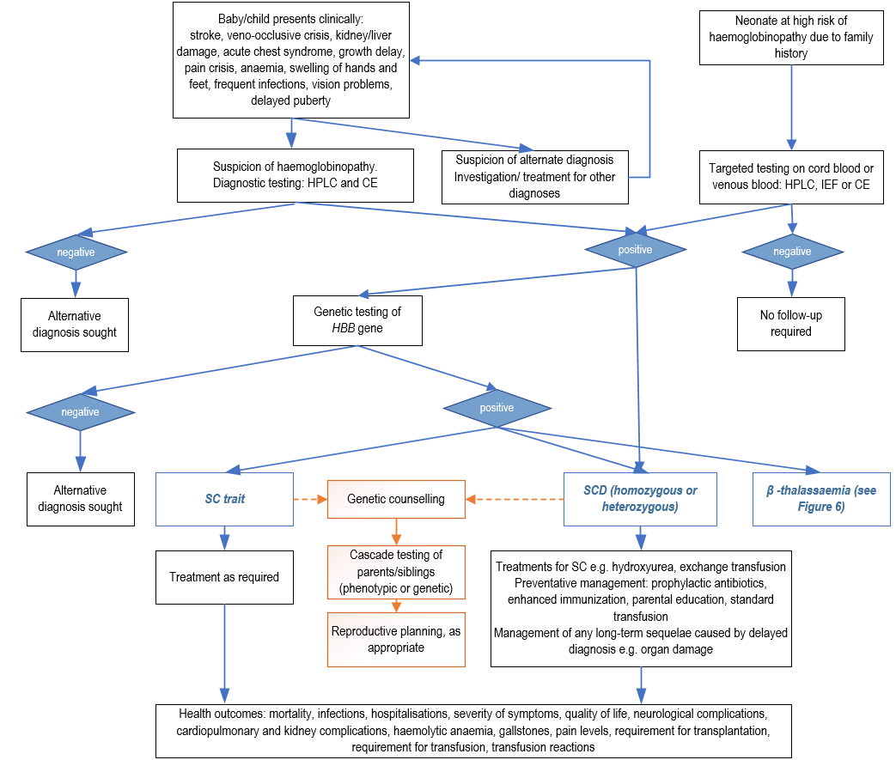
Figure 5 Current clinical management algorithm for sickle cell disease (without universal NBS)
CE = capillary electrophoresis; HBB = haemoglobin subunit beta; HPLC = high performance liquid chromatography; IEF = isoelectric focusing; MBS = Medicare Benefits Schedule; NBS = newborn bloodspot screening; SC = sickle cell; SCD = sickle cell disease

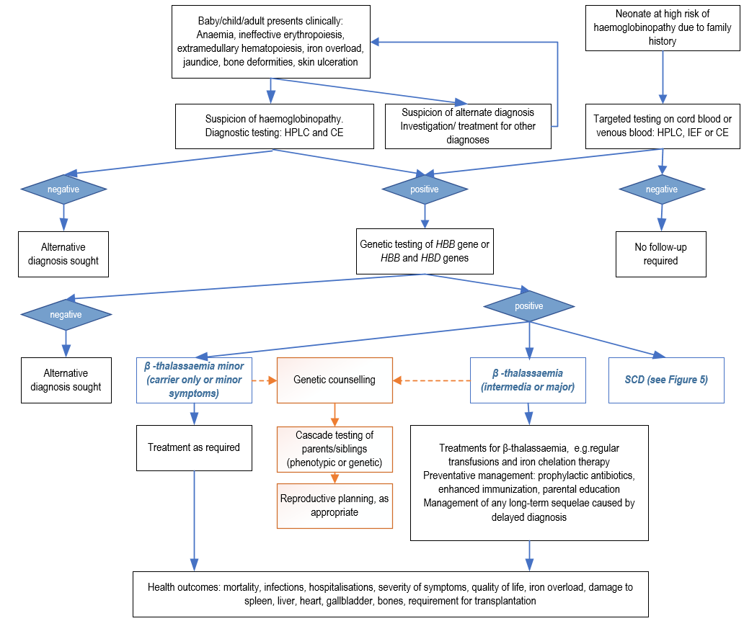
Figure 6 Current clinical management algorithm for β-thalassaemia (without universal NBS)
CE = capillary electrophoresis; HBB = haemoglobin subunit beta; HBD = haemoglobin subunit delta; HPLC = high performance liquid chromatography; IEF = isoelectric focusing; MBS = Medicare Benefits Schedule; NBS = newborn bloodspot screening; SCD = sickle cell disease

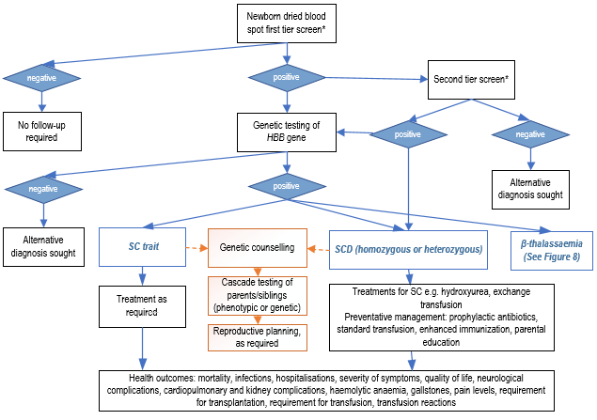
Figure 7 Proposed clinical management algorithm for sickle cell disease (with universal NBS)
CE = capillary electrophoresis; HBB = haemoglobin subunit beta; HPLC = high performance liquid chromatography; IEF = isoelectric focusing; MBS = Medicare Benefits Schedule; NBS = newborn bloodspot screening; SC = sickle cell; SCD = sickle cell disease
*Options for first and second-tier screening are HPLC, CE, IEF, MALDI-TOF, ESI-MS/MS and qPCR
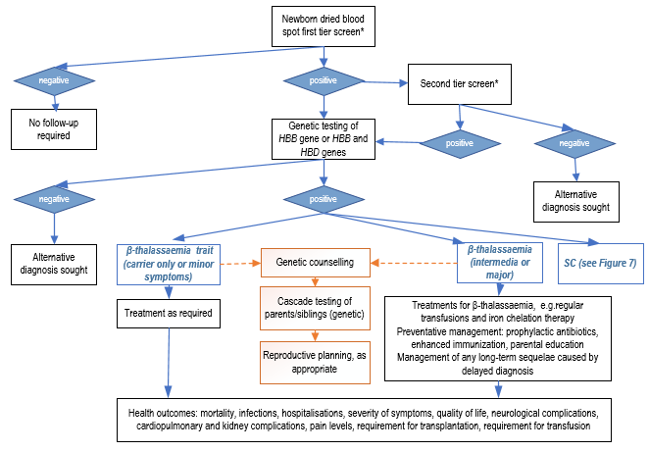
Figure 8 Proposed clinical management algorithm for β-thalassaemia (with universal NBS)
HBB = haemoglobin subunit beta; HBD = haemoglobin subunit delta; HPLC; high performance liquid chromatography; HSCT = haemopoietic stem cell transplantation; IEF = isoelectric focusing; SC trait = sickle cell trait; SCD = sickle cell disease
*Options for first and second-tier screening are HPLC, CE, IEF, MALDI-TOF, ESI-MS/MS and qPCR

Proposed economic evaluation
The expectation is that the evidence on newborn bloodspot screening for haemoglobinopathies will demonstrate superior effectiveness and non-inferior safety, compared to no universal newborn screening for haemoglobinopathies. The appropriate form of health economic evaluation is therefore a. cost-utility analysis or cost-effectiveness analysis (see Table 14).
Although there is a policy preference for independent consideration of the conditions (i.e. SCD and β-thalassaemia), in this case, the original application was for NBS of SCD, and the other conditions were added as they may also be detected by the same screening test (depending on the test protocol chosen).
The proposal is to provide two scenarios in the economics and financial sections: 1) for SCD only, and 2) SCD and β-thalassaemia, with marginal analyses to consider the additional costs/benefits of moving from scenario 1 to 2. This will allows MSAC’s advice on screening for SCD to not be affected by the suitability of screening for β-thalassaemia, in line with policy preference.
Table 14 Classification of comparative effectiveness and safety of the proposed intervention, compared with its main comparator, and guide to the suitable type of economic evaluation
Comparative safety- |  | Comparative effectiveness
 | Inferior | Uncertainª | Noninferior^{b} | Superior
Inferior | Health forgone: need other supportive factors | Health forgone possible: need other supportive factors | Health forgone: need other supportive factors | ? Likely CUA
Uncertainª | Health forgone possible: need other supportive factors | ? | ? | ? Likely CEA/CUA
Noninferior^{b} | Health forgone: need other supportive factors | ? | CMA | CEA/CUA
Superior | ? Likely CUA | ? Likely CEA/CUA | CEA/CUA | CEA/CUA
CEA=cost-effectiveness analysis; CMA=cost-minimisation analysis; CUA=cost-utility analysis
? = reflect uncertainties and any identified health trade-offs in the economic evaluation, as a minimum in a cost-consequences analysis
ª ‘Uncertainty’ covers concepts such as inadequate minimisation of important sources of bias, lack of statistical significance in an underpowered trial, detecting clinically unimportant therapeutic differences, inconsistent results across trials, and trade-offs within the comparative effectiveness and/or the comparative safety considerations
^{b} An adequate assessment of ‘noninferiority’ is the preferred basis for demonstrating equivalence

Proposal for public funding
The proposal is for haemoglobinopathies to be added to Australia’s NBS programs . If a haemoglobinopathy is diagnosed via NBS, then follow-on cascade testing of first-degree relatives is also proposed, however this is not covered by NBS program funding.

4.5 What is the cost of the test protocol?
The application stated that in Australia, HPLC costs between AU$90 and AU$100. This is consistent with MBS items for HPLC or CE (MBS items 65078 and 65081 have fees of $90.20 and $96.60).
In the pre-PASC teleconference between the applicants, the Department and the assessment group, it was suggested that genetic testing may be an appropriate method for confirmatory testing for the newborn, and also for cascade testing of family members. PASC considered that the cost for a laboratory to conduct genetic testing of the HBB gene or the HBB and HBD genes was approximately $500.
Genetic testing is one methodology option for the confirmatory diagnostic test as part of NBS. The policy area advises that if the confirmatory test is the 2nd tier performed within the NBS laboratory, to confirm whether the 1st tier was indeed an abnormal screen (and not a false positive), then this should be covered by NBS funding. However, if the genetic test is the final, diagnostic test, performed outside the NBS laboratory (referred to an appropriate Department in a tertiary hospital), then this is outside NBS funding. If the genetic testing component is not covered by NBS funding, then the policy area proposes it be funded by State/Territory funding rather than the MBS. The Department of Health and Aged Care informed PASC that it is exploring with the states/territories how the cascade testing of family members would be funded, and that it would be premature to propose MBS items relating to NBS at this stage. PASC accepted that the MBS is not proposed to be the funding source for cascade testing.

Summary of public consultation input
PASC noted and welcomed consultation input from 8 professional organisations, 3 consumer organisations and 4 health professionals. The organisations that submitted input were:
- The New South Wales NBS Programme and CHW Haematology Department (NSW NBS Programme)
- Thalassaemia and Sickle Cell Australia (TASCA)
- Genetic Undiagnosed and Rare Disease Collaborative Australia (GUARD)
- South Australia Women’s and Children’s Hospital, department of Haematology/oncology (WCH)
- The Newborn Screening Committee of the Human Genetics Society of Australia (HGSA)
- Rare Voices Australia
- Royal Children’s Hospital/Royal Women’s Hospital, Victoria (RCH/RWH)
- PathWest Haemoglobinopathy Reference Laboratory and Perth Children’s Hospital Haematology Department (PathWest)
- Victorian Clinical Genetics Service (VCGS)
- Australian Haemoglobinopathy Registry (HbR)
- Haematology Society of Australia and New Zealand (HSANZ)
The consultation feedback received was mixed. Most respondents acknowledged potential benefits of public funding for Newborn Bloodspot Screening for Sickle Cell Disease and Beta Thalassaemia. However, several respondents were not supportive implementing the proposed service.
The consultation feedback raised concerns in relation to the proposed test method, the detection of genetic carriers, and the detection of non-paternity.
Clinical need and public health significance
- The main benefits of public funding received in the consultation feedback included:
  - Benefits from earlier diagnosis. This included earlier initiation of treatment and monitoring which could reduce disease complications and improve quality of life. Some respondents considered public funding would help reduce disease associated mortality and morbidity and may therefore reduce grief experienced by families.
  - Improved access to testing and avoiding diagnostic odyssey.
- The main disadvantages of public funding received in the consultation feedback included:
  - Identifying carriers who will not develop disease
  - Potential to identify people with mild disease. Analytical screening results may not predict the phenotypic variability seen with the beta-thalassaemias.
  - Potential for false positives (e.g. other haemoglobinopathies).
  - Infants with beta-thalassaemia are less likely to benefit from early invention.
- The consultation feedback identified a range of health services as being needed to be delivered after the intervention. This included a range of health services needed for the management of SCD and thalassemia. Other services included carer education, reproductive health services (counselling, preimplantation genetic diagnostic testing), and grief counselling.
Indication(s) for the proposed medical service and clinical claim
- The consultation feedback ranged from strongly agreeing to strongly disagreeing with the proposed populations. Several respondents supported screening of all Australian newborns and highlighted limitations of targeted testing by ethnicity. However, others considered targeted antenatal and neonatal testing is adequate for early identification and diagnosis.
- Some respondents considered that newborn screening for beta thalassaemia may not be as beneficial as SCD as this group are less likely to benefit from early intervention.
- The consultation feedback ranged from disagreeing to strongly agreeing with the proposed comparator. Some respondents considered no screening was the appropriate comparator due to variable screening practices across Australia. Others suggested targeted testing could be an appropriate comparator.
Additional comments
Several respondents provided feedback on testing methods. The NSW NBS laboratory recommended the use of MALDI-TOF to screen for the thalassemias. MS/MS protocols are available for detecting only disease states of SCD. VCGS suggested a 1-tier testing for SCD using qPCR that could be delivered alongside Severe Combined Immunodeficiency (SCID) and spinal muscular atrophy (SMA). VCGS also stated that the current technology proposed is not feasible for large-scale cost-effective operation. WCH stated with IEF may miss a number of variants.
The NSW NBS laboratory also considered all newborns should have a pretransfusion bloodspot sample where possible and repeat testing at term for preterm infants.
HGSA and an individual specialist considered that implementation would require additional resources to set up the methodologies and new equipment would be required.
HGSA considered policy decision would need to be made regarding reporting of other hemoglobinopathies not on the agreed panel if a comprehensive haemoglobin analytical method is chosen as the first tier.
Rare Voices Australia highlighted that ensuring timely and accurate diagnosis of rare disease is a priority under the National Strategic Action Plan for Rare Diseases and expressed support for newborn bloodspot screening for any conditions that meet the NBS NPF.
VCGS was not supportive of introduction of the broader thalassaemia screening because of the infrastructure and feasibility of laboratory testing difficulties. Due to difficulties associated with the proposed testing process and other issues they did not support implementation of screening as outlined in the MSAC application.
GUARD stated that equitable access needs to be ensured for all Australians, regardless of geography. GUARD also emphasised the importance of the proposed service meeting the needs of CALD and indigenous communities.
PathWest, HbR, and HSANZ stated that universal NBS should not replace appropriate antenatal or pre-pregnancy testing.
PASC noted that consultation feedback from Sydney Children’s Hospital Network proposed implementing a screening strategy for sickle cell disease which would not also identify carriers. The applicants disagreed with this approach. An expert advisor to PASC explained that when newborn screening programs were first implemented, no one wanted to diagnose carriers. However, in 2022, most parents want to know if they are carriers, and this information may be useful for broader family members.
Although PathWest suggested that targeted neonatal testing is a reasonable alternative to universal neonatal screening, an expert advisor to PASC explained that determining the origin of families through a questionnaire is complex, and may not identify everyone at risk.

Next steps
After ratification of the post-PASC PICO, the application will progress as a Department Contracted Assessment Report.

Appendix A NBS National Policy Framework (NBS NPF) Criteria
NBS National Policy Framework Criteria
The condition
- The condition should be a serious health problem that leads to significant morbidity or mortality.

  - What data are there on the incidence of the condition, including in the Australian population? How is this incidence determined—through screening studies, international programs, cases identified clinically, modelled estimates based on data from variant databases or some other means? Are there any known differences in incidence in Australian sub-populations?

  - What is the burden of disease associated with the condition, including morbidity and mortality? Does the burden of disease vary between individuals?

- There should be a benefit to conducting screening in the newborn period.

- While the benefit to the baby must always be the first consideration, for some conditions a benefit for the family and/or community, as well as the benefit to the baby, may also be important and warrant consideration. This might include benefits to the family for conditions where there is currently no intervention and which will be likely to lead to early mortality but where a definitive diagnosis might be aided by a screening test.

  - What are the known health benefits from early detection that exist, or can be achieved, through screening for the condition? This may include early intervention, prevention of symptoms or reduction in condition severity.

  - Why is screening for this condition during the newborn period the most beneficial method of early detection?

  - Does detection of this condition provide families with actionable information that assists them in making informed choices about reproduction in the future?

  - What emotional or social benefits does early detection provide?

  - What harms may arise from screening for the condition in the newborn period?

- The natural history of the condition, including development from latent to declared disease, should be adequately understood.

  - What information is known on the natural history of the condition in Australia or comparable international populations?
  - When would the condition usually be detected clinically?

  - Explore the current knowledge of penetrance of the condition. Are there known benign or milder late-onset forms?

- There should be a suitable test protocol to identify the presence of the condition.
  - What test protocols could be used to identify the presence of the condition? Is there consensus on the most appropriate test protocol?

  - When considering the test protocol, what is the clinical and analytic validity based on a consideration of:
  - Sensitivity;
  - Specificity;
  - False positive rate;
  - False negative rate;
  - Positive predictive value;
  - Negative predicative value.

  - Is the test protocol simple and reliable?
  - Can the test protocol be performed on the available dried bloodspot?
  - Can the test be multiplexed within existing newborn bloodspot screening panels?

  - What is the cost of the test protocol?

  - Will genetic testing be used as part of the test protocol? If genetic testing is needed:

- Will this be by common mutations or sequencing?
- Which mutations would be tested?
- What is the penetrance of the mutations?
- Are there variants of uncertain significance?

- The test protocol should, on balance, be socially and ethically acceptable to health professionals and the public.

  - Can the test protocol detect other conditions of clinical or unknown significance and/or carriers and, if so, what are the implications?
  - What are the potential benefits and harms associated with the preferred test protocol(s)?
The Intervention
- Health care services for diagnosis and management should be available so that these services can be offered if there is an abnormal screening result.

  - What health care services are currently involved in the diagnosis and ongoing management of the condition?
  - What impact would screening for the condition have on the health care services that would be required to support diagnosis and management following an abnormal screening result?

  - Is diagnostic testing readily available and reliable?
  - Do current health care services have capacity to support the diagnosis and ongoing management of the condition?

  - Are current health care services of sufficient quality to support the diagnosis and ongoing management of this condition?

  - Is there equitable access to these health care services for families, including those from rural and remote areas?
- There should be an accepted intervention for those diagnosed with the condition.

  - What accepted intervention(s) is (are) available for newborns that receive an early diagnosis through screening?
  - How well is the intervention and treatment pathway understood? Is there agreement on when intervention is required?

  - How effective is the intervention? Does it alleviate the symptoms of the condition or slow or halt its progression? What influence does the intervention have on quality and length of life?

  - How urgent is the intervention? Does the intervention need to be initiated before symptoms of the condition present?

  - Is the intervention readily available and accessible?

  - What are the potential harms associated with the intervention, and to what extent can these harms be mitigated or managed?

  - What is the cost of the intervention? What costs will be incurred for the diagnosis, management, and treatment of conditions, including the costs for false positives?

  - Is there equitable access to the intervention for families, including those from rural and remote areas?

Additional considerations
- The benefit of screening a condition must be weighed against its impact on the program as a whole.

  - Can screening for this condition be achieved within the current screening pathway?

  - Is the addition of this condition likely to require ethical considerations that may warrant a separate consent process?

  - Would it be likely that screening for the condition would impact negatively upon other elements of the program? For example, could it be anticipated that participation rates might fall?

  - Are there any additional costs, such as the purchasing of new technology or training, which are associated with screening for this condition?

  - What is the economic impact of excluding/including the condition? Do benefits exceed costs? Is it cost-effective to screen? It may be necessary for a detailed economic evaluation to consider this these questions and other relevant economic issues.
- What other information relevant to decision making should be considered that has not been captured elsewhere?

References
Abt Associates 2022, A Rapid review of the Newborn Blood Screening in Sickle Cell Disease and b-thalassemia.

AIHW 2022, National Perinatal Data Collection annual update 2020 - data tables, <https://www.aihw.gov.au/reports/mothers-babies/australias-mothers-babies/contents/demographics-of-mothers-and-babies/key-statistics-and-trends>.

Argent, E, Emder, P, Monagle, P, Mowat, D, Petterson, T, Russell, S, Sachdev, R, Stone, C & Ziegler, DS 2012, 'Australian Paediatric Surveillance Unit study of haemoglobinopathies in Australian children', J Paediatr Child Health, vol. 48, no. 4, Apr, pp. 356-360.

Arishi, WA, Alhadrami, HA & Zourob, M 2021, 'Techniques for the Detection of Sickle Cell Disease: A Review', Micromachines (Basel), vol. 12, no. 5, May 5.

BetterHealth VIC, Newborn bloodspot screening, Victoria Department of Health, BetterHealth channel, viewed 4 Oct 22, <https://www.betterhealth.vic.gov.au/health/conditionsandtreatments/newborn-screening>.

Centers for Disease Control Prevention and Association of Public Health Laboratories 2015, Hemoglobinopathies: Current Practices for Screening, Confirmation and Follow-up.

Dasauni, P, Chhabra, V, Kumar, G & Kundu, S 2021, 'Advances in mass spectrometric methods for detection of hemoglobin disorders', Analytical Biochemistry, vol. 629 (no pagination), 15 Sep.

Davies SC, Cronin E, Gill M, Greengross P, Hickman M & Normand C 2000, Screening for sickle cell disease and thalassaemia: a systematic review with supplementary research, Health Technology Assessment NHS R&D HTA Programme, United Kiingdom.

El-Haj, N & Hoppe, CC 2018, 'Newborn Screening for SCD in the USA and Canada', Int J Neonatal Screen, vol. 4, no. 4, Dec, p. 36.

Gaston, MH, Verter, JI, Woods, G, Pegelow, C, Kelleher, J, Presbury, G, Zarkowsky, H, Vichinsky, E, Iyer, R, Lobel, JS & et al. 1986, 'Prophylaxis with oral penicillin in children with sickle cell anemia. A randomized trial', N Engl J Med, vol. 314, no. 25, Jun 19, pp. 1593-1599.

Genetic Science Learning Centre, Hemoglobin Disorders, University of Utah, viewed 30th September 2022, <https://learn.genetics.utah.edu/content/genetics/hemoglobin>.

Giordano, P 2013, 'Newborn Screening for Haemoglobinopathies', in M Angastiniotis, A Eleftheriou & R Galanello (eds), Prevention of Thalassaemias and Other Haemoglobin Disoders, 2nd edn, vol. 1, Nicosia, Cyprus.

Goonasekera, HW, Paththinige, CS & Dissanayake, VHW 2018, 'Population Screening for Hemoglobinopathies', Annu Rev Genomics Hum Genet, vol. 19, Aug 31, pp. 355-380.

Government of Western Australia 2017, Neonatal screening: haemoglobin disorders: Clinical Practice Guidelines. .

Huisman, T & et al 2022, A database of Human Hemoglobin Variants and Thallasemias, viewed 30th September 2022, <https://globin.bx.psu.edu/cgi-bin/hbvar/counter>.

Huynh, T, Greaves, R, Mawad, N, Greed, L, Wotton, T, Wiley, V, Ranieri, E, Rankin, W, Ungerer, J, Price, R, Webster, D & Heather, N 2022, 'Fifty years of newborn screening for congenital hypothyroidism: current status in Australasia and the case for harmonisation', Clin Chem Lab Med, vol. 60, no. 10, Sep 27, pp. 1551-1561.

IHE 2016, Newborn blood spot screening for galactosemia, tyrosinemia type I, homocystinuria, sickle cell anemia, sickle cell/beta-thalassemia, sickle cell/hemoglobin C disease, and severe combined immunodeficiency, Alberta STE Report, IHE, Canada.

King, L, Fraser, R, Forbes, M, Grindley, M, Bortolusso Ali, S & Reid, M 2007, 'Newborn sickle cell disease screening: The Jamaican experience (1995-2006)', Journal of medical screening, vol. 14, 02/01, pp. 117-122.

Kunz, JB, Awad, S, Happich, M, Muckenthaler, L, Lindner, M, Gramer, G, Okun, JG, Hoffmann, GF, Bruckner, T, Muckenthaler, MU & Kulozik, AE 2016, 'Significant prevalence of sickle cell disease in Southwest Germany: results from a birth cohort study indicate the necessity for newborn screening', Annals of Hematology, vol. 95(3), 01 Feb, pp. 397-402.

Modell, B & Darlison, M 2008, 'Global epidemiology of haemoglobin disorders and derived service indicators', Bull World Health Organ, vol. 86, no. 6, Jun, pp. 480-487.

Monash University, Haemoglobinopathy Registry (HbR), Monash, Victoria, viewed 30th September 2022, <https://www.monash.edu/medicine/sphpm/registries/hbr>.

MSAC 2021, Guidelines for preparing assessments for the Medical Services Advisory Committee, <www.msac.gov.au/internet/msac/publishing.nsf/Content/Documents-for-Applicants-and-Assessment-Groups>.

NBS, N 2022, Consultation Survey on MSAC Application 1737.

RACGP 2018, Genomics in general practice: Haemoglobinopathies, <https://www.racgp.org.au/clinical-resources/clinical-guidelines/key-racgp-guidelines/view-all-racgp-guidelines/genomics/haemoglobinopathies>.

Serjeant, GR 1997, 'Sickle-cell disease', The Lancet, vol. 350, no. 9079, pp. 725-730.

Serjeant, GR 2013, 'The natural history of sickle cell disease', Cold Spring Harb Perspect Med, vol. 3, no. 10, Oct 1, p. a011783.

Sobota, A, Sabharwal, V, Fonebi, G & Steinberg, M 2015, 'How we prevent and manage infection in sickle cell disease', British Journal of Haematology, vol. 170(6), 01 Sep, pp. 757-767.

Streetly, A, Sisodia, R, Dick, M, Latinovic, R, Hounsell, K & Dormandy, E 2018, 'Evaluation of newborn sickle cell screening programme in England: 2010-2016', Archives of disease in childhood, vol. 103(7), 01 Jul, pp. 648-653.

The Lancet Global, H 2022, 'Homing in on haemoglobinopathies', Lancet Glob Health, vol. 10, no. 1, Jan, p. e1.

Wang, Y, Liu, G, Caggana, M, Kennedy, J, Zimmerman, R, Oyeku, SO, Werner, EM, Grant, AM, Green, NS & Grosse, SD 2015, 'Mortality of New York children with sickle cell disease identified through newborn screening', Genetics in Medicine, vol. 17(6), 04 Jun, pp. 452-459.

Weatherall, DJ & Clegg, JB 2001, 'Inherited haemoglobin disorders: an increasing global health problem', Bulletin of the World Health Organization, vol. 79, pp. 704-712.

Wild, BJ, Green, BN & Stephens, AD 2004, 'The potential of electrospray ionization mass spectrometry for the diagnosis of hemoglobin variants found in newborn screening', Blood Cells, Molecules, and Diseases, vol. 33(3), November/December, pp. 308-317.

Zanella-Cleon, I, Joly, P, Becchi, M & Francina, A 2009, 'Phenotype determination of hemoglobinopathies by mass spectrometry', Clinical Biochemistry, vol. 42(18), December, pp. 1807-1817.

Qld Children’s Hospital is the largest children’s hospital in Qld and attracts patients with complex conditions from all over Qld. https://www.childrens.health.qld.gov.au/qch/ (Source: Abt Associates rapid review)
MSAC public summary document (PSD), application 1628 – Alpha-1 Antitrypsin Genotyping. “MSAC noted the applicant’s claim that IEF is being phased out because it is a time-consuming and difficult technique requiring specific expertise, and that it cannot be batch processed to the same degree as genetic tests.” (pg 3).
Wajcman H, Moradkhani K (2011). Abnormal haemoglobins: detection & characterization. Indian J Med Res: 134(4):538-46.
Personal communication, Dr Jacobus Ungerer, Pathology Queensland, received via email 7th October 2022

