MSAC Application 1740

NT-proBNP to aid in the diagnosis of patients with suspected heart failure in the non-hospital setting

PICO Confirmation

Summary of PICO/PPICO criteria to define question(s) to be addressed in an Assessment Report to the Medical Services Advisory Committee (MSAC)
Table 1 PICO set 1 for NT-proBNP testing in patients who have suspected but uncertain heart failure diagnosis in a primary care setting
Component | Description
Population | People with signs and/or symptoms consistent with heart failure in whom a heart failure diagnosis is suspected but uncertain  Setting: primary care
Intervention | NT-proBNP testing as part of the initial clinical assessment (which may include cardiorespiratory history and physical examination and assessment, blood chemistry assessment, thyroid function tests; full blood count, ECG, and chest X-ray)
Comparator/s | Clinical assessment without NT-proBNP testing
Reference standard | Standard diagnostic workup / consensus clinical diagnosis based on all available information
Outcomes | Test Performance  - Diagnostic accuracy (sensitivity, specificity)  - Concordance  - Positive and negative predictive values  - Prognostic value  Health Outcomes  - All-cause hospitalisation  - Heart failure hospitalisation  - All-cause mortality  - Heart-failure related death  - Health-related quality of life  Change in management  - Time to correct diagnosis  - Echocardiograms received  - Referrals made/ avoided  - Time to appropriate treatment  Safety  - Adverse events due to testing  - Psychological adverse events due to testing (positive result, negative result, true or false results)  - Harms associated with any changes in management  Healthcare resources  - Cost-effectiveness  - Total Australian Government health care costs.
ECG: Electrocardiography; NT-proBNP: N-terminal (NT)-pro BB-type natriuretic peptide

Table 2 PICO set 2 for NT-proBNP testing in patients who are referred to a specialist or consultant physician with a suspected but uncertain heart failure diagnosis
Component | Description
Population | People with signs and/or symptoms consistent with heart failure in whom a heart failure diagnosis is suspected but uncertain  Setting: specialist physician practice
Prior tests | Initial clinical assessment may include cardiorespiratory history and physical examination and assessment, blood chemistry assessment, thyroid function tests; full blood count, ECG, and chest X-ray
Intervention | NT-proBNP testing + echocardiogram
Comparator/s | Echocardiogram
Reference standard | Standard diagnostic workup / consensus clinical diagnosis based on all available information
Outcomes | Test Performance  - Diagnostic accuracy (sensitivity, specificity)  - Concordance  - Positive and negative predictive values  - Prognostic value  Health Outcomes  - All-cause hospitalisation  - Heart failure hospitalisation  - All-cause mortality  - Heart-failure related death  - Health-related quality of life  Change in management  - Time to correct diagnosis  - Echocardiograms received  - Time to appropriate treatment  Safety  - Adverse events due to testing  - Psychological adverse events due to testing (positive result, negative result, true or false results)  - Harms associated with any changes in management  Healthcare resources  - Cost-effectiveness  - Total Australian Government health care costs.
ECG: Electrocardiography; NT-proBNP: N-terminal (NT)-pro BB-type natriuretic peptide

Purpose of application
An application requesting Medicare Benefits Schedule (MBS) listing of N-terminal (NT)- pro B-type natriuretic peptide (NT-proBNP) assays, for exclusion of the diagnosis of heart failure (HF) was received from the Roche Diagnostics Australia Pty Limited by the Department of Health and Aged Care.
The proposal was for the use of NT-proBNP testing to be limited to cardiologists (or general practitioners working under the supervision of a cardiologist), in a non-hospital setting. The clinical claim was that the use of NT-proBNP assays with or without an echocardiogram in the diagnosis of HF results in non-inferior effectiveness and safety, and superiority in terms of effective use of healthcare resources, in patients with suspected heart failure compared to an echocardiogram alone.
The application claimed that NT-proBNP can be used to accurately triage patients, ruling out patients who do not have heart failure, and can therefore avoid an unnecessary echocardiogram. The claim was that this allows earlier investigations and treatment for alternative diagnoses.
PASC noted that HF is associated with non-specific symptoms, which makes discrimination between HF and other cardiac and non-cardiac diseases difficult. Initial assessment of non-acute HF occurs in primary care. Limiting access to the MBS item for NT-proBNP to cardiologists, as per the application, could lead to an approximately 3-6-month delay depending on waitlists to see a cardiologist. PASC considered that this would limit the utility of NT-proBNP. Making NT-proBNP testing available in primary care (general practice and appropriate nurse practitioners), as part of the initial assessment, is more likely to be useful in reducing hospitalisation, time to correct diagnosis and appropriate treatment and addressing access to services issue for the remote and rural population. PASC considered that the pre-test probability would be higher in the cardiologist-requested population, however it was less likely to be cost-effective because echocardiograms are less likely to be reduced in the cardiologist setting. PASC advised the PICO should be split to contain two separate PICO sets for requesting an NT-proBNP test in the primary care setting and by a cardiologist. PASC considered that while the second PICO set is intended to primarily examine the cardiologist requestor setting, there will be times when a patient presents to a specialist or consultant physician other than a cardiologist with signs and/or symptoms of heart failure, so requestors should not exclude other specialists. PASC therefore advised that requestors in the cardiologist requestor setting should be expanded to all specialists or consultant physicians.
The PICO confirmation has therefore been amended to allow for testing within the primary care setting (PICO set 1), or in specialist physician practice (PICO set 2).

PICO criteria

Population
PICO set 1
The population of interest is patients presenting to the primary care setting with signs and symptoms of heart failure, where the diagnosis is suspected but uncertain.
PICO set 2
For PICO set 2, the population of interest is all patients who are referred to a specialist or consultant physician with a suspected but uncertain HF diagnosis.
Both PICO sets exclude those with acute symptoms presenting to an emergency department (who may already use MBS item 66830 for BNP or NT-proBNP testing), and those patients who may have been suspected of heart failure based on symptoms, age, and history, but where the initial assessment have led a GP or a specialist physician to suspect an alternative diagnosis.
Clinical presentation
Heart failure (HF) is a complex clinical syndrome with typical symptoms that initially manifest on physical exertion. As the disease progresses, symptoms can occur at a low level of physical activity and in some cases, even at rest. It involves an inability to fill the ventricle with blood or reduced blood ejection to fulfil the requirements of the vital metabolising organs. The most common contributing factor to HF is ventricular systolic and/or diastolic dysfunction. Additionally, cardiac structural abnormalities ranging from the valves to the endocardium, pericardium and conduction system can also lead to HF.
HF has heterogenous symptoms, most of which are non-specific. Patients with suspected HF may present to primary care for diagnosis and triage. Due to the non-specificity of symptoms, a definitive diagnosis of HF is difficult. The signs of HF can be classified into cardiac strain and dysfunction (tachycardia, murmurs, third heart sound, and displaced apex beat), congestion (abnormal cardiac filling and high venous pressure, hepatic enlargement and tenderness, peripheral oedema, pulmonary crackles, pleural effusions, and ascites) and reduced end-organs perfusion. The symptoms and signs of chronic HF are listed in Table 3. Owing to the compensatory mechanism, patients in earlier stages of HF present with no specific signs or signs and symptoms only on physical and emotional exertion but as the syndrome progresses symptoms manifest at a low level of physical activity and in advanced cases even at rest.
Table 3 Typical and less typical signs and symptoms of HF
More typical HF symptoms | More specific HF signs
Dyspnoea | Elevated jugular venous pressure
Orthopnoea | Hepatojugular reflux
Paroxysmal nocturnal dyspnoea | Third heart sound
Fatigue | Laterally displaced apex beat
Less typical HF symptoms | Less specific HF signs
Nocturnal cough | Weight gain (>2 kg/wk)
Wheeze | Weight loss (in advanced HF)
Abdominal bloating | Peripheral oedema (ankle, sacrum)
Anorexia | Pulmonary crackles
Confusion (elderly) | Pleural effusions
Depression | Cardiac murmur
Palpitations | Tachycardia
Dizziness | Tachypnoea
Syncope | Cheyne-Stokes respirations
Bendopnea (shortness of breath when leaning forward) | Ascites
HF: heart failure
Source: p. 1136, Table 1, National Heart Foundation of Australia and CSANZ: Guidelines for the Prevention, Detection, and Management of Heart Failure in Australia (Atherton et al. 2018)
One of the dominant but non-specific symptoms of HF is dyspnoea or breathlessness which progresses as the disease advances, resulting in a reduced ability to function and engage in daily activities. Dyspnoea can indicate different pathophysiological conditions along with HF. But certain patterns are typical of HF such as paroxysmal nocturnal dyspnoea, orthopnoea and bendopnea. In most cases, the non-specificity of dyspnoea can present a clinical challenge to healthcare providers. Thus, approaches to further evaluate the patient will differ according to the duration and severity of the dyspnoea, as well as the patient’s age and general health status.
Dyspnoea and other related less typical symptoms such as nocturnal cough, and wheezing are caused by reduced forward flow from the left ventricle resulting in higher pressure in the pulmonary capillary bed (Kemp and Conte 2012, Dubé et al. 2016). In a study, it was observed that 72% of HF patients stopped engaging in physical activities and exercise because of dyspnoea (Clark et al. 1995). Fatigue is also commonly observed in patients suspected of HF as the heart is unable to sustain the required amount of cardiac output to conserve blood flow to the brain and heart and fulfil the needs of the metabolising organs.
The patients diagnosed with HF are usually classified depending on their left ventricular ejection fraction (LVEF) reflecting the percentage of ventricular volume ejected per heartbeat. It is measured using two-dimensional or three-dimensional echocardiography. The two main types of HF are HF with reduced ejection fraction (HFrEF) and HF with a preserved ejection fraction (HFpEF). The National Heart Foundation of Australia and Cardiac Society of Australia and New Zealand (CSANZ) guidelines defined HFrEF as clinical symptoms of HF with measured LVEF < 50% (Atherton et al. 2018). However, if LVEF is mildly reduced with values 41 - 49%, additional criteria such as objective evidence of high filling pressure or signs of HF are required for classification. Studies have used different LVEF cut-offs to identify patients with HFrEF ranging from 25 - 40% (Booth et al. 2014, Brunner-La Rocca and Sanders-van Wijk 2019). However, CSANZ recommends a cut-off value of 50% to inform management and therapeutic strategies. Patients diagnosed with HFrEF have reduced left ventricular systolic function which results in the activation of neurohormonal and inflammatory systems, cardiac remodelling, decreased end-organ perfusion and worsening cardiac function. On the contrary, HFpEF is far more difficult to diagnose due to the preservation of the key biomarker of HF (i.e., LVEF) (Borlaug and Paulus 2010). The diagnosis of HFpEF is dependent on the clinical symptoms which are largely non-specific. Three main criteria for HFpEF are:
- Clinical symptoms of HF;
- Measured LVEF of at least 50%; and
- Objective evidence of diastolic dysfunction or structural heart disease without an alternative cause.
One of the main challenges in the differential diagnosis of HF in a non-hospital setting is the association with significant multimorbidity. The comorbid conditions commonly observed with HF are chronic obstructive pulmonary disease (COPD), acute coronary syndrome, myocarditis, valvular heart disease, hypertrophic cardiomyopathy, pulmonary hypertension, renal dysfunction, and stroke (Bosch et al. 2019). Multimorbidity may lead to exacerbated progression and severity of HF, nonfatal complications, hospitalisations, increased utilisation of healthcare resources and in some cases death. The risk of comorbidity tends to increase with age with approximately 3 out of 4 adults >65 years of age having multiple comorbidities. The prevalence of the comorbid conditions is higher in HF patients with preserved ejection fraction than in those with reduced ejection fraction. A study observed that HF patients with preserved ejection fraction had one extra chronic condition, on average, as compared to patients with reduced ejection fraction (Chamberlain et al. 2015). Another study conducted in Australia with patients aged ≥ 45 years who presented to general practitioners (GPs) found that 98.2% of HF patients have at least one comorbidity, 44.7% have six or more whereas 16.9% have nine or more comorbidities (Taylor et al. 2017). A list of comorbid conditions is provided in Table 4 along with the respective prevalence in HF patients observed in the ‘Study of Heart failure in the Australian Primary carE setting’ (SHAPE) study.
Table 4 Comorbidities in HF population
Comorbid conditions | Prevalence in HF population
Hypertension | 41.1%
Chronic Obstructive Pulmonary Disease and Asthma | 25.1%
Depression and anxiety | 18.4%
Ischaemic heart disease | 12.9%
Diabetes | 11.9%
Osteoporosis | 9.5%
Renal Impairment | 4.0%
Atrial fibrillation | 3.6%
HF: Heart failure
Source: Sindone et al. (2021)
Prevalence of disease
There are limited epidemiological data on HF in non-hospital settings. While HF impacts approximately 1% of the population in Western countries, the prevalence is strongly associated with aging. A study observed that the prevalence of HF increases from 3% in the adult population aged 65–74 years to 7% in the population aged 75 – 84 years and > 10% in the population aged above 85 years (Mosterd and Hoes 2007, Taylor et al. 2017).
In Australia, approximately 6.9 cases per 1000 adults aged ≥ 45 years are diagnosed with HF each year with a higher prevalence in men (7.4%) than in women (3.5%) (Chan et al. 2016). A retrospective cohort study conducted in Australia estimated the HF prevalence by analysing the medical records and consultation notes for pre-specified HF terms between July 2013 and June 2018 from 43 general practices. During the study period, there were 1.12 million active HF patients who visited general practices three or more times. Among the active population, the age-standardized prevalence was estimated to be 2.20% (95% CI 2.168–2.23%). and the age-standardised incidence was 0.348% per year (95% CIs: 0.342–0.354%). The applicant extrapolated the age-standardised incidence rate reported in this study to the latest and projected population figures for Australia. The estimates indicated that in 2023, approximately 73,367 incident HF cases (aged ≥ 18 years) will be managed in general practices in Australia.
It is important to note that the prevalence of HF is much higher in First Nations Australians. The National Aboriginal and Torres Strait Islander Health Survey indicated that the Indigenous to non-Indigenous age-standardised prevalence ratio is 1.7 times higher whereas mortality attributed to HF is twice as high in First Nations Australians than in non-Indigenous Australians (Woods et al. 2012) (Table 5). First Nations Australians aged 25 – 34 have a similar risk of cardiovascular disease as that of non-Indigenous Australians aged 45 – 54 years. Additionally, the majority of the HF cases (65%) detected in the First Nations Australians had not been diagnosed previously indicating a significant unidentified burden of HF in the First Nations Australians (Agostino et al. 2020).
Table 5 Rates of HF and preventable hospitalisations in First Nations Australians and non-indigenous Australians across years
Year | Age standardised rate of HF per 100,000 |  | Number of potentially preventable hospitalisations
 | First Nations Australians | Non-indigenous Australians | First Nations Australians | Non-indigenous Australians
2014-2015 | 479 | 195 | 1,853 | 53,658
2015-2016 | 481 | 208 | 1,908 | 59,056
2016-2017 | 475 | 209 | 1,973 | 60,861
2017-2018 | 462 | 201 | 2,051 | 60,503
Sources: AIHW analysis of National Hospital Morbidity Database and ABS estimated resident populations June 2014 - 2018
Expected size of the population to be tested
The application proposed that cardiologists should be able to access the proposed MBS item for NT-proBNP testing for patients with suspected but uncertain HF diagnosis. The size of the population will therefore depend on how many patients are referred by GPs to cardiologists and are found to have an uncertain diagnosis after initial assessment.
PASC noted that the availability of the proposed item for use in primary care will have implications for the expected size of the population (proposed number of tests) provided by the applicant. The expected size of the population has been updated in Table 6 providing the estimated numbers of NT-proBNP tests for PICO set 1 and 2.
Following PASC, the expected size of the population who would be eligible for NT-proBNP testing in primary care (PICO set 1) was estimated based on the number of patients with suspected HF diagnosis (including definite or probable or possible HF diagnosis) who present to a GP as provided in the application based on the SHAPE study. The estimated number of NT-proBNP tests that would be conducted in a primary care setting is 188,658 in 2023, increasing to 216,202 in 2025. The application estimated the number of patients with a suspected HF diagnosis who would be eligible for NT-proBNP testing (if restricted to being requested by a cardiologist in a non-hospital setting; PICO set 2) to be 20,064 – 85,368 in 2023, increasing to 22,993–97,832 in 2025. These estimates were based on annual incidence rate reported in the SHAPE study (Liew et al. 2020). A previous Australian study estimated a comparatively lower HF incidence in Australia. Chan et al applied international epidemiological estimates to Australian population data 2014 to suggest HF incidence rate of 0.27% per year. However, this study only estimated de novo cases of HF predominantly associated with HFrEF (Chan et al. 2016).
In the application, the total Australian population in 2023 and the projected growth to 2025 were based on the Australian Bureau of Statistics projections. Table 6 presents the estimation of the number of patients with suspected HF who will be eligible to use the proposed service as per both PICO set 1 and 2.

Table 6 Patients with suspected HF who will use NT-proBNP testing
Year | 2023 | 2024 | 2025
Australian population projection ≥18 years | 21,082,471 | 21,411,852 | 21,744,502
HF incident patients who present to a GP (incidence 0.348%) | 73,367 | 74,513 | 75,671
Number of patients with suspected HF who present to a GP* | 209,620 | 212,895 | 216,202
Projected uptake of NT-proBNP tests | 90% | 100% | 100%
Estimated number of NT-proBNP tests (PICO set 1) | 188,658 | 212,895 | 216,202
Estimated number of NT-proBNP tests (PICO set 2) | 20,064 – 85,368 | 22,642 – 96,335 | 22,993–97,832
Estimated number of NT-proBNP tests in total (for both PICO sets 1 and 2) | 208,722 – 274,026 | 235,537 – 308,230 | 239,195 – 314,034
* Assuming 35% of patients who present to a GP have confirmed HF diagnosis (Ontario Health (Quality) 2021)
NT-proBNP: N-terminal (NT)-pro B-type natriuretic peptide
Source: table 3, page 32 of the application
Patients with a definitive HF diagnosis will undergo echocardiography only for the characterisation of the disease and do not form part of the population for this application.
Therefore, it is not clear if applicant’s projection for PICO set 2 included patients with definitive HF diagnosis who will not seek NT-proBNP for the HF diagnosis. The Assessment Report should include a clear justification and basis for the estimates of use, as per the MSAC Guidelines. It is also important to note that use of NT-proBNP will depend on the requestors’ referral propensity. While NT-proBNP can reduce the risk of overdiagnosis which may result due to simply relying on patients’ symptoms and signs, some specialists also believed that enhanced access to natriuretic peptide testing may lead to indiscriminate testing and increased risk of false positive results (Campbell et al. 2011).
PASC noted that there would be a possibility of broad usage of this test, specifically in primary care. This is mainly because patients who present to a GP with HF symptoms often have comorbidities (e.g. obesity) that account for symptoms such as shortness of breath, so where a diagnosis of HF was suspected but uncertain these patients would be eligible for testing even if there was ultimately another cause for their symptoms. The applicant proposed that patients with unconfirmed HF are eligible for a maximum of one NT-proBNP test in a 12-month period. PASC noted that the frequency restriction would help limit overservicing. The assessment report should take into consideration the financial impact of the potential for broad usage of NT-proBNP tests that extends beyond the intended population defined by the item descriptor.

Intervention
PASC noted that for PICO set 1, the intervention is NT-proBNP testing, as part of the initial assessment to be requested by a GP to evaluate patients in whom signs and symptoms are suggestive of HF but the diagnosis is uncertain.
For PICO set 2, the proposed intervention for patients who are referred to a specialist or consultant physician with a suspected but uncertain HF diagnosis is NT-proBNP testing in addition to an echocardiogram.
Natriuretic peptides are a family of hormones secreted primarily from the heart, kidneys and brain that cause vasodilation and natriuresis. The peptides include atrial natriuretic peptide (ANP),B-type natriuretic peptide (BNP), C-type natriuretic peptide and urodilatin (Potter et al. 2009). In response to a failing heart, renin–angiotensin–aldosterone system (RAAS) is activated to maintain cardiac output and circulatory homeostasis by increasing peripheral vasoconstriction, blood volume retention and ventricular remodelling. This physiological response further increases the heart workload due to increased ventricular resistance and after-load. The circulatory volume overload and stretching of cardiac myocytes act as a stimulus for the cardiac secretion of the 108 amino acids long polypeptide precursor, pro-B-type natriuretic peptide (proBNP) into the ventricles. The proBNP is then cleaved enzymatically into 32-peptide active hormone BNP and 76-peptide inactive N-terminal proBNP (NT-proBNP). Both BNP and NT-proBNP function to defend the cardiovascular system from the implications of chronic volume overload and work as counter-regulatory hormones to stabilise circulatory function (Latini and Masson 2013, Booth et al. 2014).
Due to a short half-life of approximately 20 minutes, BNP is rapidly metabolised in the blood, which requires quick processing of BNP samples for its quantification. On the other hand, NT-proBNP is metabolised passively by organs such as kidneys with high blood flow, resulting in a longer half-life of about 60-120 minutes. This makes NT-proBNP an important cardiovascular biomarker for the diagnosis of HF as it offers a longer half-life and good stability at different temperatures. Studies recommend that BNP samples should be analysed within 4 hours whereas NT-proBNP samples can be stored for up to 2 days at room temperature (Cowie et al. 2010). Moreover, a large variability has been observed in the results of BNP assays with the same sample having 40% heterogeneity in results due to the use of different methods (Rawlins et al. 2005).
While similar existing MBS item 66830 (for quantitation of BNP or NT-proBNP for the diagnosis of HF in patients presenting with dyspnoea to a hospital Emergency Department; Table 7) includes both BNP and NT-proBNP, the applicant proposed testing of NT-proBNP alone. The applicant’s basis for proposing including NT-proBNP only is that it has a longer half-life than BNP, and that NT-proBNP testing is also suitable for use in patients taking the ARNi class of HF drug. However, the application form included evidence supporting both BNP and NT-proBNP testing, stated both biomarkers have utility for the detection of HF (p21), and the CSANZ 2018 Guidelines recommendation 5.2.1.3 is that BNP or NT-proBNP should be measured where HF diagnosis is uncertain. In July 2022 MSAC supported testing of NT-proBNP alone rather than of BNP or NT-proBNP, though for a different patient population (MSAC application 1689; see Table 7).
PASC noted the applicant had proposed testing of the NT-proBNP biomarker alone, though the CSANZ Guidelines and the existing MBS item for testing in the emergency department setting (66830) support testing of BNP or NT-proBNP, and the evidence base in the application form included both biomarkers. PASC noted that the applicant stated that it proposed NT-proBNP alone because BNP has a shorter half-life, and because its intention with this application was to expand the MBS-funded use of Roche’s NT-proBNP assay. PASC considered it was probably reasonable to restrict the intervention to NT-proBNP testing.
Table 7 MBS items for similar testing already MBS-listed and/or supported by MSAC
Category 6 – Pathology services
Group P2 - Chemical
MBS item 66830
Quantitation of BNP or NT-proBNP for the diagnosis of heart failure in patients presenting with dyspnoea to a hospital Emergency Department
(Item is subject to rule 25)

Fee: $58.50 Benefit: 75% = $43.90 85% = $49.75
MBS item supported under MSAC application 1689
Quantification of laboratory-based NT-proBNP testing in a patient with systemic sclerosis (scleroderma) to assess risk of pulmonary arterial hypertension, requested by:
- a medical practitioner (other than a specialist or consultant physician) in consultation with a specialist or consultant physician who manages the treatment of the patient
- a specialist or consultant physician
Maximum of two tests in a 12-month period.
Fee: $58.50 Benefit: 75% = $43.90 85% = $49.75

Explanatory note: NT-proBNP testing should be performed along with a pulmonary function test (PFT) measuring diffusing capacity for carbon monoxide in accordance with the 2012 Australian Scleroderma Interest Group (ASIG) pulmonary arterial hypertension (PAH) screening algorithm. Repeat testing within a 12-month period should only be performed for a patient presenting with new symptoms suggestive of PAH since last assessment or a patient that has a borderline NT-proBNP level between 168-209 pg/mL.

The applicant’s proposal is that testing in the non-hospital setting should have a frequency restriction of once per year. The existing testing for the same patient population in the ED setting (MBS item 66830) has a frequency restriction of not more than 6 times in a 12-month period. It is also possible that multiple NT-proBNP tests for different episodes (one as a non-hospital patient and one as an Emergency Department patient) could be clinically appropriate.
NT-proBNP assays are conducted on a sample of the patient’s blood that is collected through a peripheral blood test. The application indicated that at least one proprietary technology used for quantitating NT-proBNP, the technology used in the Elecsys® NT-proBNP II and Elecsys® NT-proBNP II STAT assays, is well established, and included in the Australian Register of Therapeutic Goods (ARTG 200275, class 2 in vitro device), and that NT-proBNP assays developed by other vendors could also be used. Elecsys® NT-proBNP assay is an automated electrochemiluminescent assay comprised of two monoclonal antibodies that are directed against the N-terminal part (1 – 76 amino acids) of NT-proBNP and can measure the level of circulating NT-proBNP in human plasma and serum. It is a two-step sandwich assay with an 18-minute incubation, while the Elecsys® NT-proBNP II STAT assay is a rapid one-step sandwich assay with a 9-minute incubation. These assays can also be used for the existing MBS-funded quantitation of BNP or NT-proBNP for the diagnosis of HF in patients presenting with dyspnoea to a hospital Emergency Department (MBS item 66830).
The reference range for NT-proBNP may vary depending on the control population. The NT-proBNP cut-offs for ruling HF in or out are related to many factors such as age, gender, comorbidities, and body mass index (BMI) (Rudolf et al. 2020). An increase in NT-proBNP concentration is observed with aging and women usually have higher values than men. The increase in the NT-proBNP level with age reflects a higher heart disease burden but may also be related to a lower estimated glomerular filtration rate (Sullivan et al. 2005, Ballo et al. 2016, Najbjerg et al. 2019). Therefore, along with cardiovascular variables, renal dysfunction may also contribute to a high level of natriuretic peptides in the aging population. A reference range and specific cut-off value must be analysed in conjunction with an appropriate measure of kidney function to confirm HF diagnosis. A study found a sharp increase in NT-proBNP levels after 50 years of age with a 7% increase every decade in patients aged above 50 (Luchner et al. 2005, Larry et al. 2011). Thus, age-dependent cut-offs are usually applied to diagnose HF using NT-proBNP levels as shown in Table 8.
Table 8 NT-proBNP diagnostic cut-off values for different age groups
 | Age group | NT-proBNP (ng/L)
HF rule out | For all age groups (years) | <300
HF rule-in | <50 | >450
 | 50 – 75 | >900
 | >75 | >1800
HF: Heart failure; NT-proBNP: N-terminal (NT)-pro B-type natriuretic peptide
Source: Table 4, p. 1138, National Heart Foundation of Australia and CSANZ: Guidelines for the Prevention, Detection, and Management of Heart Failure in Australia (Atherton et al. 2018)
Rationale
PASC noted that for all patients with an NT-proBNP value below the rule-out threshold (<300 ng/L), the diagnosis of heart failure would be excluded, which allows an expedited diagnostic process (including alternative specialist referral where appropriate). For patients where NT-proBNP testing does not exclude heart failure, referral for cardiology assessment and/or echocardiogram may be expedited where necessary and treatment for heart failure more confidently commenced in primary care where appropriate. PASC noted that owing to a long waiting time for a specialist assessment and/or echocardiography, many patients are prescribed symptom relief medications rather than an HF-specific treatment. In the SHAPE study, authors observed that many medications prescribed to the study cohort (HF patients) such as macrolide antibiotics (29.9%), systemic corticosteroids (25.80%), nonsteroidal anti-inflammatory drugs (23.9%) and tricyclic antidepressants (9.4%) may be inappropriate or contraindicated in HF and exacerbate chronic HF (Sindone et al. 2021).
For PICO set 2, PASC considered that cardiologists are likely to conduct an echocardiogram even with NT-proBNP testing, so advised that in this population NT-proBNP testing is not a rule-out test but will be used in addition to all services included in the standard diagnostic workup for HF (including echocardiography). PASC considered that it is not clear what role NT-proBNP result plays in the diagnosis of patients with HFrEF as reduced ejection fraction is highly suggestive of heart failure, however, NT-proBNP testing can provide additional diagnostic value specifically for patients with preserved ejection fraction (HFpEF). Unlike HFrEF, diagnosis of HFpEF is more challenging as there is no single echocardiographic parameter that is diagnostic of HF (Tanase et al. 2019). A diagnosis usually relies on one or more abnormalities on echocardiogram including ejection fraction, diastolic dysfunction, left ventricular hypertrophy, valve stenosis or regurgitation, left atrial enlargement or elevated estimated pulmonary artery systolic pressure. High levels of BNP or NT-proBNP correlate with the severity of diastolic dysfunction and high filling pressure. Despite NT-proBNP levels being lower in patients with HFpEF as compared to HFrEF, PASC considered NT-proBNP testing to be of value in the standard diagnostic work-up in patients with HFpEF. PASC considered it is important to note that different factors may influence NT-proBNP levels such as age (increases with age), sex (higher in women) atrial fibrillation, myocardial ischaemia, renal dysfunction (higher levels with dysfunction, though the effect of reduced glomerular filtration rate (GFR) is more marked for NT-proBNP than for BNP), or obesity (lower in obese individuals), and thus has low specificity. Moreover, patients with mildly or near-normal elevated filling pressure may present with normal NT-proBNP levels and may receive false negative results (Huis In 't Veld et al. 2016, Tanase et al. 2019).

Comparator(s)
PICO set 1
For PICO set 1 (primary care), the comparator to NT-proBNP testing as part of the initial investigations was proposed to be no NT-proBNP testing (i.e. initial assessment without NT-proBNP testing). In this comparator scenario, if patients are still suspected of HF after the initial investigations (i.e. without NT-proBNP testing), they would then be referred for a specialist clinical assessment (by a cardiologist and/or TTE) for confirmation or exclusion of the HF diagnosis. If the initial investigations determined HF was unlikely, patients may then be investigated for an alternative diagnosis, or referred to a different type of specialist, such as a respiratory physician. PASC considered this was appropriate.
PASC further commented that if the echocardiogram were regarded as part of the intervention and comparator rather than subsequent, then an alternative approach to use a weighted comparator (comprising an evidence-based proportion of patients receiving echocardiogram, and the remainder receiving only initial assessment) appeared reasonable. Under either approach, the assessment will need to include the uptake rate of echocardiogram in both intervention and comparator arms, informed by real world evidence if possible. PASC considered that in the world with NT-proBNP testing, there will be a non-zero proportion of patients under the rule-out threshold who progress to TTE, regardless of the guidelines. PASC considered that in clinical practice, guidelines are a reference tool and are deviated from for a plethora of reasons. PASC noted that assessments are expected to use the best available evidence, and considered that it would not be appropriate for the assessment to assume strict alignment with guideline practices in place of evidence-based estimates.
Initial Assessment
For those suspected of having HF, guidelines suggest the following procedures in the initial assessment (Atherton et al. 2018, McDonagh et al. 2021, Heidenreich et al. 2022):
- cardiorespiratory physical examination and assessment (MBS item 110);
- blood chemistry (electrolytes, urea/creatinine, glucose) assessment (MBS item 66509);
- thyroid function tests (MBS item 66719);
- full blood count (MBS item 65070);
- electrocardiogram (ECG) (MBS item 11704) and chest X-ray (MBS item 58500)
The CSANZ 2018 guidelines (Atherton et al. 2018) indicated that a patient with suspected heart failure will be assessed by taking a history and conducting a cardiorespiratory physical examination and chest-x-ray. The cardiorespiratory physical examination includes assessment of vital signs (heart rate/rhythm, blood pressure, respiratory rate, and temperature), peripheral perfusion and volume status (jugular venous pressure, peripheral and sacral oedema, ascites, and hepatic congestion), cardiac palpitation, and auscultation (apex best, gallop rhythm, and murmurs and auscultation of lung fields). However, chest X-ray and physical examination do not necessarily rule out the diagnosis of HF (Atherton et al. 2018).
An ECG, blood biochemistry, thyroid functions and full blood count tests may be performed to investigate underlying reasons for fluid overload and comorbid conditions in patients suspected of HF. In some cases, additional tests such as haemodynamic testing, stress testing (stress ECG, stress echocardiography or stress nuclear study), invasive coronary angiography and spirometry and respiratory function testing may also be requested for patients presenting with particular clinical presentations. For instance, invasive coronary angiography may be considered for patients suspected of HF associated with a history of exertional angina or suspected ischaemic LV dysfunction.
PICO set 2
For PICO set 2 (patients referred to a specialist or consultant physician), PASC noted that the comparator to the NT-proBNP assay + echocardiogram is echocardiogram (transthoracic echocardiogram (TTE)) using an item currently available on the MBS (MBS item 55126). The TTE would be used to confirm and characterise HF, or exclude a HF diagnosis. PASC considered this was appropriate.
Transthoracic Echocardiogram (TTE)
TTE is a non-invasive procedure that uses ultrasound (2 -7 MHz) to evaluate the functional and morphological condition of the heart. Different imaging modalities used are M-mode, two-dimensional spectral Doppler, and colour Doppler echocardiography. TTE enables the evaluation of the systolic and diastolic left ventricular function, assessment of valves and pericardium, measurement of left and right heart chambers, and estimation of systolic pulmonary artery pressure. The quantification of LV end-diastolic and end-systolic volumes, left ventricular size and LVEF using TTE guides the classification of HF ejection fraction phenotype to enable evidence-based treatment. Although TTE cannot provide an absolute measure of LV filling pressure which is a cause of more than 90% HF-related hospitalisation, TTE-derived indices have been used in many studies to measure LV filling pressure (Marwick 2015, Dini et al. 2018, Fitzsimons and Doughty 2021). However, a potential limitation of TTE is the accessibility in regional and remote regions and long waiting periods in metropolitan areas. For patients who do not have HF, waiting for an echocardiogram may delay the diagnosis of other conditions.
The echocardiogram service under MBS item 55126 is restricted to once every two years. The MBS item descriptor and its current use (2020 – 2022) from MBS statistics are shown in Table 9, though noting that this utilisation represents more than the current number of comparator services as this item can be used for multiple indications.

Table 9 MBS statistics on use of the comparator MBS item
Comparator MBS item descriptor | Financial year
 | 20/21 | 21/22
MBS item 55126:  Note: the service only applies if the patient meets the requirements of the descriptor and the requirements of Note: IR.1.2.  Initial real time transthoracic echocardiographic examination of the heart with real time colour flow mapping from at least 3 acoustic windows, with recordings on digital media, if the service:  - is for the investigation of any of the following:  - symptoms or signs of cardiac failure;  - suspected or known ventricular hypertrophy or dysfunction;  - pulmonary hypertension;  - valvular, aortic, pericardial, thrombotic or embolic disease;  - heart tumour;  - symptoms or signs of congenital heart disease;  - other rare indications; and  - is not associated with a service to which:  - another item in this Subgroup applies (except items 55137, 55141, 55143, 55145 and 55146); or  - an item in Subgroup 2 applies (except items 55118 and 55130); or  - an item in Subgroup 3 applies  Applicable not more than once in a 24-month period  Fee: $240.05 Benefit: 75% = $180.05 85% = $204.05 | 902,724 | 766,017
Note IR.1.2
1. For any particular patient, a service associated with an attendance item listed in Part 2 of the general medical services table does not apply if a service to which item 55126, 55127, 55128, 55129, 55132, 55133, 55134, 55137, 55141, 55143, 55145 or 55146 applies is provided on the same day; unless:
- the attendance service is provided after the service where clinical management decisions are made; or
- the decision to perform the service on the same day was made during the attendance service subject to clinical assessment.

Reference standard (for investigative technologies only)
There is no single, non-invasive test that can be considered a reference standard for the diagnosis of HF. The presence of varying clinical phenotypes and heterogeneous risk factors in different patient populations make it challenging to establish a unifying diagnostic approach (Smeets et al. 2016). Specifically, patients with HFpEF may present with varied clinical symptoms, apparent normal cardiac structure on echocardiogram, no apparent volume overload, and low levels of natriuretic peptides (Barandiarán Aizpurua et al. 2020, Myhre et al. 2020). Therefore, it is unclear which echocardiogram parameters and which NT-proBNP cut-off value should be used. All diagnostic tests such as clinical and imaging examination, exercise capacity and ventricular performance have limitations when used independently for HF diagnosis.
The reference standard to confirm HF is largely the systematic diagnostic approach including initial clinical assessment (cardiorespiratory examination, laboratory, and imaging analysis) and TTE. Current guidelines for the management of HF recommend that diagnostic and treatment decisions should be based on cardiologist opinion integrating clinical and objective tests including TTE (Atherton et al. 2018, McDonagh et al. 2021, Heidenreich et al. 2022). The reference standard for use in the assessment is therefore systematic clinical diagnosis (incorporating all available information).

PASC noted that the reference standard was systematic clinical diagnosis and PASC considered this was appropriate.

Outcomes
The clinical claim made by the applicant is that NT-proBNP testing plus standard diagnostic workup is non-inferior compared to standard diagnostic workup alone in terms of diagnostic accuracy and superior in terms of efficient use of healthcare resources.
PASC considered that in the primary care setting (PICO set 1), NT-proBNP testing in addition to initial assessment as a rule-out test may result in superior health outcomes due to a decrease in the time taken to determine a correct diagnosis and for the patient to receive appropriate treatment.

PASC noted that HF is generally underdiagnosed in primary care, therefore considered the applicant’s claim of reduction in echocardiogram in the primary practice setting is unlikely. PASC considered that if this testing were supported, referrals for echocardiograms may initially increase but the majority of referrals would be appropriate. The additional cost associated with an increase in echocardiogram referrals may be offset by costs associated with a reduction in inappropriate treatment, HF-related hospitalisation, and morbidity. The assessment report needs to establish if there is any cost-offset from an increase in echocardiograms and the resulting change in the patient’s management.

For PICO set 2, the benefits of the unique information provided by NT-proBNP testing over echocardiogram alone must be justified given the additional cost. PASC discussed that NT-proBNP testing may provide incremental information that can inform the diagnosis and treatment, such as the selection of appropriate treatment and dosage (but not to titrate HF medication). This is relevant to the subset of patients with HFpEF in whom echocardiogram will be less conclusive due to the ejection fraction being normal. In these cases, the NT-proBNP result will provide additional diagnostic information and may have superior diagnostic accuracy than echocardiogram alone.
Clinical effectiveness
Any direct evidence available comparing the health outcomes (overall survival/ mortality) of patients tested with an NT-proBNP assay ± echocardiogram versus the comparator echocardiogram should be reported. No claim was made by the applicant regarding the use of NT-proBNP as a prognostic indicator, although some published articles do examine its role for this purpose.
Test Performance
- Diagnostic accuracy (sensitivity, specificity)
- Concordance
- Positive and negative predictive value
- Prognostic value
Change in management
- Time to correct diagnosis
- Echocardiograms received
- Referrals made/ avoided
- Time to appropriate treatment

Health Outcomes
- All-cause hospitalisation
- Heart failure hospitalisation
- All-cause mortality
- Heart-failure related death
- Health-related quality of life
Safety
- Adverse events due to testing
- Psychological adverse events due to testing (positive result, negative result, true or false results)
- Harms associated with any changes in management

Healthcare resources
- Cost-effectiveness
- Total Australian Government health care costs (number and cost of patients tested)

Assessment framework
PASC considered that in PICO set 1, the appropriate clinical claim was superior health outcomes due to decrease in time to correct diagnosis and earlier appropriate treatment when NT-proBNP is used as part of the initial assessment for patients with signs/symptoms of HF vs no NT-proBNP testing (i.e. initial assessment without NT-proBNP) in the primary care setting. For patients with an NT-proBNP value below the rule-out threshold, NT-proBNP is a rule-out test and it is proposed that it will replace the subsequent existing MBS test (TTE). For patients with NT-proBNP value above the rule-out threshold, HF treatment may be initiated while the patient is waiting to see a cardiologist and/or echocardiogram. The applicant claimed that NT-proBNP levels are consistent with the clinical severity of HF, indicating that the test result may have value in addition to whether or not HF is ruled out, and that the triage test of NT-proBNP assay can reduce the time to correct diagnosis and treatment by avoiding unnecessary echocardiogram, which could result in superior effectiveness in those with alternative diagnoses. Therefore, for the primary care setting a triage assessment framework is proposed with superior health outcomes (Figure 1).PASC noted that the applicant had made a claim of non-inferiority in relation to the cardiologist requestor setting. However, for PICO set 2, PASC considered that the appropriate clinical claim for NT-proBNP + echocardiography vs echocardiography alone was also a claim of superior effectiveness, as it expected that the additional information provided by NT-proBNP testing in characterising HF would result in more appropriate treatments being given, which would improve health outcomes. For PICO set 2, the assessment framework is from test via change in management to health outcomes (Figure 2).
PASC considered that the clinical claim being a claim of superiority meant a cost-minimisation analysis was not appropriate and full linked evidence approach going through to health outcomes was the most appropriate for both PICO sets. Scoping searches found there was unlikely to be direct evidence of the impact of NT-proBNP testing on health outcomes.
The assessment questions related to each assessment framework are listed below.

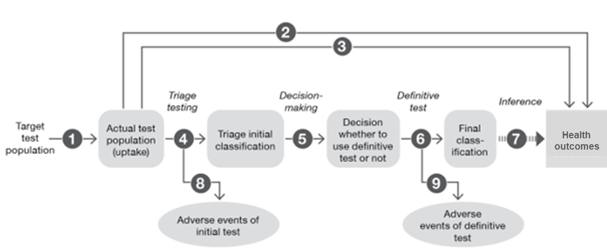
Figure 1 Assessment framework for PICO set 1: NT-proBNP test +initial assessment are used to triage for echocardiography with the inference that the outcomes will result in a superior health outcome with significant difference in time to diagnosis

PICO set 1:
Population
- In those with a suspected but uncertain diagnosis of heart failure, would any patient receive NT-proBNP + initial assessment, who would not have otherwise received NT- proBNP? (i.e. is the decision-threshold for clinicians for requesting a NT-proBNP test different to referral for an echocardiogram, or is equity of access different, or is patient compliance any different? Would being classified as high risk by NT-proBNP improve compliance or access to an echocardiogram compared to not having NT-proBNP test results?)
Direct Evidence
- Does the use of NT-proBNP testing + initial assessment result in inferior/non-inferior or superior effectiveness (health outcomes) compared with initial assessment alone, in patients in whom signs and symptoms suggest possible heart failure diagnosis in a non-hospital setting? (Note: although it is not expected that this direct from test to health outcomes will be available, if it is identified during the assessment process, it should be presented).
Test Performance
- Does the use of NT-proBNP testing + initial assessment in patients with suspected but uncertain HF result in the same diagnosis or clinical decisions compared to no NT-proBNP (i.e. Initial assessment alone) in patients with a suspected but uncertain diagnosis of having heart failure? (concordance)
- What is the diagnostic accuracy of the initial assessment of HF including NT-proBNP compared with the initial assessment excluding NT-proBNP in patients with signs and symptoms suggestive of HF diagnosis? How does the information from the NT-proBNP test + initial assessment differ from that of the no NT-proBNP testing scenario (i.e. initial assessment alone)?
Change in Management
- Does the addition of the NT-proBNP test to the initial assessment lead to a change in management of the patient compared to the initial assessment without NT-proBNP? (E.g. change in rate of referrals to cardiologists or other specialists, change in rate of echocardiograms, or treatments received).
- Is there a difference in the time to [appropriate] diagnosis in patients tested with NT-proBNP assays vs no NT-proBNP?
- Is there a difference in the time to [appropriate] treatment in patients tested with NT-proBNP assays + initial assessment vs no NT-proBNP (i.e. initial assessment alone)?
Health Outcomes
- Does a shorter time to treatment of HF or alternative diagnosis, lead to better health outcomes, than a longer time to diagnosis/treatment?
- What are the clinical consequences of false positive or false negative NT-proBNP test results?
Safety
- What are the harms of the NT-proBNP assay in the diagnosis of heart failure in the non-hospital setting? (Physical, or psychological harms from test, test results (including false positive and negative results), and subsequent management changes where they differ from initial assessment alone).
- Are there any safety concerns with management changes resulting from NT-proBNP as part of the initial assessment, where they differ from initial assessment without NT-proBNP (e.g. receiving early treatment for HF prior to seeing a cardiologist/having an echocardiogram to confirm/characterise HF)?
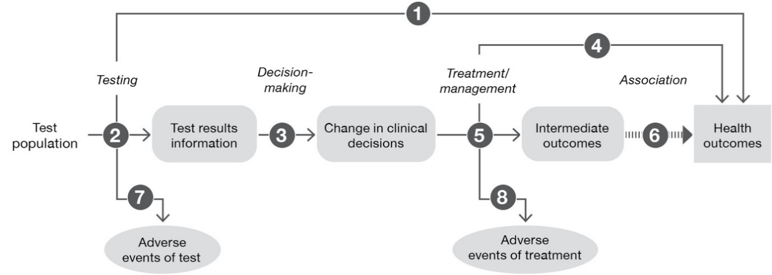
Figure 2 Assessment framework for PICO set 2: health outcomes after NT-proBNP testing + echocardiography are superior.

PICO set 2:
Direct Evidence
- Does the use of NT-proBNP testing + echocardiography result in inferior/non-inferior or superior effectiveness (health outcomes) compared with echocardiography alone, in patients in whom signs and symptoms suggest a possible but uncertain diagnosis of heart failure non-hospital setting? (Note: although it is not expected that this direct from test to health outcomes will be available, if it is identified during the assessment process, it should be presented).
Test performance
- What is the diagnostic accuracy of the NT-proBNP assay ± echocardiography when used to diagnose heart failure in the non-hospital setting compared to echocardiography alone?
Change in management
- Does the availability of new information from the NT-proBNP test +echocardiography vs echocardiography alone lead to a change in management of the patient? (Impact on management includes further investigations, surveillance, and treatment).
Health outcomes (to be assessed if there is a change in diagnosis, timing of diagnosis or treatment, or patient behaviour resulting from the use of NT-proBNP; health outcomes inferred to be non-inferior if no changes)
- How do the changes in management, resulting from the use of NT-proBNP + echocardiography rather than echocardiography alone, impact patient health outcomes?
Safety
- What are the harms of the NT-proBNP assay + echocardiography in the diagnosis of heart failure in the non-hospital setting? (Physical, or psychological harms from test, test results (including false positive and negative results)).
- Are there any safety concerns with changes in management resulting from NT-proBNP in addition to echocardiography, compared to echocardiography alone?
Previously, MSAC did not support public funding for the use of BNP assays in the diagnosis of heart failure in patients presenting with dyspnoea in the non-hospital setting (MSAC application 1087, part B – the year 2007). MSAC’s decision was mainly based on the major uncertainty around cost-effectiveness in the non-hospital setting. The assessment report should consider MSAC’s observations made on application 1087 (summarised in Appendix A) for the quantitation of NT-proBNP for diagnosis of HF in a non-hospital setting.

Clinical management algorithms
Current clinical management algorithms
Several international clinical management guidelines have been developed for the early detection and management of HF. There is a general consensus in all these guidelines that there is no single diagnostic test for HF. The diagnostic workup depends upon the clinical judgement based on the systematic assessment of history, physical cardiorespiratory examination, and appropriate laboratory tests.
The application provided the current clinical management algorithm (Figure 3) in the absence of NT-proBNP testing. The algorithm is adapted from the CSANZ HF 2018 guidelines.
On presentation to primary care, patients with typical symptoms such as breathlessness, fatigue, and ankle swelling which are suggestive of HF receive an initial clinical assessment including cardiorespiratory physical examination, chest X-ray, ECG, blood biochemistry, thyroid function, and full blood count tests. This helps in ruling in the diagnosis of HF. If patients are suspected of having heart failure they would likely be referred a cardiologist. Patients with clinical indicators (i.e. symptoms and signs provided in Table 2) supportive of HF at present require an echocardiogram to characterise the disease and evaluate cardiac chamber volumes, LV systolic and diastolic function, intracardiac filling pressures, LV wall thickness, valve structure and function and pulmonary artery pressure. However, if the initial investigations do not result in a confirmed diagnosis, yet HF is still considered possible, patients undergo an echocardiogram to exclude or confirm HF diagnosis. After receiving a confirmed diagnosis of HF, patients can proceed to receive specific HF treatment whereas, in patients in which HF diagnosis is excluded, alternative causes of the symptoms are investigated.
Given GPs are able to order echocardiograms, specialist referral should be placed in the clinical algorithm for current management both before and after echocardiogram. No specialist referral is also possible, because GPs can manage HF (or at least initial appropriate therapy) without a cardiologist. PASC commented based on consultation with a range of GPs that an estimated >80% of patients would ultimately be referred, given the range of HF therapies available.

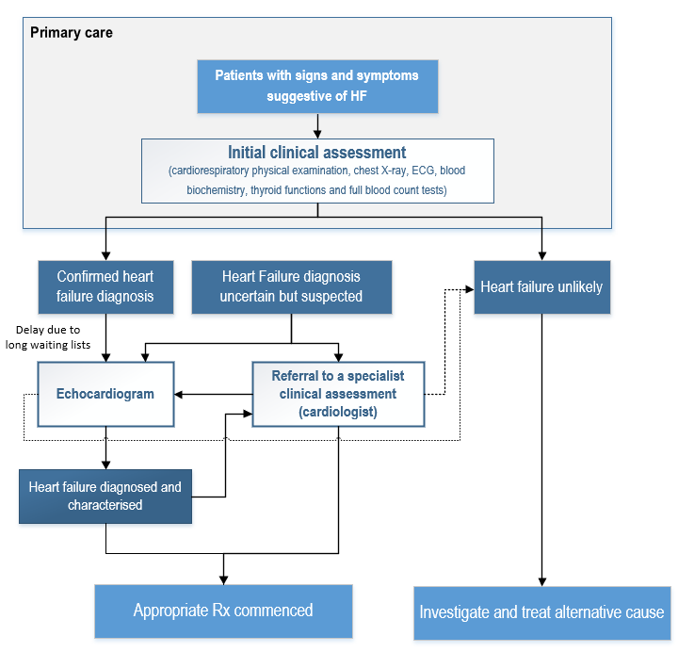
Heart failure likely
Heart failure diagnosis confirmed and characterised
NT-proBNP: N-terminal pro B-type natriuretic peptide; ECG: electrocardiography; Rx: treatment
Note: The grey shaded primary care box indicates events that should take place in primary care; events outside the primary care box can take place in primary care or specialist care.
Source: Figure compiled during the PICO preparation based on Figure 1, p27 of the application and (Atherton et al. 2018)
Figure 3 Current clinical management pathway for a patient suspected of having HF, updated to incorporate PASC’s advice
Proposed clinical management algorithms
The applicant has proposed the clinical management algorithm based on recommendations provided by CSANZ HF 2018 and multiple international guidelines. The following proposed clinical management algorithms are adapted from the application and updated to incorporate PASC’s advice.
In the proposed clinical management algorithm for PICO set 1 (Figure 4), on presentation to primary care, patients with typical symptoms which are suggestive of HF will receive an NT-proBNP test as part of the initial clinical assessment including cardiorespiratory physical examination, chest X-ray, ECG, blood biochemistry, thyroid functions, and full blood count tests. This helps in ruling out the diagnosis of HF and informing management/ referral pathways. Patients with an initial assessment indicative of HF diagnosis and NT-proBNP value above the threshold are referred for a specialist clinical assessment (performed by a cardiologist) including TTE for exclusion or confirmation of HF.
PASC noted that for PICO set 1, the NT-proBNP testing is proposed relatively early in the diagnostic process of HF as a triage test. The applicant’s clinical expert, Prof. Andrew Sindone, noted that while it was located after other initial tests in the CSANZ guidelines, this had only been because it was not publicly funded in Australia. The department and the applicant supported shifting NT-proBNP testing to be conducted as part of the initial assessment as this will be in line with clinical practice internationally. PASC considered this was appropriate.
Given GPs are able to order echocardiograms, specialist referral should be placed in the clinical algorithm for PICO set 1 both before and after echocardiogram. No specialist referral is also possible, because a proportion of patients with NT-proBNP levels above the exclusion threshold will have a GP referred echocardiogram, and where the result is consistent with HF may be managed by the GP without the need for specialist referral. PASC considered that in the world with NT-proBNP testing, there will be a non-zero proportion of patients under the rule-out threshold who progress to TTE, regardless of the guidelines.
In PICO set 2 (Figure 5), patients with typical signs and symptoms suggestive of HF receive initial assessment in primary care and if HF diagnosis is suspected, patients are referred to a cardiologist or other specialist or consultant physician. In a specialist clinical assessment (performed by a cardiologist), patients will receive an NT-proBNP test and echocardiogram. In patients in which both tests concordantly confirm HF diagnosis (NT-proBNP value above the exclusion threshold), patients can proceed to receive specific HF treatment. In patients in whom HF diagnosis is excluded based on both tests, alternative causes of the symptoms are investigated. However, PASC noted that in cases of non-concordance between NT-proBNP and echocardiogram, a cardiologist would place more weight on the findings of the echocardiogram than the NT-proBNP result. Also, many patients will have already had an NT-proBNP test before reaching the specialist, and the clinical management algorithm should clarify that for PICO set 2 an NT-proBNP test is requested by the specialist when it has not previously been performed.

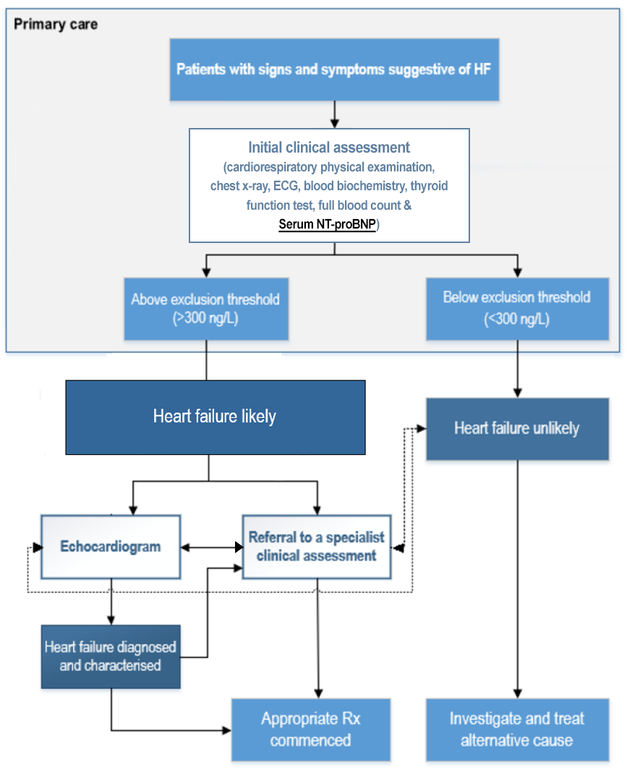
NT-proBNP: N-terminal pro B-type natriuretic peptide; ECG: electrocardiography; Rx: treatment
Note: The applicant suggested annual testing of NT-proBNP no more than once in a 12-month period
Note: The grey shaded primary care box indicates events that should take place in primary care; events outside the primary care box can take place in primary care or specialist care.
Source: Figure compiled during the post-PASC PICO preparation based on Figure 2, p29 of the application and (Atherton et al. 2018).
Figure 4 Proposed clinical management algorithm for PICO set 1: Adapted from the National Heart Foundation of Australia and Cardiac Society of Australia and New Zealand (CSANZ) 2018 Guidelines algorithm, updated to incorporate PASC’s advice.

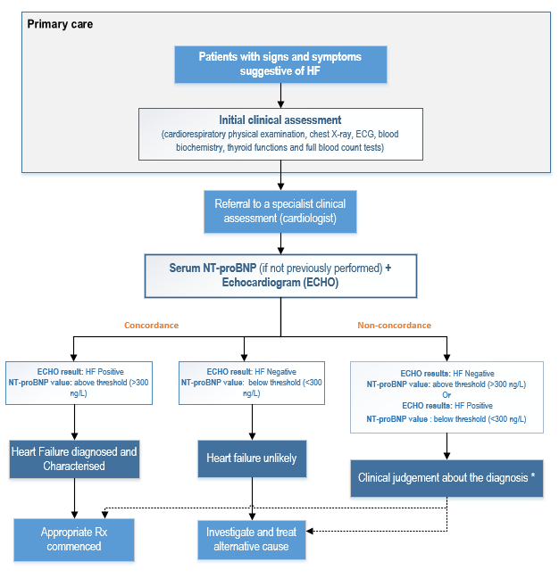
NT-proBNP: N-terminal pro-B-type natriuretic peptide; ECG: electrocardiography; Rx: treatment
*PASC noted that in most cases, where there is a discrepancy then cardiologists will place more weight on echocardiogram results than NT-proBNP results. In a sub-population of patients with preserved ejection fraction, NT-proBNP test will be useful in influencing the diagnosis as echocardiogram will be less conclusive due to the ejection fraction being normal.
Note: The applicant suggested annual testing no more than once in a 12-month period
Source: Figure compiled during the PICO preparation based on Figure 2, p29 of the application and (Atherton et al. 2018).
Figure 5 Proposed clinical management algorithm for PICO set 2: Adapted from the National Heart Foundation of Australia and Cardiac Society of Australia and New Zealand (CSANZ) 2018 Guidelines algorithm, updated to incorporate PASC’s advice.

Proposed economic evaluation
The application proposed a non-inferior clinical claim, implicitly suggesting the non-inferior safety and effectiveness for NT-proBNP testing plus echocardiogram compared to echocardiogram alone in the setting of cardiologist-requested testing (PICO set 2).
For PICO set 1, PASC advised the appropriate clinical claim was superior health outcomes and non-inferior safety for NT-proBNP testing compared to no NT-proBNP testing.
For PICO set 2, PASC advised the proposed clinical claim was also superior effectiveness (at least for a subpopulation of patients who have HFpEF) and non-inferior safety for NT-proBNP + echocardiogram compared to echocardiogram alone.
PASC therefore advised that for both PICO sets the type of economic evaluations that should be presented based on these claims, are cost-utility or cost-effectiveness analyses.
Table 10 Classification of comparative effectiveness and safety of the proposed intervention, compared with its main comparator, and guide to the suitable type of economic evaluation
Comparative safety- |  | Comparative effectiveness
 | Inferior | Uncertainª | Noninferior^{b} | Superior
Inferior | Health forgone: need other supportive factors | Health forgone possible: need other supportive factors | Health forgone: need other supportive factors | ? Likely CUA
Uncertainª | Health forgone possible: need other supportive factors | ? | ? | ? Likely CEA/CUA
Noninferior^{b} | Health forgone: need other supportive factors | ? | CMA | CEA/CUA
Superior | ? Likely CUA | ? Likely CEA/CUA | CEA/CUA | CEA/CUA
CEA=cost-effectiveness analysis; CMA=cost-minimisation analysis; CUA=cost-utility analysis
? = reflect uncertainties and any identified health trade-offs in the economic evaluation, as a minimum in a cost-consequences analysis
ª ‘Uncertainty’ covers concepts such as inadequate minimisation of important sources of bias, lack of statistical significance in an underpowered trial, detecting clinically unimportant therapeutic differences, inconsistent results across trials, and trade-offs within the comparative effectiveness and/or the comparative safety considerations
^{b} An adequate assessment of ‘noninferiority’ is the preferred basis for demonstrating equivalence

Proposal for public funding
The applicant’s proposed MBS item descriptor for patients with suspected but uncertain HF in a non-hospital setting, is presented in Table 11 (red text are edits suggested by the HTA group). The proposed fee and benefit are the same as MBS Item 66830 (the quantitation of BNP or NT-proBNP for the diagnosis of HF in patients presenting with dyspnoea to a hospital Emergency Department). However, the proposed item descriptor does not include BNP, and is only for patients presenting in a non-hospital setting. The applicant’s proposal was that the item should be restricted to cardiologists.
PASC considered that NT-proBNP testing in primary care should be assessed separately from where the request is made by a cardiologist. An additional MBS item has therefore been proposed, for use in primary care (in case the MSAC chooses to support funding in one but not both settings). PASC further considered that while BBBB is intended primarily for use by cardiologists, there will be times when a patient presents to a different type of specialist or consultant physician with signs and/or symptoms of heart failure, so requestors should not exclude other specialists. PASC therefore advised that requestors for BBBB should be expanded to all specialists or consultant physicians. If MSAC advises that NT-proBNP should be available without reference to a particular requesting practitioner (i.e. in both primary care setting and specialist physician setting), then only one MBS item would be required.
PASC noted that the department requested it should be made clear that this indication is not for monitoring of response to treatment or for screening purposes. The department considered that the wording of the item descriptor in association with the frequency restriction limit the risk of leakage.
Table 11 Proposed MBS item descriptors for patients with suspected but uncertain HF diagnosis in a non-hospital setting, updated to incorporate PASC’s advice
Category 6 – Pathology services
Group P2 Chemical
MBS item AAAA (for PICO set 1)
Quantitation of NT-proBNP for the exclusion of a diagnosis of heart failure in patients presenting to a non-hospital setting, where all of the following apply:
(a) Heart failure may be suspected based on signs and symptoms but diagnosis is uncertain
(b) The service is requested by a general practitioner or appropriate nurse practitioners

(c) The patient does not have a confirmed heart failure diagnosis

Applicable not more than once in a 12-month period
Fee: $58.50 Benefit: 75% = $43.90 85% = $49.75
MBS item BBBB (for PICO set 2)
Quantitation of NT-proBNP for the exclusion of a diagnosis of heart failure in patients presenting to a non-hospital setting, where all of the following apply:
(a) Heart failure is suspected but diagnosis is uncertain based on initial assessment
(b) The service is requested by a specialist or consultant physician practicing as a specialist cardiologist
(c) The patient does not have a confirmed heart failure diagnosis

Applicable not more than once in a 12-month period
Fee: $58.50 Benefit: 75% = $43.90 85% = $49.75

Summary of public consultation input
Consultation feedback was received from four organisations which are listed below:
- Lung Foundation Australia (LFA)
- National Heart Foundation of Australia (The Heart Foundation)
- Royal Australian College of General Practitioners (RACGP)
- Royal College of Pathologists of Australasia (RCPA)
The consultation feedback received was all supportive of public funding for NT-proBNP to aid in the diagnosis of patients with suspected heart failure in the non-hospital setting.
Clinical need and public health significance
The main benefits of public funding received in the consultation feedback related to early diagnosis of lung conditions and heart failure leading to early treatment and better health and financial outcomes. A further benefit identified was complying with international guidelines from the UK, US, and Europe; that all recommend the use of NT-proBNP to diagnose or rule out HF in primary care/ambulatory settings.
The Department sought feedback from several general practice organisations on whether this test should be used in the primary care setting. The RACGP proposed that testing should be available for GPs to conduct in their practices.
The main disadvantages of public funding received in the consultation feedback were limitations to accessing specialist and laboratory services, particularly for those in rural and remote areas.
The proposed population, clinical claim, service description and fee
The consultation agreed with the proposed population and clinical claims. Neither organisation commented on the proposed comparator, service descriptor or fee.
Additional comments
The Heart Foundation stated that First Nation people are 1.4 times more likely to die from heart failure than non-indigenous Australians. They added that hospitalisation rates for people with heart failure are substantially higher in remote areas compared with major cities. The RACGP refer to a B-type natriuretic peptide (BNP) test and not specifically NT-proBNP testing. Targeted consultation was received from the RCPA regarding the usage of BNP versus NT-proBNP. The RCPA considered BNP and NT-pro-BNP both clinically perform well and should yield similar results, noting that NT-proBNP has a longer half-life and is more stable.
PASC noted that there was consultation from five professional medical organisations. PASC considered the consensus was that:
- There was support for the use of NT-proBNP testing in the diagnosis of HF as a good rule-out test as it can shorten the time to diagnosis and appropriate treatment.
- NT-proBNP testing may be better placed in primary care due to difficulty in accessing the cardiology services and TTE.
- In some cases, NT-proBNP testing may also provide prognostic information.

Next steps
PASC noted that the applicant has elected to progress its application as an applicant-developed assessment report (ADAR).

Applicant comment on the ratified PICO Confirmation
The Applicant does not agree that cardiologists will order an NT-proBNP test in conjunction with an echocardiogram regardless of the result of the NT-proBNP test. This is direct conflict with the established utility of NT-proBNP as an effective rule-out test for heart failure, as noted in the evidence-based NHFA/CSANZ heart failure guidelines. These Guidelines were developed by an expert clinical committee using published literature. It is acknowledged that a small number of clinicians may deviate from these guidelines, but it is not appropriate to generalise PASC’s opinion that NT-proBNP and echocardiogram will be ordered concomitantly, to all cardiologists. This scenario is addressed and explored in the assessment report.
The CSANZ Guidelines for the Prevention, Detection, and Management of Heart Failure in Australia are based on evidence. The Guidelines were developed by an expert working group of Australian clinicians and stakeholders with recognised expertise in the diagnosis of heart failure. The process involved consultation to inform the systematic review of published trials and systematic reviews, with the final content of the Guidelines informed by other international clinical guidelines and local clinical expertise. Practice recommendations were made using GRADE methodology. Therefore, while the Guidelines are only a reference, they are based on a robust methodology to evaluate published evidence and shaped by an expert panel to reflect how practice should be conducted in Australia. In these Guidelines, NT-proBNP testing for diagnosis in patients with suspected heart failure when the initial diagnosis is uncertain carries a Strong GRADE recommendation with High quality evidence. The evidence used to inform this recommendation is addressed in the assessment report.

References
Agostino, JW, et al. 2020.'Cardiovascular disease risk assessment for Aboriginal and Torres Strait Islander adults aged under 35 years: a consensus statement', Med J Aust, 212,(9): 422-427.
Atherton, JJ, et al. 2018.'National Heart Foundation of Australia and Cardiac Society of Australia and New Zealand: guidelines for the prevention, detection, and management of heart failure in Australia 2018', Heart, Lung and Circulation, 27,(10): 1123-1208.
Ballo, P, et al. 2016.'Prognostic role of N-terminal pro-brain natriuretic peptide in asymptomatic hypertensive and diabetic patients in primary care: impact of age and gender : Results from the PROBE-HF study', Clin Res Cardiol, 105,(5): 421-431.
Barandiarán Aizpurua, A, et al. 2020.'Validation of the HFA-PEFF score for the diagnosis of heart failure with preserved ejection fraction', European Journal of Heart Failure, 22,(3): 413-421.
Booth, RA, et al. 2014.'Performance of BNP and NT-proBNP for diagnosis of heart failure in primary care patients: a systematic review', Heart Fail Rev, 19,(4): 439-451.
Borlaug, BA and WJ Paulus 2010.'Heart failure with preserved ejection fraction: pathophysiology, diagnosis, and treatment', European Heart Journal, 32,(6): 670-679.
Bosch, L, et al. 2019.'Heart failure in primary care: prevalence related to age and comorbidity', Prim Health Care Res Dev, 20: e79.
Brunner-La Rocca, HP and S Sanders-van Wijk 2019.'Natriuretic Peptides in Chronic Heart Failure', Card Fail Rev, 5,(1): 44-49.
Campbell, SM, et al. 2011.'Diagnostic triage and the role of natriuretic peptide testing and echocardiography for suspected heart failure: an appropriateness ratings evaluation by UK GPs', Br J Gen Pract, 61,(588): e427-435.
Chamberlain, AM, et al. 2015.'Multimorbidity in Heart Failure: A Community Perspective', The American Journal of Medicine, 128,(1): 38-45.
Chan, YK, et al. 2016.'Current and projected burden of heart failure in the Australian adult population: a substantive but still ill-defined major health issue', BMC Health Serv Res, 16,(1): 501.
Clark, A, et al. 1995.'Muscle fatigue and dyspnoea in chronic heart failure: two sides of the same coin?', European Heart Journal, 16,(1): 49-52.
Cowie, MR, et al. 2010.'Recommendations on the clinical use of B-type natriuretic peptide testing (BNP or NTproBNP) in the UK and Ireland', British Journal of Cardiology, 17,(2): 76.
Dini, FL, et al. 2018.'Optimizing management of heart failure by using echo and natriuretic peptides in the outpatient unit', Heart Failure: From Research to Clinical Practice: Volume 3: 145-159.
Dubé, B-P, et al. 2016.'Exertional dyspnoea in chronic heart failure: the role of the lung and respiratory mechanical factors', European Respiratory Review, 25,(141): 317-332.
Fitzsimons, S and RN Doughty 2021.'Role of transthoracic echocardiogram in acute heart failure', Reviews in Cardiovascular Medicine, 22,(3): 741-754.
Heidenreich, PA, et al. 2022.'2022 AHA/ACC/HFSA Guideline for the Management of Heart Failure: A Report of the American College of Cardiology/American Heart Association Joint Committee on Clinical Practice Guidelines', Circulation, 145,(18): e895-e1032.
Huis In 't Veld, AE, et al. 2016.'How to diagnose heart failure with preserved ejection fraction: the value of invasive stress testing', Neth Heart J, 24,(4): 244-251.
Kemp, CD and JV Conte 2012.'The pathophysiology of heart failure', Cardiovascular Pathology, 21,(5): 365-371.
Larry, HB, et al. 2011.'What is the best approximation of reference normal for NT-proBNP? Clinical levels for enhanced assessment of NT-proBNP (CLEAN)', Journal of Medical Laboratory and Diagnosis, 2,(2): 16-21.
Latini, R and S Masson 2013.'NT-proBNP: A Guide to Improve the Management of Patients with Heart Failure', Ejifcc, 24,(3): 78-84.
Liew, D, et al. 2020.'Epidemiology of heart failure: Study of Heart failure in the Australian Primary carE setting (SHAPE)', ESC Heart Fail, 7,(6): 3871-3880.
Luchner, A, et al. 2005.'Effect of compensated renal dysfunction on approved heart failure markers: direct comparison of brain natriuretic peptide (BNP) and N-terminal pro-BNP', Hypertension, 46,(1): 118-123.
Marwick, TH 2015.'The role of echocardiography in heart failure', Journal of Nuclear Medicine, 56,(Supplement 4): 31S-38S.
McDonagh, TA, et al. 2021.'2021 ESC Guidelines for the diagnosis and treatment of acute and chronic heart failure: Developed by the Task Force for the diagnosis and treatment of acute and chronic heart failure of the European Society of Cardiology (ESC) With the special contribution of the Heart Failure Association (HFA) of the ESC', European Heart Journal, 42,(36): 3599-3726.
Mosterd, A and AW Hoes 2007.'Clinical epidemiology of heart failure', Heart, 93,(9): 1137-1146.
Myhre, PL, et al. 2020.'Diagnosing heart failure with preserved ejection fraction in 2019: the search for a gold standard', European Journal of Heart Failure, 22,(3): 422-424.
Najbjerg, AG, et al. 2019.'NT-proBNP to exclude heart failure in primary care - a pragmatic, cluster-randomized study', Scand J Clin Lab Invest, 79,(5): 334-340.
Ontario Health (Quality) 2021.'Use of B-Type Natriuretic Peptide (BNP) and N-Terminal proBNP (NT-proBNP) as Diagnostic Tests in Adults With Suspected Heart Failure: A Health Technology Assessment', Ont Health Technol Assess Ser, 21,(2): 1-125.
Potter, LR, et al. 2009.'Natriuretic peptides: their structures, receptors, physiologic functions and therapeutic applications', Handb Exp Pharmacol,(191): 341-366.
Rawlins, ML, et al. 2005.'Performance characteristics of four automated natriuretic peptide assays', American journal of clinical pathology, 123,(3): 439-445.
Rudolf, H, et al. 2020.'NT-proBNP for risk prediction of cardiovascular events and all-cause mortality: The getABI-study', Int J Cardiol Heart Vasc, 29: 100553.
Sindone, AP, et al. 2021.'Clinical characteristics of people with heart failure in Australian general practice: results from a retrospective cohort study', ESC Heart Fail, 8,(6): 4497-4505.
Smeets, M, et al. 2016.'Diagnostic rules and algorithms for the diagnosis of non-acute heart failure in patients 80 years of age and older: a diagnostic accuracy and validation study', BMJ Open, 6,(10): e012888.
Sullivan, DR, et al. 2005.'Utility of brain natriuretic peptide (BNP) measurement in cardiovascular disease', Heart Lung Circ, 14,(2): 78-84.
Tanase, DM, et al. 2019.'Natriuretic Peptides in Heart Failure with Preserved Left Ventricular Ejection Fraction: From Molecular Evidences to Clinical Implications', Int J Mol Sci, 20,(11).
Taylor, CJ, et al. 2017.'Heart failure and multimorbidity in Australian general practice', Journal of comorbidity, 7,(1): 44-49.
Woods, JA, et al. 2012.'Heart failure among Indigenous Australians: a systematic review', BMC Cardiovasc Disord, 12: 99.

Appendix A
The assessment report should consider the following MSAC observations regarding application 1087,
part B (BNP assays in the diagnosis of heart failure in the non-hospital setting).
Table MSAC observations regarding BNP assays for the diagnosis of HF in the non-hospital setting - May 2007
MSAC observations | Updated evidence required
Patient population  MSAC recommended research on the use of BNP in the general practice setting to identify appropriate usage and the patient group most likely to benefit in the non-hospital setting. | The assessment report should consider how to address MSAC’s previous comments around identifying the patient group most likely to benefit.
Test Performance  MSAC found that there was sufficient evidence that BNP assays, when used in the diagnosis of HF, are effective and safe. However, the assessment report identified that it is unlikely that the use of the BNP test would result in earlier identification of HF than currently for patients due to the low positive predictive value of the test and thus the need for further testing. | The assessment report should provide updated evidence on the test performance and the resulting change in management (time to appropriate diagnosis and treatment) to support the clinical claim in this application.  (Questions 3 - 6 of the assessment framework).
Health Outcomes  Clinical impact of the test (i.e., on health outcomes) was unknown in non-hospital settings. | If there is a change in diagnosis, timing of diagnosis or treatment, or patient behaviour resulting from the use of NT-proBNP, the assessment report should assess whether this change in management leads to better health outcomes.  (Question 7 of the assessment framework).
Cost-effectiveness  MSAC found that there was major uncertainty around the cost-effectiveness of BNP testing in the non-hospital setting.  Cost-effectiveness usually depended on referral propensity. This was explored, though the three referral pattern scenarios all assumed that 100% of patients would currently receive an echocardiogram as per guidelines, and MSAC was concerned that available data suggested that actual echocardiogram referral rates may range from 3.8% to 17.7% for patients with new symptoms suggestive of HF. Results of a one-way sensitivity analysis suggested that BNP testing would not be cost saving if GPs currently refer this patient group to echocardiography at a rate of 60% or lower. | The assessment report should assess whether NT-proBNP testing leads to healthcare resource saving compared to the cost of providing the test.  Consider how to address MSAC’s previous concerns around the actual rate of referral to echocardiogram for the comparator.
BNP: B-type natriuretic peptide; HF: Heart failure; NT-proBNP: N-terminal (NT)-pro BB-type natriuretic peptide
Note: The MSAC application 1087 report (part B) assessed the use of both BNP and NT-proBNP testing to rule out HF in patients presenting in a non-hospital setting.

