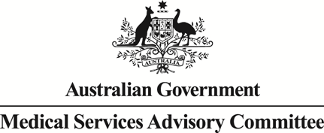
Public Summary Document

Report to the Medical Services Advisory Committee on utilisation of Medicare Benefits Schedule (MBS) item 18379 following MSAC Application 1272: Intravesical injection of botulinum toxin type A (Botox®) into the bladder wall for urinary incontinence due to idiopathic overactive bladder (IOAB)
MBS items considered: 18379 and 36851
Date of MSAC consideration: July 2017
Context for decision: MSAC makes its advice in accordance with its Terms of Reference, see the MSAC Website

Purpose
The purpose of the report presented to the Medical Services Advisory Committee (MSAC) was to inform MSAC of the real world impacts of the utilisation of MBS item 18379 following MSAC Application 1272. MSAC then uses this information to ensure that the new item resulting from this application is being used as intended.
The report is not intended to be a review of the clinical information covered during the application process.

MSAC’s advice
MSAC considered actual utilisation data and compared it with the utilisation predicted prior to implementation of the MBS listing for intravesical injection of botulinum toxin in the bladder wall for urinary incontinence due to IOAB and recommended no further action.

Summary of consideration and rationale for MSAC’s advice
MSAC noted that actual utilisation of the item number was markedly below that expected with just 718 services in 2016–17, although the use of the item is continuing to grow. MSAC noted that this procedure is similar to item 18375 (treatment of urinary incontinence due to neurogenic detrusor overactivity (NDO)), for which the predicted versus actual use was reported at its November 2016 meeting. The actual utilisation for item 18375 was also substantially lower than predicted. MSAC considered that the estimated utilisation of the service (using an epidemiological approach) did not reflect actual patient interest in and willingness to undergo this invasive procedure. MSAC recommended that in estimating utilisation for future applications, current utilisation of an unfunded service should be considered and reflected.
MSAC noted that the low uptake of the service may be due to the Pharmaceutical Benefits Scheme (PBS) prescribing restrictions and that the recent recommendation by the Pharmaceutical Benefits Advisory Committee (PBAC) to allow gynaecologists to prescribe this treatment on the PBS may increase uptake. MSAC noted that there has been movement from the generic item (item 36851) to item 18379.
In considering the data on the fee charged for item 18379 MSAC noted that there was variability between states in the range of out-of-pocket expenses and in the rate of inflation of fees charged for the service over the last two years. MSAC noted differences in the average fee charged for this service (approximately $450 in 2015-16) compared to injection of botulinum toxin in NDO (approximately $400 in 2015-16) and for the generic item number (approximately $330 in 2015-16). MSAC recommended that consumers be directed to the Public Summary Documents (PSDs) for predicted versus actual items to assist with transparency of out-of-pocket fees charged.
In considering claiming data, MSAC noted that MBS item 18379 was predominantly claimed alone. MSAC noted that (as with item 18375), in some cases item 18379 was co-claimed with other cystoscopy items, despite cystoscopy being included in the item descriptor. MSAC noted that these co-claiming issues may require review. MSAC recommended that no further review is required for item 18379.

Methodology
An application is selected for consideration if the resulting new item(s) or item amendment(s) have been on the MBS for approximately 24 months or longer or if there were particular concerns about utilisation such that MSAC requested to consider it earlier. The specific applications for each MSAC meeting are selected by the MSAC Executive which is composed of the Chairs of MSAC and its sub-committees.
A report on the utilisation is developed by the Department of Health (the department) with information on a number of metrics including state variation, patient demographics, services per patient, practitioner’s providing the service, data on fees and co-claiming of services. The number of metrics included in a report is dependent on the annual service volume for the MBS item(s) under consideration i.e. an item with very low utilisation will have less data to analyse. Where service volumes are too low, information is suppressed to protect patient privacy.
Where possible the report compares data on real world utilisation to the assumptions made during the MSAC assessment. Most of these assumptions are drawn from the assessment report.
Relevant stakeholders are provided an opportunity to comment on the findings in the report before it is presented to the MSAC. It is intended that stakeholders are given at least three weeks to consider the reports.
The stakeholder version of the report does not contain information on assumptions from the MSAC consideration if this information is not already publicly available. This is to protect the commercial in confidence of the original applicants. The same principle is applied to this document.
Once MSAC has considered the report its advice is made available online at the MSAC Website.

Results

Utilisation
Utilisation of item 18379 is lower than expected with 309 services in 2014-15 and 718 services in 2015-16. It was expected that there would be a decrease in utilisation of item 36851 due to the restriction for injecting botulinum toxin under this item. There was a 9% decrease in services under item 36851 in 2015-16 from the previous year. Service volumes had been previously increasing by 38% and 10% in 2013-14 and 2014-15, respectively
(Table 1). A month by month comparison of service volumes under item 36851 relative to item 18379 is at Figure 1.
Table 1: Services, growth and benefits paid for item 18379 between 2014-15 and 2016-17; and item 36851 between 2011-12 and 2016-17 by date of service
 |  | 2011-12 | 2012-13 | 2013-14 | 2014-15* | 2015-16 | 2016-17**
18379 | Services |  |  |  | 309 | 718 | 611
 | Benefits |  |  |  | $53,184 | $123,630 | $105,272
36851 | Services | 731 | 876 | 1,207 | 1,323 | 1,207 | 695
 | Growth |  | 20% | 38% | 10% | -9%
 | Benefits | $94,112 | $120,190 | $167,401 | $185,504 | $153,154 | $84,864
Source: Medicare Statistics database (Cognos) - 19 April 2017
*Listing effective from 1 November 2014
**2016-17 financial year includes data to 28 February 2017
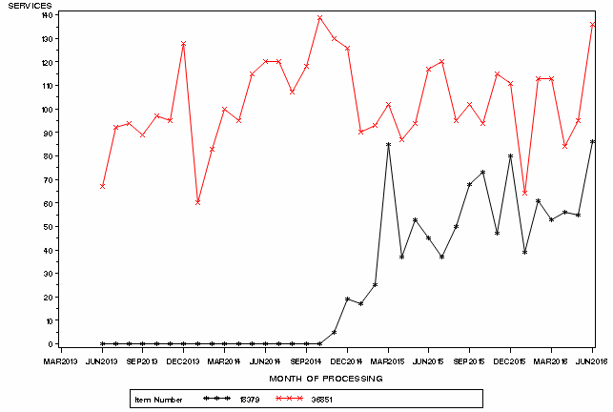

Figure 1: Month by month comparison of service volumes for items 36851 and 18379
Source: Medicare Statistics Online

Patient breakdown
There were 635 patients who claimed item 18379 in 2015-16. Of these, 534 were new patients and 101 were continuing from the previous financial year. Continuing patients received an average of 1.28 services under item 18379 in 2015-16 (Table 2). In
2015-16, 12% of patients received two or more services under item 18379 (Table 3). About 7% of patients have received 3 or more services since the listing of the item (Table 4).
The service is predominantly claimed by females aged 55-84. About 16 services in 2015-16 were provided to adults aged 24 or below (Figure 2).

Table 2: Number of new and continuing patients who received MBS item 18379 by financial year
Financial Year | New Patients | New Services | Continuing Patients | Continuing Services | Services per Patient (Continuing)
2014-15 | 293 | 309 | - | - | -
2015-16 | 534 | 589 | 101 | 129 | 1.28
2016-17 (to 31 Dec 16) | 330 | 342 | 191 | 200 | 1.05

Table 3: Number of services per patient in 2014-15 and 2015-16
Financial | Services | Count | Percentage
2014-15 | 1 | 277 | 95%
 | 2 | 16 | 5%
2015-16 | 1 | 558 | 88%
 | 2 | 71 | 11%
 | 3 | 6 | 1%

Table 4: Number of services per patient since service listed 1 November 2014 to 31 December 2016
Services per Patient | Count | Percentage
1 | 859 | 74%
2 | 214 | 18%
3 | 62 | 5%
4+ | 22 | 2%
Source for tables 4-6: Department of Health

a)
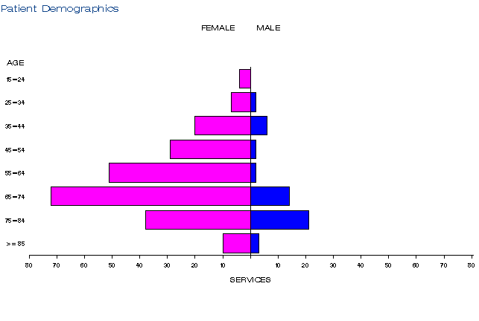
b)
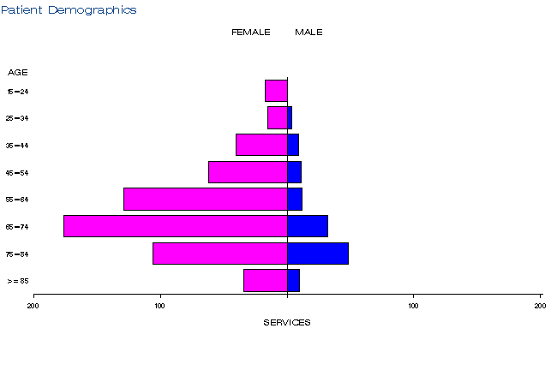

c)
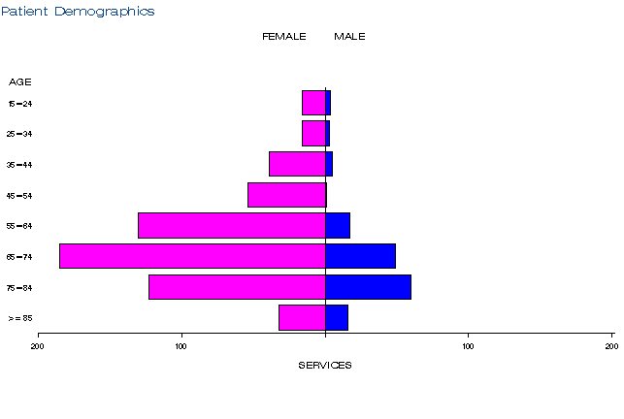

Figure 2: Demographic profile for MBS item 18379 for 2014-15 (a), 2015-16 (b) and 2016-17 (c)
Source: Medicare Statistics Online

Practitioner breakdown
There has been a gradual increase in the number of practitioners providing services under item 18379. There were 59 practitioners in 2015-16, increasing to 70 practitioners in 2016-17 (Table 5). About 25% of practitioners have provided close to 80% of all services (Table 6). Close to 90% of services were provided by urology specialists (Table 7).
While the item is restricted to urologists and urogynaecologists only, data indicates some services were being provided by specialists in obstetrics and gynaecology. However, given the data is based on provider billing behaviour (i.e. derived specialty as opposed to registered specialty), it is likely that these services were provided by urologists or urogynaecologists, but not classified as such in the data.

Table 5: Number of practitioners providing services under item 18379 in 2014-15 to 2016-17
Financial year | Practitioners | Services | Average
2014-15 | 40 | 309 | 7.7
2015-16 | 59 | 718 | 12.2
2016-17 (to 31 Dec 16) | 70 | 542 | 7.7
All Years | 89 | 1,569 | 17.6
Table 6: Cumulative percentage of medical practitioners providing item 18379 and how many services each percentile accounts for in 2014-15 to 2016-17
Provider Cumulative % | 2014-15 | 2015-16 | 2016-17 (to 31 Dec 16) | All Years
10% | 45.3 | 46.9 | 45.0 | 53.3
20% | 63.4 | 65.7 | 60.7 | 71.9
25% | 70.6 | 72.0 | 66.9 | 78.7
30% | 76.1 | 77.8 | 72.1 | 84.4
40% | 83.8 | 86.1 | 81.4 | 91.0
50% | 89.6 | 92.4 | 88.4 | 94.6
60% | 93.5 | 95.3 | 92.3 | 96.6
70% | 96.1 | 97.2 | 94.8 | 97.8
75% | 96.8 | 97.9 | 96.1 | 98.4
80% | 97.4 | 98.4 | 97.4 | 98.9
90% | 98.7 | 99.2 | 98.7 | 99.4
99% | 99.9 | 99.9 | 99.9 | 99.9
Table 7: Number of services by provider specialty under item 18379 between 2014-15 and 2016-17 (to 31 Dec 16)
Derived Major Specialty | Number of services | Percentage
Specialist - Surgery - Urology | 1,374 | 88%
Specialist - Obstetrics and Gynaecology | 103 | 7%
Specialist - Urogynaecology | 92 | 6%
Source for tables 5-7: Department of Health

Co-claiming
In the majority of cases (about 80% of episodes), item 18379 was not claimed with another item (Tables 10-12). Similar to the finding in the predicted vs actual report for item 18375, the most common co-claimed items were those for cystoscopy (including items 36827, 36840 and 36812). The co-claiming of item 36812 may be inappropriate given the descriptor of this item specifies “not being a service associated with any other urological endoscopic procedure on the lower urinary tract except a service to which item 37327 applies”.
While the injection service provided under item 18379 already includes cystoscopy, the cystoscopy items being co-claimed appear to relate to the provision of other services such as diathermy, biopsy or hydrodilatation. The service was also co-claimed with specialist consultation items 104, 105 and item 11900 (urine flow study). The claiming of these items on the same occasion of service is specifically prohibited in the descriptor of item 18379.
Given the claiming restriction in place, there were no occasions in which item 36851 for cystoscopy with injection into the bladder wall was co-claimed with item 18379.

Table 8: Top 10 instances of co-claiming with MBS item 18379 in 2014-15
# | Items | Episodes | Services | Schedule Fee for combination | Number of providers | Number of patients | % of episodes
1 | 18379 | 248 | 248 | $57,003 | 35 | 233 | 80.26%
2 | 18379, 105 | 12 | 24 | $3,274 | np | 12 | 3.88%
3 | 18379, 105, 11900, 55068 | 11 | 44 | $3,689 | np | 11 | 3.56%
4 | 18379, 36827 | np | 12 | $2,758 | np | np | 1.94%
5 | 18379, 36812 | np | np | $1,190 | np | np | 0.97%
6 | 18379, 36840 | np | np | $1,659 | np | np | 0.97%
7 | 18379, 36845 | np | np | $2,764 | np | np | 0.97%
8 | 18379, 104,11917 | np | np | $1,488 | np | np | 0.65%
9 | 18379, 105,11917 | np | np | $1,402 | np | np | 0.65%
10 | 18379, 36667, 36668 | np | np | $929 | np | np | 0.65%

Table 9: Top 10 instances of co-claiming with MBS item 18379 in 2015-16
# | Items | Episodes | Services | Schedule Fee for combination | Number of providers | Number of patients | % of episodes
1 | 18379 | 579 | 580 | $133,313 | 47 | 518 | 80.87%
2 | 18379, 36827 | 20 | 40 | $9,194 | np | 18 | 2.79%
3 | 18379, 36840 | 18 | 36 | $9,955 | np | 18 | 2.51%
4 | 18379, 36812 | 13 | 26 | $5,155 | np | 11 | 1.82%
5 | 18379, 36836 | np | 14 | $3,218 | np | np | 0.98%
6 | 18379, 36667, 36668 | np | 18 | $2,786 | np | np | 0.84%
7 | 18379, 105 | np | np | $1,321 | np | np | 0.56%
8 | 18379, 36854 | np | np | $2,785 | np | np | 0.56%
9 | 18379, 37011 | np | np | $1,293 | np | np | 0.56%
10 | 18379, 36827, 36840 | np | np | $2,004 | np | np | 0.42%

Table 10: Top 10 instances of co-claiming with MBS item 18379 in 2016-17 (to 31 Dec 16)
# | Items | Episodes | Services | Schedule Fee for combination | Number of providers | Number of patients | % of episodes
1 | 18379 | 437 | 437 | $100,444 | 59 | 425 | 80.63%
2 | 18379, 36827 | 30 | 60 | $13,791 | np | 27 | 5.54%
3 | 18379, 36812 | 12 | 24 | $4,759 | np | 12 | 2.21%
4 | 18379, 36840 | 11 | 22 | $6,084 | np | 11 | 2.03%
5 | 18379, 37011 | np | 12 | $1,939 | np | np | 1.11%
6 | 18379, 105 | np | np | $1,091 | np | np | 0.74%
7 | 18379, 36667 | np | np | $1,545 | np | np | 0.74%
8 | 18379, 105, 36840 | np | np | $1,788 | np | np | 0.55%
9 | 18379, 18264, 36827 | np | np | $1,323 | np | np | 0.37%
10 | 18379, 35571 | np | np | $1,567 | np | np | 0.37%
Source for Tables 8-10: Department of Health
NP = not printed

Data on fee charged
The average fee charged for item 18379 has increased from $431 in 2014-15 to $472 in
2016-17 (Table 11). This is likely related to the 95th percentile fee charged in NSW which
was $1,000 in 2015-16 and 2016-17. The 95th percentile fee charged in New South Wales is significantly higher than other states which ranged from $600 to $658. Services were not bulk billed in most states, although there was a 47% bulk billing rate in NSW in 2014-15, which decreased to 1.5% in 2015-16 and 2% in 2016-17. Services billed to items 18375 and 36851 also have a very low bulk billing rate (less than 1%).
In 2015-16, the average fee charged for items 18375 and 36851 was about $400 and $330, respectively, comparatively lower compared to item 18379.
Table 11: Statistics on fees charged for MBS item 18379 for 2014-15 to 2016-17 by date of service (provider State/Territory)
 |  | NSW | Vic | Qld | SA | WA | TAS | NT | ACT | AUS
2014-15 | Average Fee Charged | $349.36 | $405.42 | $413.03 | $516.71 | $244.64 | np | np | np | $430.51
 | Standard  Deviation | $88.05 | $93.33 | $122.24 | $152.96 | $25.25 | np | np | np | $133.64
 | Median | $361.85 | $383.20 | $360.70 | $607.00 | n/a (4) | np | np | np | $383.20
 | 75th Percentile | $383.20 | $486.00 | $483.00 | $655.90 | n/a (4) | np | np | np | $535.00
 | 95th Percentile | $535.00 | $600.00 | $622.00 | $655.90 | n/a (4) | np | np | np | $655.90
 | Bulk Billed  Rate | 46.9% | - | - | - | - | np | np | np | 9.7%
2015-16 | Average Fee Charged | $452.74 | $401.95 | $399.95 | $586.57 | $401.42 | np | np | np | $449.44
 | Standard  Deviation | $229.37 | $96.44 | $95.96 | $108.61 | $166.16 | np | np | np | $154.78
 | Median | $365.30 | $386.16 | $363.90 | $623.60 | $346.08 | np | np | np | $407.90
 | 75th Percentile | $535.00 | $409.75 | $383.15 | $657.90 | $535.00 | np | np | np | $545.00
 | 95th Percentile | $1,000.00 | $600.00 | $650.00 | $657.90 | $650.00 | np | np | np | $657.90
 | Bulk Billed  Rate | 1.5% | 0.6% | - | - | - | np | np | np | 0.6%
2016-17  (to 31 Dec 16) | Average Fee Charged | $494.38 | $407.33 | $453.94 | $595.11 | $505.42 | np | np | np | $472.13
 | Standard  Deviation | $247.20 | $95.35 | $134.40 | $101.14 | $189.86 | np | np | np | $164.76
 | Median | $365.30 | $383.20 | $383.15 | $613.00 | $650.00 | np | np | np | $409.75
 | 75th Percentile | $545.00 | $409.75 | $545.00 | $657.90 | $650.00 | np | np | np | $600.00
 | 95th Percentile | $1,100.00 | $600.00 | $650.00 | $657.90 | $650.00 | np | np | np | $657.90
 | Bulk Billed  Rate | 2.0% | - | - | - | - | np | np | np | 0.4%
Source: Department of Health
NP = not printed

Background
In May 2013, a minor submission requesting MBS listing of the procedure to inject Botox for the treatment of urinary incontinence due to IOAB was received from Allergan Australia Pty Ltd. The application was co-dependent on an application to PBAC for PBS listing of the medicine component of the service.
MSAC’s role was to consider the wording of the MBS item descriptor, the MBS fee and the financial implications of publicly funding the injection procedure. PBAC assessed the efficacy, cost-effectiveness and safety of Botox for IOAB.
On 28 November 2013, MSAC supported the listing of a new MBS item for intravesical injection of Botox into the bladder wall for urinary incontinence due to IOAB (now item 18379). The descriptor and timing of implementation of the service reflected the recommendations of PBAC. MBS and PBS listing occurred on 1 November 2014. In line with the PBS listing, the MBS service was restricted to specialists in urology and urogynaecology.
The MSAC Public Summary Document notes that utilisation was estimated using an epidemiological approach with 10,000 – 50,000 patients expected to initiate treatment during year 1. However, MSAC also noted that this estimate may be well beyond current capacity of the limited number of specialists and hospitals able to render the service. In addition, the estimates do not account for the split of services provided to private patients rendered in private or public hospitals (eligible for MBS funding) and public patients in public hospitals (not eligible for MBS funding).
The procedure is similar to injection Botox for urinary incontinence due to NDO - Application 1221. This service was MBS listed under item 18375 on 1 October 2013, following a positive recommendation by MSAC in April 2013.
Injecting Botox into the bladder wall was not formally approved for funding via the MBS prior to consideration by MSAC. However, expert opinion was that the service was being performed under MBS item 36851 (cystoscopy with injection into the bladder wall) and that patients were paying for the drug in the absence of PBS subsidy. Item 36851 was not originally listed for such use; it was mainly intended for bulking agent injections into the bladder. Therefore, item 36851 was amended to restrict its billing for the injection of Botox following the listing items 18375 and 18379. The same MBS fee applies to 36851, 18375 and 18379.
In March 2017, PBAC recommended expanding the PBS listing for IOAB to also allow gynaecologists to provide the treatment. The MBS and PBS restrictions were revised to reflect this recommendation on 1 July 2017.

Item descriptor
18379 | Botulinum Toxin Type A Purified Neurotoxin Complex (Botox), intravesical injection of, with cystoscopy, for the treatment of urinary incontinence, including all such injections on any one day, if:  (a) the urinary incontinence is due to idiopathic overactive bladder in a patient: and  (b) the patient is at least 18 years of age; and  (c) the patient has urinary incontinence that is inadequately controlled by at least 2 alternative anti- cholinergic agents, as manifested by having experienced at least 14 episodes of urinary incontinence per week before commencement of treatment with botulinum toxin; and  (d) the patient is willing and able to self-catheterise; and  (e) treatment is not provided on the same occasion as a service mentioned in item 104, 105, 110, 116, 119, 11900 or 11919  For each patient-applicable not more than once except if the patient achieves at least a 50% reduction in urinary incontinence episodes from baseline at any time during the period of 6 to 12 weeks after first treatment  (Anaes.)  Fee: $229.85 Benefit: 75% = $172.40
36851 | Cystoscopy, with injection into bladder wall, other than a service associated with a service to which item 18375 or 18379 applies (H) (Anaes.)  Fee: $229.85 Benefit: 75% = $172.40

Further information on MSAC
MSAC Terms of Reference and other information are available on the MSAC Website.

The 95th percentile fee charged represents that 95% of the time the fee is below this amount but in 5% of cases, the fee is higher than this.

