Ratified
PICO Confirmation
Application 1672:
Procedures for the insertion or removal of a leadless permanent pacemaker for the treatment of bradyarrhythmia

Summary of PICO/PPICO criteria to define the question(s) to be addressed in an Assessment Report to the Medical Services Advisory Committee (MSAC)
Table 1 PICO for transcatheter insertion of a leadless pacemaker in patients with bradycardia
Component | Description
Population | Patientsª in whom single-chamber ventricular pacing (mode VVIR) is indicated due to one or more of the following conditions:  - symptomatic paroxysmal or permanent high-grade atrioventricular (AV) block in the presence of atrial fibrillation (AF)  - symptomatic paroxysmal or permanent high-grade AV block in the absence of AF, as an alternative to dual-chamber pacing, when atrial lead placement is considered difficult, high risk or not deemed necessary for effective therapy  - symptomatic sinus node dysfunction (SND), as an alternative to atrial or dual-chamber pacing, when atrial lead placement is considered difficult, high risk, or not deemed necessary for effective therapy.
Intervention | Percutaneous transcatheter insertion, or retrieval with or without replacement, and surgical explantation, of a leadless pacemaker (LPM) for single-chamber ventricular pacing:  - Micra Transcatheter Pacing System (Medtronic)
Comparator | Standard single-chamber transvenous pacemaker (TV-PM)
Outcomes | Technical performance  - pacing performance (sensing, impedance, pacing threshold)  - battery life  - adaptability (rate response)  Patient-relevant effectiveness outcomes  - mortality (all-cause and cardiovascular)  - exercise capacity  - change of medication  - progression or recurrence of cardiac arrhythmias  - switch to an alternative device (a different pacemaker or defibrillator)  - symptoms of cardiac arrhythmias (pre-syncope or syncope)  - health-related quality of life  - patient satisfaction  Safety outcomes  - major procedure-related complications (infection, pericardial effusion, cardiac tamponade/perforation, thromboembolism, vascular complications [bleeding, arteriovenous/atrioventricular fistula, pseudoaneurysm, haematoma])  - Right ventricular dysfunction  - Atrioventricular (AV – tricuspid & mitral) valve regurgitation  - Pacemaker syndrome  - major device-related complications (device dislodgement, device malfunction, battery failure, device infection, pacemaker-induced arrhythmia)  - device revision, retrieval, replacement, explantation  - any serious adverse event  Health care resources  - procedure duration  - implant success rate  - time to hospital discharge  - procedure-related and follow-up costs (including downstream hospitalisations and device monitoring)  - cost of device and consumables  Total Australian Government health care costs  - total cost to the Medicare Benefits Schedule (MBS)  - total cost to other health care budgets
Assessment question | What is the safety, effectiveness and cost-effectiveness of fully implantable leadless pacemakers (LPMs) versus single-chamber transvenous pacemakers (TV-PMs) for patients with bradyarrhythmia in whom single-chamber ventricular pacing is indicated?
ª With anatomy that can tolerate a 23 French sheath at the vascular insertion site.

Purpose of application
An application requesting Medicare Benefits Schedule (MBS) listing of the service to insert a fully implantable leadless pacemaker (LPM) for the management of bradyarrhythmia was received from Medtronic Australasia Pty Ltd by the Department of Health.
The clinical claim made in the application is that, relative to standard single-chamber transvenous pacemakers (TV-PM), the transcatheter LPM is noninferior in terms of effectiveness (pacing performance) and superior in terms of safety (procedure-related and device-related complications).

PICO criteria

Population

Bradycardia
Bradycardia, or cardiac bradyarrhythmia, is defined as abnormally slow heart rhythm, as a result of the disturbance of the generation or conduction of cardiac electrical activity. A resting heart rate less than 60 beats per minute (bpm) in adults, other than well trained athletes, is considered bradycardia; however, population studies frequently use a lower cut-off of 50 bpm (Kusumoto et al. 2019).
Within the heart there is a natural pacemaker, the sinoatrial (SA) node, located within the right atrium. The SA node sets the heart rate by spontaneously generating electrical activity which initiates depolarisation and contraction of the right atrium. The electrical signal is then propagated through the right atrium to the ventricles through the atrioventricular (AV) junction. The AV junction consists of the AV node and the bundle of His and is located at the base of the intra-atrial septum extending into the interventricular septum. In a normally functioning heart this is the only electrical connection between the atrium and the ventricles. Following electrical conduction through this system, there is resulting depolarisation and contraction of the ventricles.
There are several conditions that can cause disruption in this pathway. Such disruptions result in arrythmias, of which bradycardia is the most common. Depending on the location of the conduction abnormality, or the presence of symptomatic bradycardia, the treatment of these conditions is usually permanent cardiac pacing.
Bradycardia can be broadly categorised as stemming from sinus node dysfunction (SND) or AV block. Definitions and descriptions of SND and AV block are provided as Attachment 1 (taken from the 2018 American College of Cardiology / American Heart Association/ Heart Rhythm Society [ACC/AHA/HRS] guideline on the evaluation and management of patients with bradycardia and cardiac conduction delay). While SND is often related to age-dependent, progressive, degenerative fibrosis of the sinus nodal tissue and surrounding atrial myocardium, which in turn can result in abnormalities of sinus node and atrial impulse formation, the leading cause of progressive AV block is the degenerative disease of the AV node.
The clinical presentation of bradycardia ranges from insidious symptoms to episodes of syncope, explained by the underlying electrophysiologic issue. Symptomatic bradycardia is defined in the 2018 ACC/AHA/HRS guideline as a “documented bradyarrhythmia that is directly responsible for development of the clinical manifestations of syncope or presyncope, transient dizziness or light headedness, heart failure symptoms, or confusional states resulting from cerebral hypoperfusion attributable to slow heart rate” (Kusumoto et al. 2019).

Permanent pacing
Permanent pacing works by preventing the heart from beating slower than a predefined rate, by delivering an electrical stimulus to the myocardium when required. In conventional pacing this occurs via a transvenous lead which is in contact with the myocardium either in the atrium or ventricle depending on the lead location. The electrical impulse triggers localised depolarisation, which is then propagated causing either atrial or ventricular contraction. The effectiveness of therapy is monitored regularly by clinicians, with device check-ups at regular intervals or if a patient presents with symptomatic bradycardia.
Currently available permanent pacemakers are available in two main forms: single-chamber (atrial or ventricular pacing only) or dual-chamber (paces both the atrium and ventricles). In addition, these pacemakers are available in various pacing modes. Selection of the ideal pacing mode involves consideration of the patient’s overall physical condition, comorbidities, exercise capacity, and chronotropic response to exercise in addition to the underlying rhythm disturbance (Hayes, 2021). Patient preference must also be taken into account.

Single-chamber pacing
The TV-PM is an example of a single-chamber pacing device. In single-chamber pacing, a single-chamber of the heart is sensed and paced. This can be either the atrium or the ventricle.
In single-chamber ventricular pacing, the electrical activity in the ventricle is sensed, and the ventricle is paced as required. Single-chamber ventricular pacing is most commonly used in patients with atrial fibrillation (AF) who require a pacemaker due to slow ventricular response (Semlitsch et al. 2020); however, it is also used in patients with bradycardia due to AV block or SND if other pacing modes are not appropriate (e.g., in people who have specific factors such as frailty or comorbidities that influence the balance of risks and benefits in favour of single-chamber pacing) (NICE, 2018).
The populations suitable for single-chamber ventricular pacing are defined below:
- symptomatic paroxysmal or permanent high-grade AV block in the presence of AF
- symptomatic paroxysmal or permanent high-grade AV block in the absence of AF, as an alternative to dual-chamber pacing, when atrial lead placement is considered difficult, high risk or not deemed necessary for effective therapy (refer to Figure 3)
- symptomatic SND, as an alternative to atrial or dual-chamber pacing, when atrial lead placement is considered difficult, high risk, or not deemed necessary for effective therapy (refer to Figure 4).
PASC noted that the indication for single-chamber ventricular pacing requires a degree of subjective interpretation on behalf of the clinician in terms of “when atrial lead placement is considered difficult, high risk or not deemed necessary for effective therapy”. PASC acknowledged that this is not necessarily a problem, but it does mean that there is some subjectivity in determining patient need for the device. The applicant’s clinical expert advised that for the majority of patients who are indicated single-chamber ventricular pacing, either option (surgical or percutaneous) would be possible and patient preference would be taken into consideration.
Conventional single-chamber TV-PMs have a long history of use and have essentially remained unchanged over time, with reliance on a pulse generator which sits in a subcutaneous pocket (created at time of insertion) and a connecting transvenous lead system. Although TV-PMs are an effective intervention in patients with cardiac arrhythmias, they are associated with serious complications (most notably infections) attributable to the pocket and leads.
To overcome the safety concerns with the TV-PM, fully implantable, self-contained, intracardiac leadless pacemakers (LPMs) have been developed, omitting the need for a generator pocket and transvenous leads. Other possible advantages include patient satisfaction due the absence of a scar and subcutaneous device location. The current generation of these devices are solely indicated for right ventricular pacing.
The applicant claims that all patients eligible for conventional single-chamber ventricular pacemakers (mode VVI) with response modulation would be suitable for consideration of implantation with an LPM. LPMs also provide a treatment option for patients who are eligible for a TV-PM but are deemed unsuitable due to venous access issues or prior infections.

Referral and diagnosis
In Australia, patients with symptomatic bradycardia may initially present to the hospital or to a general practitioner, with subsequent referral to a specialist cardiologist. In the lead up to being considered eligible for single-chamber ventricular pacing, evaluation of the patient’s history and physical examination constitutes a pivotal component of the medical evaluation, together with a resting electrocardiography (ECG) to document rhythm, rate and conduction, and to screen for structural heart disease or systemic illness (Kusumoto et al. 2019). Further non-invasive testing may include exercise ECG testing, ambulatory ECG, imaging, laboratory testing, genetic testing and sleep apnoea testing. Invasive testing (such as implantable cardiac monitors and electrophysiology studies) may be required in some patients where non-invasive tests are non-diagnostic (Kusumoto et al. 2019).

Estimated size of the proposed population in Australia
The use of permanent pacemakers increases with age. Approximately 70-80% of pacemakers are implanted in the over 65 age group (Gregoratos et al. 1999), with aging associated with an increased risk of arrhythmias and conduction disorders (Wasmer et al. 2017). With an increasingly aging population in Australia, it is expected the number of pacemakers inserted annually will continue to rise.
The Australian and New Zealand cardiac implantable electronic device survey for the 2017 calendar year (Mond et al. 2019) collected sales data directly from companies providing pacemakers and other implantable cardioverter-defibrillators (ICDs). The study found that in 2017, there were 17,971 new pacemakers (745 per million population) and 3,462 replacements sold in Australia. Of the total number of pacemakers (new and replacements), 21% (4,464) were single-chamber devices.
The current number of single-chamber TV-PM implantation procedures subsidised on the MBS can be estimated based on Medicare statistics for MBS item 38350 (for insertion, removal or replacement of single chamber permanent transvenous electrode). The historical utilisation of MBS item 38350 is provided in Figure 1. In the past 2-3 years, around 3,000-3,200 services were provided under this MBS item. Given that all single-chamber TV-PM devices provided through the MBS require the lead, the usage data for MBS item 38350 is a reasonable representation of the number of implant procedures as well. However, some of the services provided under MBS item 38350 relate to lead complications including revisions.
Another relevant MBS item is 38353, for insertion, removal or replacement of the TV-PM device itself. As shown in Figure 1, the service volume for MBS item 38353 is currently four times more than that for MBS item 38350, because it relates to services for single-chamber and dual-chamber pacemakers. Applying the proportion of all pacemakers that were single-chamber devices from the survey in Mond et al. 2019 (i.e., 21%), approximately 2,553 single-chamber TV-PM implantation services are estimated for 2021.
Figure 1 Number of services for MBS items 38350 and 38353, calendar years 1994 – 2020
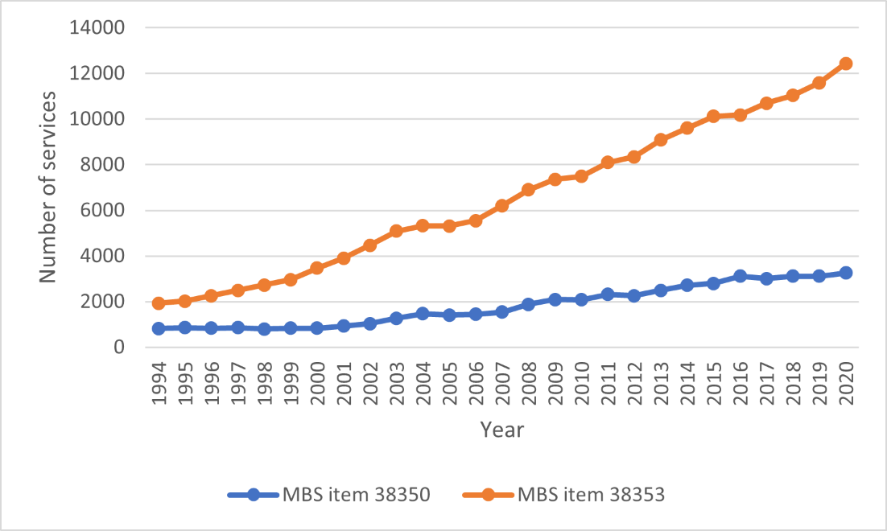
Source: MBS Item Statistics Reports, Medicare Australia, accessed 07 July 2021.
An estimate of current usage of LPMs in Australia was not provided in the application. However, an Australian article states that in 2018, fewer than 100 LPMs had been implanted in Australia (Koh & Lau, 2018). These numbers are expected to rise with increased clinical acceptance of the technology and as more operators are trained in the procedure.
The applicant provided an updated estimate of the likely usage of the LPM device based on recent utilisation data. The applicant claims that usage in the last three years is approximately REDACTED.

Intervention
According to the application, the only available single-chamber implantable transcatheter pacing system in Australia is Medtronic’s Micra Transcatheter Pacing System (TPS), Model MC1VR01 referred to as Micra VR. The Micra VR is a programmable cardiac device that monitors and regulates the patient’s heart rate by providing rate-responsive bradycardia pacing to the right ventricle. It is inserted via the femoral vein and implanted directly into the right ventricular myocardium (see Figure 2), negating the need for transvenous leads.
Similar to TV-PMs, Micra VR has traditional remote monitoring capabilities, but it is not capable of Bluetooth monitoring due to its small size.
The application advises that the next generation Micra LPM device will be available in due course, which will pace the right ventricle and sense the electrical signals in the atrium to allow for synchronised AV pacing of the ventricle (Micra AV); however, MSAC Application 1672 is limited to the Micra LPM for pacing to the right ventricle only without sensing in the atrium.
Figure 2 Medtronic’s Micra VR
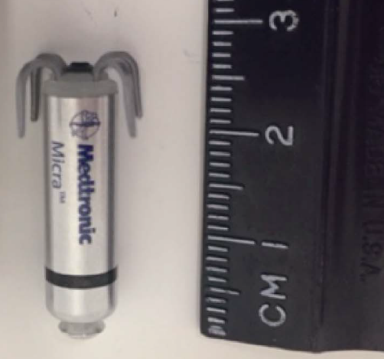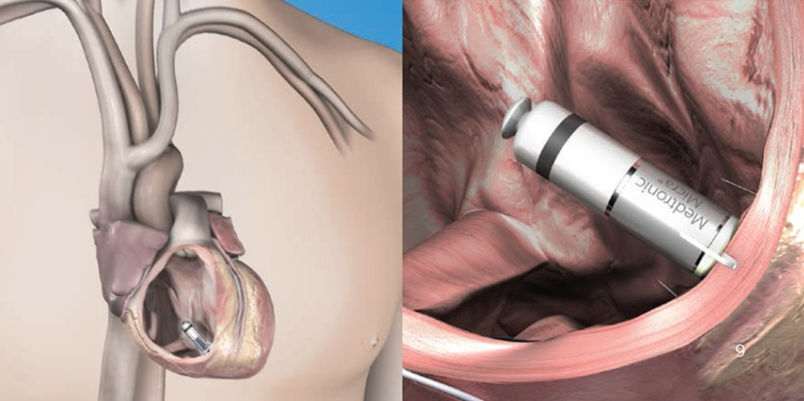
Source: MSAC Application 1672
The Micra VR is a miniaturised device measuring 25.9 mm long, 2.8 mm diameter and 1.75 grams. The device senses the electrical activity of the patient’s heart using sensing and pacing electrodes enclosed in a hermetically sealed titanium capsule. The device monitors the heart rhythm for bradycardia and responds to bradycardia by providing pacing therapy based on programmed pacing parameters. Rate-response is controlled through an activity-based sensor.

The components of the Micra VR system include:
- the LPM device (which is drug-eluting, with controlled-release dexamethasone)
- a single-use delivery catheter to deliver, deploy and test device placement
- a single-use introducer (23 French sheath).
A standard Medtronic cardiac device programmer is used in conjunction with the Micra VR system. The programmer is applicable to all implantable Medtronic cardiac devices and is not device-specific.
After placing the introducer sheath in the femoral vein in the groin, the pacemaker is delivered to the apex of the right ventricle using the steerable delivery catheter. The minimum size 23 French introducer may preclude use in individuals where this is unable to be used for anatomical reasons. The Micra VR has an active fixation mechanism consisting of four electrically inactive tines designed to anchor it in the cardiac tissue at the implant location (shown in Figure 2). Fluoroscopic guidance is used throughout the procedure to navigate the delivery system, deploy the device, and assess the adequacy of the device fixation in the patient’s cardiac tissue. Initial electrical measurements are taken to help determine whether the sensing, electrode impedance, and pacing threshold values are acceptable for the device implant. If the Micra VR needs to be repositioned after removing the tether during the initial implant procedure, the original introducer and delivery system can be used.
An Australian observational study of 79 patients undergoing LPM insertion reported implantation failure in three patients; two (2.5%) due to excessive venous tortuosity and one (1.3%) due to inadequate sensing (Denman et al. 2019).
PASC queried the mobility of the device if it becomes dislodged from the myocardium. The applicant’s clinical expert acknowledged that it is possible for the device to get stuck in the pulmonary artery. In that case, it would generally be retrieved due to concerns about the potential for thrombus formation around it and the creation of a pulmonary emboli.
The Micra VR does not usually need to be explanted as it can be programmed to ‘Device Off’ mode, which permanently disables pacing and sensing, allowing it to remain in the body beyond its useful life. The Micra VR takes up less than 1% of the volume of a normal right ventricle and it has been reported that at least three devices could be accommodated in the right ventricle and trabeculation (Fagerlund et al. 2018). At the end of the battery longevity, the Micra VR is expected to be fully encapsulated and would be permanently programmed to ‘Device Off’ to allow an additional Micra VR or transvenous therapy to be added. This feature is also available in instances where a patient’s clinical indication changes, requiring them to have a different therapy. It is not the intention that a patient will receive a new device as a consequence of hardware upgrade. The intention is for the original Micra device to remain in place until the end of service is reached.
PASC raised concerns about the implications of leaving the device in situ after its useful life, particularly for patients who could potentially end up with several abandoned devices in their right ventricle. PASC considered this to be an important issue for younger people in whom single-chamber ventricular pacing is indicated. Although this subpopulation may not be large, there is potential for them to accrue multiple devices during their lifetime. The applicant acknowledged that no in vivo studies have been conducted to determine the maximum number of LPM (Micra) devices that can be implanted within a single ventricle. However, a study has been conducted on six human cadaver hearts and one reanimated human heart (not deemed viable for transplant) that were each implanted with multiple LPM devices (Omdahl et al. 2016). The study concluded that the right ventricle can comfortably accommodate three Micra devices, with the potential in some larger hearts for even more. As such, the applicant has placed no ceiling on the maximum number of devices that can be implanted in a single patient. The applicant explained that there are separate locations within the right ventricle where the devices can be implanted, such as the apex, the septum or the outflow tract.
There may be some circumstances where retrieval of the Micra VR is necessary (e.g., in the case of infection). The device has a retrieval feature so that it can be snared and removed if not encapsulated. The applicant’s data suggests that the device is 75% encapsulated at 4 months post-implant and fully encapsulated at one year. According to the Micra MC1VR01 Clinician Manual, retrieval of the device after it is fully encapsulated may result in injury to the patient’s cardiac tissue and should only be attempted by centres with expertise in the removal of implanted leads (particularly with cardiac surgery backup). A similar situation exists for transvenous leads, whereby faulty leads are often left in place and a patient may accrue multiple leads over their lifetime. If explantation of transvenous leads is required due to infection or other reasons, the procedure requires specialist techniques.
At the PASC meeting, the applicant’s clinical expert acknowledged that if the device were to be implanted in a younger person, it would be preferable to extract the old device, if possible. The expectation from clinicians is that over time, methods will be developed to successfully extract an encapsulated device without the need for cardiac surgery. If this cannot be achieved and new technologies have not been developed in the meantime, then a patient who reaches capacity in the right ventricle may need to switch to a transvenous system.
PASC queried whether the level of encapsulation could be adequately assessed by transoesophageal echocardiography (TOE) to determine whether simple retrieval or surgical explant is necessary. The applicant’s clinical expert explained that based on experience with transvenous leads, echo provides some information; however, the full extent of encapsulation is not known until surgery.
The application states that the longevity of the LPM battery is 12 years (Duray et al. 2017). According to the Micra MC1VR01 Clinician Manual, the service life of the device is affected by the programmed settings for certain features such as rate-response.

Setting
The procedure is performed as an inpatient service, either in the public or private hospital setting by specialist cardiologists (interventional cardiologist, cardiac electrophysiologist) or cardiac surgeons in a cardiac catheterisation laboratory or operating room. Cardiologists who intend to perform insertion of an LPM device undergo a comprehensive training program provided by Medtronic.
According to an Australian observational study (Denman et al. 2019), the procedure time for LPM insertion was 29 minutes (interquartile range [IQR]: 21–43 minutes) of which fluoroscopy time was 8 minutes (IQR: 5–13 minutes). Most procedures only required local anaesthetic, although 5% required general anaesthesia (all of which involved extraction of a previously implanted transvenous device and re-implantation of an LPM as a single procedure).
According to the application, the first 24 hours after the procedure is critical in terms of monitoring the patient for adverse events and complications, particularly given the potential risk of bleeding due to the large (23 Fr) sheath. An overnight stay is generally recommended, although in some cases patients may be released home on the same day as the procedure.

Prerequisites
Proficiency in femoral venous access and large bore catheter manipulation are recommended. Upon satisfaction of the prerequisites, physicians are invited to complete the required Micra components on Medtronic Academy educational components. The Implanter Training Pathway has two components: completion of online modules and attendance at a Medtronic sponsored in-person training course. This in-person training includes didactic learning, observing Micra implant procedures, and hands-on procedural training (e.g., implant simulator, cadaver and animal model, videos and demonstration models).
The applicant recommends that a minimum of the first 10 implants be supported by a Medtronic Micra Technical Expert representative. The application states that additional support beyond the first 10 cases will be made available.

Regulatory approval
The Micra VR is currently included on the Australian Register of Therapeutic Goods (ARTG), together with an ‘introducer’ for insertion of the device (see Table 2 for details).
Table 2 Leadless pacemakers and consumables on the ARTG
Product name & Sponsor | ARTG summary | Functional description | Intended purpose
Micra single chamber transcatheter pacing system - Intracardiac pacemaker  Medtronic Australasia Pty Ltd | ARTG ID: 283235  Start date: 06/12/2016  Category: AIMD  GMDN: 60789 Intracardiac pacemaker | MR Conditional single chamber implantable transcatheter pacing system with SureScan technology is a programmable cardiac device that monitors and regulates the patient's heart rate by providing rate-responsive bradycardia pacing to the right ventricle.  The device senses the electrical activity of the patient's heart, using the sensing and pacing electrodes enclosed in the titanium capsule of the device. | Indicated for use in patients who have experienced one or more of the following conditions:  - symptomatic paroxysmal or permanent high-grade AV block in the presence of AF  - symptomatic paroxysmal or permanent high-grade AV block in the absence of AF, as an alternative to dual chamber pacing, when atrial lead placement is considered difficult, high risk, or not deemed necessary for effective therapy  - symptomatic bradycardia-tachycardia syndrome or sinus node dysfunction (sinus bradycardia or sinus pauses), as an alternative to atrial or dual chamber pacing, when atrial lead placement is considered difficult, high risk, or not deemed necessary for effective therapy.  Rate-responsive pacing is indicated to provide increased heart rate appropriate to increasing levels of activity.
Micra Introducer - Model MI2355A - Cardiovascular device introducer, non-steerable  Medtronic Australasia Pty Ltd | ARTG ID: 221570  Start date: 24/03/2014  Category: Class III  GMDN: 57941 Cardiovascular device introducer, non-steerable | The Micra introducer is a single-use, disposable, hydrophilically coated sheath that provides a flexible and hemostatic conduit for the insertion of intravascular devices into the venous system to minimize blood loss. The system is comprised of 2 components: a dilator that accommodates a guidewire and an introducer. | The Micra introducer is intended to provide a conduit for the insertion of devices into the venous system and to minimize blood loss associated with such insertions.
Source: Therapeutic Goods Administration, ARTG Public Summary, accessed 7 July 2021.
Note that the Nanostim leadless cardiac pacemaker from St Jude Medical (now Abbott) was recalled from the Australian market by the Therapeutic Goods Administration (TGA) in 2016 due to battery malfunction specific to the device, hence is no longer marketed in Australia.
According to the applicant, other leadless pacemakers are in earlier stages of development and are expected to be several years away from readiness for market entry.

Comparator
The nominated comparator is the insertion of a standard, single-chamber TV-PM. This consists of a pulse generator (containing the battery and the machinery for sensing and timing of electrical impulses) and a lead (an insulated wire that delivers electrical impulses from the pulse generator to the heart). Insertion of the pulse generator requires a surgical incision in the chest to create a subcutaneous pocket. A single lead is inserted percutaneously either via subclavian, cephalic or axillary veins, and guided transvenously via the tricuspid valve into the right ventricle. The position of the wire is checked using fluoroscopy. The lead can either be attached passively with tines (spikes at the end of the wire), which become fixed via granulation tissue formation, or can be actively fixed to the myocardium using a screw.
The health care resources that are needed to be delivered at the same time as the comparator service are similar to those delivered at the same time as the proposed intervention, and includes anaesthesia, fluoroscopy, the professional service itself and hospitalisation. The duration of stay is the same for both procedures, with patients generally admitted overnight. According to an Australian study (Denman et al. 2019), the procedure time of the insertion of the LPM and a TV-PM is similar (around 30 minutes).
There are two item numbers listed on the MBS that are used to claim the single-chamber TV-PM procedure; one item relevant to the insertion of the pacemaker device itself (MBS item 38353) and one item for the component of the service that relate to the insertion of the TV lead (MBS item 38350). While item 38350 is specific to the insertion of the lead for a single-chamber pacemaker, item 38353 can be used for the insertion of either a dual- or single-chamber pacemaker.
Category 3 – THERAPEUTIC PROCEDURES
38350
SINGLE CHAMBER PERMANENT TRANSVENOUS ELECTRODE, insertion, removal or replacement of, including cardiac electrophysiological services where used for pacemaker implantation
Multiple Operation Rule
(Anaes.)
Fee: $664.55 Benefit: 75% = $498.45
(See para TN.8.60 of explanatory notes to this Category)
38353
PERMANENT CARDIAC PACEMAKER, insertion, removal or replacement of, not for cardiac resynchronisation therapy, including cardiac electrophysiological services where used for pacemaker implantation
Multiple Operation Rule
(Anaes.)
Fee: $265.80 Benefit: 75% = $199.35
(See para TN.8.60 of explanatory notes to this Category)
TN.8.60
The fees for the insertion of a pacemaker (Items 38350, 38353 and 38356) cover the testing of cardiac conduction or conduction threshold, etc related to the pacemaker and pacemaker function. Accordingly, additional benefits are not payable for such routine testing under Item 38209 or 38212 (Cardiac electrophysiological studies).
Source: MBS Online, accessed 7 July 2021.
A separate MBS item is available for percutaneous extraction of chronically implanted transvenous leads (MBS item 38358). Refer to Attachment 2 for the additional MBS item mentioned in TN.8.214.
Category 3 – THERAPEUTIC PROCEDURES
38358
Extraction of one or more chronically implanted transvenous pacing or defibrillator leads, by percutaneous method, with locking stylets and snares, with extraction sheaths (if any), if:
(a) the leads have been in place for more than 6 months and require removal; and
(b) the service is performed:
(i) in association with a service to which item 61109 or 60509 applies; and
(ii) by a specialist or consultant physician who has undertaken the training to perform the service; and
(iii) in a facility where cardiothoracic surgery is available and a thoracotomy can be performed immediately and without transfer; and
(c) if the service is performed by an interventional cardiologist—a cardiothoracic surgeon is in attendance during the service
(H)
Multiple Operation Rule
(Anaes.) (Assist)
Fee: $2,089.00 Benefit: 75% = $1,566.75
(See para TN.8.64, TN.8.214 of explanatory notes to this Category)
TN.8.64
Intravascular Extraction of Permanent Pacing Leads - (Item 38358)
For the purposes of Item 38358 specialists or consultant physicians claiming this item must have training recognised by the Lead Extraction Advisory Committee of the Cardiac Society of Australia and New Zealand, and the Department of Human Services notified of that recognition. The procedure should only be undertaken in a hospital capable of providing cardiac surgery.
TN.8.214
International guidelines and claiming guide for extraction of leads
International guidelines state that delays from injury to open access to the heart of more than 5–10 minutes are often associated with a fatal outcome. Preparations for this procedure should provide for this rare but life threatening circumstance.
Claiming guide:
When the service to which item 38358 applies is provided to a patient by an accredited interventional cardiologist the following claiming will apply:
- Item 38358 is to be claimed by the accredited interventional cardiologist; and
- Item 90300 is to be claimed by the standby cardiothoracic surgeon.
When the service to which item 38358 applies is provided to a patient by an accredited cardiothoracic surgeon the following claiming will apply:
- Item 38358 is to be claimed by the accredited cardiothoracic surgeon; and
- Item 90300 is also claimable by the cardiothoracic surgeon.

Various single-chamber pacemaker generators are available on the July 2021 PL (Grouping 08.04.03) with a benefit of $3,948 ($5,398 for TV-PMs with a remote monitoring service). Right ventricular pacemaker leads (Groupings 08.08.08 and 08.08.09) are listed on the PL with benefits ranging from $831 to $1,732.

Outcomes

Technical performance
Three main technical performance outcomes are relevant:
- pacing performance (sensing, impedance, pacing threshold)
- battery life
- adaptability (rate response).
Battery longevity is an important consideration for implanted devices as there are risks associated with reintervention for device replacement. Long-term real-world data are preferable to bench testing to support battery life claims.

Patient-relevant effectiveness outcomes
The application did not specify any patient-relevant effectiveness outcomes but these are likely to be most influential for MSAC decision-making. Patient-relevant effectiveness outcomes include:
- mortality (all-cause and cardiovascular)
- exercise capacity
- change of medication
- progression or recurrence of cardiac arrhythmias
- switch to an alternative device (a different pacemaker or defibrillator)
- symptoms of cardiac arrhythmias (pre-syncope or syncope)
- health-related quality of life
- patient satisfaction (including patient lack of concerns about the device).

Safety outcomes
The assessment should capture major intraoperative and postoperative complications, including long-term device-related complications. Major procedure-related or device-related complications are those that resulted in death, permanent loss of device function as a result of mechanical or electrical dysfunction, hospitalisation, prolongation of hospitalisation by at least 48 hours, or system revision.
The following safety outcomes are considered relevant to the comparison of LPM versus TV-PM:
- major procedure-related complications (cardiac tamponade/perforation, pericardial effusion, venous thromboembolism, infection, vascular complications [bleeding, pseudoaneurysm, haematoma, arteriovenous/atrioventricular fistula])
- Right ventricular dysfunction
- Atrioventricular (AV – tricuspid & mitral) valve regurgitation
- Pacemaker syndrome
- major device-related complications (device dislodgement, device malfunction, battery failure, device infection, pacemaker-induced arrhythmia)
- device revision, retrieval, replacement
- device explantation
- any serious adverse event
PASC noted that the application hinges on adequate demonstration of superior safety relative to transvenous pacing.

Health care resources
Health care resource use and costs are required for the economic evaluation. Health care resource considerations include:
- procedure duration
- implant success rate
- time to hospital discharge
- procedure-related and follow-up costs (including downstream hospitalisations)
- cost of device and consumables.
For the proposed intervention, the application stated that the cost of the LPM device and consumables would be proposed and justified in the assessment report.

Total Australian Government health care costs
- total cost to the MBS
- total cost to other health care budgets.

Clinical management algorithms
The work up and lead up to diagnosis of patients will not change as a consequence of the introduction of the proposed intervention.
While there are no Australian-specific algorithms available for the management of patients with bradycardia, the application claims that – based on local expert advice – Australian clinicians refer to the 2018 ACC/AHA/HRS guidelines on the management of patient with bradycardia (Kusomoto et al. 2019). The 2013 European Society of Cardiology (ESC) guidelines on cardiac pacing (Brignole et al. 2013) are broadly similar to the ACC/AHA/HRS guidelines but are somewhat dated (noting that an update of these guidelines is expected in 2021). The clinical place in therapy for LPM, as illustrated in Figure 3 and Figure 4, was confirmed with local experts by the applicant and is consistent with the populations currently indicated for LPM based on the Micra VR indications (ARTG 283235).
The applicant claims that the pacing performance of the Micra device is arguably the same irrespective of the indication for pacing, SND or AV block, as per the standard, single-chamber TV-PM. The applicant stated that based on local expert advice from three electrophysiologists, the overall majority of patients for whom LPM would be considered reflect patients with AV block, with only a minority of SND considered suitable for LPM. This is because there is a subset of patients with SND who may require atrial pacing support at a later point in time. Atrial pacing is not a function available in current LPM devices. For these patients, an upgrade to a dual-chamber TV-PM would be required (requiring atrial lead placement).
Figure 3 AV block management algorithm, including insertion of a leadless pacemaker
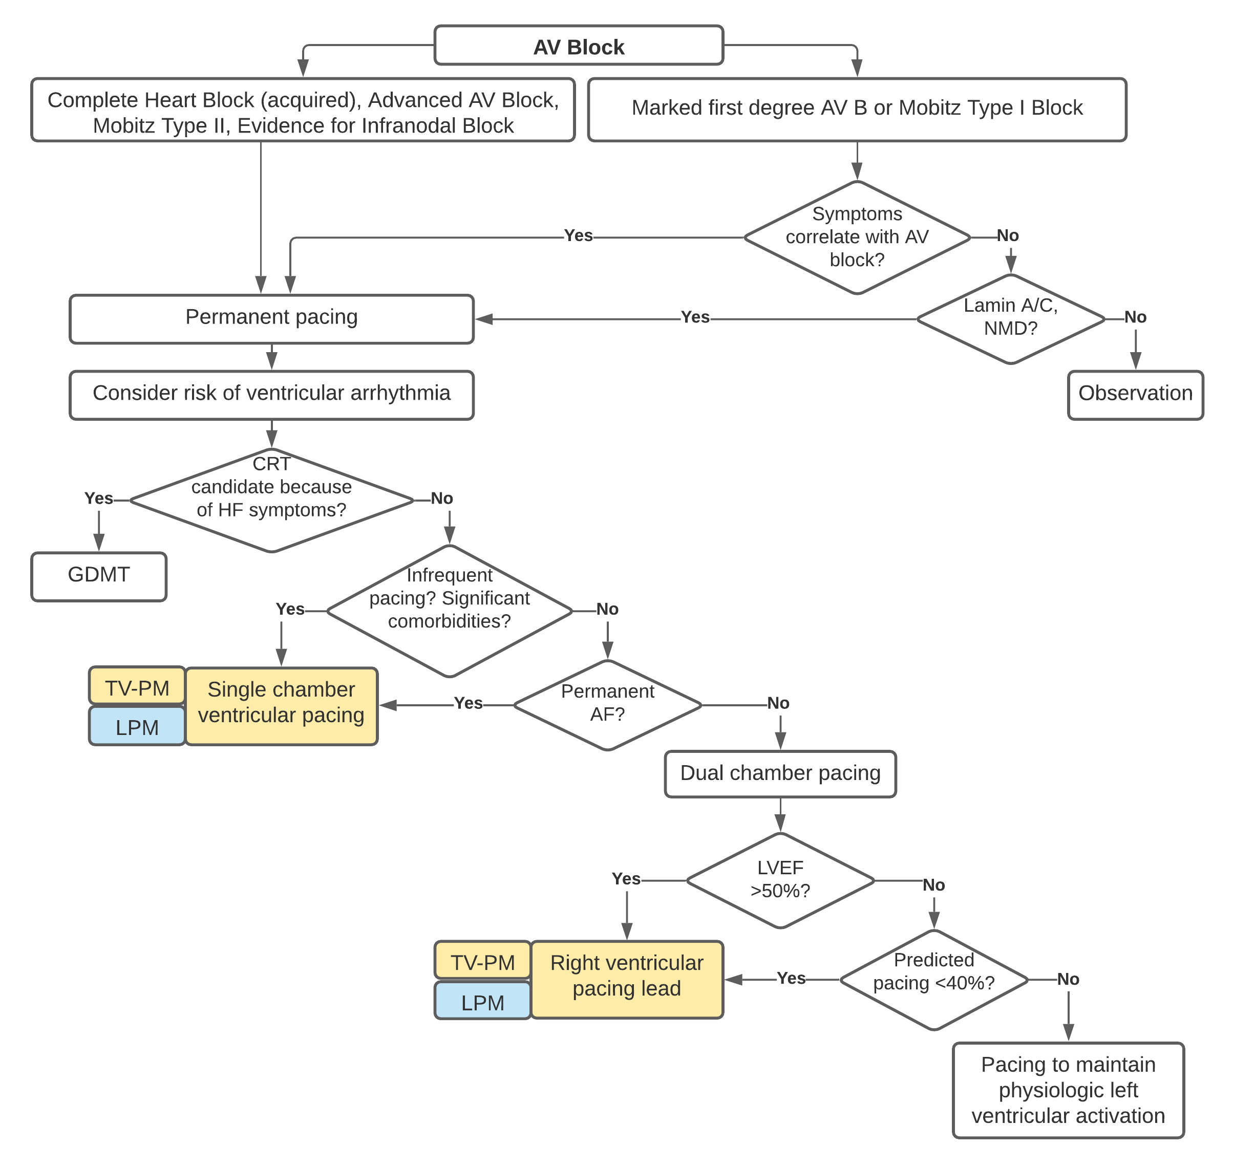
Source: Simplified algorithm derived from Kusomoto et al. 2018, with addition of the proposed intervention (LPM) in blue.
Abbreviations: AF, atrial fibrillation; AV, atrioventricular; CRT, cardiac resynchronisation therapy; GDMT, guideline-directed management and therapy; HF, heart failure; LPM, leadless pacemaker; LVEF, left ventricular ejection fraction; NMD, neuromuscular disease; TV-PM, single-chamber transvenous pacemaker.
Figure 4 Sinus node dysfunction management algorithm, including insertion of leadless pacemaker
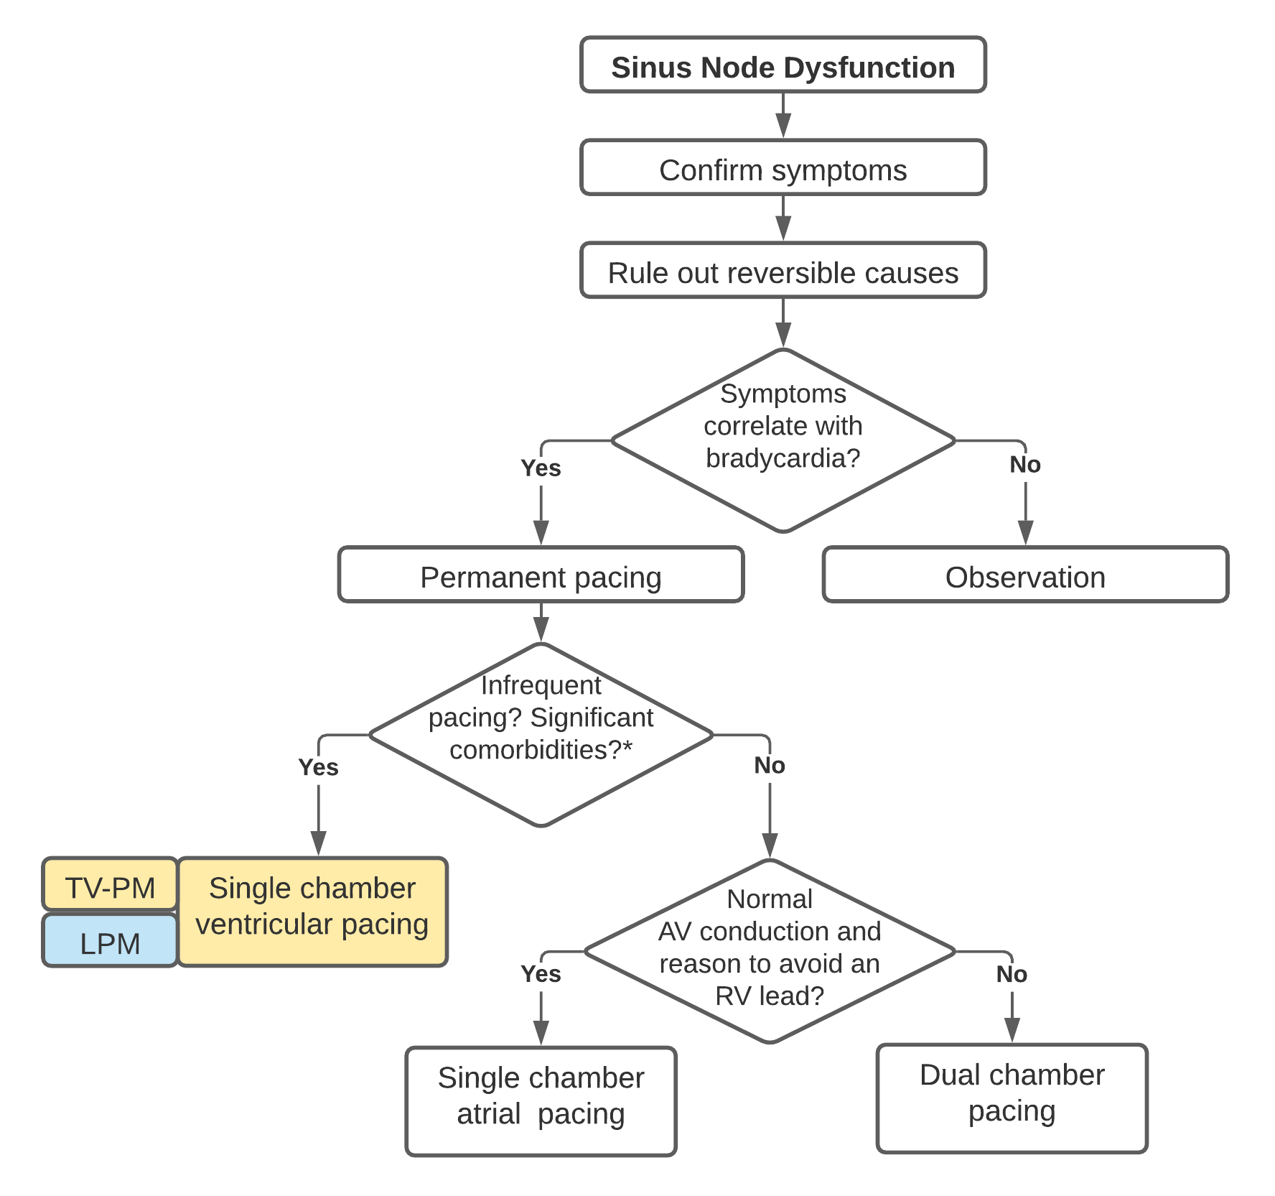
Source: Simplified algorithm derived from Kusomoto et al. 2018, with addition of the proposed intervention (LPM) in blue.
*Symptomatic patients with very infrequent need for pacing for rate support or patients with significant comorbidities.
Abbreviations: AV, atrioventricular; LPM, leadless pacemaker; RV, right ventricular; TV-PM, single-chamber transvenous pacemaker.
The frequency of monitoring of patients after the procedure may vary by treatment centres; however, patients who received a TV-PM or an LPM are generally followed up at 1 week, 3 months, 6 months and then every 6–12 months by a specialist cardiologist or general practitioner.

Proposed economic evaluation
On the basis of the applicant’s clinical claim that single-chamber leadless pacemakers have non-inferior effectiveness and superior safety compared with single-chamber TV-PMs, the appropriate economic evaluation is a cost-effectiveness analysis or a cost-utility analysis.
MSAC prefers that the economic evaluation is based on results from direct randomised trials [MSAC Guidelines Version 1.0 May 2021, p.154]. Any uncertainties in the clinical claims arising from deficiencies in the clinical evidence will require careful identification and testing in the economic analysis to increase confidence in the results.

Proposal for public funding
The applicant proposed a single new MBS item for insertion and removal of an LPM. Although not explicitly mentioned in the proposed descriptor in the application, the item is intended to apply to percutaneous procedures only. It is possible for LPMs to be inserted/retrieved during open surgery, but an open approach is off-label and uncommon and will differ from a percutaneous approach in terms of complexity and time.
The time and complexity for percutaneous insertion of an LPM is expected to differ from that of percutaneous LPM retrieval, which becomes more challenging the longer the device has been in place. In situations where LPM retrieval is attempted, a new LPM may or may not be inserted during the same procedure.
PASC considered whether a separate MBS item may be required for the scenario where surgical explantation of the device is needed after it has become bound within the myocardium. PASC received advice from the applicant’s clinical expert that explantation of the LPM is similar to that of transvenous leads, whereby the procedure to remove the device after it has become encapsulated is entirely different in terms of complexity to retrieval prior to encapsulation. PASC agreed that for LPMs, a parallel schedule to that of transvenous pacemakers is appropriate, with separate items for retrieval and explantation.
Four scenarios are relevant to this application and a different fee may apply to each:
- Percutaneous insertion of an LPM (MBS item WWWWW)
- This applies to initial (first) LPM insertion and any repositioning that is required during the same procedure. It also applies to insertion of a subsequent LPM device where LPM retrieval is not performed during the same procedure (i.e., the existing device remains in place and a new device is added).
- Percutaneous LPM retrieval and replacement (MBS item XXXXX)
- This applies where an LPM is retrieved and replaced with a new LPM during the same percutaneous procedure.
- Percutaneous removal of an LPM (MBS item YYYYY)
- This applies when one or more LPMs are retrieved during a single percutaneous procedure and are not replaced with a new device.
- Surgical explantation of an LPM (MBS item ZZZZZ)
- This applies when one or more LPMs have become encapsulated in the myocardium and require surgical explantation. This procedure is considerably more complex and risky than percutaneous retrieval and requires specialist techniques.
The scenarios outlined above are reflected in the four separate MBS items shown below.
PASC acknowledged that the proposed item descriptors are device agnostic, which is appropriate.

Category 3 – THERAPEUTIC PROCEDURES
MBS item WWWWW
LEADLESS PERMANENT CARDIAC PACEMAKER, SINGLE-CHAMBER VENTRICULAR, percutaneous insertion of, including cardiac electrophysiological services
Multiple Operation Rule
(Anaes.)
Fee: $797.45
MBS item XXXXX
LEADLESS PERMANENT CARDIAC PACEMAKER, SINGLE-CHAMBER VENTRICULAR, percutaneous retrieval and replacement of, including cardiac electrophysiological services
Multiple Operation Rule
(Anaes.)
Fee: TBD
MBS item YYYYY
LEADLESS PERMANENT CARDIAC PACEMAKER, SINGLE-CHAMBER VENTRICULAR, percutaneous retrieval of
Multiple Operation Rule
(Anaes.)
Fee: TBD
MBS item ZZZZZ
LEADLESS PERMANENT CARDIAC PACEMAKER, SINGLE-CHAMBER VENTRICULAR, surgical explantation of
Multiple Operation Rule
(Anaes.) (Assist)
Fee: TBD

The applicant has proposed a fee of $797.45 for percutaneous insertion of an LPM capable of single-chamber ventricular pacing. This fee is informed by the combined fee for MBS items 38350 and 38353 (taking the multiple operation rule into account), on the basis that the total procedure duration for LPM insertion is comparable to that of insertion of a single-chamber TV-PM and electrode.
PASC considered whether it may be more appropriate to base the fee on a catheter-based cardiac procedure on the MBS, such as catheter-based valve replacement, given the similarities to the LPM insertion procedure. The applicant’s clinical experts confirmed that in terms of time taken and skill required, LPM insertion is comparable to implantation of a TV-PM. On that basis, PASC agreed that it may be appropriate for the proposed fee for LPM insertion to be based on the fee for insertion of a conventional pacemaker and transvenous leads, but that it would need to be appropriately justified in the assessment report.
PASC queried whether the insertion item should be limited to once only or if there is a basis for the procedure being undertaken on multiple occasions in a single patient. The applicant’s clinical expert explained that a patient may receive multiple devices over their lifetime, similar to the situation for transvenous leads.
The application does not propose fees or provide time estimates for LPM explantation, LPM retrieval or for LPM retrieval with replacement during the same procedure. It will be important to justify these fees during the assessment phase.
Similar to TN.8.60 (which applies to MBS items 38350 and 38353), an explanatory note is required to clarify that additional benefits are not payable on the same occasion for cardiac electrophysiological studies.
It is intended that the proposed items for LPM insertion and retrieval are to be claimed in conjunction with an existing MBS item for fluoroscopy (e.g., MBS item 61109).

Private health insurance
No leadless pacemakers were available on the July 2021 Prostheses List (PL). The applicant intends to submit an application in early 2022 to include the Micra TPS (also referred to as Micra VR) on the PL. The cost of the Micra device and consumables were not disclosed in the application but will be provided in the Applicant Developed Assessment Report (ADAR).

Summary of public consultation input
The department received one response from a health professional to targeted consultation. The response was supportive of the application noting that advantages of the proposed intervention would relate to patient satisfaction, and reduction of lead and pocket complications.
PASC noted that the one response received at targeted consultation was supportive of the application.

Next steps
PASC noted that the applicant has elected to the application as an ADAR (Applicant Developed Assessment Report), targeting the June 2022 ESC meeting and the July 2022 MSAC meeting.

Applicant Comments on the PICO Confirmation
Proposal for public funding
Medtronic advised it will work with clinical experts in order to justify the appropriate fees in the assessment report.
Next Steps
The applicant confirmed it intends to submit an ADAR.

References
Brignole, M., Auricchio, A., Baron-Esquivias, G., Bordachar, P., Boriani, G., Breithardt, O-A., Cleland, J., Deharo, J-C., Delgado, V., Elliott, P.M., Gorenek, B., Israel, C.W., Leclercq, C., Linde, C., Mont, L., Padeletti, L., Sutton, R., Vardas, P.E. (2013) The Task Force on cardiac pacing and resynchronization therapy of the European Society of Cardiology (ESC). Developed in collaboration with the European Heart Rhythm Association (EHRA). 2013 ESC Guidelines on cardiac pacing and cardiac resynchronization therapy. European Heart Journal. 34:2281-329.
Denman, R.A., Lee, A.C., Mengel, C., Townsend, S., Betts, J., Bovey, N., Wright, D., Davison, O., Haqqani, H.M. (2019) Leadless permanent pacing: A single centre Australian experience. Heart, Lung and Circulation. 28, 1677–82.
Duray, G.Z., Ritter, P., El-Chami, M., Narasimhan, C., Omar, R., Tolosana, J.M., Zhang, S., Soejima, K., Steinwender, C., Rapallini, L., Cicic, A., Fagan, D.H., Liu, S., Reynolds, D., Micra Transcatheter Pacing Study Group. (2017) Long-term performance of a transcatheter pacing system: 12-Month results from the Micra Transcatheter Pacing Study. Heart Rhythm. 14:702-09.
Fagerlund, B.C., Harboe, I., Giske, L., Movik, E., Ørjasæter, I.K., Tjelle, T.E. (2018) The MicraTM Transcatheter Pacing System, a leadless pacemaker, in patients indicated for single‐chamber ventricular pacemaker implantation: A single technology assessment from the Norwegian Institute of Public Health (Folkehelseinstituttet). Oslo: Norwegian Institute of Public Health.
Gregoratos G. (1999) Permanent pacemakers in older persons. Journal of the American Geriatric Society. 47(9):1125-35.
Hayes, D.L. (2021) Modes of cardiac pacing: Nomenclature and selection. In M. Link and B.C. Downey (eds.) UpToDate. Retrieved 20 July 2021, from https://www.uptodate.com/contents/modes-of-cardiac-pacing-nomenclature-and-selection?topicRef=941&source=see_link
Koh, D., Lau, K.K. (2018) A new leadless cardiac conduction device. Journal of Medical Imaging and Radiation Oncology. 62:375-6.
Kusomoto, F.M., Schoenfeld, M.H., Barrett, C., Edgerton, J.R., Ellenbogen, K.A., Gold, M.R., Coldschlager, N.F., Hamilton, R.M., Joglar, J.A., Kim, R.J., Lee, R., Marine, J.E., McLeod, C.J., Oken, K.R., Patton, K.K., Pellegrini, C.N., Selzman, K.A., Thompson, A., Varosy, P.D. (2019) 2018 ACC/AHA/HRS guideline on the evaluation and management of patients with bradycardia and cardiac conduction delay. A report of the American College of Cardiology/American Heart Association Task Force on Clinical Practice Guidelines and the Heart Rhythm Society. Circulation. 140(8):e382-e482.
National Institute for Health and Care Excellence (NICE). Interventional procedure overview of leadless cardiac pacemaker implantation for bradyarrhythmias. Interventional Procedures Programme, IP 1192 [IPG626]. August 2018. Retrieved 20 July 2021, from https://www.nice.org.uk/guidance/ipg626/evidence
Omdahl, P., Eggen, M.D., Bonner, M.D., Iaizzo, P.A., Wika, K. (2016) Right ventricular anatomy can accommodate multiple Micra Transcatheter Pacemakers. Pacing Clin Electrophysiol. 39(4):393-7.
Semlitsch, Th., Zipp, C., Loder, C. (2020) Leadless Pacemakers for Right Ventricle Pacing. Decision Support Document No. 97/2. Update 2020; Vienna: Ludwig Boltzmann Institute for Health Technology Assessment.
Wasmer, K., Eckardt, L., Breithardt, G. (2017) Predisposing factors for atrial fibrillation in the elderly. Journal of Geriatric Cardiology. 14:179-84.

Attachment 1
Table 3 Definitions of sinus node dysfunction (SND) and atrioventricular (AV) block
Term | Definition or description
SND (with accompanying symptoms)
Sinus bradycardia | Sinus rate <50 bpm
Ectopic atrial bradycardia | Atrial depolarisation attributable to an atrial pacemaker other than the sinus node with a rate <50 bpm
Sinoatrial exit block | Evidence that blocked conduction between the sinus node and adjacent atrial tissue is present. Multiple electrocardiographic manifestations including “group beating” of atrial depolarisation and sinus pauses.
Sinus pause | Sinus node depolarises >3 s after the last atrial depolarisation
Sinus node arrest | No evidence of sinus node depolarisation
Tachycardia-bradycardia (“tachy-brady”) syndrome | Sinus bradycardia, ectopic atrial bradycardia, or sinus pause alternating with periods of abnormal atrial tachycardia, atrial flutter, or AF. The tachycardia may be associated with suppression of sinus node automaticity and a sinus pause of variable duration when the tachycardia terminates.
Chronotropic incompetence | Broadly defined as the inability of the heart to increase its rate commensurate with increased activity or demand, in many studies translates to failure to attain 80% of expected heart rate reserve during exercise.
Isorhythmic dissociation | Atrial depolarisation (from either the sinus node or ectopic atrial site) is slower than ventricular depolarisation (from an AV nodal, His bundle, or ventricular site).
AV block
First-degree AV block | P waves associated with 1:1 AV conduction and a PR interval >200 ms (this is more accurately defined as AV delay because no P waves are blocked)
Second-degree AV block | P waves with a constant rate (<100 bpm) where AV conduction is present but not 1:1
Mobitz type I | P waves with a constant rate (<100 bpm) with a periodic single nonconducted P wave associated with P waves before and after the nonconducted P wave with inconstant PR intervals
Mobitz type II | P waves with a constant rate (< 100 bpm) with a periodic single nonconducted P wave associated with other P waves before and after the nonconducted P wave with constant PR intervals (excluding 2:1 AV block)
2:1 AV block | P waves with a constant rate (or near constant rate because of ventriculophasic sinus arrhythmia) rate (<100 bpm) where every other P wave conducts to the ventricles
Advanced, high-grade or high-degree AV block | ≥2 consecutive P waves at a constant physiologic rate that do not conduct to the ventricles with evidence for some AV conduction
Third-degree AV block (complete heart block) | No evidence of AV conduction
Vagally mediated AV block | Any type of AV block mediated by heightened parasympathetic tone
Infranodal block | AV conduction block where clinical evidence or electrophysiologic evidence suggests that the conduction block occurs distal to the AV node
Source: Kusumoto (2019) Table 3 p.e390.
Abbreviations: AF, atrial fibrillation; AV, atrioventricular; bpm, beats per minute; ms, millisecond; s, second; SND, sinus node dysfunction.

Attachment 2
Category 1 – PROFESSIONAL ATTENDANCES
Group A37 – Cardiothoracic Surgeon Attendance for Lead Extraction
90300
Professional attendance by a cardiothoracic surgeon in the practice of the surgeon’s speciality, if:
(a) the service is performed in conjunction with a service (the lead extraction service) to which item 38358 applies; and
(b) the surgeon is:
(i) either performing, or providing surgical backup for the provider (who is not a cardiothoracic surgeon) who is performing, the lead extraction service; and
(i) present for the duration of the lead extraction service, other than during the low risk pre and post extraction phases; and
(iii) able to immediately scrub in and perform a thoracotomy if major complications occur (H)
Fee: $895.25 Benefit: 75% = $671.45
(See para TN.8.214 of explanatory notes to this Category)

Taken from the ARTG indications for Medtronic’s Micra Transcatheter Pacing System (Table 2). These indications are broadly consistent with the 2018 ACC/AHA/HRS guideline (Kusumoto et al. 2018).
Calculated using Schedule fee for MBS items 38350 and 38353 at 7 July 2021.

