Public Summary Document
Application No. 1689 – Quantification of NT-proBNP in patients with systemic sclerosis, and in patients with diagnosed pulmonary arterial hypertension
Applicant: Janssen-Cilag Pty Ltd
Date of MSAC consideration: 28-29 July 2022
Context for decision: MSAC makes its advice in accordance with its Terms of Reference, visit the MSAC website

1. Purpose of application
An application requesting Medicare Benefits Schedule (MBS) listing of N-terminal pro B-type natriuretic peptide (NT-proBNP) biomarker assay for (1) detection of pulmonary arterial hypertension (PAH) in patients with systemic sclerosis (SSc), and for (2) risk assessment of patients diagnosed with PAH was received from Janssen-Cilag Australia Pty Ltd by the Department of Health.

2. MSAC’s advice to the Minister
After considering the strength of the available evidence in relation to comparative safety, clinical effectiveness, cost-effectiveness and total cost, MSAC supported the creation of a new Medicare Benefits Schedule (MBS) item for the quantification of laboratory-based NT-proBNP testing for patients with systemic sclerosis (SSc or scleroderma) to assess the risk of pulmonary arterial hypertension (PAH). For this population, MSAC advised that the proposed test was safe and had at least non-inferior effectiveness, with acceptable cost-effectiveness and financial implications.
MSAC did not support public funding for NT-proBNP testing in patients with an established diagnosis of PAH. MSAC advised that the extent of substitution of transthoracic echocardiogram (TTE) is uncertain, resulting in uncertain cost-effectiveness and total financial implications.

Consumer summary
This is an application from Janssen-Cilag Australia Pty Ltd requesting Medicare Benefits Schedule (MBS) listing of NT-proBNP biomarker assay, via blood test for patients with systemic sclerosis to detect pulmonary arterial hypertension, and for risk-assessment in patients already diagnosed with pulmonary arterial hypertension.
Systemic sclerosis is a type of scleroderma that causes hardening or tightening of the skin and other internal organs, including the blood vessels. This can lead to high pressures in the blood vessels between the heart and lungs, which is called pulmonary arterial hypertension (PAH). Patients with PAH can experience shortness of breath, chest pain and fainting. It gets worse over time if not treated and can lead to heart failure. There is no cure for PAH, but it can be managed with a range of medications. Early diagnosis and treatment are important to slow down disease progression.
People with systemic sclerosis are usually checked for PAH every year, which currently involves a lung function test and a transthoracic echocardiogram (TTE), which is an ultrasound test of the heart. A TTE is performed by a trained sonographer or cardiologist with specialised ultrasound equipment, and it takes about one hour. N-terminal pro B-type natriuretic peptide (NT-proBNP) is a blood test that can be used instead of TTE. NT-proBNP is a hormone that is released by the heart as heart pressure increases. Higher levels in the bloodstream may indicate problems with the heart, one of which is PAH. The NT-proBNP blood test to detect PAH has not previously been listed on the MBS.
MSAC considered that NT-proBNP testing was at least as effective as TTE at detecting PAH and was better at correctly identifying patients who do not have PAH. If patients with systemic scleroderma could have a lung function test and a blood test which showed a normal NT-proBNP level, they might not need to have a TTE that year. This would reduce the number of other tests people would need to have, saving money and time. MSAC considered that it would be appropriate for the patient’s regular doctor (GP) to refer the patient for NT-proBNP testing, if done in consultation with the patient’s specialist. This would make NT-proBNP testing more accessible to more patients. GPs are already able to refer patients for lung function testing.
If problems were detected from the NT-proBNP test and the lung function test, patients would then need to have a TTE and other tests to further assess for PAH or other problems.
MSAC did not support funding for monitoring or assessing risk using NT-proBNP testing in patients who have already been diagnosed with PAH. In these patients, NT-proBNP testing is not expected to perform better than TTE, and these patients may require TTE anyway for other clinical reasons. MSAC considered this could make NT-proBNP testing an unnecessary additional test that might not change how the patient was managed. MSAC considered this may not be cost-effective. MSAC thought that it was possible that doctors may use NT-proBNP testing for patients with other types of heart conditions that have not been assessed by MSAC for clinical or cost-effectiveness, which would increase the overall cost to the government. MSAC considered that having an MBS item that is only for people with systemic sclerosis would reduce use in patients with other types of heart conditions.
MSAC’s advice to the Commonwealth Minister for Health and Aged Care
MSAC supported MBS listing of NT-proBNP testing in patients with systemic sclerosis. In these patients, the test is safe and effective and will replace the need for more expensive TTE in many cases, so it is expected to result in savings to MBS expenditure. It will also reduce the number of specialised imaging appointments patients need to schedule and attend, replacing them with a simple blood test.
MSAC did not support MBS listing of NT-proBNP in patients who have already been diagnosed with pulmonary arterial hypertension. In these patients, the test is safe and effective, but it would not change patient management, and it may result in less savings than the application estimated.

3. Summary of consideration and rationale for MSAC’s advice
MSAC noted that the purpose of the application was to seek MBS funding for N-terminal pro B-type natriuretic peptide (NT-proBNP) biomarker assay to help detect pulmonary arterial hypertension (PAH) in patients with SSc, and for risk assessment in patients diagnosed with PAH.
PAH is a rare, debilitating and progressive condition characterised by a sustained elevation of pulmonary vascular resistance (due to narrowing of the pulmonary arteries). PAH can cause shortness of breath and other symptoms, initially during exercise and eventually at rest as the condition progresses. If left untreated, PAH leads to right heart failure and death. The prognosis for patients with PAH is poor. MSAC noted that early detection of PAH in patients with SSc is important to allow earlier introduction of disease-modifying therapy.
MSAC noted that NT-proBNP is more stable than BNP and assays from different manufacturers show greater concordance of results than those for BNP. MSAC also noted that there can be variation in NT-proBNP levels day-to-day and week-to-week in the same patient due to natural biological variability and analytical variability. This means that, for repeated tests, there may be some changes within the normal variability for that patient.
MSAC noted the clinical management algorithms. For population 1 (SSc), the current clinical management algorithm involves annual TTE and pulmonary function testing (PFT) to determine the need for right heart catheterisation (RHC) to definitively diagnose PAH. The proposed clinical management algorithm replaces TTE with NT-proBNP testing. Patients who screen positive using NT-proBNP and PFT or have symptoms of PAH may then undergo TTE, but patients who screen negative do not need TTE. For population 2 (people with PAH) NT-proBNP will be used alongside other assessments to assess a patient’s risk of death or clinical worsening. MSAC noted that NT-proBNP testing would replace TTE in patients with stable symptoms and may be used in addition to TTE in patients whose symptoms are worsening.
MSAC accepted the proposed comparators. For population 1, the comparator was annual testing with TTE and PFT to determine the need for further testing including RHC. For population 2, the comparator was a risk assessment (without NT-proBNP) every 3–6 months to guide the need for repeat TTE and/or RHC if symptoms worsen or there is a change in therapy.
MSAC noted that, as a blood test, NT-proBNP testing has similar safety compared with the comparators. For population 1, NT-proBNP may be comparatively safer if more people can avoid unnecessary RHCs.
MSAC noted that public consultation input was supportive of the application.
MSAC considered that the clinical claim of non-inferior comparative clinical effectiveness was reasonable for both populations. MSAC noted that for Population 1, there were multiple comparative and non-comparative studies, and one direct comparative study provided linked evidence of the effectiveness of NT-proBNP testing in SSc patients at risk for developing PAH. However, different NT-proBNP thresholds were used in different studies, and diagnostic accuracy studies were based on initial screening rather than serial testing. MSAC also noted that for Population 2, there was limited evidence which suggested that risk stratification calculators that included NT-proBNP were at least as effective as those that did not.
For population 1, studies on diagnostic accuracy that included NT-proBNP in the algorithms (including the Australian Scleroderma Interest Group [ASIG] algorithm) had similar or better sensitivity and specificity compared with algorithms using TTE based on the European Society of Cardiology and European Respiratory Society (ESC/ERS) guidelines. MSAC considered that a key advantage of NT-proBNP is its increased specificity compared with TTE-based testing. For every 1,000 SSc patients tested using the ASIG algorithm, 224 fewer patients would undergo unnecessary further tests including RHC and one patient would avoid a missed diagnosis of PAH compared with the ESC/ERC guidelines-based algorithm using TTE (based on 1% annual incidence). For Population 1, MSAC accepted that approximately 10% of patients would require a second NT-proBNP test within a 12-month period due to having a NT-proBNP level of 168-209 pg/mL which is close of the threshold for further testing (210 pg/mL). This was based on data from Australian Scleroderma Cohort Study.
For population 2, MSAC noted the studies showing that increasing NT-proBNP levels are associated with morbidity and mortality outcomes in PAH. MSAC noted the studies on the likelihood that risk stratification strategies can predict mortality and/or cardiac morbidity in patients with PAH. A high versus low stratification results in a prediction of a 6–7-fold increased risk of adverse outcomes, and an intermediate vs low stratification results in a prediction of a
2–2.5-fold increased risk. MSAC considered that the REVEAL Lite 2 risk stratification calculator (which includes NT-proBNP results) was non-inferior to other calculators in identifying patients who were likely to die in the next year.
For population 2, MSAC noted the study by Benza et al. (2021) reported on the effect of missing variables on the REVEAL Lite 2 risk stratification calculator. The C-index (goodness of fit) for the REVEAL Lite 2 was 0.73 when all six variables were included. MSAC noted the C-index decreased from 0.73 to 0.70 when NT-proBNP was missing. MSAC considered that this suggests that NT-proBNP is an important variable in the REVEAL Lite 2 risk stratification calculator, however it remained non-inferior to risk assessment without NT-proBNP.
MSAC noted that clinical guidelines consider the aim of PAH treatment is to achieve or maintain a low risk profile based on data from clinical assessment, exercise tests, biochemical markers, and echocardiographic and haemodynamic evaluations. MSAC noted the more recent CHEST guidelines (2019), which include recommendations for treatment escalation in PAH patients with evidence of progression of disease, and/or markers of poor clinical prognosis. MSAC noted that these recommendations were based around a patient’s World Health Organization (WHO) functional class and recommended treatment escalation for patients with a functional class III/IV patients. MSAC noted that this group of patients are typically classified as having an intermediate or high risk of outcomes and would have already been escalated for TTE.
The applicant-developed assessment report (ADAR) stated that, for Population 2, NT-proBNP testing would be performed twice per year in most circumstances, but up to four times per year in patients with worsening symptoms or changes in therapy. MSAC noted that risk assessment using NT-proBNP would not result in any downstream changes in patient management. Rather, it is expected to reduce the number of patients requiring TTE compared with the current risk calculation algorithm. However, MSAC considered the extent to which NT-proBNP would reduce TTE is unclear. MSAC noted that the proportion of patients with stable PAH who would not require TTE was not reported. MSAC noted that patients with worsening symptoms would also undergo TTE; therefore, the value of NT-proBNP testing for this group of patients was uncertain.
MSAC also considered the proportion of patients who will have TTE despite “normal” NT-proBNP (such as patients with ongoing symptoms in both populations, or to guide therapy in population 2) is uncertain.
MSAC noted that equity of access to TTE was a significant consideration, particularly for patients in population 1 in rural and remote areas.
MSAC noted the economic evaluation, which was a cost-minimisation analysis. MSAC considered that the modelled cost savings for population 1 (revised after ESC; saving of $87.98 per patient per year) were reasonable. MSAC noted that the economic evaluation for both populations was driven by the decrease in TTE. However, MSAC noted that, for population 1, the cost saving due to TTE reduction will only apply to patients who are currently undergoing TTE screening, which is variable. It was also noted that rheumatologists (and potentially other specialists) may not be referring patients for annual TTE, particularly during the COVID-19 pandemic, so cost savings may be overestimated. However, MSAC considered that the benefits of earlier diagnosis for patients who are tested and the clear cost savings for those who avoid unnecessary TTE warrants MBS listing for population 1. MSAC noted that the economic evaluation did not include any reduction in unnecessary RHC for patients in population 1, therefore the cost savings are likely to be underestimated. For population 2, the extent of TTE substitution was uncertain.
MSAC considered that the financial and budgetary estimates were reasonable. MSAC noted that approximately 4,811 patients in population 1 would require annual NT-proBNP testing. Approximately 2,107 patients in population 2 would require NT-proBNP testing 2–4 times a year. MSAC considered that the applicant’s estimate in the pre-MSAC response that 10% of patients in population 1 would require a second NT-proBNP test within one year was conservative and appropriate.
MSAC considered whether the requestors should be restricted to specialist physicians such as cardiologists, rheumatologists, respiratory physicians and general physicians. The applicant did not object to limiting who can request the item to minimise leakage. MSAC considered that cardiologists would not be likely to see patients in population 1. MSAC also considered that a patient’s GP should play a role in testing and coordination. This would help improve access for patients who cannot regularly see a specialist for a range of reasons (including geographical access or long wait times for appointments). It may also streamline the process and reduce specialist consultations for the purpose of requesting an annual test. MSAC considered consultation between the GP and the specialist was important to minimise over-testing and unnecessary repeat tests and ensure that the projected cost savings are realised. MSAC considered that patient access would be improved by not restricting the item to specified specialists, and the risk of leakage would be minimal as the patient population is well defined and patients would be seeing a specialist for management. MSAC therefore advised that the item descriptor should state that the test can be requested by a treating medical practitioner “in consultation with a specialist”. GPs are able to refer patients for lung function testing.
For population 2, the applicant did not provide evidence to support a reduction in TTE services. The applicant confirmed that NT-proBNP could be used up to four times per year in some patients, but twice per year in most circumstances.
MSAC advised that the MBS item descriptor for population 1 should specify a maximum of two tests per patient in any one year. MSAC considered that the explanatory notes for the item should clarify that a second test in any one year is warranted if there is a change in symptoms that may indicate the development of PAH since the last assessment, or NT-proBNP levels which are borderline (between 168 and 209 pg/mL). MSAC considered that the proposed fee for the Type C procedure was appropriate.
MSAC advised that NT-proBNP testing was safe and had at least non inferior effectiveness compared with TTE-based testing to detect PAH in patients with SSC. For this population, MSAC considered NT-proBNP testing had acceptable cost-effectiveness. For this population, NT-proBNP is likely to decrease the use of TTE and possibly downstream RHC and is therefore likely to be cost saving. MSAC advised that education for clinicians about the ASIG algorithm would help ensure TTE is used when its use is indicated by patients’ symptoms, LFT and NT-proBNP results. MSAC considered that utilisation of the item for population 1 should be reviewed in 2 years to ensure that the test is only being used for patients with SSc, and to confirm that the rate of second tests per patient per year remains within expectations at approximately 10%.
For population 2, MSAC considered NT-proBNP may decrease the use of TTE, although MSAC considered the estimated substitution of TTE in the ADAR to be uncertain. For population 2, NT-proBNP is not expected to effect downstream management or improve outcomes, leading to uncertain clinical utility and cost-effectiveness. MSAC considered that, for population 2 to be reconsidered, the applicant may need to identify a PAH population where NT-proBNP could substitute TTE. MSAC advised a future application for this population would also need to demonstrate that monitoring using NT-proBNP would decrease TTE frequency (using a cost-minimisation analysis) or improve clinical outcomes (using a cost-effectiveness analysis).
MSAC supported the following MBS item descriptor for population 1:
Category 6 – PATHOLOGY SERVICES
Group P2 - Chemical
Quantification of laboratory-based NT-proBNP testing in a patient with systemic sclerosis (scleroderma) to assess risk of pulmonary arterial hypertension, requested by:
- a medical practitioner (other than a specialist or consultant physician) in consultation with a specialist or consultant physician who manages the treatment of the patient
- a specialist or consultant physician
Maximum of two tests in a 12 month period.
Fee: $58.50 Benefit: 75% = 43.90 85% = $49.75
Proposed explanatory note
NT-proBNP testing should be performed along with a pulmonary function test (PFT) measuring diffusing capacity for carbon monoxide in accordance with the 2012 Australian Scleroderma Interest Group (ASIG) pulmonary arterial hypertension (PAH) screening algorithm.
Repeat testing within a 12 month period should only be performed for a patient presenting with new symptoms suggestive of PAH since last assessment or a patient that has a borderline NT-proBNP level between 168-209 pg/mL.

4. Background
MSAC has not previously considered testing of plasma NT-proBNP levels in patients with SSc and PAH.

5. Prerequisites to implementation of any funding advice
NT-proBNP tests are TGA approved. There are five companies offering seven laboratory-based assays. The Royal College of Pathologists Australia (RCPA) has Quality Assurance Programs for NT-proBNP.

6. Proposal for public funding
The applicant has proposed two new MBS item descriptors for NT-proBNP testing, one for each of the two populations to be tested. The proposed fee and benefit are the same as for the current MBS Item 66830 (BNP/NT-proBNP testing for the detection of heart failure).
Table 1 Presentation of the newly proposed MBS item descriptors
Category 6 - PATHOLOGY SERVICES – (proposed category description)
Group P2 – Chemical (proposed group description)
Proposed item descriptor for Population 1:
Quantification of laboratory-based NT proBNP testing in patients with systemic sclerosis (scleroderma) in assessing the risk of pulmonary arterial hypertension that requires right heart catheterisation for definitive diagnosis.
Maximum of two tests per patient in any one year.
Fee: $58.50 Benefit: 75% = $43.90 85% = $49.75
Proposed item descriptor for Population 2:
Quantification of laboratory-based NT proBNP testing in patients with diagnosed pulmonary arterial hypertension for ongoing risk assessment.
Maximum of 4 tests per patient in any one year.
Fee: $58.50 Benefit: 75% = $43.90 85% = $49.75
The proposed item descriptors are unchanged compared to the proposed item descriptors presented in the ratified PICO.
However, the item descriptor for population 1 states: Maximum of two tests per patient in any one year. This is not consistent with the proposed clinical management algorithm, which recommends annual testing. The applicant had advised PASC that a second NT-proBNP test would be performed where results are borderline or in patients with worsening symptoms. However, this had not been incorporated into the clinical management algorithm and no further information about the proportion of patients likely to meet clinical criteria requiring two tests in a single year was provided in the ADAR. The economic model assumed 10% of SSc patients would have a second NT-proBNP test within one year.
MSAC may wish to consider if there is sufficient data to support two tests per year for some patients and defining those eligible for two tests. No evidence was identified to determine the consequences of additional testing per year on subsequent TTE and/or RHC use. Additionally, as the test is a simple blood test, it is feasible that clinicians may request a second test in a broader range of SSc patients.
NT-proBNP is a non-invasive blood test already available from many diagnostic laboratories for the detection of heart failure. This application does not include point-of-care testing for NT-proBNP.
Due to poor access to transthoracic echocardiogram (TTE), especially for those located in rural and remote areas, annual testing of patients with SSc for PAH and risk stratification of patients with PAH is not currently performed consistently.
Public funding would enable NT-proBNP testing to be more equitable and accessible, and lead to more regular and widespread testing for PAH in patients with SSc and risk assessment in patients with PAH.
As elevated NT-proBNP levels are not specific to PAH, this test is proposed as part of a testing algorithm for population 1 (SSc patients) and as part of a risk assessment strategy in Population 2 (PAH patients).

7. Population

Population 1: Patients with systemic sclerosis (SSc)
Scleroderma is a chronic, rare connective tissue disorder with unknown and complex pathogenesis. It is primarily characterised by the thickening and hardening of the skin. Scleroderma is categorised into two forms: localised scleroderma and SSc.
PAH is a major cause of mortality in SSc, accounting for approximately 30% of SSc-related deaths. SSc is a multi-organ autoimmune disease characterised by vasculopathy and fibrosis. SSc is a rare disease. Australia has one of the highest prevalence rates of SSc worldwide with a prevalence of around 20/100,000 people.
Among the connective tissue diseases, SSc is associated with one of the highest increases in mortality and morbidity rates compared with age, and sex-matched peers. There is no cure for SSc, leading to significant morbidity, mortality, and poor health-related quality of life.
In Australia, SSc is associated with an average reduction in life expectancy of 11.3 years for women, and 25.8 years for men, compared with the general population.
Early recognition of SSc-PAH is difficult as early disease is clinically silent and the heterogeneous nature of SSc makes interpretation of fatigue and dyspnoea challenging. PAH occurs in 8-12% of asymptomatic Australian SSc patients with an annual incidence of PAH in SSc of approximately 0.7-1.4% in Australia. Early treatment with advanced pulmonary vasodilators for PAH improves functional class, exercise capacity, haemodynamics, quality of life, and survival.
The Australian Scleroderma Interest group (ASIG) recommends annual testing for PAH patients with SSc. In this population, the NT-proBNP assay will largely replace the routine use of TTE in testing for patients at high risk of PAH. The proposed clinical management algorithm is mainly based on the ASIG algorithm, which combines the results from the NT-proBNP assay and a pulmonary function test (PFT). Therefore, PFT will continue to be used in all patients to determine the Diffusing capacity for carbon monoxide (DLCO) and the Forced vital capacity (FVC) / DLCO ratio. Only those identified as high risk, based on the combined results, will go on to receive right heart catheterisation (RHC) for definitive diagnosis of PAH, but may have an intermediate TTE, at the physician’s discretion, to exclude other contributing factors for pulmonary hypertension (PH). Those identified at low risk of PAH will be excluded from further testing by either TTE or RHC, but will be re-tested for signs of PAH annually.

Population 2: Patients with pulmonary arterial hypertension (PAH)
PH is a condition of increased blood pressure in the arteries of the lungs and has been classified into five categories sharing similar pathological findings, hemodynamic characteristics, and management. PAH is classified as World Health Organisation (WHO) Group 1 PH disease. Other categories of PH include PH due to left heart disease (WHO Group 2), PH due to lung diseases and/or hypoxia (WHO Group 3), chronic thromboembolic PH (WHO Group 4). WHO Group 5 is defined as PH with unclear and/or multifactorial mechanisms.
PAH is a rare, severe, intractable, and debilitating progressive clinical condition characterised by a sustained elevation of pulmonary vascular resistance (due to narrowing of the pulmonary arteries), which if left untreated ultimately leads to right heart failure and death.
The symptoms of PAH are initially non-specific and mainly related to progressive right ventricular (RV) dysfunction, with ongoing symptoms typically induced by exertion, including shortness of breath, fatigue, weakness, angina, and syncope. Symptoms at rest occur only in advanced cases.
Clinical guidelines for PAH recommend an assessment of the patient’s risk of PAH deterioration to guide treatment. However, there is no definitive set of parameters for a patient’s risk assessment and there are several PAH risk assessment algorithms available, most of which predict mortality.
The 2015 European Society of Cardiology / European Respiratory Society (ESC/ERS) guidelines recommend a series of variables to stratify patients into low, intermediate, and high-risk categories, which correspond to estimated one-year mortality rates of <5%, 5–10% and >10% respectively.
The main treatment goal of PAH therapy is to reach a low-risk status. Patients not reaching the clinical goals aligned with low-risk are considered to have an inadequate response to treatment. However, this does not align with PBS restrictions for PAH therapies, which are based on WHO functional class. PBAC has previously accepted that the treatment goal is to achieve a low-risk status (paragraph 5.11, November 2019 PBAC PSD).
The proposed intervention is the NT-proBNP assay to be utilised in a multi-parameter assessment of risk status as part of regular routine monitoring of patients with PAH. NT-proBNP testing will partially replace TTE. Regular assessment is a key part of the evaluation of patients with PAH. NT-proBNP serum/plasma levels would be measured when patients are assessed by their PAH physician twice per year, and this information would be integrated with the results of other investigations. In some circumstances, where there are signs of clinical/symptom worsening or changes in therapy, testing may occur every 3 months.
The ADAR recommends that the REVEAL Lite 2 Risk Calculator be used to expedite risk assessment in the clinic, where comprehensive data for all patients may be lacking and time constrained. REVEAL Lite 2 uses six non-invasive variables: WHO functional class (FC), 6-minute walking distance (6MWD), vital signs (heart rate and blood pressure) and parameters that can be measured via blood tests (NT-proBNP and estimated glomerular filtration rate [eGFR]).
Initially the patients would have a clinical assessment of WHO FC, heart rate and blood pressure to look for signs of stable or worsening PAH. All patients would also have routine blood tests, including NT-proBNP and eGFR, and undergo a 6MWD test. Only patients with signs of worsening disease (either from initial assessment or from the results of further tests) will undergo TTE. If the results from the TTE also indicate worsening disease, the patient then undergoes RHC to confirm disease progression.

8. Comparator

Population 1: Patients with systemic sclerosis (SSc)
In the absence of MBS funded NT-proBNP testing, current clinical assessment for risk of PAH in patients with SSc is dependent on annual testing with TTE and PFT, regardless of the presence or absence of the risk factors, to identify patients who should undergo RHC to confirm the diagnosis.
The ADAR indicated that the appropriate comparator for NT-proBNP testing should be TTE. However, PASC indicated that the comparator should be TTE plus PFT. NT-proBNP assessment would replace TTE for most patients, but PFT would still occur in all patients.

Population 2: Patients with pulmonary arterial hypertension (PAH)
Risk stratification in patients with established PAH is generally performed by a comprehensive analysis including TTE and RHC at diagnosis, with ongoing assessments at regular intervals. TTE is frequently used in the risk assessment of PAH patients, whereas RHC is often performed again in patients with clinical worsening or changes of therapy.
Thus, the ADAR suggested that the appropriate comparator for the proposed NT-proBNP test in this population is TTE. PASC indicated the comparator should be a risk assessment tool that does not use NT-proBNP testing, such as the French Pulmonary Hypertension Network (FPHN) ItinérAIR-HTAP predictive equation.

9. Summary of public consultation input
Consultation input was received from seven (7) organisations and six (6) individuals, five of whom were specialists and one being a nurse. No input was received from individual consumers and carers. The organisations that submitted input were:
- Australian Scleroderma Interest Group (ASIG)
- Scleroderma Australia
- Thoracic Society of Australia and New Zealand (TSANZ)
- Australian Rheumatology Association (ARA)
- Public Pathology Australia (PPA)
- The Royal College of Pathologists of Australasia (RCPA)
- Lung Foundation Australia (LFA)

The consultation feedback received was supportive of public funding of NT-proBNP testing in patients with systemic sclerosis, and in patients with diagnosed pulmonary arterial hypertension. All submissions identified benefits of the proposed testing and only two identified disadvantages.

Benefits
Organisations considered that patients would benefit from a more accessible and convenient test compared to TTE or RHC, especially those located in rural and remote areas. Two specialists emphasized that during the COVID-19 pandemic there was reduced access to TTE for PAH screening and that NTproBNP is a convenient test and will improve access for patients with SSC to annual screening. ASIG advised that annual testing of patients with scleroderma for PAH is the standard of care but it is often performed ad-hoc, or not at all. Three individuals considered that that test would allow patients to receive the recommended standard of care according to international guidelines. Similarly, due to poor access to TTE and the invasive nature of right heart catheterization (RHC), risk stratification of patients with PAH is not performed consistently. Scleroderma Australia noted that TTE for detection of PAH is uncomfortable and can have limited accuracy where there is a lack of tricuspid regurgitation Doppler signal, whereas the NT-proBNP test would provide patients with a more convenient and accurate test.
Organisations noted that public funding would make NT-proBNP testing more equitable and accessible and lead to more regular and widespread testing for PAH in patients with SSc and risk stratification for patients with PAH. This could lead to earlier diagnosis of PAH in patients with SSC, resulting in improved survival, quality of life and PAH WHO Functional Class (FC). For patients with PAH, regular risk stratification would inform treatment and improve survival, WHO FC, and quality of life for patients and carers. Four individuals reiterated that NTproBNP testing would assist in earlier detection and monitoring of the disease.
ASIG considered that NT-proBNP testing would reduce the need for TTEs and RHCs and result in cost savings overall.
A specialist in cardiac-related biomarkers noted that NT-proBNP, a biomarker of myocardial stress, may be elevated in patients with PH and is an independent risk predictor in these patients, and noted that natriuretic peptides (including NT-proBNP) remain the only biomarkers that are widely used in routine clinical practice of PH centres as well as in clinical trials. The specialist noted that test levels correlated with myocardial dysfunction and provided prognostic information at the time of diagnosis and during follow-up assessments.
PPA considered that the test has good sensitivity with a strong negative predictive value and could be used in the initial testing to rule out the condition in patients with normal/negative results.
One specialist supported access to allied health professionals who would encourage patients to engage in physical activity can improve quality of life for PAH patients.

Disadvantages
A specialist noted that natriuretic peptides are not specific for PH and can be elevated in almost any heart disease, and so they need to be considered in the overall clinical context of a patient’s condition. PPA raised awareness that other factors that could affect results are gender (higher in women than men), age (levels of NT-proBNP can increase with age) and BMI (an inverse relationship with BMI).
PPA noted that public funding of the proposed intervention has the potential to impact the continuity of care if patients choose other pathology providers who use different platforms and interpret results differently.

10. Characteristics of the evidence base
The medical literature was searched on 9th November 2021 (Embase) and 28th December 2021 (Cochrane Library) to identify relevant studies and systematic reviews/meta-analysis. No temporal limits were applied during the searching.
The commentary considered the literature search should have included another database such as PubMed. The pre-ESC response clarified that searches were conducted in both Embase and Medline (database for PubMed) using Embase.com.
Table 2 Search terms used for searching the EMBASE platform
Category | Description | Search terms
Population | Systemic Sclerosis patients at risk for development of pulmonary arterial hypertension | 'systemic sclerosis'/exp OR 'systemic sclerosis' NEAR/3 'pulmonary arterial hypertension' OR 'scleroderma' NEAR/3 'pulmonary arterial hypertension' OR 'scleroderma' NEAR/3 'pah' OR 'systemic sclerosis' NEAR/3 'pah' OR 'ssc-pah' OR 'ssc' NEAR/3 'pulmonary arterial hypertension' OR 'pulmonary arterial hypertension'/exp OR 'pulmonary arterial hypertension' OR 'pah'
Intervention | NT-proBNP | 'n terminal pro b type natriuretic peptide' OR 'n terminal pro brain natriuretic peptide' OR 'n terminal probrain natriuretic peptide' OR 'n-terminal pro-brain natriuretic peptide' OR 'nt-probnp'
Outcomes | Diagnostic performance | 'accuracy':ti,ab,kw OR 'accurate':ti,ab,kw OR 'sensitivity':ti,ab,kw OR 'specificity':ti,ab,kw OR 'positive predictive value':ti,ab,kw OR 'ppv':ti,ab,kw OR 'negative predictive value':ti,ab,kw OR 'npv':ti,ab,kw OR 'predictive value':ti,ab,kw
Abbreviations – NT-proBNP: n terminal pro b type natriuretic peptide
The ADAR did not provide a description of the number of articles identified for each search string. The use of the diagnostic performance string would not be appropriate to search for articles reporting on health outcomes or on change in management outcomes.
Summary of the included evidence for Population 1.
Table 3 Key features of the key included evidence
References | N | Study Design | Risk of bias | Patient population | Outcome(s) | Use in modelled evaluation
Accuracy of the NT-proBNP assay compared to RHC to detect SSc-PAH
Williams et al. (2006) | 109 | Case-control | Low | SSc patients | Sensitivity Specificity | Not used
Ciurzyński et al. (2008) | 51 | Case-control | High | SSc patients | Sensitivity Specificity | Not used
Chung et al. (2017) | 157 | Prospective cohort | Low | SSc patients | Sensitivity Specificity | Not used
Cavagna et al. (2010) | 135 | Cohort | Low | SSc patients | Sensitivity Specificity | Not used
Mukerjee et al. (2003) | 49 | Prospective cohort | Unclear | SSc patients | Sensitivity Specificity | Not used
Allanore et al. (2008) | 101 | Prospective cohort | Low | SSc patients | Sensitivity Specificity | Not used
Költő et al. (2014)6 | 144 | Prospective cohort | Low | SSc patients | Sensitivity Specificity | Not used
Meta-analysis | 747 | Included: Williams et al. (2006), Ciurzyński et al. (2008), Chung et al. (2017), Cavagna et al. (2010), Mukerjee et al. (2003), Allanore et al. (2008) and Költő et al. (2014)6 |  |  |  | Not used
Accuracy of the NT-proBNP-based algorithms compared to RHC to detect SSc-PAH
Hao et al. (2015) | 37 | Retrospective cohort | Low | SSc patients | Sensitivity Specificity | Not used
Thakkar et al. (2013) | 39 | Cohort | High | SSc patients | Sensitivity Specificity | Not used
Bauer et al. (2021) | 201 | Cohort | Low | SSc patients | Sensitivity Specificity | Not used
Castillo et al. (2017) | 63 | Retrospective cohort | Low | SSc patients | Sensitivity Specificity | Not used
Coghlan et al. (2014) | 319 | Cohort | Unclear | SSc patients | Sensitivity Specificity | Not used
Meta-analysis (DETECT) | 373 | Included: Bauer et al. (2021), Castillo et al. (2017), Coghlan et al. (2014) and Hao et al. (2015) |  |  |  | Not used
Meta-analysis (ASIG) | 76 | Included: Thakkar et al. (2013) and Hao et al. (2015) |  |  |  | Not used
Meta-analysis (ESC/ERS) | 156 | Included: Castillo et al. (2017), Thakkar et al. (2013) and Hao et al. (2015) |  |  |  | Not used
Ability of NT-proBNP-based algorithms to predict mortality
Williams et al. (2006) | 109 | Longitudinal | Moderate | SSc patients | Risk of death | Not used
Mathai et al. (2010) | 98 | Longitudinal | Moderate | SSc patients | Risk of death | Not used
Allanore et al. (2008) | 101 | Longitudinal | Not done | SSc patients | Risk of death | Not used
Költő et al. (2014) | 144 | Longitudinal | Not done | SSc patients | Risk of death | Not used
ASIG = Australian Scleroderma Interest Group testing algorithm; DETECT = Evidence-Based Detection of Pulmonary Arterial Hypertension in Systemic Sclerosis testing algorithm; ESC/ERS = European Society of Cardiology / European Respiratory Society guidelines; NT-proBNP = N-terminal pro-brain natriuretic peptide; PAH = pulmonary arterial hypertension; RHC = right heart catheterisation; SSc = systemic sclerosis
Table 4 Key features of all included evidence
Criterion | Type of evidence supplied | Extent of evidence supplied | Overall risk of bias in evidence base
Accuracy and performance of the test (cross-sectional accuracy) | A study of test accuracy: an independent comparison with a valid reference standard among consecutive or randomly selected persons with a defined clinical presentation | ☒ k=17 n=2,225 | k=9 low  k=1 high  k=7 unclear
Prognostic evidence (longitudinal accuracy) | Comparison of outcomes in patients receiving usual care, conditioned on the presence or absence of biomarker-positive status | ☒ k=4 n=452 | Moderate
Change in patient management | Evidence to show that test result guides decisions about treatment | ☒ k=3 n=458 | NR
Health outcomes | None | ☐ k=0 n=0
Predictive effect | None | ☐ k=0 n=0
Other | None | ☐ k=0 n=0
k=number of studies, n=number of patients; NR = not reported
Summary of the included evidence for Population 2.
Table 5 Key features of the key included evidence
References | N | Study Design | Risk of bias | Patient population | Outcome(s) | Use in modelled evaluation
Accuracy of NT-proBNP levels in predicting mortality or RVSD as an early indicator of mortality
Van Albada et al. (2008) | 24 | Cohort | NR | Children with PAH | Sensitivity Specificity | Not used
Fijalkowska et al. (2006) | 36 | Prospective cohort | NR | Severe PH patients | Sensitivity Specificity | Not used
Padervinskiene et al. (2020) | 47 | Prospective cohort | NR | Precapillary PH patients | Sensitivity Specificity | Not used
Leuchte et al. (2007) | 118 | Prospective Cohort | NR | Patients with isolated PH | Sensitivity Specificity | Not used
Blyth et al. (2007) | 25 | Prospective cohort | NR | PH patients | Sensitivity Specificity | Not used
Meta-analysis | 2,200 | Included: Van Loon et al. (2010), Simpson et al. (2020), Seyyedi et al (2019), Plácido et al. (2017) and Fijalkowska et al. (2006) |  |  |  | Not used
Ability of NT-proBNP levels to predict mortality
Van Loon et al. (2010) | 52 | Cohort | Moderate | Children with PAH | Mortality | Not used
Simpson et al. (2020) | 2,017 | Cohort | Moderate | PAH patients | Mortality | Not used
Seyyedi et al (2019) | 52 | Prospective cohort | Moderate | Severe PH patients | Mortality | Not used
Plácido et al. (2017) | 43 | Prospective cohort | Moderate | PH patients | Mortality | Not used
Fijalkowska et al. (2006) | 55 | Prospective cohort | Moderate | Severe PH patients | Mortality | Not used
Chida et al. (2014) | 59 | Retrospective Cohort | Moderate | Patients with IPAH/heritable PAH | Mortality | Not used
Meta-analysis | 2,200 | Included: Van Loon et al. (2010), Simpson et al. (2020), Seyyedi et al (2019), Plácido et al. (2017) and Fijalkowska et al. (2006) |  |  |  | Not used
Ability of NT-proBNP-based risk assessment calculators to predict mortality
Dardi et al. (2021) | 576 | Retrospective registry | Moderate | Patients with IPAH/heritable/drug induced PAH | Mortality | Not used
Benza et al. (2021) | 1,685 | Retrospective registry | Moderate | PAH patients surviving ≥1 year | Mortality | Not used
Siddiqui et al. (2018) | 98 | Prospective cohort | Moderate | Precapillary PH patients | Mortality | Not used
Geenen et al. (2019) | 106 | Prospective cohort | Moderate | PH patients | Mortality | Not used
Deng et al. (2019) | 80 | Retrospective cohort | Moderate | PAH-CHD patients | Mortality | Not used
Meta-analysis (high vs low) | 3,676 | Included: Dardi et al. (2021); Benza et al. (2021) and Deng et al. (2019) |  |  |  | Not used
Meta-analysis (per increment) | 204 | Included: Siddiqui et al. (2018) and Geenen et al. (2019) |  |  |  | Not used
CHD = congenital heart disease; IPAH = idiopathic pulmonary arterial hypertension; N= number of studies; NR = not reported; PAH = pulmonary arterial hypertension; PH = pulmonary hypertension; RVSD = right ventricular systolic dysfunction
Table 6 Key features of the included evidence
Criterion | Type of evidence supplied | Extent of evidence supplied | Overall risk of bias in evidence base
Accuracy and performance of the test (cross-sectional accuracy) | A study of test accuracy: an independent comparison with a valid reference standard among consecutive or randomly selected persons with a defined clinical presentation | ☒ k=9 n=2,456 | NR
Prognostic evidence (longitudinal accuracy) | Comparison of outcomes in patients receiving usual care, conditioned on the presence or absence of biomarker-positive status | ☒ k=26 n=9,629 | Moderate risk of bias
Change in patient management | None | ☐ k=0 n=0
Health outcomes | None | ☐ k= n=
Predictive effect |  | ☐ k= n=
Other | None | ☐ k= n=
k=number of studies, n=number of patients; NR = not reported.

11. Comparative safety
The safety of the NT-proBNP test was not discussed in the ADAR. However, considering that the test requires a blood sample, it is a relatively safe procedure.
In Population 1, the use of the NT-proBNP test, as part of the ASIG algorithm, may reduce the number of false positive results and hence the number of SSc patients requiring the invasive RHC procedure. These patients will avoid possible adverse safety outcomes from the RHC procedure. Thus, the ASIG algorithm may have a slightly superior safety profile compared with the current testing protocol.
In Population 2, the use of the NT-proBNP test, as part of the REVEAL Lite 2 risk calculator, may reduce the number of PAH patients requiring TTE, as both procedures are relatively safe, the REVEAL Lite 2 risk calculator has non-inferior safety compared with the current TTE-based risk stratification guidelines.

12. Comparative effectiveness
The ADAR presented summaries of test performance across platforms. As all five tests are subject to RCPA Quality Assurance Programs, their accuracy in the diagnostic laboratory should be satisfactory.
The ADAR did not provide a reasonable analysis of the evidence base. All data for population 1 was extracted into a single table with no attempt to group results according to the index test (NT-proBNP alone or as part of a testing algorithm), reference test (RHC or TTE) used and the disease diagnosed (PAH or PH). A similar approach was used for Population 2.
The analysis below was conducted during the evaluation.

Population 1 – The detection of PAH in SSc patients

The accuracy and effectiveness of the NT-proBNP test compared to RHC
Ten studies investigated the accuracy of high NT-proBNP levels in detecting PAH (k=9) or PH (k=1) in SSC patients, however, the cut-off value for NT-proBNP level differed in nearly all studies. Meta-analysis of these studies showed evidence of a threshold effect (Figure 1). As the NT-proBNP cut-off value increased, the sensitivity decreased, and the specificity increased. This indicates that at low cut-off values, there is a larger proportion of false positive patients and a smaller proportion of false negative patients than at higher cut-off values. Thus, the usefulness of NT-proBNP testing alone to diagnose SSc-PAH is very dependent on the chosen cut-off.
The results from the study by Chung et al. (2017) are of specific interest as the cut-off used in this study for NT-proBNP (210 pg/ml) is the same as the proposed cut-off for elevated NT-proBNP levels in the ASIG algorithm. The authors found that the sensitivity of NT-proBNP levels ≥210 pg/ml predicting PAH in SSc patients was 73% and the specificity was 78%. The prevalence of PAH in the Australian SSc population is 8–12% (section 1.4). Thus, the positive predictive value (PPV) is 22.4–31.2%, indicating that most patients with a positive test result will be falsely positive. Conversely, the negative predictive value (NPV) is 95.5–97.1%, indicating that only 3–5% of SSc patients with a negative test result will be falsely negative.
Four studies used univariate and/or multivariate regression analysis to evaluate the relationship between NT-proBNP levels and the development of PAH/PH in SSc patients. All four studies found a positive relationship between NT-proBNP levels and the likelihood of developing PAH/PH in SSc patients, but only two reached statistical significance.
Chung et al. (2017), which used the same cut-off for elevated NT-proBNP levels as proposed in the ASIG algorithm, found that at any particular time, 1.6 times as many patients with NT-proBNP levels ≥210 pg/ml were likely to develop PAH than patients with NT-proBNP levels below 210 pg/ml, although this did not reach statistical significance (HR = 1.6; 95% CI 0.2, 14.3; p=0.68).
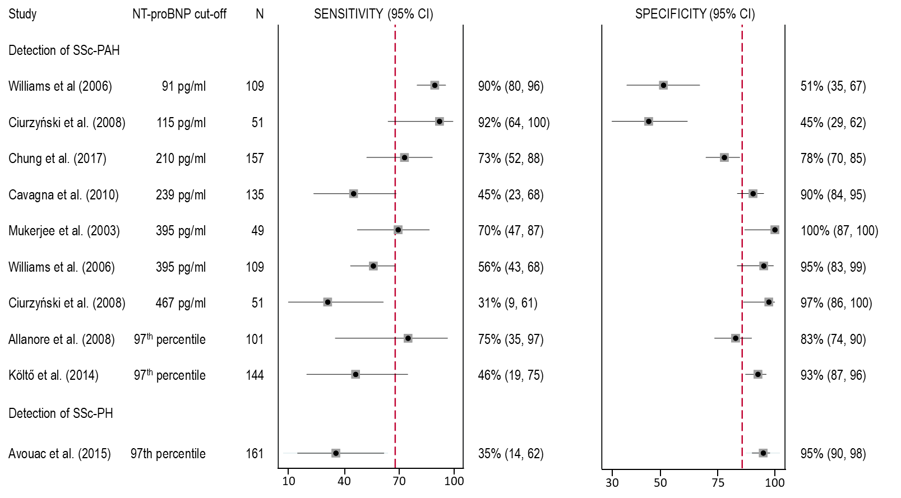
Figure 1 Forest plot of the accuracy of NT-proBNP in detecting patients with SSc-PAH
The red dashed line represents the pooled sensitivity and specificity values
CI = confidence interval; NT-proBNP = N-terminal pro-brain natriuretic peptide; PAH = pulmonary arterial hypertension; PH = pulmonary hypertension; SSc = systemic sclerosis

The accuracy of testing algorithms that include NT-proBNP testing
Five studies reported on the accuracy of using a NT-proBNP-based algorithm to detect SSc-PAH and/or SSc-PH. Two different algorithms were used. The two Australian studies used the ASIG algorithm, which uses both NT-proBNP serum levels and pulmonary function tests (PFTs) and is proposed in the ADAR for clinical use in testing Australian SSc patients. One of the Australian studies and the other three studies used the DETECT algorithm that was developed by the DETECT (Evidence-Based Detection of Pulmonary Arterial Hypertension in Systemic Sclerosis) study investigators. This algorithm combined eight variables (telangiectasia, anti-centromere antibody, NT-proBNP, serum urate, FVC/DLCO on PFT, right axis deviation on electrocardiogram, right atrium area, and tricuspid regurgitant jet velocity on TTE) and uses a two-step decision tree.
Three studies compared the accuracy of NT-proBNP-based algorithms with that of diagnosis according to the European Society of Cardiology/European Respiratory Society (ESC/ERS) guidelines. All three studies used RHC to confirm the presence of PH/PAH disease. The guidelines recommend diagnosis of SSc-PAH based on symptoms and TTE. However, the symptoms of PAH are usually very mild and non-specific in the early stages, making it difficult to identify patients who are developing PAH.
Meta-analysis of the results from the studies reporting on the accuracy of NT-proBNP-based algorithms (the intervention) and TTE-based guidelines (the comparator), both compared to RHC (the reference standard) was performed. As a minimum of four studies are required for meta-analysis, pooled sensitivity and specificity values could not be obtained for all groups. The median values and the range were reported for those groups with less than four studies. The pooled/median results are summarised in Table 7.
There was no true difference between the ASIG and DETECT algorithms in their ability to detect either SSc-PAH or SSc-PH when compared to RHC. The pooled/median sensitivity ranged from 95% to 98%, and the pooled/median specificity ranged from 45% to 55%.
The ASIG and DETECT algorithms were as sensitive as the TTE-based ESC/ERS guideline recommendations for detecting either SSc-PAH or SSc-PH. However, the ESC/ERS guidelines appear to be less specific than the ASIG and DETECT algorithms, with a median specificity of 32%. Overall, these results suggest that the NT-proBNP-based algorithms are at least as effective at diagnosing SSc patients with possible PAH as the ‘symptom plus TTE’-based approach recommended in the guidelines.
Table 7 Summary of the pooled/median accuracy of NT-proBNP based algorithms and TTE-based guidelines compared to RHC
Algorithm | Sensitivity (pooled or median) | Specificity (pooled or median)
ASIG for SSc-PAH (k=2) | 97% (range 94–100) | 55% (range 55–55)
DETECT for SSc-PAH (k=5) | 95% (95% CI 74, 99) | 54% (95% CI 39, 68)
ESC/ERS guidelines for detecting SSc-PAH (k=3) | 94.1% (range 91.4–96.3) | 32.3% (range 31.8–85.7)
ASIG for SSc-PH (k=2) | 93% (range 89–98) | 55% (range 55–55)
DETECT for SSc-PH (k=1) | 98% (95% CI 90, 100) | 45% (95% CI 27, 64)
ESC/ERS guidelines for detecting SSc-PH (k=3) | 92.6% (range 80.8–97.4) | 31.8% (range 25.8–87.1)
The ASIG and DETECT algorithms are NT-proBNP based, whereas the ESC/ERS guidelines are TTE-based.
Pooled values presented with 95% CIs. Median values presented with the range of values.
ASIG = Australian Scleroderma Interest Group testing algorithm; CI = confidence interval; DETECT = Evidence-Based Detection of Pulmonary Arterial Hypertension in Systemic Sclerosis testing algorithm; ESC/ERS = European Society of Cardiology / European Respiratory Society guidelines; NT-proBNP = N-terminal pro-brain natriuretic peptide; PAH = pulmonary arterial hypertension; PH = pulmonary hypertension; RHC = right heart catheterisation; SSc = systemic sclerosis
Thus, by using the NT-proBNP-based algorithms to triage patients for RHC, few patients with PAH are missed due to a false negative result. On the other hand, approximately half of the patients who are truly negative will get a false positive result. These patients will be required to undergo the more invasive RHC test to rule out PAH/PH disease.
The commentary reported positive predictive value (PPV) and negative predictive value (NPV) based on the long-term prevalence of PAH in SSc. ESC considered the results should be recalculated based on an annual prevalence of approximately 1%. Using the annual prevalence of 1%, the PPV of the ASIG algorithm in detecting PAH is 2%, indicating that almost all patients with a positive test result will be falsely positive. Conversely, the negative predictive value (NPV) is 99.9%, indicating that almost no SSc patients with a negative test result will be falsely negative. Nevertheless, this will still result in fewer patients having unnecessary RHC as testing according to the current ESC/ERS guidelines results in 68% of patients without PAH undergoing RHC. The PPV for the ESC/ERS guidelines in detecting PAH is 1%, and the NPV is 99.8% based on 1% annual prevalence.
The number of SSc patients per 1,000 tested who would receive positive and negative test results for both the current (TTE-based ESC/ERS guidelines) and the proposed (ASIG algorithm) clinical management pathways are summarised in Table 8. Thus, per 1,000 SSc patients tested using the ASIG algorithm, 224 fewer patients would undergo an unnecessary RHC and 1 patient would have avoided a missed diagnosis of PAH compared with the ESC/ERS guidelines.
Table 8 Summary of the number per 1,000 SSc patients who will be triaged to RHC, and the number misdiagnosed based on a PAH prevalence of 12%
Per 1,000 patients | ASIG algorithm | ESC/ERS guidelines
PAH prevalence of 12% (Commentary)
Total number of patients with PAH (SSc-PAH) | 120 | 120
Number SSc-PAH patients with a positive test result (TP) | 116 | 113
Number SSc-PAH patients with a negative test result (FN: missed diagnosis) | 4 | 7
Number SSc patients without PAH with a positive test result (FP) | 396 | 596
Number of patients with a positive test result who will undergo RHC (TP+FP) | 512 | 709
PAH incidence 1% per year (revised by ESC)
Total number of patients with PAH (SSc-PAH) | 10 | 10
Number SSc-PAH patients with a positive test result (TP) | 10 | 9
Number SSc-PAH patients with a negative test result (FN: missed diagnosis) | 0 | 1
Number SSc patients without PAH with a positive test result (FP) | 446 | 670
Number of patients with a positive test result who will undergo RHC (TP+FP) | 455 | 680
The ASIG algorithm is NT-proBNP based, whereas the ESC/ERS guidelines are TTE-based. The median sensitivity and specificity values used to calculate TP, FP and FN numbers for the ASIG algorithm and the ESC/ERS guidelines are taken from Table 7. Values are rounded and may not add up exactly.
ASIG = Australian Scleroderma Interest Group testing algorithm; ESC/ERS = European Society of Cardiology / European Respiratory Society guidelines; FN = false negative; FP = false positive; NT-proBNP = N-terminal pro-brain natriuretic peptide; PAH = pulmonary arterial hypertension; RHC = right heart catheterisation; SSc = systemic sclerosis; TP = true positive

Change in Management
Three studies reported on change in management outcomes. Whereas the Australian study by Thakkar et al (2013) used the proposed ASIG testing algorithm, the other two studies by Castillo et al. (2017) and Coghlan et al. (2014) used the DETECT algorithm. These results were compared to the protocol in the ESC/ERS guidelines.
Overall, the evidence suggests that the NT-proBNP-based ASIG testing algorithm would reduce the number of false positive SSc patients (who do not have PAH) undergoing an unnecessary RHC, when compared with the current TTE-based ERC/ERS guidelines. The number of SSc patients with signs of PAH who will undergo a RHC is not expected to differ greatly between the current and proposed testing methods. Likewise, the number of SSc patients with a missed diagnosis of PAH is expected to be low (<10%), which is similar to the number with a missed diagnosis using the current ERC/ERS guidelines.

Clinical Management Algorithms for Population 1
The ESC noted the proposed clinical management algorithm for population 1 with NT-proBNP testing in the PICO Confirmation for Application 1689 based on Australian Scleroderma Interest Group (Figure 2. below). ESC considered that this algorithm did not capture those patients who required a repeat screening in 6 months, due to borderline screening results or worsening symptoms. It is estimated that this would occur in approximately 10% of patients (Figure 3)
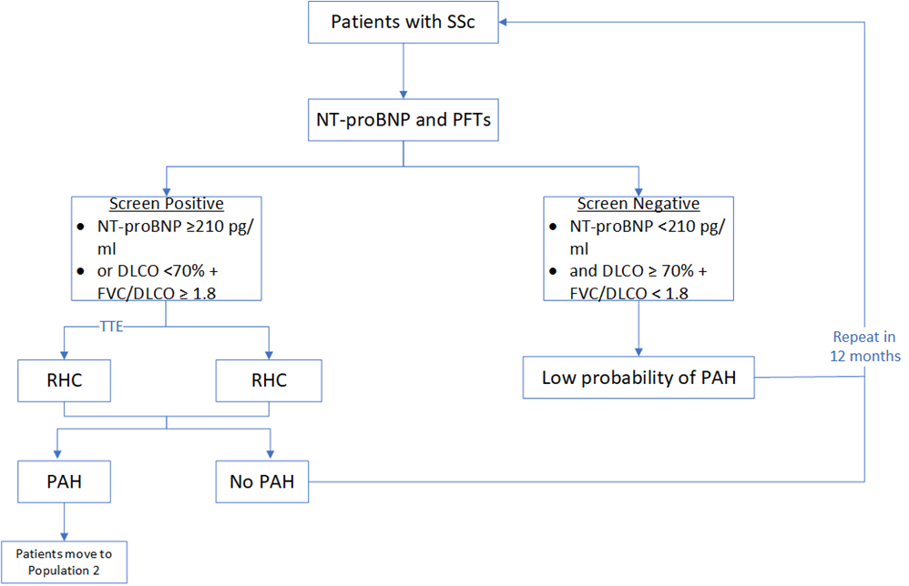
Figure 2 Proposed clinical management algorithm (population 1): Summary of the Australian Scleroderma Interest group (ASIG) algorithm, as proposed in the application
ASIG= Australian Scleroderma Interest Group; NT-proBNP= N-terminal pro-B-type natriuretic peptide; PFTs= pulmonary function tests; DLCO= diffusing capacity of lung for carbon monoxide; FVC= forced vital capacity; TTE= transthoracic echocardiography; RHC= right heart catheterisation; PAH= pulmonary arterial hypertension.
Note: The applicant suggested annual testing, but a maximum of 2 NT-proBNP tests per year could be requested if the results are borderline or there is worsening of symptoms.
Source: Figure compiled during the PICO preparation based on Figure 5, p28 of the application and (Saygin and Domsic, 2019).
Below is the updated clinical management algorithm based on ESC considerations.
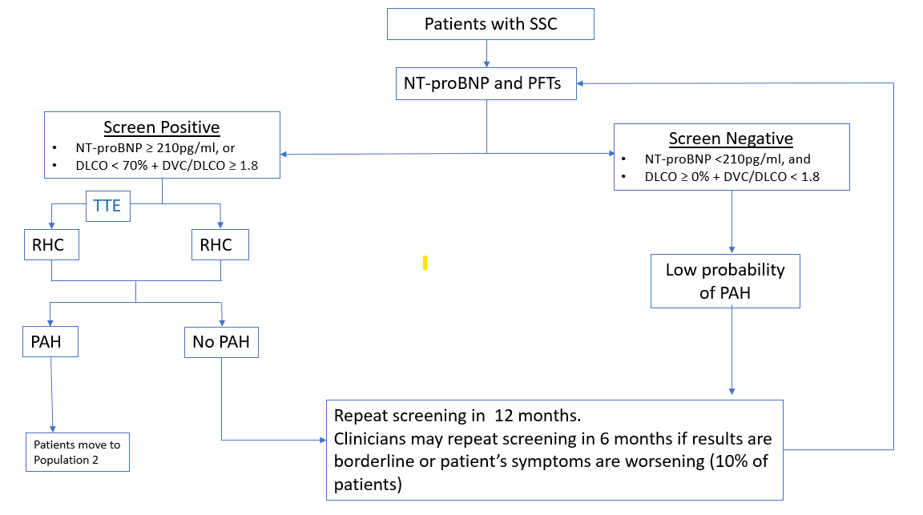
Figure 3 Updated clinical management algorithm based on ESC considerations
ASIG= Australian Scleroderma Interest Group; NT-proBNP= N-terminal pro-B-type natriuretic peptide; PFTs= pulmonary function tests; DLCO= diffusing capacity of lung for carbon monoxide; FVC= forced vital capacity; TTE= transthoracic echocardiography; RHC= right heart catheterisation; PAH= pulmonary arterial hypertension.
Clinical claim
The use of the ASIG algorithm with annual NT-proBNP testing to triage SSc patients suspected of having PAH for RHC, would be non-inferior compared with the current TTE-based ERC/ERS guidelines.
Although using the ASIG algorithm will result in fewer SSc patients with a false positive test result undergoing RHC, the number of true positive SSc patients who will undergo a RHC is not expected to differ greatly between the current and proposed testing methods. Likewise, the number of SSc patients with a missed diagnosis of PAH is expected to be close to zero, which is similar to the number with a missed diagnosis using the current ERC/ERS guidelines.
The ASIG testing algorithm, if used annually, will not result in any downstream change in patient management. However, it would reduce the number of false positive SSc patients undergoing an unnecessary invasive RHC, when compared with the current TTE-based ERC/ERS guidelines. Thus, the ASIG algorithm may have a slightly superior safety profile.
However, no evidence was identified to determine the consequences of an additional NT-proBNP test per year on subsequent TTE and/or RHC use.

Population 2 – The detection of worsening PAH in patients already diagnosed with PAH

The accuracy and effectiveness of the NT-proBNP test compared to RHC
Eight studies reported on the accuracy of NT-proBNP in predicting mortality/morbidity events using receiver operating characteristic (ROC) curve analysis. The optimum cut-off level for NT-proBNP, which provides sensitivity and specificity estimates with the lowest false negative and false positive rates, was determined in six of these studies, and the area under the curve (AUC) was reported in seven. The AUC (range 0.746 to 0.94) indicates mostly moderate test performance (0.7–0.9). The AUC was above 0.9, indicating high-test performance, in only two of the seven studies. Thus, elevated NT-proBNP levels is a moderate predictor of mortality/morbidity events in PAH patients.
Five studies reported on the sensitivity and specificity of high NT-proBNP levels predicting mortality (k=4) or right ventricular systolic dysfunction (RVSD) as an early indicator of mortality (k=1). Meta-analysis of the results from these studies are shown as a Forest Plot (Figure 4). There are insufficient studies to determine if there is a threshold effect caused by the varied NT-proBNP cut-off levels. However, high NT-proBNP levels appear to be highly sensitive as a predictor of death, but not very specific.
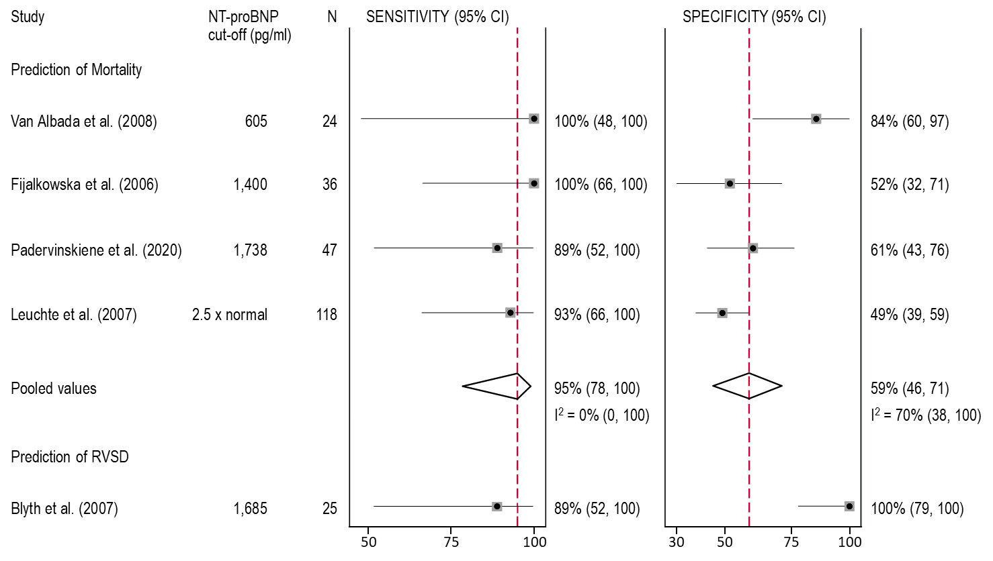
Figure 4 Forest plot of the accuracy of NT-proBNP in predicting mortality or RVSD as an early indicator of mortality
CI = confidence interval; NT-proBNP = N-terminal pro-brain natriuretic peptide; RVSD = right ventricular systolic dysfunction

The ability of the NT-proBNP test to predict mortality
Eighteen studies investigated the association between NT-proBNP levels and various mortality/morbidity outcomes using regression analysis models with thirteen reporting HRs with 95% CIs. These studies used either different NT-proBNP cut-offs, or continuous data (normal or log-transformed) and all eighteen studies found that higher levels of NT-proBNP were associated with an increased risk of death, transplantation, hospitalisation for cardiac causes, or worsening of PAH requiring additional treatment.
Meta-analysis of the HRs for predicting cardiac morbidity and/or mortality was conducted. Ten studies reported on the likelihood of having a morbidity/mortality event for every unit increase in NT-proBNP level and three studies reported on the proportional increase among patients with high NT-proBNP levels compared with those with low levels. Each of the studies used a different incremental increase or a different cut-off value to represent high NT-proBNP levels (Figure 5).
For the studies reporting on the HR per incremental increase in NT-proBNP levels, there was considerable heterogeneity (90%) between the studies reporting on mortality as an outcome. This is likely due to chance in the five out of six studies enrolling less than 60 patients. Due to the wide CIs seen in four of the six studies, the pooled HR did not reach statistical significance. For the composite morbidity/mortality outcomes, there was less heterogeneity between studies, and narrower CIs for most studies and the pooled HRs for the composite outcomes reached statistical significance. However, at any given time, patients were 1.6–1.7 times more likely to have a morbidity/mortality event for every unit increase in NT-proBNP level.
All three studies reporting on the likelihood of an event occurring in patients with high NT-proBNP levels found that significantly more patients had an event compared to patients with lower NT-proBNP levels, at any given time point (Figure 5).
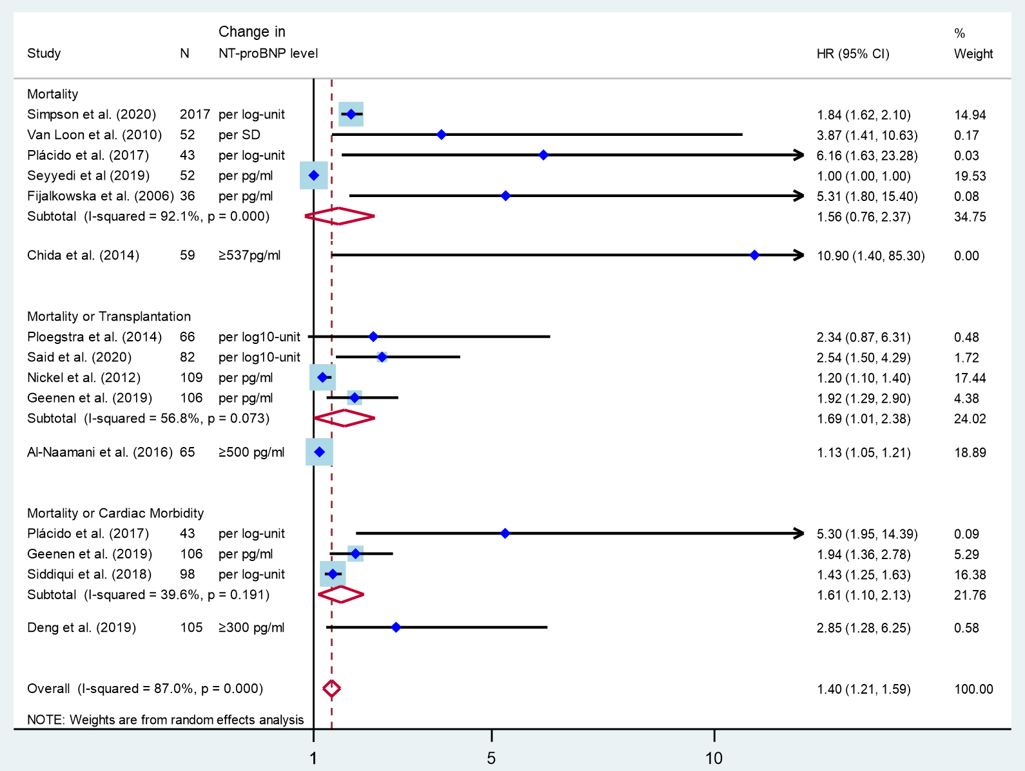
Figure 5 Forest plot of the likelihood that increasing NT-proBNP levels can predict mortality and/or cardiac morbidity in patients with PAH
CI = confidence interval; HR = hazard ratio; NT-proBNP = N-terminal pro-brain natriuretic peptide

TTE in the prediction of mortality and/or morbidity
In the current management algorithm, TTE based algorithms are used to monitor worsening of PAH. Five studies included TTE parameters in their regression models to assess their ability to predict mortality and/or morbidity events.
All five studies found various TTE parameters to be predictive of mortality and/or morbidity events in univariate analysis. In the multivariate models, RV basal diameter, RA fractional area (Plácido et al. 2017), and tricuspid annular plane systolic excursion (TAPSE; Ploegstra et al. 2014) remained significantly associated with survival. Whereas, RV basal diameter (Plácido et al. 2017) and worsening right ventricular global longitudinal strain (RVGLS; Siddiqui et al. 2018) were independently predictive of death or hospitalisation.
Thus, while TTE has clinical value in diagnosing PAH, it is less useful in determining the prognosis of patients with PAH. None of the TTE parameters were consistently associated with the likelihood of having a cardiac-related mortality/morbidity event.

Risk stratification calculators that include NT-proBNP in the prediction of mortality and/or morbidity
Ten studies investigated the usefulness of various risk stratification calculators that included NT-proBNP testing in predicting mortality/morbidity events. All studies found that the risk of morbidity and or mortality was higher in the high risk and intermediate risk groups compared with the low risk group. The differences were statistically significant in all studies that provided p-values (k=7).
The study by Benza et al. (2021), reported on the REVEAL Lite 2 risk stratification strategy, which is proposed by the ADAR to be implemented in Australia. Analysis using the Cox proportional hazard model found little difference in the ability of REVEAL Lite 2 strategy to predict mortality compared to the REVEAL 2,0 strategy. At any given time point, 2.3 times (REVEAL Lite 2) and 2.5 times (REVEAL 2,0) as many patients in the intermediate group are likely to die compared to those in the low risk groups. Similarly, when comparing the high risk and low risk groups, the high risk groups are 6.4 times (REVEAL Lite 2) and 7.1 times (REVEAL 2.0) as many patients are likely to die at any given time point. Thus, the REVEAL Lite 2 risk stratification strategy is likely to be useful in the clinical setting to predict a patient’s risk of death within the next 12 months.
Meta-analysis of the results from the five studies reporting HRs was conducted (Figure 6). There was no heterogeneity between the studies reporting on the same stratification differences. PAH patients stratified to the high-risk group, regardless of risk stratification calculator or morbidity/mortality outcome, were at least 6.7 times more likely to have a morbidity/mortality event at any time point, than those in the low-risk group. Patients in the intermediate group were at least twice as likely to have a morbidity/mortality event at any time point, than those in the low-risk group.
Two studies investigated the increased likelihood of having a morbidity/mortality event with increasing risk measured either per elevated biomarker or per one SD increase in risk score. The studies found that at any given time, patients were 1.3–1.7 times more likely to have a morbidity/mortality event for every unit of increased risk.
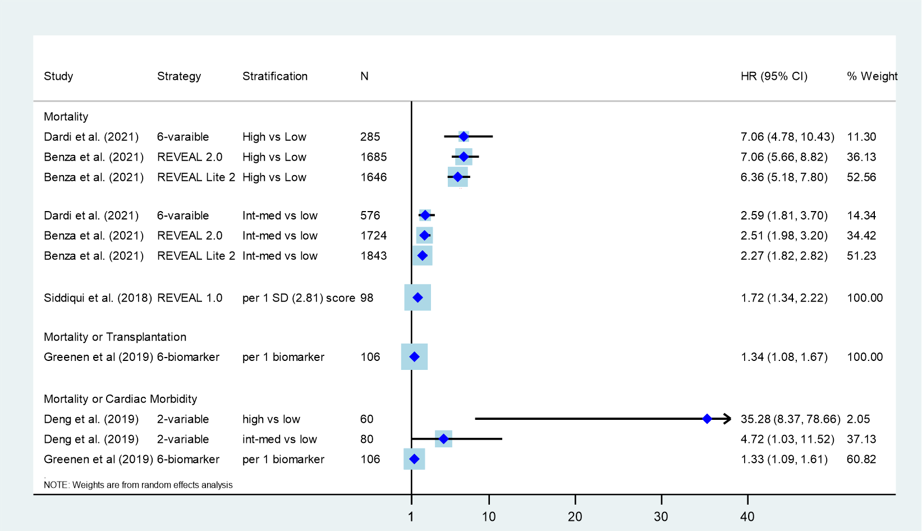
Figure 6 Forest plot of the likelihood that risk stratification strategies can predict mortality and/or cardiac morbidity in patients with PAH
CI = confidence interval; HR = hazard ratio; Int-med = intermediate; NT-proBNP = N-terminal pro-brain natriuretic peptide; PAH = pulmonary arterial hypertension; SD = standard deviation

Comparison of risk stratification calculators that do and do not include NT-proBNP in the prediction of mortality and/or morbidity
One study by Benza et al. (2021), examined the value of each of the six variables in the REVEAL Lite 2 calculator (that has been proposed for use in Australia). The authors found that the absence of NT-proBNP test results had the largest impact on the performance of the 6-variable REVEAL Lite 2 risk stratification calculator with the resultant risk calculation being less discriminatory (the C-index fell from 0.73 to 0.70).
Another three studies were identified that compared the ability of risk stratification calculators that do and do not include NT-proBNP to predict morbidity/mortality of PAH patients.
Benza et al. (2019) included the French Pulmonary Hypertension Registry (FPHR) strategy, which assessed a number of low-risk variables: WHO FC, 6MWD, right atrial pressure (RAP), and cardiac index according to thresholds prescribed by the 2015 ESC/ERS guidelines. Benza et al. (2019) found that the REVEAL 2.0 risk calculator demonstrated greater risk discrimination than the FPHR risk calculator in patients enrolled in the REVEAL registry.
Another study by Sitbon et al (2015) identified during evaluation, compared the REVEAL risk score calculator (including BNP/NT-proBNP, TTE and RHC) and FPHN ItinérAIR-HTAP predictive equation. PASC considered FPHN ItinérAIR-HTAP predictive equation to be the most appropriate comparator for Population 2. The FPHN ItinérAIR-HTAP is a three-term equation (including female sex, greater 6MWD and higher cardiac output) predicting survival at 3 years from diagnosis. The authors found that the REVEAL risk score calculator and FPHN ItinérAIR-HTAP predictive equation showed good discrimination and calibration for prediction of survival in the FPHN and REVEAL cohorts, respectively. The authors suggest that this indicates prognostic generalisability in geographically different PAH populations that may be useful in clinical practice.
Dardi et al (2021) found that the C-index indicated that the risk discrimination of the Bologna simplified risk table was similar to the COMPERA strategy and only slightly inferior to the FPHR strategy (p=0.014).
Overall, the evidence suggests that risk stratification calculators that included NT-proBNP were at least as effective as those that did not include NT-proBNP in identifying patients likely to die in the next year.

Change in Management
No evidence of change in management was identified for Population 2.
The commentary considered that limited evidence suggests that risk stratification calculators that included NT-proBNP were at least as effective as those that did not. Thus, the use of the REVEAL Lite 2 risk calculator, which incorporates the NT-proBNP result, to triage patients for RHC will not result in any downstream change in management. The commentary considered that it will however, reduce the number of patients requiring TTE.

Clinical claim
Overall, the evidence suggests that REVEAL Lite 2 risk stratification calculator (which includes NT-proBNP results) was non-inferior to other risk stratification calculators, whether or not they included NT-proBNP results in identifying patients likely to die in the next year.
The REVEAL Lite 2 risk stratification calculator will not result in any downstream change in patient management. It will however, reduce the number of patients requiring TTE compared to the current risk calculation strategy. The proportion of patients with stable disease who will not require TTE was not reported. As there are no safety concerns either for the NT-proBNP test or for TTE, the REVEAL Lite 2 risk stratification calculator has a non-inferior safety profile compared to other risk stratification calculators.

13. Economic evaluation
The ADAR adopted a cost-minimisation approach (CMA). The analysis was presented for each population separately, and then weighted by the expected distribution of use across the eligible populations.
The MBS fee requested was based on that for NT-proBNP testing (Fee: $58.50; MBS item code 66830) and was the same across Population 1 and 2. This is lower than the service fee most likely to be replaced in each algorithm i.e., TTE (Fee: $236.25; MBS item code 55126/55129). ESC noted that MBS item 55133 used in the ADAR is not for the investigation of PH/PAH. This was revised for the ESC report.
In Population 1, the submission has assumed almost complete substitution of TTE by NT-proBNP (some TTE use following NT-proBNP was assumed in a small proportion of patients). ESC requested the test performance parameters be calculated based on an annual incidence of 1% (Morrisroe 2017). This would result in a screen positive rate of 46% for the ASIG algorithm. NT-proBNP remained cost saving if all screen positive patients receive a subsequent TTE. The net cost difference per patient (with NT-proBNP compared to TTE) presented for Population 1 was uncertain due to the inconsistencies in the submission for:
- The assumption for the proportion of patients and the test frequencies of TTE or NT-proBNP services per year (i.e. average of 1.1 tests per patient per year in each arm), and
- The assumption that approximately 10% of SSc patients diagnosed with PAH (who test positive for NT-proBNP test) would undertake an additional TTE test was not consistent with the screen positive rate for the ASIG algorithm. The extent of TTE use following NT-proBNP testing in the proposed intervention arm is uncertain.
The CMA has not considered the implications for improved accuracy with NT-proBNP. This may be conservative, as a net reduction in RHC costs and costs of repeat testing in those with false negative results may be expected assuming annual NT-proBNP testing. While the analysis does account for a second NT-proBNP test per year in a small proportion of patients (as the applicant had advised PASC that a second test would be performed for borderline results or for patients with worsening symptoms), the eligibility criteria was not defined in the MBS item descriptor. The implications of either (i) use of NT-proBNP in a broader range of patients than intended or (ii) subsequent TTE and/or RHC use were not considered in the analysis. There is a risk that the cost savings estimated may not be realised should use of a second test per year be higher than expected though consequences may differ if there is more use of NT-proBNP compared to TTE that may result in more RHCs being performed (due to false positive results associated with the NT-proBNP test). MSAC may wish to consider if there is sufficient data to support two tests per year for some patients and defining eligibility criteria for patients to have two NT-proBNP tests.
The cost-minimisation analysis (revised post ESC) and the submission’s base case for Population 1 is presented in the table below.
Table 9 Total cost per patient per year associated with testing algorithms without and with NT-proBNP testing in Population 1 (revised post ESC meeting)
Parameter | Current clinical management algorithm (without NT-proBNP) | Proposed clinical management algorithm (with NT-proBNP) | Source/Notes
Proportion of patients undergoing two tests per year | 10% | 10% | Local clinician advice. Consistent with ESC revisions to clinical algorithm
Proportion of patients undergoing one test per year | 90% | 90%
NT-proBNP Test Fee | $58.50 | $58.50 | MBS 66830
TTE Test Fee (ADAR) | $212.65 | $212.65 | MBS item 55133 ª
TTE Test Fee (revised) | $236.25 | $236.25 | MBS 55126 /55129
Proportion of patients screened positive for SSc-PAH | 68% | 46% | Recalculated based on 1% annual incidence. Refer to Table 8
Proportion of patients tested positive for SSc-PAH  (annual incidence) | 1% | 1% | Morrisroe (2017) annual incidence
Proportion of patients tested positive for SSc-PAH (ADAR) | 10% | 10% | Australian Rheumatology Association. Prevalence and proportion of patients testing positive used interchangeably.
TTE test/year for patient tested positive in screening test | 0.0 | 1.0 | Patients tested positive with NT-proBNP are recommended to undergo a TTE test. ADAR assumed 10% of patients would also receive TTE after positive NT-proBNP (based on 10% PAH prevalence). The ASIG algorithm (Thakkar 2012) states screen positive patients should be referred for TTE and considered for additional investigations, such as HRCT or 6MWT, and RHC, if appropriate.
No. NT-proBNP tests/patient/year | − | 1.1 | -
No. TTE tests/patient/year | 1.1 | 0.0 | -
Total NT-proBNP test cost/patient/year | $0.00 | $64.35 | -
Total TTE test cost/patient/year | $236.25  (ADAR = $233.92) | $107.54  (ADAR = $21.27) | Revised based on screen positive rate.
Total cost per patient | $259.88  (ADAR = $233.92) | $171.89  (ADAR = $85.62) | -
Net cost difference per patient | -$87.98 (ADAR = -$148.30) |  | -
Source: Revised post ESC. Adapted from Table 28 of the ‘ADAR 1689 NTproBNP MSAC ADAR 1689 – FINAL’ using the Excel workbook ‘ADAR 1689 NT-proBNP MSAC SSc_PAH_Section 3B’
Abbreviations: HRCT = high resolution computed tomography; MBS= Medicare Benefits Schedule; NT-proBNP= N-terminal proB-type natriuretic peptide; PAH = pulmonary arterial hypertension; RHC = right heart catheterisation; SSc = systemic sclerosis; TTE= Transthoracic Echocardiogram; 6MWT = six-minute walk test.
ª ADAR used the fee for MBS item 55133 ($212.65) for patients with isolated pericardial effusion or pericarditis for patients using certain PBS medicines with cardiotoxic side effects. MBS items 55126 and 55129 ($236.25) can be used for investigation of PAH.
In Population 2, the submission has assumed complete substitution of TTE by NT-proBNP
(i.e. 2.15 tests/patient/year in each arm. The commentary considered that this was not reasonable as patients who are symptomatic or who are found to have worsening symptoms following NT-proBNP would likely still use TTE. No data are available to reliably estimate the proportion of patients in whom NT-proBNP would substitute TTE.
Table 10 Total cost per patient per year associated with testing algorithms without and with NT-proBNP testing in Population 2 (revised post ESC meeting)
Parameter | Current clinical management algorithm (without NT-proBNP) | Proposed clinical management algorithm (with NT-proBNP) | Source/Notes
Proportion of patients undergoing 4 risk assessments/year | 5% | 5% | Local clinician advice
Proportion of patients undergoing 3 risk assessments/year | 5% | 5%
Proportion of patients undergoing 2 risk assessments/year | 90% | 90%
NT-proBNP Test Fee | $58.50 | $58.50 | MBS 66830
TTE Test Fee (ADAR) | $212.65 | $212.65 | MBS item 55133 ª
TTE Test Fee (revised) | $236.25 | $236.25 | MBS 55126, 55129 ª
No. NT-proBNP tests/patient/year ^{b} | − | 2.15
No. TTE tests/patient/year ^{b} | 2.15 | −
Total NT-proBNP test cost/patient/year | $0.00 | $125.78 ^{c}
Total TTE Test cost/patient/year | $507.94  (ADAR = $457.20) | $0.00
Total cost per patient | $507.94  (ADAR = $457.20) | $125.78
Net cost difference per patient (with NTproBNP - without NTproBNP) | -$382.16  (ADAR = -$331.42)
Sensitivity analysis: All patients have annual TTE | -$145.91
Source: Revised post ESC. Adapted from Table 29 of the ‘ADAR 1689 NTproBNP MSAC ADAR 1689 – FINAL’ using the Excel workbook ‘ADAR 1689 NT-proBNP MSAC SSc_PAH_Section 3B’
Abbreviations: MBS= Medicare Benefits Schedule; NT-proBNP= N-terminal proB-type natriuretic peptide; PAH = pulmonary arterial hypertension;
SSc = systemic sclerosis; TTE= Transthoracic Echocardiogram.
ª ADAR used the fee for MBS item 55133 ($212.65) for patients with isolated pericardial effusion or pericarditis for patients using certain PBS medicines with cardiotoxic side effects. MBS items 55126 and 55129 ($236.25) can be used for investigation of PAH. Item 55126 cannot be used more than once in a 24 month period. Other TTE tests are claimed using MBS item 55129
^{b} This is calculated by weighting of proportion of patients undergoing two/three/four assessments per year (using TTE) = $236.25 x [(5% x 4) + (5% x 3) + (90% x 2)]
^{c} This is calculated by weighting of proportion of patients undergoing two/three/four assessments per year (using NT-proBNP) = $58.50 x [(5% x 4) + (5% x 3) + (90% x 2)]
Under the submission's assumption of 2.15 TTE per patient per year, substitution would need to occur in at least 28% of patients for the conclusion of cost savings to remain (average 0.59 TTE per patient per year substituted). Using the revised cost of TTE, substitution would need to occur in at least 25% of patients for the conclusion of cost savings to remain (average 0.53 TTE per patient per year substituted).
Risk assessment using NT-proBNP remained cost saving if all patients had one TTE per year in addition to NT-proBNP.
In the revised financial analysis, where a reduction in use of 1 TTE per patient per year was assumed, substitution would need to occur in 50% of patients for the conclusion of cost savings to remain.
Table 11 Total cost per patient per year associated with testing algorithms without and with NT-proBNP testing: Population 1 and 2 (revised post ESC using fees for MBS item numbers 55126,55129)
Parameter | Current clinical management algorithm (without NT-proBNP) | Proposed clinical management algorithm (with NT-proBNP)
Total cost per patient-Population 1 (ADAR) | $259.88 | $87.98
Total cost per patient-Population 1 (Revised) | $259.88 | $171.89 ª
Total cost per patient-Population 2 (ADAR) | $457.20 | $125.78
Total cost per patient-Population 2 (Revised) | $507.94 | $125.78
Percentage of patients in Population 1 | 70%
Percentage of patients in Population 2 | 30%
Weighted average cost per patient for Population 1 and 2 | $335.43  (ADAR $301.92) | $157.85  (ADAR $97.85)
Net cost difference per patient (with NTproBNP - without NTproBNP) | -$177.58 (ADAR = -$204.07)
Revised | -$238.36
Source: Adapted from Table 30 of the ‘ADAR 1689 NTproBNP MSAC ADAR 1689 – FINAL’ using the Excel workbook ‘ADAR 1689 NT-proBNP MSAC SSc_PAH_Section 3B’
Abbreviations: NT-proBNP= N-terminal proB-type natriuretic peptide.
ª This is the total cost per patient in the current intervention (1 TTE test = $236.25 and the total cost per patient in the proposed intervention (1 NT-proBNP test and 0.01 TTE test) ($60.86 = $58.50 + $2.36).
Note: Estimates in italics text were revised after ESC to align use of testing with the revised to reflect corrected TTE costs and 1-year incidence for Population 1.
While the weights used to calculate an overall cost difference were reasonable, the commentary and ESC considered the weighted net cost difference derived is highly uncertain, as the estimated cost savings in Population 1 are likely to be underestimated (as RHC and repeat testing costs have not been included). The commentary considered that the cost savings in Population 2 are likely to be overestimated.

14. Financial/budgetary impacts
An epidemiological approach was used to estimate the financial implications of proposed NT-proBNP testing in both Population 1 and Population 2.
The submission estimated a cost saving to the MBS of $794,208 in Year 1 increasing to $896,623 in Year 6 based on full MBS fee rather than the 85% rebate. The cost savings were revised to $906,859 in Year 1, increasing to $1,069,842 in Year 6, when using the corrected MBS costs for TTE, the 85% rebate, and the revised population with PAH.
The sensitivity analyses presented in the submission showed that all scenarios resulted in net financial savings. However, the estimated cost savings in Population 1 likely to be underestimated and in Population 2 the cost saving estimates are highly uncertain as the submission has assumed complete substitution of TTE with NT-proBNP.
The submission’s estimated cost-savings in Population 1 are uncertain due to the underestimated uptake rates, overestimated testing frequencies, and the uncertainty related to the additional use of TTE in the patients who have tested positive for NT-proBNP. As for the economic analysis, the submission has not considered a change in use or cost of RHC or repeat testing in patients with false negative test results. The commentary considered that the overall estimated cost-savings appear to be underestimated.
In Population 2, the high estimates for the number of PAH patients (based on 10% PBS script data that were used in submission’s sensitivity analysis) appear more reasonable as Year 1 estimates are lower than the number of patients treated with PBS subsidised PAH medicines in 2016). This population may be associated with an increase in costs to the MBS, as patients who are symptomatic or who are stable but have test results suggestive of worsening PAH would still undergo TTE. No data are available to inform the proportion of patients in whom a reduction in TTE use is expected. Threshold analyses (Section 3) indicated that the conclusion of cost savings would not change if this proportion exceeded 25% (using the corrected cost of TTE). That however was under the assumption of a reduction in use of 2.15 TTE tests per patient. The financial analysis assumes a reduction of 1 TTE per patient, and so the proportion substitution required to maintain the conclusion of cost savings would need to be at least 50% (based on the revised analysis). The commentary noted that public consultation feedback patients may not receive the recommended number of TTEs in rural and remote areas due to accessibility and acceptability issues for TTE. The commentary queried whether cost savings would be realised in this population.
The financial implications to the MBS resulting from the proposed listing of NT-proBNP are summarised in Table 12.
Table 12 Net financial implications of NT-proBNP to the TTE (revised post ESC meeting)
Parameter | Year 1 | Year 2 | Year 3 | Year 4 | Year 5 | Year 6
Estimated use and cost of the proposed health technology
Number of people eligible for NT-proBNP test – population 1 | 5,345 | 5,429 | 5,512 | 5,594 | 5,674 | 5,753
Number of people who receive NT-proBNP test – population 1 | 4,811 | 4,886 | 4,961 | 5,035 | 5,107 | 5,178
NT-proBNP tests – population 1 (1.1/pt/yr) | 5,292 | 5,375 | 5,457 | 5,538 | 5,618 | 5,696
Cost to the MBS – population 1  ($58.50, 100% fee) | $309,579 | $314,446 | $319,253 | $323,982 | $328,637 | $333,193
Cost to the MBS – population 1 ª  ($49.75, 85% fee) | 263,275 | $267.413 | $271.501 | $275.523 | $279,481 | $283,357
Number of people eligible for NT-proBNP test – population 2 | 2,341 | 2,883 | 2,927 | 2,970 | 3,013 | 3,055
Eligible people – population 2 (Revised ^{b} ) | 2,341 | 2,846 | 3,396 | 3,447 | 3,498 | 3,548
People tested– population 2 (revised) | 2,107 | 2,561 | 3,056 | 3,102 | 3,148 | 3,193
NT-proBNP tests – population 2 (2/pt/yr) | 4,214 | 5,123 | 6,113 | 6,205 | 6,296 | 6,386
Cost to the MBS – population 2  ($58.50, 100% fee) | $246,634 | $299,837 | $357,782 | $363,155 | $368,528 | $373,796
Cost to the MBS – population 2  ($49.75, 85% fee) | $209,637 | $254,859 | $304,112 | $308,679 | $313,246 | $317,723
Total NTproBNP cost to MBS (85% fee) | $472,911 | $522,273 | $575,613 | $584,202 | $592,727 | $601,080
Change in use and cost of other health technologies
Change in use of TTE (Revised ^{c}) | -6,918 | -7,448 | -8,018 | -8,137 | -8,255 | -8,371
Net change in costs to the MBS  ($200.85, 85% fee) ^{d} | -$1,379,770 | -$1,486,095 | -$1,600,369 | -$1,624,200 | -$1,647,803 | -$1,670,922
Net financial impact to the MBS | -$906,859 | -$963,823 | -$1,024,756 | -$1,039,998 | -$1,055,075 | -$1,069,842
Source: Adapted from Table 41 of the ‘ADAR 1689 NTproBNP MSAC ADAR 1689 – FINAL’ using the Excel workbook ‘ADAR 1689 NT-proBNP MSAC SSc_PAH_Section 4’
MBS = Medicare Benefits Schedule; NT-proBNP N-terminal pro-brain natriuretic peptide; PAH = pulmonary arterial hypertension;
SSc = systemic sclerosis; TTE = Transthoracic Echocardiogram
ª The cost to the MBS is revised by multiplying the ‘Number of services of NT-proBNP in Population 1’, by the 85% benefit for MBS item 66830 (=$49.75).
^{b} The “Total patients with PAH” is revised by adding the “Total patients with PAH” in Year (n) and “Incident number of PAH patients” in Year (n+1) (see last row of Table 35)
^{c} This figure is the total number of TTE tests affected from the proposed intervention, and equals to the sum of net TTE changes in Population 1 (Row (C – E) and Row J in Table 40. It includes change in the number of TTE tests in Population 1 and patient number changes in Population 2 (as revised in the commentary)
^{d} Net change in costs to the MBS is revised by multiplying the ‘Change in use of TTE’ in Row J, by the 85% benefit for MBS items 55126 / 55129 (=$200.85).
Note: Revised figures in italics are calculated during evaluation.

15. Other relevant information
ESC considered NT-proBNP would be a more accessible test than TTE, particularly for people who live in rural and remote areas. The value of knowing could be a relevant consideration as NT-proBNP may result in a subsequent diagnosis of PAH for population 1 and provide prognostic information for Population 2.

16. Key issues from ESC to MSAC
Main issues for MSAC consideration
Clinical issues:
- The clinical management algorithms would have been benefited from further detail:
- For population 1 (patients with systemic sclerosis): The algorithm and item descriptor need to detail the characteristics of those patients with “indeterminate’’ results or whose symptoms are worsening, who may need a second NT-proBNP test and pulmonary function test within the next 6 months. It could be assumed that this would apply to 10% of patients.
- For population 2 (patients diagnosed with pulmonary arterial hypertension): The degree of NT-proBNP level change to trigger change in therapy or need for a right heart catheterisation (RHC) is unclear. It is unclear whether using a risk assessment tool that includes NT-proBNP levels will change patients’ risk assessment.
- The frequency of testing proposed needs further consideration based on the response from the applicant on the clinical algorithm. However, the proposed frequency in the item descriptors is likely reasonable. It may be reasonable to limit requestors to specialists who manage patients with systemic sclerosis (SSc) and pulmonary arterial hypertension (PAH) to reduce the risk of leakage, however risks reducing accessibility.
- Predictive value of testing for Population 1 is based on a high prevalence of PAH (12%) among patients with SSc that reflects long term incidence rather than 1 year incidence. ESC considered that this should be recalculated based on an annual incidence of 1% to reflect annual screening. ESC considered a lower prevalence (1% annual incidence) would mean false positives will be higher for both arms. Screening using the NT-proBNP-based algorithm such as the Australian Scleroderma Interest Group (ASIG) algorithm has more specificity than the comparator TTE and pulmonary function test (PFT), leading to reduced numbers of referrals for RHC compared to transthoracic echocardiogram (TTE) and PFT for false positives.
- The evidence to support the non-inferiority of NT-proBNP-based risk assessment was not strong, however, the evidence suggested that it was unlikely to be inferior to risk assessment without NT-proBNP. The evidence to support change in clinical management was not strong for Population 2. Patients may still undergo TTE for a variety of reasons including annual screening, rising NT-proBNP levels (irrespective of overall risk assessment) or if their clinical status deteriorates.
- The evidence base did not strongly support a claim of non-inferiority, however the evidence suggested that NT-proBNP was unlikely to be inferior and unlikely to cause harm. MSAC may wish to consider whether the clinical evidence is sufficient in the context of likely cost savings and greater accessibility of NT-proBNP testing.
Economic issues:
- The cost minimisation approach was appropriate and assumed the intervention was clinically equivalent. The assumptions underlying the economic evaluation for Population 1 are conservative, as the cost savings for RHC avoided were not included. In addition, applying the correct TTE fee to the model would further increase net cost savings. NT-proBNP was cost saving in most clinically plausible sensitivity analyses because it is likely that NT-proBNP will replace at least some TTEs.
Financial issues:
- For both populations, there is a risk that the cost savings estimated may be smaller or not be realised if the rate of substitution of TTE is substantially lower than expected and/or the number of tests per year is higher than expected. However, ESC considered that it was highly likely that substantial substitution of TTE would occur. Sensitivity analysis suggests the economic and financial results are robust to plausible variations in key assumptions with the worst case tested resulting in a small net cost for Government.
- There is potential for leakage into other populations as NT-proBNP can be used in other clinical situations including post-capillary pulmonary hypertension due to left heart disease.
Other relevant considerations:
- The value of knowing could be a relevant consideration as NT-proBNP may result in a subsequent diagnosis of PAH for population 1 and provide prognostic information for Population 2.
- NT-proBNP would be a more accessible test than TTE, particularly for people who live in rural and remote areas.

ESC discussion
ESC noted that this is application requesting Medicare Benefits Schedule (MBS) listing of
N-terminal pro B-type natriuretic peptide (NT-proBNP) biomarker assay for (1) detection of pulmonary arterial hypertension (PAH) in patients with systemic sclerosis (SSc) or (2) risk assessment of patients diagnosed with PAH. The application was received from Janssen-Cilag Australia Pty Ltd.
ESC noted that NT-proBNP tests are approved by the Therapeutic Goods Administration (TGA). There are five companies offering seven assays. The Royal College of Pathologists of Australasia (RCPA) Quality Assurance Programs include NT-proBNP testing.
ESC noted that, for Population 1, the test will be used as a screening test for PAH in patients with SSc. For Population 2, the test aims to determine risk of death and/or adverse clinical outcome as part of a multiparameter assessment for patients with PAH. ESC considered the current treatment paradigm for PAH was to achieve a low-risk status.
ESC noted that the item descriptor for each population had a different limit on the number of tests that could be repeated and that this was likely appropriate. ESC considered the MBS item descriptor should clarify that the item for Population 2 is solely for patients with pulmonary arterial hypertension to prevent use for post-capillary pulmonary hypertension. ESC considered that it may be appropriate to limit requesting practitioners to specialists who manage SSC and PAH.
ESC noted that the proposed clinical management algorithm for Population 1 should include detail on patients with borderline screening results or whose symptoms are worsening (10% of patients), who would require a repeat screen within 6 months (refer to Figure 3 for the revised clinical management algorithm for Population 1 following the ESC meeting).
ESC noted the consultation feedback was supportive. ESC noted that equity of access was raised as an issue. The proposed intervention would address this issue by reducing the need for people to travel and the associated costs (and discomfort) of an echocardiogram. ESC noted that TTE would not detect PAH in a meaningful proportion of Population 1 due to inadequate tricuspid regurgitation. ESC noted that increased access to NT-proBNP could result in patient benefits through earlier diagnosis and treatment. ESC considered MBS funding could enable more PAH screening through, addressing the backlog of screening that did not occur during COVID-19 lockdowns and future-proof provision in potential future pandemic lockdowns.
ESC noted that the safety of the NT-proBNP test was not discussed in the applicant-developed assessment report (ADAR). However, considering that the test requires a blood sample, it is a relatively safe procedure. For Population 1, ESC noted that screening using NT-proBNP may result in a slightly superior safety profile compared with the current testing protocol, as it reduces the number of SSc patients requiring the invasive procedure. These patients will avoid possible adverse safety outcomes from the RHC procedure.
For Population 1, ESC noted that the diagnostic performance of NT-proBNP and pulmonary function test (PFT) as part of the Australian Scleroderma Interest Group (ASIG) algorithm has more specificity than TTE and PFT (ESC/ERC guidelines) and may reduce the number of false positive results. This may reduce the need for an invasive right heart catheterisation (RHC) procedure to diagnose PAH. ESC noted the predictive value testing for Population 1 is based on a high prevalence of PAH (12%) among patients with SSc that reflects long-term incidence rather than 1 year incidence. ESC considered the predictive value of testing should be recalculated based on an annual incidence of 1% to reflect annual screening. ESC noted this would affect both the intervention and comparator. Based on the recalculated figures, the number of SSc patients with a missed diagnosis of PAH is expected to be close to zero, which is similar to the current ERC/ERS guidelines. ESC considered the evidence for change in clinical management for Population 1 was not strong, other than fewer referrals for RHC.
As both procedures are relatively safe, a risk stratification assessment that included NT-proBNP such as the REVEAL Lite 2 risk calculator has non-inferior safety compared with the current TTE-based risk stratification guidelines.
For Population 2, ESC considered that there was limited evidence to suggest that risk stratification assessment that included NT-proBNP were at least as effective as those that did not. ESC noted that the evidence suggests that REVEAL Lite 2 risk stratification calculator (which includes NT-proBNP results) was non-inferior to other risk stratification calculators in identifying patients likely to die in the next year. ESC noted that the use of the NT-proBNP test, as part of the REVEAL Lite 2 risk calculator could reduce the number of patients requiring TTE compared to the current risk calculation assessment strategy, however, ESC considered patients may still undergo TTE annually following recommendation from a multidisciplinary team. ESC noted that the proportion of patients with stable disease who will not require TTE was not reported. ESC noted that there was no convincing evidence regarding change in management for Population 2. ESC considered rising NT-proBNP, irrespective of the subsequent risk assessment may trigger referral for TTE. ESC considered that it was unclear how the use of a risk assessment tool that includes NT-proBNP influences decisions regarding which patients require RHC and how patients’ risk assessment classification might change.
Overall, ESC considered that the evidence base for both populations did not strongly support a claim of non-inferiority, however the evidence presented suggested that NT-proBNP was unlikely to be inferior and unlikely to cause harm. MSAC may wish to consider whether the clinical evidence is sufficient in the context of likely cost savings and greater accessibility of NT-proBNP testing.
ESC noted that that a cost-minimisation analysis was used for the economic analysis, based on a clinical claim of non-inferiority and clinical equivalence. ESC noted that the analysis assessed and compared the average cost per patient per year under current care patterns and that proposed by the intervention. From this, it is estimated that the intervention will be cost saving overall for both populations. ESC noted the ADAR used the incorrect MBS fee for TTE and considered a higher fee of $236.25 (for MBS items 55126 and 55129) should be used instead. ESC noted this would favour NT-proBNP.
For Population 1, ESC noted that the intervention resulted in an estimated savings of $148 per patient per year in the ADAR. This reduced to savings of $88 per patient per year when an annual incidence of 1% was used and the cost of TTE was attributed to all test positive patients (46% using the ASIG algorithm [with NT-proBNP] and 68% using the ESC/ERC algorithm). ESC noted the sensitivity analyses for Population 1 suggested screening using the ASIG algorithm would remain cost saving across a range of plausible assumptions. ESC considered the assumptions were generally conservative as the costs of RHC were not included (and are likely to further increase cost savings) and avoided repeat testing in (a small number) of false negatives.
ESC noted that for Population 2, the estimated cost savings were $331 per patient per year in the ADAR ($323.16 using corrected TTE costs). ESC considered this but that these results are more uncertain because of the uncertainty around the extent of substitution of TTE in this population. ESC noted that the sensitivity analysis suggests that the results are robust over plausible scenarios (due to the higher cost of TTE), including if all patients had an annual TTE.
ESC noted that the ADAR based its cost estimates to the MBS on 100% rebate of the test fees for NT-proBNP and TTE, and noted the revised calculations based on 85% rebate in the Commentary.
ESC noted the estimated net savings to the MBS of approximately $4,650,000 over 6 years. This increased to net savings of approximately $6 million (over 6 years) using the commentary’s revised eligible population, higher MBS fee for TTE (corrected), and 85% MBS rebate
ESC noted that financial impact estimates depend on the extent of substitution of TTE. Additional NT-proBNP testing in those from Population 1 who undergo more than yearly NT-proBNP testing (10%) was not incorporated as part of the commentary’s financial impact evaluation. The actual utilisation of the proposed service may therefore be higher than estimated, noting the uncertainty of this assumption. However, ESC noted that there is confidence that NT-proBNP will substitute for TTE in Population 1 and cost savings will occur in most plausible scenarios due to the difference in cost between NT-proBNP and TTE.
ESC noted that there is a risk that the cost-savings in Population 2 may not be realised, as NT-proBNP has the potential to become an add-on test rather than a replacement prognostic/monitoring test, as some clinicians might still request both TTE and NT-proBNP testing. However, ESC also noted that for Population 2 NT-proBNP it would remain cost saving or result in a negligible cost across plausible sensitivity analyses. The model appropriately tested the relevant assumptions, so ESC did not consider that a reanalysis would be required.
ESC considered that there may be a risk of leakage into other populations as NT-proBNP can be used in other clinical situations. ESC noted MBS utilisation data suggested this may be already occurring for MBS item 66830 for the quantification of BNP or NT-proBNP for the diagnosis of heart failure in patients presenting with dyspnoea to a hospital emergency department.

17. Applicant comments on MSAC’s Public Summary Document
Janssen welcomes the MSAC’s advice to support the MBS listing of NT-proBNP testing in patients with systemic sclerosis to detect pulmonary arterial hypertension (Population 1). However, Janssen is disappointed with the MSAC decision in relation to MBS listing of NT-proBNP testing for risk-assessment in patients already diagnosed with pulmonary arterial hypertension (Population 2). The recent release of ESC/ERS Guidelines highlights the importance of NT-proBNP as part of routine risk assessment and provides greater clarity on the role of NT-proBNP testing in this population. Janssen will review the details of the MSAC’s advice and will continue to work with the Department and stakeholders to ensure funded access NT-proBNP testing in patients diagnosed with PAH.

18. Further information on MSAC
MSAC Terms of Reference and other information are available on the MSAC Website: visit the MSAC website

Sitbon O, Benza RL, Badesch DB, Barst RJ, Elliott CG, Gressin V, Lemarié JC, Miller DP, Muros-Le Rouzic E, Simonneau G, Frost AE, Farber HW, Humbert M, McGoon MD. (2015) Validation of two predictive models for survival in pulmonary arterial hypertension. Eur Respir J. 46(1):152-64.

