Application 1490:
Breast magnetic resonance imaging (MRI) for breast implant-associated anaplastic large cell lymphoma
DRAFT
PICO Confirmation
(to guide a new application to MSAC)
(Version 0.1)

This PICO Confirmation Template is to be completed to guide a new request for public funding for new or amended medical service(s) (including, but not limited to the Medicare Benefits Schedule (MBS)). It is relevant to proposals for both therapeutic and investigative medical services.
Please complete all questions that are applicable to the proposed service, providing relevant information only.
Should you require any further assistance, departmental staff are available through the Health Technology Assessment (HTA Team) on the contact number and email below to discuss the application form, or any other component of the Medical Services Advisory Committee process.
Phone: +61 2 6289 7550
Email: hta@health.gov.au
Website: http://www.msac.gov.au

Version Control
Document History
Version Number | Date Changed | Author | Reason for Change
0.1 | 21 June 2017 | Jacqueline Parsons | First draft

Document Approval
Version Number | Date Changed | Author | Reason for Change
1.0 |  |  | Document released for publication

Summary of PICO/PPICO criteria to define the question(s) to be addressed in an Assessment Report to the Medical Services Advisory Committee (MSAC)
Table 1: Summary of PICO criteria for an assessment of breast magnetic resonance imaging to improve staging and workup in patients with breast implant-associated anaplastic large cell lymphoma (assuming direct evidence is available)
Component | Description
Patients | Patients with breast implant-associated anaplastic large cell lymphoma (BIA-ALCL), diagnosed by ultrasound and biopsy
Intervention | Standard lymphoma workup including PET/CT scan plus breast MRI to inform lymphoma surgery
Comparator | Standard lymphoma workup including PET/CT scan to inform lymphoma surgery
Outcomes | MRI-associated safety:  reaction to contrast medium  claustrophobia  unknown contraindications to MRI resulting in injury  any other safety outcome associated with MRI  Direct surgical effectiveness outcomes:  Survival  Recurrence-free survival  Completeness of capsulectomy or excision of any mass  Need for further surgery (ie if margins are not clear)  Length of hospital stay  Cosmesis (appearance of surgical site)  Other surgery-related safety outcomes  Patient satisfaction and quality of life
MRI = magnetic resonance imaging; PET/CT = positron emission tomography / computed tomography
Research questions for direct evidence:
What is the safety of using breast MRI in the staging and surgical workup of patients with BIA-ALCL?
What is the clinical effectiveness of breast MRI in the staging and surgical workup of patients with BIA-ALCL?

Table 2: Summary of PICO criteria for an assessment of breast magnetic resonance imaging to improve staging and workup in patients with breast implant-associated anaplastic large cell lymphoma (assuming no direct evidence is available and a linked evidence approach is applied)
Component | Description
Patients | Patients with breast implant-associated anaplastic large cell lymphoma (BIA-ALCL), diagnosed by ultrasound and biopsy
Intervention | Standard lymphoma workup including PET/CT scan plus breast MRI to inform lymphoma surgery
Comparator | Standard lymphoma workup including PET/CT scan to inform lymphoma surgery
Reference standard | Histopathology
Outcomes | Diagnostic accuracy of MRI for staging:  Sensitivity and specificity  Positive and negative likelihood ratios  Positive and negative predictive values  Receiver operator characteristic curves, area under the curve  Impact on change in management:  Any change in surgical technique or treatment decision made by clinicians in response to the information provided by the MRI  Effectiveness of change in management:  Mortality  Survival, recurrence-free survival  Rate of recurrence  Length of hospital stay  Patient quality of life  Patient satisfaction  Cosmesis (appearance of surgical site)
MRI = magnetic resonance imaging; PET/CT = positron emission tomography / computed tomography
Research questions for linked evidence:
What is the accuracy of breast MRI in the staging and surgical workup of patients with BIA-ALCL?
What is the impact on change in management as a result of using breast MRI in the staging and surgical workup of patients with BIA-ALCL?
What impact does the change in management have on health outcomes? (The intervention and comparator to be assessed for this research question will depend on what changes are identified in the prior linked evidence step).
PICO or PPICO rationale for therapeutic and investigative medical services only
Population
The population is patients with diagnosed breast implant-associated anaplastic large cell lymphoma (BIA-ALCL). BIA-ALCL is a rare but serious complication of breast implants. It is a form of rare T-cell non-Hodgkin’s lymphoma, and presents in two ways: the seroma type, and the mass type. The seroma type consists of a malignant effusion with or without the inner lining of the capsule involved. In this type, cure is usually achieved by removing the implant and capsule. The mass type, or infiltrative disease, is less common but has a worse prognosis and is treated with surgery, as well as other oncological treatments. Worldwide recognition of BIA-ALCL has resulted in statements about the risk of BIA-ALCL from the World Health Organization (WHO), the United States (US) Food and Drug Administration (FDA) and the Therapeutic Goods Administration (TGA) in Australia (Swerdlow, Campo et al. 2016, FDA 2017, TGA 2017).
In order to diagnose BIA-ALCL, patients will have undergone ultrasound and biopsy, with cytology of the biopsied fluid confirming the ALCL diagnosis. It should be noted that BIA-ALCL is a rare disease and thus identifying current clinical practice is difficult. There have been 46 cases of BIA-ALCL in Australia to date, all of which have occurred since 2007 (TGA 2017). It is suspected that the disease is under-diagnosed, and the TGA are working with research groups to obtain better estimates of the incidence(TGA 2017). A statement for members of the Australian Society of Plastic Surgeons, the Australasian Society of Aesthetic Plastic Surgeons and the New Zealand Association of Plastic Surgeons (included with the application) notes that all Australian cases of the disease have been in women with textured implants, and evidence from the US suggests more cases associated with textured implants compared to smooth. Other than the surface of the implant, there appear to be no other consistent risk factors for BIA-ALCL.
Rationale
Patients with diagnosed BIA-ALCL undergo lymphoma workup and staging, with multiple tests and imaging to inform treatment. Surgery is the mainstay of treatment and often cures the BIA-ALCL.
Prior test (investigative services only - if prior tests are to be included)
NA.
Intervention
Breast magnetic resonance imaging (MRI) is an established technique for imaging of the breast tissue, usually for the purposes of detecting new breast cancers or the extent of breast cancer diagnosed by other methods. It is currently listed on the Medicare Benefits Schedule (MBS) for:
- identification of primary cancers in cases of metastatic cancer in the regional lymph nodes where the primary cancer is unknown (items 63487-8);
- for early detection of breast cancer in patients at high risk of the disease (items 63457 and 63464), and follow up of these scans (items 63458 and 63467); and,
- for evaluation of implant integrity in patients with an implant manufactured by Poly Implant Prothese (items 63501-2 and 63504-5).
The intervention is intended to provide additional information to the clinical team caring for the person with BIA-ALCL, with the intention of making initial surgery more effective and reducing the need for repeat surgery if tumour margins are not clear. It is also intended to help identify the need for any other necessary treatments, such as chemotherapy.
Breast MRI would be undertaken by qualified radiologists in private or public hospital settings, or private radiology clinics. It requires a dedicated breast coil to perform. The breast MRI would be ordered by a specialist physician or surgeon, as the patient would be under the care of a specialist team once BIA-ALCL is diagnosed. This item would not be available to general practitioners (GPs).
Rationale
The breast MRI is intended to help clinicians stage the disease and to provide the best possible guidance (the workup) for surgery, to ensure that complete excision of lymphoma, implants and the surrounding fibrous capsule is achieved, as well as any mass or lymph nodes that require excision. Positron emission tomography – computed tomography (PET/CT) scanning is also used at this stage in the treatment of the BIA-ALCL, and breast MRI is intended to add further information to the clinical picture, to improve the surgical outcomes.
Comparator
The comparator is standard care, including PET/CT imaging to stage the lymphoma and prepare for surgery, but without MRI.
Rationale
Staging and workup under the existing clinical management algorithm would include PET/CT imaging, alongside a range of clinical tests required by the physician and surgeon team. A relevant MBS item is available for PET/CT imaging in patients with newly diagnosed non-Hodgkin’s lymphoma (MBS item 61620). However, it should be noted that this item is not available for patients with indolent non-Hodgkin’s lymphoma, and BIA-ALCL can take an indolent form, so it is not clear if this item would be applicable in all cases (Brody, Deapen et al. 2015).
Outcomes
Patient relevant
The relevant outcomes relate to the success of the surgery in ensuring that the entirety of the malignant tissue is excised, and the need for further surgery if surgical margins are not clear. Later outcomes relating to this include survival and recurrence-free survival.
MRI is generally considered very safe, especially when patients are adequately screened beforehand (for example, to exclude patients with implanted medical devices). However, relevant safety outcomes for the intervention include reaction to any contrast medium used, claustrophobia, and other reactions to the MRI resulting in injury, such as unknown contraindications.
Healthcare system
MRI is relatively widely available in Australia across metropolitan and some rural areas, however the MBS website is not up-to-date with regards to which MRI providers are MBS eligible and have the breast coil. Access to breast MRI could be an issue. The suggested MBS item descriptor specifies that only a specialist can order the MRI scan, and this is appropriate given that the patient already has a diagnoses of ALCL and will be under the care of a team of specialists. This oncology care is likely to be delivered predominantly in Australian cities.
Other healthcare system implications include costs associated with having to repeat surgery if margins are not clear, or for cosmetic reasons.
Rationale
As the premise of using MRI in addition to the other tests in the clinical pathway is to better inform surgery, it is relevant that the direct and indirect results of surgery are the outcomes.
Linked evidence approach
The effectiveness of a test for staging depends on whether it improves patient outcomes, and this is assessed in studies that directly investigate the impact of the test on those outcomes. Should no direct evidence be available, a linked evidence approach can be used (Medical Services Advisory Committee 2016). The linked evidence approach uses test performance, the impact on change in management of the patient based on the results of the test, and the impact of the change in management on patient outcomes to ascertain if the test is effective. If there is evidence that the incremental information provided by breast MRI allows more accurate staging of BIA-ALCL, then the further two steps of linked evidence should be undertaken. This may require extra literature searches. The reference standard is histopathology. The outcomes for a linked evidence approach are:
Accuracy of MRI for staging (e.g. classification of localised vs advanced disease, detection of effusion or mass, assessment of resection margin, Stage I to IV or relevant staging system):
Sensitivity and specificity, positive and negative likelihood ratios, positive and negative predictive values, Receiver operator characteristic curves, area under the curve.
Impact on change in management:
Any change in surgical technique or treatment decision made by clinicians in response to the information provided by the MRI.
Effectiveness of change in management:
Mortality, survival, recurrence-free survival, rate of recurrence, length of hospital stay, patient quality of life, patient satisfaction, cosmesis (appearance of surgical site).

Current clinical management algorithm for identified population
A clinical management algorithm for Australian clinical practice was not included in the application. Thus the clinical management algorithm presented was developed by the evaluator and informed by both discussion with the applicant and using guidelines produced for Australia and New Zealand plastic surgeons which were included with the application. It should be noted that National Health and Medical Research Council (NHMRC)-approved clinical practice guidelines for lymphoma have not been updated since 2005, and these guidelines look at ALCL in general, not BIA-ALCL (Australian Cancer Network Diagnosis and Management of Lymphoma Guidelines Working Party 2005). ALCL which originates in the breast is usually a B-cell lymphoma, whereas BIA-ALCL is a T-cell lymphoma. Information about standard care for patients with ALCL, including surgical workup, is not presented in these guidelines. The current clinical management algorithm is at Figure 1.
Figure 1: Current clinical management algorithm for patients with diagnosed BIA-ALCL
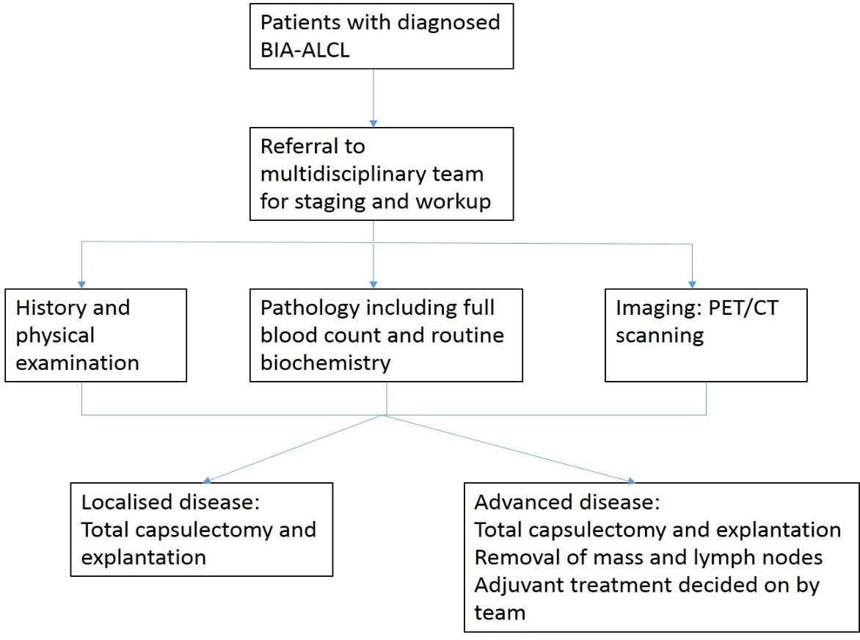

Proposed clinical management algorithm for identified population
The proposed clinical management algorithm (Figure 2) is simply the current algorithm with the addition of breast MRI at the staging and workup stage.

Figure 2: Proposed clinical management algorithm for patients with diagnosed BIA-ALCL
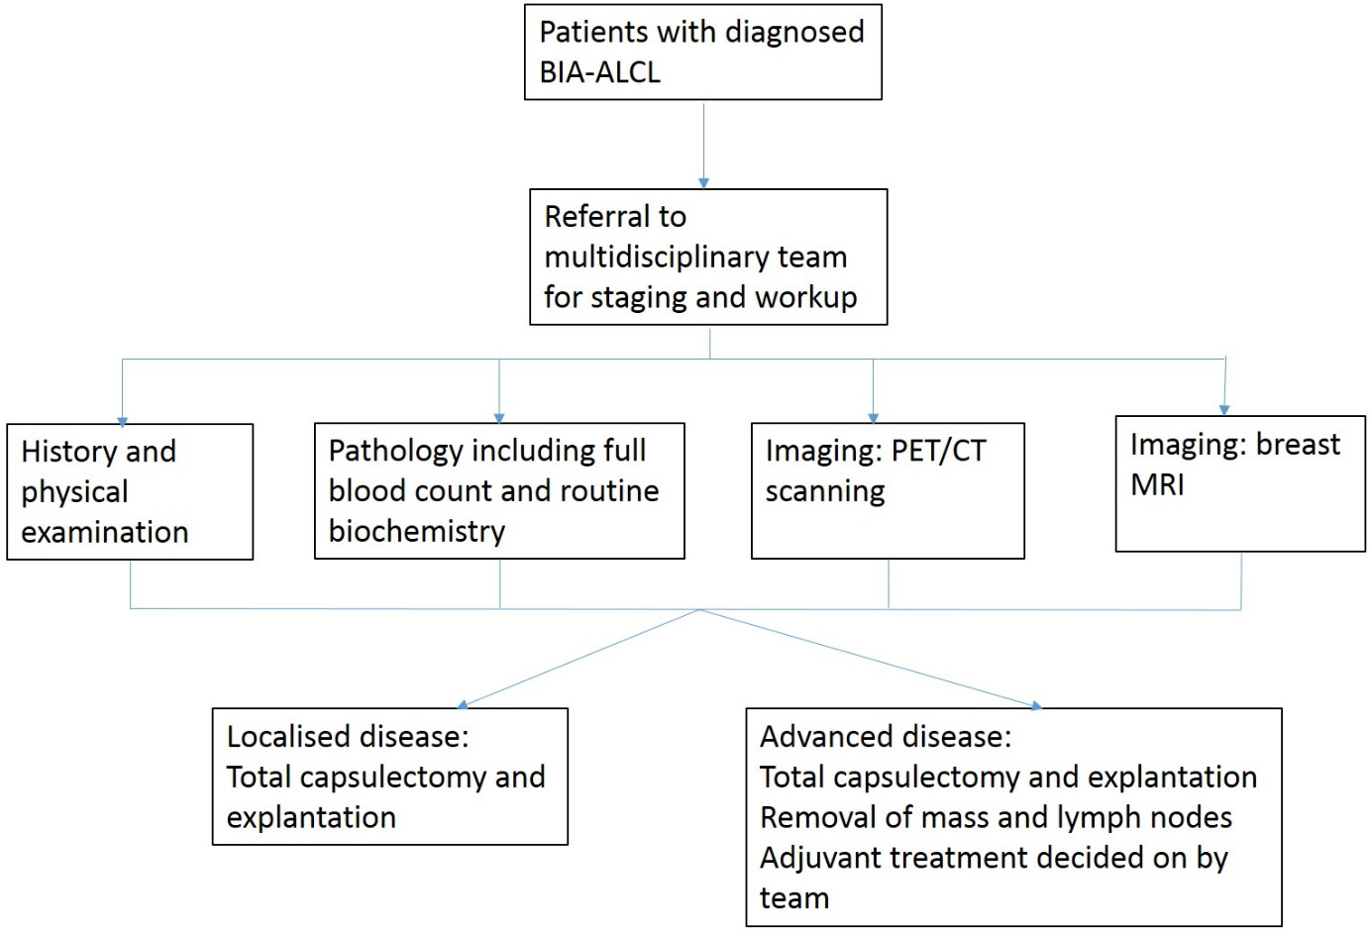

Proposed economic evaluation
None of the studies included with the application provide evidence that breast MRI results in better surgical results. The only study that compares imaging in BIA-ALCL considered a case series of patients with the disease who had one or more of ultrasound, CT, MRI, PET-CT or mammography. Each of these imaging modalities was then judged on its ability to identify a mass or effusion adjacent to the implant. The impact of imaging on the surgical outcome was not reported.
As the clinical claim is likely to be for non-inferior safety and superior effectiveness, a cost-effectiveness analysis or cost-utility analysis is the likely suitable economic evaluation. However, given the likelihood of a lack of evidence to support the clinical claim, it is likely that only a financial analysis will be possible.

Proposed item descriptor
The application suggests an amendment to existing breast MRI items to accommodate this population. However, after discussion with the applicant and Department of Health, it was agreed a new item number would be required. The wording of the proposed new MBS item is outlined below.

Category: Category 5 – Diagnostic imaging services

Proposed item descriptor: MBS [item number]
MAGNETIC RESONANCE IMAGING performed under the professional supervision of an eligible provider at an eligible location where the patient is referred by a specialist or by a consultant physician and where:
(a) a dedicated breast coil is used; and
(b) the request for scan identifies that the patient has a breast implant in situ, and ALCL has been diagnosed.
Fee: $ As per current fee ($690) for screening MRI in high risk women

References
Australian Cancer Network Diagnosis and Management of Lymphoma Guidelines Working Party (2005). Guidelines for the Diagnosis and Management of Lymphoma. Sydney, Aus, The Cancer Council Australia and Australian Cancer Network.
Brody, G. S., D. Deapen, C. R. Taylor, L. Pinter-Brown, S. R. House-Lightner, J. S. Andersen, G. Carlson, M. G. Lechner and A. L. Epstein (2015). "Anaplastic large cell lymphoma occurring in women with breast implants: analysis of 173 cases." Plast Reconstr Surg 135(3): 695-705.
FDA. (2017). "Breast Implant-Associated Anaplastic Large Cell Lymphoma." Retrieved 6 July, 2017, from https://www.fda.gov/medicaldevices/productsandmedicalprocedures/implantsandprosthetics/breastimplants/ucm239995.htm.
Medical Services Advisory Committee (2016). Technical Guidelines for preparing assessment reports for the Medical Services Advisory Committee – Service Type: Investigative (Version 3.0). Canberra, Australia, Department of Health.
Swerdlow, S. H., E. Campo, S. A. Pileri, N. L. Harris, H. Stein, R. Siebert, R. Advani, M. Ghielmini, G. A. Salles, A. D. Zelenetz and E. S. Jaffe (2016). "The 2016 revision of the World Health Organization classification of lymphoid neoplasms." Blood 127(20): 2375-2390.
TGA. (2017). "Safety Information- Alerts: Breast implants." Retrieved 6 July, 2017, from https://www.tga.gov.au/alert/breast-implants.

