Medical Services Advisory Committee (MSAC)
Public Summary Document
Application No. 1662.2 – The reduction of mitral regurgitation through tissue approximation using transvenous/transeptal techniques
Applicant: Edwards Lifesciences Pty Limited
Date of MSAC consideration: 4-5 April 2024
Context for decision: MSAC makes its advice in accordance with its Terms of Reference, visit the MSAC website

1. Purpose of application
An application requesting Medicare Benefits Schedule (MBS) listing for transcatheter mitral valve repair (TMVr) using the PASCAL Transcatheter Valve Repair System (PASCAL) for the treatment of degenerative mitral regurgitation (DMR) was received from Edwards Lifesciences by the Department of Health and Age Care.

2. MSAC’s advice to the Minister
After considering the strength of the available evidence in relation to comparative safety, clinical effectiveness, cost-effectiveness and total cost, MSAC supported the amendment of Medicare Benefits Schedule (MBS) item 38461 for transcatheter mitral valve repair (TMVr) by transvenous or transeptal techniques to be device agnostic for the treatment of degenerative mitral regurgitation (DMR). MSAC accepted the high certainty evidence that TMVr using the PASCAL Transcatheter Valve Repair System™ had non-inferior effectiveness and safety compared with Mitraclip™, which is currently listed for TMVr under MBS item 38461. MSAC noted there was no evidence presented in the current application to support unmet need given there is a predicate device, rather MSAC considered that the PASCAL device may provide clinicians with another option for treatment. MSAC noted the cost minimisation model assumed the procedural and device costs to be equivalent for PASCAL and MitraClip and on this basis, and no increased utilisation, considered the PASCAL device should be cost neutral.
MSAC supported the following MBS item descriptor (amendment in strikethrough):
Category 3 - Therapeutic Procedures
MBS item 38461

TMVr, by transvenous or transeptal techniques, for permanent coaptation of mitral valve leaflets using one or more MitraClipTM tissue approximation implants, including intra-operative diagnostic imaging, if:
- the patient has each of the following risk factors:
- moderate to severe, or severe, symptomatic degenerative (primary) mitral valve regurgitation (grade 3+ or 4+);
- left ventricular ejection fraction of 20% or more;
- symptoms of mild, moderate or severe chronic heart failure (New York Heart Association class II, III or IV); and
- as a result of a TMVr suitability case conference, the patient has been:
- assessed as having an unacceptably high risk for surgical mitral valve replacement; and
- recommended as being suitable for the service; and
- the service is performed:
- by a cardiothoracic surgeon, or an interventional cardiologist, accredited by the TMVr accreditation committee to perform the service; and
- via transfemoral venous delivery, unless transfemoral venous delivery is contraindicated or not feasible; and
- in a hospital that is accredited by the TMVr accreditation committee as a suitable hospital for the service; and
- a service to which this item, or item 38463, applies has not been provided to the patient in the previous 5 years
Fee: $1576.45

Consumer summary
This is the third application from Edwards Lifesciences requesting Medicare Benefits Schedule (MBS) listing for a medical procedure called transcatheter mitral valve repair (TMVr).
The mitral valve sits in the left side of the heart. The heart muscle has four sections, called chambers. When everything is working well, blood travelling from the arteries in the lungs enters the heart via the upper left heart chamber. When the heart beats, blood is first squeezed out of this top left chamber, through the one-way mitral valve, into the lower left chamber. The mitral valve is supposed to close tightly again before blood is then squeezed out towards the rest of the body.
TMVr is a procedure performed to manage a condition, called mitral regurgitation, in which the mitral valve does not close tightly. This means that, with each heartbeat, some blood can flow backward from the left lower chamber to the left upper chamber again. Mitral regurgitation is made up of two conditions, degenerative mitral regurgitation (DMR) and functional mitral regurgitation (FMR). DMR occurs when the valve itself is damaged, often caused by aging or structural problems with the valve and/or supporting structures. This damage to the mitral valve can then affect the normal flow of blood throughout the heart and lead to complications. FMR occurs when the mitral valve is structurally normal, however changes caused by a condition or disease affects the size, shape or function of the left side of the heart. These changes can then prevent the mitral valve from working as it normally would and lead to ineffective blood flow throughout the heart, which can cause complications. To summarise, DMR is a problem with the valve itself, whereas FMR is where a problem with the heart’s function prevents the mitral valve from working in the usual manner. These conditions make it difficult for the heart to pump blood around the body, which can cause shortness of breath and may cause heart failure in the long term. TMVr is already funded on the MBS for another type of device (called MitraClip) for treatment of patients with DMR (MBS item 38461) and FMR (MBS item 38463).
Edwards Lifesciences in this reapplication applied to amend the MBS item 38461 to include their device, termed the PASCAL system in the DMR population only.
The PASCAL system includes a small device made of clasps, paddles and spacers. The interventional cardiologist or surgeon uses a small, customised tube called a catheter to insert the device through a vein in the leg up to the heart. Inside the heart, the device gently grasps the edges of the faulty valve to help close the valve.
Edwards Lifesciences has applied for public funding for the PASCAL device to be used for the TMVr procedure for people with mitral regurgitation who cannot have open heart surgery to repair their mitral valve. TMVr is currently already funded on the MBS when it is performed using the MitraClip device.
MSAC considered that high certainty clinical studies show that the PASCAL system is at least as safe and effective as MitraClip. MSAC considered that PASCAL could be used as an alternative to MitraClip in patients who are having this procedure. The costs of both devices are the same, so there should be no extra cost.
MSAC’s advice to the Commonwealth Minister for Health and Aged Care
MSAC supported amending existing MBS item 38461 to be device agnostic and include the PASCAL system. MSAC considered that the PASCAL system is comparatively safe, effective and good value for money.

3. Summary of consideration and rationale for MSAC’s advice
MSAC noted the purpose of this reapplication was to request MBS item 38461 be listed as device agnostic for TMVr, to enable public funding for the use of the PASCAL Transcatheter Valve Repair System (PASCAL) for the treatment of DMR. MSAC noted that currently, MBS item 38461 is device-restricted to MitraClip for use in TMVr as per MSAC 1192.3 PSD.
MSAC noted that this is the third application for this technology, which MSAC previously considered in November 2021 (MSAC 1662 PSD) and November 2022 (MSAC 1662.1 PSD). The previous applications sought amendments to the existing MBS items 38461 and 38463 to be device agnostic for the treatment of DMR and functional mitral regurgitation (FMR), respectively. MSAC recalled that the first submission in November 2021 lacked sufficient evidence to support the claim of non-inferiority safety/effectiveness and that the second submission in November 2022 similarly did not produce adequate evidence to support non-inferior safety and did not demonstrate evidence to claim an unmet need. MSAC noted that this reapplication differs from the previous two, as it seeks only to amend MBS item 38461 (DMR) to be device agnostic to allow the PASCAL system to be used in the TMVr procedure for the treatment of patients with moderate–severe or severe DMR who are ineligible for open surgical management. MSAC noted that this application does not seek to amend MBS item 38463 for patients with FMR, as sought in the previous applications. MSAC noted that this would need to be reevaluated as a separate new application if a future application was to seek device agnostic amendments for MBS item 38463.
MSAC noted the public consultation feedback was broadly supportive of the application, stating that it would improve the quality of life of patients who are unsuitable for surgery by having an additional treatment option. One consultation submission, from the sponsor of MitraClip, did not support the application – citing the evidence presented for the use of MitraClip was based on a mixed population of patients with FMR and DMR, with no separate evidence for the DMR population alone.
MSAC noted that the revised MBS item descriptor does not specify whether the device should be used for native mitral valve repair only, or whether valve-in-valve intervention (following failed surgical or transcatheter implanted valve) is permitted. MSAC considered that the indication as defined in the Australian Register of Therapeutic Goods (ARTG) would adequately restrict PASCAL use to native valve repair. The Department noted that PASCAL or MitraClip use does not preclude the future use of a separate transcatheter-delivered, or surgical valve replacement device.
MSAC supported that as per the item descriptor for MBS item 38461, this MBS service would continue to be available only to providers who are accredited with the Transcatheter Mitral Valve Therapies Accreditation Committee. MSAC also confirmed the MBS item fee would remain at $1,576.45 and that the 5-year claiming restriction valid.
MSAC noted the proposed clinical management algorithm for patients with DMR, who have an unacceptable high risk for surgical valve replacement and considered that the comparator (TMVr using the MitraClip device) was appropriate.
MSAC noted that the current ADAR provided new evidence from the low risk of bias CLASP IID randomised control trial (RCT) to support the clinical claim that the PASCAL device is non-inferior in safety compared to the MitraClip device. MSAC considered the CLASP IID was a head-to-head trial that included direct evidence of comparative effectiveness between the PASCAL and MitraClip device. The primary safety endpoint was rate of composite major adverse events (MAEs) at 30 days, with secondary safety analysis of rate of MAEs at 1 year. The primary effectiveness endpoint of the CLASP IID study was the proportion of patients with mitral regurgitation (MR) severity of ≤2+ at 6 months, with secondary analysis of MR severity at 1 year.
In terms of comparative safety, MSAC noted the rate of MAEs at 30 days between PASCAL (4.6%) and MitraClip (5.4%) with an absolute difference of -0.8%. MSAC considered safety was well substantiated by the 95% CI, in that the upper limit of the one-sided 95% CI of 4.6% was substantially lower and well within the pre-specified non-inferiority margin of 15%. MSAC noted the MAEs for PASCAL and MitraClip (n = 199 for PASCAL, n = 95 for MitraClip) was 8.2% and 9.6% at 6-months; 15.3% and 11.7% at 12-months respectively. MSAC noted the comparative safety of both devices was maintained to 1 year. In addition, MSAC noted the Kaplan-Meier (KM) estimate for freedom from MAE at 1 year was 84.7% for PASCAL and 88.3% for MitraClip (p=0.471). MSAC considered the KM adequately demonstrated that freedom from hospitalisation due to heart failure at 1 year was similar for both PASCAL and MitraClip.
In terms of comparative effectiveness, MSAC noted the proportion of patients with MR severity ≤2+ at 6 months was 97.9% with PASCAL and 95.7% with MitraClip (absolute difference of 2.2%). MSAC noted the lower limit of the one-sided 95% CI at -2.5% was well within the proposed 18% non-inferiority margin. MSAC noted that comparative effectiveness of both devices was maintained to 1 year; the MR severity of ≤2+ was 96.0% in the PASCAL group and 93.8% in the MitraClip group.
MSAC noted that a more stringent margin of non-inferiority had not been presented, as the margins were pre-specified in the CLASP IID trial protocol. However, MSAC considered that the margins for safety and effectiveness at 6 months and 1 year were met and would hold under a stricter margin.
Overall, MSAC accepted the high certainty from the evidence that TMVr using the PASCAL Transcatheter Valve Repair System™ had non-inferior effectiveness and safety compared with MitraClip.
MSAC noted that the CLASP IID RCT data was only provided at the 1-year interval however, MSAC agreed with ESC that the available data at the 1-year interval demonstrated no new signal for concern regarding comparative safety and effectiveness, and that the outcomes were similar between PASCAL and MitraClip at the same 1-year interval.
MSAC noted the current ADAR did not make a claim of unmet clinical need. MSAC noted that the CLASP IID Registry contains evidence for some patients who were unsuitable for MitraClip mitral transcatheter edge-to-edge (TEER), went on to receive PASCAL TEER, MSAC considered that some patients with complex mitral valve anatomy could benefit from an additional treatment option, as clinicians report that PASCAL is more manoeuvrable when compared with MitraClip. MSAC considered that although the PASCAL device may provide clinicians with an additional treatment option for some patients due to their mitral anatomy, this does not demonstrate filling unmet need.
MSAC noted the economic evaluation was a cost-minimisation analysis. MSAC noted the applicant considered that PASCAL was likely to be cost-neutral, compared with MitraClip. MSAC considered the procedure costs base case, 30 days for PASCAL and MitraClip ($34,374 and $34,374 respectively) had no difference and thus agreed with the applicant and ESC, that amending MBS item 38461 to be listed as device agnostic for MitraClip and PASCAL would be cost neutral. Reintervention and adverse events (AE) costs are included in the economic evaluation, based on the CLASP IID trial direct comparative rate of MAEs at 30 days (base case) and 1 year (sensitivity analyses). MSAC noted the base case for PASCAL had a cost saving at 30 days ($591 for PASCAL, compared with $891 for MitraClip) and at 1-year ($1,490 for PASCAL, compared with $1,990 for MitraClip). However, MSAC noted that as the total AE cost for MitraClip and PASCAL (including heart failure hospitalisation costs) was neutral at both 30 days ($1,264 and $1,009 respectively) and 1-year ($2,398 and $2,356 respectively). MSAC considered the minimal difference in cost at 30 days and 1-year – inclusive of heart failure hospitalisation costs – resulted in the devices being considered as cost equivalent.
MSAC noted that under the proposed amendments for a device agnostic listing, there would be no offsets as where clinically indicated, PASCAL would be replacing MitraClip. MSAC considered this would result in no significant increase in utilisation for MBS item 38461 if listed as device agnostic. MSAC therefore agreed with ESC that the devices are cost neutral and no increase in utilisation was expected.
MSAC noted the financial and budgetary estimates, including the $0 net financial impact to the MBS. MSAC noted that the market growth/hospitalisations were uncertain, however considered the applicant’s 10% assumed market growth to be a reasonable estimate. MSAC agreed with ESC that the real-world data from the registry around the proportion of patients who have been treated using PASCAL rather than MitraClip could help validate the estimated 10% growth rate and aid decision making. However, MSAC considered that irrespective of the estimated growth and hospitalisation rate, the net financial impact to the MBS would be negligible.
MSAC noted that the applicant has requested that the Medical Devices and Human Tissue Advisory Committee (MDHTAC) review their prescribed list (PL) application for a redacted PL listing. MSAC considered that the PL listing (if supported by MDHTAC) would be subject to the amendment of MBS item 38461 to be listed as device agnostic. MSAC noted that as it supported amending MBS item 38461 to be device agnostic, PL listing for the PASCAL device would be subject to Government’s consideration of MSAC’s recommendation, prior to consideration by MDHTAC. MSAC advised the MHDTAC that MSAC’s assessment of cost-effectiveness was based on an all-inclusive price for the PASCAL intervention and for the comparator (i.e. prices that include the main device and any ancillary devices or accessories required for implantation).
MSAC recalled that some hospitals are being charged costs higher than the PL benefit for cardiac devices, which may be incurred by the hospital or patient. MSAC noted the pre-ESC response confirmed that there are no proposed costs for the PASCAL that will be charged outside of the standard hospital/insurer arrangements.
MSAC supported the item descriptor should be amended as device agnostic and mention “tissue approximation implants,” rather than specifying the device as MitraClip or PASCAL. MSAC noted this may mean than any future tissue approximation implants may be able to proceed directly from listing on the ARTG to the MDHTAC without the requirement for evaluation by MSAC. MSAC noted the desirability of device-agnostic MBS item descriptors, but also the need to ensure adequate evidence of clinical outcomes for new products.

4. Background
This is the third application for this technology. It was previously considered by MSAC in November 2021 (MSAC 1662 PSD) and November 2022 (MSAC 1662.1 PSD). These previous applications sought amendments of the existing MBS items 38461 and 38463 to be device agnostic for the treatment of degenerative mitral regurgitation (DMR) and functional mitral regurgitation (FMR). The current Applicant-Developed Assessment Report (ADAR) only proposes amendment of the MBS item 38461 to be device agnostic, allowing the PASCAL system to be used in the TMVr procedure for the treatment of patients with moderate-severe or severe DMR who are ineligible for open surgical management.
The MBS items 38461 and 38463 were introduced to the MBS in July 2021 for the provision of TMVr using the MitraClip system. The use of MitraClip technology was considered and supported by MSAC in September 2020 (MSAC 1192.3 PSD).
In November 2021, MSAC considered application 1662 and did not support amending MBS items 38461 and 38463 for TMVr to be device agnostic or include the PASCAL system. MSAC considered the quality of evidence for TMVr using the PASCAL system to be low and did not adequately support the claim of clinical non-inferiority for safety and effectiveness. MSAC advised that higher quality evidence would be needed to support the claim of non-inferiority. MSAC also considered that an unmet clinical need for an alternative device was not clearly demonstrated.
In November 2022, MSAC considered application 1662.1 and did not support updating the above-mentioned MBS items to be device agnostic. MSAC considered that the limited new evidence presented did not change its previous conclusions from November 2021, that the evidence did not adequately support the claim of non-inferior safety and effectiveness of TMVr using the PASCAL system compared to MitraClip, and that an unmet clinical need was not clearly demonstrated.
Table 1 presents the key issues raised by MSAC and ESC during their previous consideration of this application in November 2022, and how these issues are addressed in this ADAR.
Table 1 Summary of key matters of concern
Component | Matter of concern | How the current assessment report addresses it
Clinical need | MSAC considered that an unmet clinical need for an alternative device was not clearly demonstrated (PSD, p3). | No unmet need has been claimed in this ADAR.
Clinical claim – Safety | MSAC considered the safety profile of PASCAL to be promising, but longer-term comparative safety is uncertain (PSD, p4). | The ADAR newly presents direct comparative evidence for the 1-year follow-up for CLASP IID trial and this includes MAEs, cardiac mortality and mortality. Results show that severe bleeding events remained higher for patients in the PASCAL group compared to MitraClip at both 6 months and 12 months (10.2% versus 5.5%). Cardiovascular death was higher in the MitraClip group compared to PASCAL at both 6 months and 12 months (7.4% versus 3.7%). While these differences were not statistically significant, the trial was powered for composite rather than individual MAEs.
Clinical claim – Effectiveness | MSAC considered the point estimates from CLASP IID to be suggestive of non-inferiority, but MSAC was concerned that these conclusions were based on a wide margin for non-inferiority. MSAC had the same concerns with the comparative effectiveness evidence as it did with the comparative safety evidence (sample size and long-term outcomes). MSAC concerns included small sample sizes for long-term outcomes, variable or incomplete follow-up for the published comparative studies, limitation with unanchored MAIC and naïve comparisons limited by not having a common comparator (PSD, p4-5). | The ADAR newly presents direct comparative evidence for the 1-year follow-up for CLASP IID trial and this includes reduction in MR severity, NYHA functional class and quality of life outcomes. MSAC have previously considered that 2-year outcomes for functional outcomes such as overall survival and NYHA class would be informative for demonstrating non-inferiority. MSAC previously noted that non-inferiority should be assessed using a more stringent non-inferiority margin than used in the interim CLASP IID trial results, however no changes have been made to the non-inferiority margins. The applicant suggests calculation parameters are based on published literature, but does not provide the references for these studies. Nonetheless, the CLASP IID RCT results suggest that a stricter non-inferiority margin would have been satisfied.
Cost-minimisation | MSAC considered the cost-minimisation analysis used for the economic evaluation to be appropriate but was not supported by sufficient clinical evidence for the clinical claim of non-inferiority (PSD, p5). | The cost-minimisation approach presented in MSAC Application No. 1662.1 has been updated with new comparative safety data on the rates of MAEs from the CLASP IID study at 30 days (base case) and 1 year (sensitivity analysis) follow-up. The cost minimisation analysis claims cost-neutrality of PASCAL compared to MitraClip.
Financial- device cost | MSAC noted that some hospitals are being charged costs higher than the Prescribed List of Medical Devices and Human Tissue Products (Prescribed List, formally known as Prosthesis List) benefit for cardiac devices. MSAC noted the applicant confirmed that the proposed Prescribed List benefit will fully reimburse the price of the PASCAL device, implant system and guide sheath, but did not confirm if there were additional consumable costs that may be charged outside of the standard hospital/insurer arrangements (PSD, p5). | The applicant proposes an arrangement where the device fee will only be charged once per procedure, as per MSAC Application No. 1192.3. MSACs concerns about additional consumable costs are not addressed.
Financial - utilisation | MSAC considered the utilisation estimates to be uncertain. MSAC advised that a claim of unmet clinical need should be addressed in the context of patients who are unable to undergo TMVr using current generation MitraClip devices (PSD, p5). | The current ADAR has not claimed unmet need or technical superiority over the current MitraClip device. However, there remains uncertainty as to how much larger the total number of TMVr market may become should the PASCAL device become available. The applicant notes that an increase of 10% in the market size would add ~$redacted in net costs to the health system, which provides an indication of the cost of any increases in the market size.
Source: Table 2, p18-19 of MSAC 1662.2 ADAR.
Abbreviations: ADAR, Applicant-Developed Assessment Report; MAEs, major adverse events; MAIC, matching-adjusted indirect comparison; MR, mitral regurgitation; MSAC, Medicare Services Advisory Committee; NYHA, New York Heart Association; PSD, Public Summary Document; TMVr, transcatheter mitral valve repair.

5. Prerequisites to implementation of any funding advice
Items on the ARTG that are relevant to this application are shown in Table 2.
Table 2 Edwards PASCAL Transcatheter Valve Repair System listed on the ARTG
ARTG ID | ARTG name
342270 | Edwards Lifesciences Pty Ltd - PASCAL Transcatheter Valve Repair System – Implant System - mitral valve clip
342271 | Edwards Lifesciences Pty Ltd - PASCAL Transcatheter Valve Repair System – Guide Sheath - Catheter, intravascular, guiding
329680 | Edwards Lifesciences Pty Ltd - Cardiac implantation catheter holder
329150 | Edwards Lifesciences Pty Ltd - Cardiac implantation catheter table
410289 | Edwards Lifesciences Pty Ltd – PASCAL Precision System – PASCAL Ace Implant System – mitral valve clip
410290 | Edwards Lifesciences Pty Ltd – PASCAL Precision System – Guide Sheath – mitral valve clip
410288 | Edwards Lifesciences Pty Ltd – PASCAL Precision System –Implant System – mitral valve clip
371670 | Edwards Lifesciences Pty Ltd – PASCAL Transcatheter Valve Repair System – PASCAL Ace Implant System – mitral valve clip
421719 | Edwards Lifesciences Pty Ltd – Cardiac implantation catheter table
Source: Table 3, p19 of MSAC 1662.2 ADAR.
Abbreviations: ARTG, Australian Register of Therapeutic Goods.
Physicians and relevant hospital staff (scrub nurse, radiographers, echo technicians) require accreditation by qualified Edwards Lifesciences personnel before involvement in a PASCAL TMVr procedure. Physician accreditation includes an initial intensive training program which includes the Procedure Didactic, Echo Didactic, Septal Puncture/Echo recommendations, Dry Bench and simulator training, and device delivery through a Beating Heart Model:
- Device procedure classroom training >1 hour,
- Demo device hands-on training > 1hour,
- Imaging/Echo classroom training > 1hour,
- Case discussion > 1hour.
To be eligible for the training program the physician must meet the following requirements:
- Be either a cardiologist or a cardiac surgeon,
- Have experience in transseptal technique and have an understanding or experience in structural heart disease (patent foramen ovale, atrial septal defect, aortic valve, etc.),
- Have a multidisciplinary team to support the procedure, including:
  - A dedicated echocardiologist for patient screening and to be present during the procedure,
  - A cardiac surgeon or interventional cardiologist to provide support,
- Identify five suitable patients prior to training,
- Be able to continue to have a reasonable volume of patients so as to maintain minimum skills levels and optimal patient outcomes.
The PASCAL device is not currently listed on the Prescribed List of Medical Devices and Human Tissue Products (Prescribed List).

6. Proposal for public funding
This application has excluded MBS item 38463 compared to the previous application 1662.1 and seeks to modify existing MBS item 38461 for TMVr using the MitraClip system for the treatment of moderate-severe or severe DMR to become device-agnostic. The proposed amendments are presented in Table 3.
Table 3 Presentation of the proposed MBS item
Category 3 - Therapeutic Procedures
MBS item 38461

TMVr, by transvenous or transeptal techniques, for permanent coaptation of mitral valve leaflets using one or more MitraClips™ tissue approximation implants, including intra‑operative diagnostic imaging, if:
- the patient has each of the following risk factors:
- moderate to severe, or severe, symptomatic degenerative (primary) mitral valve regurgitation (grade 3+ or 4+);
- left ventricular ejection fraction of 20% or more;
- symptoms of mild, moderate or severe chronic heart failure (New York Heart Association class II, III or IV); and
- as a result of a TMVr suitability case conference, the patient has been:
- assessed as having an unacceptably high risk for surgical mitral valve replacement; and
- recommended as being suitable for the service; and
- the service is performed:
- by a cardiothoracic surgeon, or an interventional cardiologist, accredited by the TMVr accreditation committee to perform the service; and
- via transfemoral venous delivery, unless transfemoral venous delivery is contraindicated or not feasible; and
- in a hospital that is accredited by the TMVr accreditation committee as a suitable hospital for the service; and
- a service to which this item, or item 38463, applies has not been provided to the patient in the previous 5 years
Fee: $1576.45
Source: Table 8, p26 of MSAC 1662.2 ADAR
Abbreviations: MBS, Medicare Benefits Schedule; TMVr, transcatheter mitral valve repair.
The PASCAL system is a catheter-based technique for the delivery of a permanent implant to the mitral valve via transeptal access. The PASCAL system consists of the Implant System, Guide Sheath as well as the optional stabiliser and cardiac implantation catheter table. The implant clasps the anterior and posterior leaflets around a spacer, thus creating a double orifice and reducing mitral regurgitation.
This proposal indicates that PASCAL system would be delivered to the same DMR patients and in the same clinical setting as the MitraClip system. The current MBS item can only be claimed once every five years for each patient. Patient’s risk factors and suitability for TMVr procedure should be determined by a multidisciplinary heart team (MDHT). The delivery of PASCAL system is restricted to be performed only by a cardiothoracic surgeon, or an interventional cardiologist, accredited by the TMVr accreditation committee to perform the service in a hospital accredited to perform the procedure. The ADAR also stated that physicians and relevant hospital staff must be accredited by qualified Edwards Lifesciences personnel.
The proposed MBS item fee is the same as the existing fee for MBS items 38461.
If the MBS item 38461 become device agnostic, it would allow for all future similar devices to be used as long as the safety, effectiveness and cost effectiveness had been assessed.

7. Population
The proposed population for TMVr using the PASCAL system has changed from MSAC’s previous 2022 consideration. This ADAR excluded the MBS item 38463 and consequently treatment for the FMR population. However, the proposed DMR population (MBS item 38461) remains the same and aligns with the current population already listed for this procedure on the MBS using the MitraClip system (item 38461).
Patients with DMR:
- Moderate-severe or severe mitral regurgitation (grade 3+ or 4+)
- Left ventricular ejection fraction (LVEF) ≥20%
- Symptoms of mild, moderate or severe chronic heart failure (New York Heart Association [NYHA] class II, III, or IV)
- Assessed as having unacceptably high risk for surgical valve replacement by a TMVr case conference
The proposed clinical management algorithm for DMR patients, shown in Figure 1, remains unchanged from the previous application. This algorithm was based on the clinical algorithm presented in MSAC application 1192.3 (for MitraClip) and aligns with the proposed MBS item descriptor.
Figure 1 Proposed clinical management algorithm for DMR
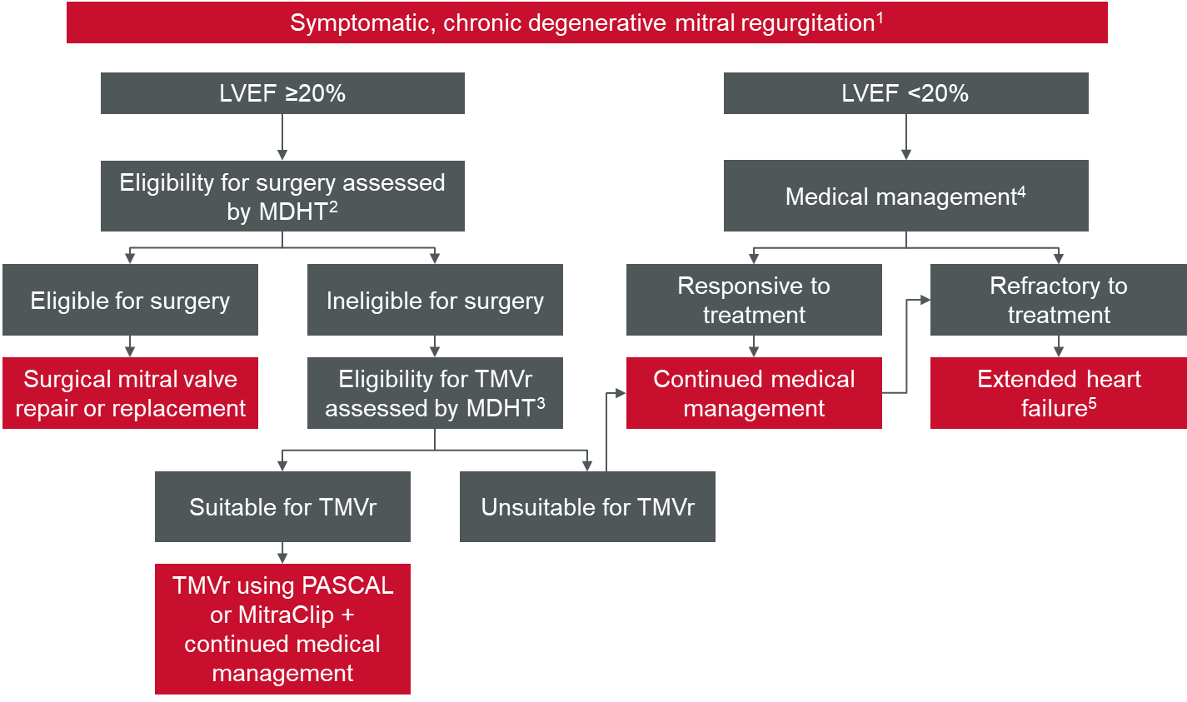
Source: Figure 1, p25 of MSAC 1662.2 ADAR.
Abbreviations: DMR, degenerative mitral regurgitation; LVEF, left ventricular ejection fraction; MDHT, multidisciplinary heart team; TMVr, transcatheter mitral valve repair.
Notes: 1. Symptomatic DMR defined as NYHA class ≥2 and MR grade 3+ or 4+; 2. Eligibility for surgery determined considering frailty, surgical risk score, major organ system dysfunction, and procedure-specific impediments; 3. Eligibility for TMVr requires MR grade 3+ or 4+, LVEF ≥20%, symptoms of mild, moderate or severe chronic heart failure (NYHA class II, III or IV); 4. Maximally tolerated guideline-directed medical therapy; 5. Extended heart failure treatment included heart transplant, cardiac resynchronisation therapy; ventricular assist devices; and cardiac restraint devices

8. Comparator
The proposed comparator is TMVr using the MitraClip device. This comparator is unchanged from the previous application.

9. Summary of public consultation input
Consultation input was welcomed from two (2) professional organisations:
- Australian & New Zealand Society of Cardiac & Thoracic Surgeons (ANZSCTS)
- Abbott Medical Australia Pty Ltd.

ANZSCTS was supportive of the application and noted percutaneous therapies potentially offer better symptom control and quality of life (when combined with optimal medical therapy) for specific populations considered not suitable / or high risk for surgery.
ANZSCTS supported the change of MBS descriptors 38461 and 38463, and recommended these item numbers should not be restrictive to a specific company’s brand.
Abbott Medical Australia was not supportive of the application. Abbott Australasia Pty Ltd was the Applicant for MSAC Application 1192.3, where MSAC supported public funding of Transcatheter mitral valve repair (TMVr) with MitraClip™ for patients with both DMR (degenerative mitral regurgitation) and FMR (functional mitral regurgitation), leading to the implementation of Medicare Benefits Schedule (MBS) items 38461 and 38463, specific to MitraClip technology.
Abbott Medical Australia states that the PASCAL Transcatheter Valve Repair System™ (PASCAL™) does not meet the same standard of clinical evidence that was demonstrated by MitraClip as part of MSAC Application 1192.3. Additionally, the randomised controlled trial data for PASCAL is limited to the DMR population, the clinical study follow-up in the DMR population is limited to 12 months, and as the comparator (MitraClip) arm of the CLASP IID study did not fully represent the most advanced generation i.e., fourth generation of MitraClip.
Abbott Medical Australia considered that although the proposed population is consistent with MBS item 38461 only (DMR) and not with 38463 (FMR), it was important to note that there is a mixed aetiology group (presenting with both DMR and FMR). Abbott Medical Australia considered that indication creep from DMR to FMR through mixed aetiology could pose a significant clinical risk to the patients funded through the MBS in Australia.

10. Characteristics of the evidence base
In November 2022, MSAC did not support MSAC application 1662.1 as it considered that the quality of evidence remained largely unchanged from the initial application (1662) and did not adequately support the clinical claim of non-inferiority. MSAC advised that additional evidence should be adequately powered, with direct comparative reporting of:
- Rates of MAEs including reintervention with at least 12 months follow-up,
- MR reduction and with at least 12 months follow-up in the FMR and DMR populations,
- Quality of life data,
MSAC considered 2-year outcomes for functional outcomes such as overall survival and NYHA class would also be informative for demonstrating non-inferiority. MSAC considered that non-inferiority should be assessed using a more stringent non-inferiority margin than used in the interim CLASP IID trial results.
The current ADAR (1662.2) sought to address these concerns by presenting new direct comparative evidence from the CLASP IID RCT that directly compared PASCAL to the MitraClip.
The key features of the CLASP IID trial included in the current ADAR are provided in Table 4.
Table 4 Key features of the included evidence
References | N | Design/duration | Risk of bias | Patient population | Outcome(s) | Use in modelled evaluation
Direct randomized comparative study
Clinical Trial - Edwards PASCAL CLASP IID/ IIF Pivotal Clinical Trial (CLASP IID/IIF) | 300 | A prospective, multicenter, randomized, controlled pivotal trial (ongoing) | Low | At least moderate-severe DMR at prohibitive surgical risk.  Age ≥18 years  Prohibitive risk for mitral valve surgery  Candidate for M-TEER with the PASCAL system but not for MitraClip  Degenerative mitral regurgitation (3+ to 4+)  Suitable valve and regurgitant jet morphology  LVEF ≥20%, LVEDD ≤80 mm | SAFETY:  Adverse events at 30 days, 6 months, 12 months;  Mortality and cardiac mortality at 1 year  EFFICACY:  MR severity ≤2+ and ≤1+ at 30 days, 6 months, 1 year;  NYHA functional class at 6 months and 12 months, and QoL at 6 and 12 months | Adverse events at 30 days and 1 year are used in the updated cost-minimisation.
Abbreviations: DB, double blind; DMR, degenerative mitral regurgitation; LVEDD, left ventricular end-diastolic diameter; LVEF, left ventricular ejection fraction; OL, open label; OS, overall survival; PFS, progression-free survival; MR, mitral regurgitation; NYHA, New York Heart Association.
The CLASP IID study included different device generations of PASCAL and MitraClip. In the PASCAL group, 52.6% of patients received the PASCAL implant, 39.2% received the PASCAL Ace implant and 8.2% received a combination. In the MitraClip group, 30.5% of patients received NT, NTR, XTR implants, 68.4% received (G4) NT, NTW, XT or XTW implants and 1.1% received a combination.

11. Comparative safety
The current ADAR provided new evidence from the CLASP IID RCT to support the clinical claim that the PASCAL device is non-inferior in safety compared to the MitraClip device. The primary safety endpoint was rate of MAEs at 30 days with secondary safety analysis of rate of MAEs at 1 year (Table 5).
The rate of composite MAEs at 30 days (Figure 2) was 4.6% for patients in the PASCAL arm compared to 5.4% in the MitraClip arm (absolute difference –0.8%). The upper limit of the one-sided 95% CI (4.6%) was lower than the pre-specified non-inferiority margin of 15%. No literature was provided to support the non-inferiority margin.
Figure 2 Non-inferiority for safety and effectiveness
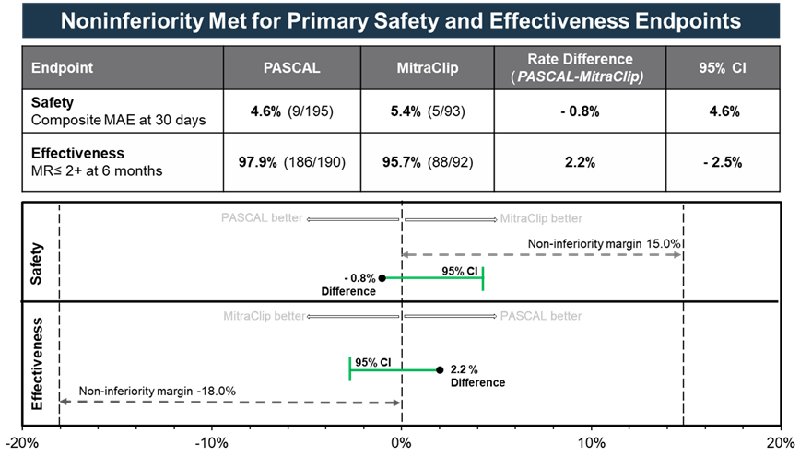
Source: Figure 3, p40 of MSAC 1662.2 ADAR.
Abbreviations: CI, confidence interval; MAE, major adverse events; MR, mitral regurgitation
At 1 year, the rate of composite MAEs was 15.3% for patients in the PASCAL arm compared to 11.7% in the MitraClip arm for an absolute difference of 3.6%. The upper limit of the one-sided 95% CI was 11.9% which is lower than the pre-specified non-inferiority margin of 15%. There were no statistical differences in MAEs between the PASCAL and MitraClip groups (Table 5).
Table 5 Summary of MAEs at 30 days and 1 year
 | PASCAL  N=199 |  | MitraClip  N=95
 | 6 months | 1 year | 6 months | 1 year | p-value (1 year)
Composite MAE rate ª | 16 (8.2%) | 29 (15.3%) | 9 (9.6%) | 11 (11.7%) | 0.471
Cardiovascular mortality | 3 (1.6%) | 7 (3.7%) | 5 (5.3%) | 7 (7.4%) | 0.165
Stroke | 1 (0.5%) | 4 (2.2%) | 1 (1.1%) | 1 (1.1 %) | 0.552
Myocardial infarction | 0 (0.0%) | 0 (0.0%) | 1 (1.1 %) | 1 (1.1 %) | 0.143
Need for new renal replacement therapy | 2 (1.1%) | 2 (1.1%) | 0 (0.0%) | 1 (1.1 %) | 0.975
Severe bleeding ^{b} | 10 (5.1%) | 19 (10.2%) | 4 (4.4%) | 5 (5.5%) | 0.209
Nonelective mitral valve reintervention (percutaneous or surgical) | 4 (2.1 %) | 4 (2.1 %) | 2 (2.1%) | 2 (2.1%) | 0.962
Other events
All-cause death | 9 (4.6%) | 17 (8.8%) | 6 (6.3%) | 8 (8.4%) | 0.953
Heart failure hospitalisation | 7 (3.7%) | 15 (8.1%) | 3 (3.3%) | 3 (3.3%) | 0.146
Transient ischemic attack | - | 1 (0.5%) | - | 1 (1.1%) | 0.595
Major vascular events | - | 0 (0.0%) | - | 0 (0.0%) | -
Source: Table 16, p54 of MSAC 1662.2 ADAR.
Abbreviations: CEC, clinical events committee; MAE, major adverse event.
Notes: Categorical variables: Patients n (%). Denominator includes patients who had an MAE or did not have an MAE but were followed for at least 30 days. 6 patient(s) did not have an MAE and were not followed for at least 30 days.
ª patients may experience more than one event.
^{b} major, extensive, life-threatening, or fatal bleeding defined by the Mitral Valve Academic Research Consortium criteria.
The commentary considered that the CLASP IID RCT evidence supported the applicant’s claim of non-inferiority in terms of safety, as measured by MAEs at 30 days and 1 year. The remaining considerations are the wide window of measurement, where ’30 day’ results were measured between 23 and 270 days, and ‘1 year’ results were measured between 223 and 579 days. The RCT results could be biased if one arm of the trial systematically measured earlier or later than the other. However, the CLASP IID Post Approval Study Report (PASR) shows that 81.9% of PASCAL and 81.1% of MitraClip patients were visited within a tighter window of 23 to 37 days for the 30 day results. Similarly, the PASR reports that 72.9% of PASCAL patients and 76.8% of MitraClip patients were visited within a tighter window of 320 to 410 days for the 1-year results, suggesting the risk of bias from this issue is low. The Kaplan-Meier (KM) estimate for freedom from MAE at 1 year was 84.7% for patients in the PASCAL group and 88.3% for the MitraClip group (p=0.471) (Figure 3).The Kaplan-Meier (KM) estimate for freedom from MAE at 1 year was 84.7% for patients in the PASCAL group and 88.3% for the MitraClip group (p=0.471).
The commentary also noted the higher rates of severe bleeding for PASCAL, which occurred for 10.2% of patients the PASCAL arm versus 5.5% in the MitraClip arm. The ADAR states that the majority of these events were unrelated to the PASCAL device but no further information was provided to support this claim.
Figure 3 KM curve for major adverse events
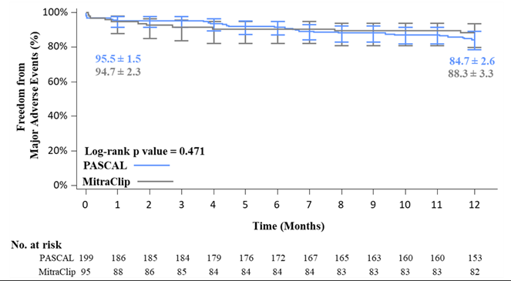
Source: Figure 4, p43 of MSAC 1662.2 ADAR.
Abbreviations: KM, Kaplan-Meier
Notes: Kaplan-Meier estimates for freedom from major adverse events (MAE) (Kaplan-Meier estimate ± SE). Error bars represent 95% CI.
The KM estimates for freedom from all-cause mortality at 1 year were similar, PASCAL 91.2% vs MitraClip 91.6% (p = 0.953). Freedom from cardiovascular mortality was 96.3% for the PASCAL group vs 92.6% for the MitraClip, (p = 0.165) and freedom from HFH was 91.9% vs 96.7%, respectively (p = 0.146). The KM estimate for freedom from all-cause mortality and HFH was 84.9% vs 89.4%, respectively (p = 0.340) (Figure 4).

Figure 4 KM curve for freedom from CEC-adjudicated mortality and heart failure hospitalisation
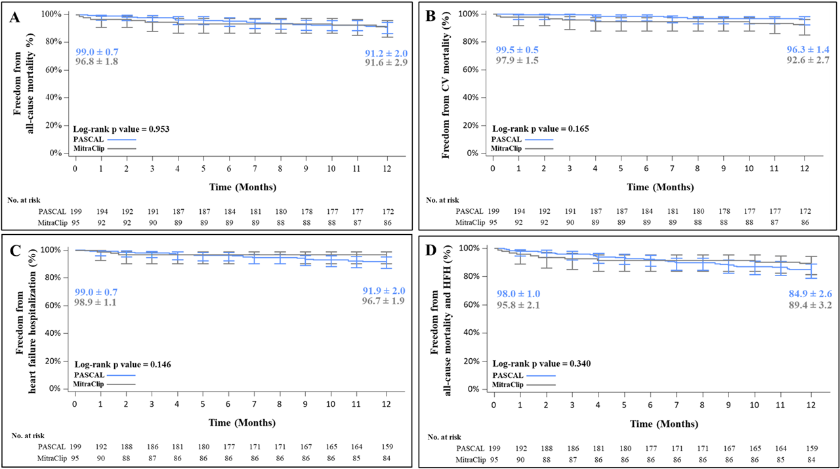
Source: Figure 5, p45 of MSAC 1662.2 ADAR.
Abbreviations: CEC, Clinical events committee; CV, cardiovascular; HFH, heart failure hospitalisation; KM, Kaplan-Meier
Notes: Kaplan-Meier estimates for freedom from A) all-cause mortality, B) cardiovascular mortality, C) heart failure hospitalisation and D) all-cause mortality and heart failure hospitalisation. Graph shows KM estimate ± SE and error bars represent 95% CI

12. Comparative effectiveness
The current ADAR provided new direct comparative evidence from the CLASP IID RCT to support the clinical claim that the PASCAL device is non-inferior in effectiveness compared to the MitraClip device. The primary effectiveness endpoint of the CLASP IID study was the proportion of patients with MR severity ≤2+ at 6 months, with secondary analysis of MR severity at 1 year. A non-inferiority margin of -18% was pre-specified however, no literature was provided to support the chosen non-inferiority margin.
MR ≤2+ at 6 months was achieved by 97.9% and 95.7% of patients in the PASCAL and MitraClip groups respectively (Figure 2). The absolute difference was 2.2% and the lower bound of the one-sided 95% CI was –2.5%. This was within the pre-specified non-inferiority margin of –18%.
The proportion of patients with MR ≤2+ at 1 year was 96.0% in the PASCAL group and 93.8% in the MitraClip group with an absolute difference of 2.2% (Figure 5). The one-sided 95% lower confidence bound was –3.9% which was within the pre-specified non-inferiority margin of –18.0%.
Figure 5 Non-inferiority for effectiveness at 1 year
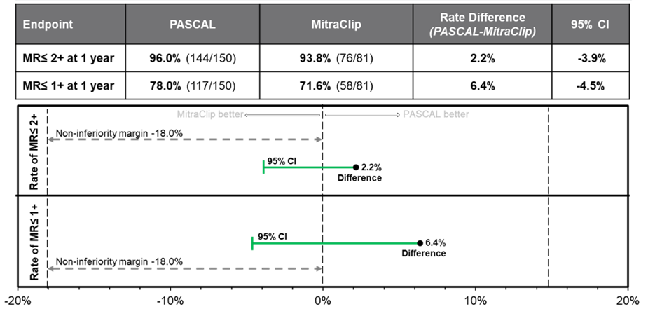 Source: Figure 7, p47 of MSAC 1662.2 ADAR.
Abbreviations: CI, confidence interval; MAE, major adverse events; MR, mitral regurgitation
Figure 6 MR severity assessed by TTE
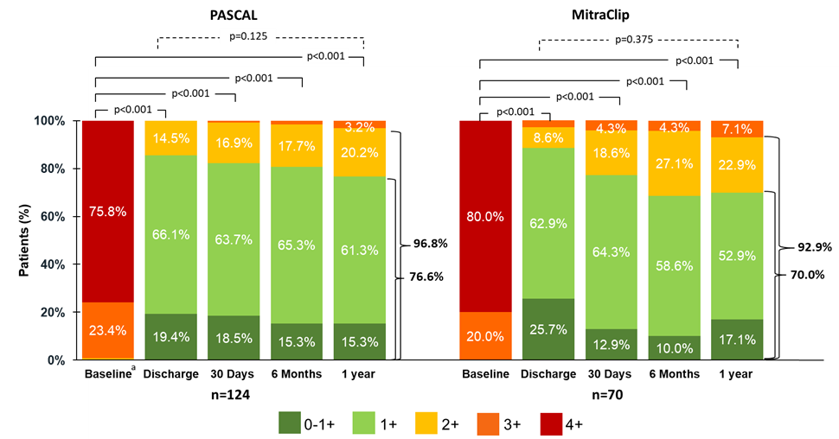
Source: Figure 11, p55 of MSAC 1662.2 ADAR.
Abbreviations: MR, mitral regurgitation; TTE, transthoracic echocardiogram.
The commentary considered that the CLASP IID RCT results support the clinical claim of non-inferiority in effectiveness outcomes between PASCAL and MitraClip at 6 months and 1 year. The remaining considerations are:
- The imbalance in the initial MR severity between arms, with the PASCAL group having a lower proportion of MR 4+ relative to the MitraClip group (73.2% to 81.1%, p = 0.113). While the difference is not statistically significant, reduction in MR severity is a key effectiveness outcome. As a result, imbalance at baseline could bias the study in favour of PASCAL if it remains unadjusted for, and
- The -18% non-inferiority margin which has previously been considered too large by MSAC. This has not been revised. The ADAR states that this margin is considered clinically acceptable, and that the components used to determine the rate of control are based on a review of published literature. This literature is not specified. The ADAR notes that the finding of non-inferiority would hold under a stricter margin.
The CLASP IID study also showed significant and comparable improvement in functional and quality of life outcomes, specifically the NYHA functional class, KCCQ, and EQ-5D scores, for patients in both PASCAL and MitraClip arms:
- In both arms, patients experienced improvement in NYHA functional class following treatment, with the proportion of people in NYHA functional class I-II being 88.3% for PASCAL and 86.8% for MitraClip at 1 year (p = 0.834). MSAC had previously considered that 2-year NYHA follow up would be informative for supporting non-inferiority.
- Significant improvement from baseline to 1 year was observed in both groups for KCCQ scores (p<0.05 vs baseline). The mean overall KCCQ score improved by 15.2 points in the PASCAL group and 15.1 points in the MitraClip group corresponding to a moderate to large improvement in quality of life following TMVr. ANCOVA analysis found no significant difference between groups at 1 year (p=0.447).
- Significant improvements in EQ-5D-5L scores were observed for both the PASCAL and MitraClip groups at 1 year (p<0.05 vs baseline). Scores improved by 9.7 and 7.5 points, in the PASCAL and MitraClip groups, respectively. ANCOVA analysis found no significant difference between groups at 1 year (p=0.766).

13. Economic evaluation
The ADAR presented a cost-minimisation model (Table 6) as per the previous ADAR (MSAC 1662.1), with the following adjustments:
- Confined to DMR as FMR was removed from this application
- Updated rates of adverse advents based on the randomised control trial direct comparison between PASCAL and the MitraClip.
Table 6 Summary of the economic evaluation
Component | Description
Perspective | Australian Healthcare System
Comparator | MitraClip
Type(s) of analysis | Cost minimisation
Time horizon | 30 days (also 1 year presented in Excel model but not presented in ADAR)
Computational method | Cohort expected value
Generation of the base case | Trial-based
Direct health technology costs | The direct healthcare cost (procedural cost) of PASCAL is equivalent to MitraClip
Other costs or cost offsets | Reintervention and adverse event costs are included in the economic evaluation based on the CLASP IID RCT direct comparative rate of MAEs at 30 days (base case) and 1 year (sensitivity analysis).
Software | Excel
Source: Table 17, p58 of MSAC 1662.2 ADAR.
Abbreviations: MAEs, major adverse events.
Procedure costs
As per the previous ADAR, the current ADAR reported the costs of the procedure include MBS and non-MBS related costs and are assumed to be equal for both PASCAL and MitraClip populations (Table 7). Minor changes were made in the current ADAR to reflect 2023 unit costs. The commentary considered these costings to be appropriate, with the exception of the post-procedure echocardiogram which, following advice from the department, is more appropriately modelled off MBS item 55127 instead of item 55133.
Table 7 Disaggregated and total cost of PASCAL and MitraClip over 30 days in the base case
Procedural costs | PASCAL | MitraClip
MDHT coordination (MBS item 6082) | $56.05 | $56.05
MDHT attendance (MBS item (6084) | $125.40 | $125.40
Anaesthetics (MBS item 21936) | $109.00 | $109.00
Post-procedure echocardiogram (MBS item 55127) | $249.95 | $249.95
TMVr procedure (MBS item 38461) | $1,576.45 | $1,576.45
non-ICU stay (Hospital cost associated with TMVr) | $2,271.37 | $2,271.37
ICU stay (Hospital cost associated with TMVr) | $3,600.00 | $3,600.00
PASCAL device | $26,386.00 | $0.00
MitraClip device | $0.00 | $26,386.00
Total procedure costs | $34,374.22 | $34,374.22
Source: Table 23, p63-64 of MSAC 1662.2 ADAR.
Abbreviations: ICU, intensive care unit; MDHT, multidisciplinary heart team; TMVr, transcatheter mitral valve repair
Major adverse event costs
The difference between this ADAR and the previous ADAR (1662.1) is the evidence to support the rates of AEs, which are derived from the updated data (in both the 30 day and 1-year models) and costed based on mapping of ICD-10 procedures to DRG codes. Based on the rate of MAEs observed in each arm, the total downstream cost for PASCAL and MitraClip are presented in Table 8.
Table 8 Cost of MAEs at 30 days and 1 year
AE | PASCAL  N=199 |  | MitraClip  N=95
 | 30 days | 1 year | 30 days | 1 year
Cardiovascular mortality | $74.48 | $551.15 | $327.71 | $1,102.30
Stroke | $53.11 | $233.68 | $116.84 | $116.84
Myocardial infarction | $0.00 | $0.00 | $111.26 | $111.26
Need for new renal replacement therapy | $0.00 | $6.44 | $0.00 | $6.44
Severe bleeding ª | $34.86 | $98.78 | $21.30 | $53.26
Nonelective mitral valve reintervention (percutaneous or surgical) | $428.63 | $600.09 | $314.33 | $600.09
Total | $591.08 | $1,490.13 | $891.45 | $1,990.19
Heart failure hospitalisation ^{b} | $395.84 | $866.56 | $353.04 | $353.04
Total including HFH | $1,008.57 | $2,397.65 | $1,263.80 | $2,356.11
Source: Table 22, p63 of MSAC 1662.2 ADAR.
Abbreviations: AE, adverse event; HFH, heart failure hospitalisation
Notes: ª major, extensive, life-threatening, or fatal bleeding defined by the Mitral Valve Academic Research Consortium criteria. ^{b} Included in a sensitivity analysis only.
Total costs – base case
The total cost of PASCAL and MitraClip inclusive of MAEs over the base case of 30 days is shown in Table 9. The total cost of PASCAL over 30 days is $34,965.30 compared to $35,265.67 for MitraClip. PASCAL results in savings of $300.36 per patient over 30 days. The nominal cost saving for PASCAL is due to a higher proportion of lower cost MAEs versus the MitraClip (bleeding events), which has a higher proportion of higher cost MAEs (cardiovascular mortality, myocardial infarction), however none of the differences in rates of MAEs were statistically significant.
Table 9 Total cost of PASCAL and MitraClip - base case (30 days)
 | PASCAL | MitraClip
Procedural costs | $34,374.22 | $34,374.22
MAEs | $591.08 | $891.45
Total cost | $34,965.30 | $35,265.67
Difference | –$300.36
Source: Table 24, p64 of MSAC 1662.2 ADAR.
Abbreviations: MAEs, major adverse events.
Overall, the conclusion that PASCAL will likely be cost-neutral compared to MitraClip is reasonable. The procedure costs are equal, and the downstream costs are likely to be comparable.
Sensitivity analyses
Only a small combination of sensitivity analyses is presented, varying the time horizon (1 year versus 30 days in the base case), and adding heart failure hospitalisation as a further MAE (Table 10). The results of the sensitivity analyses show the base case results are robust to a longer time horizon and the inclusion of further adverse events, however it was unclear as to why a 1-year horizon and the HFHs were not considered as the base case. Adoption of a 1-year time horizon with inclusion of HFHs increases the incremental costs of PASCAL from -$300.36 to $41.55, however as with other MAEs, the difference in rates of HFHs was not statistically significant. Overall, given the safety findings, the analysis supports a conclusion that PASCAL will likely be cost-neutral compared to MitraClip.
Table 10 Sensitivity analyses of PASCAL compared to MitraClip
 | PASCAL | MitraClip | Incremental cost of PASCAL
Base case | $34,965.30 | $35,265.67 | –$300.36
1-year time horizon | $35,857.91 | $36,357.97 | –$500.06
Include HFH, 30 days | $35,382.79 | $35,638.02 | –$255.23
Include HFH, 1 year | $36,771.87 | $36,730.32 | $41.55
Source: Table 25, p65 of MSAC 1662.2 ADAR.
Abbreviations: HFH, heart failure hospitalisation

14. Financial/budgetary impacts
The financial implications to the MBS resulting from the proposed listing of PASCAL are summarised in Table 11. Under the assumption that any procedure using the PASCAL device would be offset by a reduction in MitraClip procedures, the listing of PASCAL would result in no net increase to the MBS budget. The commentary considered this to be a reasonable assumption given that there are no changes to the eligibility criteria for the TMVr, and the changes make the existing items device agnostic.
Table 11 Net financial implications of listing PASCAL in item 38461 for the DMR population to the MBS
Parameter | Year 2024 | Year 2025 | Year 2026 | Year 2027 | Year 2028
Number of people who receive TMVr procedures for DMR conducted with PASCAL | 75 | 83 | 91 | 100 | 110
Number of people who receive TMVr procedures for DMR conducted with MitraClip | -75 | -83 | -91 | -100 | -110
Net change in MBS item 38461 utilisation | 0 | 0 | 0 | 0 | 0
Cost of PASCAL in the DMR population at 75% benefit | $119,237 | $131,210 | $144,385 | $158,883 | $174,838
Cost of MitraClip in the DMR population at 75% benefit | -$119,237 | -$131,210 | -$144,385 | -$158,883 | -$174,838
Net financial impact to MBS | $0 | $0 | $0 | $0 | $0
Source: Table 36, p71 od MSAC 1662.2 ADAR.
Abbreviations: DMR, degenerative mitral regurgitation; MBS, Medicare Benefits Schedule; TMVr, transcatheter mitral valve repair
MSAC has previously noted that there may be unmet need met by the PASCAL device, leading to the possibility of increased patient numbers. Increasing supply and access via an alternative device option may also lead to increased patient numbers. As a result, a sensitivity analysis is presented exploring the potential impact of market growth due to PASCAL (Table 12). This analysis shows that at 10% market growth, the budget impact to the MBS of the additional procedures would be $34,968 by 2028.
Table 12 Sensitivity analysis: Net financial implications of listing PASCAL in item 38461 for the DMR population to the MBS
Parameter | Year 2024 | Year 2025 | Year 2026 | Year 2027 | Year 2028
Number of people who receive TMVr procedures for DMR conducted with PASCAL | 90 | 99 | 109 | 120 | 132
Number of people who receive TMVr procedures for DMR conducted with MitraClip | -75 | -83 | -91 | -100 | -110
Net change in MBS item 38461 utilisation | 15 | 17 | 18 | 20 | 22
Cost of PASCAL in the DMR population at 75% benefit | $143,084 | $157,452 | $173,262 | $190,660 | $209,805
Cost of MitraClip in the DMR population at 75% benefit | -$119,237 | -$131,210 | -$144,385 | -$158,883 | -$174,838
Net financial impact to the MBS | $23,847 | $25,242 | $28,887 | $31,777 | $34,968
Source: Table 37, p73 of MSAC 1662.2 ADAR.
Abbreviations: DMR, degenerative mitral regurgitation; MBS, Medicare Benefits Schedule; TMVr, transcatheter mitral valve repair
The financial implications to total health budgets resulting from the proposed listing of PASCAL are summarised in Table 13. The proposed price for PASCAL aligns with the current listed price for MitraClip of $26,386.00. Procedure costs are expected to be the same. Under the assumption of no market growth, any procedure using the PASCAL device would be offset by a reduction in MitraClip procedures. It is noted that the ADAR financial analysis did not include the downstream hospitalisation costs associated with MAEs. Including these based on 30-day MAEs but excluding HFHs as per the ADAR economic evaluation base case would provide annual saving of $33,077 by 2028. However, using 1-year MAEs including HFHs would result in a cost increase of $4,575.
Including market growth of 10% with no downstream hospitalisations would result in net costs to the health system of $redacted by 2028. Including downstream costs for 1-year MAEs and HFHs would increase this to $redacted by 2028. The costs are linearly related to the estimate of market growth.
Table 13 Sensitivity analysis: Net financial impact of listing PASCAL in item 38461 for the DMR population on total health budgets
Scenario | Year 2024 | Year 2025 | Year 2026 | Year 2027 | Year 2028
No market growth, no downstream hospitalisation costs | $0 | $0 | $0 | $0 | $0
No market growth, downstream hospitalisations based on 30 day MAEs excluding HFHs | -$22,558 | -$24,823 | -$27,316 | -$30,059 | -$33,077
No market growth, downstream hospitalisations based on 1 year MAEs including HFHs | $3,120 | $3,433 | $3,778 | $4,157 | $4,575
10% market growth, no downstream hospitalisation costs | $redacted | $redacted | $redacted | $redacted | $redacted
10% market growth, downstream hospitalisations based on 30 day MAEs excluding HFHs | $redacted | $redacted | $redacted | $redacted | $redacted
10% market growth, downstream hospitalisations based on 1 year MAEs including HFHs | $redacted | $redacted | $redacted | $redacted | $redacted
Source: Commentary Table 3, p74 of MSAC 1662.2 ADAR+in-line commentary.
Abbreviations: DMR, degenerative mitral regurgitation; MBS, Medicare Benefits Schedule; TMVr, transcatheter mitral valve repair; HFH heart failure hospitalisations; MAE major adverse events.

15. Other relevant information
Nil.

16. Key issues from ESC to MSAC
Main issues for MSAC consideration
Clinical issues:
- Claim of non-inferiority safety at 6 months and 1 year is supported by RCT evidence.
- Claim of non-inferiority effectiveness at 6 months and 1 year is supported by RCT evidence.
- Although unmet need was not claimed in this ADAR reapplication (nor previously accepted by MSAC), ESC considered it may be possible that some patients may be unsuitable for MitraClip, thus providing a potential unmet need.
Economic issues:
- With the new data supplied in the ADAR, ESC considered PASCAL likely to be cost neutral compared with MitraClip.
Financial issues:
- The cost of all accessories was included in the PASCAL price.
- ESC considered it reasonable that the availability of an alternative device and/or potential unmet need may drive a small but not insignificant market growth, so an assumed 10% market growth scenario was tested.
- ESC considered that real world data from the registry around the proportion of patients who have been treated using PASCAL rather than MitraClip could help validate the estimated 10% growth rate and aid decision making.

ESC discussion
ESC noted that this is an application from Edwards Lifesciences requesting Medicare Benefits Schedule (MBS) listing for a transcatheter mitral valve repair (TMVr) using the PASCAL Transcatheter Valve Repair System (PASCAL) for the treatment of degenerative mitral regurgitation (DMR).
ESC noted that this is the third application for this technology, which MSAC previously considered in November 2021 and November 2022. The previous applications sought amendments to the existing MBS items 38461 and 38463 to be device agnostic for the treatment of degenerative mitral regurgitation (DMR) and functional mitral regurgitation (FMR), respectively.
In November 2021, MSAC advised that higher quality evidence for TMVr using the PASCAL system would be needed to support the claim of non-inferiority in application 1662. MSAC also considered that an unmet clinical need for an alternative device was not clearly demonstrated. In November 2022, MSAC considered that the limited new evidence did not change its previous conclusions from November 2021 and again stated that an unmet clinical need was not clearly demonstrated in application 1662.1.
ESC noted that the current applicant-developed assessment report (ADAR) only proposes amendment of the MBS item 38461 to be device agnostic, to allow the PASCAL system to be used in the TMVr procedure for the treatment of patients with moderate–severe or severe DMR who are ineligible for open surgical management.
ESC noted that the PASCAL device is not currently listed on the Prescribed List of Medical Devices and Human Tissue Products (Prescribed List).
ESC noted and welcomed consultation input from 1 specialist organisation.
ESC noted that previous consultation feedback from surgeons also supported the application.
ESC noted that the proposed comparator is TMVr using the MitraClip device. This comparator is unchanged from the previous application.
ESC noted that the current ADAR provided new evidence from the CLASP IID randomised control trial (RCT) to support the clinical claim that the PASCAL device is non-inferior in safety compared to the MitraClip device. The primary safety endpoint was rate of major adverse events (MAEs) at 30 days, with secondary safety analysis of rate of MAEs at 1 year.
ESC noted that the rate of composite MAEs at 30 days was 4.6% for patients in the PASCAL arm compared to 5.4% in the MitraClip arm (absolute difference –0.8%). The upper limit of the one-sided 95% CI (4.6%) was lower than the pre-specified non-inferiority margin of 15%. At 1 year, the rate of composite MAEs was 15.3% for patients in the PASCAL arm compared to 11.7% in the MitraClip arm for an absolute difference of 3.6%. The upper limit of the one-sided 95% CI was 11.9%, which, again, was lower than the pre-specified non-inferiority margin of 15%.
ESC noted that there were no statistically significant differences in MAEs between the PASCAL and MitraClip groups. ESC also noted that no literature was provided to support the non-inferiority margin.
ESC noted the numerically higher rates of severe bleeding for PASCAL, which occurred for 10.2% of patients the PASCAL arm versus 5.5% in the MitraClip arm. ESC agreed with the applicant’s pre-ESC response that stated most of these events were unrelated to the PASCAL device.
ESC noted that the current ADAR provided new direct comparative evidence from the CLASP IID RCT. The primary effectiveness endpoint of the CLASP IID study was the proportion of patients with mitral regurgitation (MR) severity of ≤2+ at 6 months, with secondary analysis of MR severity at 1 year. A non-inferiority margin of –18% was pre-specified; however, no literature was provided to support the chosen non-inferiority margin.
MR severity of ≤2+ at 6 months was achieved by 97.9% and 95.7% of patients in the PASCAL and MitraClip groups, respectively. The absolute difference was 2.2% and the lower bound of the one-sided 95% CI was –2.5%. This was within the pre-specified non-inferiority margin of –18%.
ESC noted that the proportion of patients with MR severity of ≤2+ at 1 year was 96.0% in the PASCAL group and 93.8% in the MitraClip group with an absolute difference of 2.2%. The one-sided 95% lower confidence bound was –3.9%, which was within the pre-specified non-inferiority margin of –18.0%.
ESC considered that the CLASP IID RCT results support the clinical claim of non-inferiority in effectiveness outcomes between PASCAL and MitraClip at 6 months and 1 year.
ESC noted the commentary considered the imbalance in the initial MR severity between arms, although not statistically significant, could bias the study in favour of PASCAL. However, ESC noted that the risk of bias was assessed as low for group allocation and considered the difference in allocation acceptable.
ESC noted that the stricter margin of non-inferiority previously requested by MSAC had not been presented but considered that the margins for safety and effectiveness at 6 months and 1 year were met and would be likely to hold under a stricter margin.
ESC noted that the ADAR does not make a claim of unmet clinical need (nor has a claim been previously accepted by MSAC). However, in its pre-ESC response, the applicant stated that the ADAR presents evidence that, although many patients are currently being treated with MitraClip, this may not be the optimal choice for all. Previous studies have shown that, for patients who would not have met the echocardiographic criteria for the MitraClip, the need for mitral valve reintervention is increased. This re-intervention is not only costly to the health system but may also negatively impact patient quality of life. Support from specialists provided during the public consultation noted that PASCAL can be used in more complex mitral valve anatomies and is more manoeuvrable than MitraClip. Overall, clinicians noted that having access to a variety of devices will allow clinicians to choose the device best suited to the patient however, clinicians indicated that there are unlikely to be many patients not being treated in the current market that could benefit from PASCAL.
ESC noted that the ADAR presented a cost-minimisation model as per the previous ADAR (MSAC 1662.1), with the following adjustments:
- It was confined to DMR, as FMR was removed from this application.
- It used updated rates of adverse advents based on the RCT direct comparison between PASCAL and MitraClip.
As in the previous ADAR, ESC noted that the current ADAR assumed the costs of the procedure assumed to be equal for both PASCAL and MitraClip arms. Minor changes were made in the current ADAR to reflect 2023-unit costs. ESC considered these costings to be appropriate, except for the post-procedure echocardiogram, which, following advice from the Department, was more appropriately modelled off MBS item 55127 instead of item 55133.
ESC noted that the difference between this ADAR and the previous ADAR (1662.1) is the evidence to support the rates of MAEs, which are derived from the updated data (in both the 30-day and 1-year models) and costed based on mapping of ICD-10 procedures to diagnosis-related group (DRG) codes. Based on the rate of MAEs observed in each arm, the total cost of PASCAL over 30 days is $34,965.30 compared to $35,265.67 for MitraClip. PASCAL results in savings of $300.36 per patient over 30 days. The nominal cost saving for PASCAL is due to a higher proportion of lower-cost MAEs versus the MitraClip (bleeding events), which has a higher proportion of higher cost MAEs (cardiovascular mortality, myocardial infarction); however, none of the differences in rates of MAEs were statistically significant.
ESC noted the sensitivity analyses presented – varying the time horizon (1 year versus 30 days in the base case) and adding heart failure hospitalisation (HFH) as another MAE. The results of the sensitivity analyses show the base case results are robust to a longer time horizon and the inclusion of further adverse events. Adoption of a 1-year time horizon with inclusion of HFHs changes the incremental cost of PASCAL from –$300.36 to $41.55; however, as with other MAEs, the difference in rates of HFHs was not statistically significant. Overall, given the safety findings, ESC agreed with the commentary conclusion that PASCAL is likely to be cost-neutral compared with MitraClip.
ESC noted that under the assumption that any procedure using the PASCAL device would be offset by a reduction in MitraClip procedures, the listing of PASCAL would result in no net increase to the MBS budget. ESC considered this to be reasonable given that there are no changes to the eligibility criteria for the TMVr, and the changes make the existing items device agnostic. However, ESC noted concerns from the consumer feedback and commentary regarding potential for unmet need and increased patient numbers due to increasing supply and access to PASCAL. ESC noted the sensitivity analysis exploring the potential impact of market growth due to PASCAL shows that at 10% market growth, the budget impact to the MBS of the additional procedures would be $34,968 by 2028. ESC considered that real world data from the registry around the proportion of a patients treated successfully with PASCAL who are unsuitable for MitraClip could help define the potential unmet need population and validate the growth rate estimates, aiding decision making around the financial/budgetary impacts.
ESC noted the financial implications to total health budgets resulting from the proposed listing of PASCAL assumes no market growth, where any procedure using the PASCAL device would be offset by a reduction in MitraClip. The proposed price for PASCAL aligns with the current Prescribed List price for MitraClip of $26,386.00. Procedure costs are expected to be the same. ESC noted that the ADAR financial analysis did not include the downstream hospitalisation costs associated with MAEs. Including these based on 30-day MAEs but excluding HFHs as per the ADAR economic evaluation base case would provide annual saving of $33,077 by 2028. However, using 1-year MAEs including HFHs would result in a cost increase of $4,575.
Including market growth of 10% with no downstream hospitalisations would result in net costs to the health system of $redacted by 2028. Including downstream costs for 1-year MAEs and HFHs would increase this to $redacted by 2028.
ESC considered the 10% estimate of market growth to be informative for an argument to test what impact it has, particularly given that the applicant has proposed the impact is small or none.
ESC recalled the previous MSAC’s concern about additional costs of accessories and non-standard consumables that may be charged outside of the standard hospital/insurer arrangements that were not addressed in the ADAR. ESC noted that this application is for the whole PASCAL system to be listed on the Prescribed List, not only the device. The pre-ESC response stated the proposed fee for PASCAL on the Prescribed List includes all device and consumable costs that may be incurred. In line with existing arrangements for MitraClip, only one device fee will be charged per procedure, irrespective of the number of devices used. The applicant in its pre-ESC response also confirmed that there are there are no proposed costs that will be charged outside the standard arrangements.
ESC noted that although MSAC considered 2 years’ worth of data for functional outcomes such as overall survival and NYHA class would be informative for demonstrating noninferiority, only 1 year is available. ESC noted that the primary endpoints and secondary analyses for comparative safety and effectiveness demonstrated non-inferiority. ESC also considered that although uncertain, the 1-year clinical trial data did not suggest that comparative effectiveness would reduce over the immediate longer term. Thus, ESC did not expect the additional data likely to substantially influence decision-making.

17. Applicant comments on MSAC’s Public Summary Document
Edwards Lifesciences is pleased MSAC supported the amendment of (MBS) item 38461 for transcatheter mitral valve repair (TMVr) by transvenous or transeptal techniques to be device agnostic allowing the PASCAL device to be included for the treatment of degenerative mitral regurgitation (DMR) giving clinicians and patients additional clinical treatment options.

18. Further information on MSAC
MSAC Terms of Reference and other information are available on the MSAC Website: visit the MSAC website

