Public Summary Document
Application No. 1395 – Fluorescence guided resection of high grade (grade IV) glioma that are glioblastoma multiforme (GBM) using Gliolan (aminolevulinic acid)
Applicant: Specialised Therapeutics Australia Pty Ltd
Date of MSAC consideration: MSAC 68th Meeting, 24-25 November 2016
Context for decision: MSAC makes its advice in accordance with its Terms of Reference, visit the MSAC website

Purpose of application and links to other applications
An application requesting new Medicare Benefits Schedule (MBS) listings for fluorescence guided resection of high grade glioma that are glioblastoma multiforme (GBM) using oral aminolevulinic acid hydrochloride (ALA) was received by the Department of Health from Specialised Therapeutics Australia Pty Ltd.

MSAC’s advice to the Minister
After considering the strength of the available evidence in relation to the comparative safety, clinical effectiveness and cost-effectiveness, MSAC did not support public funding of fluorescence guided resection of high grade glioma that are GBM using oral ALA.
MSAC noted that evidence for safety and effectiveness was derived from a single randomised controlled trial (RCT) with a significant risk of bias. While the study findings indicated that the procedure was associated with higher rates of complete resection, lower residual volume and progression-free survival, MSAC considered that these outcomes would only hold clinical relevance if associated with improvements in overall survival, which was not demonstrated. MSAC was also uncertain about the clinical effectiveness of the proposed procedure compared to current best-practice radiotherapy such as image-guided radiation therapy (IGRT) and intensity modulated radiation therapy (IMRT). MSAC also noted that the application demonstrated short term improvement only.
MSAC was concerned about the high unit cost of the ALA vials cited in the application ($redacted), which was markedly higher compared to international prices, and that an MBS fee for the proposed service was not explicitly provided. MSAC also noted that in almost all cases, only one vial of ALA is required per patient and advised that the number of vials used per patient should be limited to one. MSAC advised the applicant to clarify the mechanism of funding of ALA and justify the unit cost, noting that otherwise, a price reduction would be required.

Summary of consideration and rationale for MSAC’s advice
MSAC noted that the intervention involves administering patients with oral ALA at least three hours prior to the induction of anaesthesia to assist with tumour resection. The ALA increases the levels of protoporphyrin IX in tumour cells which fluoresces under ‘blue light’ of a specific wavelength (λ = 400–410nm). The applicant claimed that this enables better delineation of the tumour and improves the chances of complete resection. MSAC noted that currently the use of oral ALA is funded in public hospitals with only 9% of use occurring in private hospital settings. The requested MBS listing was for funding during inpatient treatment in private hospitals and it was proposed that the service would be performed by specialist neurosurgeons.
MSAC noted that the proposed eligible population for the service encompassed adults with high grade glioma considered to be GBM based on the findings of preoperative magnetic resonance imaging (MRI). MSAC acknowledged that surgery under white light without the use of oral ALA was an appropriate comparator.
MSAC noted that the applicant requested funding for two new MBS items which both involved fluorescence guided resection of newly diagnosed or recurrent malignant gliomas that are GBM using oral ALA. However the second item proposed the use of the service in patients who are >75 kg in weight and, as per the applicant’s claim, require a second vial of ALA. MSAC questioned whether this was appropriate, given that few, if any, patients receive a second vial of ALA in clinical practice.
MSAC was concerned about the lack of an explicitly proposed fee for the service. While a unit cost of $redacted for one ALA vial was included in the application, MSAC noted that no information was provided to justify this cost and highlighted that a 2012 unit cost of €redacted (~AUD$redacted ) was used in an economic evaluation of the same medical service (Esteves S et al 2015). MSAC noted that aside from the use of oral ALA and ‘blue light’ functionality on neurosurgical operating microscopes to induce tumour fluorescence, the proposed service is identical to craniotomy for the removal of glioma that are GBM, currently provided under MBS item 39709 at a fee of $1,586.75. MSAC noted that the application did not make clear how the cost of ALA would be reimbursed. MSAC stressed that it is not usual or preferred that the cost of a consumable (e.g. ALA) is included within an MBS fee.
MSAC noted that the evidence supporting the comparative safety and effectiveness of the proposed service was derived from a single company-sponsored, randomised, open-label trial (MC-ALS.3/GLI) which compared fluorescence guided resection using oral ALA with standard surgery for GBM. MSAC emphasised that the study did not include any patients with recurrent tumours and that no alternative sources of evidence supporting the use of the service in this population were provided by the applicant.
MSAC was concerned that surgeons, patients and other personnel involved with direct treatment in the trial were not blinded and that consequently there was a substantial risk of performance bias which was not acknowledged by the applicant. MSAC also considered that there was a risk of attrition bias, noting that only the results of participants who met histological criteria for GBM were presented, rather than the entire intention-to-treat group. MSAC noted that this was likely to increase the apparent effectiveness of the proposed procedure. Consequently, MSAC advised that the results of the trial should be interpreted with caution.
In considering the evidence presented to support the comparative safety of the proposed service, as reported in the final study report for the MC-ALS.3/GLI trial (medac, 2009), MSAC noted that patients who received ALA prior to surgery experienced more neuro-motor, speech impairment and vision-related adverse events within seven days post-surgery compared to those who underwent standard surgery. However, the number of patients with serious adverse events was similar between the groups, with the exception of a statistically significant difference in the rates of pulmonary embolism, which was higher in patients who received ALA.
MSAC considered the evidence presented to support the comparative effectiveness of the proposed service, also derived from the final study report for the MC-ALS.3/GLI trial. MSAC highlighted that in patients with definitive GBM, fluorescence guided surgery using ALA was associated with: higher rates of complete resection; lower residual tumour volume; greater progression-free survival at six months (but not for any other time point); and greater event-free survival compared to patients who underwent standard surgery. While MSAC acknowledged these improved outcomes, the Committee considered that the results related to residual tumour volume and complete resection would only be clinically relevant if associated with improvements in overall survival. MSAC noted that this was not demonstrated by the trial as it was not powered to detect survival differences. MSAC considered that overall survival is an extremely relevant outcome given the poor prognosis of patients with GBM.
MSAC also noted that adjuvant treatments have changed since the time the MC-ALS.3/GLI trial was conducted. The evidence presented by the applicant therefore did not allow consideration of whether the benefits of the proposed service compare to those of current best practice radiotherapy such as IGRT and IMRT. In addition, the cytotoxic agent temozolamide is now routinely administered post-surgery in patients with GBM.
MSAC considered the results of the cost-utility analysis conducted to explore three main outcomes: (i) cost per life year gained; (ii) cost per QALY; and (iii) cost per year gained free of disease progression. MSAC noted that the MC-ALS.3/GLI trial did not control for subsequent therapies and only had an 18 month follow up. Hence, in an attempt to determine the impact of the intervention on survival, MSAC noted that the applicant used data from an observational prospective study by Stummer et al (2012 and unpublished), in which all patients received ALA, and comparing patients who had achieved complete resection to those with incomplete resection, to extrapolate the survival curve beyond 18 months. MSAC was concerned that the study involved a different population to that of the original MC-ALS.3/GLI trial and hence, queried its applicability to the eligible proposed population. MSAC also questioned the subsequent use of transition probabilities for progression-free and overall survival from this study in the model, noting that the unpublished data could not be independently verified. MSAC was also concerned about the choice of the utility values used and their applicability to the economic model.
MSAC noted that incremental costs of $41,233 per life year gained, $56,836 per QALY and $53,613 per year without disease progression were reported. MSAC highlighted that the applicant considered the number of ALA vials administered and the proportion of patients achieving complete resection to be the key drivers of the model. However, MSAC considered that this assertion was not clearly justified and that univariate sensitivity analyses conducted by the applicant were limited. In addition, MSAC was concerned that the model included an assumption that 50% of patients weigh >75kg and will require an extra dose of ALA, despite clinical evidence from both Australian and international settings indicating that very few patients receive more than one vial. MSAC noted that an assumption that 100% of patients will receive only a single vial of ALA decreased the incremental cost per life year gained to $30,181, incremental cost per QALY to $41,602, and incremental cost per year without disease progression to $39,243. MSAC was also concerned that the sensitivity of the model to the unit cost of ALA was not explored and noted that this was likely to be an important driver of the model. MSAC also noted that the model did not capture those patients who received ALA prior to surgery, but who did not prove to have GBM on histology. MSAC highlighted that these patients may account for approximately 10–15% of all patients and hence, advised that they should be included in the model in order to capture the cost of ALA that they would have received. MSAC noted that while ‘blue light’ functionality on neurosurgical microscopes is available as standard equipment on most new devices, a cost of approximately $40,000–$70,000 is required to upgrade older equipment, which was not factored into the economic analysis.
MSAC requested that the applicant provide a revised economic model informed by intention-to-treat rather than per-protocol datasets. MSAC advised that justification for the transition probabilities used in the model should be provided and that the applicant should ensure that the model captures patients who receive ALA but do prove to have GBM on histology. MSAC also requested more thorough examination of the drivers of the model, including the impact of the unit cost of the ALA vials on the modelled incremental costs, and that best practice radiotherapy (e.g. IGRT, IMRT) be incorporated into the model.
MSAC noted that the projected cost to the MBS of listing the proposed service was $redacted in the first year, increasing to $redacted in the fifth year of listing. MSAC highlighted that restricting the number of ALA vials to one per patient would substantially decrease projected costs to $redacted in the first year and $redacted in the fifth year of listing. MSAC noted that although an estimated redacted services were anticipated in the first year of listing, uptake may be limited, at least initially, given that not all private hospitals that perform cranial procedures have the appropriate neurosurgical microscopes with ‘blue light’ functionality to perform the procedure.

Background
MSAC has not previously considered fluorescence guided resection of high grade glioma using oral ALA.

Prerequisites to implementation of any funding advice
Gliolan® (oral ALA) is a registered trademark. Gliolan® is registered by the Therapeutic Goods Administration (TGA) and was first listed on the Australian Register of Therapeutic Goods (ARTG) in November 2013.

The TGA-approved indication is:
‘Gliolan® is indicated in adult patients for visualisation of malignant tissue during surgery for malignant gliomas that are glioblastoma multiforme (GBM) on preoperative imaging, and who are intended for resection of the tumour.’

Oral ALA is contraindicated in patients with hypersensitivity to ALA or porphyrins, acute or chronic types of porphyria, and in pregnant women.

Fluorescence guided resection of GBM using oral ALA can only be performed by neurosurgeons who have undergone a training course in this method, and who have received subsequent accreditation. Specialised Therapeutics Australia provides neurosurgeons with a distance learning based training program. Neurosurgeon training and accreditation forms part of the Risk Management Plan (RMP) agreed with the TGA for the registration of Gliolan®.

Proposal for public funding
The application proposed MBS item descriptor is shown in Table 1.

Table 1 Proposed Item Descriptor
Category 3 - THERAPEUTIC PROCEDURES
Group
T8 - SURGICAL OPERATIONS
Subgroup
7 - NEUROSURGICAL
Subheading
7 - INTRA-CRANIAL NEOPLASMS
Fluorescence guided resection of malignant glioma that are glioblastoma multiforme (GBM) using oral aminolevulinic acid hydrochloride (ALA)
Visualisation of malignant tissue using oral ALA during surgery for malignant gliomas that are GBM on preoperative imaging. Oral ALA is contraindicated in patients with hypersensitivity to ALA or porphyrins, acute or chronic types of porphyria, and in pregnant women. Oral ALA can be used for the resection of both newly diagnosed and recurrent tumours.
Group
T8 - SURGICAL OPERATIONS
Subgroup
7 - NEUROSURGICAL
Subheading
7 - INTRA-CRANIAL NEOPLASMS
Fluorescence guided resection of malignant glioma that are glioblastoma multiforme (GBM) using oral aminolevulinic acid hydrochloride (ALA)
Visualisation of malignant tissue using oral ALA during surgery for malignant gliomas that are GBM on preoperative imaging in patients weighing more than 75kg who require a second vial of oral ALA. Oral ALA is contraindicated in patients with hypersensitivity to ALA or porphyrins, acute or chronic types of porphyria, and in pregnant women. Oral ALA can be used for the resection of both newly diagnosed and recurrent tumours
Fee: Not provided by applicant
An MBS item fee was not proposed in the application. The proposed unit cost for ALA 30 mg/ml oral solution is $redacted.

Summary of Public Consultation Feedback/Consumer Issues
The PICO Advisory Sub-Committee (PASC) received one response from an organisation, three responses from specialists and one response from a care giver. All responses were supportive of the proposal.

Proposed intervention’s place in clinical management
The proposed medical service is craniotomy for removal of glioma that are GBM (identical to MBS item 39709) with the use of ALA and “blue light” fluorescence functionality on the neurosurgical operating microscope to induce tumour fluorescence. ALA is administered orally, at least three hours before the induction of anaesthesia (recommended dose of
20 mg/kg of body weight).

Oral ALA is indicated in adult patients with malignant gliomas that are considered on preoperative imaging to be GBM and intended for resection.

Oral ALA is currently funded in public hospitals; only 9% of use is in the private hospital setting.
The medical service does not affect the treatment pathway subsequent to surgery, but aims to improve the outcome of surgery by facilitating complete resection of the malignant tissue. The treatment pathways are in Figures 1, 2 and 3.

Figure 1 Treatment algorithm for surgical intervention for anaplastic gliomas/glioblastoma
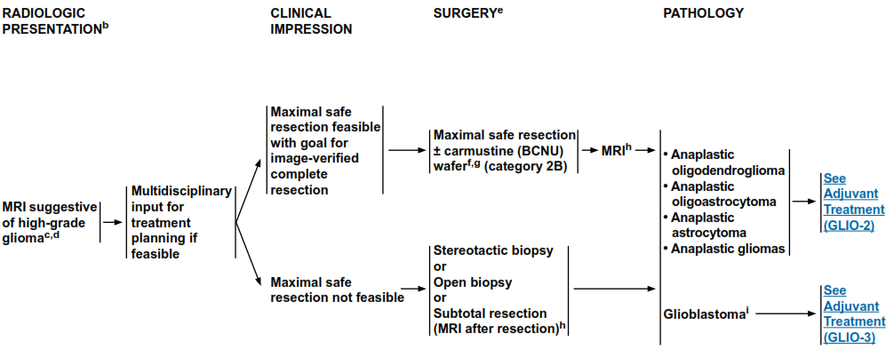
Source: NCCN guidelines Version 2.2014

Figure 2 Treatment algorithm for adjuvant therapy of anaplastic gliomas/glioblastoma
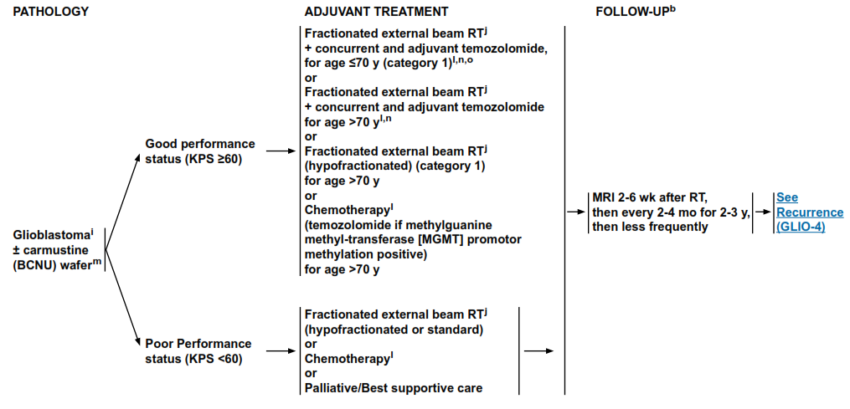
Source: NCCN guidelines Version 2.2014

Figure 3 Treatment algorithm for recurrent anaplastic gliomas/glioblastoma
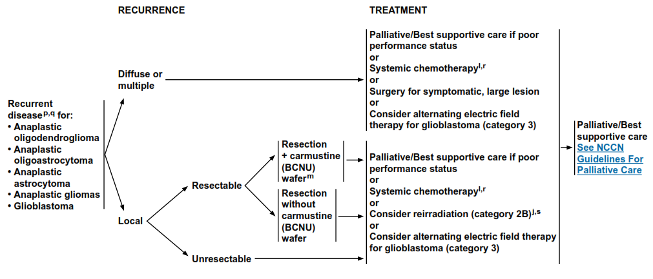
Source: NCCN guidelines Version 2.2014

Comparator
The comparator is resection of malignant glioma that is considered to be GBM on preoperative imaging, using a standard white light operating microscope (“standard surgery”).

Comparative safety
The assessment report identified one randomised controlled trial (MC-ALS.3/GLI) that compared fluorescence-guided resection using oral ALA with standard surgery for GBM. (medac, 2009).

There were more adverse events related to neuromotor, speech impairment, and impaired vision within 7 days post-surgery in the ALA-group. The type and number of patients with serious adverse events were similar except for more convulsions, hemiparesis, aphasia, and pulmonary embolism reported in the ALA-group. The only statistically significant difference was for pulmonary embolism. Moreover, there was evidence that the ALA group were more likely to experience worsening of their neurological status at 48 hours post-surgery.

There was greater deterioration on the NIH stroke score in the ALA-group at 48 hours post-surgery compared to the standard surgery-group, but only in those participants who had a NIH score >0 at baseline. The differences improved over time and by 7 days post-surgery were no longer statistically significant.

Brain oedema was also identified as a concern associated with fluorescence-guided resection with ALA. The Assessment report stated that cautions and guidance were provided to patients with tumours near brain areas with important neurological function.

Comparative effectiveness
There is evidence that fluorescence-guided resection using ALA is associated with higher rates of complete resection in those people with definitive high grade glioma compared to standard surgery using white light. Using two approaches, there is also evidence that the ALA-group had greater progression-free survival at 6-months. There was no difference for any other time point.

The critique noted that the intervention met the requirements for superiority for these two outcomes but not for the other outcomes included e.g. overall survival.
The results for patients without residual tumour and for progression-free survival are shown in Tables 2 and 3.

Table 2 Percentage of Patients without Residual Tumour in the MC-ALS.3/GLI trial
Study ID | Risk of bias | Intervention  n with event/N (%) | Comparator  n with event/N (%) | ARR (95% CI) | NNT (95% CI) | OR (95% CI)
MC-ALS.3/GLI | low | 112/176 (63.6) | 65/173 (37.6) | 26.1 (15.9, 36.2) | 4 (2.8, 6.3) | 2.91 (1.88, 4.49)
Abbreviations: ARR, absolute risk reduction; CI, confidence interval; NNT, number needed to treat; OR, odds ratio.
Source: MC-ALS.3/GLI Final Study Report Figure 11.4.1.1.1 p.103

Table 3 Result of progression-free survival in the MC-ALS.3/GLI trial
Visit | Risk of bias | Intervention  n with event/N (%) | Comparator  n with event/N (%) | ARR (95% CI) | NNT (95% CI) | OR (95% CI)
6-month visit | low | 36/176 (20.5) | 19/173 (11.0) | 9.5 (1.9, 17.0) | 11 (5.9, 52.4) | 2.08 (1.12, 3.88)
9-month-visit | low | 18/176 (10.2) | 9/173 (5.2) | 5.0 (–0.5, 10.6) | 20 | 2.08 (0.91, 4.76)
12-month-visit | low | 11/176 (6.3) | 6/173 (3.5) | 2.8 (–1.7, 7.3) | 36 | 1.86 (0.67, 5.13)
15-month-visit | low | 6/176 (3.4) | 3/173 (1.7) | 1.7 (–1.6, 5.0) | 60 | 2.00 (0.42, 12.53)
18-month-visit | low | 4/176 (2.3) | 2/173 (1.2) | 1.1 (–1.6, 3.8) | 90 | 1.99 (0.28, 22.21)
Abbreviations: ARR, absolute risk reduction; CI, confidence interval; NNT, number needed to treat; OR, odds ratio.
Source: medac 2009, MC-ALS.3/GLI Final Study Report Table 11.4.1.2.2A p.108, Table 11.4.1.4A p.116
On the basis of the benefits and harms reported in the evidence base, the submission based assessment proposed that, relative to standard surgery with white light, fluorescence-guided resection with ALA has non-inferior safety and superior effectiveness.

Economic evaluation
A cost utility analysis was presented in the Assessment Report. A summary of the key characteristics of the economic evaluation is given in Table 4.

Table 4 Summary of the economic evaluation
Perspective | Australian health care system
Comparator | Standard surgery under white light
Type of economic evaluation | Cost-utility
Sources of evidence | MC-ALS.3/GLI trial; Stummer et al (2012 & unpublished data)
Time horizon | Five years
Outcomes | Cost per life year gained (LY), cost per quality adjusted life year gained (QALY), and cost per year gained free of progression (DFS)
Methods used to generate results | Markov model
Health states | Surgery, stable disease with complete resection, stable disease with partial resection, progressive disease and death.
Cycle length | One week
Discount rate | 5%
Software packages used | Microsoft Excel 2016
The economic analysis was based on the Markov model which is a copy of the model in the report by medac (2012) published as Esteves S et al 2015. The model was adapted to the Australian setting. The model described the natural evolution of the disease, namely its progression and respective deterioration of health status in patients over time. Five health states were considered: surgery, stable disease with complete resection, stable disease with partial resection, progressive disease and death.
The overall costs and outcomes, and incremental costs and outcomes as calculated for the intervention and comparator in the model (provided by the applicant), and using the base case assumptions, are shown in Table 5.

Table 5 Incremental costs and effectiveness
 | ALA | Standard surgery | Difference
Cost | $redacted | $redacted | $redacted
QALYs | redacted | redacted | redacted
LYS | redacted | redacted | redacted
DFS | redacted | redacted | redacted
ICUR (cost per QALY) |  |  | $56,836
ICER (cost per LY gained) |  |  | $41,233
ICER  (cost per year without disease progression) |  |  | $53,613
Abbreviations: DFS, disease-free survival; ICER, Incremental Cost Effectiveness Ratio; ICUR, Incremental Cost Utility Ratio; LYS, life year saved; QALY, quality adjusted life year

Financial/budgetary impacts
An epidemiological approach was used to estimate the financial implications of the introduction of fluorescence-guided resection of GBM with oral ALA.

The SBA assumed that 50% of patients would receive an extra dose of ALA.
The financial implications to the MBS resulting from the proposed listing of fluorescence-guided resection of GBM with ALA are summarised in Table 6. The listing is expected to cost approximately $redacted million per year in the fifth year of listing.

Table 6 Total costs to the MBS associated with fluorescence-guided resection of GBM with ALA
 | 2017 | 2018 | 2019 | 2020 | 2021
Total number of resections using ALA | redacted | redacted | redacted | redacted | redacted
Total vials of oral ALA | redacted | redacted | redacted | redacted | redacted
Cost of oral ALA | $redacted | $redacted | $redacted | $redacted | $redacted
Cost to the MBS* | $redacted | $redacted | $redacted | $redacted | $redacted
Cost to the MBS*  (patients receive only 1 vial)** | $redacted | $redacted | $redacted | $redacted | $redacted
* Applicant amended data, applying 75% MBS rebate
** Equates to unit cost of ALA of $redacted in original model

Key issues from ESC for MSAC
An MBS fee has not been proposed for the medical service; however a unit cost of $redacted was applied to oral ALA (Gliolan®) in the economic evaluation without justification. ESC noted that a 2012 unit cost of €redacted (~AUD$redacted ) was used in a Portuguese economic evaluation of the medical service, which used an identical Markov model to that used in the present submission-based assessment.

ESC was uncertain about the need for the proposed MBS item for patients weighing >75 kilograms requiring a second vial of Gliolan®, as in practice few if any patients receive a second vial of Gliolan® either in Australia or elsewhere, by the Applicant’s admission.
ESC noted that the clinical evidence for safety and effectiveness of the medical service is derived from one company-sponsored, randomised, open-label, multicentre study.
ESC considered that the results of the study should be interpreted cautiously because of the risk of attrition and performance bias. No evidence was provided to support use of the medical service for tumour recurrence.
ESC noted that outcomes assessed in the study are not consistent with outcomes in the protocol. Validity and accuracy of additional outcomes: event-free survival; Karnofsky performance score; and NIH Stroke Scale, were not addressed in the assessment report.
ESC noted that the medical service had similar safety outcomes to the comparator apart from a higher risk of pulmonary embolism. Patients randomised to ALA were more likely to experience worsening of neurological functioning at 48 hours post-surgery; differences were no longer significant by 7 days post-surgery and may reflect more extensive resection.
ESC noted that there was a significant improvement in progression-free survival
6 months post-surgery for patients randomised to ALA, but there were no other significant differences for any other time point. There was a paucity of data on other outcomes, particularly overall survival (for which the trial was underpowered), which is an extremely relevant outcome given the short survival of patients with GBM.

The key drivers of the economic model were the percentage of patients administered more than one vial of ALA and the percentage of patients achieving complete resection.
ESC was concerned that the sensitivity of the model to the unit cost of ALA was not explored and is likely to be an important driver for the model.

ESC noted that the key trial did not control for subsequent therapies and patient
follow-up stopped after two years. Transition probabilities for progression-free survival and overall survival in the economic model were therefore based on an observational study by Stummer (2012 & unpublished) which also used adjuvant chemoradiation, the current standard of care.
ESC noted that there were Kaplan-Meier curves of progression-free and overall survival for both the randomised trial and the observational study and suggested that the applicant provide further information using in its pre-MSAC response using the full (intention-to-treat) dataset were used as the basis of these curves rather than the per-protocol dataset.
It was noted that, for the two primary outcomes – the proportion of patients without residual tumour and PFS – the results may be confounded, respectively, by the uncertain impact of surgical expertise and by modern adjuvant treatments. Adjuvant treatments have changed over time since the primary studies were published, with newer options for adjuvant chemotherapy as well as newer radiotherapy techniques.
ESC noted that the economic model did not capture patients who received ALA, but were subsequently shown not have GBM on histology. ESC considered that the model should include these patients in order to capture the cost of ALA more accurately.
ESC considered that availability of fluorescence-capable operating microscopes in private hospitals may limit uptake of the medical service, at least initially; this has not been included in the projections of financial impact. ESC also considered that there is potential for cost shifting between the public and private sector.

Other significant factors
Nil.

Applicant’s comments on MSAC’s Public Summary Document
Specialised Therapeutics is disappointed with MSAC's decision and will work with the department to determine a way forward.

Further information on MSAC
MSAC Terms of Reference and other information are available on the MSAC Website:
visit the MSAC website

