RATIFIED PICO

MSAC Application 1631:
Home Sleep Apnoea Test (HSAT) utilising Peripheral Arterial Tone (PAT)

Summary of PICO/PPICO criteria to define the question(s) to be addressed in an Assessment Report to the Medical Services Advisory Committee (MSAC)
Component | Description
Patients | Patients aged 18 and older with sleep-related breathing disorders (SRBDs) that have been assessed by either:  - a medical practitioner, and the patient shows clinical signs and symptoms indicating a high probability of moderate or severe obstructive sleep apnoea (OSA), determined by:  - STOP-Bang score of 3 or more AND an Epworth Sleepiness Scale score of 8 or more; OR  - OSA50 score of 5 or more AND an Epworth Sleepiness Scale score of 8 or more; OR  - High risk score on the Berlin Questionnaire AND an Epworth Sleepiness Scale score of 8 or more; OR  - a qualified sleep medicine practitioner or a consultant respiratory physician, and following professional attendance on the patient (either face‑to‑face or by video conference) the qualified sleep medicine practitioner or consultant respiratory physician determines that investigation is necessary to confirm the diagnosis of obstructive sleep apnoea.
Prior tests  (for investigative medical services only) | No prior test
Intervention | WatchPAT™ - home sleep apnoea test (HSAT) utilising peripheral arterial tone (PAT)
Comparator | The primary comparator is unattended Level 2 polysomnography (PSG) sleep studies.  The secondary comparator (and reference standard) is attended (i.e. in-laboratory) Level 1 PSG studies.
Outcomes | Efficacy,:  Primary comparator:  - Clinical sensitivity and specificity of diagnosis, and grading, of OSA comparing HSAT utilising PAT compared against Level 2 PSG.  - Positive and negative predictor values of HSAT utilising PAT compared against Level 2 PSG for the diagnosis of severity of OSA.  - HSAT utilising PAT bivariate correlation coefficient with other Level 2 PSG variables.  - Failure rates for HSAT utilising PAT and for Level 2 PSG (the proportion who have a re-test may be a sub-proportion of all test failures).  Secondary comparator:  - Clinical sensitivity and specificity of HSAT utilising PAT compared against Level 1 PSG for the diagnosis of severity of OSA.  - Positive and negative predictor values of HSAT utilising PAT compared against Level 1 PSG for the diagnosis of severity of OSA.  - HSAT utilising PAT bivariate correlation coefficient with Level 1 PSG variables.  - Failure rates for HSAT utilising PAT versus Level 1 PSG (the proportion who have a re-test may be a sub-proportion of all test failures).  Safety:  - No known additional safety issues proposed or have been identified by MSAC previously for Level 2 PSG testing. No known safety issues were identified by the applicant for WatchPAT™.  Healthcare resources:  - Cost of the WatchPAT™ device in comparison to the replacement study device (i.e. whether Level 1 or Level 2).  - Total number of HSAT utilising PAT tests estimated to be funded through the MBS per year.  - Reduction in Level 1 PSG tests.  - Number of services (e.g. specialist visits and surgeries) funded through the MBS, that are estimated to occur due to increased OSA diagnosis.  - Associated costs/cost offsets to the MBS, resulting from the assessments above.  - Change in cost of managing moderately and severely affected patients with OSA arising from a difference in categorisation using different Level 2 devices.  - Sleep scientist and sleep technician time for HSAT utilising PAT test compared to level 2 test.  - Cost of funding previously unfunded OSA diagnostic investigations.  Cost-effectiveness:  - HSAT utilising PAT is cost neutral compared to other Level 2 sleep study devices.  - Cost-minimisation analysis of: the cost per positive diagnosis of obstructive sleep apnoea compared to Level 1 PSG testing.  - Cost-consequence analyses of: the cost per patient (whose OSA is correctly identified with HSAT utilising PAT); and incremental cost per incremental number of patients (whose OSA is correctly identified with HSAT utilising PAT), compared with current Level 2 PSG tests funded through the MBS.  Total Australian Government healthcare costs:  • Cost of at home sleep apnoea study and cost offset by avoiding sleep studies in hospital.  - Uptake in MBS services for the management of OSA.

PICO or PPICO rationale for therapeutic and investigative medical services only

Population
The proposed population are patients aged 18 and older with sleep-related breathing disorders (SRBDs) that have been assessed by a medical practitioner and who show clinical signs and symptoms indicating a risk of moderate to severe obstructive sleep apnoea (OSA). Signs and symptoms of OSA can include impaired neurocognitive function, daytime somnolence, snoring, oxyhaemoglobin desaturation, repeated arousals and fragmented sleep.
Sleep apnoea (SA), is the most common type of SRBD. The most common form of SA is OSA. Additional types of SA such as Central Sleep Apnoea (CSA) and Mixed Sleep Apnoea are other types of SRBDs. OSA has been associated with a range of pathophysiological changes that impair cardiovascular function, including increased blood inflammatory markers and repeated rises in blood pressure. OSA is strongly linked to adverse health outcomes such as coronary heart disease, stroke, atrial fibrillation, diabetes, hypertension and greater mortality risk.
The severity of OSA is categorised by the frequency of obstructive respiratory events and defined by the Apnoea Hypopnoea Index (AHI), which is the average number of respiratory disturbances per hour of sleep. Mild OSA is defined as an AHI ≥5 to <15 events/hour, moderate OSA is defined as an AHI 15 to <30 and severe OSA is defined as an AHI ≥30 events/hour.,
The prevalence of OSA in the general adult population, has estimates as high as 38%, depending on the population studied and definition used.⁶ Much of this prevalent OSA is mild in severity and minimally symptomatic. However, although not associated with adverse vascular sequelae, mild OSA may still be associated with troublesome daytime symptoms in some subjects. Moderate-to-severe OSA (all patients with AHI ≥15 events/hour) is more commonly symptomatic and is associated with other adverse outcomes such as cardiovascular and cerebrovascular disease, cognitive decline, motor vehicle accidents and depression⁴. Moderate to severe AHI is found in 6–17% of the general adult population, with a recent Australian study showing a prevalence of 8.3%.^{3,} In general, both mild OSA plus daytime symptoms and moderate-to-severe OSA are indications to consider OSA treatment.
The applicant has estimated that 5-7.5% of the Level 1 PSG tests (MBS item codes 12203-12205) and 9-13.5% of the home based PSG tests (MBS item code 12250) will be substituted with the proposed intervention in the first year of listing. This assumption was based on market uptake in the European Union (EU). After the first year of listing, the applicant assumes a 5-10% annual growth in uptake thereafter.
In the 2018-2019 financial year, there were:
- 75,670 services billed for item codes 12203-12205. There was a low re-test rate among these tests, as 49 services were billed to item 12208 (repeat study following a failed study under 12203) from 63,371 in the same period (0.08%).
- 86,056 services billed for item code 12250.
Using these parameters and the applicant’s assumptions:
- 3,784-5,675 services will be offset (i.e. clinicians will use WatchPAT™ instead of Level 1 PSG devices where appropriate) from item codes 12203-12205 and,
- 7,745-11,618 services will be offset (i.e. clinicians will use WatchPAT™ instead of other Level 2 PSG devices) from item code 12250.
For the first year of listing, it is assumed that 11,259 to 17,293 services will use the proposed intervention. It is anticipated that growth in the use of HSAT utilising PAT would increase by approximately 5-10% each year thereafter.
PASC noted that the uptake may be underestimated, because proposed amendments to MBS items 12203 and 12250 to reduce the STOP-BANG criteria from a score of 4 to 3 will increase the number of patients eligible for referral for sleep studies by General Practitioners. In addition, the application noted a large pool of Australian patients with OSA who are currently un-diagnosed, who may be able to avail themselves of the technology.

Rationale
Upon presentation to a General Practitioner (GP), if it is likely upon assessment that the patient, who is 18 years or older, has SRBDs with a high probability for symptomatic moderate to severe OSA, the patient will be either proceed to a sleep study or be referred to a sleep specialist. The patient’s co-morbidities and concomitant medications would also be considered to determine the most appropriate level of sleep study. GPs may directly refer patients for a sleep test by determining eligibility through the administration of the STOP-Bang Questionnaire or the OSA50 Questionnaire or the Berlin Questionnaire; and the Epworth Sleepiness Scale.
If the GP refers the patient with suspected sleep disorders to a sleep medicine specialist or respiratory physicians, the sleep medicine specialist or the respiratory physician may determine whether a patient has a high probability of symptomatic moderate to severe OSA. This is determined by administering a screening questionnaire as detailed above and/or following a professional attendance. The patient may then proceed to a sleep test to determine if there is a diagnosis of OSA, and its severity.
The proposed intervention (WatchPAT™) is to be restricted to adults aged 18 years. The use of the WatchPAT™ is not indicated in individuals:
- that require medications such as alpha blockers, short acting nitrates (less than 3 hours before the study)
- with a permanent pacemaker (i.e. atrial pacing or VVI without sinus rhythm) and/or
- with sustained* non-sinus cardiac arrhythmias.
In the setting of sustained arrhythmia, the WatchPAT’s automated algorithm might exclude some periods of time, resulting in a reduced valid sleep time. A minimum valid sleep time of 90 minutes is required for an automated report generation. It should be noted however that 90 minutes is significantly less time than what is included in the current MBS item 12250, where the requirement ‘for a period of at least 8 hours duration’ means the overnight investigation (including patient set-up time and actual period of recording) must be of at least 8 hours duration.
PASC advised that ‘Or following referral by a medical practitioner (upon meeting sleep questionnaire criteria) for review by a qualified sleep medicine practitioner or a consultant respiratory physician’ should be added to the population description.
The applicant agreed with the PASC’s consideration of the population.

Intervention
WatchPAT™ is a HSAT that utilises the peripheral arterial tone (PAT™). It measures up to seven channels (PAT™ signal, heart rate, oximetry, actigraphy (body movement), body position, snoring sound level, and chest motion) via three points of contact. The WatchPAT™ device is attached at the patients’ chest, wrist and finger and is worn by the patient at home while they sleep.11
Figure 1 shows the three different points of contact:
- The wrist unit which includes the actigraphy sensor
- The chest sensor which includes a controller, a microphone for recording snoring sound level (measured in decibels [dB]) and an accelerometer that measures body position and chest movement and
- The finger sensor (using the PAT signal) which is used for the measurement of oxygen saturation, peripheral arterial tonometry and heart rate.¹⁴
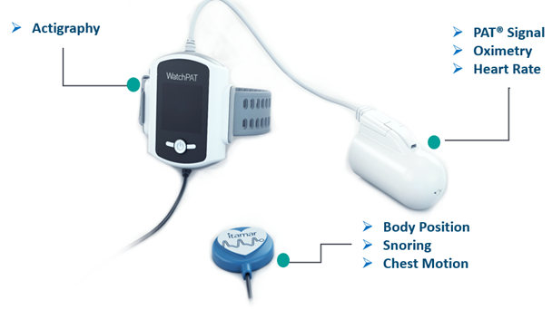

Figure 1: WatchPAT device showing three points of contact with the patient body that incorporate seven measured signals
Source: Department of Health. 2020. MSAC 1631 – Application form: HSAT utilising PAT
The WatchPAT generates a PAT respiratory disturbance index (PRDI), PAT Apnoea Hypopnea Index (PAHI), PAT central Apnoea-Hypopnea Index (PAHIc), percentage of total sleep time with Cheyne-Stokes Respiration pattern (%CSR) and PAT sleep staging identification (PSTAGES). The WatchPAT™ respiratory indices and sleep stages are estimates of conventional values and stages identification that are produced by PSG. The WatchPAT™ also incorporates an acoustic decibel detector used for snoring level and body position discrete states from the chest sensor. WatchPAT™ provides AHI, AHIc, Respiratory Disturbance Index (RDI), and Oxygen Desaturation Index (ODI) based upon True Sleep Time and Sleep Staging. AHI represents the number of apnoea-hypopnoea events per hours of sleep. ODI represents the number of desaturation event per hours of sleep. RDI represents the number of abnormal breathing events per hour of sleep. These indices are calculated by dividing the total number of events by the hours of sleep time that might be different from actual recording time.¹⁴
The PAT based technology is a form of Photoplethysmography (PPG) which is a measurement of blood volume (i.e. it measures the pulsatile changes of peripheral arterial blood volume),. However, PAT includes two elements that distinguish it from standard PPG technologies⁹:
- A unified pressure field around the distal part of the finger, and around the tip of the finger, that:
- prevents venous blood pooling and
- allows a partial unloading of arterial wall tension, that significantly increases the dynamic range of the measured signal (and thus provides a robust and clear signal with minimum artefacts).
The pressure field also buffers the measuring site which means it eliminates retrograde flow artefacts.
- An isosbestic wavelength that is not affected by the oxygen saturation level, and therefore, changes in the plethysmography amplitude provides a more accurate measurement of the changes in arterial blood changes.¹⁴
The WatchPATs’ PSTAGES, (sleep architecture) snoring level and body position provide supplemental information to its PRDI/PAHI/PAHIc as well as differentiate between REM related Sleep Apnea (SA) and non REM SA. The WatchPATs’ PSTAGES, snoring level and body position are not intended to be used as the sole or primary basis for diagnosing any SRBD, prescribing treatment, or determining whether additional diagnostic assessment is warranted.
The methodology of WatchPAT™ which uses PAT in conjunction with pulse oximetry, chest movement, snoring and actigraphy to detect sleep apnoea¹¹ is based on an apnoeic event that is terminated by a sympathetic arousal. Such arousal comprises, amongst other parameters, two simultaneous physiological changes:
- Peripheral vascular constriction
- Increase in heart rate.
Both physiological parameters can be extracted from the PAT signal, and therefore an apnoeic event is presented through a reciprocal pattern of both of these.¹⁴
There are two different versions of the WatchPAT™ devices available:
- WatchPAT™ ONE – single-use (i.e. fully disposable) HSAT device may be used by anyone who has access to a smart phone and an internet connection
- WatchPAT™ 300 – requires the use of two multi-use components, the wrist unit and the chest sensor, and a single-use finger sensor.¹⁴
The WatchPAT™ 300 was FDA approved on 17 August 2018 and will gradually replace WatchPAT™ 200. In terms of accessibility, the WatchPAT™ ONE incorporates the same technology as the WatchPAT™ 300 but due to the WatchPAT™ ONE being fully disposable it can be posted to the patients’ home and does not require collection from or return to a sleep clinic or physician’s office. This way patients can still access the test even if they live in remote areas or are limited in their ability to travel.¹⁴ In addition to 24/7 customer support, tutorial videos are available online for patients wishing to use the device from home. The applicant provided reference to ARTG 206199 which is for a sleep assessment device that is sponsored by Excellcare Pty Ltd. Under intended purpose it does state that “…..measure the peripheral arterial tonometry (PAT) signal”.
The applicant clarified that ARTG number 206199 encompasses all WatchPAT™ devices and the registration is appropriate for a Class IIa medical device and that it is common for registrations of devices not to include brand names. Further, the applicant advised that Excellcare Pty Ltd is the authorised distributor of WatchPAT™ devices in Australia. PASC noted the clarification about the listing of the WatchPAT device on the TGA.
The WatchPAT™ sleep report includes the following:
- Recording time
- Sleep data:
  - Total Sleep Time
  - Sleep latency
  - REM latency
  - Number of wakes
  - Sleep stages (Wake, Light, Deep and REM)
- Respiratory Breathing Disorder indices, calculated based on Total Sleep Time:
  - PAT Respiratory Disturbance Index (PRDI)
  - PAT Apnoea Hypopnea Index (PAHI)
  - Oxygen Desaturation Index (ODI)
  - PAT Central Apnoea Hypopnea Index (PAHIc)
  - Cheyne Stokes Respiration (CSR; central periodic breathing patterns) percentage
All indices (except CSR) are available as a nightly average, a REM period value and a Non-REM period values
- Oxygen saturation – summary of values (i.e. SaO2 (%); refer to Figure 2)
- Heart rate – summary of values (i.e. pulse rate/BPM; refer to refer to Figure 2)
- Body position data – a breakdown of all the indices per body position.
- Snoring volume level – statistics of snoring levels throughout the night.

Figure 2 shows the visual spread of the data through the entire night. Respiratory events presented at the top (blue); then snoring (orange) and body position; then oxygen desaturations (black) and heart rate; then sleep stages at the bottom.

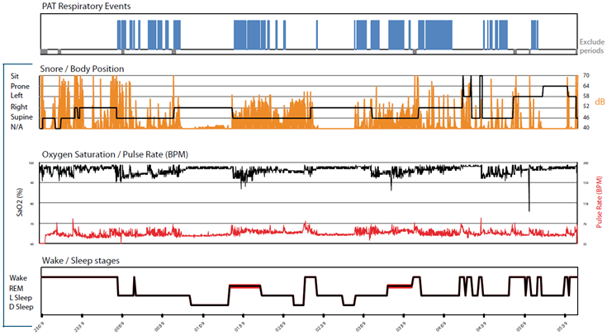

Figure 2: The hypnogram from a WatchPAT™ automated sleep report.
Source: MSAC 1631 – Application form: HSAT utilising PAT
Within one minute post-study, the raw data may be downloaded and auto-scored identifying suspected apnoea events. For an automated report generation, a minimum valid sleep time of at least 90 minutes is required. In the case of sustained (nonsinus) arrhythmia, the minimum valid sleep time might not be reached as the WatchPAT™’s automated algorithm might exclude some periods of time, resulting in a reduced valid sleep time (i.e. less than 90 minutes).¹⁴ Sustained arrhythmias are an exclusion criterion as they might have a potential effect on PAT amplitude and heart rate changes.
Although the report and results are generated automatically by the software, until recently, there was no validated method to assess and manually review and adjust the automated report, in cases of suspected inaccuracy. This issue was addressed in a recent study by the sleep research team at Johns Hopkins University, led by Prof Alan Schwartz, who introduced simple guidelines to perform manual review and adjustment of the PAT automated scoring. The study showed that the application of manual review of the automated PAT report improved correlation and agreement with PSG derived sleep and breathing indices. In most cases, the applicant stated that manual adjustment is not necessary. If necessary, this takes less than 10 minutes by a trained physician or technician.
According to the manufacturer, the recommended time for a sleep study using PAT is at least 6 hours of total sleep time. This is lower than the minimum eight-hour requirement under MBS code 12250. The signals measured are recorded and stored on the device so that they can be downloaded onto a computer or when using the WatchPAT 1 device uploaded via a smartphone to the cloud, where they are analysed utilising proprietary algorithms. The interpretation of the test results is undertaken by a sleep technologist or a sleep physician which has been accredited by the Australasian Sleep Association (ASA) and the National Association of Testing Authorities Australia (NATA).¹⁴ The applicant has stated that if the device is reimbursed under the MBS in Australia the company will provide a clinical leader who will oversee training in Australia. This is the same model used to establish use of the device in other markets (e.g. Europe). It was also anticipated, by the applicant, that a training program would become available under the supervision of the ASA if the device was being widely used in Australia.
While the service is delivered under the supervision of a sleep clinic, the attendance of a sleep technician is not required.¹⁴ This is different to other currently conducted methods (refer to Comparator section, Table 2) that either involve an in-laboratory tests (Level 1 PSG) or a test at home (Level 2 PSG) which generally requires the attendance of a sleep technician to apply the device (i.e. EEG sensors). Level 1 PSG’s are considered the gold standard in confirming a diagnosis of OSA.²³ However, as Level 1 PSG requires in-laboratory tests, it can be inconvenient to perform and can cause delays as patients are generally on waiting lists to receive a test.^{11,}
PASC confirmed the intervention but noted the need to consistently define the minimum number and type of variables for which information is collected so that the intervention is device agnostic. PASC noted that the intervention is currently being used in Australia (without reimbursement) but that the quantum of use is unclear. PASC noted concern that the intervention is potentially being used by non-sleep specialists / practitioners in Australia, in particular a publication by the Australian Sleep Association reported a dentist using the intervention outside of their scope of practice.
The applicant noted that while the device may have been used by dentists to titrate patients using mandibular splints to treat OSA, it considered that this is likely to be no different to dentists using current Level 2 PSG devices for the same purpose. However, Level 2 PSG devices generally require the attendance of a sleep technician to apply the device, which makes Level 2 PSG devices unlikely to be used in this setting.
PASC noted the potential advantages of a disposable WatchPAT device, in that it does not need to be returned, and thus infection control issues between patients and providers are minimised. This is especially relevant in relation to the COVID-19 pandemic, as there are no instructions on cleaning or sterilising non-disposable WatchPAT devices. The applicant clarified that cleaning and sterilising instructions for non-disposable WatchPAT devices are available in the operational manual.

Rationale
As previously mentioned, PSG studies can lead to delayed testing, be costly and cumbersome due to requiring in-lab testing (Level 1 PSG) or a sleep technician attending a patients’ home to apply the test (other Level 2 PSG (i.e. not WatchPAT™).¹¹ WatchPAT™ device application is seeking to use the same pathway as a Level 2 PSG device. The WatchPAT™ interface is considered to be user-friendly¹¹. WatchPAT™’s claims to have validated ability to accurately measure the total sleep time. With respect to diagnostic accuracy, a prospective, blinded, non-randomised clinical trial which presented a comparison of PSG and the WatchPAT™ in the diagnosis of OSA found that the sensitivity and specificity of detecting a patient with OSA at AHI >5 events per hour was 94% and 80%, respectively. At an AHI >15, the sensitivity and specificity were 96% and 79%, respectively. The sensitivity of detecting a patient with severe AHI (i.e. AHI >30) was 83% and the specificity was 72%. A multicentre study found that the sensitivity and specificity of the WatchPAT™ versus PSG for diagnosing sleep apnoea using a threshold of AHI ≥15 were 85% and 70%, respectively and agreement was 79% (kappa = 0.867).17 A small (n=20 subjects) study found that when compared to PSG the WatchPAT™ showed 100% specificity for mild (AHI >5) and severe OSA (AHI>30) and 100% sensitivity for mild OSA.

Comparator
The ASA Guidelines⁸ define four levels of sleep studies for diagnosing OSA according to the type and number of parameters measured (Table 1). The application considers unattended Level 2 PSG sleep studies as the main comparator to the intervention (i.e. HSAT using PAT technology). Level 1 PSG sleep study is the secondary comparator.
PASC advised that the most appropriate comparator is a Level 2 PSG study (MBS item 12250).
The applicant agreed that Level 2 PSG is the test most likely to be replaced by the WatchPAT™, however it considered that all clinical evidence validates WatchPAT™ against Level 1 PSG.
An unattended Level 2 PSG home sleep study generally requires a pre-meeting with a sleep technician. The sleep technician may apply the sensors at the clinic and the patient will leave the clinic wearing the sensors or the sleep technician may attend the patient’s home.
An attended Level 1 PSG sleep study routinely involves 12 to 13 recording channels while, an unattended Level 2 PSG sleep study usually maintains a minimum of seven recording channels. The amount of information recorded in a sleep study reduces as the level of the sleep study increases.⁶² Currently only Level 1 PSG (refer to Table 3) and Level 2 PSG (refer to Table 2) sleep studies are listed on the MBS. Once a referral has been made for a sleep study, the test may be performed as an attended Level 1 PSG at a sleep laboratory or as an unattended Level 2 PSG at the patient’s home if the referring physician deems the patient suitable for an unattended Level 2 PSG sleep study.

Table 1 Types of sleep study
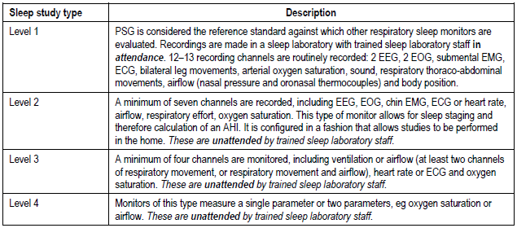
Source: MSAC 1130 Final report Table 1 p2
Abbreviations: AHI, apnoea-hypopnoea index; ECG, electrocardiogram; EEG, electroencephalography; EMG, electromyogram; EOG, electrooculogram; PSG, polysomnography

Table 2 Existing MBS items for Level 2 PSG sleep studies for obstructive sleep apnoea (main comparator)
MBS Item Number | Description | Cost
12250 | Overnight investigation of sleep for a period of at least 8 hours of a patient aged 18 years or more to confirm diagnosis of obstructive sleep apnoea, if:  (a) either:  (i) the patient has been referred by a medical practitioner to a qualified sleep medicine practitioner or a consultant respiratory physician who has determined that the patient has a high probability for symptomatic, moderate to severe obstructive sleep apnoea based on a STOP‑Bang score of 3 or more, an OSA50 score of 5 or more or a high risk score on the Berlin Questionnaire, and an Epworth Sleepiness Scale score of 8 or more; or  (ii) following professional attendance on the patient (either face‑to‑face or by video conference) by a qualified sleep medicine practitioner or a consultant respiratory physician, the qualified sleep medicine practitioner or consultant respiratory physician determines that investigation is necessary to confirm the diagnosis of obstructive sleep apnoea; and  (b) during a period of sleep, there is continuous monitoring and recording, performed in accordance with current professional guidelines, of the following measures:  (i) airflow;  (ii) continuous EMG;  (iii) continuous ECG;  (iv) continuous EEG;  (v) EOG;  (vi) oxygen saturation;  (vii) respiratory effort; and  (c) the investigation is performed under the supervision of a qualified sleep medicine practitioner; and  (d) either:  (i) the equipment is applied to the patient by a sleep technician; or  (ii) if this is not possible—the reason it is not possible for the sleep technician to apply the equipment to the patient is documented and the patient is given instructions on how to apply the equipment by a sleep technician supported by written instructions; and  (e) polygraphic records are:  (i) analysed (for assessment of sleep stage, arousals, respiratory events and cardiac abnormalities) with manual scoring, or manual correction of computerised scoring in epochs of not more than 1 minute; and  (ii) stored for interpretation and preparation of report; and  (f) interpretation and preparation of a permanent report is provided by a qualified sleep medicine practitioner with personal direct review of raw data from the original recording of polygraphic data from the patient; and  (g) the investigation is not provided to the patient on the same occasion that a service mentioned in any of items 11000 to 11005, 11503, 11700 to 11709, 11713 and 12203 is provided to the patient  Applicable only once in any 12 month period  (See para DN.1.17 of explanatory notes to this Category) | Fee: $345.75 Benefit: 75% = $259.35 85% = $293.90
Source: MBS online (accessed July 2020)
Abbreviations: ECG, electrocardiogram; EEG, electroencephalography; EMG, electromyogram; EOG, electrooculogram; MBS, Medicare benefits schedule PSG, polysomnography
Table 3 Existing MBS items for Level 1 PSG sleep studies for obstructive sleep apnoea (secondary comparator)
MBS Item Number | Description | Cost
12203 | Overnight diagnostic assessment of sleep, for a period of at least 8 hours duration, for a patient aged 18 years or more, to confirm diagnosis of a sleep disorder, if:  (a) either:  (i) the patient has been referred by a medical practitioner to a qualified sleep medicine practitioner or a consultant respiratory physician who has determined that the patient has a high probability for symptomatic, moderate to severe obstructive sleep apnoea based on a STOP‑Bang score of 3 or more, an OSA50 score of 5 or more or a high risk score on the Berlin Questionnaire, and an Epworth Sleepiness Scale score of 8 or more; or  (ii) following professional attendance on the patient (either face‑to‑face or by video conference) by a qualified sleep medicine practitioner or a consultant respiratory physician, the qualified sleep medicine practitioner or consultant respiratory physician determines that assessment is necessary to confirm the diagnosis of a sleep disorder; and  (b) the overnight diagnostic assessment is performed to investigate:  (i) suspected obstructive sleep apnoea syndrome where the patient is assessed as not suitable for an unattended sleep study; or  (ii) suspected central sleep apnoea syndrome; or  (iii) suspected sleep hypoventilation syndrome; or  (iv) suspected sleep‑related breathing disorders in association with non‑respiratory co‑morbid conditions including heart failure, significant cardiac arrhythmias, neurological disease, acromegaly or hypothyroidism; or  (v) unexplained hypersomnolence which is not attributed to inadequate sleep hygiene or environmental factors; or  (vi) suspected parasomnia or seizure disorder where clinical diagnosis cannot be established on clinical features alone (including associated atypical features, vigilance behaviours or failure to respond to conventional therapy); or  (vii) suspected sleep related movement disorder, where the diagnosis of restless legs syndrome is not evident on clinical assessment; and  (c) a sleep technician is in continuous attendance under the supervision of a qualified sleep medicine practitioner; and  (d) there is continuous monitoring and recording, performed in accordance with current professional guidelines, of the following measures:  (i) airflow;  (ii) continuous EMG;  (iii) anterior tibial EMG;  (iv) continuous ECG;  (v) continuous EEG;  (vi) EOG;  (vii) oxygen saturation;  (viii) respiratory movement (chest and abdomen);  (ix) position; and  (e) polygraphic records are:  (i) analysed (for assessment of sleep stage, arousals, respiratory events, cardiac abnormalities and limb movements) with manual scoring, or manual correction of computerised scoring in epochs of not more than 1 minute; and  (ii) stored for interpretation and preparation of report; and  (f) interpretation and preparation of a permanent report is provided by a qualified sleep medicine practitioner with personal direct review of raw data from the original recording of polygraphic data from the patient; and  (g) the overnight diagnostic assessment is not provided to the patient on the same occasion that a service mentioned in any of items 11000 to 11005, 11503, 11700 to 11709, 11713 or 12250 is provided to the patient  Applicable only once in any 12 month period.  (See para DN.1.17 of explanatory notes to this Category) | Fee: $606.35 Benefit: 75% = $454.80 85% = $521.65
12204 | Overnight assessment of positive airway pressure, for a period of at least 8 hours duration, for a patient aged 18 years or more, if:  (a) the necessity for an intervention sleep study is determined by a qualified sleep medicine practitioner or consultant respiratory physician where a diagnosis of a sleep‑related breathing disorder has been made; and  (b) the patient has not undergone positive airway pressure therapy in the previous 6 months; and  (c) following professional attendance on the patient by a qualified sleep medicine practitioner or a consultant respiratory physician (either face‑to‑face or by video conference), the qualified sleep medicine practitioner or consultant respiratory physician establishes that the sleep‑related breathing disorder is responsible for the patient’s symptoms; and  (d) a sleep technician is in continuous attendance under the supervision of a qualified sleep medicine practitioner; and  (e) there is continuous monitoring and recording, performed in accordance with current professional guidelines, of the following measures:  (i) airflow;  (ii) continuous EMG;  (iii) anterior tibial EMG;  (iv) continuous ECG;  (v) continuous EEG;  (vi) EOG;  (vii) oxygen saturation;  (viii) respiratory movement;  (ix) position; and  (f) polygraphic records are:  (i) analysed (for assessment of sleep stage, arousals, respiratory events, cardiac abnormalities and limb movements) with manual scoring, or manual correction of computerised scoring in epochs of not more than 1 minute; and  (ii) stored for interpretation and preparation of a report; and  (g) interpretation and preparation of a permanent report is provided by a qualified sleep medicine practitioner with personal direct review of raw data from the original recording of polygraphic data from the patient; and  (h) the overnight assessment is not provided to the patient on the same occasion that a service mentioned in any of items 11000 to 11005, 11503, 11700 to 11709, 11713 or 12250 is provided to the patient  Applicable only once in any 12 month period  (See para DN.1.17 of explanatory notes to this Category) | Fee: $606.35 Benefit: 75% = $454.80 85% = $521.65
12205 | Follow‑up study for a patient aged 18 years or more with a sleep‑related breathing disorder, following professional attendance on the patient by a qualified sleep medicine practitioner or consultant respiratory physician (either face-to-face or by video conference), if:  (a) any of the following subparagraphs applies:  (i) there has been a recurrence of symptoms not explained by known or identifiable factors such as inadequate usage of treatment, sleep duration or significant recent illness;  (ii) there has been a significant change in weight or changes in co‑morbid conditions that could affect sleep‑related breathing disorders, and other means of assessing treatment efficacy (including review of data stored by a therapy device used by the patient) are unavailable or have been equivocal;  (iii) the patient has undergone a therapeutic intervention (including, but not limited to, positive airway pressure, upper airway surgery, positional therapy, appropriate oral appliance, weight loss of more than 10% in the previous 6 months or oxygen therapy), and there is either clinical evidence of sub‑optimal response or uncertainty about control of sleep‑disordered breathing; and  (b) a sleep technician is in continuous attendance under the supervision of a qualified sleep medicine practitioner; and  (c) there is continuous monitoring and recording, performed in accordance with current professional guidelines, of the following measures:  (i) airflow;  (ii) continuous EMG;  (iii) anterior tibial EMG;  (iv) continuous ECG;  (v) continuous EEG;  (vi) EOG;  (vii) oxygen saturation;  (viii) respiratory movement (chest and abdomen);  (ix) position; and  (d) polygraphic records are:  (i) analysed (for assessment of sleep stage, arousals, respiratory events, cardiac abnormalities and limb movements) with manual scoring, or manual correction of computerised scoring in epochs of not more than 1 minute; and  (ii) stored for interpretation and preparation of report; and  (e) interpretation and preparation of a permanent report is provided by a qualified sleep medicine practitioner with personal direct review of raw data from the original recording of polygraphic data from the patient; and  (f) the follow‑up study is not provided to the patient on the same occasion that a service mentioned in any of items 11000 to 11005, 11503, 11700 to 11709, 11713 or 12250 is provided to the patient  Applicable only once in any 12 month period  (See para DN.1.17 of explanatory notes to this Category) | Fee: $606.35 Benefit: 75% = $454.80 85% = $521.65
Source: MBS online (accessed July 2020)
Abbreviations: ECG, electrocardiogram; EEG, electroencephalography; EMG, electromyogram; EOG, electrooculogram; MBS, Medicare benefits schedule PSG, polysomnography
The applicant is proposing that the new service (WatchPAT™ i.e. HSAT utilising PAT) will also be used as an alternative to an in-hospital Level 1 PSG sleep study in some cases. Consequently, the application considered attended (i.e. in-laboratory) Level 1 PSG sleep studies as a secondary comparator. Level 1 PSG sleep studies determine the AHI episodes per hour of sleep. This index correlates with disease severity and hence represents the gold standard. The Level 1 PSG laboratory sleep study requires an overnight stay with a sleep technician monitoring the patient overnight.
PASC noted the different types of sleep studies (i.e. levels 1–4 sleep studies) currently available, of which only Level 1 and 2 studies are MBS-funded. PASC queried whether it might also replace currently non-MBS funded level 3 and 4 studies in addition to the nominated comparators that are funded.
The applicant considered there is no reason to believe tests that are currently being conducted without a referral, outside of the Medicare system, will be replaced by a WatchPAT™ test reimbursed via an MBS item number. The applicant added that patients who may currently receive a Level 3 or 4 test without a referral, would need a referral for WatchPAT™ to receive a Medicare benefit. The applicant considered there is no reason to believe this would happen more often with WatchPAT™ then currently available Level 2 devices.

Rationale
The gold standard test for diagnosing OSA is with an in-laboratory PSG with a sleep technician in attendance throughout the night (i.e. Level 1 PSG testing). However, in-laboratory PSG is limited in its availability, is labour intensive and costly. Increasing attention has been focused on home sleep study testing. Consequently, the number of Level 1 PSG tests have been decreasing, while Level 2 PSG sleep studies have been increasing. PASC considered that the reference “gold” standard is level 1 PSG studies.
Results from Level 2 home PSG testing in general (not specific to WatchPAT™) have been shown to have a high level of agreement when compared with Level 1 PSG testing for the diagnosis of OSA.⁴ From MSAC application 1130, Level 2 PSG testing had a failure rate of 10% (range 5-20%). In more recent articles, this has reduced to 7%. A key reason for study failure include greater potential for signal loss due to the lack of an attending sleep technician.²⁴ Other reasons for high failure rates are due to typical HSAT devices using nasal cannula and/or chest belts to monitor respiration. Such sensors are uncomfortable, thus lowering patient compliance, and are at greater risk of being displaced during sleep, resulting in less reliable data. WatchPAT™ does not require nasal cannula or chest belts. The failure rate of WatchPAT™ is less than 2%. More recent data provided by the applicant suggests that the WatchPAT™ device has a 0-0.5% failure rate (based on 400,000 sleep studies).,
Current Level 2 PSG devices require a patient to be connected to the device sensors with the help of a sleep technician. The sleep technician may apply the sensors at the clinic and the patient will leave the clinic wearing the sensors or the sleep technician may attend the patient’s home. As stated previously, WatchPAT™ can be shipped directly to a patient to apply the test to themselves. Instructional videos and 24/7 customer support are also available regarding the application of the device. This increases the accessibility and availability of the WatchPAT™. The applicant advised that newer generations of the device have lower rates of failure than older ones presented in literature. Of note, the most up to date products are presented in the application, suggesting that newer generation products will be available. Should the test fail (e.g. sensor detachment resulting in an inconclusive/failed reading), the applicant has stated a new test will be provided free of charge.²⁹
PASC noted that given technical differences between Level 2 PSG studies and WatchPAT™ necessitating the need for a separate item, there will be issues regarding the ability to demonstrate non-inferiority (see section on diagnosing cardiac abnormalities, discussed as part of ‘Proposed item descriptor’). PASC noted that the fee for the intervention would require consideration of the lack of involvement of a sleep technician and sleep scientists. Other considerations for the fee are the time taken with the automatic scoring and the cost of the device.
The applicant provided a meta-analysis of 14 trials comparing WatchPAT™ to Level 1 PSG in addition to other studies. As stated in the Intervention section: Level 1 PSG requires in-laboratory tests, it can be inconvenient to perform and can cause delays as patients are generally on waiting lists to receive a test. If patients fail a Level 2 PSG study, they are to receive a Level 1 PSG study (see below).
When referring to DN.1.17 on the MBS, and in accordance with two particular points from ASA’s guidelines for sleep studies; patients may be contraindicated for a Level 2 PSG study if:
(g) previously failed or inconclusive unattended sleep study
(i): consumer preference based on a high level of anxiety about location of study or where there is unreasonable cost or disruption based on distance to be travelled, or home circumstances.
Given these factors, in addition to WatchPAT™ claiming to have a lower failure rate than other Level 2 PSG devices, this could result in a decrease in the utilisation of Level 1 PSG studies. However, some patients should undergo attended Level 1 PSG testing because of previously stated factors that may make home sleep studies unsuitable for some patients.
These include patient related factors (e.g. noise levels at home, physical or intellectual disability etc) and other related factors for sleep disorders (e.g. video confirmation of body position/change for diagnosis or comorbidities such as heart failure).⁴ PASC noted the population in whom the intervention could be performed instead of a Level 1 study needs to be further elucidated given the population group for this type of study.

Outcomes
PASC agreed with the outcomes defined in the PICO. PASC advised that the following outcomes should also be considered:
- Sleep scientist and sleep technician time for HSAT utilising PAT test compared to level 2 test
- Cost of funding previously unfunded OSA diagnostic investigations.

Patient relevant
Under the proposed amended MBS item 12250, the primary role of HSAT utilising PAT is in the diagnosis of OSA. The use of HSAT utilising PAT offers an alternative method for diagnosing OSA and would not result in a change to patient management for diagnosed OSA patients. PASC queried whether a minimum clinically important difference (MCID) for non-inferiority margin was available.
OSA is currently treated using a range of therapies, including continuous positive airway pressure (CPAP), ear, nose and throat (ENT) surgery, oral appliances and weight loss. CPAP is recognised as the gold standard treatment for OSA in adults and is the recommended first-line treatment for patients with moderate-to-severe disease¹.
A majority of patients with cardiac morbidities may have undiagnosed and untreated OSA, which contributes to worsened outcomes and reduced patient safety. For example, patients with heart failure may experience worsened outcomes including exacerbating systemic hypertension, increased risk of arrhythmias including sudden cardiac death and an elevated risk of coronary events due to OSA. In their previous consideration of sleep studies (MSAC 1130) MSAC stated that they “noted that the use of unattended sleep studies would therefore result in an earlier diagnosis of OSA; this time difference, although not clinically relevant, might be significant from a patient’s point of view”.²⁴
In a prior submission to the MSAC (MSAC 1130)^{,23}, it was assumed that for adults the safety of Level 2 PSG sleep studies were no worse than Level 1 PSG sleep studies in improving health outcomes. As stated in the same submission by MSAC: overall, unattended sleep studies were considered to be safe and effective (in terms of diagnostic accuracy) and still likely to be cost saving compared to Level 1 sleep studies. This conclusion corroborates with the application where there are no known safety events related to the use of the device.

Clinical effectiveness outcomes
As part of the wider assessment of the role of HSAT utilising PAT testing in informing management of patients with OSA, outcomes reporting on diagnostic performance and diagnostic accuracy should be presented in the assessment report, including:
Primary comparator:
- Clinical sensitivity and specificity of diagnosis, and grading, of OSA comparing HSAT utilising PAT compared against Level 2 PSG
- Positive and negative predictor values of HSAT utilising PAT compared against Level 2 PSG for the diagnosis of severity of OSA
- HSAT utilising PAT bivariate correlation coefficient with Level 2 PSG
- Failure rates for HSAT utilising PAT and for Level 2 PSG (the proportion who have a re-test may be a sub-proportion of all test failures).
Secondary comparator:
- Clinical sensitivity and specificity of HSAT utilising PAT compared against Level 1 PSG for the diagnosis of severity of OSA
- Positive and negative predictor values of HSAT utilising PAT compared against Level 1 PSG for the diagnosis of severity of OSA
- HSAT utilising PAT bivariate correlation coefficient with Level 1 PSG
- Failure rates for HSAT utilising PAT versus Level 1 PSG (the proportion who have a re-test may be a sub-proportion of all test failures).
In a previous submission (MSAC 1130),²³ MSAC considered that the limited nature of the direct evidence and the lack of comparative data made it difficult to conclude that unattended sleep studies would be as, or more, effective than referral to a sleep physician or use of a Level 1 PSG sleep study at improving the health outcomes of patients, based on direct evidence alone. Comparative data exists, with at least six citations provided by the applicant for the proposed population including a meta-analysis of 14 studies measuring correlation of sleep indexes between WatchPAT™ and Level 1 PSG studies.³¹

Healthcare resources
Key outcomes regarding healthcare resources are:
- Cost of the WatchPAT™ device in comparison to the replacement study device (i.e. whether Level 1 or Level 2)
- Total number of HSAT utilising PAT tests estimated to be funded through the MBS per year.
- Reduction in Level 1 PSG tests.
- Number of services (e.g. specialist visits and surgeries) funded through the MBS, that are estimated to occur due to increased OSA diagnosis.
- Associated costs/cost offsets to the MBS, resulting from the assessments above.
- Change in cost of managing moderately and severely affected patients with OSA arising from a difference in categorisation using different Level 2 devices.
- Sleep scientist and sleep technician time for HSAT utilising PAT test compared to level 2 test
- Cost of funding previously unfunded OSA diagnostic investigations.
Software required to use WatchPAT™ is free of charge and is available for download on computer and smartphone.

Healthcare system
As PAT technology will be novel to the Australian market, the anticipated impact may not be too rapid according to the applicant based on market uptake in the EU.²⁹ However, the applicant claims that the comparative simplicity and convenience of the service may drive uptake. This may also result in a reduction of overnight Level 1 tests conducted in hospitals and increase the number of services to MBS item 12250 (i.e. cost saving).
The applicant claims that the cost of WatchPAT™ device is captured under MBS number 12250. Hence, it would be cost neutral against other Level 2 PSG sleeping devices.
By potentially diagnosing more patients with OSA, the use of HSAT utilising PAT may result in greater demand for doctor and specialist visits to assist with lifestyle changes or therapy. A patient with moderate to severe OSA is most likely to be referred for treatment with CPAP or referred to an otolaryngologist for further assessment, which may include surgical options or use of non-surgical interventions such as a mandibular advancement device.
The assessment report should include potential cost savings to the MBS resulting from a reduction in Level 1 PSG studies.

Current and proposed clinical management algorithms

Current clinical management algorithm for identified population
To qualify for a MBS funded Level 1 or 2 PSG sleep study, patients aged 18 and older with SRBDs must have been assessed by either:
- a medical practitioner as o showing clinical signs and symptoms indicating a high probability of moderate or severe OSA, that are determined by the following screening tests:
- STOP-Bang score of 3 or more AND an Epworth Sleepiness Scale score of 8 or more; OR
- OSA50 score of 5 or more AND an Epworth Sleepiness Scale score of 8 or more; OR
- High risk score on the Berlin Questionnaire AND an Epworth Sleepiness Scale score of 8 or more⁷; OR
- a qualified sleep medicine practitioner or a consultant respiratory physician and following professional attendance on the patient (either face‑to‑face or by video conference) the qualified sleep medicine practitioner or consultant respiratory physician determines that investigation is necessary to confirm the diagnosis of obstructive sleep apnoea.
Of note, as per MBS online, the criteria for sleep study MBS items 12203 and 12250 currently specify that if the STOP-Bang Questionnaire is used in conjunction with the Epworth Sleepiness Score, then a STOP-bang score of 4 or more is required. Following a post-implementation consultation process with relevant stakeholders (see MBS Review Taskforce - Thoracic Medicine Clinical Committee Report), MBS items 12203 and 12250 are tentatively planned to be revised to specify a STOP-Bang score of 3 (instead of 4) to ensure patients with suspected moderate to severe OSA are appropriately captured and referred for testing. If this change is progressed, this may be implemented in 2021.
Individually the screening tests have high sensitivity but poor specificity resulting in a large number of false-positive cases.⁴ The sensitivity and specificity of combining STOP-BANG and OSA50 to the Epworth Sleepiness Scale results in high specificity (94-96%) but low sensitivity (36-51%). This results in a large number of false negative cases. Nonetheless, patients are required to fulfil these assessments to be considered eligible for a medical practitioner to refer the patient for a MBS funded Level 1 or 2 PSG sleep study. Alternatively, the medical practitioner may refer the patient to a qualified sleep medicine practitioner/consultant respiratory physician for further investigation. The sleep medicine specialist or the respiratory physician may determine a patient has a high probability of symptomatic moderate to severe OSA, by administering a screening questionnaire (as described above) or following a professional attendance. The patient may then be referred for further assessment via a sleep test to confirm the diagnosis of SRBD (Figure 3).
The referring clinician will consider patient related factors to determine the appropriate sleep study level for the patient (i.e. whether a MBS funded attended Level 1 or unattended Level 2 PSG study is appropriate). The ASA Guidelines⁸ for sleep studies in adults advises that patients may be unsuitable for Level 2 sleep studies if the following factors apply:
A. Patient related factors
1. Neuropsychological
- Severe intellectual disability (this may also be an issue for type 1 studies)
- Neuromuscular disease (as these result in a compromised physiological adaptation to sleep)
- Major communication difficulties (as this may be a sign of a neuropsychological issue)¹
2. Severe physical disability with inadequate carer attendance
3. Home environment unsuitable - a number of factors need to be considered including noise level, partner/family interactions, distance from sleep lab and the safety of any attending staff
4. Discretionary
- symptoms or results of former testing do not equate with clinical impression (e.g. Level 2 PSG, Level 3 and 4 limited channel devices)
- patients seeking a second opinion where the original diagnosis is uncertain.
- where “serious” medicolegal consequences may be relevant

B. Sleep disorder related factors
- Parasomnia/seizure detection requiring infrared camera or extended EEG montage
- Transcutaneous CO₂ monitoring required
- Where video confirmation regarding body positional/rotational aspects of sleep disordered breathing is essential
If the Level 1 PSG sleep study provided inconclusive results, retesting is available under MBS item 12208. If the Level 2 PSG failed, a repeat Level 2 study is unable to be billed via Medicare within 12 months of the original test. Consequently, the patient would likely undergo a Level 1 PSG study (MBS item number 12203).
In some instances, patients may be referred for a Level 3 or 4 limited channel sleep study instead of a MBS funded Level 1 or Level 2 PSG sleep study. The current ASA guideline states “Suitable patients with a high pre-test probability of moderate to severe OSA and no significant cardiorespiratory co-morbidities could be initially investigated with a Type 3 or 4 study”. These Level 3-4 sleep studies are not reimbursed by the MBS. If these tests are used to rule in OSA, the ASA guidelines suggest that there are clearly defined pathways for: 22
a) assessing the pre-test probability of a patient having moderate to severe OSA;
b) patients with co-morbidities that could confound the results are excluded;
c) inconclusive tests or results at odds with the clinical suspicion are referred for Level 1 or 2 PSG sleep studies and
d) in an appropriately resourced clinical environment, where the patients unsuitable for Level 3 and 4 studies have been excluded.
A positive Level 3 or 4 study for moderate to severe OSA in the setting of a high pre-test probability of OSA should result in the cessation of further investigation for SRBDs. Patients who may be unsuitable for Level 3 and 4 diagnostic sleep studies include:⁴²
1. Populations with a low-pre-test probability of moderate to severe OSA
2. Patients reporting symptoms suggestive of a condition other than sleep disordered breathing which will require more extensive monitoring (e.g. parasomnia, narcolepsy, periodic limb movement disorder, nocturnal epilepsy etc.).
3. Patients with any of the following (where nocturnal hypoventilation or central sleep apnoea is likely):
a. Neuromuscular disease
b. Severe chronic obstructive pulmonary disease or restrictive lung disease
c. Hypoxia and/or hypercapnia at rest, or requiring supplemental oxygen therapy
d. Morbid obesity and/or suspected obesity hypoventilation syndrome
e. Significant cardiovascular disease, i.e. recent hospitalisation for acute myocardial infarction, unstable angina, decompensated heart failure
f. Chronic narcotic use.
4. Inability to perform overnight oximetry in a non-monitored environment (e.g. active significant psychiatric disease).
If OSA, cannot be confirmed by Level 3 or 4 testing, the patient may be referred for either a Level 1 (MBS item codes: 12203-12205) or 2 (MBS item code 12250) PSG study, depending on the patient’s clinical condition. Patients with a low probability of moderate to severe OSA may be referred, by a qualified sleep medicine practitioner or a consultant respiratory physician, for Level 1 (MBS item codes: 12203-12205) or 2 (MBS item code 12250) PSG studies.
Following interpretation of the sleep study report, the sleep specialist or respiratory physician will determine if further treatment is required. The patient is likely to follow one of three pathways:
1. The test result is negative for SA (AHI<5). In this case, further investigation may be required, or no further treatment is considered necessary.
2. The test result shows mild SA (5<AHI<15). In this case, based on the symptoms, patient physiology and medical history, the specialist may suggest one of the following alternatives:
i) Lifestyle changes such as weight loss or alcohol reduction.
ii) Positional therapy (if positional apnoea is detected)
iii) Mandibular Advancement Device
iv) ENT surgical intervention.
3. The test result shows moderate or severe SA (15<AHI<30, or AHI>30). In this case, based on the patient’s symptoms, physiology and medical history, the patient is most likely to be referred for treatment with CPAP.
CPAP is the recommended first-line treatment for patients with moderate-to-severe disease¹. However, CPAP is limited by compliance, with many patients using the device for an inadequate period of time or refusing to use the device outright. Common factors for rejecting the use of CPAP include: patient and/or partner intolerance of the device, unmet patient expectations, suboptimal effect on symptoms and side effects (including bloating, numbness and CPAP-induced rhinitis). Should the patient reject or not be suitably treated by CPAP, they may be referred to an otolaryngologist for further assessment which may include surgical options (e.g. uvulopalatopharyngoplasty). In case of moderate SA, patients can also use a Mandibular Advancement Device, should CPAP not suffice.¹
PASC noted that the current clinical management algorithm is not consistent with the MBS items for Level 1 and 2 PSG sleep studies and the way that these are being used in Australia, specifically:
- The current low and high probability of moderate to severe OSA appear inconsistent with the prior assessment of high probability using questionnaire. PASC queried whether these boxes should be removed, and move straight to suitable for “level 3 or level 4” or “level 2”
- The patient population description should include “or following review by a qualified sleep medicine practitioner or a consultant respiratory physician”
- The current use of WatchPAT or PAT device (without reimbursement) should be highlighted in the algorithm.
The current clinical management algorithm was updated to reflect PASC’s advice (Figure 3).
The applicant agreed with the PASC that the current clinical algorithm included in the draft PICO, although reflective of ASA guidelines, was not reflective of actual Australian practice. The applicant considered any inclusion of unreimbursed use of WatchPAT™ in the clinical algorithm should be noted as speculative.

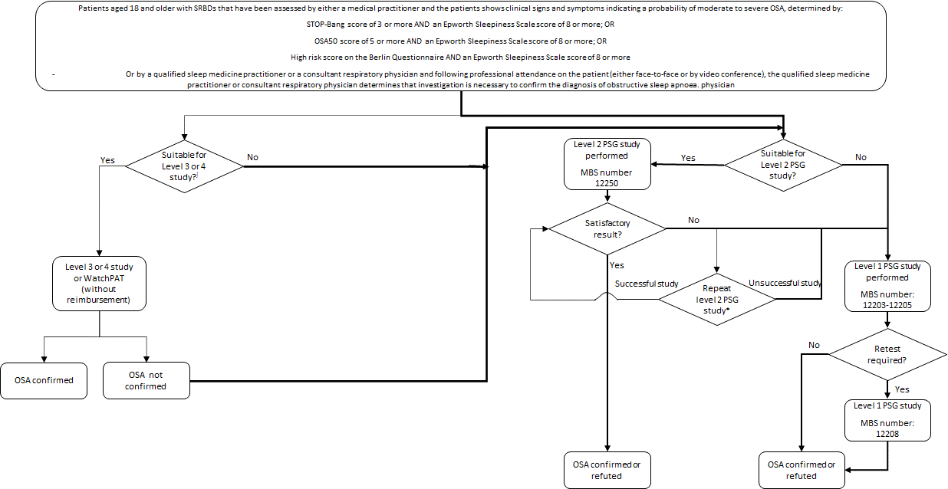

Figure 3: Current clinical algorithm for the diagnosis of OSA
Source: Adapted from Douglas (2017) 22 Figure 1 p4
Abbreviations: OSA, obstructive sleep apnoea; MBS, Medicare benefits schedule; PSG, polysomnography; SRBDs, sleep-related breathing disorders
* A repeat Type 2 study is unable to be billed via Medicare within 12 months of the original test.
∫ Patient eligibility for Level 3 or 4 studies has been provided above in the Current clinical management algorithm for identified population section
Bolded arrows signify MBS funded pathways
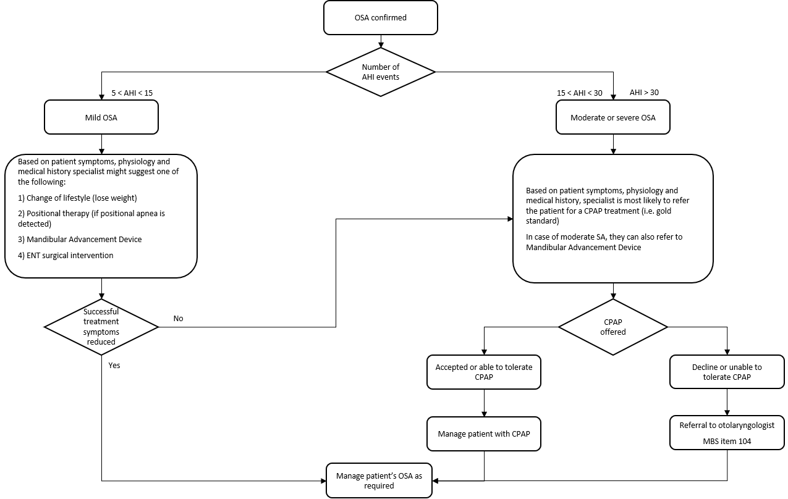

Figure 4: Current clinical algorithm for the treatment post diagnosis of OSA
Source: Adapted from applicant submission, RACGP (2016)¹ and (2019)⁴
Abbreviations: AHI, Apnoea-hypopnoea index; CPAP, continuous positive airway pressure; ENT, ear nose and throat; OSA, obstructive sleep apnoea; MBS, Medicare benefits schedule; SA, sleep apnoea

Proposed clinical management algorithm for identified population
In most cases the HSAT utilising PAT sleep study may be used instead of current Level 2 PSG sleep studies for patients 18 years and older with high probability of moderate or severe OSA . The use of the WatchPAT™ is not indicated in individuals:
- that require medications such as alpha blockers, short acting nitrates (less than 3 hours before the study).
- with a permanent pacemaker (i.e. atrial pacing or VVI without sinus rhythm) and/or
- with sustained* non-sinus cardiac arrhythmias.
- * In the setting of sustained arrhythmia, the WatchPAT™’s automated algorithm might exclude some periods of time, resulting in a reduced valid sleep time. A minimum valid sleep time of 90 minutes is required for an automated report generation.
The device can be used on children aged 12 and above. However, a restriction under MBS item 12250 is that patients must be 18 years or older. For this reason, the applicant is not seeking for use of WatchPAT™ in patients younger than 18 years of age and so is out of scope of this application.
Note: There are circumstances where some precautions may limit the use of PAT which have been mentioned in the intervention and under the current clinical algorithm sections.
The proposed intervention provides an alternative method of diagnosing OSA as demonstrated by the greyed out rectangle in Figure 5. Any changes in the clinical pathway following its introduction are not anticipated.
Figure 4, which captures current downstream services and changes in management, would remain unchanged. Thus, this figure was not reproduced below Figure 5.
PASC noted the following issues with the proposed clinical management algorithm:
- The current low and high probability of moderate to severe OSA appear inconsistent with the prior assessment of high probability using questionnaire. PASC queried whether those boxes should be removed, and the patient move straight to suitable for “level 3 or level 4” or “level 2”.
- The patient population description should include “or following review by a qualified sleep medicine practitioner or a consultant respiratory physician”
- The proposed clinical algorithm needs to be revised to provide information supporting the substitution of a Level 1 PSG study with the HSAT utilising PAT in patients who are unsuitable for a Level 2 study requires more justification (i.e. which patients are not suitable for a Level 2 study and therefore suitable for Level 1 study but can still have HSAT utilising PAT).
The proposed clinical management algorithm was updated to reflect PASC’s advice (Figure 5).

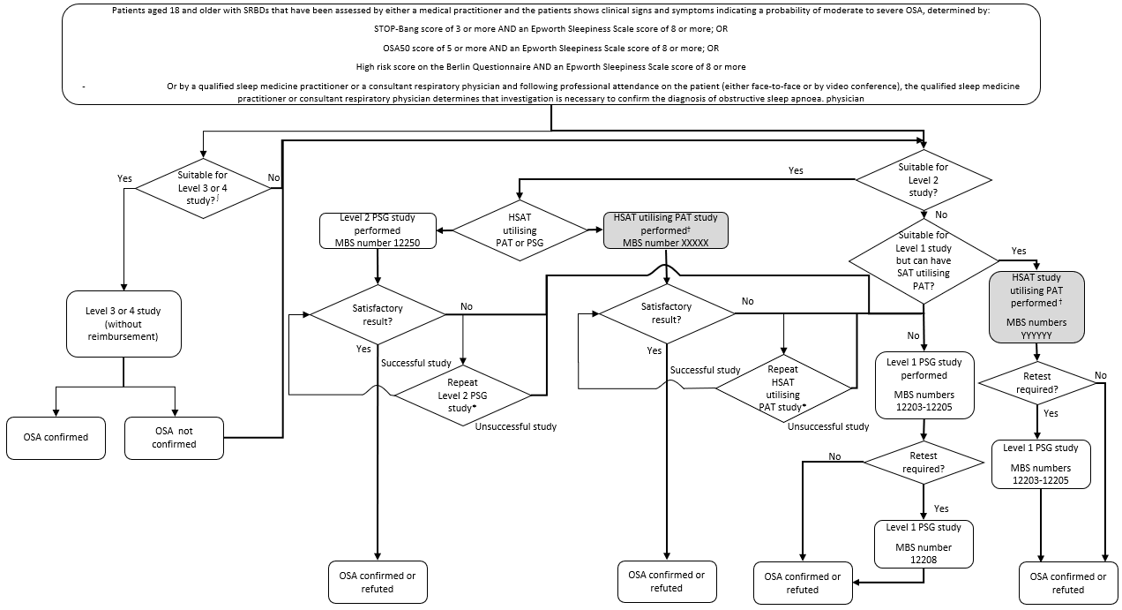

Figure 5: Proposed clinical algorithm for the diagnosis of OSA
Source: Adapted from Douglas (2017)²² Figure 1 p4
Abbreviations: OSA, obstructive sleep apnoea; MBS, Medicare benefits schedule; PSG, polysomnography; SRBDs, sleep-related breathing disorders
* A repeat Type 2 study is unable to be billed via Medicare within 12 months of the original test.
† The use of the WatchPAT™ is not indicated in individuals: that require medications such as alpha blockers, short acting nitrates (less than 3 hours before the study); with a permanent pacemaker (i.e. atrial pacing or VVI without sinus rhythm) and/or; with sustained non-sinus cardiac arrhythmias.
∫ Patient eligibility for Level 3 or 4 studies has been provided above in the Current clinical management algorithm for identified population section
Bolded arrows signify MBS funded pathways

Proposed economic evaluation
The clinical claim against the primary comparator (i.e. Level 2 PSG) is that HSAT utilising PAT is non-inferior in terms of safety and efficacy.
The applicant’s clinical claim against the secondary comparator is that HSAT utilising PAT is non-inferior against the gold standard of laboratory-based Level 1 PSG.
MSAC has previously concluded that Level 2 PSG unattended sleep studies in the diagnosis of OSA appears to be no worse than attended Level 1 PSG studies in improving health outcomes. Further, it was assumed that for adults the safety of Level 2 PSG sleep studies was no worse than Level 1 PSG sleep studies. Overall, unattended Level 2 PSG sleep studies were considered by MSAC to be safe.²⁴ However, HSAT utilising PAT has not been assessed by MSAC. As stated in the application, there are no known safety events related to the use of the device.
According to the Technical Guidelines for preparing assessment reports for the Medical Services Advisory Committee: Investigative, the required economic analysis is therefore a cost minimisation or a cost-consequence analysis.
A diagram of the proposed economic evaluation is presented below (Figure 6). Level 2 PSG sleep studies have been included pending findings of WatchPAT™ against other HSAT that may be found during the assessment process.

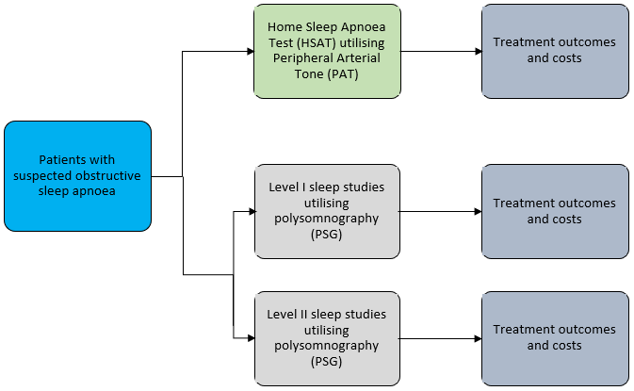

Figure 6 Basic structure of the economic evaluation for HSAT testing

PASC noted that if non-inferiority can be shown unequivocally, then a cost minimisation analysis is appropriate.
PASC advised that the economic evaluation needs to consider resources and the impact that this would have – for example, there may be a potential for reduced costs due to the intervention requiring less sleep technician or manual scoring time, but this may be offset by the cost of the device; whether the increase in equitable access may increase utilisation of sleep studies and therefore increase the total spending (budget impact); whether the analysis should consider if there will be a cost shift (patient out-of-pocket expense to MBS funding) from the change in use of Level 3 and 4 sleep studies at a patient’s expense to the use of the intervention with MBS funding and if there are cost-effectiveness impacts with this cost shift.
The applicant considered that it is unlikely that patients currently having unreimbursed level 3 or 4 tests outside of the Medicare system would change to having a reimbursed WatchPAT™ test that requires a referral, if it were to become available on the MBS. Therefore, the applicant considered analysis of a change in the use of Level 3 and 4 tests should not be required in the economic analysis.
PASC advised that the cost of the devices (e.g. disposable and non-disposable) associated with the intervention needs to be clarified.

Proposed item descriptor
The applicant proposed that the reimbursement for WatchPAT™ under the MBS is done so under an existing item number (i.e. MBS item 12250). Note that red text shows the applicant’s proposed amendments (Table 4). The green text shows suggestions from the assessment group on additional areas where the MBS descriptor may need modification to be suitable for inclusion of HSAT utilising PAT (Table 4). However, whether WatchPAT™ needs to be specifically included as an approved PAT device will need to be determined. The applicant is also aware that MBS item number 12250 is restricted to 18 years or over, even though WatchPAT™ can be used in patients that are 12 years or older. Advice provided to the applicant by the ASA was that this pathway (i.e. using an existing item number) for seeking WatchPAT™ included for reimbursement under the MBS was the best approach.

Table 4 Proposed amendments to MBS 12250 item descriptor
Category 2 – Diagnostic Procedures and Investigations
Overnight investigation of sleep for a period of at least 8 hours of a patient aged 18 years or more to confirm diagnosis of obstructive sleep apnoea, if:

(a) either:
(i) the patient has been referred by a medical practitioner to a qualified sleep medicine practitioner or a consultant respiratory physician who has determined that the patient has a high probability for symptomatic, moderate to severe obstructive sleep apnoea based on a STOP Bang score of 3 4 or more, an OSA50 score of 5 or more or a high risk score on the Berlin Questionnaire, and an Epworth Sleepiness Scale score of 8 or more; or
(ii) following professional attendance on the patient (either face to face or by video conference) by a qualified sleep medicine practitioner or a consultant respiratory physician, the qualified sleep medicine practitioner or consultant respiratory physician determines that investigation is necessary to confirm the diagnosis of obstructive sleep apnoea; and
(b) during a period of sleep, there is continuous monitoring and recording, performed in accordance with current professional guidelines, of the following measures:
(i) airflow;
(ii) continuous EMG;
(iii) continuous ECG;
(iv) continuous EEG;
(v) EOG;
(vi) oxygen saturation;
(vii) respiratory effort; and
OR
(viii) home sleep apnoea diagnostic test measuring Peripheral Arterial Tone (PAT), heart rate, oxygen saturation, actigraphy, respiratory effort, snoring level and body position.
(c) the investigation is performed under the supervision of a qualified sleep medicine practitioner; and
(d) either:
(i) the equipment is applied to a patient by the sleep technician; or
(ii) if this is not possible-the reason it is not possible for the sleep technician to apply the equipment to the patient is documented and the patient is given instructions on how to apply the equipment by a sleep technician supported by written instructions, and
e) polygraphic records are:
(i) analysed (for assessment of sleep stage, arousals, respiratory events and cardiac abnormalities) with manual scoring, or manual correction of computerised scoring in epochs of not more than 1 minute; and
(ii) stored for interpretation and preparation of report; and
(f) interpretation and preparation of a permanent report is provided by a qualified sleep medicine practitioner with personal direct review of raw data from the original recording of polygraphic data from the patient; and
(g) the investigation is not provided to the patient on the same occasion that a service mentioned in any of items 11000 to 11005, 11503, 11700 to 11709, 11713 and 12203 is provided to the patient
Applicable only once in any 12- month period
Fee: $345.75 Benefit: 75% = $259.35 85% = $293.90
(See para DN.1.17 of explanatory notes to this Category)

PASC noted issues with adapting current MBS item 12250, even with the suggested changes by the applicant and the assessment group (Table 4). PASC noted that WatchPAT is not currently registered to diagnose cardiac abnormalities; rather, it provides suspicion of some cardiac rhythm abnormalities in patients who should be investigated further. PASC advised that this makes the inclusion of this intervention under MBS item 12250 inappropriate.
PASC advised that a new MBS item number for the intervention is most appropriate. The characteristics (number and type of variables measured) of the intervention need to be stated in the new item descriptor in order to differentiate from item 12250. There will need to be rules around co-claiming or multiple claims with other similar diagnostic test items, including MBS items 12250 and 12203. PASC accepted that this new MBS item number could be claimed once per year, in line with current MBS items for PSG studies. PASC noted that the proposed fee currently includes the cost of the disposable version of the device, and advised that this needs to be made clear in the application. PASC noted that inclusion of the device cost in the fee is a policy issue for the Department. In most cases, the fees for MBS items take into consideration the professional service component and exclude the cost of consumables and devices. PASC noted that the WatchPAT could be used in hospital as well as out of hospital. A revised item descriptor, reflecting PAS’s advice has been included below (Table 5).

Table 5 PASC-proposed MBS item descriptor
Category 2 – Diagnostic Procedures and Investigations
Overnight investigation of sleep for a period of at least 8 hours of a patient aged 18 years or more to confirm diagnosis of obstructive sleep apnoea, if:

(a) either:
(i) the patient has been referred by a medical practitioner to a qualified sleep medicine practitioner or a consultant respiratory physician who has determined that the patient has a high probability for symptomatic, moderate to severe obstructive sleep apnoea based on a STOP Bang score of 3 4 or more, an OSA50 score of 5 or more or a high risk score on the Berlin Questionnaire, and an Epworth Sleepiness Scale score of 8 or more; or
(ii) following professional attendance on the patient (either face to face or by video conference) by a qualified sleep medicine practitioner or a consultant respiratory physician, the qualified sleep medicine practitioner or consultant respiratory physician determines that investigation is necessary to confirm the diagnosis of obstructive sleep apnoea; and
(b) during a period of sleep, there is continuous monitoring and recording, performed in accordance with current professional guidelines, of the following measures:
(i) peripheral arterial tone (PAT);
(ii) heart rate;
(iii) oxygen saturation;
(iv) actigraphy;
(v) chest motion;
(vi) snoring level; and
(vii) body position
(c) the investigation is performed under the supervision of a qualified sleep medicine practitioner; and
(d) either:
(i) the equipment is applied to a patient by the sleep technician;
(ii) a sleep technician provides the patient with written instructions on how to apply the equipment and upload the results for assessment by a qualified sleep technician and/or medicine practitioner
e) polygraphic records are:
(i) analysed (for assessment of sleep stage, arousals, respiratory events and cardiac abnormalities) with manual scoring, or manual correction of computerised scoring in epochs of not more than 1 minute; and
(ii) stored for interpretation and preparation of report; and
(f) interpretation and preparation of a permanent report is provided by a qualified sleep medicine practitioner with personal direct review of raw data from the original recording of polygraphic data from the patient; and
(g) the investigation is not provided to the patient on the same occasion that a service mentioned in any of items 11000 to 11005, 11503, 11700 to 11709, 11713, 12203 and 12250 is provided to the patient
Applicable only once in any 12- month period
Fee: $345.75 Benefit: 75% = $259.35 85% = $293.90
(See para DN.1.17 of explanatory notes to this Category)
Accreditation by the ASA and the NATA is required by an individual in order to score the test. A sleep physician may score the test and should determine if further treatment is needed. There is no need for specific training to perform the test itself.
Specialists and consultant physicians providing services under items 11503, 11508 and 11512 should have successfully completed a substantial course of study and training in the relevant test (i.e. for WatchPAT™), which has been endorsed by a professional medical organisation. Specialists and consultant physicians should keep appropriate records of this training.
The costs of accreditation of laboratories and professionals and the reliability of test interpretation with patient compliance is higher with medical specialist education. The applicant is conducting webinars in the Asia-Pacific region in late July 2020 to support specialist education. Software required to use WatchPAT™ is free of charge and is available for download on a computer. Assurance from the applicant that this will not change in the future will be required.
Technological considerations such as data loss due to sensor detachment and issues of patient access including rural and remote settings have been considered by the MSAC for Level 2 PSG testing. These considerations are still relevant for this assessment. WatchPAT™ has a low failure rate of 0-0.5% and can be shipped to a patient’s home. Should the test fail, the applicant has stated that a replacement is sent free of charge. The applicant also stated that the MBS item code 12250 captures the cost for the device and that there are no out of pocket expenses to patients. Again, assurances would need to be sought to not factor these potential costs into the economic model.
Consultation feedback
PASC noted the general support from the consultation feedback. However, PASC also noted that the professional association thought the application warranted assessment, but did not believe that WatchPAT satisfied the criteria for a Level 2 PSG study.
The applicant clarified that it does not claim the WatchPAT™ is a level 2, 3 or 4 device, rather it is an alternative for a Level 2 device. The applicant noted that the current classification system used by the ASA does not encompass PAT technology so cannot be applied to WatchPAT. The applicant considered a more appropriate classification is the SCOPER system.
Next steps
PASC advised that, upon ratification of the post-PASC PICO, the application can proceed to the Evaluation Sub-Committee (ESC) stage of the MSAC process.
PASC noted the applicant has tentatively elected to progress its application as an applicant developed assessment report (ADAR), but will confirm with the Department.

  - References

Of note, the scoring criteria for one of the four screening tools (STOP-Bang) will be reduced to 3 (from 4) to ensure patients with suspected moderate to severe OSA are appropriately captured and referred for testing (as per planned implementation of recommendations of the MBS Review Taskforce - Thoracic Medicine Clinical Committee Report)
Efficacy: measures the test’s ability to predict the presence or absence of disease, that is, the sensitivity, specificity and positive and negative predictive values, in this case, to accurately predict presence of sleep apnoea
Clinical validity: measures the tests ability to predict the presence or absence of disease, that is, the sensitivity, specificity and positive and negative predictive values
RDI is calculated as the number of apnoea events/hour plus the number of hypopnea events/hour plus the number of respiratory-effort related arousals (RERAs) per hour of sleep.
WatchPAT™ was included as a Level 4 study
Phan NT, Wallwork B, Panizza B (2016) Surgery for adult patients with obstructive sleep apnoea: A review for general practitioners. Australian Family Physician. 45 (8): 574-578
Marshall et al (2008). Sleep Apnea as an Independent Risk Factor for All-Cause Mortality: The Busselton Health Study. SLEEP, Vol. 31, No. 8: 1079
Adams RJ, Appleton SL, Taylor AW, et al (2017). Sleep health of Australian adults in 2016: results of the 2016 Sleep Health Foundation national survey. Sleep Health. 3(1):35-42. doi:10.1016/j.sleh.2016.11.005
Hamilton GS, Chai-Coetzer, CL (2019). Update on the assessment and investigation of adult obstructive sleep apnoea. Australian Journal of General Practice (AJGP). 48 (4): 176 -181
Young T, Palta M, Dempsey J, Skatrud J, Weber S, Badr S (1993). The occurrence of sleep-disordered breathing among middle-aged adults. N Engl J Med, 328(17):1230–35.
Appleton SL, Gill TK, Lang CJ, et al. (2018) Prevalence and comorbidity of sleep conditions in Australian adults: 2016 Sleep Health Foundation national survey. Sleep Health 4(1):13–19.
Attachment C provided by the Department provides the following website: www9.health.gov.au/mbs/fullDisplay.cfm?type=note&qt=NoteID&q=DN.1.17
MBS online “Medicare Benefits Schedule - Item 12250” http://www9.health.gov.au/mbs/fullDisplay.cfm?type=item&q=12250&qt=ItemID
Department of Health (2020). Application form: 1631 – Home sleep Apnoea test (HSAT) utilizing peripheral arterial tone (PAT), Medical Services Advisory Committee, pp. 1-33.
Wang, C, Li, Z, & Wei, X (2013). Monitoring heart and respiratory rates at radial artery based on PPG . Optik, 124 (19_: 3954–3956.
Herscovici, S, Pe'er, A, Papyan, S & Lavie, P (2006). Detecting REM sleep from the finger: an automatic REM sleep algorithm based on peripheral arterial tone (PAT) and actigraphy. Physiological measurement, 28 (2): 129.
Itamar Medical Ltd WatchPAT™ ONE - Operation Manual https://www.itamar-medical.com/wp-content/uploads/2019/11/OM2196370-Edition-7.pdf
Itamar Medical (2019). Itamar Medical Advances Simple, Accurate and Reliable Home Sleep Apnea Testing with Launch of WatchPAT™ 300, GlobeNewswire, Accessed 16 July 2020: https://www.globenewswire.com/news-release/2019/03/20/1757811/0/en/Itamar-Medical-Advances-Simple-Accurate-and-Reliable-Home-Sleep-Apnea-Testing-with-Launch-of-WatchPAT-300.html
Itamar Medical (2019). Cardio+Sleep Solutions, WatchPAT ONE Step by Step How to Use Instructional Video. Accessed 16 July 2020: https://cardiosleepsolutions.com/product/watchpat-one/
TGA. Summary for ARTG Entry: 206199. Accessed 15 June 2020: https://www.ebs.tga.gov.au/servlet/xmlmillr6?dbid=ebs/PublicHTML/pdfStore.nsf&docid=FA8A7EF442EE627ECA257B16003CC408&agid=(PrintDetailsPublic)&actionid=1
Pillar, G, Etzioni, T, Berall, M, Henkin, Y, Hwang, D, Ibrahim, M, Litman, E, Sheffy, K, Manthena, P, Penzel, T & Rama, A (2019). 0502 Watchpat is accurate in the diagnosis of sleep apnea in the presence of atrial fibrillation. Sleep, 42: A201.
Stewart SA, et al (2015). Improvement in obstructive sleep apnea diagnosis and management wait times: A retrospective analysis of home management pathway for obstructive sleep apnea. Can Respir J. 22(3):167–170. doi:10.1155/2015/516580
Pillar, G, Berall, M, Berry, R, Etzioni, T, Shrater, N, Hwang, D, Ibrahim, M, Litman, E, Manthena, P, Koren-Morag, N & Rama, A (2019). Detecting central sleep apnea in adult patients using WatchPAT—a multicenter validation study, Sleep and Breathing, pp.1-12.
Pang, KP, Gourin, CG & Terris, DJ (2007). A comparison of polysomnography and the WatchPAT in the diagnosis of obstructive sleep apnea, Otolaryngology—Head & Neck Surgery. 137 (4): 665-668.
Gan, YJ, Lim, L, & Chong, YK (2017). Validation study of WatchPat 200 for diagnosis of OSA in an Asian cohort European Archives of Oto-Rhino-Laryngology. 274 (3): 1741-1745.
Attachment A: Utilisation of Medicare Benefits Schedule (MBS) items for thoracic medicine following implementation of outcomes of the MBS Review Taskforce
Medical Services Advisory Committee (MSAC). 2010. MSAC application 1130. Accessed 15 June 2020: http://msac.gov.au/internet/msac/publishing.nsf/Content/6D179C512E2170A7CA25801000123B34/$File/1130_MSAC_PSD.pdf
Itamar medical. 2019. The Use of WatchPAT™ for Home Sleep Testing Assessment of Sleep-Related Disordered Breathing (SDB) in Heart Disease Patients – Clinical & Operational Benefits. Accessed 16 July 2020: https://www.itamar-medical.com/wp-content/uploads/2019/12/White-Paper-WatchPAT-Clinical-Operational-Benefits-White-Paper.pdf
Pittman, S. D., Ayas, N. T., MacDonald, M. M., Malhotra, A., Fogel, R. B., & White, D. P. (2004). Using a wrist-worn device based on peripheral arterial tonometry to diagnose obstructive sleep apnea: in-laboratory and ambulatory validation. Sleep, 27(5), 923–933. https://doi.org/10.1093/sleep/27.5.923
Communications with Applicant on 3 July 2020.
The CPAP clinic. 2020. TYPE 2: HOME-BASED SLEEP STUDY ($0.00 SUBJECT TO MEDICARE ELIGIBILITY). Accessed 16 July 2020: https://www.thecpapclinic.com.au/shop/item/home-based-sleep-study-type-2
Yalamanchali et al (2013). Diagnosis of Obstructive Sleep Apnea by Peripheral Arterial Tonometry. JAMA Otolaryngology Head Neck Surg. 139(12): 1343-50
MBS online “Medicare Benefits Schedule - Item 12250” http://www9.health.gov.au/mbs/fullDisplay.cfm?type=item&q=12250&qt=ItemID
Swieca, J., Hamilton, G. S., & Meaklim, H. (2017). The management, privacy and medico-legal issues of electronic CPAP data in Australia and New Zealand: Electronic CPAP data management in Australia and New Zealand. Sleep Medicine, 36, S48-S55.
Somers VK (2008). Sleep apnea and cardiovascular disease: an American Heart Association/American College Of Cardiology Foundation Scientific Statement from the American Heart Association Council for High Blood Pressure Research Professional .... American Heart Association Council for High Blood Pressure Research Professional Education Committee, Council on Clinical Cardiology. American Heart Association Stroke Council. American Heart Association Council on Cardiovascular Nursing. American College of Cardiology Foundation. Circulation. 118:1080-111.
Tietjens JR, Claman D, Kezirian EJ, De Marco T, Mirzayan A, Sadroonri B, Goldberg AN, Long C, Gerstenfeld EP, Yeghiazarians Y (2019). Obstructive sleep apnea in cardiovascular disease: a review of the literature and proposed multidisciplinary clinical management strategy. J Amer Heart Asso. 8(1):e010440.
Senaratna CV, Perret JL, Lowe A, et al (2019). Detecting sleep apnoea syndrome in primary care with screening questionnaires and the Epworth sleepiness scale. Med J Aust. 210: 65–71
Aboussouan LS (2015). Sleep-disordered Breathing in Neuromuscular Disease. Am J Respir Crit Care Med. 191(9):979-989. doi:10.1164/rccm.201412-2224CI
Douglas, J.A., Chai-Coetzer, C.L., McEvoy, D., Naughton, M.T., Neill, A.M., Rochford, P., Wheatley, J. and Worsnop, C. (2017). Guidelines for sleep studies in adults–a position statement of the Australasian Sleep Association. Sleep Med, 36(Suppl 1): S2-S22.
FDA, WatchPAT 300 Indication for use, 18 July 2018 - https://www.accessdata.fda.gov/cdrh_docs/pdf18/K180775.pdf

