Application Form
Home Sleep Apnoea Test (HSAT) utilizing Peripheral Arterial Tone (PAT)
This application form is to be completed for new and amended requests for public funding (including but not limited to the Medicare Benefits Schedule (MBS)). It describes the detailed information that the Australian Government Department of Health requires to determine whether a proposed medical service is suitable.
Please use this template, along with the associated Application Form Guidelines to prepare your application. Please complete all questions that are applicable to the proposed service, providing relevant information only. Applications not completed in full will not be accepted.
Should you require any further assistance, departmental staff are available through the Health Technology Assessment Team (HTA Team) on the contact numbers and email below to discuss the application form, or any other component of the Medical Services Advisory Committee process.

Email: hta@health.gov.au
Website: www.msac.gov.au

PART 1 – APPLICANT DETAILS

Applicant details (primary and alternative contacts)
Corporation / partnership details (where relevant):
Corporation name: REDACTED
ABN: REDACTED
Business trading name: Itamar Medical Ltd

Primary contact name: REDACTED
Primary contact numbers
Business: REDACTED
Mobile: REDACTED
Email: REDACTED

Alternative contact name: REDACTED
Alternative contact numbers
Business: REDACTED Mobile: REDACTED
Email: REDACTED
Australian contact name: REDACTED
Australian contact numbers
Business: REDACTED
Mobile: REDACTED
Email: REDACTED

(a) Are you a lobbyist acting on behalf of an Applicant?
Yes
No

If yes, are you listed on the Register of Lobbyists?
Yes
No

PART 2 – INFORMATION ABOUT THE PROPOSED MEDICAL SERVICE

Application title
Home Sleep Apnoea Test (HSAT) utilizing Peripheral Arterial Tone (PAT) for the diagnosis of Sleep Apnoea (SA) in patients with symptomatic signs of Sleep Related Breathing Disorder (SRBD).

Provide a succinct description of the medical condition relevant to the proposed service (no more than 150 words – further information will be requested at Part F of the Application Form)
Sleep Apnoea (SA) is a common Sleep Related Breathing Disorder (SRBD). The most prevalent type of SA is Obstructive Sleep Apnoea (OSA), which is characterized by a narrowing of the upper airway that impairs normal ventilation during sleep, resulting in repeated reversible blood oxygen desaturation and fragmented sleep. OSA has been associated with a range of pathophysiological changes that impair cardiovascular function, including increased blood inflammatory markers and repeated rises in blood pressure. OSA is strongly linked to a variety of health problems such as coronary heart disease, stroke, atrial fibrillation, diabetes, hypertension and greater mortality risk.

Provide a succinct description of the proposed medical service (no more than 150 words – further information will be requested at Part 6 of the Application Form)
The proposed medical service is a Home Sleep Apnoea Test (HSAT). The HSAT measures 7 channels: Peripheral Arterial Tone (PAT) signal, oximetry, actigraphy, heart rate, body position, snoring, and chest movement. By using these 7 channels, the PAT HSAT can differentiate between sleep periods and awake time periods, which allows the analysis of “true sleep time,” and can report sleep stages (light, deep, and REM sleep), AHI, ODI and other major indices necessary for the diagnosis of OSA.

(a) Is this a request for MBS funding?
Yes
No

If yes, is the medical service(s) proposed to be covered under an existing MBS item number(s) or is a new MBS item(s) being sought altogether?
Amendment to existing MBS item(s)
New MBS item(s)

If an amendment to an existing item(s) is being sought, please list the relevant MBS item number(s) that are to be amended to include the proposed medical service:
12250

If an amendment to an existing item(s) is being sought, what is the nature of the amendment(s)?
- An amendment to the way the service is clinically delivered under the existing item(s)
- An amendment to the patient population under the existing item(s)
- An amendment to the schedule fee of the existing item(s)
- An amendment to the time and complexity of an existing item(s)
- Access to an existing item(s) by a different health practitioner group
- Minor amendments to the item descriptor that does not affect how the service is delivered
- An amendment to an existing specific single consultation item
- An amendment to an existing global consultation item(s)
- Other (please describe below):

If a new item(s) is being requested, what is the nature of the change to the MBS being sought?
Not applicable
- A new item which also seeks to allow access to the MBS for a specific health practitioner group
- A new item that is proposing a way of clinically delivering a service that is new to the MBS (in terms of new technology and / or population)
- A new item for a specific single consultation item
- A new item for a global consultation item(s)

Is the proposed service seeking public funding other than the MBS?
Yes
No

What is the type of service:
Therapeutic medical service
Investigative medical service
Single consultation medical service
Global consultation medical service
Allied health service
Co-dependent technology
Hybrid health technology

For investigative services, advise the specific purpose of performing the service (which could be one or more of the following):
- To be used as a screening tool in asymptomatic populations
- Assists in establishing a diagnosis in symptomatic patients
- Provides information about prognosis
- Identifies a patient as suitable for therapy by predicting a variation in the effect of the therapy
- Monitors a patient over time to assess treatment response and guide subsequent treatment decisions

Does your service rely on another medical product to achieve or to enhance its intended effect?
Pharmaceutical / Biological
Prosthesis or device
No

(a) If the proposed service has a pharmaceutical component to it, is it already covered under an existing
Pharmaceutical Benefits Scheme (PBS) listing?
Not applicable

If yes, please list the relevant PBS item code(s):
Not applicable

If no, is an application (submission) in the process of being considered by the Pharmaceutical Benefits Advisory Committee (PBAC)?
Not applicable

If you are seeking both MBS and PBS listing, what is the trade name and generic name of the pharmaceutical?
Not applicable
Trade name: Not applicable
Generic name: Not applicable

(a) If the proposed service is dependent on the use of a prosthesis, is it already included on the Prostheses List?
Yes
No

Not applicable

If yes, please provide the following information (where relevant):
Billing code(s): Not applicable
Trade name of prostheses: Not applicable
Clinical name of prostheses: Not applicable
Other device components delivered as part of the service: Not applicable

If no, is an application in the process of being considered by a Clinical Advisory Group or the Prostheses List Advisory Committee (PLAC)?
Yes
No

Are there any other sponsor(s) and / or manufacturer(s) that have a similar prosthesis or device component in the Australian market place which this application is relevant to?
Yes
No

If yes, please provide the name(s) of the sponsor(s) and / or manufacturer(s):
Not applicable

Please identify any single and / or multi-use consumables delivered as part of the service?
Single use consumables:
The WatchPAT One is a single-use HSAT device. The WatchPAT 200 and WatchPAT 300 require the use of a single use finger sensor that is used for the measurement of Oxygen saturation, Peripheral Arterial Tonometry and Heart Rate.
Multi-use consumables:
The WatchPAT 200 and WatchPAT 300 require the use of 2 multi-use components:
1. A wrist unit that includes the user interface, control unit, data storage and actigraphy sensor.
2. A chest sensor that includes a controller, a microphone for recording snoring level and an accelerometer that measures body position and chest movement.

PART 3 – INFORMATION ABOUT REGULATORY REQUIREMENTS

(a) If the proposed medical service involves the use of a medical device, in-vitro diagnostic test, pharmaceutical product, radioactive tracer or any other type of therapeutic good, please provide the following details:
Type of therapeutic good: Home Sleep Apnoea Diagnostic medical device, which provides diagnostic aid for the detection of sleep related breathing disorders and includes comprehensive data such as sleep staging (REM sleep, light sleep, deep sleep and wake), snoring level and body position.
Manufacturer’s name: Itamar-Medical LTD
Sponsor’s name: Excellcare Pty Ltd

Is the medical device classified by the TGA as either a Class III or Active Implantable Medical Device (AIMD) against the TGA regulatory scheme for devices?
Class III
AIMD
N/A

(a) Is the therapeutic good to be used in the service exempt from the regulatory requirements of the Therapeutic Goods Act 1989?
Yes (If yes, please provide supporting documentation as an attachment to this application form)
No

If no, has it been listed or registered or included in the Australian Register of Therapeutic Goods (ARTG) by the Therapeutic Goods Administration (TGA)?
Yes (if yes, please provide details below)
No

ARTG listing, registration or inclusion number: 206199
TGA approved indication(s), if applicable: N/A
TGA approved purpose(s), if applicable:

To be used as a diagnostic tool in the medical management of sleep-related breathing disorders. Can be used in the diagnosis of myocardial ischemia and endothelium dysfunctions. To be worn on the wrist by the patient at home while they sleep along with a non-invasive finger mounted pneu-optical probe to measure the peripheral arterial tonometry signal. In addition to the PAT signal, oxygen saturation, actigraphy (body movement), pulse rate, body position and snoring (dB) are also recorded and stored on the device from which the recorded signals can be downloaded to a computer for automatic analysis and reporting utilising proprietary algorithms. Can provide analysis of respiratory disturbance, apnea-hypopnea, endothelia function, oxygen desaturation, sleep/wake states, REM/ light/deep sleep stages, heart rate, oxygen saturation level, body position and snoring.

If the therapeutic good has not been listed, registered or included in the ARTG, is the therapeutic good in the process of being considered for inclusion by the TGA?
Not applicable
Yes (please provide details below)
No

Date of submission to TGA: Not applicable
Estimated date by which TGA approval can be expected: Not applicable
TGA Application ID: Not applicable
TGA approved indication(s), if applicable: Not applicable
TGA approved purpose(s), if applicable: Not applicable

If the therapeutic good is not in the process of being considered for listing, registration or inclusion by the TGA, is an application to the TGA being prepared?
Yes (please provide details below)
No

Estimated date of submission to TGA: Not applicable
Proposed indication(s), if applicable: Not applicable
Proposed purpose(s), if applicable: Not applicable

PART 4 – SUMMARY OF EVIDENCE

Provide an overview of all key journal articles or research published in the public domain related to the proposed service that is for your application (limiting these to the English language only). Please do not attach full text articles, this is just intended to be a summary.
 | Type of study design* | Title of journal article or research project (including any trial identifier or study lead if relevant) | Short description of research (max 50 words)** | Website link to journal article or research (if available) | Date of publication***
1. | Meta-analysis | Yalamanchali et al  “Diagnosis of Obstructive Sleep Apnea by Peripheral Arterial Tonometry”  JAMA Otolaryngology Head Neck Surg. 2013 Dec; 139(12):1343-50 | Meta-analysis of 14 studies (909 patients). Assessing correlation of sleep indexes between PAT  devices and PSG (adults >18 years). AHI, RDI, consistently demonstrated high degree of correlation in sleep variables compared to PSG (r = 0.889 [95% CI, 0.862-0.911]; P < .001).  The PAT ambulatory test offered the possibility of an accurate diagnosis, with convenience and low cost | www.ncbi.nlm.nih.gov/pubmed/24158564  https://jamanetwork.com/journals/jamaotolaryngology/fullarticle/1759186 | Dec 2013
2. | Multicenter validation study | Pillar et al  “Detecting central sleep apnea in adult patients using WatchPAT”  Sleep and Breathing pp 1–12 | Assesses the accuracy of WatchPAT and the automated algorithm differentiation between Central Sleep Apnoea (CSA) and Obstructive Sleep Apnoea (OSA) compared with PSG.  84 patients with suspected Sleep Disordered Breathing (SDB) in 11 sleep centers.  WatchPAT can accurately detect overall AHI and effectively differentiate between CSA and OSA | https://link.springer.com/article/10.1007/s11325-019-01904-5 | July 2019
3. | Retrospective | Safadi et al  “The Effect of the Transition to Home Monitoring for the Diagnosis of OSAS on Test Availability, Waiting Time, Patients’ Satisfaction, and Outcome in a Large Health Provider System.”  Sleep Disord 2014; 2014:418246 | Asses the effect of transitioning from PSG to HST using WatchPAT.  Data comparison of 650,000 insured individuals between 2007-2008 to 2010-2011.  90% increase of sleep study tests following the transition to HST from PSG.  Despite the increase in number of tests, there was a 20% decrease in overall expense of OSA  diagnosis.  Average waiting time decreased from 9.9 weeks to approximately 1 week. | www.ncbi.nlm.nih.gov/pubmed/24876974 | April 2014
4. | Multi-Center Validation Study | Hedner et al  “Sleep Staging Based on Autonomic Signals”  JCSM - Journal of Clinical Sleep Medicine, 2011;7(3):301-306. | Sleep staging is based on EEG recordings representing central nervous system activity. This study was performed to examine the accuracy of partial sleep staging based on actigraphy and PAT signals. The study shows that sleep staging based on actigraphy and PAT signals is of reasonable accuracy. This may be of substantial interest and importance in the era of a shift toward unattended home sleep testing. | https://www.researchgate.net/publication/51223632_Sleep_Staging_Based_on_Autonomic_Signals_A_Multi-Center_Validation_Study | June 2011
5. | Study of diagnostic accuracy | Park et al  “Clinical usefulness of watch-PAT for assessing the surgical results of obstructive sleep apnea syndrome.”  JCSM - Journal of Clinical Sleep Medicine 2014. Jan 15;10(1):43-7 | Assess WatchPAT’s accuracy and clinical efficacy in evaluating sleep surgeries outcome in 35 OSA patients who underwent corrective airway collapse surgeries.  WatchPAT-derived RDI, AHI, oxygen saturation, and sleep time were measured before and after surgery.  WatchPAT is a highly sensitive portable device for estimating treatment results and symptomatic changes in OSA patients after sleep surgery. It is easy to use HST, with a low failure rate and minimal technical effort. | http://jcsm.aasm.org/ViewAbstract.aspx?pid=29293 | January 2014
6. | Study of diagnostic accuracy | Zhigang Zhang, et al  “A comparison of automated and manual sleep staging and respiratory event recognition in a portable sleep diagnostic device with in-lab sleep study.”  JCSM - Journal of Clinical Sleep Medicine 2020. Feb | To develop and validate an algorithm for editing WatchPAT respiratory events and sleep architecture scoring and assess the accuracy in an unselected clinical population as well as age and sex substrata. 262 participants undergo WatchPAT simultaneously with in-lab PSG: 30 for algorithm development, 62 for optimizing and 170 for validating. AHI and sleep indices were compared with PSG-derived and automated WatchPAT indices.  Results - Estimation of total sleep time (TST) was comparable between automated and manual algorithm, estimation of rapid eye movement (REM) sleep time was markedly improved to correlation of 0.64 to PSG results, Manual scoring also improved correlation and agreement with PSG AHI from 0.65, 2.5 events/h (-24.0 – 28.9) to 0.81, -4.5 events/h (-22.5 – 13.6) | https://jcsm.aasm.org/doi/abs/10.5664/jcsm.8278 | February 2020
7. | Study of diagnostic accuracy | O’Brien et al  “Validation of Watch-PAT-200 against polysomnography during pregnancy.”  JCSM - Journal of Clinical Sleep Medicine. 2012; vol 8 (3):287–294 | Compare key variables obtained from PSG and WatchPAT in pregnant women. PSGs were scored using AASM criteria; Watch-PAT was scored automatically.  31 pregnant women were studied.  Key variables generated by PSG and Watch-PAT correlated well over a wide range, including the AHI, RDI, and oxygen saturation. Among pregnant women, Watch-PAT demonstrates excellent sensitivity and specificity for identification of OSA. | https://www.ncbi.nlm.nih.gov/pmc/articles/PMC3365087/ | June 2012
8. | Study of diagnostic accuracy | Gan et al  “Validation study of WatchPat 200 for diagnosis of OSA in an Asian cohort.”  Eur Arch Otorhinolaryngol 2017 Mar;274(3):1741-1745 | 20 OSA suspected patients underwent simultaneous PSG and WatchPAT assessments.  AHI Correlation (WatchPAT and PSG) is very strong.  WatchPAT showed 100% sensitivity for mild OSA and 100% specificity for severe OSA patients compared to PSG, thus making WatchPAT a good screening test for undiagnosed general population and a good diagnostic test for people with high suspicion of OSA.  This facilitates a timelier diagnosis and potential savings  of up to $900 per patient. | www.ncbi.nlm.nih.gov/pubmed/27796555 | March 2017
9. | Study of diagnostic accuracy | Choi et al  “Validating the Watch-PAT for Diagnosing Obstructive Sleep Apnea in Adolescents.”  JCSM - Journal of Clinical Sleep Medicine. 2018 Oct 15;14(10):1741-1747 | Assess the accuracy of WatchPAT for diagnosing OSA in  adolescents compared with PSG according to respiratory rules for children (RRC) and adults (RRA).  38 adolescents with suspected OSA were assessed with the WP200 and PSG simultaneously.  There were high correlations in AHI and minimum saturation.  The WP200 may be a clinically reliable tool for diagnosing OSA in adolescents. | www.ncbi.nlm.nih.gov/pubmed/30353803 | October 2018
10. | Review | Malhotra et al  “On the cutting edge of obstructive sleep apnoea: where next?”  The Lancet Respiratory Med. 2015 May;3(5):397-403 | Clinical practice of sleep medicine is changing rapidly.  The diagnostic approach for OSA is transitioning from gold standard PSG to HST.  Measurement of SLEEP TIME, REM related sleep and BODY POSITION is important for accurate diagnosis and effective treatment.  The review covers recent insights and discoveries in OSA, with a focus on diagnostics and therapeutics. | https://www.ncbi.nlm.nih.gov/pubmed/25887980 | May 2015
11. | AASM Clinical Practice Guideline | Kapur et al  “Clinical Practice Guideline for Diagnostic Testing for Adult Obstructive Sleep Apnea: An American Academy of Sleep Medicine Clinical Practice Guideline”  JCSM - Journal of Clinical Sleep Medicine.  479 (Mar. 15, 2017). | 2017 AASM’s guidelines for OSA diagnosis accepting HSTs incorporating peripheral arterial tonometry (PAT) with oximetry and actigraphy.  PAT based devices are accepted outside the type I-IV traditionally used for sleep study classification. | https://www.ncbi.nlm.nih.gov/pubmed/28162150 | March 2017
* Categorise study design, for example meta-analysis, randomised trials, non-randomised trial or observational study, study of diagnostic accuracy, etc.
**Provide high level information including population numbers and whether patients are being recruited or in post-recruitment, including providing the trial registration number to allow for tracking purposes.
*** If the publication is a follow-up to an initial publication, please advise.

Identify yet to be published research that may have results available in the near future that could be relevant in the consideration of your application by MSAC (limiting these to the English language only). Please do not attach full text articles, this is just intended to be a summary.
Nil

PART 5 – CLINICAL ENDORSEMENT AND CONSUMER INFORMATION

List all appropriate professional bodies / organisations representing the group(s) of health professionals who provide the service (please attach a statement of clinical relevance from each group nominated):
Australasian Sleep Association (ASA)

List any professional bodies / organisations that may be impacted by this medical service (i.e. those who provide the comparator service):
Royal Australian College of Physicians (Respiratory Medicine and Sleep Medicine)

List the consumer organisations relevant to the proposed medical service (please attach a letter of support for each consumer organisation nominated):
No relevant consumer organisation can be identified.

List the relevant sponsor(s) and / or manufacturer(s) who produce similar products relevant to the proposed medical service:
At present, we are not aware of any other devices that use PAT for sleep studies.

Nominate two experts who could be approached about the proposed medical service and the current clinical management of the service(s):

Name of expert 1: REDACTED
Telephone number(s): REDACTED
Email address: REDACTED
Justification of expertise: REDACTED
Name of expert 2: REDACTED
Telephone number(s): REDACTED
Email address: REDACTED
Justification of expertise: REDACTED

Please note that the Department may also consult with other referrers, proceduralists and disease specialists to obtain their insight.

PART 6 – POPULATION (AND PRIOR TESTS), INTERVENTION, COMPARATOR, OUTCOME (PICO)

PART 6a – INFORMATION ABOUT THE PROPOSED POPULATION

Define the medical condition, including providing information on the natural history of the condition and a high level summary of associated burden of disease in terms of both morbidity and mortality:
Sleep-related breathing disorders (SRBDs) are a common problem characterised by short disruptions to normal breathing patterns that only occur during sleep. Sleep apnoea (SA) is a type of SRBD, the most common of which is Obstructive Sleep Apnoea (OSA). OSA is associated with decreased quality of life, functional impairment, and is a socio-economic burden on society. Other types of SA such as Central Sleep Apnoea (CSA) and Mixed Sleep Apnoea can similarly impact patients, and both can emerge following a cardiac event or as a result of heart failure or stroke . SA is measured by the Apnoea Hypopnea Index (AHI) which is the average number of apnoea and hypopnoea events per hour during sleep. SA severity is often divided into 3 categories: Mild SA 5<AHI<15, Moderate SA 15<AHI<30 and severe SA HAI>30.
OSA is characterised by narrowing of the upper airway that impairs normal ventilation during sleep, resulting in repeated reversible blood oxygen desaturation and fragmented sleep. OSA has been associated with a range of pathophysiological changes that impair cardiovascular function, including increased blood inflammatory markers and repeated rises in blood pressure. OSA is strongly linked to a variety of health problems such as coronary heart disease, stroke, atrial fibrillation, diabetes, hypertension and greater mortality risk.
The prevalence of OSA is estimated to be 14% of men and 5% of women, (AHI ≥ 5) , in Australia the prevalence of OSA is estimated to be 8.3% overall (men-12.9% and women 3.7%). OSA prevalence increases in middle age and is estimated to be 33.9% in men and 17.4% in women (ages 30-70) . Most patients go undiagnosed. 83% of men and 92% of women with moderate to severe OSA (AHI>15) have not been diagnosed.
Cross sectional and longitudinal studies have suggested that moderate to severe OSA is independently associated with a greater risk of all-cause mortality and a higher incidence of fatal and non-fatal cardiovascular events in patients with severe disease. OSA is also associated with daytime sleepiness and an increased incidence of road accidents. The estimated health care costs of OSA in Australia was estimated to be $408.5M in 2010.

Specify any characteristics of patients with the medical condition, or suspected of, who are proposed to be eligible for the proposed medical service, including any details of how a patient would be investigated, managed and referred within the Australian health care system in the lead up to being considered eligible for the service:
This service is appropriate for all patients who show clinical evidence (signs and symptoms) indicating an increased risk of moderate to severe SA. Patients with a history of habitual loud snoring, marked daytime sleepiness, witnessed apnoeas during sleep and high risk patients that are obese (BMI > 35 kg/m2) or with increased neck circumference (>43 cm in men, >40 cm in women) are indicated to undergo a sleep study. Patients with cardiovascular disease, or its underlying risk factors, including hypertension and obesity, are at higher risk for SRBD. OSA is particularly prevalent in patients with hypertension, atrial fibrillation, stroke and heart failure , . A majority of cardiac patients may have undiagnosed and untreated OSA, which contributes to worsened outcomes and reduced patient safety.
Figure 1: Comorbidities associated with OSA - Seet and Chung, Anaesthesiology Clin, 2010
.
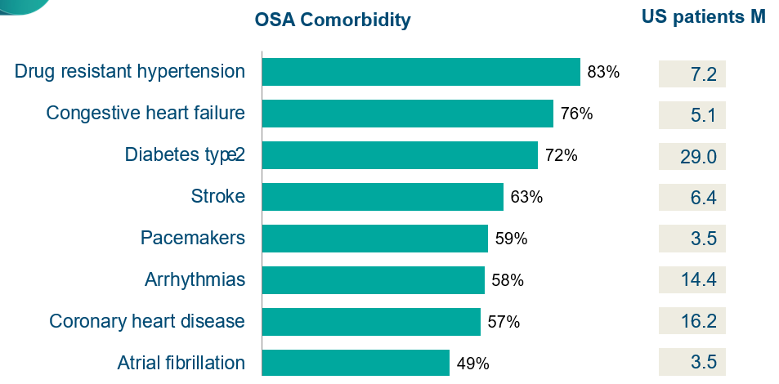

The figure above shows the Prevalence of OSA comorbidity with cardiovascular diseases.

Define and summarise the current clinical management pathway before patients would be eligible for the proposed medical service (supplement this summary with an easy to follow flowchart [as an attachment to the Application Form] depicting the current clinical management pathway up to this point):
It is likely that a patient would initially present to a General Practitioner (GP) complaining of sleep problems which may include fatigue, snoring and daytime sleepiness. The GP is likely to conclude that the patient is suffering from a sleep disorder. If it is likely that the patient may have either moderate to severe OSA, the patient will be either further screened by the GP or referred to a sleep specialist. GPs may directly refer patients for a sleep test by determining eligibility by the administration of the STOP-Bang Questionnaire, the OSA50 Questionnaire, the Berlin Questionnaire or Epworth Sleepiness Scale. The following scores are required to be eligible:
1. STOP-Bang Questionnaire – 4 or more
2. OSA50 Questionnaire - 5 or more
3. Berlin Questionnaire – High risk score
4. Epworth Sleepiness Scale – 8 or more. .
GPs may also refer patients with suspected sleep disorders to a sleep medicine specialist or respiratory physicians for further investigation. The sleep medicine specialist or the respiratory physician may determine that a patient has a high probability of having symptomatic moderate to severe SA. This is determined by administering a screening questionnaire as detailed above or following a professional attendance. The patient may then be referred for further assessment via a sleep test to confirm the diagnosis a SRBD.

PART 6b – INFORMATION ABOUT THE INTERVENTION

Describe the key components and clinical steps involved in delivering the proposed medical service:
PAT technology:
Peripheral Arterial Tonometry based technology, is a unique form of Photoplethysmography (PPG) which is a measurement of blood volume. PAT includes two elements that distinguish it from standard PPG technologies:
1. A unified pressure field around the distal part of the finger, and around the tip, that
(a) prevents venous blood pooling and
(b) allows a partial unloading of arterial wall tension, that significantly increases the dynamic range of the measured signal (and thus provides a robust and clear signal with minimum artefacts).
The pressure field also buffers the measuring site (Eliminates retrograde flow artefacts).
2. An isosbestic wavelength that is not affected by the oxygen saturation level, and therefore, changes in the Pulse Wave Amplitude provides a more accurate measurement of the changes in arterial blood changes.
Analysis of PAT signal can provide a variety of physiological parameters, such as changes in peripheral arterial blood volume, heart rate and more.
Detecting Apnoeic events with PAT technology:
The methodology of PAT technology to detect sleep apnoea is based on a known physiological phenomenon – an apnoeic event that is terminated by a sympathetic arousal. Such arousal comprises, amongst other parameters, two simultaneous physiological changes:
1. Peripheral vascular constriction
2. Increase in heart rate.
Both physiological parameters can be extracted from the PAT signal, and therefore an apnoeic event is presented through a reciprocal pattern of both of these.
The location of the PAT sensor on the patient’s body is also important. The palms and fingers are the most suitable locations for detection of sympathetic activation, since they include only a-receptors, high blood flow variability, large vascular density, and relatively high arterio-venous anastomoses, and therefore provide a clearer vascular constriction pattern.

Figure 2
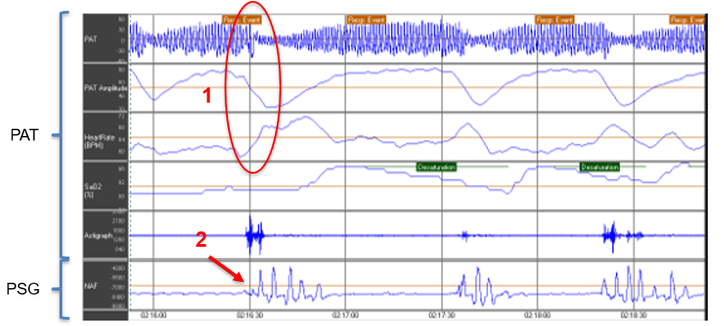
Figure 2: Simultaneous measurement of PAT and Nasal Air Flow (NAF) in Level 1 Polysomnography, showing that the reciprocal pattern of vascular constriction (PAT signal attenuates / PAT amplitude declines) and increase in heart rate (1) is correlated with the resumption of NAF activity (2) at the end of an apnoeic event.
Detecting arousals:
Arousals are manifested in the PAT and Heart Rate. Therefore, a PAT automatic algorithm is designed to analyse both signals, together with changes in oxygen saturation, and detect respiratory related arousals, for the purposes of SA diagnosis. The automatic analysis marks an arousal as an Apnoea/Hypopnea event (pAHI) or a Respiratory Effort Related Arousal (RERA) based on that analysis (figure 3). Arousals that are not respiratory related can still be presented in the raw signals of the PAT but will not be marked as respiratory events.
Figure 3
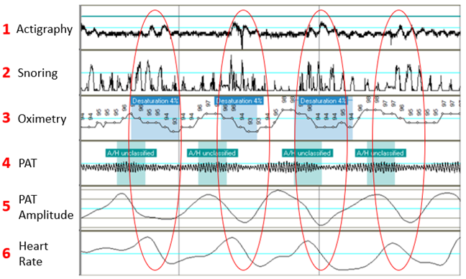
Figure 3: Example of respiratory related arousals that would be scored as AHI events, as shown in the PAT raw signals. Respiratory related arousals include the following changes in signals: Movement in the actigraphy sensor (1), Changes in snoring pattern (2), Oxygen desaturation (3), PAT attenuation / decrease in PAT amplitude (4,5) and increase in heart rate (6). The automated algorithm marks the respiratory events in green (line 4).

Figure 4
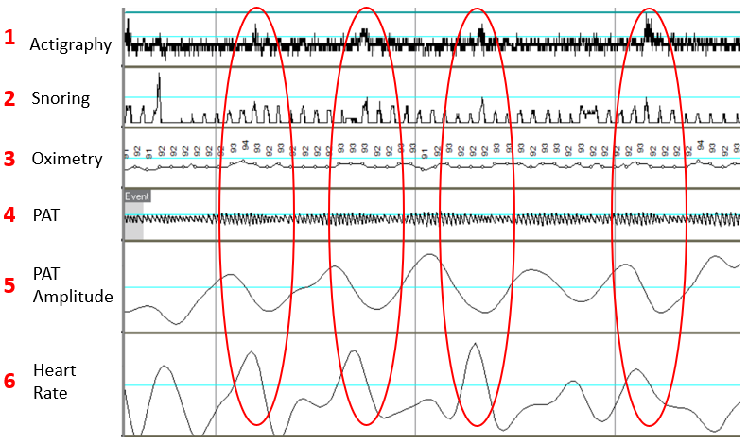
Figure 4: Example of non-respiratory arousals, caused by Periodic Limb Movement (PLM) disorder, as shown in the PAT raw signals. Each arousal is presented in changes in the actigraphy signal (1), PAT signal attenuates / amplitude decline (4,5) and increase in heart rate (6). Since PLM is not respiratory related arousal, the snoring (2) and Oxygen saturation (3) channels remain unaffected.

Detecting Sleep / Wake
The standard method for differentiating between sleep and awake times in level 1 and level 2 devices, is based on analysis of brain activity via an EEG channel. In PAT devices, that differentiation is based primarily on input from the accelerometer (actigraphy) sensor located on the patient’s wrist which measures hand movements. This is supported by measurement of other signals: frequent desaturation, for example, will indicate the patient is asleep. The automated PAT report includes Total Sleep Time, Sleep Latency, and the number of ‘wakes’.
Detecting Sleep Stages:
Once the sleep stage is detected, the differentiation of REM/Non-REM may take place. Detecting REM without the use of EEG, is based on analysis of the PAT and heart rate signals, using 15 different time and frequency domain features of the signals in order complete classification. In general, the REM period is associated with increased sympathetic activation compared to the Non-REM period. This increased sympathetic activation is displayed by the attenuated PAT signal as its variability increases, as well as an increase in heart rate variability. In most cases, the mean heart rate is elevated as well. This pattern allows accuracy in detection of REM sleep without the use of EEG as component of a sleep apnoea diagnosis.

Figure 5
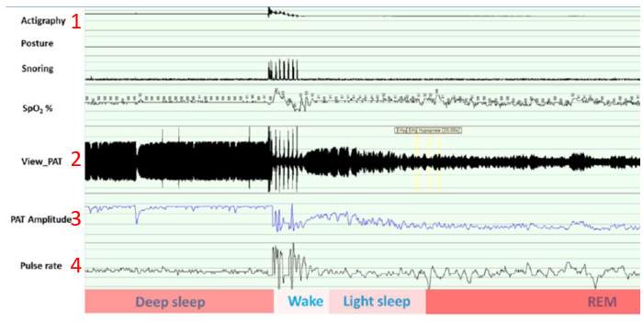
Figure 5: Different sleep stages as manifested in the Actigraphy (1) PAT signal (2), PAT amplitude (3) and Heart Rate (4).

The importance of detecting Total Sleep Time (TST) and REM:
Detecting TST is essential for the correct calculation of the main Sleep Apnoea diagnostic indices, Apnoea Hypopnoea Index (AHI) and Oxygen Desaturation Index (ODI). These indices represent the number of apnea-hypopnea events or desaturation event per hours of sleep and therefore are calculated by dividing the total number of events by the hours of sleep time that might be different from actual recording time, especially in patients with long periods of wakefulness during the night due to insomnia and nocturia. The detection of REM is important for calculation of REM Related Apnoea, which is associated with a higher risk of hypertension.
The American Academy of Sleep Medicine (AASM) scoring guidelines for SA diagnosis are considered the gold standard for the scoring of sleep studies worldwide. The guidelines require that scoring of PAT based sleep apnoea tests will include detection of TST and REM sleep. These two parameters are considered mandatory to comply with the AASM scoring guidelines for PAT.
Cardiac abnormalities:
One of the PAT signal derivatives is heart rate, and therefore the PAT signal can provide an indications of cardiac abnormalities, such as tachycardia, bradycardia, atrial fibrillation and premature heart beats. Both tachycardia and bradycardia can be detected in the heart rate channel in the raw signal. Atrial fibrillation and premature heart beats can be visually detected in the PAT channel in the raw signals.

Figure 6
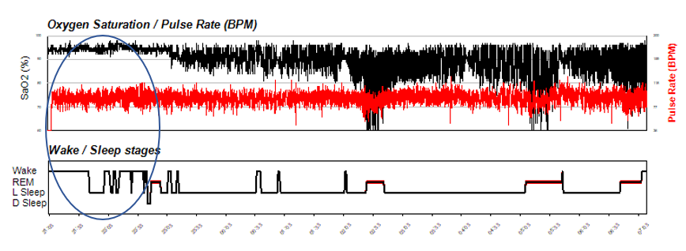
Figure 6: Example of permanent Atrial Fibrillation as seen in the PAT automated report. The heart rate signal (shown in red) suggest that there is a high heart rate variability (HRV) throughout the night.
Figure 7
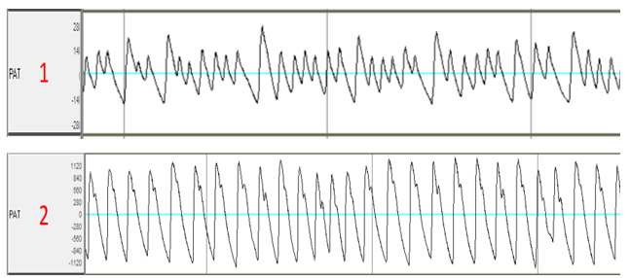
Figure 7: Example of Atrial Fibrillation (1) and normal sinus rhythm (2), as seen in the PAT raw signal.
Detecting Central Sleep Apnoea:
Once the PAT automated algorithm detects a respiratory event and marks it as an Apnoea/Hypopnea event, it can then differentiate central apnoea events from the totality of apnoea/hypopnea events. Identifying central events is based on the analysis of breathing effort. The detection of effort comes from two independent sources – a three axis accelerometer located on the chest detecting chest movement and an analysis of the effect of intrathoracic pressure variability on the upstrokes in the PAT signal. In order to further refine the detection of central events, the algorithm assesses additional parameters. These are:
1. Detection of patterns and shapes of oxygen desaturations that are associated with either Central Apnoea or Obstructive Apnoea
2. Detection of snoring during the event.
3. Detection of wrist movements, in case a breathing pattern is detected within these and comparison with the main chest effort channels.
In addition to the identification of Central Apnoea/Hypopnea events, the automated algorithm can also detect central periodic breathing patterns as Cheyne Stokes Respiration (CSR), and include in the automated report CSR as a percentage of total sleep time.

Figure 8
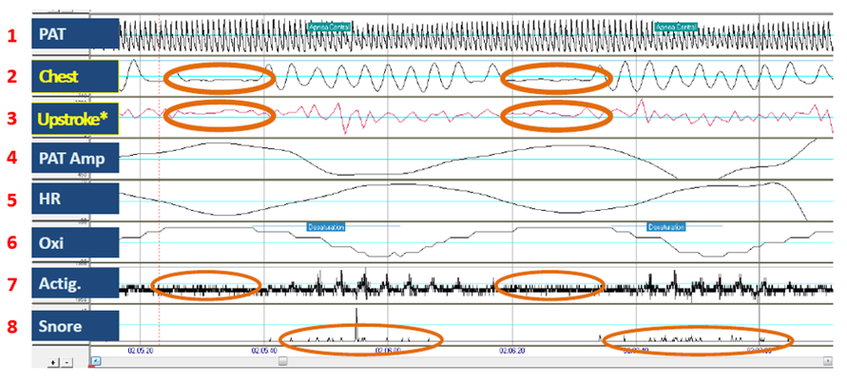
Figure 8: Central Sleep Apnoea, as shown in the raw signals of a PAT device. Both the chest sensor (2) and the PAT upstroke analysis (2) indicate that the chest wasn’t moving prior to the respiratory related arousal that indicated an Apnoea/Hypopnea event. Further analysis of the desaturation patterns (6), movements of the wrist (7) and snoring (8) strengthen the indication that this respiratory event is a central event and not obstructive.
Accuracy and manual review / adjustment of the PAT automatic scoring:
To date, the PAT based automatic sleep report, is the most validated sleep apnoea diagnostic technology. More validation studies of the PAT automated report have been performed than of any other sleep apnoea diagnostic technology. Since 2000, many validation studies of the PAT technology have been performed. Most of these studies compare the PAT automated score of Sleep Breathing Disorder (SBD) indices with that of level 1 Polysomnography (PSG). A Meta-analysis published in 2013 reviewed 14 validation studies between 2000-2013 and found a correlation of 0.889 between PAT AHI and PSG AHI.
Despite the numerous validation publications of the PAT autoscoring accuracy, until recently there was no validated method to assess the automatic report and manually adjust it, in cases of suspected inaccuracy. This issue was addressed in a recent study by the sleep research team at Johns Hopkins University, led by Prof Alan Schwartz, who introduced simple guidelines to perform manual review and adjustment of the PAT automated scoring. The study showed that the application of manual review of the automated PAT report improved correlation and agreement with PSG derived sleep and breathing indices. In most cases manual adjustment is not necessary. If necessary, this takes less than ten minutes.

Using a PAT device:
Please see below an example of the most used PAT device, WatchPAT. WatchPAT is considered a Home Sleep Apnoea Test (HSAT). The device is attached at the finger, wrist and chest. There are seven physiological signals measured through the three points of contact.

Figure 9
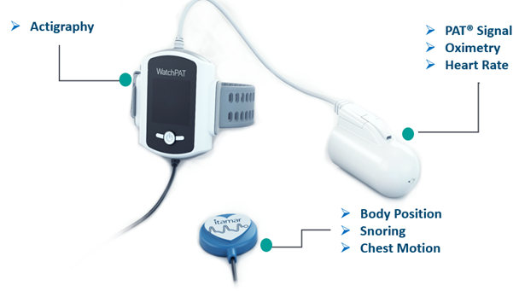
Figure 9: WatchPAT device has three points of contact with the patient body that incorporate seven measured signals.

Use of the device is as follows:
1. Once a patient has been determined to be eligible for a HSAT, they are issued with a PAT device.
2. The patient takes the device home and wears it just prior to going to bed. The device is activated by a single start button. The device will record the patient’s sleep overnight. The device is removed in the morning and returned to the sleep centre.
3. Analysis
i) Automated analysis: The device is connected to a computer, the recording is loaded from the device and analysed automatically. Within two minutes a report is generated for interpretation
ii) If required, manual review is conducted by the sleep specialist.
iii) Once the report is approved, it is clinically interpreted by the sleep specialist and a clinical diagnosis may be provided to the patient.
The WatchPAT sleep report includes the following:
    - Recording time
    - Sleep data:
      - Total Sleep Time
      - Sleep latency
      - REM latency
      - Number of wakes
      - Sleep stages (Light, Deep and REM)
    - Respiratory Breathing Disorder indices, calculated based on Total Sleep Time:
      - Respiratory Disturbance Index (pRDI)
      - Apnoea Hypopnea Index (pAHI)
      - Oxygen Desaturation Index (ODI)
      - Central Apnoea Hypopnea Index (pAHIc)
      - Cheyne Stokes Respiration (CSR) percentage
All indices (except CSR) are available as a nightly average, a REM period value and a Non-REM period values
    - Oxygen saturation – summary of values
    - Heart rate – summary of values
    - Body position data – a breakdown of all the indices per body position.
    - Snoring level – statistics of snoring levels throughout the night.
  - A visual spread of the data through the entire night, as seen below:

Figure 10
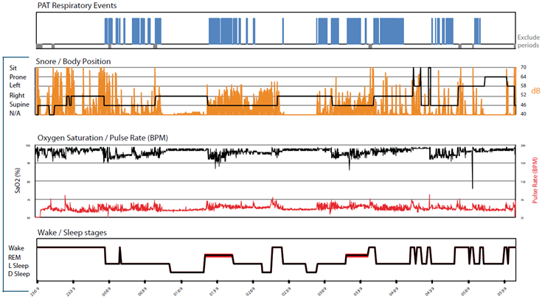

Figure 10: The hypnogram from a WatchPAT automated sleep report. Respiratory events presented at the top (blue); then snoring (orange) and body position; then oxygen desaturations (black) and heart rate; then sleep stages at the bottom.
Please see this link for a short video that demonstrates use of the WatchPAT: https://www.youtube.com/watch?v=xdM5mX0VPwM

Does the proposed medical service include a registered trademark component with characteristics that distinguishes it from other similar health components?
The acronym “PAT” is a registered trademark of Itamar Medical, however, the term “Peripheral Arterial Tone” is not a registered trademark.

If the proposed medical service has a prosthesis or device component to it, does it involve a new approach towards managing a particular sub-group of the population with the specific medical condition?
Yes, as noted above, the device utilises PAT technology and is intended for patients who are suspected to have moderate to severe SA. Patients currently receive either an in-laboratory Polysomnography (PSG) or are tested at home with a level II device. Currently available level II devices generally require the attendance of a sleep technician either in the clinic or at the patient’s home to apply the device. Due to the simplicity of the application of the WatchPAT device, the services of a sleep technician are not required.

If applicable, are there any limitations on the provision of the proposed medical service delivered to the patient (i.e. accessibility, dosage, quantity, duration or frequency):
There are no limits on accessibility of the device. The device is either collected from a sleep clinic or the device may be posted to the patient if necessary. This means that patients who live in a remote location or have limited mobility are not limited in accessing the test. Currently available Level II tests which are used at home, in most cases, require a physical meeting with a sleep technician to apply EEG sensors.
A disposable model of the device is also available and may be used by anyone who has access to a smart phone and an internet connection.

There are however some precautions that limit the use of the device in specific populations. These are specific to the WatchPAT device and are:
1. Use of one of the following medications: alpha blockers, short acting nitrates (less than 3 hours before the study).
2. Permanent pacemaker: atrial pacing or VVI without sinus rhythm.
3. Sustained* non-sinus cardiac arrhythmias. (* In the setting of sustained arrhythmia, the WatchPAT’s automated algorithm might exclude some periods of time, resulting in a reduced valid sleep time. A minimum valid sleep time of 90 minutes is required for an automated report generation).
The WatchPAT is not indicated for children under the age of 12 or that weigh less than 30 kg. Some additional precautions are recommended in children.

If applicable, identify any healthcare resources or other medical services that would need to be delivered at the same time as the proposed medical service:
Not applicable

If applicable, advise which health professionals will primarily deliver the proposed service:
The service is delivered under the supervision of a sleep clinic. Interpretation of the test must be performed by a specialist sleep physician or respiratory physician.

If applicable, advise whether the proposed medical service could be delegated or referred to another professional for delivery:
No

If applicable, specify any proposed limitations on who might deliver the proposed medical service, or who might provide a referral for it:
Any General Practitioner (GP) can directly refer eligible patients for a diagnostic home-based (unattended) sleep study for OSA when an approved assessment tool has been used. GPs may also refer eligible patients with suspected sleep disorders to a qualified adult sleep medicine physician or consultant respiratory physician for further investigation. GPs who directly refer patients for a diagnostic home sleep study, must determine a patient’s eligibility by using an approved assessment tools such as sleep questionnaires: STOP-BANG, OSA50, Berlin Questionnaire or Epworth.
The interpretation of the study and prescription of further treatment should be performed by a specialist sleep physician.

If applicable, advise what type of training or qualifications would be required to perform the proposed service, as well as any accreditation requirements to support service delivery:
Accreditation by the Australian Sleep Association (ASA) and the National Association of Testing Authorities Australia (NATA) is required by an individual in order to score the test. Either a sleep technologist or sleep physician may score the test and a sleep physician should determine if further treatment is needed. There is no need for specific training to perform the test itself.

(a) Indicate the proposed setting(s) in which the proposed medical service will be delivered (select ALL relevant settings):
Inpatient private hospital (admitted patient)
Inpatient public hospital (admitted patient)
Private outpatient clinic
Public outpatient clinic
Emergency Department
Private consulting rooms - GP
Private consulting rooms – specialist
Private consulting rooms – other health practitioner (nurse or allied health)
Private day surgery clinic (admitted patient)
Private day surgery clinic (non-admitted patient)
Public day surgery clinic (admitted patient)
Public day surgery clinic (non-admitted patient)
Residential aged care facility
Patient’s home
Laboratory
Other – please specify below
It is intended that the service would usually be performed in the patient’s home. However, there is no impediment to delivering the service in other settings such as hospitals or clinics should it be necessary.
- Where the proposed medical service is provided in more than one setting, please describe the rationale related to each:

Is the proposed medical service intended to be entirely rendered in Australia?
Yes
No – please specify below
The proposed medical service is to be entirely rendered in Australia. There is an option in some of the devices to use cloud-based solutions to deliver test data to the sleep physician for interpretation. Currently WatchPAT cloud servers are located in Europe. Should it be necessary, a dedicated server for Australian patients’ data can be placed in Australia.

PART 6c – INFORMATION ABOUT THE COMPARATOR(S)

Nominate the appropriate comparator(s) for the proposed medical service, i.e. how is the proposed population currently managed in the absence of the proposed medical service being available in the Australian health care system (including identifying health care resources that are needed to be delivered at the same time as the comparator service):
The comparator service is a Level II sleep study. It is also likely that the proposed new service would be used as an alternative to an in-hospital Level I study in some cases.
Patients who are suffering from sleep problems such as fatigue, snoring or daytime sleepiness are likely to initially present to a GP. If the GP suspects that the patient has a high probability of symptomatic moderate to severe OSA, the patient is further screened with an appropriate sleep questionnaire as described in Question 26 and may be referred directly for a sleep study. Alternatively, a GP may refer the patient to a sleep specialist or respiratory physician.
The sleep specialist or respiratory physician may also determine that the patient has a high probability of moderate to severe OSA and may refer the patient to a sleep study to confirm the diagnosis of an SRBD.

Once a referral has been made for a sleep study, the test may be performed as a Level I PSG at a sleep laboratory or as a Level II PSG at the patient’s home. The home test will generally require a meeting with a sleep technician. The sleep technician may apply the sensors at the clinic and the patient will leave the clinic wearing the sensors or the sleep technician may attend the patient’s home. The laboratory sleep study requires an overnight stay with a sleep technician monitoring the patient overnight. Following both types of sleep study, the study is manually scored by a sleep technician which usually takes 1 to 2 hours. The results are then sent to a sleep physician for interpretation and if necessary, prescription of further treatment.

Does the medical service (that has been nominated as the comparator) have an existing MBS item number(s)?
Yes (please list all relevant MBS item numbers below)
No
12203 - ADULT LABORATORY-BASED (LEVEL 1) SLEEP STUDIES
12250 - UNATTENDED (LEVEL 2) SLEEP STUDIES

Define and summarise the current clinical management pathway/s that patients may follow after they receive the medical service that has been nominated as the comparator (supplement this summary with an easy to follow flowchart [as an attachment to the Application Form] depicting the current clinical management pathway that patients may follow from the point of receiving the comparator onwards, including health care resources):
Following interpretation of the sleep study report, the sleep specialist or respiratory physician will determine if further treatment is required. The patient is likely to follow one of three pathways:
1. The test result is negative for SA (AHI<5). In this case, further investigation may be required, or no further treatment is considered necessary.
2. The test result shows mild SA (5<AHI<15). In this case, based on the symptoms, patient physiology and medical history, the specialist may suggest one of the following alternatives:
i) Lifestyle changes such as weight loss or alcohol reduction.
ii) Positional therapy (if positional apnoea is detected)
iii) Mandibular Advancement Device
iv) ENT surgical intervention.
3. The test result shows Moderate or Severe SA (15<AHI<30, or AHI>30). In this case, based on the patient’s symptoms, physiology and medical history, the patient is most likely to be referred for treatment with CPAP or in the case of moderate SA, a Mandibular Advancement Device may be considered.

(a) Will the proposed medical service be used in addition to, or instead of, the nominated comparator(s)?
In addition to (i.e. it is an add-on service)
Instead of (i.e. it is a replacement or alternative)

If instead of (i.e. alternative service), please outline the extent to which the current service/comparator is expected to be substituted:
In most cases the PAT sleep study may be used instead of current Level 2 sleep studies for patients 12 years and older . However, there are circumstances where some precautions may limit the use of PAT. These are:
    - Patients under the age of 12, or that weigh less than 30kg. Some additional precautions are recommended in children.
    - Use of one of the following medications: alpha blockers, short acting nitrates (less than 3 hours before the study).
    - Permanent pacemaker: atrial pacing or VVI without sinus rhythm.
    - Sustained non-sinus cardiac arrhythmias - In the setting of sustained arrhythmia the PAT’s automated algorithm might exclude some periods of time, resulting in a reduced valid sleep time. A minimum valid sleep time of 90 minutes is required for an automated report generation.
Based on these precautions, it is estimated that the PAT device may replace the current Level II tests in approximately 90% of cases. PAT devices may also replace 90% of Level 1 Polysomnography tests that are currently used to diagnose sleep apnoea. It is not possible to determine what percentage of Level 1 tests are conducted to diagnose sleep apnoea but from experience in other jurisdictions, it is estimated that approximately 50% of level 1 tests could be replaced.
Total = 10,425 to 15,641 in the first year.
It is anticipated that growth in the use of PAT would increase by approximately 5-10% each year.

Define and summarise how current clinical management pathways (from the point of service delivery onwards) are expected to change as a consequence of introducing the proposed medical service, including variation in health care resources (Refer to Question 39 as baseline):
As the proposed service is an alternative method of diagnosis of SA, it is not anticipated that there will be any changes in the clinical pathway following its introduction.

PART 6d – INFORMATION ABOUT THE CLINICAL OUTCOME

Summarise the clinical claims for the proposed medical service against the appropriate comparator(s), in terms of consequences for health outcomes (comparative benefits and harms):
The accuracy of devices utilising PAT technology has been validated against the gold standard of PSG in numerous studies. A meta-analysis of 14 studies (909) patients demonstrated a correlation of 0.889 in AHI between WatchPAT and PSG. A manual editing algorithm significantly increases the correlation of TST, REM sleep and AHI.

The proposed service allows the sleep physician to manually edit study data if required. The comprehensive sleep report generated from the use of PAT technology includes the same information as the comparator services. Included SA indices are: AHI, ODI, sleep time, sleep architecture (wake/sleep, REM, light and deep sleep), body position and snoring level.

Please advise if the overall clinical claim is for:
Superiority
Non-inferiority

Below, list the key health outcomes (major and minor – prioritising major key health outcomes first) that will need to be specifically measured in assessing the clinical claim of the proposed medical service versus the comparator:
Safety Outcomes:
There are no known safety events related to the use of the device.
Clinical Effectiveness Outcomes:
Correlation with Level 1 Polysomnography

PART 7 – INFORMATION ABOUT ESTIMATED UTILISATION

Estimate the prevalence and/or incidence of the proposed population:
Sleep apnoea (SA) is a type of SRBD, the most common of which is Obstructive Sleep Apnoea (OSA). OSA is associated with decreased quality of life, functional impairment, and socio-economic burden on society. The prevalence of OSA is estimated to be 14% of men and 5% of women, (AHI ≥ 5) . In Australia the prevalence of OSA is estimated to be 8.3% overall (men-12.9% and women 3.7%). It is estimated that the Australian prevalence of moderate to severe OSA, (AHI ≥ 15), is 5.7% of males and 1.2% of females.OSA prevalence increases in middle age and is estimated to be 33.9% in men and 17.4% in women (ages 30-70) . Most patients go undiagnosed. 83% of men and 92% of women with moderate to severe OSA (AHI>15) have not been diagnosed.
According to these statistics there are about 1.5 million Australian suffering from SA. Most of these people are likely to go undiagnosed. This number is likely to grow as the Australian population ages and becomes progressively more obese. In 2019, 135,148 patients underwent sleep tests.

Estimate the number of times the proposed medical service(s) would be delivered to a patient per year:
It is anticipated that the service would be delivered once, although it is possible that the service may be used to evaluate the effectiveness of treatment or to evaluate the effect of any lifestyle change such as significant weight loss.

How many years would the proposed medical service(s) be required for the patient?
The test is delivered over one night only

Estimate the projected number of patients who will utilise the proposed medical service(s) for the first full year:
As PAT technology will be novel to the Australian market, it is not anticipated that uptake of the technology will be overly rapid, although it is possible that the comparative simplicity and convenience of the service may drive uptake.
It is estimated that initially 10% to 15% of current sleep studies may be conducted with PAT technology. In 2019 a total of 135,148 sleep tests were conducted under MBS items 12203 (level 1 overnight PSG – 43,385 tests) and 12250 (home based level II test – 91,763 tests). Therefore:
10% - 15% of 50% of utilisation of 12203 = 2167 to 3,253
10% - 15% of 90% of utilisation of 12250 = 8258 to 12,388
Total = 10,425 to 15,641 in the first year.

Estimate the anticipated uptake of the proposed medical service over the next three years factoring in any constraints in the health system in meeting the needs of the proposed population (such as supply and demand factors) as well as provide commentary on risk of ‘leakage’ to populations not targeted by the service:
Since 2015 there has been an average per annum growth in home- based sleep tests claimed under item number 12250 of 5.4%. Assuming the same rate of growth in utilisation, and an initial usage rate of 10%, Table 2 outlines the anticipated usage of the new service.
Table 1: MBS 12250 utilisation
 | 2015 | 2016 | 2017 | 2018 | 2019
MBS 12250 | 74,425 | 78,648 | 85,627 | 87,180 | 91,763
% increase from  previous year | --- | 5.67% | 8.87% | 1,81% | 5.25%  Average growth 5.4%
Assuming a constant growth of 5.5% per annum in use of MBS 12250 and that 90% of this number would be appropriate for a PAT test, and an initial utilisation of 10% Table 2 calculates the anticipated use over 4 years.
Table 2: Projection of PAT test utilisation MBS 12250
 | 2021 | 2022 | 2023 | 2024
Total MBS 12250 | 96,810 | 102,134 | 107,751 | 113,677
Number of patients appropriate PAT test | 87,129 | 91,920 | 96,976 | 102,309
% Utilisation of PAT | 10 | 15 | 20 | 25
Total utilisation | 8,713 | 13,788 | 19,395 | 25,557
It is likely that a proportion of patients, who would usually undergo an inpatient sleep test would instead have a sleep test utilising PAT. Of the 50% of patients who are likely to undergo the test for suspected SA, it is estimated that utilisation will be 10% for the first year with growth of 5% every following year. The table below shows the utilisation of item number 12203 which is a hospital-based sleep test
Table 3: MBS 12203 utilisation
 | 2015 | 2016 | 2017 | 2018 | 2019
MBS 12203 | 104,200 | 108,203 | 98,443 | 87,108* | 43,385*
% change |  | 3.8% | -9.0% | -9.3% | Average growth  -4.9%
*Since November 2018, item 12203 has been split into 12203, 12204 and 12205. To calculate average growth, only the years prior to 2019 have been included
Table 4: Projection of PAT test utilisation
 | 2021 | 2022 | 2023 | 2024
Total MBS 12203 | 41,259 | 39,237 | 37,404 | 35,571
No of patients appropriate for PAT Test | 20,629 | 19,618 | 18,702 | 17,785
% Utilisation of PAT | 10 | 15 | 20 | 25
Total utilisation of PAT | 2,062 | 2,942 | 3,740 | 4,446

PART 8 – COST INFORMATION

Indicate the likely cost of providing the proposed medical service. Where possible, please provide overall cost and breakdown:
The charge for the WatchPAT test and cloud-based service is $151. There are costs incurred by the sleep clinic in instructing the patient in the use of the device, performing a manual review (when necessary) and interpreting the results.

Specify how long the proposed medical service typically takes to perform:
The service is delivered overnight at the patient’s home and there is no necessity for attendance by a health professional at the home. It is recommended that a sleep study using PAT should include at least 6 hours of total sleep time.
The service to the patient includes
i) preparation and cleaning of the device and replacement of disposable components.
ii) The patient is instructed in the use of the device. This may take place face to face or via phone or internet (video conferencing) or alternatively written instructions may be given. This may take up to 10 minutes.
Following the test and depending upon which version of the device is used, data is uploaded from the device or downloaded from the cloud to a computer and a report is generated. This takes 2 minutes.
The report is manually reviewed which may take between 5 and 15 minutes

If public funding is sought through the MBS, please draft a proposed MBS item descriptor to define the population and medical service usage characteristics that would define eligibility for MBS funding.
Category 2 – Diagnostic Procedures and Investigations
Proposed item descriptor
Overnight investigation of sleep for a period of at least 8 hours of a patient aged 18 years or more to confirm diagnosis of obstructive sleep apnoea, if
(a) either:

(i) the patient has been referred by a medical practitioner to a qualified sleep medicine practitioner or a consultant respiratory physician who has determined that the patient has a high probability for symptomatic, moderate to severe obstructive sleep apnoea based on a STOP Bang score of 4 or more, an OSA50 score of 5or more or a high risk score on the Berlin Questionnaire, and an Epworth Sleepiness Scale score of 8 or more; or
(ii) following professional attendance on the patient (either face to face or by video conference) by a qualified sleep medicine practitioner or a consultant respiratory physician, the qualified sleep medicine practitioner or consultant respiratory physician determines that investigation is necessary to confirm the diagnosis of obstructive sleep apnoea; and
(b) during a period of sleep, there is continuous monitoring and recording, performed in accordance with current professional guidelines, of the following measures:
(i) airflow;
(ii) continuous EMG;
(iii) continuous ECG;
(iv) continuous EEG;
(v) EOG;
(vi) oxygen saturation.
(vii) respiratory effort
(viii) Or, home sleep apnoea diagnostic test measuring Peripheral Arterial Tone (PAT), heart rate, oxygen saturation, actigraphy, respiratory effort, snoring level and body position to measure sleep time and sleep architecture which includes awake/sleep, REM, NON-REM, light and deep sleep.
(c) the investigation is performed under the supervision of a qualified sleep medicine practitioner; and
(d) either:
(i) the equipment is applied to a patient by the sleep technician
(ii) if this is not possible-the reason it is not possible for the sleep technician to apply the equipment to the patient is documented and the patient is given instructions on how to apply the equipment by a sleep technician supported by written instructions.
iii) the test is delivered by a PAT device and no attendance by a sleep technician is required; and
e) polygraphic records are:
(i) analysed (for assessment of sleep stage, arousals, respiratory events and cardiac abnormalities) with manual scoring, or manual correction of computerised scoring in epochs of not more than 1 minute; and
(ii) stored for interpretation and preparation of report; and
(f) interpretation and preparation of a permanent report is provided by a qualified sleep medicine practitioner with personal direct review of raw data from the original recording of polygraphic data from the patient; and
(g) the investigation is not provided to the patient on the same occasion that a service mentioned in any of items 11000 to 11005, 11503, 11700 to 11709, 11713 and 12203 is provided to the patient
Applicable only once in any 12- month period
Fee: $335.30

Kapur et al “Clinical Practice Guideline for Diagnostic Testing for Adult Obstructive Sleep Apnea: An American Academy of Sleep Medicine Clinical Practice Guideline” JCSM - Journal of Clinical Sleep Medicine. P-480 (Mar. 15, 2017).
Marshall et al “Sleep Apnea as an Independent Risk Factor for All-Cause Mortality: The Busselton Health Study”. SLEEP, Vol. 31, No. 8, 2008 (P-1079)
Robert J. Adams et al “Sleep health of Australian adults in 2016: results of the 2016 Sleep Health Foundation national survey” Sleep Health journal 3 (2017) 35–42 (P35, 37)
FDA – 510k K180775 WatchPAT 300
Agency for Healthcare Research and Quality (AHRQ). “Diagnosis and treatment of obstructive sleep apnea in adults” AHRQ Publication No. 11-EHC052. July 2011
Young T, et al “The occurrence of sleep-disordered breathing among middle- aged adults”. N Engl J Med. 1993;328:1230-1235
Kapur et al “Clinical Practice Guideline for Diagnostic Testing for Adult Obstructive Sleep Apnea: An American Academy of Sleep Medicine Clinical Practice Guideline” JCSM -. P-480 (Mar. 15, 2017)
Marshall et al “Sleep Apnea as an Independent Risk Factor for All-Cause Mortality: The Busselton Health Study”. SLEEP, Vol. 31, No. 8, 2008 (P-1079)
Robert J. Adams et al “Sleep health of Australian adults in 2016: results of the 2016 Sleep Health Foundation national survey” Sleep Health journal 3 (2017) 35–42 (P-35)
Kapur et a, 2017l P-480.
Robert J. Adams et al P-37
: Peppard PE, Young T, Barnet JH, Palta M, Hagen EW, Hla KM “Increased prevalence of sleep-disordered breathing in adults”. Am J Epidemiol. 2013;177(9):1006-1014 (P1012)
James A. Douglas et al “Guidelines for sleep studies in adults e a position statement of the Australasian Sleep Association” Sleep Medicine journal 36 (2017) S2eS22 (S7)
Marshall et al, 2008, P-1082
Marin JM “Long-term cardiovascular outcomes in men with obstructive sleep apnoea-hypopnoea with or without treatment with continuous positive airway pressure: an observational study” Lancet Vol 365, Iss 9464, P1046-1053, March 19, 2005
Treager S et al,” Obstructive sleep apnea and risk of motor vehicle crash: systemic review and meta-analysis” JCSM 2009 Dec 15;5 (6): 573-81.
Deloitte Access Economics ‘The economic cost of sleep disorders in Australia, 2010’. Sleep Health Foundation
James A. Douglas et al (2017) S10
Javaheri S, et al. “Sleep Apnea: Types, Mechanisms, and Clinical Cardiovascular Consequences”. J Am Coll Cardiol. 2017;69(7):841–858
Seet E, Chung F. “Obstructive sleep apnea: preoperative assessment”. Anesthesiol Clin. 2010 Jun;28(2):199-215. doi: 10.1016/j.anclin.2010.02.002. Review. PubMed PMID: 20488390.
Somers, K. Virend et al. “Sleep Apnea and Cardiovascular Disease”. Circulation. 2008;118:1080–1111
Stewart SA, et al. “Improvement in obstructive sleep apnea diagnosis and management wait times: A retrospective analysis of home management pathway for obstructive sleep apnea”. Can Respir J. 2015;22(3):167–170. doi:10.1155/2015/516580
Seet E, Chung F. (2010)
Australian government, department of Health, “Changes to diagnostic services for sleep disorders” MBS on-line: http://www.mbsonline.gov.au/internet/mbsonline/publishing.nsf/Content/Factsheet-SleepDisorders
MBS online “Medicare Benefits Schedule - Item 12250” http://www9.health.gov.au/mbs/fullDisplay.cfm?type=item&q=12250&qt=ItemID
Zou D, Grote L, Eder DN, Peker Y, Hedner “Obstructive apneic events induce alpha-receptor mediated digital vasoconstriction.” J. Sleep. 2004 May 1;27(3):485-9.
Detecting REM sleep from the finger: an automatic REM sleep algorithm based on peripheral arterial tone (PAT) and actigraphy, Lavi P et al, Physiol Meas. 2007 Feb;28(2):129-40
Nieto FJ, Young TB, Lind BK, et al. Association of Sleep-Disordered Breathing, Sleep Apnea, and Hypertension in a Large Community-Based Study. JAMA. 2000;283(14):1829–1836. doi:10.1001/jama.283.14.1829
Yalamanchali et al, “Diagnosis of Obstructive Sleep Apnea by Peripheral Arterial Tonometry”, JAMA Otolaryngology Head Neck Surg. 2013 Dec; 139(12):1343-50
Zhang Z et al, “A comparison of automated and manual sleep staging and respiratory event recognition in a portable sleep diagnostic device with in-lab sleep study”, Journal of Clinical Sleep Medicine, 2020 Feb. 10.5664/jcsm.8278
Australian government, department of Health, “Changes to diagnostic services for sleep disorders” MBS on-line: http://www.mbsonline.gov.au/internet/mbsonline/publishing.nsf/Content/Factsheet-SleepDisorders
FDA, WatchPAT 300 Indication for use, 18 July 2018 - https://www.accessdata.fda.gov/cdrh_docs/pdf18/K180775.pdf
Yalamanchali et al, “Diagnosis of Obstructive Sleep Apnea by Peripheral Arterial Tonometry” JAMA Otolaryngology Head Neck Surg. 2013 Dec; 139(12):1343-50
Zhang Z et al, “A comparison of automated and manual sleep staging and respiratory event recognition in a portable sleep diagnostic device with in-lab sleep study”, Journal of Clinical Sleep Medicine, 2020 Feb. 10.5664/jcsm.8278
Agency for Healthcare Research and Quality (AHRQ). “Diagnosis and treatment of obstructive sleep apnea in adults” AHRQ Publication No. 11-EHC052. July 2011
Kapur et a, 2017l P-480.
Robert J. Adams et al P-37
Cindy E. Woods et al, “Sleep Disordered Breathing and Polysomnography in Australia: Trends in Provision from 2005 to 2012 and the Impact of Home-Based Diagnosis”, JCSM, Vol. 10, No. 7, 2014 (767-772)
: Peppard PE, Young T, Barnet JH, Palta M, Hagen EW, Hla KM “Increased prevalence of sleep-disordered breathing in adults”. Am J Epidemiol. 2013;177(9):1006-1014 (P1012)
James A. Douglas et al “Guidelines for sleep studies in adults e a position statement of the Australasian Sleep Association” Sleep Medicine journal 36 (2017) S2eS22 (S7)
Cindy E. Woods et al, “2014

