Public Summary Document
Application No. 1519.1 – Tisagenlecleucel (CTL019) for treatment of relapsed or refractory diffuse large B-cell lymphoma (DLBCL)
Applicant: Novartis Pharmaceuticals Australia Pty Ltd
Date of MSAC consideration: MSAC 76th Meeting, 1-2 August 2019
Context for decision: MSAC makes its advice in accordance with its Terms of Reference, visit the MSAC website

Purpose of application
A revised application (resubmission) was received from Novartis by the Department of Health for tisagenlecleucel (TIS) for adult patients with confirmed relapsed/refractory (r/r) diffuse large B-cell lymphoma (DLBCL).
TIS is an individualised single-delivery immunocellular therapy using autologous T cells which are genetically reprogrammed with a chimeric antigen receptor (CAR) that identifies and destroys CD19-expressing (malignant and non-malignant) B-cells. TIS is a chimeric antigen receptor T-cell (CAR-T) therapy and a Class 4 Biological Product. CAR-T therapy cannot be easily defined as a service or a medicine; it is a process to genetically modify a patient’s T-cells. It is therefore not suitable for reimbursement through the Medicare Benefits Schedule (MBS) or the Pharmaceutical Benefits Scheme (PBS).
TIS is currently being jointly funded by the Commonwealth and the States under the National Health Reform Arrangements (NHRA) for use in relapsed and refractory acute lymphoblastic leukaemia in children and young adults up to age 25 years.
Consumer summary
Tisagenlecleucel (TIS) is a type of chimeric antigen receptor T cell (CAR-T) therapy. CAR-T therapy is used when patients with some types of cancer, such as lymphoma or leukaemia, don’t respond to (otherwise known as refractory), or relapse after, other types of treatment, such as chemotherapy. CAR-T therapy involves taking some of the patient’s own blood, and sending it to a laboratory where the T cells are extracted and altered so that they can attack cancer cells. The patient’s changed T cell are infused back into them to target and kill the cancer cells in the patient’s body.
This application requested public funding for TIS for patients with relapsed or refractory diffuse large B-cell lymphoma, or DLBCL.
MSAC’s recommendation to the Commonwealth Health Minister
MSAC did not support public funding for TIS for DLBCL at this time because, based on the information in the application, it is not sure how well TIS works for people with DLBCL and the sponsor has asked for a very high price for TIS. TIS can be a very toxic therapy and it can’t be used in all patients with DLBCL. MSAC felt that more work needs to be done to help doctors and patients choose whether to use TIS.
MSAC did not accept parts of the sponsor’s economic evaluation of TIS treatment. MSAC also could not calculate how many people might need TIS each year, so it could not estimate the financial impact of funding. MSAC has asked the sponsor to do more work to address these issues.

MSAC’s advice to the Minister
After considering the strength of the available evidence in relation to comparative safety, clinical effectiveness and cost-effectiveness, MSAC did not support public funding for tisagenlecleucel for the treatment of adults with confirmed relapsed/refractory diffuse large B-cell lymphoma (r/r DLBCL). MSAC recognised the unmet clinical need and accepted that tisagenlecleucel had been shown to be clinically effective in some patients. However, MSAC considered more work is needed to identify the patients most likely to benefit from treatment and, based on the outcomes of that work, to refine the estimates of number of patients and financial impact of subsidy. MSAC continued to have some concerns regarding the effectiveness and cost-effectiveness of tisagenlecleucel.

Summary of consideration and rationale for MSAC’s advice
This application was a resubmission for tisagenlecleucel (TIS) for treatment of relapsed or refractory DLBCL.

Applicant hearing
The applicant was granted a hearing, which included a slide presentation.
MSAC first heard from an Australia clinician who has treated a number of r/r DLBCL patients with TIS. The clinician described their experience using this therapy and presented clinical vignettes for two patients. Overall, the clinician considered TIS provides an important new therapeutic option for patients with r/r DLBCL who have limited other treatment options.
The applicant focussed on the use of the spline versus lognormal extrapolation methods in the modelled economic evaluation, and argued that a spline extrapolation method was better suited to the data than a lognormal extrapolation method. The applicant considered that the lognormal extrapolation was overly conservative and inconsistent with the observed data to date, and expressed the view that a lognormal extrapolation underestimates the effect of TIS.
MSAC asked the applicant about the proportion of r/r DLBCL patients who might be treated with TIS in Australia if the conditions of subsidy were aligned with the Therapeutic Goods Administration (TGA) approved indication. The clinician noted that in practice patient suitability for TIS will be based on considerations including the patient’s performance status and renal function. Older patients are more likely to have comorbidities that would render them unsuitable for TIS. However, the clinician considered it likely that in Australian clinical practice slightly more patients would be found suitable for therapy than in the JULIET clinical trial, where less than half of all screened patients went on to receive TIS (see also Figure 1 below). In their experience, more patients who begin manufacturing turn out to receive treatment. This was due to improvements in manufacturing turnaround and capacity in the commercial setting, as compared to the trial setting.
MSAC asked why the modelled ICERs were similar for the DLBCL and paediatric acute lymphoblastic leukemia (pALL) populations despite the large differences in modelled life-years (LYs) gained. MSAC noted that the economic model for the pALL population (for which funding was considered and accepted by MSAC in April 2019) estimated 6.8 life-years gained and an incremental cost-effectiveness ratio (ICER) of about $redacted per QALY. By contrast the economic model for the DLBCL population estimated an increment of 1.4 LYs and an ICER of $redacted per QALY. The applicant was unable to provide an explanation for this at the hearing which satisfied the MSAC. This point is discussed further below.
In response to being asked whether there are any randomised controlled studies being conducted in this patient population, the applicant indicated there are three international multicentre randomised controlled trials currently looking at CAR-T therapy compared with autologous stem cell transplant in DLBCL patients who relapse within 12 months of diagnosis. However, these trials are still in the recruitment stage. The applicant stated it was not aware of any ongoing randomised controlled studies in patients whose disease has relapsed after autologous stem cell transplant, ie the majority of the population in whom subsidy is currently proposed.

MSAC discussion
The MSAC noted that the population treated in the key clinical study, JULIET (C2201) was narrower than the population for whom subsidy is proposed, as a significant proportion of the screened patient population did not meet the eligibility criteria (see Figure 1). The MSAC further noted the JULIET eligibility criteria considered the fitness of the patient to receive treatment with TIS, and consequently are highly relevant to establishing the conditions of use of TIS in Australia.
In addition, even amongst those patients eligible to enrol in the JULIET study, around one-third did not go on to receive treatment with TIS; including 16/165 patients who died, between enrolment and infusion, and a further 16/165 who had their treating physician decide against further participation between enrolment and infusion.
Figure 1: Patient disposition, JULIET study
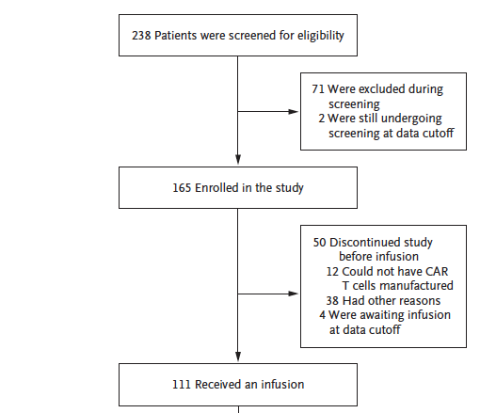
MSAC acknowledged the comments made by the clinician in the sponsor hearing that it was likely that Australian clinicians would want to treat a broader population than in the JULIET trial. However, MSAC noted evidence is currently only available for the trial population and the effectiveness and toxicity of TIS has not been established in a broader population, which will include patients who were considered too unwell for treatment in JULIET. MSAC considered it critically important that treatment with TIS is used only in patients likely to be fit enough to tolerate the treatment. MSAC recommended the Department convene a discussion with relevant stakeholders including treating clinicians, consumers, and representatives of the sponsor, Commonwealth and State/Territory governments to consider the criteria for eligibility for CAR-T therapy. MSAC considered the outcomes of that discussion should inform any future subsidy proposal made by the sponsor.
MSAC noted the inclusion of the December 2018 data cut from the JULIET trial in the resubmission had minimal effects on the observed overall survival (OS) and progression-free survival (PFS). In the December 2018 data cut, median PFS was 4.6 months (95% CI: 3.7, 5.2) which was the same as the May 2018 data cut (4.6 months [3.68, 5.19]). The median overall survival in the December 2018 data cut was 8.2 (5.8, 11.7 months) compared to 8.25 months (5.82, 11.7 months) in the May 2018 results presented at the November 2018 meeting.
MSAC agreed TIS shows an overall benefit compared with salvage chemotherapy regimen (SCR); however noted that the evidence of benefit is derived from a single arm trial in which the overall duration of follow-up remains short and the number of patients small (see Figure 2). Overall the results for TIS in treating DLBCL are not as promising as those seen for the pALL population (proportion alive at 12 months post-infusion 40% versus 71% for the pALL population).
Figure 2: Kaplan Meier plot of Overall Survival (enrolled set) for December 2018 Data cut
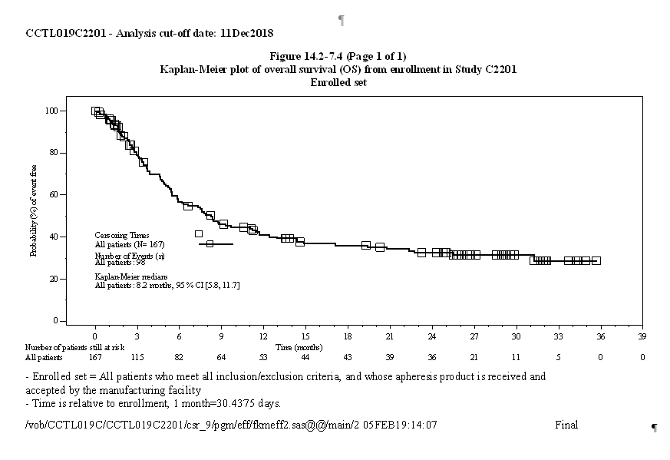
Source: Figure F142_7_04.rtf file in the update DLBCL_20 Feb folder
MSAC noted the calculated differences seen in the LYs and ICERs for the pALL and DLBCL populations. In the absence of an explanation from the sponsor during the hearing which satisfied the MSAC, an analysis was undertaken to clarify this issue:
Assuming that different extrapolations are appropriate for the two populations (lognormal for the pALL population and spline for the DLBCL population), then the higher number of LYs in the pALL population (6.8) relative to the DLBCL population (1.4) are consistent with the higher observed response rate and younger age of the pALL population. Thus, the extrapolation methods, and the inclusion of different treatment-related costs must explain the similar ICER for the two diseases. At a TIS price of $redacted the additional costs for treating DLBCL would be $redacted vs around $redacted for pALL. Thus MSAC considered the explanation for these differences must lie in a significant difference in treatment costs for DLBCL. However, it was not clear to MSAC whether the cost differences in the TIS arms of the models are an accurate reflection of differences in disease management for DLBCL relative to pALL.
MSAC noted the revised economic analysis provided by the applicant with this application resulted in a base case incremental cost per quality adjusted life year of $redacted which is somewhat higher than is usually acceptable and likely, for the reasons set out by the ESC, to be underestimated.
MSAC further noted the outcomes of the economic model are most sensitive to the price of TIS, the method of extrapolation and the starting age of the model and any reasonable variations of these give rise to unacceptably high cost effectiveness ratios.
MSAC was concerned that if treatment in Australia is given to a much wider population than included in the JULIET trial thereby including less fit patients, this would also have an unfavourable impact on the cost-effectiveness of treatment.
MSAC considered the number of patients likely to be infused in Australia is a key issue that has not been resolved by the resubmission. MSAC considered the sponsor’s revised estimates of patient numbers and financial impact of subsidy presented with the pre-MSAC response remain implausibly high, although acknowledged that the NHS England patient number estimates referred in Addendum 2 to the critique are an underestimate.
MSAC considered the patient numbers and financial impacts of subsidising TIS for r/r DLBCL would be more accurate if they were amended so:
- AIHW Australian Cancer Database figures are used to project the population diagnosed with NHL. This includes registry data for new diagnosed cases from all states and territories to 2015.
- Patients unfit for TIS are excluded. MSAC considered that the proportion of patients over age 80 in the Victorian Cancer Registry (Wong Doo et al. (2019), Table 1, p4) could be used as a proxy for estimating the proportion of patients of all ages unfit for TIS; with the addition of the proportion having an ECOG more than 2 in Crump 2017 (Table 1 p1803).
Incorporating these changes into the sponsor’s estimates results in a total number of TIS treated patients over 6 years of 1084 at a total cost of $redacted (TIS component of therapy only (see Table 1).
Table 1 Estimated costs for infused patients
DLBCL | Year 1 | Year 2 | Year 3 | Year 4 | Year 5 | Year 6 | Total
Total infused patients | 132 | 199 | 194 | 186 | 186 | 188 | 1084
TIS cost per infused patient | $redacted | $redacted | $redacted | $redacted | $redacted | $redacted | $redacted
Total cost - infused patients | $redacted | $redacted | $redacted | $redacted | $redacted | $redacted | $redacted
MSAC recognised these estimates could require further review based on the final agreed TIS eligibility criteria.
MSAC considered that, for this application to be successful, a risk-sharing agreement similar to the one put in place for the pALL population needs to developed. MSAC considered the risk-sharing arrangement should include redacted, data collection requirements and arrangements for further review(s) by MSAC. Redacted.
MSAC noted the final JULIET data would be available in 2023, and considered this might be an appropriate trigger for an MSAC review, although it may also be necessary to schedule an earlier review around 2 years after the commencement of subsidy.
MSAC considered that any resubmission could bypass ESC.

Background
This is the first resubmission for TIS for r/r diffuse DLBCL. At the November 2018 meeting, MSAC previously did not support public funding for TIS for adults with confirmed r/r DLBCL. Specifically, MSAC requested the definition of the appropriate eligible population needed to be redefined, as well as amendments made to the economic evaluation and a reduced price for TIS ascertained at which it is acceptably cost-effective [Final Public Summary Document (PSD) Application No. 1519, 2018, 2019, p6].

Prerequisites to implementation of any funding advice
This was unchanged, refer to Application 1519 Final PSD 2018, 2019, p9.

Proposal for public funding
The previous submission requested creation of a new national funding mechanism, suitable for providing equitable and affordable patient access to this highly specialised and individualised hybrid genetic therapeutic process, across both approved indications.
However, MSAC considered that the funding model for the proposed pALL population should reflect the current Commonwealth–state agreements for funding through public hospitals and that in the future, a Nationally Funded Centres Program model could be considered. For the r/r DLBCL population, it was suggested that a centre would subsequently be required in every state due to the larger patient numbers [PSD Application No. 1519, 2018, 2019, p8].
The resubmission stated that issues around the appropriate funding model for CAR-T therapies lie beyond the expertise of the applicant or scope of the resubmission. However, as noted previously, Novartis is willing to work closely with MSAC, the Department of Health and broader Australian Government to develop a suitable program that addresses these general principles and ensures timely and affordable access to this important new therapeutic process.

Requested price
The resubmission proposed a reduced effective price for the r/r DLBCL indication of redacted.

Summary of Public Consultation Feedback/Consumer Issues
This was unchanged, refer to Application 1519 Final PSD 2018, 2019, p10.

Proposed intervention’s place in clinical management
This was unchanged; refer to Application 1519 Final PSD 2018, 2019, p10.
Figure 3: Current and proposed management algorithm for DLBCL
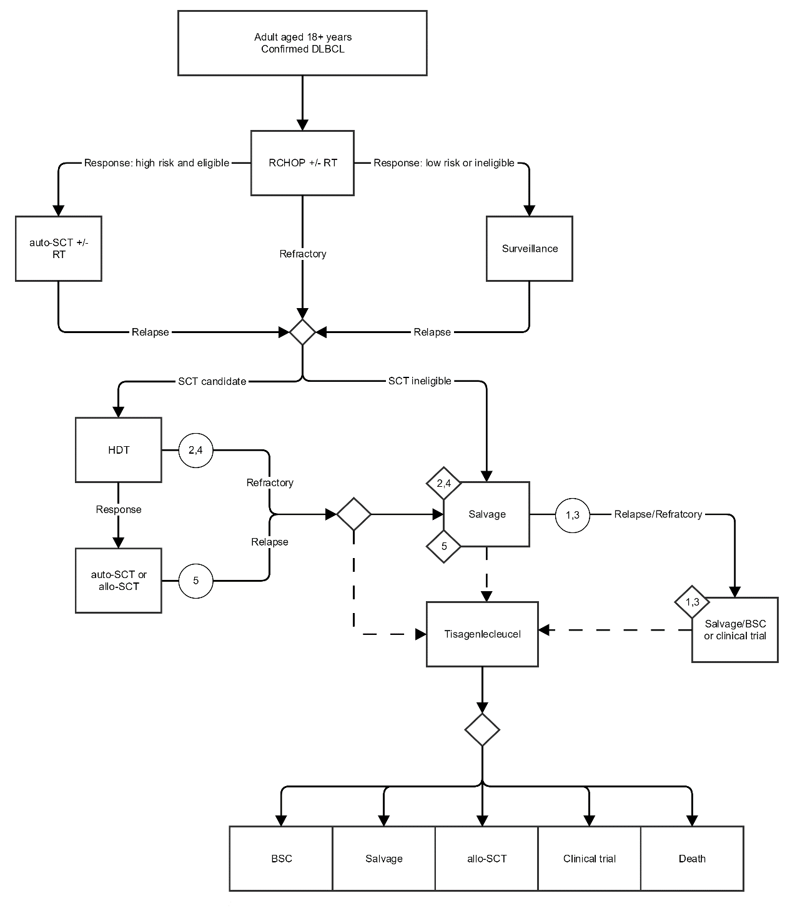
The solid lines represent current pathways, and dotted lines the proposed changes with the addition of tisagenlecleucel;
The circles indicate the patient subgroups suggested in the PICO Confirmation and the diamonds the potential comparators for each of these
Options following tisagenlecleucel treatment are also shown, noting that patients would not be eligible to return for a second infusion.

Other options for MSAC consideration
Nil.

Comparator to the proposed intervention
Consistent with the previous submission, the main comparator was SCR. MSAC previously accepted the proposed comparators Application 1519 Final PSD 2018, 2019, p10.
However, MSAC also considered that the r/r DLBCL population has other treatment options available to them, and the comparative effectiveness of TIS against these options had not been adequately explored [Final PSD, p9]. The resubmission stated there are no other therapeutic options commercially available in Australia for r/r DLBCL for which clinical effectiveness, safety or cost is significantly different to those regimens canvassed in the submission; hence the resubmission proposed the same comparator previously assessed by MSAC [Resubmission 1519.1 2019, p28].

Comparative safety
The resubmission relied on results from the data cut date of 21 May 2018 from the JULIET trial (intention-to-treat (ITT) N=167; Infused N=115). Specifically, the resubmission presented ‘non-CSR’ safety analyses, which the Critique highlighted the non-CSR analyses did not defined adverse events (AE)s in same terms (relative to CSR-based AEs in previous submission). However, the Critique stated that it was unlikely this difference in definition made a large difference.
The Critique stated overall, no substantial changes in the proportion of patients with adverse events was presented in the updated JULIET data (note Table 2 summarises safety outcomes).

Comparative effectiveness
The resubmission relied on results from the data cut date of 21 May 2018 from the JULIET trial (Table 3).
Table 3 Comparative summary results from the DLBCL trials
Outcome | JULIET (May 2018) |  | U-PEN | SCHOLAR | CORAL_E1 |  | CORAL_E2
Efficacy outcomes | Enrolled: N=167 | Infused: N=115 | N=14 (DLBCL) | N=523 | N=203 |  | N=75
ORR, n/N (%)  [95% CI] | 53/147 (36.1)  [28.3; 44.4] | 53/99 (53.5)  [43.2;63.6] | 7 (50)  NR | 134 (26.0)  [21.9,29.6] | 79 (38.9)  [32.2, 46.0] |  | 33 (44.0)  [32.5, 55.9]
Median PFS (months)  [95% CI] | 4.6  [3.7;5.2] | 2.9  [2.3;4.2] | 3.2  [0.9, NE] | NR | NR |  | NR
Median OS (months)  [95% CI] | 8.25  [5.8;11.7] | 11.1  [6.6; NE] | 22.2  [NR] | 6.3  [5.9,7.0] | 4.4  [NR] |  | 10.0  [NR]
Safety outcomes | Infused: N = 115 |  |  | Corazelli 2009: Patients = 62; Courses = 291
Patients with AEs, n(%) | 115 (100) |  | NR | Total AEs n (n per course) |  | 1,629 (5.6)
Grade ¾ | 104 (90.4) |  | NR | Grade ¾ |  | 368 (1.3)
Drug-related | 102 (88.7) |  | NR | NR
Serious AEs | 79 (68.7) |  | NR
Deaths | 3 (2.6) * |  | NR | Deaths n(%) |  | 1 (1.7)
CRS (any grade) | 66 (57.4) |  | 16 (57.0) | NR
Abbreviations: ORR = overall response rate; PFS = Progression Free Survival; OS = Overall Survival; AE = Adverse Event; CRS = Cytokine release syndrome; NE = Not evaluable; NR = not reported; CI = Confidence Interval; * Deaths within 30 days post TIS infusion
The Critique provided a comparison of results from 11 December 2018 data cut-off with resubmission’s May 2018 data cut, noting the updated results indicated similar estimates of effect size for progression free survival (PFS) and overall survival (OS). Specifically, the main new OS evidence presented is approximately 6 months more of follow-up, indicating a similar survival trend.

Economic evaluation
The resubmission presented a cost-utility analysis, using a similar model structure as previous submission. A summary of the key issues and how they were addressed in resubmission’s revised base case is provided in Table 4.
Table 4 Summary of issues raised and how they have been addressed
Issue | Response
Naïve indirect comparisons of single arm trials | No change, with the revised base case continuing to be informed by a naïve indirect comparison of results from the TIS trials with those of the SCHOLAR meta-analysis. No direct or indirect randomised trials have (or are likely to) become available which would facilitate a more formal comparison. Results of an updated MAIC analysis are presented in Section B of the resubmission, however this is considered an experimental approach and would require a likely-invalid assumption of proportional hazards in order to be incorporated in the economic evaluation.
Maturity of evidence from TIS trials | The revised base case is informed by updated results from most recent available analysis of the JULIET trial (May 2018) in which the median time from infusion to the data cut-off was 19.3 months.
Intention to treat analysis | Whilst Novartis maintains the infused population is most appropriate, acknowledging the strong views expressed by the evaluators, the resubmission adopts the ITT population in the base case analysis. The revised base case is informed by PFS and OS outcomes for the total enrolled population from the above analysis of JULIET, under an extremely conservative assumption that observed rates of non-infusion in that trial will be replicated in the real-world commercial setting. Estimated costs for this proxy ITT cohort are adjusted for the proportion of patients who do not receive TIS, under the reasonable assumption that such patients would likely receive an alternative standard chemotherapy regimen.
Unclear/uncertain extrapolation of survival curves | The revised base case is informed by data from JULIET only, as opposed to the POOLED dataset including pseudo individual patient level data from U-PEN. Furthermore, model selection is based on the best fitting parametric model for each PFS/OS dataset for TIS and SCR, as opposed to the probability weighted approach presented in the original submission. Based on these criteria, flexible cubic spline models with either 1 or 2 knots have been used to extrapolate outcomes from the observed trial period of approximately 20 months until the assumed application of a common long term mortality rate as discussed below.
Long term mortality | The common long-term survival model in the revised base case uses general age based Australian mortality rates with a standardised mortality ratio for DLBCL survivors. The model is applied from 36 months reflecting available literature suggesting that DLBCL patients achieve an effective cure after around 24 months of PFS (Maurer, Ghesquieres et al. 2014). The observed OS curve for SCR in the SCHOLAR study also flattens out after approximately 3 years, suggesting that this is where SMR adjusted mortality rates should begin to apply.
Consideration of SCT following TIS | Costs and potential quality of life effects of subsequent SCT following either TIS or SCR were included in the original model and have been retained here. Comparative rates of SCT have been obtained from the respective clinical trials. Survival outcomes drawn from the same trials are inclusive of any additional effects from these downstream procedures. However, there are insufficient data with which to separately model the effects of alternative rates of subsequent SCT post TIS or SCR.
Average age of patients in the trials vs. Australian population | The starting age of patients remains estimated based on the mean age of patients in the relevant TIS dataset; 56 years as per the enrolled population in the May 2018 analysis of JULIET. Subgroup analyses key outcomes by age presented in Section B of the resubmission did not suggest that this was an important short-term treatment effect modifier. While the potential longer term survival benefits obtained as a result of TIS treatment would theoretically be less in an older population, it is uncertain that Australian patients will be materially older or have worse life expectancy than those in JULIET. Furthermore, an redacted is being proposed which will substantively address this uncertainty.
Oversimplified costing of adverse events | A more comprehensive trial-based approach to the costing of adverse events has been implemented, which separately and discretely considers all reported Grade 3/4 events occurring at a frequency <4% in either group. This is considered an extremely conservative approach, as many of these events would be reported and managed concurrently, often within the context of the initial treatment episode. However, this is balanced by the absence of any reliable information on longer term adverse outcomes of TIS.
Underestimation of IVIg use | The assumed mean duration of IVIg use has been increased from redacted to 15 months in line with evolving clinical opinion and experience. Additional sensitivity analyses are also presented.
Constant health state utility weights | A time-based reduction in health state utilities has been added into the evaluation, as previously described in the AGCR. For the revised base case, this has been set at 0.0005 per cycle, or approximately 0.06 over 10 years.
The results of discounted total and incremental costs, outcomes and incremental cost-effectiveness ratios (ICER)s for the revised evaluation are provided in Table 5.
Table 5: Summary of discounted incremental results
Outcome | TIS | SCR | Incremental
Median PFS (months) | 4.000 | 4.000 | 0.000
Median OS (months) | 8.000 | 6.000 | 2.000
Discounted Costs | $redacted | $redacted | $redacted
Discounted Life Years | 4.007 | 2.538 | 1.469
Discounted QALYs | 3.046 | 1.768 | 1.278
Discounted Cost/LY |  |  | $redacted
Discounted Cost/QALY |  |  | $redacted

The Critique’s one-way sensitivity analyses indicated:
- for varying the method for parametric extrapolation the ICER ranged from SCR dominant (exponential for all survival curves) to $redacted (lognormal for TIS; Gamma for SCR);
- for varying the start age in model the ICER ranged from $redacted (model age: 60 years) to $redacted (model age: 70 years).
Using the lognormal curves for all parametric extrapolation, the Critique’s multivariate sensitivity analyses indicated the ICER ranged from $redacted (TIS price: $redacted) to $redacted (start age: 65 years).
In summary, the Critique stated that the resubmission’s economic evaluation based on a naïve comparison has substantial evidentiary problems that lead to high economic uncertainty and at times illogical results. Acknowledging the strong limitations of the clinical evidence, it appears likely that the ICER is extremely underestimated in the resubmission.
In the Pre-ESC response, the applicant provided an updated economic model for TIS, with the following changes applied to the re-application base case:
- The results from the December 2018 data-cut of JULIET were applied to the model (compared to May 2018 in the re-application).
- The PFS and OS extrapolation is forced from cycle 24 instead of cycle 20, reflecting the additional observed data available.
- The TIS PFS and OS extrapolation models changed from Spline 2 to Spline 1 and Spline 3, as these were the best fitting models to the updated data cut.
- The price of TIS was reduced from $redacted to $redacted.
- No changes were made to the SCR arm, other than forcing PFS and OS extrapolation from cycle 24 instead of cycle 20.
The revised base case ICER per QALY is presented in Table 6.
Table 6 Results of the revised economic evaluation
Outcome | TIS | SCR | Increment
Base case (Spline 1/3 for TIS OS/PFS and Spline 1 for SCR OS/PFS)
Discounted Costs | $redacted | $redacted | $redacted
Discounted Life Years | 3.962 | 2.538 | 1.425
Discounted QALYs | 2.992 | 1.768 | 1.225
Discounted Cost/LY |  |  | $redacted
Discounted Cost/QALY |  |  | $redacted

Financial/budgetary impacts
The resubmission’s financial estimates (Table 7) included the following changes:
- The resubmission considers the financial impact of the proposed program across all government healthcare budgets;
- Estimates of the eligible population in the first two years of the analysis have been increased to account for current prevalent relapsed / refractory DLBCL cases;
- Additional disaggregated uptake assumptions have been applied, incorporating updated expectations around geographical access and likely utilisation of CAR-T therapy;
- The previous market share approach has been discarded and revised estimates account for the total expected uptake of CAR-T therapies within the target r/r DLBCL indication;
- Cost estimates have been refined to separately consider infused and non-infused patients, explicitly assuming that the applicant will not receive any funding for the latter group;
- Increased costs related to Grade 3/4 adverse events and prolonged IVIg administration have been incorporated, consistent with the revised economic evaluation; and
- The launch price of TIS has been reduced, redacted, in line with the new pricing proposal.
Table 7: Estimated financial impact
Total Patients | Year 1 | Year 2 | Year 3 | Year 4 | Year 5 | Year 6 | Total
Eligible population | redacted | redacted | redacted | redacted | redacted | redacted | redacted
TIS patients (infused) | redacted | redacted | redacted | redacted | redacted | redacted | redacted
TIS patients (non-infused) | redacted | redacted | redacted | redacted | redacted | redacted | redacted
TIS costs (infused) | $redacted | $redacted | $redacted | $redacted | $redacted | $redacted | $redacted
Other costs (infused) | $redacted | $redacted | $redacted | $redacted | $redacted | $redacted | $redacted
Other costs (non-infused) | $redacted | $redacted | $redacted | $redacted | $redacted | $redacted | $redacted
Cost offsets (SCR) | $redacted | $redacted | $redacted | $redacted | $redacted | $redacted | $redacted
Net budget impact | $redacted | $redacted | $redacted | $redacted | $redacted | $redacted | $redacted
Source: Section E Workbook, Inputs worksheet
The Critique stated the most important change in financial estimates was the near tripling of total infused patients over the first six years of listing. Other important changes included the TIS price reduction, and the more conservative costing of AEs.
The Pre-ESC response offer of a lower price has not been incorporated into these estimates.

Key issues from ESC for MSAC
ESC key issue | ESC advice to MSAC
The definition of the eligible population remains broad | Based on TGA approved indication, MSAC may wish to define the eligible population for public funding more tightly than the TGA-approved indication.
Survival data are immature. Claims of superior effectiveness and non-inferior safety are unsubstantiated | The applicant presented the same data-cut from the JULIET study (May 2018) as the pre-ESC updates for the previous application. Results from a more recent data-cut (December 2018) are relied on in the pre-ESC Response to the current application but have not been independently evaluated. Considerable uncertainty remains around the size and the durability of the benefit. Treatment with TIS is associated with significant risk of adverse events.
Comparative effectiveness of TIS against other treatment options | The applicant has not addressed this; the applicant states that it was unclear as to what was required. Although not explicitly stated in the MSAC Advice for the previous application, ESC was of the view that it was not unreasonable to expect there to be a consideration of the effectiveness of emerging immunotherapies for the proposed population.
Issues with the economic modelling | The base case may be overly optimistic, as the following assumptions substantially affect the ICER:  - extrapolation method; and  - starting age.
Uncertainty in the budget impact | Likely that utilisation and cost estimates for TIS are significantly overestimated.
Risk mitigation proposals | The final price offer and the proposed risk-sharing arrangement may not be sufficient to offset the clinical, economic and budget uncertainties with this subsidy proposal.

ESC Discussion
Application 1519.1 is a re-application that seeks MSAC support for the public subsidy of tisagenlecleucel (TIS) for adult patients with relapsed or refractory diffuse large B-cell lymphoma (DLBCL) after two or more lines of systemic therapy.
The ESC noted the re-application included:
- an updated price;
- redacted;
- updated clinical data (the economic analysis was only updated with the new clinical data as part of the pre-ESC response);
- an updated economic analysis and
- updated financial estimates.
The ESC noted DLBCL consists of multiple diseases, some of which have poor prognosis depending on the genetic profile. The refractory and relapsed population also differ clinically. In Australia all DLBCL patients receive rituximab as part of first line combination chemotherapy. Relapsed disease is treated with chemotherapy, and then a second-line chemotherapy regimen or autologous stem cell transplantation (ASCT). Refractory disease is treated with multiple lines of therapy and many patients are never candidates for ASCT.
The ESC noted the change to the proposed eligibility for subsidy to reflect the wording of the TGA approval:
previous application: adult patients with relapsed or refractory DLBCL who are ineligible for or relapse after autologous stem cell transplant (ASCT)
current application: adult patients with relapsed or refractory DLBCL after two or more lines of systemic therapy.
The resubmission argued that the eligible population would effectively remain the same as in the previous application. However, ESC considered that the revised eligibility criteria may not adequately describe the patients most likely to benefit from therapy and advised that the MSAC may wish to include additional criteria, for example: performance status; whether or not ASCT is counted as a line of systemic therapy; and whether or not treatment with CAR-T therapy should be limited to once per lifetime. ESC further noted that the characteristics that might render patients ineligible for ASCT (e.g. older age/frailty, multiple co-morbidities) might also render them unsuitable for CAR-T therapy, and that the JULIET clinical trial protocol included a number of eligibility criteria directed at ensuring that patients are fit enough for treatment with TIS.
The ESC noted the re-application included updated clinical data from the single arm JULIET study, with headline results for the 11 December 2018 data cut-off provided post application and incorporated into the economic analysis provided with the pre-ESC response.
The ESC noted the median Progression Free Survival (PFS) based on the December 2018 cut-off of the JULIET data was 4.6 months (95% CI: 3.7, 5.2) which was the same as at the May 2018 data cut (4.6 months [3.68, 5.19]). However, ESC also noted the short median duration of follow up and very low numbers of at risk patients at later time points in the PFS and Overall Survival (OS) Kaplan Meier curves. Although the ESC was somewhat reassured by the additional clinical results, it was of the view that there continues to be considerable uncertainty around the long term outcomes of treatment.
The ESC acknowledged the sponsor proposes redacted for the DLBCL indication, and that this may be the most feasible/practical approach to addressing the concerns raised in the evaluation while providing timely access to this therapy. The ESC considered the redacted in the context of this disease. The ESC also noted the proposed redacted.
ESC noted the updated JULIET safety data, and that there were no changes to the proportion of patients with adverse events (AEs).
The ESC noted the applicant had included an extra study (Corazzelli 2009) to inform the modelling of AEs in the SCR arm of the economic model. However, the Critique noted that the Corazzelli study followed patients with B-cell non-Hodgkin lymphoma after treatment with gemcitabine and oxaliplatin (with or without rituximab). ESC agreed with the Critique that it is unclear if these AE data would be applicable to the DLBCL population treated with R-DHAP – the salvage chemotherapy most likely to be used in Australia and the one assumed for the economic evaluation. The Critique also noted that Corazzelli did not look at AEs as a proportion of events over patients treated, but rather the proportion of cycles with individual adverse events over number of courses of treatment. The ESC considered that this did not form a reasonable basis for comparison of AEs in the economic model.
The ESC noted the re-application included changes to the economic evaluation (re-application model), and that the latest version of the economic model provided with the pre-ESC response (pre-ESC model) had the following changes applied to the re-application base case:
- The results from the December 2018 data-cut of JULIET were applied to the model (compared to May 2018 in the re-application);
- The PFS and OS extrapolation was forced from cycle 24 instead of cycle 20, reflecting the additional observed data available;
- The TIS PFS and OS extrapolation models were changed from Spline 2 to Spline 1 and Spline 3, as these were the best fitting models to the updated data cut; and
- The price of TIS was reduced from $redacted to $redacted.
The ESC noted that the updated economic model is based on the intention-to-treat (ITT) population, consistent with the MSAC advice from its November 2018 consideration.
However, the ESC noted a number of issues remain with the economic model that mean that the incremental cost (ICER) per quality adjusted life year (QALY) is likely underestimated:
- The extrapolation of survival in the TIS arm may be overly optimistic. The base case (Spline 1/3 for TIS OS/PFS and Spline 1 for SCR OS/PFS) discounted cost/QALY is $redacted. Alternative extrapolation methods result in higher discounted costs/QALY (eg using lognormal for all survival curves, the discounted cost/QALY is $redacted; using loglogistic for all survival curves, the discounted cost/QALY is $redacted) (See also Table 3 in the addendum to the Critique)
- The starting age in the model (56 years) is lower than the age of diagnosis in Australia (60 – 70 years). In the model provided in the re-application, the base care discounted cost was $redacted /QALY, which increased to $redacted /QALY if the starting age in the model was 60 years and to $redacted /QALY at age 70 years.
The Critique considered it counter intuitive that the modelled ICER in the ITT population in the pre-ESC model was lower than in the infused population ($redacted versus $redacted). The same outcome was also observed in the model provided with the previous application. The applicant explained this is a mathematical artefact as a result of the extrapolation. The ESC considered the applicant’s explanation may be reasonable, with this outcome being possible in some scenarios.
The ESC noted the applicant had updated the financial estimates as follows:
- to consider the financial impact of the proposed program across all government healthcare budgets;
- the eligible population in the first two years of the analysis has been increased to account for current prevalent r/r DLBCL cases;
- additional disaggregated uptake assumptions have been applied, incorporating updated expectations around geographical access and likely utilisation of CAR-T therapy;
- the previous market share approach has been discarded and revised estimates account for the total expected uptake of CAR-T therapies within the target r/r DLBCL indication;
- cost estimates have been refined to separately consider infused and non-infused patients, explicitly assuming that the applicant will not receive any funding for the latter group;
- increased costs related to Grade 3/4 adverse events and prolonged IVIg administration have been incorporated, consistent with the revised economic evaluation; and
- the price of TIS has been reduced.
The ESC considered it likely that the utilisation and cost estimates for TIS in DLBCL are significantly over-estimated, noting:
- in an overseas program, one-third of the patients recommended for CAR-T therapy did not receive the transfusion because of disease progression or death. However the submission assumes higher uptake rates will occur in Australia;
- many patients in this DLBCL population who are unsuitable for ASCT as a second-line treatment due to comorbidities and/or age would also be unsuitable for TIS therapy, given the safety profile of TIS.
- the submission’s estimates for the total infused population in Australia greatly exceed the NHS England patient number estimates for tisagenlecleucel and for axicabtagene ciloleucal (Yescarta®), noting the UK estimates do not account for market share (ie the two populations overlap), and also the estimated UK patient population eligible for axicabtagene ciloleucal is higher to account for its wider indication. This is in spite the total population covered by NHS England being around 56 million compared to the Australian population of 26 million.
The ESC requested the Department undertake a second independent review of the utilisation and financial estimates presented in the submission and provide these to the MSAC as an annex to the critique.
Finally, the ESC noted there continue to be media reports suggesting Novartis may be experiencing difficulties in manufacturing product to regulatory standards, in particular for DLBCL patients. The ESC requested the applicant provide an update on the current manufacturing failure rate with its pre-MSAC response.
Overall, with the exception of the adoption of ITT analyses in the economic model, the ESC was of the view that none of the areas of clinical, economic or budget uncertainty previously identified by the MSAC have been substantively addressed in the re-application. The ESC considered that the redacted may not adequately address these issues and requires further development and refinement.

Other significant factors
Nil.

Applicant’s comments on MSAC’s Public Summary Document
The applicant has no comment

Further information on MSAC
MSAC Terms of Reference and other information are available on the MSAC Website:
visit the MSAC website

https://www.england.nhs.uk/wp-content/uploads/2018/12/Tisagenlecleucel-Chimeric-Antigen-Receptor-T-Cell-CAR-T-Therapy-for-ALL-and-DLBCL.pdf https://www.england.nhs.uk/wp-content/uploads/2018/12/Axicabtagene-Ciloleucel-Chimeric-Antigen-Receptor-T-Cell-CAR-T-Therapy-for-the-treatment-of-adult-patients-wit.pdf

