**MSAC Application 1789**

**Computed tomography (CT) colonography for the detection of colorectal polyps and colorectal cancer**

**PICO Set 2**

# Population

## Describe the population in which the proposed health technology is intended to be used:

The federal government has introduced faecal occult blood testing in recognition of the increasing rates of colorectal carcinoma in Australia and the utility of FOB as a screening test. However, as a screening test, it does have significant false positives, and so patients who return a positive test are recommended to undergo a diagnostic test to confirm or clear them of CRC.

It is known that significant delays occur with performing the diagnostic test (currently only colonoscopy is approved) and that these delays are more likely to occur in rural/regional settings and amongst first nation peoples and those in lower socioeconomic regions.

CTC would help to reduce the delays and would help increase compliance with diagnostic test uptake by empowering patients with a choice of diagnostic test. GP’s are responsible for organising the diagnostic test and are ideally situated to know which tests are available in the area, waitlist times and the patient’s preference.

CT Colonography is non-inferior to colonoscopy and is vastly superior to Barium Enema for the detection of colorectal cancer and polyps with advanced histology.

## Specify any characteristics of patients with, or suspected of having, the medical condition, who are proposed to be eligible for the proposed health technology, describing how a patient would be investigated, managed and referred within the Australian healthcare system in the lead up to being considered eligible for the technology:

Patients who have been offered FOB CRC screening and have a positive result are notified. They then require a diagnostic test to confirm or exclude the presence of CRC. This diagnostic test is organised by the GP and currently on endoscopy is available. There are substantial wait lists associated with this invasive test. CTC can be offered as an alternative to colonoscopy, especially in patients who do not have access to timely colonoscopy, or wish to avoid the more invasive nature of endoscopy which requires an escort due to sedation. Possible results of the CTC are:

1. No abnormality 🡪 reassure the patient
2. Polyp detected 🡪 refer for colonoscopy.
3. Cancer detected 🡪 stage the patient and refer to oncology or colorectal surgery.

## Provide a rationale for the specifics of the eligible population:

FOB has been heavily investigated and is an excellent method of addressing the high rates of CRC in Australia. This test however does have a significant false positive rate due to other conditions such as angiodysplasia and diverticular disease. It places a substantial burden on an already overstretched and struggling colonoscopy program. In addition, patients who have a true positive finding of polyp will require surveillance, further adding to the number of people requiring colonoscopy and causing further wait list issues.

CTC is available, reported by experts, safe, well tolerated and non-inferior to colonoscopy. It will be able to address the resources issues.

## Are there any prerequisite tests?

FOB screening program

## Are the prerequisite tests MBS funded?

Yes

# Intervention

## Name of the proposed health technology:

CT Colonography.

## Describe the key components and clinical steps involved in delivering the proposed health technology:

CTC is a CT scan of the colon that is performed after a bowel prep and faecal tagging. A small soft tube is positioned in the patients rectum and the colon is inflated with carbon dioxide. The patient then has two low dose CT scan’s, once on their back and the second on their front or side. No sedation is necessary and the procedure is well tolerated. Patient are able to drive themselves home and do not need an escort. In addition anaesthetic support is not necessary.

## CTC has been proven to be non-inferior to colonoscopy in multiple well conducted randomised trials (see evidence section). In addition, the break-through cancer rate is exceedingly low and is non-inferior to colonoscopy.

## A significant advantage of CTC over colonoscopy is access with this test being readily available in rural/regional settings and in lower socioeconomic areas. These areas often have high first nation representations.

## No sedation is required for the investigation and so it is logistically easier for marginalised and isolated patients.

The studies are reported by radiologists who have been accredited by the RANZCR.

## **Identify how the proposed technology achieves the intended patient outcomes**:

CTC is excellent at detecting CRC and polyps with advanced histology. It is non-inferior to colonoscopy. It is well tolerated and so will allow patients to choose which further investigation they have. By empowering patients and offering a choice, it will increase the number of patients who have a definitive test after being recommended by their GP. We know that a significant number of patients fail to have a colonoscopy after a positive FOB, and CTC will help address this issue.

## Does the proposed health technology include a registered trademark component with characteristics that distinguishes it from other similar health components?

No

## Are there any proposed limitations on the provision of the proposed health technology delivered to the patient (For example: accessibility, dosage, quantity, duration or frequency):

No

## Provide details and explain:

The test is well tolerated, readily available and has proven to be safe, accurate and cost effective. Sedation is not necessary, it is safer than colonoscopy and incomplete studies are rare. It is excellent for regional/remote areas, isolated patients and patients with co-morbidities.

## If applicable, advise which health professionals will be needed to provide the proposed health technology:

The test is performed by radiographers and is interpreted by radiologists who have been credentialed by the RANZCR.

## If applicable, advise whether delivery of the proposed health technology can be delegated to another health professional:

Only radiologists have the necessary training to interpret the test.

## If applicable, advise if there are any limitations on which health professionals might provide a referral for the proposed health technology:

General Practitioners should be the people requesting the test.

## Is there specific training or qualifications required to provide or deliver the proposed service, and/or any accreditation requirements to support delivery of the health technology?

Yes

## Provide details and explain:

The radiographers will require a brief training session (many have already done this). The test is routinely performed by radiographers in other countries including New Zealand, the UK, and the USA.

The radiologists require a FRANZCR and to have undergone additional training to be able to report the test. These processes and policies are already in place as the system is necessary as CTC is performed in Australia and to a much larger extent in New Zealand which also falls under the jurisdiction of the RANZCR.

## Indicate the proposed setting(s) in which the proposed health technology will be delivered:

Consulting rooms

Day surgery centre

Emergency Department

Inpatient private hospital

Inpatient public hospital

Laboratory

Outpatient clinic

Patient’s home

Point of care testing

Residential aged care facility

Other (please specify)

The test is performed in radiology practices. This can be public, private, hospital or community based.

## Is the proposed health technology intended to be entirely rendered inside Australia?

Yes

# Comparator

## Nominate the appropriate comparator(s) for the proposed medical service (i.e., how is the proposed population currently managed in the absence of the proposed medical service being available in the Australian healthcare system). This includes identifying healthcare resources that are needed to be delivered at the same time as the comparator service:

## The comparator is colonoscopy.

## Colonoscopy is an excellent test for assessing the colonic mucosa and CT colonography has been shown to be non-inferior. Current issues with colonoscopy include extended wait lists with virtually every state and territory having substantial waiting lists of over 100 days. These delays are more pronounced in regional/rural settings, indigenous populations and in lower socioeconomic regions.

## In addition, colonoscopy is an invasive test and CT colonography has a better safety profile.

Colonoscopy has multiple additional costs, beyond the colonoscopy MBS rebate. For example up to 5% are incomplete and then require further investigation with CTC (as per Cancer Council Guidelines). Rates of polypectomy at colnoscopy are high (most are non cancerous hyperplastic polyps). These are sent for histologic analysis at further expense. Anaesthetic fees are often added as the college of anaesthetists states that the proceduralist should not be the person giving sedation.

I am not sure if a physician consultation rebate is frequently co-claimed. No doubt MBS data will be available to answer this.

## List any existing MBS item numbers that are relevant for the nominated comparators:

32222

32223

32224

32225

32226

32228

32229

## Provide a rationale for why this is a comparator:

Colonoscopy is the only currently funded colonic test that GP’s can refer for.

## Pattern of substitution – Will the proposed health technology wholly replace the proposed comparator, partially replace the proposed comparator, displace the proposed comparator or be used in combination with the proposed comparator?

None (used with the comparator)

Displaced (comparator will likely be used following the proposed technology in some patients)

Partial (in some cases, the proposed technology will replace the use of the comparator, but not all)

Full (subjects who receive the proposed intervention will not receive the comparator)

## Outline and explain the extent to which the current comparator is expected to be substituted:

In many countries that have adopted CTC, 20-30% of colonic examinations are performed with CTC with 70-80% remaining as colonoscopy.

Current waitlists for colonoscopy are longer than recommended and this is expected to worsen with adoption of the national bowel cancer screening program. These issues are greatest in regional and remote areas, as well as in communities with vulnerable, disadvantaged and indigenous people.

As patients comorbidities increase and with the increasing use of anticoagulation, CTC’s superior safety profile will result in increased utilisation.

# Outcomes

## List the key health outcomes (major and minor – prioritising major key health outcomes first) that will need to be measured in assessing the clinical claim for the proposed medical service/technology (versus the comparator):

Health benefits

* There are multiple health benefits from adding CTC. A major benefit is reduced anxiety and stress of being told you potentially have a serious medical condition and then getting the answer quickly rather than being left in a state of unknown for months.
* Additionally, by being available in remote and rural areas, CTC improves health equity and will increase compliance with testing in these populations.
* As CTC is more available and does not require and escort, patients and carers need less time of work, which is critical given the cost of living.
* By reducing the number of patients on OC waiting lists, it will benefit high risk patients who will be able to have an OC with less delay.

Health harms

* by reducing the number of normal OC studies performed, it will reduce waiting lists allowing high risk patients to be examined in appropriate time frames.
* CTC allows the appropriate triaging of patients who require intervention reducing the rates of cancer progression while on extensive waiting lists.

Resources

* The number of normal OC studies will be reduced allowing this more invasive test to be more appropriately used for surveillance in high risk patients and in those requiring polypectomy.
* Not all endoscopists can remove large polyps and so CTC will allow appropriate referral to expert centres for lesions requiring more complex intervention.

As OC lists become more interventional it will become an easier environment for training, credentialing and upskilling with view to having highly skilled interventional endoscopists

Value of knowing

## Outcome description – include information about whether a change in patient management, or prognosis, occurs as a result of the test information:

Possible results following CTC are:

1. No abnormality 🡪 reassure the patient
2. Polyp detected 🡪 refer for colonoscopy.
3. Cancer detected 🡪 stage the patient and refer to oncology or colorectal surgery.

By reducing waiting lists CTC will reduce the number of patients upstaged from disease progression while waiting for colonoscopy. Delays with colonoscopy have been shown to result in high morbidity/mortality and greater healthcare costs.

By providing an alternate test, it will increase the number of people who under go a definitive test, again helping to reduce stage progression from waiting or ignoring symptoms.

# Proposed MBS items

## How is the technology/service funded at present? (e.g., research funding; State-based funding; self-funded by patients; no funding or payments):

Provide your response here

## Provide at least one proposed item with their descriptor and associated costs, for each Population/Intervention:

|  |  |
| --- | --- |
| MBS item number  (where used as a template for the proposed item) | 56553 |
| Category number | Diagnostic Imaging Services |
| Category description | Insert category description here |
| Proposed item descriptor | examination of the colon to the caecum by Computed Tomography Colonography, for a patient:  (a) following a positive faecal occult blood test; or |
| Proposed MBS fee | 563.35 |
| Indicate the overall cost per patient of providing the proposed health technology | Current rebate covers the cost. |
| Please specify any anticipated out of pocket expenses | Bulk Bill incentive |
| Provide any further details and explain | CTC currently has a rebate and the remuneration is not the cause of underutilisation. CTC is not used appropriately due to the current stringent rebatable indications. |

# Algorithms

## PREPARATION FOR USING THE HEALTH TECHNOLOGY

## Define and summarise the clinical management algorithm, including any required tests or healthcare resources, before patients would be eligible for the proposed health technology:

Patients will be eligible for the test once they have been reviewed and assessed by the GP. This is identical to the current situation with open access colonoscopy. The only difference is that CTC is requested instead of colonoscopy.

Is there any expectation that the clinical management algorithm before the health technology is used will change due to the introduction of the proposed health technology?

No

## USE OF THE HEALTH TECHNOLOGY

## Explain what other healthcare resources are used in conjunction with delivering the proposed health technology:

No other health care resources are used.

## Explain what other healthcare resources are used in conjunction with the comparator health technology:

Pathology, anaesthetics, nurses, physician consultation are all a routine part of colonoscopy.

## Describe and explain any differences in the healthcare resources used in conjunction with the proposed health technology vs. the comparator health technology:

CTC is quick, safe and easy. It can be performed in any radiology practice that has a CT. Consumables are minimal being a rectal catheter, tubing, gas bottle, buscopan. This compares to colonoscopy which is performed in day procedure centres with nurses, anaesthetics, endoscopy equipment, recovery areas, anaesthetic equipment etc.

## CLINICAL MANAGEMENT AFTER THE USE OF HEALTH TECHNOLOGY

## Define and summarise the clinical management algorithm, including any required tests or healthcare resources, *after* the use of the proposed health technology:

Possible results following CTC are:

1. No abnormality 🡪 reassure the patient. No further test needed.
2. Polyp detected 🡪 refer for colonoscopy.
3. Cancer detected 🡪 stage the patient (CT CAP +/- rectal MRI) and refer to oncology or colorectal surgery.

## Define and summarise the clinical management algorithm, including any required tests or healthcare resources, *after* the use of the comparator health technology:

Possible results following colonoscopy are:

1. No abnormality 🡪 reassure the patient. No further test needed.
2. Polyp detected and removed 🡪 no further test needed.
3. Polyp detected and endoscopist unable to remove 🡪 refer for colonoscopy.
4. Cancer detected 🡪 stage the patient (CT CAP +/- rectal MRI) and refer to oncology or colorectal surgery.
5. Incomplete colonoscopy 🡪 refer for CT colonography.

## Describe and explain any differences in the healthcare resources used *after* the proposed health technology vs. the comparator health technology:

This is described above.

## Insert diagrams demonstrating the clinical management algorithm with and without the proposed health technology:

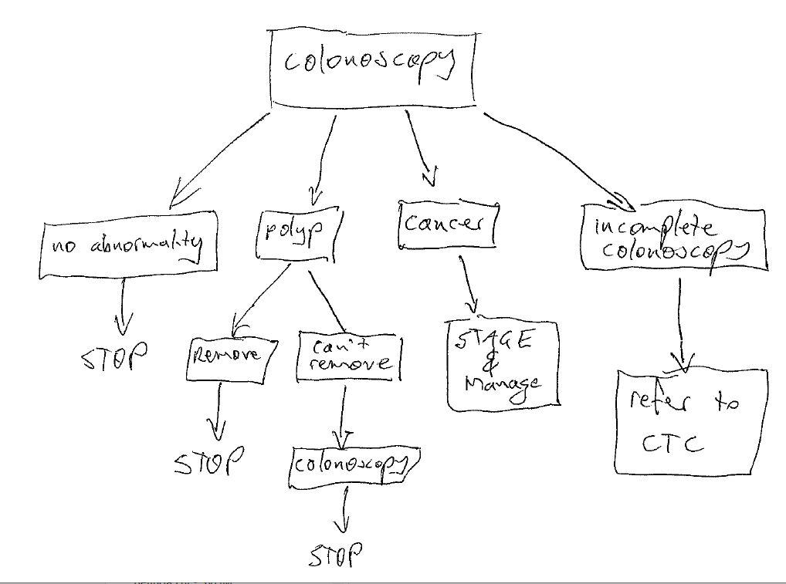

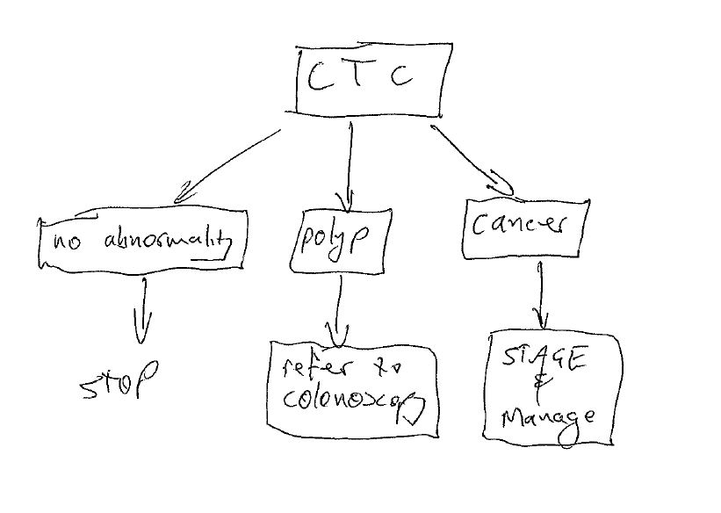

# Claims

## In terms of health outcomes (comparative benefits and harms), is the proposed technology claimed to be superior, non-inferior or inferior to the comparator(s)?

Superior

Non-inferior

Inferior

## Please state what the overall claim is, and provide a rationale:

There is a substantial body of evidence which shows the test is non-inferior. This will be listed in the appropriate section.

## Why would the requestor seek to use the proposed investigative technology rather than the comparator(s)?

The CTC is readily available and so can be used when there is no access to timely colonoscopy. In addition, the test can be used if the patient choses it in preference to colonoscopy, or if they have medical conditions such as anticoagulation.

Colonoscopy wait lists are excessive and this contributes to worse patient outcome and greater healthcare expenditure.

## Identify how the proposed technology achieves the intended patient outcomes:

It allows patients and GP’s to have control over how quickly a definite test is performed. This reduces patient anxiety and also empowers patients. Patients can also chose the test they prefer which should lead to increased compliance.

## For some people, compared with the comparator(s), does the test information result in:

**A change in clinical management?** No same as colonoscopy

**A change in health outcome?** Yes

**Other benefits?**  Yes

## Please provide a rationale, and information on other benefits if relevant:

The main benefits of the test are quicker performance time leading to less anxiety for the patient. Less chance the patient will have stage migration while waiting for the test. Greater compliance due to patients having choice. Reduced risk to patients with co-morbidities.

## In terms of the immediate costs of the proposed technology (and immediate cost consequences, such as procedural costs, testing costs etc.), is the proposed technology claimed to be more costly, the same cost or less costly than the comparator?

More costly

Same cost

Less costly

## Provide a brief rationale for the claim:

The current rebate for CTC is greater than the rebate for colonoscopy. However, the vast majority of colonoscopy are co-claimed with polypectomy. This makes the colonoscopy/polypectomy price the same as CTC. In addition, the government then pays for histology to be performed on the polyps. Anaesthetic fees are an additional expense as are any co-claimed consultation fees by the endoscopist.

# Summary of Evidence

## Provide one or more recent (published) high quality clinical studies that support use of the proposed health service/technology. At ‘Application Form lodgement’,

|  | **Type of study design** | **Title of journal article or research project** | **Short description of research** | **Website link to journal article or research** | **Date of publication\*\*\*** |
| --- | --- | --- | --- | --- | --- |
| 1. | Double blinded head to head | Computed Tomographic Virtual Colonoscopy to Screen for Colorectal Neoplasia in Asymptomatic Adults | CT colonography followed by segmentally unblinded colonoscopy proving CTC is non-inferior. | [Computed Tomographic Virtual Colonoscopy to Screen for Colorectal Neoplasia in Asymptomatic Adults | New England Journal of Medicine (nejm.org)](https://www.nejm.org/doi/full/10.1056/NEJMoa031618) | 2003 |
| 2. | Randomised control trial | CT Colonography versus Colonoscopy for the Detection of Advanced Neoplasia | Patients sent to either CTC or colonoscopy. Same number of cancers found. 4x more polyps removed in OC arm. Cx rate higher OC. Proves non-inferior. | [CT Colonography versus Colonoscopy for the Detection of Advanced Neoplasia | New England Journal of Medicine (nejm.org)](https://www.nejm.org/doi/full/10.1056/NEJMoa070543) | 2007 |
| 3 | Retrospective review | [Colorectal Findings at Repeat CT Colonography Screening after Initial CT Colonography Screening Negative for Polyps Larger than 5 mm](https://pubs.rsna.org/doi/full/10.1148/radiol.2016160582) | Retrospective review of patients with a previous normal CTC to determine interval cancer rate. Rates were low and supports accuracy of CTC and non-reporting small lesions (under 6mm). | [Colorectal Findings at Repeat CT Colonography Screening after Initial CT Colonography Screening Negative for Polyps Larger than 5 mm | Radiology (rsna.org)](https://pubs.rsna.org/doi/abs/10.1148/radiol.2016160582) | 2016 |
| 4 | Qualitative review | Wait times for gastroenterology consultation in Canada: The patients’ perspective | Long wait times directly impact patients and contribute to anxiety, lost time from work and social functioning | [Wait times for gastroenterology consultation in Canada: The patients’ perspective - PMC (nih.gov)](https://www.ncbi.nlm.nih.gov/pmc/articles/PMC2830638/) | 2010 |
| 5 | Population based analysis | [**Diseases of the Colon & Rectum (lww.com)**](https://journals.lww.com/dcrjournal/abstract/2020/02000/the_association_between_wait_times_for_colorectal.7.aspx)The Association Between Wait Times for Colorectal Cancer Treatment and Health Care Costs: A Population-Based Analysis | Length of wait time correlates with increasing cost | [Diseases of the Colon & Rectum (lww.com)](https://journals.lww.com/dcrjournal/abstract/2020/02000/the_association_between_wait_times_for_colorectal.7.aspx) | 2020 |
| 6 | Observational study | An observational study to compare the utilisation of computed tomography colonography with optical colonoscopy as the first diagnostic imaging tool in patients with suspected colorectal cancer | CTC increases colonoscopy capacity and contributes to a functional service. | [An observational study to compare the utilisation of computed tomography colonography with optical colonoscopy as the first diagnostic imaging tool in patients with suspected colorectal cancer - PubMed (nih.gov)](https://pubmed.ncbi.nlm.nih.gov/32507314/) | 2020 |
| 7 | Waitlist Data | Bowel cancer Australia wait times following positive FOB | Extended wait times. | [A Colonoscopy Wait-time and Performance Guarantee - Bowel Cancer Australia](https://www.bowelcanceraustralia.org/a-colonoscopy-wait-time-and-performance-guarantee) | 2024 |