Application Form

17p deletion testing for access to acalabrutinib in patients with relapsed or refractory chronic lymphocytic leukaemia
This application form is to be completed for new and amended requests for public funding (including but not limited to the Medicare Benefits Schedule (MBS)). It describes the detailed information that the Australian Government Department of Health requires to determine whether a proposed medical service is suitable.
Please use this template, along with the associated Application Form Guidelines to prepare your application. Please complete all questions that are applicable to the proposed service, providing relevant information only. Applications not completed in full will not be accepted.
Should you require any further assistance, departmental staff are available through the Health Technology Assessment Team (HTA Team) on the contact numbers and email below to discuss the application form, or any other component of the Medical Services Advisory Committee process.

Email: hta@health.gov.au
Website: www.msac.gov.au

PART 1 – APPLICANT DETAILS

Applicant details (primary and alternative contacts)
Corporation / partnership details (where relevant): Insert corporation/partnership details here if relevant
Corporation name: AstraZeneca Pty Ltd
ABN: REDACTED
Business trading name: REDACTED

Primary contact name: REDACTED
Primary contact numbers
Business: Insert business number here
Mobile: REDACTED
Email: REDACTED

Alternative contact name: REDACTED
Alternative contact numbers
Business: Insert business number here
Mobile: REDACTED
Email: REDACTED

(a) Are you a lobbyist acting on behalf of an Applicant?
Yes
No

If yes, are you listed on the Register of Lobbyists?
Yes
No

PART 2 – INFORMATION ABOUT THE PROPOSED MEDICAL SERVICE

Application title
17p deletion testing for access to acalabrutinib in patients with relapsed or refractory chronic lymphocytic leukaemia

Provide a succinct description of the medical condition relevant to the proposed service (no more than 150 words – further information will be requested at Part F of the Application Form)
Chronic lymphocytic leukaemia (CLL) is a life-threatening B-cell malignancy which originates in the bone marrow and results in abnormally high numbers of white blood cells. CLL is an incurable disease with conventional therapies, with its natural history being one of repeated relapse. CLL patients harbouring a 17p deletion have a particularly poor prognosis and generally respond poorly to many of the chemotherapeutic agents used to treat CLL.

Provide a succinct description of the proposed medical service (no more than 150 words – further information will be requested at Part 6 of the Application Form)
Fluorescent in situ hybridization (FISH) is a molecular cytogenetic technique used to test the presence or absence of specific chromosome regions and is often used to detect chromosome deletions such as 17p. This involves using a specific DNA probe which recognises the region to be tested. The probe is labelled with a fluorescent dye and is hybridised to the chromosomes on a microscope slide. It will only stick to its matched region. In a normal cell this will give two signals (one from each chromosome) and in a cell with a deletion will give only one signal.
The high sensitivity and specificity of FISH and the speed with which the assays can be performed have made FISH a pivotal cytogenetic technique that has provided significant advances in both the research and diagnosis of haematological malignancies, including CLL.

(a) Is this a request for MBS funding?
Yes
No

If yes, is the medical service(s) proposed to be covered under an existing MBS item number(s) or is a new MBS item(s) being sought altogether?
Amendment to existing MBS item(s)
New MBS item(s)

If an amendment to an existing item(s) is being sought, please list the relevant MBS item number(s) that are to be amended to include the proposed medical service:
MBS Item 73343

If an amendment to an existing item(s) is being sought, what is the nature of the amendment(s)?
- An amendment to the way the service is clinically delivered under the existing item(s)
- An amendment to the patient population under the existing item(s)
- An amendment to the schedule fee of the existing item(s)
- An amendment to the time and complexity of an existing item(s)
- Access to an existing item(s) by a different health practitioner group
- Minor amendments to the item descriptor that does not affect how the service is delivered
- An amendment to an existing specific single consultation item
- An amendment to an existing global consultation item(s)
- Other (please describe below):
Minor amendment to include acalabrutinib in the list of drugs for which Item 73343 can be used to determine PBS eligibility.

If a new item(s) is being requested, what is the nature of the change to the MBS being sought?
- A new item which also seeks to allow access to the MBS for a specific health practitioner group
- A new item that is proposing a way of clinically delivering a service that is new to the MBS (in terms of new technology and / or population)
- A new item for a specific single consultation item
- A new item for a global consultation item(s)

Is the proposed service seeking public funding other than the MBS?
Yes
No

If yes, please advise:
Seeking PBS listing for acalabrutinib for the treatment of patients with rrCLL.

What is the type of service:
Therapeutic medical service
Investigative medical service
Single consultation medical service
Global consultation medical service
Allied health service
Co-dependent technology
Hybrid health technology

For investigative services, advise the specific purpose of performing the service (which could be one or more of the following):
- To be used as a screening tool in asymptomatic populations
- Assists in establishing a diagnosis in symptomatic patients
- Provides information about prognosis
- Identifies a patient as suitable for therapy by predicting a variation in the effect of the therapy
- Monitors a patient over time to assess treatment response and guide subsequent treatment decisions

Does your service rely on another medical product to achieve or to enhance its intended effect?
Pharmaceutical / Biological
Prosthesis or device
No

(a) If the proposed service has a pharmaceutical component to it, is it already covered under an existing Pharmaceutical Benefits Scheme (PBS) listing?
Yes
No

If yes, please list the relevant PBS item code(s):
Insert PBS item code(s) here

If no, is an application (submission) in the process of being considered by the Pharmaceutical Benefits Advisory Committee (PBAC)?
Yes (please provide PBAC submission item number below)
No. Submission pending. Estimated submission to November 2019 cut-off for consideration at March 2020 meeting.
Insert PBAC submission item number here

If you are seeking both MBS and PBS listing, what is the trade name and generic name of the pharmaceutical?
Trade name: CALQUENCE
Generic name: Acalabrutinib

(a) If the proposed service is dependent on the use of a prosthesis, is it already included on the Prostheses List?
Yes
No

If yes, please provide the following information (where relevant):
Billing code(s): Insert billing code(s) here
Trade name of prostheses: Insert trade name here
Clinical name of prostheses: Insert clinical name here
Other device components delivered as part of the service: Insert description of device components here

If no, is an application in the process of being considered by a Clinical Advisory Group or the Prostheses List Advisory Committee (PLAC)?
Yes
No

Are there any other sponsor(s) and / or manufacturer(s) that have a similar prosthesis or device component in the Australian market place which this application is relevant to?
Yes
No

If yes, please provide the name(s) of the sponsor(s) and / or manufacturer(s):
Insert sponsor and/or manufacturer name(s) here

Please identify any single and / or multi-use consumables delivered as part of the service?
According to the RCPA QAP, in Australia, laboratories use a range of available FISH test kits, including;
- The Cytocell probe set
- The MetaSystems CLL panel
- The Vysis CLL panel
- The Cytocell CLL panel.

PART 3 – INFORMATION ABOUT REGULATORY REQUIREMENTS

(a) If the proposed medical service involves the use of a medical device, in-vitro diagnostic test, pharmaceutical product, radioactive tracer or any other type of therapeutic good, please provide the following details:
Type of therapeutic good: REDACTED
Manufacturer’s name: REDACTED
Sponsor’s name: REDACTED

Is the medical device classified by the TGA as either a Class III or Active Implantable Medical Device (AIMD) against the TGA regulatory scheme for devices?
Class III
AIMD
N/A

(a) Is the therapeutic good to be used in the service exempt from the regulatory requirements of the Therapeutic Goods Act 1989?
Yes (If yes, please provide supporting documentation as an attachment to this application form)
No

If no, has it been listed or registered or included in the Australian Register of Therapeutic Goods (ARTG) by the Therapeutic Goods Administration (TGA)?
Yes (if yes, please provide details below)
No

ARTG listing, registration or inclusion number: 196286
TGA approved indication(s), if applicable: Acquired genetic alteration IVDs - Acquired genetic alteration IVDs
TGA approved purpose(s), if applicable: For the determination of acquired genetic alterations in human clinical specimens

If the therapeutic good has not been listed, registered or included in the ARTG, is the therapeutic good in the process of being considered for inclusion by the TGA?
Yes (please provide details below)
No

Date of submission to TGA: Insert date of submission here
Estimated date by which TGA approval can be expected: Insert estimated date here
TGA Application ID: Insert TGA Application ID here
TGA approved indication(s), if applicable: If applicable, insert description of TGA approved indication(s) here
TGA approved purpose(s), if applicable: If applicable, insert description of TGA approved purpose(s) here

If the therapeutic good is not in the process of being considered for listing, registration or inclusion by the TGA, is an application to the TGA being prepared?
Yes (please provide details below)
No

Estimated date of submission to TGA: Insert date of submission here
Proposed indication(s), if applicable: If applicable, insert description of proposed indication(s)
Proposed purpose(s), if applicable: If applicable, insert description of proposed purpose(s) here

PART 4 – SUMMARY OF EVIDENCE

Provide an overview of all key journal articles or research published in the public domain related to the proposed service that is for your application (limiting these to the English language only). Please do not attach full text articles, this is just intended to be a summary.
 | Type of study design* | Title of journal article or research project (including any trial identifier or study lead if relevant) | Short description of research (max 50 words)** | Website link to journal article or research (if available) | Date of publication***
1. | Phase III Randomised trial | Acalabrutinib vs Rituximab Plus Idelalisib or Bendamustine by Investigator Choice in Relapsed/Refractory Chronic Lymphocytic Leukemia: Results From a Pre-Planned Interim Analysis of the Phase 3 ASCEND Study (ACE-CL-309) | RCT of 310 rrCLL patients. Demonstrates the clinical superiority of acalabrutinib compared with IR/BR REDACTED | 2019 EHA Late-Breaking Oral Presentation (LB2606):  https://library.ehaweb.org/eha/2019/24th | Full publication TBD
2. | Insert study design | Insert title | Insert description | Insert website link | Insert date
* Categorise study design, for example meta-analysis, randomised trials, non-randomised trial or observational study, study of diagnostic accuracy, etc.
**Provide high level information including population numbers and whether patients are being recruited or in post-recruitment, including providing the trial registration number to allow for tracking purposes. https://library.ehaweb.org/eha/2019/24th/273259/paolo.ghia.ascend.phase.3.study.of.acalabrutinib.vs.investigators.choice.of.html?f=menu%3D6%2Abrowseby%3D8%2Asortby%3D6%2Amedia%3D1%2Ace_id%3D1550%2Aces_id%3D22585%2Amarker%3D533%2Afeatured%3D16435
*** If the publication is a follow-up to an initial publication, please advise.

Identify yet to be published research that may have results available in the near future that could be relevant in the consideration of your application by MSAC (limiting these to the English language only). Please do not attach full text articles, this is just intended to be a summary.
 | Type of study design* | Title of research (including any trial identifier if relevant) | Short description of research (max 50 words)** | Website link to research (if available) | Date***
1. | For yet to be published research that may have results relevant to your application, insert the type of study design in this column and columns below | For yet to be published research that may have results relevant to your application, insert the title of research (including any trial identifier if relevant) in this column and columns below | For yet to be published research that may have results relevant to your application, insert a short description of research (max 50 words) in this column and columns below | For yet to be published research that may have results relevant to your application, insert a website link to this research (if available) in this column and columns below | For yet to be published research that may have results relevant to your application, insert date in this column and columns below
2. | Insert study design | Insert title of research | Insert description | Insert website link | Insert date
3. | Insert study design | Insert title of research | Insert description | Insert website link | Insert date
4. | Insert study design | Insert title of research | Insert description | Insert website link | Insert date
5. | Insert study design | Insert title of research | Insert description | Insert website link | Insert date
* Categorise study design, for example meta-analysis, randomised trials, non-randomised trial or observational study, study of diagnostic accuracy, etc.
**Provide high level information including population numbers and whether patients are being recruited or in post-recruitment.
***Date of when results will be made available (to the best of your knowledge).

PART 5 – CLINICAL ENDORSEMENT AND CONSUMER INFORMATION

List all appropriate professional bodies / organisations representing the group(s) of health professionals who provide the service (please attach a statement of clinical relevance from each group nominated):
The Royal College of Pathologists of Australasia (RCPA)
The Haematology Society of Australia & New Zealand (HSANZ)
A letter of support has not been requested from the above organisations due to the routine nature of the 17p deletion test in Australian practice. A statement may be provided by the College on direct request from the MSAC.

List any professional bodies / organisations that may be impacted by this medical service (i.e. those who provide the comparator service):
As 17p deletion testing is already available in the Australian health care system for the proposed population, there is no impacted comparator.

List the consumer organisations relevant to the proposed medical service (please attach a letter of support for each consumer organisation nominated):
N/A

List the relevant sponsor(s) and / or manufacturer(s) who produce similar products relevant to the proposed medical service:
N/A

Nominate two experts who could be approached about the proposed medical service and the current clinical management of the service(s):

Name of expert 1: Insert name here
Telephone number(s): Insert phone number/s here
Email address: Insert email address here
Justification of expertise: Insert a justification of expertise here

Name of expert 2: Insert name here
Telephone number(s): Insert phone number/s here
Email address: Insert email address here
Justification of expertise: Insert a justification of expertise here

Please note that the Department may also consult with other referrers, proceduralists and disease specialists to obtain their insight.

Note: No contacts have been provided given the simplicity of the application. Can be provided upon further request.

PART 6 – POPULATION (AND PRIOR TESTS), INTERVENTION, COMPARATOR, OUTCOME (PICO)

PART 6a – INFORMATION ABOUT THE PROPOSED POPULATION

Define the medical condition, including providing information on the natural history of the condition and a high level summary of associated burden of disease in terms of both morbidity and mortality:
CLL is the most common leukemia in the Western world, with an estimated 191,000 new cases globally, and prevalence that is expected to increase with improved treatment and overall survival (Union for International Cancer Control 2014, Jain, Chen et al. 2015, Fitzmaurice, Allen et al. 2017). In Australia, there were 1,597 people diagnosed with CLL in 2015 (age-standardised incidence rate of 5.8 per 100,000) and this is estimated to increase to 1,729 by 2021 (age-standardised incidence rate of 5.3 per 100,000) (Australian Institute of Health and Welfare 2019). The five-year relative survival rate in Australia between 2011–2015 was 82.8 (95% CI 81.4, 84.1) (Australian Institute of Health and Welfare 2019).
CLL is a malignancy of B cells that predominantly affects the older population who often have comorbidities. It is characterised by the proliferation and accumulation of B lymphocytes in peripheral blood, bone marrow and lymphoid organs (Cramer and Hallek 2011). The proliferation of B lymphocytes results in the accumulation of malignant cells that compromise the immune response and overcrowds the bone marrow. This reduces the number of normal blood cells (white, red and platelet cells) and alters the balance of circulating blood cells resulting in some of the presenting symptoms of CLL such as anaemia and thrombocytopaenia.
CLL is heterogeneous with a variable clinical course (Figure 1), where approximately one third of patients may never require treatment owing to death unrelated to CLL (Dighiero 2003). One third of patients have indolent disease that is largely asymptomatic, remains undetected and untreated, and which then progresses to aggressive CLL (Dighiero 2003). The final third of patients, however, exhibit aggressive disease requiring immediate treatment and have a poor prognosis despite appropriate therapy (Byrd, Stilgenbauer et al. 2004). While patients with early disease have not been shown to have a survival advantage with early treatment, most patients will eventually require therapy for their disease with the onset of symptoms or cytopenias. Despite the relatively long life expectancy for early stage disease, CLL remains an incurable disease.
Figure 1 Course of CLL
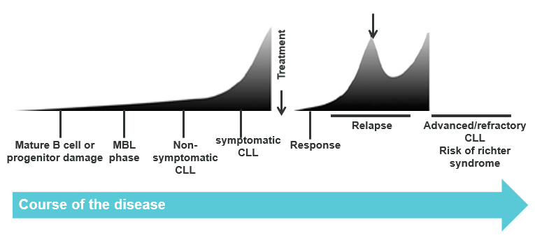
As CLL may remain undiscovered and untreated for many years, the median age at diagnosis of CLL in Australia is approximately 69.4 years (Australian Cancer Research Foundation). However, as many patients have indolent disease and are observed following diagnosis, the median age at the time of therapy initiation is approximately 75 years (Shanafelt 2013, Robak, Stilgenbauer et al. 2017, National Comprehensive Cancer Network 2019).
CLL is associated with symptoms including lymphadenopathy (swollen lymph nodes), splenomegaly (enlarged spleen), hepatomegaly (enlarged liver), anaemia, thrombocytopenia, and constitutional symptoms of malignancy (e.g. profuse night sweats, unintended weight loss and fever in the absence of infection), which have a large impact on the quality of life. A web-based survey of 1,482 CLL patients assessed the impact of CLL on the quality of life of patients (Shanafelt, Bowen et al. 2007). The study showed that CLL-related symptoms and comorbidities markedly reduced quality of life with fatigue being the most recognised disease-related symptom (Shanafelt, Bowen et al. 2007). Emotional well-being was also significantly decreased compared with that of the general population and patients with other cancer types (Shanafelt, Bowen et al. 2007). Factors associated with low quality of life scores were older age, greater fatigue, severity of comorbidities and current treatment (Shanafelt, Bowen et al. 2007). Quality of life declines rapidly after patients relapse and become more symptomatic (Eichhorst, Busch et al. 2009).

Specify any characteristics of patients with the medical condition, or suspected of, who are proposed to be eligible for the proposed medical service, including any details of how a patient would be investigated, managed and referred within the Australian health care system in the lead up to being considered eligible for the service:
In the Australian clinical setting, the majority of relapsed/refractory CLL patients will be under the care of a Haematologist and will routinely undergo FISH testing for the presence of a 17p deletion. Requests for 17 deletion testing can come from a Haematologist or Pathologist.
Well-established genetic markers (e.g. deletion of chromosome 17p [17p[del]]) can predict more aggressive disease (Hallek, Shanafelt et al. 2018). Prevalence depends on whether patients are previously untreated or have relapsed/refractory disease (Cramer and Hallek 2011). Patients with one or more 17p(del) mutations are considered unsuitable for treatment with a purine analogue.
The 17p deletion is more frequently observed in treated patients than in previously untreated patients, increasing in frequency during the course of the disease with up to 50% of patients with relapsed or refractory disease having the deletion. It is widely accepted that treatment outcomes in patients with del 17p are poor.
Figure 2 Overall survival in patients with CLL
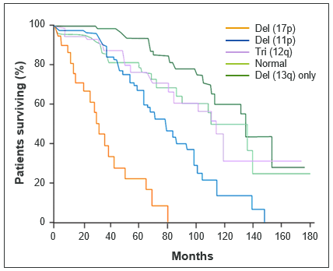
Source: Adapted from Cramer P, et al. Nat Rev Clin Oncol. 2011

Define and summarise the current clinical management pathway before patients would be eligible for the proposed medical service (supplement this summary with an easy to follow flowchart [as an attachment to the Application Form] depicting the current clinical management pathway up to this point):
The current clinical management pathway, based on Australian and international guidelines, is presented in Figure 3. The proposed medical service is already available and publicly funded in Australia. Patients who are have an identified 17p deletion following FISH testing are recommended the current standard of care Ibrutinib or venetoclax.
Figure 3. Current clinical management of rrCLL
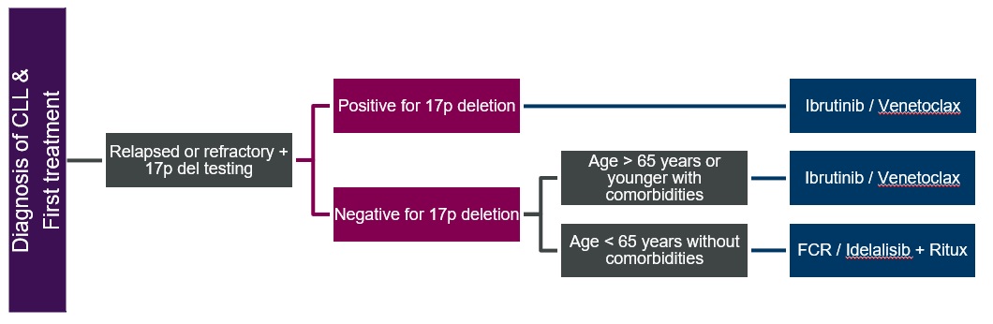

PART 6b – INFORMATION ABOUT THE INTERVENTION

Describe the key components and clinical steps involved in delivering the proposed medical service:
REDACTED
The tumor suppressor protein, p53, has been shown to play a critical role in oncogenesis and response to chemotherapy in a variety of human cancers. In humans, the TP53 gene is found on the short arm of chromosome 17 (17p13) and is reported to be suppressed or mutated in a large number of human cancers. Deletions of the 17p region resulting in abnormalities of the tumor suppressor protein p53 have been identified as one of the poorest prognostic factors for CLL as it is predictive of short time to disease progression, short response duration, lack of response to therapy and short overall survival (OS).
In patients with relapsed/refractory CLL, FISH testing is well established and involves REDACTED:
(1) Sample collection: Peripheral blood collections should be performed according to the laboratory’s institution guidelines. It is acceptable to collect the peripheral blood specimen in a sodium heparin blood collection tube. One (1) mL of peripheral blood is required for performing the assay. Specimens can be processed immediately or shipped on cold packs and stored at 2 to 8°C up to 96 hours prior to the start of sample preparation. Specimens should never be iced or frozen. Specimens that are clotted or not shipped as indicated should not be used.
(2) Preparation of the sample: Qualified pathology department personnel will undertake preparation of biopsy material, i.e., washing and fixing cells, preparing slides and specimen target, probe denaturing, hybridization and staining
(3) Interpretation of results: Slides are viewed by a qualified senior clinical scientist using a suitable filter set on an optimally performing fluorescence microscope. Results are interpreted as set out in the test kit manual and reported in accordance with NATA guidelines.

Does the proposed medical service include a registered trademark component with characteristics that distinguishes it from other similar health components?
No

If the proposed medical service has a prosthesis or device component to it, does it involve a new approach towards managing a particular sub-group of the population with the specific medical condition?
Insert description of approach here

If applicable, are there any limitations on the provision of the proposed medical service delivered to the patient (i.e. accessibility, dosage, quantity, duration or frequency):
If applicable, insert description of limitations here

If applicable, identify any healthcare resources or other medical services that would need to be delivered at the same time as the proposed medical service:
If applicable, insert description of resources or other medical services here

If applicable, advise which health professionals will primarily deliver the proposed service:
17p deletion testing is currently performed, and the results interpreted and reported by qualified pathologists.

If applicable, advise whether the proposed medical service could be delegated or referred to another professional for delivery:
Insert key components and clinical steps here

If applicable, specify any proposed limitations on who might deliver the proposed medical service, or who might provide a referral for it:
If applicable, insert specification of limitations here

If applicable, advise what type of training or qualifications would be required to perform the proposed service, as well as any accreditation requirements to support service delivery:
If applicable, insert advice regarding training or qualifications

(a) Indicate the proposed setting(s) in which the proposed medical service will be delivered (select ALL relevant settings):
Inpatient private hospital (admitted patient)
Inpatient public hospital (admitted patient)
Private outpatient clinic
Public outpatient clinic
Emergency Department
Private consulting rooms - GP
Private consulting rooms – specialist
Private consulting rooms – other health practitioner (nurse or allied health)
Private day surgery clinic (admitted patient)
Private day surgery clinic (non-admitted patient)
Public day surgery clinic (admitted patient)
Public day surgery clinic (non-admitted patient)
Residential aged care facility
Patient’s home
Laboratory
Other – please specify below
Specify further details here
- Where the proposed medical service is provided in more than one setting, please describe the rationale related to each:
Describe rationale here

Is the proposed medical service intended to be entirely rendered in Australia?
Yes
No – please specify below
Specify further details here

PART 6c – INFORMATION ABOUT THE COMPARATOR(S)

Nominate the appropriate comparator(s) for the proposed medical service, i.e. how is the proposed population currently managed in the absence of the proposed medical service being available in the Australian health care system (including identifying health care resources that are needed to be delivered at the same time as the comparator service):
Not applicable as the test is already performed routinely in the proposed patient group. REDACTED

Does the medical service (that has been nominated as the comparator) have an existing MBS item number(s)?
Yes (please list all relevant MBS item numbers below)
No
Specify item number/s here

Define and summarise the current clinical management pathway/s that patients may follow after they receive the medical service that has been nominated as the comparator (supplement this summary with an easy to follow flowchart [as an attachment to the Application Form] depicting the current clinical management pathway that patients may follow from the point of receiving the comparator onwards, including health care resources):
The proposed clinical management pathway is identical to the existing pathway with the addition of acalabrutinib to the list of drugs for which patients with an identified 17p deletion are eligible. (Figure 4)
Figure 4. Proposed clinical management of rrCLL
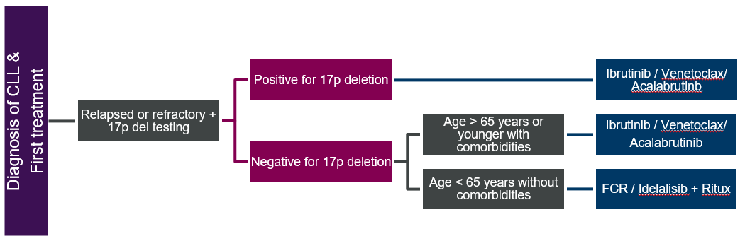

(a) Will the proposed medical service be used in addition to, or instead of, the nominated comparator(s)?
In addition to (i.e. it is an add-on service)
Instead of (i.e. it is a replacement or alternative)

If instead of (i.e. alternative service), please outline the extent to which the current service/comparator is expected to be substituted:
Outline service/comparator substitution here

Define and summarise how current clinical management pathways (from the point of service delivery onwards) are expected to change as a consequence of introducing the proposed medical service, including variation in health care resources (Refer to Question 39 as baseline):
Refer to Question 40. There will be no impact on existing healthcare resources.

PART 6d – INFORMATION ABOUT THE CLINICAL OUTCOME

Summarise the clinical claims for the proposed medical service against the appropriate comparator(s), in terms of consequences for health outcomes (comparative benefits and harms):
Based on the primary evidence, acalabrutinib is superior to idelalisib + rituximab or bendumustine + rituximab in terms of efficacy and similar in terms of safety.
Based on an indirect trial comparison, acalabrutinib is non-inferior to the current standard of care, Ibrutinib, in terms of efficacy and safety.

Please advise if the overall clinical claim is for:
Superiority
Non-inferiority

Below, list the key health outcomes (major and minor – prioritising major key health outcomes first) that will need to be specifically measured in assessing the clinical claim of the proposed medical service versus the comparator:
Safety Outcomes:
Overall, similar proportions of patients in both the acalabrutinib (93.5%) and comparator (IR 99.2%, BR 80.0%) arms experienced at least one TEAE in the ASCEND trial (Table 45.1). The proportion of patients experiencing Grade ≥3 AEs was lower in the acalabrutinib (49.4%) group compared to patients treated with IR (89.8%) and similar to patients treated with BR (48.6%). Acalabrutinib had a lower number of serious AEs (SAEs) (28.6%) compared to IR (55.9%), but similar to BR (25.7%). REDACTED
Table 1. Summary of severe AE results of the ASCEND
 | ASCEND
 | Acalabrutinib  N=154 | IR  N=118 | BR  N=35
Median duration of follow-up, months (range) | REDACTED | REDACTED
Grade 3 or 4 AE, n (%) | 70 (45.5) | 101 REDACTED | 15  REDACTED
Serious AE, n (%) | 44 (28.6) | 66 (55.9) | 9 (25.7)
Treatment-related AE, n (%) | REDACTED | REDACTED | REDACTED
Discontinuation due to AE, n (%) | REDACTED | REDACTED | REDACTED
AE leading to death, n (%) | 6 (3.9) | 5 (4.2) | 2 (5.7)
Any AE, n (%) | 144 (93.5) | 117 (99.2) | 28 (80.0)
Source: REDACTED
Abbreviations: AE, adverse event; BR, bendamustine/rituximab; IR, idelalisib/rituximab; IQR, interquartile range; N, number of patients
Clinical Effectiveness Outcomes:
Progression- Free Survival
At a median follow-up of 16.10 months in the acalabrutinib arm REDACTED acalabrutinib was associated with a statistically significant improvement in IRC-assessed PFS compared with IR/BR, with a 69% reduction in risk of disease progression or death (HR=0.31 [95% CI: 0.20, 0.49]; p<0.0001). The median estimated PFS for acalabrutinib was not reached; the median estimated PFS for IR/BR was 16.5 months REDACTED.
Figure 5. Kaplan-Meier plot for IRC-assessed PFS for acalabrutinib compared with IR/BR (ITT population)
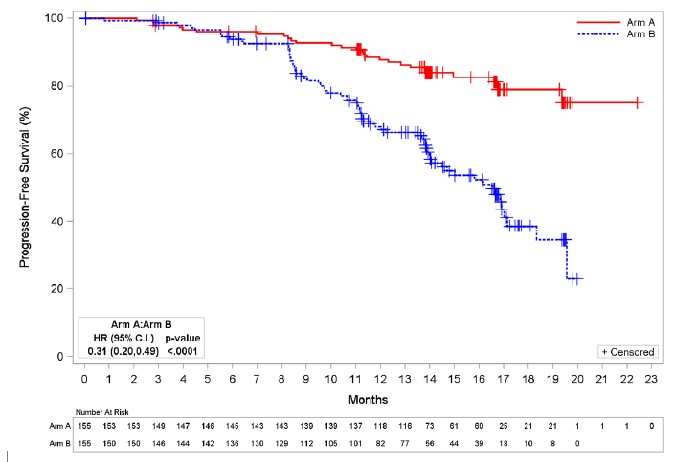
REDACTED
Abbreviations: BR, bendamustine/rituximab; C.I., confidence interval; HR, hazard ratio; IR, idelalisib/rituximab; IRC, independent review committee; ITT, intention-to-treat; PFS, progression-free survival

Overall response rate
At a median follow-up of 16.10 months in the acalabrutinib arm REDACTED, the IRC-assessed ORR for acalabrutinib and IR/BR was 81.3% (95% CI: 74.4, 86.6) and 75.5% (95% CI: 68.1, 81.6), respectively (p=0.2248) REDACTED . Partial response (PR) was achieved in 126 (81.3%) subjects in the acalabrutinib group and 115 (74.2%) subjects in the IR/BR group.
Table 2. Results of best ORR as assessed by IRC in the ASCEND trial (ITT population)
Trial ID (Comparison) | Median follow-up (months) | Intervention | Comparator | Difference (95% CI) | p value ª
 |  | n/N (%) | n/N (%)
ASCEND (Acalabrutinib vs IR/BR) | 16.10 (acala)  REDACTED | REDACTED (81.3%) | REDACTED (75.5%) | REDACTED | 0.2248
Source: REDACTED
Abbreviations: BR, bendamustine/rituximab; CI, confidence interval; HR, hazard ratio; IR, idelalisib/rituximab; ITT, intention-to-treat; IRC, independent review committee; NR, not reported.
Table Notes: a. log-rank test

PART 7 – INFORMATION ABOUT ESTIMATED UTILISATION

Estimate the prevalence and/or incidence of the proposed population:
In Australia, there were 1,597 people diagnosed with CLL in 2015 (age-standardised incidence rate of 5.8 per 100,000) and this is estimated to increase to 1,729 by 2021 (age-standardised incidence rate of 5.3 per 100,000) (Australian Institute of Health and Welfare 2019).

Estimate the number of times the proposed medical service(s) would be delivered to a patient per year:
One test per patient per lifetime

How many years would the proposed medical service(s) be required for the patient?
N/A

Estimate the projected number of patients who will utilise the proposed medical service(s) for the first full year:
There will be no change to the current utilisation of the test as it is already performed routinely in this patient population to determine PBS eligibility for other drugs e.g. Ibrutinib.

Estimate the anticipated uptake of the proposed medical service over the next three years factoring in any constraints in the health system in meeting the needs of the proposed population (such as supply and demand factors) as well as provide commentary on risk of ‘leakage’ to populations not targeted by the service:
There is no change to the proposed MBS fee, costs to the MBS or testing strategy. Utilisation is not expected to increase, as patients that will be tested for eligibility to acalabrutinib would have otherwise been tested for eligibility to ibrutinib, idelalisib or venetoclax.

PART 8 – COST INFORMATION

Indicate the likely cost of providing the proposed medical service. Where possible, please provide overall cost and breakdown:
No change to existing Item fee proposed.

Specify how long the proposed medical service typically takes to perform:
Specify duration here

If public funding is sought through the MBS, please draft a proposed MBS item descriptor to define the population and medical service usage characteristics that would define eligibility for MBS funding.
Category 6 – PATHOLOGY SERVICES
Item 73343
Proposed item descriptor: Detection of 17p chromosomal deletions by fluorescence in situ hybridisation, in a patient with relapsed or refractory chronic lymphocytic leukaemia or small lymphocytic lymphoma, on a peripheral blood or bone marrow sample, requested by a specialist or consultant physician, to determine if the requirements for access to idelalisib, ibrutinib, venetoclax or acalabrutinib on the Pharmaceutical Benefits Scheme are fulfilled.
Fee: $230.95 Benefit: 75% = $173.25 85% = $196.35

References
Union for International Cancer Control (2014). Review of cancer medicines on the WHO list of essential medicines: Chronic lymphocytic leukemia.

Australian Institute of Health and Welfare. (2019). "Cancer data in Australia." Retrieved 19 August 2019, 2019, from https://www.aihw.gov.au/reports/cancer/cancer-data-in-australia/report-editions.

Cramer, P. and M. Hallek (2011). "Prognostic factors in chronic lymphocytic leukemia-what do we need to know?" Nat Rev Clin Oncol 8(1): 38-47.

Dighiero, G. (2003). "Unsolved issues in CLL biology and management." Leukemia 17(12): 2385-2391.

Byrd, J. C., S. Stilgenbauer and I. W. Flinn (2004). "Chronic lymphocytic leukemia." Hematology Am Soc Hematol Educ Program: 163-183.

Shanafelt, T. D., D. Bowen, C. Venkat, S. L. Slager, C. S. Zent, N. E. Kay, M. Reinalda, J. A. Sloan and T. G. Call (2007). "Quality of life in chronic lymphocytic leukemia: an international survey of 1482 patients." Br J Haematol 139(2): 255-264.

Eichhorst, B. F., R. Busch, S. Stilgenbauer, M. Stauch, M. A. Bergmann, M. Ritgen, N. Kranzhofer, R. Rohrberg, U. Soling, O. Burkhard, A. Westermann, V. Goede, C. D. Schweighofer, K. Fischer, A. M. Fink, C. M. Wendtner, G. Brittinger, H. Dohner, B. Emmerich, M. Hallek and C. L. L. S. G. German (2009). "First-line therapy with fludarabine compared with chlorambucil does not result in a major benefit for elderly patients with advanced chronic lymphocytic leukemia." Blood 114(16): 3382-3391.

Hallek, M., T. D. Shanafelt and B. Eichhorst (2018). "Chronic lymphocytic leukaemia." Lancet 391(10129): 1524-1537.

REDACTED

