MSAC Application 1719

Insertion of bioabsorbable implant for nasal airway obstruction due to lateral wall insufficiency
This application form is to be completed for new and amended requests for public funding (including but not limited to the Medicare Benefits Schedule (MBS)). It describes the detailed information that the Australian Government Department of Health requires to determine whether a proposed medical service is suitable.
Please use this template, along with the associated Application Form Instructions to prepare your application. Please complete all questions that are applicable to the proposed service, providing relevant information only. Applications not completed in full will not be accepted. The separate MSAC Guidelines should be used to guide health technology assessment (HTA) content of the Application Form
Should you require any further assistance, departmental staff are available through the Health Technology Assessment Team (HTA Team) on the email below to discuss the application form, or any other component of the Medical Services Advisory Committee process.
Email: hta@health.gov.au
Website: www.msac.gov.au

PART 1 – APPLICANT DETAILS

Applicant details (primary and alternative contacts)
Corporation / partnership details (where relevant): Not relevant
Corporation name: Stryker Australia
ABN: 48 002 873 850
Business trading name: STRYKER AUSTRALIA PTY LTD

Primary contact name: REDACTED
Primary contact numbers
Business: REDACTED
Mobile: REDACTED
Email: REDACTED

Alternative contact name: REDACTED
Alternative contact numbers
Business: REDACTED
Mobile: REDACTED
Email: REDACTED

(a) Are you a consultant acting on behalf on an applicant?
Yes
No
(b) If yes what is the Applicant(s) name that you are acting on behalf of?
The alternative contact, REDACTED, is consultant acting on behalf of the Applicant as detailed in Question 1.

(a) Are you a lobbyist acting on behalf of an Applicant?
Yes
No

If yes, are you listed on the Register of Lobbyists?
Yes
No

Have you engaged a consultant on your behalf?
N/A

The alternate contact, REDACTED, is a consultant acting on behalf of the Applicant Stryker, and is listed on the Register of Lobbyists.

PART 2 – INFORMATION ABOUT THE PROPOSED MEDICAL SERVICE

Application title
Insertion of bioabsorbable implant for nasal airway obstruction due to lateral wall insufficiency

Provide a succinct description of the medical condition relevant to the proposed service (no more than 150 words – further information will be requested at Part F of the Application Form)

Nasal airway obstruction (NAO) is a condition in which the nasal passages are blocked and prevent a normal or comfortable amount of air from passing through the nose. Given nasal breathing delivers approximately 70% of airflow to the lungs (Crawford-Brown 1997), even slight narrowing of the nasal valve can lead to significant reduction in airflow and negatively impact a person’s quality of life.

Provide a succinct description of the proposed medical service (no more than 150 words – further information will be requested at Part 6 of the Application Form)
The proposed medical service involves the implantation of a bioabsorbable implant (LATERA®) to support the upper and lower cartilage inside the lateral wall of the nose by anchoring above the maxilla to provide cantilever support. By supporting the cartilage, NAO symptoms may reduce, and the patient’s breathing may improve. The implant is placed inside the nasal wall by an otolaryngologist (ear, nose, and throat [ENT] specialist) or rhinologist. The procedure is minimally invasive and can be performed under local anaesthesia.

(a) Is this a request for MBS funding?
Yes
No

If yes, is the medical service(s) proposed to be covered under an existing MBS item number(s) or is a new MBS item(s) being sought altogether?
Amendment to existing MBS item(s)
New MBS item(s)

If an amendment to an existing item(s) is being sought, please list the relevant MBS item number(s) that are to be amended to include the proposed medical service/technology:
N/A

If an amendment to an existing item(s) is being sought, what is the nature of the amendment(s)?
An amendment to the way the service is clinically delivered under the existing item(s)
An amendment to the patient population under the existing item(s)
An amendment to the schedule fee of the existing item(s)
An amendment to the time and complexity of an existing item(s)
Access to an existing item(s) by a different health practitioner group
Minor amendments to the item descriptor that does not affect how the service is delivered
An amendment to an existing specific single consultation item
An amendment to an existing global consultation item(s)
Other (please describe below):

If a new item(s) is being requested, what is the nature of the change to the MBS being sought?
A new item which also seeks to allow access to the MBS for a specific health practitioner group
A new item that is proposing a way of clinically delivering a service that is new to the MBS (in terms of new technology and / or population)
A new item for a specific single consultation item
A new item for a global consultation item(s)

Is the proposed service seeking public funding other than the MBS?
Yes
No

If yes, please advise:
N/A

What is the type of medical service/technology?
Therapeutic medical service
Investigative medical service
Single consultation medical service
Global consultation medical service
Allied health service
Co-dependent technology
Hybrid health technology

For investigative services, advise the specific purpose of performing the service (which could be one or more of the following):
N/A

Does your service rely on another medical product to achieve or to enhance its intended effect?
Pharmaceutical / Biological
Prosthesis or device
No

(a) If the proposed service has a pharmaceutical component to it, is it already covered under an existing Pharmaceutical Benefits Scheme (PBS) listing?
N/A

If yes, please list the relevant PBS item code(s):
N/A

If no, is an application (submission) in the process of being considered by the Pharmaceutical Benefits Advisory Committee (PBAC)?
N/A

If you are seeking both MBS and PBS listing, what is the trade name and generic name of the pharmaceutical?
N/A

(a) If the proposed service is dependent on the use of a prosthesis, is it already included on the Prostheses List?
Yes
No

If yes, please provide the following information (where relevant):
N/A

If no, is an application in the process of being considered by a Clinical Advisory Group or the Prostheses List Advisory Committee (PLAC)?
Yes
No

An application was lodged in September 2021, with reference number N003229.

Are there any other sponsor(s) and / or manufacturer(s) that have a similar prosthesis or device component in the Australian market place which this application is relevant to?
Yes
No

If yes, please provide the name(s) of the sponsor(s) and / or manufacturer(s):
N/A

Please identify any single and / or multi-use consumables delivered as part of the service?
Single use consumables:
- Delivery device
- Implant positioning guide

The delivery device and implant positioning guide are intended for single patient use only. The delivery device may be used to deliver multiple Implants to a single patient in a single clinical setting.

The delivery device is a single use device composed of an inner shaft, an outer handle with a push rod, a deploy button, an open button and a 16-gauge delivery cannula with a protective cover. The inner shaft includes an implant loading port which enables the loading of the Implant and includes graphics to indicate the open position. The inner shaft transitions between the open position and the cannula to collapse the implant forks within the cannula inner lumen and prepare the Implant for deployment. The outer handle includes deploy and open buttons that lock and release the handle from these respective positions. The outer handle also includes a push rod that shuttles the Implant from the implant loading port to a ready position for deployment. The implant positioning guide is packaged with the delivery device and is provided as an aid to the physician for planning the procedure and identifying the target implant location.

Multi-use consumables: N/A

PART 3 – INFORMATION ABOUT REGULATORY REQUIREMENTS

(a) If the proposed medical service involves use of a medical device, in-vitro diagnostic test, pharmaceutical product, radioactive tracer, or any other type of therapeutic good, please provide details
Type of therapeutic good: Bioabsorbable nasal implant
Manufacturer’s name: Entellus Medical Inc
Sponsor’s name: Stryker Australia Pty Ltd

Has it been listed on the Australian Register of Therapeutic Goods (ARTG) by the Therapeutic Goods Administration (TGA)? If the therapeutic good has been listed on the ARTG, please state the ARTG identification numbers, TGA-approved indication(s), and TGA-approved purpose(s).
The bioabsorbable nasal implant is not yet listed on the ARTG, however the introducer is listed, details as per below

ARTG ID: 346524 (medical device class IIa)
TGA approved indication(s), if applicable: N/A
TGA approved purpose(s), if applicable: Intended to aid in the surgical implantation of the nasal implant.

If a medical device is involved, has the medical device been classified by TGA as a Class III OR Active Implantable Medical Device (AIMD) under the TGA regulatory scheme for devices?
Class III
AIMD
N/A

Is the therapeutic good classified by TGA for Research Use Only (RUO)?
No

(a) If not listed on the ARTG, is the therapeutic good to be used in the service exempt from the regulatory requirements of the Therapeutic Goods Act 1989?
Yes (If yes, please provide supporting documentation as an attachment to this application form)
No

If the therapeutic good is not ARTG listed, is the therapeutic good in the process of being considered by TGA?

Yes (if yes, please provide details below)
No

Date of submission to TGA: 22 July 2021
Estimated date by which TGA approval can be expected: April 2022
TGA Application ID: DV-2021-DA-13574-1
Unique Product Identifier (UPI): Latera Absorbable Nasal Implant
Proposed intended purpose: Latera Absorbable Nasal Implant is indicated for supporting upper and lower lateral nasal cartilage

- If the therapeutic good is NOT in the process of being considered by TGA, is an application to TGA being prepared?
N/A

PART 4 – SUMMARY OF EVIDENCE

Provide one or more recent (published) high quality clinical studies that support use of the proposed health service/technology. At ‘Application Form lodgement’, please do not attach full text articles; just provide a summary.
ID | Type of study design | Title of journal article or research project | Short description of research (max 50 words) | Website link to journal article or research | Date of publication
1 | RCT, MC, SB (patient blinded)  USA (10 sites)  N=127 | LATERA RCT / NCT03400787  Stolovitzky P, Senior B, Ow RA, Mehendale N, Bikhazi N, Sidle DM. Assessment of bioabsorbable implant treatment for nasal valve collapse compared to a sham group: a randomized control trial. Int Forum Allergy Rhinol. 2019 Aug;9(8):850-856. doi: 10.1002/alr.22362. Epub 2019 Jun 21. | The objective of this RCT was to evaluate the safety and effectiveness of a bioabsorbable implant (latera) to support the lateral nasal wall in patients with nasal valve collapse. Patients were randomised to Latera (N=70) and sham (N=67), and patient were followed for 3 months. Three months post procedure, a statistically significantly higher proportion of Latera patients achieved response compared with sham patients (82.5% vs 54.7%; p=0.001), with response defined as a reduction in clinical severity by ≥1 category or ≥20% reduction in NOSE score). Similarly, at 3 months Latera patients achieved a significantly greater reduction in the NOSE score from baseline relative to sham (–42.4 ± 23.4 vs –22.7 ± 27.9, p < 0.0001). Seventeen Latera patients reported 19 procedure/implant‐related adverse events, all of which resolved with no clinical sequelae. | https://pubmed.ncbi.nlm.nih.gov/31226238/ | 2019
2 | Prospective, MC, single-arm, OL  USA (16 sites)  N=166 | LATERA-OFFICE / NCT02964312  Sidle, Stolovitzky, P., Ow, R. A., Silvers, S., Matheny, K., Bikhazi, N., Wani, M., Scurry, W. C., & Most, S. P. (2020). Twelve‐month outcomes of a bioabsorbable implant for in‐office treatment of dynamic nasal valve collapse. The Laryngoscope, 130(5), 1132–1137. https://doi.org/10.1002/lary.28151  Sidle, D. M., Stolovitzky, P., O'Malley, E. M., Ow, R. A., Nachlas, N. E., & Silvers, S. (2021). Bioabsorbable Implant for Treatment of Nasal Valve Collapse with or without Concomitant Procedures. Facial plastic surgery : FPS, 37(5), 673–680. https://doi.org/10.1055/s-0041-1726464 | The objective of this study was to examine 12-month outcomes for in-office treatment of dynamic NVC with Latera. One hundred sixty-six patients with severe-to-extreme class of NOSE scores were enrolled and were followed for 12 months. Patients were treated with Latera to support the lateral wall, with or without concurrent ITR, in an office setting. Patients showed significant reduction in NOSE scores throughout 12 months postoperatively (77.4 ± 13.4 baseline vs. 36.2 ± 22.7 at 1 month postoperatively, 33.0 ± 23.4 at 3 months, 32.1 ± 24.6 at 6months, and 30.3 ± 24.3 at 12 months; P < 0.001). They also showed significant reduction in VAS scores postoperatively (69.7 ± 18.1 baseline vs. 31.3 ± 27.1 at 12 months postoperatively, P < 0.001). These results were similar in patients treated with implant alone and those treated with the implant + ITR. Consistent with patient-reported outcomes, postoperative LWI scores were reduced over time (1.42 ± 0.09 and 0.93 ± 0.08 pre- and postoperatively, P < 0.001). Thirty-one patients reported 41 adverse events, all of which resolved with no clinical sequelae. | Sidle 2020: https://pubmed.ncbi.nlm.nih.gov/31254279/  Sidle 2021: https://pubmed.ncbi.nlm.nih.gov/33853139/ | 2020  2021
3 | Prospective, MC, single-arm, OL  USA (12 sites)  N=113 | LATERA-OR / NCT02952313  Stolovitzky, P., Sidle, D. M., Ow, R. A., Nachlas, N. E., & Most, S. P. (2018). A prospective study for treatment of nasal valve collapse due to lateral wall insufficiency: Outcomes using a bioabsorbable implant. The Laryngoscope, 128(11), 2483–2489. https://doi.org/10.1002/lary.27242  Sidle, D. M., Stolovitzky, P., O'Malley, E. M., Ow, R. A., Nachlas, N. E., & Silvers, S. (2021). Bioabsorbable Implant for Treatment of Nasal Valve Collapse with or without Concomitant Procedures. Facial plastic surgery : FPS, 37(5), 673–680. https://doi.org/10.1055/s-0041-1726464 | The objective of this study was to obtain outcomes data in subjects with severe to extreme class NOSE scores undergoing placement of the Latera Implant with or without concurrent septoplasty and/or turbinate reduction procedures in an operating room setting. One hundred and thirteen patients with severe-to-extreme class of NOSE scores were enrolled and were followed for 24 months. Patients were treated with Latera in the operating room with the option for concomitant ITR and/or septoplasty. Six months post procedure, 95.3% of patients achieved response, with response defined as a reduction in clinical severity by ≥1 category or ≥20% reduction in NOSE score. Similarly, at 24 months follow up, 96% of patients achieved response. One hundred and thirteen patients reported 10 adverse events. | Stolovitzky 2018:  https://pubmed.ncbi.nlm.nih.gov/29756407/  Sidle 2021: https://pubmed.ncbi.nlm.nih.gov/33853139/ | 2018  2021
4 | Combined analysis of first 101 patients from LATERA-OR and LATERA-OFFICE  Prospective, MC, single-arm  USA (14 sites) | Stolovitzky, P., Sidle, D. M., Ow, R. A., Nachlas, N. E., & Most, S. P. (2018). A prospective study for treatment of nasal valve collapse due to lateral wall insufficiency: Outcomes using a bioabsorbable implant. The Laryngoscope, 128(11), 2483–2489. https://doi.org/10.1002/lary.27242 | The objective of this study was to examine 6-month outcomes for treatment of lateral nasal wall insufficiency with a bioabsorbable implant. One hundred and one patients with severe-to-extreme class of NOSE scores were enrolled. Patients were treated with a bioabsorbable implant designed to support lateral wall, with or without concurrent septoplasty and/or turbinate reduction procedure(s). Patients showed significant reduction in NOSE scores at 1, 3, and 6 months postoperatively (79.5 ± 13.5 preoperatively, 34.6 ± 25.0 at 1 month, 32.0 ± 28.4 at 3 months, and 30.6 ± 25.8 at 6 months postoperatively; p < 0.01 for all). They also showed significant reduction in VAS scores postoperatively (71.9 ± 18.8 preoperatively, 32.7 ± 27.1 at 1 month, 30.1 ± 28.3 at 3 months, and 30.7 ± 29.6 at 6 months postoperatively; p < 0.01 for all). These results were similar in patients treated with the implant alone compared to those treated with the implant and adjunctive procedures. Consistent with patient-reported outcomes, postoperative LWI scores were demonstrably lower (1.83 ± 0.10 and 1.30 ± 0.11 pre- and postoperatively; p < 0.01). Seventeen patients reported 19 adverse events, all of which resolved with no clinical sequelae. | https://pubmed.ncbi.nlm.nih.gov/29756407/ | 2018
5 | Prospective, MC, single-arm  First-in-human  Germany (3 sites)  N=30 | San Nicoló, M., Stelter, K., Sadick, H., Bas, M., & Berghaus, A. (2017). Absorbable Implant to Treat Nasal Valve Collapse. Facial plastic surgery : FPS, 33(2), 233–240. https://doi.org/10.1055/s-0037-1598655  San Nicoló, M., Stelter, K., Sadick, H., Bas, M., & Berghaus, A. (2018). A 2-Year Follow-up Study of an Absorbable Implant to Treat Nasal Valve Collapse. Facial plastic surgery : FPS, 34(5), 545–550. https://doi.org/10.1055/s-0038-1672213 | The objective of this study was to evaluate the safety and effectiveness of an absorbable implant (Latera) for lateral cartilage support in subjects with NVC with 12 months follow-up. Thirty subjects with NOSE score ≥ 55 and isolated NVC were treated. At 12 months, the mean score was 35.2 ± 29.2, reflecting an average within-patient reduction of –40.9 ± 31.2 points. The majority (76%) of the subjects were responders defined as a reduction in clinical severity by ≥1 category or ≥20% reduction in NOSE score. There were no adverse changes in cosmetic appearance at 12 months post procedure. Three implants in three subjects required retrieval within 30 days post procedure and resulted in no clinical sequelae. | San Nicoló 2017: https://pubmed.ncbi.nlm.nih.gov/28388804/  San Nicoló 2018: https://pubmed.ncbi.nlm.nih.gov/30227454/ | 2017  2018
6 | Single-arm  USA (sites NR)  N=155 | D Saadat, R Ow, D Liepert, 0558 Less Invasive Procedure for the Treatment of Nasal Obstruction: Impact on Daytime Drowsiness, Sleep, Volume 41, Issue suppl_1, April 2018, Page A208, https://doi.org/10.1093/sleep/zsy061.557  (Abstract only) | The objective of this study was to investigate outcomes of an absorbable implant (Latera) for supporting lateral cartilage in the nasal valve to improve breathing. The implant was placed into the lateral nasal wall of subjects with isolated NVC or NVC with turbinate hypertrophy. The mean baseline ESS total score was 8.87 (SD 5.47) and mean change at 3 months was -3.32 (SD 4.75, p < 0.001). Mean baseline NOSE score was 76.93 (SD 13.26) and the mean 3 month change was -44 (SD 25.27, p <0.001). Results were similar for subjects with (mean -3.58) and without (-2.88) turbinate reduction. | https://academic.oup.com/sleep/article/41/suppl_1/A208/4988595 | 2018
ESS, Epworth Sleepiness Scale; ITR, inferior turbinate reduction; LWI, lateral wall insufficiency; MC, multicentre; NR, not reported; NVC, Nasal Valve Collapse; OL, open label; RCT, randomised controlled trial; SB, single-blind; SD, standard deviation; NAO, nasal airway obstruction; NOSE, nasal obstruction symptom evaluation.
Notes:
NOSE score severity was classified as follows: mild (5 to 25 points), moderate (30 to 50 points), severe (55 to75 points), or extreme (80 to 100 points).
ESS categories are 0–5 (low normal), 6–10 (high normal), 11–12 (mild excessive), 13–15 (moderate excessive) and 16–24 (severe excessive)

Identify yet-to-be-published research that may have results available in the near future (that could be relevant to your application). Do not attach full text articles; this is just a summary.
No yet to be published research were identified via a search of clinicaltrials.gov.

PART 5 – CLINICAL ENDORSEMENT AND CONSUMER INFORMATION

List all appropriate professional bodies/organisations representing the health professionals who provide the service. For MBS-related applications ONLY, please attach a brief ‘Statement of Clinical Relevance’ from the most relevant college/society.
Australia and New Zealand Rhinologic Society (ANZRS) represent rhinologists in Australia and Australian Society of Otolaryngology Head and Neck Surgery (ASOHNS) is the representative organisation for Ear Nose and Throat Head and Neck surgeons in Australia. A statement of clinical relevance from both organisations have been attached.

List any professional bodies / organisations that may be impacted by this medical service (i.e. those who provide the comparator service):
The comparator procedure is provided by the same specialists as the proposed intervention.

List the consumer organisations relevant to the proposed medical service (noting there is NO NEED to attach a support letter at the ‘Application Lodgement’ stage of the MSAC process):
N/A

List the relevant sponsor(s) and / or manufacturer(s) who produce similar products relevant to the proposed medical service:
There are no relevant sponsor(s) and / or manufacturer(s) who produce similar products relevant to the proposed medical service.
- Nominate two experts that can be contacted about the proposed medical service, and current clinical management of the condition:

Name of expert 1: REDACTED
Telephone number(s): REDACTED
Email address: REDACTED
Justification of expertise: REDACTED

Name of expert 2: REDACTED
Telephone number(s): REDACTED
Email address: REDACTED
Justification of expertise: REDACTED

PART 6 – POPULATION (AND PRIOR TESTS), INTERVENTION, COMPARATOR, OUTCOME (PICO)

PART 6a – INFORMATION ABOUT THE PROPOSED POPULATION

Define the medical condition, including providing information on the natural history of the condition and a high level summary of associated burden of disease (in terms of both morbidity and mortality):
Nasal airway obstruction (NAO), the sensation of insufficient airflow or difficult breathing through the nose, is a common presenting symptom in otolaryngology practices and has been described as a source of significant patient discomfort and financial burden (Clark 2018, Mohan 2018). NAO limits airflow through the nose with significant quality of life consequences. Even slight narrowing of the nasal valve can lead to significant reduction in airflow. Symptoms of NAO may include nasal congestion or stuffiness, nasal blockage or obstruction, trouble breathing through the nose, trouble sleeping, and inability to get enough air through the nose during exercise or exertion.
The nasal cavity commences at the external nasal valve, which is defined by the lower lateral cartilages, inferior septum, nostril sill and alae. Superiorly, the septum and nasal bones provide the structural support of the nose. The septum is the midline structure separating the two nostrils and is composed of cartilage anteriorly and bone posteriorly. The internal nasal valve is the narrowest aspect of the nasal cavity and is formed by the septum, inferior turbinate and upper lateral cartilage on either side. There are three turbinates (superior, middle and inferior) that arise from the lateral nasal wall; their function is to humidify, warm and filter air. Inferolateral to each turbinate is a corresponding meatus into which the paranasal sinuses and nasolacrimal duct open. An overview of the nasal anatomy is provided in Figure 1.
The internal nasal valve represent the narrowest segment of the nasal airway. It has a cross-sectional area of approximately 40 to 60 mm² and accounts for approximately two thirds of total nasal airway resistance. As such, collapse or stenosis of this area can significantly contribute to nasal airway obstruction and is thought to be one of the most common causes of nasal obstruction (Chandra 2009).
Aetiologies of nasal obstruction consist of inflammatory and anatomic (including inferior turbinate hypertrophy, septal deviation, and nasal valve dysfunction) contributors (Clark 2018). Nasal valve dysfunction can have static and dynamic components, where dynamic nasal valve dysfunction (hereby defined as nasal valve collapse [NVC]) is caused by lateral wall insufficiency (Clark 2018). NVC is recognised as a distinct and primary cause for symptomatic nasal airway obstruction by the American Academy of Otolaryngology – Head and Neck Surgery clinical consensus statement for the diagnosis and management of nasal valve compromise (Rhee 2010). Many patients have more than one anatomic cause for their nasal obstruction (Clark 2018).
The proposed population specifically refers to patients with NAO where nasal valve collapse is caused by lateral wall insufficiency.
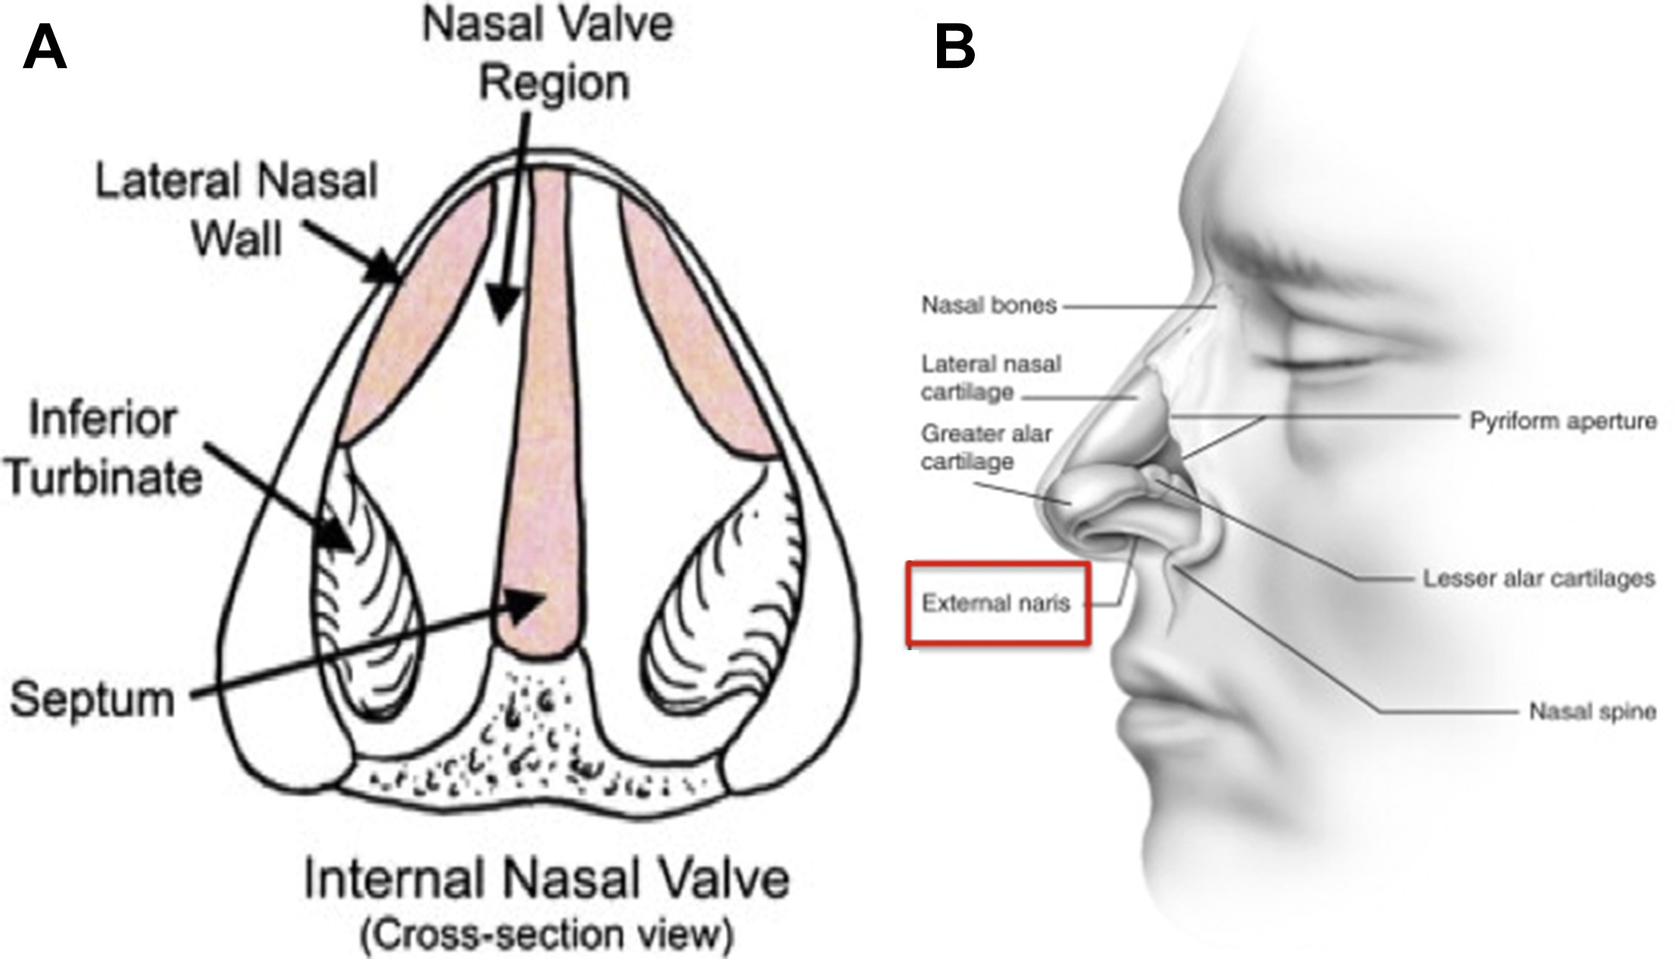
Figure 1 Nasal anatomy – internal and external valves
Source: Hsu 2018, Figure 4.

Specify the characteristics of patients with (or suspected of having) the medical condition, who would be eligible for the proposed medical service/technology (including details on how a patient would be investigated, managed and referred within the Australian health care system, in the lead up to being eligible for the service):
The target population for the proposed service is patients with NAO due to lateral wall insufficiency confirmed by positive modified Cottle manoeuvre and having a self-reported Nasal Obstruction Symptom Evaluation (NOSE) scale score of greater than 45.
The NOSE score is a patient completed instrument used to assess nasal obstruction. It is a brief questionnaire consisting of 5 self-rated items (Nasal congestion or stuffiness; nasal blockage or obstruction; trouble breathing through the nose; trouble sleeping; unable to get enough air through the nose during exercise or exertion). Each items are scored from 0 to 4 with 0 representing not a problem and 4 representing severe problem. The NOSE score represents the sum of the responses to the 5 individual items and ranges from 0 to 20, with the sum converted to a 100-point scale by multiplying the total score by 5. Based on the NOSE score, patients can be classified as having mild (5-25), moderate (30-50), severe (55-75) and extreme (80-100) severity.
To be eligible for functional rhinoplasty, the proposed comparator, patient must have a NOSE score of greater than 45. Whilst the pivotal RCT for the insertion of bioabsorbable implant (Latera) vs sham procedure included patients with a NOSE score of ≥55 (Stolovitzky 2018), the proposed patient population is aligned with the NOSE score of >45 as per the rhinoplasty MBS listings.
The modified Cottle manoeuvre refers to an assessment performed to assess the internal nasal valve integrity by providing intranasal stabilisation of the lateral nasal wall using an instrument to gently support the lateral nasal wall cartilage on each side of the nose while the patient is asked to inspire. A modified Cottle manoeuvre is considered positive if the patient reports improvement in breathing (Clark 2018). A positive Modified Cottle manoeuvre was an eligibility criteria of the Latera RCT (Stolovitzky 2018).
The RCT also stipulated that to be eligible, patients must have failed to benefit from at least 4 weeks of medical management based on local standard of care (eg, nasal steroids or antihistamines), as evidenced by lack of efficacy or tolerability. This criterion is not included in the proposed patient population, given this is not stipulated in the rhinoplasty item descriptors on the MBS, and given this represents first line, conservative management in these patients. That is, by the time the patient is meeting the proposed patient characteristics and seeking specialist consultation, the patient would have already failed conservative management.

PART 6b – INFORMATION ABOUT THE INTERVENTION

Describe the key components and clinical steps involved in delivering the proposed medical service/technology:
The LATERA Absorbable Nasal Implant System is composed of the implant, delivery device, and implant positioning guide (Latera Instructions for Use). The implant is predominantly cylindrical in shape with a diameter of 1 mm and is available in two lengths, 20mm and 24mm, with a forked distal end for anchoring and features on the proximal end for increased flexibility (Latera Instructions for Use). The Implant is composed of Poly (L-lactide-co-D-L-lactide) 70:30 copolymer which is absorbed in the body over a period of approximately 18 months (Latera Instructions for Use). The implant is depicted in Figure 2.
The delivery device is a single use device composed of an inner shaft, an outer handle with a push rod, a deploy button, an open button and a 16-gauge delivery cannula with a protective cover (Latera Instructions for Use). The inner shaft includes an implant loading port which enables the loading of the implant and include graphics to indicate the open position (Latera Instructions for Use). The inner shaft transitions between the open position and the cannula to collapse the Implant forks within the cannula inner lumen and prepare the Implant for deployment (Latera Instructions for Use). The outer handle includes deploy and open buttons that lock and release the handle from these respective positions (Latera Instructions for Use). The outer handle also includes a push rod that shuttles the implant from the implant loading port to a ready position for deployment (Latera Instructions for Use).
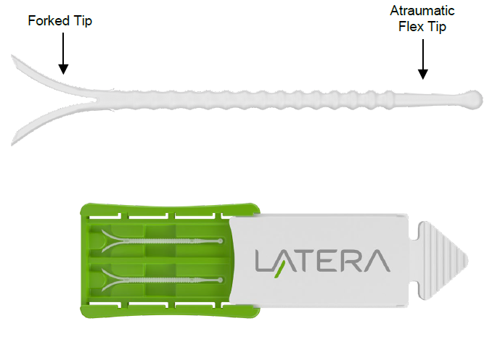
Figure 2 LATERA Absorbable Nasal Implant and Packaging

Table 1 provides steps involved in delivering the Latera implant. Three general steps are involved: implant target location and device preparation, implant delivery and disposal.
Table 1 Steps involved in delivering the Latera implant
Implant target location and device preparation
1. The implant is available in two lengths, 20mm and 24mm. Nasal anatomy (i.e. nose size, length of maxilla/nasal bone, alar crease position, etc.) should be considered in selecting an appropriate implant length. A ruler may be used to help determine the desired size.
2. Standard surgical procedures should be used to prepare the site for implantation (e.g. cleaning, disinfection, anaesthetic, etc.)
3. Prior to implantation, identify the target implant location and cannula insertion trajectory. The forked distal tip of the Implant should be positioned adjacent and across the maxilla bone and the cylindrical portion of the Implant should be positioned to support the upper and lower lateral cartilage. The proximal tip of the implant should be placed cephalic to the supra-alar crease.
4. Use the implant positioning guide to mark the surgical trajectory using a standard surgical pen. The holes provided on the Implant Positioning Guide allow for marking the base of implant forked tip and the spherical end of the atraumatic proximal tip. The distal mark correlates to the final position of the cannula tip prior to Implant delivery.
5. Retract the outer handle of the delivery device by gripping the distal flange of the inner shaft, holding the open button in the depressed position and gently pulling until the push rod is clear of the implant loading port. On devices with inner shaft graphics, the green ring will be proximal to the solid black line graphic when the push rod is clear of the implant loading port. Continue to retract the outer handle fully until the pushrod is clear of the implant loading port.
6. Using sterile surgical forceps transfer the Implant from the plastic tray to the implant loading port of the delivery device.
7. Slowly advance the outer handle until the outer handle locks into the ready position to advance the implant into the delivery cannula. While advancing, watch the implant load into cannula inner lumen. This positions the implant at the tip of the cannula in the ready position.
Implant Delivery
8. Identify the cannula insertion point, Figure 3(a), to provide the maximum distance between the cannula insertion point and the target position of the proximal tip of the Implant to ensure the Implant is fully embedded within the tissue, Figure 3(b).
9. The ala is everted under direct visualization, and the delivery cannula is inserted perpendicular to the septum through the nasal vestibular lining of the lateral wall within the nasal cavity near the margin of the nostril. A small conventional scalpel incision at the target cannula entry location may be optionally created to ease cannula puncture.
10. The cannula should pass along the center of the thickness of the lateral wall to avoid piercing medial through the mucosa or lateral through the skin as it traverses the wall to the target location.
11. When the cannula reaches the bony cartilaginous junction, the cannula is passed over the maxillary bone to the target depth.
12. If the nasal tissue has compressed or bunched-up during cannula insertion, relax the tissue to its native position. Verify that the cannula is inserted deep enough such that the tip of the cannula is positioned over the maxilla bone.
13. The implant forks will expand to their original shape as they exit the cannula tip in the orientation they are loaded. Using the implant fork orientation features on the distal end of the delivery device as a reference for fork orientation, verify that the delivery device rotation about its axis is appropriate to deliver the forks parallel to the underlying bone.
14. When the cannula is in the appropriate location and orientation, the deploy button can be depressed and released and the outer handle can be carefully advanced to the deployed position. Keep fingers proximal to the green ring when deploying the implant. Cannula may be stabilised with off-hand while deploying, if desired. The Implant forks are driven approximately 4 mm into the tissue beyond the distal tip of the cannula when deployed.
15. Following deployment, apply slight compression over deployed forks cephalic to the cannula tip (Figure 4a) and slowly withdraw the cannula from the tissue. Take care to not alter the angle or rotational orientation of the delivery device while withdrawing or the Implant could be dislodged.
16. After complete withdrawal, visually examine the insertion site to ensure the Implant is not exposed and is fully embedded within the tissue. Do not compress or fold the lateral wall to visualize the insertion site. The insertion site may be optionally closed by conventional suture techniques.
17. If multiple implantation attempts are required, a second insertion should utilize a different pierce point within the mucosa and follow a different cannula trajectory.
18. Counsel the patient to avoid manipulation of the nose during the acute healing period (e.g., Week 1: do not pinch or blow nose; Weeks 1-2: avoid strenuous activity; Weeks 1-4: do not place objects inside of nose).
Disposal: The delivery device should be disposed of in a biohazard sharps disposal container. The implant positioning guide and implant container may be disposed of along with standard medical waste.
Source: Latera Instructions for Use

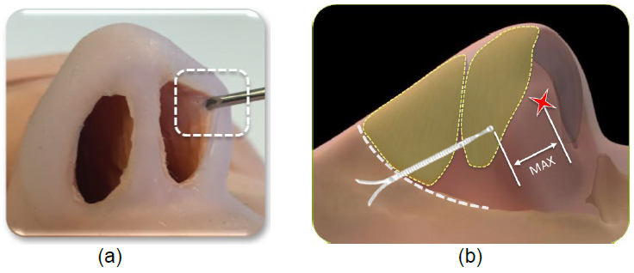
Figure 3 Images showing (a) approximate caudal cannula pierce position in the vestibular lining at the margin of the nostril and (b) the distance intended to be maximized between cannula pierce point and the proximal tip of the Implant

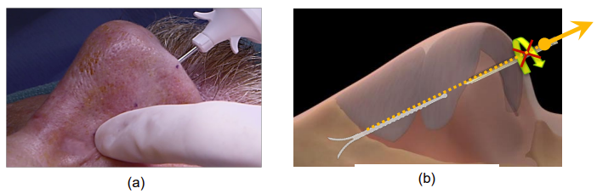
Figure 4 Images of the Delivery Device withdrawal: (a) compression over deployed forks cephalic to the cannula tip (b) withdrawal without

Does the proposed medical service include a registered trademark component with characteristics that distinguishes it from other similar health components?
No

If the proposed medical service has a prosthesis or device component to it, does it involve a new approach towards managing a particular sub-group of the population with the specific medical condition?
Yes, Latera provides a new minimally invasive approach towards managing patients with NAO (with a NOSE score of >45). Currently, patients either live with NAO with medications for symptom relief or undergo functional rhinoplasty.

If applicable, are there any limitations on the provision of the proposed medical service delivered to the patient (i.e. accessibility, dosage, quantity, duration or frequency)?
Latera is intended to be delivered once only, therefore there aren’t any limitations regarding dosage, quantity or duration.

If applicable, identify any healthcare resources or other medical services that would need to be delivered at the same time as the proposed medical service:
Anaesthetics will be required for the delivery of Latera. Depending on the setting in which Latera is delivered, anaesthetics can be local (in office) or general. In the RCT for Latera, procedures were performed in the physicians’ office with local anaesthetics (Stolovitzky 2019). Local expert advice states that the procedure is mostly performed with local anaesthetics in Australia.

If applicable, advise which health professionals will primarily deliver the proposed service:
Ear, nose and throat (ENT) specialists and rhinologists will primarily deliver proposed service

If applicable, advise whether the proposed medical service could be delegated or referred to another professional for delivery:
The service will be delegated or referred to another professional for delivery.

If applicable, specify any proposed limitations on who might deliver the proposed medical service, or who might provide a referral for it:
General practitioners (GP) may refer patients to ENT specialists or rhinologists for the delivery of Latera.

If applicable, advise what type of training or qualifications would be required to perform the proposed service, as well as any accreditation requirements to support service delivery:
The LATERA procedure needs to be undertaken by a qualified ENT surgeon or rhinologist. Further it is recommended that they do Stryker training on a head model to familiarise them with the procedure. The first case a physician performs must be attended by a company representative. It is also recommended for the first three cases that the company representative be present.

(a) Indicate the proposed setting(s) in which the proposed medical service will be delivered (select ALL relevant settings):
Inpatient private hospital (admitted patient)
Inpatient public hospital (admitted patient)
Private outpatient clinic
Public outpatient clinic
Emergency Department
Private consulting rooms - GP
Private consulting rooms – specialist
Private consulting rooms – other health practitioner (nurse or allied health)
Private day surgery clinic (admitted patient)
Private day surgery clinic (non-admitted patient)
Public day surgery clinic (admitted patient)
Public day surgery clinic (non-admitted patient)
Residential aged care facility
Patient’s home
Laboratory
Other – please specify below
- Where the proposed medical service is provided in more than one setting, please describe the rationale related to each:
The delivery of the proposed medical service, insertion of a bioabsorbable implant, is a minimally invasive and easily performed procedure that can be performed as in patient hospital service or as a day surgery clinic and is typically performed under local anaesthesia. The procedure can also be performed in private consulting rooms. Based on local expert advice, it is expected the proposed procedure is performed as day surgery, with few patients requiring overnight stay.

Is the proposed medical service intended to be entirely rendered in Australia?
Yes
No – please specify below

PART 6c – INFORMATION ABOUT THE COMPARATOR(S)

Nominate the appropriate comparator(s) for the proposed medical service (i.e. how is the proposed population currently managed in the absence of the proposed medical service being available in the Australian health care system). This includes identifying health care resources that are needed to be delivered at the same time as the comparator service):
Consistent with the current algorithm (see Figure 6), the appropriate comparator to the insertion of bioabsorbable implant in patients with NAO due to due to lateral wall insufficiency is functional rhinoplasty. Functional rhinoplasty is the gold standard treatment in the proposed patient population. Furthermore, the requested listing of the insertion of bioabsorbable implant is aligned with that of the MBS item descriptors for rhinoplasty, in that it targets patients with a NOSE score of greater than 45. The rhinoplasty procedure is generally performed using general anaesthesia and are typically performed as a day procedure. Based on local expert advice, approximately one third of procedures require an overnight stay.
Additionally, conservative management is the appropriate comparator in the population that meet eligibility for rhinoplasty, but who elect not to have the procedure or are contraindication to the procedure, and are currently managed on conservative management (see Figure 6). Conservative management is explained in more detail in Part 6c.
There is currently no minimally invasive procedure for NAO due to lateral wall insufficiency listed on the MBS. The letter of support of clinical relevance provided by the ANZRS confirm the clinical need for a minimally invasive intervention to be available for these patients, as an alternative to rhinoplasty and conservative management. The letter also mentions two additional minimally invasive therapies, the Vivaer System (Aerin) – radiofrequency and ALAR™ Nasal Valve Stent (Medtronic) – stent. The Medtronic’s ALAR stent is listed on the ARTG for the following indication: “Intended to support and immobilize intranasal tissue and cartilage during the post-operative healing period following intranasal and nasal valve surgery” (ARTG entry 218121). As such, the procedure is used in the post-operative healing period as an add on to rhinoplasty, meaning it is not a comparator to the insertion of bioabsorbable implant in these patients. Aerin’s radiofrequency system is not yet registered on the ARTG and as such, is not a comparator.

Does the medical service (that has been nominated as the comparator) have an existing MBS item number(s)?
Yes (please list all relevant MBS item numbers below)
No

Rhinoplasty: MBS Items 45632, 45641, 45644, and 45650.

(a) Will the proposed medical service/technology be used in addition to, or instead of, the nominated comparator(s)?
In addition to (i.e. it is an add-on service)
Instead of (i.e. it is a replacement or alternative)

If yes, please outline the extent to which the current service/comparator is expected to be substituted
It is expected that the listing of the insertion of bioabsorbable implant will substitute REDACTED of the current rhinoplasty patients who is indicated for the treatment of NAO due to lateral wall insufficiency.

PART 6c CONTINUED – INFORMATION ABOUT ALGORITHMS (CLINICAL MANAGEMENT PATHWAYS)s

Define and summarise the CURRENT clinical management pathway (algorithm) that patients follow when they receive the COMPARATOR service (i.e. the landscape before the proposed service is introduced). An easy-to-follow flowchart is preferred, depicting the current clinical management pathway), but dot-points would be acceptable. Please include health care resources used in the current landscape (e.g. pharmaceuticals, diagnostics and investigative services, etc.).
There are no published Australian-specific treatment guidelines for the management of patients due to lateral wall insufficiency nor are there well recognised international guidelines to direct choice of interventions in the management of these patients. Hence, Australian expert advice was sought to inform the current management of patients with NAO due to lateral wall insufficiency.

The Royal Australian College of General Practitioners (RACGP) provides guidance on the clinical assessment and diagnosis of nasal airway obstruction as published in the Australian Family Physician (Esmaili and Acharya 2017). As noted previously, NAO may have inflammatory causes or anatomical abnormalities (fixed or dynamic) with management dependent on aetiology. The first objective of the physician is therefore to establish the cause.

Assessment
The physician will obtain the history of clinical presentation, including the NOSE score, and perform a physical examination taking into consideration airflow dynamics and areas where increased resistance can occur. Typically, an external examination of the nose focusing on deformities of the bony and cartilaginous structures of the nose and adjacent tissues will be performed followed by examination of the internal anatomy. The internal nasal valve provides the greatest resistance to airflow, therefore even minor narrowing can cause nasal obstruction. The Cottle manoeuvre, which is a test of nasal valve integrity, can be performed to help diagnosis nasal valve collapse (Esmaili and Acharya 2017). It is performed by retracting the cheek laterally, pulling the upper lateral cartilage away from the septum and widening the internal nasal valve angle. If the patient’s symptoms are relieved with this manoeuvre, the patients has a positive test, suggesting that the cause of the nasal airway obstruction is related to the nasal valve area (eg, dorsal septal deviation, lack of upper lateral cartilage integrity) (Chandra 2009). A modified Cottle manoeuvre may also be used, which is performed using an instrument placed on the inside the wall to simulate opening of the valve, with the same objective.

Further assessments that may be performed include an anterior rhinoscopy of the nose (Esmaili and Acharya 2017). This is performed using an instrument called a nasal speculum, which is placed in the nostril that helps widen the opening and a strong headtorch to shine light into the nose. Fibre optic nasal endoscopy may be needed if diagnosis remains unclear, where a flexible scope is inserted into the nostril to examine. This procedure would be performed by a specialist.

In terms of imaging, computed tomography (CT) is the preferred imaging modality for the nose and paranasal sinuses (Esmaili and Acharya 2017). This was confirmed by the local expert.

A flow chart of the clinical assessment is provided in Figure 5. Conservative management generally consists of medical therapy. Patients with anatomic aetiology and symptomatic despite medical therapy warrant referral to a specialist for consideration of surgery.
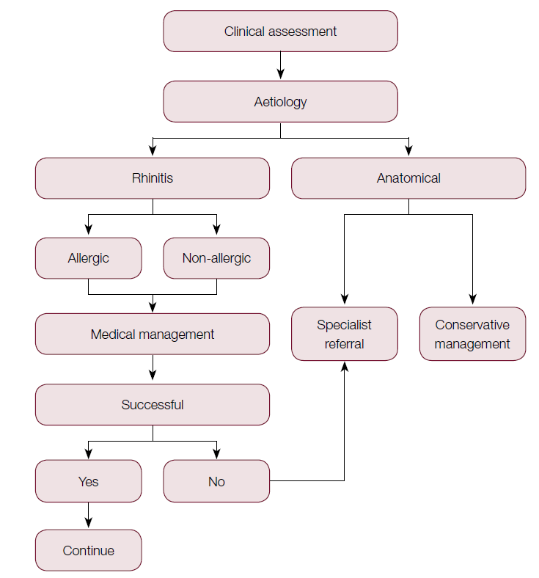
Figure 5 Clinical assessment flow chart of NAO
Source: Esmaili and Acharya 2017, Figure 1

Anatomical aetiology of NAO can be either fixed (such as deviation of the septum or hypertrophy of the turbines) or dynamic (lateral wall insufficiency). The turbinates are small structures inside the nose that cleanse and humidify air that passes through the nostrils into the lungs. They are made by a bony structure surrounded by vascular tissue and a mucous membrane, and can become swollen and inflamed by allergies, irritation or infection, causing nasal obstruction and producing an excessive amount of mucous which leads to congestion. Radiofrequency turbinate reduction is a procedure in which a needle-like instrument is inserted into the turbinate and energy is transmitted to the tissue to cause a controlled damage, so by the time healing process occurs, the turbinates will be reduced, allowing improved airflow through the nose. Septoplasty is a surgical procedure to straighten the bone and cartilage dividing the space between the two nostrils (i.e. septum).

The proposed population for this Application refers specifically to patients with NAO due to lateral wall insufficiency (dynamic anatomic aetiology). As per local expert advice, the first line conservative management of patients with lateral wall insufficiency may include management (i.e. nasal steroids or antihistamines) or temporary external supports (i.e. Breath right).

According to Australian expert in the management of patients with NAO, patients who have dynamic nasal valve collapse caused by lateral wall insufficiency and who are symptomatic despite conservative management have two options; either undergo functional rhinoplasty or continue conservative management and hence put up with the symptoms. Functional rhinoplasty is reimbursed in Australia via the MBS for patients who have a NOSE score greater than 45, reflecting severe symptoms. Some patients elect not to undergo rhinoplasty because it is an invasive open surgical procedure requiring general anaesthesia and / or may be contraindicated for the procedure.

A simple algorithm of nasal airway obstruction due to lateral wall insufficiency with severe symptoms (NOSE score greater than 45) is provided in Figure 6.

It should be noted that some patients have more than one aetiology that contributes to NAO, in that they may have turbinate hypertrophy and /or deviation of the septum. In these circumstances, the rhinoplasty would be combined with turbinate reduction and/or septoplasty.

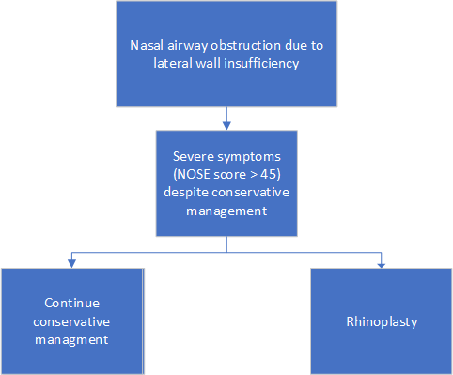
Figure 6 Current algorithm of the management of NAO due to lateral wall insufficiency

Define and summarise the PROPOSED clinical management pathway (algorithm) that patients would follow after the proposed service/technology is introduced, including variation in health care resources.
Figure 7 provides the proposed algorithm of patients with NAO due to lateral wall insufficiency after the introduction of the medical service, insertion of bioabsorbable implant. Reimbursement of the proposed service on the MBS would provide a treatment option for patients with nasal valve collapse that are currently on conservative management and electing not to undergo, or who are precluded from, rhinoplasty, and it would provide a minimally invasive treatment option for functional rhinoplasty candidates.
In patients that have more than one aetiology that contributes to NAO, that is, they may have nasal wall insufficiency as well as turbinate hypertrophy and /or deviation of the septum, the insertion of bioabsorbable implant would be used as an alternate to rhinoplasty to correct the nasal wall insufficiency.

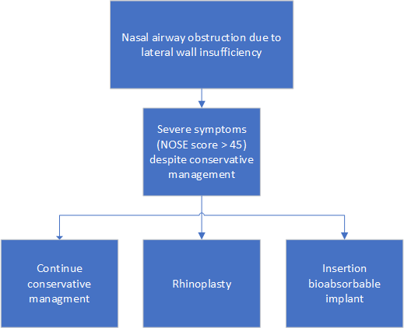
Figure 7 Proposed algorithm of the management of NAO due to lateral wall insufficiency after the introduction of the proposed service

PART 6d – INFORMATION ABOUT CLINICAL OUTCOMES

Summarise the clinical claims for the proposed medical service against the appropriate comparator(s), in terms of consequences for health outcomes (comparative benefits and harms):
Relative to functional rhinoplasty, the insertion of bioabsorbable implant is expected to deliver similar improvements in symptoms, as assessed by the NOSE score. Relative to functional rhinoplasty, the insertion of the bioabsorbable implant is expected to be at least as safe. In terms of health care resource utilisation, the insertion of bioabsorbable implant may be associated with reduced length of hospital stay relative to functional rhinoplasty.
Relative to conservative management (i.e. standard of care), the insertion of bioabsorbable implant is expected to deliver superior improvements in symptoms, as assessed by the NOSE score. The insertion of bioabsorbable implants is expected to have a tolerable safety profile, with procedural adverse events observed in clinical trials resolving with no clinical sequelae.

Please state what the overall clinical claim is:
Non-inferior effectiveness versus rhinioplasty; superior effectivenss versus standard of care.

List the key health outcomes (major and minor – prioritising major key health outcomes first) that will need to be measured in assessing the clinical claim for the proposed medical service/technology (versus the comparator):

Safety Outcomes:
Serious adverse events
Procedure-related adverse events
AEs/complications (e.g. dislodgment of implant; implant retrieval; infection; bleeding)
Clinical Effectiveness Outcomes
Responder rates
Change from baseline in NOSE score
Change in lateral wall insufficiency scores
Change in visual analogue scale
Change in satisfaction measures
Healthcare resources
Costs to deliver the intervention
Cost of hospitalisation
Costs of post-surgical follow-ups and care
Costs of adverse event management

PART 7 – INFORMATION ABOUT ESTIMATED UTILISATION

Estimate the prevalence and/or incidence of the condition in the proposed population:
The proposed population targeted for the proposed medical service is defined as nasal airway obstruction due to lateral wall insufficiency confirmed by positive modified Cottle manoeuvre and having a self-reported NOSE scale score of greater than 45.

A pragmatic search of the literature failed to identify any epidemiological studies to inform the prevalence or incidence of nasal airway obstruction in Australia or elsewhere.

The search did identify a recent study that was conducted to estimate the distribution of NOSE Scale, routinely used to diagnose nasal obstruction in clinical practice, in the Australian population (Stefani et al, 2020). The study used a market research agency to randomly survey 502 participants with no history of rhinoplasty, septoplasty or turbinectomy. Patients self-completed the questionnaire before completing the NOSE Scale. The results of the study showed that 9.6% of the study participants had a NOSE score of > 45 and would therefore meet the criterion for MBS funded rhinoplasty. However, while participants recruited to the study intended to represent the general population, a greater proportion of participants had major risk factors such as obstructive sleep apnoea (OSA), CPAP usage, cleft palate and nose trauma than would be expected. A review of the social and economic cost of sleep disorders in Australia (Sleep Health Foundation April 2021) estimated 0.78 million persons over the age of 15 had OSA in Australia in 2020 representing approximately 3.8% of the population of whom, 11.8% would use CPAP. Conversely, the study by Stefani et al reported 8.6% of patients with self-reported OSA of whom 28% used CPAP. Given the skewed distribution of risk factors in the study, it is possible that selection bias may be responsible for the high prevalence of NOSE scores > 45. Indeed, the high proportion of the Australian population who would be eligible for MBS funded rhinoplasty based on the results of the study by Stefani et al, does not align with actual current usage (Table 1), though this may also indicate that many patients with a self-reported NOSE score of >45 may not consider themselves to be severe enough to want to pursue surgical treatment.

Accordingly, the size of the patient population who would be eligible for the proposed service was derived, as a proxy, from available MBS statistics for services related to functional rhinoplasty, the only intervention currently available to treat NAO due to lateral wall insufficiency in Australia.

There are currently three MBS item numbers for the provision of functional rhinoplasty for the treatment of NAO (Table 2). Eligibility requirements for each MBS item are identical and only apply where:

(a) the indication for surgery is:
(i) airway obstruction and the patient has a self-reported NOSE Scale score of greater than 45; or
(ii) significant acquired, congenital or developmental deformity; and
(b) photographic and/or NOSE Scale evidence demonstrating the clinical need for this service is documented in the patient notes.
An analysis of utilisation of the MBS items showed that 5,657 patients elected to undergo rhinoplasty in 2021 (Table 2). Of note, however, the item numbers listed are not specific to nasal airway obstruction due to lateral wall insufficiency alone. While no specific data to Australia is readily available to inform the proportion of patient with NAO that is due to lateral wall insufficiency (also referred to as nasal valve collapse [NVC]), a survey conducted in the US among patients complaining of nasal obstruction and a NOSE score >50, estimate the prevalence of NVC to be 73% (Clark 2018). Applying this to the estimates derived from the MBS data, it is estimated that 4,130 (5,657*73%) rhinoplasties were performed for the treatment of lateral wall insufficiencies in 2021. furthermore, given the MBS items are also relevant to patients with acquired, congenital or developmental deformity, this number is likely to be over-estimated.

Table 2 Utilisation of MBS items for rhinoplasty
MBS item | Descriptor | 2021 utilisation
45632 | Rhinoplasty, partial, involving correction of one or both lateral cartilages, one or both alar cartilages or one or both lateral cartilages and alar cartilages | 522
45641 | Rhinoplasty, total, including correction of all bony and cartilaginous elements of the external nose, with or without autogenous cartilage or bone graft from a local site (nasal) | 4,286
45644 | Rhinoplasty, total, including correction of all bony and cartilaginous elements of the external nose involving autogenous bone or cartilage graft obtained from distant donor site, including obtaining of graft | 849
Total |  | 5,657

It is acknowledged that there exists a patient pool with severe NVC who are unwilling to undergo a rhinoplasty due to concerns relating to the general anaesthetic, invasive nature of the procedure and/or extensive recovery time or that are contraindicated to the procedure. Consequently, MBS funding of the proposed service may result in a number of patients on conservative management electing to have the proposed service who would otherwise not have chosen to undergo a rhinoplasty procedure.

Estimate the number of times the proposed medical service/technology would be delivered to a patient per year:
The proposed medical service is intended to be delivered once only.

How many years would the proposed medical service/technology be required for the patient?
As stated in Q.45, the proposed medical service is to be a once off service.

Estimate the projected number of patients who will utilise the proposed medical service(s) for the first full year:
Projected uptake of current MBS item numbers relevant to rhinoplasty for the treatment of NVC (45632, 45641 and 45644) is projected based on historical use over the last 10-years (see Figure 8). Assuming continued linear growth it is estimated 6,289 patients will utilise these MBS items in the first full year of listing (assumed to be 2024). Applying an uptake rate of REDACTED patients are projected to utilise the proposed medical service in the first full year (see Table 3).
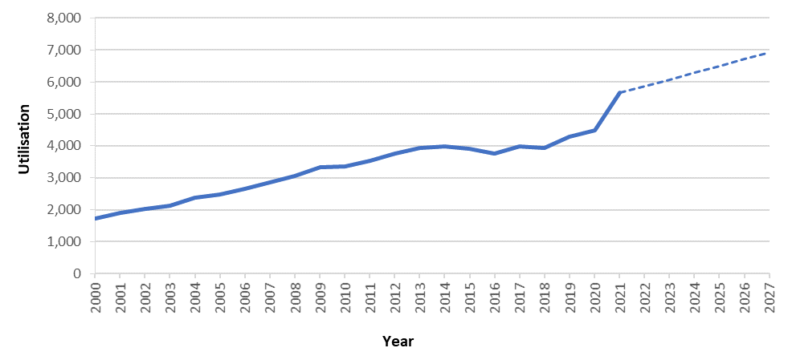
Figure 8 Historical and projected utilisation of MBS items 45632, 45641 and 45644
As a less invasive alternative to rhinoplasty, it is expected that some patients who would otherwise not have undergone rhinoplasty will also utilise the service, meaning total expected utilisation may exceed this.
Note, these projected numbers are indicative only and will be finalised in the applicant developed assessment report (ADAR).

Estimate the anticipated uptake of the proposed medical service/technology over the next three years, factoring in any constraints in the health system in meeting the needs of the proposed population (such as supply and demand factors), as well as provide commentary on risk of ‘leakage’ to populations not targeted by the service.
As presented in Table 3, the uptake of the proposed medical service is projected to increase from REDACTED in the first full year of listing to between REDACTED and REDACTED over the next three years. Increased uptake over these years reflects the expected impact of increased market awareness and wider adoption among ENT and rhinology specialists.
Table 3 Projected utilisation of proposed MBS service in first 3 years of funding
Population | Year 1  (2024) | Year 2  (2025) | Year 3  (2026) | Year 4  (2027)
Estimated population who would have undergone rhinoplasty in the absence of the proposed service | 6,289 | 6,500 | 6,710 | 6,921
Proportion of patient with NAO that is due to lateral wall insufficiency | 73% | 73% | 73% | 73%
Total patients eligible for insertion of bioabsorbable implant | 4,591 | 4,745 | 4,899 | 5,052
Uptake rate of proposed service in patients who would have undergone rhinoplasty | REDACTED | REDACTED | REDACTED | REDACTED
Estimated utilisation in patients who would have undergone rhinoplasty | REDACTED | REDACTED | REDACTED | REDACTED

While the proposed procedure is perceived to be minimally invasive in comparison with rhinoplasty, the decision to undergo the proposed procedure for the treatment of NVC is unlikely to be taken lightly given the irreversible nature of the procedure. Furthermore, the procedure is highly specific to the nature of the nasal obstruction. In light of this, leakage to less severe patients or to patients with other causes of nasal airway obstruction is considered to be low.

PART 8 – COST INFORMATION

Indicate the likely cost of providing the proposed medical service. Where possible, please provide overall cost and breakdown:
The proposed cost of the bioabsorbable implant REDACTED per procedure. As per local expert advice, it is expected that the procedure will be performed using local anaesthesia. The proposed fee for the procedure of insertion of the bioabsorbable implant will be determined and justified in the ADAR based on appropriate benchmark MBS item fee commensurate to the time, complexity and qualification of the specialist performing the procedure.
Row | Parameters | Cost | Source/calculation
A | Bioabsorbable implant | REDACTED | Proposed Prostheses List benefit
B | Procedure / medical service cost | TBC | ADAR will determine and justify appropriate benchmark MBS item fee commensurate to the time, complexity and qualification of the specialist performing the procedure.
C | Hospitalisation (if applicable) | $427 | PHDB annual report, 2018, 2019 (v9.0) AR-DRG D10Z ‘Nasal Procedures’: Average accommodation hospital charge per separation
 | Total | TBC | A+B+C
PHDB, Private Hospital Data Bureau

Specify how long the proposed medical service/technology typically takes to perform:
Based on local expert advice, the procedure takes approximately 10 minutes.

If public funding is sought through the MBS, please draft a proposed MBS item descriptor to define the population and usage characteristics that defines eligibility for the medical service/technology.
Drafts of the proposed MBS item descriptors are provided below. It is the intention that the procedure be performed unilaterally and bilaterally, and as such two MBS item have been proposed.
The NOSE Scale cut-off score of greater than 45 is consistent with the MBS item restrictors for rhinoplasty for nasal airway obstruction.
Category 3 - THERAPEUTIC PROCEDURES
Proposed item descriptor: Unilateral insertion of bioabsorbable implant for nasal airway obstruction due to lateral wall insufficiency confirmed by positive modified Cottle manoeuvre and the patient has a self-reported NOSE Scale score of greater than 45
Fee: $TBC
Category 3 - THERAPEUTIC PROCEDURES
Proposed item descriptor: Bilateral insertion of bioabsorbable implant for nasal airway obstruction due to lateral wall insufficiency confirmed by positive modified Cottle manoeuvre and the patient has a self-reported NOSE Scale score of greater than 45
Fee: $TBC

If public funding is sought through an alternative (non-MBS) funding arrangement, please draft a service description to define the population and usage characteristics that defines eligibility for the service/technology.
Not appliable

References
Chandra, Patadia, M. O., & Raviv, J. (2009). Diagnosis of Nasal Airway Obstruction. Otolaryngologic Clinics of North America, 42(2), 207–. https://doi.org/10.1016/j.otc.2009.01.004
Clark, Del Signore, A. G., Raithatha, R., & Senior, B. A. (2018). Nasal Airway Obstruction: Prevalence and Anatomic Contributors. Ear, Nose, & Throat Journal, 97(6), 173–176. https://doi.org/10.1177/014556131809700615
Crawford-Brown, Theoretical and Mathematical Foundations of Human Health Risk Analysis; 1997, Page 103.
D Saadat, R Ow, D Liepert, 0558 Less Invasive Procedure for the Treatment of Nasal Obstruction: Impact on Daytime Drowsiness, Sleep, Volume 41, Issue suppl_1, April 2018, Page A208, https://doi.org/10.1093/sleep/zsy061.557
Esmaili, & Acharya, A. (2017). Clinical assessment, diagnosis and management of nasal obstruction. Australian Family Physician, 46(7), 499–503.
Latera (Absorbable Nasal Implant System) Instructions for Use. Available at: https://ent.stryker.com/sites/default/files/2019-12/4485-001%20rB%20IFU%2C%20LATERA%20Absorbable%20Nasal%20Implant%20System.pdf
Mohan, Fuller, J. C., Ford, S. F., & Lindsay, R. W. (2018). Diagnostic and Therapeutic Management of Nasal Airway Obstruction: Advances in Diagnosis and Treatment. JAMA Facial Plastic Surgery, 20(5), 409–418. https://doi.org/10.1001/jamafacial.2018.0279
Rhee JS et al. 2010. Clinical Consensus Statement: Diagnosis and Management of Nasal Valve Compromise. Otolaryngol Head Neck Surg. 143(1): 48–59. doi:10.1016/j.otohns.2010.04.019.
San Nicoló, M., Stelter, K., Sadick, H., Bas, M., & Berghaus, A. (2017). Absorbable Implant to Treat Nasal Valve Collapse. Facial plastic surgery : FPS, 33(2), 233–240. https://doi.org/10.1055/s-0037-1598655
San Nicoló, M., Stelter, K., Sadick, H., Bas, M., & Berghaus, A. (2018). A 2-Year Follow-up Study of an Absorbable Implant to Treat Nasal Valve Collapse. Facial plastic surgery : FPS, 34(5), 545–550. https://doi.org/10.1055/s-0038-1672213
Sidle, D. M., Stolovitzky, P., O'Malley, E. M., Ow, R. A., Nachlas, N. E., & Silvers, S. (2021). Bioabsorbable Implant for Treatment of Nasal Valve Collapse with or without Concomitant Procedures. Facial plastic surgery : FPS, 37(5), 673–680. https://doi.org/10.1055/s-0041-1726464
Sidle, Stolovitzky, P., Ow, R. A., Silvers, S., Matheny, K., Bikhazi, N., Wani, M., Scurry, W. C., & Most, S. P. (2020). Twelve‐month outcomes of a bioabsorbable implant for in‐office treatment of dynamic nasal valve collapse. The Laryngoscope, 130(5), 1132–1137.
Sleep Health Foundation. 2021. Rise and try to shine: The social and economic cost of sleep disorders in Australia Sleep Health Foundation April 2021. https://www.sleephealthfoundation.org.au/files/Special_reports/Social_Economic_Cost_of_sleep_disorders_20042021.pdf
Stolovitzky P, Senior B, Ow RA, Mehendale N, Bikhazi N, Sidle DM. Assessment of bioabsorbable implant treatment for nasal valve collapse compared to a sham group: a randomized control trial. Int Forum Allergy Rhinol. 2019 Aug;9(8):850-856. doi: 10.1002/alr.22362. Epub 2019 Jun 21.
Stolovitzky, P., Sidle, D. M., Ow, R. A., Nachlas, N. E., & Most, S. P. (2018). A prospective study for treatment of nasal valve collapse due to lateral wall insufficiency: Outcomes using a bioabsorbable implant. The Laryngoscope, 128(11), 2483–2489. https://doi.org/10.1002/lary.27242

https://o2vent.com/wp-content/uploads/documents/resources/Nose%20Questionaire%20(OM179US%20).pdf (accessed 8 March 2022)

