Applicant Submitted Protocol
for
Bronchial Thermoplasty for the Treatment of Uncontrolled Severe Asthma

Medical Services Advisory Committee

Application 1384

For Consideration by the

Protocol Advisory Sub-Committee (PASC)

June 2014

Title of Application
Bronchial thermoplasty for the treatment of uncontrolled severe asthma

Purpose of application
Please indicate the rationale for the application and provide one abstract or systematic review that will provide background.
This application requests a new MBS item for bronchial thermoplasty.
Bronchial thermoplasty is a new non-drug minimally invasive bronchoscopic procedure for the treatment of uncontrolled severe asthma.
The intention of the submission based assessment (SBA) will be to demonstrate the clinical and cost effectiveness of bronchial thermoplasty in the treatment of uncontrolled severe asthma.
For a recent systematic review of bronchial thermoplasty, the reader is referred to the following article: Torrego A, Solà I, Munoz AM, Roqué i Figuls M, Yepes-Nuñez JJ, Alonso-Coello P, Plaza V. Bronchial thermoplasty for moderate or severe persistent asthma in adults. Cochrane Database of Systematic Reviews 2014, Issue 3. [It is important to note, however, that while the systematic review describes the available randomised controlled trials evidence base for bronchial thermoplasty, the overall conclusions of the review are not applicable to the specific population of asthma patients targeted for bronchial thermoplasty as a service on the MBS]
Note:
This application follows the recent recommendation of The American College of Chest Physicians (ACCP/CHEST) that “all public and private insurers provide coverage and payment for bronchial thermoplasty ….. for those adult patients with severe persistent, poorly-controlled asthma who continue to experience asthma exacerbations, emergency department visits and hospitalizations despite maximal medical treatment” (ACCP/CHEST, 2014).
The recommendation goes on to state the ACCP “believe that, given the extensive body of evidence demonstrating …safety, effectiveness, and durability, bronchial thermoplasty is not experimental and should not be withheld from patients pending additional clinical trials.”
The ACCP/CHEST has issued this statement because many of the currently published coverage policies and treatment guidelines were finalised prior to the publication of five year follow-up data from the Asthma in Research 2 (AIR2) study, the pivotal randomised controlled trial of bronchial thermoplasty.
The position statement in its entirety can be found at: http://www.chestnet.org/Guidelines-and-Resources/Payment-Practice-and-Quality/Coding-Regulations-and-Reimbursement/Regulations-and-Reimbursement

Population and medical condition eligible for the proposed medical services
Provide a description of the medical condition (or disease) relevant to the service.

Asthma
Asthma is a chronic respiratory disease, affecting approximately one in ten of the general population in Australia (ACAM 2011). By international standards, the prevalence of asthma in Australia is high and particularly common amongst indigenous Australians.
The disease is characterised by inflammation of the airways, excess mucus production, airway hyper-responsiveness and an increase in airway smooth muscle bulk in which the airways narrow excessively in response to stimuli. In susceptible individuals, this inflammation causes recurrent episodes of wheezing, breathlessness, chest tightness, and coughing. These episodes are usually associated with widespread but variable airflow obstruction that is often reversible either spontaneously or with treatment. Asthma attacks have a significant impact on a patient’s life, limiting participation in many activities. In severe cases, asthma attacks can be life threatening. In 2009, there were 411 deaths attributed to asthma, representing 1.6 per 100,000 people and 0.29% of all deaths in that year (ACAM, 2011).

Goal of asthma care
The goal of asthma care is to achieve and maintain control of the clinical manifestations of the disease for prolonged periods. When asthma is well controlled, patients can prevent most attacks; avoid troublesome day and night symptoms and keep physically active. In general, the achievement of good clinical control of asthma leads to a reduction in the frequency of exacerbations.
The medical management of asthma adopts a stepped approach, consistent with that outlined in the Global Initiative for Asthma Guidelines (see GINA, 2014 for the most recent iteration) which, in general, involves the use of bronchodilator and inhaled corticosteroid (ICS) therapies (Figure 1). Ongoing treatment decisions are based on a cycle of assessment, adjustment of treatment, and review of response. Controller medication is adjusted, up or down, to achieve good symptom control and minimise future risk of exacerbations, fixed airflow limitation and medication side effects. All asthma patients should be prescribed an inhaled short-acting beta2 agonist (SABA) to be used ‘as needed’ to relieve symptoms (Step 1). Patients whose asthma symptoms persist should also receive a daily preventer (controller) medication (Step 2). This is usually a low dose inhaled corticosteroid (ICS). In patients who remain symptomatic on low dose ICS treatment, the addition of a long-acting beta2 agonist (LABA) improves symptoms and is generally preferred to the option of increasing to a higher dose of ICS (Step 3). In those patients not controlled on a low dose ICS/LABA combination therapy, an increase in ICS dose may be considered (Step 4). Patients with persistent symptoms, despite correct inhaler technique and good adherence to Step 4 treatment, should be referred to a specialist with expertise in the management of severe asthma (Step 5). Add-on treatment options which may be considered at Step 5 include low-dose oral corticosteroids, omalizumab (allergic asthma patients only), and bronchial thermoplasty (see Figure 2). [Source: GINA 2014, Chapter 3, Part B).
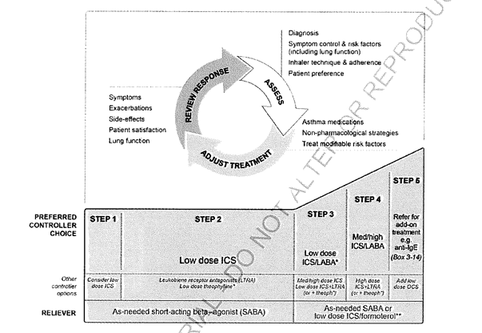
Figure 1 Stepwise approach asthma management (GINA, 2014)

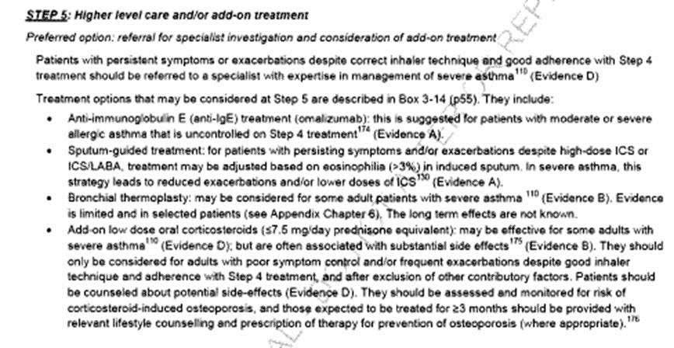
Figure 2 Step 5: Higher level care and/or add-on treatment (GINA, 2014)
It is important to note that consideration of bronchial thermoplasty as a Step 5 treatment option included in the GINA 2014 Guideline was prior to the publication of five year follow-up data from the Asthma in Research 2 (AIR2) study, the pivotal randomised controlled trial of bronchial thermoplasty (Wechsler et al, 2013) and the subsequent ACCP/CHEST position statement referred to earlier (See Section 2).
Source - GINA, 2014: Step 5 Higher level care and/or add-on treatments, p35

Uncontrolled severe asthma
Levels of asthma symptom control are categorised as good, partial and poor (NACA, 2014) (equivalent to the GINA categories of well controlled, partly controlled and uncontrolled, respectively [GINA, 2014]). The severity of a patient’s asthma is defined by the type and intensity of medication therapy needed to achieve good asthma control.
For the majority of patients, their asthma symptoms are well controlled with the correct use of standard inhaled asthma medication therapy and stimulus avoidance. However, approximately 5-10% of patients with asthma have severe disease which remains uncontrolled, despite optimised asthma therapy. These patients have a greatly increased risk of experiencing a serious asthma exacerbation, resulting in a visit to the hospital emergency department, a hospital admission or death. Care for these patients represents a major public health burden; patients with severe or difficult-to-treat asthma account for the majority of asthma-related morbidity, mortality and healthcare costs (total asthma-related healthcare totalled $606 million in 2004-05 [ACAM, 2011]), despite comprising only a small proportion of the total asthma population. Even though this patient population represents only 10% of all asthma sufferers, European data suggest patients with severe uncontrolled asthma accounts for approximately 50% of all direct and indirect costs of the disease (See Peters et al 2006).

Role of airway smooth muscle
Airway smooth-muscle (ASM) tissue surrounds the walls of the airways. People with asthma have more ASM than people who don’t have asthma (Figure 3). The thickness of the ASM correlates with asthma severity (Woodruff et al, 2004; Cox et al, 2004; Benayoun et al, 2003). ASM hypertrophy and hyperplasia and contraction play a central role in bronchial obstruction in patients with severe asthma. It is the contraction of the ASM, whether in response to an allergen, an irritant, psychological stress, or other neural activation, that leads to the airway narrowing and airflow obstruction and is responsible for the symptoms experienced by asthma patients (Figure 3).
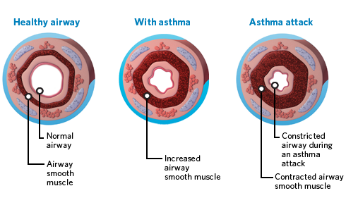
Figure 3 The role of airway smooth muscle in an asthma attack

Aim of bronchial thermoplasty in severe asthma
The aim of bronchial thermoplasty is to reduce the amount of excess smooth-muscle tissue (Figure 2). With less of this tissue, the airways constrict less, breathing is easier, and there is less likelihood of an asthma exacerbation.
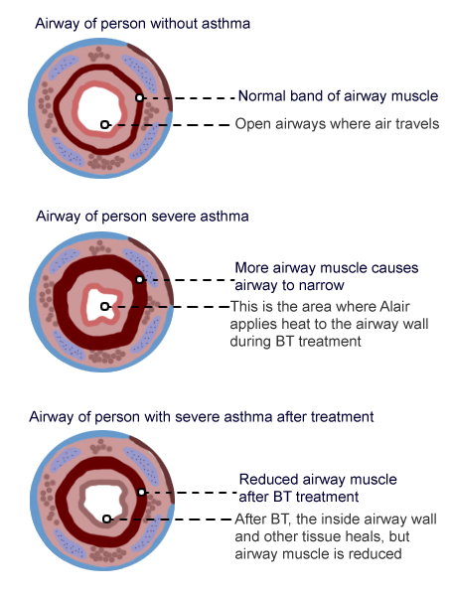
Figure 4 Airways before and after bronchial thermoplasty

Define the proposed patient population that would benefit from the use of this service. This could include issues such as patient characteristics and /or specific circumstances that patients would have to satisfy in order to access the service.

Uncontrolled severe asthma
Severe asthma is associated with the greatest amount of ASM thickening responsible for increased airway hyperresponsiveness. Patients with severe asthma are therefore the patients likely to benefit most from bronchial thermoplasty as a means of ASM mass reduction.
The proposed patient population that would benefit from the use of bronchial thermoplasty as a service available on the MBS would be adult patients (at least 18 years old) with severe asthma whose asthma symptoms are not well controlled despite optimised asthma therapy (OAT).
OAT in these patients includes adherence to maximal inhaled therapy.
Maximal inhaled therapy includes a high dose of an inhaled corticosteroid (budesonide 1600 μg/day or fluticasone 1000 μg/day or equivalent) plus a long-acting beta₂ agonist ([at least salmeterol 50 μg bid or eformoterol 12 μg bid or equivalent) (NACA, 2014).
Prior to accessing the service on the MBS, a diagnosis of uncontrolled severe asthma would be required to rule out the possibility of non-asthma related causes and other possible reasons for symptoms such as avoidable exposure to aggravating factors, poor medication compliance and bad inhaler technique. The process to confirm uncontrolled severe asthma is described below and illustrated in Figure 4.

Current management of poorly controlled asthma
Patients poorly controlled on their current asthma medication, regardless of asthma severity regimen, may be referred to a severe asthma care clinic (SAC) or a respiratory specialist external to a SAC or they may be managed by a general physician experienced in the management of patients with severe asthma. . The flow diagram presented in Figure 5 illustrates a typical journey of such patients, based on the protocol followed by the SAC at the John Hunter Hospital, NSW and adheres to local guidelines for the management of difficult to treat asthma (NACA, 2014).
Referrals are first assessed to confirm that symptoms are not due to some underlying non-asthma related cause. This assessment generally involves testing of pulmonary function and documenting reversible airway obstruction or airway hyperresponsiveness to rule out, for example, vocal cord dysfunction, hyperventilation, Chronic obstructive pulmonary disease (COPD). On confirmation that the on-going symptoms are due to asthma, a number of further checks may be made before any change in medication regimen is considered. These include:
Identification and management of factors which may aggravate the underlying asthma
This includes identification and elimination of exposure to allergens or other triggers of asthma, e.g., drugs including aspirin and other non-steroidal anti-inflammatory medications (NSAIDs), microbial volatile organic compounds released from excess indoor mould growth, dust mites, occupational allergens or irritants, or the better management of comorbid disorders which may exacerbate asthma, e.g. gastro reflux disease, uncontrolled allergic rhinitis, endocrinopathies, or recognition of psychological factors. Other significant aggravating factors may include obesity and psychological stress.
Optimising patient’s asthma management skills
This includes educating the patient in regard to the principles of good asthma management, the correct use of asthma medications and devices and the formation of a written Asthma Action Plan. An Asthma Action Plan is a written plan produced for the purpose of a patient’s self-management of their asthma exacerbations. The action plan is characterised by being individualised to the patient’s underlying asthma severity and treatment. It is also a written plan which informs participants about: when and how to modify medications in response to worsening asthma; and how to access the medical system in response to worsening asthma.
Assessment of treatment compliance
This includes assessment of compliance and adherence to the current medication regimen and documentation of the correct use of inhalers. For "difficult asthmatics," this is particularly necessary because, although counterintuitive, asthmatics that are more ill are actually less likely to take their medicines. Even when patients are compliant, use of improper inhaler techniques may prevent appropriate delivery of the drug.
Once poor compliance and bad inhaler technique have been ruled out, the current ICS therapy regimen is optimised. That is to achieve the optimal dose of ICS, either with or without LABA. If asthma is not controlled on the current ICS-based treatment regimen, then treatment is stepped up until control is achieved.
The goal of asthma treatment is to achieve and maintain asthma control with the least medication necessary. Therefore, if symptom control is achieved and maintained over a prolonged period (3 months), there should then be a gradual stepwise reduction in treatment.
Patients who do not reach an acceptable level of control despite treatment with a maximum high dose of ICS in combination with a LABA can be considered as having uncontrolled severe asthma.
Currently, the only further medication options available to these patients are maintenance oral corticosteroids and/or omalizumab (which is for allergic asthma patients only) (please see Section 6 on comparators later in the document).

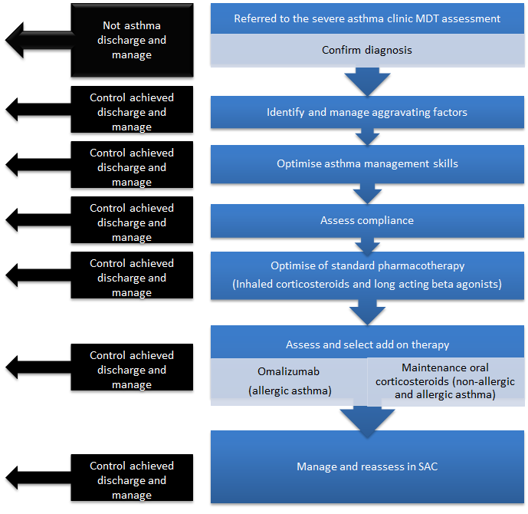
Figure 5 Current management of poorly controlled asthma

MDT, multidiscipline team; SAC, severe asthma clinic

Note: In patients not controlled on optimised asthma therapy which includes a maximum high dose of ICS plus LABA, the addition of maintenance oral corticosteroids and/or omalizumab (allergic asthma patients only) may be also considered. The John Hunter Hospital also considers the addition of montelukas and immunosuppressive therapies (e.g., methotrexate, cyclosporine). However, montelukast treatment is not subsidised by the PBS for people aged 15 years or over and therefore is not relevant to this submission; the immunosuppressive are not indicated for asthma.
(Source: John Hunter Hospital NSW)
Indicate if there is evidence for the population who would benefit from this service i.e. international evidence including inclusion / exclusion criteria. If appropriate provide a table summarising the population considered in the evidence.
Key evidence for the efficacy and safety of bronchial thermoplasty in the treatment of asthma is provided by three multi -centred, multi-national randomised controlled trials: AIR2, RISA and AIR (Castro et al, 2010; Pavord et al, 2007; Cox et al, 2007).
AIR2 is a randomised sham-controlled trial of bronchial thermoplasty conducted in adult patients with uncontrolled severe asthma. The proposed population targeted for the proposed bronchial thermoplasty service on the MBS is largely based on the patient eligibility criteria for the inclusion in the AIR2 trial.
RISA and AIR differed from AIR2 in that patients randomised to the control group did not receive a sham procedure. While patients included in the RISA trial match the proposed population targeted for the bronchial thermoplasty service on the MBS, patients included in AIR had more moderate disease reasonably controlled by their current medication.
It is anticipated the SBA will consider AIR2 as the pivotal trial evidence for bronchial thermoplasty, with RISA and AIR providing supportive evidence.
The eligibility criteria for entry into AIR2 are summarised in Table 1. The inclusion criteria reflect patients with severe asthma who are symptomatic despite treatment with high doses of ICS and LABA (the current standard of care for severe asthma).
The SBA will seek to address any issues of the trial data applicability to the proposed population targeted for the bronchial thermoplasty service on the MBS

Table 1 Eligibility criteria for inclusion in the AIR2 randomised sham controlled trial of bronchial thermoplasty (Castro et al, 2010)
Inclusion criteria | Exclusion criteria
- Age 18-65 years | - Life-threatening asthma (current exacerbation)  - Chronic sinus disease  - Respiratory diseases such as emphysema  - Use of immunosuppressants, beta-adrenergic blocking agents or anticoagulants  - History in the previous year of  - three or more hospitalisations for asthma, OR  - three or more lower respiratory tract infections, OR  - four or more pulses of oral corticosteroid use for asthma
- Diagnosis of asthma requiring regular maintenance medications of:
  - High dose inhaled corticosteroid (1000 µg/day beclomethasone or equivalent) and long-acting beta2 agonist (>100 µg/d salmeterol or equivalent)

[Other permitted medications: leukotriene modifiers, omalizumab (if used for at least 1 year prior), and oral corticosteroids (OCS) 10 mg/d or less.]

- Stable maintenance asthma medications for at least 4 weeks before entry
- Airway hyperresponsiveness
- Pre-bronchodilator FEV1 percentage of predicted ≥ 60%
- At least two days of asthma symptoms during the four-week baseline period
- A baseline Asthma Quality of Life Questionnaire (AQLQ) score 6.25 or lower
- Non-smoker for at least one year with less than 10 pack-year smoking history
FEV₁, pre-bronchodilator forced expiratory volume in one second.

Provide details on the expected utilisation, if the service is to be publicly funded.
Table 2 provides a preliminary estimate of the prevalent pool of patients who are potential candidates for bronchial thermoplasty on the MBS. These preliminary estimates suggest a prevalent pool of 50,000 to 75,000 patients could be eligible for bronchial thermoplasty in Australia.

Table 2 Estimation of prevalent pool of potential candidate patients for bronchial thermoplasty service on the MBS
Population | Estimated prevalence | Number of Australians | Source
All adult Australians ≥18 years |  | 17,902,257 | ABS (2013)  3101.0 - Australian Demographic Statistics; Table 59
All asthma | 10.2% of Australians | 1,826,030 | AIHW http://www.aihw.gov.au/asthma (2011 data)
Severe asthma | ~20% of all asthma | 365,206 | Peters et al, 2006; Rabe et al 2004
Uncontrolled severe asthma | 20% of all severe asthma | 73,041 | Peters et al, 2006; Bleecker and Davis 2008.
Confirmed uncontrolled severe asthma | 68% of all severe uncontrolled asthma | 49,668 | Robinson et al, 2003
Severe allergic asthma | 50% of all severe asthma | 24,834 | Peters et al, 2006
Caution: Definitions of severe uncontrolled asthma may differ according to sources but generally reflects patients who remain symptomatic despite high dose ICS and LABA medication therapy (i.e., GINA Step 4 therapy). Data are not necessarily based on Australian sources and therefore their generalisability to the Australian population is subject to uncertainty.
Note 1: Sources in the literature (for example: Partridge 2007; Rabe and Davis 2008; Moore et al 2006; Barnes and Woolcock 1998) frequently cite 5 to 10% of all asthma is severe uncontrolled asthma. The lower estimate of 5% is consistent with the information in the table above provided by Peters et al 2006 (that is: 20% of 20% = 4%). If the upper estimate of 10% is applicable, then the prevalent pool could be more than double that presented here. However, data from Robinson et al 2003 suggest a lower percentage of patients are likely to have confirmed severe uncontrolled asthma i.e., after ruling out non-asthma related causes, avoidable aggravating factors, poor medication compliance and bad inhaler technique. Based on this information, an estimated of a prevalent pool of 50 to 75,000 is reasonable.
However, capacity constraints will limit the uptake of the bronchial thermoplasty service to a finite number of centres. In Australia, patients would be treated in the private or public hospital setting only. There is expected to be 20 facilities providing bronchial thermoplasty when the therapy is established in Australian clinical practice. Each facility would have approximately two trained physicians providing the service. Due to resource capacity in each facility, each physician is likely to provide two bronchial thermoplasty procedures per month. Under these circumstances the number of private patients who would be treated with bronchial thermoplasty per year would be well under 400 patients. [For information: there are currently 12 centres of excellence, each treating approximately 10 patients per year.]

Intervention – proposed medical service
Provide a description of the proposed medical service.
Bronchial thermoplasty is a novel intervention in which controlled thermal energy from a radiofrequency (RF) source is delivered to the airway wall as a means of reducing excess ASM mass.
Bronchial thermoplasty involves the application of controlled heat via radiofrequency waves during the bronchoscopy. The system used consists of a radiofrequency generator (Figure 6a) and a single use catheter with a basket carrying four expandable electrodes (Figure 6 b).The energy applied by the electrodes is transformed into heat on contact with the mucosa.
The software temperature set point in the Alair controller is 65°C (other controllers may allow different settings). This is the temperature set when the firmware for the controller is installed at manufacture. The feedback from the generator guarantees an exact temperature of 65°C and a 10 second activation. The controller uses the temperature measured every 0.02 seconds via a thermocouple attached to one of the electrodes as feedback. The controller adjusts the RF power between 0-18W to control the set temp of 65°C using a standard proportional-integral-derivative (PID) control algorithm. It is not possible for the user to change the PID algorithm, or the temperature setting of the controller.
The temperature of 65°C was selected on the basis of preliminary studies conducted in animals (Danek et al 2004; Brown et al 2005a&b) and humans (Miller et al, 2005; Cox et al 2006) with the goal of achieving a reduction, rather than eradication, of the ASM mass.
Note: The pivotal and supportive randomised clinical trials evidence supporting the efficacy and safety of bronchial thermoplasty that will be presented in the SBA, is based on the use of the controller set at 65°C.

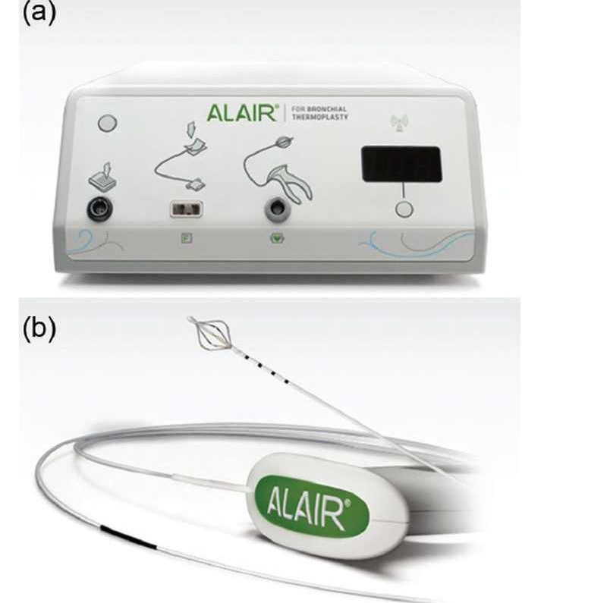
Figure 6 Alair® System
- Alair radiofrequency Controller (Boston Scientific): The Alair RF Controller provides temperature-controlled delivery of RF energy to the Alair Catheter. The Alair RF Controller is designed with a proprietary set of control parameters and algorithms to deliver the correct intensity and duration of thermal energy sufficient to reduce the mass of airway smooth muscle tissue, while limiting long-term impact to surrounding tissues. Numerous safety features have been incorporated into the design of the Alair RF Controller and Alair Catheter to minimize the chance of unintended over-treatment. These features have been developed and tested through extensive pre-clinical studies
- Alair catheter (Boston Scientific): The sterile, single-use, disposable device is designed with a proprietary set of control parameters and algorithms to deliver therapeutic RF energy to the airways via a standard bronchoscope.

The procedure
A complete course of bronchial thermoplasty is performed over 3 inpatient outpatient visits, each scheduled approximately 3 weeks apart.
The procedure is usually performed with the patient under moderate sedation or light general anaesthesia.
The first procedure treats the airways in the right lower lobe, the second treats the airways of the left lower lobe and the third and final procedure treats the airways in both upper lobes. All accessible airways are treated with the exception of the right middle lobe, because of the theoretical concern of inducing right middle lobe syndrome.
After the airway has been examined bronchoscopically, the catheter is introduced under direct visualization through the bronchoscope working channel. The single-use catheter fits through a 2-mm working channel of a standard 5-mm bronchoscope. This catheter has an expandable 4-electrode array at its distal tip that has heating- and temperature-sensing elements for feedback control.
The procedure can be viewed on the video clip provided in this link: http://www.btforasthma.com/video/procedure.htm
The steps are as follows:
- A standard flexible bronchoscope is introduced into the bronchial tree through either the nose or the mouth, and the catheter is introduced into the patient's airways through the bronchoscope.
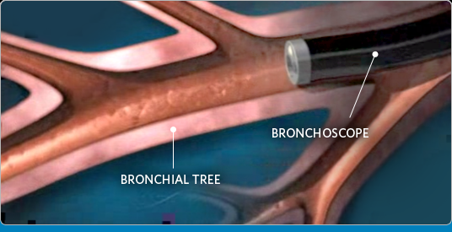
- The bronchoscope is then navigated to the first target treatment site, typically the most distal airway in the targeted lobe.
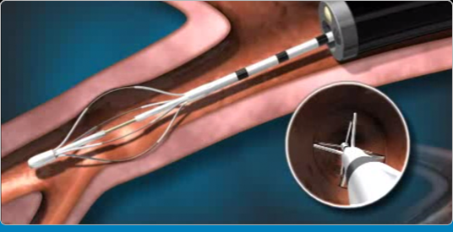
- Once the catheter is positioned at the desired location of the airway, the electrode array at the tip of the catheter is expanded to contact the airway wall. The radiofrequency (RF) controller is activated to deliver RF energy through the catheter to the patient's airway wall
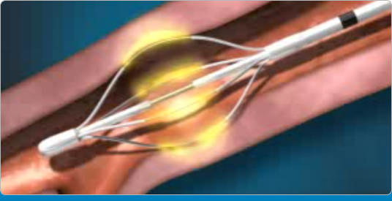
Please note: No significant heat is generated during the procedure; the colour yellow in the illustration above is for purpose of demonstration only
- Once the catheter is in the site to be treated, the 4-electrode array is expanded until the 4 wires are in firm contact with the airway wall circumferentially.

- The bronchoscopist initiates the delivery of RF energy through a footswitch. The energy heats the wall of a portion of the airways in a controlled manner. The delivery of energy uses continuous feedback to tightly control the degree and time of tissue heating to decrease ASM mass without airway perforation or stenosis: 65°C for 10 seconds per activation.
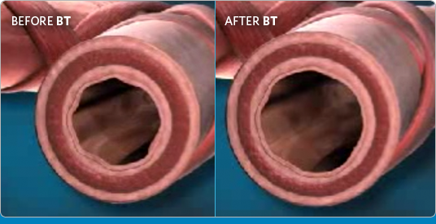
- The application of heat to the airway wall is intended to reduce the amount of excessive airway smooth muscle present in the airways and limit its ability to constrict and narrow the airway.
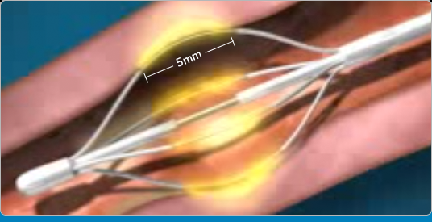
Please note: No significant heat is generated during the procedure; the colour yellow in the illustration above is for purpose of demonstration only

- A single activation of the catheter delivers RF energy over a distance of 5 mm (the length of the exposed electrodes within the electrode array). Audible and visual cues from the RF Controller signify proper delivery of RF energy.

- After each activation, the catheter is repositioned and subsequent activations are performed contiguously (adjacent but not overlapping) along the airway. This technique is used in all accessible airways distal to the mainstem bronchi and ≥ 3 mm in diameter.

- Each procedure usually requires 50-75 activations of the device to cover the targeted airways, as determined during treatment planning. The sites are treated meticulously and are recorded on a bronchial airway map to ensure that the treatment sites are not skipped or overlapped.

If the service is for investigative purposes, describe the technical specification of the health technology and any reference or “evidentiary” standard that has been established.
Not applicable
Indicate whether the service includes a registered trademark with characteristics that distinguish it from any other similar health technology.
The Alair® Bronchial Thermoplasty System developed by the applicant (Boston Scientific) is the only bronchial thermoplasty system currently listed on the ARTG. However, the applicant is supportive of a generic MBS item (not brand specific) for the bronchial thermoplasty service.

Indicate the proposed setting in which the proposed medical service will be delivered and include detail for each of the following as relevant: inpatient private hospital, inpatient public hospital, outpatient clinic, emergency department, consulting rooms, day surgery centre, residential aged care facility, patient’s home, laboratory. Where the proposed medical service will be provided in more than one setting, describe the rationale related to each.
It is proposed that bronchial thermoplasty will be delivered in the following settings:
- Inpatient private hospital
- Inpatient public hospital
Describe how the service is delivered in the clinical setting. This could include details such as frequency of use (per year), duration of use, limitations or restrictions on the medical service or provider, referral arrangements, professional experience required (e.g.: qualifications, training, accreditation etc.), healthcare resources, access issues (e.g.: demographics, facilities, equipment, location etc.).

Where is the procedure performed?
Bronchial thermoplasty is performed at inpatient facilities appropriately equipped to perform bronchoscopy (bronchoscopy/endoscopy suite) and equipped to handle respiratory emergencies. The expected number of facilities providing bronchial thermoplasty when the therapy is established in Australian clinical practice has been outlined previously in Section 3.
Like many other flexible endoscopy procedures, bronchial thermoplasty is conducted under moderate sedation or light general anaesthesia. Post-procedure, patients are observed and monitored for approximately 2-4 hours. There may be a transient increase in the frequency and worsening of respiratory-related symptoms immediately following bronchial thermoplasty. These events typically occur within one day of the procedure and resolve within seven days, on average, with standard care.
An overnight hospital stay may be appropriate in the event of worsening asthma symptoms after the procedure.

How often is the procedure required?
Bronchial thermoplasty is performed in 3 outpatient visits, each scheduled approximately 3 weeks apart. Dividing the treatment into 3 bronchoscopy sessions minimises the risk of inducing an asthma exacerbation or diffuse airway oedema. This also avoids excessive procedural length; a bronchial thermoplasty procedure takes about 45 to 60 minutes, compared to a standard bronchoscopy, which takes 10 to 20 minutes.
After all 3 procedures are performed the treatment is complete; the course of treatment is intended as a single, once per lifetime treatment and is not repeated.

Who performs the procedure?
Bronchial thermoplasty should only be performed by pulmonologists experienced in bronchoscopy. Currently, the required bronchial thermoplasty training in the specific use of the Alair® Bronchial Thermoplasty System is provided by the applicant, and includes:
- Review of Alair System Catheter Directions for Use and Controller Operator’s Manual
- Guided didactic instruction in computer simulation-based Bronchial Thermoplasty Learning Centre
- Detailed in-service training of the Alair® System
- Hands-on training with Alair® System in a lung model prior to initial cases
- Proctoring of initial cases by Boston Scientific Health Care Industry Representative (HCIR)
- Ongoing support of cases when requested
Physicians undergo training through an accredited programme of Alair® delivery with Boston Scientific (the applicant) under the supervision of a qualified proctor. Training is provided free of charge. The service should only be provided by an interventional pulmonologist or a respiratory physician.
The current and expected numbers of facilities providing bronchial thermoplasty and trained physicians performing the procedure has been outlined previously in Section 3.

Periprocedural care of patients
Patients selected for bronchial thermoplasty should be monitored by a medical team (including a pulmonologist or an experienced bronchoscopist).
To be eligible for bronchial thermoplasty a patient must have stable asthma symptoms without an increase in rescue inhaler usage and no recent exacerbations or infections in the 4 weeks preceding the procedure. If a patient meets these criteria, he or she should receive prednisone at 50 mg/d for the 3 days before the procedure, the day of the procedure, and the day after the procedure to minimise inflammation after bronchial thermoplasty. On the day of the procedure, the patient’s post-bronchodilator forced expiratory volume in 1 second (FEV1) should be within 10% of his or her documented baseline and oxygen saturation should be greater than 90%.
Bronchial thermoplasty should only be performed in patients who are safely able to undergo bronchoscopy. The procedure should be postponed if any of the following conditions are present:
- Active respiratory infection
- Asthma exacerbation or changing dose of systemic corticosteroids (up or down) in the past 14 days
- Known coagulopathy
- Patient is unable to stop taking anticoagulants, antiplatelet agents, aspirin, or non-steroidal anti-inflammatory medications (NSAIDS) before the procedure with physician guidance
Before the procedure, patients should receive a short-acting bronchodilator and an anti-sialagogue, typically atropine (0.4–0.6 mg IV/IM) or glycopyrrolate (0.2–0.4 mg IV/IM). Albuterol or another SABA should be administered by a nebuliser (2.5–5.0 mg) or by metered-dose inhaler (4–8 puffs). A topical anesthetic should be used to numb the posterior pharynx and larynx before the procedure according to institutional practice.
Moderate sedation should be used during the procedure according to institutional guidelines. Some physicians may perform bronchial thermoplasty under general anaesthesia. The amount of sedation given during bronchial thermoplasty can often be much higher than during typical bronchoscopy due to the fact that the procedure lasts longer (approximately 45-60 minutes compared to 10-20 minutes). During the procedure, topical anaesthesia is required to suppress the cough reflex. The decision for managing the airway during bronchial thermoplasty is based on the preference of the bronchoscopist; typically, 3 aliquots of 2 mL 1% lidocaine at the level of the vocal cords, followed by 2 mL aliquots of 1% lidocaine along the trachea, on the carina, and down each main stem bronchus. Additional 2 mL aliquots of 1% lidocaine are used as needed during the procedure to anesthetise treated airways.
Following the bronchial thermoplasty treatment, the patient should be monitored similar to other bronchoscopy procedures (patient should be observed for 3-4 hours before discharge). The patient can be discharged to home the same day if breathing, heart rate, blood pressure, level of oxygen in the blood, and lung function tests are near normal levels.
Before proceeding with the second and third sessions, a follow up appointment should be made to assess the patient’s level of asthma control.
Once the course of treatment (3 sessions) is complete, another procedure is not necessary.

Co-dependent information (if not a co-dependent application go to Section 6)
Please provide detail of the co-dependent nature of this service as applicable.
Not applicable

Comparator – clinical claim for the proposed medical service
Please provide details of how the proposed service is expected to be used, for example is it to replace or substitute a current practice; in addition to, or to augment current practice.
The availability of bronchial thermoplasty is not anticipated to change the management of asthma patients in terms of use of existing inhaled asthma medications (i.e., ICS, LABA, SABA). Bronchial thermoplasty is not intended to replace these therapies.
If listed, bronchial thermoplasty will potentially provide an alternative treatment option for patients with severe uncontrolled asthma, who currently receive maintenance treatment with oral corticosteroids (MOCS), and/or (in allergic asthma only) omalizumab, and/or best supportive care (BSC), which is in addition to their existing high dose inhaled asthma medications (See Figure 7 and Figure 8 in Section 9 for more information).
Currently, MOCS therapy represents the only effective add-on treatment option for patients with a confirmed diagnosis of uncontrolled severe non-allergic asthma and the first-line add-on treatment option for patients diagnosed with uncontrolled severe allergic asthma. However, prolonged treatment with OCS is associated with significant dose-response related morbidities, such as osteoporosis, diabetes/hyperglycemia, cardiovascular disease, cardiovascular events, cerebrovascular events, cataracts, ocular hypertension and glaucoma (Manson et al, 2009), which limits their use. Bronchial thermoplasty is considered to represent an effective and, in the long term, a much safer alternative treatment option to MOCS in both uncontrolled severe allergic and non-allergic asthma.
In patients with uncontrolled severe non-allergic asthma who are intolerant or contra-indicated to OCS or are corticosteroid resistant, best supportive care is the only treatment option in addition to their existing inhaled asthma medications. Bronchial thermoplasty therefore represents an effective further treatment option for these patients.
Omalizumab is a second-line add-on treatment option for patients with uncontrolled severe allergic asthma after trial on MOCS. Bronchial thermoplasty potentially represents an effective alternative to omalizumab in these patients.
[Note: Bronchial thermoplasty will not be considered as an add-on therapy to omalizumab reimbursed on the PBS, because patients not responding adequately to omalizumab do not continue to receive this therapy on the PBS.]

Expected health outcomes relating to the medical service
Identify the expected patient-relevant health outcomes if the service is recommended for public funding, including primary effectiveness (improvement in function, relief of pain) and secondary effectiveness (length of hospital stays, time to return to daily activities).
If bronchial thermoplasty is recommended for public funding, the expected patient-relevant benefits include:
- A reduction in asthma exacerbations
- A reduction in emergency department visits
- A reduction in hospitalisations
- Improved health-related quality of life
- Prevention of the decline in lung function
- Change in medication usage
As explained previously, the availability of bronchial thermoplasty as a publicly funded service is not anticipated to change the management of asthma patients in terms of use of existing inhaled asthma medications (i.e., ICS, LABA, SABA). However, the SBA will present evidence to demonstrate there may be a reduction in MOCS and reliever medications following the bronchial thermoplasty procedure.
Describe any potential risks to the patient.
There may be a transient increase in the frequency and worsening of respiratory-related symptoms immediately following bronchial thermoplasty. These events typically occur within one day of the procedure and resolve within seven days, on average, with standard care.
A long-term (5 year) follow-up of patients in the AIR2 trial has shown essentially no changes in the rate of respiratory events of patients post bronchial thermoplasty compared to untreated patients; and FEV1 and forced vital capacity remain stable.
Currently, there are no studies evaluating the histological changes in the airways after bronchial thermoplasty in humans with severe asthma. Post-treatment alterations in airway smooth muscles, inflammation, and potential effects on distal airways in asthmatics remain uncharacterised. It is worth noting however, that the AIR2 follow-up at 5 years showed no structural changes due to bronchial thermoplasty in high resolution computed tomography (CT) scans (Weschler et al, 2013).
Specify the type of economic evaluation.
In brief, it is anticipated that cost-utility analysis will be the appropriate economic evaluation against each of the relevant comparators.
Based on the anticipated clinical claims, the appropriate economic evaluations, dependent on comparator and patient population, are summarised in Table 3.
The potential comparators to bronchial thermoplasty in different severe uncontrolled asthma patient populations and anticipated clinical claims are also summarised.
In brief, it is anticipated the SBA will make the following claims for bronchial thermoplasty relative to each of the comparators:
- non-inferior efficacy in the long-term (on the basis that continuous MOCS therapy cannot be sustained) and superior safety to MOCS with overall net clinical benefit
- superior efficacy and non-inferior safety (in the longer term) to best supportive care
- the efficacy claim against omalizumab is potentially one of non-inferiority. However, it is anticipated the SBA will propose superior safety (in the longer term) to omalizumab.
For each of the comparators a claim of “net clinical benefit” (after accounting for both safety and efficacy claims) is anticipated meaning cost-utility analysis is the appropriate form of economic evaluation.
Table 3 Summary of anticipated clinical claims for bronchial thermoplasty relative to potential comparators, and appropriate economic evaluations
Population | Severe uncontrolled asthma
 | Non-Allergic |  | Allergic
 | First-line | Second-line (failed or contra-indicated to MOCS) | First-line | Second-line (failed or contra-indicated to MOCS) | Third-line (failed OM)
Comparator | MOCS | BSC | MOCS | OM | BSC
Anticipated efficacy claim for BT | Non-inferior to MOCS in the long-term | Superior to BSC | Non-inferior to MOCS in the long-term | Non-inferior to OM | Superior to BSC
Anticipated safety claim for BT | Superior to MOCS | Inferior (short term)  Non-inferior (longer-term) | Superior to MOCS | Inferior (short term)  Superior (longer-term) | Inferior (short term)  Non-inferior (longer-term)
Overall therapeutic claim for BT | Net clinical benefit | Net clinical benefit | Net clinical benefit | Net clinical benefit | Net clinical benefit
Appropriate economic evaluation | Cost utility analysis | Cost utility analysis | Cost utility analysis | Cost utility analysis | Cost utility analysis
BSC, best supportive care; BT, bronchial thermoplasty; MOCS, maintenance treatment with oral corticosteroids; OM, omalizumab
Please note: the “Line” of treatment in the above table refers to the order of treatment received as an uncontrolled asthma patient. That is, it is not inclusive of all lines of treatment received to reach this point in the clinical management algorithm for asthma.

Fee for the proposed medical service
Explain the type of funding proposed for this service.
The MBS fee will reflect the physician time performing the procedure (together with relevant pre and post operative consultations). Other costs of the procedure are accrued by the private hospital.
The existing MBS 41892 item code for ‘BRONCHOSCOPY with 1 or more endobronchial biopsies or other diagnostic or therapeutic procedures’ reflects neither the complexity nor the duration of the bronchial thermoplasty procedure and is insufficient to cover the total cost of the specialist’s time.
The SBA will also identify existing MBS listed bronchoscopy procedures of a similar complexity and duration to bronchial thermoplasty and use them as benchmarks to derive an appropriate MBS item fee for bronchial thermoplasty.
Please indicate the direct cost of any equipment or resources that are used with the service relevant to this application, as appropriate.
Capital costs
- The cost of a bronchial thermoplasty generator and radiofrequency controller will be included in the economic evaluation of the SBA.
Consumable costs
- The cost of a bronchial thermoplasty catheter will be included in the economic evaluation of the SBA.
Professional time
- This is the MBS item number being requested. That is, the fee charged by the treating physician to perform the bronchial thermoplasty procedure.
- Initial (MBS item 104) and follow up (MBS item 105) specialist consultations will be required.
Anaesthetist
- Not all procedures will require the presence of an anaesthetist. However, the proposed MBS item descriptor will allow for concomitant billing of Anaesthesia services.
Assistants
- The procedure does not require professional physician assistance.
Hospital admission and theatre costs
- These costs will incorporate theatre nurses and other resources utilised by the patient during the hospital admission for the procedure (e.g., pre procedural work-up).
Concomitant medications
- Peri and post procedural oral steroids and other work-up (see Section 4 for more detail).

All costs and resource use (medical services, hospital services, equipment, medications) will be analysed in the submission based assessment.
Provide details of the proposed fee.
An appropriate MBS fee will be derived through the submission based assessment.
An appropriate MBS item fee applied to each of the three sessions of bronchial thermoplasty will be benchmarked against existing MBS listed bronchoscopy procedures and will reflect the relative complexity and duration of the procedure.
For example, an expert advisory board for bronchial thermoplasty, consisting of Australian respiratory medicine specialists, suggest the cost of the bronchial thermoplasty procedure would be better reflected by a fee 4 times that reimbursed by MBS item 41892 or twice that of MBS item 30710, that is to say ~$1000.

Clinical Management Algorithm - clinical place for the proposed intervention
Provide a clinical management algorithm (e.g.: flowchart) explaining the current approach (see (6) Comparator section) to management and any downstream services (aftercare) of the eligible population/s in the absence of public funding for the service proposed preferably with reference to existing clinical practice guidelines.
The process of identification of patients with severe uncontrolled asthma has already been described (see Section 3 and Figure 5). The current algorithm for the onward clinical management of these patients is shown in Figure 7. This algorithm is based on local and international guidelines for the treatment of severe asthma (NACA 2014; GINA 2014), taking into consideration the restricted use of omalizumab on the Pharmaceutical Benefits Schedule (PBS). Briefly, PBS funded omalizumab is available only to patients with uncontrolled severe allergic asthma meeting specified eligibility criteria including maintenance treatment with oral corticosteroid therapy (at least 10 mg per day prednisolone or equivalent) for at least 6 weeks, unless contra-indicated or not tolerated. For patients with uncontrolled severe non-allergic asthma, maintenance treatment with oral corticosteroid therapy is the only indicated medication option.
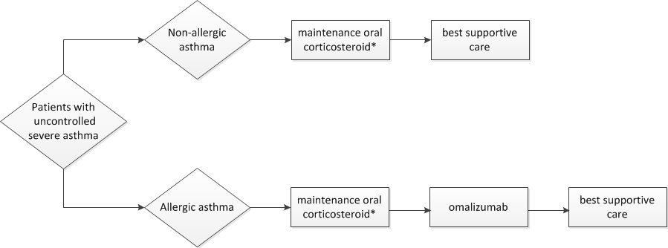
Figure 7 Current management of severe uncontrolled asthma in the absence of public funding for bronchial thermoplastyª.
*Patients contra-indicated, intolerant or resistant to maintenance oral corticosteroids pass on through to the next line of treatment. Current treatment options available to patients with uncontrolled include maintenance oral corticosteroids, omalizumab (allergic asthma only) and best supportive care.
ªUncontrolled severe asthma is defined as asthma symptoms not well controlled despite to optimised asthma therapy that includes maximal inhaled therapy, including ICS (budesonide 1600 μg/day or fluticasone 1000 μg/day or equivalent), plus LABA (at least salmeterol 50 μg bid or eformoterol 12 μg bid or equivalent), after ruling out non-asthma related causes, avoidable aggravating factors, poor medication compliance and bad inhaler technique (see Figure 5).

Provide a clinical management algorithm (e.g.: flowchart) explaining the expected management and any downstream services (aftercare) of the eligible population/s if public funding is recommended for the service proposed.
Figure 8 shows the algorithm on the onward clinical management of patients should bronchial thermoplasty be reimbursed on the MBS. This figure clearly identifies maintenance treatment with oral corticosteroids, omalizumab and best supportive care as three potentially relevant comparators to bronchial thermoplasty, depending on progression through the algorithm. Note: the algorithm does not preclude the possibility that patients undergoing bronchial thermoplasty instead of receiving omalizumab may subsequently receive MOCS.

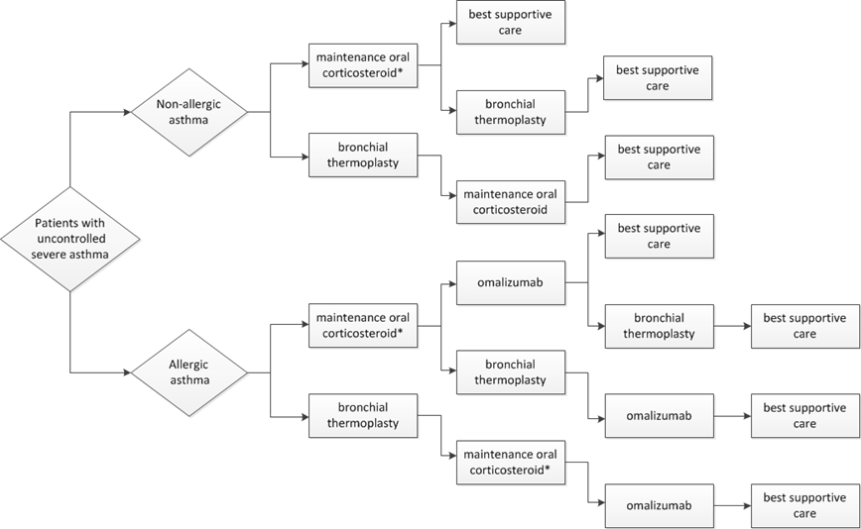
Figure 8 Possible clinical management algorithm for severe uncontrolled asthma if public funding is recommended for bronchial thermoplasty^{a,b,c}
*Patients contra-indicated, intolerant or resistant to maintenance oral corticosteroids pass on through to the next line of treatment
ªUncontrolled severe asthma is defined as asthma symptoms not well controlled despite optimised asthma therapy that includes maximal inhaled therapy, including ICS (budesonide 1600 μg/day or fluticasone 1000 μg/day or equivalent), plus LABA (at least salmeterol 50 μg bid or eformoterol 12 μg bid or equivalent), after ruling out non-asthma related causes, avoidable aggravating factors, poor medication compliance and bad inhaler technique (see Figure 4).b or MOCS.
^{b}The algorithm does not preclude the possibility that patients undergoing bronchial thermoplasty instead of receiving omalizumab may subsequently receive maintenance oral corticosteroid therapy (MOCS)
^{c}Branch points in the algorithm show where bronchial thermoplasty offers an alternative treatment option, thereby identifying the potential comparators to bronchial thermoplasty as MOCS, omalizumab (allergic asthma only) and best supportive care, depending on progression through the algorithm

It is important to note the proposed position in the algorithm that includes bronchial thermoplasty is broadly consistent with the recent recommendation issued by the ACCP/CHEST (CHEST, 2014) and the updated evidence report on prevention and management of asthma issued by the Global Initiative for Asthma (GINA, 2014).

Regulatory Information
Please provide details of the regulatory status. Noting that regulatory listing must be finalised before MSAC consideration.
The Alair® Bronchial Thermoplasty System is included on the Australian Register of Therapeutic Goods (ARTG).
The Alair® Bronchial Thermoplasty system consists of 2 major components: the Alair® Radiofrequency Controller (ARTG 197304) and the Alair® Catheter (ARTG 197491). The Alair® power supply (ARTG 197081) comprises the power cord and footswitch that connects the Alair Radiofrequency Controller to the main power supply.
The Therapeutic Goods Administration (TGA) approved indication for the Alair® Bronchial Thermoplasty System is for the treatment of asthma in patients 18 years and older (the scope of the application for bronchial thermoplasty is therefore confined to adult asthma patients only).
No other items are ARTG registered with this indication.

Decision analytic
Provide a summary of the PICO as well as the health care resource of the comparison/s that will be assessed, define the research questions and inform the analysis of evidence for consideration by MSAC (as outlined in
Table 4).

Table 4 Summary of PICO to define research question
PICO | Comments
Patients  Adult patients (at least 18 years old) with severe asthma whose asthma symptoms are not well controlled despite optimised asthma therapy (OAT) | - OAT in these patients includes adherence to maximal inhaled therapy.  - Maximal inhaled therapy includes a high dose of an inhaled corticosteroid (budesonide 1600 μg/day or fluticasone 1000 μg/day or equivalent) plus a long-acting beta2 agonist ([at least salmeterol 50 μg bid or eformoterol 12 μg bid or equivalent).  - Confirmation required that asthma symptoms are not due to comorbidities, persistent environmental exposures, psychological factors, poor medication compliance and bad inhaler technique.  - Consistent with the clinical trial evidence base (AIR2, RISA)
Intervention  Bronchial thermoplasty | Complete course of treatment comprises 3 procedures  The course of treatment is intended as a single, once per lifetime treatment
Comparators  - MOCS  - Omalizumab (allergic asthma patients only)  - Best supportive care alone | - Omalizumab is PBS funded for uncontrolled severe allergic asthma
Outcomes
- Asthma exacerbations
- Lung function
- Emergency department visits
- Hospitalisations
- Medication usage
- Other healthcare resource use
- Health related quality of life
- Lost productivity (work absenteeism)
- Proportion of patients completing the complete course of bronchial thermoplasty (i.e., three sessions)
- Safety outcomes

MOSC, maintenance treatment with oral corticosteroids; OAT, optimised asthma therapy; PBS, Pharmaceutical Benefits Schedule

Healthcare resources
Using Table 5 provide a list of the health care resources whose utilisation is likely to be impacted should the proposed intervention be made available as requested whether the utilisation of the resource will be impacted due to differences in outcomes or due to availability of the proposed intervention itself.
See below.

Questions for public funding
Please list questions relating to the safety, effectiveness and cost-effectiveness of the service / intervention relevant to this application, for example:
• Which health / medical professionals provide the service
• Are there training and qualification requirements
• Are there accreditation requirements
- What proportion of the Australian adult population fit the definition of uncontrolled severe asthma? Of these:
  - What proportion currently receives MOCS?
  - What proportion currently receives omalizumab?
  - What proportion currently receives best supportive care only?
  - Of these, how many would be eligible for the proposed service?

- What is the efficacy of bronchial thermoplasty, compared to each comparator?
  - What is the evidence for sustained efficacy of bronchial thermoplasty relative to each comparator?

- What is the safety of bronchial thermoplasty, compared to the comparator?
  - What is the short term safety of bronchial thermoplasty relative to each comparator?
  - What is the evidence for the long term safety of bronchial thermoplasty relative to each comparator?

- How exchangeable are the outcomes in the evidence base for the bronchial thermoplasty with those for each comparator?

- How generalisable are the outcomes in the evidence base for the bronchial thermoplasty to each of the populations targeted for the proposed service on the MBS

- What is the cost effectiveness of bronchial thermoplasty, compared to each comparator?

Table 5 List of resources to be considered in the economic analysis
 | Provider of resource | Setting in which resource is provided | Proportion of patients receiving resource | Number of units of resource per relevant time horizon per patient receiving resource | Disaggregated unit cost
 |  |  |  |  | MBS | Safety nets* | Other government budget | Private health insurer | Patient | Total cost
Resources provided to identify eligible population
None over and above current standard practice ª
Resources provided to deliver proposed intervention (See Section 4 above for more information)
Bronchoscopist ª | Consultant Physician | Outpatient/Private rooms | 85% | up to 3 | MBS 105/104
Capital costs (ALAIR generator) | Private Hospital | Private Hospital | 100% | N/A
Consumable costs (ALAIR Catheter) | Private Hospital | Private Hospital | 100% | up to 3 |  |  |  | TBD
Professional time | Consultant Physician | Private Hospital | 100% | up to 3 | Proposed MBS fee of approx. $1,000
Anaesthetist | Anaesthetist | Private Hospital | TBD | TBD
Hospital admission and theatre costs | Private Hospital | Private Hospital | 100% |  |  |  |  | AR-DRG casemix
Concomitant medications | PBS | Outpatient and Private Hospital | 100% | See Section 4 |  |  | <$100  (PBS) |  |  | <$100  (PBS)
Resources provided in association with proposed intervention
Included above
Resources provided to deliver comparator 1: BSC
Asthma drugs
Resources provided to deliver comparator 2: OMALIZUMAB
Asthma drugs, specifically omalizumab
Resources provided to deliver comparator 3: Maintenance oral corticosteroids
Asthma drugs, specifically prednisolone
Resources provided in association with comparators 1, 2 and 3 (and proposed intervention)
Ongoing asthma management, including GP and specialists consultations, A&E visits, hospitalisations as required (likely to vary according to outcomes achieved)
Resources used to manage patients successfully treated with the proposed intervention
Ongoing asthma management, including GP and specialists consultations, A&E visits, hospitalisations as required (likely to vary according to outcomes achieved)
Resources used to manage patients who are unsuccessfully treated with the proposed intervention
Ongoing asthma management, including GP and specialists consultations, A&E visits, hospitalisations as required (likely to vary according to outcomes achieved)
Resources used to manage patients successfully treated with comparators 1, 2 and 3 (and proposed intervention)
Ongoing asthma management, including GP and specialists consultations, A&E visits, hospitalisations as required (likely to vary according to outcomes achieved)
Resources used to manage patients who are unsuccessfully treated comparators 1, 2 and 3 (and proposed intervention)
Ongoing asthma management, including GP and specialists consultations, A&E visits, hospitalisations as required (likely to vary according to outcomes achieved)
* Include costs relating to both the standard and extended safety net.
ª A bronchoscopist would be required in the work up and monitoring of the patient pre-procedure as well as at the procedure

References
Australian Bureau of Statistics (ABS) 3101.0 - Australian Demographic Statistics; March 2013. Table 59 http://www.abs.gov.au/AUSSTATS/abs@.nsf/DetailsPage/3101.0Mar%202013?OpenDocument (Accessed 14/05/2014)
Australian Centre for Asthma Monitoring (ACAM). Asthma in Australia 2011. AIHW Asthma Series no. 4. Cat. no. ACM 22. Canberra: AIHW.
http://www.aihw.gov.au/publication-detail/?id=10737420159 (Accessed 14/05/2014)
Authoritative information and statistics to promote better health and wellbeing (AIHW). Asthma. http://www.aihw.gov.au/asthma (Accessed 14/05/2014)
Benayoun L, Druilhe A, Dombret MC, Aubier M, Pretolani M. Airway structural alterations selectively associated with severe asthma .Am J Respir Crit Care Med. 2003 May 15; 167(10):1360-8.
Barnes PJ and Woolcock AJ. Difficult asthma. Eur Respir J 1998; 12: 1209–1218.
Bleecker EJ and Davis TH.. The Epidemiology of Severe Asthma: The TENOR Study and SARP (NIH). An Update on Severe Asthma. World Allergy Forum: Barcelona, Spain. 2008. http://www.worldallergy.org/educational_programs/world_allergy_forum/barcelona2008/bleecker.php (Accessed 14/05/2014)
Brown RH, Wizeman Z, Danek C, Mitzner W. Effect of bronchial thermoplasty on airway distensibility. Eur Respir J 2005a; 26: 277–282.
Brown RH, Wizeman Z, Danek C, Mitzner W. In vivo evaluation of the effectiveness of bronchial thermoplasty with computed tomography. J Appl Physiol. 2005b; 98: 1603–1606,
Castro M, Rubin SA, Laviolette M et al. Effectiveness and Safety of Bronchial Thermoplasty in the Treatment of Severe Asthma. A Multicenter, Randomized, Double-Blind, Sham-Controlled Clinical Trial. Am J Respir Crit Care Med. 2010. Vol 181. pp 116–124.
The American College of Chest Physicians (ACCP/CHEST). Position Statement for Coverage and Payment for Bronchial Thermoplasty. 2014. http://www.chestnet.org/Guidelines-and-Resources/Payment-Practice-and-Quality/Coding-Regulations-and-Reimbursement/Regulations-and-Reimbursement. (Accessed 19/05/2014)
H. Chen, P.D. Blanc, M.L. Hayden, E.R. Bleecker, A. Chawla, J.H. Lee, TENOR Study Group. Assessing productivity loss and activity impairment in severe or difficult-to-treat asthma. Value Health, 11 (2008), pp. 231–239
Cox G, Thomspn NC, Rubin SA et al. Asthma Control during the Year after Bronchial Thermoplasty. N Engl J Med 2007;356:1327-37.
Cox G, Miller JD, McWilliams A et al. Bronchial Thermoplasty for Asthma. Am J Respir Crit Care Med. 2006. Vol 173. pp 965–969.
Cox PG, Miller J, Mitzner W, Leff AR. Radiofrequency ablation of airway smooth muscle for sustained treatment of asthma: preliminary investigations. Eur Respir J. 2004 Oct;24(4):659-63.
Danek CJ, Lonbard CM, Dungworth DL et al Reduction in airway hyperresponsiveness to methacholine by the application. Appl Physiol. 2004. 97: 1946–1953,
Global Initiative for Asthma (GINA). Global strategy for asthma management and prevention. Revised 2014. http://www.ginasthma.org/documents/4 (Accessed 20/05/2014).

Miller JD. A prospective feasibility study of bronchial thermoplasty in the human airway. Chest. 2005; 127 (6):1999–2006
Moore WC, Bleecker ER, Curran-Everett D et al. Characterization of the severe asthma phenotype by the National Heart, Lung, and Blood Institute’s Severe Asthma Research Program. J. Allergy Clin Immunol. 2007 Feb;119(2):405-13
National Asthma Council Australia (NACA). Australian Asthma Handbook. http://www.asthmahandbook.org.au/ (Accessed 14/05/2014)
Partridge MR. Examining the unmet need in adults with severe asthma. Eur Respir Rev 2007; 16: 104, 67–72.
Pavord ID1, Cox G, Thomson NC, Rubin AS, Corris PA, Niven RM, Chung KF, Laviolette M; RISA Trial Study Group. Safety and efficacy of bronchial thermoplasty in symptomatic, severe asthma. Am J Respir Crit Care Med. 2007 Dec 15;176(12):1185-91. Epub 2007 Sep 27.
Peters SP, Ferguson G, Deniz Y et al Uncontrolled asthma: A review of the prevalence, disease burden and options for treatment. Respiratory Medicine. 2006. 100, 1139–1151
Rabe K. Severe asthma - determinants and treatment. An Update on Severe Asthma. World Allergy Forum: Barcelona, Spain. 2008. http://www.worldallergy.org/educational_programs/world_allergy_forum/barcelona2008/rabe.php (Accessed 14/05/2014)
Rabe KF, Adachi M, Lai CKW et al. Worldwide severity and control of asthma in children and adults: The global Asthma Insights and Reality surveys. J Allergy Clin Immunol 2004;114:40-7.)
Robinson DS, Campbell DA, Durham SR et al. Systematic assessment of difficult-to-treat asthma. Eur Respir J 2003; 22: 478–483
Torrego A, Solà I, Munoz AM, Roqué i Figuls M, Yepes-Nuñez JJ, Alonso-Coello P, Plaza V. Bronchial thermoplasty for moderate or severe persistent asthma in adults. Cochrane Database of Systematic Reviews 2014, Issue 3.
Wechsler ME, Laviolette M, Rubin AS et al. Bronchial thermoplasty: Long-term safety and effectiveness in patients with severe persistent asthma. J Allergy Clin Immunol. 2013 Dec;132(6):1295-302. doi: 10.1016/j.jaci.2013.08.009. Epub 2013 Aug 30.
Woodruff, PG, Dolglanov GM, Ferrando RE et al. Hyperplasia of smooth muscle in mild to moderate asthma without changes in cell size or gene expression. Am J Respir Crit Care Med. 2004. 169:1001-1006.

