Public Summary Document
Application No. 1544 – Genome-wide microarray testing for people with multiple myeloma and chronic lymphocytic leukaemia
Applicant: The Royal College of Pathologists of Australasia (RCPA)
Date of MSAC consideration: MSAC 77th Meeting, 28-29 November 2019
Context for decision: MSAC makes its advice in accordance with its Terms of Reference, visit the MSAC website

Purpose of application
A proposal to extend the Medicare Benefits Schedule (MBS) listing of genome-wide microarray (GWMA) testing to include patients with multiple myeloma (MM) and chronic lymphocytic leukaemia (CLL), was referred from the Genetics Working Group of the MBS Reviews Taskforce. The RCPA agreed to act as applicant for this application.

MSAC’s advice to the Minister
After considering the strength of the available evidence in relation to comparative safety, clinical effectiveness and cost-effectiveness, MSAC supported MBS funding of genome-wide microarray testing (GWMA) for people with multiple myeloma (MM) and chronic lymphocytic leukaemia (CLL), because MSAC accepted that GWMA was superior to karyotyping.
For MM, MSAC supported the creation of a new MBS item for GWMA limited to one use per patient lifetime, acknowledging the complementary nature of this test with fluorescence in situ hybridisation (FISH), which MSAC had supported in August 2019.
For CLL, MSAC supported the modification of MBS item 73343 to allow either FISH or GWMA as alternatives, limited to testing no more frequently than one test per year, and accepting that the requested fee for GWMA also apply to FISH testing on the grounds that the current fee underestimates the cost of all the probes necessary for complete testing.
MSAC advised that implementation of this advice in relation to MBS item 73343 would need coordination via the PBAC to change the existing and recommended PBS restrictions for ibrutinib, idelalisib and venetoclax.
MSAC recommended that this item number be reviewed in two years, to ensure that all similar testing item numbers align with each other in terms of costing, testing frequency and technologies.
Consumer summary
The Genetics Working Group of the MBS Reviews Taskforce recommended extending public funding through the MBS for genetic testing in people with multiple myeloma (MM) and chronic lymphocytic leukaemia (CLL), which are cancers of blood cells. The test would be done by a method called genome-wide microarray testing (GWMA), which is a pathology laboratory tool used to analyse large numbers of genes at one time.
Some people with MM and CLL have certain genetic mutations. These people are often sicker than people who don’t have these mutations. People with MM and CLL can already get a genetic test called karyotyping through the MBS. Karyotyping can tell them if they have any of these mutations. However, karyotyping is a less accurate method, and GWMA can largely replace it. GWMA is faster and identifies more affected patients than karyotyping. Using GWMA means that people with CLL and MM will find out their results faster. For people with CLL, it means they might get a different treatment faster.
MSAC’s advice to the Commonwealth Minister for Health
MSAC supported public funding of GWMA testing for people with CLL or MM. This is because MSAC believes GWMA is a better and faster test than karyotyping.

Summary of consideration and rationale for MSAC’s advice
MSAC noted the purpose of the application was to extend the current genome-wide microarray (GWMA) genetic testing item 73292 to include analysis of two haematological malignancies – multiple myeloma (MM) and chronic lymphocytic leukaemia (CLL). MSAC accepted that GWMA is superior technology to karyotyping, and noted that GWMA testing has already replaced karyotyping in some jurisdictions. GWMA is faster (2-4 days turnaround time rather than 18 days for karyotyping), more accurate, detects more genetic variations, and has a lower failure rate than karyotyping. MSAC accepted that detecting chromosomal arrangements in CLL and MM has prognostic value; for CLL, testing also has predictive value in helping select appropriate treatment options.
MSAC noted the clinical algorithms for CLL and MM, and the significant out-of-pocket costs for patients currently undergoing genetic testing via GMWH or FISH (unless the patient has relapsed/refractory CLL). However, MSAC noted that the relevant part of Application 1526 has been supported and would cover the patient costs of FISH testing of patients with MM.
In relation to the results of the accuracy studies reported in Section 11, MSAC considered that the greater failure rate of karyotyping could not be disregarded in these analyses. In addition, MSAC considered that “karyotyping + FISH” could not be considered to be a reference standard, and thus that additional GWMA findings could not be considered to be false positive results. MSAC considered that the total count of copy number variation (CNVs) would have prognostic value for a patient with MM (and possibly CLL) beyond detecting whether the patient had any CNV. MSAC agreed with the Applicant that combining all GWMA types in these analyses resulted in the inclusion of GWMA techniques which have since been superseded as they were inferior to the techniques now used in Australia, which mostly involve single nucleotide polymorphism (SNP) GWMA.
MSAC noted the economic evaluation only included the cost of substituting karyotyping ± FISH for GWMA without any additional economic analysis of healthcare resource usage beyond the procedural item for re-biopsy in 4% of patients with MM, and considered this to be overly simplified. In addition, the cost-minimisation analysis excluded the cost of failed tests associated with karyotyping (60-80% failed culture rates), and did not consider the potential reduction in cost of FISH in MM. These omissions favoured the comparator. On balance, MSAC considered GWMA to have acceptable cost-effectiveness (relative to the comparator) and that the modelling uncertainties would not have a large impact on the budget estimates. MSAC therefore considered that the estimated budgetary impact was reasonable.
MSAC advised on the following issues for implementation:
- MSAC advised that GWMA should replace fluorescence in situ hybridisation (FISH) for CLL in many instances. MSAC considered that FISH testing for 17p deletion (del(17p)) in CLL would need to remain on the MBS until there was a transfer in technology to GWMA. In some cases, FISH may be required as back-up for samples with a low tumour percentage. Thus, GMWA would not immediately replace FISH for CLL. MSAC suggested that MBS item 73343 be modified to allow either FISH or GWMA as alternatives (i.e. technology agnostic) and limited to testing no more frequently than one test per year. MSAC accepted the requested fee for GWMA ($589.90) also apply to FISH testing on the grounds that the current fee ($230.95) underestimates the cost of all the probes necessary for complete testing. MSAC advised that these probes should cover all the relevant targets identified for the most widely used FISH probe panel in CLL: (del(17p), del(11q), del(13q), and trisomy 12).
- However, MSAC noted that GWMA cannot replace FISH for patients with MM. Many patients with MM have balanced translocations, which cannot be detected by GWMA. Thus, FISH and GWMA will both be required for some MM testing until another technology(ies) can replace the need for FISH. MSAC advised that a new MBS item be created for GWMA testing in MM along the lines proposed in this application, but avoiding co-claiming with MBS items 73287 and 73829 as well as 73290. MSAC accepted the proposed fee of $589.90 and that testing should be limited to once per patient lifetime until further review. MSAC recalled that it had recently supported FISH for chromosome translocations t(4;14), t(14;16), t(14;20) and 1q gain and del(17p) in MM (see Application 1526), but recommended that the Department review this set of applications to ensure that publicly funded FISH testing in patients with MM has not been overlooked.
MSAC noted that implementation of its advice in relation to MBS item 73343 would need coordination via the PBAC to change the existing and recommended PBS restrictions for ibrutinib, idelalisib and venetoclax.
MSAC noted that patients with CLL or small lymphocytic lymphoma (SLL) with a tumour protein 53 (TP53) pathogenic variant carry a similar poor prognosis as patients with del(17p) (see Application 1560). The TP53 gene is located on chromosome 17p. Thus, TP53 function is lost in patients with del(17p), but patients may lose TP53 function even with an intact chromosome 17p due to other types of pathogenic variants. FISH can detect translocations and insertions/deletions, but is unable to detect other types of genetic variations. Immunoglobulin heavy chain (IGHV) hypermutation status is associated with a favourable prognosis for patients with CLL or SLL. However, MSAC advised that a separate application for TP53 and IGHV genetic testing be prepared to cover patients with CLL or SLL, as genetic sequencing is required to detect these pathogenic variants and so cannot be considered under the current application, which is for GWMA. There is also a need to consider the optimal timing of these test alternatives, noting the small incremental yield of the proposed additional testing.
MSAC noted that, due to technological advances in the future, some items would need close review to ensure that all funded tests are in line with each other in terms of rebate, frequency of testing and technology used. Therefore, MSAC recommended a review in two years of any items that arise from the following:
Application 1544 (GWMA for CLL and MM)
Application 1526 (FISH for translocations & deletions in MM)
Application 1560 (FISH for del(17p) in CLL or SLL)
any future applications for TP53 and IGHV testing for CLL or SLL.
MSAC also recommended contacting haematologists to determine a reduced testing frequency for FISH testing in patients with MM (currently once per year). As this test is prognostic only and does not allow access to treatment options, it is important that it not be overused. MSAC recommended contacting the associated professional colleges to communicate this information, and seek support for requesting FISH testing in patients with MM only once per lifetime, consistent with the MSAC advice for GWMA.

Background
This is the first application for GWMA testing for patients with MM and CLL. MSAC has not previously considered this application.
In 2017, the MBS Review Taskforce Genetics Working Group (GWG) of the Pathology Clinical Committee (PCC) requested advice from the MSAC Executive on extending access to GWMA testing to the following two additional populations beyond those currently specified in MBS item 73292. These are in antenatal testing, when invasive testing is undertaken to investigate a pregnancy where there are major fetal ultrasound abnormalities, in lieu of karyotyping; and for two specific chronic haematological malignancies, MM and CLL. In July 2017, the Department sought MSAC Executive’s agreement that an MSAC review of the proposed extension of access to 73292 was necessary, and that the appropriate assessment pathway was to be assessed by all MSAC committees.
The MSAC Executive agreed that MSAC consideration was appropriate. However, the MSAC Executive considered that the PICO was well defined with sufficient evidence of clinical utility, and that there was no requirement for consideration by PASC.
The Department, informed by members of the GWG and the HTA assessment group, subsequently recognised the need to divide the two additional populations into separate Applications (1533 and 1544), and develop a PICO for each patient group, which were submitted to PASC. This Application 1544 is for the haematological malignancy testing population.

Prerequisites to implementation of any funding advice
The critique stated that no prerequisites involving quality assurance programs were presented in the application. The National Pathology Accreditation Advisory Council (NPAAC) advised MSAC that an external quality assurance program (EQA) is available for the test.

Proposal for public funding
The MBS item descriptor proposed in the application is presented in Table 1.
Table 1 Proposed MBS item descriptor
Category 6 (Pathology Services) – Group P7 Genetics
Item number XXXXX
Analysis of chromosomes by genome-wide micro-array in diagnostic studies of a patient with multiple myeloma or chronic lymphocytic leukaemia (including a service in item 73290, if performed)
- 1 or more tests.
Fee: $589.90 Benefit: 75% = $442.45 85% = $506.50

Summary of public consultation feedback/consumer issues
Nil.

Proposed intervention’s place in clinical management

Multiple myeloma
The current and proposed clinical management algorithms are presented in Figure 1 and Figure 2, respectively. The application stated that the proposed algorithm uses GWMA and FISH testing once patients have been diagnosed with MM, rather than karyotyping and FISH (see outlined in red below).
The MM algorithm was based on European Society for Medical Oncology (ESMO), Myeloma Australia and guidelines published by Pugh and colleagues (2018) from a Cancer Genomics Consortium working group. As part of current treatment guidelines, cytogenetics analysis is to be conducted at initial diagnostic work-up with 3-12 monthly monitoring depending on a patient’s risk of progression to symptomatic MM. However, patients are not necessarily treated until they have symptomatic MM.
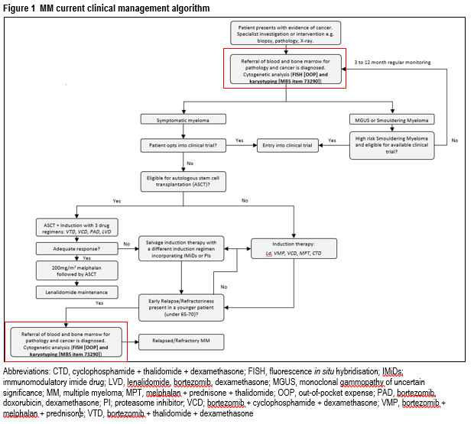

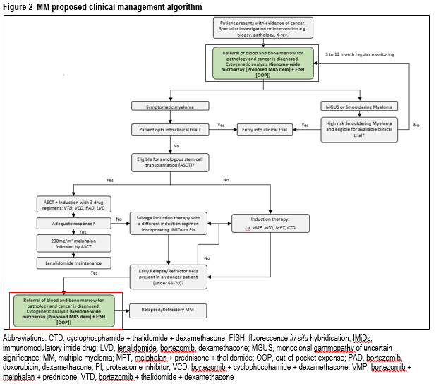
The clinical claim is that GWMA and FISH testing in MM compared to conventional karyotyping and FISH is likely to result in better prognostication for patients and/or identification of high-risk patients for which an alternative drug therapy is superior for overall survival.

Chronic lymphocytic leukaemia
The current and proposed clinical management algorithms are presented in Figure 3 and Figure 4, respectively. The proposed algorithm uses GWMA rather than karyotyping and FISH (see outlined in red below).The CLL algorithm was based on ESMO guidelines.
Patients with early stage or inactive disease are monitored for the progression of their disease and receive regular blood tests to determine if their disease has become active (i.e. a “wait and watch” approach). For those with active or advanced stage disease, del(17p) status and fitness levels are used to determine suitability of treatment with chemotherapy agents such as fludarabine or chlorambucil, immunotherapy agents such as rituximab or ibrutinib, or allogenic haematopoietic stem cell transplant. Ibrutinib is only currently PBS-subsidised for relapsing/remitting CLL in Australia.
GWMA occupies the same place in the clinical algorithm in MM as it does in CLL. However, FISH is not used with the microarray in CLL.
The detection of del(17p) by GWMA is intended to assess the patient’s prognosis from CLL and to allow patients to access PBS-subsidised medicines reserved for those with del(17p) – ibrutinib, idelalisib and venetoclax. While access to these medicines requires the detection of del(17p) by FISH for patients with relapsed/refractory disease, the detection of del(17p) by conventional karyotyping at initial diagnosis would nonetheless be prognostically informative.
In its pre-MSAC response, the Applicant stated the second red square in Figure 3 (for CLL) should state “Cytogenic analysis (FISH and karyotyping)” rather than “Cytogenic analysis (FISH [OOP] and karyotyping)”. In addition, the Applicant acknowledged that the outcome of Application 1560 17p deletion testing by fluorescence in situ hybridisation for access to ibrutinib in patients with previously untreated chronic lymphoid leukaemia or small lymphocytic lymphoma may affect the clinical algorithms for patients with CLL; however, until such time that this request is implemented, FISH testing remains an out-of-pocket expense.
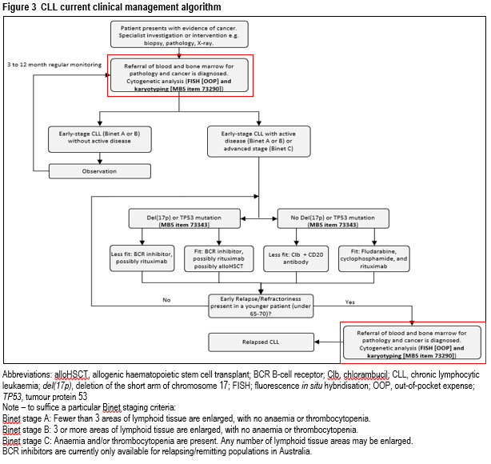In its pre-MSAC response, the Applicant stated the first red square in Figure 4 (for CLL) should state “Cytogenic analysis (genome-wide microarray and FISH [OOP])” and the second red box should read “Cytogenic analysis (genome-wide microarray and FISH [MBS item number 73343])”.
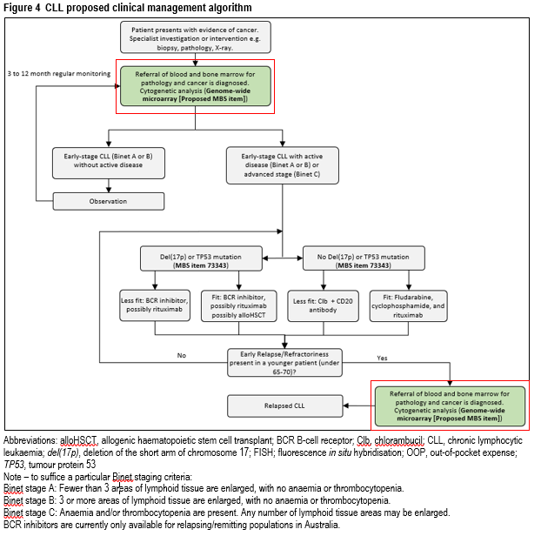
The clinical claim is that GWMA testing in CLL compared to conventional karyotyping and FISH is likely to result in better prognostication for patients and identification of high-risk patients for which an alternative drug therapy is superior for overall survival.

Comparator
The application’s nominated comparators for GWMA were conventional karyotyping and FISH testing. Both of these were reference standards nominated in the PICO confirmation. The application stated that GWMA would likely be employed with FISH testing for MM, but is likely to replace conventional karyotyping in diagnostic assessments in CLL.
However, in its pre-MSAC response, the Applicant stated FISH for del(17p) in CLL is still required. In addition, the Applicant stated that the description of karyotyping should be amended to more adequately reflect the limitations of this technique, in that karyotyping is able to detect trisomy, monosomy, larger deletions and duplications, large translocations and balanced translocations as well as larger genetic rearrangements.

Comparative safety
The assessment report stated that 19 studies were included in the evidence base, five studies for MM and 14 for CLL. The assessment report stated that the level of evidence for all studies used in analyses was very low and prone to a high risk of bias. Specifically, there was no direct evidence available to assess the comparative safety of GWMA testing compared to karyotyping and FISH, and in terms of unexpected prognosis, adverse events related to chemotherapy or targeted treatment.
Overall for both populations (MM, CLL), the assessment report stated that there are no additional safety issues arise relating to sample collection as GWMA testing is conducted on the same sample used for conventional karyotyping and FISH.

Comparative effectiveness
The assessment report assumed the reference standards used in the analysis were considered the gold standard: estimates of test accuracy are based on the assumption that theoretically the tests are 100% sensitive and specific. Any disagreements are assumed to be due to the incorrect classification by the index test. For one of the analyses, the reference standard comprised two tests (karyotyping + FISH). This resulted in a risk of verification and incorporation bias. The assessment report noted conventional karyotyping is an imperfect gold standard, which has low success rates in detecting patients with a copy number variation (CNV) and total count of CNV.
In its pre-MSAC response, the Applicant disagreed with the assumption for the reference standard, and considered the following statement to be key: “ideally the reference standard is the best available, clinically accepted, error free procedure to do so”.

Multiple myeloma

Accuracy
The results for detection of CNVs from individual studies (n=4) is presented in Figure 5 and from the assessment report’s pooled analysis is presented in Table 2. The assessment report stated that the small trial sizes (sample sizes of n < 50, were common) could likely overestimate the sensitivity and positive predictive value (PPV) of the intervention, and provide an inaccurate estimate of its specificity and negative predictive value (NPV).
Figure 5 Forest plot of sensitivity and specificity of genome wide microarray + FISH vs conventional karyotyping + FISH in multiple myeloma
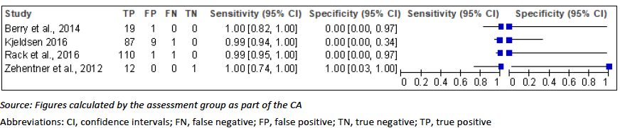
Note: not all patients in Zehentner et al., 2012 necessarily received both tests comprising the reference standard, thereby biasing results towards the index test.
In its pre-MSAC response, the Applicant stated that only Zehentner et al. 2012 (of the 5 studies for MM) reported on the use of a number of tests bacterial artificial chromosome (BAC) array-comparative genomic hybridisation (aCGH)/ oligonculeotid array-comparative genomic hybridisation (oaCGH)/ single nucleotide polymorphism (SNP).
Table 2 Summary statistics for genome-wide microarray + FISH compared to conventional karyotyping + FISH (reference standard) for patients with MM
Accuracy (k=4) | Index test  (n=242) | Comparator  (n=242)
Sensitivity, [95% CI] | 0.99 [0.97-1.00] | 1
Specificity, [95% CI] | 0.08 [0.002-0.38] | 1
Positive predictive value, [95% CI] | 0.95 [0.95-0.96] | 1
Negative predictive value, [95% CI] | 0.33 [0.05-0.84] | 1
Source: Table constructed for the assessment report.
Abbreviations: CI, confidence interval
Comparing GWMA to conventional karyotyping (without FISH), the assessment report noted GWMA detected 70.6% more patients with a CNV (98.0% vs. 27.4%).
In its pre-MSAC response, the Applicant stated that the majority of MM studies included in the application reported on the use of comparative genomic hybridisation (CGH) arrays, not SNP arrays (compared with karyotyping), which would be the test of choice in Australian laboratories. CGH array is an older technology which is being phased out.

Therapeutic efficacy (change in management)
The assessment report stated that no evidence was identified regarding therapeutic efficacy. Once a patient is diagnosed with MM they are not necessarily treated until they become symptomatic irrespective of the CNVs detected. Transplant still remains recommended first-line treatment. Therefore, the assessment report stated the impact of a false positive or false negative is minimal.

Therapeutic effectiveness (health benefit from change in management)
The assessment report stated that genome wide microarray could negate the current re-biopsy rate (4% in Kyle et al. 2003).
The assessment report stated that GWMA + FISH in MM is non-inferior to FISH + conventional karyotyping for the detection of CNVs in MM. (Hence, substituting conventional karyotyping with GWMA is unlikely to have an additional impact on patient prognosis and clinical outcomes). However, it could be inferred that that GWMA is superior to conventional karyotyping when FISH is not used.

Chronic lymphocytic leukaemia

Accuracy

Detection of CNVs
The results using conventional karyotyping + FISH as the reference standard from individual studies (n=6) is presented in Figure 6 and from the assessment report’s pooled analysis is presented in Table 3. The critique highlighted this was appropriate as GWMA was compared with FISH + conventional karyotyping in the CLL setting.
The assessment report stated the specificity of GWMA was lower than the sensitivity calculated for the detection of CNVs in patients with CLL. This can be attributed to the very few patients who did not have a CNV detected. The assessment report stated that the small trial sizes (sample sizes of n <50, were common) could likely overestimate the efficacy of the index test, and provide inaccurate estimate of the specificity.
Figure 6 Forest plot of sensitivity and specificity of genome-wide microarray compared to FISH and conventional karyotyping in CLL studies
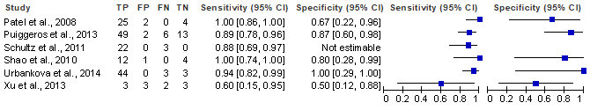
Source: Figure constructed for the assessment report.
Abbreviations: CI, confidence interval; FN, false negative; FP, false positive; TN, true negative; TP, true positive
Note, Xu et al 2013 had broad confidence intervals likely to the study’s small sample size.
Table 3 Summary statistics for genome-wide microarray compared to conventional karyotyping + FISH (reference standard) for patients with CLL
Accuracy (k=6) | Index test  (n=204) | Comparator  (n=204)
Sensitivity, [95% CI] | 0.92 [0.86-0.95] | 1
Specificity, [95% CI] | 0.77 [0.60-0.90] | 1
Positive predictive value, [95% CI] | 0.95 [0.91-0.97] | 1
Negative predictive value, [95% CI] | 0.66 [0.53-0.77] | 1
Source: Table constructed for the assessment report.
Abbreviations: CI, confidence interval

Detection of del(17p)/TP53
The results using conventional karyotyping as the reference standard from individual studies (n=2) is presented in Figure 7 and from the assessment report’s pooled analysis is presented in Table 4.
Figure 7 Forest plot of sensitivity and specificity of genome-wide microarray compared to conventional karyotyping in the detection of del(17p)/TP53 in CLL studies
Source: Figure constructed for the assessment report.
Abbreviations: CI, confidence interval; FN, false negative; FP, false positive; TN, true negative; TP, true positive
Table 4 Summary statistics for genome-wide microarray compared to conventional karyotyping (reference standard) for detecting del(17p)/TP53 for patients with CLL
Accuracy (k=2) | Index test  (n=153) | Comparator  (n=153)
Sensitivity, [95% CI] | 0.86 [0.57-0.98] | 1
Specificity, [95% CI] | 0.94 [0.88-0.97] | 1
Positive predictive value, [95% CI] | 0.57 [0.41-0.72] | 1
Negative predictive value, [95% CI] | 0.98 [0.95-0.99] | 1
Source: Table constructed for the assessment report.
Abbreviations: CI, confidence interval
Comparing GWMA to conventional karyotyping (without FISH), the assessment report noted GWMA detected 4.5% more patients with a del(17p) (13.7% vs. 9.2%).
The results using FISH as the reference standard from individual studies (n=2) is presented in Figure 8 and from the assessment report’s pooled analysis is presented in Table 5.
In its pre-MSAC response, the applicant noted the data for detection of CNVs in CLL and detection of del(17p)/TP53 in CLL is likely to have come from a CGH array and not an SNP-microarray (used widely in Australian laboratories) where the B allele frequency (BAF) of the SNPs can be used as an internal control to confidently make calls. SNP-microarrays should be stated as the preferred array choice as copy neutral loss of heterozygosity (cnLOH) and internal control is paramount. SNP-microarrays also identify triploidy and enable the alignment of data in complex hypo/hyper diploid samples. Clarification of the type of array used (CGH arrays or SNP-microarrays) should also be stated when discussing high false negative rates for del(17p)/TP53 in patients with CLL. The Applicant also highlighted how “Guidelines indicate SNP-microarrays should be sued for investigation of malignancies and not CGH arrays” (Rack et al. 2019; Schoumans et al. 2016). Of the 14 studies in CLL, only Zhang et al. 2011 compared the use of a SNP-array alone to FISH.
Figure 8 Forest plot of sensitivity and specificity of genome-wide microarray compared to FISH in the detection of del(17p)/TP53 in CLL studies
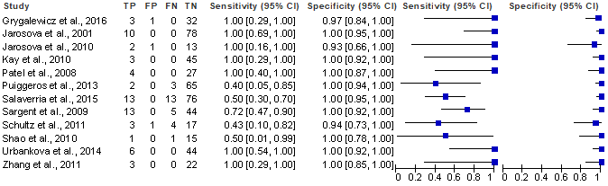
Source: Figure constructed for the assessment report.
Abbreviations: CI, confidence intervals; FN, false negative; FP, false positive; TN, true negative; TP, true positive
Table 5 Summary statistics for genome-wide microarray compared to FISH (reference standard) for detecting del(17p)/TP53 for patients with CLL
Accuracy (k=12) | Index test  (n=570) | Comparator  (n=570)
Sensitivity, [95% CI] | 0.71 [0.60-0.80] | 1
Specificity, [95% CI] | 0.99 [0.98-1.00] | 1
Positive predictive value, [95% CI] | 0.95 [0.87-0.98] | 1
Negative predictive value, [95% CI] | 0.95 [0.93-0.96] | 1
Source: Table constructed for the assessment report.
Abbreviations: CI, confidence interval
GWMA had a low PPV for the detection of del(17p)/TP53 against conventional karyotyping only (0.57 [0.41-0.72]). This is likely due to the high false positive rate of GWMA against conventional karyotyping. For other analyses (vs. FISH), a PPV of 95% or above was calculated.
In its pre-MSAC response, the Applicant stated GWMA will detect the abnormalities targeted by FISH including 17p deletions; however, in some circumstances (such as low tumour percentages), GWMA may be less sensitive than FISH.

Therapeutic efficacy (change in management)
No evidence was identified regarding therapeutic efficacy. Patients with early stage or inactive CLL are monitored for the progression of their disease and receive regular blood tests to determine if their disease has become active. Additionally, patient age and the presence or absence of del(17p) or TP53 pathogenic variants should then help direct treatment options.
The critique stated that patients with CLL with identified CNVs (in particular del(17p) or TP53 pathogenic variants) are eligible for reimbursed treatment with idelalisib, venetoclax or ibrutinib in the relapsed or refractory setting. Newly diagnosed, previously untreated patients with del(17p) are eligible for privately funded treatment with ibrutinib. Leakage associated with treatment decisions deviating from what is indicated by the test results is not anticipated either because treatments are privately funded or because of the PBS restrictions.
The assessment report stated that GWMA was non-inferior to conventional karyotyping and FISH for the detection of del(17p)/TP53 in patients with CLL. Consequently, this would lead to minimal changes in patients receiving medication for CLL with del(17p)/TP53. However, GWMA had a higher false negative rate when compared to FISH for this pathogenic variant. This would result in suboptimal outcomes for these patients. MSAC disagreed with this conclusion because it this result was based on outmoded GWMA techniques which have been superseded in Australian practice.

Therapeutic effectiveness (health benefit from change in management)
The assessment report stated that GWMA is non-inferior to FISH + conventional karyotyping for the detection of CNVs in CLL. GWMA was also non-inferior to conventional karyotyping and FISH for the detection of del(17p)/TP53 in CLL. Hence, the addition of GWMA is unlikely to have an additional impact on patient prognosis and clinical outcomes.
Clinical claim
Overall, the clinical evaluation claimed non-inferior efficacy and non-inferior safety in the comparison of GWMA against karyotyping + FISH. Furthermore, there would be no difference in outcomes as a result of GWMA testing because, although GWMA may detect more CNVs, there is currently no change in treatment as a result. This is because the CNVs detected have unknown significance or, while they have an impact on prognosis, clinical guidelines have not yet been established to direct patients to different treatments.

Economic evaluation
The assessment report presented a cost-minimisation analysis in MM and CLL of genome wide microarray (+ FISH in MM) vs. karyotyping + FISH (Table 6).
Table 6 Summary of the economic evaluation
Perspective | Cost of testing (including biopsies as needed) only
Comparator | Karyotyping + FISH
Type of economic evaluation | Cost-minimisation
Sources of evidence | Systematic review; MBS
Time horizon | None, only for the length of time it takes to complete genomic testing
Outcomes | Cost of genomic testing
Methods used to generate results | Cohort expected value analysis
Discount rate | Not applicable (time horizon is less than 1 year)
Software packages used | Microsoft Excel 2016
Source: Table 3, p21 of the critique
The overall costs and incremental costs as calculated for the testing strategy and comparative testing strategy in the model, and using the base case assumptions, are shown in Table 7.
Table 7 Results of the economic evaluation
 | Intervention | Comparator | Increment
MM
Genomic testing
Number of tests per patient | 1.00 | 1.00
Cost per test | $897.90ª | $702.55^{b} | $195.35
Total cost of genomic testing | $897.90 | $702.55 | $195.35
Biopsy
Rate of biopsy |  | 4%^{c}
Number of biopsies |  | 0.04
Cost per biopsy |  | $4.40  $4.47
Total cost | $897.90 | $706.95  $707.02 | $190.95  $190.88
CLL
Genomic testing
Number of tests per patient | 1.00 | 1.00
Cost per test | $589.90 | $649.55^{d} | -$59.65
Total cost | $589.90 | $649.55 | -$59.65
Source: Table 4, p22 of the critique
ª Cost of GWMA ($589.90; proposed fee in Table 1) + MM FISH panel ($308)
^{b} Cost of MM FISH panel ($308) = karyotyping ($394.55; MBS item 73290)
^{c} Kyle et al., 2003
^{d} Cost of CLL FISH panel ($255) = karyotyping ($394.55; MBS item 73290)
Note, the values italicised reflect the updated fee for bone marrow biopsy which increased from $109.90 at the time of completion of the assessment report to $111.65 (as of July 2019).
The critique stated the modelled results were most sensitive to the cost of GWMA (which would be expected given that it has the highest unit price).
In its pre-MSAC response, the Applicant considered for MM, only the FISH component would be reduced as less regions would be analysed. Specifically, only ~50% of cases would require >1 FISH probe as an IGH translocation only occurs in ~50% of patients. In addition, the Applicant queried whether the economic analysis considered the reduced testing/turnaround time of GWMA versus karyotyping, given there is a large reduction in analysis time for GWMA as microarray results are definitive and not open to interpretation.

Financial/budgetary impacts
An epidemiological approach has been used to estimate the financial implications of the introduction of GWMA for haematological malignancies. The financial impact was generated based on the incidence of MM and CLL and estimated the number of karyotyping and bone marrow biopsy services which would be affected by the introduction of GWMA.
The financial implications to the MBS resulting from the proposed listing of GWMA are summarised in Table 8.
Table 8 Total costs to the MBS associated with genome-wide microarray for haematological malignancies
-Parameter | 2019 | 2020 | 2021 | 2022 | 2023
Multiple myeloma
Genome-wide microarray
Change in the number of services | 1,917 | 1,964 | 2,011 | 2,058 | 2,105
Cost of genome-wide microarray | $1,002,914 | $1,027,464 | $1,052,014 | $1,076,564 | $1,101,114
Karyotyping
Change in the number of services | -1,917 | -1,964 | -2,011 | -2,058 | -2,105
Cost of karyotyping | -$612,995 | -$628,000 | -$643,005 | -$658,011 | -$673,016
Biopsy
Change in the number of services (multiple myeloma only) | -78 | -80 | -82 | -84 | -86
Cost of biopsies | -$6,807 | -$6,974 | -$7,141 | -$7,307 | -$7,474
Total impact in MM | -$383,112 | -$392,490 | -$401,868 | -$411,246 | -$420,624
Chronic lymphocytic leukaemia
Genome-wide microarray
Change in the number of services | 1,494 | 1,533 | 1,572 | 1,611 | 1,650
Cost of genome-wide microarray | $781,565 | $801,967 | $822,370 | $842,772 | $863,174
Karyotyping-
Change in the number of services | -1,494 | -1,533 | -1,572 | -1,611 | -1,650
Cost of karyotyping | -$477,703 | -$490,173 | -$502,644 | -$515,114 | -$527,584
Total impact in CLL | $303,862 | $311,794 | $319,726 | $327,658 | $335,590
Overall (MM and CLL)
Total cost to MBS | $686,974 | $704,284 | $721,594 | $738,904 | $756,215
Source: Table 5, p23 of the critique
The critique noted the assessment report’s sensitivity analyses investigated the impact of arbitrary changes (±20%) to key variables (number of tests per person, comparator substitution rate), rather than plausible changes.
Overall, the critique stated that the expected number of services is likely to be underestimated as the analysis has not considered retesting by patients with relapsed or refractory disease, nor has it considered patients who have early stage CLL or patients with high-risk smouldering MM (who are ineligible for a clinical trial) who require repeat testing every 3 to 12 months.

Key issues from ESC for MSAC
ESC key issue | ESC advice to MSAC
For del(17p) CLL, can GWMA be used alone or does it have to be used with FISH? | Clarify with the RCPA whether, in practice, GWMA can replace fluorescence in situ hybridisation (FISH) for detecting deletions in chromosome 17p deletion (del(17p)) in all patients with CLL on the basis of sufficiently similar analytical performance for this biomarker. Linked evidence approach would suggest both GWMA+FISH is required.
Item descriptor | The item descriptor should be disease specific, not test specific. If recommended to list, a new item number is required. This is also the approach preferred by PASC.  If the clinical claim of non-inferiority is accepted, and if FISH is replaced by GWMA in CLL, then item 73290 could be used to replace karyotyping with no additional clinical benefit, but at a higher cost.  The classification of CLL also encompasses the much smaller subgroup of small lymphocytic leukaemia – while no data has been presented in this group, should the descriptor permit GWMA use?
Amend item 73343 and Application 1560 to include GWMA | If this application is recommended to list, then MBS item 73343 and Application 1560 (to be considered by MSAC in November 2019) may need to be amended to include GWMA testing. (Currently, these only consider FISH.)
Economic evaluation | This was not a true cost-minimisation approach. If appropriate, the intervention should be priced the same as the weighted comparator.
Cost of repeat testing | The financial estimates will need to be adjusted depending on how these tests would be used in clinical practice.

ESC discussion
ESC noted the two options for possible item descriptors: one that is test centric and the other that is disease centric. ESC noted and agreed with PASC’s preference for a disease-specific descriptor, as per the application, which would require new MBS items.
ESC noted that chromosome 17p deletion (del(17p)) is a marker of poor treatment response and more aggressive disease in patients with both chronic lymphocytic leukaemia (CLL) and multiple myeloma (MM).
ESC noted the confusion around whether genome-wide microarray (GWMA) would replace or complement fluorescence in situ hybridisation (FISH) for del(17p) testing in the clinical algorithms. The assessment report stated that, for multiple myeloma (MM), GWMA will replace karyotyping, but not FISH – that is, it will be used in combination with FISH. However, in the chronic lymphocytic leukaemia (CLL) clinical algorithm, GWMA is stated to replace both FISH and karyotyping. ESC considered this to be a significant contradiction between the two conditions, and also noted that, in CLL, FISH for del(17p) is used to determine access to targeted therapies. ESC also noted the limited linked evidence suggesting that FISH is actually superior to GWMA for detecting del(17p) in CLL. Both the assessment report and the critique commented that it is unlikely that GWMA would be used to replace FISH solely for this purpose. However, a letter from the Royal College of Pathologists of Australasia (RCPA) stated that ‘South Australia transitioned to the genome microarray for CLL and no longer perform FISH analysis for the standard FISH panels’, suggesting that clinicians are replacing FISH with GWMA. ESC considered this must be clarified with the RCPA before the application is considered by MSAC. The RCPA subsequently confirmed that this was correct.
ESC noted that the significant advantage of GWMA was time to get results (2–4 days) compared with karyotyping (18 days), which could become more significant in the future if faster treatment decisions are required. ESC noted that the speed of results with GWMA is also an advantage from a consumer perspective. In addition, it was discussed at ESC that GWMA is capable of detecting the numerous driver mutations in each disease and pathogenic variants other than del(17p) which may be predictive for targeted therapy use, or prognostic, in either CLL or MM.
ESC noted there are pathogenic variants which are common across CLL, MM and also numerous other B-cell malignancies which may be identified using GWMA.
ESC acknowledged that GWMA detects more copy number variations (CNVs) than FISH and karyotyping, but that this information does not necessarily lead to change in treatment as many CNVs currently have unknown clinical significance or there is no associated targeted therapy which can change patient management.
ESC noted the critique’s comment that the assessment report should have addressed the prognostic evidence of GWMA testing in CLL and MM, with a focus on cytogenic abnormalities of known clinical significance. However, ESC agreed with the pre-ESC response, that the impact of known CNVs on patient management and outcome is minimal at this stage and thus not necessary to include (with the exception of del(17p) CLL).
ESC noted that the economic evaluation was a limited cost-minimisation analysis, with only the costs of tests considered. ESC queried whether a cost-effectiveness analysis would have been more appropriate, given the two tests attract different fees.
ESC queried whether GWMA’s higher fee (about $190–$200 more than karyotyping) was justified, as a higher cost overall should be supported by superior outcomes at acceptable cost-effectiveness. ESC also noted that this cost may not have included the cost of re-biopsy for the comparator. However, ESC did not consider there to be enough evidence to make the claim of superiority, although the shorter turnaround time for GWMA results is a major advantage.
ESC noted the heterogeneity in fees for current similar MBS items (e.g. MBS items 73287, 73289 and 73290) and apparent jurisdictional variance in item usage, which could affect the overall financial impact.
ESC noted that the economic evaluation did not include the cost of failed tests in the comparator (favours comparator), and queried whether this should be factored into the model. ESC also queried whether repeat testing (no limit to re-use of the test in the proposed MBS item descriptor) would happen in the event of MBS listing.
ESC noted the cost saving for CLL (-$59.65; see Table 7) in the assessment report’s cost-minimisation analysis might not apply if GWMA and FISH for del(17p) were used as complementary tests in clinical practice.
ESC noted that many laboratories would use GWMA rather than karyotyping and FISH given the choice, as GWMA attracts a higher fee and is faster; this must be considered in the budget impacts. Sensitivity analyses show that the model is sensitive to increasing the number of tests per person (e.g. for people who have relapsed) and the higher cost of GWMA, which need to be included in the estimates of budget impact.
ESC noted the possibility of next-generation sequencing being used in haematological malignancies in the future (e.g. NGS endorsed by MM guidelines), which is more expensive and will have a large impact on budgets.

Other significant factors
Nil.

Applicant’s comments on MSAC’s Public Summary Document
The College and its Haematology Advisory Committee support the expansion of MBS item number 73292 to allow annual testing using of genome-wide microarray testing (GWMA) for patients with chronic lymphocytic leukaemia (CLL) at the time of disease progression in an incurable disease. Regarding the question as to whether small lymphocytic lymphoma (SLL) should be included in the submission: clinically SLL and CLL are the same disease. The ‘once per lifetime’ limitation for patients with multiple myeloma (MM), as opposed to ‘not more than yearly’ for patients with CLL is concerning because of two reasons:
1) Monoclonal gammopathy of undetermined significance (MGUS) and smoldering MM precede progression to MM, and it is not uncommon for laboratories to receive requests for cytogenetics (FISH and karyotype or array) accompanied by a referral with ‘MGUS, ?progression MM’. If an SNP array is referred for such a request and it returns a normal result, the MBS descriptor would seem to preclude another array test when it is required for prognostication at time of diagnosis of MM prior to commencement of treatment.
2) The College appreciates that there is inadequate evidence at present to support treatment change based on GWMA at disease progression in MM, but given that karyotyping is approved at disease progression and plasma cells have low proliferative index and are known to be difficult to grow in culture, we feel that GWMA should be considered as an alternative to routine karyotyping in these patients.
The College would therefore like to seek reimbursement for MM on an annual basis in keeping with the criteria for CLL, noting that both are incurable diseases with recurrent presentations.

Further information on MSAC
MSAC Terms of Reference and other information are available on the MSAC Website:
visit the MSAC website

