Applicant Submitted Proposed Protocol
For
Melanoma surveillance photography – total body photography and digital dermoscopy
Australasian College of Dermatologists

Medical Services Advisory Committee
Application 1356

For consideration by
Protocol Advisory Subcommittee (PASC)

January 2014

Title of Application
Application 1356 - Melanoma surveillance photography – total body photography and digital dermoscopy

Purpose of application
Please indicate the rationale for the application and provide one abstract or systematic review that will provide background.

The purpose of the application for a medicare item for melanoma surveillance photography, digital dermoscopy and serial follow up digital dermoscopy is to make this technology more accessible to the patients who are at high risk of melanoma. Many melanomas are identified by patients themselves, patients’ relatives, General Practitioners (GP) and Dermatologists. Some melanomas however are subtle in their appearance and it is only with baseline photography and comparative photography over time that they can be identified. The reason that the submission suggests the item number should be restricted to Dermatologists is that they are the recognised experts in Melanoma diagnosis. Melanoma surveillance photography assists in the early diagnosis of melanoma and therefore reduces risk of metastatic melanoma in addition to the methods of surveillance we already have.. Refer to Attachment A.

Population and medical condition eligible for the proposed medical services
Provide a description of the medical condition (or disease) relevant to the service.

Melanoma is a cancer of the pigments cells of the skin (melanocytes). Melanoma may grow out of an existing melanocytic naevus (“mole”) or from a single melanocyte on otherwise clear skin. Sun exposure is a major risk factor for melanoma and Australians have a high risk due to our geography/sun exposure. Once established in the skin melanoma can spread to elsewhere in the body and kill (metastasis). The single most effective method of preventing metastasis is to surgically cut the melanoma out of the skin at the earliest point in its development.
Define the proposed patient population that would benefit from the use of this service. This could include issues such as patient characteristics and /or specific circumstances that patients would have to satisfy in order to access the service.

The proposed population would be Medicare eligible persons age 18 years or over and at high risk of developing melanoma. All patients would be to be referred by a General Practitioner or Specialist. Ultimately the assessment of melanoma risk as “high” would be at the discretion of the referring Doctor. Generally however the patient would have one or more of the following features.
1. Personal history of melanoma
2. Family history of melanoma
3. More than 100 common naevi
4. Five or more dysplastic (atypical naevi) naevi
5. Severe sun damaged skin/solarium use
6. Past non-melanoma skin cancer
7. Depressed immune system
8. Fair skin (Fitzpatrick Type 1 skin)
Indicate if there is evidence for the population who would benefit from this service i.e. international evidence including inclusion / exclusion criteria. If appropriate provide a table summarising the population considered in the evidence.

High melanoma risk populations worldwide are stratified to receive special surveillance and care. Refer to Attachment A
Provide details on the expected utilisation, if the service is to be publicly funded.

There are approximately 22 million Australians. Perhaps 10% of Australians are at high risk and 1% of Australians are at very high risk of melanoma.
Australia wide there are approximately 25000 – 30000 active patients who have undergone Dermatologist led digital melanoma surveillance photography in the last decade. The average number of follow up photography visits after initial baseline assessment and photography is 1-2 per patient over that period. It would be expected if a medicare item number became available that there would be a greater uptake both of initial photography and follow up photography. There would seem to be approximately a 10% growth rate per year in patient photography numbers at present
In a well defined patient population of approximately 250 000 in North Queensland where only referred patients were given access to a Dermatologist led comprehensive melanoma surveillance photographic diagnostic service the following patients numbers and visits have been observed. Time period: 1/7/07 – 31/12/13. Total initial visits 1014. Total follow up visits 894. Total photography sessions (1014 + 894) 1908. This is less than 1% of the background population. With this service over the period July 2010 – June 2013 there were 16 melanomas identified by Dermatologist led comprehensive melanoma surveillance photography.

Intervention – proposed medical service
Provide a description of the proposed medical service.
Referred Service to Dermatologist. Restricted to patients 18 years of age and older who are at high risk of melanoma.
Total body photography, digital dermoscopic photography of naevi. Photography performed by Dermatologist or Melanographer. Initial baseline studies and follow up studies (minimum follow up period 1 per calendar year). Written report to be provided to referring Doctor outlining management including suggestions for skin excisions for suspicious lesions.

If the service is for investigative purposes, describe the technical specification of the health technology and any reference or “evidentiary” standard that has been established.

It is difficult to classify melanoma surveillance photography as to the type of service, consultative or investigative. The proposed comparator is clinical consultation. With comprehensive melanoma surveillance photography the Dermatologist may not see the patient at all and in that respect it can act similar to a teledermatology consult (albeit sometimes with scores of images). Photography is a form of clinical measurement and ideally in melanoma surveillance photography it is the comparison of photography over time that is just as important as the initial assessment. The service does not really fit in the category of an investigation. There are requirements regarding technical specifications although there are no published standards to the knowledge of the author. The image capture device (usually a digital camera, but sometimes a videocamera) requires to be able to record enough detail. It is more important that the person taking the photographs is competent in clinical photography. The cameras available commercially for this purpose seem adequate however digital cameras record more detail than video cameras. The computer hardware/software needs to be able to store and access the data and at a reasonable speed. The computer viewing screen used for image interpretation requires to be of enough size and resolution to see precise detail. The commercially available melanoma surveillance photography units on the market seem adequate in these respects.
Indicate whether the service includes a registered trademark with characteristics that distinguish it from any other similar health technology.

There are several commercially available hardware/software packages specifically designed for melanoma surveillance photography. This application does not advocate specifically for any particular system. It is up to the individual Dermatologist to be satisfied that the system being used is clinically adequate for purpose.
Indicate the proposed setting in which the proposed medical service will be delivered and include detail for each of the following as relevant: inpatient private hospital, inpatient public hospital, outpatient clinic, emergency department, consulting rooms, day surgery centre, residential aged care facility, patient’s home, laboratory. Where the proposed medical service will be provided in more than one setting, describe the rationale related to each.
The service is a non urgent service. It would be provided on an outpatient basis. As the set up and lighting conditions require standardization it would usually be a requirement that the patient came to the service rather than the service coming to them in hospital or at home/nursing home.. In many cases there is a requirement for a melanographer to perform the photography. The service would be performed at the Dermatologists rooms or where the melanographer has the appropriate facilities. There should also be the provision for the service to be provided at “off site” premises so that small and remote communities could also be serviced.
Describe how the service is delivered in the clinical setting. This could include details such as frequency of use (per year), duration of use, limitations or restrictions on the medical service or provider, referral arrangements, professional experience required (e.g.: qualifications, training, accreditation etc.), healthcare resources, access issues (e.g.: demographics, facilities, equipment, location etc.).

A patient is assessed as high risk by their attending General Practitioner, Dermatologist or other Specialist (eg Oncologist, Melanoma Surgeon). A referral is produced to a specific Dermatologist who provides melanoma surveillance photography services. The Dermatologist should be a Fellow of The Australasian College of Dermatologist (or equivalent) and registered with AHPRA as a Specialist Dermatologist. There are no other special requirements for the reporting Dermatologist at this point. The total body photography and digital dermoscopy of individual naevi is specialised and time consuming. Although this may be performed by the Dermatologist, more likely it will be performed by a Melanographer. A Melanographer by definition for the purposes of this submission is a registered nurse with experience in both dermatology clinical practice and photography. The Melanographer works under instruction from the reporting Dermatologist. During the photography session the Melanographer assesses the patients’ melanoma risk category and also counsels the patient on home and self – assessment for melanoma. The photography session requires a specific area either within the Dermatologists rooms or at another site (such as a studio) used by the Melanographer. The facilities usually require adequate lighting and a one room photographic studio. Computer access is required and the digital capture camera and specialised hardware/software is required. If the site used for photography is other than the Dermatologists primary site of practice it would be appropriate that the site is registered with Medicare as a Practice site for the Dermatologist and have its own unique provider number. The reporting Dermatologist views and reports on the images and recommends whether there is any evidence of melanoma and if so recommends appropriate action such as surgical excision of a suspicious lesion. A printed report is provided for the referring Doctor. The reporting Dermatologist also makes a suggestion when follow up comparative photography should occur. Whilst this could be at very short intervals (eg 3 months) the usual minimum time for follow photography would be 1 year. For this reason it is suggested a medicare rebate for a patient should only be available at a maximum of one study per calendar year.

Co-dependent information (if not a co-dependent application go to Section 6)
Please provide detail of the co-dependent nature of this service as applicable

This is not a co-dependent service

Comparator – clinical claim for the proposed medical service
Please provide details of how the proposed service is expected to be used, for example is it to replace or substitute a current practice; in addition to, or to augment current practice.

Ideally patients at high risk of melanoma perform their own self examination at home, have a spouse of relative/friend look at inaccessible places such as the back regularly, see their General Practitioner regularly and are under the care of a Dermatologist. Those who would benefit from melanoma surveillance photography would have their photography in addition to the above measures routinely as a baseline and repeated as per the Dermatologists recommendations. ie melanoma surveillance photography would augment current practice.
Realistically however many high risk patients do not examine themselves and in fact do not visit their GP let alone see a Dermatologist. Many high risk patients are not identified as high risk by their GPs or if they are they are not offered Dermatologist consultation by the General Practitioner. Patient access to Dermatologist and many other Specialist services are restricted due to long waiting lists – particularly in non-metropolitan Australia. Melanoma surveillance photography itself is time consuming. This is the reason the task of photography may be delegated to a Melanographer under the instruction of the reporting Dermatologist. The interpretation of the images and reporting is always performed by the Dermatologist and a referring General Practitioner can have a written report on the photography returned within 24hours of the photography taking place. Access to Dermatologist led Melanoma surveillance photography is usually much quicker than access to face to face consultation. This is because of the availability of the Melanographer to do the time consuming photography and the fact the Dermatologist can generate a report at any time of the day (not just restricted to normal working hours). This being the case some General Practitioners who have high risk patients refer them directly to a Dermatologist for melanoma surveillance photography only (not clinical consultation) as they (the GP) will receive an opinion more quickly on whether the patient has a melanoma or not.
In summary melanoma surveillance photography is best used to augment current clinical practice. In reality however it is sometimes used as a surrogate for Dermatologist clinical consultation.

Expected health outcomes relating to the medical service
Identify the expected patient-relevant health outcomes if the service is recommended for public funding, including primary effectiveness (improvement in function, relief of pain) and secondary effectiveness (length of hospital stays, time to return to daily activities).
Melanoma surveillance photography as a comprehensive service is designed to assist in the early diagnosis of melanoma. Early diagnosis of melanoma reduces risk of metastasis and death. The measurable expected health outcome is early diagnosis of melanoma.
Describe any potential risks to the patient.

There are no physical risks to the patient. As with all clinical data and clinical photography the information and images require secure storage and access. The issue of clinical data and photographic images reaching non-authorised recipients is a serious and important concern. Often the patients will take a copy of their images on disk or other storage media to use at home for their own comparative skin examinations.
Specify the type of economic evaluation.

Dermatologist led Melanoma surveillance photography (baseline and follow up) in conjunction with Dermatologist clinical consultation and clinical follow up is superior to Dermatologist clinical consultation alone in the identification of melanoma and specifically early melanoma.
Dermatologist led Melanoma surveillance photography (baseline and follow up) is superior to General Practitioner clinical examination and follow up
Dermatologist led Melanoma surveillance photography is not inferior compared to Dermatologist consultation

Fee for the proposed medical service
Explain the type of funding proposed for this service.

This service would be provided as an out-patient service with the patient paying a fee to the service provider (Dermatologist). The patient would then be eligible for a medicare rebate through the medicare system.

Please indicate the direct cost of any equipment or resources that are used with the service relevant to this application, as appropriate.

The service requires a geographical location – usually the size of a consulting room with studio quality diffuse lighting features. This could be provided at the Dermatologists rooms or located/rented at a site remote from the Dermatologists rooms. Rental cost for this area vary depending on geography.
The image capture, computer equipment – hardware software, image viewing screens, internet access, studio outfitting setup could be set up for an estimate of $20 000 - $40 000.
Melanographers spend approximately 1 hour with an average patient in direct contact. The average patient requires (apart from the full body photography) between 30-40 individual naevi to be photographed clinically and then dermoscopically. A Melanographer (RN with special skills in Dermatology and Photography – permanent rates) commands about $40/hr (this figure does not include superannuation, and leave requirements)
The patients require booking in, directions, logging of details including personal and referral details, receipt of payment, typing of report, sending report etc – which are all secretarial/practice staff roles – similar to all other patients. It is hard to quantify the cost per patient for secretarial support.
Consumables – paper, printer consumable, alcohol wipes, tissues, bin liners, disposable water cups, patient information handouts – all minor costs but cumulative
Computer maintainence, computer hardware upgrades, software upgrades, digital camera breakdown, IT consultant fees. These are variable costs but almost inevitable and occasionally cost a few thousand dollars.
Dermatologists time and professional skill in reading images and producing report with recommendations.
Provide details of the proposed fee.
Some providers will set fees dependent on how many naevi are photographed as this impacts on the time taken to photograph and report. For example if a patient had 120 naevi for photography this might take 2 hours to photograph and cost twice what a patient who had 35 naevi to photograph.
A reasonable fee for an average referred high risk patient (who would have perhaps 30-40 naevi for photography) would be $350. The payment is to the reporting Dermatologist and any costs for payment of staff, equipment and resources is the responsibility of the reporting Dermatologist
For the purposes of a medicare item rebate it would be simplest not to differentiation between how many naevi are photographed per patient ie have a single rebate rather than a schedule depending on the number of naevi. Similarly the time, effort and resources are similar for initial and follow up sessions so it would be simplest to have a single medicare item being the same for initial and follow up studies.

Clinical Management Algorithm - clinical place for the proposed intervention
Provide a clinical management algorithm (e.g.: flowchart) explaining the current approach (see (6) Comparator section) to management and any downstream services (aftercare) of the eligible population/s in the absence of public funding for the service proposed preferably with reference to existing clinical practice guidelines.
Current Management of Patients at High Risk of Developing Melanoma supported by current Medicare items.

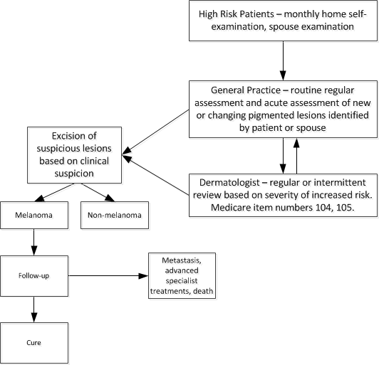
Provide a clinical management algorithm (e.g.: flowchart) explaining the expected management and any downstream services (aftercare) of the eligible population/s if public funding is recommended for the service proposed.

Proposed Management of Patients at High Risk of Developing Melanoma supported by Medicare Item for Melanoma surveillance photography
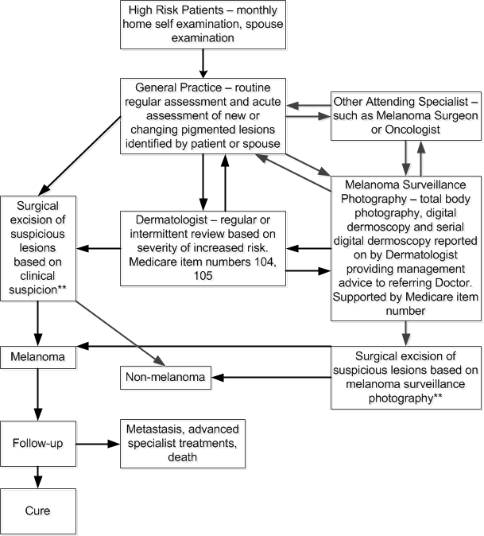
** Once a decision to excise a lesion for possible melanoma is made this can be performed by the referring GP, Dermatologist or the patient can be referred to a Surgeon for excision.

Regulatory Information
Please provide details of the regulatory status. Noting that regulatory listing must be finalised before MSAC consideration.

Decision analytic
Provide a summary of the PICO as well as the health care resource of the comparison/s that will be assessed, define the research questions and inform the analysis of evidence for consideration by MSAC (as outlined in Table 1).
See below

Healthcare resources
Using tables 2 and 3, provide a list of the health care resources whose utilisation is likely to be impacted should the proposed intervention be made available as requested whether the utilisation of the resource will be impacted due to differences in outcomes or due to availability of the proposed intervention itself.

Questions for public funding
Please list questions relating to the safety, effectiveness and cost-effectiveness of the service / intervention relevant to this application, for example:
- Which health / medical professionals provide the service
- Dermatologist – Fellow of the Australasian College of Dermatologists (or equivalent) and registered with AHPRA as Specialist Dermatologist
- Melanographer – Registered Nurse (under Dermatologist instruction)
- Are there training and qualification requirements
Apart from above a Melanogapher requires training in Dermatology Nursing and Photography
- Are there accreditation requirements
Currently there are no specific accreditation requirements apart from the supervising Dermatologist ensuring that any Melanographer used in the practice is competent as outlined above

Table 1: Summary of PICO to define research question

PICO | Comments
Patients aged 18yr of age and over at high risk of developing melanoma especially those presenting with multiple naevi. | “High risk” determined by referring Doctor with risk factors including 1. Personal history of melanoma 2. Family history of melanoma 3. Multiple atypical naevi 4. Large numbers of common naevi 5. fair skin 6. multiple sunburns or solarium use 7. depressed immune system 8. non-melanoma skin cancer
Intervention – Comprehensive melanoma surveillance photography, baseline and follow up including total body photography, digital dermoscopy and serial comparative digital dermoscopy with formal review of images and report by Dermatologist | Maximum of 1 study per calendar year eligible for rebate
Comparator – Dermatologists Specialist consultation | Medicare items 104 and 105
Outcomes – Early detection of melanoma, reduction in surgical morbidity, improved cure rate | The goal is to identify melanomas that would not be identified by other clinical methods and particularly focus on early detection as melanoma early in its development is less likely to metastasize

For investigative services
Prior tests | -
Reference standard | -

Table 2: List of resources to be considered in the economic analysis

 | Provider of resource | Setting in which resource is provided | Proportion of patients receiving resource | Number of units of resource per relevant time horizon per patient receiving resource | Disaggregated unit cost
 |  |  |  |  | MBS | Safety nets* | Other government budget | Private health insurer | Patient | Total cost
Resources provided to identify eligible population
Referrer | General Practitioner | General Practice
Referrer | Dermatologist | Specialist practice
Referrer | Non Dermatologist Specialist | Specialist practice
Resources provided to deliver proposed intervention
Diagnosis | Melanographer | Surgery or studio
Diagnosis | Dermatologist | Surgery
Treatment | Referring Doctor | Surgical excision of suspicious lesions
Resources provided in association with proposed intervention
Physical location | Melanographer | Studio or Surgery
Physical location | Dermatologist | Surgery or Studio
Computer Hardware | Dermatologist | Surgery or Studio
Computer software | Dermatologist | Surgery or Studio
Secretarial Support | Dermatologist | Surgery or Studio
Staff training | Dermatologist | Melanographer training
Education | Dermatologist | General Practice
IT connectivity and maintainence | Dermatologist | Surgery or Studio
Resources provided to deliver comparator 1
Consultation | Dermatologist | Surgery |  |  | 104
Resources provided in association with comparator 1
(e.g., pre-treatments, co-administered interventions, resources used to monitor or in follow-up, resources used in management of adverse events, resources used for treatment of down-stream conditions)
Resource 1
Resource 2
Resources provided to deliver comparator 2
Resource 1
Resource 2
Resources provided in association with comparator 2
Resource 1
Resource 2
Resources used to manage patients successfully treated with the proposed intervention
Treatment | General Practitioner | Surgical excision of possible melanoma
Treatment | Specialist – Dermatologist or Surgeon | Surgical excision of possible melanoma
Resources used to manage patients who are unsuccessfully treated with the proposed intervention
Resource 1
Resource 2
Resources used to manage patients successfully treated with comparator 1
Treatment | Dermatologist | Surgical excision of skin lesion suspicious of melanoma
Resources used to manage patients who are unsuccessfully treated with comparator 1
Resource 1
Resource 2
* Include costs relating to both the standard and extended safety net.

Table 3: Alternative summary of resources table for state transition models
 | Provider of resource | Setting in which resource is provided | Proportion  of patients receiving resource | Number of units of resource per cycle per patient receiving resource | Disaggregated unit cost
 |  |  |  |  | MBS | Safety nets* | Other government budgets  (PBS, hospitals,  etc) | Private health insurer | Patient | Total cost
Health state 1
Resource 1
Resource 2
Health state 2
Resource 1
Resource 2
Health state 3
Resource 1
Resource 2
* Include costs relating to both the standard and extended safety net.
ATTACHMENT A: REFERENCES
1. Journal article. Salerni G. Carrera C., Lovatto L. et al. Benefits of Total Body Photography and Digital Dermoscopy (“Two-step method of Digital Follow-Up”) in the Early Dignosis of Melanoma in High Risk Patients. J Am Acad Dermatol. 2012 July;67(1):e17-e27 and
2. Clinical Practice Guidelines for the Management of Melanoma in Australia and New Zealand. Cancer Council Australia/NHMRC 2008.

