Public Summary Document
Application No. 1599 – Genomic testing for the diagnosis of heritable cardiomyopathies
Applicant: Royal College of Pathologists of Australasia (RCPA)
Date of MSAC consideration: MSAC 81st Meeting, 31 March – 1 April 2021
Context for decision: MSAC makes its advice in accordance with its Terms of Reference, visit the MSAC website

Purpose of application
An application requesting Medicare Benefits Schedule (MBS) listing of genomic testing for the diagnosis of heritable cardiomyopathies was received from the Royal College of Pathologists of Australasia (RCPA) by the Department of Health. The PICO Advisory Sub-committee (PASC) recommended this application follow the clinical utility card (CUC) format, which is designed for use in MSAC applications related to genetic testing for germline variants.

MSAC’s advice to the Minister
After considering the strength of the available evidence in relation to comparative safety, clinical effectiveness and cost-effectiveness, MSAC supported the creation of Medicare Benefits Schedule (MBS) items for genomic testing for heritable cardiomyopathies in:
i) affected individuals, ii) cascade testing in biological relatives, iii) cascade testing in the reproductive partners of people with recessively inherited variants to enable informed reproductive decision making, and iv) a data re-analysis item. MSAC considered that testing is safe and effective, probably cost-effective, and is already recommended in clinical guidelines and thus constitutes accepted clinical practice in Australia. Supporting public funding for this testing is expected to decrease inequity in testing, and to have only a modest financial effect on the MBS. MSAC also advised that where a first-degree relative is unavailable or declines cascade testing, it would be appropriate for a second-degree relative to be considered eligible for publicly funded cascade testing.
The item descriptors for this testing, as proposed or supported by MSAC, are provided in section 6 of this document.
Consumer summary
The Royal College of Pathologists of Australasia (RCPA) applied for public funding via the Medicare Benefits Schedule (MBS) for genetic testing of certain heart muscle problems. These would include hypertrophic cardiomyopathy (unusually thick heart muscle), dilated cardiomyopathy (weak heart muscle) and arrhythmogenic cardiomyopathy (where some of the heart muscle is replaced with scar tissue or fat). These problems can make it harder for the heart to pump blood around the body. In people with these problems, their heart can beat abnormally or they can die suddenly. Many of these problems are inherited (passed from parent to child) and have a genetic cause. But in other people, they can have a non-genetic cause.
The test would include testing a minimum of 22 genes that are known to be involved in these inherited heart muscle problems, which may confirm or rule out a genetic cause. The test is for people who have signs or symptoms of one of these heart muscle problems. In many cases, the person being tested will already know they have one of these heart muscle problems, but may not know which type, or whether the cause is genetic or non-genetic.
If the test shows a genetic variant relevant for one of these problems, then their first-degree relatives (parents, children, brothers and sisters) and their reproductive partners may also be recommended to get tested, even if they do not have symptoms. Where a first-degree relative is unavailable, a second-degree relative (grandparents, grandchildren, uncles, aunts, nephews and nieces) can be tested. This is called cascade testing. Cascade testing allows people to make more informed health and family planning decisions.
The main benefit of genetic testing in this case is for the family members of the person with cardiomyopathy. If a family member also has a genetic variant, then they can be monitored, make lifestyle and behavioural changes and, sometimes, start early treatment and management before they show any symptoms. If a family member does not have a genetic variant, they do not need to be monitored or treated. This is also cost-effective for the health system.
Reproductive partners of some people with particular gene variants will also be advised to consider testing. The need for this testing depends on the gene and how it is inherited.
New genes are often being discovered, and may be added in the future to the group of genes tested. Pathology laboratories can sequence the patient’s whole exome (all of a person’s genetic makeup), and re-analyse the same data later as new genes are identified.
MSAC’s recommendation to the Commonwealth Minister for Health
MSAC recommended funding genetic testing for cardiomyopathies on the MBS. MBS items should address initial testing, cascade testing, reproductive partner testing and data re-analysis as new genes are identified. MSAC considered that this type of genetic testing is safe and effective, probably good value for money, is already recommended in clinical guidelines, and is accepted clinical practice.

Summary of consideration and rationale for MSAC’s advice
MSAC noted that this application requested MBS items for genetic testing for the cardiomyopathies hypertrophic cardiomyopathy (HCM), dilated cardiomyopathy (DCM) and arrhythmogenic cardiomyopathy (ACM). The application included cascade (variant-specific) testing in relevant family members if a clinically actionable pathogenic/likely pathogenic variant is identified in an affected individual. Reproductive partner testing is included to enable informed reproductive decision making among those with recessively inherited variants.
MSAC noted that the application was for a panel of 22 genes associated with cardiomyopathies, and that this testing is already established in several public sector laboratories in Australia. MSAC also noted that genetic testing for cardiomyopathies is recommended internationally and in clinical management guidelines. Public funding for this testing would address an unmet need and ensure equity of access to testing.
MSAC noted the strong support from the targeted consultation, which emphasised equity of care regardless of location of the patient and their family.
MSAC considered the genetic testing to have non-inferior safety compared to no genetic testing.
MSAC noted the non-inferior effectiveness for genetic testing in affected individuals. The genotype rarely changes clinical management, and patients are managed according to their phenotype. However, Fabry disease (GLA gene) and variants in the LMNA gene are (albeit rare) exceptions, where the genotype does alter clinical management. MSAC noted that people with LMNA pathogenic variants have a high risk of sudden death due to ventricular arrhythmias. Clinical management for these patients includes inserting an implantable cardioverter-defibrillator (ICD). MSAC also noted that genetic testing for cardiomyopathies may facilitate early management in some cases.
MSAC noted the strong clinical validity for genetic testing in cardiomyopathies:
HCM often has a genetic cause.
Prognosis is worse for patients with HCM if a pathogenic variant or multiple variants are identified.
Prognosis is worse for patients with DCM who have LMNA variants.
Genetic testing is a major diagnostic criterion for arrhythmogenic right ventricular cardiomyopathy (ARVC), a subtype of ACM.
Penetrance of the relevant genes is at least 40–70% in adults.
MSAC acknowledged that the main clinical utility and superior effectiveness relate to cascade testing. Without genetic testing, all first-degree relatives of an affected individual are recommended for monitoring every 1–5 years as they may be at risk for the condition. MSAC considered the main benefit of cascade testing was likely releasing relatives who do not carry the familial variant from long-term surveillance. Alternately, if a family member is found to carry a pathogenic variant, it may facilitate early management and lifestyle and behavioural changes.
MSAC considered the evidence for clinical effectiveness to be at high risk of bias, mainly due to incomplete reporting. It is uncertain if genetic testing increases compliance with monitoring, or if monitoring affects health outcomes.
MSAC recommended reproductive partner testing be funded for conditions with a recessive inheritance pattern. MSAC noted that, for reproductive partner testing, gene sequencing would be needed, as the partner needs to be tested for all variants within the same gene as the recessive variant found in the index case. Since most of the cost of next generation sequencing (NGS) testing is in the library preparation and sequencing, which is the same whether one or 22 genes are interrogated, MSAC advised the fee for item CCCC should be the same as that for AAAA ($1,200). MSAC noted that this was higher than the fee for the existing cystic fibrosis reproductive partner testing item (MBS item 73349), but considered that $1,200 was appropriate due to the greater complexity of single gene sequencing required here compared to that for the cystic fibrosis gene, CFTR. MSAC also considered that, if it was not possible to gain information from a first-degree relative (e.g. due to death), then it would be appropriate to test second-degree relatives as part of cascade testing item BBBB. MSAC noted that the applicant did not recommend testing for reproductive partners, however MSAC considered that to not support reproductive partner testing would create inequity for patients depending on the inheritance of their genetic variant.
MSAC considered it appropriate to create an additional MBS item (DDDD) that allows re-analysis when the original testing used a full capture and sequencing background (i.e. beyond the original gene panel), due to rapid advancements in the identification of genes that contribute to cardiomyopathy. MSAC considered it appropriate for a specialist or consultant physician to make this request, but not a genetic counsellor, because this is a medical decision and the re-analysis can take quite some time to perform. MSAC considered that a generic reinterrogation item for genetic testing would be appropriate, as would generic items for cascade testing and reproductive partner testing.
MSAC discussed the potential co-claiming of cardiac panels (with those previously supported in MSAC Application 1598) and considered that the overlap between the two panels was low and so co-claiming was unlikely to be a material issue. MSAC considered that if the original testing had been performed on a full NGS capture and sequencing background, the re-analysis item would apply for the second panel. However, the restriction imposing a minimum 18-month wait for data re-analysis may be problematic if using a generic re-analysis item, as it would not be suitable for a patient to wait 18 months to have the other cardiac gene panel reviewed. MSAC advised that the 18-month restriction only applies to re-analysis using the same panel, as re-analysing data for other indications (e.g. a non-cardiac panel) would be reasonable provided there is an appropriate indication. MSAC advised that the Department consider adding wording in the descriptor that could link the first test with the second one through the reinterrogation, and that an exception to the wait time for reinterrogation could be made based on strong clinical suspicion. MSAC noted this might result in leakage.
MSAC noted the issues around the economic evaluation, especially regarding the translation and transformation of the benefits into quality-adjusted life years (QALYs) for identifying LMNA pathogenic variants. MSAC noted the stepped approach taken in the economic analysis resulted in an incremental cost-effectiveness ratio (ICER) of $67,556 per QALY and a cost per variant detected of $2,446, for testing affected individuals and first-degree relatives. MSAC noted the incremental cost is largely based on cost savings by avoiding long-term clinical surveillance in variant-negative relatives. MSAC considered that genetic testing was probably cost-effective, but noted the following areas of uncertainty:
whether genetic testing increases compliance with ongoing monitoring or whether monitoring impacts health outcomes
whether an ICD is implanted on the basis of phenotype, if an LMNA pathogenic variant is identified.
MSAC noted that the key drivers of the ICER included the time horizon, diagnostic yield in affected individuals, the number of relatives eligible for cascade testing, uptake of periodic monitoring (with or without genetic testing), the treatment effect of ICDs modelled and the inclusion of a utility benefit in relatives without an identified pathogenic variant.
MSAC noted that extending cascade testing eligibility to all second-degree relatives (i.e. distinct from the inclusion of second-degree relatives as a substitute for an unavailable first-degree relative, as supported by MSAC) decreased the ICER to $25,012 per QALY. MSAC also noted that the cost of ICDs has been decreasing, which had not been captured. Thus, MSAC considered the cost savings were likely to be greater than proposed in the model by avoiding monitoring in relatives who test negative.
MSAC noted the modest proposed incremental costs to the MBS of $992,017 in the first year up to $1.6 million in year 5, based on the cost of testing being $1,200 as agreed by the applicant in the pre-ESC response. MSAC noted that if the test cost were $1,800, then testing would cost $1.4 million in year 1 to $2.3 million by year 5.
MSAC noted the ethical issues associated with the application, and the importance of pre- and post-test genetic counselling, plus the communication process among family members involved in the genetic testing.

Other discussion
MSAC considered record keeping for families who have undergone genetic testing. Many genetics services keep records and link families, but future genetic testing will likely extend to a wider range of requestors, and MSAC considered it important to have a way of tracking this testing, including across states and territories.
MSAC also noted potential access issues for the relatives of individuals who die from sudden cardiac death, as deceased people are not eligible for genetic testing on the MBS, but would be potentially eligible for state-funded testing. If deceased people do not receive genetic testing under funding mechanisms other than the MBS, relatives may be unable to access testing.
MSAC also raised the issue of whether data re-analysis should also apply to NGS data obtained through testing for an unrelated indication. It considered that this strengthens the rationale to develop a generic data re-analysis item.
MSAC noted issues around the consent process for genetic testing. MSAC noted that many laboratories use a standard consent form from Australian Genomics, and that many laboratories are moving towards using a single diagnostic test form. Cardiologists may require education or refresher training on the ethical issues in genomic testing in cardiomyopathies, to facilitate consent.
MSAC queried whether diagnostic yield from different categories of requestors for all genetic conditions could be reported. This would provide valuable information about the knowledge of genetic testing from different requestors, so targeted training could be provided to individuals with a diagnostic yield well above or below the expected rate for their category of requestor.

Background
MSAC has not previously considered genomic testing for the diagnosis of cardiomyopathies.
A related application is MSAC application 1598 – Genetic testing for diagnosis of inheritable cardiac rhythm disorders, supported by MSAC in November 2020. Application 1598 was an application to test 20 genes implicated in inherited cardiac arrhythmias or channelopathies, where one gene (SCN5A) is in common with the exemplar genes proposed in this application.

Prerequisites to implementation of any funding advice
Pathology laboratories must participate in an External Quality Assurance Program (EQAP) and obtain National Association of Testing Authorities (NATA) accreditation to offer MBS-funded genetic testing services in Australia.
The National Pathology Accreditation Advisory Council (NPAAC) commented that this testing is already established in a number of public sector laboratories in Australia. The RCPA QAP Pty Ltd advised that it is currently in a partnership arrangement with the European Molecular Genetics Quality Network (EMQN) to provide a QAP for the heritable cardiomyopathy testing being sought by this application.

Proposal for public funding
The Department-Contracted Assessment Report (DCAR) proposed three MBS items for genetic testing for the diagnosis of cardiomyopathies:
- for detection of a heritable form of cardiomyopathy for a paediatric or adult patient, who fulfils diagnostic criteria for cardiomyopathy (Table 1);
- for testing an asymptomatic paediatric or adult individual, who has a relative with an identified heritable form of cardiomyopathy (Table 2);
- for the testing of reproductive partners of individuals who have been diagnosed with a recessively inherited form of cardiomyopathy (Table 3).
The applicant did not include MBS items for reproductive partner testing, or a re-analysis item. However the former was proposed in the PICO and the latter was proposed by the Department prior to the meeting of the MSAC Evaluation Sub-Committee (ESC).
In the majority of cases, cardiomyopathies appear to follow a dominant inheritance pattern. If the pathogenic variant is inherited in a dominant manner then testing of second-degree relatives (provided first-degree relatives are available) and partner testing is not required.
The suggested item descriptor AAAA, as presented in the DCAR, did not specify the genes that should be included in a panel for heritable cardiomyopathies, nor the number of genes that should be on the panel. The Department suggested that the exemplar genes should form the minimum set of genes on any panel used to conduct the tests, and that they be listed in the item descriptor (as reflected in MSAC’s supported item descriptor, Table 1). MSAC also supported the addition of an explanatory note to item AAAA, as in previous Application 1598:
The rapidly expanding field of genomic medicine has resulted in recognition of an increasing number of genetic causes of cardiac diseases. Use of genomic testing methods that permit re-analysis of existing data for variants in newly described clinically relevant genes are recommended/encouraged.
The PICO Confirmation noted that PASC queried the proposed MBS fee of $1,800 for item AAAA, when other similar gene panel testing has an MBS fee of $1,200. The assessment used a fee of $1,200 for estimating the financial impact of genetic testing on the MBS, and in the pre-ESC response, the applicant agreed that $1,200 is appropriate.
MSAC considered that in the occasional situation where the first-degree biological relative is unavailable or declines testing, it would be appropriate to test a second-degree biological relative. MSAC proposed amending the proposed item descriptor to allow this, either by adding reference to second-degree relatives where the first-degree relative is unavailable or by reference to an at-risk relative (noting that the proposed approaches are not reflected in Table 2). MSAC’s support for a generic biological cascade testing item is also not reflected in Table 2.
MSAC considered that reproductive partner testing (CCCC) is generally considered important by families who are known to carry a recessive variant. MSAC advised that, consistent with previously supported reproductive partner testing items, this testing needs to sequence the whole gene because unrelated partners are unlikely to have the same variant. MSAC advised that the fee for reproductive partner testing should be $1,200, in line with affected individual panel testing (as reflected in Table 3). MSAC’s support for a generic reproductive partner testing item is not reflected in Table 3.

Table 1 Proposed item descriptor for genetic testing for heritable cardiomyopathies
Item number AAAA Category 6 – PATHOLOGY SERVICES –Group P7 Genetics
Characterisation of pathogenic or likely pathogenic germline gene variants in at least the following genes:
MYPBC3 and MYH7 and TNNI3 and TNNT2 and TPM1 and ACTC1 and MYL2 and MYL3 and PRKAG2 and LAMP2 and GLA and LMNA and SCN5A and TTN and RBM20 and PLN and DSP and MYH7 and DSC2 and DSG2 and DSP and JUP and PKP2 and TMEM43
in a patient for whom clinical, relevant family history and/or laboratory findings suggest there is a high probability suggestive of a heritable cardiomyopathy (hypertrophic cardiomyopathy (HCM), dilated cardiomyopathy (DCM) and/or arrhythmogenic cardiomyopathy (ACM)), requested by a specialist or consultant physician.
Applicable once per lifetime.*
MBS Fee: $1,200 Benefit: 75%=$900 85%=$1,020
Source: MSAC (based on the draft item descriptor proposed by the Department)

Table 2 Proposed item descriptor for predictive genetic testing of family members of individuals diagnosed with a heritable cardiomyopathy
Item number BBBB Category 6 – PATHOLOGY SERVICES-Group P7Genetics
Characterisation of one or more pathogenic or likely pathogenic germline gene variants, mentioned in item AAAA, in a patient who is a first degree biological relative of a patient with a pathogenic or likely pathogenic germline gene variant confirmed by laboratory findings requested by a specialist or consultant physician for the purpose of assessing risk or future risk of a heritable cardiomyopathy (hypertrophic cardiomyopathy (HCM), dilated cardiomyopathy (DCM) and/or arrhythmogenic cardiomyopathy (ACM)).
Applicable once per variant per lifetime.*
MBS Fee: $400 Benefit: 75%=$300 85%=$340
Source: MSAC (based on the draft item descriptor proposed by the Department)

Table 3 Proposed item descriptor for predictive genetic testing of reproductive partners of individuals diagnosed with a heritable cardiomyopathy
Item number CCCC Category 6 – PATHOLOGY SERVICES-Group P7Genetics
Characterisation of one or more recessive pathogenic or likely pathogenic germline genes mentioned in item AAAA, in a patient:
- who is a reproductive partner of a known carrier of a pathogenic or likely pathogenic germline gene confirmed by laboratory findings; and
- for whom carrier status of a pathogenic or likely pathogenic germline gene is unknown; and
- for whom clinical, family history and/or laboratory findings suggest there is low probability suggestive of a heritable cardiomyopathy;
requested by specialist or consultant physician for the purpose of determining the reproductive risk of the patient with their reproductive partner.
Applicable once per gene per lifetime.*
MBS Fee: $1,200 Benefit: 75%=$900 85%=$1,020
Source: MSAC (based on the draft item descriptor proposed by the Department).
*PN.0.23 Prior to ordering these tests the ordering practitioner should ensure the patient (or approximate proxy) has given informed consent. Testing should only be performed after genetic counselling. Appropriate genetic counselling should be provided to the patient either by the specialist treating practitioner, a genetic counselling service or a clinical geneticist on referral. Further counselling may be necessary upon receipt of the test results.
MSAC proposed a draft descriptor for the data re-analysis item, for an altered or expanded phenotype, and where the original testing had used a full NGS capture and sequence background (Table 4). MSAC advised that re-analysis should be requestable by the same types of specialists who request the original test (AAAA), not by a genetic counsellor. MSAC’s support for a generic data re-analysis item is not reflected in Table 4.

Table 4 Proposed item descriptor for data re-analysis for genetic testing for heritable cardiomyopathies
Item number DDDD Category 6 – PATHOLOGY SERVICES – Group P7, Genetics
Re-analysis of whole exome or genome data obtained in performing a service to which item AAAA applies, for characterisation of previously unreported germline variants related to the clinical phenotype, if:
- the re-analysis is requested by a consultant physician practicing as a clinical geneticist or a cardiologist; and
- the patient is strongly suspected of having a heritable cardiomyopathy; and
- the re-analysis is performed at least 18 months after:
  - a service to which item AAAA applies; or
  - a service to which this item applies.
Applicable only twice per lifetime.
MBS Fee: $500 Benefit: 75%=$375 85%=$425
Source: MSAC (based on the draft item descriptor in the Departmental policy paper)
The DCAR stated that the practice notes associated with the proposed MBS items suggest requiring post-test counselling in affected individuals who test positive, pre-test counselling in all family members undergoing genetic testing, and post-test counselling in family members who test positive. The Department proposed that reproductive partners who test positive should also receive post-test counselling.
The DCAR proposed that the genetic test be ordered by a specialist or consultant physician such as their cardiologist. Counselling can be further provided by another treating specialist medical practitioner, or with input from a cardiac-genetic counsellor. MSAC advised that specialists should be able to request these tests after obtaining informed consent, and that consultation with a clinical geneticist should not be required.

Summary of public consultation feedback/consumer Issues
Targeted consultation feedback was received from three genomics organisations. One organisation also provided data on current presentation and testing in Australia. No consumer feedback/consumer comments were received for this application.
Feedback was strongly supportive of public funding for genetic testing for the diagnosis of cardiomyopathies. One group noted that cardiomyopathies may be the most common cardiac genetic condition in patients referred for genetic services in their state. Consultation feedback suggested the main advantages were:
- The major benefit is enabling cascade and predictive testing in family members, leading to preventative measures or release from surveillance.
- Releasing family members from surveillance frees up capacity within the healthcare system.
- Improve diagnostic certainty, and potentially provide information about prognosis.
- A genetic diagnosis can influence choice of therapy, and deliver improved outcomes.
- Both positive and negative diagnosis can provide ‘peace of mind’ for patients and their families.
- Public funding would provide equity of care across Australia, and enable best practice to be followed regardless of the location of the patient and their family.
- Public funding would provide sustainable funding for genetic testing, which is currently lacking.
Disadvantages of the proposed testing were:
- Testing may not result in a genetic diagnosis.
- Variable genetic penetrance of some variants may mean that even if a patient is found to be genetically affected, they would not necessarily have progressed to disease. However, this would not occur often and would be a minor impact compared to missing a fully penetrant variant in an affected individual.
- Some families may not wish to be offered or know the outcome of genetic tests.
Relevant technical comments received in consultation feedback were:
- Strong support that genetic counselling be required for the affected individual and their family, so they understand the full impact of a genetic diagnosis.
  - Counselling to be carried out by a genetic counsellor or appropriately experienced clinician (specialist cardiologist or clinical geneticist).
- The MBS item descriptor should at a minimum include the genes listed in the application, to ensure the funded tests cover the appropriate genes.
- While the item descriptor should be method-agnostic, the fee should cover not only a genetic panel but also sequencing-based testing methods, to enable data re-analysis if required. This would also mean repeated testing could be avoided. There would also be flow-on research benefits from using whole exome/genome sequencing, providing significant value for future clinical outcomes.
  - One possibility would be to include tiered analytical complexity options, with commensurate fees for each. This would allow analysis of a larger number of genes for patients with more complex presentations.
- The proposed fee of $1,800 may not fully cover the cost of this test – the real cost was estimated by one provider to be $2,200, though the proposed fee would still go a long way towards offsetting the cost of testing. The organisation emphasised that they would not want to see the proposed items not be supported on the basis that they do not cover the full fee-for-service.
- Consider including an exome/genome data re-analysis item, similar to MSAC Application 1476 (genetic testing for childhood syndromes).

Proposed intervention’s place in clinical management

Description of Proposed Intervention
The proposed intervention is genetic testing for the diagnosis of cardiomyopathies (hypertrophic cardiomyopathy (HCM), dilated cardiomyopathy (DCM), and arrhythmogenic cardiomyopathy (ACM)), in affected individuals as well as cascade testing in their biological relatives and reproductive partners.
Genetic testing in affected individuals may be useful for confirming (or changing) diagnosis, informing prognosis, reducing the risk of adverse outcomes through changes to patient management, and allowing cascade genetic testing of potentially affected family members. When a dominantly inherited pathogenic variant is identified in the index patient, cascade family testing can reveal family members who are at risk for the familial cardiomyopathy type (variant positive) and those who are not at risk (variant negative). For recessively inherited pathogenic variants, cascade family testing can reveal relatives who are at risk of having an affected child. Variant negative family members are considered not at risk for the familial form of cardiomyopathy and do not require any special management or annual surveillance. However, they still have a population-risk for other forms of cardiomyopathy.
The DCAR noted the applicant identified the following 22 germline genes as “exemplar” genes:
- HCM: MYPBC3, MYH7, TNNI3, TNNT2, TPM1, ACTC1, MYL2, MYL3 plus “mimic” genes PRKAG2, LAMP2, GLA
- DCM: LMNA, SCN5A, TTN, RBM20, PLN, DSP, MYH7
- ACM: DSC2, DSG2, DSP, JUP, PKP2, and TMEM43
In addition, the applicant identified further facilitated genes for each cardiomyopathy.
It is also proposed that if a clinically actionable pathogenic/likely pathogenic (P/LP) variant is identified in an affected individual, then known variant testing for that single variant be funded by the MBS for the purpose of testing relevant family members. Reproductive partner testing is also proposed, to enable informed reproductive decision-making among those with the rare forms of recessively inherited variants.

Description of Medical Condition(s)
Common inherited cardiomyopathies comprise a small group of related but clinically distinct primary cardiomyopathies. These are hypertrophic cardiomyopathy (HCM), dilated cardiomyopathy (DCM) and arrhythmogenic cardiomyopathy (ACM). ACM has been used as a term to encompass arrhythmogenic right ventricular cardiomyopathy (ARVC), arrhythmogenic right ventricular dysplasia (ARVD), and other cardiomyopathies with marked arrhythmogenic phenotypes that may involve either the right or left ventricles.
Cardiomyopathies are a cause of arrhythmias, valvular dysfunction, outflow tract obstruction, progressive heart failure and/or sudden cardiac death. Due to the hereditary nature of many cardiomyopathies, once a patient is diagnosed, related family members are offered monitoring for signs and symptoms of cardiomyopathy, and treated once a clinical diagnosis is made.

Clinical management algorithm
Genetic testing is proposed to be offered in addition to existing testing.
For affected individuals with suspected HCM, the current and proposed clinical management algorithms are shown in Figure 1.
The current and proposed algorithms for cascade testing of asymptomatic biological relatives of people with HCM are shown in Figure 2. The proposed algorithm for cascade testing of reproductive partners of patients with HCM is shown in Figure 3.
For affected individuals with suspected DCM, the current and proposed clinical management algorithms are shown in Figure 4. For affected individuals with suspected ACM, the current and proposed clinical management algorithms are shown in Figure 5. The cascade testing algorithms (for relatives and reproductive partners) for DCM and ACM are (apart from the disease subtype) the same as for HCM, so are not repeated.

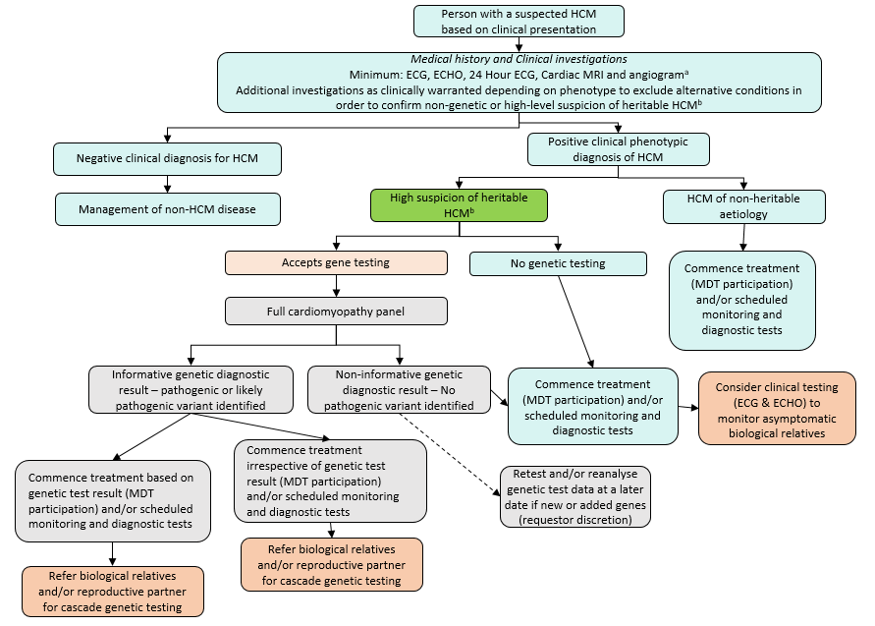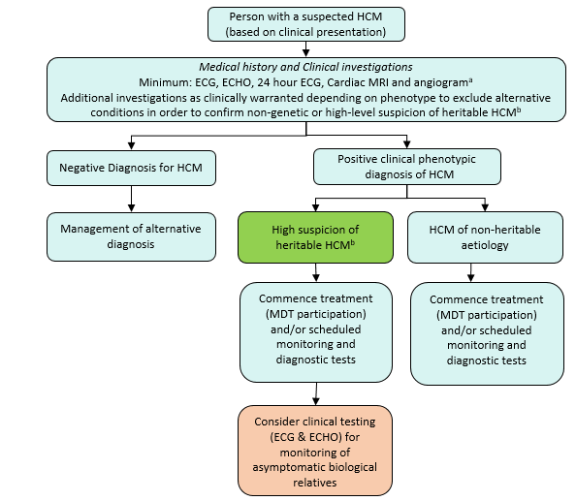Figure 1 Current (top) and proposed (bottom) clinical algorithm for affected individuals with suspected HCM
ª MBS items: 55116: Exercise stress echocardiography; 55122: Exercise stress echocardiography; 11700: Twelve lead electrocardiography; 11709: Continuous ECG recording (Holter) of ambulatory patient; 11712: Multi-channel ECG monitoring; 57360: Computed tomography of the coronary arteries
^{b} ‘high suspicion of heritable HCM’ based on personal disease history, patient age, and pedigree
Source: Ratified PICO, Figures 1A and 1B

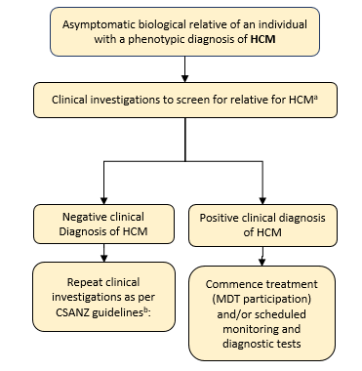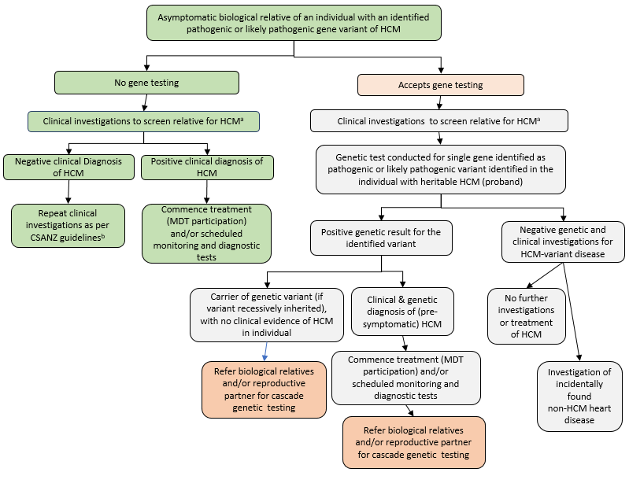Figure 2 Current (top) and proposed (bottom) clinical algorithm for cascade testing of asymptomatic biological relatives of patients with HCM
Source: Ratified PICO, Figures 2A and 2B
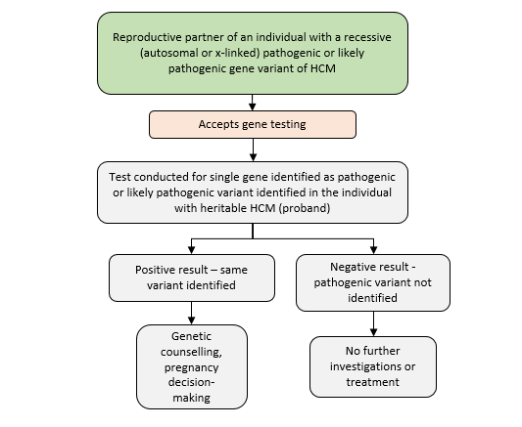

Figure 3 Proposed clinical management algorithm for cascade testing of asymptomatic reproductive partners of patients with HCM
Source: Ratified PICO, Figure 2C

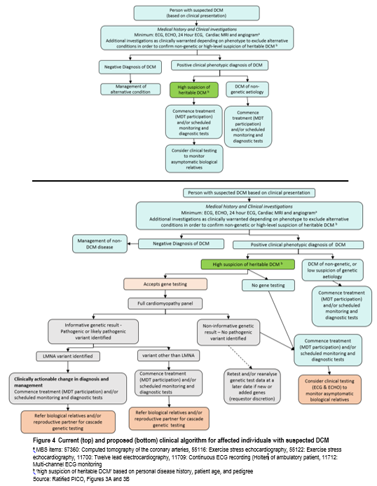

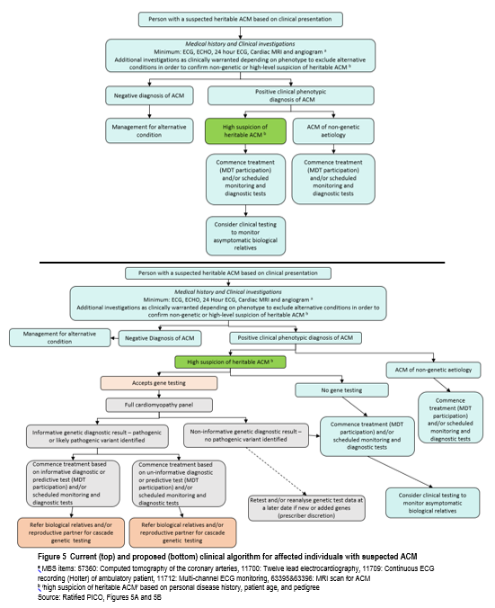

Comparator
The DCAR stated that the comparator for affected individuals was no genetic testing, with management directed by cardiac signs and symptoms, and the results of investigations.
The comparator for cascade testing in relatives was no genetic testing, with regular monitoring for identification of cardiomyopathy symptoms.

Comparative safety
The DCAR stated that no safety concerns were identified for testing affected individuals or for cascade testing of relatives. For cascade testing, no evidence was identified that described the safety of clinical monitoring, however genetic testing may result in a proportion (typically 50%) of family members avoiding any risks associated with monitoring.

Comparative effectiveness

Clinical claims
For affected patients: On the basis of the evidence, relative to clinical assessment alone, genetic testing for cardiomyopathies has a non-inferior safety and non-inferior effectiveness.
For family members: On the basis of the evidence, relative to clinical assessment alone, genetic testing for cardiomyopathies has non-inferior safety and superior effectiveness.

Analytical validity
The DCAR stated that the detection of P/LP variants for cardiomyopathy, including insertions or deletions and single nucleotide variants, using next generation sequencing (NGS) gene panel testing, was reported to have an accuracy equivalent to or approaching that of Sanger Sequencing. The analytical sensitivity and specificity were reported to be 100%, and reproducibility of NGS across multiple runs was 99.45% across 5651 variants.

Clinical validity
The DCAR described the clinical validity of genetic testing for cardiomyopathies in terms of incremental diagnostic information and incremental prognostic information.
There were substantial differences in phenotypes between patients with an identified pathogenic variant and those in whom the pathogenic variant is not identified, particularly in the sarcomere genes of HCM. In general, where a pathogenic variant has been identified, the clinical phenotype appeared to be more severe. This may indicate that many or most of the more severe pathogenic variants are included on testing panels.
The prognosis for patients with a clinical diagnosis of HCM who have an identified pathogenic variant was poorer than for those where no pathogenic variant was identified. For patients with DCM, a pathogenic variant identified in the Lamin A/C (LMNA) gene appeared to be associated with a worse prognosis than other pathogenic variants, however there was no difference in survival between patients with and without pathogenic variants. In patients with a diagnosis of ACM, the evidence indicates that prognosis is similar regardless of whether a pathogenic variant is identified or not.

Clinical utility
The DCAR described two primary reasons for conducting genetic testing for cardiomyopathies.
Firstly, the detection of a curated cardiomyopathy gene variant in an affected individual permits the cascade screening of relevant family members to identify those at future risk of cardiomyopathy. If the variant is identified in family members, monitoring is offered. If the variant is not identified, then monitoring can safely be avoided. The avoidance of monitoring in family members may be associated with cost-savings.
Secondly, the detection of a gene variant may assist in making a more accurate diagnosis than from phenotype alone, and/or inform the prognosis from the cardiomyopathy. In most cases, no change in the management of an affected patient would occur as a result of the genetic test. However, some pathogenic variants have been associated with an elevated risk of sudden cardiac death, and cardiologists may recommend an ICD. While the identification of some genotypes may indicate a different prognosis, or more malignant clinical course, it is acknowledged that the utility of genetic testing for risk stratification is limited due to the genetic heterogeneity of cardiomyopathies. Evidence suggests that combinations of more than one pathogenic variant in an individual may contribute to the observed penetrance and severity of the phenotype. The relevance, and possible utility, of genetic testing for phenotypically diagnosed cardiomyopathy patients may increase into the future.
The DCAR found that key uncertainties remaining around clinical issues were:
- The evidence to support the clinical validity of genetic testing for HCM, DCM and ACM is strong. The identification of a genotype may provide additional diagnostic and prognostic information. However, the evidence regarding the impact that genetic testing has on management of the affected individual is limited.
- The most likely circumstance under which genetic testing may inform clinical management occurs when a pathogenic variant in the LMNA gene is identified. There is poor quality evidence that patients who are diagnosed with an LMNA pathogenic variant may receive an ICD. The key uncertainty with the identified evidence is whether the ICD is implanted on the basis of phenotypic findings or on the basis of the identification of an LMNA pathogenic variant.
- The key benefit of genetic testing is realised in family members of an index patient with an identified pathogenic variant. For family members who do not carry the pathogenic variant, ongoing monitoring may be forgone. For pre-symptomatic family members who do carry the pathogenic variant, monitoring is offered, and intervention may be offered at an earlier time-point.
- Key uncertainties remain relating to whether genetic testing increases compliance with ongoing monitoring, or whether monitoring is likely to impact on health outcomes.
In the pre-ESC response, the applicant stated that while arrhythmia risk (i.e. sudden cardiac death) has been modelled as an important outcome, the development of heart failure, which may be ameliorated by early medical therapy (including relatives found to be genotype positive who can be closely monitored), is likely to represent a much bigger burden of disease. In the rejoinder, the assessment group responded that evidence of a change in management due to genetic testing was only identified for a small proportion of patients with DCM found to have a pathogenic/likely pathogenic (P/LP) variant in LMNA. No evidence was identified to support changes in management due to genetic testing for the prevention of heart failure development. Thus the economic model, when translating outcomes into life years and quality-adjusted life years, is driven by sudden cardiac deaths avoided in the small proportion of patients with LMNA-related DCM. Benefits in the population eligible for testing more broadly are not captured in these metrics (as these were not able to be quantified), however additional outcomes were reported (such as the additional number of genotype-positive relatives monitored).

Translation issues
The DCAR’s analysis identified two issues in translating the results of the clinical evaluation for use in the economic analysis, and presented transformation pre-modelling studies for each. A summary of the translation issues is presented in Table 5.
- How should the economic analysis capture the benefits (and costs) of identifying LMNA-related DCM?
- How to transform the benefits of identifying LMNA-related DCM into quality-adjusted life years (QALYs)?

Table 5 Summary of results of pre-modelling studies and their uses in the economic evaluation
Pre-modelling study | Results used in the economic evaluation
Change in management in LMNA-related DCM | Given the weak evidence presented in the clinical assessment to support a change in management in LMNA-related DCM, the base case economic analysis will be presented in a stepped manner. The first step will include the reporting of an outcome that is ‘people with clinically actionable variants identified’. The purpose of this outcome is to identify the proportion of people in whom there may be a clinically actionable change in management, due to the identification of a LMNA variant.  Subsequent steps in the base case analysis will transform the outcome of ‘people with clinically actionable variants identified’ into life years gained associated with earlier ICD implantation.
Utilities | Additional life years gained associated with earlier implantation of ICDs in LMNA-related DCM will be transformed into QALYs. Quality-of-life effects related to the implantation procedure and ongoing effects of ICDs will be incorporated into the analysis.  While the existing economic literature modelled a utility benefit associated with a genotype-negative result, this was not supported by the evidence identified in the clinical assessment. Sensitivity analyses are presented exploring this assumption.
DCM = dilated cardiomyopathy; ICD = implantable cardiac defibrillator; LMNA = lamin A/C gene; QALY = quality-adjusted life year.
Source: DCAR, Table 18

Economic evaluation
Cost-effectiveness and cost-utility analyses were presented comparing genetic testing for cardiomyopathies, with no genetic testing for cardiomyopathies (Table 6).

Table 6 Summary of the economic evaluation
Perspective | Australian health care system
Population | Affected individuals: People clinically diagnosed with cardiomyopathy, who have a suspected heritable cause;  Relatives: First-degree relatives of affected cases identified with P/LP variant(s)
Prior testing | Tests required to diagnose cardiomyopathy and exclude non-familiar causes in affected cases
Intervention: | Affected individuals: Genetic testing, with management directed by cardiac signs and symptoms, and measures of cardiomyopathy.  Relatives: Genetic testing, with regular monitoring for identification of cardiomyopathy symptoms in those that are found to carry the familial variant
Comparator | Affected cases: No genetic testing, with management directed by cardiac signs and symptoms, and measures of cardiomyopathy.  Relatives: No genetic testing, with regular monitoring for identification of cardiomyopathy symptoms
Type of economic evaluation | Cost-effectiveness analysis, cost-utility analysis
Outcomes | - People with genetically confirmed status  - People with positive genotyping identified  - People with clinically actionable pathogenic variants identified  - No. relatives that are appropriately monitored  - No. ICDs implanted  - No. SCD events  - Life-years gained  - QALYs gained
Sources of evidence | Systematic review of the clinical literature.  Additional published literature where required.
Methods used to generate results | Decision-tree and Markov model
Cohorts modelled | Affected individuals (age 43 at model entry)  Relatives of affected cases (age 18 at model entry)
Time horizon | Lifetime (to age 100)
Health states | Asymptomatic  Cardiomyopathy, lower-risk of SCD  Cardiomyopathy, higher-risk of SCD  Cardiomyopathy, higher-risk of SCD – with ICD  Dead (SCD)  Dead (all-cause)
Cycle length | 1 year
Transition probabilities | Derived from the literature
Software packages used | TreeAge Pro and Excel 2016
ICD = implantable cardiac defibrillator; P/LP = pathogenic or likely pathogenic; QALY = quality-adjusted life year; SCD = sudden cardiac death
Source: DCAR, Table 21
The DCAR stated that the claim of superior effectiveness was made on the basis that genetic testing provides the ability to rule out lifelong periodic monitoring in genotype-negative family members. As genetic testing may allow better targeting of monitoring in relatives, an analysis presenting the cost per additional relative who is being appropriately monitored is presented. In this analysis, ‘appropriately monitored’ captures both genotype-positive relatives who uptake monitoring (where no difference across model arms is expected in the base case), in addition to genotype-negative relatives who are not monitored.
One subgroup of patients in which genetic testing appears to be associated with a clinically actionable change in management is those with DCM who are found to have an LMNA variant, although the data identified during the clinical evaluation were too limited to form the basis of a superiority claim. In Australian practice, change in management in these patients is supported by an Australian study, in addition to guidelines,, and the ratified 1599 PICO Confirmation. Therefore the base case economic analysis incorporated this in the subgroup of affected cases identified with LMNA-related DCM. This economic model was presented in a stepped manner, with various intermediate cost-effectiveness outcomes, and ultimately through to a cost-utility analysis, reporting an incremental cost-effectiveness ratio (ICER) per additional quality-adjusted life year (QALY) gained (Table 7). Australian Genomics data on diagnostic yield (Austin et al., 2021) were used in the DCAR’s economic and financial analyses.

Table 7 Results of the stepped economic evaluation (affected case and cascade testing)
 | GT available | GT not available |  | Increment | ICER
Step 1 – Direct costs and outcomes of testing
Costs | $1,636 | $0 |  | $1,636
Outcomes
Affected cases with P/LP variants identified | 0.3254 | 0.0000 |  | 0.3254
Relatives with P/LP variants identified | 0.3436 | 0.0000 |  | 0.3436
Total with P/LP variants identified | 0.6690 | 0.0000 |  | 0.6690 | $2,446
No. with known genetic status | 1.6872 | 0.0000 |  | 1.6872
No. with clinically actionable P/LP variants identified | 0.0056 | 0.0000 |  | 0.0056 | $290,204
Step 2 – Include monitoring costs.
The cost of monitoring is included over relatives’ lifetime, assuming no difference in the rate of uptake of periodic monitoring in relatives with or without genetic testing
Costs | $2,649 | $2,406 |  | $243
Outcomes
No. appropriately monitored | 1.1941 | 0.8505 |  | 0.3436 | $707
No. genotype-positives monitored | 0.3436 | 0.3436 |  | 0.0000
No. genotype-negatives monitored | 0.0000 | 0.3436 |  | –0.3436
Total with P/LP variants identified | 0.6690 | 0.0000 |  | 0.6690
No. with clinically actionable P/LP variants identified | 0.0056 | 0.0000 |  | 0.0056 | $43,072
Step 3 – Model a change in management on identification of LMNA DCM P/LP variants
Transformation of the outcome of the ‘no. with clinically actionable P/LP variants identified’ into the number of additional ICDs implanted and the number of SCD events avoided. More frequent monitoring in genotype-positive relatives is also applied.
Costs | $46,016 | $45,558 |  | $458
Outcomes
No. ICDs implanted ª | 0.8932 | 0.8900 |  | 0.0032
SCD events ª | 0.9208 | 0.9216 |  | –0.0008 | $562,169
Total positives identified | 0.6690 | 0.0000 |  | 0.6690 | $684
No. appropriately monitored | 1.1941 | 0.8505 |  | 0.3436 | $1,332
Step 4 – Transformation of SCD events avoided into life-years gained
Costs | $46,016 |  | $45,558 | $458
LYs | 44.8362 |  | 44.8255 | 0.0107 |  | $42,959
Step 5 – Transformation of life-years gained into QALYs
Costs | $46,016 | $45,558 |  | $458
QALYs | 34.2222 | 34.2155 |  | 0.0068 | $67,556
Total with P/LP variants identified  (excluding clinically actionable P/LP variants) | 0.6634 | 0.0000 |  | 0.6634
No. appropriately monitored  (excluding clinically actionable P/LP variants) | 1.1840 | 0.8433 |  | 0.3407
ª Outcomes measures of ‘Number of SCD events’ and ‘Number of ICDs implanted’ are expressed in undiscounted terms since they are more interpretable as counts rather than a collated measure of overall outcome value.
DCM = dilated cardiomyopathy; GT = genetic testing; ICD = implantable cardiac defibrillator; ICER = incremental cost-effectiveness ratio; LMNA = lamin A/C gene; LY = life year; P/LP = pathogenic or likely pathogenic; QALY = quality-adjusted life year; SCD =sudden cardiac death.
Source: DCAR. Table 4
The cost of proposed genetic testing is largely offset by monitoring costs in relatives found to be genotype-negative. Small incremental costs are projected over the lifetime time horizon modelled ($243). Genetic testing is associated with better targeting of monitoring to at-risk relatives – driven by a reduction in monitoring of genotype-negative relatives. The ICER per additional relative that is appropriately monitored was estimated to be $707.
While the transformation of outcomes into QALYs captures the change in management in people identified with clinically actionable P/LP variants, benefits in the broader populations eligible for testing may not be captured in this metric. Therefore, it could be considered that in addition to the incremental QALY gain with the introduction of genetic testing, other benefits would also apply, including an increase in the number of relatives that are appropriately monitored.
Considering changes in management in patients with LMNA-related DCM, the ICER per additional QALY gained was estimated to be $67,556 – however benefits in the broader populations eligible for testing (such as an increase in appropriate monitoring) may not be captured in this metric. Given the relatively small incremental QALY gain estimated (as the benefits in this subgroup are spread across the total eligible population), the ICER was observed to be sensitive to a number of changes in the model. The model was most sensitive to the choice of discount rate, model time horizon, yield in affected cases, number of relatives eligible for testing, uptake of periodic monitoring (with or without genetic testing), the treatment effect of ICDs modelled and the inclusion of a utility benefit in genotype-negative relatives (Table 8).

Table 8 Key univariate sensitivity analyses
 | Inc. cost | Inc. QALYs | ICER
Base case | $458 | 0.0068 | $67,556
Discount rate (base case: 5%)
0% | –$967 | 0.0265 | Dominant | −
3.5% | $235 | 0.0096 | $24,439 | −64%
Time horizon (base case: to age 100) (i.e. up to 82 cycles)
20 cycles | $646 | 0.0033 | $198,565 | 194%
Yield in affected cases (base case: 37% HCM, 23% DCM, 31% ACM) ⁸
Lower estimates identified in the literature, 32% HCM, 32.5% DCM, 34% ACM) | $570 | 0.0098 | $58,288 | −14%
Upper estimates identified in the literature, 44% HCM, 46% DCM, 59% ACM) | $298 | 0.0139 | $21,545 | −68%
Assuming half the base case yield | $829 | 0.0034 | $244,664 | 262%
Proportion of LMNA variants in DCM (base case: 4.5%) ⁸
0% | $243 | 0.0000 | Dominated | −
No. relatives per proband (base case: 5.2)
3.5 | $753 | 0.0059 | $127,561 | 89%
7 | $154 | 0.0077 | $20,092 | −70%
Uptake of genetic testing (and periodic monitoring ± genetic testing) (base case: 40.4%)
30% | $688 | 0.0061 | $112,841 | 67%
50% | $245 | 0.0074 | $33,110 | −51%
60% | $23 | 0.0081 | $2,915 | −96%
70% | –$198 | 0.0087 | Dominant | −
Treatment effect of ICDs (base case: RR = 0.45)
RR = 0.002 | $501 | 0.0162 | $30,863 | −54%
RR = 0.04 | $496 | 0.0153 | $32,553 | −52%
RR = 0.76 | $437 | 0.0022 | $195,950 | 190%
Cost of genetic testing
Cost of proposed panel testing (base case: $1,200), $1,800 | $1,058 | 0.0068 | $156,110 | 131%
Monitoring frequency
HCM (base case: annually up to 21, every two years to age 40, then every five years), every three years | $707 | 0.0068 | $104,346 | 54%
All cardiomyopathy types, no monitoring after age 40 | $584 | 0.0068 | $86,234 | 28%
Utility benefit with genetic testing in genotype-negative (base case: none)
+ 0.07 utility benefit in first year | $458 | 0.0297 | $15,425 | −77%
+ 0.07 ongoing utility benefit | $458 | 0.4730 | $968 | −99%
ACM = arrhythmogenic cardiomyopathy; DCM = dilated cardiomyopathy; HCM = hypertrophic cardiomyopathy; ICD = implantable cardiac defibrillator; ICER = incremental cost-effectiveness ratio; LMNA = lamin A/C; QALY = quality-adjusted life year.
Source: DCAR, Table 45
The DCAR stated that the reproductive partner testing item in the ratified PICO was omitted from economic and financial analyses because the majority of variants have a dominant mode of inheritance, and because insufficient data were available to quantify the costs and benefits of partner testing. In the pre-ESC response, the applicant stated that autosomal recessive cardiomyopathies are very rare, and so it considered that reproductive partner testing is not warranted in this setting. MSAC considered that while recessive variants may be less common, not supporting reproductive partner testing would create inequity for patients.

Financial/budgetary impacts
The DCAR used a market-based approach to estimate the extent of use and financial implications of listing cardiomyopathy gene panel testing on the MBS. This was based on extrapolations of data collected in the 2017 RCPA Genetic Testing Survey and audit data from the Australian Genomics Health Alliance (Austin et al., 2021 ⁸).
Estimated utilisation is provided below (Table 9). In the pre-ESC response, the applicant questioned the appropriateness of the 53.5% growth rate estimated by the DCAR for years 1-2 after listing, as this was based on a highly specific genetic test, MBS item 73295. The applicant suggested a more appropriate testing growth rate could be calculated from MBS item 73296, which experienced growth of 11.4% and 16.4% in its first two years – averaging these would be in line with the rate of 13.3% used for subsequent years. The rejoinder presented amended analyses accordingly.

Table 9 Estimated use of proposed genetic testing
 | 2021-22 | 2022-23 | 2023-24 | 2024-25 | 2025-26
Affected cases
Growth in testing from previous year (with MBS listing) | 13.3% | 13.3% | 13.3% | 13.3% | 13.3%
Number of diagnostic tests | 712 | 807 | 914 | 1,035 | 1,173
Cascade testing
No. affected individuals that have a P/LP variant, 32.5% ⁸ | 232 | 263 | 297 | 337 | 382
No. FDRs eligible for testing, per proband | 5.2
Uptake of testing in FDRs | 40.4%
No. predictive tests in FDRs, 2.1 per proband | 487 | 552 | 625 | 708 | 802
Total predictive tests | 487 | 552 | 625 | 708 | 802
FDR = first-degree relative; P/LP = pathogenic or likely pathogenic
Source: DCAR Table 48, updated to incorporate testing growth rate changes as per the rejoinder.
In addition to the use and cost of proposed genetic testing, an increase in post-test consultations and counselling (counselling herein is costed according to a specialist physician consultation item) in those found to be genotype-positive has also been assumed.
The expected net financial implications associated with the proposed listings over five years are presented in Table 10.

Table 10 Net financial implications for the MBS
 | 2021-22 | 2022-23 | 2023-24 | 2024-25 | 2025-26
Affected individuals
Number of diagnostic tests | 712 | 807 | 914 | 1,035 | 1,173
Cost of testing to the MBS  ($1,115.30 per test) | $794,452 | $899,897 | $1,019,338 | $1,154,632 | $1,307,883
No. affected cases with a P/LP variant identified, 32.5% ⁸ | 232 | 263 | 297 | 337 | 382
Cost of consultation/counselling  ($67.20 per consultation) | $15,590 | $17,674 | $19,958 | $22,646 | $25,670
Cascade testing
No. predictive tests in FDRs,  2.1 per proband | 487 | 552 | 625 | 708 | 802
Cost of testing to the MBS  ($340.00 per test) | $165,578 | $187,555 | $212,449 | $240,646 | $272,587
Relatives that require post-test counselling | 244 | 276 | 313 | 354 | 401
Cost of post-test consultation/counselling  ($67.20 per consultation) | $16,397 | $18,547 | $21,034 | $23,789 | $26,947
Total cost to the MBS | $992,017 | $1,123,673 | $1,272,779 | $1,441,713 | $1,633,088
FDR = first-degree relative; P/LP = pathogenic or likely pathogenic
Source: DCAR Table 5, updated by the Department to incorporate testing growth rate changes as per the rejoinder.
The DCAR commented that the financial analyses are most sensitive to assumptions regarding the number of relatives that take up cascade screening, the cost of testing, diagnostic yield in affected cases, and the rate of growth in the number of diagnostic tests performed (Table 11).

Table 11 Sensitivity analyses around the financial implications to the MBS
 | 2021-22 | 2022-23 | 2023-24 | 2024-25 | 2025-26
Base case | $992,017 | $1,123,673 | $1,272,779 | $1,441,713 | $1,633,088
Cost of diagnostic testing (base case: $1,200)
$900 | $778,059 | $881,723 | $998,625 | $1,130,917 | $1,281,552
$1,800 | $1,418,859 | $1,608,023 | $1,821,225 | $2,062,417 | $2,337,252
Diagnostic yield in affected cases (base case: 32.5%) ⁸
10% | $854,923 | $968,852 | $1,096,844 | $1,243,066 | $1,407,651
40% | $1,037,098 | $1,174,849 | $1,330,750 | $1,507,281 | $1,707,552
59% | $1,152,321 | $1,305,450 | $1,478,710 | $1,674,814 | $1,897,382
Annual genetic testing growth rate 2016-17 to 2020-21 (base case: 13.3%)
5% | $677,804 | $768,148 | $869,858 | $985,571 | $1,116,743
10% | $855,146 | $968,930 | $1,098,172 | $1,244,937 | $1,410,099
15% | $1,067,594 | $1,209,317 | $1,371,134 | $1,553,752 | $1,759,809
20% | $1,320,870 | $1,496,283 | $1,695,882 | $1,921,625 | $2,177,132
Annual growth in genetic testing after listing (base case: 13.3%)
15% | $992,017 | $1,140,182 | $1,311,434 | $1,507,648 | $1,733,732
FDRs per proband that uptake testing (base case: 2.1)
1 | $896,718 | $1,015,861 | $1,150,289 | $1,303,215 | $1,476,269
3 | $1,070,068 | $1,212,375 | $1,372,208 | $1,555,022 | $1,761,699
5 | $1,243,418 | $1,408,888 | $1,594,126 | $1,806,828 | $2,047,129
SDRs per proband, 1 (base case: 0) | $1,070,899 | $1,213,218 | $1,373,810 | $1,556,367 | $1,763,061
Post-test consultation/counselling fees, MBS item 133  (base case: MBS item 116) | $1,004,315 | $1,137,583 | $1,288,554 | $1,459,555 | $1,653,298
MBS rebate (base case: all 85% benefit)
All 75% benefit | $815,127 | $923,863 | $1,046,273 | $1,184,876 | $1,342,732
Half 85% benefit, half 75% benefit | $903,394 | $1,023,905 | $1,159,575 | $1,313,184 | $1,488,138
FDR = first-degree relative; SDR = second-degree relative
Source: DCAR Table 54, updated by the Department to incorporate testing growth rate changes as per the rejoinder.

Key issues from ESC for MSAC
ESC key issue | ESC advice to MSAC
Evidence to support the clinical validity of genetic testing is strong | Identification of a genetic variant may provide additional diagnostic and prognostic information for affected individuals with HCM and DCM. This does not appear to be the case for ACM. However, no studies reported on the value of this additional information for patients or their clinicians.
Evidence regarding the impact that genetic testing has on patient management is limited and weak | The only evidence for a change in clinical management of the affected individuals was for those with LMNA genetic variants in DCM. Patients who are diagnosed with an LMNA pathogenic variant may receive an ICD. The key uncertainty with the identified evidence is whether the ICD is implanted on the basis of phenotypic findings or on the basis of the identification of an LMNA pathogenic variant.
The key benefit of genetic testing is realised in family members of an index patient with an identified pathogenic variant | When a pathogenic variant is not identified in the affected individual, the evidence suggests there is some uncertainty as to whether this will obviate the need for follow-up of all family members.  For family members who do not carry the pathogenic variant, ongoing monitoring may be forgone.  For pre-symptomatic family members who do carry the pathogenic variant, monitoring is offered, and intervention may be recommended at an earlier time than in the absence of genetic testing.
Most cardiomyopathies have an autosomal dominant inheritance pattern | While autosomal recessive inheritance is rare across these phenotypes, some recessive variants causing DCM are characterised, thus there is a need for a reproductive partner testing item where this is observed, as not having one would create inequity based on genotype. Cascade testing should be limited to first-degree relatives in all situations.
Evidence to support change in management is weak | The economic model found that benefits accrue only to two groups:  - those affected individuals with a DCM-LMNA variant, from reduction in SCD  - genotype-negative relatives from a reduction in monitoring.  Evidence is lacking for other benefits, such as delayed onset of cardiac failure due to better management.
Testing growth rates lower than in DCAR | The utilisation, and therefore also the cost, of testing presented in the DCAR was likely overestimated. The rejoinder revised the expected growth rate of testing for years 1-2, and found that testing would cost ~$1.6 million per year by year five rather than ~$3 million.
Value of knowing | For affected individuals, the value of knowing may apply in this setting in relation to there being no personal benefit from knowing one’s genotype, but there may be benefit for their relatives. This knowledge does not have an explicit value, nor is it able to be quantified; however, it should be considered.

ESC discussion
ESC noted that this application was for the Medicare Benefits Schedule (MBS) listing of genetic testing for:
- detecting a heritable form of cardiomyopathy for a paediatric or adult patient who fulfils diagnostic criteria for hypertrophic cardiomyopathy (HCM), dilated cardiomyopathy (DCM) or arrhythmogenic cardiomyopathy (ACM)
- testing an asymptomatic paediatric or adult individual who has a (first-degree) relative with an identified heritable form of cardiomyopathy.
ESC noted the support for the application from the targeted consultation, and noted that this genetic testing gives consumers “peace of mind”.
ESC noted that the applicant did not include MBS items for relevant partner testing of identified probands, or a specific item for fetal testing. These were proposed during the assessment. ESC noted that in most cases (80–90%), cardiomyopathies follow an autosomal dominant (AD) inheritance pattern, but in DCM, at least two variants in DSP (coding for desmoplakin) and TNNI3 (coding for cardiac troponin I) are recessively inherited. However, ESC noted the concern of inequity to individuals with recessively inherited variants if reproductive partner testing is not supported. ESC agreed with the applicant that testing of second-degree relatives is not required, and that cascade testing should be limited to first-degree relatives.
ESC noted that the descriptor for proposed item AAAA does not specify the genes that should be included in a panel nor the number of genes that should be on the panel. ESC agrees with the Department’s suggestion that the descriptor should include all 22 exemplar gene markers as a minimum for testing and reporting. ESC agreed with the proposed 22 genes, noting that this number of genes may increase over time. ESC also agreed with the proposal that if a pathogenic/likely pathogenic variant is identified in an affected individual, then known variant testing for that single variant in family members is appropriate.
ESC noted the proposed fee of $1,800 for gene panel testing (item AAAA) and agreed with the Department’s suggestion that a fee of $1,200 is comparable with other gene panel testing fees and thus more appropriate. ESC noted that the applicant agreed with a fee of $1,200.
ESC considered the Department’s proposed practice note to accompany the proposed MBS item to be appropriate.
ESC considered the request for the item BBBB to be “applicable once per lifetime” to possibly be inappropriate, as it is possible another relative will be found to have a different variant. ESC considered “applicable once per variant per lifetime” to be more appropriate.
ESC noted the request for re-analysis if further variants become known in the future, and considered that additional variants could be included on the panel at the same fee.
ESC noted the proposed descriptor for item CCCC reflects the detection of a single pathogenic or likely pathogenic variant previously identified by item AAAA in a reproductive partner, and considered that the descriptor should instead reflect single gene sequencing. ESC considered that this proposed change in method might support a revised fee.
ESC noted that no evidence was identified that described the safety of clinical monitoring; however, genetic testing may result in a proportion (typically 50%) of family members avoiding any risks associated with monitoring.
ESC noted that the diagnostic and prognostic validity varied depending on the cardiomyopathy subtype and the variant; however, patients found to have a pathogenic variant appeared to have more severe clinical disease and prognosis. ESC considered that most of the studies used had a high risk of bias.
ESC noted that there was very little evidence regarding impact on change in patient management for most variants and cardiomyopathy subtypes. The most compelling evidence to support a change in management that is guided by genotyping alone is the identification of a pathogenic variant in the LMNA gene in patients with DCM. Key changes in management include the insertion of an implantable cardioverter-defibrillator (ICD), which can be a risky procedure. If there is a change in management associated with the identification of a pathogenic variant associated with a poor prognosis, it is likely to be related to an increase in monitoring or other intermediary steps.
ESC noted that the evidence shows that variant-positive family members have or may develop cardiomyopathy. The reported penetrance is variable and rate of onset of cardiomyopathy depends on the age at testing and the length of follow-up. However, it is unclear if a diagnosis of cardiomyopathy would always have been made in the absence of genetic testing, arising from non-genetic cascade testing of relatives of probands. For family members, much of the benefit comes from the cardiac surveillance avoided if no pathogenic variant is identified through cascade testing. However, this outcome was not thoroughly explored in the evidence base.
ESC noted the clinical claims that:
- for affected patients, on the basis of the evidence, relative to clinical assessment alone, genetic testing for cardiomyopathies has non-inferior safety and non-inferior effectiveness.
- for family members, on the basis of the evidence, relative to clinical assessment alone, genetic testing for cardiomyopathies has non-inferior safety and superior effectiveness.
ESC noted that a cost-effectiveness analysis was presented due the superiority claim of testing family members. However, ESC noted that the benefit only accrues for the LMNA-related DCM sub-group, where there is weak evidence for a change in management (i.e. these patients are eligible for an ICD) and a reduction in sudden cardiac death (SCD). Variants in LMNA are 4.5% of variants in patients with DCM, or an overall diagnostic yield of 1.1% amongst patients with cardiomyopathy (given that ~25% of patients with cardiomyopathy have DCM), so ESC considered the overall number of patients expected to benefit to be low. ESC noted the pre-ESC response stating that a higher value may be gained from reducing the onset of heart failure, which can be mediated by earlier medical therapy. However, ESC agreed with the rejoinder that that there was currently no evidence found for a change in management.
ESC noted that the cost per quality-adjusted life year (QALY) is $326,350 for patients and $67,556 for patients and relatives. ESC noted that the improved incremental cost-effectiveness ratio (ICER) with first-degree relative testing was driven by their assumed lower age (18 years), thus increasing the possible number of life years gained. ESC also noted that the incremental QALYs gained are very small: 0.0041 for patients and 0.0068 for patients and relatives.
ESC noted that the DCAR used a growth rate of testing of 53.5% in the first two years based on testing growth observed for a highly specific genetic test for access to a drug, and agreed with the pre-ESC response that rates seen in more comparable genetic tests would be appropriate. ESC also noted that a backlog of testing the prevalent population was not expected in this case as many patients have already been tested. Thus, ESC agreed with the pre-ESC response that a growth rate of 13.3% in the first two years is appropriate, and that as per the rejoinder, testing would likely cost ~$1.58 million per year by year five.
ESC noted that the ‘value of knowing’ might apply to this application to provide patients with knowledge of the genetic basis for their condition, but noted that this information does not have an explicit utility value that is readily quantifiable.
Consumer issues noted by ESC included the potential need for research, and education for healthcare professionals. Age thresholds for testing, and the applicability of genetic testing to underrepresented populations (for example, Aboriginal and Torres Strait Islander populations) were identified as equity issues. In addition, laboratories vary in the genes related to arrhythmias that they test for.

Other significant factors
Nil.

Applicant comments on MSAC’s Public Summary Document
The applicant has nil comments to make on the PSD. The applicant express their delight in MSAC approving public funding for the genetic testing of cardiomyopathies, which will have long-term benefits for many of their patients and their families. The College is also especially pleased that the MSAC acknowledged that, by supporting public funding for this testing, the significant inequity in access to genetic testing in Australia would decrease.

Further information on MSAC
MSAC Terms of Reference and other information are available on the MSAC Website:
visit the MSAC website

Daoud, H., et al. 2019. 'Genetic Diagnostic Testing for Inherited Cardiomyopathies: Considerations for Offering Multi-Gene Tests in a Health Care Setting', J Mol Diagn, 21: 437-48.
Hershberger, R. E. & Morales, A. 2016. 'LMNA-Related Dilated Cardiomyopathy.' in M. P. Adam, H. H. Ardinger, R. A. Pagon, S. E. Wallace, L. J. H. Bean, K. Stephens and A. Amemiya (eds.), GeneReviews((R)) (Seattle (WA)).
Priori, S. G., et al. 2015. '2015 ESC Guidelines for the management of patients with ventricular arrhythmias and the prevention of sudden cardiac death: The Task Force for the Management of Patients with Ventricular Arrhythmias and the Prevention of Sudden Cardiac Death of the European Society of Cardiology (ESC). Endorsed by: Association for European Paediatric and Congenital Cardiology (AEPC)', Eur Heart J, 36: 2793-867.
Ramchand, J., et al. 2020. 'Prospective Evaluation of the Utility of Whole Exome Sequencing in Dilated Cardiomyopathy', Journal of the American Heart Association, 9.
Atherton, J. J., et al. 2018. 'National Heart Foundation of Australia and Cardiac Society of Australia and New Zealand: Guidelines for the Prevention, Detection, and Management of Heart Failure in Australia 2018', Heart Lung Circ, 27: 1123-208.
Fatkin, D., R. et al. 2016. 'The Cardiac Society of Australia and New Zealand. Diagnosis and Management of Familial Dilated Cardiomyopathy - Position Statement'. https://www.csanz.edu.au/wp-content/uploads/2016/11/Familial-Dilated-Cardiomyopathy_25-Nov-2016-1.pdf.
Hershberger, R. E, & Morales, A. 2018. 'Dilated cardiomyopathy overview.' in, Genereviews®[internet] (University of Washington, Seattle).
Austin, R, et al. 2021 ‘Investigation of current models of care for genetic heart disease in Australia: A national clinical audit’, Int J Cardiol, 330: 128-134.
Ingles, J., et al. 2012. 'A cost-effectiveness model of genetic testing for the evaluation of families with hypertrophic cardiomyopathy', Heart, 98: 625-30.
Wordsworth, S., et al. 2010. 'DNA testing for hypertrophic cardiomyopathy: a cost-effectiveness model', Eur Heart J, 31: 926-35.
Catchpool, M., et al. 2019. 'A cost-effectiveness model of genetic testing and periodical clinical screening for the evaluation of families with dilated cardiomyopathy', Genet Med, 21: 2815-22.

