Application Form

(New and Amended

Requests for Public Funding)

(Version 2.4)
This application form is to be completed for new and amended requests for public funding (including but not limited to the Medicare Benefits Schedule (MBS)). It describes the detailed information that the Australian Government Department of Health requires in order to determine whether a proposed medical service is suitable.
Please use this template, along with the associated Application Form Guidelines to prepare your application. Please complete all questions that are applicable to the proposed service, providing relevant information only. Applications not completed in full will not be accepted.
Should you require any further assistance, departmental staff are available through the Health Technology Assessment Team (HTA Team) on the contact numbers and email below to discuss the application form, or any other component of the Medical Services Advisory Committee process.
Phone: +61 2 6289 7550
Fax: +61 2 6289 5540
Email: hta@health.gov.au
Website: www.msac.gov.au

PART 1 – APPLICANT DETAILS

Applicant details (primary and alternative contacts)
Corporation / partnership details (where relevant): Novartis Pharmaceuticals Australia Pty Ltd
Corporation name: REDACTED
ABN: REDACTED
Business trading name: REDACTED

Primary contact name: REDACTED
Primary contact numbers
Business: REDACTED
Mobile: REDACTED
Email: REDACTED

Alternative contact name: REDACTED
Alternative contact numbers
Business: REDACTED
Mobile REDACTED
Email: REDACTED

(a) Are you a lobbyist acting on behalf of an Applicant?
Yes
No

If yes, are you listed on the Register of Lobbyists?
Yes
No

PART 2 – INFORMATION ABOUT THE PROPOSED MEDICAL SERVICE

Application title
Tisagenlecleucel (CTL019) for treatment of refractory CD19-positive leukaemia and lymphoma

Provide a succinct description of the medical condition relevant to the proposed service (no more than 150 words – further information will be requested at Part F of the Application Form)
Acute lymphoblastic leukaemia (ALL) is the malignant proliferation of lymphoid progenitor cells in the bone marrow. Diffuse large B-cell lymphoma (DLBCL) is an aggressive and common subtype of Non-Hodgkin lymphoma (NHL)

Provide a succinct description of the proposed medical service (no more than 150 words – further information will be requested at Part 6 of the Application Form)
Tisagenlecleucel is an autologous, murine anti-CD19 chimeric antigen receptor T cell (CAR-T) therapeutic process, involving harvesting, modifying, expanding and re-infusing a patient's own immune T-cells, to target and destroy certain cancerous cells.

(a) Is this a request for MBS funding?
Yes
No

If yes, is the medical service(s) proposed to be covered under an existing MBS item number(s) or is a new MBS item(s) being sought altogether?
Amendment to existing MBS item(s)
New MBS item(s)

If an amendment to an existing item(s) is being sought, please list the relevant MBS item number(s) that are to be amended to include the proposed medical service:
Not applicable

If an amendment to an existing item(s) is being sought, what is the nature of the amendment(s)?
- An amendment to the way the service is clinically delivered under the existing item(s)
- An amendment to the patient population under the existing item(s)
- An amendment to the schedule fee of the existing item(s)
- An amendment to the time and complexity of an existing item(s)
- Access to an existing item(s) by a different health practitioner group
- Minor amendments to the item descriptor that does not affect how the service is delivered
- An amendment to an existing specific single consultation item
- An amendment to an existing global consultation item(s)
- Other (please describe below):
Not applicable

If a new item(s) is being requested, what is the nature of the change to the MBS being sought?
Not applicable

Is the proposed service seeking public funding other than the MBS?
Yes
No

If yes, please advise:
REDACTED
Indicatively, this program would have two distinct components: the first encompassing those aspects of the proposed therapeutic process performed entirely within an REDACTED hospital setting; the second comprising the totality of the process of transportation, manufacturing and quality control of tisagenlecleucel from an individual patient’s T cells, in centralised Novartis manufacturing facility.
While it might be feasible to accommodate key elements of the first part of the proposed funding program within existing activity based public hospital funding models and arrangements for the supply of PBS medicines in public hospitals, differences between these nationally could potentially lead to inequities in patient access to the tisagenlecleucel therapeutic process.
REDACTED. Novartis understands that as tisagenlecleucel has been designated and will be registered as a class 4 biologic, rather than a drug, current legislation would not permit it to be funded via the Pharmaceutical Benefits Scheme (PBS).

What is the type of service:
Hybrid health technology

See responses to Part 6 for further information.

For investigative services, advise the specific purpose of performing the service:
Not applicable

Does your service rely on another medical product to achieve or to enhance its intended effect?
Pharmaceutical / Biological

See responses to Part 6 for further information.

(a) If the proposed service has a pharmaceutical component to it, is it already covered under an existing Pharmaceutical Benefits Scheme (PBS) listing?
Yes

Medicines likely to be used for lymphodepleting chemotherapy prior to reinfusion of tisagenlecleucel, including fludarabine, cyclophosphamide, cytarabine, etoposide, or bendamustine are all listed on the PBS, as Section 100 Chemotherapy Items for Public Hospital Use.

Tocilizumab, which is recommended to manage severe adverse events of cytokine release syndrome (CRS), sometimes associated with tisagenlecleucel therapy is also listed on the PBS, albeit with an authority required restriction that does not include this indication.

Intravenous immunoglobulin (IVIG), which is recommended to manage events of B-cell aplasia, that are also sometimes associated with tisagenlecleucel therapy, is currently funded via the National Blood Authority (NBA), although again not specifically for this indication.

It is Novartis’ understanding that neither tisagenlecleucel itself, nor the broader hybrid health technology, would eligible for PBS listing.

If yes, please list the relevant PBS item code(s):
Fludarabine:4393F; Cyclophosphamide:4327R; Cytarabine:4357H; Etoposide:4228C; Bendamustine:10760H
Tocilizumab: 1056G,1058J,10060L,10064Q,10068X,10071C,10072D,10073E,10077J,10078K,10079L,10081N

If no, is an application (submission) in the process of being considered by the Pharmaceutical Benefits Advisory Committee (PBAC)?
Yes (please provide PBAC submission item number below)
No

If you are seeking both MBS and PBS listing, what is the trade name and generic name of the pharmaceutical?
Not applicable

(a) If the proposed service is dependent on the use of a prosthesis, is it already included on the Prostheses List?
Not applicable

If yes, please provide the following information (where relevant):
Not applicable

If no, is an application in the process of being considered by a Clinical Advisory Group or the Prostheses List Advisory Committee (PLAC)?
Not applicable

Are there any other sponsor(s) and / or manufacturer(s) that have a similar prosthesis or device component in the Australian market place which this application is relevant to?
Yes
No

If yes, please provide the name(s) of the sponsor(s) and / or manufacturer(s):
Not currently applicable, however other manufacturers of CAR-T therapies, for use in these and other indications, are likely to enter the Australian market in due course.

Please identify any single and / or multi-use consumables delivered as part of the service?
Different parts of the tisagenlecleucel process would have distinct requirements in terms of consumables.

Leukapheresis requires a specialised apheresis unit, incorporating polyvinyl tubing that draws blood from the patient and moves it through centrifuges and/or filters to separate blood products. Various systems are available, a comparison of which is available at: www.medicalexpo.com/medical-manufacturer/apheresis-machine-1676.html. Single use consumables used during the leukapheresis process include sets, tubing, bowls, anticoagulant and replacement fluids.

Lymphodepleting chemotherapy, would typically comprise a short course intravenous (IV) regimen such as: fludarabine and concurrent cyclophosphamide; or cytarabine and concurrent etoposide; or bendamustine monotherapy. In addition to the medicines, administration would require standard IV administration sets and consumables.

The process of manufacturing tisagenlecleucel from a patient’s T cells is technology, labour and equipment intensive and too complex to adequately describe in this brief application form. It is suffice to note that specialised manufacturing facilities have been built for the purpose, and it involves a multitude of items of capital equipment and single and multi-use consumables.

Tisagenlecleucel is administered to the patient as a single IV infusion (REDACTED) and would involve relatively standard IV administration sets and consumables.

Management of serious adverse events which are sometimes associated with tisagenlecleucel therapy may also require IV infusion of medicines (tocilizumab) or blood products (IVIG) involving various consumables.

In rare cases, severe adverse events may require admission to an intensive care unit, involving other unspecified single use consumable items.

PART 3 – INFORMATION ABOUT REGULATORY REQUIREMENTS

(a) If the proposed medical service involves the use of a medical device, in-vitro diagnostic test, pharmaceutical product, radioactive tracer or any other type of therapeutic good, please provide the following details:
Type of therapeutic good: Class 4 biological product
Manufacturer’s name: Novartis
Sponsor’s name: Novartis Pharmaceuticals Australia

Is the medical device classified by the TGA as either a Class III or Active Implantable Medical Device (AIMD) against the TGA regulatory scheme for devices?
Class III
AIMD
N/A

(a) Is the therapeutic good to be used in the service exempt from the regulatory requirements of the Therapeutic Goods Act 1989?
Yes (If yes, please provide supporting documentation as an attachment to this application form)
No

If no, has it been listed or registered or included in the Australian Register of Therapeutic Goods (ARTG) by the Therapeutic Goods Administration (TGA)?
Yes (if yes, please provide details below)
No

ARTG listing, registration or inclusion number: Not available
TGA approved indication(s), if applicable: Not available
TGA approved purpose(s), if applicable: Not available

If the therapeutic good has not been listed, registered or included in the ARTG, is the therapeutic good in the process of being considered for inclusion by the TGA?
Yes (please provide details below)
No

Date of submission to TGA: Not yet submitted
Estimated date by which TGA approval can be expected: Not available
TGA Application ID: Not available
TGA approved indication(s), if applicable: Not available
TGA approved purpose(s), if applicable: Not available

If the therapeutic good is not in the process of being considered for listing, registration or inclusion by the TGA, is an application to the TGA being prepared?
Yes (please provide details below)
No

Estimated date of submission to TGA: REDACTED
Proposed indication(s), if applicable: REDACTED
Proposed purpose(s), if applicable: Single episode of treatment with curative intent

PART 4 – SUMMARY OF EVIDENCE

Provide an overview of all key journal articles or research published in the public domain related to the proposed service that is for your application (limiting these to the English language only). Please do not attach full text articles, this is just intended to be a summary.
 | Type of study design* | Title of journal article or research project (including any trial identifier or study lead if relevant) | Short description of research (max 50 words)** | Website link to journal article or research (if available) | Date of publication***
ALL
1. | NCT01626495: A phase I/IIA study of two different kinds of CART19 cells for 76 patients aged 1-24 years with chemotherapy resistant or refractory CD19+ leukemia and lymphoma.  NCT01029366: A pilot, phase I, single arm, single center, open label study to determine the safety, efficacy and cellular kinetics of CART19 (CTL019) in 26 adult patients with chemotherapy resistant or refractory CD19+ leukemia and lymphoma | Mueller, K. et al. Cellular kinetics of CTL019 in relapsed/refractory B-cell acute lymphoblastic leukemia and chronic lymphocytic leukemia. Blood. 2017 (Sep 21). NCT01626495, NCT01747486 & NCT01029366. | Cellular kinetic analyses of CTL019 in a cohort of 103 patients with ALL or CLL treated across three clinical studies. | https://www.ncbi.nlm.nih.gov/pubmed/28935694 | 2017
2. |  | Maude, S. et al. Chimeric antigen receptor T cells for systained remission in lukaemia. N Engl J Med. 2014;371(16):1507. NCT01626495 & NCT01029366 | Analysis of outcomes for 25 paediatric and 5 adult patients with relapsed or refractory ALL recruited across two Phase I/II clinical trials. | https://www.ncbi.nlm.nih.gov/pubmed/25317870 | 2014
3. |  | Fitzgerald, J. et al. Cytokine release syndrome after chimeric antigen receptor T cell therapy for acute lymphoblastic leukaemia. Crit Care Med. 2017; 45(2): e124. NCT01626495 | Retrospective analysis of cytokine release syndrome (CRS) outcomes in a subgroup of patients enrolled in NCT01626495. | https://www.ncbi.nlm.nih.gov/pubmed/27632680 | 2017
DLBCL
4. | NCT02030834: A phase IIa study to estimate the efficacy of a single infusion of CLT019 in 51 adult patients non-Hodgkins Lymphoma | Schuster, S. Treatment with chimeric antigen receptor modified T cells directed against CD19 (CTL019) results in durable remissions in patients iwth relapsed or refractory DLBCL. Blood. 2016 128:3026. (Abstract). NCT02030834. | Analysis of outcomes for 13 DLBCL patients entrolled in this larger Phase II study. | http://www.bloodjournal.org/content/128/22/3026 | 2016
* Categorise study design, for example meta-analysis, randomised trials, non-randomised trial or observational study, study of diagnostic accuracy, etc.
**Provide high level information including population numbers and whether patients are being recruited or in post-recruitment, including providing the trial registration number to allow for tracking purposes.
*** If the publication is a follow-up to an initial publication, please advise.

Identify yet to be published research that may have results available in the near future that could be relevant in the consideration of your application by MSAC (limiting these to the English language only). Please do not attach full text articles, this is just intended to be a summary.
 | Type of study design* | Title of research (including any trial identifier if relevant) | Short description of research (max 50 words)** | Website link to research (if available) | Date***
ALL
1. | Ongoing phase II, single arm, multicenter trial to determine the efficacy and safety of CTL019 in 75 pediatric patients (3-23 years) with relapsed / refractory B-cell ALL | ELIANA: Global registration trial of efficacy and safety of CTL019 in pediatric and young adult patients with relapsed / refractory ALL. CLT019B2202; NCT02435849. | A clinical study report is available for the second interim analysis of the trial with a data cut off of 25 April 2017. Data are included up to the date when all patients infused with tisagenlecleucel have concluded the primary ORR endpoint. | https://clinicaltrials.gov/ct2/show/NCT02435849  See also EHA 2017 abstract^ | 2017
DLBCL
2. | Ongoing phase II, single arm, multicenter trial to determine the efficacy and safety of CTL019 in 99 adult patients with relapsed / refractory DLBCL | JULIET: Global trial of the efficacy and safety of CTL019 in adult patients with relapsed or refractory DLBCL. CTL019C2201; NCT02445248 | A clinical study report is available for the first interim analysis (also the pre-specified primary endpoint analysis of ORR for 51 patients) with a data cut off date of 8 March 2017. | https://clinicaltrials.gov/ct2/show/NCT02445248  See also ICML 2017 abstract^^ | 2017
* Categorise study design, for example meta-analysis, randomised trials, non-randomised trial or observational study, study of diagnostic accuracy, etc.
**Provide high level information including population numbers and whether patients are being recruited or in post-recruitment.
***Date of when results will be made available (to the best of your knowledge).
^ https://learningcenter.ehaweb.org/eha/2017/22nd/181763/stephan.a.grupp.global.registration.trial.of.efficacy.and.safety.of.ctl019.in.html?f=topic=1574*media=3
^^http://onlinelibrary.wiley.com/doi/10.1002/hon.2437_6/full

PART 5 – CLINICAL ENDORSEMENT AND CONSUMER INFORMATION

List all appropriate professional bodies / organisations representing the group(s) of health professionals who provide the service (please attach a statement of clinical relevance from each group nominated):
Haematology Society of Australia and New Zealand (HSANZ)
Australasian Leukaemia & Lymphoma Group (ALLG)
The Australian and New Zealand Children's Haematology/Oncology Group (ANZCHOG)

List any professional bodies / organisations that may be impacted by this medical service (i.e. those who provide the comparator service):
The same groups as above

List the relevant consumer organisations relevant to the proposed medical service (please attach a letter of support for each consumer organisation nominated):
The Leukaemia Foundation
Lymphoma Australia

List the relevant sponsor(s) and / or manufacturer(s) who produce similar products relevant to the proposed medical service:
Not applicable

Nominate two experts who could be approached about the proposed medical service and the current clinical management of the service(s):

Name of expert 1: REDACTED
Telephone number(s): REDACTED
Email address: REDACTED
Justification of expertise: REDACTED

Name of expert 2: REDACTED
Telephone number(s): REDACTED
Email address: REDACTED
Justification of expertise: REDACTED

Please note that the Department may also consult with other referrers, proceduralists and disease specialists to obtain their insight.

PART 6 – POPULATION (AND PRIOR TESTS), INDICATION, COMPARATOR, OUTCOME (PICO)

PART 6a – INFORMATION ABOUT THE PROPOSED POPULATION

Define the medical condition, including providing information on the natural history of the condition and a high level summary of associated burden of disease in terms of both morbidity and mortality:
ALL is the malignant proliferation of lymphoid progenitor cells in the bone marrow, characterised by an excess of malignant lymphoblasts. The majority of ALL malignancies are of B-cell origin. ALL is a relatively rare condition, with approximately 380 people diagnosed in Australia each year. Although ALL can occur at any age, it has a bimodal incidence distribution, with approximately 60% of the cases occurring in patients aged < 20 years (with a peak between 2 to 5 years) and a second peak in adults aged >60 years.
Approximately 80% of ALL patients are cured following first line therapy, comprising various treatment regimens administered over 2-3 years. However, approximately 20% of paediatric patients relapse at least once and achieving and maintaining remission becomes increasingly challenging with each relapse. Patients with a second relapse have few effective treatment options and their prognosis is typically poor, with long-term survival <10%.
DLBCL is a common and aggressive pathological subtype of Non-Hodgkin Lymphoma (NHL). It can affect any age group, but is more common in older adults, with the average age at diagnosis in Europe being 65 to 70 years. The estimated incidence of DLBCL in Australia is approximately 2,070 patients per year. With the advent of first-line rituximab and anthracycline containing combination regimens, approximately 60% of patients with DLBCL achieve and maintain complete remission after first-line therapy, however 40% of patients do not completely respond to treatment, with approximately 10% having refractory disease and 30% subsequently relapsing.
For relapsed and/or refractory patients, platinum-based chemotherapy regimens followed by high dose chemotherapy and autologous stem cell transplant (HD-ASCT) is considered standard of care. However, around 50% of relapsed/refractory patients are not considered eligible or suitable for HD-ASCT because of advanced age and comorbidities. Moreover, for patients who are initially considered suitable for HD-ASCT, only about half will have a sufficient response to chemotherapy to proceed to HD-ASCT, while of those proceeding to HD-ASCT, only 40% are ultimately cured.

Specify any characteristics of patients with the medical condition, or suspected of, who are proposed to be eligible for the proposed medical service, including any details of how a patient would be investigated, managed and referred within the Australian health care system in the lead up to being considered eligible for the service:
Population 1: paediatric patients (3-25 years) with confirmed relapsed/refractory B-cell ALL, who are primary refractory, chemo refractory, relapsed after ASCT, or otherwise ineligible for ASCT.
Population 2: adult patients (≥ 18 years) with confirmed relapsed/refractory DLBCL after ≥ 2 lines of chemotherapy and not eligible for ASCT.
In both cases, patients would be managed by a haematologist or haematological oncologist in a specialist unit within a public teaching hospital. However the clinical journey by which patients will have arrived within this setting will be heterogeneous.

Define and summarise the current clinical management pathway before patients would be eligible for the proposed medical service (supplement this summary with an easy to follow flowchart depicting the current clinical management pathway up to this point):
Patients in both populations will be extensively pre-treated, with effectively no approved therapeutic options available. The clinical management pathways for both conditions are complex and heterogeneous, based on patient characteristics and response to prior therapy. Current management algorithms are provided as attachments to the application, noting that these are indicative and cover only the more common treatment options and pathways.

PART 6b – INFORMATION ABOUT THE INTERVENTION

Describe the key components and clinical steps involved in delivering the proposed medical service:
This is a hybrid health technology that involves leukapheresis to harvest the patient’s T cells, administration of lymphodepleting chemotherapy, controlled transportation of cryopreserved T cells to a centralised manufacturing facility, genetic reprogramming and expansion of the T cells to create tisagenlecleucel, strict quality control and release procedures, and transportation of finished product back to the hospital site for reinfusion into the patient. A diagrammatic summary of the process is provided below.

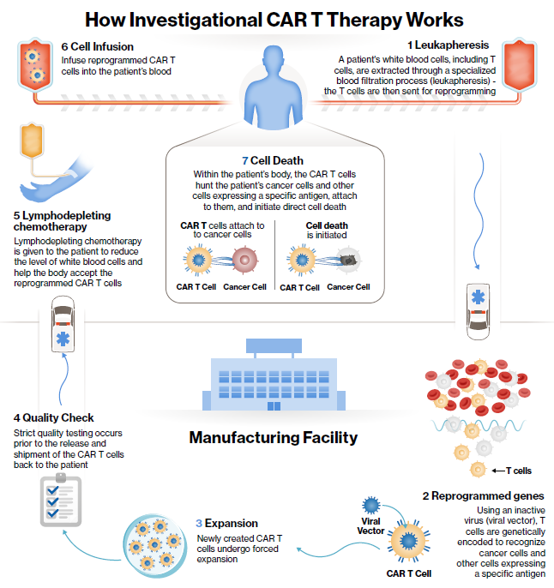

Does the proposed medical service include a registered trademark component with characteristics that distinguishes it from other similar health components?
Yes, tisagenlecleucel will be supplied as a trademarked class 4 biological product (Kymriah®).

If the proposed medical service has a prosthesis or device component to it, does it involve a new approach towards managing a particular sub-group of the population with the specific medical condition?
Not applicable

If applicable, are there any limitations on the provision of the proposed medical service delivered to the patient (i.e. accessibility, dosage, quantity, duration or frequency):
REDACTED

If applicable, identify any healthcare resources or other medical services that would need to be delivered at the same time as the proposed medical service:
No other services would be delivered at the same time as tisagenlecleucel. However lymphodepleting chemotherapy is required a few days prior to tisagenlecleucel administration and some patients may require other treatments shortly thereafter for management of adverse events (e.g. tocilizumab or IVIG).

If applicable, advise which health professionals will primarily deliver the proposed service:
Haematologists and haemotological oncologists

If applicable, advise whether the proposed medical service could be delegated or referred to another professional for delivery: Not appropriate

If applicable, specify any proposed limitations on who might deliver the proposed medical service, or who might provide a referral for it:
REDACTED

If applicable, advise what type of training or qualifications would be required to perform the proposed service as well as any accreditation requirements to support service delivery:
REDACTED

(a) Indicate the proposed setting(s) in which the proposed medical service will be delivered (select all relevant settings):
Inpatient public hospital
Outpatient clinic
REDACTED
- Where the proposed medical service is provided in more than one setting, please describe the rationale related to each:
REDACTED

Is the proposed medical service intended to be entirely rendered in Australia?
Yes
No – please specify below
REDACTED

PART 6c – INFORMATION ABOUT THE COMPARATOR(S)

Nominate the appropriate comparator(s) for the proposed medical service, i.e. how is the proposed population currently managed in the absence of the proposed medical service being available in the Australian health care system (including identifying health care resources that are needed to be delivered at the same time as the comparator service):
The target population in both indications is relapsed and/or refractory to established chemotherapy and relapsed following and/or otherwise ineligible for ASCT. The appropriate comparator is therefore best supportive care (BSC), comprising further minimally toxic chemotherapy, palliative care, or a clinical trial.

Does the medical service that has been nominated as the comparator have an existing MBS item number(s)?
Yes (please provide all relevant MBS item numbers below)
No
There is no specific MBS item number, although elements of BSC would clearly be eligible for funding under Medicare.

Define and summarise the current clinical management pathways that patients may follow after they receive the medical service that has been nominated as the comparator depicting the current clinical management pathway that patients may follow from the point of receiving the comparator onwards including health care resources):
The nominated comparator (BSC) is a largely ineffective, primariliy palliative, last line of therapy for patients in both indications.

(a) Will the proposed medical service be used in addition to, or instead of, the nominated comparator(s)?
Yes
No

If yes, please outline the extent of which the current service/comparator is expected to be substituted:
In both target populations, tisagenlecleucel would represent a new and more effective last line therapy that would substitute and supplement an ill-defined and generally ineffective standard of BSC.

Define and summarise how current clinical management pathways (from the point of service delivery onwards) are expected to change as a consequence of introducing the proposed medical service including variation in health care resources (Refer to Question 39 as baseline):
Tisagenlecleucel would represent a new last-line treatment option, substituting best supportive care. The remainder of the algorithm would remain unchanged. See attached proposed algorithm.

PART 6d – INFORMATION ABOUT THE CLINICAL OUTCOME

Summarise the clinical claims for the proposed medical service against the appropriate comparator(s), in terms of consequences for health outcomes (comparative benefits and harms):
ALL: Based on ELIANA trial
The primary efficacy analysis, including 63 subjects who received a single infusion of tisagenlecleucel manufactured at the US facility reported an overall response rate (ORR) of 82.5% [95%CI: 70.9, 91.0]. All patients who achieved Complete Remission (CR) with or without complete blood count recovery, also achieved Minimal Residual Disease (MRD) in bone marrow. Tisagenlecleucel induced sustained clinical meaningful remission in the majority of patients, with 29 of 52 patients still in remission at data-cut off.
The most common adverse events (AEs; ≥ 20% patients) were: cytokine release syndrome (CRS; REDACTED), hypogammaglobulinaemia (REDACTED), febrile neutropenia (REDACTED), hypotension (REDACTED), pyrexia (REDACTED), tachycardia (REDACTED) and decreased appetite (REDACTED). REDACTED
DLBCL: Based on the JULIET trial
The primary efficacy analysis, including 81 patients who received tisagenlecleucel produced in the US manufacturing facility, with minimum follow up of 3 months post infusion, reported an ORR of 53.1% [95% CI: 41.7%, 64.3%]. Thirty-two patients (39.5%) achieved CR and 11 (13.6%) achieved PR. REDACTED. The probability of being event-free at Month 3 and 6 was estimated at 79.7% [95% CI: 61.7%, 89.9%] and 73.5% [95% CI: 52.0%, 86.6%] respectively.
REDACTED
The most common tisagenlecleucel-related AEs (>10% patients) of any grade were: CRS, REDACTED

Please advise if the overall clinical claim is for:
Superiority
Non-inferiority

Below, list the key health outcomes (major and minor – prioritising major key health outcomes first) that will need to be specifically measured in assessing the clinical claim of the proposed medical service versus the comparator:
Safety Outcomes: Rates of adverse events (AEs) and serious adverse events (SAEs), events of special interest (cytokine release syndrome, tumour lysis syndrome and febrile neutropenia) events suspected to be drug related and those leading to treatment/study withdrawal.
Clinical Effectiveness Outcomes: Overall response rate (ORR) progression free survival (PFS) overall survival (OS) health related quality of life (HRQoL) and healthcare resource utilisation (HCRU).

PART 7 – INFORMATION ABOUT ESTIMATED UTILISATION

Estimate the prevalence and/or incidence of the proposed population:
REDACTED

Estimate the number of times the proposed medical service(s) would be delivered to a patient per year:
The proposed treatment regimen is a single infusion per lifetime

How many years would the proposed medical service(s) be required for the patient?
The proposed treatment regimen is a single infusion per lifetime

Estimate the projected number of patients who will utilise the proposed medical service(s) for the first full year:
REDACTED

Estimate the anticipated uptake of the proposed medical service over the next three years factoring in any constraints in the health system in meeting the needs of the proposed population (such as supply and demand factors) as well as provide commentary on risk of ‘leakage’ to populations not targeted by the service:
REDACTED

PART 8 – COST INFORMATION

Indicate the likely cost of providing the proposed medical service. Where possible, please provide overall cost and breakdown:
The cost of providing the service will be multi-faceted and has not yet been fully defined. Additional information around the likely total cost and its break down will be provided in due course.

Specify how long the proposed medical service typically takes to perform:
REDACTED

If public funding is sought through the MBS, please draft a proposed MBS item descriptor to define the population and medical service usage characteristics that would define eligibility for MBS funding.
Category Not applicable - See Part 2, Question 6.g.

Proposed item descriptor: Not applicable
Fee: $Not applicable

PART 9 – FEEDBACK
The Department is interested in your feedback.

How long did it take to complete the Application Form?
Two weeks

(a) Was the Application Form clear and easy to complete?
Yes
No

If no, provide areas of concern:
The text form fields are difficult to use and have insufficient space for many responses, including several for which a different (larger) word count constraint is specified in the question.

(a) Are the associated Guidelines to the Application Form useful?
Yes
No

If no, what areas did you find not to be useful?
Insert feedback here

(a) Is there any information that the Department should consider in the future relating to the questions within the Application Form that is not contained in the Application Form?
Yes
No

If yes, please advise:
Insert feedback here

Figure 1: Summary clinical management algorithm for paediatric ALL prior to tisagenlecleucel availability
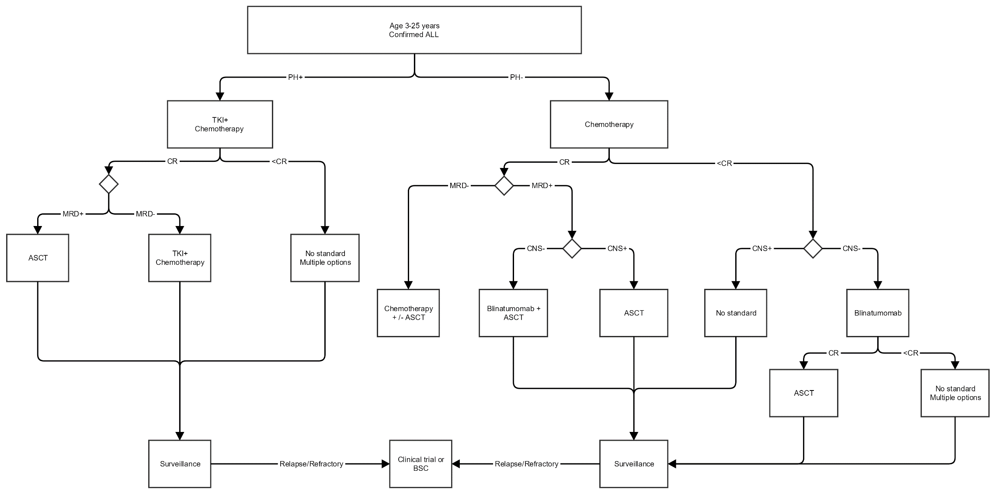
Abbreviations: ALL = acute lymphoblastic leukemia; ASCT = allogenic stem cell transplant; CNS = central nervous system involvement; CR = Complete response; BSC = Best Supportive Care; MRD = Minimum Residual Disease; PH = Philadelphia chromosome; TKI = tyrosine kinase inhibitor (imatinib, dasatinib, nilotinib, ponatinib).

Figure 2: Summary clinical management algorithm for paediatric ALL with tisagenlecleucel availability
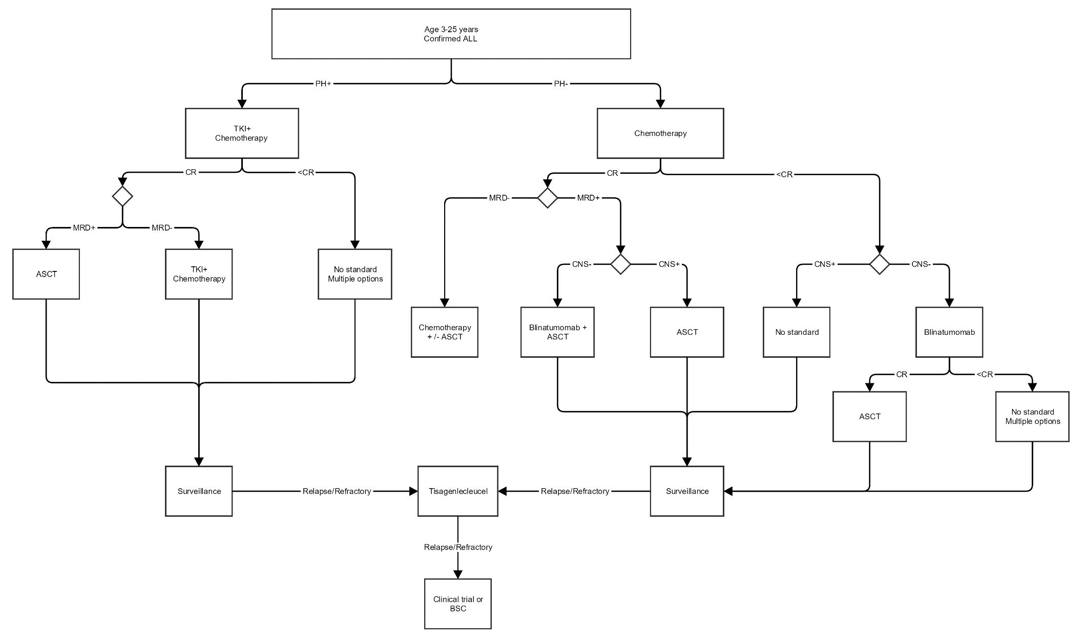
Abbreviations: ALL = acute lymphoblastic leukemia; ASCT = allogenic stem cell transplant; CNS = central nervous system involvement; CR = Complete response; BSC = Best Supportive Care; MRD = Minimum Residual Disease; PH = Philadelphia chromosome; TKI = tyrosine kinase inhibitor (imatinib, dasatinib, nilotinib, ponatinib).

Figure 3: Summary clinical management algorithm for adult DLBCL prior to tisagenlecleucel availability
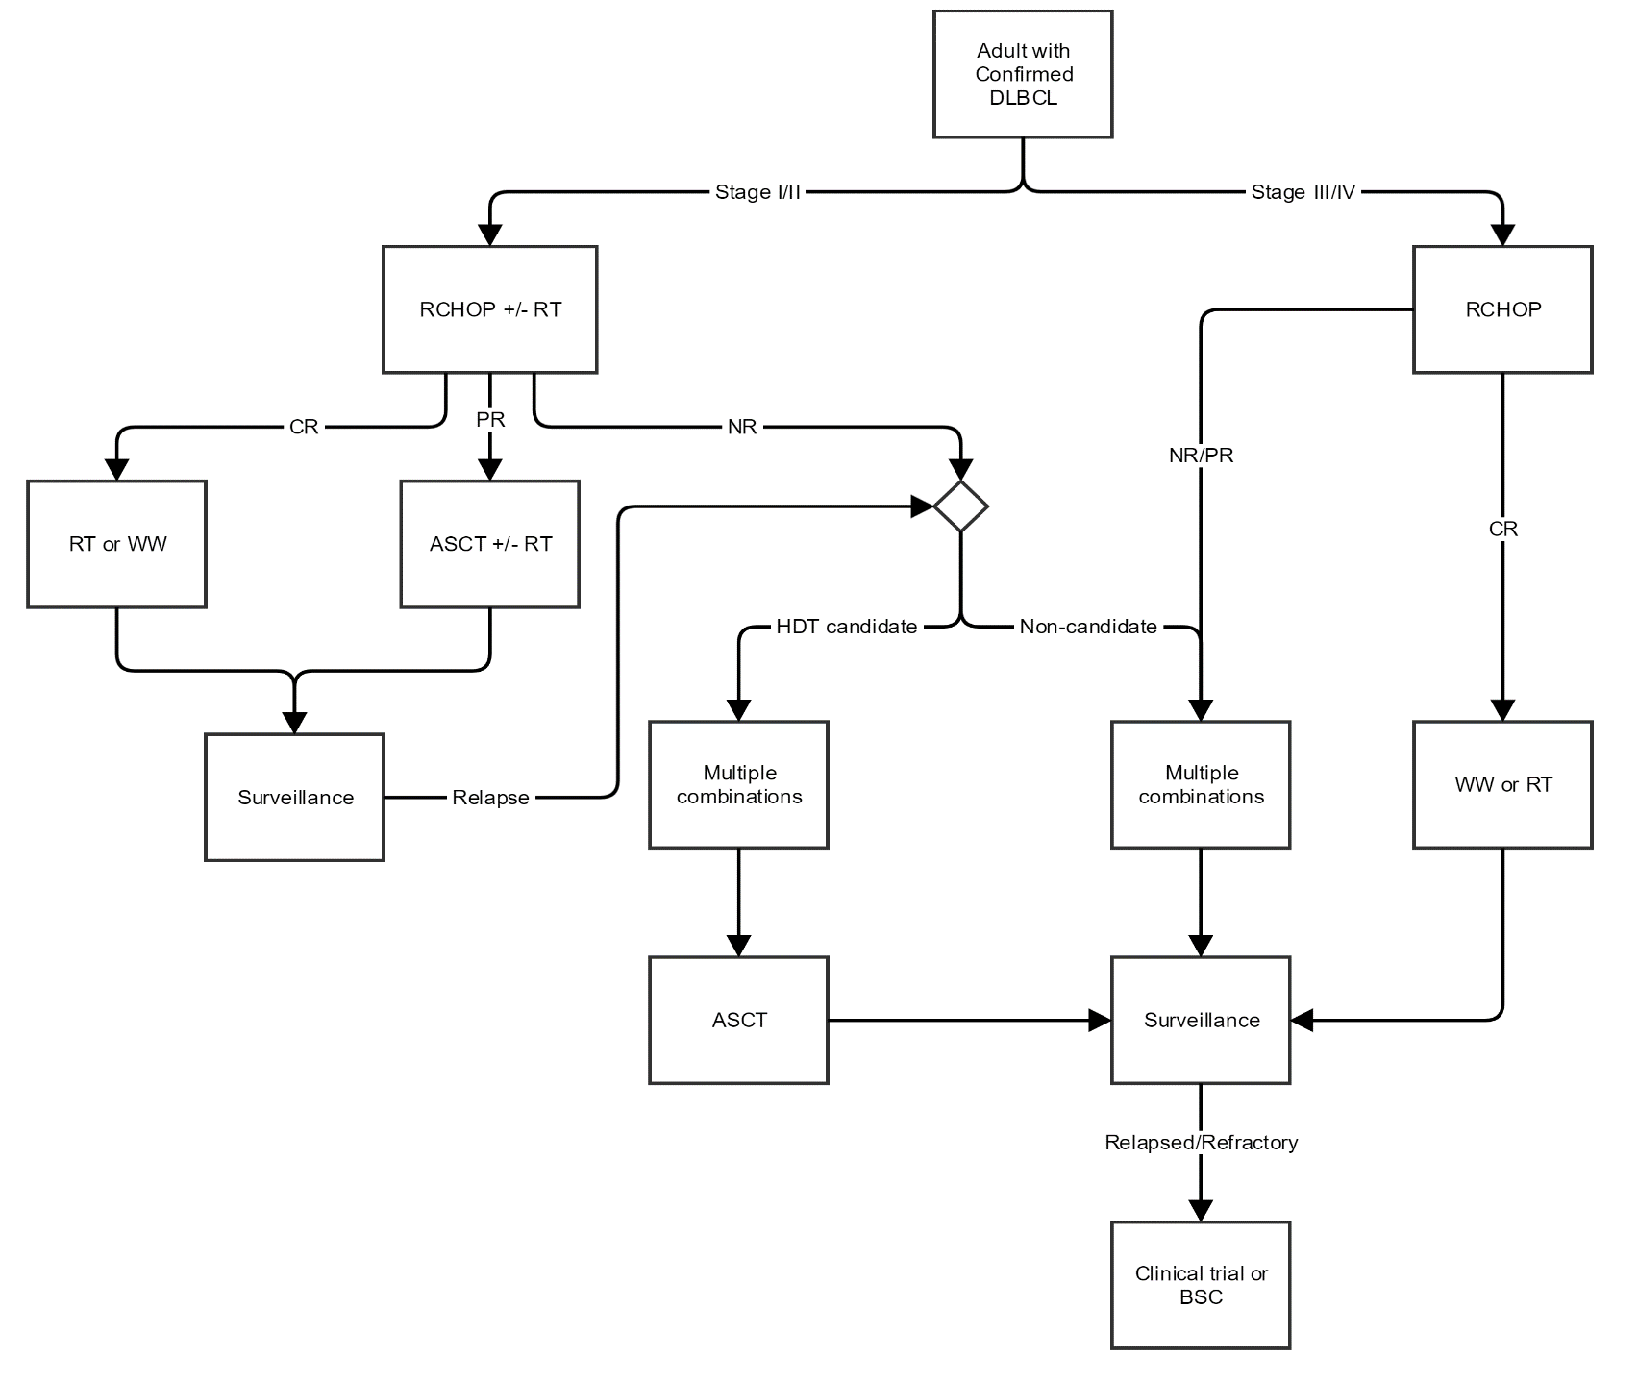
Abbreviations: ASCT = Autologous Stem Cell Transplant; BSC = Best Supportive Care; CR = Complete Response; NR = No Response; PR = Partial Response; RCHOP = Rituximab, Cyclophosphamide, Doxorubicin, Vincristine & Prednisolone; RT = Radiotherapy; WW = Watch and Wait;
Figure 4: Summary clinical management algorithm for adult DLBCL with tisagenlecleucel availability
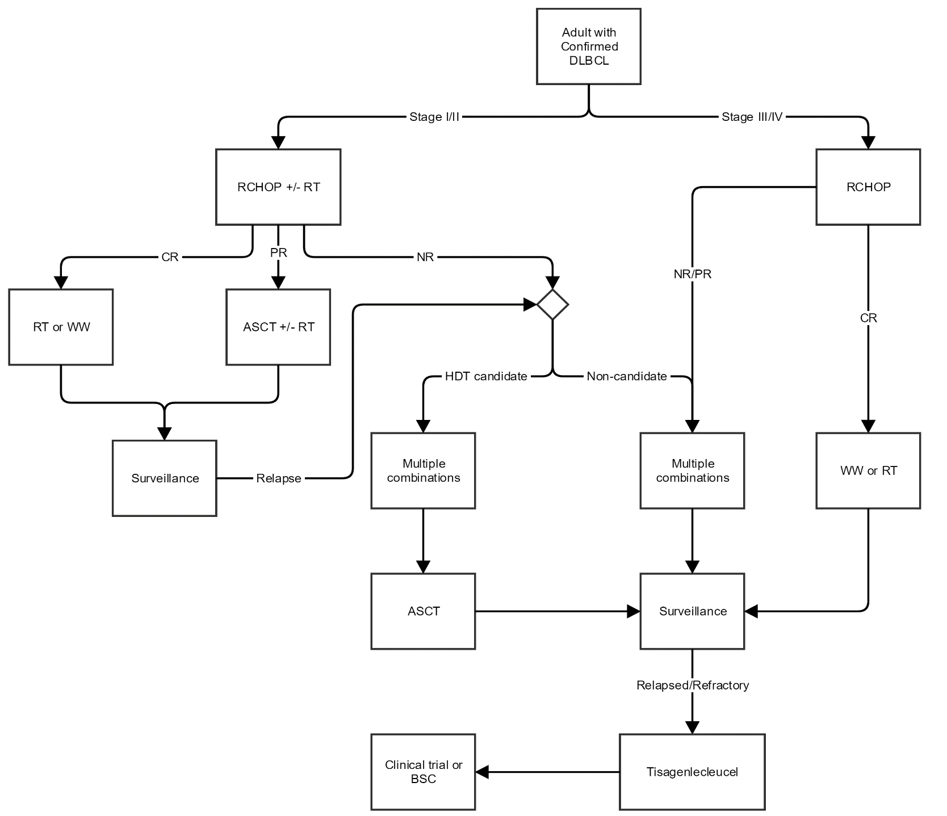
Abbreviations: ASCT = Autologous Stem Cell Transplant; BSC = Best Supportive Care; CR = Complete Response; NR = No Response; PR = Partial Response; RCHOP = Rituximab, Cyclophosphamide, Doxorubicin, Vincristine & Prednisolone; RT = Radiotherapy; WW = Watch and Wait

