1273

Final Decision Analytic Protocol to guide the assessment of matrix-induced autologous chondrocyte implantation (MACI)

October 2012

Table of Contents
MSAC and PASC 3
Purpose of this document 3
Purpose of application 4
Background 4
Current arrangements for public reimbursement 4
Regulatory status 5
Intervention 6
Description 6
Delivery of the intervention 7
Prerequisites 8
Co-administered and associated interventions 8
Listing proposed and options for MSAC consideration 10
Proposed MBS listing 10
Clinical place for proposed intervention 12
Clinical claim 21
Outcomes and health care resources affected by introduction of proposed intervention 21
Clinical outcomes 21
Health care resources 22
Proposed structure of economic evaluation (decision-analytic) 23
References 29

MSAC and PASC

The Medical Services Advisory Committee (MSAC) is an independent expert committee appointed by the Minister for Health and Ageing (the Minister) to strengthen the role of evidence in health financing decisions in Australia. MSAC advises the Minister on the evidence relating to the safety, effectiveness, and cost-effectiveness of new and existing medical technologies and procedures and under what circumstances public funding should be supported.

The Protocol Advisory Sub-Committee (PASC) is a standing sub-committee of MSAC. Its primary objective is the determination of protocols to guide clinical and economic assessments of medical interventions proposed for public funding.

Purpose of this document

This document is intended to provide a decision analytic protocol to guide the assessment of an intervention for a particular population of patients.

The protocol guiding the assessment of the health intervention has been developed using the widely accepted “PICO” approach. The PICO approach involves a clear articulation of the following aspects of the question for public funding that the assessment is intended to answer:

Patients – specification of the characteristics of the patients in whom the intervention is to be considered for use
Intervention – specification of the proposed intervention and how it is delivered
Comparator – specification of the therapy most likely to be replaced by the proposed intervention
Outcomes – specification of the health outcomes and the healthcare resources likely to be
affected by the introduction of the proposed intervention

Purpose of application

A proposal for an application, received from Sanofi-Aventis Australia Pty Ltd by the Department of Health and Ageing (DoHA) in January 2012, stated (on the summary sheet) that it intended to request MBS listing of matrix-induced autologous chondrocyte implantation (MACI) and autologous chondrocyte implantation (ACI) for treatment of chondral defects in knee and ankle joints.

On the basis of further correspondence received from the applicant and advice from the MSAC expert standing panel, PASC determined that it would not be appropriate to assume that MACI and ACI are clinically equivalent and therefore resolved that the question for public funding should be limited to the comparative effectiveness, safety and cost-effectiveness of MACI.

On the basis of the clarification provided in the applicant’s response to the draft DAP, which made it clear that the applicant intended seeking an MBS listing for chondral defects in the knee only on the grounds that the Australian Orthopaedic Association (AOA) did not endorse the use of MACI in the ankle, PASC resolved that the question for public funding should be limited to the use of MACI for chondral defects of the knee only.

Background

Current arrangements for public reimbursement

On 12 May 2009, Genzyme Australasia Pty Ltd requested that MSAC consider listing of MACI/ACI on the MBS for chondral defects of the knee and ankle. At this meeting, MSAC provided the following advice:

“MSAC does not support public funding for matrix‐induced autologous chondrocyte implantation or autologous chondrocyte implantation for the treatment of chondral defects in the knee and other joints, due to the increased cost compared to existing procedures and the lack of evidence showing short term or long‐term improvements in clinical outcomes”.

As a result, on 1 November 2011, MBS item numbers 49557 [KNEE, diagnostic arthroscopy of (including biopsy, simple trimming of meniscal margin or plica)] and 49563 [KNEE, arthroscopic surgery of, involving 1 or more of: meniscus repair; osteochondral graft; or chondral graft] were amended to specifically exclude procedures related to MACI/ACI. In addition, MACI/ACI was removed from the Prostheses List in February 2012. Consequently, MACI/ACI is no longer publicly funded, nor funded under private health insurance.

PASC noted that, although an explanatory note (T8.121) had been added to MBS item numbers 49557 and 49563 indicating that MSAC evaluated the available evidence and did not support public funding for MACI or ACI for the treatment of chondral defects in the knee and other joints and that Medicare benefits are not payable in association with this technology, the same explanatory note does not appear to have been added to MBS items relating to diagnostic arthroscopy or arthroscopic surgery of the ankle (MBS Items 49700 and 49703). PASC noted that utilisation of the equivalent MBS items for the ankle was relatively low; however, PASC resolved that the Department of Health should follow up on whether those items should be amended to specifically exclude procedures relating to MACI/ACI

and should clarify the reimbursement status for MACI/ACI in the management of chondral defects in the ankle.

Justification for reconsideration by MSAC

The justification for reconsideration of an application to include MACI on the MBS is that new evidence is to become available. The SUMMIT trial, a prospective randomised trial currently being undertaken by Genzyme (a fully owned subsidiary of Sanofi-Aventis), which compares MACI to microfracture is due to report in September 2012. The proposal stated that the application would analyse results from the SUMMIT trial in combination with results of other recently published studies comparing MACI to microfracture and 10-year follow-up data from a study reported by Bentley in 2003 that compared ACI to mosaicplasty.

Furthermore, the applicant claimed that the application considered at the MSAC December 2010 meeting did not include a full cost-effectiveness analysis due to a lack of comparative effectiveness data. Only a cost analysis comparing MACI/ACI, mosaicplasty and microfracture was presented in the application. It was proposed that results of a full economic evaluation could be presented in a new application based on the results from a 2011 Cochrane review, along with the 10-year follow-up data from the Bentley study and the SUMMIT trial results. The economic evaluation was proposed to be presented as a stepped economic analysis, translating the clinical trial data into the costs and outcomes likely to be realised in real-life Australian clinical practice, over a longer time frame (i.e. 10+ years). The proposal stated that this would help address the concern that MSAC has expressed over the lack of certainty surrounding the long-term benefits associated with MACI over its comparators in the Australian clinical setting as it would extrapolate the effect of MACI using long-term study data.

PASC recalled that a key concern raised by MSAC at the time of its last consideration of MACI/ACI was the lack of evidence in relation to long term functional outcomes associated with these procedures. PASC noted that, at the time of MSAC’s last consideration, there were no studies available that provided evidence of comparative performance of MACI/ACI over the long-term (>5 years). On this basis, MSAC determined there was not sufficient evidence to conclude that MACI/ACI is superior to other treatments. PASC therefore, in the draft version of this DAP, advised that the applicant should only submit a new application if this key concern is directly addressed by the data from the SUMMIT trial. The applicant’s response to the Consultation DAP argued that a requirement for 5-year RCT data is unreasonable, and would unnecessarily delay access to MACI and claimed that data from the 2-year SUMMIT trial, together with other existing clinical studies, will be sufficient to establish the clinical efficacy and safety of MACI. PASC advises that any trial data presented to MSAC is likely to be more persuasive to MSAC if the trial is applicable to Australian population. Given the short time horizon of the SUMMIT trial (2 years), extrapolation of data would be necessary to estimate costs and benefits over a relevant time horizon (as acknowledged by the application). PASC noted that this extrapolation
step would introduce substantial uncertainty around the results of an economic analysis.

Regulatory status

A search of the Australian Register of Therapeutic Goods (ARTG) located approvals for the sealant and membrane used in MACI, as follows:

TISSEEL VH S/D (frozen) fibrin sealant syringe (ARTG number 147141) sponsored by Baxter Healthcare Pty Ltd, is approved by the TGA for the following: ‘TISSEEL is indicated as a sealant and/or adhesive for use in autologous chondrocyte implantation (ACI) or matrix- induced autologous chondrocyte implantation (MACI) procedures’.

Matricel ACI-MAIX Collagen Membrane - Tissue reconstructive material, biological (ARTG number 121056) sponsored by Verigen Australia Pty Ltd and manufactured by Matricel GmbH, Germany has TGA approval as a ‘component for the seeding of Autologous Cells for the purpose of joint implant’.

The proposal notes that the biological implant product used in MACI is currently exempt from Part 3-2 (Registration and listing of therapeutic goods) of the Therapeutic Goods Act 1989 (the Act), i.e., exempt from the requirement to register the product on the ARTG. The biological implant product used in MACI, however, complies with Part 3-3 (Manufacturing of therapeutic goods) of the Act which is the requirement to have a current Good Manufacturing Practice (GMP) licence. Under the new Biologicals Regulatory Framework, the biological implant product used in MACI can continue to be supplied under the existing requirements during the three year transitional period which commenced in May 2011. Post the transition period, which ends in May 2014, the biological implant product used in MACI must be registered on the ARTG in order to continue supply of the product. It also notes that a submission is expected to be made to the TGA requesting approval of the biological implant product used in MACI for the indication of “repair of symptomatic cartilage defects of the knee (Modified Outerbridge Grade III or IV) in skeletally mature patients” in November 2012.

Intervention

Description

Hyaline articular cartilage provides a smooth and resilient surface at the ends of bones, allowing virtually frictionless movement within the knee joint. It acts as a shock absorber, cushioning the bone from forces of more than five times the body’s weight.

Damage to the articular cartilage can be caused directly by injury (often as a result of sporting activity), or spontaneously (referred to as osteochondritis dissecans [OCD]). Loss of cartilage alone is referred to as chondral damage, whereas loss of bone and cartilage is known as osteochondral damage. Symptoms associated with the loss of hyaline cartilage include knee pain, knee swelling, knee locking and giving way of the knee joint. It has been shown that articular cartilage damage to the joint surface can lead to osteoarthritis as a consequence of its limited capacity for repair.

Arthroscopic lavage and debridement of injured synovial joints are typically used in the first line treatment of chondral lesions in Australia. Arthroscopic lavage rids the joint of inflammatory mediators, loose cartilage and any cartilaginous debris that may harbour in the synovial space and cause synovitis, joint effusion or pathomechanical problems such as crepitus. Debridement removes loose cartilage and collagenous debris that may facilitate a degenerative change or accentuate a traumatic event.

When lavage and debridement fail to relieve symptoms (or where arthroscopic lavage and debridement are not indicated), additional procedures which aim to fill the cartilage defect are considered. These can be categorised as:

• Stimulation of repair by methods that allow entry of marrow cells into the cartilage defect
(predominantly microfracture); and
• Direct replacement of cartilage, either by:
o Mosaicplasty which requires use of osteochondral autografts taken from a non- weight-bearing area to fill the defect; or
o MACI/ACI which involves culturing the chondrocyte cells and transplanting them back into the defect with the aim of the chondrocytes synthesising cartilage to repair the defect.

Genzyme (now Sanofi-Aventis Australia Pty Ltd) has been granted patents in Australia covering the biological implant product used in MACI (including the use of chondrocytes to manufacture the product). These patents will expire in 2017. Autologous chondrocytes isolated from a cartilage biopsy, are cultured and then seeded onto a purified, resorbable, porcine-derived collagen type I/III membrane (ACI-Maix™) manufactured by Matricel GmbH, Germany.

Delivery of the intervention

MACI is a two-stage operative approach that is generally conducted over a period of approximately five weeks.

The first step of the MACI procedure is to harvest a small amount of the patient’s cartilage (i.e., biopsy) from a lesser load bearing, non-articulating surface of the joint. The surgeon may perform an arthroscopy specifically to obtain a biopsy, or may obtain the cartilage biopsy while performing another arthroscopic procedure on the knee.

During the arthroscopy, an arthroscope is inserted into the affected knee joint through a small incision in the skin, allowing the surgeon to see the inside of the joint. Another small incision is made to allow the insertion of other instruments.

Once complete, the cartilage biopsy is placed into transport media and packaged into a specifically designed biopsy transport kit supplied by the Sanofi-Aventis Australia Pty Ltd’s cell processing facility (Verigen) in Perth, Western Australia. The kit is then shipped to the processing facility, where the cells are cultured aseptically over a period of several weeks to expand the cell population from a few hundred thousand to over 10 million cells. These cells are seeded onto the sterile ACI-Maix™ membrane at a density between 0.5 million to 1.0 million cells per cm2. Once seeded, the MACI implant is returned to the surgeon for the second stage of the process, implantation.

Once the MACI implant is received by the surgeon, the MACI implant is re-implanted into the joint via a second procedure. The surgeon will make an incision in the knee and prepare the defect by clearing away any and all damaged tissue. Fibrin sealant is applied as a thin layer into the bottom of the empty defect. The implant is then placed in the defect in the subchondral bone and gentle pressure is applied to allow polymerisation of the fibrin sealant until the membrane is secured. Over several

months, these cells create a matrix that covers the articular surface – in effect, replacing the lost cartilage in the knee.

The proposal stated that MACI would be a once-off procedure over the lifetime of the patient. In order to facilitate both the clinical and economic evaluation, the Consultation DAP suggested that the proposed item descriptor for MACI should include a limit of the number of times the item could be claimed under the MBS. PASC resolved that the item descriptor should state that the item is claimable only once per knee per patient per lifetime. In its response to the Consultation DAP, the applicant claimed that limiting the number of times the intervention may be used in a patient to one procedure per knee, per lifetime may place patients who may incur another lesion in the same knee at a disadvantage. The applicant therefore suggested that MACI implant should instead be limited to once per lesion, per lifetime. Expert advice suggested that it was, on occasion, appropriate to repeat MACI for the same lesion. PASC advised that the suggested listing could be expanded to allow for repeat and additional procedures however, if the listing were expanded to permit more than one service per patient per lifetime, then the application should also present evidence of effectiveness of repeat or additional MACI procedures. Furthermore, the cost-effectiveness analysis would need to be adjusted to include the costs and benefits of repeat or additional MACI procedures. Alternatively, if the applicant considers that the risk of a repeat or additional MACI in a patient is so low that it should be considered negligible then the application should present evidence (e.g., from a registry) demonstrating the rate of repeat or additional MACIs in patients having had MACI.

Prerequisites

MACI is performed in the same environment and by the same medical professionals as microfracture and mosaicplasty – that is, it is performed in a specialised procedure area (generally a hospital) by orthopaedic surgeons and assisted by other staff. The MACI implant procedure (harvesting of biopsy and subsequent implantation of MACI implant), due to the surgical nature, is limited to hospitals with orthopaedic specialised surgical theatres. MACI will be performed by orthopaedic surgeons with skills in the assessment and treatment of knee injuries including arthroscopic surgery.

The proposal states that special training is required in the techniques of MACI and that Sanofi-Aventis Australia Pty Ltd provides training for orthopaedic surgeons and hospital staff that perform the MACI procedure. Specifically, hospital staff that handle surgical procedures involving the collection of donor material for MACI undergo training for receipt, collection and dispatch of the biopsy and the transport packaging system. This training is completed prior to approval and receipt of a collection/transport kit. Re-training is completed based upon a quarterly review of recorded transport deviations as well as the number of donor biopsies submitted to the processing plant (2 in 12 months). Time taken to complete the training is approximately one hour.

Co-administered and associated interventions

In addition to the procedures for procurement of the chondrocytes and for implantation of the cultured chondrocytes for which listing on the MBS is to be requested, the proposal notes that patients will require other MBS services including MBS items 23061 and 23063 (anaesthesia for procurement of chondrocytes and for implantation, Table 1 and Table 2, respectively) and 51303 (assistance for both procurement of chondrocytes and for implantation, Table 3). Further, patients will require supply of the materials (e.g., sealant, membrane upon which chondrocytes are cultured) to be

used in MACI. As noted in the proposal, the TISSEEL Fibrin Sealant Syringe is currently priced at $380 and the MACI implant (including costs for the retrieval of chondrocytes, processing, storage and transport of the MACI implant from the processing plant to the hospital) is currently priced at $11,400. These two costs represent the prostheses portion of MACI. These materials are currently not listed on the Prostheses Listed (but were listed until February 2012). Correspondence from the applicant states that, although it is the intention of the applicant to have MACI re-listed on the Prostheses List, it believed that a submission to the Prostheses List Advisory Committee (PLAC) was not necessary and that it assumed that MACI would be automatically listed on the Prostheses List should it be granted an MBS listing. PASC advised that the applicant’s understanding that re-listing of MACI on the Prostheses List would be automatic should MACI gain MBS listing needed to be corrected. Should MACI be recommended for inclusion on the MBS by MSAC and the listing be approved by Cabinet, an application would need to be submitted to the PLAC requesting inclusion of MACI on the Prostheses
List.

Table 1: MBS item descriptor for anaesthesia, applicable during biopsy
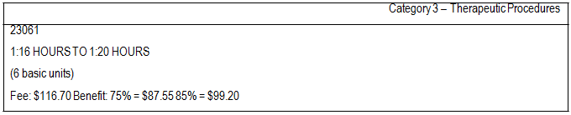
Table 2: MBS item descriptor for anaesthesia, applicable during implant
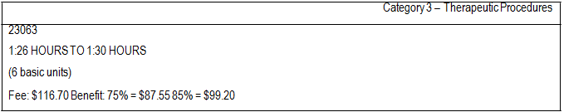
Table 3: MBS item descriptor for assistance, applicable during biopsy and implant
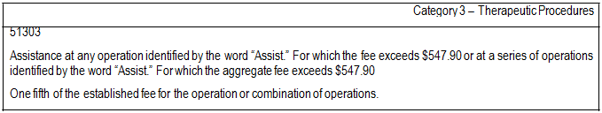

The proposal states that suitability for MACI is determined through arthroscopy and/or magnetic resonance imaging (MRI) where the location, depth and size of the lesion, as well as the quality of the surrounding cartilage degree of undermining cartilage and the status of the opposing chondral surface can be evaluated. Although the proposal acknowledges that patients will require MRI (or CT arthrogram where MRI is contraindicated) or arthroscopy for assessment of lesion size, it proposes to exclude costs for such investigations from the economic and financial analyses to be presented in the submission on the grounds that it claims patients are assessed for lesion size regardless of treatment selection. PASC considered that all patients should have been assessed by MRI and arthroscopy prior to consideration of MACI as a possible intervention. On this basis, PASC considered that the exclusion

of costs for such investigations from the economic evaluation was reasonable as the costs would be common to both the proposed and current scenarios.

PASC noted that the list of associated interventions nominated by the proposal did not include any resources used in post-operative care. PASC resolved that resources used in postoperative care (including follow-up assessments and rehabilitation services) should be included in the list of associated interventions.

Listing proposed and options for MSAC consideration

Proposed MBS listing

The proposal states that prior to the determination that MACI would no longer be reimbursed under the MBS, clinicians were utilising MBS item numbers 49557 (diagnostic arthroscopy of knee [including biopsy, simple trimming of meniscal margin or plica]) and 49563 (arthroscopic surgery of knee, involving 1 or more of: meniscus repair; osteochondral graft; or chondral graft) to claim for MACI procedures. The proposal states that clinicians consider that the benefits for MBS item numbers 49557 and 49563 adequately reflect the time and expertise required for MACI in terms of remuneration.

Table 4 provides details of the MBS listing that is to be proposed for the first surgical procedure, biopsy for collection of chondrocytes, and Table 5 provides details of the MBS listing to be proposed
for the second surgical procedure, implantation of cultured chondrocytes.

Table 4: Proposed MBS item descriptor for biopsy
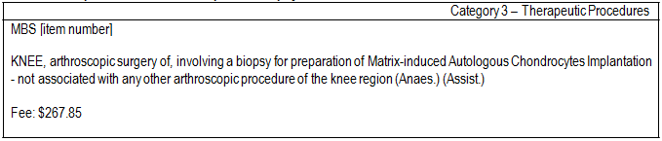
Table 5: Proposed MBS item descriptors for MACI implantation
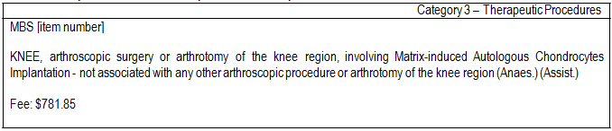

The proposed schedule fees are identical to the current (May 2012) schedule fees for MBS item numbers 49557 (diagnostic arthroscopy of
the knee) and 49563 (arthroscopic surgery of the knee). The proposal estimates the likely market prices for the biopsy portion of the procedure as between
$267.85 [MBS item 49557] and $705.00 [AMA number fee MW205, which corresponds to MBS item number 49557] but does not provide an average fee (with a distribution around that average fee). For the implantation portion of the procedure, the proposal estimates the market price ranges between
$781.85 [MBS item number 49563] and $2305.00 [AMA number fee MW225, corresponds to MBS item

number 49563] but does not provide an average fee (with a distribution around that average fee). PASC resolved that data for the distribution of actual fees for these items should be sought and presented in the application and that the economic evaluation should adopt a societal (or more specifically, a healthcare perspective) and should thus include both costs to the MBS and out-of- pocket costs borne by patients.

The proposal notes that as no profit can be derived from trade in human tissue under the Human Tissue Act, autologous human tissue prostheses such as the one developed for MACI are not profitable. As a result, the price charged for the MACI implant represents the service cost of providing the implant (including only those costs legitimately incurred for the retrieval, processing, storage and transport of the MACI implant from the processing plant to the hospital), currently priced at $11,400. In addition, the TISSEEL Fibrin Sealant Syringe is currently priced at $380.00. These two costs represent the prostheses portion of MACI and were listed on the Prostheses List until February 2012.

The proposal states that, ideally, the procedure should be targeted towards patients with symptomatic full thickness chondral or osteochondral defects which are surrounded by healthy, normal cartilage in an otherwise healthy knee.

The MACI procedure is suitable for patients who fulfil the following criteria:

• Cause of defect trauma or osteochondritis dissecans (OCD);
• The patient is accepting of a rehabilitation program; and
• Defect size greater or equal than 2 cm2.

The MACI procedure is not suitable for patients who fulfil the following criteria:

• Focal articular cartilage defects associated with rheumatoid arthritis, inflammatory arthritis or osteoarthritis;
• Unstable or mal-alignment joints, excess bow leg or knock knee deformities, unless corrected prior to or concurrently with MACI procedure;
• Maltracking patella if not corrected prior to or concurrent with MACI procedure;
• Systemic or localised infections;
• Obesity greater than one and a half times the ideal body weight for height;
• Blood tests positive for HIV-1, HIV-2, Hepatitis-B, Hepatitis-C, HTLV or Syphilis; and
• Known history of allergy or hypersensitivity to antibiotics, antifungal agents i.e. gentamicin, other amino glycosides or materials derived of bovine or porcine origin.

In addition to the criteria listed above, as discussed in the section describing the intervention (see p.6), arthroscopic lavage and debridement of injured synovial joints is typically used in the first line treatment of chondral lesions in Australia and MACI is to be reserved for situations where lavage and debridement have failed to relieve symptoms (or is not indicated). In addition, the proposal suggested that MACI should be limited to patients aged 15-55 years. PASC resolved that the proposed item descriptors for MACI should be revised (e.g., as shown in Table 6) to reflect the described positioning of the procedure in practice. It would need to demonstrated in an application that the positioning in the clinical trial providing the key evidence was consistent with the positioning of the procedure in practice e.g., limited to patients aged 15-55 who have previously undergone arthroscopic lavage or

debridement (or in whom such treatment is not indicated) and still have symptoms, and who satisfy other specific criteria (e.g., in terms of lesion size, cause of injury, co-morbidities).

Table 6: Example of a revised proposed MBS item descriptor for biopsy
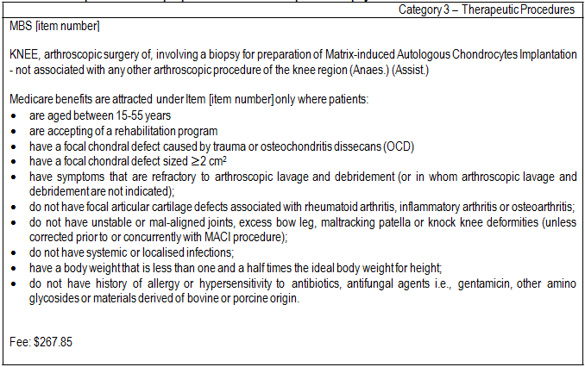

Clinical place for proposed intervention

The clinical pathway for patients with articular pain as presented in the proposal is shown in Figure 1. The proposal states that patients with articular pain will first undergo non-surgical conservative treatment. Patients that have ongoing symptoms despite conservative treatment will have formal diagnosis through arthroscopy or magnetic resonance imaging (MRI) at which point lesion size will be determined. If the patient is aged between 15-55 years with a focal defect in an otherwise normal knee, consideration is given to surgical intervention.

Clinical experts advised that children under 15 would rarely experience the conditions in which MACI was indicated. They also advised that age was a prognostic indicator of a successful procedure. It was considered that chondrocyte cells of older patients do not grow as well as those of younger patients. However, the clinical experts noted that the specific age cut-off of 55 years (versus 50 versus 45 years) was arbitrary.

The clinical pathway as presented in the proposal did not include debridement or arthroscopic lavage despite the claim that MACI would typically be used in patients in whom debridement or arthroscopic lavage had failed. However, the clinical experts advised that debridement and/or arthroscopic lavage would generally be performed at the same time as the original diagnostic arthroscopy if indicated.

Figure 1: Clinical pathway for the treatment of patients with articular pain
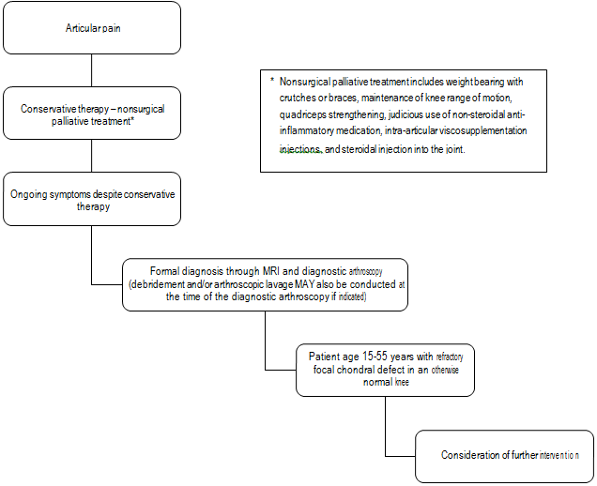

The current clinical management algorithm (as provided in the proposal) for patients requiring additional cartilage repair in the scenario where MACI is not reimbursed is shown in Figure 2. In the current scenario, the proposal claimed that patients with symptomatic injury and a lesion between 2 and 4 cm2 undergo either mosaicplasty or microfracture, whereas patients with symptomatic injury and a lesion >4 cm2 receive no treatment.

Figure 2: Current clinical management algorithm (as provided in the proposal) for patients requiring additional cartilage repair showing a scenario where MACI not publicly funded

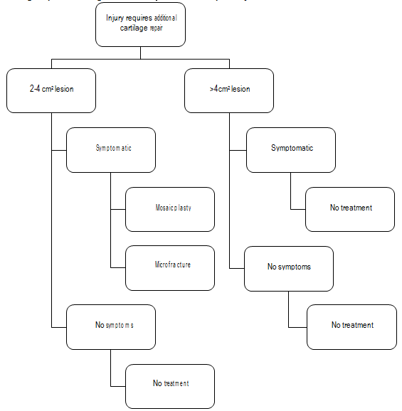

The proposed clinical management algorithm (as provided in the proposal) for patients requiring additional cartilage repair that would apply in the scenario where MACI is reimbursed is shown in Figure 3. In the proposed scenario, patients with symptomatic injury and a lesion between 2 and
4 cm2 are claimed to undergo either mosaicplasty, microfracture or MACI, whilst patients with
symptomatic injury and a lesion >4 cm2 receive either no treatment or MACI.

Figure 3: Proposed clinical management algorithm for patients requiring additional cartilage repair showing a scenario where MACI is publicly funded

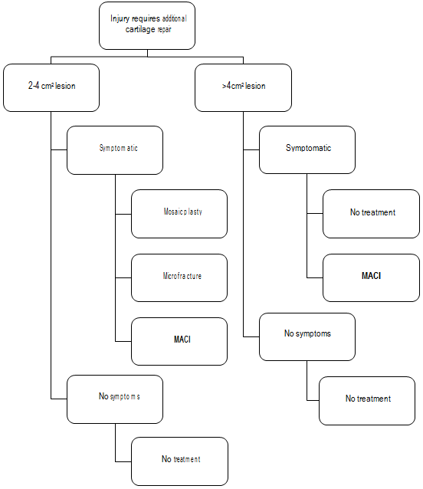
Patients with lesions less than 2 cm2 were not included as MACI is assumed to not be indicated in the management of such lesions. Figure 2 and Figure 3 do not consider the possibility that patients with symptomatic lesions sized between 2 and 4 cm2 may not receive active treatment. PASC noted expert advice that some clinicians would prefer to manage patients by watchful waiting (with conservative management) rather than microfracture in the scenario where MACI was not available. As discussed in further detail below, advice was received during the consultation period indicating that there was minimal use of microfracture in practice.

The clinical experts advised that microfracture could be used in patients with larger lesions but this was probably not included as an option for patients with lesions >4 cm2 in the algorithm because results are significantly inferior in patients with larger lesions.

PASC determined that the clinical place for MACI was, primarily, in substitution of conservative management (or watchful waiting) as shown in Figure 4.

Figure 4: Clinical management algorithm for patient with ongoing pain from a chondral defect showing the clinical place for MACI should it be publicly funded
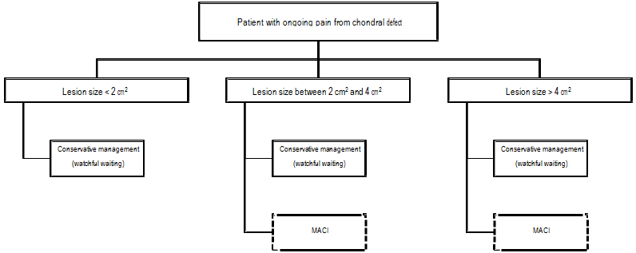
Following the consultation period, upon consideration of both expert advice and advice from the sponsor, PASC resolved that MACI would not be used in place of either osteotomy or arthroscopic lavage and debridement and thus neither osteotomy nor arthroscopic lavage and debridement were appropriate comparators. It was noted that knee replacement surgery is predominantly performed in patients aged >55 years, as shown in Figure 5. PASC also advised that data from the MBS and the Joint Registry should be reviewed to assist in the identification of the age range of likely recipients of treatment with MACI.

Figure 5 Distribution of utilisation of MBS item 49518 (knee replacement) by gender and age

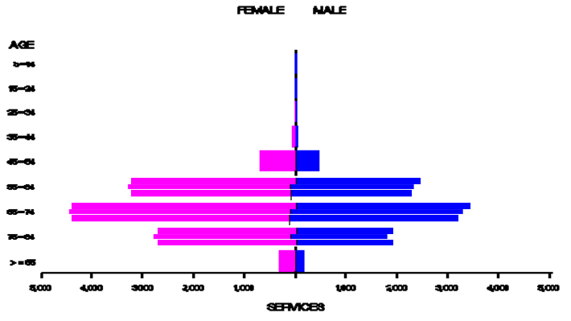Comparator

Microfracture is a technique where the subchondral bone is violated with an awl, allowing bleeding and the passage of mesenchymal stem cells (multipotent stem cells that can differentiate into a variety of lineages), red blood cells, platelets, fat, and growth factors from the bone marrow. This allows for a predominately fibrocartilage repair with a varying amount of hyaline cartilage. Microfracture has become the dominant technique as it is able to be performed arthroscopically.

Mosaicplasty is a technique of creating an osteochondral autograft by harvesting and transplanting many small cylindrical osteochondral plugs from the less weight-bearing periphery of the patellofemoral area and inserting them into drilled tunnels in the defective section of cartilage.

The proposal states that, based on a recent review article from the University of Western Australia (Meyerkort 2010), the most appropriate comparator for MACI for lesions sized between 2-4 cm2, is microfracture. For lesions >4 cm2, there is no appropriate comparator as there are no treatments that are deemed effective in larger lesions other than MACI:

“Our current recommendation for the patient who has a symptomatic full thickness chondral lesion >4 cm2 would be a second-generation ACI repair, such as MACI or Hyalograft C for the reasons of simplicity, no morbidity or periosteal harvesting, and ability to generate a hyaline- like repair. Microfracture remains an acceptable technique for lesions <2 cm2. Lesions between 2 and 4 cm2 can be treated with ACI or microfracture as first-line therapy, depending on the activity level of the patient, surgeon preference, and resource availability.”

The proposal nominated microfracture (which was suggested to be claimed under MBS item number
49561, Table 7) and mosaicplasty (MBS item number 49563, Table 8) as the appropriate comparators for lesions between 2 and 4 cm2, and ‘no treatment’ for lesions >4 cm2.

Table 7: MBS item descriptor for microfracture
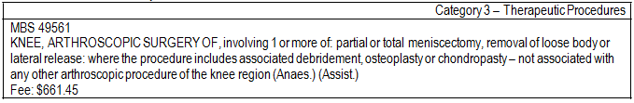
Table 8: MBS item descriptor for mosaicplasty
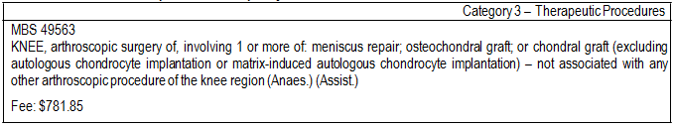
In the 2010/2011 financial year, 47,985 services for MBS item 49561 (the item the proposal claimed related to microfracture) were claimed through Medicare. The total associated cost to the MBS was
$22,551,990. The distribution of utilisation of the service by patient demographic variables of gender and age is shown in Figure 6.

Figure 6 Distribution of utilisation of MBS item 49561 (the item the proposal claimed was used for microfracture) by gender and age
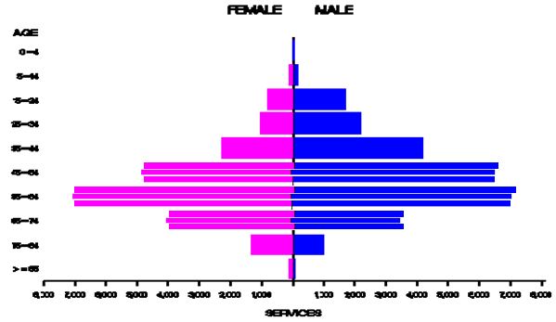In the 2010/2011 financial year, 995 services for MBS item 49563 (mosaicplasty) were claimed through Medicare. The total associated cost to the MBS was $558,580. The distribution of utilisation of the service by patient demographic variables of gender and age is shown in Figure 7.

Figure 7 Distribution of utilisation of MBS item 49563 (mosaicplasty) by gender and age
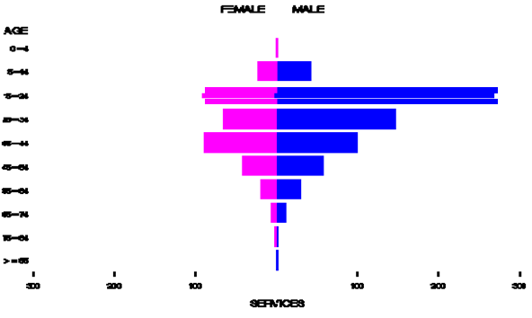The proposal states that mosaicplasty is mainly used in patients with lesions <2 cm2 and that MACI is only indicated in patients with lesions >2 cm2. Additionally, the proposal states that it is not widely used in Australia (confirmed by data utilisation in shown in Figure 7; 995 services were claimed in Australia in the 2010/2011 financial year). On the basis of the low use of mosaicplasty in practice, PASC determined that mosaicplasty should probably not be considered an appropriate comparator however noted that it was predominantly used in younger patients.

Advice received during the consultation period suggested that microfracture was more commonly reimbursed using MBS Item 49559 (arthroscopic surgery of the knee involving chondroplasty requiring multiple drilling or carbon fibre [or similar] implant; including any associated debridement or oestoplasty) as opposed to Item 49561 (as claimed by the applicant). In the 2011/2012 financial year,
206 services for MBS item 49559 were claimed through Medicare. The total associated cost to the MBS was $58,420. The distribution of utilisation of the service by patient demographic variables of gender and age is shown in Figure 8. PASC noted that the age profile of patients making claims under this item was more similar to the age profile of patients expected to undergo MACI. However, PASC also noted the low utilisation of this item. On the basis of low use of the item, PASC advised that MACI was likely to be used more widely than microfracture and thus microfracture should also not be considered an appropriate comparator.

PASC resolved that the appropriate comparator for MACI (in both patients with lesions sized 2-4 cm2 and patients with lesions sized >4 cm2) was primarily watchful waiting (conservative or no treatment followed by knee replacement surgery when indicated) or, secondarily, earlier partial or full knee replacement.

Figure 8 Distribution of utilisation of MBS item 49559 by gender and age
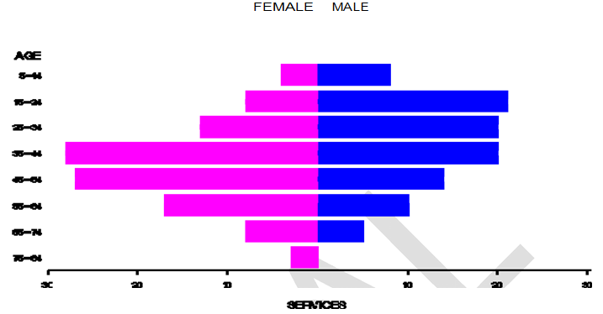

Clinical claim

The proposal indicates that the clinical claim that will be made in the application is that MACI is superior to microfracture (and mosaicplasty), both in terms of safety and efficacy. As discussed in the above section discussing the appropriate comparator, both microfracture and mosaicplasty were considered not to be appropriate comparators for MACI.

PASC resolved that the clinical claims that should be made in an application are that MACI (in both patients with lesions sized 2-4 cm2 and patients with lesions sized >4 cm2) is superior to primarily watchful waiting (conservative or no treatment followed by knee replacement surgery when indicated) or, secondarily, earlier partial or full knee replacement. with respect to:

• the rate of complete remissions (and therefore less need for subsequent surgeries);
• filling of the chondral defect with regenerating tissue;
• clinical outcomes (as measured by patient scores including domains such as limp, locking, pain, stair-climbing, use of supports, instability, swelling, and squatting).

On the basis of this claim, it is proposed that the application would present a cost-effectiveness or cost-utility analysis. PASC resolved that the presentation of a cost-effectiveness or cost-utility analysis was appropriate if the clinical evidence unequivocally demonstrates the superiority of MACI over the comparators that are determined to be appropriate.

Outcomes and health care resources affected by introduction of proposed intervention

Clinical outcomes

The proposal suggests that the comparative clinical performance (effectiveness) of MACI should be assessed based on, but not limited to:

• Quality of life scores
• 6-minute walking times
• Time of rehabilitation
• Pain
• Development of arthritis
o Imaging evaluation (arthroscopy, magnetic resonance imaging)
o Knee function, (modified Cincinnati knee score)
o Re-treatment, including requirement for knee replacements

The proposal notes that, due to the need to allow time for recovery, final outcomes should be reported at 12 months or later.

The proposal states that safety will be assessed based on adverse events recorded.

PASC determined that the proposed outcomes are appropriate as a basis for determination of comparative effectiveness of the interventions.

PASC determined that a 12 month time horizon would be insufficient for determining the comparative effectiveness of the intervention and comparator. As discussed on p.5, PASC recalled that a key concern raised by MSAC at the time of its last consideration of MACI/ACI was the lack of evidence in relation to long term functional outcomes associated with these procedures. PASC noted that at the time of MSAC’s last consideration there were no studies available that provided evidence of comparative performance of MACI/ACI over the long-term (>5 years). On this basis, MSAC determined there was not sufficient evidence to conclude that MACI/ACI is superior to other treatments. PASC therefore advised that the applicant should only submit a new application if this key concern is directly addressed by the data from the SUMMIT trial. As discussed previously in this document, the applicant maintains that data from the 2-year SUMMIT trial, together with other existing clinical studies, will be sufficient to establish the clinical efficacy and safety of MACI. PASC advise that the trial presented to MSAC is likely to be persuasive to MSAC if the trial applicable to Australian population. Given the short time horizon of the SUMMIT trial (2 years), extrapolation of data would be necessary to estimate costs and benefits over a relevant time horizon (as acknowledged by the application). PASC noted that this extrapolation step would introduce substantial uncertainty around the results of an economic analysis.

Health care resources

The proposal states that the healthcare resources expected to be impacted should MACI be made available on the MBS are:

For MACI:

• MACI implant (Prostheses List cod VAP01)
• TISSEEL Fibrin Sealant Syringe (BX214)
• Pre-anaesthesia consultation (MBS item number 17610)
• Initiation anaesthesia (MBS item number 21382)
• Biopsy (MBS item number 49557)
o Anaesthesia (MBS item number 23061)
o Assistance (MBS item number 51300)
• Implant surgical procedure (MBS item number 49563)
o Anaesthesia (MBS item number 23063)
o Assistance (MBS item number 51303)
• Hospital stay of 2 days (AR-DRG I18Z) For the microfracture comparator:
• Pre-anaesthesia consultation (MBS item number 17610)
• Initiation anaesthesia (MBS item number 21382)
• Microfracture surgical procedure (MBS item number 49561)
o Anaesthesia (MBS item number 23043)
o Assistance (MBS item number 51300)
• Hospital stay of 1 day (AR-DRG I18Z)

For the mosaicplasty comparator:

• Surgical kit
• Pre-anaesthesia consultation (MBS item number 17610)
• Initiation anaesthesia (MBS item number 21382)
• Mosaicplasty surgical procedure (MBS item number 49563)
o Anaesthesia (MBS item number 23063)
o Assistance (MBS item number 51303)
• Hospital stay of 2 days (AR-DRG I18Z)

As discussed, PASC resolved that, given the low extent of use, neither microfracture nor mosaicplasty are the appropriate comparators. PASC resolved that the healthcare resources associated with the more appropriate comparator of conservative management/watchful waiting (potentially followed by early total or partial knee replacement) will need to be detailed, depending on advice received during the public consultation phase of the DAP development process.

PASC resolved that resources used in postoperative care (including follow-up assessments and rehabilitation services) following MACI (& following knee replacement) should be included in the economic and financial analyses. It agreed with the sponsor that resources that need to be included in the analysis include: follow-up consultations, post-operative image scanning, physiotherapy, as well as other resources used in rehabilitation such as continuous ice flow machines and continuous passive motion machines.

Proposed structure of economic evaluation (decision-analytic)

The primary questions for public funding, as stated in the proposal, are:

• What is the safety, effectiveness, and cost-effectiveness of MACI in patients with articular cartilage defects between 2 and 4 cm2 compared with watchful waiting?
• What is the safety, effectiveness, and cost-effectiveness of MACI in patients with articular cartilage defects >4 cm2 compared with conservative or no treatment?

PASC resolved that it was appropriate for a question for public funding to be developed for two separate populations (that differ in lesion size) as proposed. PASC noted that splitting of the population by the size of the defect would require presentation of evidence separately for each of the subgroups.

Table 9 provides the PICO criteria for MACI.

Table 9: Summary of extended PICO to define the question for public funding that assessment will investigate
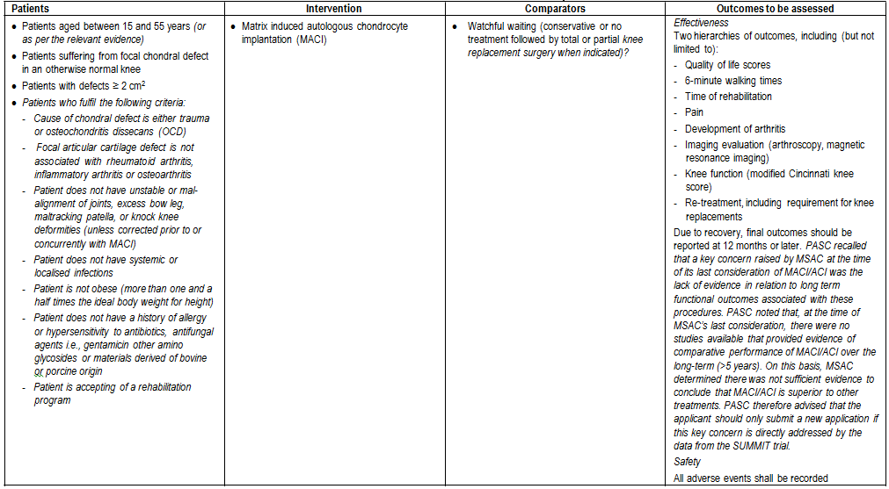

The structure for a simple analytic Markov model, comparing the inclusion of MACI within the clinical treatment algorithm as presented in the proposal is shown in Figure 9. PASC determined that an issue with the model presented is that it does not facilitate calculation of overall cost-effectiveness of MACI for all lesions >2 cm2 in size. As discussed in the sections discussing the clinical management algorithms and the comparator, the appropriate comparator in both models is conservative management. PASC considered that it was important any model used to conduct the economic analysis included health states that differentiated between patients who had pain and those in whom pain was resolved (rather than all being captured in a health state currently described as “well”). For example, PASC noted that the model does not appear to differentiate between patients with “resolved chondral lesions” and those with “refractory chondral lesions” that continue to be problematic. PASC advised that the model should include a health state for patients in the “recovery” period post-MACI where patients are undergoing rehabilitation. The model should also consider the potential for “relapse” of the chondral defect. The model should include knee replacement as a consequence of osteoarthritis rather than as an independent event. PASC noted that an alternate structure for the Markov process to address these issues is provided in Figure 10 but noted that the appropriate comparator was conservative management.

The model presented in the proposal is configured as a decision tree, the main branches of which represented the two main management strategies being assessed:

i. MACI
ii. Standard of care, which varies depending on the lesion size

Figure 9: Structure of proposed decision analysis
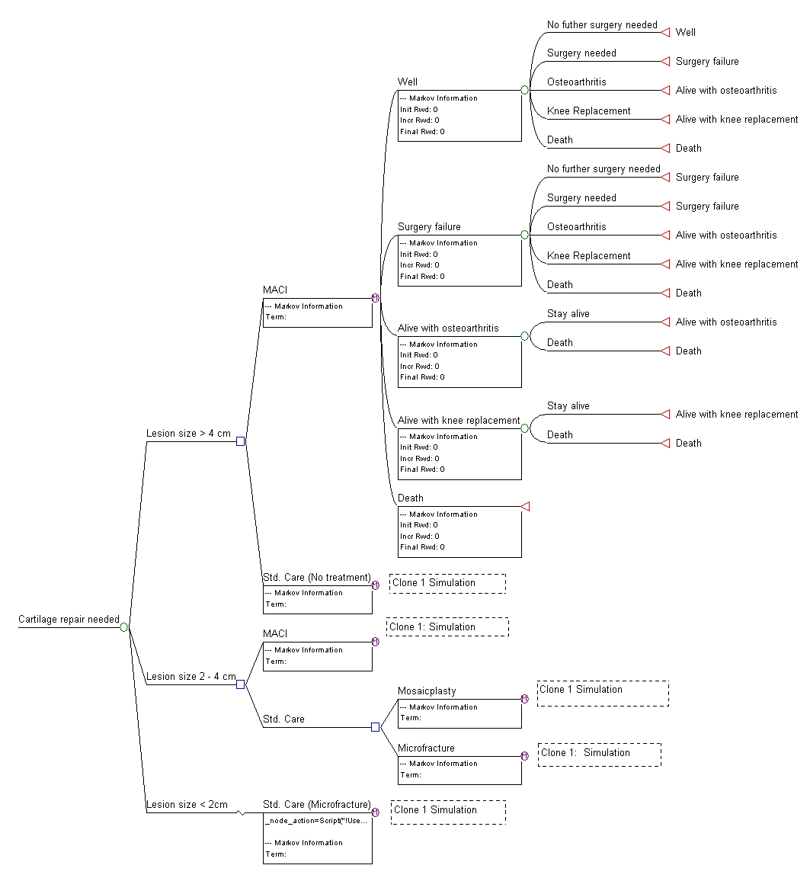The branches were identical for both management strategies and therefore for simplicity, only the sub-branches of one (MACI) on lesions larger than 4 cm2 are illustrated. The square is the ‘decision node’, the point at which the two management options were defined. Circles represent ‘chance nodes’, from which emanated ‘transition states’, indicating events to which a subject was susceptible in each yearly cycle. The likelihoods of entering various transition states were determined by their underlying transition probabilities. Triangles represent ‘terminal nodes’, the points at which a cycle ended and was quantified in terms of health and costs. From there, a subject is cycled back to the ‘Markov nodes’, indicated by encircled ‘M’s, in order to be channelled into a health state, either one previously occupied or an alternative, depending on the transition state through which the subject most recently passed.

The simulation can begin with all patients in the well (but with chondral damage) health state, free of failure, and without osteoarthritis or knee replacement. With progressive cycles, some subjects may need a secondary surgery (a term that PASC noted is not adequately explained), may develop osteoarthritis, may require a knee replacement and/or die. These events were captured by five health states: ‘well’, ‘surgery failure’, ‘alive with osteoarthritis’, ‘alive with knee replacement’ and ‘death’.

Within any cycle, subjects in the health state ‘well’ and ‘surgery failure’ were exposed to the following events (transition states):

• No further surgery needed
• Surgery needed
• Osteoarthritis
• Knee replacement
• Death

From the health state ‘alive with osteoarthritis’ and ‘alive with knee replacement’, subjects could move to the following health states:

• State alive
• Death

No transition states emanated from the health state ‘dead’. It is an absorbing state.

Figure 10: Alternate structure for Markov process in an economic evaluation

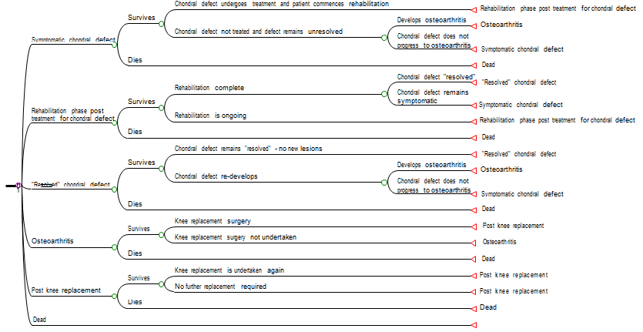Data sources for transition probabilities

i. Distribution of patients according to lesion size: to be determined from expert opinion.
ii. Surgery failure for MACI, mosaicplasty and microfracture from time of surgery: to be obtained from the clinical evidence.

iii. Incident osteoarthritis following MACI,: to be obtained from the literature and supplemented with expert opinion/patient registry data. PASC noted that a key concern raised by MSAC at the time of its last consideration of MACI/ACI was the lack of evidence in relation to long term functional outcomes associated with these procedures. PASC noted that, at the time of MSAC’s last consideration, there were no studies available that provided evidence of comparative performance of MACI/ACI over the long-term (>5 years). On this basis, MSAC determined there was not sufficient evidence to conclude that MACI/ACI is superior to other treatments. PASC therefore advised that the applicant should consider only submitting a new application if this key concern is directly addressed by the available data.
iv. Frequency of knee replacement operation following MACI surgery: to be obtained from the literature and supplemented with expert opinion/patient registry data.
v. Death among subjects in each of the health states: to be obtained from the clinical evidence and age/gender death tables from ABS.

Costs and utilities to be used in the model

The costs to be used in the model are stated in Table 11. In addition to this, the cost of short and long term cost of knee replacement will be sourced from the Public Sector cost weights, including rehabilitation cost when appropriate. A similar approach will be used to estimate the costs of osteoarthritis.

Utility values will be obtained from the published literature where appropriate.

The proposal states that if MACI were to be publicly funded, it is expected that the usage of all resources associated with mosaicplasty and microfracture (i.e., all resources provided to delivery mosaicplasty and microfracture as listed in Table 10) would be reduced. As discussed, PASC has determined that there is very low use of both microfracture and mosaicplasty and advised that the appropriate comparator is conservative management.

Table 10: List of resources to be considered in the economic analysis
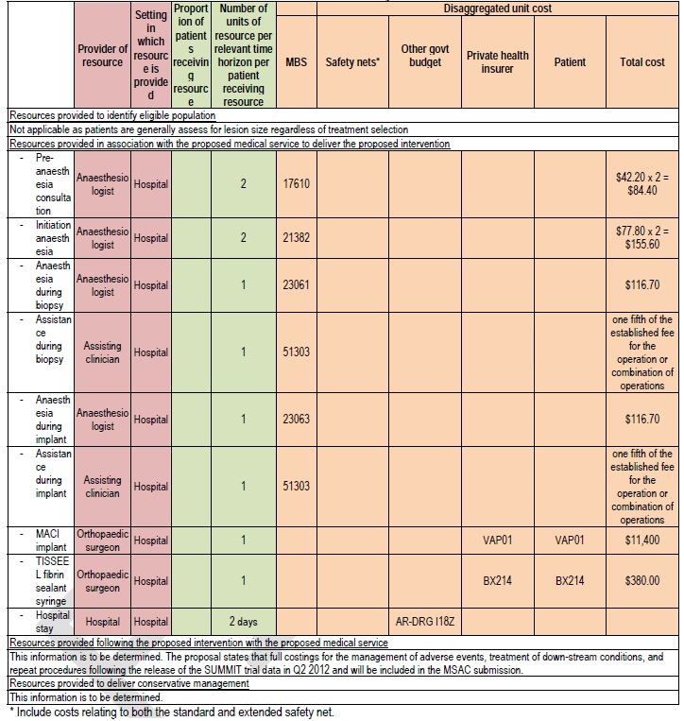

References

Meyerkort D, Wood D, Zheng MH. One-stage vs two-stage cartilage repair: a current review. Orthop
Res Rev. 2010:2

