MSAC Application 1766
Genetic testing to detect AKT pathway alterations in patients with hormone receptor-positive, HER2-negative advanced breast cancer, to determine eligibility for PBS subsidised capivasertib treatment

Applicant: AstraZeneca Pty Ltd

PICO Confirmation

Summary of PICO/PPICO criteria to define question(s) to be addressed in an Assessment Report to the Medical Services Advisory Committee (MSAC)
Table 1 PICO for genetic testing to detect AKT pathway alterations in patients with HR+/HER2- advanced breast cancer.
Component | Description
Population | Test population  Patients with locally advanced (inoperable) or metastatic hormone receptor–positive/human epidermal growth factor receptor 2–negative (HR+/HER2-) or HER2-low breast cancer following recurrence or progression on or after aromatase inhibitor (AI) therapy, with or without a cyclin-dependent kinase 4 and 6 (CDK4/6) inhibitor.  Treatment population  Patients in the test population with a tier 1 genetic variant in the AKT pathway, for second line treatment.
Prior tests | - Tests required to confirm diagnosis of breast cancer (i.e. biopsy)  - Tests required to confirm stage of cancer (i.e. mammogram or ultrasound, lymph node assessment, computed tomography, magnetic resonance imaging)  - Tests required to confirm biomarker status: oestrogen receptor (ER) and progesterone receptor status (PR) to define HR status, and HER2 status
Intervention | Test: Tumour tissue testing using Next Generation Sequencing (NGS) to characterise tier 1 genetic variants in all three genes (PIK3CA, AKT1 and PTEN genes) associated with abrogation of the AKT pathway.  Treatment: Capivasertib + fulvestrant for patients found to have AKT pathway tier 1 alterations
Comparator/s | Test comparator: No tumour testing for AKT pathway alterations.  Treatment comparator (following treatment failure with an AI): a range of different treatment options and no clear standard of care for second line treatment  - Alternate endocrine therapy + CDK4/6 inhibitor  - Everolimus + fulvestrant/exemestane/tamoxifen  - Chemotherapy
Clinical utility standard | The CAPItello-291 trial utilised NGS with FoundationOneCDx assay to detect PIK3CA/AKT1/PTEN tier I variants in tumour tissue. Results showed significant improvement in progression free survival (PFS) among patients with AI-resistant HR+/HER2– advanced breast cancer in the overall population, with a more pronounced benefit in AKT pathway altered tumours.
Outcomes | Test outcomes  Efficacy/effectiveness  - Analytical performance, diagnostic and predictive accuracy of AKT pathway alterations testing using NGS (sensitivity, specificity, positive predictive value (PPV), and negative predictive value (NPV)).  - Comparison of the analytical performance (concordance and discordance) of the clinical utility standard, with respect to PIK3CA, AKT1 and PTEN status, to the proposed tier 1 AKT pathway alterations testing including PTEN copy number variants testing using NGS (commercial or in-house developed).  - Clinical validity of test:  - Differential prognostic effect of the proposed AKT pathway alteration testing in advanced breast cancer, particularly including an assessment of whether this prognostic effect varies further according to whether the patient is positive or negative for AKT pathway alterations.  - Clinical utility of test:  - Treatment effect modification of capivasertib as a consequence of PIK3CA/AKT1/PTEN status.  - Whether AKT pathway alteration testing better targets patients that are likely to respond most to capivasertib.  - Other test related considerations:  - Test turnaround time.  - Test failure rates and re-biopsy rates.  Safety outcomes  - Adverse events associated with biopsy/re-biopsy for patients with inadequate tissue for tumour testing.  Healthcare resources  - Estimated number of patients to be tested.  - Cost of test intervention and associated delivery cost.  - Cost of re-biopsy.  - Cost of re-test.  Treatment outcomes  Efficacy/effectiveness  - Progression free survival (PFS).  - Overall survival (OS).  - Response rate.  - Quality of life.  Safety Outcomes  - Comparative safety and tolerability of capivasertib + fulvestrant, compared to alternative treatments in patients with/without AKT pathway alterations, assessed by adverse events, discontinuation rates, deaths and collection of clinical chemistry/haematology parameters.  Healthcare resources  - Cost of treatment intervention.  Total Australian Government Healthcare costs  - Total cost to the Medicare Benefits Schedule (MBS).  - Total cost to the Pharmaceutical Benefits Scheme (PBS).  - Total cost to other healthcare services.
Assessment questions | What is the safety, effectiveness, cost-effectiveness, and total costs of a genetic test to detect tier 1 AKT pathway alteration (PIK3CA, AKT1 and PTEN, including PTEN copy number variants), versus no testing, in a patient with locally advanced (inoperable) or metastatic HR+/HER2- (including HER2-low) breast cancer?

Purpose of application
The codependent application requested:
- Medicare Benefits Schedule (MBS) listing of genetic testing to detect AKT pathway alterations (PIK3CA, AKT1 or PTEN) for the determination of patient eligibility for treatment; and
- Pharmaceutical Benefits Scheme (PBS) Authority Required listing of capivasertib, in addition to fulvestrant, for the treatment of locally advanced (inoperable) or metastatic hormone receptor–positive/human epidermal growth factor receptor 2–negative (HR+/HER2-) breast cancer, following recurrence or progression on or after aromatase inhibitor (AI) therapy, with or without a cyclin-dependent kinase 4 and 6 (CDK4/6 inhibitor), was received by the Department of Health and Aged Care, from AstraZeneca Pty Ltd.
Based on the CAPitello-291 trial, the use of the proposed genetic testing to detect AKT pathway alterations results in superior health benefits, compared to current standard practice of no test and standard of care therapy. In the CAPItello-291 trial, the addition of capivasertib to fulvestrant treatment led to a significant improvement in progression free survival (PFS) (7.3 months in capivasertib + fulvestrant arm, vs 3.1 months in placebo-fulvestrant arm) among patients with AKT pathway altered tumours and HR+/HER2- advanced breast cancer, who had disease progression during or after previous AI therapy , with or without a CDK4/6 inhibitor, when compared to treatment with fulvestrant alone.
Capivasertib was undergoing Therapeutic Goods Administration (TGA) evaluation (as at April 2024) for treatment of locally advanced (inoperable) or metastatic breast cancer, referred to as advanced breast cancer for brevity. In May 2024, capivasertib was registered for the following indication: in combination with fulvestrant for the treatment of adult patients with hormone receptor (HR) positive, human epidermal growth factor receptor 2 (HER2) negative (defined as IHC 0 or 1+, or IHC 2+/ISH-) locally advanced or metastatic breast cancer following recurrence or progression on or after an endocrine based regimen.
An application will be made to the Pharmaceutical Benefits Advisory committee (PBAC) and the applicant’s proposed PBAC meeting date relevant to this codependent application is 6th November 2024.
Of note, there is a ratified PICO (application 1604 – February 2020) regarding PIK3CA mutation testing in postmenopausal women or men with advanced breast cancer who have progressed during/following treatment with an aromatase inhibitor.

PICO criteria

Population
The proposed population was patients with breast cancer (BC) with locally advanced (inoperable) or metastatic HR+/HER2- subtype, following recurrence or progression on or after AI therapy, with or without a CDK4/6 inhibitor. The HER2- subtype potentially includes HER2-low. Patients with confirmed AKT pathway (PIK3CA, AKT1 or PTEN) altered tumours will be eligible for capivasertib + fulvestrant treatment.
PASC agreed that the test population was patients with locally advanced (inoperable) or metastatic HR+/HER2- or HER2-low BC (HER2 IHC 2+, ISH neg) following recurrence or progression on or after AI therapy, with or without a CDK4/6 inhibitor.
The inclusion of HER2- and HER2-low subtypes in the proposed population are in accordance with the study population in the key trial (CAPItello- 291). There are evolving data to suggest potential treatment benefit in using HER2 inhibitors in patients with HER2-low BC, but currently, HER2 inhibitors can only be accessed by patients with HER2+. Hence, PASC confirmed the test population should include patients with HER2- and HER2-low subtypes, who are currently not eligible for HER2 inhibitors.

Background
Breast cancer (BC) is the most commonly diagnosed cancer among Australian women (AIHW 2022). In 2022, around 20,428 newly diagnosed cases of BC were reported in Australia, with approximately 5% of these cases classified as metastatic (advanced) BC (AIHW 2022; Cancer Australia 2019). While the overall relative 5-year survival rate for BC is good at 92%, the survival rates vary depending on certain prognostic factors, including patient characteristics, stage of disease and hormone receptor (HR) and HER2 status (NBCF 2024). Notably, women with stages 3 (locally advanced) and 4 (advanced/metastatic) BC have lower 5-year survival rates of 81% and 32%, respectively (NCBF 2024).

HR+/HER2-
HR+/HER2- BC is the most common subtype, accounting for 70% of metastatic breast cancer (MBC) cases (Turner et al. 2023). HR+ patients harbour tumour cells with receptors for estrogen and/or progesterone, in which the hormones drive growth of HR+ tumours. On the other hand, HER2- indicates absence of amplified HER2/neu protein production by tumour cells, which is associated with less aggressive and invasive type of BC. Many HR+/HER2- patients experience disease progression despite receiving first line (1L) treatment with ET + CDK4/6 inhibitor, and distant recurrences remain unmet challenges (Jin et al. 2023; Turner et al. 2023). The 5-year survival rate of advanced BC with HR+/HER2- subtype was lower at a rate of 34%, compared to HR+/HER2+ (46%) and HR-/HER2+ (40%) subtypes (NCI 2024). The survival rate of HER2+ BC patients appeared to improve with the availability of new HER2 targeted treatments (Jin et al. 2023; Swain et al. 2023). HER2 targeted treatments were effective in HER2+ as well as potentially HER2-low BC patients, leading to reclassification of HER2- into HER2-low and HER2- status (Li et al. 2023).
About one third of patients with HR+/HER2- MBC face an unmet need for a targeted treatment regimen, especially following relapse or disease progression with 1L treatment with ET +/- CDK4/6 inhibitor (Viale et al. 2023). One of the reasons is the dysregulation of the PI3K/AKT/mTOR signalling pathway which drives treatment resistance and disease progression in cancer (Glaviano et al. 2023; Venetis et al. 2022).

AKT pathway alteration (PIK3CA, AKT1 or PTEN)
The AKT pathway or PI3K/AKT/mTOR pathway is physiologically involved in cell metabolism, growth, proliferation and apoptosis (Cerma et al. 2023). Under normal physiological cellular activity, stimulation of the growth factor receptor leads to activation of phosphoinositide 3-kinases (PI3K), which catalyses the conversion of phosphatidylinositol 4,5-bisphosphate (PIP2) to phosphatidylinositol (3,4,5)-trisphosphate (PIP3) (Martorana et al. 2021). This conversion to PIP3 is reversed by PTEN, which is the main negative regulator of PI3K signalling (Cerma et al. 2023). PIP3 binds to AKT and phosphoinositide dependent kinase (PDK), activating AKT and the downstream signalling cascades, including mammalian target of rapamycin (mTOR) (Martorana et al. 2021).
AKT is the key node in the PI3K/AKT/mTOR signalling pathway as phosphorylated AKT activates over 100 substrates and regulates cell growth, proliferation, survival, and metabolism (Cerma et al. 2023; Martorana et al. 2021). There are three AKT isoforms (AKT1, AKT2 and AKT3) and they are encoded by different genes (Martorana et al. 2021). AKT1 is involved in proliferation and growth, promoting tumour initiation and suppressing apoptosis (Martorana et al. 2021). AKT2 regulates cytoskeleton dynamics and the role of AKT3 is largely controversial (Martorana et al. 2021). Figure 1 illustrates molecular mechanisms of AKT activation and the downstream signalling cascade.
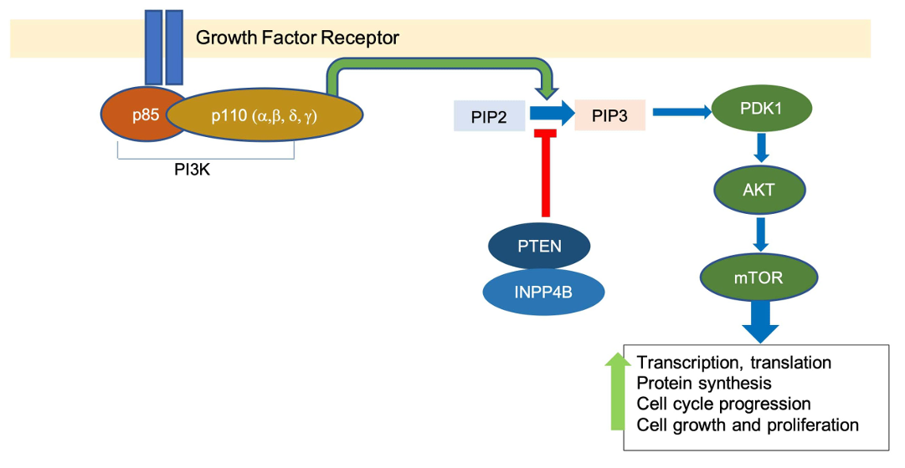
Figure 1 Molecular mechanisms of AKT activation and downstream signalling cascade
Source: Retrieved from The Role of PI3K Inhibition in the Treatment of Breast Cancer, Alone or Combined With Immune Checkpoint Inhibitors (Zhang & Richmond 2021) an open-access article distributed under the terms of the Creative Commons Attribution License (CC BY).
Abbreviations: AKT=serine/threonine kinase; INPP4B= inositol polyphosphate 4-phosphatase; mTOR=mammalian target of rapamycin; PDK1=phosphoinositide-dependent kinase 1; PI3K= phosphoinositide 3-kinase; PIP2=phosphatidyl-inositol-diphosphate; PIP3=phosphatidyl-inositol-triphosphate; PTEN=phosphatase and tensin homolog;
Note: PI3K is composed of a heterodimer of a p85 regulatory subunit and a p110 catalytic subunit (Zhang & Richmond 2021)
AKT pathway alterations include:
- Activating tier I variants in PIK3CA (catalytic subunit of PI3K) or AKT1, which can inappropriately activate the pathway. PIK3CA tier I variants account for up to 45% of BC cases (Martorana et al., 2021).
- Loss of function variants in PTEN, which can lead to loss of pathway inhibition and inappropriate activation of pathway signalling, accounts for up to 35% of the BC cases (Martorana et al., 2021).

Alterations in the AKT pathway are associated with tumour progression and resistance to treatment (Rimawi et al. 2018; Skolariki et al. 2022). The CAPitello-291 trial demonstrated that the addition of capivasertib to fulvestrant treatment significantly improved PFS (hazard ratio (HR) = 0.50; 95% CI: 0.38 to 0.65) in patients with AI-resistant HR+/HER2- advanced breast cancer and positive AKT pathway alterations (Turner et al., 2023). In the SOLAR-1 trial, patients who tested positive for PIK3CA tier I variants had prolonged PFS (HR = 0.65; 95% CI: 0.50 to 0.85) after treatment with alpelisib and fulvestrant (André et al., 2019). PTEN status has been suggested as a predictor of response to different antitumour agents in several clinical trials (Carbognin et al., 2019).
Further information is needed as to whether the PIK3CA/AKT1/PTEN tier I variants are stable over time or change in response to previous treatment, or between the primary tumour and metastatic disease. It is essential to know the clinical and cost-effectiveness consequences of misallocation of treatment due to changes in tier I variant status. Whether it would be more cost-effective to deliver the medicine without the use of AKT pathway testing, given the clinical efficacy in CAPitello-291 of capivasertib in the total advanced BC population and the number of cases in which AKT pathway tumour analysis was not successful but derived benefit as well as the cases with a proven PIK3CA/AKT1 tier I variants which affect up to 45% of BC cases, is worth considering.
PASC acknowledged that PIK3CA/AKT and mTOR pathways are the crucial drivers in tumorigenesis and around 50% of BC tumours will have genetic variants which constitutively activate the AKT pathway and drive the resistance to ET. Abrogation can occur due to genetic activation, genetic loss of inhibition and non-genetic mechanisms. PIK3CA gene has four hotspot variants which result in genetic activation effects. The prevalence of PIK3CA variants in HR+ BC was about 40%. However, there was an issue with the poor concordance between primary and secondary tumour tissues, where 16% of them were discordant. The prevalence of PTEN variants (sequence variants and copy number variants) leading to loss of inhibition function occurred in about 5-10% of HR+ BC cases. Germline PTEN pathogenic variants are very rare and confer a predisposition to cancer syndromes. AKT variants leading to genetic activation occurred in about 5% of HR+ BC cases.

Treatment options
According to the European Society for Medical Oncology (ESMO) 2021 guidelines, the 1L standard-of-care treatment for HR+/HER2- advanced BC is a combination of ET + CDK4/6 inhibitor (Gennari et al. 2021). For patients with imminent organ failure, chemotherapy is recommended as 1L treatment. In addition, the National Comprehensive Cancer Network 2024 (NCCN) guidelines recommend fulvestrant monotherapy or fulvestrant + CDK4/6 inhibitor or fulvestrant + non-steroidal AI (e.g., anastrozole, letrozole) as 1L therapy (NCCN 2024). For patients with visceral crisis and germline BRCA1/2 pathogenic variant, poly (ADP-ribose) polymerase (PARP) inhibitor is preferred (NCCN 2024).
In Australia, tamoxifen is offered as initial adjuvant ET for men and premenopausal women with oestrogen receptor (ER)-positive invasive BC with low risk of recurrence (Cancer Australia 2020). Gonadotrophin releasing hormone agonist is added to ET for premenopausal women with ER-positive BC and higher risk of recurrence (Cancer Australia 2020). An AI is offered as initial adjuvant ET for ER-positive postmenopausal women with intermediate/high risk of recurrence (Cancer Australia 2020). AI + CDK4/6 inhibitors (e.g., ribociclib, palbociclib, abemaciclib) are TGA-approved and PBS-listed as initial and subsequent therapy following prior ET therapy, in HR+/HER2- advanced breast cancer (DHAC 2024).
For second line treatment, the ESMO (2020) guidelines recommend PI3K inhibitor for patients with PIK3CA tier I variants, everolimus + exemestane/tamoxifen/fulvestrant, PARP inhibitor for patients with gBRCAm, and chemotherapy. The NCCN (2024) guidelines suggest capivasertib + fulvestrant in the presence of PIK3CA/AKT1/PTEN alterations.
The application mentioned the key unmet need for second line treatment of HR+ recurrent unresectable BC or MBC is to develop better ET-based options with a tolerable safety profile and wide therapeutic window, before the tumour becomes endocrine refractory. The SOLAR-1 study demonstrated an improvement in PFS of 5.7 to 11 months with the addition of alpha-specific PI3K inhibitor alpelisib to fulvestrant in patients with HR+/HER2− advanced breast cancer with tumours harbouring a PIK3CA tier I variants, who had relapsed or progressed on an AI. Despite these advances, these tumours eventually develop endocrine resistance necessitating the use of chemotherapy and thus, HR+/HER2− advanced breast cancer remains an area of unmet medical need, especially post-CDK4/6 inhibitor use.
Capivasertib is a pan-AKT serine/threonine kinase -inhibitor which, in combination with fulvestrant, inhibits both ER signalling and AKT activity in the PIK3CA/AKT1/PTEN pathway, resulting in antiproliferative activity in BC cell lines.
PASC noted that the study population in CAPItello-291 trial was heterogenous, as patients had received varying types and numbers of previous lines of treatment. The majority of the patients (71-81%) had received one line of ET and many had received chemotherapy as neoadjuvant or adjuvant therapy (48-51%). The study excluded patients with previous mTOR or PI3K targeted treatment. The trial did not specify the patients with PTEN variants by loss of function variants or deletion, albeit PTEN alteration occurred in <10% of the study population.
The treatment population proposed in the current application, were patients in the test population with a tier 1 genetic variant in the AKT pathway. The applicant noted that whether biomarker testing is required to determine eligibility to the treatment will be based on the TGA approved indication for capivasertib (currently under TGA evaluation). The applicant further noted that the United States Food and Drug Administration (US FDA and Canada have approved the indication in the biomarker positive population only.

Estimates for the size of the testing population
The applicant will present a detailed utilisation analysis in the integrated co-dependent MSAC/PBAC assessment report. The applicant suggested the uptake of the proposed health technology by the proposed population was estimated to be 100% in years 1-3.
It is estimated that approximately 2,400 patients/year would be eligible for AKT pathway alteration testing. Table 2 provides an annual estimate of the number of patients with locally advanced (inoperable) or metastatic HR+/HER2- breast cancer who are eligible for proposed AKT pathway alteration testing.
Table 2 Estimates of testing population
Population | Parameter | Estimates | Source
A | Incidence of BC in year 2023 | 20,500 | (AIHW 2023)
B | Patients with locally advanced and MBC (16.7%) | 3,424 | (NCCI 2013)
C | Patients in population B with HR+/HER- BC (70%) | 2,397 | (NCBF 2024; Turner et al. 2023)
D | Patients in population C who are eligible for testing (100%) | 2,397 | p6 of MSAC application 1766
Source: Figures in italics were estimated during development of PICO Confirmation 1766
Abbreviations: AIHW= Australian Institute of Health and Welfare; BC=breast cancer; HR+/HER2–= hormone receptor–positive, human epidermal growth factor receptor 2–negative; MBC=metastatic breast cancer; MSAC= Medical Services Advisory Committee; NBCF= National Breast Cancer Foundation; NCCI=National Cancer Control Indicators; p=page.
The estimates were made based on the following assumptions:
- The incidence rate of BC remains constant over the years. Of note, as the BreastScreen Australia Program promotes early detection of BC and detection of unsuspected BC in women (AIHW 2023), plus the growth of ageing population in Australia, BC incidence rates may increase over time.
- All patients are assumed to receive AI therapy and develop AI-resistance (either in adjuvant or MBC setting) within a year.
- Patients with stage 1 and 2 BC remain with no disease progression.

Prior tests
- Biopsy and imaging (mammogram, ultrasound, or magnetic resonance imaging) to confirm diagnosis of BC.
- Staging workup, which is guided by symptoms and may include clinical and ultrasound assessment of lymph nodes, computed tomography, bone scan, x-rays, magnetic resonance imaging, and fluorodeoxyglucose positron emission tomography–computed tomography.
- Molecular diagnostic studies including immunohistochemical evaluation of HR status and immunohistochemical plus/minus in situ hybridisation evaluation to determine HER2 status.

Intervention

Testing for AKT pathway alteration (PIK3CA/AKT1/PTEN)
The proposed intervention is a codependent health technology for the purpose of identifying a patient as suitable for a pharmacological treatment. The proposed investigative technology is somatic genetic testing which uses Next Generation Sequencing (NGS) to detect AKT pathway alterations in tumour tissue from patients with HR+/HER2- advanced breast cancer. NGS enables identification of hundreds of genes at a time and can identify pathogenic variants in PI3KCA, AKT1 and PTEN. Presence of PI3KCA/AKT1/PTEN pathogenic variants confirm AKT pathway alterations, which then determine a patient’s eligibility for treatment with capivasertib (an AKT serine/threonine kinase inhibitor). A positive test could also inform eligibility for other future PBS-listed AKT pathway inhibitors. Based on the CAPitello-291 trial, the addition of capivasertib to fulvestrant treatment significantly improved PFS in patients with AI-resistant HR+/HER2- advanced breast cancer in the overall population, with a more pronounced benefit in proven AKT pathway altered tumours. (Turner et al. 2023). Capivasertib is currently undergoing TGA evaluation for treatment in this population.
PASC indicated that the test intervention was tumour tissue testing using NGS to characterise tier 1 genetic variants in all three genes (PIK3CA, AKT1 and PTEN genes) associated with abrogation of the AKT pathway. Tier 1 corresponds to somatic pathogenic variants of strong clinical significance.
The applicant proposed that a specialist (e.g., medical oncologist, breast surgeon, interventional radiologist) can request AKT pathway alteration testing and has to provide the specimen for testing. The specimen can be fresh tissue from the site of local recurrence or metastasis or archival tissues. The tumour tissue specimen can be obtained from formalin-fixed paraffin-embedded (FFPE) blocks following primary tumour debulking surgery. Re-testing and/or re-biopsy may be required in some patients whom tumour tissue sample is available after disease progression. The applicant suggested that fresh biopsies at metastases growth are preferred, and archival tissue may be used in case of bone or brain metastases due to difficulty of biopsy extraction and the likelihood of test failure using these sample types. According to the CAPItello-291 trial protocol, archival or newly collected FFPE tumour samples were used to test for PIK3CA, AKT1 and PTEN tier I variants. If the tissue sample was inadequate for testing, the study site collected fresh sample before starting treatment. Other points of consideration are costs of block retrieval, costs (and patient harms) of obtaining new samples as well as confidence that the sample is a representation of patient’s tier I AKT 1 variant burden at time of treatment decision.
PASC considered that the test would be preferentially performed using tumour tissue biopsied from the site of recurrence or metastasis after progression on AI +/- CDK4/6 inhibitor, but archival tissue could be used, based on FAKTION (an earlier phase two randomised trial of 140 people), where 80% of the samples were of primary tumour. In the FAKTION study, patients with AKT-altered tumour had statistically significant longer overall survival (OS) of 38.9 months with capivasertib versus 20 months in the placebo arm (HR=0.46, 95% CI: 0.27-0.79, two-sided p=0.0047). In the AKT-non-altered tumour subgroup, the difference in OS was not statistically significant between capivasertib and placebo arm (HR=0.86, 95% CI 0.49-1.52, two-sided p=0.6) (Howell et al. 2022).
In the CAPItello-291 study, 40% of the study population in the treatment arm and 48.5% in the control arm did not have an AKT pathway alteration detected. The genetic alteration status was unknown in 16.3% in the treatment arm and 13.6% in the control arm. Treatment with capivasertib + fulvestrant resulted in a statistically significant improvement in PFS in the overall population (including patients with, without and unknown AKT pathway-altered tumours; HR=0.60, 95% CI: 0.51-0.71, p<0.001) and for patients with proven AKT pathway-altered tumours only (HR=0.5, 95% CI: 0.38-0.65, p<0.001). However, patients with AKT pathway non-altered tumours (excluding patients with unknown AKT pathway status) had a statistically non-significant improvement in PFS (HR=0.79, 95% CI: 0.61-1.02). PASC deduced that the benefits in prolonged PFS in patients with AKT pathway non-altered tumours including unknown AKT pathway status appeared to come from patients with unknown AKT pathway status (HR 0.52, 95% CI: 0.32-0.83), rather than from patients with proven non-altered AKT pathway.
Based on the results from the FAKTION and CAPItello-291 studies, PASC agreed that the AKT-testing was worthwhile insofar as it appears to predict response to capivasertib. The applicant noted that whether AKT-testing is required to determine eligibility to the treatment will be based on the proposed TGA indication for capivasertib (currently under TGA evaluation). The applicant further noted that the US FDA and Canada have approved the indication in the AKT-positive population only.
When a tissue sample is not readily available, the applicant initially proposed that a plasma sample could potentially be used to analyse the circulation tumour DNA (ctDNA). It was proposed that plasma sample testing could be requested by the specialist and the plasma sample to be taken at a pathology collection service. Analysis of the ctDNA in the plasma sample is performed in a similar way to the tissue sample. The applicant suggested that ctDNA is a viable alternative where a tumour sample cannot be attained (i.e., bone or brain metastases). Referring to the protocol for CAPItello-291 trial, the use of ctDNA was for exploratory biomarker analysis and the applicant indicated that the results of the exploratory analysis as well as patient outcome data should be available by REDACTED. There are biological plausibility issues raised in regard to ctDNA. Biopsies from tumour tissue samples may have tier I variants that are non-concordant with those present in ctDNA, which could affect testing accuracy (Davidson et al., 2021). Low level of tier I variants in plasma samples could inaccurately represent specific tumour burden and affect clinical decisions (Davidson et al., 2021). ctDNA analytical performance may be reduced in detecting copy number variants relevant to somatic PTEN – associated disease compared to tumour testing. While there is an association between ctDNA analyses and treatment response rate and disease relapse, prospective clinical trials to evaluate the prognostic potential of ctDNA are lacking (Davidson et al., 2021). Notably, the poor stability and short half-life of ctDNA are factors for consideration as they can affect the prognostic and predictive value of ctDNA analysis (Sant et al., 2022). ctDNA analysis for breast biomarkers is still at its infancy in Australia. A private laboratory claimed to be the first one to offer ctDNA testing in Australia and is currently offering testing for lung, colorectal cancer and melanoma only, with out-of-pocket expenses (Australian Clinical Labs 2024).
PASC noted that tumour tissue samples (i.e. somatic testing) should be used for AKT pathway testing and the applicant has chosen not to include ctDNA testing as part of the proposed test. PASC noted the applicant’s view that while ctDNA testing is emerging, the data is still evolving. PASC advised that if ctDNA testing were to be proposed as an alternative to tumour tissue AKT pathway testing, a full comparative assessment including comparative analytical performance between tumour and ctDNA testing and comparison of health outcomes with tumour and ctDNA testing should be presented. The applicant concurred and informed that they may submit a separate application once data is available.
PASC advised that copy number variant determination in somatic tissue samples using NGS (required for capturing all PTEN variants) usually requires a large panel, potentially at a higher cost.
PASC noted the need to consider the longer time needed for sample analysis if a large panel is desired. PASC considered that the choice of the test needs to be justified and compared against the clinical utility standard (likely to be FoundationOneCDx used in the trials and primary data to be provided by the applicant for PTEN deletions).
PASC emphasised that genetic testing should be treatment focused and currently there is no MBS item for AKT pathway alteration testing, leading to inequity of access to treatment. A positive AKT pathway alteration, with a tier I variant in AKT or upstream of AKT in the pathway, would inform treatment with an AKT inhibitor. PASC suggested that PTEN status was an important factor given the loss of inhibition function was related to ET resistance. An AKT pathway testing positive for PIK3CA tier 1 variants and negative for PTEN tier I variants could inform treatment with a PIK3CA inhibitor.
A registered molecular/anatomical pathologist is responsible for conducting the detection, diagnosis and reporting of the pathology result. The pathologists are able to select the genes of interest using NGS. For this proposed intervention, a )gene panel using NGS to identify PIK3CA, AKT1 and/or PTEN tier I variants can be selected to confirm AKT pathway alterations.

The laboratory personnel involved in gene panel genetic testing should receive the same training and qualifications as for other cancer biomarker testings. The pathology laboratories should be National Association of Testing Authorities Australia (NATA) accredited and the laboratory service of genetic testing for AKT pathway alterations (PIK3CA/AKT1/PTEN) would be monitored and audited by the Royal College of Pathologists of Australasia (RCPA) via a Quality Assurance Program.

Next Generation Sequencing (NGS)
NGS is capable of sequencing a massive number of genes in the DNA and RNA as well as the entire genome, in a relatively short period of time, and negates the need for multiple assays for multiple mutations (Qin 2019). NGS can detect variants/mutations in the genes/genome and aid disease diagnosis, prognosis, as well as therapeutic decisions (Qin 2019). Focused panel sequencing is commonly used in clinical oncology, where the targeted NGS assays are specified for a disease and the identification of targeted gene mutations is based on current guidelines for the disease (Qin 2019). NCCN Guidelines Version 1 2024 recommend assessment of biomarker PIK3CA or AKT1 or PTEN via NGS using blood or tumour tissue (if blood sample is negative for mutations, tumour tissue testing is recommended), in patients with HR+/HER2- unresectable local/regional/stage IV BC after disease progression or recurrence after at least one prior line of ET, including one line containing CDK4/6 inhibitor. NCCN (2024) guidelines recommend capivasertib + fulvestrant as preferred second line or subsequent line therapy in the presence of PIK3CA/AKT1/PTEN alterations. This suggests AKT pathway-alteration testing to be conducted prior to second line treatment.
PASC agreed that the treatment intervention was capivasertib + fulvestrant for patients found to have tier 1 AKT pathway genetic alterations. However, PASC questioned if AKT pathway testing to inform treatment should only be used prior to second line treatment or whether the testing should be extended for use prior to third line treatment as well. This was because there was no clear pathway for the next treatment options due to a range of treatment options available in the second line setting, for patients who have progressed on AI +/- CDK4/6 inhibitor, and genetic treatment marker profiles may not be stable and may evolve with the disease in response to previous treatment
There are several key steps in NGS (Figure 2): DNA fragmentation, library preparation, massive parallel sequencing, bioinformatics analysis, and variant/mutation annotation and interpretation (Qin 2019). These steps are expanded below:
- DNA fragmentation - targeted DNA is broken into multiple short segments, usually 100-300 base pair in length, using mechanical methods, enzymatic digestions and other methods (Qin 2019). The short segments of the targeted DNA sequence are retrieved using specific complementary probes and this method is known as hybridization capture assay (Qin 2019). Polymerase chain reaction (PCR) amplification method can also be used to amplify the targeted DNA segments (Qin 2019). The DNA segments are then ready for library preparation (Qin 2019).
- Library preparation – DNA segments are modified by adding sequencing primers/adaptors to them (Qin 2019).
- Sequencing - The library is uploaded onto a sequencing matrix/chip in a specific sequencer system to generate sequence information (Qin 2019).
- Data analysis and interpretation – The sequence information is analysed using bioinformatics software, where the sequence information is compared to a human genome reference, for identification of variants/mutations in targeted DNA segments (Qin 2019).

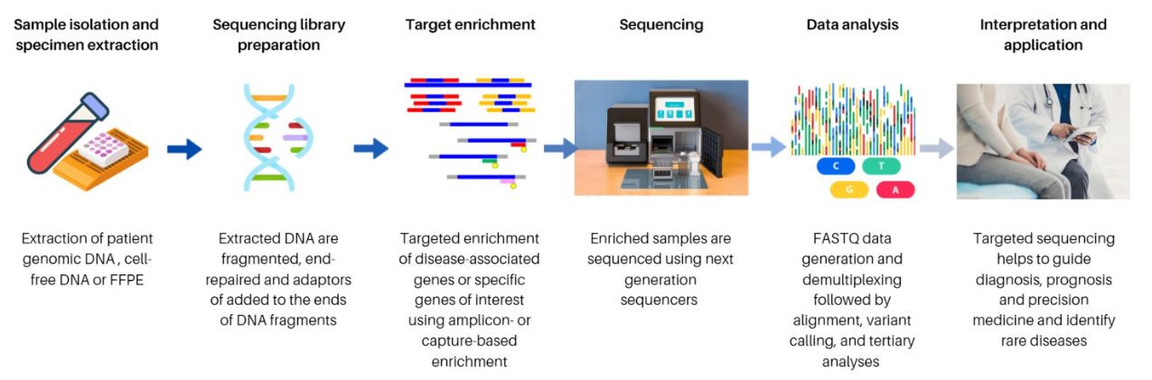
Figure 2 Next generation sequencing (NGS) procedure
Source: Retrieved from Targeted Sequencing Approach and Its Clinical Applications for the Molecular Diagnosis of Human Diseases (Pei XM et al 2023), an open-access article distributed under the terms of the Creative Commons Attribution License (CC BY).
Abbreviations: DNA=Deoxyribonucleic acid; FFPE=formalin-fixed paraffin-embedded.
Note: FASTQ is a text-based sequencing data file format that stores both raw sequence data and quality scores

In the CAPItello-291 trial, the study population was tested with NGS using FoundationOneCDx assay to detect AKT pathway alterations and this test is currently unavailable in Australia. Furthermore, it is not clear how this test compares with other commercial or in-house developed tests. FoundationOneCDx is FDA-approved to identify PIK3CA biomarker using breast tissue sample (FDA 2023). Of note, FoundationOneCDx assay can also assess AKT1 and PTEN biomarkers. As for ctDNA analysis, FoundationOne Liquid CDx is the only FDA-approved companion diagnostic test to analyse guideline-recommended genes (such as PIK3CA) from blood samples, with the intention of identifying patients who may benefit from targeted treatment (Foundation Medicine Inc 2024). However, assessment of AKT1 and PTEN biomarker using FoundationOne Liquid CDx is currently unavailable (Foundation Medicine Inc 2024).
PASC highlighted that the FoundationOneCDx assay used in the CAPItello-291 trial could identify a wide range of genes including BRCA1/2, PIK3CA, AKT, mTOR and PTEN. Hence, AKT pathway testing using a test such as the FoundationOneCDx assay that identifies other clinically informative biomarkers (e.g. BRCA1/2) could be a one-test-for-all to assist clinicians in differentiating between various second line treatments.
PASC advised a comparison of the analytical performance (concordance and discordance) of the clinical utility standard, with respect to detection of tier 1 variants in PIK3CA, AKT1 and PTEN genes (including PTEN copy number variants) using NGS (commercial or in-house developed).

NGS in Australia
There are currently limited NGS in vitro diagnostics (IVD) approved by the Australian Register of Therapeutic Goods (ARTG):
- Illumina (ARTG ID 297844) - NGS IVD intended for the purposes of human genetic testing (DHAC 2017)
- ThermoFisher Scientific (ARTG ID 426895) - Oncomine™ Dx Target Test is indicated as a companion diagnostic to aid selection of patients with non-small cell lung cancer for targeted therapies (DHAC 2023).
NGS that is not approved by TGA as a commercial test is considered to be an in-house IVD device and subject to regulation according to IVD regulatory framework (NPAA 2017).
As of 15th February 2024, there are 27 NATA accredited organisations which provide DNA sequencing of human tissue using NGS technology in Australia (NATA 2024b). These organisations comply with the relevant National Pathology Accreditation Advisory Council (NPAAC) requirements and have ISO 15189 accreditation which ensure valid and reliable testing services (NATA 2024a).

Challenges with NGS
Tumour assessment using NGS inevitably introduces heterogeneities. Firstly, the size and quality of tissue samples obtained from resections, biopsies and cytology specimens is potentially inconsistent, thereby increasing variability (NPAAC 2017). Also, variable tissue processing methods employed by different laboratories may further compound the issue of variability (NPAAC 2017). Furthermore, testing of blood samples for ctDNA is not routinely performed at the moment, as further studies are required to correlate the findings with clinical utility, as well as testing for sensitivity and specificity (NPAAC 2017).
PASC recommended a one-off test to characterise all relevant tier 1 variants in PIK3CA, AKT1 and PTEN genes, rather than two-step sequential testing with PIK3CA/AKT variants first, followed by PTEN variants, to increase the use of a limited tissue sample and due to limited DNA in tissue samples. However, PASC acknowledged that laboratories can choose to conduct two-step sequential testing if this is more practical for them.
While laboratory services in Australia vary greatly depending on whether they only look for hotspot mutations or copy number variants for PTEN, PASC recognised that laboratory services can pick up PTEN deletion, at a cost.

Comparator(s)

Test comparator
The proposed test comparator is ‘no testing’ of tumour tissue for AKT pathway alterations. Prior to this application, there was no subsidised test available to determine AKT pathway alteration status or to guide targeted treatment for HR+/HER2- advanced breast cancer patients. It is worth mentioning that there is a ratified PICO (application 1604 – February 2020) on PIK3CA mutation testing in postmenopausal women or men with advanced BC who have progressed during/following treatment with an AI. This application did not progress to the assessment phase.
PASC agreed that the test comparator was no tumour testing for AKT pathway alterations.

Treatment comparator
The comparator to capivasertib + fulvestrant is standard practice. Current standard practice comprises a range of treatment options but the optimal sequence of endocrine-based therapy is uncertain after progression on CDK4/6 inhibitors (Gennari et al. 2021). The treatment sequence is dependent on which agents were used previously, duration of response to previous ET, disease burden, patient preference and treatment availability (Gennari et al. 2021). Patients who relapsed on adjuvant AI therapy are advised to receive a combination of fulvestrant and CDK4/6 inhibitor (Gennari et al. 2021). Rechallenge therapy with CDK4/6 inhibitor may be possible after a treatment-free interval of 12 months based on evidence regarding rechallenge with other therapies (Gennari et al. 2021). It is also clinically acceptable to use ET + CDK4/6 inhibitor as a subsequent therapy in the case of lack of access to CDK4/6 inhibitor in 1L setting and in the event of 1L treatment with chemotherapy due to imminent organ failure. The ESMO 2021 guidelines recommend testing for PIK3CA, ESR1, BRCA1/2 tier I variants. Table 3 summarises second-line treatment options for HR+/HER2- advanced BC following relapse with AI +/- CDK4/6 inhibitor.
PASC noted the proposed treatment comparator was standard of care for second line treatments. PASC acknowledged that there were a range of different treatment options and no clear standard of care for second line treatment. PASC noted the choice of treatment comparator is a matter for PBAC.
PASC highlighted that everolimus, an mTOR inhibitor which interacts with the AKT pathway, was actively excluded in both CAPItello-291 and FAKTION trials, as were prior PI3K inhibitors. Everolimus is TGA registered, and PBS listed for the treatment of postmenopausal women with HR+/HER2- advanced BC in combination with exemestane after failure of treatment with letrozole or anastrozole. However, there was no prerequisite for genetic testing despite everolimus targeting the mTOR, which is part of the AKT pathway.
Table 3 Second line treatment options for HR+/HER2- advanced breast cancer following relapse with AI +/- CDK4/6 inhibitor
Second line treatment options | TGA approved | PBS listed | Biomarker
Fulvestrant + CDK4/6 inhibitor | Yes | Yes | -
ET + CDK4/6 inhibitor | Yes | Yes | -
Capivasertib* + fulvestrant | No* | No* | PIK3CA/AKT1/PTEN#
Alpelisib* + fulvestrant | Yes | No* | PIK3CA#
Exemestane + everolimus | Yes | Yes | ESR1
Tamoxifen + everolimus | Yes | Yes | ESR1
Fulvestrant + everolimus | Yes | Yes | ESR1
PARP inhibitor (e.g., olaparib) | Yes | No ª | gBRCAm
Abbreviations: AKT=serine/threonine kinase; CDK=Cyclin-dependent kinase; ESR1=Estrogen receptor gene 1; ET=endocrine therapy; gBRCAm=germline breast cancer gene mutation; PARP=Poly (ADP-ribose) polymerase; PBS=Pharmaceutical Benefits Scheme; PIK3CA=phosphatidylinositol-4,5-bisphosphate 3-kinase catalytic subunit alpha; PTEN=phosphatase and tensin homolog; TGA=Therapeutic Goods Administration.
Note: CDK4/6 inhibitor includes palbociclib, ribociclib, abemaciclib
Endocrine therapy (ET) includes AI (anastrozole, exemestane, letrozole), fulvestrant, tamoxifen,
*Capivasertib (AKT serine/threonine inhibitor) and alpelisib (PIK3CA inhibitor) are currently not PBS-listed for breast cancer treatment
#PIK3CA, AKT1, ESR1 testing are currently not MBS-listed but they are available for privately funded testing (Sonic Healthcare 2024)
ª Olaparib and germline BRCA1/2 testing to be considered at the July 2024 PBAC meeting and August 2024 MSAC meeting, respectively.

Reference standard (for investigative technologies only)
Sanger sequencing could be used as the reference standard to determine concordance with NGS. However, Sanger sequencing of PIK3CA/AKT1/PTEN variant testing is not currently available. In this case the accuracy of the proposed test may need to be demonstrated by direct from test to health outcomes evidence showing a health benefit resulting from use of test, or by a comparison against a suitable clinical utility standard.
PASC acknowledged that there was no reference standard for AKT pathway testing.

Clinical utility standard (for codependent investigative technologies only)
A reference standard is not currently available for the proposed test. Therefore, the accuracy of the proposed test may need to be demonstrated by comparison against a suitable clinical utility standard, which is FoundationOneCDx in this case. Based on the CAPItello-291 trial, FoundationOneCDx assay was used to detect PIK3CA/AKT1/PTEN variants in breast tumour tissue of patients with HR+/HRE2- following treatment relapse with AI +/- CDK4/6 inhibitor. The breast tumour tissue could be archival, or newly collected FFPE tumour sample collected as part of routine clinical practice for analysis. Treatment with capivasertib + fulvestrant resulted in significant improvement in PFS in the overall population, with a more pronounced benefit in AKT pathway altered tumours. FoundationOneCDx is currently not available in Australia and laboratories may use other NGS IVDs and in-house assays for identification of PIK3CA/AKT1/PTEN tier I variants. In the pre-PASC meeting, the applicant stated that concordance studies have found high concordance between the FoundationOneCDx and the Roche Avenio platform, a similar assay to FoundationOneCDx that is used in Australia. The applicant stated that they will supply this data at a later date.
PASC noted that there is no reference standard for AKT pathway testing. The test used in the CAPItello-291 trial was FoundationOneCDx, which is not available in Australia. Moreover, there was no NGS IVD registered on the ARTG. However, there were comparable tests at research settings in Australia, such as Roche AVENIO.
PASC considered the concordance assessment results provided by the applicant’s clinical expert. The concordance assessment was conducted by Monash Pathology. In addition to assessing the concordance between FoundationOneCDx and Monash Pathology’s Roche AVENIO Comprehensive Genomic Profiling (CGP) panel, the results were also correlated against local IVD NATA accredited panel Illumina TS70 ($300). The Illumina TS70 panel seemed to target hotspot sequence variants only. It did not identify or intend to identify deletion. PASC noted that Roche AVENIO CGP was not registered on the ARTG and it was estimated to cost ~$1,900 to $2,200, covering 326 genes, copy number variants, gene fusions, tumour mutation burden, homologous recombination deficiency and loss of heterozygosity.
The concordance assessment showed that 16/21 samples were concordant between FoundationOneCDx and Roche AVENIO CGP. PASC noted that data relating to the level of tumour enrichment in the tested samples (proportion of DNA from tumour and that from surrounding non-tumour tissue) were not provided with the concordance assessment, and therefore considered that this introduces uncertainty in the interpretation of the results of the assessment.
Based on the concordance assessment provided by the applicant, PASC considered that:
- neither FoundationOneCDx nor AVENIO identified PTEN deletion (loss of exons 1-3)
- both AVENIO and FoundationOneCDx identified 19 out of 25 variants
- FoundationOneCDx failed on four samples, which were identified by AVENIO
- FoundationOneCDx did not identify a PTEN point variation (p.D268E), which was detected by both AVENIO and the inhouse TS70
PASC requested that the applicant provide primary data on PTEN deletion detection from available studies because neither FoundationOneCDx nor AVENIO identified PTEN deletions in the concordance assessment.

Outcomes
For the purpose of this co-dependent MSAC/PBAC application, the following treatment outcomes apply:

Test outcomes
Efficacy/effectiveness
- Analytical performance, diagnostic and predictive accuracy of AKT pathway alterations testing using NGS (sensitivity, specificity, positive predictive value (PPV), negative predictive value (NPV), etc).
- Comparison of the analytical performance (concordance and discordance) of the clinical utility standard, with respect to PIK3CA, AKT1 and PTEN status, to proposed AKT pathway alterations testing including PTEN copy number variants testing using NGS (commercial or in-house developed).
- Clinical validity of test:
  - Differential prognostic effect of the proposed AKT pathway alterations testing in advanced BC, particularly including an assessment of whether this prognostic effect varies further according to whether the patient is positive or negative AKT pathway alterations.

- Clinical utility of test:
  - Treatment effect modification of capivasertib as a consequence of PIK3CA/AKT1/PTEN tier I variants status.
  - Whether AKT pathway alteration testing better target patients that are likely to respond most to capivasertib.
- Other test related considerations:
  - Test turnaround time.
  - Test failure rates and re-biopsy rates.
Safety outcomes
- Adverse events associated with biopsy/re-biopsy for patients with inadequate tissue for tumour testing.
Healthcare resources
- Cost of test intervention and associated delivery cost.
- Cost of re-biopsy.
- Cost of re-test.

Treatment outcomes
Efficacy/effectiveness outcomes
- PFS.
- Overall survival.
- Response rate.
- Quality of life.
Safety Outcomes
- Comparative safety and tolerability of capivasertib + fulvestrant, compared to alternative treatments (no standard of care), in patients with/without AKT pathway alterations, assessed by adverse events, discontinuation rates, deaths and collection of clinical chemistry/haematology parameters.
Healthcare resources
- Cost of treatment intervention.
Total Australian Government Healthcare costs
- Total cost to the MBS.
- Total cost to the PBS.
- Total cost to other healthcare services.

PASC acknowledged the proposed outcomes mentioned in the draft PICO but proposed amendments to the following outcomes in red:
- Efficacy outcome:
  - Comparison of the analytical performance (concordance and discordance) of the clinical utility standard, with respect to PIK3CA, AKT1 and PTEN status, to the proposed AKT pathway alterations testing including PTEN copy number variants testing using NGS (commercial or in-house developed)
PASC considered that comparison of the proposed treatment to placebo is not warranted as there are many other treatment options available for these patients in the second line setting.
PASC proposed to rewrite the safety outcome for the treatment (which previously referred to placebo) as follows:
- Safety outcome:
  - Comparative safety and tolerability of capivasertib + fulvestrant, compared to alternative treatments) in patients with/without AKT pathway alterations, assessed by adverse events, discontinuation rates, deaths and collection of clinical chemistry/haematology parameters.
The test and treatment outcomes outlined in draft PICO were amended based on PASC’s advice.

Assessment framework (for investigative technologies)
Figure 3 illustrates the assessment framework which conceptually provides the steps between the target test population and the final health outcomes.
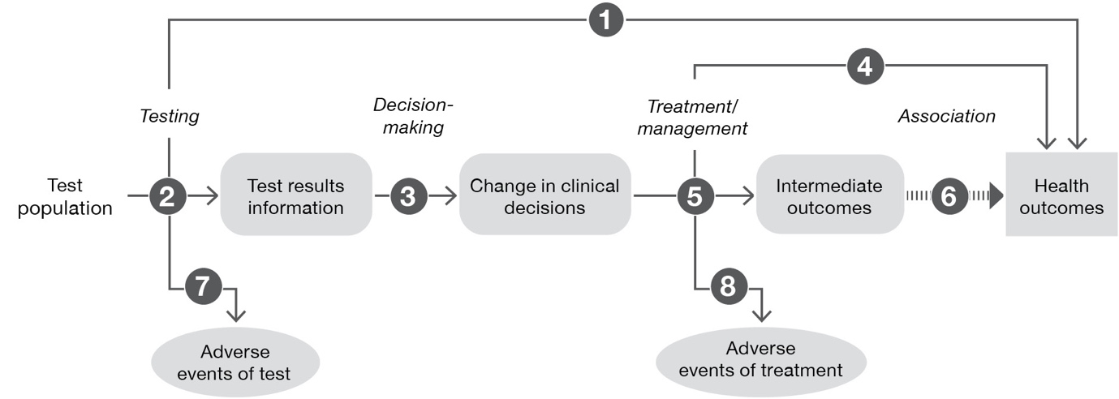
Health Outcomes:
PFS, OS, RR, QoL
Test population:
Patients with locally advanced (inoperable) or metastatic HR+/HER2- breast cancer following recurrence or progression on or after AI therapy +/- a CDK4/6 inhibitor.

Test:
NGS to detect AKT pathway alteration
Treatment:
Capivasertib + fulvestrant
Figure 3 Assessment framework showing the links from the test population to health outcomes
Abbreviations: AKT= serine/threonine kinase; AI=aromatase inhibitor; CDK=cyclin-dependent kinase; HR+/HER2-=hormone receptor positive human epidermal growth factor receptor 2 negative; NGS=next generation sequencing; OS=overall survival; PFS=progression free survival; QoL=quality of life; RR=response rate.
Notes: 1: no direct evidence from test to health outcomes; 2: test accuracy; 3: change in management based on test results; 4: influence of treatment with capivasertib + fulvestrant on health outcomes; 5: influence of the change in management on intermediate outcomes; 6: association of intermediate outcomes with health outcomes; 7: adverse events due to testing; 8: adverse events due to treatment
The proposed target test population is patients with locally advanced (inoperable) or metastatic HR+/HER2- BC following recurrence or progression on or after AI therapy +/- a CDK4/6 inhibitor. The target test population is to be offered genetic testing using NGS, with the purpose of identifying AKT pathway alterations (PIK3CA, ATK1 or PTEN tier I variants) in tumour tissue. The test outcomes can be AKT pathway alteration positive or negative. Patients with positive test outcome are then eligible for treatment with capivasertib + fulvestrant. In the CAPItello-291 trial, treatment with capivasertib + fulvestrant resulted in significant improvement in PFS among patients with AKT pathway alterations (PIK3CA, AKT1, or PTEN), HR+/HER2- advanced breast cancer who had disease progression following 1L treatment.
Referring to Figure 3, the assessment questions related to the assessment framework are:
- What is the test accuracy (sensitivity, specificity, PPV, NPV) of the proposed test intervention?
- What are the adverse events related to the test and treatment invention?
- What is the effect of capivasertib + fulvestrant on health outcomes in AKT pathway-altered, AKT pathway-non altered and unknown AKT status patients?
PASC noted and accepted the assessment framework.

Clinical management algorithms
The applicant proposed current and revised treatment algorithms with capivasertib + fulvestrant for HR+/HER2- BC (Appendix 1).

Current clinical management algorithm for identified population
Figure 4 illustrates the current treatment algorithm in test population and the algorithm developed during PICO confirmation development by the assessment group.
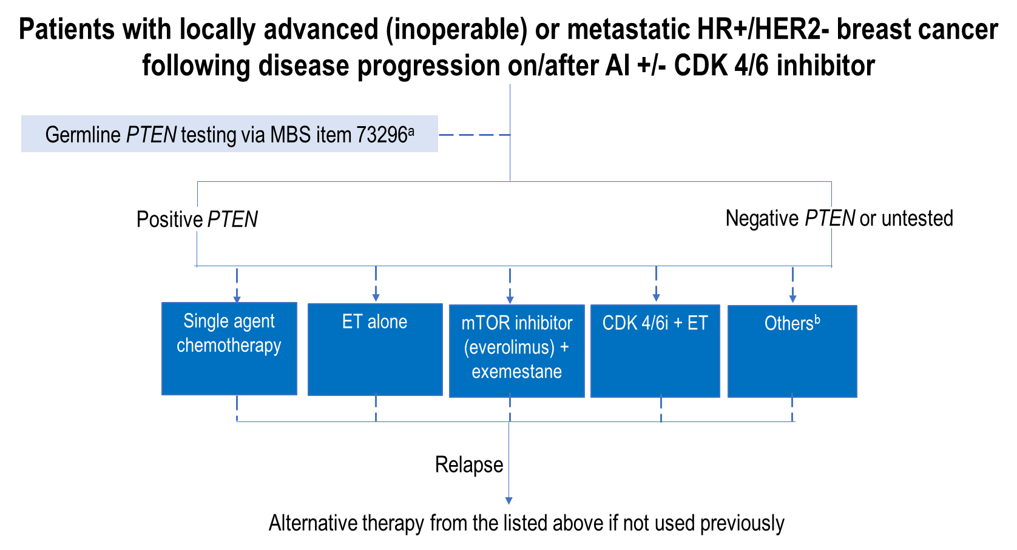
Figure 4 Current clinical management algorithm for patients with locally advanced (inoperable) or metastatic HR+/HER2- breast cancer following disease progression on/after AI +/- CDK4/6 inhibitor.
Source: Developed by the assessment group during PICO development, adapted from Table 1, p14 of MSAC application 1766 PICO set
Abbreviations: AI=aromatase inhibitor; CDK4/6 inhibitor=cyclin dependent kinase 4 and 6 inhibitor; ET=endocrine therapy; HR+/HER2-=hormone receptor–positive/human epidermal growth factor receptor 2–negative; MBS= Medicare Benefits Schedule; mTOR=mammalian target of rapamycin; PTEN=phosphatase and tensin homolog.
Note: dashed lines indicate test/treatment in selected patients; solid lines suggest flow of treatment paths.
a Not all patients receive germline PTEN testing because MBS item 73296 is available to eligible patients who fulfill clinical and family history criteria, and this MBS item may include/exclude PTEN pathogenic variants.
^{b} Other treatment options include PIK3CA inhibitor (not PBS-listed) and poly (ADP-ribose) polymerase (PARP) inhibitors (e.g., olaparib, – not PBS listed).
In contrast to the applicant’s current treatment algorithm, Figure 4 includes germline PTEN testing via MBS item 73296. Patients in the proposed population may or may not have received germline PTEN testing through MBS item 73296. MBS item 73296 is for characterisation of germline gene variants in a patient with breast, ovarian, fallopian tube, or primary peritoneal cancer; and for whom clinical and family history criteria place the patient at greater than 10% risk of having a pathogenic or likely pathogenic gene associated with breast, ovarian, fallopian tube, or primary peritoneal cancer. However, patients who test positive for germline PTEN pathogenic variants, currently have no targeted treatment options.

Proposed clinical management algorithm for identified population
The NCCN (2024) guidelines recommend the assessment of PIK3CA or AKT1 or PTEN tier I variants via NGS in patients with HR+/HER2- advanced breast cancer. Capivasertib + fulvestrant is preferred as second line or subsequent line therapy in the presence of PIK3CA/AKT1/PTEN alterations (NCCN, 2024). Figure 5 illustrates the proposed treatment algorithm, which was developed during PICO confirmation.
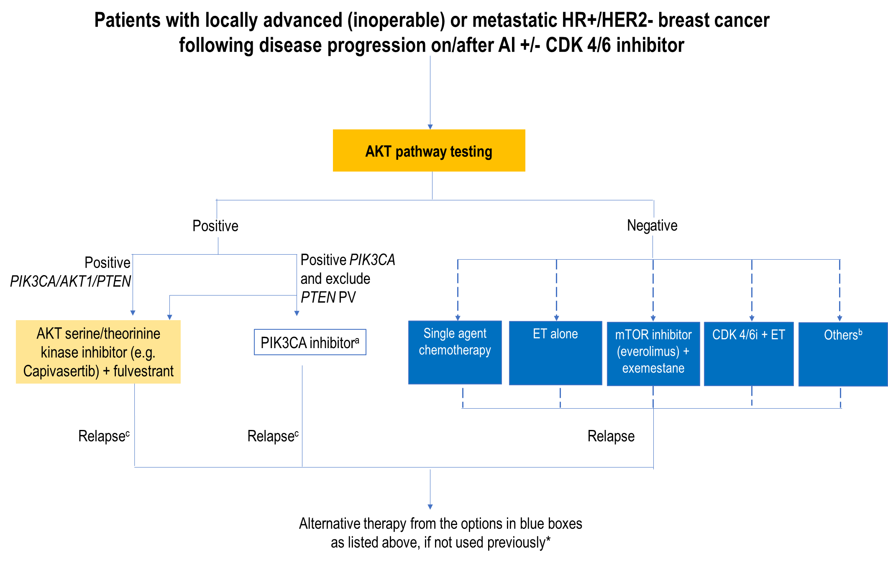
Figure 5 Proposed clinical management algorithm in patients with locally advanced (inoperable) or metastatic HR+/HER2- breast cancer following disease progression on/after AI +/- CDK4/6 inhibitor.
Source: Developed by the assessment group during PICO development, adapted from Table 2, p14 of MSAC application 1766 PICO set
Abbreviations:; AI=aromatase inhibitor; AKT=serine/threonine kinase; CDK4/6 inhibitor=cyclin dependent kinase 4 and 6 inhibitor; ET=endocrine therapy; gBRCAm=germline breast cancer gene mutation; mTOR=mammalian target of rapamycin; HR+/HER2= hormone receptor–positive/human epidermal growth factor receptor 2; PIK3CA=phosphatidylinositol-4,5-bisphosphate 3-kinase catalytic subunit alpha; mTOR= mammalian target of rapamycin; PTEN=phosphatase and tensin homolog; PV = pathogenic variant
Note: dashed lines indicate treatment in selected patients; solid lines suggest flow of management paths.
ª PIK3CA inhibitor is currently registered with TGA but not PBS-listed.
^{b} Other treatment options include poly (ADP-ribose) polymerase (PARP) inhibitor (not PBS listed).
^{c} The role of AKT-serine/threonine kinase inhibitor as the subsequent line of treatment after relapse with PIK3CA inhibitor is undefined, vice versa. The NCCN (2024) guidelines recommend both treatment options as preferred second or subsequent lines therapy, based on the presence of biomarkers.
* Upon disease relapse, an alternative therapy from the options in blue boxes is used for subsequent line of treatment, if not used previously. The sequence of treatment options is not defined, based on NCCN (2024) guidelines and ESMO (2021) guidelines.

In contrast to the applicant’s revised algorithm, Figure 5 includes the following:
- AKT pathway testing regardless if the test population had or had not received germline PTEN testing.
- Capivasertib, an AKT serine/threonine kinase inhibitor, plus fulvestrant, as the preferred treatment option for patients who tested positive for PIK3CA/AKT1/PTEN
- PIK3CA inhibitor (e.g., alpelisib) as a treatment option for patients who test positive for PIK3CA tier I variants and excluding PTEN tier I variants. Although PIK3CA inhibitors are currently registered with the TGA, they are not currently PBS-listed.
- In the event of disease progression with the treatment using AKT serine/threonine kinase inhibitor and fulvestrant, the next treatment options can be chemotherapy, ET alone, mTOR inhibitor + exemestane, ET + CDK4/6 inhibitor or poly (ADP-ribose) polymerase (PARP) inhibitor, depending on previous lines of treatment, treatment availability and patients’ preference.
During PICO development, the applicant advised that CAPItello-291 trial recruited patients with endocrine resistant disease (who had received up to two previous lines of AI for MBC or progressed within 12 months of end of adjuvant ET treatment) as well as patients who had received up to 1L of treatment for MBC. However, most of the patients (~60%) in the CAPItello-291 trial received Capivasertib in the second line setting for metastatic disease. Therefore, the place of capivasertib (first-, second- or third-line) in practice is unclear.
The timing of AKT pathway alteration testing is not specified in the revised treatment algorithm. Based on a communication received from the applicant during the PICO development process, the applicant noted that they are of the understanding that clinicians’ preference is to request AKT pathway alteration testing at time of metastatic disease diagnosis or after resistance to 1L therapy. Clinicians are likely to initiate CDK4/6 inhibitor as 1L therapy due to reimbursed access (through the PBS) of this treatment and request an AKT pathway altered tumour test to identify a targeted second line treatment, in which the test result would be received 6-8 weeks later. Depending on the result of the NGS test, a clinician may consider initiating capivasertib as second line advanced breast cancer treatment (either after progression on a CDK4/6 inhibitor or immediately).
The eviQ guidelines recommend germline PTEN genetic testing where clinically relevant in individuals where a tier I variant has been identified using somatic tumour testing, and a germline variant is suspected. To be cost-effective, however, the germline PTEN testing needs to be variant specific. Variant -specific testing is currently available through MBS item 73297, but that item is for patients who have biological relatives who have had a pathogenic or likely pathogenic gene variant identified in one or more of the genes included in the MBS item (PTEN being one of these genes). Therefore, PASC’s advice was sought on whether germline testing through item 73297 needs to be amended to allow for the testing of patients with somatic tier I variants or a new item created to allow germline PTEN testing of these patients.
PASC’s advice was also sought on whether AKT pathway testing is required for patients who have germline PTEN pathogenic variants, as tested with MBS item 73296. It is not clear if the presence of germline PTEN pathogenic variants is reflective of the somatic PTEN tier 1 variants burden in breast tumour tissue.
There is no available evidence to inform the sequence of targeted treatments for patients who test positive to AKT pathway alteration testing. For example, patients who test positive for only the PIK3CA tier 1 variants are eligible for both PIK3CA inhibitors and capivasertib. The exact treatment sequence for these patients and for those who relapse following AKT serine/threonine kinase inhibitors is not yet established in guidelines or the literature. This is a matter for PBAC consideration.
PASC’s advice was sought on the following questions:
- Do patients who are positive for somatic PTEN tier I variants require germline PTEN testing to investigate whether they have a heritable condition?
If so, the Assessment Group suggested that the most appropriate MBS item number is 73297 though noting that this would require amendment as it is currently only available to a patient who has a biological relative who has had a pathogenic or likely pathogenic gene variant identified in one or more of the genes included in the MBS item (PTEN being one of these genes). Therefore, should this item be amended, or a new item created to allow germline PTEN testing of patients with somatic PTEN tier I variants to occur?
- Should patients who test positive to germline PTEN pathogenic variants (tested under MBS item 73296) also receive AKT pathway testing to confirm that their tumour cells are positive to PTEN tier I variants before they are eligible for capivasertib treatment?
PASC suggested that patients with somatic PTEN tier I variants could be eligible for characterisation of germline gene variants including copy number variants, in BRCA1 or BRCA2 genes via modifications to an MBS item, such as 73302, which could be amended to include PTEN variants. However, post-PASC, the Department advised a separate MBS item should be proposed in the ADAR as the Department have the following concerns about the ability to amend 73302 to include PTEN copy number variants:
- The fee for 73302 is $400 and it is used to test a much larger patient population than is required for this co-dependent application and cannot be readily increased to accommodate PTEN testing.
- Item 73302 has a restriction which means it cannot be used in a patient who underwent initial germline testing under 73296.
PASC accepted this (out-of-session) and supported the development of a separate MBS item for PTEN variant germline confirmation testing for patients with somatic PTEN tier 1 variants.
PASC advised that germline PTEN testing via MBS item 73296 and 73297 was uninformative for determining eligibility for capivasertib and has been routinely excluded in BC germline testing in many Australian states due to low prevalence (0.02% of BC cases) and therefore increased likelihood of identifying a class 3 variant of unknown significance which increases clinical uncertainty. Therefore, PASC considered that all eligible patients as per ‘test population’ should be eligible for the proposed AKT pathway testing, regardless of whether they had claimed MBS item 73296 or 73297 previously.
The proposed clinical management algorithm was amended to exclude germline PTEN testing.

Proposed economic evaluation
The overall clinical claim is for superiority. The applicant has claimed that the proposed codependent technology (AKT pathway alteration testing and capivasertib + fulvestrant treatment) is superior in terms of comparative effectiveness versus the comparator (no testing and current standard practice) in patients with HR+/HER2- locally advanced (inoperable) or metastatic breast cancer, who have progressed on or after treatment with an ET +/- CDK4/6 inhibitor. Referring to the CAPItello-291 trial, the most frequently reported adverse events of grade 3 or higher and serious adverse events were rash, diarrhoea, hyperglycaemia, and vomiting, with higher incidences in the capivasertib + fulvestrant group. Serious adverse events were more common in the capivasertib + fulvestrant group (16% vs 8%, in placebo-fulvestrant group). Therefore, the comparative safety of capivasertib to placebo appeared likely inferior, based on the information obtained during PICO development. According to the guidelines for preparing assessments for the MSAC (version 1.2 2021), a cost-utility analysis would be appropriate in this setting.
PASC noted and accepted the proposed economic evaluation.
PASC enquired whether it may be more cost-effective to deliver treatment without requiring AKT pathway testing beforehand. The applicant responded that it depends on the TGA’s approved indication, as to whether the indication is for the overall population (no biomarker testing required for treatment eligibility) or biomarker-specific population. The cost-effectiveness analysis would be based on the TGA approved population. If the TGA indication is approved for the overall population, PASC considered that the applicant may wish to present an economic evaluation allowing a comparison of the cost effectiveness of the treatment with versus without the test. The applicant noted that the US FDA and Canada approved the indication in the biomarker population only. PASC noted that the UK National Institute for Health and Care Excellence (NICE) is planning to analyse the cost-effectiveness without the test, and a subpopulation analysis included patients with the genetic variants as a secondary analysis.
Capivasertib (Trade name: TRUQAP) was registered on the ARTG on the 9th of May 2024 (post-PASC meeting) for the following indication: "TRUQAP is indicated in combination with fulvestrant for the treatment of adult patients with hormone receptor (HR) positive, human epidermal growth factor receptor 2 (HER2) negative (defined as IHC 0 or 1+, or IHC 2+/ISH-) locally advanced or metastatic breast cancer following recurrence or progression on or after an endocrine based regimen."

Proposal for public funding

The applicant proposed the following MBS item descriptor and was updated based on PASC advice, as follows:
Category 6 – PATHOLOGY SERVICES
MBS item *XXXX
A test of tumour tissue for full characterisation of tier 1 PIK3CA, AKT1 and PTEN gene variants including PTEN copy number variants, associated with abrogation of the AKT pathway, in a patient with:
• locally advanced (inoperable) or metastatic hormone receptor positive, HER2- breast cancer; AND
• following recurrence or progression on or after aromatase inhibitor therapy, with or without a CDK4/6 inhibitor.
As requested by a specialist or consultant physician, to determine eligibility for a treatment listed on the Pharmaceutical Benefits Scheme (PBS) for this context.
Once per primary tumour diagnosis.
Fee: $XX Benefit: 75% = $XX 85% = $XX
PASC agreed that the MBS item is applicable once per primary tumour diagnosis (allowing for treatment decision-making for a potential second BC tumour).
The applicant proposed MBS item descriptor was amended to include “AND following recurrence or progression on or after aromatase inhibitor therapy, with or without a CDK4/6 inhibitor”, so as to be consistent with the target test population as well as the study population in the CAPitello-291 trial.
The proposed MBS item descriptor is silent on test methodology based on the advice of the Department in order to take into account current laboratory preferences as well as technological advancements to future-proof the descriptor.
AKT serine/threonine kinase inhibitors are not currently PBS-listed. An application for capivasertib will be submitted to the PBAC and the applicant’s proposed PBAC meeting date relevant to this codependent application is 6th November 2024.
The applicant was unable to propose an MBS fee because the cost of the current test was unknown. The applicant was advised to consult with the RCPA to seek additional advice on any uncertainty, including suitable MBS fee.
PASC noted that no fee had been supplied by applicant.
Referring to existing and similar MBS items, the fee for AKT pathway-alteration testing which targets three genes could potentially cost around $1,000-$1,200.
- MBS item 73433 using NGS testing for NTRK1, NTRK2, NTRK3 genes in tumour tissues – Fee: $1,000
- MBS item 73337 for EGFR gene in tumour tissue – Fee: $397.35
Germline PTEN testing is currently available via MBS item 73296 at a fee of $1,200 (inclusive of at least three genes testing). MBS item 73296 includes the characterisation of germline gene variants, in genes associated with breast, ovarian, fallopian tube or primary peritoneal cancer, which must include at least: BRCA1 and BRCA 2 genes; and one or more STK11, PTEN, CDH1, PALB2 and TP53. PASC’s advice is sought as to whether the claimed MBS item 73296 should affect patients’ eligibility for this proposed MBS item for AKT pathway alterations testing. On the one hand, patients with positive germline PTEN pathogenic variants (via item 73296) could be excluded from access to proposed AKT pathway testing because they are already deemed eligible for treatment due to testing positive for the germline PTEN pathogenic variant. On the other hand, testing for PIK3CA and AKT1 through the proposed AKT pathway testing may provide extra prognostic/predictive information above germline PTEN testing alone, in patients with positive germline PTEN pathogenic variants.
PASC’s advice was sought on whether it is appropriate for the MBS item descriptor to be agnostic on treatment. PASC considered that the MBS item descriptor could be treatment agnostic and confirmed that using the wording “treatment listed on the Pharmaceutical Benefits Scheme (PBS) for this context”, as per the proposed MBS item descriptor above, was appropriate.
PASC’s advice was sought as to whether the claimed MBS item 73296 should affect patients’ eligibility for the proposed MBS item for AKT pathway alterations testing.
PASC emphasised that there is high demand for treatment-focussed testing and the proposed AKT pathway testing is mainly for assessing the eligibility for second line treatment. PASC queried whether testing prior to third line treatment decision making may also be appropriate and considered that the population with this clinical need would be very small.
For the purpose of funding of germline testing of PTEN somatic variants, PASC accepted the Department’s advice that this should be achieved through the development of a separate MBS item rather than through modification/amendment of MBS item 73302, as discussed in the previous section. PASC noted that there is also some State-based funding for germline testing in the public setting.
The applicant’s clinical expert advised that large panel Illumina TSO 500 and AVENIO have similar costs of around AUD $REDACTED, which was REDACTED compared to FoundationOneCDx (USD $REDACTED). While there was no consensus on cost or market price, it was believed that testing cost will eventually reduce.
PASC recommended that a list of IVDs available in Australia and their costs should be compiled to help determine the appropriate fee. PASC mentioned that the genetic tumour tissue testing is agnostic on test methodology and fees could be reimbursed based on the laboratories’ service.

Summary of public consultation input
PASC noted and welcomed consultation input from 2 organisations. The 2 organisations that submitted input were:
- Australian Pathology
- Breast Cancer Network Australia (BCNA)

The consultation feedback received was all supportive.
Clinical need and public health significance
The main benefits of public funding received in the consultation feedback included equitable access to the test to receive the clinically appropriate PBS listed targeted treatment. BCNA noted that this test will provide more treatment options to patients resistant to 1L endocrine therapies. Consultation noted additional time of overall survival are highly valued by patients and their families. More treatment options give more time with loved ones and allocate more time in paid employment or other roles such as volunteering or caring.
PASC queried if there were any accessibility issues for people who live in remote areas. Monash Pathology (the applicant’s clinical expert) assured PASC that because the AKT pathway testing is done on FFPE samples, oncologists could order the test at a regional hospital and then send the sample to metropolitan hospitals for analysis which meant that patients did not need to travel to the main laboratory for the test to be undertaken.
Indication(s) for the proposed medical service and clinical claim
The consultation feedback strongly agreed with the proposed population, noting a minimum of 10,500 people living with metastatic BC in Australia.
The consultation feedback agreed with the proposed comparator. Australian Pathology input noted the complexity of PTEN gene testing as it can have variants anywhere in the gene. The proposed service was not clear whether it included testing for multiple types of PTEN variants including detection of single nucleotide variants and deletions of PTEN gene which makes it more complex to the other current MBS listed items which identify one type of genetic variant.
The consultation feedback strongly agreed with the proposed clinical claim.
Cost information for the proposed medical service
The consultation feedback ranged from disagreeing to agreeing with the proposed service descriptor. The input that disagreed with the descriptor indicated lack of adequate description for scope of PTEN gene testing. Australian Pathology advocated for fewer restrictions in the item descriptor for equity and access, noting referral from clinicians should be sufficient to justify most of the tests. With respect to the “once in lifetime” test frequency restriction. Australian Pathology indicated that pathology providers cannot currently verify if patients have been previously tested. They considered Medicare would need to make provision for providers to check patients Medicare claims history prior to the testing being performed.
Australian Pathology indicated that no fee has been proposed in the application, advising using the prior similar tests somatic BRCA (73301, 100% fee $1,200) or the glioma panel (73249, 100% fee $887.90), as benchmark to setup a cost for the proposed service.
PASC noted that the Breast Cancer Network Australia highly supported the codependent submission as the current out-of-pocket expenses were $3,000-$5,000 for testing and emphasised the importance of extending patients’ lives.
PASC agreed on the importance of keeping any out-of-pocket costs to a minimum.

Next steps
PASC noted that the application will progress as an integrated codependent submission to both MSAC and PBAC.

Applicant Comments on Ratified PICO
The applicant had no comment.

Appendix 1
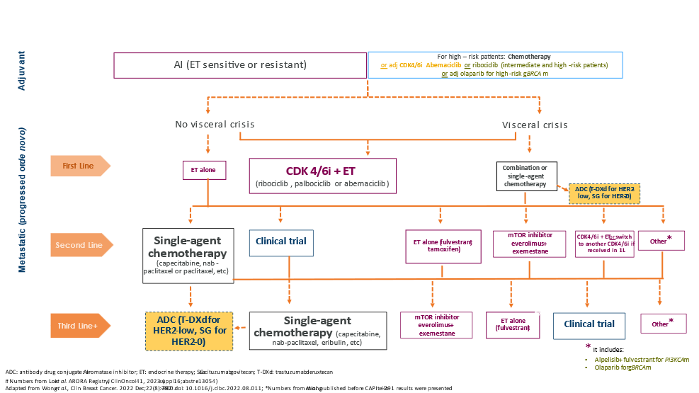
Appendix Figure 1: Current treatment algorithm in patients with HR+/HER2- breast cancer
Source: Table 1, p14 of MSAC application 1766 PICO set
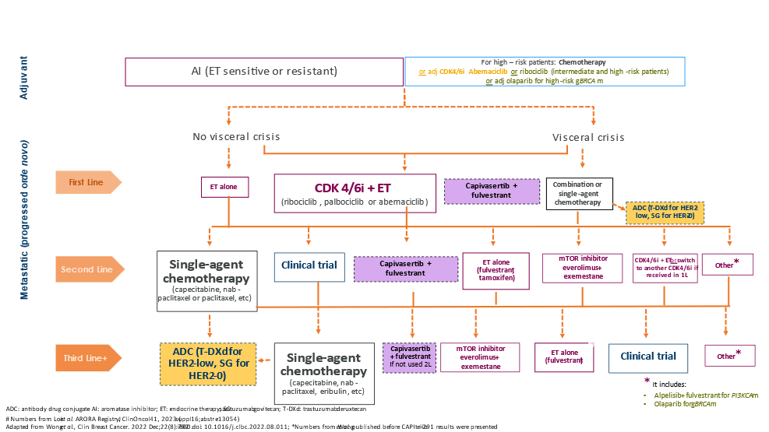
Appendix Figure 2: Revised treatment algorithm in patients with HR+/HER2- breast cancer (capivasertib)
Source: Table 2, p14 of MSAC application 1766 PICO set

References
Australian Clinical Labs (2024) Circulating Tumour DNA (ctDNA) Testing in Plasma, accessed 2024 March 5. https://www.clinicallabs.com.au/aspect/
Australian Institute of Health and Welfare (2022) Cancer, accessed 2024 February 01. https://www.aihw.gov.au/reports/australias-health/cancer
Australian Institute of Health and Welfare (2023) BreastScreen Australia monitoring report 2023, accessed 2024 February 20. https://www.aihw.gov.au/reports/cancer-screening/breastscreen-australia-monitoring-report-2023/summary
Australian Institute of Health and Welfare (2023 Aug 31) Cancer data in Australia, accessed 2024 February 29. https://www.aihw.gov.au/reports/cancer/cancer-data-in-australia/contents/overview-of-cancer-in-australia-2023
Cancer Australia (2019) Top 10 best practices for people with metastatic breast cancer, accessed 2024 March 13. https://www.canceraustralia.gov.au/about-us/news/top-10-best-practices-people-metastatic-breast-cancer
Cancer Australia (2020) Guidance for the management of early breast cancer, accessed 2024 February 29. https://www.guidancebreastcancer.gov.au/treatment-systemic-therapy/endocrine-therapy/initial-adjuvant-endocrine-therapy-men-and-premenopausal-women
Cerma, K, et al. (2023). Targeting PI3K/AKT/mTOR Pathway in Breast Cancer: From Biology to Clinical Challenges. Biomedicines, 11(1), 109. https://www.mdpi.com/2227-9059/11/1/109
Department of Health and Aged Care (2017) Illumina Australia Pty Ltd - Human genetics-related IVDs (297844), accessed 2024 Feb 28. https://www.tga.gov.au/resources/artg/297844
Department of Health and Aged Care (2023) Thermo Fisher Scientific Australia Pty Ltd, accessed 2024 February 28. https://www.tga.gov.au/resources/artg/426895
Department of Health and Aged Care (2024) Medicine Status Website, accessed 2024 February 29. https://www.pbs.gov.au/medicinestatus/search.html
Food and Drug Administration (2023 Dec 21) List of Cleared or Approved Companion Diagnostic Devices (In Vitro and Imaging Tools), accessed 2024 February 09. https://www.fda.gov/medical-devices/in-vitro-diagnostics/list-cleared-or-approved-companion-diagnostic-devices-in-vitro-and-imaging-tools
Foundation Medicine Inc (2024) FoundationOne®Liquid CDx, accessed 2024 February 09. https://www.foundationmedicine.com/test/foundationone-liquid-cdx
Gennari, A, et al. (2021). ESMO Clinical Practice Guideline for the diagnosis, staging and treatment of patients with metastatic breast cancer. Annals of Oncology, 32(12), 1475-1495. https://doi.org/10.1016/j.annonc.2021.09.019
Glaviano, A, et al. (2023). PI3K/AKT/mTOR signaling transduction pathway and targeted therapies in cancer. Molecular Cancer, 22(1). https://doi.org/10.1186/s12943-023-01827-6
Howell, SJ, et al. (2022). Fulvestrant plus capivasertib versus placebo after relapse or progression on an aromatase inhibitor in metastatic, oestrogen receptor-positive, HER2-negative breast cancer (FAKTION): overall survival, updated progression-free survival, and expanded biomarker analysis from a randomised, phase 2 trial. The Lancet Oncology, 23(7), 851-864. https://doi.org/10.1016/s1470-2045(22)00284-4
Jin, X, et al. (2023). Molecular classification of hormone receptor-positive HER2-negative breast cancer. Nature Genetics, 55(10), 1696-1708. https://doi.org/10.1038/s41588-023-01507-7
Li, Y, et al. (2023). Comprehensive characterization of HER2-low breast cancers: implications in prognosis and treatment. eBioMedicine, 91, 104571. https://doi.org/10.1016/j.ebiom.2023.104571
Martorana, F, et al. (2021). AKT Inhibitors: New Weapons in the Fight Against Breast Cancer? Frontiers in Pharmacology, 12. https://doi.org/10.3389/fphar.2021.662232
National Association of Testing Authorities Australia (2024a) ISO 15189 Human Pathology, accessed 2024 February 15. https://nata.com.au/accreditation/medical-laboratory-accreditation-iso-15189/
National Association of Testing Authorities Australia (2024b) Search accredited organisations, accessed 2024 February 15. https://nata.com.au/?post_type=site&s=massively+parallel+seqeuncing&filter=&state=&status=
National Breast Cancer Foundation (2024) Breast Cancer Stats, accessed 2024 February 01. https://nbcf.org.au/about-breast-cancer/breast-cancer-stats/#:~:text=1%20in%207%20women%20are,including%2030%2D40%20males).
National Cancer Control Indicators (2018 Apr) Distribution of cancer stage, accessed 2024 February 05. https://ncci.canceraustralia.gov.au/diagnosis/distribution-cancer-stage/distribution-cancer-stage
National Cancer Institute (2024) Cancer Stat Facts: Female Breast Cancer Subtypes, accessed 2024 February 02. https://seer.cancer.gov/statfacts/html/breast-subtypes.html
National Comprehensive Cancer Network (2024 Jan 25) NCCN Clinical Practice Guidelines in Oncology Breast Cancer, accessed 2024 February 08. https://www.nccn.org/guidelines/recently-published-guidelines
National Pathology Accreditation Advisory Council. (2017). Requirements for Human Medical Genome Testing Utilising Massively Parallel Sequencing Technologies [Australian Government Department of Health.
Qin, D. (2019). Next-generation sequencing and its clinical application. Cancer Biology &amp; Medicine, 16(1), 4-10. https://doi.org/10.20892/j.issn.2095-3941.2018.0055
Rimawi, MF, et al. (2018). Low PTEN levels and PIK3CA mutations predict resistance to neoadjuvant lapatinib and trastuzumab without chemotherapy in patients with HER2 over-expressing breast cancer. Breast Cancer Res Treat, 167(3), 731-740. https://doi.org/10.1007/s10549-017-4533-9
Skolariki, A, et al. (2022). Role of PI3K/Akt/mTOR pathway in mediating endocrine resistance: concept to clinic. Explor Target Antitumor Ther, 3(2), 172-199. https://doi.org/10.37349/etat.2022.00078
Sonic Healthcare (2024) Breast cancer focused gene panel, accessed 2024 February 16. https://www.sonicgenetics.com.au/our-tests/all-our-tests/breast-cancer-focused-gene-panel/
Swain, SM, et al. (2023). Targeting HER2-positive breast cancer: advances and future directions. Nature Reviews Drug Discovery, 22(2), 101-126. https://doi.org/10.1038/s41573-022-00579-0
Turner, NC, et al. (2023). Capivasertib in Hormone Receptor–Positive Advanced Breast Cancer. New England Journal of Medicine, 388(22), 2058-2070. https://doi.org/10.1056/nejmoa2214131
Venetis, K, et al. (2022). Analytical Performance of Next-Generation Sequencing and RT-PCR on Formalin-Fixed Paraffin-Embedded Tumor Tissues for PIK3CA Testing in HR+/HER2− Breast Cancer. Cells, 11(22), 3545. https://doi.org/10.3390/cells11223545
Viale, G, et al. (2023). Retrospective study to estimate the prevalence and describe the clinicopathological characteristics, treatments received, and outcomes of HER2-low breast cancer. ESMO Open, 8(4), 101615. https://doi.org/10.1016/j.esmoop.2023.101615
Zhang, Z, & Richmond, A. (2021). The Role of PI3K Inhibition in the Treatment of Breast Cancer, Alone or Combined With Immune Checkpoint Inhibitors. Front Mol Biosci, 8, 648663. https://doi.org/10.3389/fmolb.2021.648663

Patients with unknown AKT pathway status are those where no sample was available or there was a pre-analytical or post-analytical failure which prevented the sample from being analysed.
Patients with AKT pathway non-altered tumours encompasses those where an AKT pathway alteration was not detected and those with unknown AKT pathway status.

