Application Form
Genetic testing for inherited kidney disease
(other than Alport syndrome)
This application form is to be completed for new and amended requests for public funding (including but not limited to the Medicare Benefits Schedule (MBS)). It describes the detailed information that the Australian Government Department of Health requires in order to determine whether a proposed medical service is suitable.
Please use this template, along with the associated Application Form Guidelines to prepare your application. Please complete all questions that are applicable to the proposed service, providing relevant information only. Applications not completed in full will not be accepted.
Should you require any further assistance, departmental staff are available through the Health Technology Assessment Team (HTA Team) on the contact numbers and email below to discuss the application form, or any other component of the Medical Services Advisory Committee process.
Phone: +61 2 6289 7550
Fax: +61 2 6289 5540
Email: hta@health.gov.au
Website: www.msac.gov.au

PART 1 – APPLICANT DETAILS

Applicant details (primary and alternative contacts)
Corporation / partnership details: N/A (Private individual)
Corporation name: N/A
ABN: N/A
Business trading name: N/A

Primary contact name: REDACTED
Alternative contact name: REDACTED

(a) Are you a lobbyist acting on behalf of an Applicant?
Yes
No

If yes, are you listed on the Register of Lobbyists?
Yes
No

PART 2 – INFORMATION ABOUT THE PROPOSED MEDICAL SERVICE

Application title
Genetic testing for inherited kidney disease (other than Alport syndrome)

Provide a succinct description of the medical condition relevant to the proposed service (no more than 150 words – further information will be requested at Part F of the Application Form)
Currently, about 25,000 Australians have end-stage kidney failure (ESKF) which requires treatment with dialysis or a kidney transplant (ANZDATA).
There are many different causes for kidney failure but at least 50% of children and 10% of adults have an inherited kidney disease. Many inherited kidney diseases are undiagnosed which means that affected individuals are not treated and subsequently develop kidney failure at a younger age and require more years of dialysis. This is also true for the affected individuals’ undiagnosed family members.
Dialysis is expensive costing an average of $80,000 a year (most patients require at least 3 years of dialysis before receiving a transplant) and is associated with high morbidity, including a 40 times increased death rate from heart disease than age and sex-matched controls.
Treatment with ACE inhibitors delays the onset of kidney failure in both the index cases with inherited kidney disease and their affected family members. In some cases, ACE inhibitor treatment delays the onset of kidney failure sufficiently long that affected individuals never need dialysis or a transplant. However this depends on an early and accurate diagnosis, which is what genetic testing provides.

Provide a succinct description of the proposed medical service (no more than 150 words – further information will be requested at Part 6 of the Application Form)
Many individuals with inherited end-stage kidney failure do not know their underlying diagnosis even after years of testing. In general, genetic testing provides the diagnosis more accurately than any other investigation.
The proposed service is for a nephrologist or geneticist to refer the subject for genetic testing based on their clinical features. Most laboratories use whole exome sequencing (WES) and then examine likely genes for pathogenic variants. Testing occurs once in a lifetime for the index case, and once only in a simplified form, for other family members.
Genetic testing indicates the diagnosis in the index case and affected family members. It enables treatment to delay renal failure in some cases; reduces the time of the ‘diagnostic odyssey’ and cost of tests; enables the anticipation of complications and avoids kidney donation from an affected family member; enables accurate family planning; and names the disease, which is empowering for both the individual and their clinicians.
Genetic testing also excludes the disease diagnosis in unaffected family members with certainty.

(a) Is this a request for MBS funding?
Yes
No

If yes, is the medical service(s) proposed to be covered under an existing MBS item number(s) or is a new MBS item(s) being sought altogether?
Amendment to existing MBS item(s) OR new item number

New MBS item(s)
This application is for genetic testing in many kinds of inherited kidney disease and could also be considered an Amendment (a broadening to all kidney disease from Alport syndrome only) to the MBS item numbers 73298 and 73299 which are for the genetic diagnosis of Alport syndrome (73298) and in a member of a family with Alport syndrome where the mutation is known (73299). The advantages of genetic testing are identical for Alport syndrome and for all forms of inherited kidney disease.

If an amendment to an existing item(s) is being sought, please list the relevant MBS item number(s) that are to be amended to include the proposed medical service:
73298 and 73299 (an amendment to these item numbers would simply issues)

If an amendment to an existing item(s) is being sought, what is the nature of the amendment(s)?
- An amendment to the way the service is clinically delivered under the existing item(s)
- An amendment to the patient population under the existing item(s)
- An amendment to the schedule fee of the existing item(s)
- An amendment to the time and complexity of an existing item(s)
- Access to an existing item(s) by a different health practitioner group
- Minor amendments to the item descriptor that does not affect how the service is delivered
- An amendment to an existing specific single consultation item
- An amendment to an existing global consultation item(s)
- X Other (please describe below):
Extension from Alport syndrome to include other inherited forms of kidney disease too

If a new item(s) is being requested, what is the nature of the change to the MBS being sought?
- A new item which also seeks to allow access to the MBS for a specific health practitioner group
- A new item that is proposing a way of clinically delivering a service that is new to the MBS (in terms of new technology and / or population)
- A new item for a specific single consultation item
- A new item for a global consultation item(s)

Is the proposed service seeking public funding other than the MBS?
Yes
No

If yes, please advise:
N/A

What is the type of service:
Therapeutic medical service
Investigative medical service
Single consultation medical service
Global consultation medical service
Allied health service
Co-dependent technology
Hybrid health technology

For investigative services, advise the specific purpose of performing the service (which could be one or more of the following):
- To be used as a screening tool in asymptomatic populations
- Assists in establishing a diagnosis in symptomatic patients
- Provides information about prognosis
- Identifies a patient as suitable for therapy by predicting a variation in the effect of the therapy
- Monitors a patient over time to assess treatment response and guide subsequent treatment decisions

Does your service rely on another medical product to achieve or to enhance its intended effect?
Pharmaceutical / Biological
Prosthesis or device
No

(a) If the proposed service has a pharmaceutical component to it, is it already covered under an existing Pharmaceutical Benefits Scheme (PBS) listing?
Yes
No

If yes, please list the relevant PBS item code(s):
Insert PBS item code(s) here

If no, is an application (submission) in the process of being considered by the Pharmaceutical Benefits Advisory Committee (PBAC)?
Yes (please provide PBAC submission item number below)
No
Insert PBAC submission item number here

If you are seeking both MBS and PBS listing, what is the trade name and generic name of the pharmaceutical?
Trade name: Insert trade name here
Generic name: Insert generic name here

(a) If the proposed service is dependent on the use of a prosthesis, is it already included on the Prostheses List?
Yes
No
If yes, please provide the following information (where relevant):
Billing code(s): Insert billing code(s) here
Trade name of prostheses: Insert trade name here
Clinical name of prostheses: Insert clinical name here
Other device components delivered as part of the service: Insert description of device components here

If no, is an application in the process of being considered by a Clinical Advisory Group or the Prostheses List Advisory Committee (PLAC)?
Yes
No

Are there any other sponsor(s) and / or manufacturer(s) that have a similar prosthesis or device component in the Australian market place which this application is relevant to?
Yes
No

If yes, please provide the name(s) of the sponsor(s) and / or manufacturer(s):
Insert sponsor and/or manufacturer name(s) here

Please identify any single and / or multi-use consumables delivered as part of the service?
Single use consumables: Insert description of single use consumables here
Multi-use consumables: Insert description of multi use consumables here

PART 3 – INFORMATION ABOUT REGULATORY REQUIREMENTS

(a) If the proposed medical service involves the use of a medical device, in-vitro diagnostic test, pharmaceutical product, radioactive tracer or any other type of therapeutic good, please provide the following details:
N/A

Is the medical device classified by the TGA as either a Class III or Active Implantable Medical Device (AIMD) against the TGA regulatory scheme for devices?
Class III
AIMD
N/A

(a) Is the therapeutic good to be used in the service exempt from the regulatory requirements of the Therapeutic Goods Act 1989?
Yes (If yes, please provide supporting documentation as an attachment to this application form)
No

If no, has it been listed or registered or included in the Australian Register of Therapeutic Goods (ARTG) by the Therapeutic Goods Administration (TGA)?
Yes (if yes, please provide details below)
No

N/A

If the therapeutic good has not been listed, registered or included in the ARTG, is the therapeutic good in the process of being considered for inclusion by the TGA?
Yes (please provide details below)
No

N/A

If the therapeutic good is not in the process of being considered for listing, registration or inclusion by the TGA, is an application to the TGA being prepared?
Yes (please provide details below)
No

N/A

PART 4 – SUMMARY OF EVIDENCE

Provide an overview of all key journal articles or research published in the public domain related to the proposed service that is for your application (limiting these to the English language only). Please do not attach full text articles, this is just intended to be a summary.

 | Type of study design* | Title of journal article or research project (including any trial identifier or study lead if relevant) | Short description of research (max 50 words)** | Website link to journal article or research  (if available) | Date of publication***
1. | Review | Vivante and Hildebrandt: Exploring the genetic basis of early-onset chronic kidney disease | Review of the advantages of genetic diagnosis of early onset kidney disease (see Table below) | Nature Reviews Nephrology 2016:12: 133-146 | 2016
2. | Review | Bockenhauer et al: Genetic testing in renal disease | Review of advantages of genetic testing for renal disease: diagnosis; precise genetic counselling; better understanding of pathophysiology; improving clinical treatment | Ped Nephrol 2012; 27: 873-883 | 2012 (one of earliest manuscripts)
3. | Review of a laboratory’s experience | Al-Hamed et al. Genetic spectrum of Saudi Arabian patients with antenatal cystic kidney disease and ciliopathy phenotypes using a targeted renal gene panel | Describes their experience where they found causative/inferred mutations in 28 of 44 families (64%); this allowed for preimplantation diagnosis in future pregnancies | J Med Genet 2016;53: 338-347 | 2016
4. | Review of an Australian clinical laboratory’s experience | Mallett et al . Massively parallel sequencing and targeted exomes in familial kidney disease can diagnose underlying genetic disorders | Ten panels with 207 genes. Australian series. Overall 58 mutations identified in 135 families (43%) for a variety of inherited diseases. Same rate for children (46%) and adults (40%). Genetic testing changed diagnosis in about 25% of patients | Kidney International 2017;92: 1493-1506 | 2017
5. | Review | Connaughton et al. Personalised medicine in chronic kidney disease by detection of monogenic mutations | Monogenic mutations in about 450 genes explain 30% of the paediatric cohort and 5 – 30% of the adult cohort with CKD. Allows personalised treatment: formal diagnosis; and screening for additional extrarenal features; better understanding of disease pathogenesis and potentially new targeted treatments | NDT 2019; 1-8 | 2019
6. |  | Connaughton et al monogenic causes of CKD in adults | WES in 114 families; detected a pathogenic mutation in a known CKD gene in 42 families (37%). No difference in rate of genetic diagnosis in childhood versus adult onset CKD. WES confirmed the clinical diagnosis in 40% of families; corrected the clinical diagnosis in 22% of families: and established a diagnosis for the first time in 38% of families. | Kid Int 2019;95: 914-928 | 2019
7 | Review of a Japanese laboratory’s experience | Mori et al. Comprehensive genetic testing approach for major inherited kidney diseases, using next generation sequencing with a custom panel | Panel of 127 genes:73 individuals with inherited kidney disease from 56 families. Mutations found in ? 35 people (48%). Technique fast, easy and accurate. | Clin Exp Nephrol 2017:21:63 - 75 | 2017
8 | Review of a UK multidisciplinary clinic for genetic diagnosis over previous 5 years | Alkanderi et al: Lessons learned from a multidisciplinary renal genetics clinic | 80 index cases; 164 other family members; 3.5% familial haematuria; and 31% cystic disease.  “The value of a precise diagnosis is increasingly important, valued and achievable. Families have often seen many doctors … (who ) have not been able to offer a ..diagnosis. There is almost certainly a health economic value of ending the diagnostic odyssey for patients with genetic and often rare diseases. Other similar clinics in London, Manchester and Cambridge. Experience broadened known clinical features | QJM 2017; 453 - 457 | 2017
9 | Sensitivity of WES | Bullich et al: A kidney-disease gene panel allows a comprehensive genetic diagnosis of cystic and glomerular inherited kidney disease. | 140 genes. Validation cohort of 116 patients and demonstrated 99% sensitivity. Diagnostic cohort of 207 patients with cystic disease and 98 with glomerular disease. Mutations found in 78% and 62% respectively. Found a novel diagnosis in 15%. Changed diagnosis in 2%. Thus NGS necessary to establish correct diagnosis in 17% of patients. Especially valuable in patients with nonspecific or atypical phenotypes. | Kidney International;2018: 94: 363-71. | 2018
10 | Review | Duvuyst et al: Rare inherited kidney diseases: challenges, opportunities and perspectives | Review.’At least 10% of all adults and nearly all children who receive renal-replacement therapy have an inherited kidney disease.’ Their disease affects their quality of life. Also, difficult to diagnose because of ‘variable phenotypes, fragmented clinical and biological data, no standardisation for diagnostic procedures and poor understanding of pathogenesis and natural history’. NGS is ‘particularly well-suited to target the kidney’. Absence of accurate biomarkers for kidney disease is an issue. A kidney biopsy is still the gold-standard. Many inherited kidney diseases are now considered to comprise multiple different diseases. Carriers are difficult to identify accurately clinically. | Lancet 2014;383:1844-59 | 2014
11 | Prospective analysis of gene testing for sporadic (non-familial) polycystic kidney disease | Neumann et al. Adult patients with sporadic polycystic kidney disease; the importance of screening for mutations in the PKD1 and PKD2 genes | 30 patients with multiple cysts and no family history of ADPKD had 24 mutations in PKD1 and 6 in PKD2. ‘Molecular genetic screening for mutations is essential for the definitive diagnosis’. | Int Urol Nephrol 2012:44:1753-1762 | 2012
12 | Prospective analysis of gene testing for sporadic (non-familial) polycystic kidney disease | Fujimaru et al. Kidney enlargement and multiple liver cyst formation implicate mutations in PKD1/2 in adult sporadic polycystic kidney disease | 53 patients with sporadic cystic kidney disease. 32 had PKD1 or PKD2 mutations, and 3 had mutations in other cystic kidney diseases. | Clinical Genetics 2018: 94: 125 – 131. | 2018
13 | US economic evaluation for genetic diagnosis. Retrospective chart review (of general patients, but said to be the first economic evaluation of NGS) | Shashi et al. The utility of medical genetics diagnostic evaluation in the context of next-generational sequencing for undiagnosed genetic disorders. | General clinical genetics setting.500 patients 455 children and 45 adults. 39 were assessed as not having a genetic disorder.212 of the other 461 cases (46%) had a genetic diagnosis based on traditional approach. Same for adults and children. The other 249 were believed to have a genetic disease but were undiagnosed with traditional means. The undiagnosed patients had more tests and more clinic visits at greater cost than those who were diagnosed. The authors concluded that where the diagnosis is not made at the initial visit using conventional means, the average cost per diagnosis is $25,000, and likely to be even greater. NGS is about 50% effective in making a diagnosis. Thus NGS is economically feasible for patients who remain undiagnosed after the initial visit. | Genetics in Medicine 2014; 16: 176- 182 | 2014
14 | Dutch economic evaluation of NGS for genetic diagnosis. | Monroe et al. Effectiveness of whole-exome sequencing and costs of the traditional diagnostic trajectory in children with intellectual disability | Much more cost efficient to do NGS than traditional testing – in children with intellectual disability | Genetics in Medicine 2016; 18: 949 - 956 | 2016

The above Table is a selection of published studies. Studies use the terms WES (Whole Exome Sequencing) or NGS (Next Generation Sequencing) interchangeably.

The following Figure reviews the diagnostic yield of genetic testing in different types of chronic kidney failure in children and adults. It is from Connaughton and Hildebrandt, Nephrol Dial Transplantation 2019: 1-8. Personalised medicine in chronic kidney disease by detection of monogenic mutations. It demonstrates for these common phenotypes (coloured boxes), the likely mutation detection rate for each.
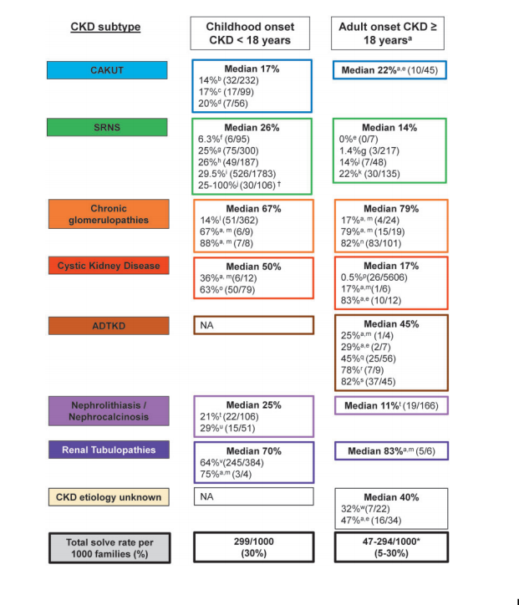
The following Table is taken from Vivante and Hildebrandt, Nature Reviews Nephrology 2016 “Exploring the genetic basis of early-onset chronic kidney disease” and describes the advantages of genetic diagnosis of ALL forms of inherited kidney disease, in people under the age of 25 years. (The authors are paediatricians.)
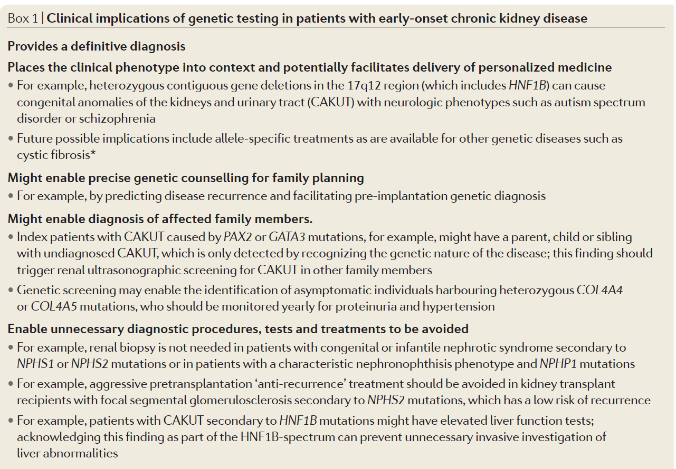
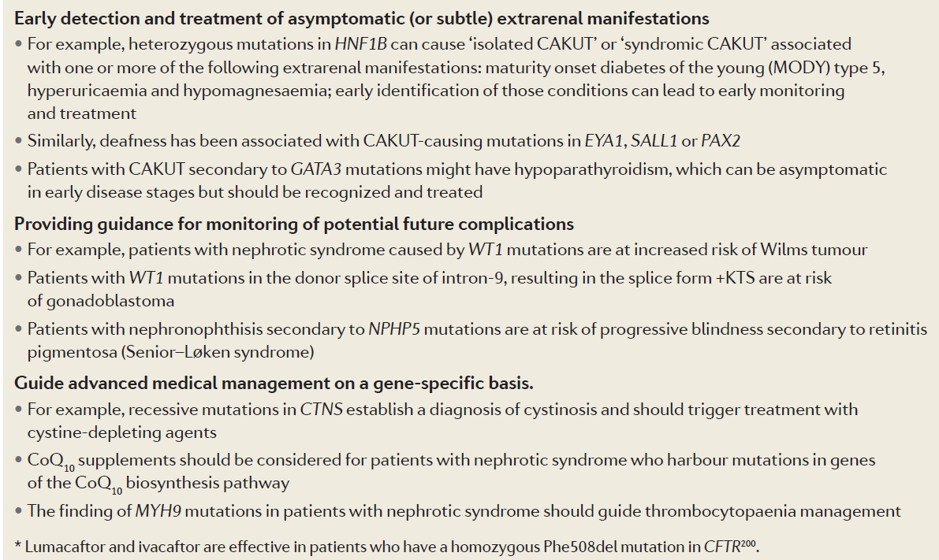
Indications for genetic testing in Autosomal dominant polycystic kidney disease (ADPKD). This manuscript suggests special indications for testing for mutations in ADPKD but there is now strong evidence that the risk of kidney failure depends on the type of ADPKD mutation. Specific treatment in the form of Tolvaptan is available to delay kidney failure in ADPKD in individuals with the highest risk. Dr Danny Gale who is the UK leader in ADPKD management at UCL Department of Nephrology now uses genetic testing in all patients with ADPKD to determine those likely to develop early kidney failure and in whom more aggressive treatment is required. (Ars et al Spanish guidelines for the management of autosomal dominant polycystic kidney disease. Nephrol Dial Transplant 2014; 29: 95-105).
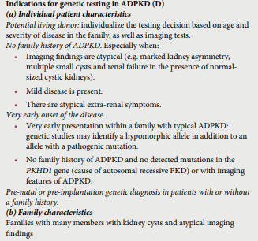
* Categorise study design, for example meta-analysis, randomised trials, non-randomised trial or observational study, study of diagnostic accuracy, etc.
**Provide high level information including population numbers and whether patients are being recruited or in post-recruitment, including providing the trial registration number to allow for tracking purposes.
*** If the publication is a follow-up to an initial publication, please advise.

Identify yet to be published research that may have results available in the near future that could be relevant in the consideration of your application by MSAC (limiting these to the English language only). Please do not attach full text articles, this is just intended to be a summary.

None known* Categorise study design, for example meta-analysis, randomised trials, non-randomised trial or observational study, study of diagnostic accuracy, etc.
**Provide high level information including population numbers and whether patients are being recruited or in post-recruitment.
***Date of when results will be made available (to the best of your knowledge).
The applicant is not aware of any yet to be published research.

PART 5 – CLINICAL ENDORSEMENT AND CONSUMER INFORMATION

List all appropriate professional bodies / organisations representing the group(s) of health professionals who provide the service (please attach a statement of clinical relevance from each group nominated):
Royal College of Pathologists of Australasia
Human Genetics Society of Australasia
Australian Institute of Medical Laboratory Scientists
Australasian Society of Genetic Counsellors
Royal Australasian College of Physicians
Australian and New Zealand Society of Nephrology
Transplant Society of Australia and New Zealand
KidGen

List any professional bodies / organisations that may be impacted by this medical service (i.e. those who provide the comparator service):
Royal Australasian College of Physicians
Australian and New Zealand Society of Nephrology
Transplant Society of Australia and New Zealand
Royal Australasian College of Radiologists
Renal Society of Australasia

List the relevant consumer organisations relevant to the proposed medical service (please attach a letter of support for each consumer organisation nominated):
Kidney Health Australia
Rare Voices Australia
PKD Australia
Tuberous Sclerosis Australia
Fabry Australia
Mito Foundation

List the relevant sponsor(s) and / or manufacturer(s) who produce similar products relevant to the proposed medical service:
N/A

Nominate two experts who could be approached about the proposed medical service and the current clinical management of the service(s):
Name of expert 1: REDACTED
Telephone number(s): REDACTED
Email address: REDACTED
Justification of expertise: Expert clinical nephrologist

Name of expert 1: REDACTED
Telephone number(s): REDACTED
Email address: REDACTED
Justification of expertise: Expert clinical nephrologist

Please note that the Department may also consult with other referrers, proceduralists and disease specialists to obtain their insight.

PART 6 – POPULATION (AND PRIOR TESTS), INDICATION, COMPARATOR, OUTCOME (PICO)

PART 6a – INFORMATION ABOUT THE PROPOSED POPULATION

Define the medical condition, including providing information on the natural history of the condition and a high level summary of associated burden of disease in terms of both morbidity and mortality:
There are currently 25,000 individuals in Australia who have reached end-stage kidney failure and are undergoing treatment in the form of dialysis or a kidney transplant (ANZDATA Registry). About 10% of these are children. According to one study, inherited kidney disease is responsible for nearly all children who develop end-stage renal failure and 10% of all adults (Devuyst,2014). Another study suggests that 50% of children and 20% of adults with end-stage kidney failure have an inherited kidney disease (Grunfeld, 2005).
Renal failure itself has a high morbidity with a risk of myocardial infarction that is up to 40 times greater than that of age- and gender- matched normal individuals. Thus the risk for a person with kidney failure is much higher from heart disease than from renal failure itself. They are also at risk of pulmonary oedema, extreme lethargy, peripheral neuropathy, bone fractures, stunted growth, and serious infections. Dialysis itself has its own risks of myocardial ischemia, arrhythmias due to fluid shifts, and profound hypotension.
Most patients are dialysed for only an average of 3 years and then undergo renal transplantation. Transplantation has an increased mortality around the time of surgery, and then an increased risk of losing the transplant through immunological rejection or surgical complications, in the first year. Over the next 10 years, the transplant recipient’s major risk is of infections from immunosuppression and from cancer. The average life expectancy of a kidney graft is about 12 years and almost everyone with a transplant eventually loses their graft through chronic rejection. Patients may have up to 3 transplants in their lifetime, with periods of dialysis in between while they wait for the best immunologically-matched kidney.
Patients with renal failure are also more likely to have multiple hospital admissions. The cost of dialysis averages $80,000 pa. A renal transplant costs about $80,000 in the first year decreasing to $10,000 a year after that.

Specify any characteristics of patients with the medical condition, or suspected of, who are proposed to be eligible for the proposed medical service, including any details of how a patient would be investigated, managed and referred within the Australian health care system in the lead up to being considered eligible for the service:
There are many different causes of inherited kidney disease, with mutations in many different genes.
Syndrome | These diagnoses result in kidney failure (% cases) | % genes known | % detection rate of genetic testing (children – adults) (Connaughton and Hildebrandt, 2019) | Genetics required to detect disease in family members | Main alternative methods of diagnosis | % accuracy of alternate method of diagnosis | Specific treatment available
Haematuria (Alport syndrome, Thin basement membrane nephropathy) | YES (90% of most men by the age of 40; 15% of women by 60 years) | 100% (n=3) | 67% - 79% (chronic glomerulonephritis) | YES | Kidney biopsy, histology and electron microscopy; sometimes collagen IV chain immunohistochemistry | 50% but 20% in women since often no renal biopsy | YES (RAAS blockade); from an early age may be necessary
Other causes of haematuria including aHUS, C3 glomerulopathy | YES (100%) | >80% (n=10) | 67% - 79% (chronic glomerulonephritis) | YES | Kidney biopsy, histology and immune-histochemistry; complement levels and specialised complement tests; but needs genetic testing for confirmation | 70% but | YES
Proteinuria/Nephrotic syndrome (FSGS, focal and segmental glomerulosclerosis) | YES (100%) | 50% (n=50) | 26% - 14% | NO | Kidney biopsy, histology and immune-histochemistry | Indicates FSGS but not whether to use steroids or likely to recur | Steroids not helpful with inherited FSGS; recurrence unlikely after transplant
Cystic kidney disease (ADPKD, ARPKD, medullary cystic kidney disease, HNF1b, nephronophthisis) | YES (100%) | >80% (n=10) | 50% - 17% , but 45% for medullary cystic kidney disease in adults | Often | Renal imaging (ultrasound and CT scan) and sometimes renal biopsy, testing for diabetes | Depends on age and disease type; disease type determines extrarenal clinical features | YES, Tolvaptan for ADPKD
Tubular defects | Often (40%) | >80% (n=60) | 70% - 83% | NO | Urine and serum biochemistry and enzyme assays; but nearly impossible to determine exact diagnosis without genetic testing | 30- 60 % (often mistakes without genetic testing) | YES for some types
Nephronothiasis/  nephrocalcinosis | Sometimes (<10%) | 117 | 25% - 11% (Daga KI 2018) | YES | Urine and serum biochemistry, stone analysis; imaging | Usually tests do not result in a precise diagnosis | YES for some types
Other rare diseases eg Bardet Biedl, cystinosis, hyperoxaluria, Fabry disease, premature stone disease | YES (80%) | >80% (n=45) | > 80% | NO | Kidney biopsy, biochemistry, imaging (ultrasound, CT scan). Again very complicated workup and usually needs genetic testing | 60% but mistakes are made | For some types
CAKUT (structural abnormalities present from childhood) | Sometimes (30%) | 30% (n=50) | 17% - 22% | NO | Imaging (ultrasound, CT scan, MRI, intravenous pyelogram | Underlying mutant gene cannot be determined | NO

Patients would be referred by nephrologist for genetic testing. Nephrologist would in general provide genetic counselling and advice re treatment and clinical course. Patients would ask for referral to genetic counsellor about other at risk family members. Nephrologist or Genetic counsellor would organise cascade testing.

Define and summarise the current clinical management pathway before patients would be eligible for the proposed medical service (supplement this summary with an easy to follow flowchart [as an attachment to the Application Form] depicting the current clinical management pathway up to this point):
Patient is seen by GP and referred to nephrologist who considers a genetic diagnosis likely. The nephrologist may perform some basic biochemical tests, and renal imaging. They are then likely to perform more complicated biochemical and imaging tests on the basis of their clinical suspicion. The patient may also be seen by a clinical geneticist or genetic counsellor.
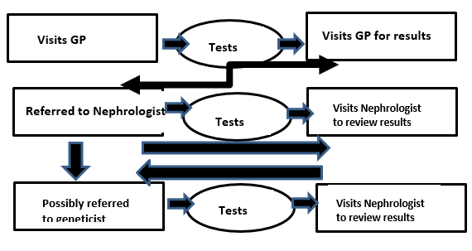

PART 6b – INFORMATION ABOUT THE INTERVENTION

Describe the key components and clinical steps involved in delivering the proposed medical service:
GP performs preliminary tests, reviews patient and refers them to a nephrologist
Nephrologist reviews patient, may assess patient for further complications or to differentiate between genetic and non-genetic causes
When nephrologist decides that genetic cause is likely, refers patient for genetic testing.
Nephrologist reviews patient with test results and may start specific treatment. They will also ask about other likely affected family members and will arrange to see them too. Will ask patient if they would like to see geneticist or genetic counsellor and will then refer patient
Patient may also ask for specific advice re family planning and be referred to genetic counsellor

Does the proposed medical service include a registered trademark component with characteristics that distinguishes it from other similar health components?
No

If the proposed medical service has a prosthesis or device component to it, does it involve a new approach towards managing a particular sub-group of the population with the specific medical condition?
No

If applicable, are there any limitations on the provision of the proposed medical service delivered to the patient (i.e. accessibility, dosage, quantity, duration or frequency):
Not applicable

If applicable, identify any healthcare resources or other medical services that would need to be delivered at the same time as the proposed medical service:
Possibly an appointment with a geneticist or genetic counsellor

If applicable, advise which health professionals will primarily deliver the proposed service:
Nephrologist and in some cases clinical geneticist or genetic counsellor

If applicable, advise whether the proposed medical service could be delegated or referred to another professional for delivery:
No.Identifying that the patient has a likely inherited form of kidney disease is only a decision that a nephrologist makes. This is generally a complicated field.
However a geneticist or genetic counsellor can provide advice re family planning and who else in the family needs to be tested.

If applicable, specify any proposed limitations on who might deliver the proposed medical service, or who might provide a referral for it:

A nephrologist or clinical geneticist should request the genetic testing for the inherited form of kidney disease.

If applicable, advise what type of training or qualifications would be required to perform the proposed service as well as any accreditation requirements to support service delivery:

The person requesting the test would be a nephrologist or clinical geneticist. This person would be a physician. The person undertaking the test would be a scientist in a NATA-accredited pathology laboratory.

(a) Indicate the proposed setting(s) in which the proposed medical service will be delivered (select all relevant settings):
Inpatient private hospital
Inpatient public hospital
Outpatient clinic
Emergency Department
Consulting rooms
Day surgery centre
Residential aged care facility
Patient’s home
Laboratory
Other – please specify below
Specify further details here
- Where the proposed medical service is provided in more than one setting, please describe the rationale related to each:
The referral for the genetic testing would be made by a nephrologist or clinical geneticist in a public hospital or in their private rooms.

Is the proposed medical service intended to be entirely rendered in Australia?
Yes
No – please specify below

The initial patient clinical evaluation, extracting the blood and sending it to an Australian diagnostic laboratory. The patient is then followed up again in Australia

PART 6c – INFORMATION ABOUT THE COMPARATOR(S)

Nominate the appropriate comparator(s) for the proposed medical service, i.e. how is the proposed population currently managed in the absence of the proposed medical service being available in the Australian health care system (including identifying health care resources that are needed to be delivered at the same time as the comparator service):

The comparators are different for each syndrome
Syndrome | Main alternative methods of diagnosis
Haematuria (Alport syndrome, Thin basement membrane nephropathy) | Kidney biopsy, histology and electron microscopy; sometimes collagen IV chain immunohistochemistry
Other causes of haematuria including aHUS, C3 glomerulopathy | Kidney biopsy, histology and immune-histochemistry; complement levels and specialised complement tests; but needs genetic testing for confirmation
Proteinuria/Nephrotic syndrome (FSGS, focal and segmental glomerulosclerosis) | Kidney biopsy, histology and immune-histochemistry
Cystic kidney disease (ADPKD, ARPKD, medullary cystic kidney disease, HNF1b, nephronophthisis) | Renal imaging (ultrasound and CT scan) and sometimes renal biopsy, testing for diabetes
Tubular defects | Urine and serum biochemistry and enzyme assays; but nearly impossible to determine exact diagnosis without genetic testing
Nephronothiasis/  nephrocalcinosis | Urine and serum biochemistry, stone analysis; multiple forms of imaging
Other rare diseases eg Bardet Biedl, cystinosis, hyperoxaluria, Fabry disease, premature stone disease | Kidney biopsy, biochemistry, imaging (ultrasound, CT scan). Again very complicated workup and usually needs genetic testing
CAKUT (structural abnormalities present from childhood) | Imaging (ultrasound, CT scan, MRI, intravenous pyelogram)

Does the medical service that has been nominated as the comparator have an existing MBS item number(s)?
Yes (please provide all relevant MBS item numbers below)
No
Test | Item number
Serum biochemistry- routine | 66512
Complement testing | 71089
Urine biochemistry
Renal biopsy | 36561
Renal biopsy - Light microscopy, immunohistochemistry and electron microscopy of biopsy | 72813/72847/72851
Abdominal ultrasound | 55014
Renal CT scan/abdominal CT scan | 56501/56507
Abdominal MRI < 16 years | 63425
Stone analysis | 66590
Although many tests may be undertaken most patients do not obtain an accurate diagnosis

Define and summarise the current clinical management pathways that patients may follow after they receive the medical service that has been nominated as the comparator (supplement this summary with an easy to follow flowchart [as an attachment to the Application Form] depicting the current clinical management pathway that patients may follow from the point of receiving the comparator onwards including health care resources):
The nephrologist uses the test results to develop a diagnosis and then institutes specific therapy (eg Tolvaptan, anti C5a therapy in atypical HUS). In other cases the nephrologist uses generic treatment to delay the onset of renal failure such as RAAS blockade, better BP control, and reduction of statin levels.
The nephrologist then typically invites other at-risk family members to attend for a consultation and cascade genetic testing. The nephrologist will provide information about inheritance at this follow up meeting or will refer the patient to a geneticist/ genetic counsellor for advice. Depending on the diagnosis and the family member’s disease status, the nephrologist will arrange further treatment, and review for monitoring kidney function deterioration.

(a) Will the proposed medical service be used in addition to, or instead of, the nominated comparator(s)?
Yes No Genetic testing will be used instead of many of the comparator testing methods.

If yes, please outline the extent of which the current service/comparator is expected to be substituted:
The complicated comparator tests such as a renal biopsy will not be necessary.

Define and summarise how current clinical management pathways (from the point of service delivery onwards) are expected to change as a consequence of introducing the proposed medical service including variation in health care resources (Refer to Question 39 as baseline):
The diagnosis will be made sooner (the ‘diagnostic odyssey’ is shortened) and specific treatment instituted sooner so acting immediately to delay renal function deterioration
The clinician can stop repeating tests and performing new tests in an attempt to obtain the diagnosis.
The patient will not have to attend for multiple appointments and multiple often repeated tests.
The patient’s diagnosis will be known sooner.
The patients will see the nephrologist, undergo definitive genetic testing, be given the appropriate treatment, and subsequently reviewed at appropriate intervals. Their family members may also be screened for the disease.
- Change in clinical practice – Genetic testing may
Indicate the diagnosis with certainty
Predict future clinical complications and the prognosis with greater certainty
Predict clinical course including early onset renal failure and an urgent need for treatment
Indicate the usefulness of individual therapies eg steroids do not work in inherited FSGS
Indicate specific mutation type eg for missense or nonsense mutations that dictate type of treatment needed
Detect asymptomatic (subtle) extrarenal manifestations allowing early treatment
Indicate potential future complications that need to be monitored for
Guide advanced medical management on a gene-specific basis
Indicate that disease will recur after transplantation
Ensure that a disease carrier does not act as kidney donor. This can result in the kidney donor themselves developing kidney failure
Help avoid unnecessary diagnostic procedures, tests and treatments

2.Indicates the probability of the health outcome
The patient’s prognosis will be evident usually from the time of diagnosis since the clinical course of most of these diseases is known

3.Results in changes to family planning decisions
Indicates who else in the family is at risk and enables earlier treatment from a younger age
Can be used to determine if an embryo is affected in preimplantation IVF studies, or if an early stage foetus is affected

4.More compelling than current tests – shortens and makes less burdensome the diagnostic odyssey
Knowing the diagnosis may also reduce the burden of guilt for the parents

5. Naming of the disease, empowers both the individual and their clinician

6. Genetic testing provides conclusive evidence of the disease diagnosis where there is ‘value in knowing’

PART 6d – INFORMATION ABOUT THE CLINICAL OUTCOME

Summarise the clinical claims for the proposed medical service against the appropriate comparator(s), in terms of consequences for health outcomes (comparative benefits and harms):
Typically the patient and their affected family members have been undiagnosed for years and often the index case has undergone many unnecessary investigations some of which are invasive, such as renal biopsy, annual cystoscopy.

Genetic testing enables an accurate diagnosis to be made in 30 – 95% of patients suspected of having inherited kidney disease
This means that the unnecessary tests can cease
It also means that correct treatment can be instituted and unnecessary medications ceased.
It also means that the nephrologist can anticipate or test for associated complications and manage them effectively.
In certain diseases knowing the accurate diagnosis indicates the prognosis, anticipate recurrence and enables preemptive treatment to start.
This information means that affected individuals can make informed reproductive decisions.

It also means that the nephrologist can screen other at risk family members and commence treatment early in order to delay end-stage kidney failure. Identifying affected family members means that they will not be used as kidney donors

Please advise if the overall clinical claim is for:
Superiority
Non-inferiority

Below, list the key health outcomes (major and minor – prioritising major key health outcomes first) that will need to be specifically measured in assessing the clinical claim of the proposed medical service versus the comparator:
Safety Outcomes: List safety outcomes here
Fewer renal biopsies need to be performed. Patients undergo fewer investigations with fewer associated risks.
Patients can commence definitive treatment that delays end-stage renal failure and the need for dialysis or transplantation. This also reduces the risk of death from heart disease.

Clinical Effectiveness Outcomes: List clinical effectiveness outcomes here
Patients can commence definitive treatment to delay end-stage renal failure and the need for dialysis or transplantation
Patients need fewer tests and this reduces the burden of their diagnostic odyssey
Patients can make accurate and informed reproductive decisions

PART 7 – INFORMATION ABOUT ESTIMATED UTILISATION

Estimate the prevalence and/or incidence of the proposed population:
Prevalence of KIDNEY DISEASE = 237,800 IN 2017-2018 (ABS). Most of these will have diabetic or renovascular disease.
Possibly 2000 would be tested in the first year and 2000 each year after that.

Estimate the number of times the proposed medical service(s) would be delivered to a patient per year:
Each patient would require testing once in a lifetime.

How many years would the proposed medical service(s) be required for the patient?
Once in a lifetime only

Estimate the projected number of patients who will utilise the proposed medical service(s) for the first full year:

Possibly 2000 would be tested in the first year and 2000 each year after that.

Estimate the anticipated uptake of the proposed medical service over the next three years factoring in any constraints in the health system in meeting the needs of the proposed population (such as supply and demand factors) as well as provide commentary on risk of ‘leakage’ to populations not targeted by the service:
2000 in first year, then cascade screening means that maybe 2000 each year after this.

PART 8 – COST INFORMATION

Indicate the likely cost of providing the proposed medical service. Where possible, please provide overall cost and breakdown:
$1200 – WES now available in Australia for $500 per test; an extra $500 is needed for the interpretation of variants. This is similar to the cost for Alport gene testing item numbers 73298 and 73299. The cost will fall with time.

Specify how long the proposed medical service typically takes to perform:
Three months currently. Samples are batched for testing (taking possibly 4 weeks); testing (4 weeks) and then kidney WES batched for interpretation and multidisciplinary meeting to decide on likely pathogenicity (4 weeks)

If public funding is sought through the MBS, please draft a proposed MBS item descriptor to define the population and medical service usage characteristics that would define eligibility for MBS funding.
Category – Pathology Services Genetics
Diagnostic genetic testing of individuals with inherited kidney disease
Characterisation of germline gene variants in one or more of the genes implicated in inherited kidney disease in a patient with a renal abnormality, for whom clinical and family history criteria, as assessed by a treating specialist using a quantitative algorithm, place the patient at > 10% risk of having a clinically actionable pathogenic mutation identified.

Or more simply: Characterisation of germline gene variants in one or more of the genes implicated in inherited kidney disease in a person whom a nephrologist or clinical geneticist strongly suspects of inherited kidney disease.
Fee: $1200

Predictive genetic testing of family members
“Request by a clinical geneticist, or a medical specialist providing professional genetic counselling services, for the detection of a clinically actionable pathogenic mutation previously identified in a gene listed in Item XXXX in a relative.”

Fee: $400

